RELATÓRIO DO TESTE

Cadastro de Locação de Equipamentos - Apoio Ortopédico – Cenário 1: Preenchimento completo e salvamento

Data do teste: 21/08/2025 16:00:13

🚀 Iniciando teste de consulta da Agenda/CRM

🔄 Acessando sistema...

✅ Acessando sistema realizada com sucesso.

Screenshot: acessando sistema

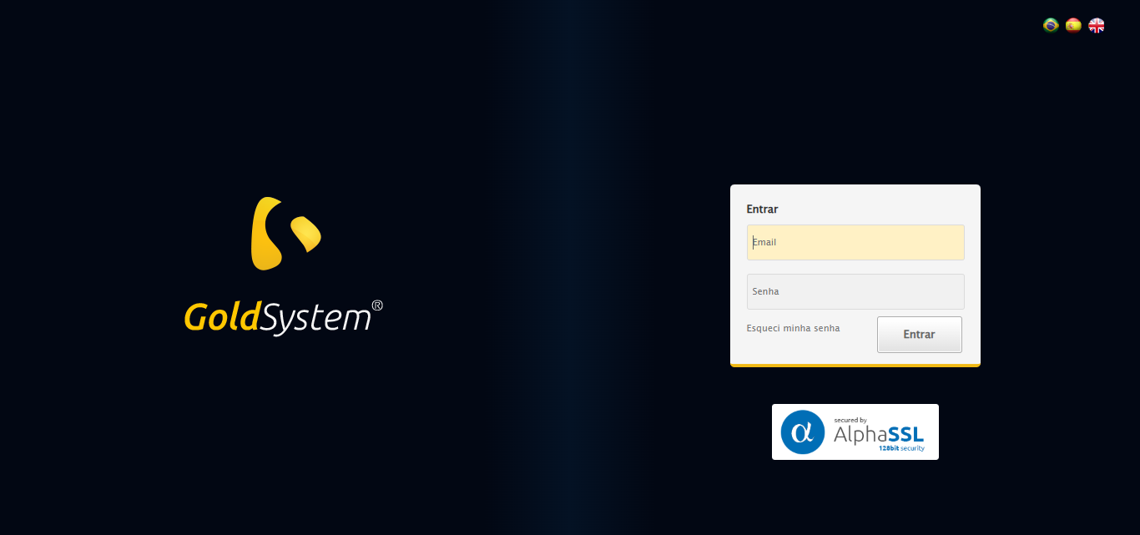

🔄 Realizando login...

✅ Realizando login realizada com sucesso.

Screenshot: realizando login

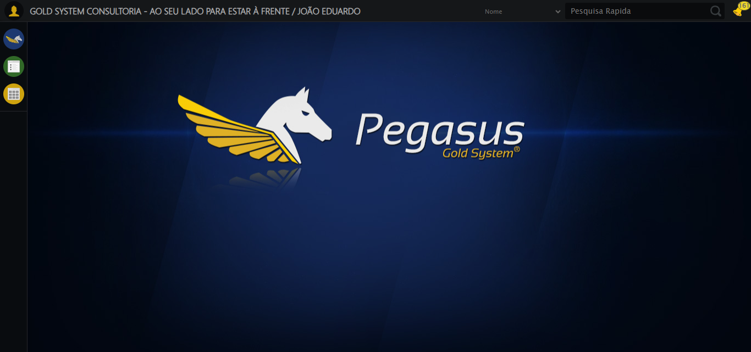

🔄 Ajustando zoom e abrindo menu...

🔍 Zoom ajustado para 90%.

✅ Ajustando zoom e abrindo menu realizada com sucesso.

Screenshot: ajustando zoom e abrindo menu

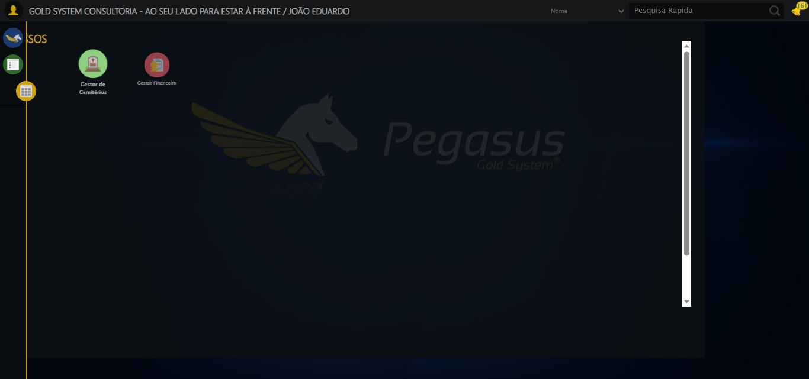

🔄 Acessando Apoio Ortopédico...

✅ Acessando Apoio Ortopédico realizada com sucesso.

Screenshot: acessando apoio ortopédico

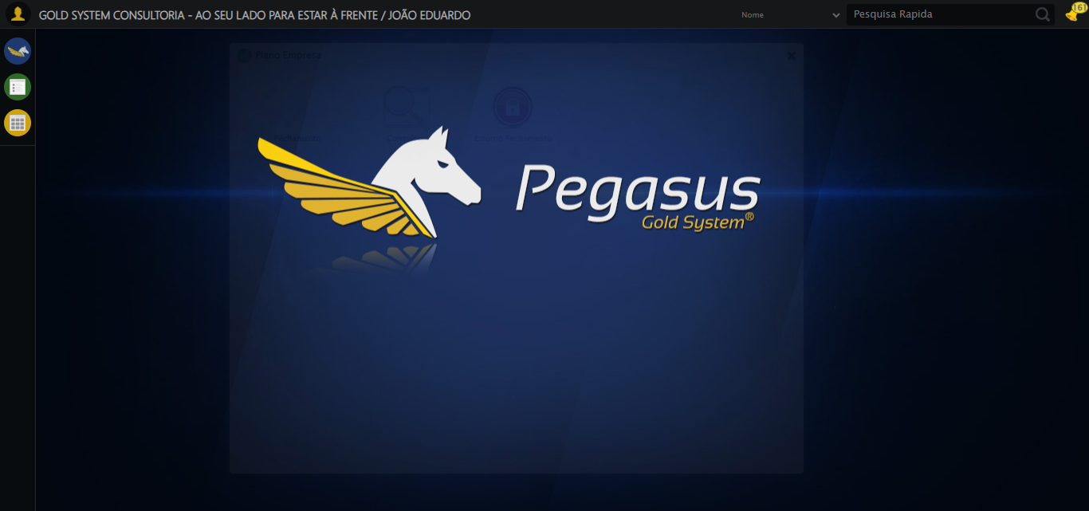

🔄 Clicando em Locação de Equipamentos...

⚠️ Tentativa 1 falhou para Clicando em Locação de Equipamentos, tentando novamente...

🔄 Clicando em Locação de Equipamentos... (Tentativa 2)

❌ Erro inesperado ao clicando em locação de equipamentos: Message: target frame detached  
 (failed to check if window was closed: disconnected: Unable to receive message from renderer)  
 (Session info: chrome=139.0.7258.128)  
Stacktrace:  
 GetHandleVerifier [0x0xacffc3+65331]  
 GetHandleVerifier [0x0xad0004+65396]  
 (No symbol) [0x0x8c3dc0]  
 (No symbol) [0x0x8b4920]  
 (No symbol) [0x0x8b3a91]  
 (No symbol) [0x0x8d1709]  
 (No symbol) [0x0x937e4c]  
 (No symbol) [0x0x9524d9]  
 (No symbol) [0x0x9312d6]  
 (No symbol) [0x0x900910]  
 (No symbol) [0x0x901784]  
 GetHandleVerifier [0x0xd138b3+2439203]  
 GetHandleVerifier [0x0xd0eae2+2419282]  
 GetHandleVerifier [0x0xaf712a+225434]  
 GetHandleVerifier [0x0xae6e08+159096]  
 GetHandleVerifier [0x0xaedd5d+187597]  
 GetHandleVerifier [0x0xad7ad8+96840]  
 GetHandleVerifier [0x0xad7c62+97234]  
 GetHandleVerifier [0x0xac277a+9962]  
 BaseThreadInitThunk [0x0x75abfcc9+25]  
 RtlGetAppContainerNamedObjectPath [0x0x776d82ae+286]  
 RtlGetAppContainerNamedObjectPath [0x0x776d827e+238]

⚠️ Erro ao tirar screenshot erro_clicando em locação de equipamentos: Message: no such window: target window already closed  
from unknown error: web view not found  
 (Session info: chrome=139.0.7258.128)  
Stacktrace:  
 GetHandleVerifier [0x0xacffc3+65331]  
 GetHandleVerifier [0x0xad0004+65396]  
 (No symbol) [0x0x8c3f63]  
 (No symbol) [0x0x8a2e69]  
 (No symbol) [0x0x937c7e]  
 (No symbol) [0x0x9524d9]  
 (No symbol) [0x0x9312d6]  
 (No symbol) [0x0x900910]  
 (No symbol) [0x0x901784]  
 GetHandleVerifier [0x0xd138b3+2439203]  
 GetHandleVerifier [0x0xd0eae2+2419282]  
 GetHandleVerifier [0x0xaf712a+225434]  
 GetHandleVerifier [0x0xae6e08+159096]  
 GetHandleVerifier [0x0xaedd5d+187597]  
 GetHandleVerifier [0x0xad7ad8+96840]  
 GetHandleVerifier [0x0xad7c62+97234]  
 GetHandleVerifier [0x0xac277a+9962]  
 BaseThreadInitThunk [0x0x75abfcc9+25]  
 RtlGetAppContainerNamedObjectPath [0x0x776d82ae+286]  
 RtlGetAppContainerNamedObjectPath [0x0x776d827e+238]

🔄 Preenchendo o Número do Contrato...

⚠️ Tentativa 1 falhou: Message: no such window: target window already closed  
from unknown error: web view not found  
 (Session info: chrome=139.0.7258.128)  
Stacktrace:  
 GetHandleVerifier [0x0xacffc3+65331]  
 GetHandleVerifier [0x0xad0004+65396]  
 (No symbol) [0x0x8c3f63]  
 (No symbol) [0x0x8a2e69]  
 (No symbol) [0x0x937c7e]  
 (No symbol) [0x0x9524d9]  
 (No symbol) [0x0x9312d6]  
 (No symbol) [0x0x900910]  
 (No symbol) [0x0x901784]  
 GetHandleVerifier [0x0xd138b3+2439203]  
 GetHandleVerifier [0x0xd0eae2+2419282]  
 GetHandleVerifier [0x0xaf712a+225434]  
 GetHandleVerifier [0x0xae6e08+159096]  
 GetHandleVerifier [0x0xaedd5d+187597]  
 GetHandleVerifier [0x0xad7ad8+96840]  
 GetHandleVerifier [0x0xad7c62+97234]  
 GetHandleVerifier [0x0xac277a+9962]  
 BaseThreadInitThunk [0x0x75abfcc9+25]  
 RtlGetAppContainerNamedObjectPath [0x0x776d82ae+286]  
 RtlGetAppContainerNamedObjectPath [0x0x776d827e+238]

⚠️ Tentativa 2 falhou: Message: no such window: target window already closed  
from unknown error: web view not found  
 (Session info: chrome=139.0.7258.128)  
Stacktrace:  
 GetHandleVerifier [0x0xacffc3+65331]  
 GetHandleVerifier [0x0xad0004+65396]  
 (No symbol) [0x0x8c3f63]  
 (No symbol) [0x0x8a2e69]  
 (No symbol) [0x0x937c7e]  
 (No symbol) [0x0x9524d9]  
 (No symbol) [0x0x9312d6]  
 (No symbol) [0x0x900910]  
 (No symbol) [0x0x901784]  
 GetHandleVerifier [0x0xd138b3+2439203]  
 GetHandleVerifier [0x0xd0eae2+2419282]  
 GetHandleVerifier [0x0xaf712a+225434]  
 GetHandleVerifier [0x0xae6e08+159096]  
 GetHandleVerifier [0x0xaedd5d+187597]  
 GetHandleVerifier [0x0xad7ad8+96840]  
 GetHandleVerifier [0x0xad7c62+97234]  
 GetHandleVerifier [0x0xac277a+9962]  
 BaseThreadInitThunk [0x0x75abfcc9+25]  
 RtlGetAppContainerNamedObjectPath [0x0x776d82ae+286]  
 RtlGetAppContainerNamedObjectPath [0x0x776d827e+238]

⚠️ Tentativa 3 falhou: Message: no such window: target window already closed  
from unknown error: web view not found  
 (Session info: chrome=139.0.7258.128)  
Stacktrace:  
 GetHandleVerifier [0x0xacffc3+65331]  
 GetHandleVerifier [0x0xad0004+65396]  
 (No symbol) [0x0x8c3f63]  
 (No symbol) [0x0x8a2e69]  
 (No symbol) [0x0x937c7e]  
 (No symbol) [0x0x9524d9]  
 (No symbol) [0x0x9312d6]  
 (No symbol) [0x0x900910]  
 (No symbol) [0x0x901784]  
 GetHandleVerifier [0x0xd138b3+2439203]  
 GetHandleVerifier [0x0xd0eae2+2419282]  
 GetHandleVerifier [0x0xaf712a+225434]  
 GetHandleVerifier [0x0xae6e08+159096]  
 GetHandleVerifier [0x0xaedd5d+187597]  
 GetHandleVerifier [0x0xad7ad8+96840]  
 GetHandleVerifier [0x0xad7c62+97234]  
 GetHandleVerifier [0x0xac277a+9962]  
 BaseThreadInitThunk [0x0x75abfcc9+25]  
 RtlGetAppContainerNamedObjectPath [0x0x776d82ae+286]  
 RtlGetAppContainerNamedObjectPath [0x0x776d827e+238]

✅ Preenchendo o Número do Contrato realizada com sucesso.

⚠️ Erro ao tirar screenshot preenchendo o número do contrato: Message: no such window: target window already closed  
from unknown error: web view not found  
 (Session info: chrome=139.0.7258.128)  
Stacktrace:  
 GetHandleVerifier [0x0xacffc3+65331]  
 GetHandleVerifier [0x0xad0004+65396]  
 (No symbol) [0x0x8c3f63]  
 (No symbol) [0x0x8a2e69]  
 (No symbol) [0x0x937c7e]  
 (No symbol) [0x0x9524d9]  
 (No symbol) [0x0x9312d6]  
 (No symbol) [0x0x900910]  
 (No symbol) [0x0x901784]  
 GetHandleVerifier [0x0xd138b3+2439203]  
 GetHandleVerifier [0x0xd0eae2+2419282]  
 GetHandleVerifier [0x0xaf712a+225434]  
 GetHandleVerifier [0x0xae6e08+159096]  
 GetHandleVerifier [0x0xaedd5d+187597]  
 GetHandleVerifier [0x0xad7ad8+96840]  
 GetHandleVerifier [0x0xad7c62+97234]  
 GetHandleVerifier [0x0xac277a+9962]  
 BaseThreadInitThunk [0x0x75abfcc9+25]  
 RtlGetAppContainerNamedObjectPath [0x0x776d82ae+286]  
 RtlGetAppContainerNamedObjectPath [0x0x776d827e+238]

🔄 Preechendo Observações...

❌ Erro inesperado ao preechendo observações: Message: no such window: target window already closed  
from unknown error: web view not found  
 (Session info: chrome=139.0.7258.128)  
Stacktrace:  
 GetHandleVerifier [0x0xacffc3+65331]  
 GetHandleVerifier [0x0xad0004+65396]  
 (No symbol) [0x0x8c3f63]  
 (No symbol) [0x0x8a2e69]  
 (No symbol) [0x0x937c7e]  
 (No symbol) [0x0x9524d9]  
 (No symbol) [0x0x9312d6]  
 (No symbol) [0x0x900910]  
 (No symbol) [0x0x901784]  
 GetHandleVerifier [0x0xd138b3+2439203]  
 GetHandleVerifier [0x0xd0eae2+2419282]  
 GetHandleVerifier [0x0xaf712a+225434]  
 GetHandleVerifier [0x0xae6e08+159096]  
 GetHandleVerifier [0x0xaedd5d+187597]  
 GetHandleVerifier [0x0xad7ad8+96840]  
 GetHandleVerifier [0x0xad7c62+97234]  
 GetHandleVerifier [0x0xac277a+9962]  
 BaseThreadInitThunk [0x0x75abfcc9+25]  
 RtlGetAppContainerNamedObjectPath [0x0x776d82ae+286]  
 RtlGetAppContainerNamedObjectPath [0x0x776d827e+238]

⚠️ Erro ao tirar screenshot erro_preechendo observações: Message: no such window: target window already closed  
from unknown error: web view not found  
 (Session info: chrome=139.0.7258.128)  
Stacktrace:  
 GetHandleVerifier [0x0xacffc3+65331]  
 GetHandleVerifier [0x0xad0004+65396]  
 (No symbol) [0x0x8c3f63]  
 (No symbol) [0x0x8a2e69]  
 (No symbol) [0x0x937c7e]  
 (No symbol) [0x0x9524d9]  
 (No symbol) [0x0x9312d6]  
 (No symbol) [0x0x900910]  
 (No symbol) [0x0x901784]  
 GetHandleVerifier [0x0xd138b3+2439203]  
 GetHandleVerifier [0x0xd0eae2+2419282]  
 GetHandleVerifier [0x0xaf712a+225434]  
 GetHandleVerifier [0x0xae6e08+159096]  
 GetHandleVerifier [0x0xaedd5d+187597]  
 GetHandleVerifier [0x0xad7ad8+96840]  
 GetHandleVerifier [0x0xad7c62+97234]  
 GetHandleVerifier [0x0xac277a+9962]  
 BaseThreadInitThunk [0x0x75abfcc9+25]  
 RtlGetAppContainerNamedObjectPath [0x0x776d82ae+286]  
 RtlGetAppContainerNamedObjectPath [0x0x776d827e+238]

🔄 Avançando para a aba: 'Adicionar Equipamentos'...

❌ Erro inesperado ao avançando para a aba: 'adicionar equipamentos': Message: no such window: target window already closed  
from unknown error: web view not found  
 (Session info: chrome=139.0.7258.128)  
Stacktrace:  
 GetHandleVerifier [0x0xacffc3+65331]  
 GetHandleVerifier [0x0xad0004+65396]  
 (No symbol) [0x0x8c3f63]  
 (No symbol) [0x0x8a2e69]  
 (No symbol) [0x0x937c7e]  
 (No symbol) [0x0x9524d9]  
 (No symbol) [0x0x9312d6]  
 (No symbol) [0x0x900910]  
 (No symbol) [0x0x901784]  
 GetHandleVerifier [0x0xd138b3+2439203]  
 GetHandleVerifier [0x0xd0eae2+2419282]  
 GetHandleVerifier [0x0xaf712a+225434]  
 GetHandleVerifier [0x0xae6e08+159096]  
 GetHandleVerifier [0x0xaedd5d+187597]  
 GetHandleVerifier [0x0xad7ad8+96840]  
 GetHandleVerifier [0x0xad7c62+97234]  
 GetHandleVerifier [0x0xac277a+9962]  
 BaseThreadInitThunk [0x0x75abfcc9+25]  
 RtlGetAppContainerNamedObjectPath [0x0x776d82ae+286]  
 RtlGetAppContainerNamedObjectPath [0x0x776d827e+238]

⚠️ Erro ao tirar screenshot erro_avançando para a aba_ _adicionar equipamentos_: Message: no such window: target window already closed  
from unknown error: web view not found  
 (Session info: chrome=139.0.7258.128)  
Stacktrace:  
 GetHandleVerifier [0x0xacffc3+65331]  
 GetHandleVerifier [0x0xad0004+65396]  
 (No symbol) [0x0x8c3f63]  
 (No symbol) [0x0x8a2e69]  
 (No symbol) [0x0x937c7e]  
 (No symbol) [0x0x9524d9]  
 (No symbol) [0x0x9312d6]  
 (No symbol) [0x0x900910]  
 (No symbol) [0x0x901784]  
 GetHandleVerifier [0x0xd138b3+2439203]  
 GetHandleVerifier [0x0xd0eae2+2419282]  
 GetHandleVerifier [0x0xaf712a+225434]  
 GetHandleVerifier [0x0xae6e08+159096]  
 GetHandleVerifier [0x0xaedd5d+187597]  
 GetHandleVerifier [0x0xad7ad8+96840]  
 GetHandleVerifier [0x0xad7c62+97234]  
 GetHandleVerifier [0x0xac277a+9962]  
 BaseThreadInitThunk [0x0x75abfcc9+25]  
 RtlGetAppContainerNamedObjectPath [0x0x776d82ae+286]  
 RtlGetAppContainerNamedObjectPath [0x0x776d827e+238]

🔄 Selecionando o Equipamento...

✅ Selecionando o Equipamento realizada com sucesso.

⚠️ Erro ao tirar screenshot selecionando o equipamento: Message: no such window: target window already closed  
from unknown error: web view not found  
 (Session info: chrome=139.0.7258.128)  
Stacktrace:  
 GetHandleVerifier [0x0xacffc3+65331]  
 GetHandleVerifier [0x0xad0004+65396]  
 (No symbol) [0x0x8c3f63]  
 (No symbol) [0x0x8a2e69]  
 (No symbol) [0x0x937c7e]  
 (No symbol) [0x0x9524d9]  
 (No symbol) [0x0x9312d6]  
 (No symbol) [0x0x900910]  
 (No symbol) [0x0x901784]  
 GetHandleVerifier [0x0xd138b3+2439203]  
 GetHandleVerifier [0x0xd0eae2+2419282]  
 GetHandleVerifier [0x0xaf712a+225434]  
 GetHandleVerifier [0x0xae6e08+159096]  
 GetHandleVerifier [0x0xaedd5d+187597]  
 GetHandleVerifier [0x0xad7ad8+96840]  
 GetHandleVerifier [0x0xad7c62+97234]  
 GetHandleVerifier [0x0xac277a+9962]  
 BaseThreadInitThunk [0x0x75abfcc9+25]  
 RtlGetAppContainerNamedObjectPath [0x0x776d82ae+286]  
 RtlGetAppContainerNamedObjectPath [0x0x776d827e+238]

🔄 Adicionando Equipamento:...

❌ Erro ao clicar robusto: Message: no such window: target window already closed  
from unknown error: web view not found  
 (Session info: chrome=139.0.7258.128)  
Stacktrace:  
 GetHandleVerifier [0x0xacffc3+65331]  
 GetHandleVerifier [0x0xad0004+65396]  
 (No symbol) [0x0x8c3f63]  
 (No symbol) [0x0x8a2e69]  
 (No symbol) [0x0x937c7e]  
 (No symbol) [0x0x9524d9]  
 (No symbol) [0x0x9312d6]  
 (No symbol) [0x0x900910]  
 (No symbol) [0x0x901784]  
 GetHandleVerifier [0x0xd138b3+2439203]  
 GetHandleVerifier [0x0xd0eae2+2419282]  
 GetHandleVerifier [0x0xaf712a+225434]  
 GetHandleVerifier [0x0xae6e08+159096]  
 GetHandleVerifier [0x0xaedd5d+187597]  
 GetHandleVerifier [0x0xad7ad8+96840]  
 GetHandleVerifier [0x0xad7c62+97234]  
 GetHandleVerifier [0x0xac277a+9962]  
 BaseThreadInitThunk [0x0x75abfcc9+25]  
 RtlGetAppContainerNamedObjectPath [0x0x776d82ae+286]  
 RtlGetAppContainerNamedObjectPath [0x0x776d827e+238]

✅ Adicionando Equipamento: realizada com sucesso.

⚠️ Erro ao tirar screenshot adicionando equipamento_: Message: no such window: target window already closed  
from unknown error: web view not found  
 (Session info: chrome=139.0.7258.128)  
Stacktrace:  
 GetHandleVerifier [0x0xacffc3+65331]  
 GetHandleVerifier [0x0xad0004+65396]  
 (No symbol) [0x0x8c3f63]  
 (No symbol) [0x0x8a2e69]  
 (No symbol) [0x0x937c7e]  
 (No symbol) [0x0x9524d9]  
 (No symbol) [0x0x9312d6]  
 (No symbol) [0x0x900910]  
 (No symbol) [0x0x901784]  
 GetHandleVerifier [0x0xd138b3+2439203]  
 GetHandleVerifier [0x0xd0eae2+2419282]  
 GetHandleVerifier [0x0xaf712a+225434]  
 GetHandleVerifier [0x0xae6e08+159096]  
 GetHandleVerifier [0x0xaedd5d+187597]  
 GetHandleVerifier [0x0xad7ad8+96840]  
 GetHandleVerifier [0x0xad7c62+97234]  
 GetHandleVerifier [0x0xac277a+9962]  
 BaseThreadInitThunk [0x0x75abfcc9+25]  
 RtlGetAppContainerNamedObjectPath [0x0x776d82ae+286]  
 RtlGetAppContainerNamedObjectPath [0x0x776d827e+238]

🔄 Selecionando o Equipamento...

✅ Selecionando o Equipamento realizada com sucesso.

⚠️ Erro ao tirar screenshot selecionando o equipamento: Message: no such window: target window already closed  
from unknown error: web view not found  
 (Session info: chrome=139.0.7258.128)  
Stacktrace:  
 GetHandleVerifier [0x0xacffc3+65331]  
 GetHandleVerifier [0x0xad0004+65396]  
 (No symbol) [0x0x8c3f63]  
 (No symbol) [0x0x8a2e69]  
 (No symbol) [0x0x937c7e]  
 (No symbol) [0x0x9524d9]  
 (No symbol) [0x0x9312d6]  
 (No symbol) [0x0x900910]  
 (No symbol) [0x0x901784]  
 GetHandleVerifier [0x0xd138b3+2439203]  
 GetHandleVerifier [0x0xd0eae2+2419282]  
 GetHandleVerifier [0x0xaf712a+225434]  
 GetHandleVerifier [0x0xae6e08+159096]  
 GetHandleVerifier [0x0xaedd5d+187597]  
 GetHandleVerifier [0x0xad7ad8+96840]  
 GetHandleVerifier [0x0xad7c62+97234]  
 GetHandleVerifier [0x0xac277a+9962]  
 BaseThreadInitThunk [0x0x75abfcc9+25]  
 RtlGetAppContainerNamedObjectPath [0x0x776d82ae+286]  
 RtlGetAppContainerNamedObjectPath [0x0x776d827e+238]

🔄 Adicionando Equipamento:...

❌ Erro ao clicar robusto: Message: no such window: target window already closed  
from unknown error: web view not found  
 (Session info: chrome=139.0.7258.128)  
Stacktrace:  
 GetHandleVerifier [0x0xacffc3+65331]  
 GetHandleVerifier [0x0xad0004+65396]  
 (No symbol) [0x0x8c3f63]  
 (No symbol) [0x0x8a2e69]  
 (No symbol) [0x0x937c7e]  
 (No symbol) [0x0x9524d9]  
 (No symbol) [0x0x9312d6]  
 (No symbol) [0x0x900910]  
 (No symbol) [0x0x901784]  
 GetHandleVerifier [0x0xd138b3+2439203]  
 GetHandleVerifier [0x0xd0eae2+2419282]  
 GetHandleVerifier [0x0xaf712a+225434]  
 GetHandleVerifier [0x0xae6e08+159096]  
 GetHandleVerifier [0x0xaedd5d+187597]  
 GetHandleVerifier [0x0xad7ad8+96840]  
 GetHandleVerifier [0x0xad7c62+97234]  
 GetHandleVerifier [0x0xac277a+9962]  
 BaseThreadInitThunk [0x0x75abfcc9+25]  
 RtlGetAppContainerNamedObjectPath [0x0x776d82ae+286]  
 RtlGetAppContainerNamedObjectPath [0x0x776d827e+238]

✅ Adicionando Equipamento: realizada com sucesso.

⚠️ Erro ao tirar screenshot adicionando equipamento_: Message: no such window: target window already closed  
from unknown error: web view not found  
 (Session info: chrome=139.0.7258.128)  
Stacktrace:  
 GetHandleVerifier [0x0xacffc3+65331]  
 GetHandleVerifier [0x0xad0004+65396]  
 (No symbol) [0x0x8c3f63]  
 (No symbol) [0x0x8a2e69]  
 (No symbol) [0x0x937c7e]  
 (No symbol) [0x0x9524d9]  
 (No symbol) [0x0x9312d6]  
 (No symbol) [0x0x900910]  
 (No symbol) [0x0x901784]  
 GetHandleVerifier [0x0xd138b3+2439203]  
 GetHandleVerifier [0x0xd0eae2+2419282]  
 GetHandleVerifier [0x0xaf712a+225434]  
 GetHandleVerifier [0x0xae6e08+159096]  
 GetHandleVerifier [0x0xaedd5d+187597]  
 GetHandleVerifier [0x0xad7ad8+96840]  
 GetHandleVerifier [0x0xad7c62+97234]  
 GetHandleVerifier [0x0xac277a+9962]  
 BaseThreadInitThunk [0x0x75abfcc9+25]  
 RtlGetAppContainerNamedObjectPath [0x0x776d82ae+286]  
 RtlGetAppContainerNamedObjectPath [0x0x776d827e+238]

🔄 Selecionando o Equipamento...

✅ Selecionando o Equipamento realizada com sucesso.

⚠️ Erro ao tirar screenshot selecionando o equipamento: Message: no such window: target window already closed  
from unknown error: web view not found  
 (Session info: chrome=139.0.7258.128)  
Stacktrace:  
 GetHandleVerifier [0x0xacffc3+65331]  
 GetHandleVerifier [0x0xad0004+65396]  
 (No symbol) [0x0x8c3f63]  
 (No symbol) [0x0x8a2e69]  
 (No symbol) [0x0x937c7e]  
 (No symbol) [0x0x9524d9]  
 (No symbol) [0x0x9312d6]  
 (No symbol) [0x0x900910]  
 (No symbol) [0x0x901784]  
 GetHandleVerifier [0x0xd138b3+2439203]  
 GetHandleVerifier [0x0xd0eae2+2419282]  
 GetHandleVerifier [0x0xaf712a+225434]  
 GetHandleVerifier [0x0xae6e08+159096]  
 GetHandleVerifier [0x0xaedd5d+187597]  
 GetHandleVerifier [0x0xad7ad8+96840]  
 GetHandleVerifier [0x0xad7c62+97234]  
 GetHandleVerifier [0x0xac277a+9962]  
 BaseThreadInitThunk [0x0x75abfcc9+25]  
 RtlGetAppContainerNamedObjectPath [0x0x776d82ae+286]  
 RtlGetAppContainerNamedObjectPath [0x0x776d827e+238]

🔄 Adicionando Equipamento:...

❌ Erro ao clicar robusto: Message: no such window: target window already closed  
from unknown error: web view not found  
 (Session info: chrome=139.0.7258.128)  
Stacktrace:  
 GetHandleVerifier [0x0xacffc3+65331]  
 GetHandleVerifier [0x0xad0004+65396]  
 (No symbol) [0x0x8c3f63]  
 (No symbol) [0x0x8a2e69]  
 (No symbol) [0x0x937c7e]  
 (No symbol) [0x0x9524d9]  
 (No symbol) [0x0x9312d6]  
 (No symbol) [0x0x900910]  
 (No symbol) [0x0x901784]  
 GetHandleVerifier [0x0xd138b3+2439203]  
 GetHandleVerifier [0x0xd0eae2+2419282]  
 GetHandleVerifier [0x0xaf712a+225434]  
 GetHandleVerifier [0x0xae6e08+159096]  
 GetHandleVerifier [0x0xaedd5d+187597]  
 GetHandleVerifier [0x0xad7ad8+96840]  
 GetHandleVerifier [0x0xad7c62+97234]  
 GetHandleVerifier [0x0xac277a+9962]  
 BaseThreadInitThunk [0x0x75abfcc9+25]  
 RtlGetAppContainerNamedObjectPath [0x0x776d82ae+286]  
 RtlGetAppContainerNamedObjectPath [0x0x776d827e+238]

✅ Adicionando Equipamento: realizada com sucesso.

⚠️ Erro ao tirar screenshot adicionando equipamento_: Message: no such window: target window already closed  
from unknown error: web view not found  
 (Session info: chrome=139.0.7258.128)  
Stacktrace:  
 GetHandleVerifier [0x0xacffc3+65331]  
 GetHandleVerifier [0x0xad0004+65396]  
 (No symbol) [0x0x8c3f63]  
 (No symbol) [0x0x8a2e69]  
 (No symbol) [0x0x937c7e]  
 (No symbol) [0x0x9524d9]  
 (No symbol) [0x0x9312d6]  
 (No symbol) [0x0x900910]  
 (No symbol) [0x0x901784]  
 GetHandleVerifier [0x0xd138b3+2439203]  
 GetHandleVerifier [0x0xd0eae2+2419282]  
 GetHandleVerifier [0x0xaf712a+225434]  
 GetHandleVerifier [0x0xae6e08+159096]  
 GetHandleVerifier [0x0xaedd5d+187597]  
 GetHandleVerifier [0x0xad7ad8+96840]  
 GetHandleVerifier [0x0xad7c62+97234]  
 GetHandleVerifier [0x0xac277a+9962]  
 BaseThreadInitThunk [0x0x75abfcc9+25]  
 RtlGetAppContainerNamedObjectPath [0x0x776d82ae+286]  
 RtlGetAppContainerNamedObjectPath [0x0x776d827e+238]

🔄 Avançando para a aba: 'Resumo'...

❌ Erro inesperado ao avançando para a aba: 'resumo': Message: no such window: target window already closed  
from unknown error: web view not found  
 (Session info: chrome=139.0.7258.128)  
Stacktrace:  
 GetHandleVerifier [0x0xacffc3+65331]  
 GetHandleVerifier [0x0xad0004+65396]  
 (No symbol) [0x0x8c3f63]  
 (No symbol) [0x0x8a2e69]  
 (No symbol) [0x0x937c7e]  
 (No symbol) [0x0x9524d9]  
 (No symbol) [0x0x9312d6]  
 (No symbol) [0x0x900910]  
 (No symbol) [0x0x901784]  
 GetHandleVerifier [0x0xd138b3+2439203]  
 GetHandleVerifier [0x0xd0eae2+2419282]  
 GetHandleVerifier [0x0xaf712a+225434]  
 GetHandleVerifier [0x0xae6e08+159096]  
 GetHandleVerifier [0x0xaedd5d+187597]  
 GetHandleVerifier [0x0xad7ad8+96840]  
 GetHandleVerifier [0x0xad7c62+97234]  
 GetHandleVerifier [0x0xac277a+9962]  
 BaseThreadInitThunk [0x0x75abfcc9+25]  
 RtlGetAppContainerNamedObjectPath [0x0x776d82ae+286]  
 RtlGetAppContainerNamedObjectPath [0x0x776d827e+238]

⚠️ Erro ao tirar screenshot erro_avançando para a aba_ _resumo_: Message: no such window: target window already closed  
from unknown error: web view not found  
 (Session info: chrome=139.0.7258.128)  
Stacktrace:  
 GetHandleVerifier [0x0xacffc3+65331]  
 GetHandleVerifier [0x0xad0004+65396]  
 (No symbol) [0x0x8c3f63]  
 (No symbol) [0x0x8a2e69]  
 (No symbol) [0x0x937c7e]  
 (No symbol) [0x0x9524d9]  
 (No symbol) [0x0x9312d6]  
 (No symbol) [0x0x900910]  
 (No symbol) [0x0x901784]  
 GetHandleVerifier [0x0xd138b3+2439203]  
 GetHandleVerifier [0x0xd0eae2+2419282]  
 GetHandleVerifier [0x0xaf712a+225434]  
 GetHandleVerifier [0x0xae6e08+159096]  
 GetHandleVerifier [0x0xaedd5d+187597]  
 GetHandleVerifier [0x0xad7ad8+96840]  
 GetHandleVerifier [0x0xad7c62+97234]  
 GetHandleVerifier [0x0xac277a+9962]  
 BaseThreadInitThunk [0x0x75abfcc9+25]  
 RtlGetAppContainerNamedObjectPath [0x0x776d82ae+286]  
 RtlGetAppContainerNamedObjectPath [0x0x776d827e+238]

🔄 Finalizando cadastro...

❌ Erro inesperado ao finalizando cadastro: Message: no such window: target window already closed  
from unknown error: web view not found  
 (Session info: chrome=139.0.7258.128)  
Stacktrace:  
 GetHandleVerifier [0x0xacffc3+65331]  
 GetHandleVerifier [0x0xad0004+65396]  
 (No symbol) [0x0x8c3f63]  
 (No symbol) [0x0x8a2e69]  
 (No symbol) [0x0x937c7e]  
 (No symbol) [0x0x9524d9]  
 (No symbol) [0x0x9312d6]  
 (No symbol) [0x0x900910]  
 (No symbol) [0x0x901784]  
 GetHandleVerifier [0x0xd138b3+2439203]  
 GetHandleVerifier [0x0xd0eae2+2419282]  
 GetHandleVerifier [0x0xaf712a+225434]  
 GetHandleVerifier [0x0xae6e08+159096]  
 GetHandleVerifier [0x0xaedd5d+187597]  
 GetHandleVerifier [0x0xad7ad8+96840]  
 GetHandleVerifier [0x0xad7c62+97234]  
 GetHandleVerifier [0x0xac277a+9962]  
 BaseThreadInitThunk [0x0x75abfcc9+25]  
 RtlGetAppContainerNamedObjectPath [0x0x776d82ae+286]  
 RtlGetAppContainerNamedObjectPath [0x0x776d827e+238]

⚠️ Erro ao tirar screenshot erro_finalizando cadastro: Message: no such window: target window already closed  
from unknown error: web view not found  
 (Session info: chrome=139.0.7258.128)  
Stacktrace:  
 GetHandleVerifier [0x0xacffc3+65331]  
 GetHandleVerifier [0x0xad0004+65396]  
 (No symbol) [0x0x8c3f63]  
 (No symbol) [0x0x8a2e69]  
 (No symbol) [0x0x937c7e]  
 (No symbol) [0x0x9524d9]  
 (No symbol) [0x0x9312d6]  
 (No symbol) [0x0x900910]  
 (No symbol) [0x0x901784]  
 GetHandleVerifier [0x0xd138b3+2439203]  
 GetHandleVerifier [0x0xd0eae2+2419282]  
 GetHandleVerifier [0x0xaf712a+225434]  
 GetHandleVerifier [0x0xae6e08+159096]  
 GetHandleVerifier [0x0xaedd5d+187597]  
 GetHandleVerifier [0x0xad7ad8+96840]  
 GetHandleVerifier [0x0xad7c62+97234]  
 GetHandleVerifier [0x0xac277a+9962]  
 BaseThreadInitThunk [0x0x75abfcc9+25]  
 RtlGetAppContainerNamedObjectPath [0x0x776d82ae+286]  
 RtlGetAppContainerNamedObjectPath [0x0x776d827e+238]

🔄 Recusando geração de Documento da Locação...

❌ Erro inesperado ao recusando geração de documento da locação: Message: no such window: target window already closed  
from unknown error: web view not found  
 (Session info: chrome=139.0.7258.128)  
Stacktrace:  
 GetHandleVerifier [0x0xacffc3+65331]  
 GetHandleVerifier [0x0xad0004+65396]  
 (No symbol) [0x0x8c3f63]  
 (No symbol) [0x0x8a2e69]  
 (No symbol) [0x0x937c7e]  
 (No symbol) [0x0x9524d9]  
 (No symbol) [0x0x9312d6]  
 (No symbol) [0x0x900910]  
 (No symbol) [0x0x901784]  
 GetHandleVerifier [0x0xd138b3+2439203]  
 GetHandleVerifier [0x0xd0eae2+2419282]  
 GetHandleVerifier [0x0xaf712a+225434]  
 GetHandleVerifier [0x0xae6e08+159096]  
 GetHandleVerifier [0x0xaedd5d+187597]  
 GetHandleVerifier [0x0xad7ad8+96840]  
 GetHandleVerifier [0x0xad7c62+97234]  
 GetHandleVerifier [0x0xac277a+9962]  
 BaseThreadInitThunk [0x0x75abfcc9+25]  
 RtlGetAppContainerNamedObjectPath [0x0x776d82ae+286]  
 RtlGetAppContainerNamedObjectPath [0x0x776d827e+238]

⚠️ Erro ao tirar screenshot erro_recusando geração de documento da locação: Message: no such window: target window already closed  
from unknown error: web view not found  
 (Session info: chrome=139.0.7258.128)  
Stacktrace:  
 GetHandleVerifier [0x0xacffc3+65331]  
 GetHandleVerifier [0x0xad0004+65396]  
 (No symbol) [0x0x8c3f63]  
 (No symbol) [0x0x8a2e69]  
 (No symbol) [0x0x937c7e]  
 (No symbol) [0x0x9524d9]  
 (No symbol) [0x0x9312d6]  
 (No symbol) [0x0x900910]  
 (No symbol) [0x0x901784]  
 GetHandleVerifier [0x0xd138b3+2439203]  
 GetHandleVerifier [0x0xd0eae2+2419282]  
 GetHandleVerifier [0x0xaf712a+225434]  
 GetHandleVerifier [0x0xae6e08+159096]  
 GetHandleVerifier [0x0xaedd5d+187597]  
 GetHandleVerifier [0x0xad7ad8+96840]  
 GetHandleVerifier [0x0xad7c62+97234]  
 GetHandleVerifier [0x0xac277a+9962]  
 BaseThreadInitThunk [0x0x75abfcc9+25]  
 RtlGetAppContainerNamedObjectPath [0x0x776d82ae+286]  
 RtlGetAppContainerNamedObjectPath [0x0x776d827e+238]

🔄 Fechando modal Apoio Ortopédico...

❌ Erro ao clicar robusto: Message: no such window: target window already closed  
from unknown error: web view not found  
 (Session info: chrome=139.0.7258.128)  
Stacktrace:  
 GetHandleVerifier [0x0xacffc3+65331]  
 GetHandleVerifier [0x0xad0004+65396]  
 (No symbol) [0x0x8c3f63]  
 (No symbol) [0x0x8a2e69]  
 (No symbol) [0x0x937c7e]  
 (No symbol) [0x0x9524d9]  
 (No symbol) [0x0x9312d6]  
 (No symbol) [0x0x900910]  
 (No symbol) [0x0x901784]  
 GetHandleVerifier [0x0xd138b3+2439203]  
 GetHandleVerifier [0x0xd0eae2+2419282]  
 GetHandleVerifier [0x0xaf712a+225434]  
 GetHandleVerifier [0x0xae6e08+159096]  
 GetHandleVerifier [0x0xaedd5d+187597]  
 GetHandleVerifier [0x0xad7ad8+96840]  
 GetHandleVerifier [0x0xad7c62+97234]  
 GetHandleVerifier [0x0xac277a+9962]  
 BaseThreadInitThunk [0x0x75abfcc9+25]  
 RtlGetAppContainerNamedObjectPath [0x0x776d82ae+286]  
 RtlGetAppContainerNamedObjectPath [0x0x776d827e+238]

✅ Fechando modal Apoio Ortopédico realizada com sucesso.

⚠️ Erro ao tirar screenshot fechando modal apoio ortopédico: Message: no such window: target window already closed  
from unknown error: web view not found  
 (Session info: chrome=139.0.7258.128)  
Stacktrace:  
 GetHandleVerifier [0x0xacffc3+65331]  
 GetHandleVerifier [0x0xad0004+65396]  
 (No symbol) [0x0x8c3f63]  
 (No symbol) [0x0x8a2e69]  
 (No symbol) [0x0x937c7e]  
 (No symbol) [0x0x9524d9]  
 (No symbol) [0x0x9312d6]  
 (No symbol) [0x0x900910]  
 (No symbol) [0x0x901784]  
 GetHandleVerifier [0x0xd138b3+2439203]  
 GetHandleVerifier [0x0xd0eae2+2419282]  
 GetHandleVerifier [0x0xaf712a+225434]  
 GetHandleVerifier [0x0xae6e08+159096]  
 GetHandleVerifier [0x0xaedd5d+187597]  
 GetHandleVerifier [0x0xad7ad8+96840]  
 GetHandleVerifier [0x0xad7c62+97234]  
 GetHandleVerifier [0x0xac277a+9962]  
 BaseThreadInitThunk [0x0x75abfcc9+25]  
 RtlGetAppContainerNamedObjectPath [0x0x776d82ae+286]  
 RtlGetAppContainerNamedObjectPath [0x0x776d827e+238]

🔍 Verificando mensagens de alerta...

ℹ️ Nenhuma mensagem de alerta encontrada.

✅ Teste concluído.

✅ Teste executado com sucesso!