RELATÓRIO DO TESTE

Cadastro de Locação de Equipamentos - Apoio Ortopédico – Cenário 1: Preenchimento completo e salvamento

Data do teste: 21/08/2025 17:14:22

🚀 Iniciando teste de Cadastro de Locação de Equipamentos

🔄 Acessando sistema...

✅ Acessando sistema realizada com sucesso.

Screenshot: acessando sistema

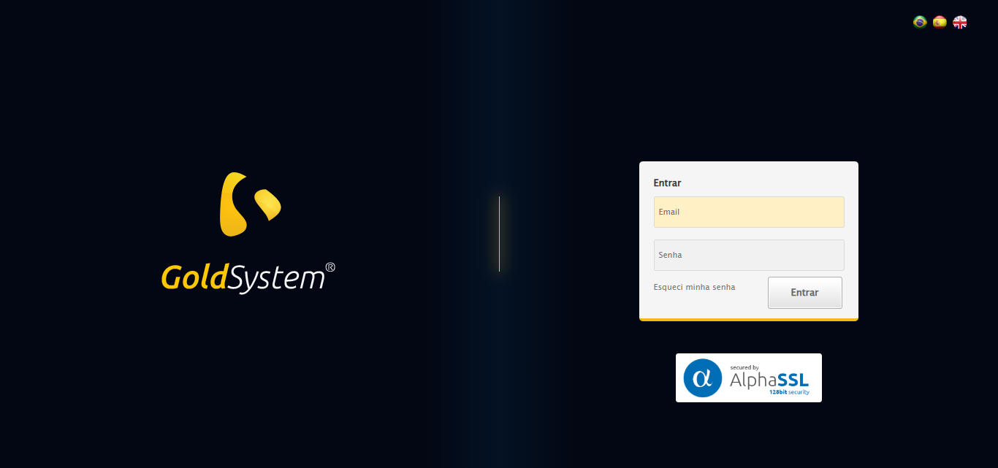

🔄 Realizando login...

✅ Realizando login realizada com sucesso.

Screenshot: realizando login

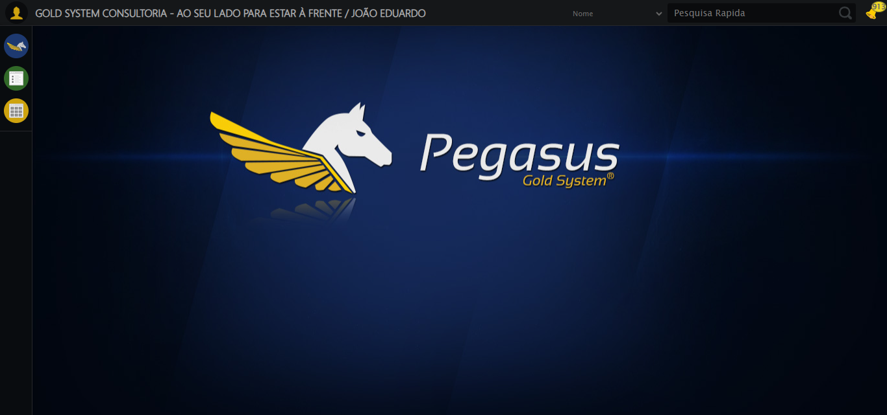

🔄 Ajustando zoom e abrindo menu...

🔍 Zoom ajustado para 90%.

✅ Ajustando zoom e abrindo menu realizada com sucesso.

Screenshot: ajustando zoom e abrindo menu

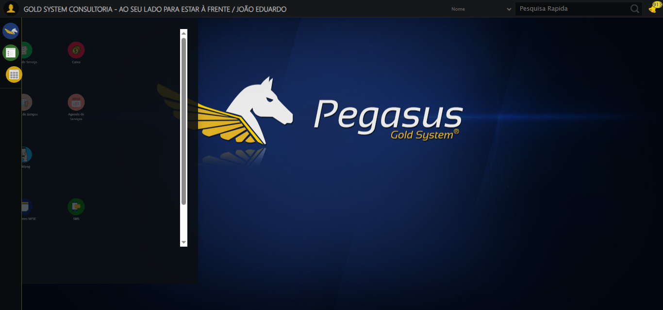

🔄 Acessando Apoio Ortopédico...

✅ Acessando Apoio Ortopédico realizada com sucesso.

Screenshot: acessando apoio ortopédico

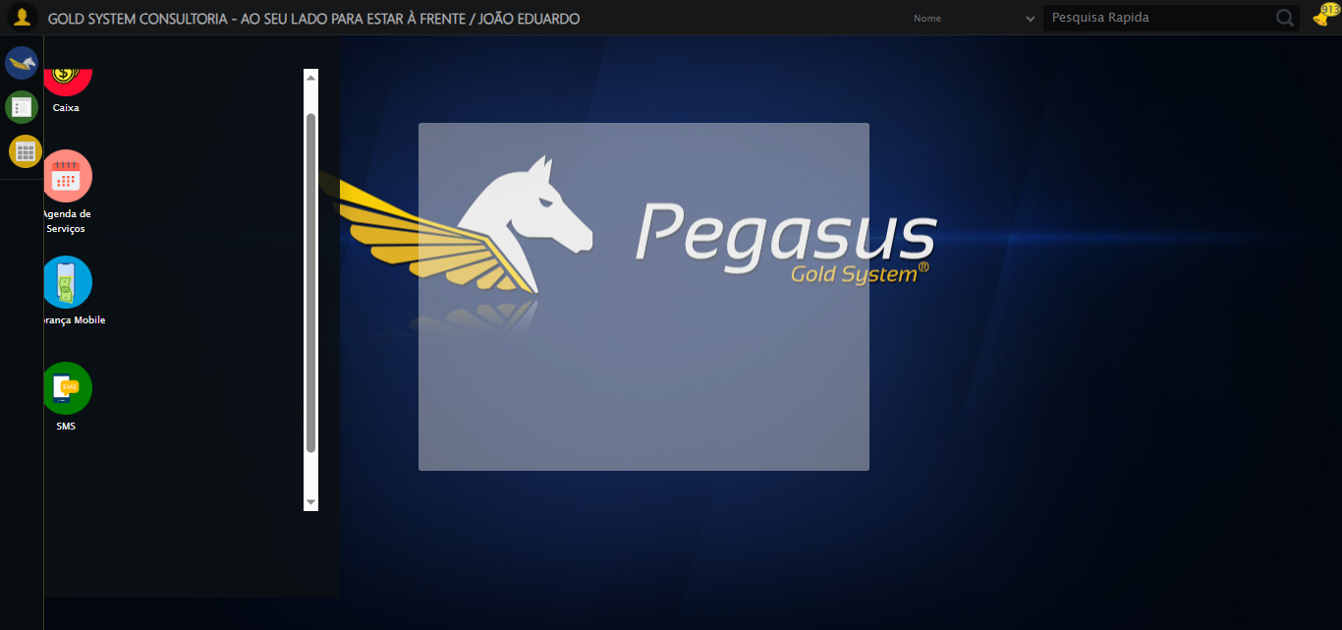

🔄 Clicando em Locação de Equipamentos...

✅ Clicando em Locação de Equipamentos realizada com sucesso.

Screenshot: clicando em locação de equipamentos

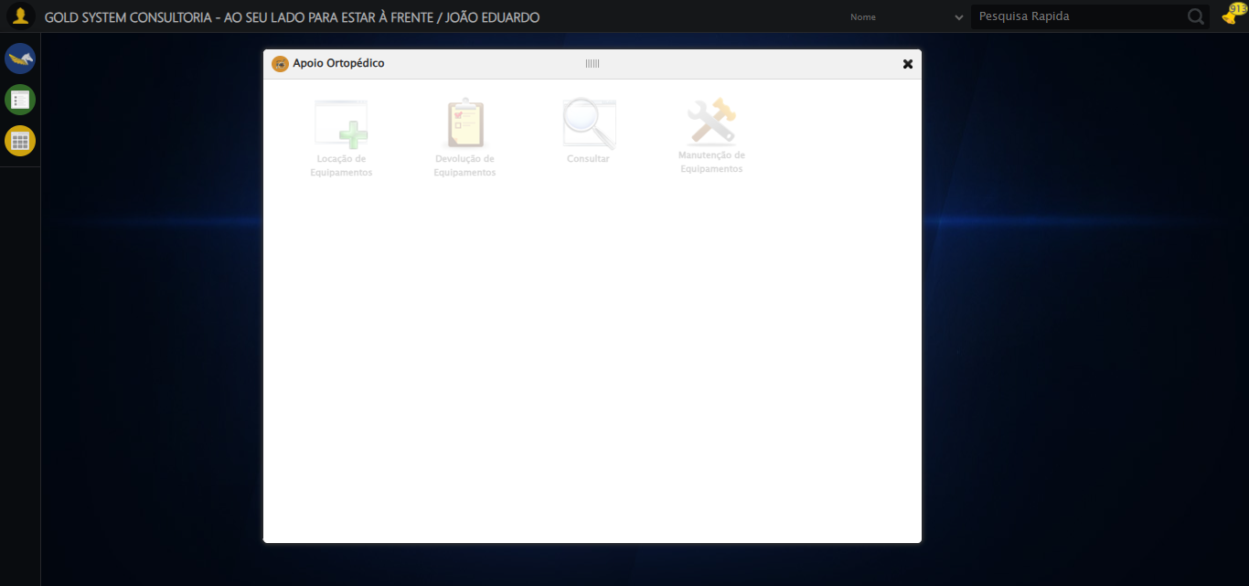

🔄 Preenchendo o Número do Contrato...

✅ Preenchendo o Número do Contrato realizada com sucesso.

Screenshot: preenchendo o número do contrato

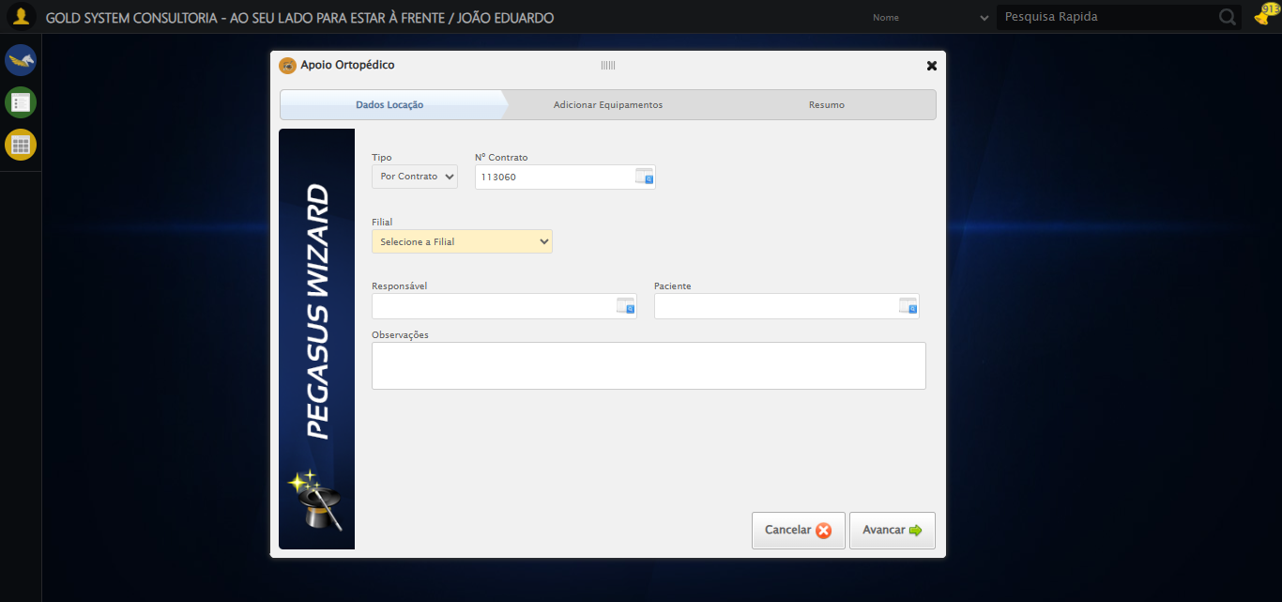

🔄 Preenchendo Observações...

✅ Preenchendo Observações realizada com sucesso.

Screenshot: preenchendo observações

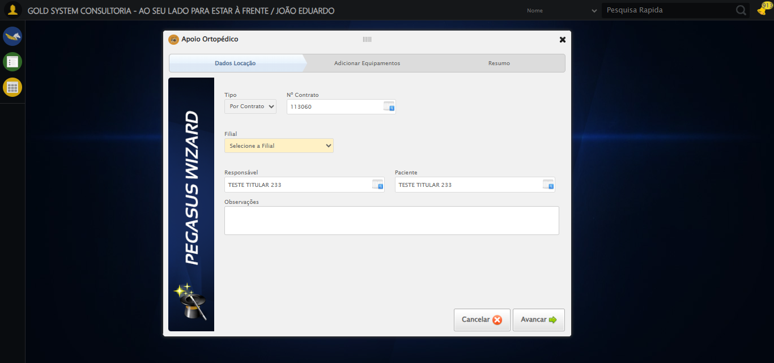

🔄 Avançando para a aba: 'Adicionar Equipamentos'...

✅ Avançando para a aba: 'Adicionar Equipamentos' realizada com sucesso.

Screenshot: avançando para a aba_ _adicionar equipamentos_

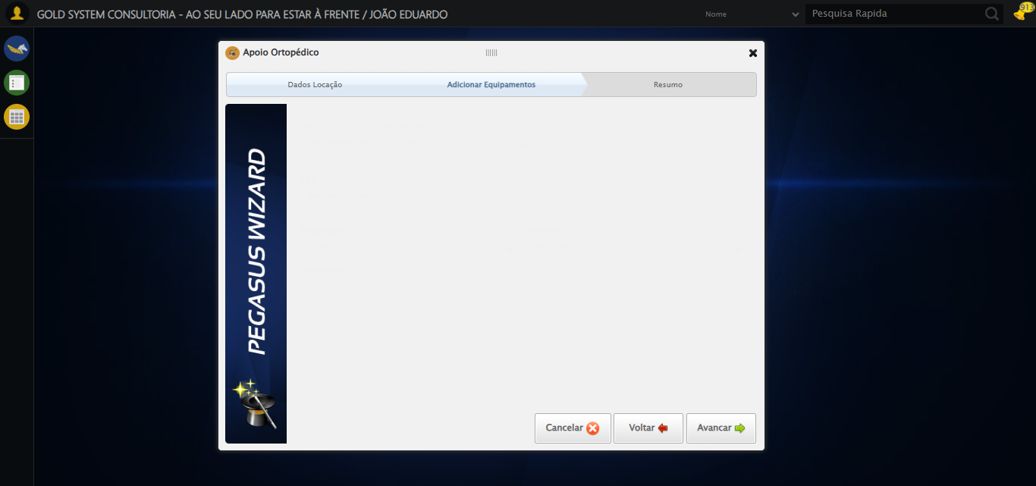

🔄 Abrindo Lov de Equipamentos...

⚠️ Tentativa 1 falhou para Abrindo Lov de Equipamentos, tentando novamente...

🔄 Abrindo Lov de Equipamentos... (Tentativa 2)

❌ Erro inesperado ao abrindo lov de equipamentos: Message: target frame detached  
 (failed to check if window was closed: disconnected: Unable to receive message from renderer)  
 (Session info: chrome=139.0.7258.128)  
Stacktrace:  
 GetHandleVerifier [0x0xacffc3+65331]  
 GetHandleVerifier [0x0xad0004+65396]  
 (No symbol) [0x0x8c3dc0]  
 (No symbol) [0x0x8b4920]  
 (No symbol) [0x0x8b3a91]  
 (No symbol) [0x0x8d1709]  
 (No symbol) [0x0x937e4c]  
 (No symbol) [0x0x9524d9]  
 (No symbol) [0x0x9312d6]  
 (No symbol) [0x0x900910]  
 (No symbol) [0x0x901784]  
 GetHandleVerifier [0x0xd138b3+2439203]  
 GetHandleVerifier [0x0xd0eae2+2419282]  
 GetHandleVerifier [0x0xaf712a+225434]  
 GetHandleVerifier [0x0xae6e08+159096]  
 GetHandleVerifier [0x0xaedd5d+187597]  
 GetHandleVerifier [0x0xad7ad8+96840]  
 GetHandleVerifier [0x0xad7c62+97234]  
 GetHandleVerifier [0x0xac277a+9962]  
 BaseThreadInitThunk [0x0x75abfcc9+25]  
 RtlGetAppContainerNamedObjectPath [0x0x776d82ae+286]  
 RtlGetAppContainerNamedObjectPath [0x0x776d827e+238]

⚠️ Erro ao tirar screenshot erro_abrindo lov de equipamentos: Message: invalid session id: session deleted as the browser has closed the connection  
from disconnected: not connected to DevTools  
 (Session info: chrome=139.0.7258.128); For documentation on this error, please visit: https://www.selenium.dev/documentation/webdriver/troubleshooting/errors#invalidsessionidexception  
Stacktrace:  
 GetHandleVerifier [0x0xacffc3+65331]  
 GetHandleVerifier [0x0xad0004+65396]  
 (No symbol) [0x0x8c3f63]  
 (No symbol) [0x0x8b38e0]  
 (No symbol) [0x0x8d1709]  
 (No symbol) [0x0x937e4c]  
 (No symbol) [0x0x9524d9]  
 (No symbol) [0x0x9312d6]  
 (No symbol) [0x0x900910]  
 (No symbol) [0x0x901784]  
 GetHandleVerifier [0x0xd138b3+2439203]  
 GetHandleVerifier [0x0xd0eae2+2419282]  
 GetHandleVerifier [0x0xaf712a+225434]  
 GetHandleVerifier [0x0xae6e08+159096]  
 GetHandleVerifier [0x0xaedd5d+187597]  
 GetHandleVerifier [0x0xad7ad8+96840]  
 GetHandleVerifier [0x0xad7c62+97234]  
 GetHandleVerifier [0x0xac277a+9962]  
 BaseThreadInitThunk [0x0x75abfcc9+25]  
 RtlGetAppContainerNamedObjectPath [0x0x776d82ae+286]  
 RtlGetAppContainerNamedObjectPath [0x0x776d827e+238]

🔄 Preenchendo Equipamento...

⚠️ Tentativa 1 falhou: Message: invalid session id; For documentation on this error, please visit: https://www.selenium.dev/documentation/webdriver/troubleshooting/errors#invalidsessionidexception  
Stacktrace:  
 GetHandleVerifier [0x0xacffc3+65331]  
 GetHandleVerifier [0x0xad0004+65396]  
 (No symbol) [0x0x8c3dc0]  
 (No symbol) [0x0x8ffbd8]  
 (No symbol) [0x0x931396]  
 (No symbol) [0x0x92cf70]  
 (No symbol) [0x0x92c4f6]  
 (No symbol) [0x0x8959b5]  
 (No symbol) [0x0x895f0e]  
 (No symbol) [0x0x89639d]  
 GetHandleVerifier [0x0xd138b3+2439203]  
 GetHandleVerifier [0x0xd0eae2+2419282]  
 GetHandleVerifier [0x0xaf712a+225434]  
 GetHandleVerifier [0x0xae6e08+159096]  
 GetHandleVerifier [0x0xaedd5d+187597]  
 (No symbol) [0x0x895680]  
 (No symbol) [0x0x894e8e]  
 GetHandleVerifier [0x0xe2a2ec+3580508]  
 BaseThreadInitThunk [0x0x75abfcc9+25]  
 RtlGetAppContainerNamedObjectPath [0x0x776d82ae+286]  
 RtlGetAppContainerNamedObjectPath [0x0x776d827e+238]

⚠️ Tentativa 2 falhou: Message: invalid session id; For documentation on this error, please visit: https://www.selenium.dev/documentation/webdriver/troubleshooting/errors#invalidsessionidexception  
Stacktrace:  
 GetHandleVerifier [0x0xacffc3+65331]  
 GetHandleVerifier [0x0xad0004+65396]  
 (No symbol) [0x0x8c3dc0]  
 (No symbol) [0x0x8ffbd8]  
 (No symbol) [0x0x931396]  
 (No symbol) [0x0x92cf70]  
 (No symbol) [0x0x92c4f6]  
 (No symbol) [0x0x8959b5]  
 (No symbol) [0x0x895f0e]  
 (No symbol) [0x0x89639d]  
 GetHandleVerifier [0x0xd138b3+2439203]  
 GetHandleVerifier [0x0xd0eae2+2419282]  
 GetHandleVerifier [0x0xaf712a+225434]  
 GetHandleVerifier [0x0xae6e08+159096]  
 GetHandleVerifier [0x0xaedd5d+187597]  
 (No symbol) [0x0x895680]  
 (No symbol) [0x0x894e8e]  
 GetHandleVerifier [0x0xe2a2ec+3580508]  
 BaseThreadInitThunk [0x0x75abfcc9+25]  
 RtlGetAppContainerNamedObjectPath [0x0x776d82ae+286]  
 RtlGetAppContainerNamedObjectPath [0x0x776d827e+238]

⚠️ Tentativa 3 falhou: Message: invalid session id; For documentation on this error, please visit: https://www.selenium.dev/documentation/webdriver/troubleshooting/errors#invalidsessionidexception  
Stacktrace:  
 GetHandleVerifier [0x0xacffc3+65331]  
 GetHandleVerifier [0x0xad0004+65396]  
 (No symbol) [0x0x8c3dc0]  
 (No symbol) [0x0x8ffbd8]  
 (No symbol) [0x0x931396]  
 (No symbol) [0x0x92cf70]  
 (No symbol) [0x0x92c4f6]  
 (No symbol) [0x0x8959b5]  
 (No symbol) [0x0x895f0e]  
 (No symbol) [0x0x89639d]  
 GetHandleVerifier [0x0xd138b3+2439203]  
 GetHandleVerifier [0x0xd0eae2+2419282]  
 GetHandleVerifier [0x0xaf712a+225434]  
 GetHandleVerifier [0x0xae6e08+159096]  
 GetHandleVerifier [0x0xaedd5d+187597]  
 (No symbol) [0x0x895680]  
 (No symbol) [0x0x894e8e]  
 GetHandleVerifier [0x0xe2a2ec+3580508]  
 BaseThreadInitThunk [0x0x75abfcc9+25]  
 RtlGetAppContainerNamedObjectPath [0x0x776d82ae+286]  
 RtlGetAppContainerNamedObjectPath [0x0x776d827e+238]

✅ Preenchendo Equipamento realizada com sucesso.

⚠️ Erro ao tirar screenshot preenchendo equipamento: Message: invalid session id; For documentation on this error, please visit: https://www.selenium.dev/documentation/webdriver/troubleshooting/errors#invalidsessionidexception  
Stacktrace:  
 GetHandleVerifier [0x0xacffc3+65331]  
 GetHandleVerifier [0x0xad0004+65396]  
 (No symbol) [0x0x8c3dc0]  
 (No symbol) [0x0x8ffbd8]  
 (No symbol) [0x0x931396]  
 (No symbol) [0x0x92cf70]  
 (No symbol) [0x0x92c4f6]  
 (No symbol) [0x0x8959b5]  
 (No symbol) [0x0x895f0e]  
 (No symbol) [0x0x89639d]  
 GetHandleVerifier [0x0xd138b3+2439203]  
 GetHandleVerifier [0x0xd0eae2+2419282]  
 GetHandleVerifier [0x0xaf712a+225434]  
 GetHandleVerifier [0x0xae6e08+159096]  
 GetHandleVerifier [0x0xaedd5d+187597]  
 (No symbol) [0x0x895680]  
 (No symbol) [0x0x894e8e]  
 GetHandleVerifier [0x0xe2a2ec+3580508]  
 BaseThreadInitThunk [0x0x75abfcc9+25]  
 RtlGetAppContainerNamedObjectPath [0x0x776d82ae+286]  
 RtlGetAppContainerNamedObjectPath [0x0x776d827e+238]

❌ ERRO FATAL: Message: invalid session id; For documentation on this error, please visit: https://www.selenium.dev/documentation/webdriver/troubleshooting/errors#invalidsessionidexception  
Stacktrace:  
 GetHandleVerifier [0x0xacffc3+65331]  
 GetHandleVerifier [0x0xad0004+65396]  
 (No symbol) [0x0x8c3dc0]  
 (No symbol) [0x0x8ffbd8]  
 (No symbol) [0x0x931396]  
 (No symbol) [0x0x92cf70]  
 (No symbol) [0x0x92c4f6]  
 (No symbol) [0x0x8959b5]  
 (No symbol) [0x0x895f0e]  
 (No symbol) [0x0x89639d]  
 GetHandleVerifier [0x0xd138b3+2439203]  
 GetHandleVerifier [0x0xd0eae2+2419282]  
 GetHandleVerifier [0x0xaf712a+225434]  
 GetHandleVerifier [0x0xae6e08+159096]  
 GetHandleVerifier [0x0xaedd5d+187597]  
 (No symbol) [0x0x895680]  
 (No symbol) [0x0x894e8e]  
 GetHandleVerifier [0x0xe2a2ec+3580508]  
 BaseThreadInitThunk [0x0x75abfcc9+25]  
 RtlGetAppContainerNamedObjectPath [0x0x776d82ae+286]  
 RtlGetAppContainerNamedObjectPath [0x0x776d827e+238]

⚠️ Erro ao tirar screenshot erro_fatal: Message: invalid session id; For documentation on this error, please visit: https://www.selenium.dev/documentation/webdriver/troubleshooting/errors#invalidsessionidexception  
Stacktrace:  
 GetHandleVerifier [0x0xacffc3+65331]  
 GetHandleVerifier [0x0xad0004+65396]  
 (No symbol) [0x0x8c3dc0]  
 (No symbol) [0x0x8ffbd8]  
 (No symbol) [0x0x931396]  
 (No symbol) [0x0x92cf70]  
 (No symbol) [0x0x92c4f6]  
 (No symbol) [0x0x8959b5]  
 (No symbol) [0x0x895f0e]  
 (No symbol) [0x0x89639d]  
 GetHandleVerifier [0x0xd138b3+2439203]  
 GetHandleVerifier [0x0xd0eae2+2419282]  
 GetHandleVerifier [0x0xaf712a+225434]  
 GetHandleVerifier [0x0xae6e08+159096]  
 GetHandleVerifier [0x0xaedd5d+187597]  
 (No symbol) [0x0x895680]  
 (No symbol) [0x0x894e8e]  
 GetHandleVerifier [0x0xe2a2ec+3580508]  
 BaseThreadInitThunk [0x0x75abfcc9+25]  
 RtlGetAppContainerNamedObjectPath [0x0x776d82ae+286]  
 RtlGetAppContainerNamedObjectPath [0x0x776d827e+238]

✅ Teste concluído.

❌ Teste finalizado com erros.