RELATÓRIO DO TESTE

Cadastro de Locação de Equipamentos - Apoio Ortopédico – Cenário 1: Preenchimento completo e salvamento

Data do teste: 22/08/2025 14:32:13

🚀 Iniciando teste de Cadastro de Locação de Equipamentos

🔄 Acessando sistema...

✅ Acessando sistema realizada com sucesso.

Screenshot: acessando sistema



🔄 Realizando login...

✅ Realizando login realizada com sucesso.

Screenshot: realizando login

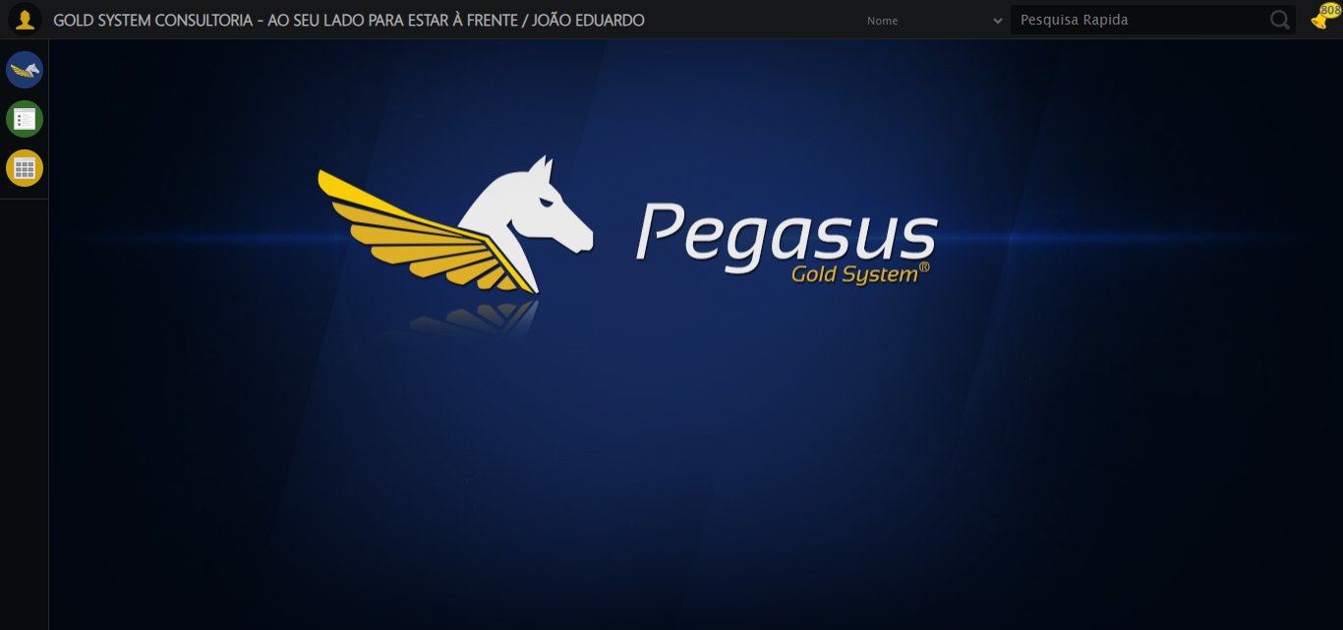

🔄 Ajustando zoom e abrindo menu...

🔍 Zoom ajustado para 90%.

✅ Ajustando zoom e abrindo menu realizada com sucesso.

Screenshot: ajustando zoom e abrindo menu

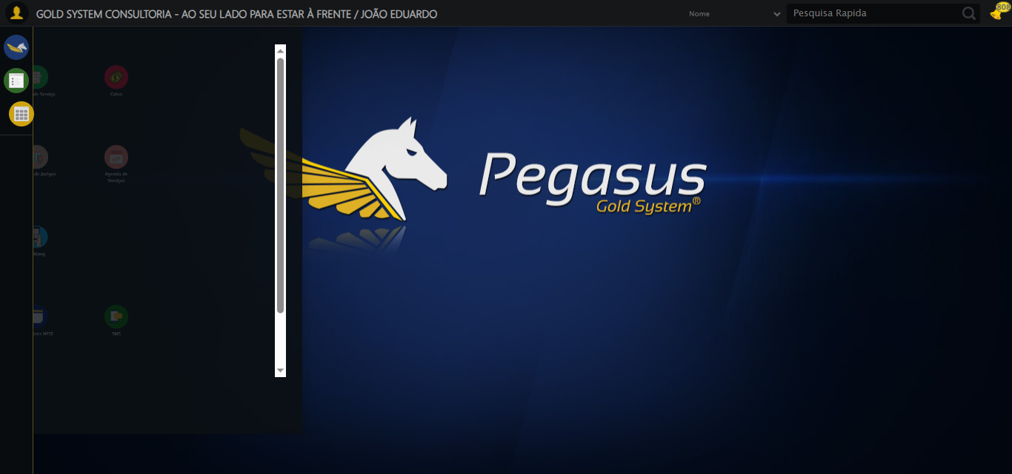

🔄 Acessando Apoio Ortopédico...

✅ Acessando Apoio Ortopédico realizada com sucesso.

Screenshot: acessando apoio ortopédico

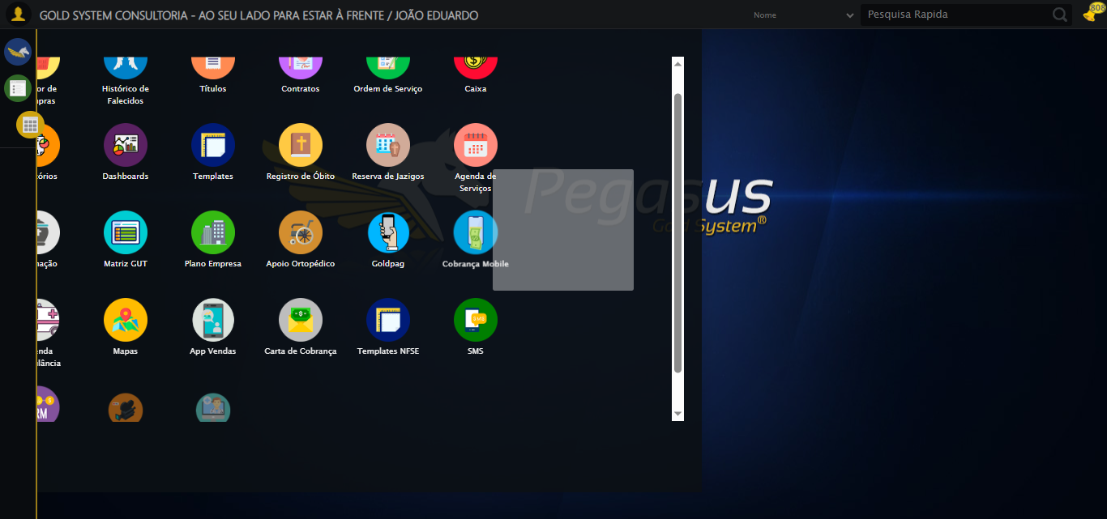

🔄 Clicando em Locação de Equipamentos...

✅ Clicando em Locação de Equipamentos realizada com sucesso.

Screenshot: clicando em locação de equipamentos

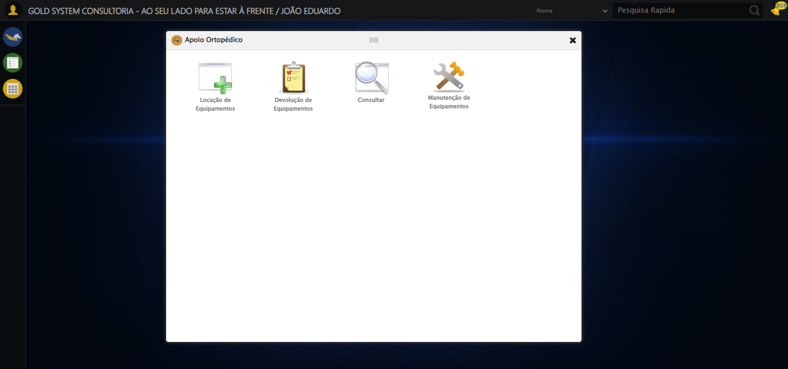

🔄 Preenchendo o Número do Contrato...

✅ Preenchendo o Número do Contrato realizada com sucesso.

Screenshot: preenchendo o número do contrato

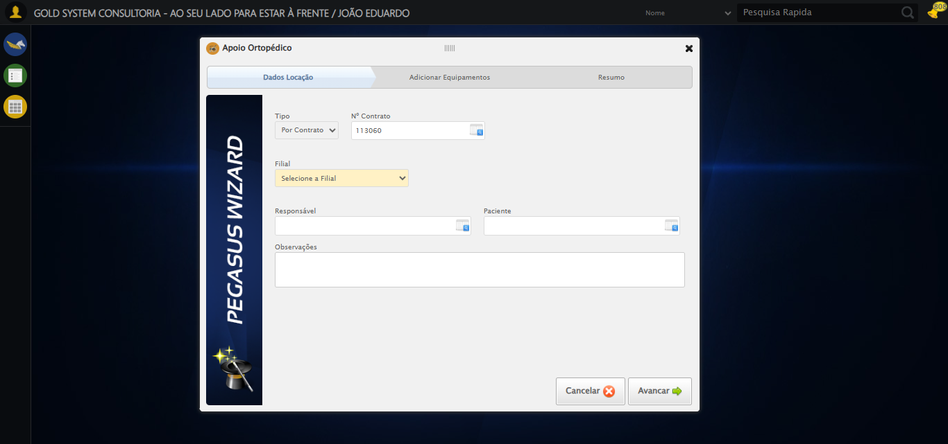

🔄 Preenchendo Observações...

✅ Preenchendo Observações realizada com sucesso.

Screenshot: preenchendo observações



🔄 Avançando para a aba: 'Adicionar Equipamentos'...

✅ Avançando para a aba: 'Adicionar Equipamentos' realizada com sucesso.

Screenshot: avançando para a aba_ _adicionar equipamentos_

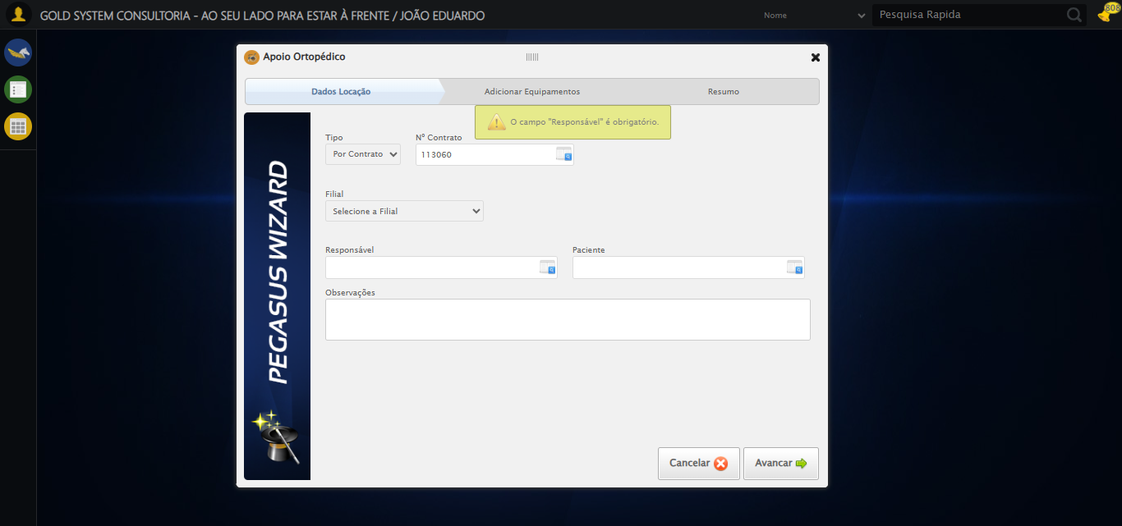

🔄 Abrindo Lov de Equipamentos...

❌ Erro inesperado ao abrindo lov de equipamentos: Message: invalid session id: session deleted as the browser has closed the connection  
from disconnected: not connected to DevTools  
 (Session info: chrome=139.0.7258.128); For documentation on this error, please visit: https://www.selenium.dev/documentation/webdriver/troubleshooting/errors#invalidsessionidexception  
Stacktrace:  
 GetHandleVerifier [0x0x126ffc3+65331]  
 GetHandleVerifier [0x0x1270004+65396]  
 (No symbol) [0x0x1063f63]  
 (No symbol) [0x0x10538e0]  
 (No symbol) [0x0x1071709]  
 (No symbol) [0x0x10d7e4c]  
 (No symbol) [0x0x10f24d9]  
 (No symbol) [0x0x10d12d6]  
 (No symbol) [0x0x10a0910]  
 (No symbol) [0x0x10a1784]  
 GetHandleVerifier [0x0x14b38b3+2439203]  
 GetHandleVerifier [0x0x14aeae2+2419282]  
 GetHandleVerifier [0x0x129712a+225434]  
 GetHandleVerifier [0x0x1286e08+159096]  
 GetHandleVerifier [0x0x128dd5d+187597]  
 GetHandleVerifier [0x0x1277ad8+96840]  
 GetHandleVerifier [0x0x1277c62+97234]  
 GetHandleVerifier [0x0x126277a+9962]  
 BaseThreadInitThunk [0x0x75abfcc9+25]  
 RtlGetAppContainerNamedObjectPath [0x0x776d82ae+286]  
 RtlGetAppContainerNamedObjectPath [0x0x776d827e+238]

⚠️ Erro ao tirar screenshot erro_abrindo lov de equipamentos: Message: invalid session id; For documentation on this error, please visit: https://www.selenium.dev/documentation/webdriver/troubleshooting/errors#invalidsessionidexception  
Stacktrace:  
 GetHandleVerifier [0x0x126ffc3+65331]  
 GetHandleVerifier [0x0x1270004+65396]  
 (No symbol) [0x0x1063dc0]  
 (No symbol) [0x0x109fbd8]  
 (No symbol) [0x0x10d1396]  
 (No symbol) [0x0x10ccf70]  
 (No symbol) [0x0x10cc4f6]  
 (No symbol) [0x0x10359b5]  
 (No symbol) [0x0x1035f0e]  
 (No symbol) [0x0x103639d]  
 GetHandleVerifier [0x0x14b38b3+2439203]  
 GetHandleVerifier [0x0x14aeae2+2419282]  
 GetHandleVerifier [0x0x129712a+225434]  
 GetHandleVerifier [0x0x1286e08+159096]  
 GetHandleVerifier [0x0x128dd5d+187597]  
 (No symbol) [0x0x1035680]  
 (No symbol) [0x0x1034e8e]  
 GetHandleVerifier [0x0x15ca2ec+3580508]  
 BaseThreadInitThunk [0x0x75abfcc9+25]  
 RtlGetAppContainerNamedObjectPath [0x0x776d82ae+286]  
 RtlGetAppContainerNamedObjectPath [0x0x776d827e+238]

🔄 Preenchendo Equipamento...

⚠️ Tentativa 1 falhou: Message: invalid session id; For documentation on this error, please visit: https://www.selenium.dev/documentation/webdriver/troubleshooting/errors#invalidsessionidexception  
Stacktrace:  
 GetHandleVerifier [0x0x126ffc3+65331]  
 GetHandleVerifier [0x0x1270004+65396]  
 (No symbol) [0x0x1063dc0]  
 (No symbol) [0x0x109fbd8]  
 (No symbol) [0x0x10d1396]  
 (No symbol) [0x0x10ccf70]  
 (No symbol) [0x0x10cc4f6]  
 (No symbol) [0x0x10359b5]  
 (No symbol) [0x0x1035f0e]  
 (No symbol) [0x0x103639d]  
 GetHandleVerifier [0x0x14b38b3+2439203]  
 GetHandleVerifier [0x0x14aeae2+2419282]  
 GetHandleVerifier [0x0x129712a+225434]  
 GetHandleVerifier [0x0x1286e08+159096]  
 GetHandleVerifier [0x0x128dd5d+187597]  
 (No symbol) [0x0x1035680]  
 (No symbol) [0x0x1034e8e]  
 GetHandleVerifier [0x0x15ca2ec+3580508]  
 BaseThreadInitThunk [0x0x75abfcc9+25]  
 RtlGetAppContainerNamedObjectPath [0x0x776d82ae+286]  
 RtlGetAppContainerNamedObjectPath [0x0x776d827e+238]

⚠️ Tentativa 2 falhou: Message: invalid session id; For documentation on this error, please visit: https://www.selenium.dev/documentation/webdriver/troubleshooting/errors#invalidsessionidexception  
Stacktrace:  
 GetHandleVerifier [0x0x126ffc3+65331]  
 GetHandleVerifier [0x0x1270004+65396]  
 (No symbol) [0x0x1063dc0]  
 (No symbol) [0x0x109fbd8]  
 (No symbol) [0x0x10d1396]  
 (No symbol) [0x0x10ccf70]  
 (No symbol) [0x0x10cc4f6]  
 (No symbol) [0x0x10359b5]  
 (No symbol) [0x0x1035f0e]  
 (No symbol) [0x0x103639d]  
 GetHandleVerifier [0x0x14b38b3+2439203]  
 GetHandleVerifier [0x0x14aeae2+2419282]  
 GetHandleVerifier [0x0x129712a+225434]  
 GetHandleVerifier [0x0x1286e08+159096]  
 GetHandleVerifier [0x0x128dd5d+187597]  
 (No symbol) [0x0x1035680]  
 (No symbol) [0x0x1034e8e]  
 GetHandleVerifier [0x0x15ca2ec+3580508]  
 BaseThreadInitThunk [0x0x75abfcc9+25]  
 RtlGetAppContainerNamedObjectPath [0x0x776d82ae+286]  
 RtlGetAppContainerNamedObjectPath [0x0x776d827e+238]

⚠️ Tentativa 3 falhou: Message: invalid session id; For documentation on this error, please visit: https://www.selenium.dev/documentation/webdriver/troubleshooting/errors#invalidsessionidexception  
Stacktrace:  
 GetHandleVerifier [0x0x126ffc3+65331]  
 GetHandleVerifier [0x0x1270004+65396]  
 (No symbol) [0x0x1063dc0]  
 (No symbol) [0x0x109fbd8]  
 (No symbol) [0x0x10d1396]  
 (No symbol) [0x0x10ccf70]  
 (No symbol) [0x0x10cc4f6]  
 (No symbol) [0x0x10359b5]  
 (No symbol) [0x0x1035f0e]  
 (No symbol) [0x0x103639d]  
 GetHandleVerifier [0x0x14b38b3+2439203]  
 GetHandleVerifier [0x0x14aeae2+2419282]  
 GetHandleVerifier [0x0x129712a+225434]  
 GetHandleVerifier [0x0x1286e08+159096]  
 GetHandleVerifier [0x0x128dd5d+187597]  
 (No symbol) [0x0x1035680]  
 (No symbol) [0x0x1034e8e]  
 GetHandleVerifier [0x0x15ca2ec+3580508]  
 BaseThreadInitThunk [0x0x75abfcc9+25]  
 RtlGetAppContainerNamedObjectPath [0x0x776d82ae+286]  
 RtlGetAppContainerNamedObjectPath [0x0x776d827e+238]

✅ Preenchendo Equipamento realizada com sucesso.

⚠️ Erro ao tirar screenshot preenchendo equipamento: Message: invalid session id; For documentation on this error, please visit: https://www.selenium.dev/documentation/webdriver/troubleshooting/errors#invalidsessionidexception  
Stacktrace:  
 GetHandleVerifier [0x0x126ffc3+65331]  
 GetHandleVerifier [0x0x1270004+65396]  
 (No symbol) [0x0x1063dc0]  
 (No symbol) [0x0x109fbd8]  
 (No symbol) [0x0x10d1396]  
 (No symbol) [0x0x10ccf70]  
 (No symbol) [0x0x10cc4f6]  
 (No symbol) [0x0x10359b5]  
 (No symbol) [0x0x1035f0e]  
 (No symbol) [0x0x103639d]  
 GetHandleVerifier [0x0x14b38b3+2439203]  
 GetHandleVerifier [0x0x14aeae2+2419282]  
 GetHandleVerifier [0x0x129712a+225434]  
 GetHandleVerifier [0x0x1286e08+159096]  
 GetHandleVerifier [0x0x128dd5d+187597]  
 (No symbol) [0x0x1035680]  
 (No symbol) [0x0x1034e8e]  
 GetHandleVerifier [0x0x15ca2ec+3580508]  
 BaseThreadInitThunk [0x0x75abfcc9+25]  
 RtlGetAppContainerNamedObjectPath [0x0x776d82ae+286]  
 RtlGetAppContainerNamedObjectPath [0x0x776d827e+238]

🔄 Pesquisando equipamento...

❌ Erro inesperado ao pesquisando equipamento: Message: invalid session id; For documentation on this error, please visit: https://www.selenium.dev/documentation/webdriver/troubleshooting/errors#invalidsessionidexception  
Stacktrace:  
 GetHandleVerifier [0x0x126ffc3+65331]  
 GetHandleVerifier [0x0x1270004+65396]  
 (No symbol) [0x0x1063dc0]  
 (No symbol) [0x0x109fbd8]  
 (No symbol) [0x0x10d1396]  
 (No symbol) [0x0x10ccf70]  
 (No symbol) [0x0x10cc4f6]  
 (No symbol) [0x0x10359b5]  
 (No symbol) [0x0x1035f0e]  
 (No symbol) [0x0x103639d]  
 GetHandleVerifier [0x0x14b38b3+2439203]  
 GetHandleVerifier [0x0x14aeae2+2419282]  
 GetHandleVerifier [0x0x129712a+225434]  
 GetHandleVerifier [0x0x1286e08+159096]  
 GetHandleVerifier [0x0x128dd5d+187597]  
 (No symbol) [0x0x1035680]  
 (No symbol) [0x0x1034e8e]  
 GetHandleVerifier [0x0x15ca2ec+3580508]  
 BaseThreadInitThunk [0x0x75abfcc9+25]  
 RtlGetAppContainerNamedObjectPath [0x0x776d82ae+286]  
 RtlGetAppContainerNamedObjectPath [0x0x776d827e+238]

⚠️ Erro ao tirar screenshot erro_pesquisando equipamento: Message: invalid session id; For documentation on this error, please visit: https://www.selenium.dev/documentation/webdriver/troubleshooting/errors#invalidsessionidexception  
Stacktrace:  
 GetHandleVerifier [0x0x126ffc3+65331]  
 GetHandleVerifier [0x0x1270004+65396]  
 (No symbol) [0x0x1063dc0]  
 (No symbol) [0x0x109fbd8]  
 (No symbol) [0x0x10d1396]  
 (No symbol) [0x0x10ccf70]  
 (No symbol) [0x0x10cc4f6]  
 (No symbol) [0x0x10359b5]  
 (No symbol) [0x0x1035f0e]  
 (No symbol) [0x0x103639d]  
 GetHandleVerifier [0x0x14b38b3+2439203]  
 GetHandleVerifier [0x0x14aeae2+2419282]  
 GetHandleVerifier [0x0x129712a+225434]  
 GetHandleVerifier [0x0x1286e08+159096]  
 GetHandleVerifier [0x0x128dd5d+187597]  
 (No symbol) [0x0x1035680]  
 (No symbol) [0x0x1034e8e]  
 GetHandleVerifier [0x0x15ca2ec+3580508]  
 BaseThreadInitThunk [0x0x75abfcc9+25]  
 RtlGetAppContainerNamedObjectPath [0x0x776d82ae+286]  
 RtlGetAppContainerNamedObjectPath [0x0x776d827e+238]

🔄 Selecionando equipamento...

❌ Erro inesperado ao selecionando equipamento: Message: invalid session id; For documentation on this error, please visit: https://www.selenium.dev/documentation/webdriver/troubleshooting/errors#invalidsessionidexception  
Stacktrace:  
 GetHandleVerifier [0x0x126ffc3+65331]  
 GetHandleVerifier [0x0x1270004+65396]  
 (No symbol) [0x0x1063dc0]  
 (No symbol) [0x0x109fbd8]  
 (No symbol) [0x0x10d1396]  
 (No symbol) [0x0x10ccf70]  
 (No symbol) [0x0x10cc4f6]  
 (No symbol) [0x0x10359b5]  
 (No symbol) [0x0x1035f0e]  
 (No symbol) [0x0x103639d]  
 GetHandleVerifier [0x0x14b38b3+2439203]  
 GetHandleVerifier [0x0x14aeae2+2419282]  
 GetHandleVerifier [0x0x129712a+225434]  
 GetHandleVerifier [0x0x1286e08+159096]  
 GetHandleVerifier [0x0x128dd5d+187597]  
 (No symbol) [0x0x1035680]  
 (No symbol) [0x0x1034e8e]  
 GetHandleVerifier [0x0x15ca2ec+3580508]  
 BaseThreadInitThunk [0x0x75abfcc9+25]  
 RtlGetAppContainerNamedObjectPath [0x0x776d82ae+286]  
 RtlGetAppContainerNamedObjectPath [0x0x776d827e+238]

⚠️ Erro ao tirar screenshot erro_selecionando equipamento: Message: invalid session id; For documentation on this error, please visit: https://www.selenium.dev/documentation/webdriver/troubleshooting/errors#invalidsessionidexception  
Stacktrace:  
 GetHandleVerifier [0x0x126ffc3+65331]  
 GetHandleVerifier [0x0x1270004+65396]  
 (No symbol) [0x0x1063dc0]  
 (No symbol) [0x0x109fbd8]  
 (No symbol) [0x0x10d1396]  
 (No symbol) [0x0x10ccf70]  
 (No symbol) [0x0x10cc4f6]  
 (No symbol) [0x0x10359b5]  
 (No symbol) [0x0x1035f0e]  
 (No symbol) [0x0x103639d]  
 GetHandleVerifier [0x0x14b38b3+2439203]  
 GetHandleVerifier [0x0x14aeae2+2419282]  
 GetHandleVerifier [0x0x129712a+225434]  
 GetHandleVerifier [0x0x1286e08+159096]  
 GetHandleVerifier [0x0x128dd5d+187597]  
 (No symbol) [0x0x1035680]  
 (No symbol) [0x0x1034e8e]  
 GetHandleVerifier [0x0x15ca2ec+3580508]  
 BaseThreadInitThunk [0x0x75abfcc9+25]  
 RtlGetAppContainerNamedObjectPath [0x0x776d82ae+286]  
 RtlGetAppContainerNamedObjectPath [0x0x776d827e+238]

🔄 Adicionando equipamento...

❌ Erro inesperado ao adicionando equipamento: Message: invalid session id; For documentation on this error, please visit: https://www.selenium.dev/documentation/webdriver/troubleshooting/errors#invalidsessionidexception  
Stacktrace:  
 GetHandleVerifier [0x0x126ffc3+65331]  
 GetHandleVerifier [0x0x1270004+65396]  
 (No symbol) [0x0x1063dc0]  
 (No symbol) [0x0x109fbd8]  
 (No symbol) [0x0x10d1396]  
 (No symbol) [0x0x10ccf70]  
 (No symbol) [0x0x10cc4f6]  
 (No symbol) [0x0x10359b5]  
 (No symbol) [0x0x1035f0e]  
 (No symbol) [0x0x103639d]  
 GetHandleVerifier [0x0x14b38b3+2439203]  
 GetHandleVerifier [0x0x14aeae2+2419282]  
 GetHandleVerifier [0x0x129712a+225434]  
 GetHandleVerifier [0x0x1286e08+159096]  
 GetHandleVerifier [0x0x128dd5d+187597]  
 (No symbol) [0x0x1035680]  
 (No symbol) [0x0x1034e8e]  
 GetHandleVerifier [0x0x15ca2ec+3580508]  
 BaseThreadInitThunk [0x0x75abfcc9+25]  
 RtlGetAppContainerNamedObjectPath [0x0x776d82ae+286]  
 RtlGetAppContainerNamedObjectPath [0x0x776d827e+238]

⚠️ Erro ao tirar screenshot erro_adicionando equipamento: Message: invalid session id; For documentation on this error, please visit: https://www.selenium.dev/documentation/webdriver/troubleshooting/errors#invalidsessionidexception  
Stacktrace:  
 GetHandleVerifier [0x0x126ffc3+65331]  
 GetHandleVerifier [0x0x1270004+65396]  
 (No symbol) [0x0x1063dc0]  
 (No symbol) [0x0x109fbd8]  
 (No symbol) [0x0x10d1396]  
 (No symbol) [0x0x10ccf70]  
 (No symbol) [0x0x10cc4f6]  
 (No symbol) [0x0x10359b5]  
 (No symbol) [0x0x1035f0e]  
 (No symbol) [0x0x103639d]  
 GetHandleVerifier [0x0x14b38b3+2439203]  
 GetHandleVerifier [0x0x14aeae2+2419282]  
 GetHandleVerifier [0x0x129712a+225434]  
 GetHandleVerifier [0x0x1286e08+159096]  
 GetHandleVerifier [0x0x128dd5d+187597]  
 (No symbol) [0x0x1035680]  
 (No symbol) [0x0x1034e8e]  
 GetHandleVerifier [0x0x15ca2ec+3580508]  
 BaseThreadInitThunk [0x0x75abfcc9+25]  
 RtlGetAppContainerNamedObjectPath [0x0x776d82ae+286]  
 RtlGetAppContainerNamedObjectPath [0x0x776d827e+238]

🔄 Abrindo Lov de Equipamentos...

❌ Erro inesperado ao abrindo lov de equipamentos: Message: invalid session id; For documentation on this error, please visit: https://www.selenium.dev/documentation/webdriver/troubleshooting/errors#invalidsessionidexception  
Stacktrace:  
 GetHandleVerifier [0x0x126ffc3+65331]  
 GetHandleVerifier [0x0x1270004+65396]  
 (No symbol) [0x0x1063dc0]  
 (No symbol) [0x0x109fbd8]  
 (No symbol) [0x0x10d1396]  
 (No symbol) [0x0x10ccf70]  
 (No symbol) [0x0x10cc4f6]  
 (No symbol) [0x0x10359b5]  
 (No symbol) [0x0x1035f0e]  
 (No symbol) [0x0x103639d]  
 GetHandleVerifier [0x0x14b38b3+2439203]  
 GetHandleVerifier [0x0x14aeae2+2419282]  
 GetHandleVerifier [0x0x129712a+225434]  
 GetHandleVerifier [0x0x1286e08+159096]  
 GetHandleVerifier [0x0x128dd5d+187597]  
 (No symbol) [0x0x1035680]  
 (No symbol) [0x0x1034e8e]  
 GetHandleVerifier [0x0x15ca2ec+3580508]  
 BaseThreadInitThunk [0x0x75abfcc9+25]  
 RtlGetAppContainerNamedObjectPath [0x0x776d82ae+286]  
 RtlGetAppContainerNamedObjectPath [0x0x776d827e+238]

⚠️ Erro ao tirar screenshot erro_abrindo lov de equipamentos: Message: invalid session id; For documentation on this error, please visit: https://www.selenium.dev/documentation/webdriver/troubleshooting/errors#invalidsessionidexception  
Stacktrace:  
 GetHandleVerifier [0x0x126ffc3+65331]  
 GetHandleVerifier [0x0x1270004+65396]  
 (No symbol) [0x0x1063dc0]  
 (No symbol) [0x0x109fbd8]  
 (No symbol) [0x0x10d1396]  
 (No symbol) [0x0x10ccf70]  
 (No symbol) [0x0x10cc4f6]  
 (No symbol) [0x0x10359b5]  
 (No symbol) [0x0x1035f0e]  
 (No symbol) [0x0x103639d]  
 GetHandleVerifier [0x0x14b38b3+2439203]  
 GetHandleVerifier [0x0x14aeae2+2419282]  
 GetHandleVerifier [0x0x129712a+225434]  
 GetHandleVerifier [0x0x1286e08+159096]  
 GetHandleVerifier [0x0x128dd5d+187597]  
 (No symbol) [0x0x1035680]  
 (No symbol) [0x0x1034e8e]  
 GetHandleVerifier [0x0x15ca2ec+3580508]  
 BaseThreadInitThunk [0x0x75abfcc9+25]  
 RtlGetAppContainerNamedObjectPath [0x0x776d82ae+286]  
 RtlGetAppContainerNamedObjectPath [0x0x776d827e+238]

🔄 Preenchendo Equipamento...

⚠️ Tentativa 1 falhou: Message: invalid session id; For documentation on this error, please visit: https://www.selenium.dev/documentation/webdriver/troubleshooting/errors#invalidsessionidexception  
Stacktrace:  
 GetHandleVerifier [0x0x126ffc3+65331]  
 GetHandleVerifier [0x0x1270004+65396]  
 (No symbol) [0x0x1063dc0]  
 (No symbol) [0x0x109fbd8]  
 (No symbol) [0x0x10d1396]  
 (No symbol) [0x0x10ccf70]  
 (No symbol) [0x0x10cc4f6]  
 (No symbol) [0x0x10359b5]  
 (No symbol) [0x0x1035f0e]  
 (No symbol) [0x0x103639d]  
 GetHandleVerifier [0x0x14b38b3+2439203]  
 GetHandleVerifier [0x0x14aeae2+2419282]  
 GetHandleVerifier [0x0x129712a+225434]  
 GetHandleVerifier [0x0x1286e08+159096]  
 GetHandleVerifier [0x0x128dd5d+187597]  
 (No symbol) [0x0x1035680]  
 (No symbol) [0x0x1034e8e]  
 GetHandleVerifier [0x0x15ca2ec+3580508]  
 BaseThreadInitThunk [0x0x75abfcc9+25]  
 RtlGetAppContainerNamedObjectPath [0x0x776d82ae+286]  
 RtlGetAppContainerNamedObjectPath [0x0x776d827e+238]

⚠️ Tentativa 2 falhou: Message: invalid session id; For documentation on this error, please visit: https://www.selenium.dev/documentation/webdriver/troubleshooting/errors#invalidsessionidexception  
Stacktrace:  
 GetHandleVerifier [0x0x126ffc3+65331]  
 GetHandleVerifier [0x0x1270004+65396]  
 (No symbol) [0x0x1063dc0]  
 (No symbol) [0x0x109fbd8]  
 (No symbol) [0x0x10d1396]  
 (No symbol) [0x0x10ccf70]  
 (No symbol) [0x0x10cc4f6]  
 (No symbol) [0x0x10359b5]  
 (No symbol) [0x0x1035f0e]  
 (No symbol) [0x0x103639d]  
 GetHandleVerifier [0x0x14b38b3+2439203]  
 GetHandleVerifier [0x0x14aeae2+2419282]  
 GetHandleVerifier [0x0x129712a+225434]  
 GetHandleVerifier [0x0x1286e08+159096]  
 GetHandleVerifier [0x0x128dd5d+187597]  
 (No symbol) [0x0x1035680]  
 (No symbol) [0x0x1034e8e]  
 GetHandleVerifier [0x0x15ca2ec+3580508]  
 BaseThreadInitThunk [0x0x75abfcc9+25]  
 RtlGetAppContainerNamedObjectPath [0x0x776d82ae+286]  
 RtlGetAppContainerNamedObjectPath [0x0x776d827e+238]

⚠️ Tentativa 3 falhou: Message: invalid session id; For documentation on this error, please visit: https://www.selenium.dev/documentation/webdriver/troubleshooting/errors#invalidsessionidexception  
Stacktrace:  
 GetHandleVerifier [0x0x126ffc3+65331]  
 GetHandleVerifier [0x0x1270004+65396]  
 (No symbol) [0x0x1063dc0]  
 (No symbol) [0x0x109fbd8]  
 (No symbol) [0x0x10d1396]  
 (No symbol) [0x0x10ccf70]  
 (No symbol) [0x0x10cc4f6]  
 (No symbol) [0x0x10359b5]  
 (No symbol) [0x0x1035f0e]  
 (No symbol) [0x0x103639d]  
 GetHandleVerifier [0x0x14b38b3+2439203]  
 GetHandleVerifier [0x0x14aeae2+2419282]  
 GetHandleVerifier [0x0x129712a+225434]  
 GetHandleVerifier [0x0x1286e08+159096]  
 GetHandleVerifier [0x0x128dd5d+187597]  
 (No symbol) [0x0x1035680]  
 (No symbol) [0x0x1034e8e]  
 GetHandleVerifier [0x0x15ca2ec+3580508]  
 BaseThreadInitThunk [0x0x75abfcc9+25]  
 RtlGetAppContainerNamedObjectPath [0x0x776d82ae+286]  
 RtlGetAppContainerNamedObjectPath [0x0x776d827e+238]

✅ Preenchendo Equipamento realizada com sucesso.

⚠️ Erro ao tirar screenshot preenchendo equipamento: Message: invalid session id; For documentation on this error, please visit: https://www.selenium.dev/documentation/webdriver/troubleshooting/errors#invalidsessionidexception  
Stacktrace:  
 GetHandleVerifier [0x0x126ffc3+65331]  
 GetHandleVerifier [0x0x1270004+65396]  
 (No symbol) [0x0x1063dc0]  
 (No symbol) [0x0x109fbd8]  
 (No symbol) [0x0x10d1396]  
 (No symbol) [0x0x10ccf70]  
 (No symbol) [0x0x10cc4f6]  
 (No symbol) [0x0x10359b5]  
 (No symbol) [0x0x1035f0e]  
 (No symbol) [0x0x103639d]  
 GetHandleVerifier [0x0x14b38b3+2439203]  
 GetHandleVerifier [0x0x14aeae2+2419282]  
 GetHandleVerifier [0x0x129712a+225434]  
 GetHandleVerifier [0x0x1286e08+159096]  
 GetHandleVerifier [0x0x128dd5d+187597]  
 (No symbol) [0x0x1035680]  
 (No symbol) [0x0x1034e8e]  
 GetHandleVerifier [0x0x15ca2ec+3580508]  
 BaseThreadInitThunk [0x0x75abfcc9+25]  
 RtlGetAppContainerNamedObjectPath [0x0x776d82ae+286]  
 RtlGetAppContainerNamedObjectPath [0x0x776d827e+238]

🔄 Pesquisando equipamento...

❌ Erro inesperado ao pesquisando equipamento: Message: invalid session id; For documentation on this error, please visit: https://www.selenium.dev/documentation/webdriver/troubleshooting/errors#invalidsessionidexception  
Stacktrace:  
 GetHandleVerifier [0x0x126ffc3+65331]  
 GetHandleVerifier [0x0x1270004+65396]  
 (No symbol) [0x0x1063dc0]  
 (No symbol) [0x0x109fbd8]  
 (No symbol) [0x0x10d1396]  
 (No symbol) [0x0x10ccf70]  
 (No symbol) [0x0x10cc4f6]  
 (No symbol) [0x0x10359b5]  
 (No symbol) [0x0x1035f0e]  
 (No symbol) [0x0x103639d]  
 GetHandleVerifier [0x0x14b38b3+2439203]  
 GetHandleVerifier [0x0x14aeae2+2419282]  
 GetHandleVerifier [0x0x129712a+225434]  
 GetHandleVerifier [0x0x1286e08+159096]  
 GetHandleVerifier [0x0x128dd5d+187597]  
 (No symbol) [0x0x1035680]  
 (No symbol) [0x0x1034e8e]  
 GetHandleVerifier [0x0x15ca2ec+3580508]  
 BaseThreadInitThunk [0x0x75abfcc9+25]  
 RtlGetAppContainerNamedObjectPath [0x0x776d82ae+286]  
 RtlGetAppContainerNamedObjectPath [0x0x776d827e+238]

⚠️ Erro ao tirar screenshot erro_pesquisando equipamento: Message: invalid session id; For documentation on this error, please visit: https://www.selenium.dev/documentation/webdriver/troubleshooting/errors#invalidsessionidexception  
Stacktrace:  
 GetHandleVerifier [0x0x126ffc3+65331]  
 GetHandleVerifier [0x0x1270004+65396]  
 (No symbol) [0x0x1063dc0]  
 (No symbol) [0x0x109fbd8]  
 (No symbol) [0x0x10d1396]  
 (No symbol) [0x0x10ccf70]  
 (No symbol) [0x0x10cc4f6]  
 (No symbol) [0x0x10359b5]  
 (No symbol) [0x0x1035f0e]  
 (No symbol) [0x0x103639d]  
 GetHandleVerifier [0x0x14b38b3+2439203]  
 GetHandleVerifier [0x0x14aeae2+2419282]  
 GetHandleVerifier [0x0x129712a+225434]  
 GetHandleVerifier [0x0x1286e08+159096]  
 GetHandleVerifier [0x0x128dd5d+187597]  
 (No symbol) [0x0x1035680]  
 (No symbol) [0x0x1034e8e]  
 GetHandleVerifier [0x0x15ca2ec+3580508]  
 BaseThreadInitThunk [0x0x75abfcc9+25]  
 RtlGetAppContainerNamedObjectPath [0x0x776d82ae+286]  
 RtlGetAppContainerNamedObjectPath [0x0x776d827e+238]

🔄 Selecionando equipamento...

❌ Erro inesperado ao selecionando equipamento: Message: invalid session id; For documentation on this error, please visit: https://www.selenium.dev/documentation/webdriver/troubleshooting/errors#invalidsessionidexception  
Stacktrace:  
 GetHandleVerifier [0x0x126ffc3+65331]  
 GetHandleVerifier [0x0x1270004+65396]  
 (No symbol) [0x0x1063dc0]  
 (No symbol) [0x0x109fbd8]  
 (No symbol) [0x0x10d1396]  
 (No symbol) [0x0x10ccf70]  
 (No symbol) [0x0x10cc4f6]  
 (No symbol) [0x0x10359b5]  
 (No symbol) [0x0x1035f0e]  
 (No symbol) [0x0x103639d]  
 GetHandleVerifier [0x0x14b38b3+2439203]  
 GetHandleVerifier [0x0x14aeae2+2419282]  
 GetHandleVerifier [0x0x129712a+225434]  
 GetHandleVerifier [0x0x1286e08+159096]  
 GetHandleVerifier [0x0x128dd5d+187597]  
 (No symbol) [0x0x1035680]  
 (No symbol) [0x0x1034e8e]  
 GetHandleVerifier [0x0x15ca2ec+3580508]  
 BaseThreadInitThunk [0x0x75abfcc9+25]  
 RtlGetAppContainerNamedObjectPath [0x0x776d82ae+286]  
 RtlGetAppContainerNamedObjectPath [0x0x776d827e+238]

⚠️ Erro ao tirar screenshot erro_selecionando equipamento: Message: invalid session id; For documentation on this error, please visit: https://www.selenium.dev/documentation/webdriver/troubleshooting/errors#invalidsessionidexception  
Stacktrace:  
 GetHandleVerifier [0x0x126ffc3+65331]  
 GetHandleVerifier [0x0x1270004+65396]  
 (No symbol) [0x0x1063dc0]  
 (No symbol) [0x0x109fbd8]  
 (No symbol) [0x0x10d1396]  
 (No symbol) [0x0x10ccf70]  
 (No symbol) [0x0x10cc4f6]  
 (No symbol) [0x0x10359b5]  
 (No symbol) [0x0x1035f0e]  
 (No symbol) [0x0x103639d]  
 GetHandleVerifier [0x0x14b38b3+2439203]  
 GetHandleVerifier [0x0x14aeae2+2419282]  
 GetHandleVerifier [0x0x129712a+225434]  
 GetHandleVerifier [0x0x1286e08+159096]  
 GetHandleVerifier [0x0x128dd5d+187597]  
 (No symbol) [0x0x1035680]  
 (No symbol) [0x0x1034e8e]  
 GetHandleVerifier [0x0x15ca2ec+3580508]  
 BaseThreadInitThunk [0x0x75abfcc9+25]  
 RtlGetAppContainerNamedObjectPath [0x0x776d82ae+286]  
 RtlGetAppContainerNamedObjectPath [0x0x776d827e+238]

🔄 Adicionando equipamento...

❌ Erro inesperado ao adicionando equipamento: Message: invalid session id; For documentation on this error, please visit: https://www.selenium.dev/documentation/webdriver/troubleshooting/errors#invalidsessionidexception  
Stacktrace:  
 GetHandleVerifier [0x0x126ffc3+65331]  
 GetHandleVerifier [0x0x1270004+65396]  
 (No symbol) [0x0x1063dc0]  
 (No symbol) [0x0x109fbd8]  
 (No symbol) [0x0x10d1396]  
 (No symbol) [0x0x10ccf70]  
 (No symbol) [0x0x10cc4f6]  
 (No symbol) [0x0x10359b5]  
 (No symbol) [0x0x1035f0e]  
 (No symbol) [0x0x103639d]  
 GetHandleVerifier [0x0x14b38b3+2439203]  
 GetHandleVerifier [0x0x14aeae2+2419282]  
 GetHandleVerifier [0x0x129712a+225434]  
 GetHandleVerifier [0x0x1286e08+159096]  
 GetHandleVerifier [0x0x128dd5d+187597]  
 (No symbol) [0x0x1035680]  
 (No symbol) [0x0x1034e8e]  
 GetHandleVerifier [0x0x15ca2ec+3580508]  
 BaseThreadInitThunk [0x0x75abfcc9+25]  
 RtlGetAppContainerNamedObjectPath [0x0x776d82ae+286]  
 RtlGetAppContainerNamedObjectPath [0x0x776d827e+238]

⚠️ Erro ao tirar screenshot erro_adicionando equipamento: Message: invalid session id; For documentation on this error, please visit: https://www.selenium.dev/documentation/webdriver/troubleshooting/errors#invalidsessionidexception  
Stacktrace:  
 GetHandleVerifier [0x0x126ffc3+65331]  
 GetHandleVerifier [0x0x1270004+65396]  
 (No symbol) [0x0x1063dc0]  
 (No symbol) [0x0x109fbd8]  
 (No symbol) [0x0x10d1396]  
 (No symbol) [0x0x10ccf70]  
 (No symbol) [0x0x10cc4f6]  
 (No symbol) [0x0x10359b5]  
 (No symbol) [0x0x1035f0e]  
 (No symbol) [0x0x103639d]  
 GetHandleVerifier [0x0x14b38b3+2439203]  
 GetHandleVerifier [0x0x14aeae2+2419282]  
 GetHandleVerifier [0x0x129712a+225434]  
 GetHandleVerifier [0x0x1286e08+159096]  
 GetHandleVerifier [0x0x128dd5d+187597]  
 (No symbol) [0x0x1035680]  
 (No symbol) [0x0x1034e8e]  
 GetHandleVerifier [0x0x15ca2ec+3580508]  
 BaseThreadInitThunk [0x0x75abfcc9+25]  
 RtlGetAppContainerNamedObjectPath [0x0x776d82ae+286]  
 RtlGetAppContainerNamedObjectPath [0x0x776d827e+238]

🔄 Abrindo Lov de Equipamentos...

❌ Erro inesperado ao abrindo lov de equipamentos: Message: invalid session id; For documentation on this error, please visit: https://www.selenium.dev/documentation/webdriver/troubleshooting/errors#invalidsessionidexception  
Stacktrace:  
 GetHandleVerifier [0x0x126ffc3+65331]  
 GetHandleVerifier [0x0x1270004+65396]  
 (No symbol) [0x0x1063dc0]  
 (No symbol) [0x0x109fbd8]  
 (No symbol) [0x0x10d1396]  
 (No symbol) [0x0x10ccf70]  
 (No symbol) [0x0x10cc4f6]  
 (No symbol) [0x0x10359b5]  
 (No symbol) [0x0x1035f0e]  
 (No symbol) [0x0x103639d]  
 GetHandleVerifier [0x0x14b38b3+2439203]  
 GetHandleVerifier [0x0x14aeae2+2419282]  
 GetHandleVerifier [0x0x129712a+225434]  
 GetHandleVerifier [0x0x1286e08+159096]  
 GetHandleVerifier [0x0x128dd5d+187597]  
 (No symbol) [0x0x1035680]  
 (No symbol) [0x0x1034e8e]  
 GetHandleVerifier [0x0x15ca2ec+3580508]  
 BaseThreadInitThunk [0x0x75abfcc9+25]  
 RtlGetAppContainerNamedObjectPath [0x0x776d82ae+286]  
 RtlGetAppContainerNamedObjectPath [0x0x776d827e+238]

⚠️ Erro ao tirar screenshot erro_abrindo lov de equipamentos: Message: invalid session id; For documentation on this error, please visit: https://www.selenium.dev/documentation/webdriver/troubleshooting/errors#invalidsessionidexception  
Stacktrace:  
 GetHandleVerifier [0x0x126ffc3+65331]  
 GetHandleVerifier [0x0x1270004+65396]  
 (No symbol) [0x0x1063dc0]  
 (No symbol) [0x0x109fbd8]  
 (No symbol) [0x0x10d1396]  
 (No symbol) [0x0x10ccf70]  
 (No symbol) [0x0x10cc4f6]  
 (No symbol) [0x0x10359b5]  
 (No symbol) [0x0x1035f0e]  
 (No symbol) [0x0x103639d]  
 GetHandleVerifier [0x0x14b38b3+2439203]  
 GetHandleVerifier [0x0x14aeae2+2419282]  
 GetHandleVerifier [0x0x129712a+225434]  
 GetHandleVerifier [0x0x1286e08+159096]  
 GetHandleVerifier [0x0x128dd5d+187597]  
 (No symbol) [0x0x1035680]  
 (No symbol) [0x0x1034e8e]  
 GetHandleVerifier [0x0x15ca2ec+3580508]  
 BaseThreadInitThunk [0x0x75abfcc9+25]  
 RtlGetAppContainerNamedObjectPath [0x0x776d82ae+286]  
 RtlGetAppContainerNamedObjectPath [0x0x776d827e+238]

🔄 Preenchendo Equipamento...

⚠️ Tentativa 1 falhou: Message: invalid session id; For documentation on this error, please visit: https://www.selenium.dev/documentation/webdriver/troubleshooting/errors#invalidsessionidexception  
Stacktrace:  
 GetHandleVerifier [0x0x126ffc3+65331]  
 GetHandleVerifier [0x0x1270004+65396]  
 (No symbol) [0x0x1063dc0]  
 (No symbol) [0x0x109fbd8]  
 (No symbol) [0x0x10d1396]  
 (No symbol) [0x0x10ccf70]  
 (No symbol) [0x0x10cc4f6]  
 (No symbol) [0x0x10359b5]  
 (No symbol) [0x0x1035f0e]  
 (No symbol) [0x0x103639d]  
 GetHandleVerifier [0x0x14b38b3+2439203]  
 GetHandleVerifier [0x0x14aeae2+2419282]  
 GetHandleVerifier [0x0x129712a+225434]  
 GetHandleVerifier [0x0x1286e08+159096]  
 GetHandleVerifier [0x0x128dd5d+187597]  
 (No symbol) [0x0x1035680]  
 (No symbol) [0x0x1034e8e]  
 GetHandleVerifier [0x0x15ca2ec+3580508]  
 BaseThreadInitThunk [0x0x75abfcc9+25]  
 RtlGetAppContainerNamedObjectPath [0x0x776d82ae+286]  
 RtlGetAppContainerNamedObjectPath [0x0x776d827e+238]

⚠️ Tentativa 2 falhou: Message: invalid session id; For documentation on this error, please visit: https://www.selenium.dev/documentation/webdriver/troubleshooting/errors#invalidsessionidexception  
Stacktrace:  
 GetHandleVerifier [0x0x126ffc3+65331]  
 GetHandleVerifier [0x0x1270004+65396]  
 (No symbol) [0x0x1063dc0]  
 (No symbol) [0x0x109fbd8]  
 (No symbol) [0x0x10d1396]  
 (No symbol) [0x0x10ccf70]  
 (No symbol) [0x0x10cc4f6]  
 (No symbol) [0x0x10359b5]  
 (No symbol) [0x0x1035f0e]  
 (No symbol) [0x0x103639d]  
 GetHandleVerifier [0x0x14b38b3+2439203]  
 GetHandleVerifier [0x0x14aeae2+2419282]  
 GetHandleVerifier [0x0x129712a+225434]  
 GetHandleVerifier [0x0x1286e08+159096]  
 GetHandleVerifier [0x0x128dd5d+187597]  
 (No symbol) [0x0x1035680]  
 (No symbol) [0x0x1034e8e]  
 GetHandleVerifier [0x0x15ca2ec+3580508]  
 BaseThreadInitThunk [0x0x75abfcc9+25]  
 RtlGetAppContainerNamedObjectPath [0x0x776d82ae+286]  
 RtlGetAppContainerNamedObjectPath [0x0x776d827e+238]

⚠️ Tentativa 3 falhou: Message: invalid session id; For documentation on this error, please visit: https://www.selenium.dev/documentation/webdriver/troubleshooting/errors#invalidsessionidexception  
Stacktrace:  
 GetHandleVerifier [0x0x126ffc3+65331]  
 GetHandleVerifier [0x0x1270004+65396]  
 (No symbol) [0x0x1063dc0]  
 (No symbol) [0x0x109fbd8]  
 (No symbol) [0x0x10d1396]  
 (No symbol) [0x0x10ccf70]  
 (No symbol) [0x0x10cc4f6]  
 (No symbol) [0x0x10359b5]  
 (No symbol) [0x0x1035f0e]  
 (No symbol) [0x0x103639d]  
 GetHandleVerifier [0x0x14b38b3+2439203]  
 GetHandleVerifier [0x0x14aeae2+2419282]  
 GetHandleVerifier [0x0x129712a+225434]  
 GetHandleVerifier [0x0x1286e08+159096]  
 GetHandleVerifier [0x0x128dd5d+187597]  
 (No symbol) [0x0x1035680]  
 (No symbol) [0x0x1034e8e]  
 GetHandleVerifier [0x0x15ca2ec+3580508]  
 BaseThreadInitThunk [0x0x75abfcc9+25]  
 RtlGetAppContainerNamedObjectPath [0x0x776d82ae+286]  
 RtlGetAppContainerNamedObjectPath [0x0x776d827e+238]

✅ Preenchendo Equipamento realizada com sucesso.

⚠️ Erro ao tirar screenshot preenchendo equipamento: Message: invalid session id; For documentation on this error, please visit: https://www.selenium.dev/documentation/webdriver/troubleshooting/errors#invalidsessionidexception  
Stacktrace:  
 GetHandleVerifier [0x0x126ffc3+65331]  
 GetHandleVerifier [0x0x1270004+65396]  
 (No symbol) [0x0x1063dc0]  
 (No symbol) [0x0x109fbd8]  
 (No symbol) [0x0x10d1396]  
 (No symbol) [0x0x10ccf70]  
 (No symbol) [0x0x10cc4f6]  
 (No symbol) [0x0x10359b5]  
 (No symbol) [0x0x1035f0e]  
 (No symbol) [0x0x103639d]  
 GetHandleVerifier [0x0x14b38b3+2439203]  
 GetHandleVerifier [0x0x14aeae2+2419282]  
 GetHandleVerifier [0x0x129712a+225434]  
 GetHandleVerifier [0x0x1286e08+159096]  
 GetHandleVerifier [0x0x128dd5d+187597]  
 (No symbol) [0x0x1035680]  
 (No symbol) [0x0x1034e8e]  
 GetHandleVerifier [0x0x15ca2ec+3580508]  
 BaseThreadInitThunk [0x0x75abfcc9+25]  
 RtlGetAppContainerNamedObjectPath [0x0x776d82ae+286]  
 RtlGetAppContainerNamedObjectPath [0x0x776d827e+238]

🔄 Pesquisando equipamento...

❌ Erro inesperado ao pesquisando equipamento: Message: invalid session id; For documentation on this error, please visit: https://www.selenium.dev/documentation/webdriver/troubleshooting/errors#invalidsessionidexception  
Stacktrace:  
 GetHandleVerifier [0x0x126ffc3+65331]  
 GetHandleVerifier [0x0x1270004+65396]  
 (No symbol) [0x0x1063dc0]  
 (No symbol) [0x0x109fbd8]  
 (No symbol) [0x0x10d1396]  
 (No symbol) [0x0x10ccf70]  
 (No symbol) [0x0x10cc4f6]  
 (No symbol) [0x0x10359b5]  
 (No symbol) [0x0x1035f0e]  
 (No symbol) [0x0x103639d]  
 GetHandleVerifier [0x0x14b38b3+2439203]  
 GetHandleVerifier [0x0x14aeae2+2419282]  
 GetHandleVerifier [0x0x129712a+225434]  
 GetHandleVerifier [0x0x1286e08+159096]  
 GetHandleVerifier [0x0x128dd5d+187597]  
 (No symbol) [0x0x1035680]  
 (No symbol) [0x0x1034e8e]  
 GetHandleVerifier [0x0x15ca2ec+3580508]  
 BaseThreadInitThunk [0x0x75abfcc9+25]  
 RtlGetAppContainerNamedObjectPath [0x0x776d82ae+286]  
 RtlGetAppContainerNamedObjectPath [0x0x776d827e+238]

⚠️ Erro ao tirar screenshot erro_pesquisando equipamento: Message: invalid session id; For documentation on this error, please visit: https://www.selenium.dev/documentation/webdriver/troubleshooting/errors#invalidsessionidexception  
Stacktrace:  
 GetHandleVerifier [0x0x126ffc3+65331]  
 GetHandleVerifier [0x0x1270004+65396]  
 (No symbol) [0x0x1063dc0]  
 (No symbol) [0x0x109fbd8]  
 (No symbol) [0x0x10d1396]  
 (No symbol) [0x0x10ccf70]  
 (No symbol) [0x0x10cc4f6]  
 (No symbol) [0x0x10359b5]  
 (No symbol) [0x0x1035f0e]  
 (No symbol) [0x0x103639d]  
 GetHandleVerifier [0x0x14b38b3+2439203]  
 GetHandleVerifier [0x0x14aeae2+2419282]  
 GetHandleVerifier [0x0x129712a+225434]  
 GetHandleVerifier [0x0x1286e08+159096]  
 GetHandleVerifier [0x0x128dd5d+187597]  
 (No symbol) [0x0x1035680]  
 (No symbol) [0x0x1034e8e]  
 GetHandleVerifier [0x0x15ca2ec+3580508]  
 BaseThreadInitThunk [0x0x75abfcc9+25]  
 RtlGetAppContainerNamedObjectPath [0x0x776d82ae+286]  
 RtlGetAppContainerNamedObjectPath [0x0x776d827e+238]

🔄 Selecionando equipamento...

❌ Erro inesperado ao selecionando equipamento: Message: invalid session id; For documentation on this error, please visit: https://www.selenium.dev/documentation/webdriver/troubleshooting/errors#invalidsessionidexception  
Stacktrace:  
 GetHandleVerifier [0x0x126ffc3+65331]  
 GetHandleVerifier [0x0x1270004+65396]  
 (No symbol) [0x0x1063dc0]  
 (No symbol) [0x0x109fbd8]  
 (No symbol) [0x0x10d1396]  
 (No symbol) [0x0x10ccf70]  
 (No symbol) [0x0x10cc4f6]  
 (No symbol) [0x0x10359b5]  
 (No symbol) [0x0x1035f0e]  
 (No symbol) [0x0x103639d]  
 GetHandleVerifier [0x0x14b38b3+2439203]  
 GetHandleVerifier [0x0x14aeae2+2419282]  
 GetHandleVerifier [0x0x129712a+225434]  
 GetHandleVerifier [0x0x1286e08+159096]  
 GetHandleVerifier [0x0x128dd5d+187597]  
 (No symbol) [0x0x1035680]  
 (No symbol) [0x0x1034e8e]  
 GetHandleVerifier [0x0x15ca2ec+3580508]  
 BaseThreadInitThunk [0x0x75abfcc9+25]  
 RtlGetAppContainerNamedObjectPath [0x0x776d82ae+286]  
 RtlGetAppContainerNamedObjectPath [0x0x776d827e+238]

⚠️ Erro ao tirar screenshot erro_selecionando equipamento: Message: invalid session id; For documentation on this error, please visit: https://www.selenium.dev/documentation/webdriver/troubleshooting/errors#invalidsessionidexception  
Stacktrace:  
 GetHandleVerifier [0x0x126ffc3+65331]  
 GetHandleVerifier [0x0x1270004+65396]  
 (No symbol) [0x0x1063dc0]  
 (No symbol) [0x0x109fbd8]  
 (No symbol) [0x0x10d1396]  
 (No symbol) [0x0x10ccf70]  
 (No symbol) [0x0x10cc4f6]  
 (No symbol) [0x0x10359b5]  
 (No symbol) [0x0x1035f0e]  
 (No symbol) [0x0x103639d]  
 GetHandleVerifier [0x0x14b38b3+2439203]  
 GetHandleVerifier [0x0x14aeae2+2419282]  
 GetHandleVerifier [0x0x129712a+225434]  
 GetHandleVerifier [0x0x1286e08+159096]  
 GetHandleVerifier [0x0x128dd5d+187597]  
 (No symbol) [0x0x1035680]  
 (No symbol) [0x0x1034e8e]  
 GetHandleVerifier [0x0x15ca2ec+3580508]  
 BaseThreadInitThunk [0x0x75abfcc9+25]  
 RtlGetAppContainerNamedObjectPath [0x0x776d82ae+286]  
 RtlGetAppContainerNamedObjectPath [0x0x776d827e+238]

🔄 Adicionando equipamento...

❌ Erro inesperado ao adicionando equipamento: Message: invalid session id; For documentation on this error, please visit: https://www.selenium.dev/documentation/webdriver/troubleshooting/errors#invalidsessionidexception  
Stacktrace:  
 GetHandleVerifier [0x0x126ffc3+65331]  
 GetHandleVerifier [0x0x1270004+65396]  
 (No symbol) [0x0x1063dc0]  
 (No symbol) [0x0x109fbd8]  
 (No symbol) [0x0x10d1396]  
 (No symbol) [0x0x10ccf70]  
 (No symbol) [0x0x10cc4f6]  
 (No symbol) [0x0x10359b5]  
 (No symbol) [0x0x1035f0e]  
 (No symbol) [0x0x103639d]  
 GetHandleVerifier [0x0x14b38b3+2439203]  
 GetHandleVerifier [0x0x14aeae2+2419282]  
 GetHandleVerifier [0x0x129712a+225434]  
 GetHandleVerifier [0x0x1286e08+159096]  
 GetHandleVerifier [0x0x128dd5d+187597]  
 (No symbol) [0x0x1035680]  
 (No symbol) [0x0x1034e8e]  
 GetHandleVerifier [0x0x15ca2ec+3580508]  
 BaseThreadInitThunk [0x0x75abfcc9+25]  
 RtlGetAppContainerNamedObjectPath [0x0x776d82ae+286]  
 RtlGetAppContainerNamedObjectPath [0x0x776d827e+238]

⚠️ Erro ao tirar screenshot erro_adicionando equipamento: Message: invalid session id; For documentation on this error, please visit: https://www.selenium.dev/documentation/webdriver/troubleshooting/errors#invalidsessionidexception  
Stacktrace:  
 GetHandleVerifier [0x0x126ffc3+65331]  
 GetHandleVerifier [0x0x1270004+65396]  
 (No symbol) [0x0x1063dc0]  
 (No symbol) [0x0x109fbd8]  
 (No symbol) [0x0x10d1396]  
 (No symbol) [0x0x10ccf70]  
 (No symbol) [0x0x10cc4f6]  
 (No symbol) [0x0x10359b5]  
 (No symbol) [0x0x1035f0e]  
 (No symbol) [0x0x103639d]  
 GetHandleVerifier [0x0x14b38b3+2439203]  
 GetHandleVerifier [0x0x14aeae2+2419282]  
 GetHandleVerifier [0x0x129712a+225434]  
 GetHandleVerifier [0x0x1286e08+159096]  
 GetHandleVerifier [0x0x128dd5d+187597]  
 (No symbol) [0x0x1035680]  
 (No symbol) [0x0x1034e8e]  
 GetHandleVerifier [0x0x15ca2ec+3580508]  
 BaseThreadInitThunk [0x0x75abfcc9+25]  
 RtlGetAppContainerNamedObjectPath [0x0x776d82ae+286]  
 RtlGetAppContainerNamedObjectPath [0x0x776d827e+238]

🔄 Avançando para a aba: 'Resumo'...

❌ Erro inesperado ao avançando para a aba: 'resumo': Message: invalid session id; For documentation on this error, please visit: https://www.selenium.dev/documentation/webdriver/troubleshooting/errors#invalidsessionidexception  
Stacktrace:  
 GetHandleVerifier [0x0x126ffc3+65331]  
 GetHandleVerifier [0x0x1270004+65396]  
 (No symbol) [0x0x1063dc0]  
 (No symbol) [0x0x109fbd8]  
 (No symbol) [0x0x10d1396]  
 (No symbol) [0x0x10ccf70]  
 (No symbol) [0x0x10cc4f6]  
 (No symbol) [0x0x10359b5]  
 (No symbol) [0x0x1035f0e]  
 (No symbol) [0x0x103639d]  
 GetHandleVerifier [0x0x14b38b3+2439203]  
 GetHandleVerifier [0x0x14aeae2+2419282]  
 GetHandleVerifier [0x0x129712a+225434]  
 GetHandleVerifier [0x0x1286e08+159096]  
 GetHandleVerifier [0x0x128dd5d+187597]  
 (No symbol) [0x0x1035680]  
 (No symbol) [0x0x1034e8e]  
 GetHandleVerifier [0x0x15ca2ec+3580508]  
 BaseThreadInitThunk [0x0x75abfcc9+25]  
 RtlGetAppContainerNamedObjectPath [0x0x776d82ae+286]  
 RtlGetAppContainerNamedObjectPath [0x0x776d827e+238]

⚠️ Erro ao tirar screenshot erro_avançando para a aba_ _resumo_: Message: invalid session id; For documentation on this error, please visit: https://www.selenium.dev/documentation/webdriver/troubleshooting/errors#invalidsessionidexception  
Stacktrace:  
 GetHandleVerifier [0x0x126ffc3+65331]  
 GetHandleVerifier [0x0x1270004+65396]  
 (No symbol) [0x0x1063dc0]  
 (No symbol) [0x0x109fbd8]  
 (No symbol) [0x0x10d1396]  
 (No symbol) [0x0x10ccf70]  
 (No symbol) [0x0x10cc4f6]  
 (No symbol) [0x0x10359b5]  
 (No symbol) [0x0x1035f0e]  
 (No symbol) [0x0x103639d]  
 GetHandleVerifier [0x0x14b38b3+2439203]  
 GetHandleVerifier [0x0x14aeae2+2419282]  
 GetHandleVerifier [0x0x129712a+225434]  
 GetHandleVerifier [0x0x1286e08+159096]  
 GetHandleVerifier [0x0x128dd5d+187597]  
 (No symbol) [0x0x1035680]  
 (No symbol) [0x0x1034e8e]  
 GetHandleVerifier [0x0x15ca2ec+3580508]  
 BaseThreadInitThunk [0x0x75abfcc9+25]  
 RtlGetAppContainerNamedObjectPath [0x0x776d82ae+286]  
 RtlGetAppContainerNamedObjectPath [0x0x776d827e+238]

🔄 Finalizando cadastro...

❌ Erro inesperado ao finalizando cadastro: Message: invalid session id; For documentation on this error, please visit: https://www.selenium.dev/documentation/webdriver/troubleshooting/errors#invalidsessionidexception  
Stacktrace:  
 GetHandleVerifier [0x0x126ffc3+65331]  
 GetHandleVerifier [0x0x1270004+65396]  
 (No symbol) [0x0x1063dc0]  
 (No symbol) [0x0x109fbd8]  
 (No symbol) [0x0x10d1396]  
 (No symbol) [0x0x10ccf70]  
 (No symbol) [0x0x10cc4f6]  
 (No symbol) [0x0x10359b5]  
 (No symbol) [0x0x1035f0e]  
 (No symbol) [0x0x103639d]  
 GetHandleVerifier [0x0x14b38b3+2439203]  
 GetHandleVerifier [0x0x14aeae2+2419282]  
 GetHandleVerifier [0x0x129712a+225434]  
 GetHandleVerifier [0x0x1286e08+159096]  
 GetHandleVerifier [0x0x128dd5d+187597]  
 (No symbol) [0x0x1035680]  
 (No symbol) [0x0x1034e8e]  
 GetHandleVerifier [0x0x15ca2ec+3580508]  
 BaseThreadInitThunk [0x0x75abfcc9+25]  
 RtlGetAppContainerNamedObjectPath [0x0x776d82ae+286]  
 RtlGetAppContainerNamedObjectPath [0x0x776d827e+238]

⚠️ Erro ao tirar screenshot erro_finalizando cadastro: Message: invalid session id; For documentation on this error, please visit: https://www.selenium.dev/documentation/webdriver/troubleshooting/errors#invalidsessionidexception  
Stacktrace:  
 GetHandleVerifier [0x0x126ffc3+65331]  
 GetHandleVerifier [0x0x1270004+65396]  
 (No symbol) [0x0x1063dc0]  
 (No symbol) [0x0x109fbd8]  
 (No symbol) [0x0x10d1396]  
 (No symbol) [0x0x10ccf70]  
 (No symbol) [0x0x10cc4f6]  
 (No symbol) [0x0x10359b5]  
 (No symbol) [0x0x1035f0e]  
 (No symbol) [0x0x103639d]  
 GetHandleVerifier [0x0x14b38b3+2439203]  
 GetHandleVerifier [0x0x14aeae2+2419282]  
 GetHandleVerifier [0x0x129712a+225434]  
 GetHandleVerifier [0x0x1286e08+159096]  
 GetHandleVerifier [0x0x128dd5d+187597]  
 (No symbol) [0x0x1035680]  
 (No symbol) [0x0x1034e8e]  
 GetHandleVerifier [0x0x15ca2ec+3580508]  
 BaseThreadInitThunk [0x0x75abfcc9+25]  
 RtlGetAppContainerNamedObjectPath [0x0x776d82ae+286]  
 RtlGetAppContainerNamedObjectPath [0x0x776d827e+238]

🔄 Recusando geração de Documento da Locação...

❌ Erro inesperado ao recusando geração de documento da locação: Message: invalid session id; For documentation on this error, please visit: https://www.selenium.dev/documentation/webdriver/troubleshooting/errors#invalidsessionidexception  
Stacktrace:  
 GetHandleVerifier [0x0x126ffc3+65331]  
 GetHandleVerifier [0x0x1270004+65396]  
 (No symbol) [0x0x1063dc0]  
 (No symbol) [0x0x109fbd8]  
 (No symbol) [0x0x10d1396]  
 (No symbol) [0x0x10ccf70]  
 (No symbol) [0x0x10cc4f6]  
 (No symbol) [0x0x10359b5]  
 (No symbol) [0x0x1035f0e]  
 (No symbol) [0x0x103639d]  
 GetHandleVerifier [0x0x14b38b3+2439203]  
 GetHandleVerifier [0x0x14aeae2+2419282]  
 GetHandleVerifier [0x0x129712a+225434]  
 GetHandleVerifier [0x0x1286e08+159096]  
 GetHandleVerifier [0x0x128dd5d+187597]  
 (No symbol) [0x0x1035680]  
 (No symbol) [0x0x1034e8e]  
 GetHandleVerifier [0x0x15ca2ec+3580508]  
 BaseThreadInitThunk [0x0x75abfcc9+25]  
 RtlGetAppContainerNamedObjectPath [0x0x776d82ae+286]  
 RtlGetAppContainerNamedObjectPath [0x0x776d827e+238]

⚠️ Erro ao tirar screenshot erro_recusando geração de documento da locação: Message: invalid session id; For documentation on this error, please visit: https://www.selenium.dev/documentation/webdriver/troubleshooting/errors#invalidsessionidexception  
Stacktrace:  
 GetHandleVerifier [0x0x126ffc3+65331]  
 GetHandleVerifier [0x0x1270004+65396]  
 (No symbol) [0x0x1063dc0]  
 (No symbol) [0x0x109fbd8]  
 (No symbol) [0x0x10d1396]  
 (No symbol) [0x0x10ccf70]  
 (No symbol) [0x0x10cc4f6]  
 (No symbol) [0x0x10359b5]  
 (No symbol) [0x0x1035f0e]  
 (No symbol) [0x0x103639d]  
 GetHandleVerifier [0x0x14b38b3+2439203]  
 GetHandleVerifier [0x0x14aeae2+2419282]  
 GetHandleVerifier [0x0x129712a+225434]  
 GetHandleVerifier [0x0x1286e08+159096]  
 GetHandleVerifier [0x0x128dd5d+187597]  
 (No symbol) [0x0x1035680]  
 (No symbol) [0x0x1034e8e]  
 GetHandleVerifier [0x0x15ca2ec+3580508]  
 BaseThreadInitThunk [0x0x75abfcc9+25]  
 RtlGetAppContainerNamedObjectPath [0x0x776d82ae+286]  
 RtlGetAppContainerNamedObjectPath [0x0x776d827e+238]

🔄 Fechando modal Apoio Ortopédico...

❌ Erro ao clicar robusto: Message: invalid session id; For documentation on this error, please visit: https://www.selenium.dev/documentation/webdriver/troubleshooting/errors#invalidsessionidexception  
Stacktrace:  
 GetHandleVerifier [0x0x126ffc3+65331]  
 GetHandleVerifier [0x0x1270004+65396]  
 (No symbol) [0x0x1063dc0]  
 (No symbol) [0x0x109fbd8]  
 (No symbol) [0x0x10d1396]  
 (No symbol) [0x0x10ccf70]  
 (No symbol) [0x0x10cc4f6]  
 (No symbol) [0x0x10359b5]  
 (No symbol) [0x0x1035f0e]  
 (No symbol) [0x0x103639d]  
 GetHandleVerifier [0x0x14b38b3+2439203]  
 GetHandleVerifier [0x0x14aeae2+2419282]  
 GetHandleVerifier [0x0x129712a+225434]  
 GetHandleVerifier [0x0x1286e08+159096]  
 GetHandleVerifier [0x0x128dd5d+187597]  
 (No symbol) [0x0x1035680]  
 (No symbol) [0x0x1034e8e]  
 GetHandleVerifier [0x0x15ca2ec+3580508]  
 BaseThreadInitThunk [0x0x75abfcc9+25]  
 RtlGetAppContainerNamedObjectPath [0x0x776d82ae+286]  
 RtlGetAppContainerNamedObjectPath [0x0x776d827e+238]

✅ Fechando modal Apoio Ortopédico realizada com sucesso.

⚠️ Erro ao tirar screenshot fechando modal apoio ortopédico: Message: invalid session id; For documentation on this error, please visit: https://www.selenium.dev/documentation/webdriver/troubleshooting/errors#invalidsessionidexception  
Stacktrace:  
 GetHandleVerifier [0x0x126ffc3+65331]  
 GetHandleVerifier [0x0x1270004+65396]  
 (No symbol) [0x0x1063dc0]  
 (No symbol) [0x0x109fbd8]  
 (No symbol) [0x0x10d1396]  
 (No symbol) [0x0x10ccf70]  
 (No symbol) [0x0x10cc4f6]  
 (No symbol) [0x0x10359b5]  
 (No symbol) [0x0x1035f0e]  
 (No symbol) [0x0x103639d]  
 GetHandleVerifier [0x0x14b38b3+2439203]  
 GetHandleVerifier [0x0x14aeae2+2419282]  
 GetHandleVerifier [0x0x129712a+225434]  
 GetHandleVerifier [0x0x1286e08+159096]  
 GetHandleVerifier [0x0x128dd5d+187597]  
 (No symbol) [0x0x1035680]  
 (No symbol) [0x0x1034e8e]  
 GetHandleVerifier [0x0x15ca2ec+3580508]  
 BaseThreadInitThunk [0x0x75abfcc9+25]  
 RtlGetAppContainerNamedObjectPath [0x0x776d82ae+286]  
 RtlGetAppContainerNamedObjectPath [0x0x776d827e+238]

🔍 Verificando mensagens de alerta...

ℹ️ Nenhuma mensagem de alerta encontrada.

✅ Teste concluído.

✅ Teste executado com sucesso!