RELATÓRIO DO TESTE

Autorização PIMS - Gestor de Compras – Cenário 1: Preenchimento completo e salvamento

Data do teste: 07/10/2025 16:22:47

🚀 Iniciando teste de Autorização de PIMS

🔄 Acessando sistema...

✅ Acessando sistema realizada com sucesso.

Screenshot: acessando sistema

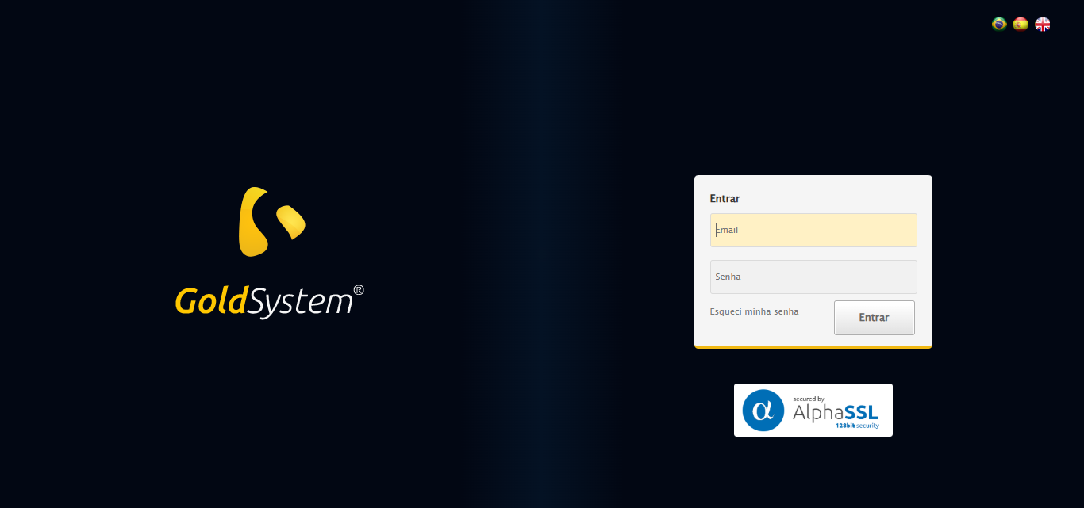

🔄 Realizando login...

✅ Realizando login realizada com sucesso.

Screenshot: realizando login

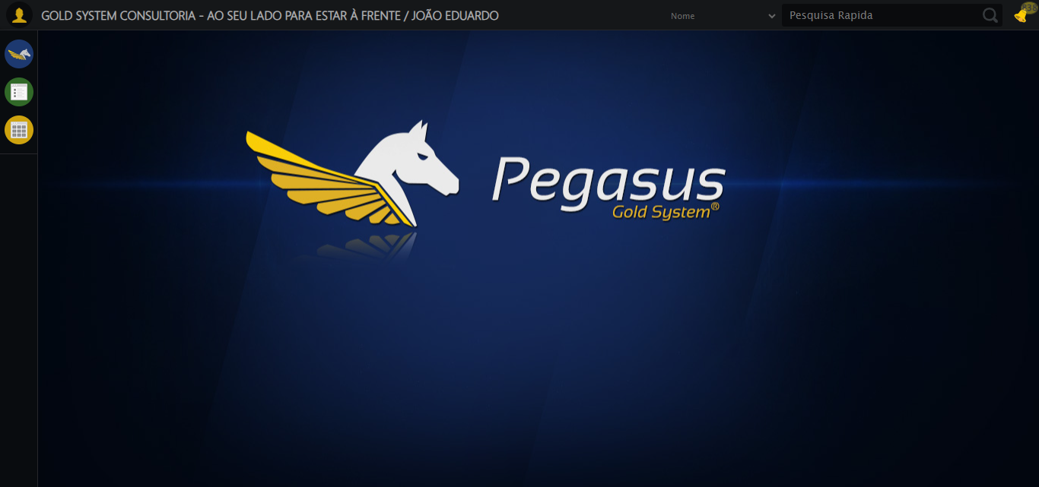

🔄 Ajustando zoom e abrindo menu...

🔍 Zoom ajustado para 90%.

✅ Ajustando zoom e abrindo menu realizada com sucesso.

Screenshot: ajustando zoom e abrindo menu

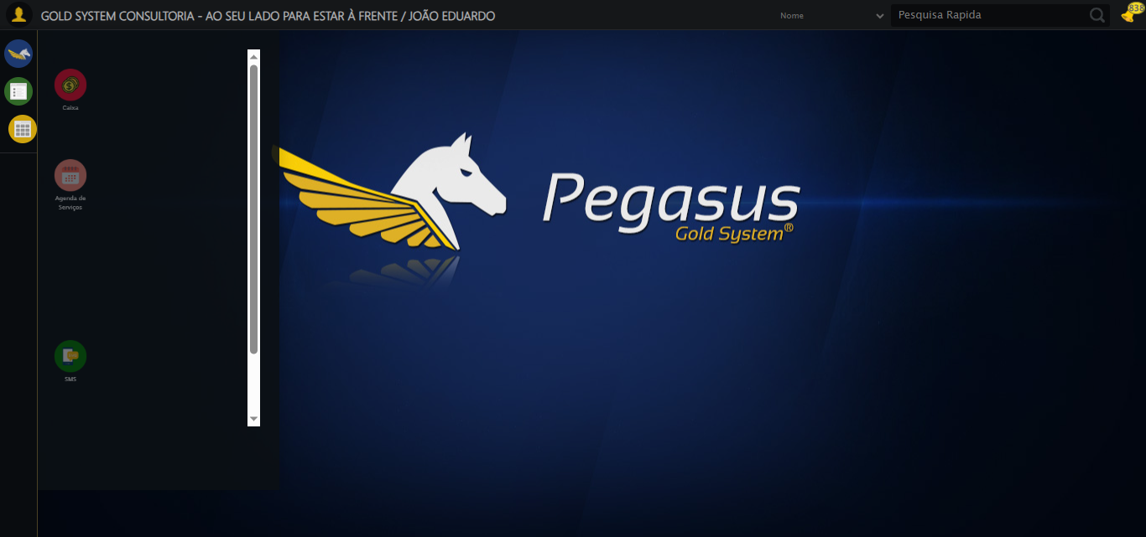

🔄 Acessando Gestor de Compras...

✅ Acessando Gestor de Compras realizada com sucesso.

Screenshot: acessando gestor de compras

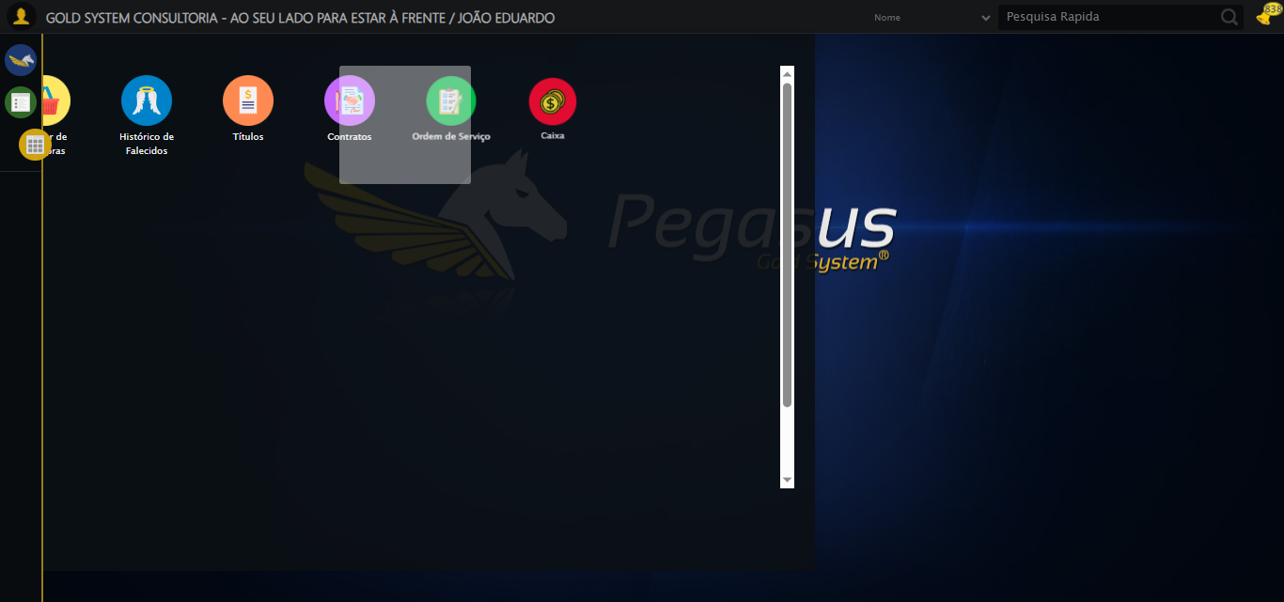

🔄 Clicando em Autorização de PIMS...

✅ Clicando em Autorização de PIMS realizada com sucesso.

Screenshot: clicando em autorização de pims

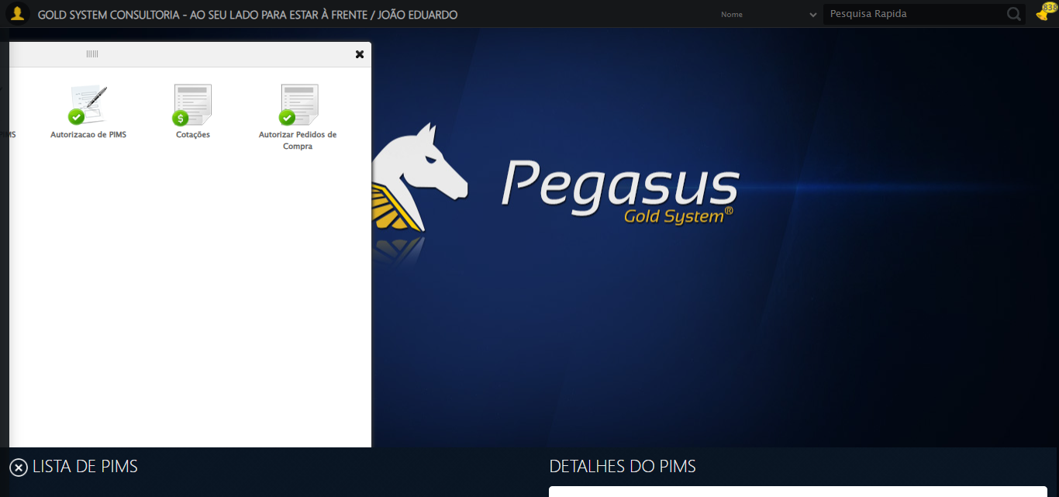

🔄 Preenchendo Número do PIMS...

⚠️ Tentativa 1 falhou: Message:   
Stacktrace:  
 GetHandleVerifier [0x0xccc333+65459]  
 GetHandleVerifier [0x0xccc374+65524]  
 (No symbol) [0x0xaed973]  
 (No symbol) [0x0xb376e7]  
 (No symbol) [0x0xb37a8b]  
 (No symbol) [0x0xb7dea2]  
 (No symbol) [0x0xb59e44]  
 (No symbol) [0x0xb7b606]  
 (No symbol) [0x0xb59bf6]  
 (No symbol) [0x0xb2b38e]  
 (No symbol) [0x0xb2c274]  
 GetHandleVerifier [0x0xf4eda3+2697763]  
 GetHandleVerifier [0x0xf49ec7+2677575]  
 GetHandleVerifier [0x0xcf4194+228884]  
 GetHandleVerifier [0x0xce49f8+165496]  
 GetHandleVerifier [0x0xceb18d+192013]  
 GetHandleVerifier [0x0xcd47d8+99416]  
 GetHandleVerifier [0x0xcd4972+99826]  
 GetHandleVerifier [0x0xcbebea+10346]  
 BaseThreadInitThunk [0x0x755bfcc9+25]  
 RtlGetAppContainerNamedObjectPath [0x0x773a82ae+286]  
 RtlGetAppContainerNamedObjectPath [0x0x773a827e+238]

⚠️ Tentativa 2 falhou: Message:   
Stacktrace:  
 GetHandleVerifier [0x0xccc333+65459]  
 GetHandleVerifier [0x0xccc374+65524]  
 (No symbol) [0x0xaed973]  
 (No symbol) [0x0xb376e7]  
 (No symbol) [0x0xb37a8b]  
 (No symbol) [0x0xb7dea2]  
 (No symbol) [0x0xb59e44]  
 (No symbol) [0x0xb7b606]  
 (No symbol) [0x0xb59bf6]  
 (No symbol) [0x0xb2b38e]  
 (No symbol) [0x0xb2c274]  
 GetHandleVerifier [0x0xf4eda3+2697763]  
 GetHandleVerifier [0x0xf49ec7+2677575]  
 GetHandleVerifier [0x0xcf4194+228884]  
 GetHandleVerifier [0x0xce49f8+165496]  
 GetHandleVerifier [0x0xceb18d+192013]  
 GetHandleVerifier [0x0xcd47d8+99416]  
 GetHandleVerifier [0x0xcd4972+99826]  
 GetHandleVerifier [0x0xcbebea+10346]  
 BaseThreadInitThunk [0x0x755bfcc9+25]  
 RtlGetAppContainerNamedObjectPath [0x0x773a82ae+286]  
 RtlGetAppContainerNamedObjectPath [0x0x773a827e+238]

⚠️ Tentativa 3 falhou: Message:   
Stacktrace:  
 GetHandleVerifier [0x0xccc333+65459]  
 GetHandleVerifier [0x0xccc374+65524]  
 (No symbol) [0x0xaed973]  
 (No symbol) [0x0xb376e7]  
 (No symbol) [0x0xb37a8b]  
 (No symbol) [0x0xb7dea2]  
 (No symbol) [0x0xb59e44]  
 (No symbol) [0x0xb7b606]  
 (No symbol) [0x0xb59bf6]  
 (No symbol) [0x0xb2b38e]  
 (No symbol) [0x0xb2c274]  
 GetHandleVerifier [0x0xf4eda3+2697763]  
 GetHandleVerifier [0x0xf49ec7+2677575]  
 GetHandleVerifier [0x0xcf4194+228884]  
 GetHandleVerifier [0x0xce49f8+165496]  
 GetHandleVerifier [0x0xceb18d+192013]  
 GetHandleVerifier [0x0xcd47d8+99416]  
 GetHandleVerifier [0x0xcd4972+99826]  
 GetHandleVerifier [0x0xcbebea+10346]  
 BaseThreadInitThunk [0x0x755bfcc9+25]  
 RtlGetAppContainerNamedObjectPath [0x0x773a82ae+286]  
 RtlGetAppContainerNamedObjectPath [0x0x773a827e+238]

✅ Preenchendo Número do PIMS realizada com sucesso.

Screenshot: preenchendo número do pims

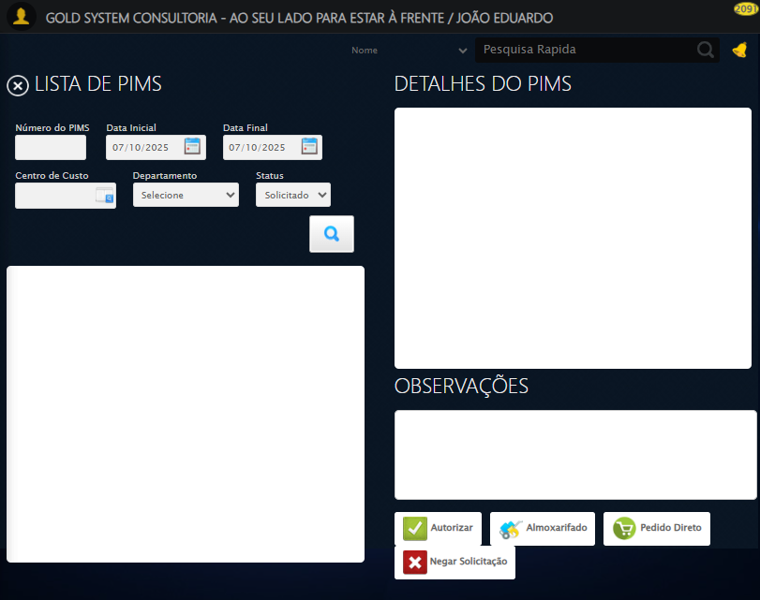

🔄 Preenchendo Data inicial...

✅ Preenchendo Data inicial realizada com sucesso.

Screenshot: preenchendo data inicial

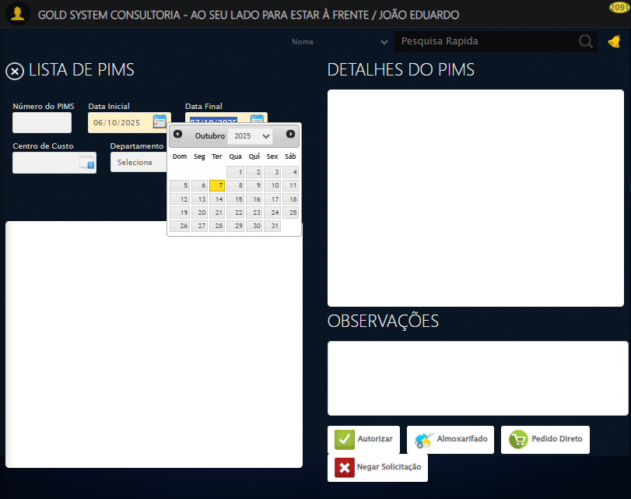

🔄 Selecionando Centro de Custo...

❌ Erro ao interagir com elemento //a[@class='sprites sp-openLov']: Message: invalid selector: An invalid or illegal selector was specified  
 (Session info: chrome=140.0.7339.208); For documentation on this error, please visit: https://www.selenium.dev/documentation/webdriver/troubleshooting/errors#invalidselectorexception  
Stacktrace:  
 GetHandleVerifier [0x0xccc333+65459]  
 GetHandleVerifier [0x0xccc374+65524]  
 (No symbol) [0x0xaed973]  
 (No symbol) [0x0xaf4330]  
 (No symbol) [0x0xaf6734]  
 (No symbol) [0x0xaf67c8]  
 (No symbol) [0x0xb36f74]  
 (No symbol) [0x0xb37a8b]  
 (No symbol) [0x0xb7dea2]  
 (No symbol) [0x0xb59e44]  
 (No symbol) [0x0xb7b606]  
 (No symbol) [0x0xb59bf6]  
 (No symbol) [0x0xb2b38e]  
 (No symbol) [0x0xb2c274]  
 GetHandleVerifier [0x0xf4eda3+2697763]  
 GetHandleVerifier [0x0xf49ec7+2677575]  
 GetHandleVerifier [0x0xcf4194+228884]  
 GetHandleVerifier [0x0xce49f8+165496]  
 GetHandleVerifier [0x0xceb18d+192013]  
 GetHandleVerifier [0x0xcd47d8+99416]  
 GetHandleVerifier [0x0xcd4972+99826]  
 GetHandleVerifier [0x0xcbebea+10346]  
 BaseThreadInitThunk [0x0x755bfcc9+25]  
 RtlGetAppContainerNamedObjectPath [0x0x773a82ae+286]  
 RtlGetAppContainerNamedObjectPath [0x0x773a827e+238]

⚠️ Tentativa 1 falhou para Selecionando Centro de Custo, tentando novamente...

🔄 Selecionando Centro de Custo... (Tentativa 2)

❌ Erro ao interagir com elemento //a[@class='sprites sp-openLov']: Message: invalid selector: An invalid or illegal selector was specified  
 (Session info: chrome=140.0.7339.208); For documentation on this error, please visit: https://www.selenium.dev/documentation/webdriver/troubleshooting/errors#invalidselectorexception  
Stacktrace:  
 GetHandleVerifier [0x0xccc333+65459]  
 GetHandleVerifier [0x0xccc374+65524]  
 (No symbol) [0x0xaed973]  
 (No symbol) [0x0xaf4330]  
 (No symbol) [0x0xaf6734]  
 (No symbol) [0x0xaf67c8]  
 (No symbol) [0x0xb36f74]  
 (No symbol) [0x0xb37a8b]  
 (No symbol) [0x0xb7dea2]  
 (No symbol) [0x0xb59e44]  
 (No symbol) [0x0xb7b606]  
 (No symbol) [0x0xb59bf6]  
 (No symbol) [0x0xb2b38e]  
 (No symbol) [0x0xb2c274]  
 GetHandleVerifier [0x0xf4eda3+2697763]  
 GetHandleVerifier [0x0xf49ec7+2677575]  
 GetHandleVerifier [0x0xcf4194+228884]  
 GetHandleVerifier [0x0xce49f8+165496]  
 GetHandleVerifier [0x0xceb18d+192013]  
 GetHandleVerifier [0x0xcd47d8+99416]  
 GetHandleVerifier [0x0xcd4972+99826]  
 GetHandleVerifier [0x0xcbebea+10346]  
 BaseThreadInitThunk [0x0x755bfcc9+25]  
 RtlGetAppContainerNamedObjectPath [0x0x773a82ae+286]  
 RtlGetAppContainerNamedObjectPath [0x0x773a827e+238]

⚠️ Tentativa 2 falhou para Selecionando Centro de Custo, tentando novamente...

🔄 Selecionando Centro de Custo... (Tentativa 3)

❌ Erro ao interagir com elemento //a[@class='sprites sp-openLov']: Message: invalid selector: An invalid or illegal selector was specified  
 (Session info: chrome=140.0.7339.208); For documentation on this error, please visit: https://www.selenium.dev/documentation/webdriver/troubleshooting/errors#invalidselectorexception  
Stacktrace:  
 GetHandleVerifier [0x0xccc333+65459]  
 GetHandleVerifier [0x0xccc374+65524]  
 (No symbol) [0x0xaed973]  
 (No symbol) [0x0xaf4330]  
 (No symbol) [0x0xaf6734]  
 (No symbol) [0x0xaf67c8]  
 (No symbol) [0x0xb36f74]  
 (No symbol) [0x0xb37a8b]  
 (No symbol) [0x0xb7dea2]  
 (No symbol) [0x0xb59e44]  
 (No symbol) [0x0xb7b606]  
 (No symbol) [0x0xb59bf6]  
 (No symbol) [0x0xb2b38e]  
 (No symbol) [0x0xb2c274]  
 GetHandleVerifier [0x0xf4eda3+2697763]  
 GetHandleVerifier [0x0xf49ec7+2677575]  
 GetHandleVerifier [0x0xcf4194+228884]  
 GetHandleVerifier [0x0xce49f8+165496]  
 GetHandleVerifier [0x0xceb18d+192013]  
 GetHandleVerifier [0x0xcd47d8+99416]  
 GetHandleVerifier [0x0xcd4972+99826]  
 GetHandleVerifier [0x0xcbebea+10346]  
 BaseThreadInitThunk [0x0x755bfcc9+25]  
 RtlGetAppContainerNamedObjectPath [0x0x773a82ae+286]  
 RtlGetAppContainerNamedObjectPath [0x0x773a827e+238]

❌ Erro ao selecionando centro de custo após 3 tentativas: Message:   
Stacktrace:  
 GetHandleVerifier [0x0xccc333+65459]  
 GetHandleVerifier [0x0xccc374+65524]  
 (No symbol) [0x0xaed973]  
 (No symbol) [0x0xb376e7]  
 (No symbol) [0x0xb37a8b]  
 (No symbol) [0x0xb7dea2]  
 (No symbol) [0x0xb59e44]  
 (No symbol) [0x0xb7b606]  
 (No symbol) [0x0xb59bf6]  
 (No symbol) [0x0xb2b38e]  
 (No symbol) [0x0xb2c274]  
 GetHandleVerifier [0x0xf4eda3+2697763]  
 GetHandleVerifier [0x0xf49ec7+2677575]  
 GetHandleVerifier [0x0xcf4194+228884]  
 GetHandleVerifier [0x0xce49f8+165496]  
 GetHandleVerifier [0x0xceb18d+192013]  
 GetHandleVerifier [0x0xcd47d8+99416]  
 GetHandleVerifier [0x0xcd4972+99826]  
 GetHandleVerifier [0x0xcbebea+10346]  
 BaseThreadInitThunk [0x0x755bfcc9+25]  
 RtlGetAppContainerNamedObjectPath [0x0x773a82ae+286]  
 RtlGetAppContainerNamedObjectPath [0x0x773a827e+238]

Screenshot: erro_selecionando centro de custo

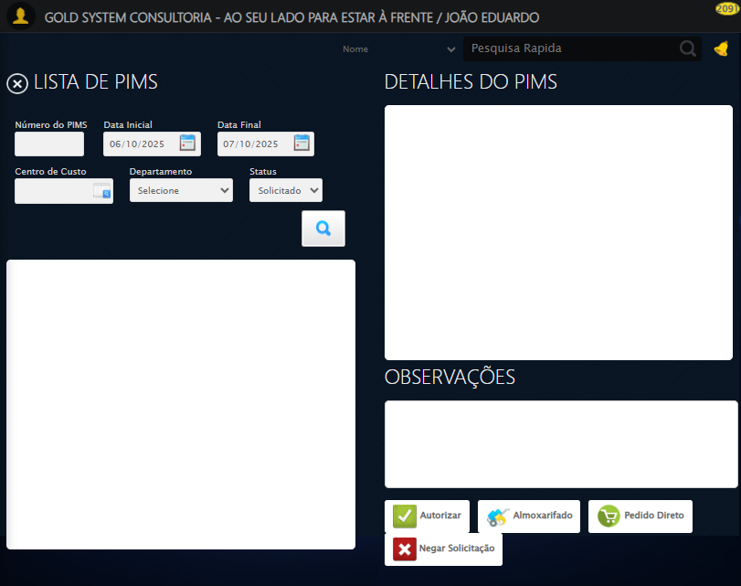

🔄 Selecionando Departamento...

⚠️ Tentativa 1 falhou para Selecionando Departamento, tentando novamente...

🔄 Selecionando Departamento... (Tentativa 2)

⚠️ Tentativa 2 falhou para Selecionando Departamento, tentando novamente...

🔄 Selecionando Departamento... (Tentativa 3)

❌ Erro ao selecionando departamento após 3 tentativas: Message:   
Stacktrace:  
 GetHandleVerifier [0x0xccc333+65459]  
 GetHandleVerifier [0x0xccc374+65524]  
 (No symbol) [0x0xaed973]  
 (No symbol) [0x0xb376e7]  
 (No symbol) [0x0xb37a8b]  
 (No symbol) [0x0xb7dea2]  
 (No symbol) [0x0xb59e44]  
 (No symbol) [0x0xb7b606]  
 (No symbol) [0x0xb59bf6]  
 (No symbol) [0x0xb2b38e]  
 (No symbol) [0x0xb2c274]  
 GetHandleVerifier [0x0xf4eda3+2697763]  
 GetHandleVerifier [0x0xf49ec7+2677575]  
 GetHandleVerifier [0x0xcf4194+228884]  
 GetHandleVerifier [0x0xce49f8+165496]  
 GetHandleVerifier [0x0xceb18d+192013]  
 GetHandleVerifier [0x0xcd47d8+99416]  
 GetHandleVerifier [0x0xcd4972+99826]  
 GetHandleVerifier [0x0xcbebea+10346]  
 BaseThreadInitThunk [0x0x755bfcc9+25]  
 RtlGetAppContainerNamedObjectPath [0x0x773a82ae+286]  
 RtlGetAppContainerNamedObjectPath [0x0x773a827e+238]

Screenshot: erro_selecionando departamento

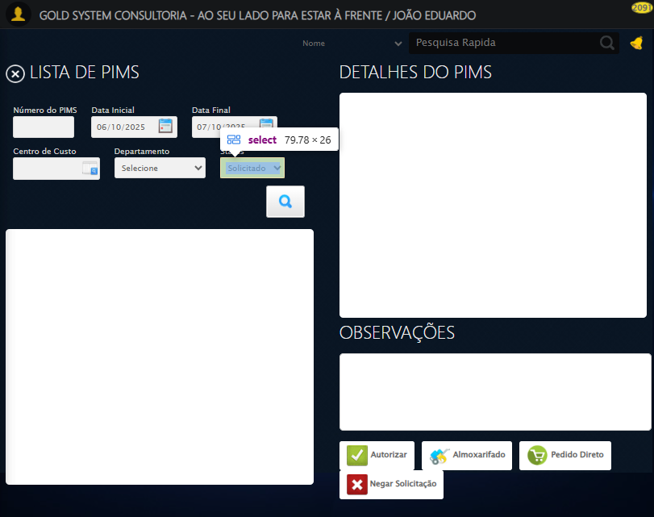

🔄 Selecionando Status...

⚠️ Tentativa 1 falhou para Selecionando Status, tentando novamente...

🔄 Selecionando Status... (Tentativa 2)

❌ Erro inesperado ao selecionando status: Message: no such window: target window already closed  
from unknown error: web view not found  
 (Session info: chrome=140.0.7339.208)  
Stacktrace:  
 GetHandleVerifier [0x0xccc333+65459]  
 GetHandleVerifier [0x0xccc374+65524]  
 (No symbol) [0x0xaed973]  
 (No symbol) [0x0xacc19d]  
 (No symbol) [0x0xb6059e]  
 (No symbol) [0x0xb7aef9]  
 (No symbol) [0x0xb59bf6]  
 (No symbol) [0x0xb2b38e]  
 (No symbol) [0x0xb2c274]  
 GetHandleVerifier [0x0xf4eda3+2697763]  
 GetHandleVerifier [0x0xf49ec7+2677575]  
 GetHandleVerifier [0x0xcf4194+228884]  
 GetHandleVerifier [0x0xce49f8+165496]  
 GetHandleVerifier [0x0xceb18d+192013]  
 GetHandleVerifier [0x0xcd47d8+99416]  
 GetHandleVerifier [0x0xcd4972+99826]  
 GetHandleVerifier [0x0xcbebea+10346]  
 BaseThreadInitThunk [0x0x755bfcc9+25]  
 RtlGetAppContainerNamedObjectPath [0x0x773a82ae+286]  
 RtlGetAppContainerNamedObjectPath [0x0x773a827e+238]

⚠️ Erro ao tirar screenshot erro_selecionando status: Message: no such window: target window already closed  
from unknown error: web view not found  
 (Session info: chrome=140.0.7339.208)  
Stacktrace:  
 GetHandleVerifier [0x0xccc333+65459]  
 GetHandleVerifier [0x0xccc374+65524]  
 (No symbol) [0x0xaed973]  
 (No symbol) [0x0xacc19d]  
 (No symbol) [0x0xb6059e]  
 (No symbol) [0x0xb7aef9]  
 (No symbol) [0x0xb59bf6]  
 (No symbol) [0x0xb2b38e]  
 (No symbol) [0x0xb2c274]  
 GetHandleVerifier [0x0xf4eda3+2697763]  
 GetHandleVerifier [0x0xf49ec7+2677575]  
 GetHandleVerifier [0x0xcf4194+228884]  
 GetHandleVerifier [0x0xce49f8+165496]  
 GetHandleVerifier [0x0xceb18d+192013]  
 GetHandleVerifier [0x0xcd47d8+99416]  
 GetHandleVerifier [0x0xcd4972+99826]  
 GetHandleVerifier [0x0xcbebea+10346]  
 BaseThreadInitThunk [0x0x755bfcc9+25]  
 RtlGetAppContainerNamedObjectPath [0x0x773a82ae+286]  
 RtlGetAppContainerNamedObjectPath [0x0x773a827e+238]

🔄 Pesquisando......

❌ Erro inesperado ao pesquisando...: Message: no such window: target window already closed  
from unknown error: web view not found  
 (Session info: chrome=140.0.7339.208)  
Stacktrace:  
 GetHandleVerifier [0x0xccc333+65459]  
 GetHandleVerifier [0x0xccc374+65524]  
 (No symbol) [0x0xaed973]  
 (No symbol) [0x0xacc19d]  
 (No symbol) [0x0xb6059e]  
 (No symbol) [0x0xb7aef9]  
 (No symbol) [0x0xb59bf6]  
 (No symbol) [0x0xb2b38e]  
 (No symbol) [0x0xb2c274]  
 GetHandleVerifier [0x0xf4eda3+2697763]  
 GetHandleVerifier [0x0xf49ec7+2677575]  
 GetHandleVerifier [0x0xcf4194+228884]  
 GetHandleVerifier [0x0xce49f8+165496]  
 GetHandleVerifier [0x0xceb18d+192013]  
 GetHandleVerifier [0x0xcd47d8+99416]  
 GetHandleVerifier [0x0xcd4972+99826]  
 GetHandleVerifier [0x0xcbebea+10346]  
 BaseThreadInitThunk [0x0x755bfcc9+25]  
 RtlGetAppContainerNamedObjectPath [0x0x773a82ae+286]  
 RtlGetAppContainerNamedObjectPath [0x0x773a827e+238]

⚠️ Erro ao tirar screenshot erro_pesquisando...: Message: no such window: target window already closed  
from unknown error: web view not found  
 (Session info: chrome=140.0.7339.208)  
Stacktrace:  
 GetHandleVerifier [0x0xccc333+65459]  
 GetHandleVerifier [0x0xccc374+65524]  
 (No symbol) [0x0xaed973]  
 (No symbol) [0x0xacc19d]  
 (No symbol) [0x0xb6059e]  
 (No symbol) [0x0xb7aef9]  
 (No symbol) [0x0xb59bf6]  
 (No symbol) [0x0xb2b38e]  
 (No symbol) [0x0xb2c274]  
 GetHandleVerifier [0x0xf4eda3+2697763]  
 GetHandleVerifier [0x0xf49ec7+2677575]  
 GetHandleVerifier [0x0xcf4194+228884]  
 GetHandleVerifier [0x0xce49f8+165496]  
 GetHandleVerifier [0x0xceb18d+192013]  
 GetHandleVerifier [0x0xcd47d8+99416]  
 GetHandleVerifier [0x0xcd4972+99826]  
 GetHandleVerifier [0x0xcbebea+10346]  
 BaseThreadInitThunk [0x0x755bfcc9+25]  
 RtlGetAppContainerNamedObjectPath [0x0x773a82ae+286]  
 RtlGetAppContainerNamedObjectPath [0x0x773a827e+238]

🔄 Validando registros PIMS...

❌ Erro ao validar ou clicar no PIMS: Message: no such window: target window already closed  
from unknown error: web view not found  
 (Session info: chrome=140.0.7339.208)  
Stacktrace:  
 GetHandleVerifier [0x0xccc333+65459]  
 GetHandleVerifier [0x0xccc374+65524]  
 (No symbol) [0x0xaed973]  
 (No symbol) [0x0xacc19d]  
 (No symbol) [0x0xb6059e]  
 (No symbol) [0x0xb7aef9]  
 (No symbol) [0x0xb59bf6]  
 (No symbol) [0x0xb2b38e]  
 (No symbol) [0x0xb2c274]  
 GetHandleVerifier [0x0xf4eda3+2697763]  
 GetHandleVerifier [0x0xf49ec7+2677575]  
 GetHandleVerifier [0x0xcf4194+228884]  
 GetHandleVerifier [0x0xce49f8+165496]  
 GetHandleVerifier [0x0xceb18d+192013]  
 GetHandleVerifier [0x0xcd47d8+99416]  
 GetHandleVerifier [0x0xcd4972+99826]  
 GetHandleVerifier [0x0xcbebea+10346]  
 BaseThreadInitThunk [0x0x755bfcc9+25]  
 RtlGetAppContainerNamedObjectPath [0x0x773a82ae+286]  
 RtlGetAppContainerNamedObjectPath [0x0x773a827e+238]

✅ Validando registros PIMS realizada com sucesso.

⚠️ Erro ao tirar screenshot validando registros pims: Message: no such window: target window already closed  
from unknown error: web view not found  
 (Session info: chrome=140.0.7339.208)  
Stacktrace:  
 GetHandleVerifier [0x0xccc333+65459]  
 GetHandleVerifier [0x0xccc374+65524]  
 (No symbol) [0x0xaed973]  
 (No symbol) [0x0xacc19d]  
 (No symbol) [0x0xb6059e]  
 (No symbol) [0x0xb7aef9]  
 (No symbol) [0x0xb59bf6]  
 (No symbol) [0x0xb2b38e]  
 (No symbol) [0x0xb2c274]  
 GetHandleVerifier [0x0xf4eda3+2697763]  
 GetHandleVerifier [0x0xf49ec7+2677575]  
 GetHandleVerifier [0x0xcf4194+228884]  
 GetHandleVerifier [0x0xce49f8+165496]  
 GetHandleVerifier [0x0xceb18d+192013]  
 GetHandleVerifier [0x0xcd47d8+99416]  
 GetHandleVerifier [0x0xcd4972+99826]  
 GetHandleVerifier [0x0xcbebea+10346]  
 BaseThreadInitThunk [0x0x755bfcc9+25]  
 RtlGetAppContainerNamedObjectPath [0x0x773a82ae+286]  
 RtlGetAppContainerNamedObjectPath [0x0x773a827e+238]

🔄 Selecionando todos os itens da lista...

❌ Erro ao tentar selecionar os itens da lista: Message: no such window: target window already closed  
from unknown error: web view not found  
 (Session info: chrome=140.0.7339.208)  
Stacktrace:  
 GetHandleVerifier [0x0xccc333+65459]  
 GetHandleVerifier [0x0xccc374+65524]  
 (No symbol) [0x0xaed973]  
 (No symbol) [0x0xacc19d]  
 (No symbol) [0x0xb6059e]  
 (No symbol) [0x0xb7aef9]  
 (No symbol) [0x0xb59bf6]  
 (No symbol) [0x0xb2b38e]  
 (No symbol) [0x0xb2c274]  
 GetHandleVerifier [0x0xf4eda3+2697763]  
 GetHandleVerifier [0x0xf49ec7+2677575]  
 GetHandleVerifier [0x0xcf4194+228884]  
 GetHandleVerifier [0x0xce49f8+165496]  
 GetHandleVerifier [0x0xceb18d+192013]  
 GetHandleVerifier [0x0xcd47d8+99416]  
 GetHandleVerifier [0x0xcd4972+99826]  
 GetHandleVerifier [0x0xcbebea+10346]  
 BaseThreadInitThunk [0x0x755bfcc9+25]  
 RtlGetAppContainerNamedObjectPath [0x0x773a82ae+286]  
 RtlGetAppContainerNamedObjectPath [0x0x773a827e+238]

✅ Selecionando todos os itens da lista realizada com sucesso.

⚠️ Erro ao tirar screenshot selecionando todos os itens da lista: Message: no such window: target window already closed  
from unknown error: web view not found  
 (Session info: chrome=140.0.7339.208)  
Stacktrace:  
 GetHandleVerifier [0x0xccc333+65459]  
 GetHandleVerifier [0x0xccc374+65524]  
 (No symbol) [0x0xaed973]  
 (No symbol) [0x0xacc19d]  
 (No symbol) [0x0xb6059e]  
 (No symbol) [0x0xb7aef9]  
 (No symbol) [0x0xb59bf6]  
 (No symbol) [0x0xb2b38e]  
 (No symbol) [0x0xb2c274]  
 GetHandleVerifier [0x0xf4eda3+2697763]  
 GetHandleVerifier [0x0xf49ec7+2677575]  
 GetHandleVerifier [0x0xcf4194+228884]  
 GetHandleVerifier [0x0xce49f8+165496]  
 GetHandleVerifier [0x0xceb18d+192013]  
 GetHandleVerifier [0x0xcd47d8+99416]  
 GetHandleVerifier [0x0xcd4972+99826]  
 GetHandleVerifier [0x0xcbebea+10346]  
 BaseThreadInitThunk [0x0x755bfcc9+25]  
 RtlGetAppContainerNamedObjectPath [0x0x773a82ae+286]  
 RtlGetAppContainerNamedObjectPath [0x0x773a827e+238]

❌ ERRO FATAL: log() takes 2 positional arguments but 3 were given

⚠️ Erro ao tirar screenshot erro_fatal: Message: no such window: target window already closed  
from unknown error: web view not found  
 (Session info: chrome=140.0.7339.208)  
Stacktrace:  
 GetHandleVerifier [0x0xccc333+65459]  
 GetHandleVerifier [0x0xccc374+65524]  
 (No symbol) [0x0xaed973]  
 (No symbol) [0x0xacc19d]  
 (No symbol) [0x0xb6059e]  
 (No symbol) [0x0xb7aef9]  
 (No symbol) [0x0xb59bf6]  
 (No symbol) [0x0xb2b38e]  
 (No symbol) [0x0xb2c274]  
 GetHandleVerifier [0x0xf4eda3+2697763]  
 GetHandleVerifier [0x0xf49ec7+2677575]  
 GetHandleVerifier [0x0xcf4194+228884]  
 GetHandleVerifier [0x0xce49f8+165496]  
 GetHandleVerifier [0x0xceb18d+192013]  
 GetHandleVerifier [0x0xcd47d8+99416]  
 GetHandleVerifier [0x0xcd4972+99826]  
 GetHandleVerifier [0x0xcbebea+10346]  
 BaseThreadInitThunk [0x0x755bfcc9+25]  
 RtlGetAppContainerNamedObjectPath [0x0x773a82ae+286]  
 RtlGetAppContainerNamedObjectPath [0x0x773a827e+238]

✅ Teste concluído.

❌ Teste finalizado com erros.