RELATÓRIO DO TESTE

Autorização PIMS - Gestor de Compras – Cenário 4: Preenchimento completo e efetuação de Pedido Direto

Data do teste: 07/10/2025 18:00:31

🚀 Iniciando teste de Autorização de PIMS

🔄 Acessando sistema...

✅ Acessando sistema realizada com sucesso.

Screenshot: acessando sistema

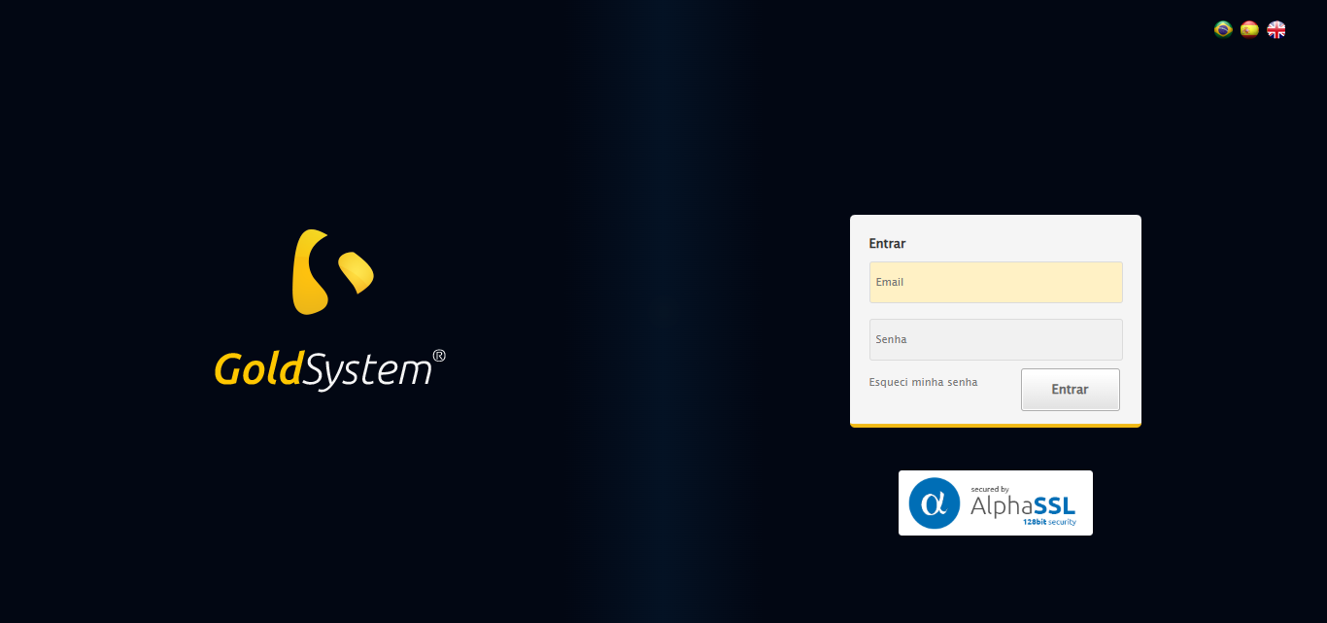

🔄 Realizando login...

✅ Realizando login realizada com sucesso.

Screenshot: realizando login

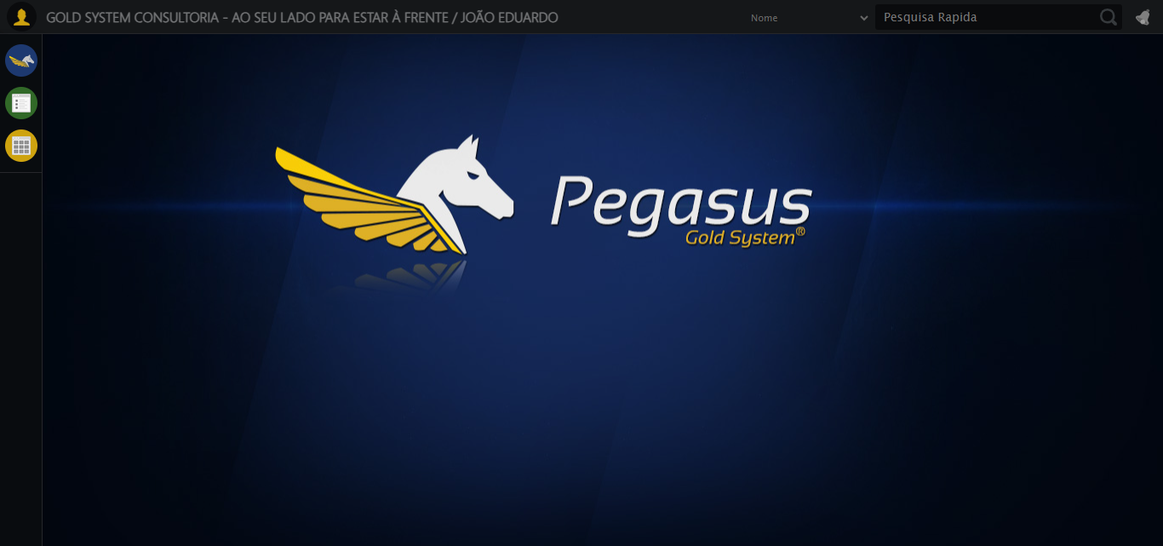

🔄 Ajustando zoom e abrindo menu...

🔍 Zoom ajustado para 90%.

✅ Ajustando zoom e abrindo menu realizada com sucesso.

Screenshot: ajustando zoom e abrindo menu

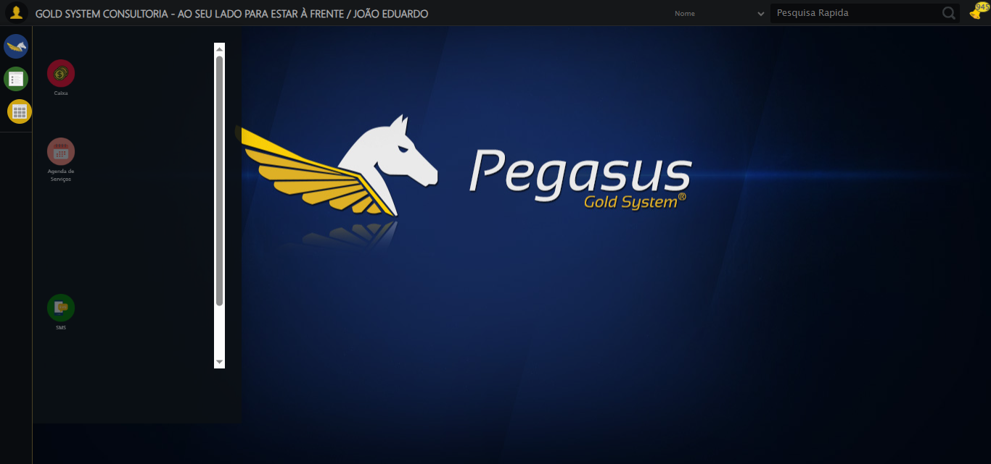

🔄 Acessando Gestor de Compras...

✅ Acessando Gestor de Compras realizada com sucesso.

Screenshot: acessando gestor de compras

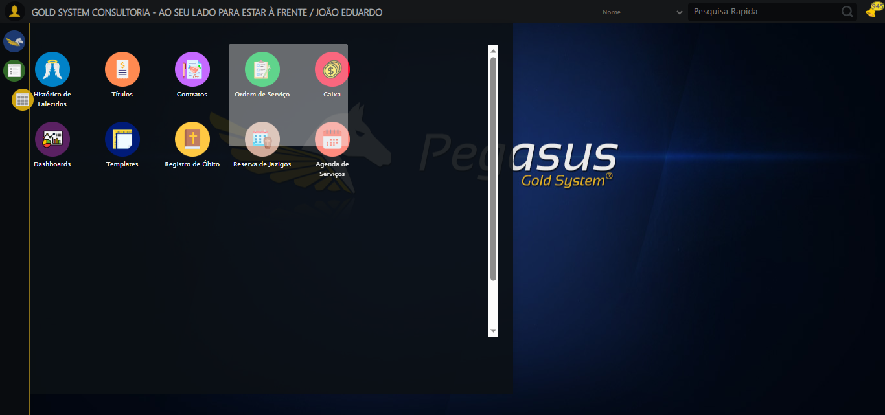

🔄 Clicando em Autorização de PIMS...

✅ Clicando em Autorização de PIMS realizada com sucesso.

Screenshot: clicando em autorização de pims

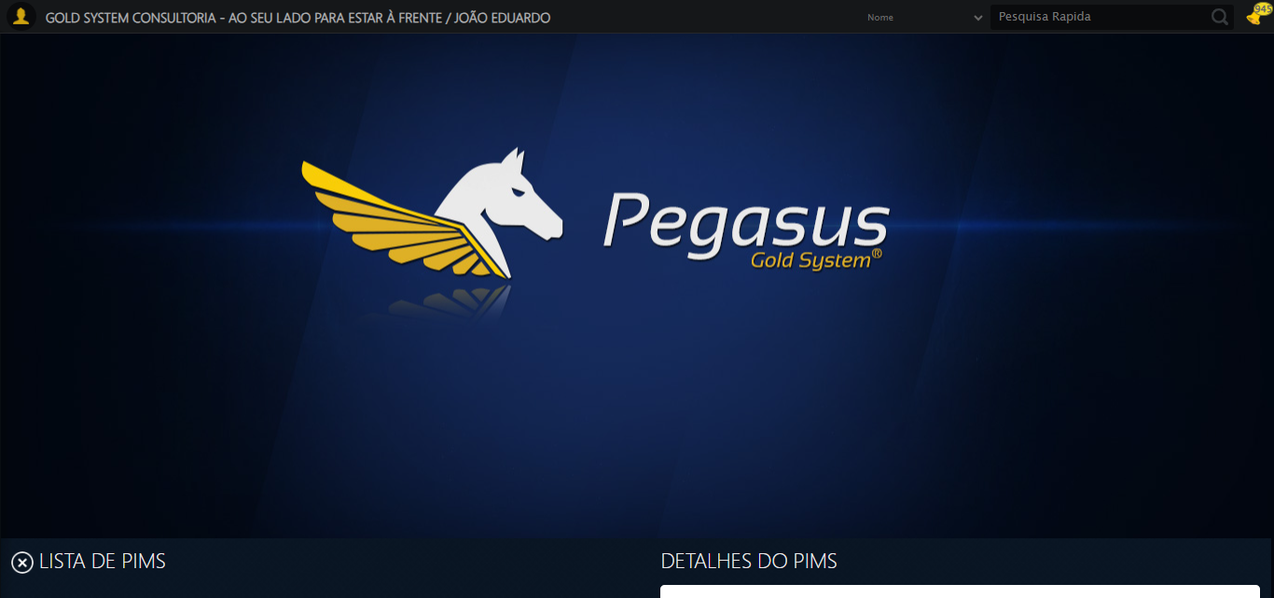

🔄 Preenchendo Número do PIMS...

✅ Preenchendo Número do PIMS realizada com sucesso.

Screenshot: preenchendo número do pims

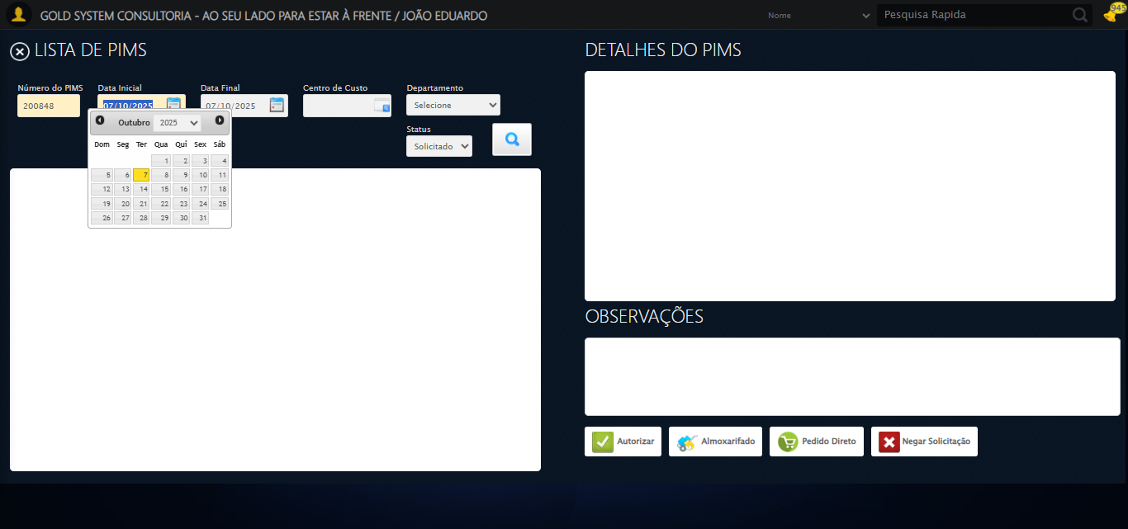

🔄 Preenchendo Data inicial...

✅ Preenchendo Data inicial realizada com sucesso.

Screenshot: preenchendo data inicial

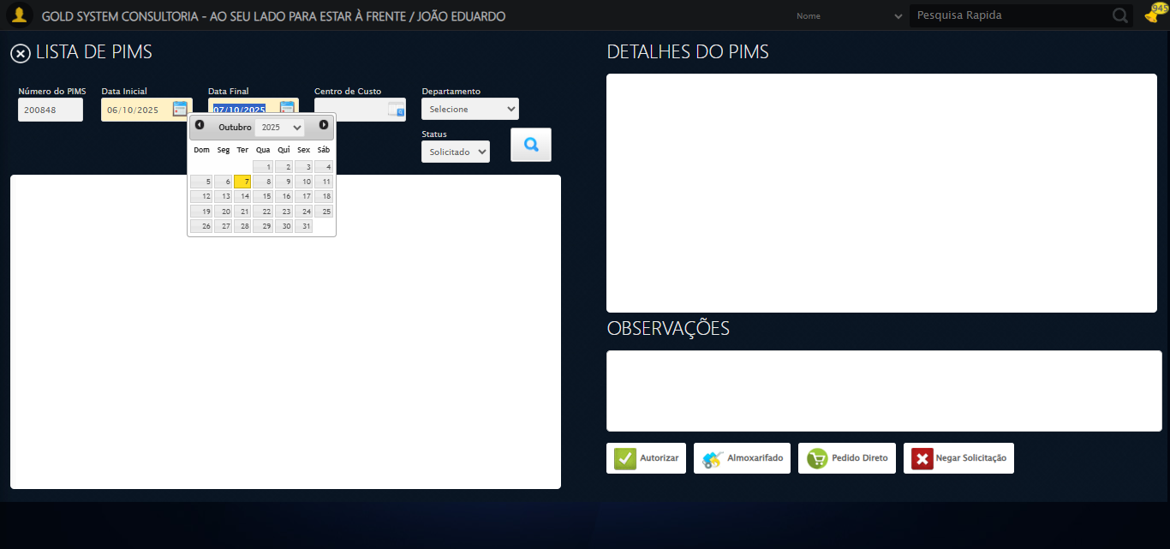

🔄 Selecionando Departamento...

✅ Selecionando Departamento realizada com sucesso.

Screenshot: selecionando departamento

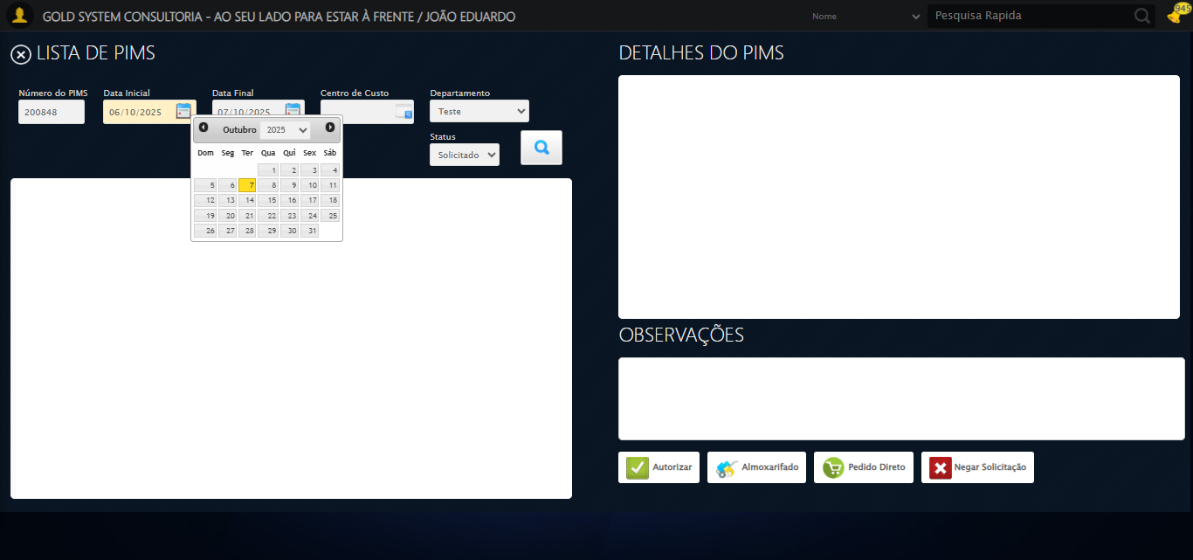

🔄 Selecionando Status...

✅ Selecionando Status realizada com sucesso.

Screenshot: selecionando status



🔄 Pesquisando......

✅ Pesquisando... realizada com sucesso.

Screenshot: pesquisando...

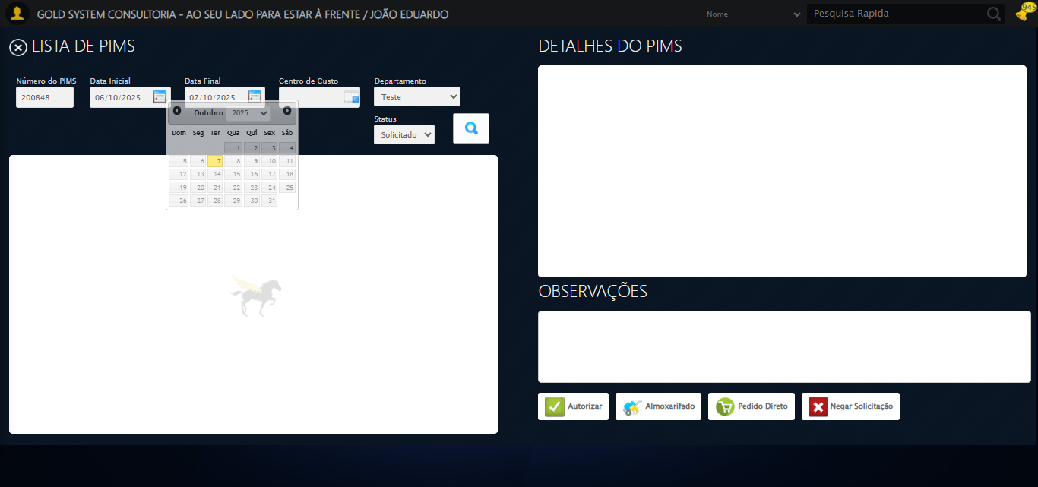

🔄 Selecionando PIMS...

⚠️ Tentativa 1 falhou para Selecionando PIMS, tentando novamente...

🔄 Selecionando PIMS... (Tentativa 2)

⚠️ Tentativa 2 falhou para Selecionando PIMS, tentando novamente...

🔄 Selecionando PIMS... (Tentativa 3)

❌ Erro ao selecionando pims após 3 tentativas: Message: no such element: Unable to locate element: {"method":"xpath","selector":"(//li[contains(@class, 'itemSimple')])[1]"}  
 (Session info: chrome=140.0.7339.208); For documentation on this error, please visit: https://www.selenium.dev/documentation/webdriver/troubleshooting/errors#nosuchelementexception  
Stacktrace:  
 GetHandleVerifier [0x0xadc333+65459]  
 GetHandleVerifier [0x0xadc374+65524]  
 (No symbol) [0x0x8fd973]  
 (No symbol) [0x0x9476e7]  
 (No symbol) [0x0x947a8b]  
 (No symbol) [0x0x98dea2]  
 (No symbol) [0x0x969e44]  
 (No symbol) [0x0x98b606]  
 (No symbol) [0x0x969bf6]  
 (No symbol) [0x0x93b38e]  
 (No symbol) [0x0x93c274]  
 GetHandleVerifier [0x0xd5eda3+2697763]  
 GetHandleVerifier [0x0xd59ec7+2677575]  
 GetHandleVerifier [0x0xb04194+228884]  
 GetHandleVerifier [0x0xaf49f8+165496]  
 GetHandleVerifier [0x0xafb18d+192013]  
 GetHandleVerifier [0x0xae47d8+99416]  
 GetHandleVerifier [0x0xae4972+99826]  
 GetHandleVerifier [0x0xacebea+10346]  
 BaseThreadInitThunk [0x0x755bfcc9+25]  
 RtlGetAppContainerNamedObjectPath [0x0x773a82ae+286]  
 RtlGetAppContainerNamedObjectPath [0x0x773a827e+238]

Screenshot: erro_selecionando pims

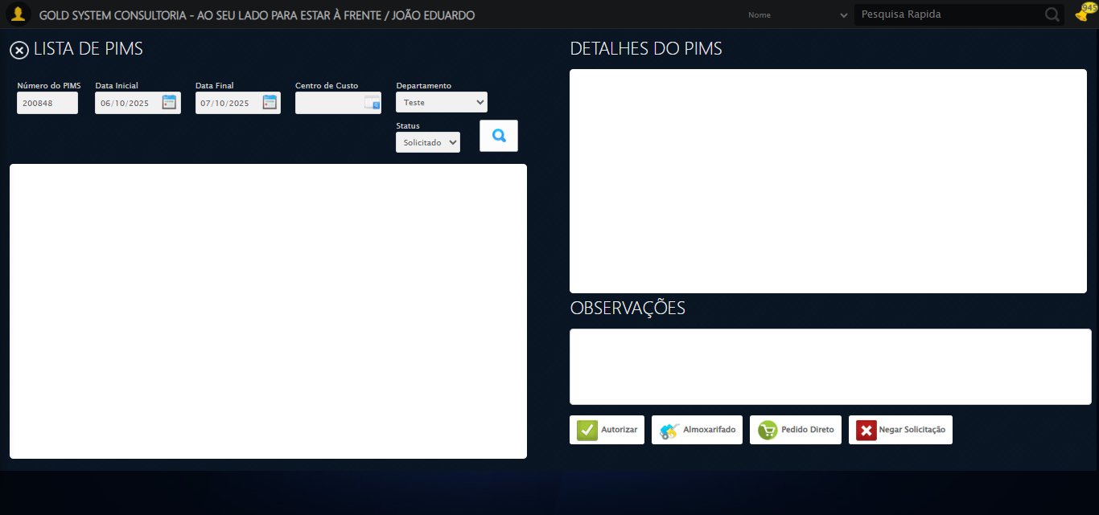

🔄 Selecionando itens para a Autorização de PIMS...

✅ Selecionando itens para a Autorização de PIMS realizada com sucesso.

Screenshot: selecionando itens para a autorização de pims

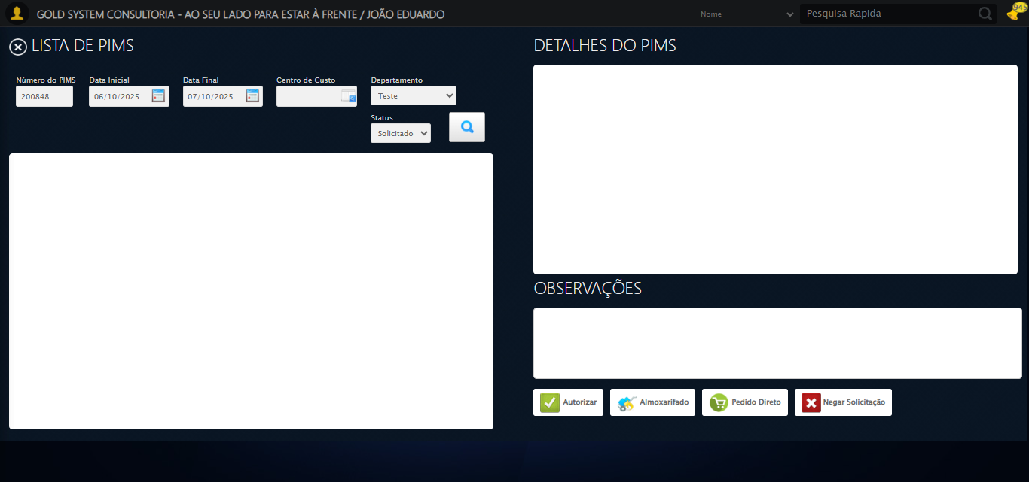

🎯 Tentativa 1: Preenchendo textarea 0 (ID: (sem id), name: (sem name)) com 129 caracteres

▶️ Estratégia 1…

✅ Preenchido com sucesso pela estratégia 1: 'TESTE OBSERVAÇÃO SELENIUM AUTOMATIZADO (Automação de Testes)…'

🔄 Preenchendo Observações...

❌ Erro inesperado ao preenchendo observações: 'bool' object is not callable

Screenshot: erro_preenchendo observações

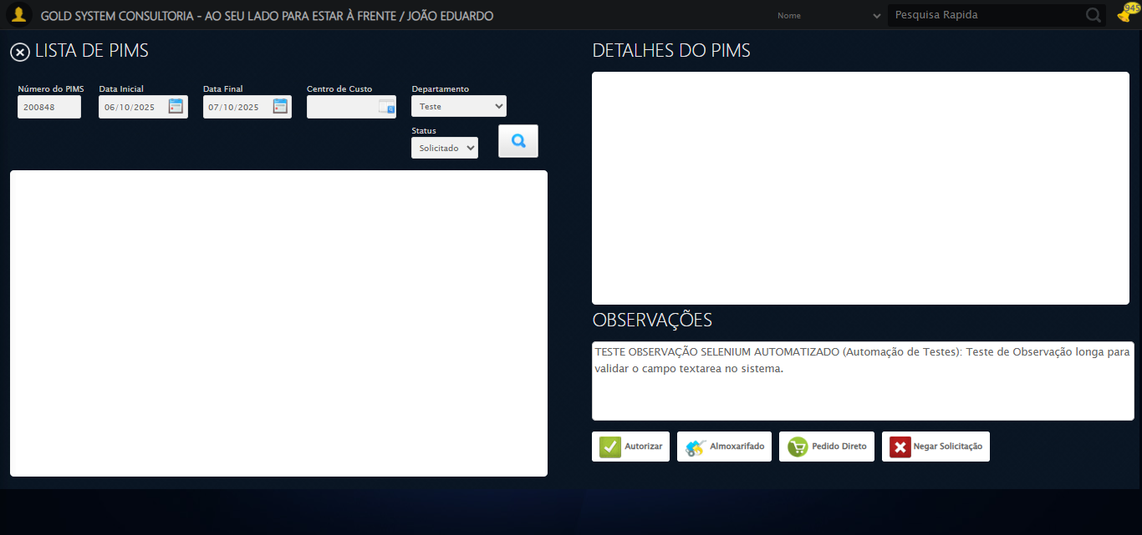

🔄 Clicando no botão Pedido Direto...

✅ Clicando no botão Pedido Direto realizada com sucesso.

Screenshot: clicando no botão pedido direto

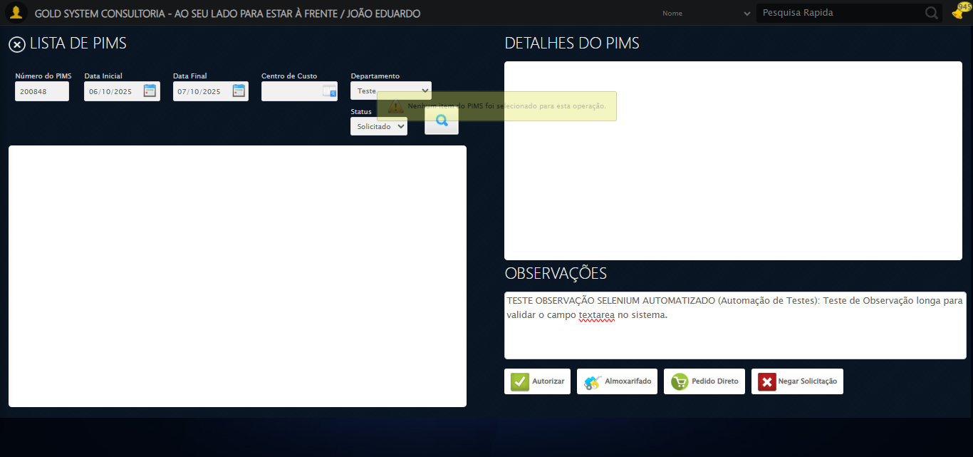

🔄 Selecionando Fornecedor...

⚠️ Tentativa 1/3 falhou: Message:   
Stacktrace:  
 GetHandleVerifier [0x0xadc333+65459]  
 GetHandleVerifier [0x0xadc374+65524]  
 (No symbol) [0x0x8fd973]  
 (No symbol) [0x0x9476e7]  
 (No symbol) [0x0x947a8b]  
 (No symbol) [0x0x98dea2]  
 (No symbol) [0x0x969e44]  
 (No symbol) [0x0x98b606]  
 (No symbol) [0x0x969bf6]  
 (No symbol) [0x0x93b38e]  
 (No symbol) [0x0x93c274]  
 GetHandleVerifier [0x0xd5eda3+2697763]  
 GetHandleVerifier [0x0xd59ec7+2677575]  
 GetHandleVerifier [0x0xb04194+228884]  
 GetHandleVerifier [0x0xaf49f8+165496]  
 GetHandleVerifier [0x0xafb18d+192013]  
 GetHandleVerifier [0x0xae47d8+99416]  
 GetHandleVerifier [0x0xae4972+99826]  
 GetHandleVerifier [0x0xacebea+10346]  
 BaseThreadInitThunk [0x0x755bfcc9+25]  
 RtlGetAppContainerNamedObjectPath [0x0x773a82ae+286]  
 RtlGetAppContainerNamedObjectPath [0x0x773a827e+238]  
. Retentando…

⚠️ Tentativa 2/3 falhou: Message:   
Stacktrace:  
 GetHandleVerifier [0x0xadc333+65459]  
 GetHandleVerifier [0x0xadc374+65524]  
 (No symbol) [0x0x8fd973]  
 (No symbol) [0x0x9476e7]  
 (No symbol) [0x0x947a8b]  
 (No symbol) [0x0x98dea2]  
 (No symbol) [0x0x969e44]  
 (No symbol) [0x0x98b606]  
 (No symbol) [0x0x969bf6]  
 (No symbol) [0x0x93b38e]  
 (No symbol) [0x0x93c274]  
 GetHandleVerifier [0x0xd5eda3+2697763]  
 GetHandleVerifier [0x0xd59ec7+2677575]  
 GetHandleVerifier [0x0xb04194+228884]  
 GetHandleVerifier [0x0xaf49f8+165496]  
 GetHandleVerifier [0x0xafb18d+192013]  
 GetHandleVerifier [0x0xae47d8+99416]  
 GetHandleVerifier [0x0xae4972+99826]  
 GetHandleVerifier [0x0xacebea+10346]  
 BaseThreadInitThunk [0x0x755bfcc9+25]  
 RtlGetAppContainerNamedObjectPath [0x0x773a82ae+286]  
 RtlGetAppContainerNamedObjectPath [0x0x773a827e+238]  
. Retentando…

⚠️ Tentativa 1 falhou para Selecionando Fornecedor, tentando novamente...

🔄 Selecionando Fornecedor... (Tentativa 2)

⚠️ Tentativa 1/3 falhou: Message:   
Stacktrace:  
 GetHandleVerifier [0x0xadc333+65459]  
 GetHandleVerifier [0x0xadc374+65524]  
 (No symbol) [0x0x8fd973]  
 (No symbol) [0x0x9476e7]  
 (No symbol) [0x0x947a8b]  
 (No symbol) [0x0x98dea2]  
 (No symbol) [0x0x969e44]  
 (No symbol) [0x0x98b606]  
 (No symbol) [0x0x969bf6]  
 (No symbol) [0x0x93b38e]  
 (No symbol) [0x0x93c274]  
 GetHandleVerifier [0x0xd5eda3+2697763]  
 GetHandleVerifier [0x0xd59ec7+2677575]  
 GetHandleVerifier [0x0xb04194+228884]  
 GetHandleVerifier [0x0xaf49f8+165496]  
 GetHandleVerifier [0x0xafb18d+192013]  
 GetHandleVerifier [0x0xae47d8+99416]  
 GetHandleVerifier [0x0xae4972+99826]  
 GetHandleVerifier [0x0xacebea+10346]  
 BaseThreadInitThunk [0x0x755bfcc9+25]  
 RtlGetAppContainerNamedObjectPath [0x0x773a82ae+286]  
 RtlGetAppContainerNamedObjectPath [0x0x773a827e+238]  
. Retentando…

⚠️ Tentativa 2/3 falhou: Message: invalid session id: session deleted as the browser has closed the connection  
from disconnected: not connected to DevTools  
 (Session info: chrome=140.0.7339.208); For documentation on this error, please visit: https://www.selenium.dev/documentation/webdriver/troubleshooting/errors#invalidsessionidexception  
Stacktrace:  
 GetHandleVerifier [0x0xadc333+65459]  
 GetHandleVerifier [0x0xadc374+65524]  
 (No symbol) [0x0x8fd973]  
 (No symbol) [0x0x8ecdf0]  
 (No symbol) [0x0x90b4af]  
 (No symbol) [0x0x970775]  
 (No symbol) [0x0x98aef9]  
 (No symbol) [0x0x969bf6]  
 (No symbol) [0x0x93b38e]  
 (No symbol) [0x0x93c274]  
 GetHandleVerifier [0x0xd5eda3+2697763]  
 GetHandleVerifier [0x0xd59ec7+2677575]  
 GetHandleVerifier [0x0xb04194+228884]  
 GetHandleVerifier [0x0xaf49f8+165496]  
 GetHandleVerifier [0x0xafb18d+192013]  
 GetHandleVerifier [0x0xae47d8+99416]  
 GetHandleVerifier [0x0xae4972+99826]  
 GetHandleVerifier [0x0xacebea+10346]  
 BaseThreadInitThunk [0x0x755bfcc9+25]  
 RtlGetAppContainerNamedObjectPath [0x0x773a82ae+286]  
 RtlGetAppContainerNamedObjectPath [0x0x773a827e+238]  
. Retentando…

❌ Erro inesperado ao selecionando fornecedor: Message: invalid session id; For documentation on this error, please visit: https://www.selenium.dev/documentation/webdriver/troubleshooting/errors#invalidsessionidexception  
Stacktrace:  
 GetHandleVerifier [0x0xadc333+65459]  
 GetHandleVerifier [0x0xadc374+65524]  
 (No symbol) [0x0x8fd7c0]  
 (No symbol) [0x0x93a663]  
 (No symbol) [0x0x969cb6]  
 (No symbol) [0x0x96555e]  
 (No symbol) [0x0x964ad3]  
 (No symbol) [0x0x8ce73d]  
 (No symbol) [0x0x8cecbe]  
 (No symbol) [0x0x8cf15d]  
 GetHandleVerifier [0x0xd5eda3+2697763]  
 GetHandleVerifier [0x0xd59ec7+2677575]  
 GetHandleVerifier [0x0xb04194+228884]  
 GetHandleVerifier [0x0xaf49f8+165496]  
 GetHandleVerifier [0x0xafb18d+192013]  
 (No symbol) [0x0x8ce3f2]  
 (No symbol) [0x0x8cdb72]  
 GetHandleVerifier [0x0xeb340c+4092044]  
 BaseThreadInitThunk [0x0x755bfcc9+25]  
 RtlGetAppContainerNamedObjectPath [0x0x773a82ae+286]  
 RtlGetAppContainerNamedObjectPath [0x0x773a827e+238]

⚠️ Erro ao tirar screenshot erro_selecionando fornecedor: Message: invalid session id; For documentation on this error, please visit: https://www.selenium.dev/documentation/webdriver/troubleshooting/errors#invalidsessionidexception  
Stacktrace:  
 GetHandleVerifier [0x0xadc333+65459]  
 GetHandleVerifier [0x0xadc374+65524]  
 (No symbol) [0x0x8fd7c0]  
 (No symbol) [0x0x93a663]  
 (No symbol) [0x0x969cb6]  
 (No symbol) [0x0x96555e]  
 (No symbol) [0x0x964ad3]  
 (No symbol) [0x0x8ce73d]  
 (No symbol) [0x0x8cecbe]  
 (No symbol) [0x0x8cf15d]  
 GetHandleVerifier [0x0xd5eda3+2697763]  
 GetHandleVerifier [0x0xd59ec7+2677575]  
 GetHandleVerifier [0x0xb04194+228884]  
 GetHandleVerifier [0x0xaf49f8+165496]  
 GetHandleVerifier [0x0xafb18d+192013]  
 (No symbol) [0x0x8ce3f2]  
 (No symbol) [0x0x8cdb72]  
 GetHandleVerifier [0x0xeb340c+4092044]  
 BaseThreadInitThunk [0x0x755bfcc9+25]  
 RtlGetAppContainerNamedObjectPath [0x0x773a82ae+286]  
 RtlGetAppContainerNamedObjectPath [0x0x773a827e+238]

🔍 Verificando mensagens de alerta...

ℹ️ Nenhuma mensagem de alerta encontrada.

🔄 Preenchendo Contato do Fornecedor...

⚠️ Tentativa 1 falhou: Message: invalid session id; For documentation on this error, please visit: https://www.selenium.dev/documentation/webdriver/troubleshooting/errors#invalidsessionidexception  
Stacktrace:  
 GetHandleVerifier [0x0xadc333+65459]  
 GetHandleVerifier [0x0xadc374+65524]  
 (No symbol) [0x0x8fd7c0]  
 (No symbol) [0x0x93a663]  
 (No symbol) [0x0x969cb6]  
 (No symbol) [0x0x96555e]  
 (No symbol) [0x0x964ad3]  
 (No symbol) [0x0x8ce73d]  
 (No symbol) [0x0x8cecbe]  
 (No symbol) [0x0x8cf15d]  
 GetHandleVerifier [0x0xd5eda3+2697763]  
 GetHandleVerifier [0x0xd59ec7+2677575]  
 GetHandleVerifier [0x0xb04194+228884]  
 GetHandleVerifier [0x0xaf49f8+165496]  
 GetHandleVerifier [0x0xafb18d+192013]  
 (No symbol) [0x0x8ce3f2]  
 (No symbol) [0x0x8cdb72]  
 GetHandleVerifier [0x0xeb340c+4092044]  
 BaseThreadInitThunk [0x0x755bfcc9+25]  
 RtlGetAppContainerNamedObjectPath [0x0x773a82ae+286]  
 RtlGetAppContainerNamedObjectPath [0x0x773a827e+238]

⚠️ Tentativa 2 falhou: Message: invalid session id; For documentation on this error, please visit: https://www.selenium.dev/documentation/webdriver/troubleshooting/errors#invalidsessionidexception  
Stacktrace:  
 GetHandleVerifier [0x0xadc333+65459]  
 GetHandleVerifier [0x0xadc374+65524]  
 (No symbol) [0x0x8fd7c0]  
 (No symbol) [0x0x93a663]  
 (No symbol) [0x0x969cb6]  
 (No symbol) [0x0x96555e]  
 (No symbol) [0x0x964ad3]  
 (No symbol) [0x0x8ce73d]  
 (No symbol) [0x0x8cecbe]  
 (No symbol) [0x0x8cf15d]  
 GetHandleVerifier [0x0xd5eda3+2697763]  
 GetHandleVerifier [0x0xd59ec7+2677575]  
 GetHandleVerifier [0x0xb04194+228884]  
 GetHandleVerifier [0x0xaf49f8+165496]  
 GetHandleVerifier [0x0xafb18d+192013]  
 (No symbol) [0x0x8ce3f2]  
 (No symbol) [0x0x8cdb72]  
 GetHandleVerifier [0x0xeb340c+4092044]  
 BaseThreadInitThunk [0x0x755bfcc9+25]  
 RtlGetAppContainerNamedObjectPath [0x0x773a82ae+286]  
 RtlGetAppContainerNamedObjectPath [0x0x773a827e+238]

⚠️ Tentativa 3 falhou: Message: invalid session id; For documentation on this error, please visit: https://www.selenium.dev/documentation/webdriver/troubleshooting/errors#invalidsessionidexception  
Stacktrace:  
 GetHandleVerifier [0x0xadc333+65459]  
 GetHandleVerifier [0x0xadc374+65524]  
 (No symbol) [0x0x8fd7c0]  
 (No symbol) [0x0x93a663]  
 (No symbol) [0x0x969cb6]  
 (No symbol) [0x0x96555e]  
 (No symbol) [0x0x964ad3]  
 (No symbol) [0x0x8ce73d]  
 (No symbol) [0x0x8cecbe]  
 (No symbol) [0x0x8cf15d]  
 GetHandleVerifier [0x0xd5eda3+2697763]  
 GetHandleVerifier [0x0xd59ec7+2677575]  
 GetHandleVerifier [0x0xb04194+228884]  
 GetHandleVerifier [0x0xaf49f8+165496]  
 GetHandleVerifier [0x0xafb18d+192013]  
 (No symbol) [0x0x8ce3f2]  
 (No symbol) [0x0x8cdb72]  
 GetHandleVerifier [0x0xeb340c+4092044]  
 BaseThreadInitThunk [0x0x755bfcc9+25]  
 RtlGetAppContainerNamedObjectPath [0x0x773a82ae+286]  
 RtlGetAppContainerNamedObjectPath [0x0x773a827e+238]

✅ Preenchendo Contato do Fornecedor realizada com sucesso.

⚠️ Erro ao tirar screenshot preenchendo contato do fornecedor: Message: invalid session id; For documentation on this error, please visit: https://www.selenium.dev/documentation/webdriver/troubleshooting/errors#invalidsessionidexception  
Stacktrace:  
 GetHandleVerifier [0x0xadc333+65459]  
 GetHandleVerifier [0x0xadc374+65524]  
 (No symbol) [0x0x8fd7c0]  
 (No symbol) [0x0x93a663]  
 (No symbol) [0x0x969cb6]  
 (No symbol) [0x0x96555e]  
 (No symbol) [0x0x964ad3]  
 (No symbol) [0x0x8ce73d]  
 (No symbol) [0x0x8cecbe]  
 (No symbol) [0x0x8cf15d]  
 GetHandleVerifier [0x0xd5eda3+2697763]  
 GetHandleVerifier [0x0xd59ec7+2677575]  
 GetHandleVerifier [0x0xb04194+228884]  
 GetHandleVerifier [0x0xaf49f8+165496]  
 GetHandleVerifier [0x0xafb18d+192013]  
 (No symbol) [0x0x8ce3f2]  
 (No symbol) [0x0x8cdb72]  
 GetHandleVerifier [0x0xeb340c+4092044]  
 BaseThreadInitThunk [0x0x755bfcc9+25]  
 RtlGetAppContainerNamedObjectPath [0x0x773a82ae+286]  
 RtlGetAppContainerNamedObjectPath [0x0x773a827e+238]

🔄 Preenchendo Telefone do Fornecedor...

⚠️ Tentativa 1 falhou: Message: invalid session id; For documentation on this error, please visit: https://www.selenium.dev/documentation/webdriver/troubleshooting/errors#invalidsessionidexception  
Stacktrace:  
 GetHandleVerifier [0x0xadc333+65459]  
 GetHandleVerifier [0x0xadc374+65524]  
 (No symbol) [0x0x8fd7c0]  
 (No symbol) [0x0x93a663]  
 (No symbol) [0x0x969cb6]  
 (No symbol) [0x0x96555e]  
 (No symbol) [0x0x964ad3]  
 (No symbol) [0x0x8ce73d]  
 (No symbol) [0x0x8cecbe]  
 (No symbol) [0x0x8cf15d]  
 GetHandleVerifier [0x0xd5eda3+2697763]  
 GetHandleVerifier [0x0xd59ec7+2677575]  
 GetHandleVerifier [0x0xb04194+228884]  
 GetHandleVerifier [0x0xaf49f8+165496]  
 GetHandleVerifier [0x0xafb18d+192013]  
 (No symbol) [0x0x8ce3f2]  
 (No symbol) [0x0x8cdb72]  
 GetHandleVerifier [0x0xeb340c+4092044]  
 BaseThreadInitThunk [0x0x755bfcc9+25]  
 RtlGetAppContainerNamedObjectPath [0x0x773a82ae+286]  
 RtlGetAppContainerNamedObjectPath [0x0x773a827e+238]

⚠️ Tentativa 2 falhou: Message: invalid session id; For documentation on this error, please visit: https://www.selenium.dev/documentation/webdriver/troubleshooting/errors#invalidsessionidexception  
Stacktrace:  
 GetHandleVerifier [0x0xadc333+65459]  
 GetHandleVerifier [0x0xadc374+65524]  
 (No symbol) [0x0x8fd7c0]  
 (No symbol) [0x0x93a663]  
 (No symbol) [0x0x969cb6]  
 (No symbol) [0x0x96555e]  
 (No symbol) [0x0x964ad3]  
 (No symbol) [0x0x8ce73d]  
 (No symbol) [0x0x8cecbe]  
 (No symbol) [0x0x8cf15d]  
 GetHandleVerifier [0x0xd5eda3+2697763]  
 GetHandleVerifier [0x0xd59ec7+2677575]  
 GetHandleVerifier [0x0xb04194+228884]  
 GetHandleVerifier [0x0xaf49f8+165496]  
 GetHandleVerifier [0x0xafb18d+192013]  
 (No symbol) [0x0x8ce3f2]  
 (No symbol) [0x0x8cdb72]  
 GetHandleVerifier [0x0xeb340c+4092044]  
 BaseThreadInitThunk [0x0x755bfcc9+25]  
 RtlGetAppContainerNamedObjectPath [0x0x773a82ae+286]  
 RtlGetAppContainerNamedObjectPath [0x0x773a827e+238]

⚠️ Tentativa 3 falhou: Message: invalid session id; For documentation on this error, please visit: https://www.selenium.dev/documentation/webdriver/troubleshooting/errors#invalidsessionidexception  
Stacktrace:  
 GetHandleVerifier [0x0xadc333+65459]  
 GetHandleVerifier [0x0xadc374+65524]  
 (No symbol) [0x0x8fd7c0]  
 (No symbol) [0x0x93a663]  
 (No symbol) [0x0x969cb6]  
 (No symbol) [0x0x96555e]  
 (No symbol) [0x0x964ad3]  
 (No symbol) [0x0x8ce73d]  
 (No symbol) [0x0x8cecbe]  
 (No symbol) [0x0x8cf15d]  
 GetHandleVerifier [0x0xd5eda3+2697763]  
 GetHandleVerifier [0x0xd59ec7+2677575]  
 GetHandleVerifier [0x0xb04194+228884]  
 GetHandleVerifier [0x0xaf49f8+165496]  
 GetHandleVerifier [0x0xafb18d+192013]  
 (No symbol) [0x0x8ce3f2]  
 (No symbol) [0x0x8cdb72]  
 GetHandleVerifier [0x0xeb340c+4092044]  
 BaseThreadInitThunk [0x0x755bfcc9+25]  
 RtlGetAppContainerNamedObjectPath [0x0x773a82ae+286]  
 RtlGetAppContainerNamedObjectPath [0x0x773a827e+238]

✅ Preenchendo Telefone do Fornecedor realizada com sucesso.

⚠️ Erro ao tirar screenshot preenchendo telefone do fornecedor: Message: invalid session id; For documentation on this error, please visit: https://www.selenium.dev/documentation/webdriver/troubleshooting/errors#invalidsessionidexception  
Stacktrace:  
 GetHandleVerifier [0x0xadc333+65459]  
 GetHandleVerifier [0x0xadc374+65524]  
 (No symbol) [0x0x8fd7c0]  
 (No symbol) [0x0x93a663]  
 (No symbol) [0x0x969cb6]  
 (No symbol) [0x0x96555e]  
 (No symbol) [0x0x964ad3]  
 (No symbol) [0x0x8ce73d]  
 (No symbol) [0x0x8cecbe]  
 (No symbol) [0x0x8cf15d]  
 GetHandleVerifier [0x0xd5eda3+2697763]  
 GetHandleVerifier [0x0xd59ec7+2677575]  
 GetHandleVerifier [0x0xb04194+228884]  
 GetHandleVerifier [0x0xaf49f8+165496]  
 GetHandleVerifier [0x0xafb18d+192013]  
 (No symbol) [0x0x8ce3f2]  
 (No symbol) [0x0x8cdb72]  
 GetHandleVerifier [0x0xeb340c+4092044]  
 BaseThreadInitThunk [0x0x755bfcc9+25]  
 RtlGetAppContainerNamedObjectPath [0x0x773a82ae+286]  
 RtlGetAppContainerNamedObjectPath [0x0x773a827e+238]

🔄 Preenchendo E-mail do Fornecedor...

⚠️ Tentativa 1 falhou: Message: invalid session id; For documentation on this error, please visit: https://www.selenium.dev/documentation/webdriver/troubleshooting/errors#invalidsessionidexception  
Stacktrace:  
 GetHandleVerifier [0x0xadc333+65459]  
 GetHandleVerifier [0x0xadc374+65524]  
 (No symbol) [0x0x8fd7c0]  
 (No symbol) [0x0x93a663]  
 (No symbol) [0x0x969cb6]  
 (No symbol) [0x0x96555e]  
 (No symbol) [0x0x964ad3]  
 (No symbol) [0x0x8ce73d]  
 (No symbol) [0x0x8cecbe]  
 (No symbol) [0x0x8cf15d]  
 GetHandleVerifier [0x0xd5eda3+2697763]  
 GetHandleVerifier [0x0xd59ec7+2677575]  
 GetHandleVerifier [0x0xb04194+228884]  
 GetHandleVerifier [0x0xaf49f8+165496]  
 GetHandleVerifier [0x0xafb18d+192013]  
 (No symbol) [0x0x8ce3f2]  
 (No symbol) [0x0x8cdb72]  
 GetHandleVerifier [0x0xeb340c+4092044]  
 BaseThreadInitThunk [0x0x755bfcc9+25]  
 RtlGetAppContainerNamedObjectPath [0x0x773a82ae+286]  
 RtlGetAppContainerNamedObjectPath [0x0x773a827e+238]

⚠️ Tentativa 2 falhou: Message: invalid session id; For documentation on this error, please visit: https://www.selenium.dev/documentation/webdriver/troubleshooting/errors#invalidsessionidexception  
Stacktrace:  
 GetHandleVerifier [0x0xadc333+65459]  
 GetHandleVerifier [0x0xadc374+65524]  
 (No symbol) [0x0x8fd7c0]  
 (No symbol) [0x0x93a663]  
 (No symbol) [0x0x969cb6]  
 (No symbol) [0x0x96555e]  
 (No symbol) [0x0x964ad3]  
 (No symbol) [0x0x8ce73d]  
 (No symbol) [0x0x8cecbe]  
 (No symbol) [0x0x8cf15d]  
 GetHandleVerifier [0x0xd5eda3+2697763]  
 GetHandleVerifier [0x0xd59ec7+2677575]  
 GetHandleVerifier [0x0xb04194+228884]  
 GetHandleVerifier [0x0xaf49f8+165496]  
 GetHandleVerifier [0x0xafb18d+192013]  
 (No symbol) [0x0x8ce3f2]  
 (No symbol) [0x0x8cdb72]  
 GetHandleVerifier [0x0xeb340c+4092044]  
 BaseThreadInitThunk [0x0x755bfcc9+25]  
 RtlGetAppContainerNamedObjectPath [0x0x773a82ae+286]  
 RtlGetAppContainerNamedObjectPath [0x0x773a827e+238]

⚠️ Tentativa 3 falhou: Message: invalid session id; For documentation on this error, please visit: https://www.selenium.dev/documentation/webdriver/troubleshooting/errors#invalidsessionidexception  
Stacktrace:  
 GetHandleVerifier [0x0xadc333+65459]  
 GetHandleVerifier [0x0xadc374+65524]  
 (No symbol) [0x0x8fd7c0]  
 (No symbol) [0x0x93a663]  
 (No symbol) [0x0x969cb6]  
 (No symbol) [0x0x96555e]  
 (No symbol) [0x0x964ad3]  
 (No symbol) [0x0x8ce73d]  
 (No symbol) [0x0x8cecbe]  
 (No symbol) [0x0x8cf15d]  
 GetHandleVerifier [0x0xd5eda3+2697763]  
 GetHandleVerifier [0x0xd59ec7+2677575]  
 GetHandleVerifier [0x0xb04194+228884]  
 GetHandleVerifier [0x0xaf49f8+165496]  
 GetHandleVerifier [0x0xafb18d+192013]  
 (No symbol) [0x0x8ce3f2]  
 (No symbol) [0x0x8cdb72]  
 GetHandleVerifier [0x0xeb340c+4092044]  
 BaseThreadInitThunk [0x0x755bfcc9+25]  
 RtlGetAppContainerNamedObjectPath [0x0x773a82ae+286]  
 RtlGetAppContainerNamedObjectPath [0x0x773a827e+238]

✅ Preenchendo E-mail do Fornecedor realizada com sucesso.

⚠️ Erro ao tirar screenshot preenchendo e-mail do fornecedor: Message: invalid session id; For documentation on this error, please visit: https://www.selenium.dev/documentation/webdriver/troubleshooting/errors#invalidsessionidexception  
Stacktrace:  
 GetHandleVerifier [0x0xadc333+65459]  
 GetHandleVerifier [0x0xadc374+65524]  
 (No symbol) [0x0x8fd7c0]  
 (No symbol) [0x0x93a663]  
 (No symbol) [0x0x969cb6]  
 (No symbol) [0x0x96555e]  
 (No symbol) [0x0x964ad3]  
 (No symbol) [0x0x8ce73d]  
 (No symbol) [0x0x8cecbe]  
 (No symbol) [0x0x8cf15d]  
 GetHandleVerifier [0x0xd5eda3+2697763]  
 GetHandleVerifier [0x0xd59ec7+2677575]  
 GetHandleVerifier [0x0xb04194+228884]  
 GetHandleVerifier [0x0xaf49f8+165496]  
 GetHandleVerifier [0x0xafb18d+192013]  
 (No symbol) [0x0x8ce3f2]  
 (No symbol) [0x0x8cdb72]  
 GetHandleVerifier [0x0xeb340c+4092044]  
 BaseThreadInitThunk [0x0x755bfcc9+25]  
 RtlGetAppContainerNamedObjectPath [0x0x773a82ae+286]  
 RtlGetAppContainerNamedObjectPath [0x0x773a827e+238]

🔄 Preenchendo Valor do frete...

⚠️ Tentativa 1 falhou: Message: invalid session id; For documentation on this error, please visit: https://www.selenium.dev/documentation/webdriver/troubleshooting/errors#invalidsessionidexception  
Stacktrace:  
 GetHandleVerifier [0x0xadc333+65459]  
 GetHandleVerifier [0x0xadc374+65524]  
 (No symbol) [0x0x8fd7c0]  
 (No symbol) [0x0x93a663]  
 (No symbol) [0x0x969cb6]  
 (No symbol) [0x0x96555e]  
 (No symbol) [0x0x964ad3]  
 (No symbol) [0x0x8ce73d]  
 (No symbol) [0x0x8cecbe]  
 (No symbol) [0x0x8cf15d]  
 GetHandleVerifier [0x0xd5eda3+2697763]  
 GetHandleVerifier [0x0xd59ec7+2677575]  
 GetHandleVerifier [0x0xb04194+228884]  
 GetHandleVerifier [0x0xaf49f8+165496]  
 GetHandleVerifier [0x0xafb18d+192013]  
 (No symbol) [0x0x8ce3f2]  
 (No symbol) [0x0x8cdb72]  
 GetHandleVerifier [0x0xeb340c+4092044]  
 BaseThreadInitThunk [0x0x755bfcc9+25]  
 RtlGetAppContainerNamedObjectPath [0x0x773a82ae+286]  
 RtlGetAppContainerNamedObjectPath [0x0x773a827e+238]

⚠️ Tentativa 2 falhou: Message: invalid session id; For documentation on this error, please visit: https://www.selenium.dev/documentation/webdriver/troubleshooting/errors#invalidsessionidexception  
Stacktrace:  
 GetHandleVerifier [0x0xadc333+65459]  
 GetHandleVerifier [0x0xadc374+65524]  
 (No symbol) [0x0x8fd7c0]  
 (No symbol) [0x0x93a663]  
 (No symbol) [0x0x969cb6]  
 (No symbol) [0x0x96555e]  
 (No symbol) [0x0x964ad3]  
 (No symbol) [0x0x8ce73d]  
 (No symbol) [0x0x8cecbe]  
 (No symbol) [0x0x8cf15d]  
 GetHandleVerifier [0x0xd5eda3+2697763]  
 GetHandleVerifier [0x0xd59ec7+2677575]  
 GetHandleVerifier [0x0xb04194+228884]  
 GetHandleVerifier [0x0xaf49f8+165496]  
 GetHandleVerifier [0x0xafb18d+192013]  
 (No symbol) [0x0x8ce3f2]  
 (No symbol) [0x0x8cdb72]  
 GetHandleVerifier [0x0xeb340c+4092044]  
 BaseThreadInitThunk [0x0x755bfcc9+25]  
 RtlGetAppContainerNamedObjectPath [0x0x773a82ae+286]  
 RtlGetAppContainerNamedObjectPath [0x0x773a827e+238]

⚠️ Tentativa 3 falhou: Message: invalid session id; For documentation on this error, please visit: https://www.selenium.dev/documentation/webdriver/troubleshooting/errors#invalidsessionidexception  
Stacktrace:  
 GetHandleVerifier [0x0xadc333+65459]  
 GetHandleVerifier [0x0xadc374+65524]  
 (No symbol) [0x0x8fd7c0]  
 (No symbol) [0x0x93a663]  
 (No symbol) [0x0x969cb6]  
 (No symbol) [0x0x96555e]  
 (No symbol) [0x0x964ad3]  
 (No symbol) [0x0x8ce73d]  
 (No symbol) [0x0x8cecbe]  
 (No symbol) [0x0x8cf15d]  
 GetHandleVerifier [0x0xd5eda3+2697763]  
 GetHandleVerifier [0x0xd59ec7+2677575]  
 GetHandleVerifier [0x0xb04194+228884]  
 GetHandleVerifier [0x0xaf49f8+165496]  
 GetHandleVerifier [0x0xafb18d+192013]  
 (No symbol) [0x0x8ce3f2]  
 (No symbol) [0x0x8cdb72]  
 GetHandleVerifier [0x0xeb340c+4092044]  
 BaseThreadInitThunk [0x0x755bfcc9+25]  
 RtlGetAppContainerNamedObjectPath [0x0x773a82ae+286]  
 RtlGetAppContainerNamedObjectPath [0x0x773a827e+238]

✅ Preenchendo Valor do frete realizada com sucesso.

⚠️ Erro ao tirar screenshot preenchendo valor do frete: Message: invalid session id; For documentation on this error, please visit: https://www.selenium.dev/documentation/webdriver/troubleshooting/errors#invalidsessionidexception  
Stacktrace:  
 GetHandleVerifier [0x0xadc333+65459]  
 GetHandleVerifier [0x0xadc374+65524]  
 (No symbol) [0x0x8fd7c0]  
 (No symbol) [0x0x93a663]  
 (No symbol) [0x0x969cb6]  
 (No symbol) [0x0x96555e]  
 (No symbol) [0x0x964ad3]  
 (No symbol) [0x0x8ce73d]  
 (No symbol) [0x0x8cecbe]  
 (No symbol) [0x0x8cf15d]  
 GetHandleVerifier [0x0xd5eda3+2697763]  
 GetHandleVerifier [0x0xd59ec7+2677575]  
 GetHandleVerifier [0x0xb04194+228884]  
 GetHandleVerifier [0x0xaf49f8+165496]  
 GetHandleVerifier [0x0xafb18d+192013]  
 (No symbol) [0x0x8ce3f2]  
 (No symbol) [0x0x8cdb72]  
 GetHandleVerifier [0x0xeb340c+4092044]  
 BaseThreadInitThunk [0x0x755bfcc9+25]  
 RtlGetAppContainerNamedObjectPath [0x0x773a82ae+286]  
 RtlGetAppContainerNamedObjectPath [0x0x773a827e+238]

🔄 Preenchendo Condição de Pagamento...

⚠️ Tentativa 1 falhou: Message: invalid session id; For documentation on this error, please visit: https://www.selenium.dev/documentation/webdriver/troubleshooting/errors#invalidsessionidexception  
Stacktrace:  
 GetHandleVerifier [0x0xadc333+65459]  
 GetHandleVerifier [0x0xadc374+65524]  
 (No symbol) [0x0x8fd7c0]  
 (No symbol) [0x0x93a663]  
 (No symbol) [0x0x969cb6]  
 (No symbol) [0x0x96555e]  
 (No symbol) [0x0x964ad3]  
 (No symbol) [0x0x8ce73d]  
 (No symbol) [0x0x8cecbe]  
 (No symbol) [0x0x8cf15d]  
 GetHandleVerifier [0x0xd5eda3+2697763]  
 GetHandleVerifier [0x0xd59ec7+2677575]  
 GetHandleVerifier [0x0xb04194+228884]  
 GetHandleVerifier [0x0xaf49f8+165496]  
 GetHandleVerifier [0x0xafb18d+192013]  
 (No symbol) [0x0x8ce3f2]  
 (No symbol) [0x0x8cdb72]  
 GetHandleVerifier [0x0xeb340c+4092044]  
 BaseThreadInitThunk [0x0x755bfcc9+25]  
 RtlGetAppContainerNamedObjectPath [0x0x773a82ae+286]  
 RtlGetAppContainerNamedObjectPath [0x0x773a827e+238]

⚠️ Tentativa 2 falhou: Message: invalid session id; For documentation on this error, please visit: https://www.selenium.dev/documentation/webdriver/troubleshooting/errors#invalidsessionidexception  
Stacktrace:  
 GetHandleVerifier [0x0xadc333+65459]  
 GetHandleVerifier [0x0xadc374+65524]  
 (No symbol) [0x0x8fd7c0]  
 (No symbol) [0x0x93a663]  
 (No symbol) [0x0x969cb6]  
 (No symbol) [0x0x96555e]  
 (No symbol) [0x0x964ad3]  
 (No symbol) [0x0x8ce73d]  
 (No symbol) [0x0x8cecbe]  
 (No symbol) [0x0x8cf15d]  
 GetHandleVerifier [0x0xd5eda3+2697763]  
 GetHandleVerifier [0x0xd59ec7+2677575]  
 GetHandleVerifier [0x0xb04194+228884]  
 GetHandleVerifier [0x0xaf49f8+165496]  
 GetHandleVerifier [0x0xafb18d+192013]  
 (No symbol) [0x0x8ce3f2]  
 (No symbol) [0x0x8cdb72]  
 GetHandleVerifier [0x0xeb340c+4092044]  
 BaseThreadInitThunk [0x0x755bfcc9+25]  
 RtlGetAppContainerNamedObjectPath [0x0x773a82ae+286]  
 RtlGetAppContainerNamedObjectPath [0x0x773a827e+238]

⚠️ Tentativa 3 falhou: Message: invalid session id; For documentation on this error, please visit: https://www.selenium.dev/documentation/webdriver/troubleshooting/errors#invalidsessionidexception  
Stacktrace:  
 GetHandleVerifier [0x0xadc333+65459]  
 GetHandleVerifier [0x0xadc374+65524]  
 (No symbol) [0x0x8fd7c0]  
 (No symbol) [0x0x93a663]  
 (No symbol) [0x0x969cb6]  
 (No symbol) [0x0x96555e]  
 (No symbol) [0x0x964ad3]  
 (No symbol) [0x0x8ce73d]  
 (No symbol) [0x0x8cecbe]  
 (No symbol) [0x0x8cf15d]  
 GetHandleVerifier [0x0xd5eda3+2697763]  
 GetHandleVerifier [0x0xd59ec7+2677575]  
 GetHandleVerifier [0x0xb04194+228884]  
 GetHandleVerifier [0x0xaf49f8+165496]  
 GetHandleVerifier [0x0xafb18d+192013]  
 (No symbol) [0x0x8ce3f2]  
 (No symbol) [0x0x8cdb72]  
 GetHandleVerifier [0x0xeb340c+4092044]  
 BaseThreadInitThunk [0x0x755bfcc9+25]  
 RtlGetAppContainerNamedObjectPath [0x0x773a82ae+286]  
 RtlGetAppContainerNamedObjectPath [0x0x773a827e+238]

✅ Preenchendo Condição de Pagamento realizada com sucesso.

⚠️ Erro ao tirar screenshot preenchendo condição de pagamento: Message: invalid session id; For documentation on this error, please visit: https://www.selenium.dev/documentation/webdriver/troubleshooting/errors#invalidsessionidexception  
Stacktrace:  
 GetHandleVerifier [0x0xadc333+65459]  
 GetHandleVerifier [0x0xadc374+65524]  
 (No symbol) [0x0x8fd7c0]  
 (No symbol) [0x0x93a663]  
 (No symbol) [0x0x969cb6]  
 (No symbol) [0x0x96555e]  
 (No symbol) [0x0x964ad3]  
 (No symbol) [0x0x8ce73d]  
 (No symbol) [0x0x8cecbe]  
 (No symbol) [0x0x8cf15d]  
 GetHandleVerifier [0x0xd5eda3+2697763]  
 GetHandleVerifier [0x0xd59ec7+2677575]  
 GetHandleVerifier [0x0xb04194+228884]  
 GetHandleVerifier [0x0xaf49f8+165496]  
 GetHandleVerifier [0x0xafb18d+192013]  
 (No symbol) [0x0x8ce3f2]  
 (No symbol) [0x0x8cdb72]  
 GetHandleVerifier [0x0xeb340c+4092044]  
 BaseThreadInitThunk [0x0x755bfcc9+25]  
 RtlGetAppContainerNamedObjectPath [0x0x773a82ae+286]  
 RtlGetAppContainerNamedObjectPath [0x0x773a827e+238]

🔄 Preenchendo Forma de Pagamento...

⚠️ Tentativa 1 falhou: Message: invalid session id; For documentation on this error, please visit: https://www.selenium.dev/documentation/webdriver/troubleshooting/errors#invalidsessionidexception  
Stacktrace:  
 GetHandleVerifier [0x0xadc333+65459]  
 GetHandleVerifier [0x0xadc374+65524]  
 (No symbol) [0x0x8fd7c0]  
 (No symbol) [0x0x93a663]  
 (No symbol) [0x0x969cb6]  
 (No symbol) [0x0x96555e]  
 (No symbol) [0x0x964ad3]  
 (No symbol) [0x0x8ce73d]  
 (No symbol) [0x0x8cecbe]  
 (No symbol) [0x0x8cf15d]  
 GetHandleVerifier [0x0xd5eda3+2697763]  
 GetHandleVerifier [0x0xd59ec7+2677575]  
 GetHandleVerifier [0x0xb04194+228884]  
 GetHandleVerifier [0x0xaf49f8+165496]  
 GetHandleVerifier [0x0xafb18d+192013]  
 (No symbol) [0x0x8ce3f2]  
 (No symbol) [0x0x8cdb72]  
 GetHandleVerifier [0x0xeb340c+4092044]  
 BaseThreadInitThunk [0x0x755bfcc9+25]  
 RtlGetAppContainerNamedObjectPath [0x0x773a82ae+286]  
 RtlGetAppContainerNamedObjectPath [0x0x773a827e+238]

⚠️ Tentativa 2 falhou: Message: invalid session id; For documentation on this error, please visit: https://www.selenium.dev/documentation/webdriver/troubleshooting/errors#invalidsessionidexception  
Stacktrace:  
 GetHandleVerifier [0x0xadc333+65459]  
 GetHandleVerifier [0x0xadc374+65524]  
 (No symbol) [0x0x8fd7c0]  
 (No symbol) [0x0x93a663]  
 (No symbol) [0x0x969cb6]  
 (No symbol) [0x0x96555e]  
 (No symbol) [0x0x964ad3]  
 (No symbol) [0x0x8ce73d]  
 (No symbol) [0x0x8cecbe]  
 (No symbol) [0x0x8cf15d]  
 GetHandleVerifier [0x0xd5eda3+2697763]  
 GetHandleVerifier [0x0xd59ec7+2677575]  
 GetHandleVerifier [0x0xb04194+228884]  
 GetHandleVerifier [0x0xaf49f8+165496]  
 GetHandleVerifier [0x0xafb18d+192013]  
 (No symbol) [0x0x8ce3f2]  
 (No symbol) [0x0x8cdb72]  
 GetHandleVerifier [0x0xeb340c+4092044]  
 BaseThreadInitThunk [0x0x755bfcc9+25]  
 RtlGetAppContainerNamedObjectPath [0x0x773a82ae+286]  
 RtlGetAppContainerNamedObjectPath [0x0x773a827e+238]

⚠️ Tentativa 3 falhou: Message: invalid session id; For documentation on this error, please visit: https://www.selenium.dev/documentation/webdriver/troubleshooting/errors#invalidsessionidexception  
Stacktrace:  
 GetHandleVerifier [0x0xadc333+65459]  
 GetHandleVerifier [0x0xadc374+65524]  
 (No symbol) [0x0x8fd7c0]  
 (No symbol) [0x0x93a663]  
 (No symbol) [0x0x969cb6]  
 (No symbol) [0x0x96555e]  
 (No symbol) [0x0x964ad3]  
 (No symbol) [0x0x8ce73d]  
 (No symbol) [0x0x8cecbe]  
 (No symbol) [0x0x8cf15d]  
 GetHandleVerifier [0x0xd5eda3+2697763]  
 GetHandleVerifier [0x0xd59ec7+2677575]  
 GetHandleVerifier [0x0xb04194+228884]  
 GetHandleVerifier [0x0xaf49f8+165496]  
 GetHandleVerifier [0x0xafb18d+192013]  
 (No symbol) [0x0x8ce3f2]  
 (No symbol) [0x0x8cdb72]  
 GetHandleVerifier [0x0xeb340c+4092044]  
 BaseThreadInitThunk [0x0x755bfcc9+25]  
 RtlGetAppContainerNamedObjectPath [0x0x773a82ae+286]  
 RtlGetAppContainerNamedObjectPath [0x0x773a827e+238]

✅ Preenchendo Forma de Pagamento realizada com sucesso.

⚠️ Erro ao tirar screenshot preenchendo forma de pagamento: Message: invalid session id; For documentation on this error, please visit: https://www.selenium.dev/documentation/webdriver/troubleshooting/errors#invalidsessionidexception  
Stacktrace:  
 GetHandleVerifier [0x0xadc333+65459]  
 GetHandleVerifier [0x0xadc374+65524]  
 (No symbol) [0x0x8fd7c0]  
 (No symbol) [0x0x93a663]  
 (No symbol) [0x0x969cb6]  
 (No symbol) [0x0x96555e]  
 (No symbol) [0x0x964ad3]  
 (No symbol) [0x0x8ce73d]  
 (No symbol) [0x0x8cecbe]  
 (No symbol) [0x0x8cf15d]  
 GetHandleVerifier [0x0xd5eda3+2697763]  
 GetHandleVerifier [0x0xd59ec7+2677575]  
 GetHandleVerifier [0x0xb04194+228884]  
 GetHandleVerifier [0x0xaf49f8+165496]  
 GetHandleVerifier [0x0xafb18d+192013]  
 (No symbol) [0x0x8ce3f2]  
 (No symbol) [0x0x8cdb72]  
 GetHandleVerifier [0x0xeb340c+4092044]  
 BaseThreadInitThunk [0x0x755bfcc9+25]  
 RtlGetAppContainerNamedObjectPath [0x0x773a82ae+286]  
 RtlGetAppContainerNamedObjectPath [0x0x773a827e+238]

🔄 Preenchendo Valor unitário do produto...

⚠️ Tentativa 1 falhou: Message: invalid session id; For documentation on this error, please visit: https://www.selenium.dev/documentation/webdriver/troubleshooting/errors#invalidsessionidexception  
Stacktrace:  
 GetHandleVerifier [0x0xadc333+65459]  
 GetHandleVerifier [0x0xadc374+65524]  
 (No symbol) [0x0x8fd7c0]  
 (No symbol) [0x0x93a663]  
 (No symbol) [0x0x969cb6]  
 (No symbol) [0x0x96555e]  
 (No symbol) [0x0x964ad3]  
 (No symbol) [0x0x8ce73d]  
 (No symbol) [0x0x8cecbe]  
 (No symbol) [0x0x8cf15d]  
 GetHandleVerifier [0x0xd5eda3+2697763]  
 GetHandleVerifier [0x0xd59ec7+2677575]  
 GetHandleVerifier [0x0xb04194+228884]  
 GetHandleVerifier [0x0xaf49f8+165496]  
 GetHandleVerifier [0x0xafb18d+192013]  
 (No symbol) [0x0x8ce3f2]  
 (No symbol) [0x0x8cdb72]  
 GetHandleVerifier [0x0xeb340c+4092044]  
 BaseThreadInitThunk [0x0x755bfcc9+25]  
 RtlGetAppContainerNamedObjectPath [0x0x773a82ae+286]  
 RtlGetAppContainerNamedObjectPath [0x0x773a827e+238]

⚠️ Tentativa 2 falhou: Message: invalid session id; For documentation on this error, please visit: https://www.selenium.dev/documentation/webdriver/troubleshooting/errors#invalidsessionidexception  
Stacktrace:  
 GetHandleVerifier [0x0xadc333+65459]  
 GetHandleVerifier [0x0xadc374+65524]  
 (No symbol) [0x0x8fd7c0]  
 (No symbol) [0x0x93a663]  
 (No symbol) [0x0x969cb6]  
 (No symbol) [0x0x96555e]  
 (No symbol) [0x0x964ad3]  
 (No symbol) [0x0x8ce73d]  
 (No symbol) [0x0x8cecbe]  
 (No symbol) [0x0x8cf15d]  
 GetHandleVerifier [0x0xd5eda3+2697763]  
 GetHandleVerifier [0x0xd59ec7+2677575]  
 GetHandleVerifier [0x0xb04194+228884]  
 GetHandleVerifier [0x0xaf49f8+165496]  
 GetHandleVerifier [0x0xafb18d+192013]  
 (No symbol) [0x0x8ce3f2]  
 (No symbol) [0x0x8cdb72]  
 GetHandleVerifier [0x0xeb340c+4092044]  
 BaseThreadInitThunk [0x0x755bfcc9+25]  
 RtlGetAppContainerNamedObjectPath [0x0x773a82ae+286]  
 RtlGetAppContainerNamedObjectPath [0x0x773a827e+238]

⚠️ Tentativa 3 falhou: Message: invalid session id; For documentation on this error, please visit: https://www.selenium.dev/documentation/webdriver/troubleshooting/errors#invalidsessionidexception  
Stacktrace:  
 GetHandleVerifier [0x0xadc333+65459]  
 GetHandleVerifier [0x0xadc374+65524]  
 (No symbol) [0x0x8fd7c0]  
 (No symbol) [0x0x93a663]  
 (No symbol) [0x0x969cb6]  
 (No symbol) [0x0x96555e]  
 (No symbol) [0x0x964ad3]  
 (No symbol) [0x0x8ce73d]  
 (No symbol) [0x0x8cecbe]  
 (No symbol) [0x0x8cf15d]  
 GetHandleVerifier [0x0xd5eda3+2697763]  
 GetHandleVerifier [0x0xd59ec7+2677575]  
 GetHandleVerifier [0x0xb04194+228884]  
 GetHandleVerifier [0x0xaf49f8+165496]  
 GetHandleVerifier [0x0xafb18d+192013]  
 (No symbol) [0x0x8ce3f2]  
 (No symbol) [0x0x8cdb72]  
 GetHandleVerifier [0x0xeb340c+4092044]  
 BaseThreadInitThunk [0x0x755bfcc9+25]  
 RtlGetAppContainerNamedObjectPath [0x0x773a82ae+286]  
 RtlGetAppContainerNamedObjectPath [0x0x773a827e+238]

✅ Preenchendo Valor unitário do produto realizada com sucesso.

⚠️ Erro ao tirar screenshot preenchendo valor unitário do produto: Message: invalid session id; For documentation on this error, please visit: https://www.selenium.dev/documentation/webdriver/troubleshooting/errors#invalidsessionidexception  
Stacktrace:  
 GetHandleVerifier [0x0xadc333+65459]  
 GetHandleVerifier [0x0xadc374+65524]  
 (No symbol) [0x0x8fd7c0]  
 (No symbol) [0x0x93a663]  
 (No symbol) [0x0x969cb6]  
 (No symbol) [0x0x96555e]  
 (No symbol) [0x0x964ad3]  
 (No symbol) [0x0x8ce73d]  
 (No symbol) [0x0x8cecbe]  
 (No symbol) [0x0x8cf15d]  
 GetHandleVerifier [0x0xd5eda3+2697763]  
 GetHandleVerifier [0x0xd59ec7+2677575]  
 GetHandleVerifier [0x0xb04194+228884]  
 GetHandleVerifier [0x0xaf49f8+165496]  
 GetHandleVerifier [0x0xafb18d+192013]  
 (No symbol) [0x0x8ce3f2]  
 (No symbol) [0x0x8cdb72]  
 GetHandleVerifier [0x0xeb340c+4092044]  
 BaseThreadInitThunk [0x0x755bfcc9+25]  
 RtlGetAppContainerNamedObjectPath [0x0x773a82ae+286]  
 RtlGetAppContainerNamedObjectPath [0x0x773a827e+238]

🔄 Preenchendo Quantidade do produto...

⚠️ Tentativa 1 falhou: Message: invalid session id; For documentation on this error, please visit: https://www.selenium.dev/documentation/webdriver/troubleshooting/errors#invalidsessionidexception  
Stacktrace:  
 GetHandleVerifier [0x0xadc333+65459]  
 GetHandleVerifier [0x0xadc374+65524]  
 (No symbol) [0x0x8fd7c0]  
 (No symbol) [0x0x93a663]  
 (No symbol) [0x0x969cb6]  
 (No symbol) [0x0x96555e]  
 (No symbol) [0x0x964ad3]  
 (No symbol) [0x0x8ce73d]  
 (No symbol) [0x0x8cecbe]  
 (No symbol) [0x0x8cf15d]  
 GetHandleVerifier [0x0xd5eda3+2697763]  
 GetHandleVerifier [0x0xd59ec7+2677575]  
 GetHandleVerifier [0x0xb04194+228884]  
 GetHandleVerifier [0x0xaf49f8+165496]  
 GetHandleVerifier [0x0xafb18d+192013]  
 (No symbol) [0x0x8ce3f2]  
 (No symbol) [0x0x8cdb72]  
 GetHandleVerifier [0x0xeb340c+4092044]  
 BaseThreadInitThunk [0x0x755bfcc9+25]  
 RtlGetAppContainerNamedObjectPath [0x0x773a82ae+286]  
 RtlGetAppContainerNamedObjectPath [0x0x773a827e+238]

⚠️ Tentativa 2 falhou: Message: invalid session id; For documentation on this error, please visit: https://www.selenium.dev/documentation/webdriver/troubleshooting/errors#invalidsessionidexception  
Stacktrace:  
 GetHandleVerifier [0x0xadc333+65459]  
 GetHandleVerifier [0x0xadc374+65524]  
 (No symbol) [0x0x8fd7c0]  
 (No symbol) [0x0x93a663]  
 (No symbol) [0x0x969cb6]  
 (No symbol) [0x0x96555e]  
 (No symbol) [0x0x964ad3]  
 (No symbol) [0x0x8ce73d]  
 (No symbol) [0x0x8cecbe]  
 (No symbol) [0x0x8cf15d]  
 GetHandleVerifier [0x0xd5eda3+2697763]  
 GetHandleVerifier [0x0xd59ec7+2677575]  
 GetHandleVerifier [0x0xb04194+228884]  
 GetHandleVerifier [0x0xaf49f8+165496]  
 GetHandleVerifier [0x0xafb18d+192013]  
 (No symbol) [0x0x8ce3f2]  
 (No symbol) [0x0x8cdb72]  
 GetHandleVerifier [0x0xeb340c+4092044]  
 BaseThreadInitThunk [0x0x755bfcc9+25]  
 RtlGetAppContainerNamedObjectPath [0x0x773a82ae+286]  
 RtlGetAppContainerNamedObjectPath [0x0x773a827e+238]

⚠️ Tentativa 3 falhou: Message: invalid session id; For documentation on this error, please visit: https://www.selenium.dev/documentation/webdriver/troubleshooting/errors#invalidsessionidexception  
Stacktrace:  
 GetHandleVerifier [0x0xadc333+65459]  
 GetHandleVerifier [0x0xadc374+65524]  
 (No symbol) [0x0x8fd7c0]  
 (No symbol) [0x0x93a663]  
 (No symbol) [0x0x969cb6]  
 (No symbol) [0x0x96555e]  
 (No symbol) [0x0x964ad3]  
 (No symbol) [0x0x8ce73d]  
 (No symbol) [0x0x8cecbe]  
 (No symbol) [0x0x8cf15d]  
 GetHandleVerifier [0x0xd5eda3+2697763]  
 GetHandleVerifier [0x0xd59ec7+2677575]  
 GetHandleVerifier [0x0xb04194+228884]  
 GetHandleVerifier [0x0xaf49f8+165496]  
 GetHandleVerifier [0x0xafb18d+192013]  
 (No symbol) [0x0x8ce3f2]  
 (No symbol) [0x0x8cdb72]  
 GetHandleVerifier [0x0xeb340c+4092044]  
 BaseThreadInitThunk [0x0x755bfcc9+25]  
 RtlGetAppContainerNamedObjectPath [0x0x773a82ae+286]  
 RtlGetAppContainerNamedObjectPath [0x0x773a827e+238]

✅ Preenchendo Quantidade do produto realizada com sucesso.

⚠️ Erro ao tirar screenshot preenchendo quantidade do produto: Message: invalid session id; For documentation on this error, please visit: https://www.selenium.dev/documentation/webdriver/troubleshooting/errors#invalidsessionidexception  
Stacktrace:  
 GetHandleVerifier [0x0xadc333+65459]  
 GetHandleVerifier [0x0xadc374+65524]  
 (No symbol) [0x0x8fd7c0]  
 (No symbol) [0x0x93a663]  
 (No symbol) [0x0x969cb6]  
 (No symbol) [0x0x96555e]  
 (No symbol) [0x0x964ad3]  
 (No symbol) [0x0x8ce73d]  
 (No symbol) [0x0x8cecbe]  
 (No symbol) [0x0x8cf15d]  
 GetHandleVerifier [0x0xd5eda3+2697763]  
 GetHandleVerifier [0x0xd59ec7+2677575]  
 GetHandleVerifier [0x0xb04194+228884]  
 GetHandleVerifier [0x0xaf49f8+165496]  
 GetHandleVerifier [0x0xafb18d+192013]  
 (No symbol) [0x0x8ce3f2]  
 (No symbol) [0x0x8cdb72]  
 GetHandleVerifier [0x0xeb340c+4092044]  
 BaseThreadInitThunk [0x0x755bfcc9+25]  
 RtlGetAppContainerNamedObjectPath [0x0x773a82ae+286]  
 RtlGetAppContainerNamedObjectPath [0x0x773a827e+238]

🔄 Finalizando...

❌ Erro inesperado ao finalizando: Message: invalid session id; For documentation on this error, please visit: https://www.selenium.dev/documentation/webdriver/troubleshooting/errors#invalidsessionidexception  
Stacktrace:  
 GetHandleVerifier [0x0xadc333+65459]  
 GetHandleVerifier [0x0xadc374+65524]  
 (No symbol) [0x0x8fd7c0]  
 (No symbol) [0x0x93a663]  
 (No symbol) [0x0x969cb6]  
 (No symbol) [0x0x96555e]  
 (No symbol) [0x0x964ad3]  
 (No symbol) [0x0x8ce73d]  
 (No symbol) [0x0x8cecbe]  
 (No symbol) [0x0x8cf15d]  
 GetHandleVerifier [0x0xd5eda3+2697763]  
 GetHandleVerifier [0x0xd59ec7+2677575]  
 GetHandleVerifier [0x0xb04194+228884]  
 GetHandleVerifier [0x0xaf49f8+165496]  
 GetHandleVerifier [0x0xafb18d+192013]  
 (No symbol) [0x0x8ce3f2]  
 (No symbol) [0x0x8cdb72]  
 GetHandleVerifier [0x0xeb340c+4092044]  
 BaseThreadInitThunk [0x0x755bfcc9+25]  
 RtlGetAppContainerNamedObjectPath [0x0x773a82ae+286]  
 RtlGetAppContainerNamedObjectPath [0x0x773a827e+238]

⚠️ Erro ao tirar screenshot erro_finalizando: Message: invalid session id; For documentation on this error, please visit: https://www.selenium.dev/documentation/webdriver/troubleshooting/errors#invalidsessionidexception  
Stacktrace:  
 GetHandleVerifier [0x0xadc333+65459]  
 GetHandleVerifier [0x0xadc374+65524]  
 (No symbol) [0x0x8fd7c0]  
 (No symbol) [0x0x93a663]  
 (No symbol) [0x0x969cb6]  
 (No symbol) [0x0x96555e]  
 (No symbol) [0x0x964ad3]  
 (No symbol) [0x0x8ce73d]  
 (No symbol) [0x0x8cecbe]  
 (No symbol) [0x0x8cf15d]  
 GetHandleVerifier [0x0xd5eda3+2697763]  
 GetHandleVerifier [0x0xd59ec7+2677575]  
 GetHandleVerifier [0x0xb04194+228884]  
 GetHandleVerifier [0x0xaf49f8+165496]  
 GetHandleVerifier [0x0xafb18d+192013]  
 (No symbol) [0x0x8ce3f2]  
 (No symbol) [0x0x8cdb72]  
 GetHandleVerifier [0x0xeb340c+4092044]  
 BaseThreadInitThunk [0x0x755bfcc9+25]  
 RtlGetAppContainerNamedObjectPath [0x0x773a82ae+286]  
 RtlGetAppContainerNamedObjectPath [0x0x773a827e+238]

🔄 Fechando Modal de Autorização de PIMS...

❌ Erro inesperado ao fechando modal de autorização de pims: Message: invalid session id; For documentation on this error, please visit: https://www.selenium.dev/documentation/webdriver/troubleshooting/errors#invalidsessionidexception  
Stacktrace:  
 GetHandleVerifier [0x0xadc333+65459]  
 GetHandleVerifier [0x0xadc374+65524]  
 (No symbol) [0x0x8fd7c0]  
 (No symbol) [0x0x93a663]  
 (No symbol) [0x0x969cb6]  
 (No symbol) [0x0x96555e]  
 (No symbol) [0x0x964ad3]  
 (No symbol) [0x0x8ce73d]  
 (No symbol) [0x0x8cecbe]  
 (No symbol) [0x0x8cf15d]  
 GetHandleVerifier [0x0xd5eda3+2697763]  
 GetHandleVerifier [0x0xd59ec7+2677575]  
 GetHandleVerifier [0x0xb04194+228884]  
 GetHandleVerifier [0x0xaf49f8+165496]  
 GetHandleVerifier [0x0xafb18d+192013]  
 (No symbol) [0x0x8ce3f2]  
 (No symbol) [0x0x8cdb72]  
 GetHandleVerifier [0x0xeb340c+4092044]  
 BaseThreadInitThunk [0x0x755bfcc9+25]  
 RtlGetAppContainerNamedObjectPath [0x0x773a82ae+286]  
 RtlGetAppContainerNamedObjectPath [0x0x773a827e+238]

⚠️ Erro ao tirar screenshot erro_fechando modal de autorização de pims: Message: invalid session id; For documentation on this error, please visit: https://www.selenium.dev/documentation/webdriver/troubleshooting/errors#invalidsessionidexception  
Stacktrace:  
 GetHandleVerifier [0x0xadc333+65459]  
 GetHandleVerifier [0x0xadc374+65524]  
 (No symbol) [0x0x8fd7c0]  
 (No symbol) [0x0x93a663]  
 (No symbol) [0x0x969cb6]  
 (No symbol) [0x0x96555e]  
 (No symbol) [0x0x964ad3]  
 (No symbol) [0x0x8ce73d]  
 (No symbol) [0x0x8cecbe]  
 (No symbol) [0x0x8cf15d]  
 GetHandleVerifier [0x0xd5eda3+2697763]  
 GetHandleVerifier [0x0xd59ec7+2677575]  
 GetHandleVerifier [0x0xb04194+228884]  
 GetHandleVerifier [0x0xaf49f8+165496]  
 GetHandleVerifier [0x0xafb18d+192013]  
 (No symbol) [0x0x8ce3f2]  
 (No symbol) [0x0x8cdb72]  
 GetHandleVerifier [0x0xeb340c+4092044]  
 BaseThreadInitThunk [0x0x755bfcc9+25]  
 RtlGetAppContainerNamedObjectPath [0x0x773a82ae+286]  
 RtlGetAppContainerNamedObjectPath [0x0x773a827e+238]

🔍 Verificando mensagens de alerta...

ℹ️ Nenhuma mensagem de alerta encontrada.

🔄 Fechando modal Gestor de Compras...

❌ Erro ao clicar robusto: Message: invalid session id; For documentation on this error, please visit: https://www.selenium.dev/documentation/webdriver/troubleshooting/errors#invalidsessionidexception  
Stacktrace:  
 GetHandleVerifier [0x0xadc333+65459]  
 GetHandleVerifier [0x0xadc374+65524]  
 (No symbol) [0x0x8fd7c0]  
 (No symbol) [0x0x93a663]  
 (No symbol) [0x0x969cb6]  
 (No symbol) [0x0x96555e]  
 (No symbol) [0x0x964ad3]  
 (No symbol) [0x0x8ce73d]  
 (No symbol) [0x0x8cecbe]  
 (No symbol) [0x0x8cf15d]  
 GetHandleVerifier [0x0xd5eda3+2697763]  
 GetHandleVerifier [0x0xd59ec7+2677575]  
 GetHandleVerifier [0x0xb04194+228884]  
 GetHandleVerifier [0x0xaf49f8+165496]  
 GetHandleVerifier [0x0xafb18d+192013]  
 (No symbol) [0x0x8ce3f2]  
 (No symbol) [0x0x8cdb72]  
 GetHandleVerifier [0x0xeb340c+4092044]  
 BaseThreadInitThunk [0x0x755bfcc9+25]  
 RtlGetAppContainerNamedObjectPath [0x0x773a82ae+286]  
 RtlGetAppContainerNamedObjectPath [0x0x773a827e+238]

✅ Fechando modal Gestor de Compras realizada com sucesso.

⚠️ Erro ao tirar screenshot fechando modal gestor de compras: Message: invalid session id; For documentation on this error, please visit: https://www.selenium.dev/documentation/webdriver/troubleshooting/errors#invalidsessionidexception  
Stacktrace:  
 GetHandleVerifier [0x0xadc333+65459]  
 GetHandleVerifier [0x0xadc374+65524]  
 (No symbol) [0x0x8fd7c0]  
 (No symbol) [0x0x93a663]  
 (No symbol) [0x0x969cb6]  
 (No symbol) [0x0x96555e]  
 (No symbol) [0x0x964ad3]  
 (No symbol) [0x0x8ce73d]  
 (No symbol) [0x0x8cecbe]  
 (No symbol) [0x0x8cf15d]  
 GetHandleVerifier [0x0xd5eda3+2697763]  
 GetHandleVerifier [0x0xd59ec7+2677575]  
 GetHandleVerifier [0x0xb04194+228884]  
 GetHandleVerifier [0x0xaf49f8+165496]  
 GetHandleVerifier [0x0xafb18d+192013]  
 (No symbol) [0x0x8ce3f2]  
 (No symbol) [0x0x8cdb72]  
 GetHandleVerifier [0x0xeb340c+4092044]  
 BaseThreadInitThunk [0x0x755bfcc9+25]  
 RtlGetAppContainerNamedObjectPath [0x0x773a82ae+286]  
 RtlGetAppContainerNamedObjectPath [0x0x773a827e+238]

✅ Teste concluído.

✅ Teste executado com sucesso!