RELATÓRIO DO TESTE

Autorização PIMS - Gestor de Compras – Cenário 4: Preenchimento completo e efetuação de Pedido Direto

Data do teste: 08/10/2025 14:27:07

🚀 Iniciando teste de Autorização de PIMS

🔄 Acessando sistema...

✅ Acessando sistema realizada com sucesso.

Screenshot: acessando sistema

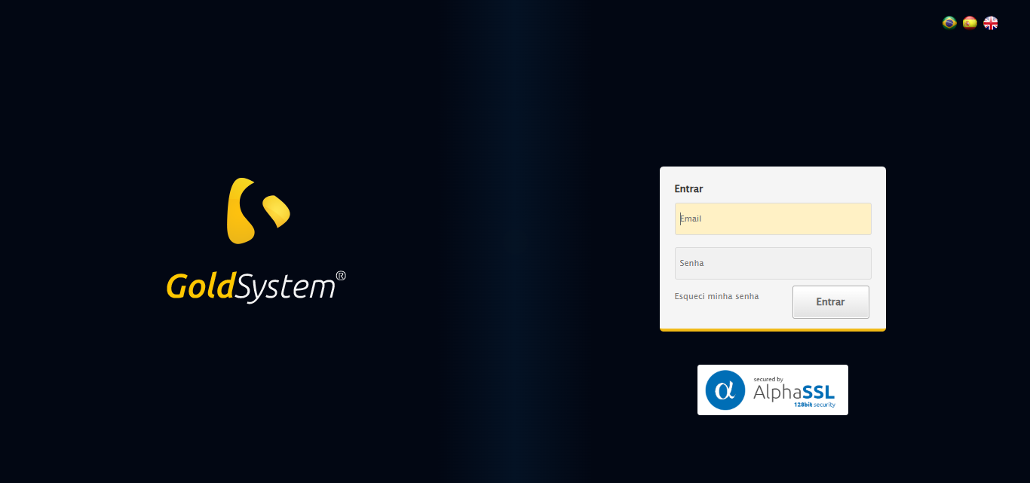

🔄 Realizando login...

✅ Realizando login realizada com sucesso.

Screenshot: realizando login

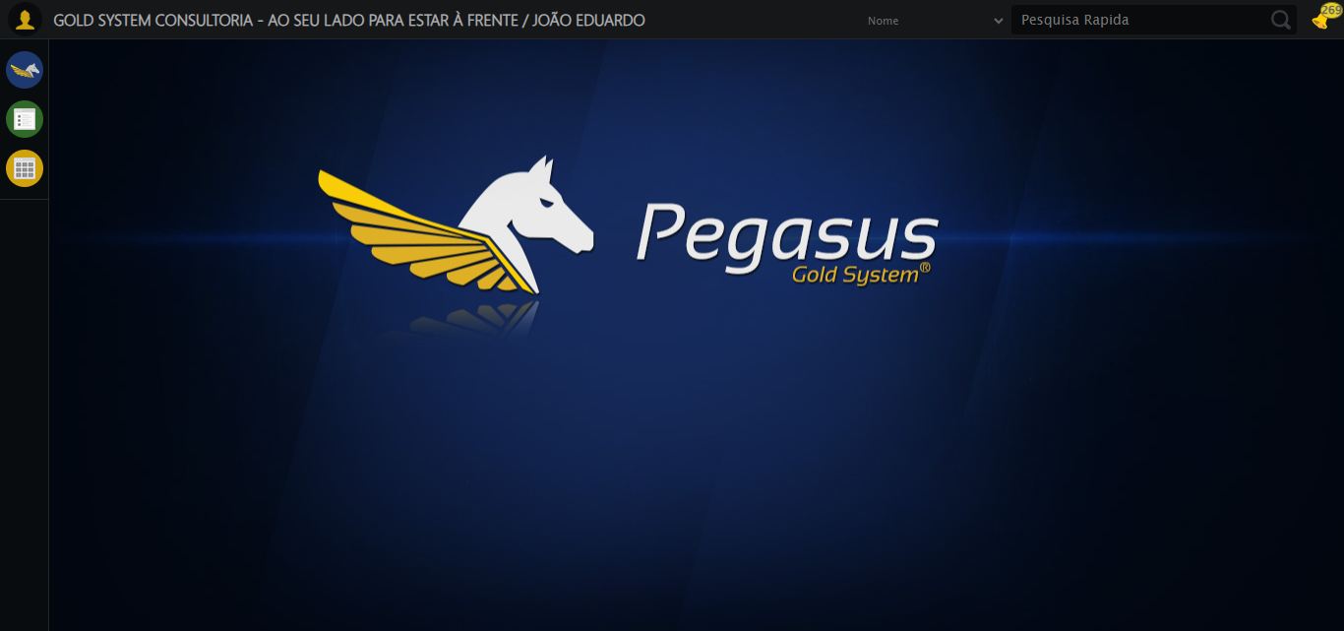

🔄 Ajustando zoom e abrindo menu...

🔍 Zoom ajustado para 90%.

✅ Ajustando zoom e abrindo menu realizada com sucesso.

Screenshot: ajustando zoom e abrindo menu

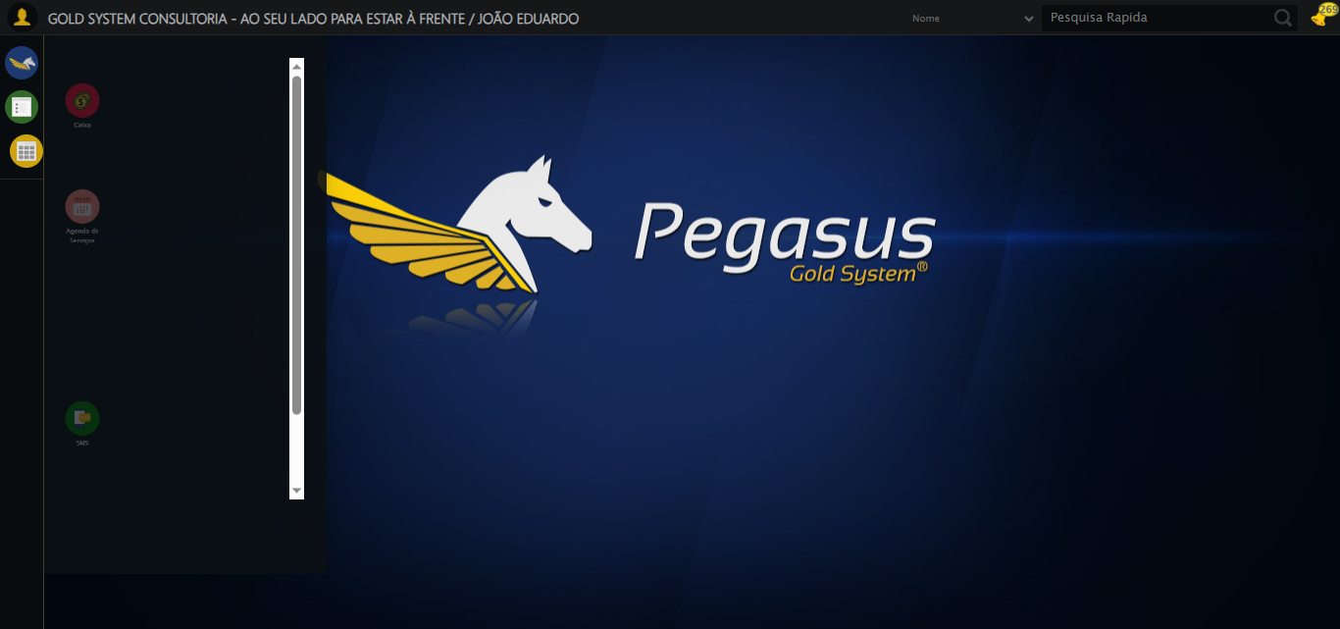

🔄 Acessando Gestor de Compras...

✅ Acessando Gestor de Compras realizada com sucesso.

Screenshot: acessando gestor de compras

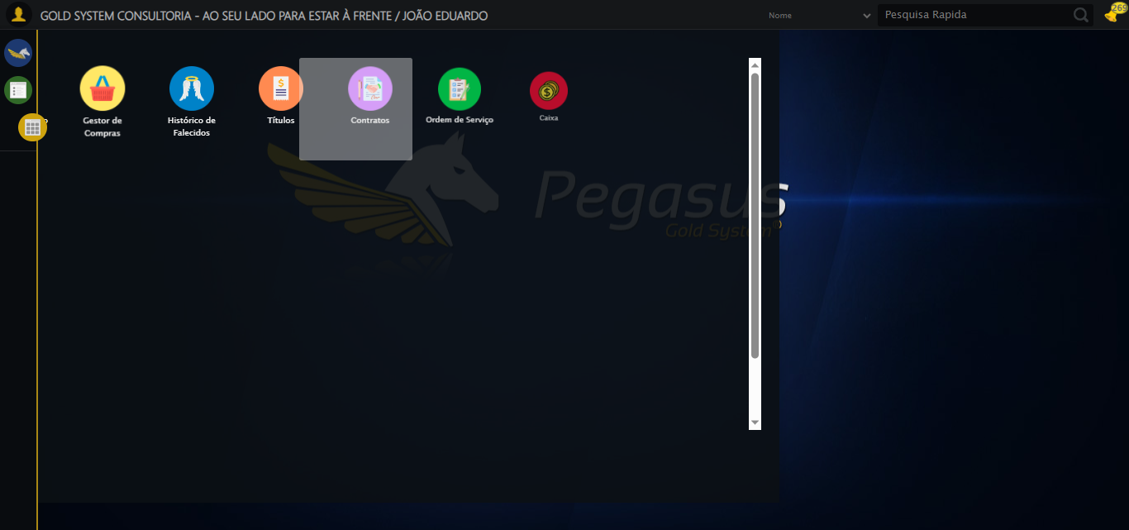

🔄 Clicando em Autorização de PIMS...

✅ Clicando em Autorização de PIMS realizada com sucesso.

Screenshot: clicando em autorização de pims

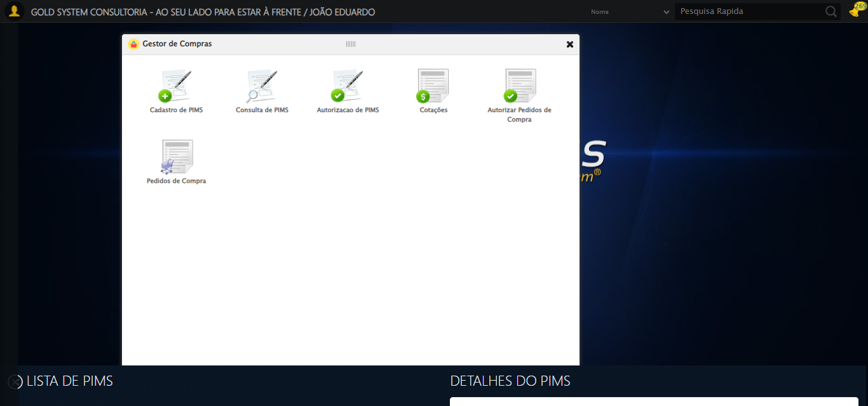

🔄 Preenchendo Data inicial...

✅ Preenchendo Data inicial realizada com sucesso.

Screenshot: preenchendo data inicial

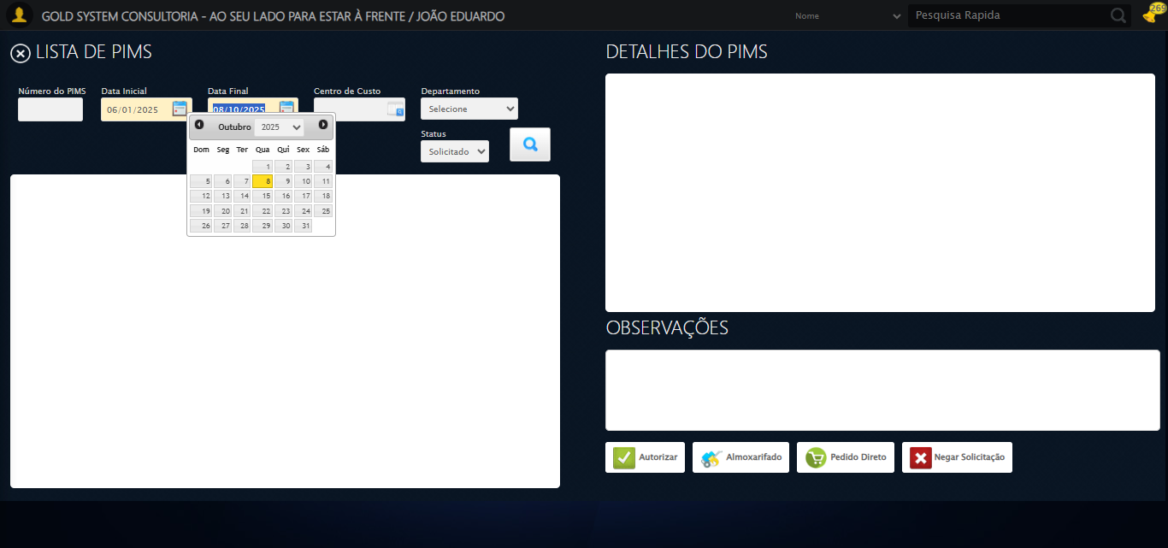

🔄 Selecionando Departamento...

✅ Selecionando Departamento realizada com sucesso.

Screenshot: selecionando departamento

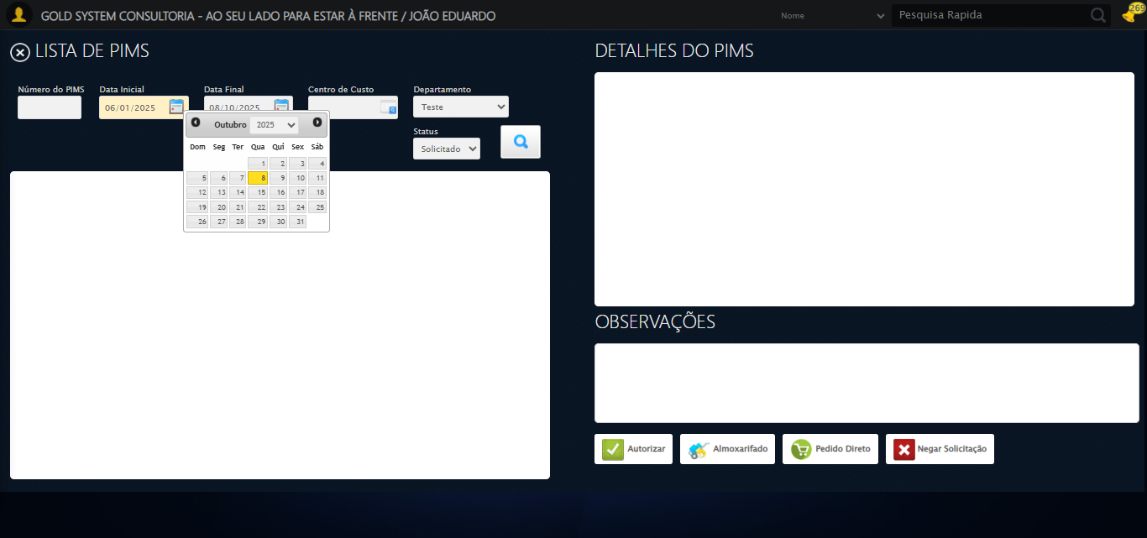

🔄 Selecionando Status...

✅ Selecionando Status realizada com sucesso.

Screenshot: selecionando status



🔄 Pesquisando......

✅ Pesquisando... realizada com sucesso.

Screenshot: pesquisando...

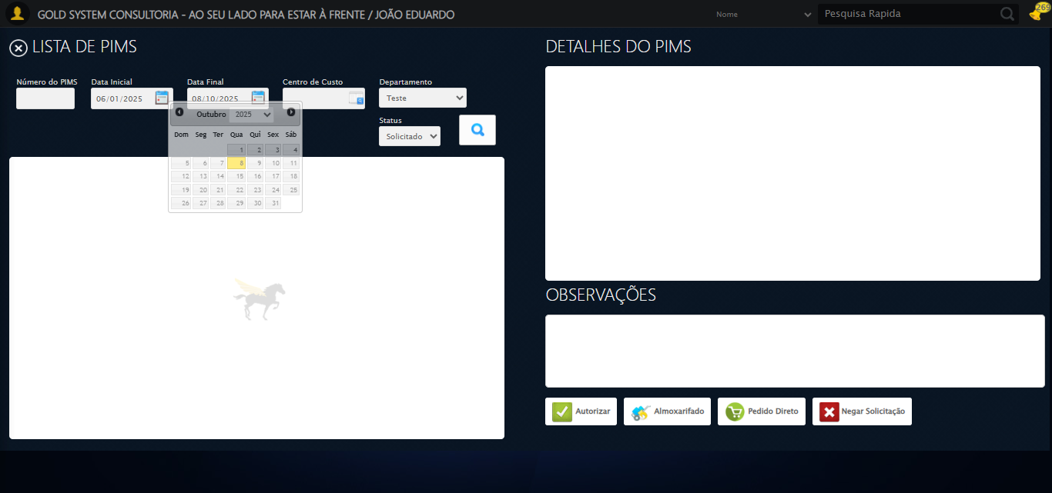

🔄 Selecionando PIMS...

✅ Selecionando PIMS realizada com sucesso.

Screenshot: selecionando pims

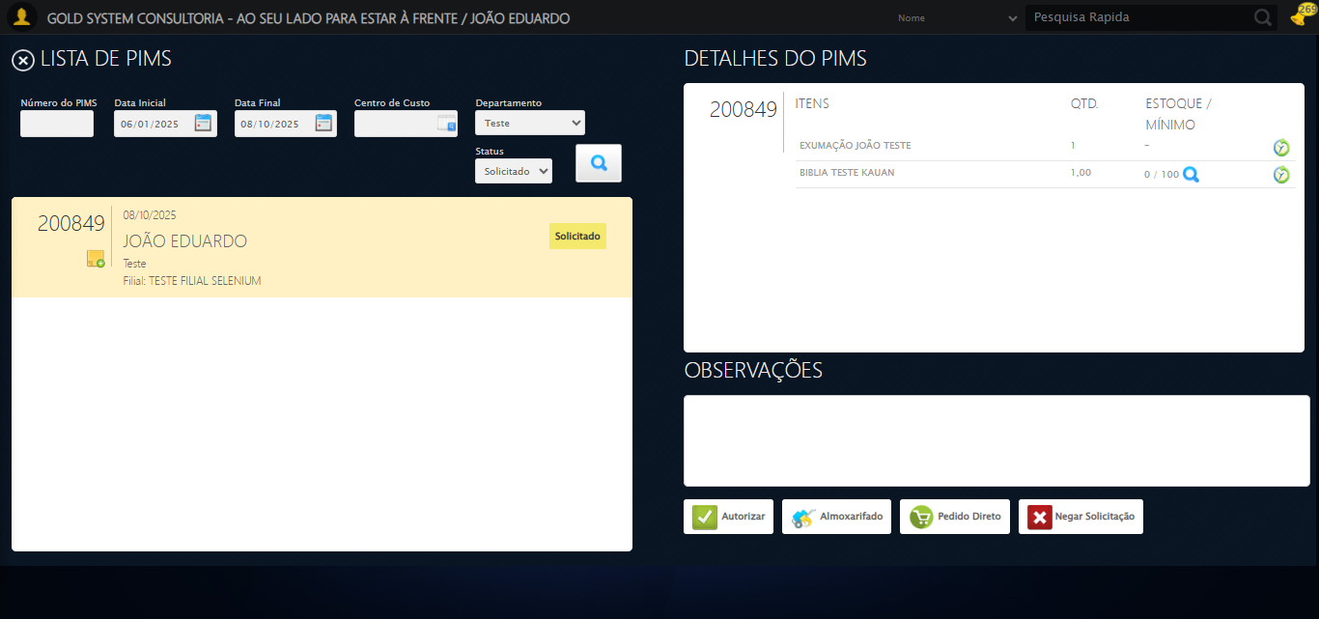

🔄 Selecionando itens para a Autorização de PIMS...

✅ Selecionando itens para a Autorização de PIMS realizada com sucesso.

Screenshot: selecionando itens para a autorização de pims

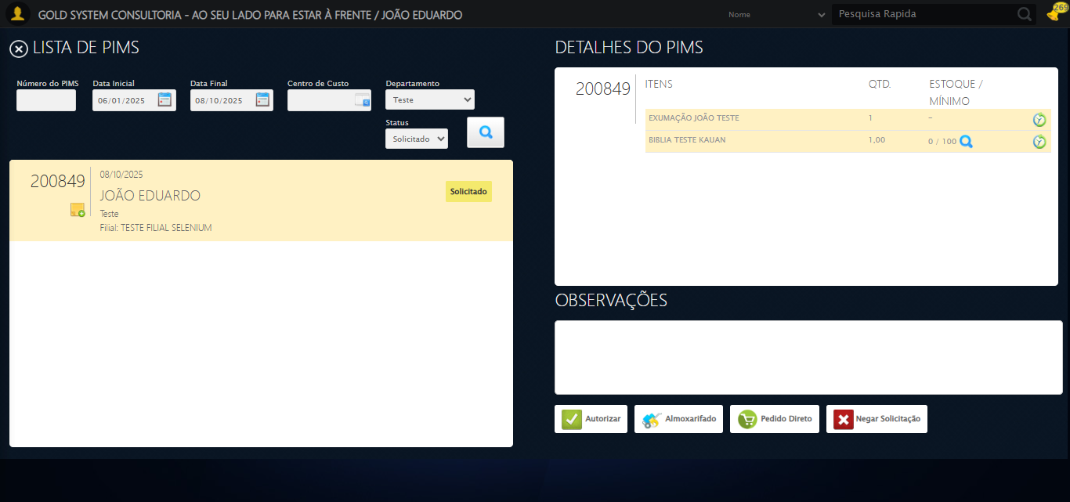

🎯 Tentativa 1: Preenchendo textarea 0 (ID: (sem id), name: (sem name)) com 129 caracteres

▶️ Estratégia 1…

✅ Preenchido com sucesso pela estratégia 1: 'TESTE OBSERVAÇÃO SELENIUM AUTOMATIZADO (Automação de Testes)…'

🔄 Preenchendo Observações...

❌ Erro inesperado ao preenchendo observações: 'bool' object is not callable

Screenshot: erro_preenchendo observações

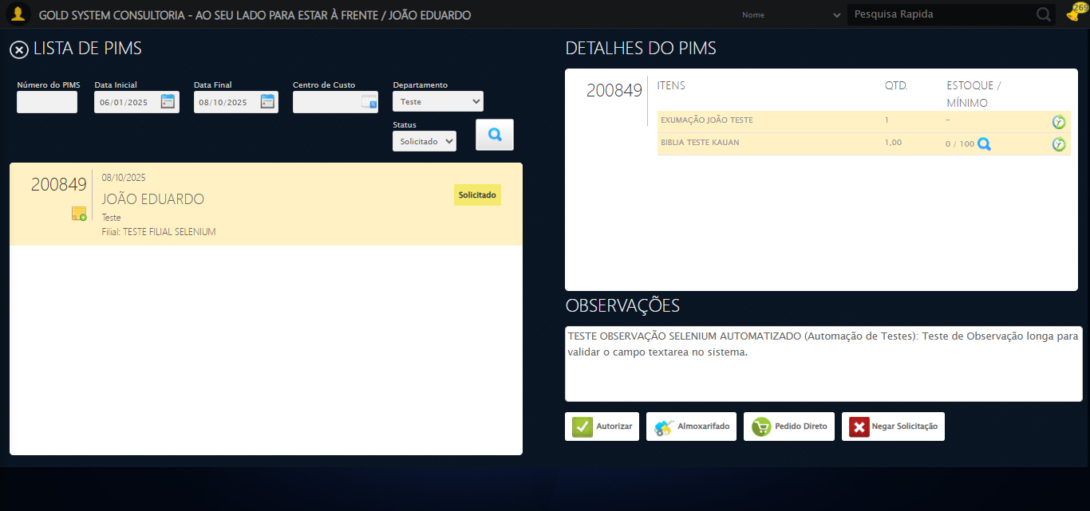

🔄 Clicando no botão Pedido Direto...

✅ Clicando no botão Pedido Direto realizada com sucesso.

Screenshot: clicando no botão pedido direto

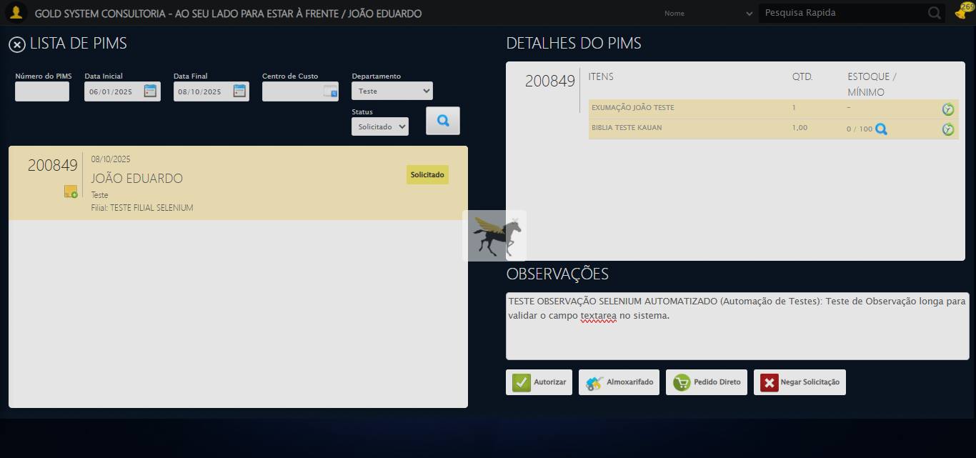

🔄 Selecionando Fornecedor...

⚠️ Tentativa 1/3 falhou: Message:   
Stacktrace:  
 GetHandleVerifier [0x0x46c333+65459]  
 GetHandleVerifier [0x0x46c374+65524]  
 (No symbol) [0x0x28d973]  
 (No symbol) [0x0x2d76e7]  
 (No symbol) [0x0x2d7a8b]  
 (No symbol) [0x0x31dea2]  
 (No symbol) [0x0x2f9e44]  
 (No symbol) [0x0x31b606]  
 (No symbol) [0x0x2f9bf6]  
 (No symbol) [0x0x2cb38e]  
 (No symbol) [0x0x2cc274]  
 GetHandleVerifier [0x0x6eeda3+2697763]  
 GetHandleVerifier [0x0x6e9ec7+2677575]  
 GetHandleVerifier [0x0x494194+228884]  
 GetHandleVerifier [0x0x4849f8+165496]  
 GetHandleVerifier [0x0x48b18d+192013]  
 GetHandleVerifier [0x0x4747d8+99416]  
 GetHandleVerifier [0x0x474972+99826]  
 GetHandleVerifier [0x0x45ebea+10346]  
 BaseThreadInitThunk [0x0x755bfcc9+25]  
 RtlGetAppContainerNamedObjectPath [0x0x773a82ae+286]  
 RtlGetAppContainerNamedObjectPath [0x0x773a827e+238]  
. Retentando…

⚠️ Tentativa 2/3 falhou: Message:   
Stacktrace:  
 GetHandleVerifier [0x0x46c333+65459]  
 GetHandleVerifier [0x0x46c374+65524]  
 (No symbol) [0x0x28d973]  
 (No symbol) [0x0x2d76e7]  
 (No symbol) [0x0x2d7a8b]  
 (No symbol) [0x0x31dea2]  
 (No symbol) [0x0x2f9e44]  
 (No symbol) [0x0x31b606]  
 (No symbol) [0x0x2f9bf6]  
 (No symbol) [0x0x2cb38e]  
 (No symbol) [0x0x2cc274]  
 GetHandleVerifier [0x0x6eeda3+2697763]  
 GetHandleVerifier [0x0x6e9ec7+2677575]  
 GetHandleVerifier [0x0x494194+228884]  
 GetHandleVerifier [0x0x4849f8+165496]  
 GetHandleVerifier [0x0x48b18d+192013]  
 GetHandleVerifier [0x0x4747d8+99416]  
 GetHandleVerifier [0x0x474972+99826]  
 GetHandleVerifier [0x0x45ebea+10346]  
 BaseThreadInitThunk [0x0x755bfcc9+25]  
 RtlGetAppContainerNamedObjectPath [0x0x773a82ae+286]  
 RtlGetAppContainerNamedObjectPath [0x0x773a827e+238]  
. Retentando…

⚠️ Tentativa 1 falhou para Selecionando Fornecedor, tentando novamente...

🔄 Selecionando Fornecedor... (Tentativa 2)

⚠️ Tentativa 1/3 falhou: Message:   
Stacktrace:  
 GetHandleVerifier [0x0x46c333+65459]  
 GetHandleVerifier [0x0x46c374+65524]  
 (No symbol) [0x0x28d973]  
 (No symbol) [0x0x2d76e7]  
 (No symbol) [0x0x2d7a8b]  
 (No symbol) [0x0x31dea2]  
 (No symbol) [0x0x2f9e44]  
 (No symbol) [0x0x31b606]  
 (No symbol) [0x0x2f9bf6]  
 (No symbol) [0x0x2cb38e]  
 (No symbol) [0x0x2cc274]  
 GetHandleVerifier [0x0x6eeda3+2697763]  
 GetHandleVerifier [0x0x6e9ec7+2677575]  
 GetHandleVerifier [0x0x494194+228884]  
 GetHandleVerifier [0x0x4849f8+165496]  
 GetHandleVerifier [0x0x48b18d+192013]  
 GetHandleVerifier [0x0x4747d8+99416]  
 GetHandleVerifier [0x0x474972+99826]  
 GetHandleVerifier [0x0x45ebea+10346]  
 BaseThreadInitThunk [0x0x755bfcc9+25]  
 RtlGetAppContainerNamedObjectPath [0x0x773a82ae+286]  
 RtlGetAppContainerNamedObjectPath [0x0x773a827e+238]  
. Retentando…

⚠️ Tentativa 2/3 falhou: Message:   
Stacktrace:  
 GetHandleVerifier [0x0x46c333+65459]  
 GetHandleVerifier [0x0x46c374+65524]  
 (No symbol) [0x0x28d973]  
 (No symbol) [0x0x2d76e7]  
 (No symbol) [0x0x2d7a8b]  
 (No symbol) [0x0x31dea2]  
 (No symbol) [0x0x2f9e44]  
 (No symbol) [0x0x31b606]  
 (No symbol) [0x0x2f9bf6]  
 (No symbol) [0x0x2cb38e]  
 (No symbol) [0x0x2cc274]  
 GetHandleVerifier [0x0x6eeda3+2697763]  
 GetHandleVerifier [0x0x6e9ec7+2677575]  
 GetHandleVerifier [0x0x494194+228884]  
 GetHandleVerifier [0x0x4849f8+165496]  
 GetHandleVerifier [0x0x48b18d+192013]  
 GetHandleVerifier [0x0x4747d8+99416]  
 GetHandleVerifier [0x0x474972+99826]  
 GetHandleVerifier [0x0x45ebea+10346]  
 BaseThreadInitThunk [0x0x755bfcc9+25]  
 RtlGetAppContainerNamedObjectPath [0x0x773a82ae+286]  
 RtlGetAppContainerNamedObjectPath [0x0x773a827e+238]  
. Retentando…

⚠️ Tentativa 2 falhou para Selecionando Fornecedor, tentando novamente...

🔄 Selecionando Fornecedor... (Tentativa 3)

⚠️ Tentativa 1/3 falhou: Message:   
Stacktrace:  
 GetHandleVerifier [0x0x46c333+65459]  
 GetHandleVerifier [0x0x46c374+65524]  
 (No symbol) [0x0x28d973]  
 (No symbol) [0x0x2d76e7]  
 (No symbol) [0x0x2d7a8b]  
 (No symbol) [0x0x31dea2]  
 (No symbol) [0x0x2f9e44]  
 (No symbol) [0x0x31b606]  
 (No symbol) [0x0x2f9bf6]  
 (No symbol) [0x0x2cb38e]  
 (No symbol) [0x0x2cc274]  
 GetHandleVerifier [0x0x6eeda3+2697763]  
 GetHandleVerifier [0x0x6e9ec7+2677575]  
 GetHandleVerifier [0x0x494194+228884]  
 GetHandleVerifier [0x0x4849f8+165496]  
 GetHandleVerifier [0x0x48b18d+192013]  
 GetHandleVerifier [0x0x4747d8+99416]  
 GetHandleVerifier [0x0x474972+99826]  
 GetHandleVerifier [0x0x45ebea+10346]  
 BaseThreadInitThunk [0x0x755bfcc9+25]  
 RtlGetAppContainerNamedObjectPath [0x0x773a82ae+286]  
 RtlGetAppContainerNamedObjectPath [0x0x773a827e+238]  
. Retentando…

⚠️ Tentativa 2/3 falhou: Message:   
Stacktrace:  
 GetHandleVerifier [0x0x46c333+65459]  
 GetHandleVerifier [0x0x46c374+65524]  
 (No symbol) [0x0x28d973]  
 (No symbol) [0x0x2d76e7]  
 (No symbol) [0x0x2d7a8b]  
 (No symbol) [0x0x31dea2]  
 (No symbol) [0x0x2f9e44]  
 (No symbol) [0x0x31b606]  
 (No symbol) [0x0x2f9bf6]  
 (No symbol) [0x0x2cb38e]  
 (No symbol) [0x0x2cc274]  
 GetHandleVerifier [0x0x6eeda3+2697763]  
 GetHandleVerifier [0x0x6e9ec7+2677575]  
 GetHandleVerifier [0x0x494194+228884]  
 GetHandleVerifier [0x0x4849f8+165496]  
 GetHandleVerifier [0x0x48b18d+192013]  
 GetHandleVerifier [0x0x4747d8+99416]  
 GetHandleVerifier [0x0x474972+99826]  
 GetHandleVerifier [0x0x45ebea+10346]  
 BaseThreadInitThunk [0x0x755bfcc9+25]  
 RtlGetAppContainerNamedObjectPath [0x0x773a82ae+286]  
 RtlGetAppContainerNamedObjectPath [0x0x773a827e+238]  
. Retentando…

❌ Erro ao selecionando fornecedor após 3 tentativas: Message:   
Stacktrace:  
 GetHandleVerifier [0x0x46c333+65459]  
 GetHandleVerifier [0x0x46c374+65524]  
 (No symbol) [0x0x28d973]  
 (No symbol) [0x0x2d76e7]  
 (No symbol) [0x0x2d7a8b]  
 (No symbol) [0x0x31dea2]  
 (No symbol) [0x0x2f9e44]  
 (No symbol) [0x0x31b606]  
 (No symbol) [0x0x2f9bf6]  
 (No symbol) [0x0x2cb38e]  
 (No symbol) [0x0x2cc274]  
 GetHandleVerifier [0x0x6eeda3+2697763]  
 GetHandleVerifier [0x0x6e9ec7+2677575]  
 GetHandleVerifier [0x0x494194+228884]  
 GetHandleVerifier [0x0x4849f8+165496]  
 GetHandleVerifier [0x0x48b18d+192013]  
 GetHandleVerifier [0x0x4747d8+99416]  
 GetHandleVerifier [0x0x474972+99826]  
 GetHandleVerifier [0x0x45ebea+10346]  
 BaseThreadInitThunk [0x0x755bfcc9+25]  
 RtlGetAppContainerNamedObjectPath [0x0x773a82ae+286]  
 RtlGetAppContainerNamedObjectPath [0x0x773a827e+238]

Screenshot: erro_selecionando fornecedor

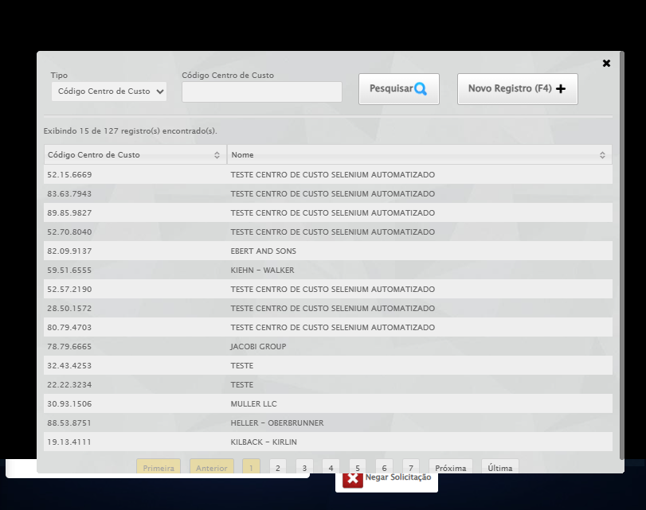

🔍 Verificando mensagens de alerta...

ℹ️ Nenhuma mensagem de alerta encontrada.

🔄 Preenchendo Contato do Fornecedor...

⚠️ Tentativa 1 falhou: Message: element click intercepted: Element <input class="contato" maxlength="30" style="width: 105px;" type="text"> is not clickable at point (363, 254). Other element would receive the click: <a class="linkAlterar" style="height: 25.8889px;"></a>  
 (Session info: chrome=140.0.7339.208); For documentation on this error, please visit: https://www.selenium.dev/documentation/webdriver/troubleshooting/errors#elementclickinterceptedexception  
Stacktrace:  
 GetHandleVerifier [0x0x46c333+65459]  
 GetHandleVerifier [0x0x46c374+65524]  
 (No symbol) [0x0x28d973]  
 (No symbol) [0x0x2ddbc0]  
 (No symbol) [0x0x2dbf23]  
 (No symbol) [0x0x2d99c7]  
 (No symbol) [0x0x2d8c66]  
 (No symbol) [0x0x2cd195]  
 (No symbol) [0x0x2f9dfc]  
 (No symbol) [0x0x2ccbf4]  
 (No symbol) [0x0x2f9fb4]  
 (No symbol) [0x0x31b606]  
 (No symbol) [0x0x2f9bf6]  
 (No symbol) [0x0x2cb38e]  
 (No symbol) [0x0x2cc274]  
 GetHandleVerifier [0x0x6eeda3+2697763]  
 GetHandleVerifier [0x0x6e9ec7+2677575]  
 GetHandleVerifier [0x0x494194+228884]  
 GetHandleVerifier [0x0x4849f8+165496]  
 GetHandleVerifier [0x0x48b18d+192013]  
 GetHandleVerifier [0x0x4747d8+99416]  
 GetHandleVerifier [0x0x474972+99826]  
 GetHandleVerifier [0x0x45ebea+10346]  
 BaseThreadInitThunk [0x0x755bfcc9+25]  
 RtlGetAppContainerNamedObjectPath [0x0x773a82ae+286]  
 RtlGetAppContainerNamedObjectPath [0x0x773a827e+238]

✅ Preenchendo Contato do Fornecedor realizada com sucesso.

Screenshot: preenchendo contato do fornecedor

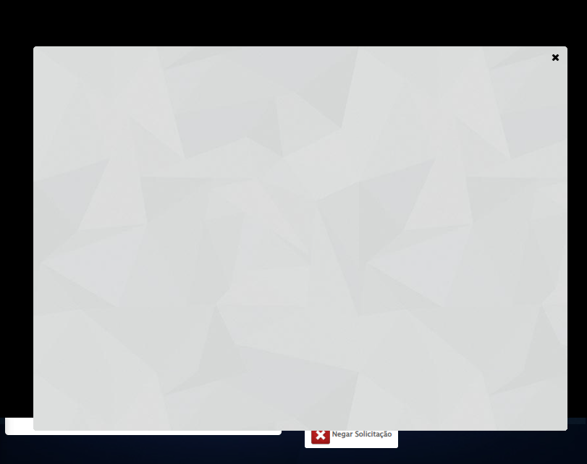

🔄 Preenchendo Telefone do Fornecedor...

⚠️ Tentativa 1 falhou: Message: element click intercepted: Element <input class="telefone" maxlength="13" type="text" style="width:80px"> is not clickable at point (477, 254). Other element would receive the click: <div class="modal overflow" style="z-index: 10018; left: 50%; top: 50%; width: 800px; height: 570px; margin-left: -400px; margin-top: -285px;">...</div>  
 (Session info: chrome=140.0.7339.208); For documentation on this error, please visit: https://www.selenium.dev/documentation/webdriver/troubleshooting/errors#elementclickinterceptedexception  
Stacktrace:  
 GetHandleVerifier [0x0x46c333+65459]  
 GetHandleVerifier [0x0x46c374+65524]  
 (No symbol) [0x0x28d973]  
 (No symbol) [0x0x2ddbc0]  
 (No symbol) [0x0x2dbf23]  
 (No symbol) [0x0x2d99c7]  
 (No symbol) [0x0x2d8c66]  
 (No symbol) [0x0x2cd195]  
 (No symbol) [0x0x2f9dfc]  
 (No symbol) [0x0x2ccbf4]  
 (No symbol) [0x0x2f9fb4]  
 (No symbol) [0x0x31b606]  
 (No symbol) [0x0x2f9bf6]  
 (No symbol) [0x0x2cb38e]  
 (No symbol) [0x0x2cc274]  
 GetHandleVerifier [0x0x6eeda3+2697763]  
 GetHandleVerifier [0x0x6e9ec7+2677575]  
 GetHandleVerifier [0x0x494194+228884]  
 GetHandleVerifier [0x0x4849f8+165496]  
 GetHandleVerifier [0x0x48b18d+192013]  
 GetHandleVerifier [0x0x4747d8+99416]  
 GetHandleVerifier [0x0x474972+99826]  
 GetHandleVerifier [0x0x45ebea+10346]  
 BaseThreadInitThunk [0x0x755bfcc9+25]  
 RtlGetAppContainerNamedObjectPath [0x0x773a82ae+286]  
 RtlGetAppContainerNamedObjectPath [0x0x773a827e+238]

⚠️ Tentativa 2 falhou: Message: no such window: target window already closed  
from unknown error: web view not found  
 (Session info: chrome=140.0.7339.208)  
Stacktrace:  
 GetHandleVerifier [0x0x46c333+65459]  
 GetHandleVerifier [0x0x46c374+65524]  
 (No symbol) [0x0x28d973]  
 (No symbol) [0x0x26c19d]  
 (No symbol) [0x0x30059e]  
 (No symbol) [0x0x31aef9]  
 (No symbol) [0x0x2f9bf6]  
 (No symbol) [0x0x2cb38e]  
 (No symbol) [0x0x2cc274]  
 GetHandleVerifier [0x0x6eeda3+2697763]  
 GetHandleVerifier [0x0x6e9ec7+2677575]  
 GetHandleVerifier [0x0x494194+228884]  
 GetHandleVerifier [0x0x4849f8+165496]  
 GetHandleVerifier [0x0x48b18d+192013]  
 GetHandleVerifier [0x0x4747d8+99416]  
 GetHandleVerifier [0x0x474972+99826]  
 GetHandleVerifier [0x0x45ebea+10346]  
 BaseThreadInitThunk [0x0x755bfcc9+25]  
 RtlGetAppContainerNamedObjectPath [0x0x773a82ae+286]  
 RtlGetAppContainerNamedObjectPath [0x0x773a827e+238]

⚠️ Tentativa 3 falhou: Message: no such window: target window already closed  
from unknown error: web view not found  
 (Session info: chrome=140.0.7339.208)  
Stacktrace:  
 GetHandleVerifier [0x0x46c333+65459]  
 GetHandleVerifier [0x0x46c374+65524]  
 (No symbol) [0x0x28d973]  
 (No symbol) [0x0x26c19d]  
 (No symbol) [0x0x30059e]  
 (No symbol) [0x0x31aef9]  
 (No symbol) [0x0x2f9bf6]  
 (No symbol) [0x0x2cb38e]  
 (No symbol) [0x0x2cc274]  
 GetHandleVerifier [0x0x6eeda3+2697763]  
 GetHandleVerifier [0x0x6e9ec7+2677575]  
 GetHandleVerifier [0x0x494194+228884]  
 GetHandleVerifier [0x0x4849f8+165496]  
 GetHandleVerifier [0x0x48b18d+192013]  
 GetHandleVerifier [0x0x4747d8+99416]  
 GetHandleVerifier [0x0x474972+99826]  
 GetHandleVerifier [0x0x45ebea+10346]  
 BaseThreadInitThunk [0x0x755bfcc9+25]  
 RtlGetAppContainerNamedObjectPath [0x0x773a82ae+286]  
 RtlGetAppContainerNamedObjectPath [0x0x773a827e+238]

✅ Preenchendo Telefone do Fornecedor realizada com sucesso.

⚠️ Erro ao tirar screenshot preenchendo telefone do fornecedor: Message: no such window: target window already closed  
from unknown error: web view not found  
 (Session info: chrome=140.0.7339.208)  
Stacktrace:  
 GetHandleVerifier [0x0x46c333+65459]  
 GetHandleVerifier [0x0x46c374+65524]  
 (No symbol) [0x0x28d973]  
 (No symbol) [0x0x26c19d]  
 (No symbol) [0x0x30059e]  
 (No symbol) [0x0x31aef9]  
 (No symbol) [0x0x2f9bf6]  
 (No symbol) [0x0x2cb38e]  
 (No symbol) [0x0x2cc274]  
 GetHandleVerifier [0x0x6eeda3+2697763]  
 GetHandleVerifier [0x0x6e9ec7+2677575]  
 GetHandleVerifier [0x0x494194+228884]  
 GetHandleVerifier [0x0x4849f8+165496]  
 GetHandleVerifier [0x0x48b18d+192013]  
 GetHandleVerifier [0x0x4747d8+99416]  
 GetHandleVerifier [0x0x474972+99826]  
 GetHandleVerifier [0x0x45ebea+10346]  
 BaseThreadInitThunk [0x0x755bfcc9+25]  
 RtlGetAppContainerNamedObjectPath [0x0x773a82ae+286]  
 RtlGetAppContainerNamedObjectPath [0x0x773a827e+238]

🔄 Preenchendo E-mail do Fornecedor...

⚠️ Tentativa 1 falhou: Message: no such window: target window already closed  
from unknown error: web view not found  
 (Session info: chrome=140.0.7339.208)  
Stacktrace:  
 GetHandleVerifier [0x0x46c333+65459]  
 GetHandleVerifier [0x0x46c374+65524]  
 (No symbol) [0x0x28d973]  
 (No symbol) [0x0x26c19d]  
 (No symbol) [0x0x30059e]  
 (No symbol) [0x0x31aef9]  
 (No symbol) [0x0x2f9bf6]  
 (No symbol) [0x0x2cb38e]  
 (No symbol) [0x0x2cc274]  
 GetHandleVerifier [0x0x6eeda3+2697763]  
 GetHandleVerifier [0x0x6e9ec7+2677575]  
 GetHandleVerifier [0x0x494194+228884]  
 GetHandleVerifier [0x0x4849f8+165496]  
 GetHandleVerifier [0x0x48b18d+192013]  
 GetHandleVerifier [0x0x4747d8+99416]  
 GetHandleVerifier [0x0x474972+99826]  
 GetHandleVerifier [0x0x45ebea+10346]  
 BaseThreadInitThunk [0x0x755bfcc9+25]  
 RtlGetAppContainerNamedObjectPath [0x0x773a82ae+286]  
 RtlGetAppContainerNamedObjectPath [0x0x773a827e+238]

⚠️ Tentativa 2 falhou: Message: no such window: target window already closed  
from unknown error: web view not found  
 (Session info: chrome=140.0.7339.208)  
Stacktrace:  
 GetHandleVerifier [0x0x46c333+65459]  
 GetHandleVerifier [0x0x46c374+65524]  
 (No symbol) [0x0x28d973]  
 (No symbol) [0x0x26c19d]  
 (No symbol) [0x0x30059e]  
 (No symbol) [0x0x31aef9]  
 (No symbol) [0x0x2f9bf6]  
 (No symbol) [0x0x2cb38e]  
 (No symbol) [0x0x2cc274]  
 GetHandleVerifier [0x0x6eeda3+2697763]  
 GetHandleVerifier [0x0x6e9ec7+2677575]  
 GetHandleVerifier [0x0x494194+228884]  
 GetHandleVerifier [0x0x4849f8+165496]  
 GetHandleVerifier [0x0x48b18d+192013]  
 GetHandleVerifier [0x0x4747d8+99416]  
 GetHandleVerifier [0x0x474972+99826]  
 GetHandleVerifier [0x0x45ebea+10346]  
 BaseThreadInitThunk [0x0x755bfcc9+25]  
 RtlGetAppContainerNamedObjectPath [0x0x773a82ae+286]  
 RtlGetAppContainerNamedObjectPath [0x0x773a827e+238]

⚠️ Tentativa 3 falhou: Message: no such window: target window already closed  
from unknown error: web view not found  
 (Session info: chrome=140.0.7339.208)  
Stacktrace:  
 GetHandleVerifier [0x0x46c333+65459]  
 GetHandleVerifier [0x0x46c374+65524]  
 (No symbol) [0x0x28d973]  
 (No symbol) [0x0x26c19d]  
 (No symbol) [0x0x30059e]  
 (No symbol) [0x0x31aef9]  
 (No symbol) [0x0x2f9bf6]  
 (No symbol) [0x0x2cb38e]  
 (No symbol) [0x0x2cc274]  
 GetHandleVerifier [0x0x6eeda3+2697763]  
 GetHandleVerifier [0x0x6e9ec7+2677575]  
 GetHandleVerifier [0x0x494194+228884]  
 GetHandleVerifier [0x0x4849f8+165496]  
 GetHandleVerifier [0x0x48b18d+192013]  
 GetHandleVerifier [0x0x4747d8+99416]  
 GetHandleVerifier [0x0x474972+99826]  
 GetHandleVerifier [0x0x45ebea+10346]  
 BaseThreadInitThunk [0x0x755bfcc9+25]  
 RtlGetAppContainerNamedObjectPath [0x0x773a82ae+286]  
 RtlGetAppContainerNamedObjectPath [0x0x773a827e+238]

✅ Preenchendo E-mail do Fornecedor realizada com sucesso.

⚠️ Erro ao tirar screenshot preenchendo e-mail do fornecedor: Message: no such window: target window already closed  
from unknown error: web view not found  
 (Session info: chrome=140.0.7339.208)  
Stacktrace:  
 GetHandleVerifier [0x0x46c333+65459]  
 GetHandleVerifier [0x0x46c374+65524]  
 (No symbol) [0x0x28d973]  
 (No symbol) [0x0x26c19d]  
 (No symbol) [0x0x30059e]  
 (No symbol) [0x0x31aef9]  
 (No symbol) [0x0x2f9bf6]  
 (No symbol) [0x0x2cb38e]  
 (No symbol) [0x0x2cc274]  
 GetHandleVerifier [0x0x6eeda3+2697763]  
 GetHandleVerifier [0x0x6e9ec7+2677575]  
 GetHandleVerifier [0x0x494194+228884]  
 GetHandleVerifier [0x0x4849f8+165496]  
 GetHandleVerifier [0x0x48b18d+192013]  
 GetHandleVerifier [0x0x4747d8+99416]  
 GetHandleVerifier [0x0x474972+99826]  
 GetHandleVerifier [0x0x45ebea+10346]  
 BaseThreadInitThunk [0x0x755bfcc9+25]  
 RtlGetAppContainerNamedObjectPath [0x0x773a82ae+286]  
 RtlGetAppContainerNamedObjectPath [0x0x773a827e+238]

🔄 Preenchendo Valor do frete...

⚠️ Tentativa 1 falhou: Message: no such window: target window already closed  
from unknown error: web view not found  
 (Session info: chrome=140.0.7339.208)  
Stacktrace:  
 GetHandleVerifier [0x0x46c333+65459]  
 GetHandleVerifier [0x0x46c374+65524]  
 (No symbol) [0x0x28d973]  
 (No symbol) [0x0x26c19d]  
 (No symbol) [0x0x30059e]  
 (No symbol) [0x0x31aef9]  
 (No symbol) [0x0x2f9bf6]  
 (No symbol) [0x0x2cb38e]  
 (No symbol) [0x0x2cc274]  
 GetHandleVerifier [0x0x6eeda3+2697763]  
 GetHandleVerifier [0x0x6e9ec7+2677575]  
 GetHandleVerifier [0x0x494194+228884]  
 GetHandleVerifier [0x0x4849f8+165496]  
 GetHandleVerifier [0x0x48b18d+192013]  
 GetHandleVerifier [0x0x4747d8+99416]  
 GetHandleVerifier [0x0x474972+99826]  
 GetHandleVerifier [0x0x45ebea+10346]  
 BaseThreadInitThunk [0x0x755bfcc9+25]  
 RtlGetAppContainerNamedObjectPath [0x0x773a82ae+286]  
 RtlGetAppContainerNamedObjectPath [0x0x773a827e+238]

⚠️ Tentativa 2 falhou: Message: no such window: target window already closed  
from unknown error: web view not found  
 (Session info: chrome=140.0.7339.208)  
Stacktrace:  
 GetHandleVerifier [0x0x46c333+65459]  
 GetHandleVerifier [0x0x46c374+65524]  
 (No symbol) [0x0x28d973]  
 (No symbol) [0x0x26c19d]  
 (No symbol) [0x0x30059e]  
 (No symbol) [0x0x31aef9]  
 (No symbol) [0x0x2f9bf6]  
 (No symbol) [0x0x2cb38e]  
 (No symbol) [0x0x2cc274]  
 GetHandleVerifier [0x0x6eeda3+2697763]  
 GetHandleVerifier [0x0x6e9ec7+2677575]  
 GetHandleVerifier [0x0x494194+228884]  
 GetHandleVerifier [0x0x4849f8+165496]  
 GetHandleVerifier [0x0x48b18d+192013]  
 GetHandleVerifier [0x0x4747d8+99416]  
 GetHandleVerifier [0x0x474972+99826]  
 GetHandleVerifier [0x0x45ebea+10346]  
 BaseThreadInitThunk [0x0x755bfcc9+25]  
 RtlGetAppContainerNamedObjectPath [0x0x773a82ae+286]  
 RtlGetAppContainerNamedObjectPath [0x0x773a827e+238]

⚠️ Tentativa 3 falhou: Message: no such window: target window already closed  
from unknown error: web view not found  
 (Session info: chrome=140.0.7339.208)  
Stacktrace:  
 GetHandleVerifier [0x0x46c333+65459]  
 GetHandleVerifier [0x0x46c374+65524]  
 (No symbol) [0x0x28d973]  
 (No symbol) [0x0x26c19d]  
 (No symbol) [0x0x30059e]  
 (No symbol) [0x0x31aef9]  
 (No symbol) [0x0x2f9bf6]  
 (No symbol) [0x0x2cb38e]  
 (No symbol) [0x0x2cc274]  
 GetHandleVerifier [0x0x6eeda3+2697763]  
 GetHandleVerifier [0x0x6e9ec7+2677575]  
 GetHandleVerifier [0x0x494194+228884]  
 GetHandleVerifier [0x0x4849f8+165496]  
 GetHandleVerifier [0x0x48b18d+192013]  
 GetHandleVerifier [0x0x4747d8+99416]  
 GetHandleVerifier [0x0x474972+99826]  
 GetHandleVerifier [0x0x45ebea+10346]  
 BaseThreadInitThunk [0x0x755bfcc9+25]  
 RtlGetAppContainerNamedObjectPath [0x0x773a82ae+286]  
 RtlGetAppContainerNamedObjectPath [0x0x773a827e+238]

✅ Preenchendo Valor do frete realizada com sucesso.

⚠️ Erro ao tirar screenshot preenchendo valor do frete: Message: no such window: target window already closed  
from unknown error: web view not found  
 (Session info: chrome=140.0.7339.208)  
Stacktrace:  
 GetHandleVerifier [0x0x46c333+65459]  
 GetHandleVerifier [0x0x46c374+65524]  
 (No symbol) [0x0x28d973]  
 (No symbol) [0x0x26c19d]  
 (No symbol) [0x0x30059e]  
 (No symbol) [0x0x31aef9]  
 (No symbol) [0x0x2f9bf6]  
 (No symbol) [0x0x2cb38e]  
 (No symbol) [0x0x2cc274]  
 GetHandleVerifier [0x0x6eeda3+2697763]  
 GetHandleVerifier [0x0x6e9ec7+2677575]  
 GetHandleVerifier [0x0x494194+228884]  
 GetHandleVerifier [0x0x4849f8+165496]  
 GetHandleVerifier [0x0x48b18d+192013]  
 GetHandleVerifier [0x0x4747d8+99416]  
 GetHandleVerifier [0x0x474972+99826]  
 GetHandleVerifier [0x0x45ebea+10346]  
 BaseThreadInitThunk [0x0x755bfcc9+25]  
 RtlGetAppContainerNamedObjectPath [0x0x773a82ae+286]  
 RtlGetAppContainerNamedObjectPath [0x0x773a827e+238]

🔄 Preenchendo Condição de Pagamento...

⚠️ Tentativa 1 falhou: Message: no such window: target window already closed  
from unknown error: web view not found  
 (Session info: chrome=140.0.7339.208)  
Stacktrace:  
 GetHandleVerifier [0x0x46c333+65459]  
 GetHandleVerifier [0x0x46c374+65524]  
 (No symbol) [0x0x28d973]  
 (No symbol) [0x0x26c19d]  
 (No symbol) [0x0x30059e]  
 (No symbol) [0x0x31aef9]  
 (No symbol) [0x0x2f9bf6]  
 (No symbol) [0x0x2cb38e]  
 (No symbol) [0x0x2cc274]  
 GetHandleVerifier [0x0x6eeda3+2697763]  
 GetHandleVerifier [0x0x6e9ec7+2677575]  
 GetHandleVerifier [0x0x494194+228884]  
 GetHandleVerifier [0x0x4849f8+165496]  
 GetHandleVerifier [0x0x48b18d+192013]  
 GetHandleVerifier [0x0x4747d8+99416]  
 GetHandleVerifier [0x0x474972+99826]  
 GetHandleVerifier [0x0x45ebea+10346]  
 BaseThreadInitThunk [0x0x755bfcc9+25]  
 RtlGetAppContainerNamedObjectPath [0x0x773a82ae+286]  
 RtlGetAppContainerNamedObjectPath [0x0x773a827e+238]

⚠️ Tentativa 2 falhou: Message: no such window: target window already closed  
from unknown error: web view not found  
 (Session info: chrome=140.0.7339.208)  
Stacktrace:  
 GetHandleVerifier [0x0x46c333+65459]  
 GetHandleVerifier [0x0x46c374+65524]  
 (No symbol) [0x0x28d973]  
 (No symbol) [0x0x26c19d]  
 (No symbol) [0x0x30059e]  
 (No symbol) [0x0x31aef9]  
 (No symbol) [0x0x2f9bf6]  
 (No symbol) [0x0x2cb38e]  
 (No symbol) [0x0x2cc274]  
 GetHandleVerifier [0x0x6eeda3+2697763]  
 GetHandleVerifier [0x0x6e9ec7+2677575]  
 GetHandleVerifier [0x0x494194+228884]  
 GetHandleVerifier [0x0x4849f8+165496]  
 GetHandleVerifier [0x0x48b18d+192013]  
 GetHandleVerifier [0x0x4747d8+99416]  
 GetHandleVerifier [0x0x474972+99826]  
 GetHandleVerifier [0x0x45ebea+10346]  
 BaseThreadInitThunk [0x0x755bfcc9+25]  
 RtlGetAppContainerNamedObjectPath [0x0x773a82ae+286]  
 RtlGetAppContainerNamedObjectPath [0x0x773a827e+238]

⚠️ Tentativa 3 falhou: Message: no such window: target window already closed  
from unknown error: web view not found  
 (Session info: chrome=140.0.7339.208)  
Stacktrace:  
 GetHandleVerifier [0x0x46c333+65459]  
 GetHandleVerifier [0x0x46c374+65524]  
 (No symbol) [0x0x28d973]  
 (No symbol) [0x0x26c19d]  
 (No symbol) [0x0x30059e]  
 (No symbol) [0x0x31aef9]  
 (No symbol) [0x0x2f9bf6]  
 (No symbol) [0x0x2cb38e]  
 (No symbol) [0x0x2cc274]  
 GetHandleVerifier [0x0x6eeda3+2697763]  
 GetHandleVerifier [0x0x6e9ec7+2677575]  
 GetHandleVerifier [0x0x494194+228884]  
 GetHandleVerifier [0x0x4849f8+165496]  
 GetHandleVerifier [0x0x48b18d+192013]  
 GetHandleVerifier [0x0x4747d8+99416]  
 GetHandleVerifier [0x0x474972+99826]  
 GetHandleVerifier [0x0x45ebea+10346]  
 BaseThreadInitThunk [0x0x755bfcc9+25]  
 RtlGetAppContainerNamedObjectPath [0x0x773a82ae+286]  
 RtlGetAppContainerNamedObjectPath [0x0x773a827e+238]

✅ Preenchendo Condição de Pagamento realizada com sucesso.

⚠️ Erro ao tirar screenshot preenchendo condição de pagamento: Message: no such window: target window already closed  
from unknown error: web view not found  
 (Session info: chrome=140.0.7339.208)  
Stacktrace:  
 GetHandleVerifier [0x0x46c333+65459]  
 GetHandleVerifier [0x0x46c374+65524]  
 (No symbol) [0x0x28d973]  
 (No symbol) [0x0x26c19d]  
 (No symbol) [0x0x30059e]  
 (No symbol) [0x0x31aef9]  
 (No symbol) [0x0x2f9bf6]  
 (No symbol) [0x0x2cb38e]  
 (No symbol) [0x0x2cc274]  
 GetHandleVerifier [0x0x6eeda3+2697763]  
 GetHandleVerifier [0x0x6e9ec7+2677575]  
 GetHandleVerifier [0x0x494194+228884]  
 GetHandleVerifier [0x0x4849f8+165496]  
 GetHandleVerifier [0x0x48b18d+192013]  
 GetHandleVerifier [0x0x4747d8+99416]  
 GetHandleVerifier [0x0x474972+99826]  
 GetHandleVerifier [0x0x45ebea+10346]  
 BaseThreadInitThunk [0x0x755bfcc9+25]  
 RtlGetAppContainerNamedObjectPath [0x0x773a82ae+286]  
 RtlGetAppContainerNamedObjectPath [0x0x773a827e+238]

🔄 Preenchendo Forma de Pagamento...

⚠️ Tentativa 1 falhou: Message: no such window: target window already closed  
from unknown error: web view not found  
 (Session info: chrome=140.0.7339.208)  
Stacktrace:  
 GetHandleVerifier [0x0x46c333+65459]  
 GetHandleVerifier [0x0x46c374+65524]  
 (No symbol) [0x0x28d973]  
 (No symbol) [0x0x26c19d]  
 (No symbol) [0x0x30059e]  
 (No symbol) [0x0x31aef9]  
 (No symbol) [0x0x2f9bf6]  
 (No symbol) [0x0x2cb38e]  
 (No symbol) [0x0x2cc274]  
 GetHandleVerifier [0x0x6eeda3+2697763]  
 GetHandleVerifier [0x0x6e9ec7+2677575]  
 GetHandleVerifier [0x0x494194+228884]  
 GetHandleVerifier [0x0x4849f8+165496]  
 GetHandleVerifier [0x0x48b18d+192013]  
 GetHandleVerifier [0x0x4747d8+99416]  
 GetHandleVerifier [0x0x474972+99826]  
 GetHandleVerifier [0x0x45ebea+10346]  
 BaseThreadInitThunk [0x0x755bfcc9+25]  
 RtlGetAppContainerNamedObjectPath [0x0x773a82ae+286]  
 RtlGetAppContainerNamedObjectPath [0x0x773a827e+238]

⚠️ Tentativa 2 falhou: Message: no such window: target window already closed  
from unknown error: web view not found  
 (Session info: chrome=140.0.7339.208)  
Stacktrace:  
 GetHandleVerifier [0x0x46c333+65459]  
 GetHandleVerifier [0x0x46c374+65524]  
 (No symbol) [0x0x28d973]  
 (No symbol) [0x0x26c19d]  
 (No symbol) [0x0x30059e]  
 (No symbol) [0x0x31aef9]  
 (No symbol) [0x0x2f9bf6]  
 (No symbol) [0x0x2cb38e]  
 (No symbol) [0x0x2cc274]  
 GetHandleVerifier [0x0x6eeda3+2697763]  
 GetHandleVerifier [0x0x6e9ec7+2677575]  
 GetHandleVerifier [0x0x494194+228884]  
 GetHandleVerifier [0x0x4849f8+165496]  
 GetHandleVerifier [0x0x48b18d+192013]  
 GetHandleVerifier [0x0x4747d8+99416]  
 GetHandleVerifier [0x0x474972+99826]  
 GetHandleVerifier [0x0x45ebea+10346]  
 BaseThreadInitThunk [0x0x755bfcc9+25]  
 RtlGetAppContainerNamedObjectPath [0x0x773a82ae+286]  
 RtlGetAppContainerNamedObjectPath [0x0x773a827e+238]

⚠️ Tentativa 3 falhou: Message: no such window: target window already closed  
from unknown error: web view not found  
 (Session info: chrome=140.0.7339.208)  
Stacktrace:  
 GetHandleVerifier [0x0x46c333+65459]  
 GetHandleVerifier [0x0x46c374+65524]  
 (No symbol) [0x0x28d973]  
 (No symbol) [0x0x26c19d]  
 (No symbol) [0x0x30059e]  
 (No symbol) [0x0x31aef9]  
 (No symbol) [0x0x2f9bf6]  
 (No symbol) [0x0x2cb38e]  
 (No symbol) [0x0x2cc274]  
 GetHandleVerifier [0x0x6eeda3+2697763]  
 GetHandleVerifier [0x0x6e9ec7+2677575]  
 GetHandleVerifier [0x0x494194+228884]  
 GetHandleVerifier [0x0x4849f8+165496]  
 GetHandleVerifier [0x0x48b18d+192013]  
 GetHandleVerifier [0x0x4747d8+99416]  
 GetHandleVerifier [0x0x474972+99826]  
 GetHandleVerifier [0x0x45ebea+10346]  
 BaseThreadInitThunk [0x0x755bfcc9+25]  
 RtlGetAppContainerNamedObjectPath [0x0x773a82ae+286]  
 RtlGetAppContainerNamedObjectPath [0x0x773a827e+238]

✅ Preenchendo Forma de Pagamento realizada com sucesso.

⚠️ Erro ao tirar screenshot preenchendo forma de pagamento: Message: no such window: target window already closed  
from unknown error: web view not found  
 (Session info: chrome=140.0.7339.208)  
Stacktrace:  
 GetHandleVerifier [0x0x46c333+65459]  
 GetHandleVerifier [0x0x46c374+65524]  
 (No symbol) [0x0x28d973]  
 (No symbol) [0x0x26c19d]  
 (No symbol) [0x0x30059e]  
 (No symbol) [0x0x31aef9]  
 (No symbol) [0x0x2f9bf6]  
 (No symbol) [0x0x2cb38e]  
 (No symbol) [0x0x2cc274]  
 GetHandleVerifier [0x0x6eeda3+2697763]  
 GetHandleVerifier [0x0x6e9ec7+2677575]  
 GetHandleVerifier [0x0x494194+228884]  
 GetHandleVerifier [0x0x4849f8+165496]  
 GetHandleVerifier [0x0x48b18d+192013]  
 GetHandleVerifier [0x0x4747d8+99416]  
 GetHandleVerifier [0x0x474972+99826]  
 GetHandleVerifier [0x0x45ebea+10346]  
 BaseThreadInitThunk [0x0x755bfcc9+25]  
 RtlGetAppContainerNamedObjectPath [0x0x773a82ae+286]  
 RtlGetAppContainerNamedObjectPath [0x0x773a827e+238]

🔄 Preenchendo Valor unitário do produto...

⚠️ Tentativa 1 falhou: Message: no such window: target window already closed  
from unknown error: web view not found  
 (Session info: chrome=140.0.7339.208)  
Stacktrace:  
 GetHandleVerifier [0x0x46c333+65459]  
 GetHandleVerifier [0x0x46c374+65524]  
 (No symbol) [0x0x28d973]  
 (No symbol) [0x0x26c19d]  
 (No symbol) [0x0x30059e]  
 (No symbol) [0x0x31aef9]  
 (No symbol) [0x0x2f9bf6]  
 (No symbol) [0x0x2cb38e]  
 (No symbol) [0x0x2cc274]  
 GetHandleVerifier [0x0x6eeda3+2697763]  
 GetHandleVerifier [0x0x6e9ec7+2677575]  
 GetHandleVerifier [0x0x494194+228884]  
 GetHandleVerifier [0x0x4849f8+165496]  
 GetHandleVerifier [0x0x48b18d+192013]  
 GetHandleVerifier [0x0x4747d8+99416]  
 GetHandleVerifier [0x0x474972+99826]  
 GetHandleVerifier [0x0x45ebea+10346]  
 BaseThreadInitThunk [0x0x755bfcc9+25]  
 RtlGetAppContainerNamedObjectPath [0x0x773a82ae+286]  
 RtlGetAppContainerNamedObjectPath [0x0x773a827e+238]

⚠️ Tentativa 2 falhou: Message: no such window: target window already closed  
from unknown error: web view not found  
 (Session info: chrome=140.0.7339.208)  
Stacktrace:  
 GetHandleVerifier [0x0x46c333+65459]  
 GetHandleVerifier [0x0x46c374+65524]  
 (No symbol) [0x0x28d973]  
 (No symbol) [0x0x26c19d]  
 (No symbol) [0x0x30059e]  
 (No symbol) [0x0x31aef9]  
 (No symbol) [0x0x2f9bf6]  
 (No symbol) [0x0x2cb38e]  
 (No symbol) [0x0x2cc274]  
 GetHandleVerifier [0x0x6eeda3+2697763]  
 GetHandleVerifier [0x0x6e9ec7+2677575]  
 GetHandleVerifier [0x0x494194+228884]  
 GetHandleVerifier [0x0x4849f8+165496]  
 GetHandleVerifier [0x0x48b18d+192013]  
 GetHandleVerifier [0x0x4747d8+99416]  
 GetHandleVerifier [0x0x474972+99826]  
 GetHandleVerifier [0x0x45ebea+10346]  
 BaseThreadInitThunk [0x0x755bfcc9+25]  
 RtlGetAppContainerNamedObjectPath [0x0x773a82ae+286]  
 RtlGetAppContainerNamedObjectPath [0x0x773a827e+238]

⚠️ Tentativa 3 falhou: Message: no such window: target window already closed  
from unknown error: web view not found  
 (Session info: chrome=140.0.7339.208)  
Stacktrace:  
 GetHandleVerifier [0x0x46c333+65459]  
 GetHandleVerifier [0x0x46c374+65524]  
 (No symbol) [0x0x28d973]  
 (No symbol) [0x0x26c19d]  
 (No symbol) [0x0x30059e]  
 (No symbol) [0x0x31aef9]  
 (No symbol) [0x0x2f9bf6]  
 (No symbol) [0x0x2cb38e]  
 (No symbol) [0x0x2cc274]  
 GetHandleVerifier [0x0x6eeda3+2697763]  
 GetHandleVerifier [0x0x6e9ec7+2677575]  
 GetHandleVerifier [0x0x494194+228884]  
 GetHandleVerifier [0x0x4849f8+165496]  
 GetHandleVerifier [0x0x48b18d+192013]  
 GetHandleVerifier [0x0x4747d8+99416]  
 GetHandleVerifier [0x0x474972+99826]  
 GetHandleVerifier [0x0x45ebea+10346]  
 BaseThreadInitThunk [0x0x755bfcc9+25]  
 RtlGetAppContainerNamedObjectPath [0x0x773a82ae+286]  
 RtlGetAppContainerNamedObjectPath [0x0x773a827e+238]

✅ Preenchendo Valor unitário do produto realizada com sucesso.

⚠️ Erro ao tirar screenshot preenchendo valor unitário do produto: Message: no such window: target window already closed  
from unknown error: web view not found  
 (Session info: chrome=140.0.7339.208)  
Stacktrace:  
 GetHandleVerifier [0x0x46c333+65459]  
 GetHandleVerifier [0x0x46c374+65524]  
 (No symbol) [0x0x28d973]  
 (No symbol) [0x0x26c19d]  
 (No symbol) [0x0x30059e]  
 (No symbol) [0x0x31aef9]  
 (No symbol) [0x0x2f9bf6]  
 (No symbol) [0x0x2cb38e]  
 (No symbol) [0x0x2cc274]  
 GetHandleVerifier [0x0x6eeda3+2697763]  
 GetHandleVerifier [0x0x6e9ec7+2677575]  
 GetHandleVerifier [0x0x494194+228884]  
 GetHandleVerifier [0x0x4849f8+165496]  
 GetHandleVerifier [0x0x48b18d+192013]  
 GetHandleVerifier [0x0x4747d8+99416]  
 GetHandleVerifier [0x0x474972+99826]  
 GetHandleVerifier [0x0x45ebea+10346]  
 BaseThreadInitThunk [0x0x755bfcc9+25]  
 RtlGetAppContainerNamedObjectPath [0x0x773a82ae+286]  
 RtlGetAppContainerNamedObjectPath [0x0x773a827e+238]

🔄 Preenchendo Quantidade do produto...

⚠️ Tentativa 1 falhou: Message: no such window: target window already closed  
from unknown error: web view not found  
 (Session info: chrome=140.0.7339.208)  
Stacktrace:  
 GetHandleVerifier [0x0x46c333+65459]  
 GetHandleVerifier [0x0x46c374+65524]  
 (No symbol) [0x0x28d973]  
 (No symbol) [0x0x26c19d]  
 (No symbol) [0x0x30059e]  
 (No symbol) [0x0x31aef9]  
 (No symbol) [0x0x2f9bf6]  
 (No symbol) [0x0x2cb38e]  
 (No symbol) [0x0x2cc274]  
 GetHandleVerifier [0x0x6eeda3+2697763]  
 GetHandleVerifier [0x0x6e9ec7+2677575]  
 GetHandleVerifier [0x0x494194+228884]  
 GetHandleVerifier [0x0x4849f8+165496]  
 GetHandleVerifier [0x0x48b18d+192013]  
 GetHandleVerifier [0x0x4747d8+99416]  
 GetHandleVerifier [0x0x474972+99826]  
 GetHandleVerifier [0x0x45ebea+10346]  
 BaseThreadInitThunk [0x0x755bfcc9+25]  
 RtlGetAppContainerNamedObjectPath [0x0x773a82ae+286]  
 RtlGetAppContainerNamedObjectPath [0x0x773a827e+238]

⚠️ Tentativa 2 falhou: Message: no such window: target window already closed  
from unknown error: web view not found  
 (Session info: chrome=140.0.7339.208)  
Stacktrace:  
 GetHandleVerifier [0x0x46c333+65459]  
 GetHandleVerifier [0x0x46c374+65524]  
 (No symbol) [0x0x28d973]  
 (No symbol) [0x0x26c19d]  
 (No symbol) [0x0x30059e]  
 (No symbol) [0x0x31aef9]  
 (No symbol) [0x0x2f9bf6]  
 (No symbol) [0x0x2cb38e]  
 (No symbol) [0x0x2cc274]  
 GetHandleVerifier [0x0x6eeda3+2697763]  
 GetHandleVerifier [0x0x6e9ec7+2677575]  
 GetHandleVerifier [0x0x494194+228884]  
 GetHandleVerifier [0x0x4849f8+165496]  
 GetHandleVerifier [0x0x48b18d+192013]  
 GetHandleVerifier [0x0x4747d8+99416]  
 GetHandleVerifier [0x0x474972+99826]  
 GetHandleVerifier [0x0x45ebea+10346]  
 BaseThreadInitThunk [0x0x755bfcc9+25]  
 RtlGetAppContainerNamedObjectPath [0x0x773a82ae+286]  
 RtlGetAppContainerNamedObjectPath [0x0x773a827e+238]

⚠️ Tentativa 3 falhou: Message: no such window: target window already closed  
from unknown error: web view not found  
 (Session info: chrome=140.0.7339.208)  
Stacktrace:  
 GetHandleVerifier [0x0x46c333+65459]  
 GetHandleVerifier [0x0x46c374+65524]  
 (No symbol) [0x0x28d973]  
 (No symbol) [0x0x26c19d]  
 (No symbol) [0x0x30059e]  
 (No symbol) [0x0x31aef9]  
 (No symbol) [0x0x2f9bf6]  
 (No symbol) [0x0x2cb38e]  
 (No symbol) [0x0x2cc274]  
 GetHandleVerifier [0x0x6eeda3+2697763]  
 GetHandleVerifier [0x0x6e9ec7+2677575]  
 GetHandleVerifier [0x0x494194+228884]  
 GetHandleVerifier [0x0x4849f8+165496]  
 GetHandleVerifier [0x0x48b18d+192013]  
 GetHandleVerifier [0x0x4747d8+99416]  
 GetHandleVerifier [0x0x474972+99826]  
 GetHandleVerifier [0x0x45ebea+10346]  
 BaseThreadInitThunk [0x0x755bfcc9+25]  
 RtlGetAppContainerNamedObjectPath [0x0x773a82ae+286]  
 RtlGetAppContainerNamedObjectPath [0x0x773a827e+238]

✅ Preenchendo Quantidade do produto realizada com sucesso.

⚠️ Erro ao tirar screenshot preenchendo quantidade do produto: Message: no such window: target window already closed  
from unknown error: web view not found  
 (Session info: chrome=140.0.7339.208)  
Stacktrace:  
 GetHandleVerifier [0x0x46c333+65459]  
 GetHandleVerifier [0x0x46c374+65524]  
 (No symbol) [0x0x28d973]  
 (No symbol) [0x0x26c19d]  
 (No symbol) [0x0x30059e]  
 (No symbol) [0x0x31aef9]  
 (No symbol) [0x0x2f9bf6]  
 (No symbol) [0x0x2cb38e]  
 (No symbol) [0x0x2cc274]  
 GetHandleVerifier [0x0x6eeda3+2697763]  
 GetHandleVerifier [0x0x6e9ec7+2677575]  
 GetHandleVerifier [0x0x494194+228884]  
 GetHandleVerifier [0x0x4849f8+165496]  
 GetHandleVerifier [0x0x48b18d+192013]  
 GetHandleVerifier [0x0x4747d8+99416]  
 GetHandleVerifier [0x0x474972+99826]  
 GetHandleVerifier [0x0x45ebea+10346]  
 BaseThreadInitThunk [0x0x755bfcc9+25]  
 RtlGetAppContainerNamedObjectPath [0x0x773a82ae+286]  
 RtlGetAppContainerNamedObjectPath [0x0x773a827e+238]

🔄 Finalizando...

❌ Erro inesperado ao finalizando: Message: no such window: target window already closed  
from unknown error: web view not found  
 (Session info: chrome=140.0.7339.208)  
Stacktrace:  
 GetHandleVerifier [0x0x46c333+65459]  
 GetHandleVerifier [0x0x46c374+65524]  
 (No symbol) [0x0x28d973]  
 (No symbol) [0x0x26c19d]  
 (No symbol) [0x0x30059e]  
 (No symbol) [0x0x31aef9]  
 (No symbol) [0x0x2f9bf6]  
 (No symbol) [0x0x2cb38e]  
 (No symbol) [0x0x2cc274]  
 GetHandleVerifier [0x0x6eeda3+2697763]  
 GetHandleVerifier [0x0x6e9ec7+2677575]  
 GetHandleVerifier [0x0x494194+228884]  
 GetHandleVerifier [0x0x4849f8+165496]  
 GetHandleVerifier [0x0x48b18d+192013]  
 GetHandleVerifier [0x0x4747d8+99416]  
 GetHandleVerifier [0x0x474972+99826]  
 GetHandleVerifier [0x0x45ebea+10346]  
 BaseThreadInitThunk [0x0x755bfcc9+25]  
 RtlGetAppContainerNamedObjectPath [0x0x773a82ae+286]  
 RtlGetAppContainerNamedObjectPath [0x0x773a827e+238]

⚠️ Erro ao tirar screenshot erro_finalizando: Message: no such window: target window already closed  
from unknown error: web view not found  
 (Session info: chrome=140.0.7339.208)  
Stacktrace:  
 GetHandleVerifier [0x0x46c333+65459]  
 GetHandleVerifier [0x0x46c374+65524]  
 (No symbol) [0x0x28d973]  
 (No symbol) [0x0x26c19d]  
 (No symbol) [0x0x30059e]  
 (No symbol) [0x0x31aef9]  
 (No symbol) [0x0x2f9bf6]  
 (No symbol) [0x0x2cb38e]  
 (No symbol) [0x0x2cc274]  
 GetHandleVerifier [0x0x6eeda3+2697763]  
 GetHandleVerifier [0x0x6e9ec7+2677575]  
 GetHandleVerifier [0x0x494194+228884]  
 GetHandleVerifier [0x0x4849f8+165496]  
 GetHandleVerifier [0x0x48b18d+192013]  
 GetHandleVerifier [0x0x4747d8+99416]  
 GetHandleVerifier [0x0x474972+99826]  
 GetHandleVerifier [0x0x45ebea+10346]  
 BaseThreadInitThunk [0x0x755bfcc9+25]  
 RtlGetAppContainerNamedObjectPath [0x0x773a82ae+286]  
 RtlGetAppContainerNamedObjectPath [0x0x773a827e+238]

🔄 Fechando Modal de Autorização de PIMS...

❌ Erro inesperado ao fechando modal de autorização de pims: Message: no such window: target window already closed  
from unknown error: web view not found  
 (Session info: chrome=140.0.7339.208)  
Stacktrace:  
 GetHandleVerifier [0x0x46c333+65459]  
 GetHandleVerifier [0x0x46c374+65524]  
 (No symbol) [0x0x28d973]  
 (No symbol) [0x0x26c19d]  
 (No symbol) [0x0x30059e]  
 (No symbol) [0x0x31aef9]  
 (No symbol) [0x0x2f9bf6]  
 (No symbol) [0x0x2cb38e]  
 (No symbol) [0x0x2cc274]  
 GetHandleVerifier [0x0x6eeda3+2697763]  
 GetHandleVerifier [0x0x6e9ec7+2677575]  
 GetHandleVerifier [0x0x494194+228884]  
 GetHandleVerifier [0x0x4849f8+165496]  
 GetHandleVerifier [0x0x48b18d+192013]  
 GetHandleVerifier [0x0x4747d8+99416]  
 GetHandleVerifier [0x0x474972+99826]  
 GetHandleVerifier [0x0x45ebea+10346]  
 BaseThreadInitThunk [0x0x755bfcc9+25]  
 RtlGetAppContainerNamedObjectPath [0x0x773a82ae+286]  
 RtlGetAppContainerNamedObjectPath [0x0x773a827e+238]

⚠️ Erro ao tirar screenshot erro_fechando modal de autorização de pims: Message: no such window: target window already closed  
from unknown error: web view not found  
 (Session info: chrome=140.0.7339.208)  
Stacktrace:  
 GetHandleVerifier [0x0x46c333+65459]  
 GetHandleVerifier [0x0x46c374+65524]  
 (No symbol) [0x0x28d973]  
 (No symbol) [0x0x26c19d]  
 (No symbol) [0x0x30059e]  
 (No symbol) [0x0x31aef9]  
 (No symbol) [0x0x2f9bf6]  
 (No symbol) [0x0x2cb38e]  
 (No symbol) [0x0x2cc274]  
 GetHandleVerifier [0x0x6eeda3+2697763]  
 GetHandleVerifier [0x0x6e9ec7+2677575]  
 GetHandleVerifier [0x0x494194+228884]  
 GetHandleVerifier [0x0x4849f8+165496]  
 GetHandleVerifier [0x0x48b18d+192013]  
 GetHandleVerifier [0x0x4747d8+99416]  
 GetHandleVerifier [0x0x474972+99826]  
 GetHandleVerifier [0x0x45ebea+10346]  
 BaseThreadInitThunk [0x0x755bfcc9+25]  
 RtlGetAppContainerNamedObjectPath [0x0x773a82ae+286]  
 RtlGetAppContainerNamedObjectPath [0x0x773a827e+238]

🔍 Verificando mensagens de alerta...

ℹ️ Nenhuma mensagem de alerta encontrada.

🔄 Fechando modal Gestor de Compras...

❌ Erro ao clicar robusto: Message: no such window: target window already closed  
from unknown error: web view not found  
 (Session info: chrome=140.0.7339.208)  
Stacktrace:  
 GetHandleVerifier [0x0x46c333+65459]  
 GetHandleVerifier [0x0x46c374+65524]  
 (No symbol) [0x0x28d973]  
 (No symbol) [0x0x26c19d]  
 (No symbol) [0x0x30059e]  
 (No symbol) [0x0x31aef9]  
 (No symbol) [0x0x2f9bf6]  
 (No symbol) [0x0x2cb38e]  
 (No symbol) [0x0x2cc274]  
 GetHandleVerifier [0x0x6eeda3+2697763]  
 GetHandleVerifier [0x0x6e9ec7+2677575]  
 GetHandleVerifier [0x0x494194+228884]  
 GetHandleVerifier [0x0x4849f8+165496]  
 GetHandleVerifier [0x0x48b18d+192013]  
 GetHandleVerifier [0x0x4747d8+99416]  
 GetHandleVerifier [0x0x474972+99826]  
 GetHandleVerifier [0x0x45ebea+10346]  
 BaseThreadInitThunk [0x0x755bfcc9+25]  
 RtlGetAppContainerNamedObjectPath [0x0x773a82ae+286]  
 RtlGetAppContainerNamedObjectPath [0x0x773a827e+238]

✅ Fechando modal Gestor de Compras realizada com sucesso.

⚠️ Erro ao tirar screenshot fechando modal gestor de compras: Message: no such window: target window already closed  
from unknown error: web view not found  
 (Session info: chrome=140.0.7339.208)  
Stacktrace:  
 GetHandleVerifier [0x0x46c333+65459]  
 GetHandleVerifier [0x0x46c374+65524]  
 (No symbol) [0x0x28d973]  
 (No symbol) [0x0x26c19d]  
 (No symbol) [0x0x30059e]  
 (No symbol) [0x0x31aef9]  
 (No symbol) [0x0x2f9bf6]  
 (No symbol) [0x0x2cb38e]  
 (No symbol) [0x0x2cc274]  
 GetHandleVerifier [0x0x6eeda3+2697763]  
 GetHandleVerifier [0x0x6e9ec7+2677575]  
 GetHandleVerifier [0x0x494194+228884]  
 GetHandleVerifier [0x0x4849f8+165496]  
 GetHandleVerifier [0x0x48b18d+192013]  
 GetHandleVerifier [0x0x4747d8+99416]  
 GetHandleVerifier [0x0x474972+99826]  
 GetHandleVerifier [0x0x45ebea+10346]  
 BaseThreadInitThunk [0x0x755bfcc9+25]  
 RtlGetAppContainerNamedObjectPath [0x0x773a82ae+286]  
 RtlGetAppContainerNamedObjectPath [0x0x773a827e+238]

✅ Teste concluído.

✅ Teste executado com sucesso!