RELATÓRIO DO TESTE

Autorização PIMS - Gestor de Compras – Cenário 4: Preenchimento completo e efetuação de Pedido Direto

Data do teste: 08/10/2025 15:02:32

🚀 Iniciando teste de Autorização de PIMS

🔄 Acessando sistema...

✅ Acessando sistema realizada com sucesso.

Screenshot: acessando sistema

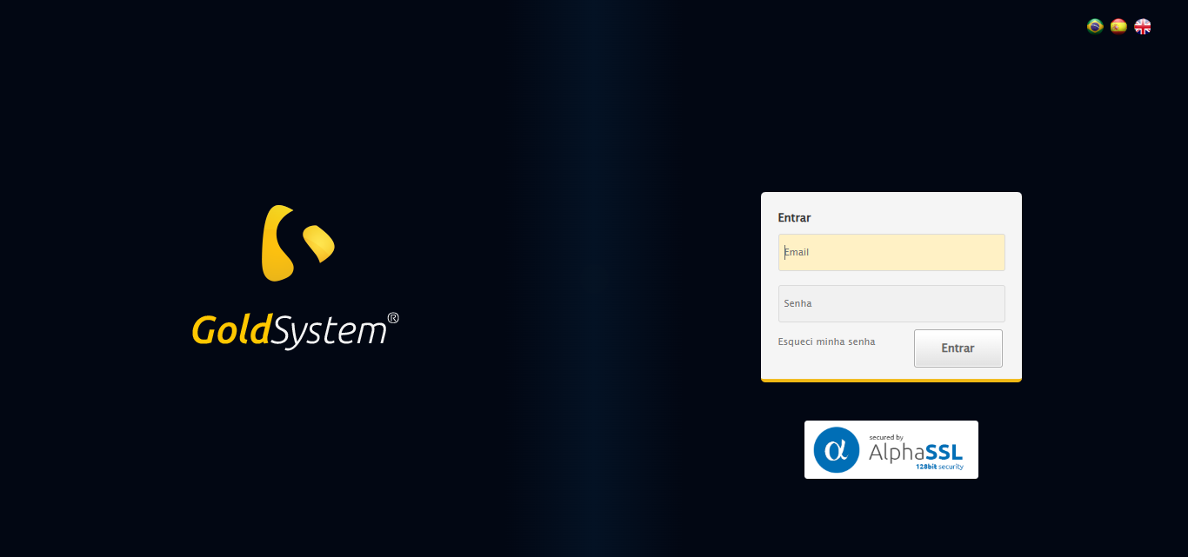

🔄 Realizando login...

✅ Realizando login realizada com sucesso.

Screenshot: realizando login

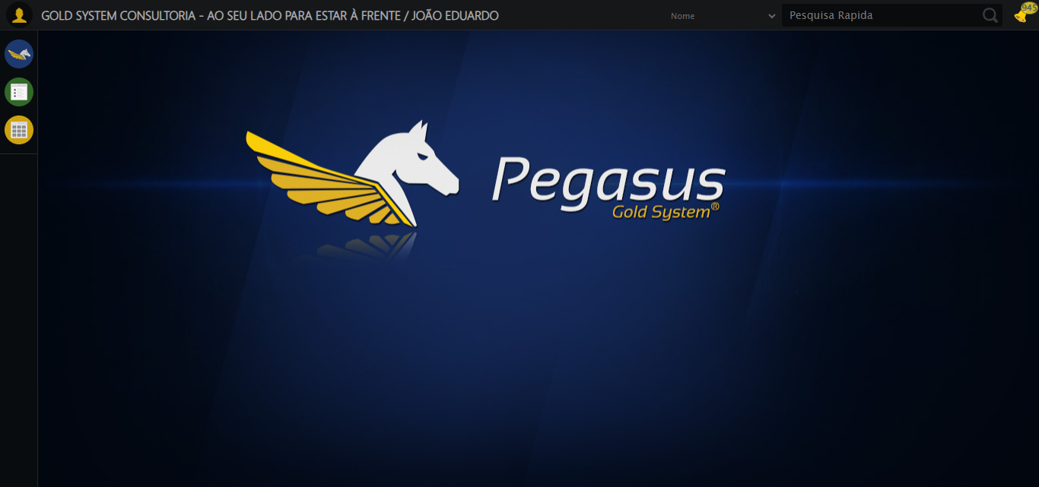

🔄 Ajustando zoom e abrindo menu...

🔍 Zoom ajustado para 90%.

✅ Ajustando zoom e abrindo menu realizada com sucesso.

Screenshot: ajustando zoom e abrindo menu

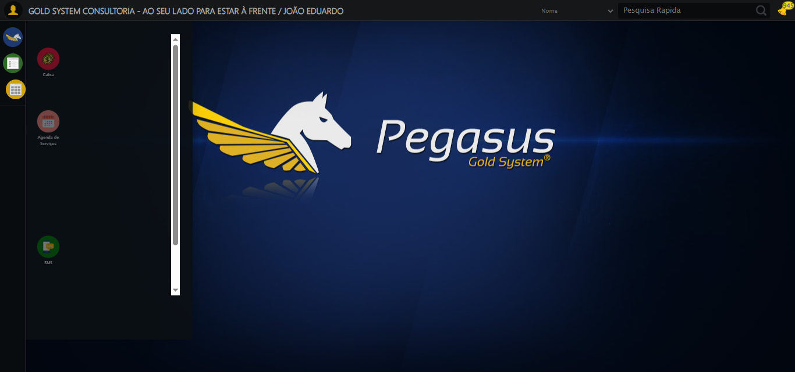

🔄 Acessando Gestor de Compras...

✅ Acessando Gestor de Compras realizada com sucesso.

Screenshot: acessando gestor de compras

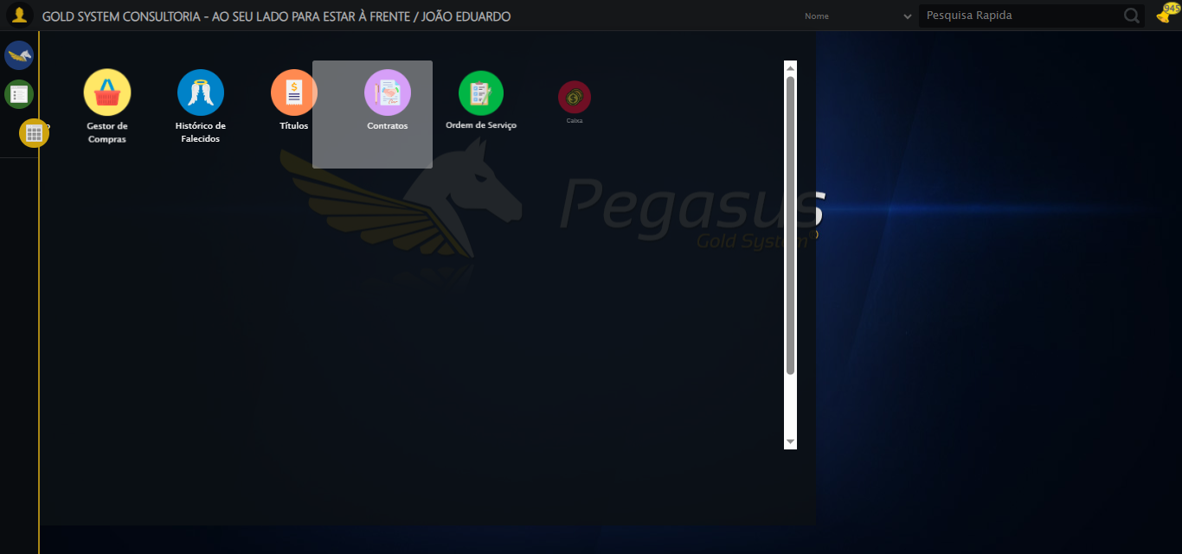

🔄 Clicando em Autorização de PIMS...

✅ Clicando em Autorização de PIMS realizada com sucesso.

Screenshot: clicando em autorização de pims

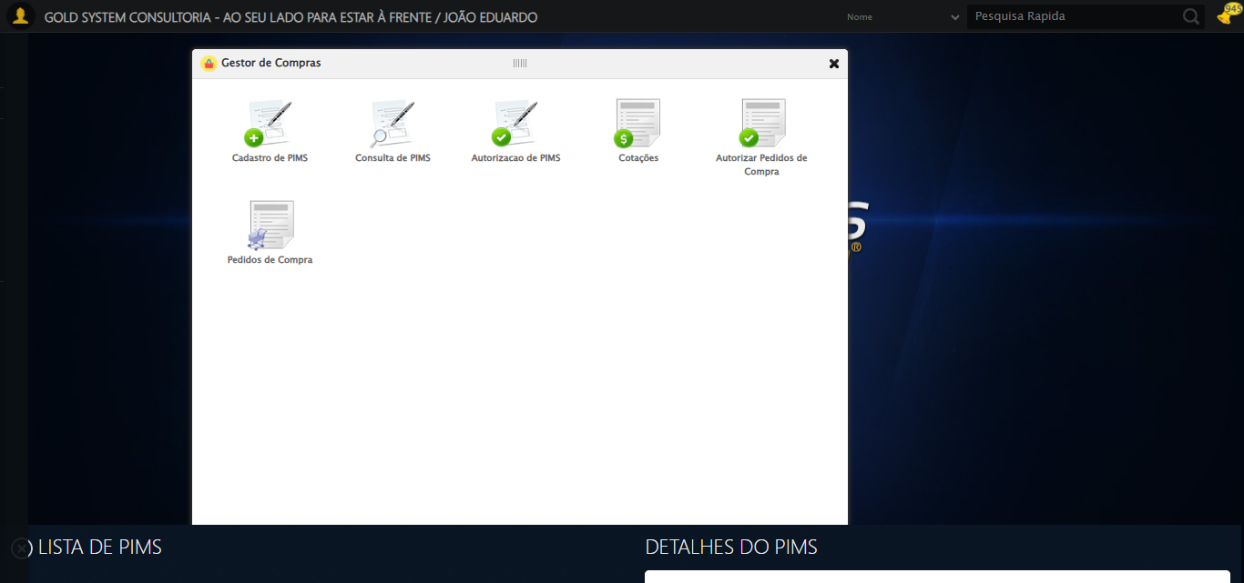

🔄 Preenchendo Data inicial...

✅ Preenchendo Data inicial realizada com sucesso.

Screenshot: preenchendo data inicial

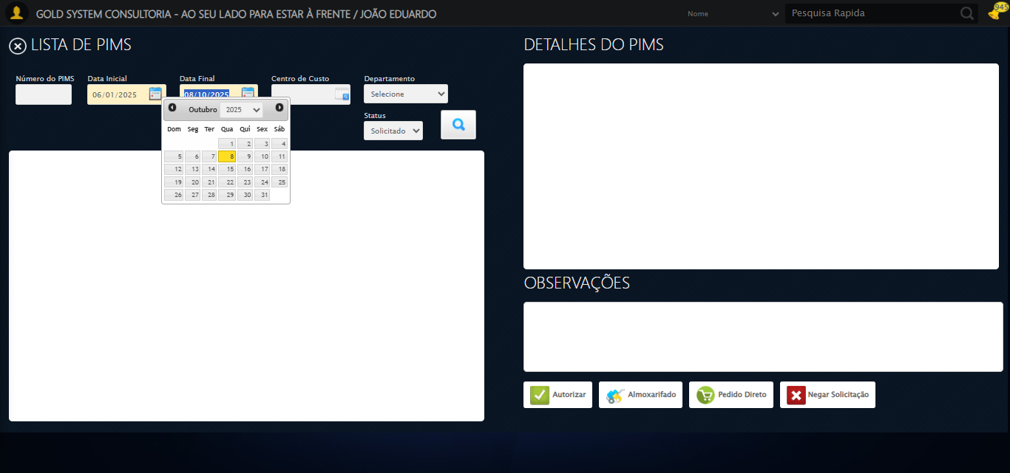

🔄 Selecionando Departamento...

✅ Selecionando Departamento realizada com sucesso.

Screenshot: selecionando departamento

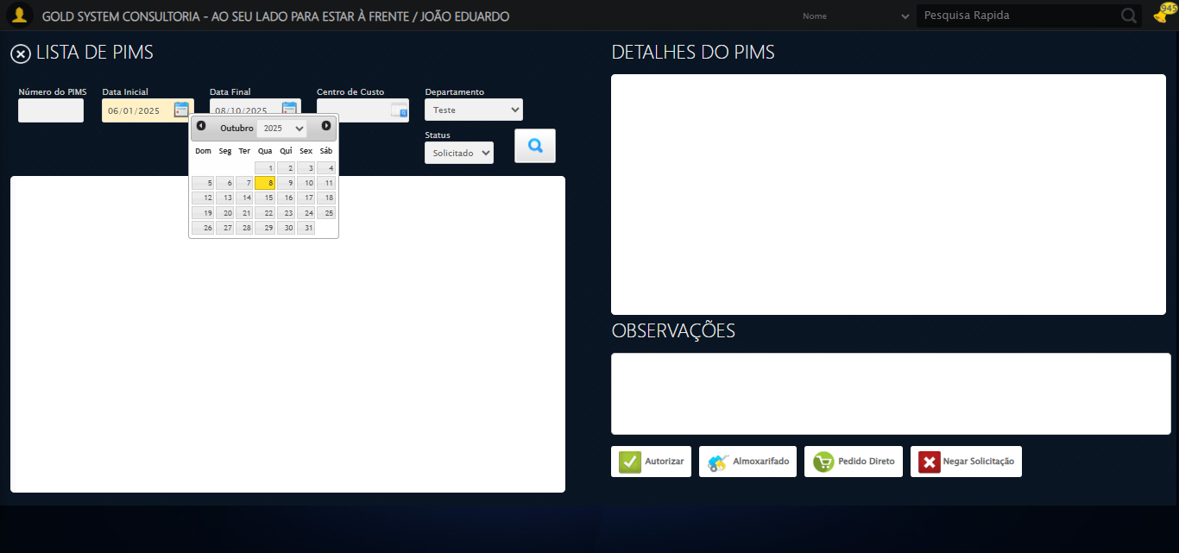

🔄 Selecionando Status...

✅ Selecionando Status realizada com sucesso.

Screenshot: selecionando status



🔄 Pesquisando......

✅ Pesquisando... realizada com sucesso.

Screenshot: pesquisando...

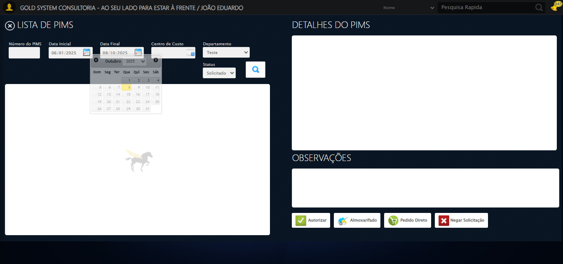

🔄 Verificando lista de PIMS...

✅ 1 registro(s) encontrado(s). Selecionando o primeiro...

🔄 Selecionando PIMS...

✅ Selecionando PIMS realizada com sucesso.

Screenshot: selecionando pims

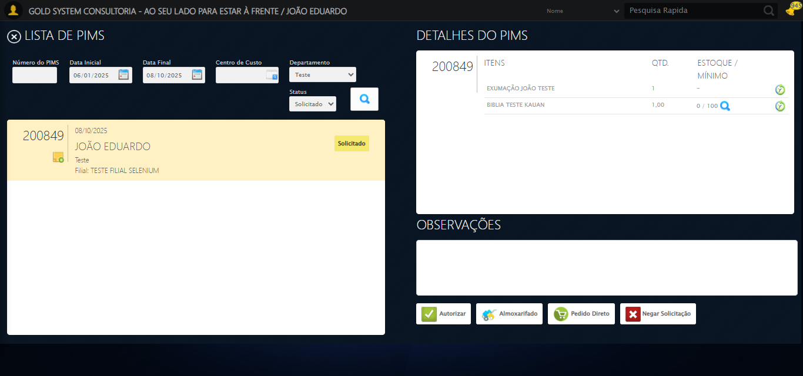

🔄 Selecionando itens para a Autorização de PIMS...

✅ Selecionando itens para a Autorização de PIMS realizada com sucesso.

Screenshot: selecionando itens para a autorização de pims

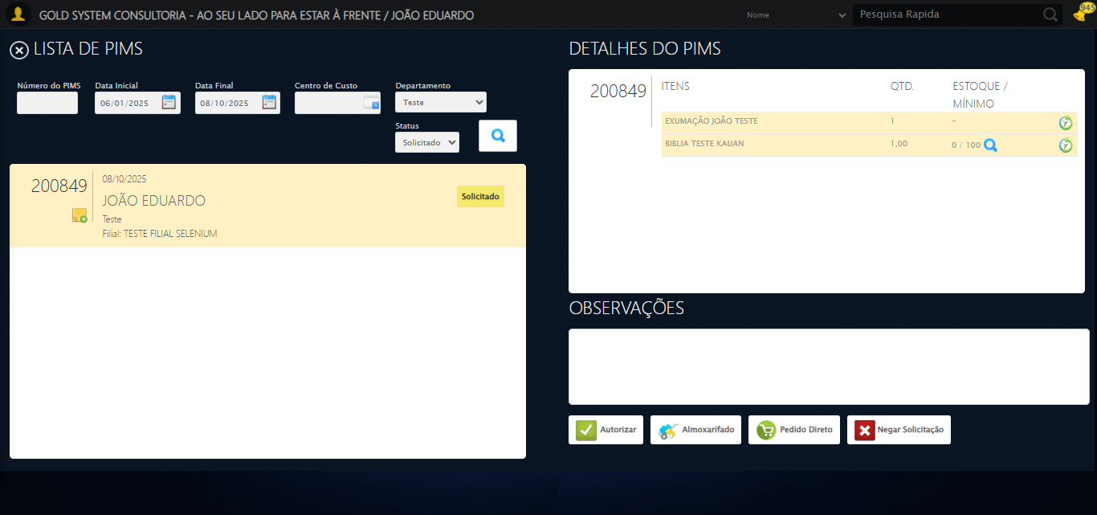

🎯 Tentativa 1: Preenchendo textarea 0 (ID: (sem id), name: (sem name)) com 129 caracteres

▶️ Estratégia 1…

✅ Preenchido com sucesso pela estratégia 1: 'TESTE OBSERVAÇÃO SELENIUM AUTOMATIZADO (Automação de Testes)…'

🔄 Preenchendo Observações...

❌ Erro inesperado ao preenchendo observações: 'bool' object is not callable

Screenshot: erro_preenchendo observações

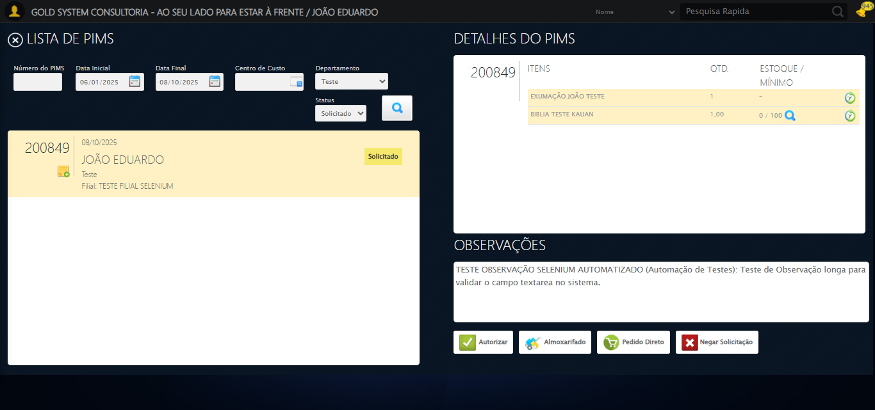

🔄 Clicando no botão Pedido Direto...

✅ Clicando no botão Pedido Direto realizada com sucesso.

Screenshot: clicando no botão pedido direto

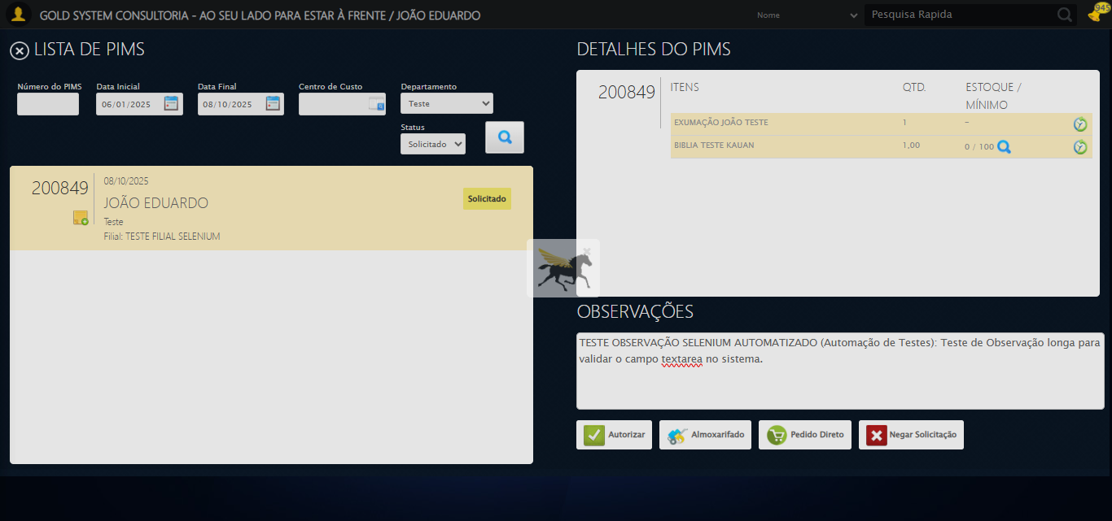

🔄 Selecionando Fornecedor...

🧭 Abrindo LOV pelo índice 1…

🔎 Tentativa 1: Localizando ícones LOV ('sp-openLov')...

🎯 Preparando clique no LOV de índice 1 (total: 2).

▶️ Estratégia 1 de clique no LOV...

✅ Clique no LOV (índice 1) realizado com sucesso (estratégia 1).

⚠️ Tentativa 1/3 falhou: Message:   
Stacktrace:  
 GetHandleVerifier [0x0xc5c333+65459]  
 GetHandleVerifier [0x0xc5c374+65524]  
 (No symbol) [0x0xa7d973]  
 (No symbol) [0x0xac76e7]  
 (No symbol) [0x0xac7a8b]  
 (No symbol) [0x0xb0dea2]  
 (No symbol) [0x0xae9e44]  
 (No symbol) [0x0xb0b606]  
 (No symbol) [0x0xae9bf6]  
 (No symbol) [0x0xabb38e]  
 (No symbol) [0x0xabc274]  
 GetHandleVerifier [0x0xededa3+2697763]  
 GetHandleVerifier [0x0xed9ec7+2677575]  
 GetHandleVerifier [0x0xc84194+228884]  
 GetHandleVerifier [0x0xc749f8+165496]  
 GetHandleVerifier [0x0xc7b18d+192013]  
 GetHandleVerifier [0x0xc647d8+99416]  
 GetHandleVerifier [0x0xc64972+99826]  
 GetHandleVerifier [0x0xc4ebea+10346]  
 BaseThreadInitThunk [0x0x755bfcc9+25]  
 RtlGetAppContainerNamedObjectPath [0x0x773a82ae+286]  
 RtlGetAppContainerNamedObjectPath [0x0x773a827e+238]  
. Retentando…

🧭 Abrindo LOV pelo índice 1…

🔎 Tentativa 1: Localizando ícones LOV ('sp-openLov')...

🎯 Preparando clique no LOV de índice 1 (total: 2).

▶️ Estratégia 1 de clique no LOV...

⚠️ Tentativa 2/3 falhou: log() takes 2 positional arguments but 3 were given. Retentando…

🧭 Abrindo LOV pelo índice 1…

🔎 Tentativa 1: Localizando ícones LOV ('sp-openLov')...

🎯 Preparando clique no LOV de índice 1 (total: 2).

▶️ Estratégia 1 de clique no LOV...

❌ Erro inesperado ao selecionando fornecedor: log() takes 2 positional arguments but 3 were given

Screenshot: erro_selecionando fornecedor

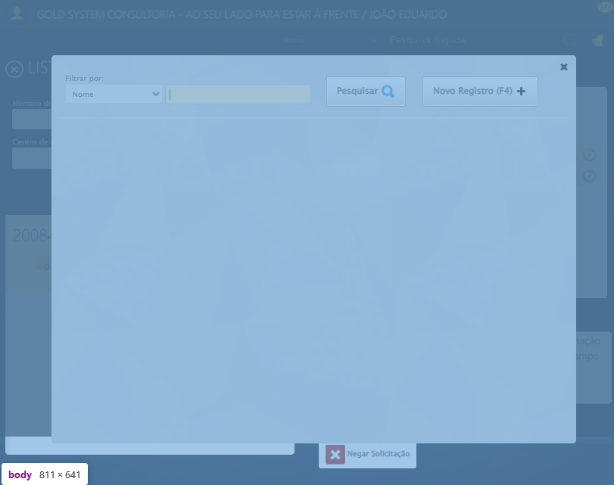

🔍 Verificando mensagens de alerta...

ℹ️ Nenhuma mensagem de alerta encontrada.

🔄 Preenchendo Contato do Fornecedor...

⚠️ Tentativa 1 falhou: Message: element click intercepted: Element <input class="contato" maxlength="30" style="width: 105px;" type="text"> is not clickable at point (363, 254). Other element would receive the click: <div class="modal overflow" style="z-index: 10004; left: 50%; top: 50%; width: 750px; height: 550px; margin-left: -375px; margin-top: -275px;">...</div>  
 (Session info: chrome=140.0.7339.208); For documentation on this error, please visit: https://www.selenium.dev/documentation/webdriver/troubleshooting/errors#elementclickinterceptedexception  
Stacktrace:  
 GetHandleVerifier [0x0xc5c333+65459]  
 GetHandleVerifier [0x0xc5c374+65524]  
 (No symbol) [0x0xa7d973]  
 (No symbol) [0x0xacdbc0]  
 (No symbol) [0x0xacbf23]  
 (No symbol) [0x0xac99c7]  
 (No symbol) [0x0xac8c66]  
 (No symbol) [0x0xabd195]  
 (No symbol) [0x0xae9dfc]  
 (No symbol) [0x0xabcbf4]  
 (No symbol) [0x0xae9fb4]  
 (No symbol) [0x0xb0b606]  
 (No symbol) [0x0xae9bf6]  
 (No symbol) [0x0xabb38e]  
 (No symbol) [0x0xabc274]  
 GetHandleVerifier [0x0xededa3+2697763]  
 GetHandleVerifier [0x0xed9ec7+2677575]  
 GetHandleVerifier [0x0xc84194+228884]  
 GetHandleVerifier [0x0xc749f8+165496]  
 GetHandleVerifier [0x0xc7b18d+192013]  
 GetHandleVerifier [0x0xc647d8+99416]  
 GetHandleVerifier [0x0xc64972+99826]  
 GetHandleVerifier [0x0xc4ebea+10346]  
 BaseThreadInitThunk [0x0x755bfcc9+25]  
 RtlGetAppContainerNamedObjectPath [0x0x773a82ae+286]  
 RtlGetAppContainerNamedObjectPath [0x0x773a827e+238]

✅ Preenchendo Contato do Fornecedor realizada com sucesso.

Screenshot: preenchendo contato do fornecedor

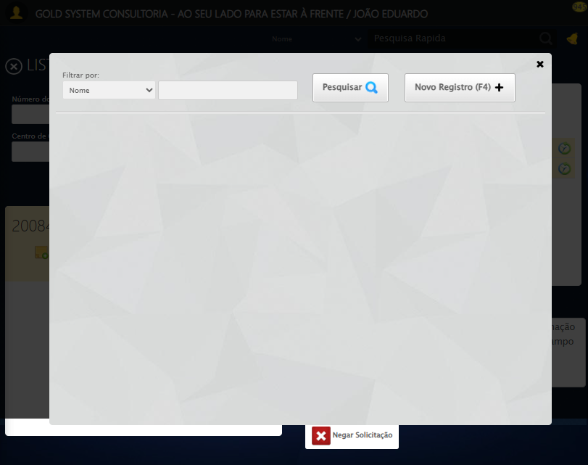

🔄 Preenchendo Telefone do Fornecedor...

⚠️ Tentativa 1 falhou: Message: element click intercepted: Element <input class="telefone" maxlength="13" type="text" style="width:80px"> is not clickable at point (477, 254). Other element would receive the click: <div class="modal overflow" style="z-index: 10004; left: 50%; top: 50%; width: 750px; height: 550px; margin-left: -375px; margin-top: -275px;">...</div>  
 (Session info: chrome=140.0.7339.208); For documentation on this error, please visit: https://www.selenium.dev/documentation/webdriver/troubleshooting/errors#elementclickinterceptedexception  
Stacktrace:  
 GetHandleVerifier [0x0xc5c333+65459]  
 GetHandleVerifier [0x0xc5c374+65524]  
 (No symbol) [0x0xa7d973]  
 (No symbol) [0x0xacdbc0]  
 (No symbol) [0x0xacbf23]  
 (No symbol) [0x0xac99c7]  
 (No symbol) [0x0xac8c66]  
 (No symbol) [0x0xabd195]  
 (No symbol) [0x0xae9dfc]  
 (No symbol) [0x0xabcbf4]  
 (No symbol) [0x0xae9fb4]  
 (No symbol) [0x0xb0b606]  
 (No symbol) [0x0xae9bf6]  
 (No symbol) [0x0xabb38e]  
 (No symbol) [0x0xabc274]  
 GetHandleVerifier [0x0xededa3+2697763]  
 GetHandleVerifier [0x0xed9ec7+2677575]  
 GetHandleVerifier [0x0xc84194+228884]  
 GetHandleVerifier [0x0xc749f8+165496]  
 GetHandleVerifier [0x0xc7b18d+192013]  
 GetHandleVerifier [0x0xc647d8+99416]  
 GetHandleVerifier [0x0xc64972+99826]  
 GetHandleVerifier [0x0xc4ebea+10346]  
 BaseThreadInitThunk [0x0x755bfcc9+25]  
 RtlGetAppContainerNamedObjectPath [0x0x773a82ae+286]  
 RtlGetAppContainerNamedObjectPath [0x0x773a827e+238]

✅ Preenchendo Telefone do Fornecedor realizada com sucesso.

Screenshot: preenchendo telefone do fornecedor

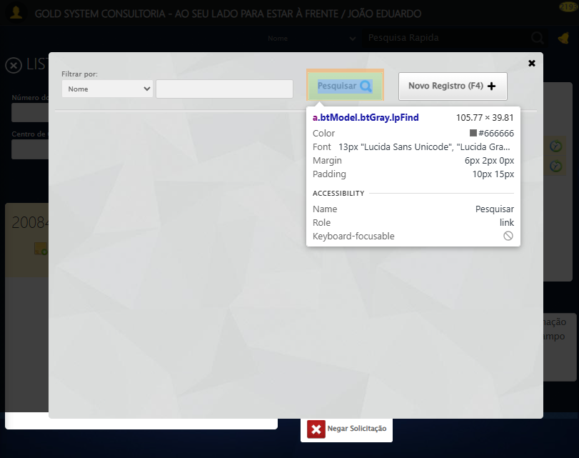

🔄 Preenchendo E-mail do Fornecedor...

⚠️ Tentativa 1 falhou: Message: element click intercepted: Element <input class="email" maxlength="50" type="text" style="width: 132px"> is not clickable at point (219, 300). Other element would receive the click: <div class="modal overflow" style="z-index: 10004; left: 50%; top: 50%; width: 750px; height: 550px; margin-left: -375px; margin-top: -275px;">...</div>  
 (Session info: chrome=140.0.7339.208); For documentation on this error, please visit: https://www.selenium.dev/documentation/webdriver/troubleshooting/errors#elementclickinterceptedexception  
Stacktrace:  
 GetHandleVerifier [0x0xc5c333+65459]  
 GetHandleVerifier [0x0xc5c374+65524]  
 (No symbol) [0x0xa7d973]  
 (No symbol) [0x0xacdbc0]  
 (No symbol) [0x0xacbf23]  
 (No symbol) [0x0xac99c7]  
 (No symbol) [0x0xac8c66]  
 (No symbol) [0x0xabd195]  
 (No symbol) [0x0xae9dfc]  
 (No symbol) [0x0xabcbf4]  
 (No symbol) [0x0xae9fb4]  
 (No symbol) [0x0xb0b606]  
 (No symbol) [0x0xae9bf6]  
 (No symbol) [0x0xabb38e]  
 (No symbol) [0x0xabc274]  
 GetHandleVerifier [0x0xededa3+2697763]  
 GetHandleVerifier [0x0xed9ec7+2677575]  
 GetHandleVerifier [0x0xc84194+228884]  
 GetHandleVerifier [0x0xc749f8+165496]  
 GetHandleVerifier [0x0xc7b18d+192013]  
 GetHandleVerifier [0x0xc647d8+99416]  
 GetHandleVerifier [0x0xc64972+99826]  
 GetHandleVerifier [0x0xc4ebea+10346]  
 BaseThreadInitThunk [0x0x755bfcc9+25]  
 RtlGetAppContainerNamedObjectPath [0x0x773a82ae+286]  
 RtlGetAppContainerNamedObjectPath [0x0x773a827e+238]

✅ Preenchendo E-mail do Fornecedor realizada com sucesso.

Screenshot: preenchendo e-mail do fornecedor

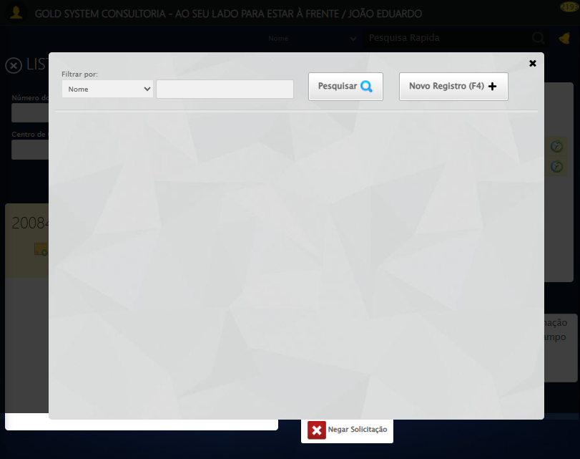

🔄 Preenchendo Valor do frete...

⚠️ Tentativa 1 falhou: Message: element click intercepted: Element <input class="frete" maxlength="15" style="width: 70px;" type="text" placeholder="R$ "> is not clickable at point (315, 329). Other element would receive the click: <div class="modal overflow" style="z-index: 10004; left: 50%; top: 50%; width: 750px; height: 550px; margin-left: -375px; margin-top: -275px;">...</div>  
 (Session info: chrome=140.0.7339.208); For documentation on this error, please visit: https://www.selenium.dev/documentation/webdriver/troubleshooting/errors#elementclickinterceptedexception  
Stacktrace:  
 GetHandleVerifier [0x0xc5c333+65459]  
 GetHandleVerifier [0x0xc5c374+65524]  
 (No symbol) [0x0xa7d973]  
 (No symbol) [0x0xacdbc0]  
 (No symbol) [0x0xacbf23]  
 (No symbol) [0x0xac99c7]  
 (No symbol) [0x0xac8c66]  
 (No symbol) [0x0xabd195]  
 (No symbol) [0x0xae9dfc]  
 (No symbol) [0x0xabcbf4]  
 (No symbol) [0x0xae9fb4]  
 (No symbol) [0x0xb0b606]  
 (No symbol) [0x0xae9bf6]  
 (No symbol) [0x0xabb38e]  
 (No symbol) [0x0xabc274]  
 GetHandleVerifier [0x0xededa3+2697763]  
 GetHandleVerifier [0x0xed9ec7+2677575]  
 GetHandleVerifier [0x0xc84194+228884]  
 GetHandleVerifier [0x0xc749f8+165496]  
 GetHandleVerifier [0x0xc7b18d+192013]  
 GetHandleVerifier [0x0xc647d8+99416]  
 GetHandleVerifier [0x0xc64972+99826]  
 GetHandleVerifier [0x0xc4ebea+10346]  
 BaseThreadInitThunk [0x0x755bfcc9+25]  
 RtlGetAppContainerNamedObjectPath [0x0x773a82ae+286]  
 RtlGetAppContainerNamedObjectPath [0x0x773a827e+238]

✅ Preenchendo Valor do frete realizada com sucesso.

Screenshot: preenchendo valor do frete

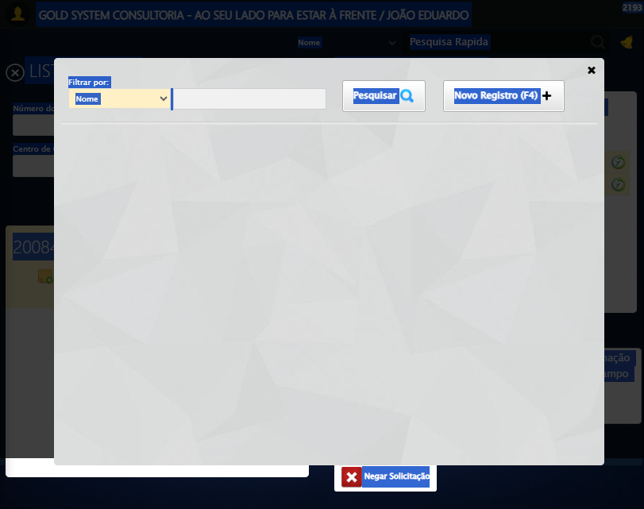

🔄 Preenchendo Condição de Pagamento...

⚠️ Tentativa 1 falhou: Message: element click intercepted: Element <input class="tipoPagamento" style="width: 110px;" maxlength="100" type="text"> is not clickable at point (557, 329). Other element would receive the click: <div class="modal overflow" style="z-index: 10004; left: 50%; top: 50%; width: 750px; height: 550px; margin-left: -375px; margin-top: -275px; opacity: 0.881898;">...</div>  
 (Session info: chrome=140.0.7339.208); For documentation on this error, please visit: https://www.selenium.dev/documentation/webdriver/troubleshooting/errors#elementclickinterceptedexception  
Stacktrace:  
 GetHandleVerifier [0x0xc5c333+65459]  
 GetHandleVerifier [0x0xc5c374+65524]  
 (No symbol) [0x0xa7d973]  
 (No symbol) [0x0xacdbc0]  
 (No symbol) [0x0xacbf23]  
 (No symbol) [0x0xac99c7]  
 (No symbol) [0x0xac8c66]  
 (No symbol) [0x0xabd195]  
 (No symbol) [0x0xae9dfc]  
 (No symbol) [0x0xabcbf4]  
 (No symbol) [0x0xae9fb4]  
 (No symbol) [0x0xb0b606]  
 (No symbol) [0x0xae9bf6]  
 (No symbol) [0x0xabb38e]  
 (No symbol) [0x0xabc274]  
 GetHandleVerifier [0x0xededa3+2697763]  
 GetHandleVerifier [0x0xed9ec7+2677575]  
 GetHandleVerifier [0x0xc84194+228884]  
 GetHandleVerifier [0x0xc749f8+165496]  
 GetHandleVerifier [0x0xc7b18d+192013]  
 GetHandleVerifier [0x0xc647d8+99416]  
 GetHandleVerifier [0x0xc64972+99826]  
 GetHandleVerifier [0x0xc4ebea+10346]  
 BaseThreadInitThunk [0x0x755bfcc9+25]  
 RtlGetAppContainerNamedObjectPath [0x0x773a82ae+286]  
 RtlGetAppContainerNamedObjectPath [0x0x773a827e+238]

⚠️ Tentativa 2 falhou: Message: no such window: target window already closed  
from unknown error: web view not found  
 (Session info: chrome=140.0.7339.208)  
Stacktrace:  
 GetHandleVerifier [0x0xc5c333+65459]  
 GetHandleVerifier [0x0xc5c374+65524]  
 (No symbol) [0x0xa7d973]  
 (No symbol) [0x0xa5c19d]  
 (No symbol) [0x0xaf059e]  
 (No symbol) [0x0xb0aef9]  
 (No symbol) [0x0xae9bf6]  
 (No symbol) [0x0xabb38e]  
 (No symbol) [0x0xabc274]  
 GetHandleVerifier [0x0xededa3+2697763]  
 GetHandleVerifier [0x0xed9ec7+2677575]  
 GetHandleVerifier [0x0xc84194+228884]  
 GetHandleVerifier [0x0xc749f8+165496]  
 GetHandleVerifier [0x0xc7b18d+192013]  
 GetHandleVerifier [0x0xc647d8+99416]  
 GetHandleVerifier [0x0xc64972+99826]  
 GetHandleVerifier [0x0xc4ebea+10346]  
 BaseThreadInitThunk [0x0x755bfcc9+25]  
 RtlGetAppContainerNamedObjectPath [0x0x773a82ae+286]  
 RtlGetAppContainerNamedObjectPath [0x0x773a827e+238]

⚠️ Tentativa 3 falhou: Message: no such window: target window already closed  
from unknown error: web view not found  
 (Session info: chrome=140.0.7339.208)  
Stacktrace:  
 GetHandleVerifier [0x0xc5c333+65459]  
 GetHandleVerifier [0x0xc5c374+65524]  
 (No symbol) [0x0xa7d973]  
 (No symbol) [0x0xa5c19d]  
 (No symbol) [0x0xaf059e]  
 (No symbol) [0x0xb0aef9]  
 (No symbol) [0x0xae9bf6]  
 (No symbol) [0x0xabb38e]  
 (No symbol) [0x0xabc274]  
 GetHandleVerifier [0x0xededa3+2697763]  
 GetHandleVerifier [0x0xed9ec7+2677575]  
 GetHandleVerifier [0x0xc84194+228884]  
 GetHandleVerifier [0x0xc749f8+165496]  
 GetHandleVerifier [0x0xc7b18d+192013]  
 GetHandleVerifier [0x0xc647d8+99416]  
 GetHandleVerifier [0x0xc64972+99826]  
 GetHandleVerifier [0x0xc4ebea+10346]  
 BaseThreadInitThunk [0x0x755bfcc9+25]  
 RtlGetAppContainerNamedObjectPath [0x0x773a82ae+286]  
 RtlGetAppContainerNamedObjectPath [0x0x773a827e+238]

✅ Preenchendo Condição de Pagamento realizada com sucesso.

⚠️ Erro ao tirar screenshot preenchendo condição de pagamento: Message: no such window: target window already closed  
from unknown error: web view not found  
 (Session info: chrome=140.0.7339.208)  
Stacktrace:  
 GetHandleVerifier [0x0xc5c333+65459]  
 GetHandleVerifier [0x0xc5c374+65524]  
 (No symbol) [0x0xa7d973]  
 (No symbol) [0x0xa5c19d]  
 (No symbol) [0x0xaf059e]  
 (No symbol) [0x0xb0aef9]  
 (No symbol) [0x0xae9bf6]  
 (No symbol) [0x0xabb38e]  
 (No symbol) [0x0xabc274]  
 GetHandleVerifier [0x0xededa3+2697763]  
 GetHandleVerifier [0x0xed9ec7+2677575]  
 GetHandleVerifier [0x0xc84194+228884]  
 GetHandleVerifier [0x0xc749f8+165496]  
 GetHandleVerifier [0x0xc7b18d+192013]  
 GetHandleVerifier [0x0xc647d8+99416]  
 GetHandleVerifier [0x0xc64972+99826]  
 GetHandleVerifier [0x0xc4ebea+10346]  
 BaseThreadInitThunk [0x0x755bfcc9+25]  
 RtlGetAppContainerNamedObjectPath [0x0x773a82ae+286]  
 RtlGetAppContainerNamedObjectPath [0x0x773a827e+238]

🔄 Preenchendo Forma de Pagamento...

⚠️ Tentativa 1 falhou: Message: no such window: target window already closed  
from unknown error: web view not found  
 (Session info: chrome=140.0.7339.208)  
Stacktrace:  
 GetHandleVerifier [0x0xc5c333+65459]  
 GetHandleVerifier [0x0xc5c374+65524]  
 (No symbol) [0x0xa7d973]  
 (No symbol) [0x0xa5c19d]  
 (No symbol) [0x0xaf059e]  
 (No symbol) [0x0xb0aef9]  
 (No symbol) [0x0xae9bf6]  
 (No symbol) [0x0xabb38e]  
 (No symbol) [0x0xabc274]  
 GetHandleVerifier [0x0xededa3+2697763]  
 GetHandleVerifier [0x0xed9ec7+2677575]  
 GetHandleVerifier [0x0xc84194+228884]  
 GetHandleVerifier [0x0xc749f8+165496]  
 GetHandleVerifier [0x0xc7b18d+192013]  
 GetHandleVerifier [0x0xc647d8+99416]  
 GetHandleVerifier [0x0xc64972+99826]  
 GetHandleVerifier [0x0xc4ebea+10346]  
 BaseThreadInitThunk [0x0x755bfcc9+25]  
 RtlGetAppContainerNamedObjectPath [0x0x773a82ae+286]  
 RtlGetAppContainerNamedObjectPath [0x0x773a827e+238]

⚠️ Tentativa 2 falhou: Message: no such window: target window already closed  
from unknown error: web view not found  
 (Session info: chrome=140.0.7339.208)  
Stacktrace:  
 GetHandleVerifier [0x0xc5c333+65459]  
 GetHandleVerifier [0x0xc5c374+65524]  
 (No symbol) [0x0xa7d973]  
 (No symbol) [0x0xa5c19d]  
 (No symbol) [0x0xaf059e]  
 (No symbol) [0x0xb0aef9]  
 (No symbol) [0x0xae9bf6]  
 (No symbol) [0x0xabb38e]  
 (No symbol) [0x0xabc274]  
 GetHandleVerifier [0x0xededa3+2697763]  
 GetHandleVerifier [0x0xed9ec7+2677575]  
 GetHandleVerifier [0x0xc84194+228884]  
 GetHandleVerifier [0x0xc749f8+165496]  
 GetHandleVerifier [0x0xc7b18d+192013]  
 GetHandleVerifier [0x0xc647d8+99416]  
 GetHandleVerifier [0x0xc64972+99826]  
 GetHandleVerifier [0x0xc4ebea+10346]  
 BaseThreadInitThunk [0x0x755bfcc9+25]  
 RtlGetAppContainerNamedObjectPath [0x0x773a82ae+286]  
 RtlGetAppContainerNamedObjectPath [0x0x773a827e+238]

⚠️ Tentativa 3 falhou: Message: no such window: target window already closed  
from unknown error: web view not found  
 (Session info: chrome=140.0.7339.208)  
Stacktrace:  
 GetHandleVerifier [0x0xc5c333+65459]  
 GetHandleVerifier [0x0xc5c374+65524]  
 (No symbol) [0x0xa7d973]  
 (No symbol) [0x0xa5c19d]  
 (No symbol) [0x0xaf059e]  
 (No symbol) [0x0xb0aef9]  
 (No symbol) [0x0xae9bf6]  
 (No symbol) [0x0xabb38e]  
 (No symbol) [0x0xabc274]  
 GetHandleVerifier [0x0xededa3+2697763]  
 GetHandleVerifier [0x0xed9ec7+2677575]  
 GetHandleVerifier [0x0xc84194+228884]  
 GetHandleVerifier [0x0xc749f8+165496]  
 GetHandleVerifier [0x0xc7b18d+192013]  
 GetHandleVerifier [0x0xc647d8+99416]  
 GetHandleVerifier [0x0xc64972+99826]  
 GetHandleVerifier [0x0xc4ebea+10346]  
 BaseThreadInitThunk [0x0x755bfcc9+25]  
 RtlGetAppContainerNamedObjectPath [0x0x773a82ae+286]  
 RtlGetAppContainerNamedObjectPath [0x0x773a827e+238]

✅ Preenchendo Forma de Pagamento realizada com sucesso.

⚠️ Erro ao tirar screenshot preenchendo forma de pagamento: Message: no such window: target window already closed  
from unknown error: web view not found  
 (Session info: chrome=140.0.7339.208)  
Stacktrace:  
 GetHandleVerifier [0x0xc5c333+65459]  
 GetHandleVerifier [0x0xc5c374+65524]  
 (No symbol) [0x0xa7d973]  
 (No symbol) [0x0xa5c19d]  
 (No symbol) [0x0xaf059e]  
 (No symbol) [0x0xb0aef9]  
 (No symbol) [0x0xae9bf6]  
 (No symbol) [0x0xabb38e]  
 (No symbol) [0x0xabc274]  
 GetHandleVerifier [0x0xededa3+2697763]  
 GetHandleVerifier [0x0xed9ec7+2677575]  
 GetHandleVerifier [0x0xc84194+228884]  
 GetHandleVerifier [0x0xc749f8+165496]  
 GetHandleVerifier [0x0xc7b18d+192013]  
 GetHandleVerifier [0x0xc647d8+99416]  
 GetHandleVerifier [0x0xc64972+99826]  
 GetHandleVerifier [0x0xc4ebea+10346]  
 BaseThreadInitThunk [0x0x755bfcc9+25]  
 RtlGetAppContainerNamedObjectPath [0x0x773a82ae+286]  
 RtlGetAppContainerNamedObjectPath [0x0x773a827e+238]

🔄 Preenchendo Valor unitário do produto...

⚠️ Tentativa 1 falhou: Message: no such window: target window already closed  
from unknown error: web view not found  
 (Session info: chrome=140.0.7339.208)  
Stacktrace:  
 GetHandleVerifier [0x0xc5c333+65459]  
 GetHandleVerifier [0x0xc5c374+65524]  
 (No symbol) [0x0xa7d973]  
 (No symbol) [0x0xa5c19d]  
 (No symbol) [0x0xaf059e]  
 (No symbol) [0x0xb0aef9]  
 (No symbol) [0x0xae9bf6]  
 (No symbol) [0x0xabb38e]  
 (No symbol) [0x0xabc274]  
 GetHandleVerifier [0x0xededa3+2697763]  
 GetHandleVerifier [0x0xed9ec7+2677575]  
 GetHandleVerifier [0x0xc84194+228884]  
 GetHandleVerifier [0x0xc749f8+165496]  
 GetHandleVerifier [0x0xc7b18d+192013]  
 GetHandleVerifier [0x0xc647d8+99416]  
 GetHandleVerifier [0x0xc64972+99826]  
 GetHandleVerifier [0x0xc4ebea+10346]  
 BaseThreadInitThunk [0x0x755bfcc9+25]  
 RtlGetAppContainerNamedObjectPath [0x0x773a82ae+286]  
 RtlGetAppContainerNamedObjectPath [0x0x773a827e+238]

⚠️ Tentativa 2 falhou: Message: no such window: target window already closed  
from unknown error: web view not found  
 (Session info: chrome=140.0.7339.208)  
Stacktrace:  
 GetHandleVerifier [0x0xc5c333+65459]  
 GetHandleVerifier [0x0xc5c374+65524]  
 (No symbol) [0x0xa7d973]  
 (No symbol) [0x0xa5c19d]  
 (No symbol) [0x0xaf059e]  
 (No symbol) [0x0xb0aef9]  
 (No symbol) [0x0xae9bf6]  
 (No symbol) [0x0xabb38e]  
 (No symbol) [0x0xabc274]  
 GetHandleVerifier [0x0xededa3+2697763]  
 GetHandleVerifier [0x0xed9ec7+2677575]  
 GetHandleVerifier [0x0xc84194+228884]  
 GetHandleVerifier [0x0xc749f8+165496]  
 GetHandleVerifier [0x0xc7b18d+192013]  
 GetHandleVerifier [0x0xc647d8+99416]  
 GetHandleVerifier [0x0xc64972+99826]  
 GetHandleVerifier [0x0xc4ebea+10346]  
 BaseThreadInitThunk [0x0x755bfcc9+25]  
 RtlGetAppContainerNamedObjectPath [0x0x773a82ae+286]  
 RtlGetAppContainerNamedObjectPath [0x0x773a827e+238]

⚠️ Tentativa 3 falhou: Message: no such window: target window already closed  
from unknown error: web view not found  
 (Session info: chrome=140.0.7339.208)  
Stacktrace:  
 GetHandleVerifier [0x0xc5c333+65459]  
 GetHandleVerifier [0x0xc5c374+65524]  
 (No symbol) [0x0xa7d973]  
 (No symbol) [0x0xa5c19d]  
 (No symbol) [0x0xaf059e]  
 (No symbol) [0x0xb0aef9]  
 (No symbol) [0x0xae9bf6]  
 (No symbol) [0x0xabb38e]  
 (No symbol) [0x0xabc274]  
 GetHandleVerifier [0x0xededa3+2697763]  
 GetHandleVerifier [0x0xed9ec7+2677575]  
 GetHandleVerifier [0x0xc84194+228884]  
 GetHandleVerifier [0x0xc749f8+165496]  
 GetHandleVerifier [0x0xc7b18d+192013]  
 GetHandleVerifier [0x0xc647d8+99416]  
 GetHandleVerifier [0x0xc64972+99826]  
 GetHandleVerifier [0x0xc4ebea+10346]  
 BaseThreadInitThunk [0x0x755bfcc9+25]  
 RtlGetAppContainerNamedObjectPath [0x0x773a82ae+286]  
 RtlGetAppContainerNamedObjectPath [0x0x773a827e+238]

✅ Preenchendo Valor unitário do produto realizada com sucesso.

⚠️ Erro ao tirar screenshot preenchendo valor unitário do produto: Message: no such window: target window already closed  
from unknown error: web view not found  
 (Session info: chrome=140.0.7339.208)  
Stacktrace:  
 GetHandleVerifier [0x0xc5c333+65459]  
 GetHandleVerifier [0x0xc5c374+65524]  
 (No symbol) [0x0xa7d973]  
 (No symbol) [0x0xa5c19d]  
 (No symbol) [0x0xaf059e]  
 (No symbol) [0x0xb0aef9]  
 (No symbol) [0x0xae9bf6]  
 (No symbol) [0x0xabb38e]  
 (No symbol) [0x0xabc274]  
 GetHandleVerifier [0x0xededa3+2697763]  
 GetHandleVerifier [0x0xed9ec7+2677575]  
 GetHandleVerifier [0x0xc84194+228884]  
 GetHandleVerifier [0x0xc749f8+165496]  
 GetHandleVerifier [0x0xc7b18d+192013]  
 GetHandleVerifier [0x0xc647d8+99416]  
 GetHandleVerifier [0x0xc64972+99826]  
 GetHandleVerifier [0x0xc4ebea+10346]  
 BaseThreadInitThunk [0x0x755bfcc9+25]  
 RtlGetAppContainerNamedObjectPath [0x0x773a82ae+286]  
 RtlGetAppContainerNamedObjectPath [0x0x773a827e+238]

🔄 Preenchendo Quantidade do produto...

⚠️ Tentativa 1 falhou: Message: no such window: target window already closed  
from unknown error: web view not found  
 (Session info: chrome=140.0.7339.208)  
Stacktrace:  
 GetHandleVerifier [0x0xc5c333+65459]  
 GetHandleVerifier [0x0xc5c374+65524]  
 (No symbol) [0x0xa7d973]  
 (No symbol) [0x0xa5c19d]  
 (No symbol) [0x0xaf059e]  
 (No symbol) [0x0xb0aef9]  
 (No symbol) [0x0xae9bf6]  
 (No symbol) [0x0xabb38e]  
 (No symbol) [0x0xabc274]  
 GetHandleVerifier [0x0xededa3+2697763]  
 GetHandleVerifier [0x0xed9ec7+2677575]  
 GetHandleVerifier [0x0xc84194+228884]  
 GetHandleVerifier [0x0xc749f8+165496]  
 GetHandleVerifier [0x0xc7b18d+192013]  
 GetHandleVerifier [0x0xc647d8+99416]  
 GetHandleVerifier [0x0xc64972+99826]  
 GetHandleVerifier [0x0xc4ebea+10346]  
 BaseThreadInitThunk [0x0x755bfcc9+25]  
 RtlGetAppContainerNamedObjectPath [0x0x773a82ae+286]  
 RtlGetAppContainerNamedObjectPath [0x0x773a827e+238]

⚠️ Tentativa 2 falhou: Message: no such window: target window already closed  
from unknown error: web view not found  
 (Session info: chrome=140.0.7339.208)  
Stacktrace:  
 GetHandleVerifier [0x0xc5c333+65459]  
 GetHandleVerifier [0x0xc5c374+65524]  
 (No symbol) [0x0xa7d973]  
 (No symbol) [0x0xa5c19d]  
 (No symbol) [0x0xaf059e]  
 (No symbol) [0x0xb0aef9]  
 (No symbol) [0x0xae9bf6]  
 (No symbol) [0x0xabb38e]  
 (No symbol) [0x0xabc274]  
 GetHandleVerifier [0x0xededa3+2697763]  
 GetHandleVerifier [0x0xed9ec7+2677575]  
 GetHandleVerifier [0x0xc84194+228884]  
 GetHandleVerifier [0x0xc749f8+165496]  
 GetHandleVerifier [0x0xc7b18d+192013]  
 GetHandleVerifier [0x0xc647d8+99416]  
 GetHandleVerifier [0x0xc64972+99826]  
 GetHandleVerifier [0x0xc4ebea+10346]  
 BaseThreadInitThunk [0x0x755bfcc9+25]  
 RtlGetAppContainerNamedObjectPath [0x0x773a82ae+286]  
 RtlGetAppContainerNamedObjectPath [0x0x773a827e+238]

⚠️ Tentativa 3 falhou: Message: no such window: target window already closed  
from unknown error: web view not found  
 (Session info: chrome=140.0.7339.208)  
Stacktrace:  
 GetHandleVerifier [0x0xc5c333+65459]  
 GetHandleVerifier [0x0xc5c374+65524]  
 (No symbol) [0x0xa7d973]  
 (No symbol) [0x0xa5c19d]  
 (No symbol) [0x0xaf059e]  
 (No symbol) [0x0xb0aef9]  
 (No symbol) [0x0xae9bf6]  
 (No symbol) [0x0xabb38e]  
 (No symbol) [0x0xabc274]  
 GetHandleVerifier [0x0xededa3+2697763]  
 GetHandleVerifier [0x0xed9ec7+2677575]  
 GetHandleVerifier [0x0xc84194+228884]  
 GetHandleVerifier [0x0xc749f8+165496]  
 GetHandleVerifier [0x0xc7b18d+192013]  
 GetHandleVerifier [0x0xc647d8+99416]  
 GetHandleVerifier [0x0xc64972+99826]  
 GetHandleVerifier [0x0xc4ebea+10346]  
 BaseThreadInitThunk [0x0x755bfcc9+25]  
 RtlGetAppContainerNamedObjectPath [0x0x773a82ae+286]  
 RtlGetAppContainerNamedObjectPath [0x0x773a827e+238]

✅ Preenchendo Quantidade do produto realizada com sucesso.

⚠️ Erro ao tirar screenshot preenchendo quantidade do produto: Message: no such window: target window already closed  
from unknown error: web view not found  
 (Session info: chrome=140.0.7339.208)  
Stacktrace:  
 GetHandleVerifier [0x0xc5c333+65459]  
 GetHandleVerifier [0x0xc5c374+65524]  
 (No symbol) [0x0xa7d973]  
 (No symbol) [0x0xa5c19d]  
 (No symbol) [0x0xaf059e]  
 (No symbol) [0x0xb0aef9]  
 (No symbol) [0x0xae9bf6]  
 (No symbol) [0x0xabb38e]  
 (No symbol) [0x0xabc274]  
 GetHandleVerifier [0x0xededa3+2697763]  
 GetHandleVerifier [0x0xed9ec7+2677575]  
 GetHandleVerifier [0x0xc84194+228884]  
 GetHandleVerifier [0x0xc749f8+165496]  
 GetHandleVerifier [0x0xc7b18d+192013]  
 GetHandleVerifier [0x0xc647d8+99416]  
 GetHandleVerifier [0x0xc64972+99826]  
 GetHandleVerifier [0x0xc4ebea+10346]  
 BaseThreadInitThunk [0x0x755bfcc9+25]  
 RtlGetAppContainerNamedObjectPath [0x0x773a82ae+286]  
 RtlGetAppContainerNamedObjectPath [0x0x773a827e+238]

🔄 Finalizando...

❌ Erro inesperado ao finalizando: Message: no such window: target window already closed  
from unknown error: web view not found  
 (Session info: chrome=140.0.7339.208)  
Stacktrace:  
 GetHandleVerifier [0x0xc5c333+65459]  
 GetHandleVerifier [0x0xc5c374+65524]  
 (No symbol) [0x0xa7d973]  
 (No symbol) [0x0xa5c19d]  
 (No symbol) [0x0xaf059e]  
 (No symbol) [0x0xb0aef9]  
 (No symbol) [0x0xae9bf6]  
 (No symbol) [0x0xabb38e]  
 (No symbol) [0x0xabc274]  
 GetHandleVerifier [0x0xededa3+2697763]  
 GetHandleVerifier [0x0xed9ec7+2677575]  
 GetHandleVerifier [0x0xc84194+228884]  
 GetHandleVerifier [0x0xc749f8+165496]  
 GetHandleVerifier [0x0xc7b18d+192013]  
 GetHandleVerifier [0x0xc647d8+99416]  
 GetHandleVerifier [0x0xc64972+99826]  
 GetHandleVerifier [0x0xc4ebea+10346]  
 BaseThreadInitThunk [0x0x755bfcc9+25]  
 RtlGetAppContainerNamedObjectPath [0x0x773a82ae+286]  
 RtlGetAppContainerNamedObjectPath [0x0x773a827e+238]

⚠️ Erro ao tirar screenshot erro_finalizando: Message: no such window: target window already closed  
from unknown error: web view not found  
 (Session info: chrome=140.0.7339.208)  
Stacktrace:  
 GetHandleVerifier [0x0xc5c333+65459]  
 GetHandleVerifier [0x0xc5c374+65524]  
 (No symbol) [0x0xa7d973]  
 (No symbol) [0x0xa5c19d]  
 (No symbol) [0x0xaf059e]  
 (No symbol) [0x0xb0aef9]  
 (No symbol) [0x0xae9bf6]  
 (No symbol) [0x0xabb38e]  
 (No symbol) [0x0xabc274]  
 GetHandleVerifier [0x0xededa3+2697763]  
 GetHandleVerifier [0x0xed9ec7+2677575]  
 GetHandleVerifier [0x0xc84194+228884]  
 GetHandleVerifier [0x0xc749f8+165496]  
 GetHandleVerifier [0x0xc7b18d+192013]  
 GetHandleVerifier [0x0xc647d8+99416]  
 GetHandleVerifier [0x0xc64972+99826]  
 GetHandleVerifier [0x0xc4ebea+10346]  
 BaseThreadInitThunk [0x0x755bfcc9+25]  
 RtlGetAppContainerNamedObjectPath [0x0x773a82ae+286]  
 RtlGetAppContainerNamedObjectPath [0x0x773a827e+238]

🔄 Fechando Modal de Autorização de PIMS...

❌ Erro inesperado ao fechando modal de autorização de pims: Message: no such window: target window already closed  
from unknown error: web view not found  
 (Session info: chrome=140.0.7339.208)  
Stacktrace:  
 GetHandleVerifier [0x0xc5c333+65459]  
 GetHandleVerifier [0x0xc5c374+65524]  
 (No symbol) [0x0xa7d973]  
 (No symbol) [0x0xa5c19d]  
 (No symbol) [0x0xaf059e]  
 (No symbol) [0x0xb0aef9]  
 (No symbol) [0x0xae9bf6]  
 (No symbol) [0x0xabb38e]  
 (No symbol) [0x0xabc274]  
 GetHandleVerifier [0x0xededa3+2697763]  
 GetHandleVerifier [0x0xed9ec7+2677575]  
 GetHandleVerifier [0x0xc84194+228884]  
 GetHandleVerifier [0x0xc749f8+165496]  
 GetHandleVerifier [0x0xc7b18d+192013]  
 GetHandleVerifier [0x0xc647d8+99416]  
 GetHandleVerifier [0x0xc64972+99826]  
 GetHandleVerifier [0x0xc4ebea+10346]  
 BaseThreadInitThunk [0x0x755bfcc9+25]  
 RtlGetAppContainerNamedObjectPath [0x0x773a82ae+286]  
 RtlGetAppContainerNamedObjectPath [0x0x773a827e+238]

⚠️ Erro ao tirar screenshot erro_fechando modal de autorização de pims: Message: no such window: target window already closed  
from unknown error: web view not found  
 (Session info: chrome=140.0.7339.208)  
Stacktrace:  
 GetHandleVerifier [0x0xc5c333+65459]  
 GetHandleVerifier [0x0xc5c374+65524]  
 (No symbol) [0x0xa7d973]  
 (No symbol) [0x0xa5c19d]  
 (No symbol) [0x0xaf059e]  
 (No symbol) [0x0xb0aef9]  
 (No symbol) [0x0xae9bf6]  
 (No symbol) [0x0xabb38e]  
 (No symbol) [0x0xabc274]  
 GetHandleVerifier [0x0xededa3+2697763]  
 GetHandleVerifier [0x0xed9ec7+2677575]  
 GetHandleVerifier [0x0xc84194+228884]  
 GetHandleVerifier [0x0xc749f8+165496]  
 GetHandleVerifier [0x0xc7b18d+192013]  
 GetHandleVerifier [0x0xc647d8+99416]  
 GetHandleVerifier [0x0xc64972+99826]  
 GetHandleVerifier [0x0xc4ebea+10346]  
 BaseThreadInitThunk [0x0x755bfcc9+25]  
 RtlGetAppContainerNamedObjectPath [0x0x773a82ae+286]  
 RtlGetAppContainerNamedObjectPath [0x0x773a827e+238]

🔍 Verificando mensagens de alerta...

ℹ️ Nenhuma mensagem de alerta encontrada.

🔄 Fechando modal Gestor de Compras...

❌ Erro ao clicar robusto: Message: no such window: target window already closed  
from unknown error: web view not found  
 (Session info: chrome=140.0.7339.208)  
Stacktrace:  
 GetHandleVerifier [0x0xc5c333+65459]  
 GetHandleVerifier [0x0xc5c374+65524]  
 (No symbol) [0x0xa7d973]  
 (No symbol) [0x0xa5c19d]  
 (No symbol) [0x0xaf059e]  
 (No symbol) [0x0xb0aef9]  
 (No symbol) [0x0xae9bf6]  
 (No symbol) [0x0xabb38e]  
 (No symbol) [0x0xabc274]  
 GetHandleVerifier [0x0xededa3+2697763]  
 GetHandleVerifier [0x0xed9ec7+2677575]  
 GetHandleVerifier [0x0xc84194+228884]  
 GetHandleVerifier [0x0xc749f8+165496]  
 GetHandleVerifier [0x0xc7b18d+192013]  
 GetHandleVerifier [0x0xc647d8+99416]  
 GetHandleVerifier [0x0xc64972+99826]  
 GetHandleVerifier [0x0xc4ebea+10346]  
 BaseThreadInitThunk [0x0x755bfcc9+25]  
 RtlGetAppContainerNamedObjectPath [0x0x773a82ae+286]  
 RtlGetAppContainerNamedObjectPath [0x0x773a827e+238]

✅ Fechando modal Gestor de Compras realizada com sucesso.

⚠️ Erro ao tirar screenshot fechando modal gestor de compras: Message: no such window: target window already closed  
from unknown error: web view not found  
 (Session info: chrome=140.0.7339.208)  
Stacktrace:  
 GetHandleVerifier [0x0xc5c333+65459]  
 GetHandleVerifier [0x0xc5c374+65524]  
 (No symbol) [0x0xa7d973]  
 (No symbol) [0x0xa5c19d]  
 (No symbol) [0x0xaf059e]  
 (No symbol) [0x0xb0aef9]  
 (No symbol) [0x0xae9bf6]  
 (No symbol) [0x0xabb38e]  
 (No symbol) [0x0xabc274]  
 GetHandleVerifier [0x0xededa3+2697763]  
 GetHandleVerifier [0x0xed9ec7+2677575]  
 GetHandleVerifier [0x0xc84194+228884]  
 GetHandleVerifier [0x0xc749f8+165496]  
 GetHandleVerifier [0x0xc7b18d+192013]  
 GetHandleVerifier [0x0xc647d8+99416]  
 GetHandleVerifier [0x0xc64972+99826]  
 GetHandleVerifier [0x0xc4ebea+10346]  
 BaseThreadInitThunk [0x0x755bfcc9+25]  
 RtlGetAppContainerNamedObjectPath [0x0x773a82ae+286]  
 RtlGetAppContainerNamedObjectPath [0x0x773a827e+238]

✅ Teste concluído.

✅ Teste executado com sucesso!