RELATÓRIO DO TESTE

Autorização de Pedido de Compra - Gestor de Compras – Cenário 1: Preenchimento completo e Autorização

Data do teste: 09/10/2025 14:51:42

🚀 Iniciando teste de Autorização de PIMS

🔄 Acessando sistema...

✅ Acessando sistema realizada com sucesso.

Screenshot: acessando sistema

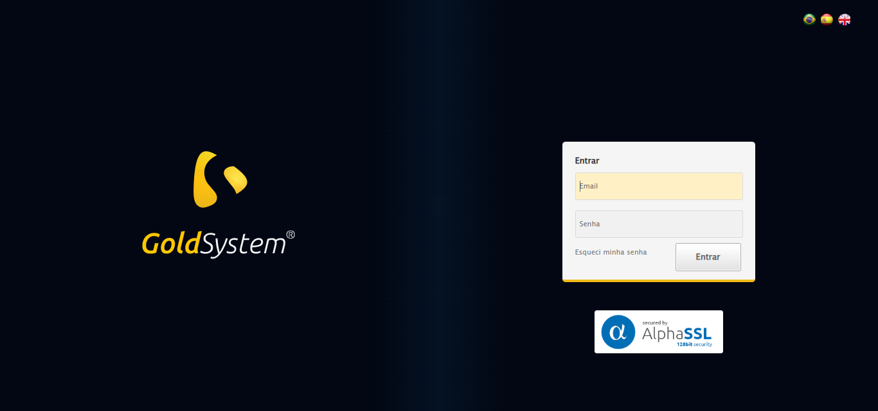

🔄 Realizando login...

✅ Realizando login realizada com sucesso.

Screenshot: realizando login

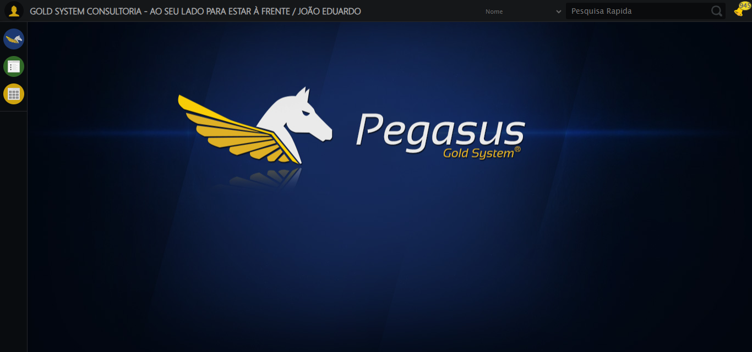

🔄 Ajustando zoom e abrindo menu...

🔍 Zoom ajustado para 90%.

✅ Ajustando zoom e abrindo menu realizada com sucesso.

Screenshot: ajustando zoom e abrindo menu

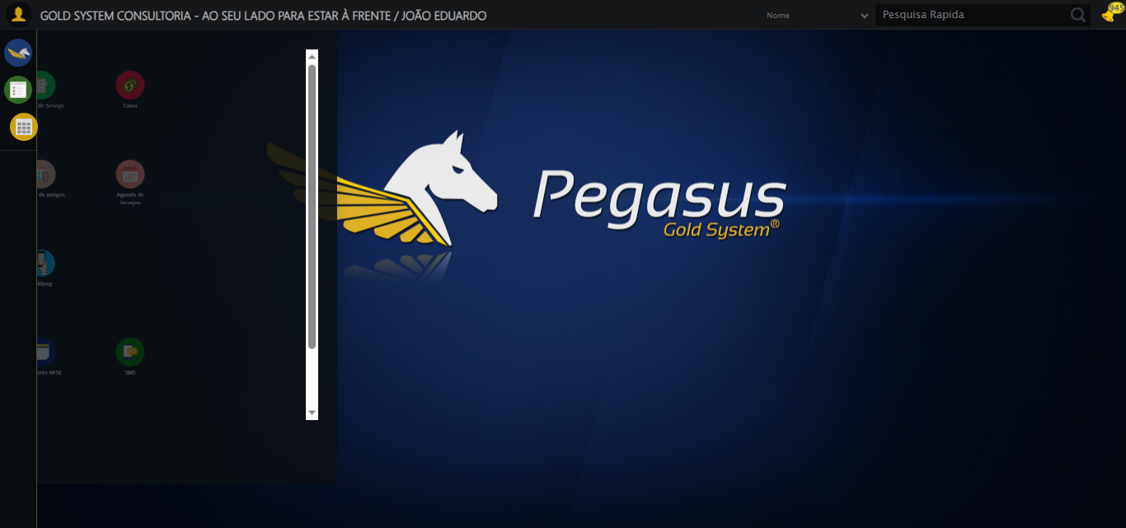

🔄 Acessando Gestor de Compras...

✅ Acessando Gestor de Compras realizada com sucesso.

Screenshot: acessando gestor de compras

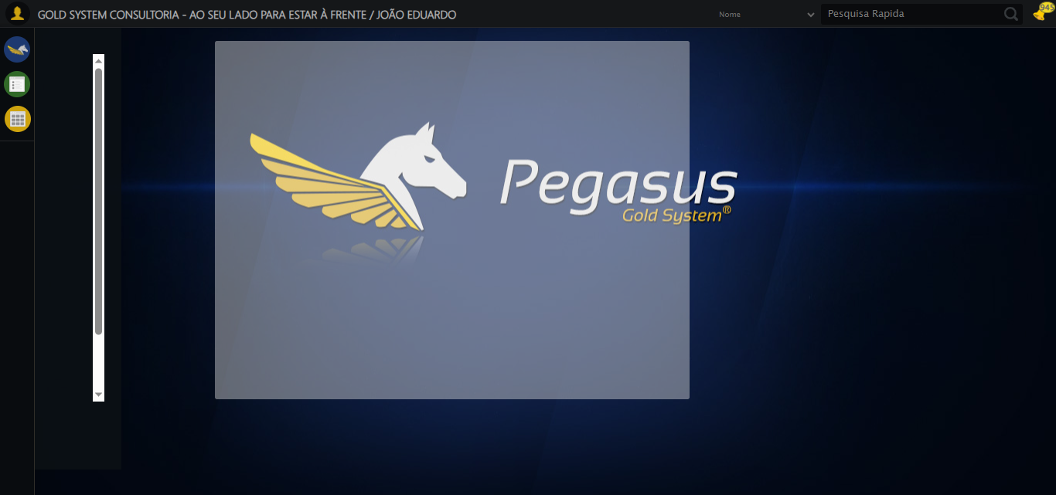

🔄 Clicando em Autorizar de Pedido de Compra...

✅ Clicando em Autorizar de Pedido de Compra realizada com sucesso.

Screenshot: clicando em autorizar de pedido de compra

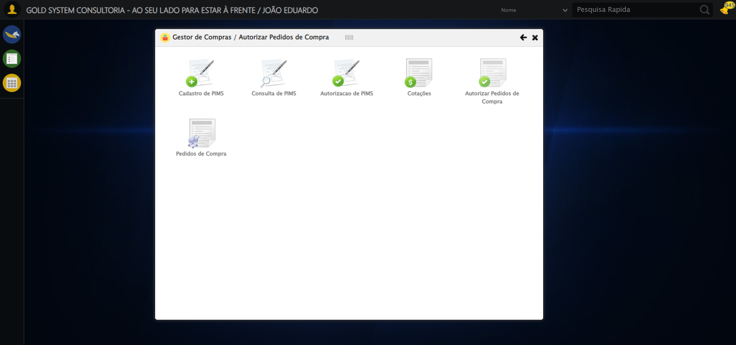

🔄 Preenchendo Data Pedido Inicial...

📊 Encontrados 2 campos datepicker

🎯 Tentativa 1: Preenchendo datepicker 0 (ID: dp1760032314549) com '20/04/2025'

Aplicando estratégia 1 para datepicker...

✅ Datepicker preenchido com estratégia 1: '20/04/2025'

✅ Preenchendo Data Pedido Inicial realizada com sucesso.

Screenshot: preenchendo data pedido inicial

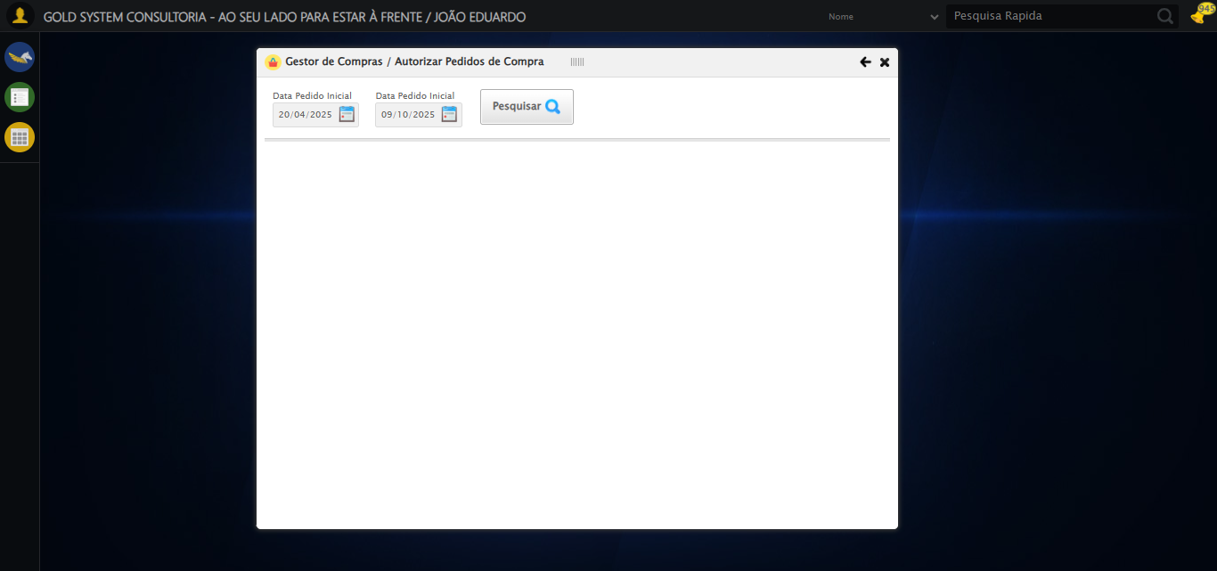

🔄 Preenchendo Data Pedido Final...

📊 Encontrados 2 campos datepicker

🎯 Tentativa 1: Preenchendo datepicker 1 (ID: dp1760032314550) com '08/10/2025'

Aplicando estratégia 1 para datepicker...

✅ Datepicker preenchido com estratégia 1: '08/10/2025'

✅ Preenchendo Data Pedido Final realizada com sucesso.

Screenshot: preenchendo data pedido final

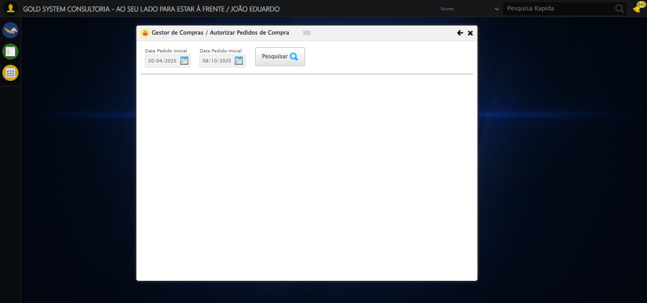

🔄 Pesquisando......

✅ Pesquisando... realizada com sucesso.

Screenshot: pesquisando...

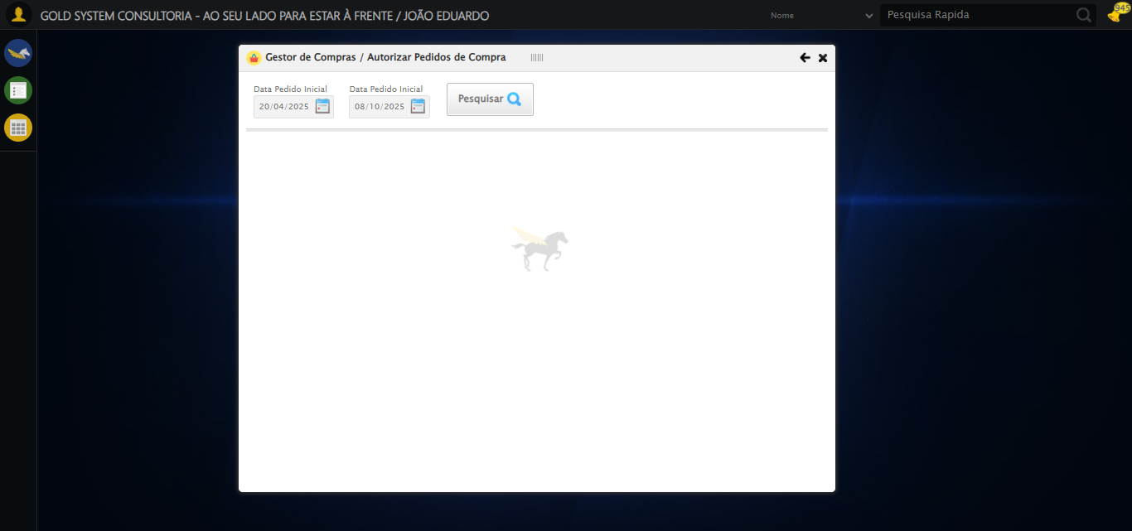

🔄 Verificando lista de Pedidos de Compra...

⚠️ Nenhum registro encontrado na lista de Pedidos de Compra.

🔄 Abrindo Detalhes do Pedido e Capturando screenshot...

❌ Erro inesperado ao abrindo detalhes do pedido e capturando screenshot: Message: invalid session id: session deleted as the browser has closed the connection  
from disconnected: not connected to DevTools  
 (Session info: chrome=140.0.7339.208); For documentation on this error, please visit: https://www.selenium.dev/documentation/webdriver/troubleshooting/errors#invalidsessionidexception  
Stacktrace:  
 GetHandleVerifier [0x0x2dc333+65459]  
 GetHandleVerifier [0x0x2dc374+65524]  
 (No symbol) [0x0xfd973]  
 (No symbol) [0x0xecdf0]  
 (No symbol) [0x0x10b4af]  
 (No symbol) [0x0x170775]  
 (No symbol) [0x0x18aef9]  
 (No symbol) [0x0x169bf6]  
 (No symbol) [0x0x13b38e]  
 (No symbol) [0x0x13c274]  
 GetHandleVerifier [0x0x55eda3+2697763]  
 GetHandleVerifier [0x0x559ec7+2677575]  
 GetHandleVerifier [0x0x304194+228884]  
 GetHandleVerifier [0x0x2f49f8+165496]  
 GetHandleVerifier [0x0x2fb18d+192013]  
 GetHandleVerifier [0x0x2e47d8+99416]  
 GetHandleVerifier [0x0x2e4972+99826]  
 GetHandleVerifier [0x0x2cebea+10346]  
 BaseThreadInitThunk [0x0x755bfcc9+25]  
 RtlGetAppContainerNamedObjectPath [0x0x773a82ae+286]  
 RtlGetAppContainerNamedObjectPath [0x0x773a827e+238]  
 (No symbol) [0x0]

⚠️ Erro ao tirar screenshot erro_abrindo detalhes do pedido e capturando screenshot: Message: invalid session id; For documentation on this error, please visit: https://www.selenium.dev/documentation/webdriver/troubleshooting/errors#invalidsessionidexception  
Stacktrace:  
 GetHandleVerifier [0x0x2dc333+65459]  
 GetHandleVerifier [0x0x2dc374+65524]  
 (No symbol) [0x0xfd7c0]  
 (No symbol) [0x0x13a663]  
 (No symbol) [0x0x169cb6]  
 (No symbol) [0x0x16555e]  
 (No symbol) [0x0x164ad3]  
 (No symbol) [0x0xce73d]  
 (No symbol) [0x0xcecbe]  
 (No symbol) [0x0xcf15d]  
 GetHandleVerifier [0x0x55eda3+2697763]  
 GetHandleVerifier [0x0x559ec7+2677575]  
 GetHandleVerifier [0x0x304194+228884]  
 GetHandleVerifier [0x0x2f49f8+165496]  
 GetHandleVerifier [0x0x2fb18d+192013]  
 (No symbol) [0x0xce3f2]  
 (No symbol) [0x0xcdb72]  
 GetHandleVerifier [0x0x6b340c+4092044]  
 BaseThreadInitThunk [0x0x755bfcc9+25]  
 RtlGetAppContainerNamedObjectPath [0x0x773a82ae+286]  
 RtlGetAppContainerNamedObjectPath [0x0x773a827e+238]  
 (No symbol) [0x0]

🔄 Clicando em Fechar...

❌ Erro inesperado ao clicando em fechar: Message: invalid session id; For documentation on this error, please visit: https://www.selenium.dev/documentation/webdriver/troubleshooting/errors#invalidsessionidexception  
Stacktrace:  
 GetHandleVerifier [0x0x2dc333+65459]  
 GetHandleVerifier [0x0x2dc374+65524]  
 (No symbol) [0x0xfd7c0]  
 (No symbol) [0x0x13a663]  
 (No symbol) [0x0x169cb6]  
 (No symbol) [0x0x16555e]  
 (No symbol) [0x0x164ad3]  
 (No symbol) [0x0xce73d]  
 (No symbol) [0x0xcecbe]  
 (No symbol) [0x0xcf15d]  
 GetHandleVerifier [0x0x55eda3+2697763]  
 GetHandleVerifier [0x0x559ec7+2677575]  
 GetHandleVerifier [0x0x304194+228884]  
 GetHandleVerifier [0x0x2f49f8+165496]  
 GetHandleVerifier [0x0x2fb18d+192013]  
 (No symbol) [0x0xce3f2]  
 (No symbol) [0x0xcdb72]  
 GetHandleVerifier [0x0x6b340c+4092044]  
 BaseThreadInitThunk [0x0x755bfcc9+25]  
 RtlGetAppContainerNamedObjectPath [0x0x773a82ae+286]  
 RtlGetAppContainerNamedObjectPath [0x0x773a827e+238]  
 (No symbol) [0x0]

⚠️ Erro ao tirar screenshot erro_clicando em fechar: Message: invalid session id; For documentation on this error, please visit: https://www.selenium.dev/documentation/webdriver/troubleshooting/errors#invalidsessionidexception  
Stacktrace:  
 GetHandleVerifier [0x0x2dc333+65459]  
 GetHandleVerifier [0x0x2dc374+65524]  
 (No symbol) [0x0xfd7c0]  
 (No symbol) [0x0x13a663]  
 (No symbol) [0x0x169cb6]  
 (No symbol) [0x0x16555e]  
 (No symbol) [0x0x164ad3]  
 (No symbol) [0x0xce73d]  
 (No symbol) [0x0xcecbe]  
 (No symbol) [0x0xcf15d]  
 GetHandleVerifier [0x0x55eda3+2697763]  
 GetHandleVerifier [0x0x559ec7+2677575]  
 GetHandleVerifier [0x0x304194+228884]  
 GetHandleVerifier [0x0x2f49f8+165496]  
 GetHandleVerifier [0x0x2fb18d+192013]  
 (No symbol) [0x0xce3f2]  
 (No symbol) [0x0xcdb72]  
 GetHandleVerifier [0x0x6b340c+4092044]  
 BaseThreadInitThunk [0x0x755bfcc9+25]  
 RtlGetAppContainerNamedObjectPath [0x0x773a82ae+286]  
 RtlGetAppContainerNamedObjectPath [0x0x773a827e+238]  
 (No symbol) [0x0]

🔄 Clicando em Aprovar Pedido...

❌ Erro inesperado ao clicando em aprovar pedido: Message: invalid session id; For documentation on this error, please visit: https://www.selenium.dev/documentation/webdriver/troubleshooting/errors#invalidsessionidexception  
Stacktrace:  
 GetHandleVerifier [0x0x2dc333+65459]  
 GetHandleVerifier [0x0x2dc374+65524]  
 (No symbol) [0x0xfd7c0]  
 (No symbol) [0x0x13a663]  
 (No symbol) [0x0x169cb6]  
 (No symbol) [0x0x16555e]  
 (No symbol) [0x0x164ad3]  
 (No symbol) [0x0xce73d]  
 (No symbol) [0x0xcecbe]  
 (No symbol) [0x0xcf15d]  
 GetHandleVerifier [0x0x55eda3+2697763]  
 GetHandleVerifier [0x0x559ec7+2677575]  
 GetHandleVerifier [0x0x304194+228884]  
 GetHandleVerifier [0x0x2f49f8+165496]  
 GetHandleVerifier [0x0x2fb18d+192013]  
 (No symbol) [0x0xce3f2]  
 (No symbol) [0x0xcdb72]  
 GetHandleVerifier [0x0x6b340c+4092044]  
 BaseThreadInitThunk [0x0x755bfcc9+25]  
 RtlGetAppContainerNamedObjectPath [0x0x773a82ae+286]  
 RtlGetAppContainerNamedObjectPath [0x0x773a827e+238]  
 (No symbol) [0x0]

⚠️ Erro ao tirar screenshot erro_clicando em aprovar pedido: Message: invalid session id; For documentation on this error, please visit: https://www.selenium.dev/documentation/webdriver/troubleshooting/errors#invalidsessionidexception  
Stacktrace:  
 GetHandleVerifier [0x0x2dc333+65459]  
 GetHandleVerifier [0x0x2dc374+65524]  
 (No symbol) [0x0xfd7c0]  
 (No symbol) [0x0x13a663]  
 (No symbol) [0x0x169cb6]  
 (No symbol) [0x0x16555e]  
 (No symbol) [0x0x164ad3]  
 (No symbol) [0x0xce73d]  
 (No symbol) [0x0xcecbe]  
 (No symbol) [0x0xcf15d]  
 GetHandleVerifier [0x0x55eda3+2697763]  
 GetHandleVerifier [0x0x559ec7+2677575]  
 GetHandleVerifier [0x0x304194+228884]  
 GetHandleVerifier [0x0x2f49f8+165496]  
 GetHandleVerifier [0x0x2fb18d+192013]  
 (No symbol) [0x0xce3f2]  
 (No symbol) [0x0xcdb72]  
 GetHandleVerifier [0x0x6b340c+4092044]  
 BaseThreadInitThunk [0x0x755bfcc9+25]  
 RtlGetAppContainerNamedObjectPath [0x0x773a82ae+286]  
 RtlGetAppContainerNamedObjectPath [0x0x773a827e+238]  
 (No symbol) [0x0]

🔄 Confirmando...

❌ Erro inesperado ao confirmando: Message: invalid session id; For documentation on this error, please visit: https://www.selenium.dev/documentation/webdriver/troubleshooting/errors#invalidsessionidexception  
Stacktrace:  
 GetHandleVerifier [0x0x2dc333+65459]  
 GetHandleVerifier [0x0x2dc374+65524]  
 (No symbol) [0x0xfd7c0]  
 (No symbol) [0x0x13a663]  
 (No symbol) [0x0x169cb6]  
 (No symbol) [0x0x16555e]  
 (No symbol) [0x0x164ad3]  
 (No symbol) [0x0xce73d]  
 (No symbol) [0x0xcecbe]  
 (No symbol) [0x0xcf15d]  
 GetHandleVerifier [0x0x55eda3+2697763]  
 GetHandleVerifier [0x0x559ec7+2677575]  
 GetHandleVerifier [0x0x304194+228884]  
 GetHandleVerifier [0x0x2f49f8+165496]  
 GetHandleVerifier [0x0x2fb18d+192013]  
 (No symbol) [0x0xce3f2]  
 (No symbol) [0x0xcdb72]  
 GetHandleVerifier [0x0x6b340c+4092044]  
 BaseThreadInitThunk [0x0x755bfcc9+25]  
 RtlGetAppContainerNamedObjectPath [0x0x773a82ae+286]  
 RtlGetAppContainerNamedObjectPath [0x0x773a827e+238]  
 (No symbol) [0x0]

⚠️ Erro ao tirar screenshot erro_confirmando: Message: invalid session id; For documentation on this error, please visit: https://www.selenium.dev/documentation/webdriver/troubleshooting/errors#invalidsessionidexception  
Stacktrace:  
 GetHandleVerifier [0x0x2dc333+65459]  
 GetHandleVerifier [0x0x2dc374+65524]  
 (No symbol) [0x0xfd7c0]  
 (No symbol) [0x0x13a663]  
 (No symbol) [0x0x169cb6]  
 (No symbol) [0x0x16555e]  
 (No symbol) [0x0x164ad3]  
 (No symbol) [0x0xce73d]  
 (No symbol) [0x0xcecbe]  
 (No symbol) [0x0xcf15d]  
 GetHandleVerifier [0x0x55eda3+2697763]  
 GetHandleVerifier [0x0x559ec7+2677575]  
 GetHandleVerifier [0x0x304194+228884]  
 GetHandleVerifier [0x0x2f49f8+165496]  
 GetHandleVerifier [0x0x2fb18d+192013]  
 (No symbol) [0x0xce3f2]  
 (No symbol) [0x0xcdb72]  
 GetHandleVerifier [0x0x6b340c+4092044]  
 BaseThreadInitThunk [0x0x755bfcc9+25]  
 RtlGetAppContainerNamedObjectPath [0x0x773a82ae+286]  
 RtlGetAppContainerNamedObjectPath [0x0x773a827e+238]  
 (No symbol) [0x0]

🔍 Verificando mensagens de alerta...

ℹ️ Nenhuma mensagem de alerta encontrada.

🔄 Fechando modal Gestor de Compras...

❌ Erro ao clicar robusto: Message: invalid session id; For documentation on this error, please visit: https://www.selenium.dev/documentation/webdriver/troubleshooting/errors#invalidsessionidexception  
Stacktrace:  
 GetHandleVerifier [0x0x2dc333+65459]  
 GetHandleVerifier [0x0x2dc374+65524]  
 (No symbol) [0x0xfd7c0]  
 (No symbol) [0x0x13a663]  
 (No symbol) [0x0x169cb6]  
 (No symbol) [0x0x16555e]  
 (No symbol) [0x0x164ad3]  
 (No symbol) [0x0xce73d]  
 (No symbol) [0x0xcecbe]  
 (No symbol) [0x0xcf15d]  
 GetHandleVerifier [0x0x55eda3+2697763]  
 GetHandleVerifier [0x0x559ec7+2677575]  
 GetHandleVerifier [0x0x304194+228884]  
 GetHandleVerifier [0x0x2f49f8+165496]  
 GetHandleVerifier [0x0x2fb18d+192013]  
 (No symbol) [0x0xce3f2]  
 (No symbol) [0x0xcdb72]  
 GetHandleVerifier [0x0x6b340c+4092044]  
 BaseThreadInitThunk [0x0x755bfcc9+25]  
 RtlGetAppContainerNamedObjectPath [0x0x773a82ae+286]  
 RtlGetAppContainerNamedObjectPath [0x0x773a827e+238]  
 (No symbol) [0x0]

✅ Fechando modal Gestor de Compras realizada com sucesso.

⚠️ Erro ao tirar screenshot fechando modal gestor de compras: Message: invalid session id; For documentation on this error, please visit: https://www.selenium.dev/documentation/webdriver/troubleshooting/errors#invalidsessionidexception  
Stacktrace:  
 GetHandleVerifier [0x0x2dc333+65459]  
 GetHandleVerifier [0x0x2dc374+65524]  
 (No symbol) [0x0xfd7c0]  
 (No symbol) [0x0x13a663]  
 (No symbol) [0x0x169cb6]  
 (No symbol) [0x0x16555e]  
 (No symbol) [0x0x164ad3]  
 (No symbol) [0x0xce73d]  
 (No symbol) [0x0xcecbe]  
 (No symbol) [0x0xcf15d]  
 GetHandleVerifier [0x0x55eda3+2697763]  
 GetHandleVerifier [0x0x559ec7+2677575]  
 GetHandleVerifier [0x0x304194+228884]  
 GetHandleVerifier [0x0x2f49f8+165496]  
 GetHandleVerifier [0x0x2fb18d+192013]  
 (No symbol) [0x0xce3f2]  
 (No symbol) [0x0xcdb72]  
 GetHandleVerifier [0x0x6b340c+4092044]  
 BaseThreadInitThunk [0x0x755bfcc9+25]  
 RtlGetAppContainerNamedObjectPath [0x0x773a82ae+286]  
 RtlGetAppContainerNamedObjectPath [0x0x773a827e+238]  
 (No symbol) [0x0]

✅ Teste concluído.

✅ Teste executado com sucesso!