RELATÓRIO DO TESTE

Cadastro de Contato Externo (CRM) – Cenário 1: Preenchimento completo e salvamento.

Data do teste: 11/08/2025 14:24:04

🚀 Iniciando teste de cadastro de CRM/Contato Externo...

🔄 Acessando sistema...

✅ Acessando sistema realizada com sucesso.

Screenshot: acessando_sistema

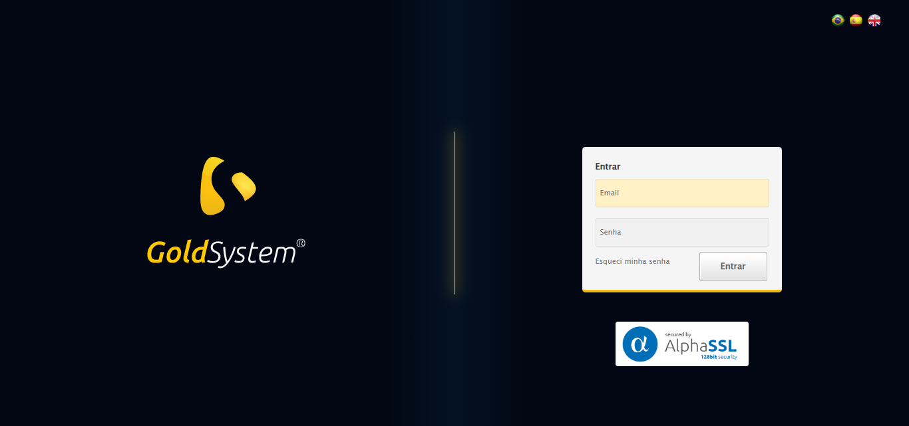

🔄 Realizando login...

✅ Realizando login realizada com sucesso.

Screenshot: realizando_login

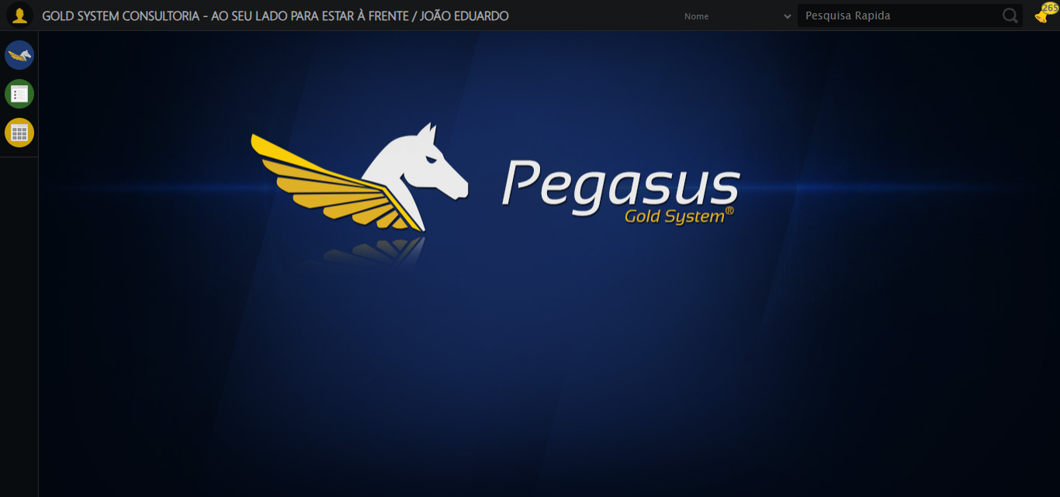

🔄 Ajustando zoom e abrindo menu...

🔍 Zoom ajustado para 90%.

✅ Ajustando zoom e abrindo menu realizada com sucesso.

Screenshot: ajustando_zoom_e_abrindo_menu

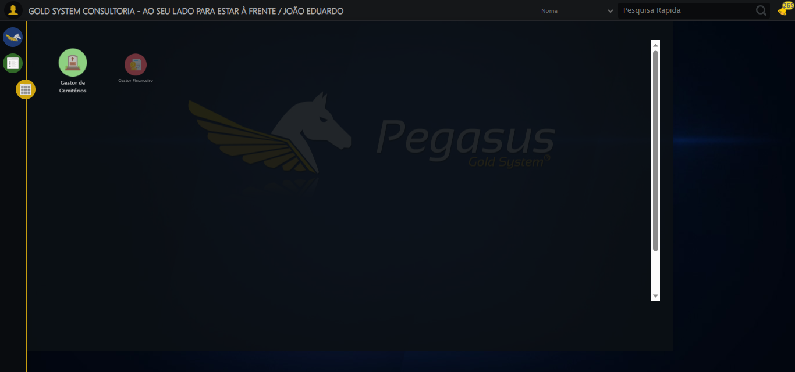

🔄 Acessando CRM...

✅ Acessando CRM realizada com sucesso.

Screenshot: acessando_crm

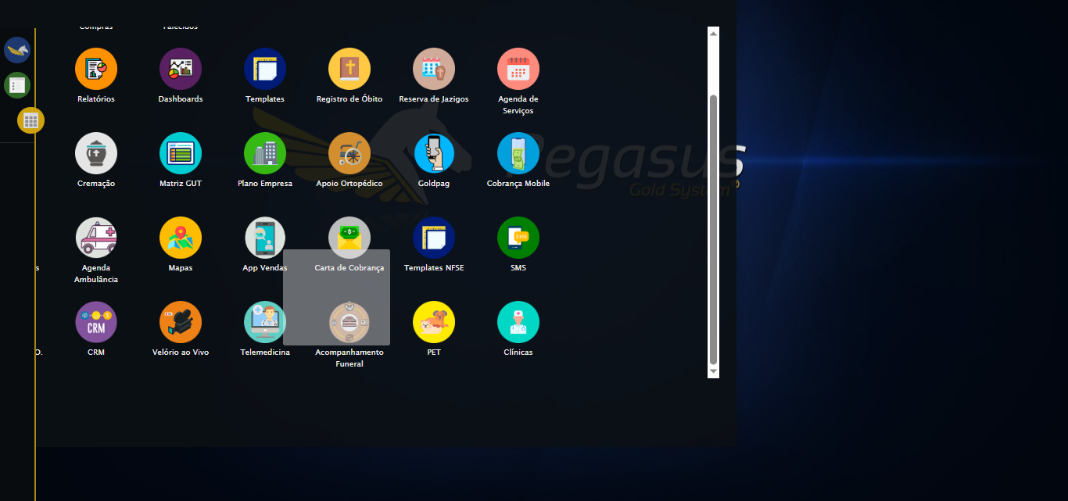

🔄 Clicando em Cadastrar Contato Externo...

✅ Clicando em Cadastrar Contato Externo realizada com sucesso.

Screenshot: clicando_em_cadastrar_contato_externo

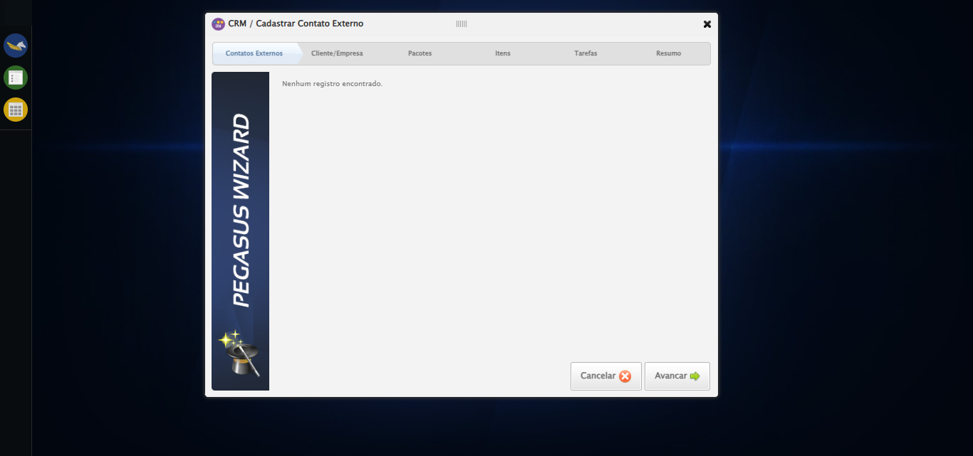

🔄 Avançando para aba: 'Cliente/Empresa'...

❌ Erro ao interagir com elemento #gsCrm > div.wdTelas > div:nth-child(4) > div.btnHolder > a:nth-child(3): Message:   
Stacktrace:  
 GetHandleVerifier [0x0x73ba83+63395]  
 GetHandleVerifier [0x0x73bac4+63460]  
 (No symbol) [0x0x582113]  
 (No symbol) [0x0x5ca85e]  
 (No symbol) [0x0x5cabfb]  
 (No symbol) [0x0x612f92]  
 (No symbol) [0x0x5ef3f4]  
 (No symbol) [0x0x6107ba]  
 (No symbol) [0x0x5ef1a6]  
 (No symbol) [0x0x5be7b2]  
 (No symbol) [0x0x5bf654]  
 GetHandleVerifier [0x0x9b8883+2672035]  
 GetHandleVerifier [0x0x9b3cba+2652634]  
 GetHandleVerifier [0x0x762bca+223466]  
 GetHandleVerifier [0x0x752cb8+158168]  
 GetHandleVerifier [0x0x75978d+185517]  
 GetHandleVerifier [0x0x743b78+96408]  
 GetHandleVerifier [0x0x743d02+96802]  
 GetHandleVerifier [0x0x72e90a+9770]  
 BaseThreadInitThunk [0x0x773dfcc9+25]  
 RtlGetAppContainerNamedObjectPath [0x0x77ba82ae+286]  
 RtlGetAppContainerNamedObjectPath [0x0x77ba827e+238]

❌ Erro inesperado ao avançando para aba: 'cliente/empresa': Não foi possível clicar no elemento: #gsCrm > div.wdTelas > div:nth-child(4) > div.btnHolder > a:nth-child(3)

Screenshot: erro_avançando_para_aba:_'cliente/empresa'

⚠️ Erro ao tirar screenshot erro_avançando_para_aba:_'cliente/empresa': [Errno 22] Invalid argument: "screenshots/erro_avançando_para_aba:_'cliente/empresa'.png"

🔄 Selecionando Cliente...

❌ Erro ao interagir com elemento #ui-id-17 > div:nth-child(1) > div:nth-child(1) > div > a: Message:   
Stacktrace:  
 GetHandleVerifier [0x0x73ba83+63395]  
 GetHandleVerifier [0x0x73bac4+63460]  
 (No symbol) [0x0x582113]  
 (No symbol) [0x0x5ca85e]  
 (No symbol) [0x0x5cabfb]  
 (No symbol) [0x0x612f92]  
 (No symbol) [0x0x5ef3f4]  
 (No symbol) [0x0x6107ba]  
 (No symbol) [0x0x5ef1a6]  
 (No symbol) [0x0x5be7b2]  
 (No symbol) [0x0x5bf654]  
 GetHandleVerifier [0x0x9b8883+2672035]  
 GetHandleVerifier [0x0x9b3cba+2652634]  
 GetHandleVerifier [0x0x762bca+223466]  
 GetHandleVerifier [0x0x752cb8+158168]  
 GetHandleVerifier [0x0x75978d+185517]  
 GetHandleVerifier [0x0x743b78+96408]  
 GetHandleVerifier [0x0x743d02+96802]  
 GetHandleVerifier [0x0x72e90a+9770]  
 BaseThreadInitThunk [0x0x773dfcc9+25]  
 RtlGetAppContainerNamedObjectPath [0x0x77ba82ae+286]  
 RtlGetAppContainerNamedObjectPath [0x0x77ba827e+238]

⚠️ Tentativa 1 falhou para Selecionando Cliente, tentando novamente...

🔄 Selecionando Cliente... (Tentativa 2)

❌ Erro ao interagir com elemento #ui-id-17 > div:nth-child(1) > div:nth-child(1) > div > a: Message:   
Stacktrace:  
 GetHandleVerifier [0x0x73ba83+63395]  
 GetHandleVerifier [0x0x73bac4+63460]  
 (No symbol) [0x0x582113]  
 (No symbol) [0x0x5ca85e]  
 (No symbol) [0x0x5cabfb]  
 (No symbol) [0x0x612f92]  
 (No symbol) [0x0x5ef3f4]  
 (No symbol) [0x0x6107ba]  
 (No symbol) [0x0x5ef1a6]  
 (No symbol) [0x0x5be7b2]  
 (No symbol) [0x0x5bf654]  
 GetHandleVerifier [0x0x9b8883+2672035]  
 GetHandleVerifier [0x0x9b3cba+2652634]  
 GetHandleVerifier [0x0x762bca+223466]  
 GetHandleVerifier [0x0x752cb8+158168]  
 GetHandleVerifier [0x0x75978d+185517]  
 GetHandleVerifier [0x0x743b78+96408]  
 GetHandleVerifier [0x0x743d02+96802]  
 GetHandleVerifier [0x0x72e90a+9770]  
 BaseThreadInitThunk [0x0x773dfcc9+25]  
 RtlGetAppContainerNamedObjectPath [0x0x77ba82ae+286]  
 RtlGetAppContainerNamedObjectPath [0x0x77ba827e+238]

⚠️ Tentativa 2 falhou para Selecionando Cliente, tentando novamente...

🔄 Selecionando Cliente... (Tentativa 3)

❌ Erro ao interagir com elemento #ui-id-17 > div:nth-child(1) > div:nth-child(1) > div > a: Message:   
Stacktrace:  
 GetHandleVerifier [0x0x73ba83+63395]  
 GetHandleVerifier [0x0x73bac4+63460]  
 (No symbol) [0x0x582113]  
 (No symbol) [0x0x5ca85e]  
 (No symbol) [0x0x5cabfb]  
 (No symbol) [0x0x612f92]  
 (No symbol) [0x0x5ef3f4]  
 (No symbol) [0x0x6107ba]  
 (No symbol) [0x0x5ef1a6]  
 (No symbol) [0x0x5be7b2]  
 (No symbol) [0x0x5bf654]  
 GetHandleVerifier [0x0x9b8883+2672035]  
 GetHandleVerifier [0x0x9b3cba+2652634]  
 GetHandleVerifier [0x0x762bca+223466]  
 GetHandleVerifier [0x0x752cb8+158168]  
 GetHandleVerifier [0x0x75978d+185517]  
 GetHandleVerifier [0x0x743b78+96408]  
 GetHandleVerifier [0x0x743d02+96802]  
 GetHandleVerifier [0x0x72e90a+9770]  
 BaseThreadInitThunk [0x0x773dfcc9+25]  
 RtlGetAppContainerNamedObjectPath [0x0x77ba82ae+286]  
 RtlGetAppContainerNamedObjectPath [0x0x77ba827e+238]

❌ Erro ao selecionando cliente após 3 tentativas: Message:   
Stacktrace:  
 GetHandleVerifier [0x0x73ba83+63395]  
 GetHandleVerifier [0x0x73bac4+63460]  
 (No symbol) [0x0x582113]  
 (No symbol) [0x0x5ca85e]  
 (No symbol) [0x0x5cabfb]  
 (No symbol) [0x0x612f92]  
 (No symbol) [0x0x5ef3f4]  
 (No symbol) [0x0x6107ba]  
 (No symbol) [0x0x5ef1a6]  
 (No symbol) [0x0x5be7b2]  
 (No symbol) [0x0x5bf654]  
 GetHandleVerifier [0x0x9b8883+2672035]  
 GetHandleVerifier [0x0x9b3cba+2652634]  
 GetHandleVerifier [0x0x762bca+223466]  
 GetHandleVerifier [0x0x752cb8+158168]  
 GetHandleVerifier [0x0x75978d+185517]  
 GetHandleVerifier [0x0x743b78+96408]  
 GetHandleVerifier [0x0x743d02+96802]  
 GetHandleVerifier [0x0x72e90a+9770]  
 BaseThreadInitThunk [0x0x773dfcc9+25]  
 RtlGetAppContainerNamedObjectPath [0x0x77ba82ae+286]  
 RtlGetAppContainerNamedObjectPath [0x0x77ba827e+238]

Screenshot: erro_selecionando_cliente

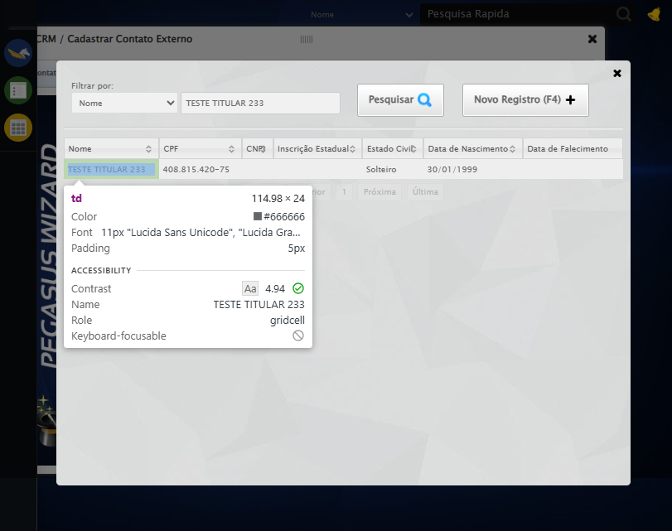

🔄 Salvando Cliente...

❌ Erro ao interagir com elemento #ui-id-17 > div:nth-child(10) > div:nth-child(5) > a: Message:   
Stacktrace:  
 GetHandleVerifier [0x0x73ba83+63395]  
 GetHandleVerifier [0x0x73bac4+63460]  
 (No symbol) [0x0x582113]  
 (No symbol) [0x0x5ca85e]  
 (No symbol) [0x0x5cabfb]  
 (No symbol) [0x0x612f92]  
 (No symbol) [0x0x5ef3f4]  
 (No symbol) [0x0x6107ba]  
 (No symbol) [0x0x5ef1a6]  
 (No symbol) [0x0x5be7b2]  
 (No symbol) [0x0x5bf654]  
 GetHandleVerifier [0x0x9b8883+2672035]  
 GetHandleVerifier [0x0x9b3cba+2652634]  
 GetHandleVerifier [0x0x762bca+223466]  
 GetHandleVerifier [0x0x752cb8+158168]  
 GetHandleVerifier [0x0x75978d+185517]  
 GetHandleVerifier [0x0x743b78+96408]  
 GetHandleVerifier [0x0x743d02+96802]  
 GetHandleVerifier [0x0x72e90a+9770]  
 BaseThreadInitThunk [0x0x773dfcc9+25]  
 RtlGetAppContainerNamedObjectPath [0x0x77ba82ae+286]  
 RtlGetAppContainerNamedObjectPath [0x0x77ba827e+238]

❌ Erro inesperado ao salvando cliente: Não foi possível clicar no elemento: #ui-id-17 > div:nth-child(10) > div:nth-child(5) > a

Screenshot: erro_salvando_cliente

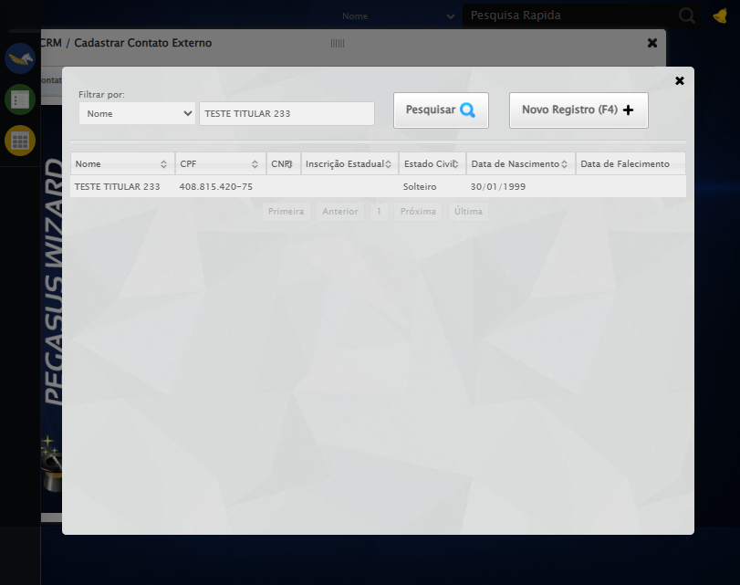

🔄 Avançando para aba: 'Pacotes'...

❌ Erro ao interagir com elemento #gsCrm > div.wdTelas > div:nth-child(4) > div.btnHolder > a:nth-child(3): Message:   
Stacktrace:  
 GetHandleVerifier [0x0x73ba83+63395]  
 GetHandleVerifier [0x0x73bac4+63460]  
 (No symbol) [0x0x582113]  
 (No symbol) [0x0x5ca85e]  
 (No symbol) [0x0x5cabfb]  
 (No symbol) [0x0x612f92]  
 (No symbol) [0x0x5ef3f4]  
 (No symbol) [0x0x6107ba]  
 (No symbol) [0x0x5ef1a6]  
 (No symbol) [0x0x5be7b2]  
 (No symbol) [0x0x5bf654]  
 GetHandleVerifier [0x0x9b8883+2672035]  
 GetHandleVerifier [0x0x9b3cba+2652634]  
 GetHandleVerifier [0x0x762bca+223466]  
 GetHandleVerifier [0x0x752cb8+158168]  
 GetHandleVerifier [0x0x75978d+185517]  
 GetHandleVerifier [0x0x743b78+96408]  
 GetHandleVerifier [0x0x743d02+96802]  
 GetHandleVerifier [0x0x72e90a+9770]  
 BaseThreadInitThunk [0x0x773dfcc9+25]  
 RtlGetAppContainerNamedObjectPath [0x0x77ba82ae+286]  
 RtlGetAppContainerNamedObjectPath [0x0x77ba827e+238]

❌ Erro inesperado ao avançando para aba: 'pacotes': Não foi possível clicar no elemento: #gsCrm > div.wdTelas > div:nth-child(4) > div.btnHolder > a:nth-child(3)

Screenshot: erro_avançando_para_aba:_'pacotes'

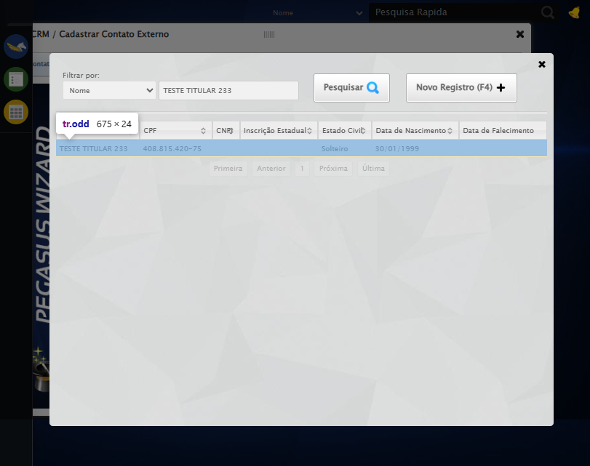

🔄 Selecionando Pacote...

❌ Erro ao interagir com elemento #gsCrm > div.wdTelas > div:nth-child(4) > div.wizardHolder > div > div.stepPacote.step3 > div > div > div > div > a: Message:   
Stacktrace:  
 GetHandleVerifier [0x0x73ba83+63395]  
 GetHandleVerifier [0x0x73bac4+63460]  
 (No symbol) [0x0x582113]  
 (No symbol) [0x0x5ca85e]  
 (No symbol) [0x0x5cabfb]  
 (No symbol) [0x0x612f92]  
 (No symbol) [0x0x5ef3f4]  
 (No symbol) [0x0x6107ba]  
 (No symbol) [0x0x5ef1a6]  
 (No symbol) [0x0x5be7b2]  
 (No symbol) [0x0x5bf654]  
 GetHandleVerifier [0x0x9b8883+2672035]  
 GetHandleVerifier [0x0x9b3cba+2652634]  
 GetHandleVerifier [0x0x762bca+223466]  
 GetHandleVerifier [0x0x752cb8+158168]  
 GetHandleVerifier [0x0x75978d+185517]  
 GetHandleVerifier [0x0x743b78+96408]  
 GetHandleVerifier [0x0x743d02+96802]  
 GetHandleVerifier [0x0x72e90a+9770]  
 BaseThreadInitThunk [0x0x773dfcc9+25]  
 RtlGetAppContainerNamedObjectPath [0x0x77ba82ae+286]  
 RtlGetAppContainerNamedObjectPath [0x0x77ba827e+238]

⚠️ Tentativa 1 falhou para Selecionando Pacote, tentando novamente...

🔄 Selecionando Pacote... (Tentativa 2)

❌ Erro ao interagir com elemento #gsCrm > div.wdTelas > div:nth-child(4) > div.wizardHolder > div > div.stepPacote.step3 > div > div > div > div > a: Message:   
Stacktrace:  
 GetHandleVerifier [0x0x73ba83+63395]  
 GetHandleVerifier [0x0x73bac4+63460]  
 (No symbol) [0x0x582113]  
 (No symbol) [0x0x5ca85e]  
 (No symbol) [0x0x5cabfb]  
 (No symbol) [0x0x612f92]  
 (No symbol) [0x0x5ef3f4]  
 (No symbol) [0x0x6107ba]  
 (No symbol) [0x0x5ef1a6]  
 (No symbol) [0x0x5be7b2]  
 (No symbol) [0x0x5bf654]  
 GetHandleVerifier [0x0x9b8883+2672035]  
 GetHandleVerifier [0x0x9b3cba+2652634]  
 GetHandleVerifier [0x0x762bca+223466]  
 GetHandleVerifier [0x0x752cb8+158168]  
 GetHandleVerifier [0x0x75978d+185517]  
 GetHandleVerifier [0x0x743b78+96408]  
 GetHandleVerifier [0x0x743d02+96802]  
 GetHandleVerifier [0x0x72e90a+9770]  
 BaseThreadInitThunk [0x0x773dfcc9+25]  
 RtlGetAppContainerNamedObjectPath [0x0x77ba82ae+286]  
 RtlGetAppContainerNamedObjectPath [0x0x77ba827e+238]

⚠️ Tentativa 2 falhou para Selecionando Pacote, tentando novamente...

🔄 Selecionando Pacote... (Tentativa 3)

❌ Erro ao interagir com elemento #gsCrm > div.wdTelas > div:nth-child(4) > div.wizardHolder > div > div.stepPacote.step3 > div > div > div > div > a: Message:   
Stacktrace:  
 GetHandleVerifier [0x0x73ba83+63395]  
 GetHandleVerifier [0x0x73bac4+63460]  
 (No symbol) [0x0x582113]  
 (No symbol) [0x0x5ca85e]  
 (No symbol) [0x0x5cabfb]  
 (No symbol) [0x0x612f92]  
 (No symbol) [0x0x5ef3f4]  
 (No symbol) [0x0x6107ba]  
 (No symbol) [0x0x5ef1a6]  
 (No symbol) [0x0x5be7b2]  
 (No symbol) [0x0x5bf654]  
 GetHandleVerifier [0x0x9b8883+2672035]  
 GetHandleVerifier [0x0x9b3cba+2652634]  
 GetHandleVerifier [0x0x762bca+223466]  
 GetHandleVerifier [0x0x752cb8+158168]  
 GetHandleVerifier [0x0x75978d+185517]  
 GetHandleVerifier [0x0x743b78+96408]  
 GetHandleVerifier [0x0x743d02+96802]  
 GetHandleVerifier [0x0x72e90a+9770]  
 BaseThreadInitThunk [0x0x773dfcc9+25]  
 RtlGetAppContainerNamedObjectPath [0x0x77ba82ae+286]  
 RtlGetAppContainerNamedObjectPath [0x0x77ba827e+238]

❌ Erro ao selecionando pacote após 3 tentativas: Message:   
Stacktrace:  
 GetHandleVerifier [0x0x73ba83+63395]  
 GetHandleVerifier [0x0x73bac4+63460]  
 (No symbol) [0x0x582113]  
 (No symbol) [0x0x5ca85e]  
 (No symbol) [0x0x5cabfb]  
 (No symbol) [0x0x612f92]  
 (No symbol) [0x0x5ef3f4]  
 (No symbol) [0x0x6107ba]  
 (No symbol) [0x0x5ef1a6]  
 (No symbol) [0x0x5be7b2]  
 (No symbol) [0x0x5bf654]  
 GetHandleVerifier [0x0x9b8883+2672035]  
 GetHandleVerifier [0x0x9b3cba+2652634]  
 GetHandleVerifier [0x0x762bca+223466]  
 GetHandleVerifier [0x0x752cb8+158168]  
 GetHandleVerifier [0x0x75978d+185517]  
 GetHandleVerifier [0x0x743b78+96408]  
 GetHandleVerifier [0x0x743d02+96802]  
 GetHandleVerifier [0x0x72e90a+9770]  
 BaseThreadInitThunk [0x0x773dfcc9+25]  
 RtlGetAppContainerNamedObjectPath [0x0x77ba82ae+286]  
 RtlGetAppContainerNamedObjectPath [0x0x77ba827e+238]

Screenshot: erro_selecionando_pacote

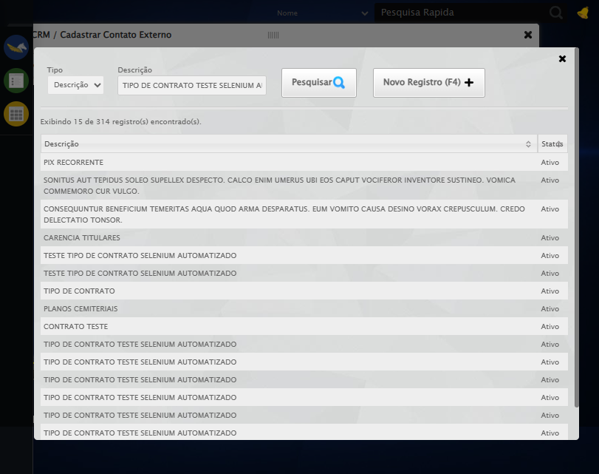

🔄 Selecionando Pacote...

✅ Selecionando Pacote realizada com sucesso.

Screenshot: selecionando_pacote

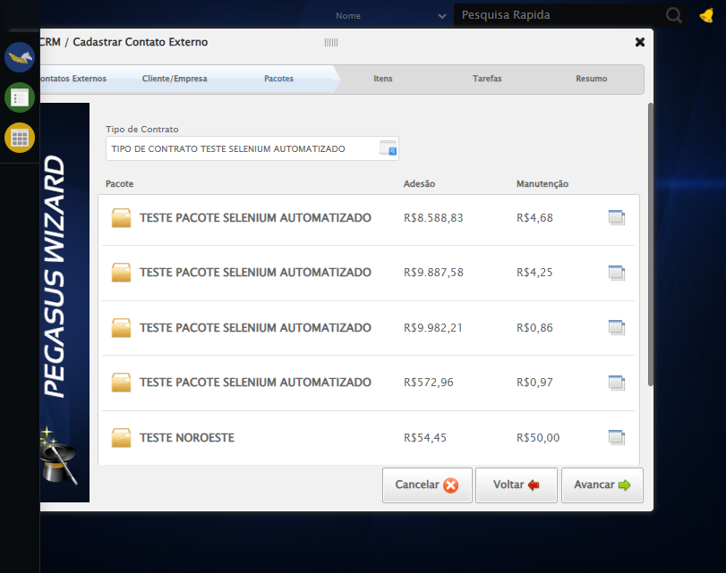

🔄 Avançando para aba: 'Itens'...

❌ Erro ao interagir com elemento #gsCrm > div.wdTelas > div:nth-child(4) > div.btnHolder > a:nth-child(3): Message:   
Stacktrace:  
 GetHandleVerifier [0x0x73ba83+63395]  
 GetHandleVerifier [0x0x73bac4+63460]  
 (No symbol) [0x0x582113]  
 (No symbol) [0x0x5ca85e]  
 (No symbol) [0x0x5cabfb]  
 (No symbol) [0x0x612f92]  
 (No symbol) [0x0x5ef3f4]  
 (No symbol) [0x0x6107ba]  
 (No symbol) [0x0x5ef1a6]  
 (No symbol) [0x0x5be7b2]  
 (No symbol) [0x0x5bf654]  
 GetHandleVerifier [0x0x9b8883+2672035]  
 GetHandleVerifier [0x0x9b3cba+2652634]  
 GetHandleVerifier [0x0x762bca+223466]  
 GetHandleVerifier [0x0x752cb8+158168]  
 GetHandleVerifier [0x0x75978d+185517]  
 GetHandleVerifier [0x0x743b78+96408]  
 GetHandleVerifier [0x0x743d02+96802]  
 GetHandleVerifier [0x0x72e90a+9770]  
 BaseThreadInitThunk [0x0x773dfcc9+25]  
 RtlGetAppContainerNamedObjectPath [0x0x77ba82ae+286]  
 RtlGetAppContainerNamedObjectPath [0x0x77ba827e+238]

❌ Erro inesperado ao avançando para aba: 'itens': Não foi possível clicar no elemento: #gsCrm > div.wdTelas > div:nth-child(4) > div.btnHolder > a:nth-child(3)

Screenshot: erro_avançando_para_aba:_'itens'

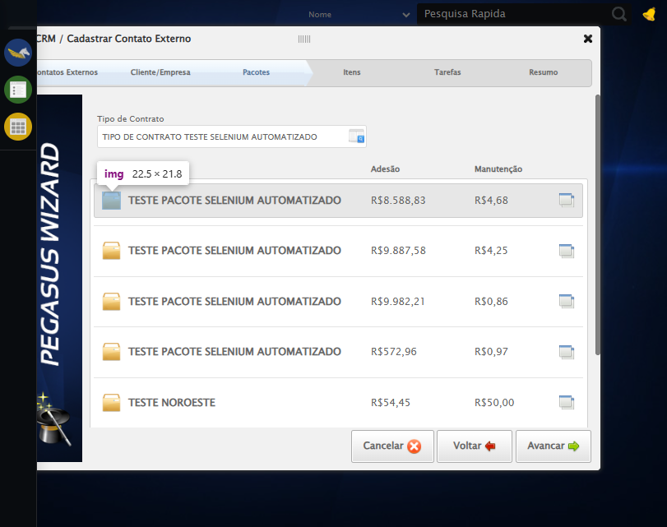

🔄 Selecionando Item...

❌ Erro ao interagir com elemento #gsCrm > div.wdTelas > div:nth-child(4) > div.wizardHolder > div > div.stepItem.step4 > div.tableProdutos > div.tbHeader > ul > li:nth-child(1) > div > div > a: Message:   
Stacktrace:  
 GetHandleVerifier [0x0x73ba83+63395]  
 GetHandleVerifier [0x0x73bac4+63460]  
 (No symbol) [0x0x582113]  
 (No symbol) [0x0x5ca85e]  
 (No symbol) [0x0x5cabfb]  
 (No symbol) [0x0x612f92]  
 (No symbol) [0x0x5ef3f4]  
 (No symbol) [0x0x6107ba]  
 (No symbol) [0x0x5ef1a6]  
 (No symbol) [0x0x5be7b2]  
 (No symbol) [0x0x5bf654]  
 GetHandleVerifier [0x0x9b8883+2672035]  
 GetHandleVerifier [0x0x9b3cba+2652634]  
 GetHandleVerifier [0x0x762bca+223466]  
 GetHandleVerifier [0x0x752cb8+158168]  
 GetHandleVerifier [0x0x75978d+185517]  
 GetHandleVerifier [0x0x743b78+96408]  
 GetHandleVerifier [0x0x743d02+96802]  
 GetHandleVerifier [0x0x72e90a+9770]  
 BaseThreadInitThunk [0x0x773dfcc9+25]  
 RtlGetAppContainerNamedObjectPath [0x0x77ba82ae+286]  
 RtlGetAppContainerNamedObjectPath [0x0x77ba827e+238]

✅ Selecionando Item realizada com sucesso.

Screenshot: selecionando_item

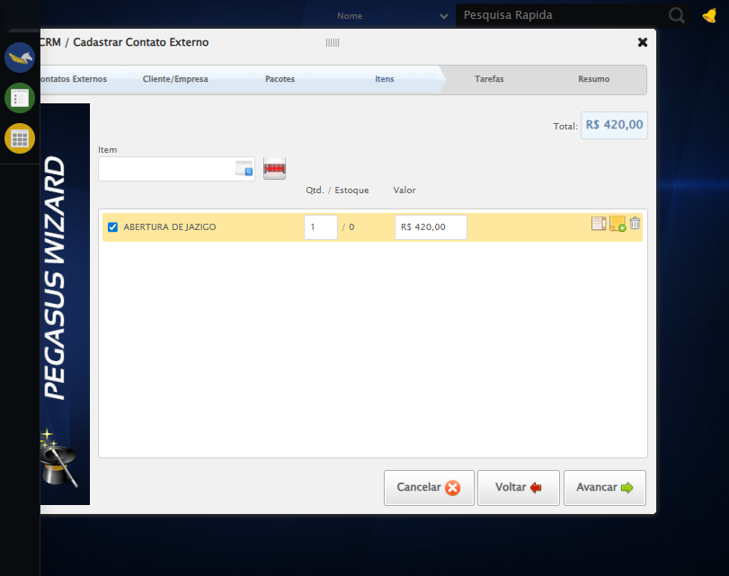

🔄 Avançando para aba: 'Tarefas'...

❌ Erro ao interagir com elemento #gsCrm > div.wdTelas > div:nth-child(4) > div.btnHolder > a:nth-child(3): Message:   
Stacktrace:  
 GetHandleVerifier [0x0x73ba83+63395]  
 GetHandleVerifier [0x0x73bac4+63460]  
 (No symbol) [0x0x582113]  
 (No symbol) [0x0x5ca85e]  
 (No symbol) [0x0x5cabfb]  
 (No symbol) [0x0x612f92]  
 (No symbol) [0x0x5ef3f4]  
 (No symbol) [0x0x6107ba]  
 (No symbol) [0x0x5ef1a6]  
 (No symbol) [0x0x5be7b2]  
 (No symbol) [0x0x5bf654]  
 GetHandleVerifier [0x0x9b8883+2672035]  
 GetHandleVerifier [0x0x9b3cba+2652634]  
 GetHandleVerifier [0x0x762bca+223466]  
 GetHandleVerifier [0x0x752cb8+158168]  
 GetHandleVerifier [0x0x75978d+185517]  
 GetHandleVerifier [0x0x743b78+96408]  
 GetHandleVerifier [0x0x743d02+96802]  
 GetHandleVerifier [0x0x72e90a+9770]  
 BaseThreadInitThunk [0x0x773dfcc9+25]  
 RtlGetAppContainerNamedObjectPath [0x0x77ba82ae+286]  
 RtlGetAppContainerNamedObjectPath [0x0x77ba827e+238]

❌ Erro inesperado ao avançando para aba: 'tarefas': Não foi possível clicar no elemento: #gsCrm > div.wdTelas > div:nth-child(4) > div.btnHolder > a:nth-child(3)

Screenshot: erro_avançando_para_aba:_'tarefas'

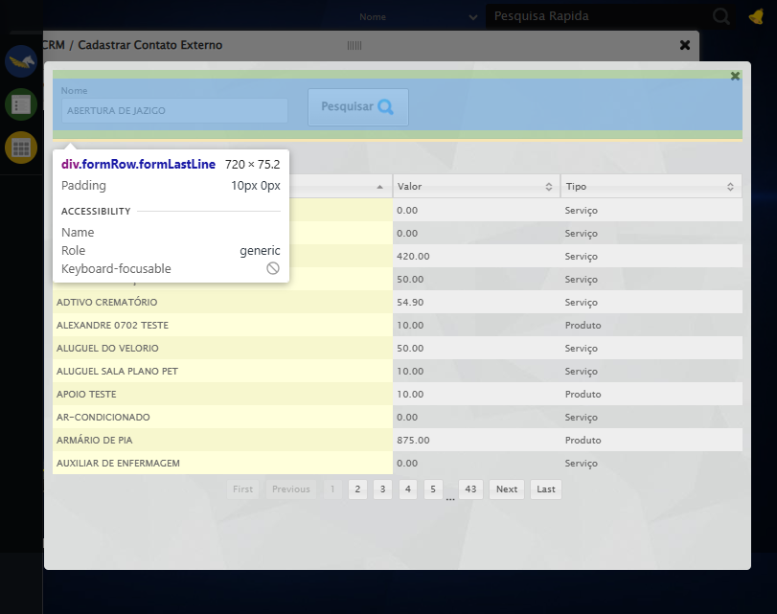

🔄 Selecionando Tipo de Tarefa...

⚠️ Tentativa 1 falhou para Selecionando Tipo de Tarefa, tentando novamente...

🔄 Selecionando Tipo de Tarefa... (Tentativa 2)

⚠️ Tentativa 2 falhou para Selecionando Tipo de Tarefa, tentando novamente...

🔄 Selecionando Tipo de Tarefa... (Tentativa 3)

❌ Erro ao selecionando tipo de tarefa após 3 tentativas: Message:   
Stacktrace:  
 GetHandleVerifier [0x0x73ba83+63395]  
 GetHandleVerifier [0x0x73bac4+63460]  
 (No symbol) [0x0x582113]  
 (No symbol) [0x0x5ca85e]  
 (No symbol) [0x0x5cabfb]  
 (No symbol) [0x0x612f92]  
 (No symbol) [0x0x5ef3f4]  
 (No symbol) [0x0x6107ba]  
 (No symbol) [0x0x5ef1a6]  
 (No symbol) [0x0x5be7b2]  
 (No symbol) [0x0x5bf654]  
 GetHandleVerifier [0x0x9b8883+2672035]  
 GetHandleVerifier [0x0x9b3cba+2652634]  
 GetHandleVerifier [0x0x762bca+223466]  
 GetHandleVerifier [0x0x752cb8+158168]  
 GetHandleVerifier [0x0x75978d+185517]  
 GetHandleVerifier [0x0x743b78+96408]  
 GetHandleVerifier [0x0x743d02+96802]  
 GetHandleVerifier [0x0x72e90a+9770]  
 BaseThreadInitThunk [0x0x773dfcc9+25]  
 RtlGetAppContainerNamedObjectPath [0x0x77ba82ae+286]  
 RtlGetAppContainerNamedObjectPath [0x0x77ba827e+238]

Screenshot: erro_selecionando_tipo_de_tarefa

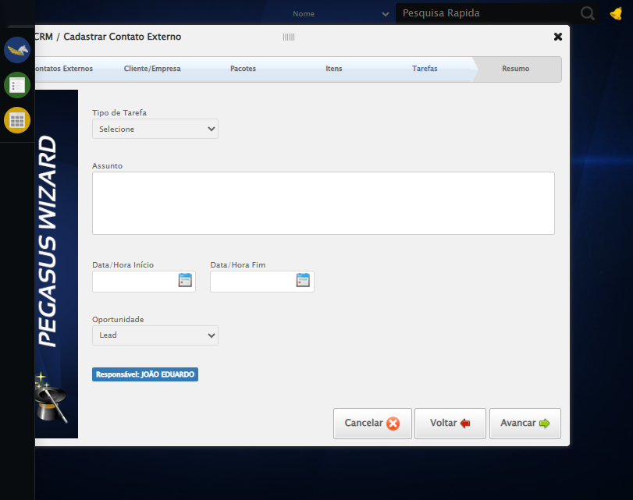

🔄 Preechendo Assunto...

⚠️ Tentativa 1 falhou para Preechendo Assunto, tentando novamente...

🔄 Preechendo Assunto... (Tentativa 2)

⚠️ Tentativa 2 falhou para Preechendo Assunto, tentando novamente...

🔄 Preechendo Assunto... (Tentativa 3)

❌ Erro ao preechendo assunto após 3 tentativas: Message:   
Stacktrace:  
 GetHandleVerifier [0x0x73ba83+63395]  
 GetHandleVerifier [0x0x73bac4+63460]  
 (No symbol) [0x0x582113]  
 (No symbol) [0x0x5ca85e]  
 (No symbol) [0x0x5cabfb]  
 (No symbol) [0x0x612f92]  
 (No symbol) [0x0x5ef3f4]  
 (No symbol) [0x0x6107ba]  
 (No symbol) [0x0x5ef1a6]  
 (No symbol) [0x0x5be7b2]  
 (No symbol) [0x0x5bf654]  
 GetHandleVerifier [0x0x9b8883+2672035]  
 GetHandleVerifier [0x0x9b3cba+2652634]  
 GetHandleVerifier [0x0x762bca+223466]  
 GetHandleVerifier [0x0x752cb8+158168]  
 GetHandleVerifier [0x0x75978d+185517]  
 GetHandleVerifier [0x0x743b78+96408]  
 GetHandleVerifier [0x0x743d02+96802]  
 GetHandleVerifier [0x0x72e90a+9770]  
 BaseThreadInitThunk [0x0x773dfcc9+25]  
 RtlGetAppContainerNamedObjectPath [0x0x77ba82ae+286]  
 RtlGetAppContainerNamedObjectPath [0x0x77ba827e+238]

Screenshot: erro_preechendo_assunto

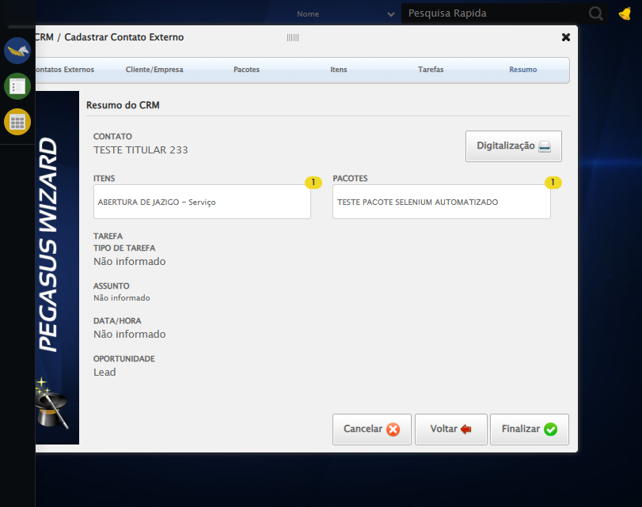

🔄 Preenchendo Data Inìcio...

📊 Encontrados 0 campos datepicker

❌ Erro inesperado ao preenchendo data inìcio: Índice 0 inválido. Encontrados 0 campos

Screenshot: erro_preenchendo_data_inìcio



🔄 Preenchendo Data Fim...

📊 Encontrados 0 campos datepicker

❌ Erro inesperado ao preenchendo data fim: Índice 1 inválido. Encontrados 0 campos

Screenshot: erro_preenchendo_data_fim



🔄 Avançando para aba: 'Resumo'...

❌ Erro ao interagir com elemento #gsCrm > div.wdTelas > div:nth-child(4) > div.btnHolder > a:nth-child(3): Message:   
Stacktrace:  
 GetHandleVerifier [0x0x73ba83+63395]  
 GetHandleVerifier [0x0x73bac4+63460]  
 (No symbol) [0x0x582113]  
 (No symbol) [0x0x5ca85e]  
 (No symbol) [0x0x5cabfb]  
 (No symbol) [0x0x612f92]  
 (No symbol) [0x0x5ef3f4]  
 (No symbol) [0x0x6107ba]  
 (No symbol) [0x0x5ef1a6]  
 (No symbol) [0x0x5be7b2]  
 (No symbol) [0x0x5bf654]  
 GetHandleVerifier [0x0x9b8883+2672035]  
 GetHandleVerifier [0x0x9b3cba+2652634]  
 GetHandleVerifier [0x0x762bca+223466]  
 GetHandleVerifier [0x0x752cb8+158168]  
 GetHandleVerifier [0x0x75978d+185517]  
 GetHandleVerifier [0x0x743b78+96408]  
 GetHandleVerifier [0x0x743d02+96802]  
 GetHandleVerifier [0x0x72e90a+9770]  
 BaseThreadInitThunk [0x0x773dfcc9+25]  
 RtlGetAppContainerNamedObjectPath [0x0x77ba82ae+286]  
 RtlGetAppContainerNamedObjectPath [0x0x77ba827e+238]

❌ Erro inesperado ao avançando para aba: 'resumo': Não foi possível clicar no elemento: #gsCrm > div.wdTelas > div:nth-child(4) > div.btnHolder > a:nth-child(3)

Screenshot: erro_avançando_para_aba:_'resumo'



🔄 Finalizando cadastro...

❌ Erro ao interagir com elemento #gsCrm > div.wdTelas > div:nth-child(4) > div.btnHolder > div: Message:   
Stacktrace:  
 GetHandleVerifier [0x0x73ba83+63395]  
 GetHandleVerifier [0x0x73bac4+63460]  
 (No symbol) [0x0x582113]  
 (No symbol) [0x0x5ca85e]  
 (No symbol) [0x0x5cabfb]  
 (No symbol) [0x0x612f92]  
 (No symbol) [0x0x5ef3f4]  
 (No symbol) [0x0x6107ba]  
 (No symbol) [0x0x5ef1a6]  
 (No symbol) [0x0x5be7b2]  
 (No symbol) [0x0x5bf654]  
 GetHandleVerifier [0x0x9b8883+2672035]  
 GetHandleVerifier [0x0x9b3cba+2652634]  
 GetHandleVerifier [0x0x762bca+223466]  
 GetHandleVerifier [0x0x752cb8+158168]  
 GetHandleVerifier [0x0x75978d+185517]  
 GetHandleVerifier [0x0x743b78+96408]  
 GetHandleVerifier [0x0x743d02+96802]  
 GetHandleVerifier [0x0x72e90a+9770]  
 BaseThreadInitThunk [0x0x773dfcc9+25]  
 RtlGetAppContainerNamedObjectPath [0x0x77ba82ae+286]  
 RtlGetAppContainerNamedObjectPath [0x0x77ba827e+238]

❌ Erro inesperado ao finalizando cadastro: Não foi possível clicar no elemento: #gsCrm > div.wdTelas > div:nth-child(4) > div.btnHolder > div

Screenshot: erro_finalizando_cadastro



🔄 Fechando modal após o salvamento...

✅ Fechando modal após o salvamento realizada com sucesso.

Screenshot: fechando_modal_após_o_salvamento

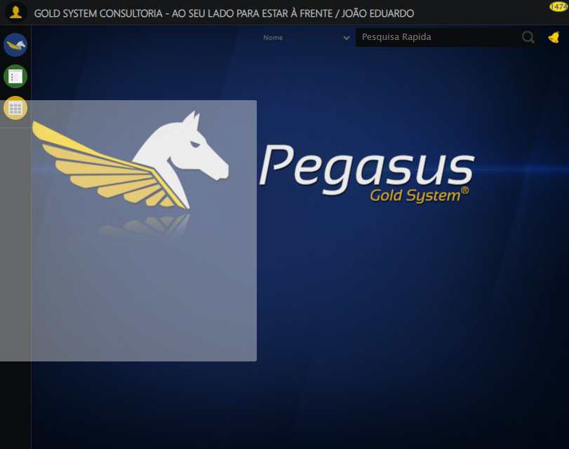

🔍 Verificando mensagens de alerta...

ℹ️ Nenhuma mensagem de alerta encontrada.

✅ Teste concluído.

✅ Teste executado com sucesso!