RELATÓRIO DO TESTE

Cadastro de Contato Externo (CRM) – Cenário 1: Preenchimento completo e salvamento.

Data do teste: 11/08/2025 15:39:02

🚀 Iniciando teste de cadastro de CRM/Contato Externo...

🔄 Acessando sistema...

✅ Acessando sistema realizada com sucesso.

Screenshot: acessando_sistema

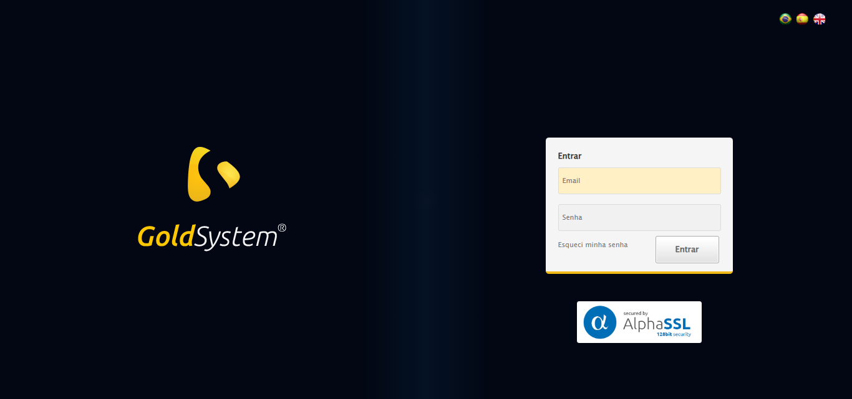

🔄 Realizando login...

✅ Realizando login realizada com sucesso.

Screenshot: realizando_login

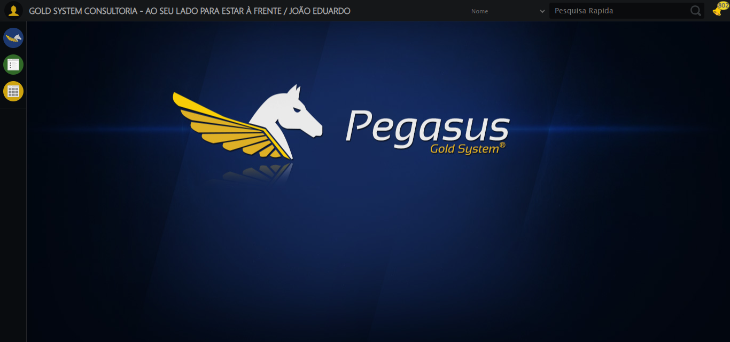

🔄 Ajustando zoom e abrindo menu...

🔍 Zoom ajustado para 90%.

✅ Ajustando zoom e abrindo menu realizada com sucesso.

Screenshot: ajustando_zoom_e_abrindo_menu

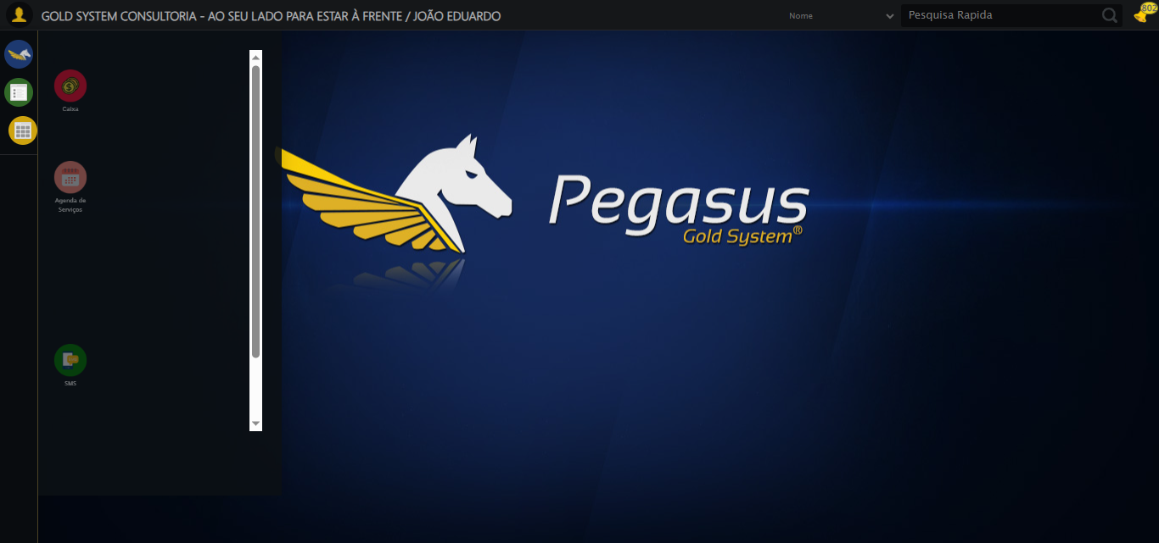

🔄 Acessando CRM...

✅ Acessando CRM realizada com sucesso.

Screenshot: acessando_crm

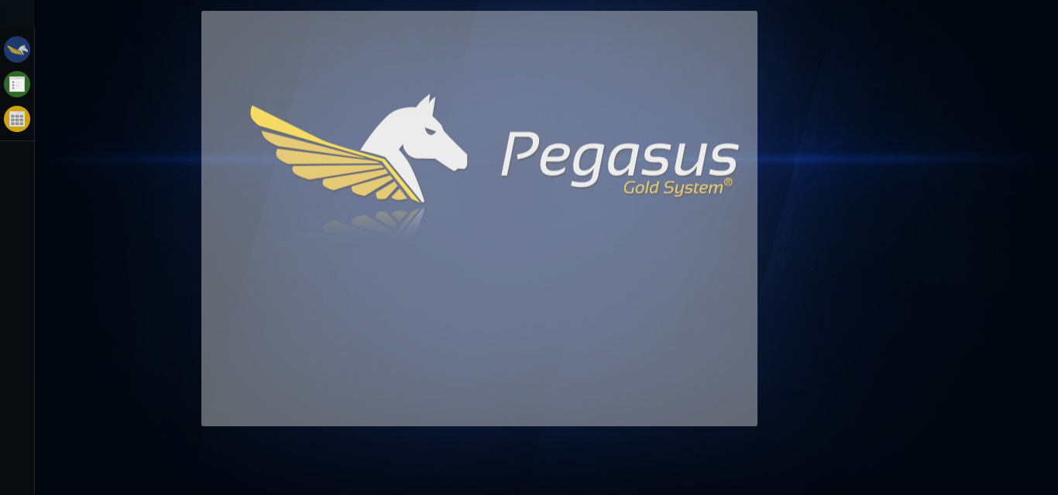

🔄 Clicando em Cadastrar Contato Externo...

✅ Clicando em Cadastrar Contato Externo realizada com sucesso.

Screenshot: clicando_em_cadastrar_contato_externo

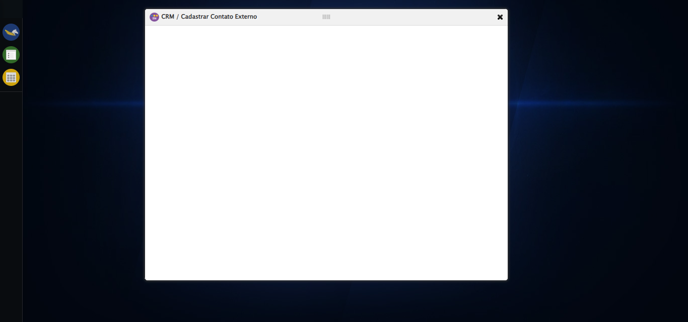

🔄 Avançando para aba: 'Cliente/Empresa'...

✅ Avançando para aba: 'Cliente/Empresa' realizada com sucesso.

Screenshot: avançando_para_aba:_'cliente/empresa'

⚠️ Erro ao tirar screenshot avançando_para_aba:_'cliente/empresa': [Errno 22] Invalid argument: "screenshots/avançando_para_aba:_'cliente/empresa'.png"

🔄 Selecionando Cliente...

✅ Selecionando Cliente realizada com sucesso.

Screenshot: selecionando_cliente

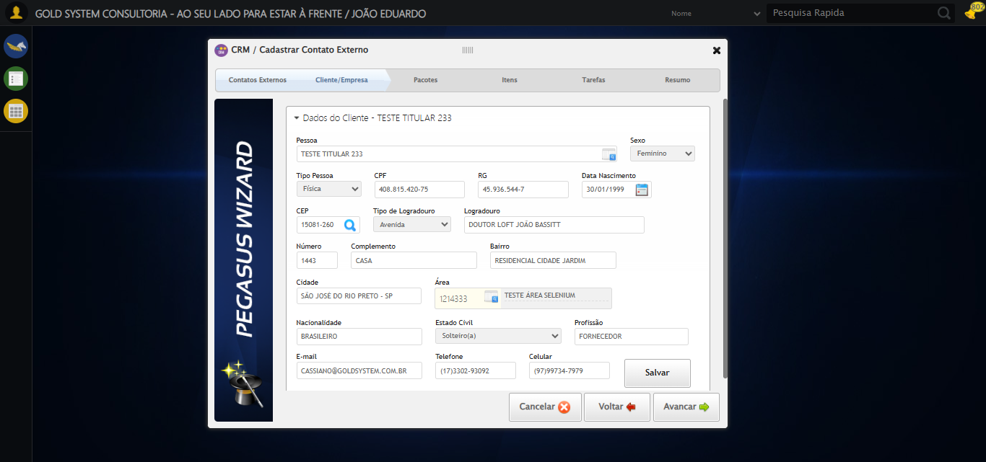

🔄 Salvando Cliente...

✅ Salvando Cliente realizada com sucesso.

Screenshot: salvando_cliente

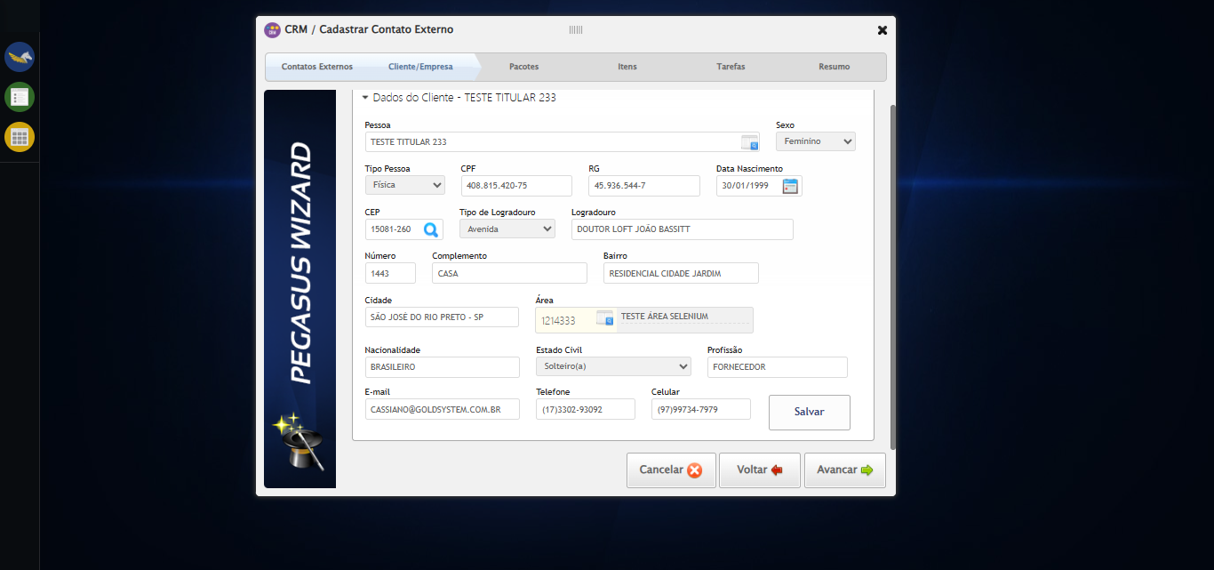

🔄 Avançando para aba: 'Pacotes'...

✅ Avançando para aba: 'Pacotes' realizada com sucesso.

Screenshot: avançando_para_aba:_'pacotes'

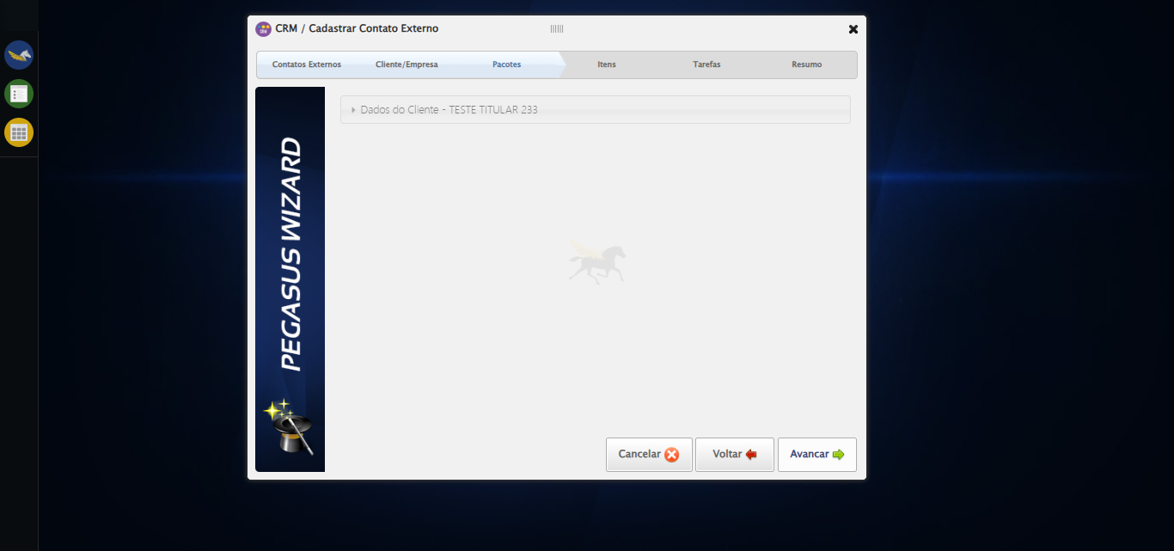

🔄 Selecionando Pacote...

❌ Erro inesperado ao selecionando pacote: Message: element click intercepted: Element <a class="btModel btGray lpFind">...</a> is not clickable at point (709, 111). Other element would receive the click: <div class="loadingContent" style="height: 590px; display: block;">...</div>  
 (Session info: chrome=138.0.7204.185)  
Stacktrace:  
 GetHandleVerifier [0x0x73ba83+63395]  
 GetHandleVerifier [0x0x73bac4+63460]  
 (No symbol) [0x0x582113]  
 (No symbol) [0x0x5d0ba0]  
 (No symbol) [0x0x5cef5a]  
 (No symbol) [0x0x5ccab7]  
 (No symbol) [0x0x5cbd6d]  
 (No symbol) [0x0x5c0515]  
 (No symbol) [0x0x5ef3ac]  
 (No symbol) [0x0x5bffa4]  
 (No symbol) [0x0x5ef624]  
 (No symbol) [0x0x6107ba]  
 (No symbol) [0x0x5ef1a6]  
 (No symbol) [0x0x5be7b2]  
 (No symbol) [0x0x5bf654]  
 GetHandleVerifier [0x0x9b8883+2672035]  
 GetHandleVerifier [0x0x9b3cba+2652634]  
 GetHandleVerifier [0x0x762bca+223466]  
 GetHandleVerifier [0x0x752cb8+158168]  
 GetHandleVerifier [0x0x75978d+185517]  
 GetHandleVerifier [0x0x743b78+96408]  
 GetHandleVerifier [0x0x743d02+96802]  
 GetHandleVerifier [0x0x72e90a+9770]  
 BaseThreadInitThunk [0x0x773dfcc9+25]  
 RtlGetAppContainerNamedObjectPath [0x0x77ba82ae+286]  
 RtlGetAppContainerNamedObjectPath [0x0x77ba827e+238]

Screenshot: erro_selecionando_pacote

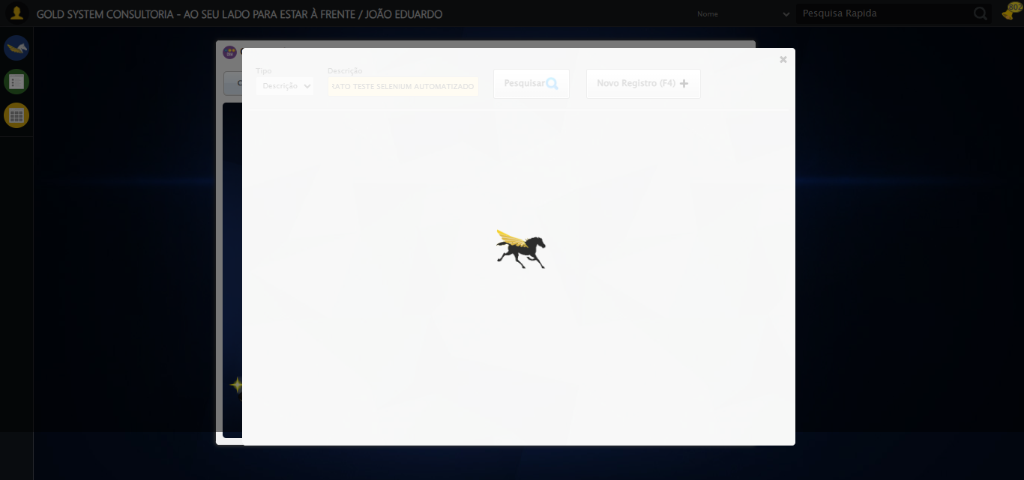

🔄 Selecionando Pacote...

❌ Erro inesperado ao selecionando pacote: Message: invalid session id: session deleted as the browser has closed the connection  
from disconnected: not connected to DevTools  
 (Session info: chrome=138.0.7204.185)  
Stacktrace:  
 GetHandleVerifier [0x0x73ba83+63395]  
 GetHandleVerifier [0x0x73bac4+63460]  
 (No symbol) [0x0x582113]  
 (No symbol) [0x0x571b20]  
 (No symbol) [0x0x58f922]  
 (No symbol) [0x0x5f5c9c]  
 (No symbol) [0x0x610099]  
 (No symbol) [0x0x5ef1a6]  
 (No symbol) [0x0x5be7b2]  
 (No symbol) [0x0x5bf654]  
 GetHandleVerifier [0x0x9b8883+2672035]  
 GetHandleVerifier [0x0x9b3cba+2652634]  
 GetHandleVerifier [0x0x762bca+223466]  
 GetHandleVerifier [0x0x752cb8+158168]  
 GetHandleVerifier [0x0x75978d+185517]  
 GetHandleVerifier [0x0x743b78+96408]  
 GetHandleVerifier [0x0x743d02+96802]  
 GetHandleVerifier [0x0x72e90a+9770]  
 BaseThreadInitThunk [0x0x773dfcc9+25]  
 RtlGetAppContainerNamedObjectPath [0x0x77ba82ae+286]  
 RtlGetAppContainerNamedObjectPath [0x0x77ba827e+238]

🔄 Avançando para aba: 'Itens'...

❌ Erro ao interagir com elemento #gsCrm > div.wdTelas > div.wdWizard.clearfix.telaConsulta > div.btnHolder > a:nth-child(3): Message: invalid session id  
Stacktrace:  
 GetHandleVerifier [0x0x73ba83+63395]  
 GetHandleVerifier [0x0x73bac4+63460]  
 (No symbol) [0x0x581f70]  
 (No symbol) [0x0x5bdaa8]  
 (No symbol) [0x0x5ef266]  
 (No symbol) [0x0x5eae65]  
 (No symbol) [0x0x5ea3e6]  
 (No symbol) [0x0x553a45]  
 (No symbol) [0x0x553f9e]  
 (No symbol) [0x0x55442d]  
 GetHandleVerifier [0x0x9b8883+2672035]  
 GetHandleVerifier [0x0x9b3cba+2652634]  
 GetHandleVerifier [0x0x762bca+223466]  
 GetHandleVerifier [0x0x752cb8+158168]  
 GetHandleVerifier [0x0x75978d+185517]  
 (No symbol) [0x0x553710]  
 (No symbol) [0x0x552f1d]  
 GetHandleVerifier [0x0xaedb9c+3938492]  
 BaseThreadInitThunk [0x0x773dfcc9+25]  
 RtlGetAppContainerNamedObjectPath [0x0x77ba82ae+286]  
 RtlGetAppContainerNamedObjectPath [0x0x77ba827e+238]

❌ Erro inesperado ao avançando para aba: 'itens': Não foi possível clicar no elemento: #gsCrm > div.wdTelas > div.wdWizard.clearfix.telaConsulta > div.btnHolder > a:nth-child(3)

⚠️ Erro ao tirar screenshot erro_avançando_para_aba:_'itens': Message: invalid session id  
Stacktrace:  
 GetHandleVerifier [0x0x73ba83+63395]  
 GetHandleVerifier [0x0x73bac4+63460]  
 (No symbol) [0x0x581f70]  
 (No symbol) [0x0x5bdaa8]  
 (No symbol) [0x0x5ef266]  
 (No symbol) [0x0x5eae65]  
 (No symbol) [0x0x5ea3e6]  
 (No symbol) [0x0x553a45]  
 (No symbol) [0x0x553f9e]  
 (No symbol) [0x0x55442d]  
 GetHandleVerifier [0x0x9b8883+2672035]  
 GetHandleVerifier [0x0x9b3cba+2652634]  
 GetHandleVerifier [0x0x762bca+223466]  
 GetHandleVerifier [0x0x752cb8+158168]  
 GetHandleVerifier [0x0x75978d+185517]  
 (No symbol) [0x0x553710]  
 (No symbol) [0x0x552f1d]  
 GetHandleVerifier [0x0xaedb9c+3938492]  
 BaseThreadInitThunk [0x0x773dfcc9+25]  
 RtlGetAppContainerNamedObjectPath [0x0x77ba82ae+286]  
 RtlGetAppContainerNamedObjectPath [0x0x77ba827e+238]

🔄 Selecionando Item...

❌ Erro ao interagir com elemento #gsCrm > div.wdTelas > div.wdWizard.clearfix.telaConsulta > div.wizardHolder > div > div.stepItem.step4 > div.tableProdutos > div.tbHeader > ul > li:nth-child(1) > div > div > a: Message: invalid session id  
Stacktrace:  
 GetHandleVerifier [0x0x73ba83+63395]  
 GetHandleVerifier [0x0x73bac4+63460]  
 (No symbol) [0x0x581f70]  
 (No symbol) [0x0x5bdaa8]  
 (No symbol) [0x0x5ef266]  
 (No symbol) [0x0x5eae65]  
 (No symbol) [0x0x5ea3e6]  
 (No symbol) [0x0x553a45]  
 (No symbol) [0x0x553f9e]  
 (No symbol) [0x0x55442d]  
 GetHandleVerifier [0x0x9b8883+2672035]  
 GetHandleVerifier [0x0x9b3cba+2652634]  
 GetHandleVerifier [0x0x762bca+223466]  
 GetHandleVerifier [0x0x752cb8+158168]  
 GetHandleVerifier [0x0x75978d+185517]  
 (No symbol) [0x0x553710]  
 (No symbol) [0x0x552f1d]  
 GetHandleVerifier [0x0xaedb9c+3938492]  
 BaseThreadInitThunk [0x0x773dfcc9+25]  
 RtlGetAppContainerNamedObjectPath [0x0x77ba82ae+286]  
 RtlGetAppContainerNamedObjectPath [0x0x77ba827e+238]

❌ Erro inesperado ao selecionando item: Message: invalid session id  
Stacktrace:  
 GetHandleVerifier [0x0x73ba83+63395]  
 GetHandleVerifier [0x0x73bac4+63460]  
 (No symbol) [0x0x581f70]  
 (No symbol) [0x0x5bdaa8]  
 (No symbol) [0x0x5ef266]  
 (No symbol) [0x0x5eae65]  
 (No symbol) [0x0x5ea3e6]  
 (No symbol) [0x0x553a45]  
 (No symbol) [0x0x553f9e]  
 (No symbol) [0x0x55442d]  
 GetHandleVerifier [0x0x9b8883+2672035]  
 GetHandleVerifier [0x0x9b3cba+2652634]  
 GetHandleVerifier [0x0x762bca+223466]  
 GetHandleVerifier [0x0x752cb8+158168]  
 GetHandleVerifier [0x0x75978d+185517]  
 (No symbol) [0x0x553710]  
 (No symbol) [0x0x552f1d]  
 GetHandleVerifier [0x0xaedb9c+3938492]  
 BaseThreadInitThunk [0x0x773dfcc9+25]  
 RtlGetAppContainerNamedObjectPath [0x0x77ba82ae+286]  
 RtlGetAppContainerNamedObjectPath [0x0x77ba827e+238]

⚠️ Erro ao tirar screenshot erro_selecionando_item: Message: invalid session id  
Stacktrace:  
 GetHandleVerifier [0x0x73ba83+63395]  
 GetHandleVerifier [0x0x73bac4+63460]  
 (No symbol) [0x0x581f70]  
 (No symbol) [0x0x5bdaa8]  
 (No symbol) [0x0x5ef266]  
 (No symbol) [0x0x5eae65]  
 (No symbol) [0x0x5ea3e6]  
 (No symbol) [0x0x553a45]  
 (No symbol) [0x0x553f9e]  
 (No symbol) [0x0x55442d]  
 GetHandleVerifier [0x0x9b8883+2672035]  
 GetHandleVerifier [0x0x9b3cba+2652634]  
 GetHandleVerifier [0x0x762bca+223466]  
 GetHandleVerifier [0x0x752cb8+158168]  
 GetHandleVerifier [0x0x75978d+185517]  
 (No symbol) [0x0x553710]  
 (No symbol) [0x0x552f1d]  
 GetHandleVerifier [0x0xaedb9c+3938492]  
 BaseThreadInitThunk [0x0x773dfcc9+25]  
 RtlGetAppContainerNamedObjectPath [0x0x77ba82ae+286]  
 RtlGetAppContainerNamedObjectPath [0x0x77ba827e+238]

🔄 Avançando para aba: 'Tarefas'...

❌ Erro ao interagir com elemento #gsCrm > div.wdTelas > div.wdWizard.clearfix.telaConsulta > div.btnHolder > a:nth-child(3): Message: invalid session id  
Stacktrace:  
 GetHandleVerifier [0x0x73ba83+63395]  
 GetHandleVerifier [0x0x73bac4+63460]  
 (No symbol) [0x0x581f70]  
 (No symbol) [0x0x5bdaa8]  
 (No symbol) [0x0x5ef266]  
 (No symbol) [0x0x5eae65]  
 (No symbol) [0x0x5ea3e6]  
 (No symbol) [0x0x553a45]  
 (No symbol) [0x0x553f9e]  
 (No symbol) [0x0x55442d]  
 GetHandleVerifier [0x0x9b8883+2672035]  
 GetHandleVerifier [0x0x9b3cba+2652634]  
 GetHandleVerifier [0x0x762bca+223466]  
 GetHandleVerifier [0x0x752cb8+158168]  
 GetHandleVerifier [0x0x75978d+185517]  
 (No symbol) [0x0x553710]  
 (No symbol) [0x0x552f1d]  
 GetHandleVerifier [0x0xaedb9c+3938492]  
 BaseThreadInitThunk [0x0x773dfcc9+25]  
 RtlGetAppContainerNamedObjectPath [0x0x77ba82ae+286]  
 RtlGetAppContainerNamedObjectPath [0x0x77ba827e+238]

❌ Erro inesperado ao avançando para aba: 'tarefas': Não foi possível clicar no elemento: #gsCrm > div.wdTelas > div.wdWizard.clearfix.telaConsulta > div.btnHolder > a:nth-child(3)

⚠️ Erro ao tirar screenshot erro_avançando_para_aba:_'tarefas': Message: invalid session id  
Stacktrace:  
 GetHandleVerifier [0x0x73ba83+63395]  
 GetHandleVerifier [0x0x73bac4+63460]  
 (No symbol) [0x0x581f70]  
 (No symbol) [0x0x5bdaa8]  
 (No symbol) [0x0x5ef266]  
 (No symbol) [0x0x5eae65]  
 (No symbol) [0x0x5ea3e6]  
 (No symbol) [0x0x553a45]  
 (No symbol) [0x0x553f9e]  
 (No symbol) [0x0x55442d]  
 GetHandleVerifier [0x0x9b8883+2672035]  
 GetHandleVerifier [0x0x9b3cba+2652634]  
 GetHandleVerifier [0x0x762bca+223466]  
 GetHandleVerifier [0x0x752cb8+158168]  
 GetHandleVerifier [0x0x75978d+185517]  
 (No symbol) [0x0x553710]  
 (No symbol) [0x0x552f1d]  
 GetHandleVerifier [0x0xaedb9c+3938492]  
 BaseThreadInitThunk [0x0x773dfcc9+25]  
 RtlGetAppContainerNamedObjectPath [0x0x77ba82ae+286]  
 RtlGetAppContainerNamedObjectPath [0x0x77ba827e+238]

🔄 Selecionando Tipo de Tarefa...

❌ Erro inesperado ao selecionando tipo de tarefa: Message: invalid session id  
Stacktrace:  
 GetHandleVerifier [0x0x73ba83+63395]  
 GetHandleVerifier [0x0x73bac4+63460]  
 (No symbol) [0x0x581f70]  
 (No symbol) [0x0x5bdaa8]  
 (No symbol) [0x0x5ef266]  
 (No symbol) [0x0x5eae65]  
 (No symbol) [0x0x5ea3e6]  
 (No symbol) [0x0x553a45]  
 (No symbol) [0x0x553f9e]  
 (No symbol) [0x0x55442d]  
 GetHandleVerifier [0x0x9b8883+2672035]  
 GetHandleVerifier [0x0x9b3cba+2652634]  
 GetHandleVerifier [0x0x762bca+223466]  
 GetHandleVerifier [0x0x752cb8+158168]  
 GetHandleVerifier [0x0x75978d+185517]  
 (No symbol) [0x0x553710]  
 (No symbol) [0x0x552f1d]  
 GetHandleVerifier [0x0xaedb9c+3938492]  
 BaseThreadInitThunk [0x0x773dfcc9+25]  
 RtlGetAppContainerNamedObjectPath [0x0x77ba82ae+286]  
 RtlGetAppContainerNamedObjectPath [0x0x77ba827e+238]

⚠️ Erro ao tirar screenshot erro_selecionando_tipo_de_tarefa: Message: invalid session id  
Stacktrace:  
 GetHandleVerifier [0x0x73ba83+63395]  
 GetHandleVerifier [0x0x73bac4+63460]  
 (No symbol) [0x0x581f70]  
 (No symbol) [0x0x5bdaa8]  
 (No symbol) [0x0x5ef266]  
 (No symbol) [0x0x5eae65]  
 (No symbol) [0x0x5ea3e6]  
 (No symbol) [0x0x553a45]  
 (No symbol) [0x0x553f9e]  
 (No symbol) [0x0x55442d]  
 GetHandleVerifier [0x0x9b8883+2672035]  
 GetHandleVerifier [0x0x9b3cba+2652634]  
 GetHandleVerifier [0x0x762bca+223466]  
 GetHandleVerifier [0x0x752cb8+158168]  
 GetHandleVerifier [0x0x75978d+185517]  
 (No symbol) [0x0x553710]  
 (No symbol) [0x0x552f1d]  
 GetHandleVerifier [0x0xaedb9c+3938492]  
 BaseThreadInitThunk [0x0x773dfcc9+25]  
 RtlGetAppContainerNamedObjectPath [0x0x77ba82ae+286]  
 RtlGetAppContainerNamedObjectPath [0x0x77ba827e+238]

🔄 Preechendo Assunto...

❌ Erro inesperado ao preechendo assunto: Message: invalid session id  
Stacktrace:  
 GetHandleVerifier [0x0x73ba83+63395]  
 GetHandleVerifier [0x0x73bac4+63460]  
 (No symbol) [0x0x581f70]  
 (No symbol) [0x0x5bdaa8]  
 (No symbol) [0x0x5ef266]  
 (No symbol) [0x0x5eae65]  
 (No symbol) [0x0x5ea3e6]  
 (No symbol) [0x0x553a45]  
 (No symbol) [0x0x553f9e]  
 (No symbol) [0x0x55442d]  
 GetHandleVerifier [0x0x9b8883+2672035]  
 GetHandleVerifier [0x0x9b3cba+2652634]  
 GetHandleVerifier [0x0x762bca+223466]  
 GetHandleVerifier [0x0x752cb8+158168]  
 GetHandleVerifier [0x0x75978d+185517]  
 (No symbol) [0x0x553710]  
 (No symbol) [0x0x552f1d]  
 GetHandleVerifier [0x0xaedb9c+3938492]  
 BaseThreadInitThunk [0x0x773dfcc9+25]  
 RtlGetAppContainerNamedObjectPath [0x0x77ba82ae+286]  
 RtlGetAppContainerNamedObjectPath [0x0x77ba827e+238]

⚠️ Erro ao tirar screenshot erro_preechendo_assunto: Message: invalid session id  
Stacktrace:  
 GetHandleVerifier [0x0x73ba83+63395]  
 GetHandleVerifier [0x0x73bac4+63460]  
 (No symbol) [0x0x581f70]  
 (No symbol) [0x0x5bdaa8]  
 (No symbol) [0x0x5ef266]  
 (No symbol) [0x0x5eae65]  
 (No symbol) [0x0x5ea3e6]  
 (No symbol) [0x0x553a45]  
 (No symbol) [0x0x553f9e]  
 (No symbol) [0x0x55442d]  
 GetHandleVerifier [0x0x9b8883+2672035]  
 GetHandleVerifier [0x0x9b3cba+2652634]  
 GetHandleVerifier [0x0x762bca+223466]  
 GetHandleVerifier [0x0x752cb8+158168]  
 GetHandleVerifier [0x0x75978d+185517]  
 (No symbol) [0x0x553710]  
 (No symbol) [0x0x552f1d]  
 GetHandleVerifier [0x0xaedb9c+3938492]  
 BaseThreadInitThunk [0x0x773dfcc9+25]  
 RtlGetAppContainerNamedObjectPath [0x0x77ba82ae+286]  
 RtlGetAppContainerNamedObjectPath [0x0x77ba827e+238]

🔄 Data Início...

⚠️ Tentativa 1 falhou: Message: invalid session id  
Stacktrace:  
 GetHandleVerifier [0x0x73ba83+63395]  
 GetHandleVerifier [0x0x73bac4+63460]  
 (No symbol) [0x0x581f70]  
 (No symbol) [0x0x5bdaa8]  
 (No symbol) [0x0x5ef266]  
 (No symbol) [0x0x5eae65]  
 (No symbol) [0x0x5ea3e6]  
 (No symbol) [0x0x553a45]  
 (No symbol) [0x0x553f9e]  
 (No symbol) [0x0x55442d]  
 GetHandleVerifier [0x0x9b8883+2672035]  
 GetHandleVerifier [0x0x9b3cba+2652634]  
 GetHandleVerifier [0x0x762bca+223466]  
 GetHandleVerifier [0x0x752cb8+158168]  
 GetHandleVerifier [0x0x75978d+185517]  
 (No symbol) [0x0x553710]  
 (No symbol) [0x0x552f1d]  
 GetHandleVerifier [0x0xaedb9c+3938492]  
 BaseThreadInitThunk [0x0x773dfcc9+25]  
 RtlGetAppContainerNamedObjectPath [0x0x77ba82ae+286]  
 RtlGetAppContainerNamedObjectPath [0x0x77ba827e+238]

⚠️ Tentativa 2 falhou: Message: invalid session id  
Stacktrace:  
 GetHandleVerifier [0x0x73ba83+63395]  
 GetHandleVerifier [0x0x73bac4+63460]  
 (No symbol) [0x0x581f70]  
 (No symbol) [0x0x5bdaa8]  
 (No symbol) [0x0x5ef266]  
 (No symbol) [0x0x5eae65]  
 (No symbol) [0x0x5ea3e6]  
 (No symbol) [0x0x553a45]  
 (No symbol) [0x0x553f9e]  
 (No symbol) [0x0x55442d]  
 GetHandleVerifier [0x0x9b8883+2672035]  
 GetHandleVerifier [0x0x9b3cba+2652634]  
 GetHandleVerifier [0x0x762bca+223466]  
 GetHandleVerifier [0x0x752cb8+158168]  
 GetHandleVerifier [0x0x75978d+185517]  
 (No symbol) [0x0x553710]  
 (No symbol) [0x0x552f1d]  
 GetHandleVerifier [0x0xaedb9c+3938492]  
 BaseThreadInitThunk [0x0x773dfcc9+25]  
 RtlGetAppContainerNamedObjectPath [0x0x77ba82ae+286]  
 RtlGetAppContainerNamedObjectPath [0x0x77ba827e+238]

⚠️ Tentativa 3 falhou: Message: invalid session id  
Stacktrace:  
 GetHandleVerifier [0x0x73ba83+63395]  
 GetHandleVerifier [0x0x73bac4+63460]  
 (No symbol) [0x0x581f70]  
 (No symbol) [0x0x5bdaa8]  
 (No symbol) [0x0x5ef266]  
 (No symbol) [0x0x5eae65]  
 (No symbol) [0x0x5ea3e6]  
 (No symbol) [0x0x553a45]  
 (No symbol) [0x0x553f9e]  
 (No symbol) [0x0x55442d]  
 GetHandleVerifier [0x0x9b8883+2672035]  
 GetHandleVerifier [0x0x9b3cba+2652634]  
 GetHandleVerifier [0x0x762bca+223466]  
 GetHandleVerifier [0x0x752cb8+158168]  
 GetHandleVerifier [0x0x75978d+185517]  
 (No symbol) [0x0x553710]  
 (No symbol) [0x0x552f1d]  
 GetHandleVerifier [0x0xaedb9c+3938492]  
 BaseThreadInitThunk [0x0x773dfcc9+25]  
 RtlGetAppContainerNamedObjectPath [0x0x77ba82ae+286]  
 RtlGetAppContainerNamedObjectPath [0x0x77ba827e+238]

✅ Data Início realizada com sucesso.

⚠️ Erro ao tirar screenshot data_início: Message: invalid session id  
Stacktrace:  
 GetHandleVerifier [0x0x73ba83+63395]  
 GetHandleVerifier [0x0x73bac4+63460]  
 (No symbol) [0x0x581f70]  
 (No symbol) [0x0x5bdaa8]  
 (No symbol) [0x0x5ef266]  
 (No symbol) [0x0x5eae65]  
 (No symbol) [0x0x5ea3e6]  
 (No symbol) [0x0x553a45]  
 (No symbol) [0x0x553f9e]  
 (No symbol) [0x0x55442d]  
 GetHandleVerifier [0x0x9b8883+2672035]  
 GetHandleVerifier [0x0x9b3cba+2652634]  
 GetHandleVerifier [0x0x762bca+223466]  
 GetHandleVerifier [0x0x752cb8+158168]  
 GetHandleVerifier [0x0x75978d+185517]  
 (No symbol) [0x0x553710]  
 (No symbol) [0x0x552f1d]  
 GetHandleVerifier [0x0xaedb9c+3938492]  
 BaseThreadInitThunk [0x0x773dfcc9+25]  
 RtlGetAppContainerNamedObjectPath [0x0x77ba82ae+286]  
 RtlGetAppContainerNamedObjectPath [0x0x77ba827e+238]

🔄 Data Fim...

⚠️ Tentativa 1 falhou: Message: invalid session id  
Stacktrace:  
 GetHandleVerifier [0x0x73ba83+63395]  
 GetHandleVerifier [0x0x73bac4+63460]  
 (No symbol) [0x0x581f70]  
 (No symbol) [0x0x5bdaa8]  
 (No symbol) [0x0x5ef266]  
 (No symbol) [0x0x5eae65]  
 (No symbol) [0x0x5ea3e6]  
 (No symbol) [0x0x553a45]  
 (No symbol) [0x0x553f9e]  
 (No symbol) [0x0x55442d]  
 GetHandleVerifier [0x0x9b8883+2672035]  
 GetHandleVerifier [0x0x9b3cba+2652634]  
 GetHandleVerifier [0x0x762bca+223466]  
 GetHandleVerifier [0x0x752cb8+158168]  
 GetHandleVerifier [0x0x75978d+185517]  
 (No symbol) [0x0x553710]  
 (No symbol) [0x0x552f1d]  
 GetHandleVerifier [0x0xaedb9c+3938492]  
 BaseThreadInitThunk [0x0x773dfcc9+25]  
 RtlGetAppContainerNamedObjectPath [0x0x77ba82ae+286]  
 RtlGetAppContainerNamedObjectPath [0x0x77ba827e+238]

⚠️ Tentativa 2 falhou: Message: invalid session id  
Stacktrace:  
 GetHandleVerifier [0x0x73ba83+63395]  
 GetHandleVerifier [0x0x73bac4+63460]  
 (No symbol) [0x0x581f70]  
 (No symbol) [0x0x5bdaa8]  
 (No symbol) [0x0x5ef266]  
 (No symbol) [0x0x5eae65]  
 (No symbol) [0x0x5ea3e6]  
 (No symbol) [0x0x553a45]  
 (No symbol) [0x0x553f9e]  
 (No symbol) [0x0x55442d]  
 GetHandleVerifier [0x0x9b8883+2672035]  
 GetHandleVerifier [0x0x9b3cba+2652634]  
 GetHandleVerifier [0x0x762bca+223466]  
 GetHandleVerifier [0x0x752cb8+158168]  
 GetHandleVerifier [0x0x75978d+185517]  
 (No symbol) [0x0x553710]  
 (No symbol) [0x0x552f1d]  
 GetHandleVerifier [0x0xaedb9c+3938492]  
 BaseThreadInitThunk [0x0x773dfcc9+25]  
 RtlGetAppContainerNamedObjectPath [0x0x77ba82ae+286]  
 RtlGetAppContainerNamedObjectPath [0x0x77ba827e+238]

⚠️ Tentativa 3 falhou: Message: invalid session id  
Stacktrace:  
 GetHandleVerifier [0x0x73ba83+63395]  
 GetHandleVerifier [0x0x73bac4+63460]  
 (No symbol) [0x0x581f70]  
 (No symbol) [0x0x5bdaa8]  
 (No symbol) [0x0x5ef266]  
 (No symbol) [0x0x5eae65]  
 (No symbol) [0x0x5ea3e6]  
 (No symbol) [0x0x553a45]  
 (No symbol) [0x0x553f9e]  
 (No symbol) [0x0x55442d]  
 GetHandleVerifier [0x0x9b8883+2672035]  
 GetHandleVerifier [0x0x9b3cba+2652634]  
 GetHandleVerifier [0x0x762bca+223466]  
 GetHandleVerifier [0x0x752cb8+158168]  
 GetHandleVerifier [0x0x75978d+185517]  
 (No symbol) [0x0x553710]  
 (No symbol) [0x0x552f1d]  
 GetHandleVerifier [0x0xaedb9c+3938492]  
 BaseThreadInitThunk [0x0x773dfcc9+25]  
 RtlGetAppContainerNamedObjectPath [0x0x77ba82ae+286]  
 RtlGetAppContainerNamedObjectPath [0x0x77ba827e+238]

✅ Data Fim realizada com sucesso.

⚠️ Erro ao tirar screenshot data_fim: Message: invalid session id  
Stacktrace:  
 GetHandleVerifier [0x0x73ba83+63395]  
 GetHandleVerifier [0x0x73bac4+63460]  
 (No symbol) [0x0x581f70]  
 (No symbol) [0x0x5bdaa8]  
 (No symbol) [0x0x5ef266]  
 (No symbol) [0x0x5eae65]  
 (No symbol) [0x0x5ea3e6]  
 (No symbol) [0x0x553a45]  
 (No symbol) [0x0x553f9e]  
 (No symbol) [0x0x55442d]  
 GetHandleVerifier [0x0x9b8883+2672035]  
 GetHandleVerifier [0x0x9b3cba+2652634]  
 GetHandleVerifier [0x0x762bca+223466]  
 GetHandleVerifier [0x0x752cb8+158168]  
 GetHandleVerifier [0x0x75978d+185517]  
 (No symbol) [0x0x553710]  
 (No symbol) [0x0x552f1d]  
 GetHandleVerifier [0x0xaedb9c+3938492]  
 BaseThreadInitThunk [0x0x773dfcc9+25]  
 RtlGetAppContainerNamedObjectPath [0x0x77ba82ae+286]  
 RtlGetAppContainerNamedObjectPath [0x0x77ba827e+238]

🔄 Avançando para aba: 'Resumo'...

⚠️ Falha ao clicar via JS: Message: invalid session id  
Stacktrace:  
 GetHandleVerifier [0x0x73ba83+63395]  
 GetHandleVerifier [0x0x73bac4+63460]  
 (No symbol) [0x0x581f70]  
 (No symbol) [0x0x5bdaa8]  
 (No symbol) [0x0x5ef266]  
 (No symbol) [0x0x5eae65]  
 (No symbol) [0x0x5ea3e6]  
 (No symbol) [0x0x553a45]  
 (No symbol) [0x0x553f9e]  
 (No symbol) [0x0x55442d]  
 GetHandleVerifier [0x0x9b8883+2672035]  
 GetHandleVerifier [0x0x9b3cba+2652634]  
 GetHandleVerifier [0x0x762bca+223466]  
 GetHandleVerifier [0x0x752cb8+158168]  
 GetHandleVerifier [0x0x75978d+185517]  
 (No symbol) [0x0x553710]  
 (No symbol) [0x0x552f1d]  
 GetHandleVerifier [0x0xaedb9c+3938492]  
 BaseThreadInitThunk [0x0x773dfcc9+25]  
 RtlGetAppContainerNamedObjectPath [0x0x77ba82ae+286]  
 RtlGetAppContainerNamedObjectPath [0x0x77ba827e+238]

✅ Avançando para aba: 'Resumo' realizada com sucesso.

⚠️ Erro ao tirar screenshot avançando_para_aba:_'resumo': Message: invalid session id  
Stacktrace:  
 GetHandleVerifier [0x0x73ba83+63395]  
 GetHandleVerifier [0x0x73bac4+63460]  
 (No symbol) [0x0x581f70]  
 (No symbol) [0x0x5bdaa8]  
 (No symbol) [0x0x5ef266]  
 (No symbol) [0x0x5eae65]  
 (No symbol) [0x0x5ea3e6]  
 (No symbol) [0x0x553a45]  
 (No symbol) [0x0x553f9e]  
 (No symbol) [0x0x55442d]  
 GetHandleVerifier [0x0x9b8883+2672035]  
 GetHandleVerifier [0x0x9b3cba+2652634]  
 GetHandleVerifier [0x0x762bca+223466]  
 GetHandleVerifier [0x0x752cb8+158168]  
 GetHandleVerifier [0x0x75978d+185517]  
 (No symbol) [0x0x553710]  
 (No symbol) [0x0x552f1d]  
 GetHandleVerifier [0x0xaedb9c+3938492]  
 BaseThreadInitThunk [0x0x773dfcc9+25]  
 RtlGetAppContainerNamedObjectPath [0x0x77ba82ae+286]  
 RtlGetAppContainerNamedObjectPath [0x0x77ba827e+238]

🔄 Finalizando cadastro...

⚠️ Falha ao clicar via JS: Message: invalid session id  
Stacktrace:  
 GetHandleVerifier [0x0x73ba83+63395]  
 GetHandleVerifier [0x0x73bac4+63460]  
 (No symbol) [0x0x581f70]  
 (No symbol) [0x0x5bdaa8]  
 (No symbol) [0x0x5ef266]  
 (No symbol) [0x0x5eae65]  
 (No symbol) [0x0x5ea3e6]  
 (No symbol) [0x0x553a45]  
 (No symbol) [0x0x553f9e]  
 (No symbol) [0x0x55442d]  
 GetHandleVerifier [0x0x9b8883+2672035]  
 GetHandleVerifier [0x0x9b3cba+2652634]  
 GetHandleVerifier [0x0x762bca+223466]  
 GetHandleVerifier [0x0x752cb8+158168]  
 GetHandleVerifier [0x0x75978d+185517]  
 (No symbol) [0x0x553710]  
 (No symbol) [0x0x552f1d]  
 GetHandleVerifier [0x0xaedb9c+3938492]  
 BaseThreadInitThunk [0x0x773dfcc9+25]  
 RtlGetAppContainerNamedObjectPath [0x0x77ba82ae+286]  
 RtlGetAppContainerNamedObjectPath [0x0x77ba827e+238]

✅ Finalizando cadastro realizada com sucesso.

⚠️ Erro ao tirar screenshot finalizando_cadastro: Message: invalid session id  
Stacktrace:  
 GetHandleVerifier [0x0x73ba83+63395]  
 GetHandleVerifier [0x0x73bac4+63460]  
 (No symbol) [0x0x581f70]  
 (No symbol) [0x0x5bdaa8]  
 (No symbol) [0x0x5ef266]  
 (No symbol) [0x0x5eae65]  
 (No symbol) [0x0x5ea3e6]  
 (No symbol) [0x0x553a45]  
 (No symbol) [0x0x553f9e]  
 (No symbol) [0x0x55442d]  
 GetHandleVerifier [0x0x9b8883+2672035]  
 GetHandleVerifier [0x0x9b3cba+2652634]  
 GetHandleVerifier [0x0x762bca+223466]  
 GetHandleVerifier [0x0x752cb8+158168]  
 GetHandleVerifier [0x0x75978d+185517]  
 (No symbol) [0x0x553710]  
 (No symbol) [0x0x552f1d]  
 GetHandleVerifier [0x0xaedb9c+3938492]  
 BaseThreadInitThunk [0x0x773dfcc9+25]  
 RtlGetAppContainerNamedObjectPath [0x0x77ba82ae+286]  
 RtlGetAppContainerNamedObjectPath [0x0x77ba827e+238]

🔄 Fechando modal após o salvamento...

❌ Erro ao interagir com elemento #gsCrm > div.wdTop.ui-draggable-handle > div > a: Message: invalid session id  
Stacktrace:  
 GetHandleVerifier [0x0x73ba83+63395]  
 GetHandleVerifier [0x0x73bac4+63460]  
 (No symbol) [0x0x581f70]  
 (No symbol) [0x0x5bdaa8]  
 (No symbol) [0x0x5ef266]  
 (No symbol) [0x0x5eae65]  
 (No symbol) [0x0x5ea3e6]  
 (No symbol) [0x0x553a45]  
 (No symbol) [0x0x553f9e]  
 (No symbol) [0x0x55442d]  
 GetHandleVerifier [0x0x9b8883+2672035]  
 GetHandleVerifier [0x0x9b3cba+2652634]  
 GetHandleVerifier [0x0x762bca+223466]  
 GetHandleVerifier [0x0x752cb8+158168]  
 GetHandleVerifier [0x0x75978d+185517]  
 (No symbol) [0x0x553710]  
 (No symbol) [0x0x552f1d]  
 GetHandleVerifier [0x0xaedb9c+3938492]  
 BaseThreadInitThunk [0x0x773dfcc9+25]  
 RtlGetAppContainerNamedObjectPath [0x0x77ba82ae+286]  
 RtlGetAppContainerNamedObjectPath [0x0x77ba827e+238]

❌ Erro inesperado ao fechando modal após o salvamento: Não foi possível clicar no elemento: #gsCrm > div.wdTop.ui-draggable-handle > div > a

⚠️ Erro ao tirar screenshot erro_fechando_modal_após_o_salvamento: Message: invalid session id  
Stacktrace:  
 GetHandleVerifier [0x0x73ba83+63395]  
 GetHandleVerifier [0x0x73bac4+63460]  
 (No symbol) [0x0x581f70]  
 (No symbol) [0x0x5bdaa8]  
 (No symbol) [0x0x5ef266]  
 (No symbol) [0x0x5eae65]  
 (No symbol) [0x0x5ea3e6]  
 (No symbol) [0x0x553a45]  
 (No symbol) [0x0x553f9e]  
 (No symbol) [0x0x55442d]  
 GetHandleVerifier [0x0x9b8883+2672035]  
 GetHandleVerifier [0x0x9b3cba+2652634]  
 GetHandleVerifier [0x0x762bca+223466]  
 GetHandleVerifier [0x0x752cb8+158168]  
 GetHandleVerifier [0x0x75978d+185517]  
 (No symbol) [0x0x553710]  
 (No symbol) [0x0x552f1d]  
 GetHandleVerifier [0x0xaedb9c+3938492]  
 BaseThreadInitThunk [0x0x773dfcc9+25]  
 RtlGetAppContainerNamedObjectPath [0x0x77ba82ae+286]  
 RtlGetAppContainerNamedObjectPath [0x0x77ba827e+238]

🔍 Verificando mensagens de alerta...

ℹ️ Nenhuma mensagem de alerta encontrada.

✅ Teste concluído.

✅ Teste executado com sucesso!