RELATÓRIO DO TESTE

Cadastro de Contato Externo (CRM) – Cenário 1: Preenchimento completo e salvamento.

Data do teste: 11/08/2025 16:57:51

🚀 Iniciando teste de cadastro de CRM/Contato Externo...

🔄 Acessando sistema...

✅ Acessando sistema realizada com sucesso.

Screenshot: acessando sistema

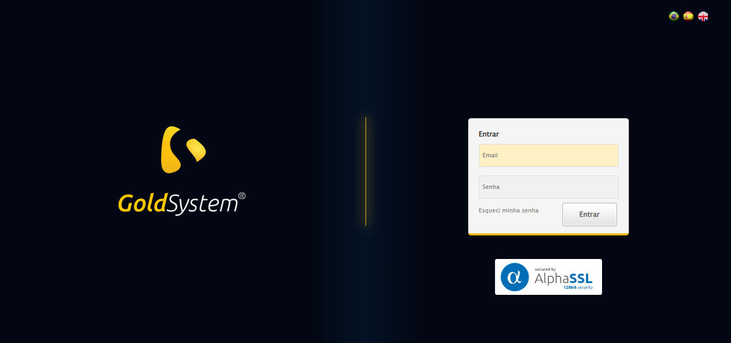

🔄 Realizando login...

❌ Erro inesperado ao realizando login: type object 'datetime.time' has no attribute 'sleep'

Screenshot: erro_realizando login

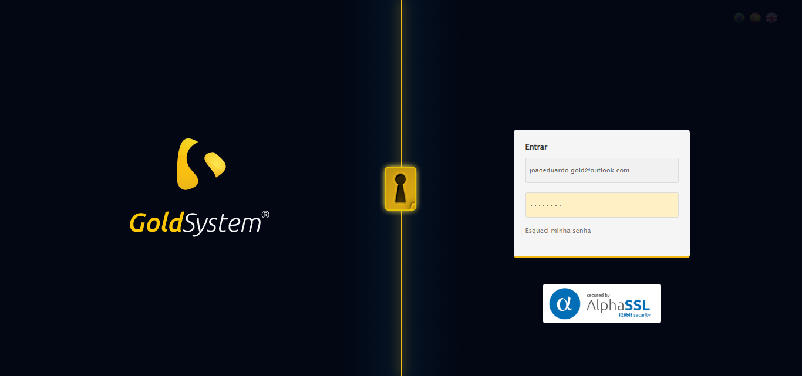

🔄 Ajustando zoom e abrindo menu...

🔍 Zoom ajustado para 90%.

✅ Ajustando zoom e abrindo menu realizada com sucesso.

Screenshot: ajustando zoom e abrindo menu



🔄 Acessando CRM...

❌ Erro inesperado ao acessando crm: Message: element not interactable  
 (Session info: chrome=138.0.7204.185)  
Stacktrace:  
 GetHandleVerifier [0x0x5dba83+63395]  
 GetHandleVerifier [0x0x5dbac4+63460]  
 (No symbol) [0x0x421f70]  
 (No symbol) [0x0x46b9f4]  
 (No symbol) [0x0x460515]  
 (No symbol) [0x0x48f3ac]  
 (No symbol) [0x0x45ffa4]  
 (No symbol) [0x0x48f624]  
 (No symbol) [0x0x4b07ba]  
 (No symbol) [0x0x48f1a6]  
 (No symbol) [0x0x45e7b2]  
 (No symbol) [0x0x45f654]  
 GetHandleVerifier [0x0x858883+2672035]  
 GetHandleVerifier [0x0x853cba+2652634]  
 GetHandleVerifier [0x0x602bca+223466]  
 GetHandleVerifier [0x0x5f2cb8+158168]  
 GetHandleVerifier [0x0x5f978d+185517]  
 GetHandleVerifier [0x0x5e3b78+96408]  
 GetHandleVerifier [0x0x5e3d02+96802]  
 GetHandleVerifier [0x0x5ce90a+9770]  
 BaseThreadInitThunk [0x0x773dfcc9+25]  
 RtlGetAppContainerNamedObjectPath [0x0x77ba82ae+286]  
 RtlGetAppContainerNamedObjectPath [0x0x77ba827e+238]

Screenshot: erro_acessando crm

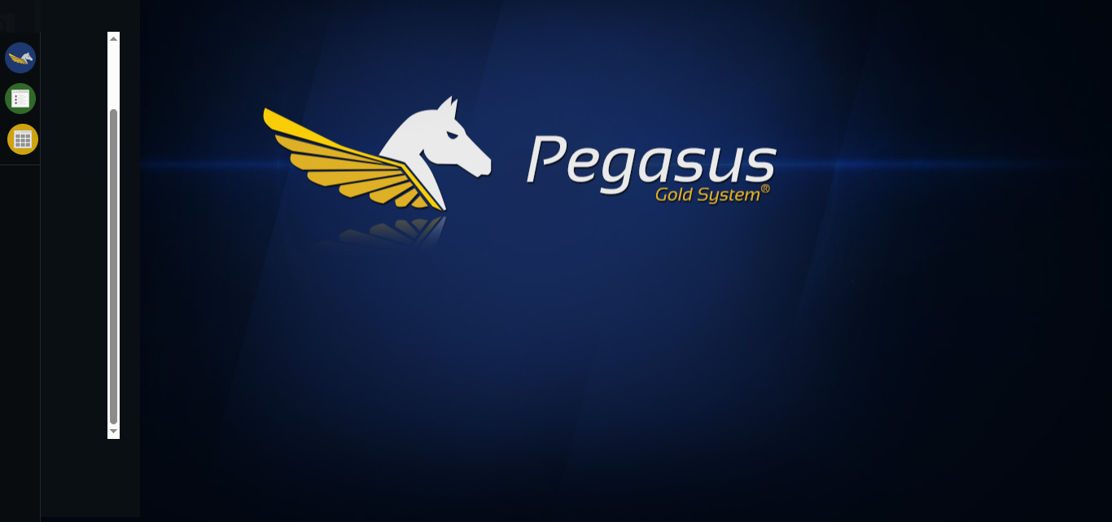

🔄 Clicando em Cadastrar Contato Externo...

❌ Erro inesperado ao clicando em cadastrar contato externo: Message: no such window: target window already closed  
from unknown error: web view not found  
 (Session info: chrome=138.0.7204.185)  
Stacktrace:  
 GetHandleVerifier [0x0x5dba83+63395]  
 GetHandleVerifier [0x0x5dbac4+63460]  
 (No symbol) [0x0x422113]  
 (No symbol) [0x0x400fb9]  
 (No symbol) [0x0x495ace]  
 (No symbol) [0x0x4b0099]  
 (No symbol) [0x0x48f1a6]  
 (No symbol) [0x0x45e7b2]  
 (No symbol) [0x0x45f654]  
 GetHandleVerifier [0x0x858883+2672035]  
 GetHandleVerifier [0x0x853cba+2652634]  
 GetHandleVerifier [0x0x602bca+223466]  
 GetHandleVerifier [0x0x5f2cb8+158168]  
 GetHandleVerifier [0x0x5f978d+185517]  
 GetHandleVerifier [0x0x5e3b78+96408]  
 GetHandleVerifier [0x0x5e3d02+96802]  
 GetHandleVerifier [0x0x5ce90a+9770]  
 BaseThreadInitThunk [0x0x773dfcc9+25]  
 RtlGetAppContainerNamedObjectPath [0x0x77ba82ae+286]  
 RtlGetAppContainerNamedObjectPath [0x0x77ba827e+238]

⚠️ Erro ao tirar screenshot erro_clicando em cadastrar contato externo: Message: no such window: target window already closed  
from unknown error: web view not found  
 (Session info: chrome=138.0.7204.185)  
Stacktrace:  
 GetHandleVerifier [0x0x5dba83+63395]  
 GetHandleVerifier [0x0x5dbac4+63460]  
 (No symbol) [0x0x422113]  
 (No symbol) [0x0x400fb9]  
 (No symbol) [0x0x495ace]  
 (No symbol) [0x0x4b0099]  
 (No symbol) [0x0x48f1a6]  
 (No symbol) [0x0x45e7b2]  
 (No symbol) [0x0x45f654]  
 GetHandleVerifier [0x0x858883+2672035]  
 GetHandleVerifier [0x0x853cba+2652634]  
 GetHandleVerifier [0x0x602bca+223466]  
 GetHandleVerifier [0x0x5f2cb8+158168]  
 GetHandleVerifier [0x0x5f978d+185517]  
 GetHandleVerifier [0x0x5e3b78+96408]  
 GetHandleVerifier [0x0x5e3d02+96802]  
 GetHandleVerifier [0x0x5ce90a+9770]  
 BaseThreadInitThunk [0x0x773dfcc9+25]  
 RtlGetAppContainerNamedObjectPath [0x0x77ba82ae+286]  
 RtlGetAppContainerNamedObjectPath [0x0x77ba827e+238]

❌ ERRO FATAL: type object 'datetime.time' has no attribute 'sleep'

⚠️ Erro ao tirar screenshot erro_fatal: Message: no such window: target window already closed  
from unknown error: web view not found  
 (Session info: chrome=138.0.7204.185)  
Stacktrace:  
 GetHandleVerifier [0x0x5dba83+63395]  
 GetHandleVerifier [0x0x5dbac4+63460]  
 (No symbol) [0x0x422113]  
 (No symbol) [0x0x400fb9]  
 (No symbol) [0x0x495ace]  
 (No symbol) [0x0x4b0099]  
 (No symbol) [0x0x48f1a6]  
 (No symbol) [0x0x45e7b2]  
 (No symbol) [0x0x45f654]  
 GetHandleVerifier [0x0x858883+2672035]  
 GetHandleVerifier [0x0x853cba+2652634]  
 GetHandleVerifier [0x0x602bca+223466]  
 GetHandleVerifier [0x0x5f2cb8+158168]  
 GetHandleVerifier [0x0x5f978d+185517]  
 GetHandleVerifier [0x0x5e3b78+96408]  
 GetHandleVerifier [0x0x5e3d02+96802]  
 GetHandleVerifier [0x0x5ce90a+9770]  
 BaseThreadInitThunk [0x0x773dfcc9+25]  
 RtlGetAppContainerNamedObjectPath [0x0x77ba82ae+286]  
 RtlGetAppContainerNamedObjectPath [0x0x77ba827e+238]

✅ Teste concluído.

❌ Teste finalizado com erros.