RELATÓRIO DO TESTE

Cadastro de Contato Externo (CRM) – Cenário 1: Preenchimento completo e salvamento.

Data do teste: 11/08/2025 17:15:16

🚀 Iniciando teste de cadastro de CRM/Contato Externo...

🔄 Acessando sistema...

✅ Acessando sistema realizada com sucesso.

Screenshot: acessando sistema

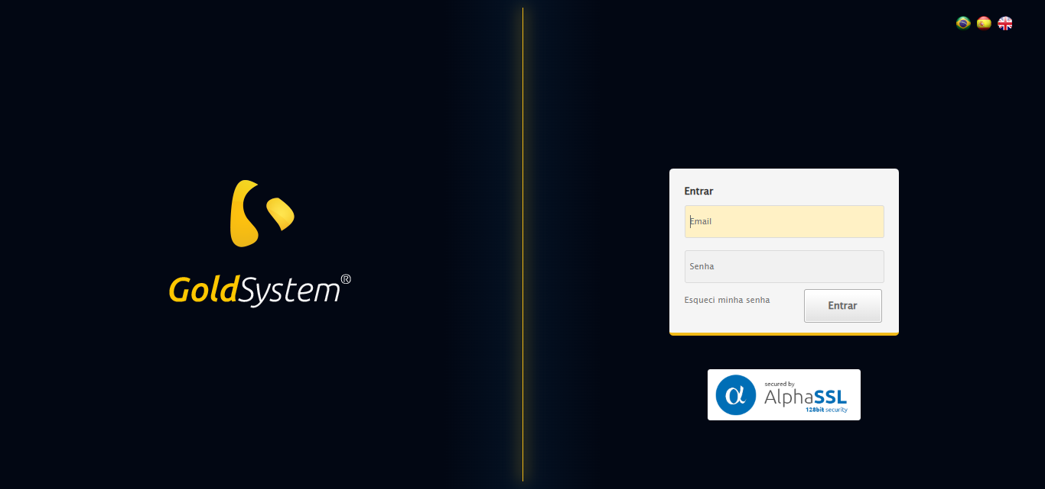

🔄 Realizando login...

✅ Realizando login realizada com sucesso.

Screenshot: realizando login

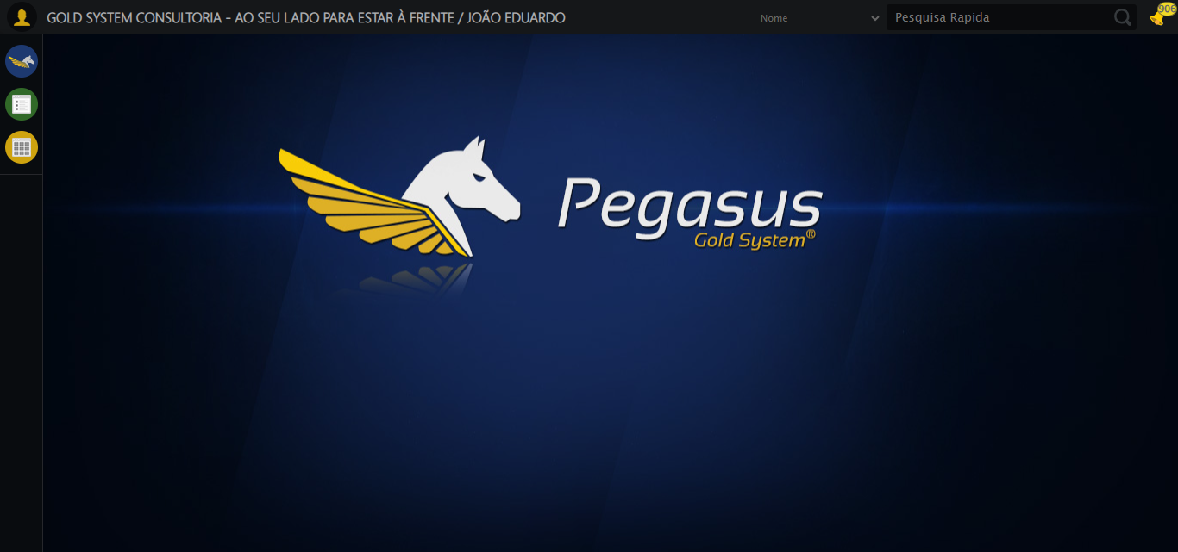

🔄 Ajustando zoom e abrindo menu...

🔍 Zoom ajustado para 90%.

✅ Ajustando zoom e abrindo menu realizada com sucesso.

Screenshot: ajustando zoom e abrindo menu

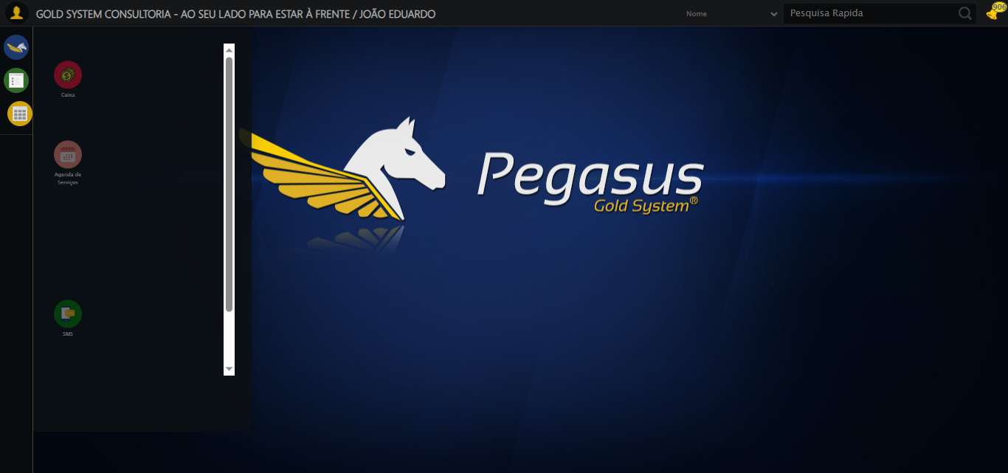

🔄 Acessando CRM...

✅ Acessando CRM realizada com sucesso.

Screenshot: acessando crm

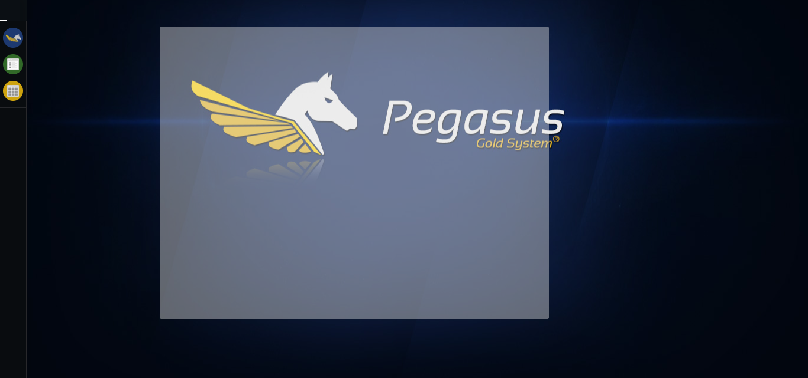

🔄 Clicando em Cadastrar Contato Externo...

✅ Clicando em Cadastrar Contato Externo realizada com sucesso.

Screenshot: clicando em cadastrar contato externo

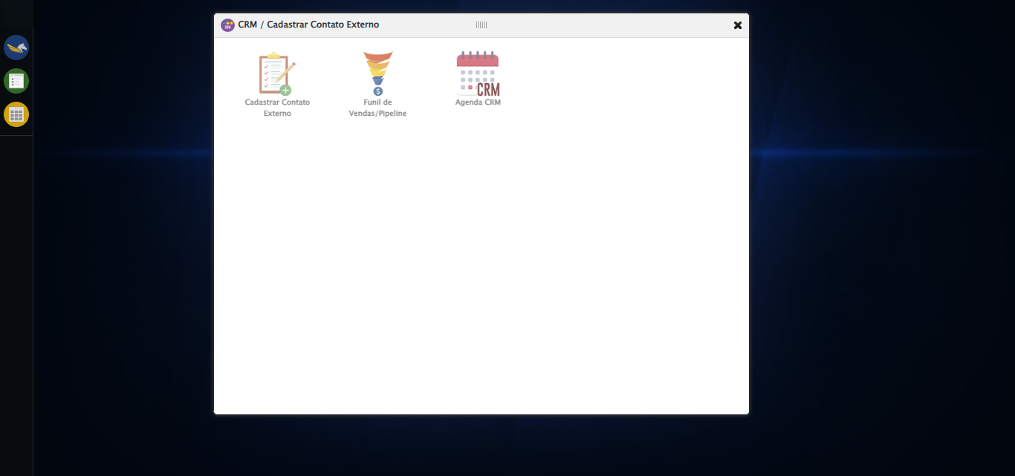

🔄 Avançando para aba: 'Cliente/Empresa'...

✅ Avançando para aba: 'Cliente/Empresa' realizada com sucesso.

Screenshot: avançando para aba_ _cliente_empresa_

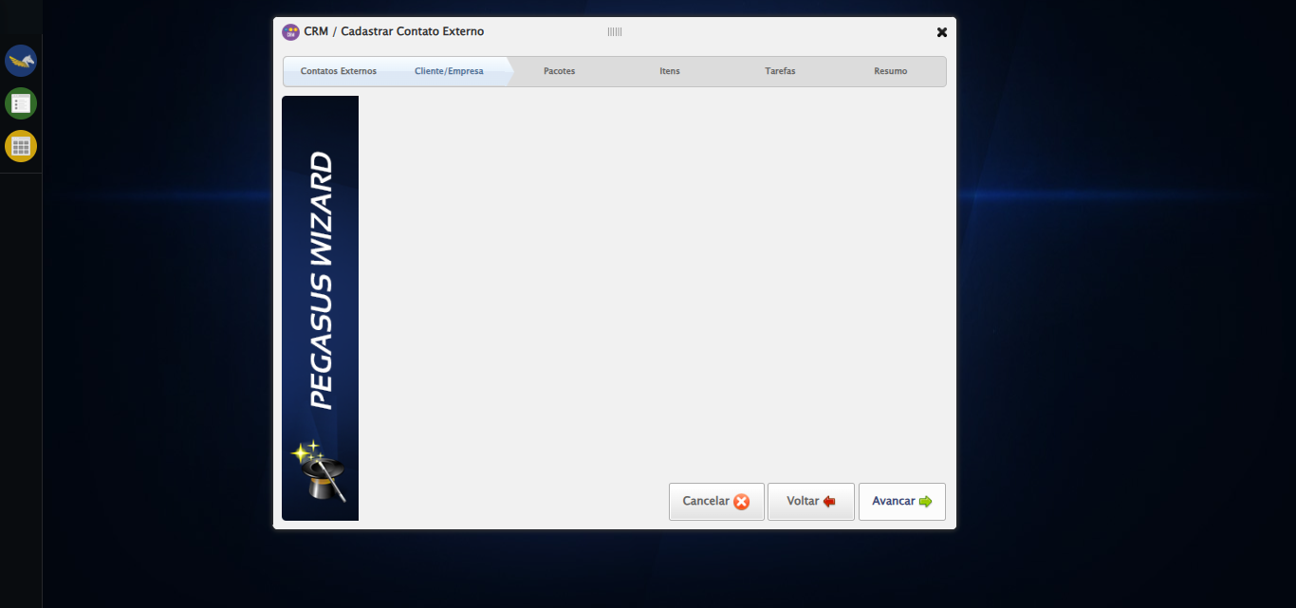

🔄 Selecionando Cliente...

✅ Selecionando Cliente realizada com sucesso.

Screenshot: selecionando cliente

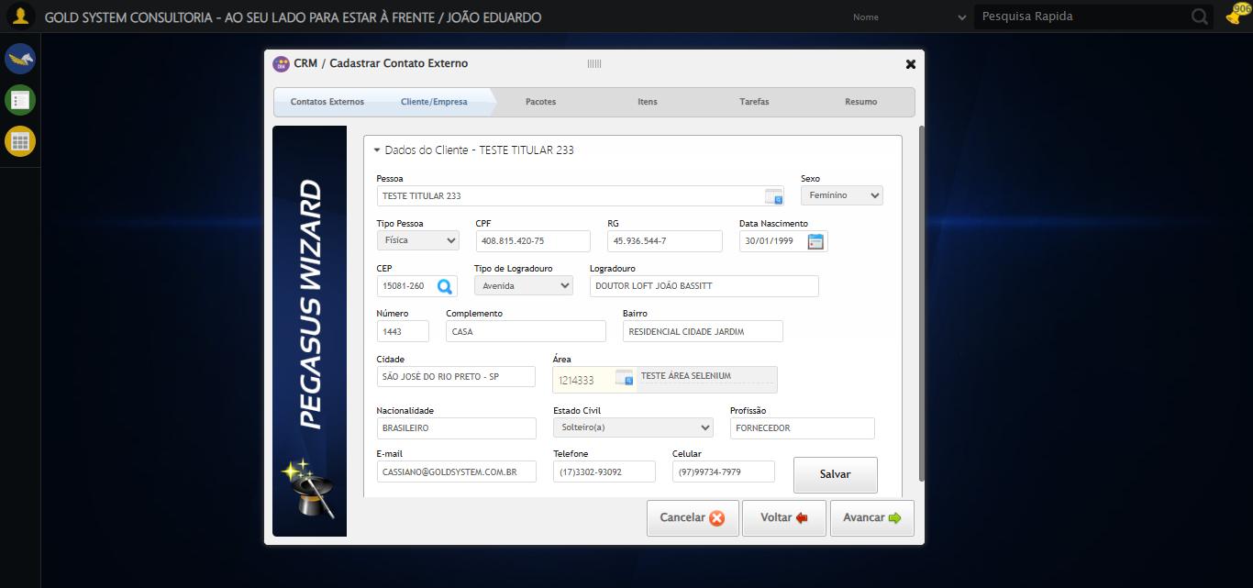

🔄 Salvando Cliente...

✅ Salvando Cliente realizada com sucesso.

Screenshot: salvando cliente

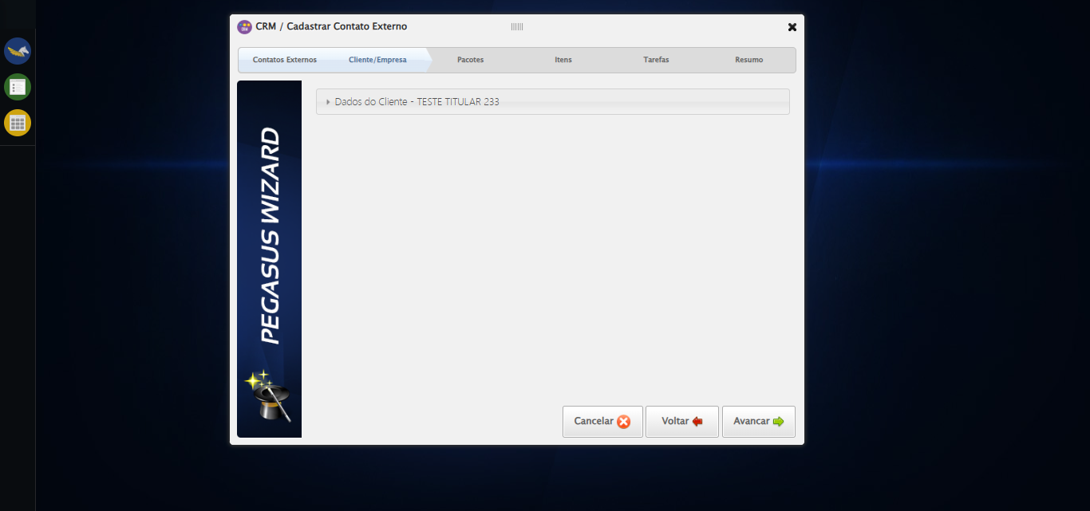

🔄 Avançando para aba: 'Pacotes'...

✅ Avançando para aba: 'Pacotes' realizada com sucesso.

Screenshot: avançando para aba_ _pacotes_

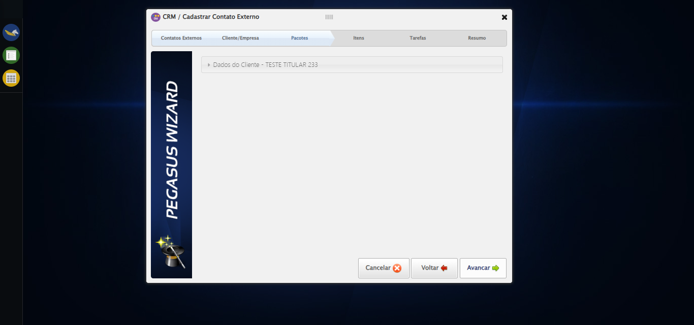

🔄 Selecionando Pacote...

✅ Selecionando Pacote realizada com sucesso.

Screenshot: selecionando pacote

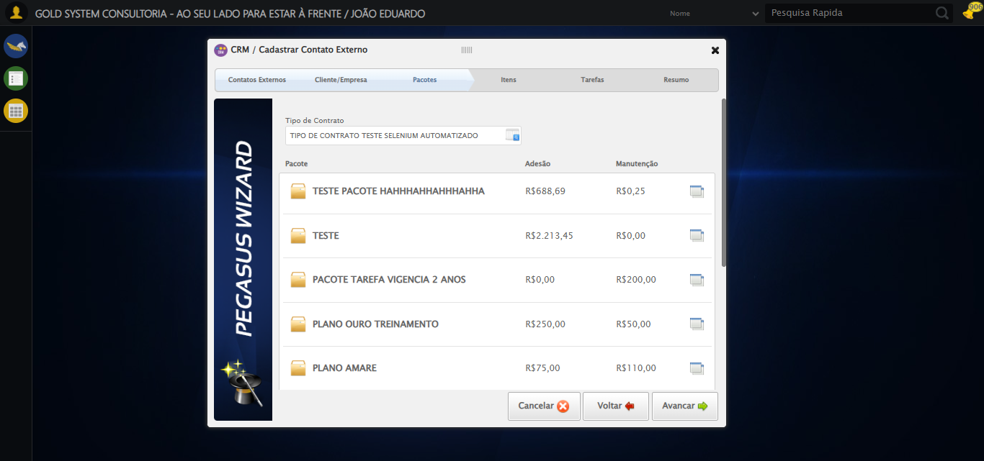

🔄 Selecionando Pacote...

✅ Selecionando Pacote realizada com sucesso.

🔄 Avançando para aba: 'Itens'...

✅ Avançando para aba: 'Itens' realizada com sucesso.

Screenshot: avançando para aba_ _itens_

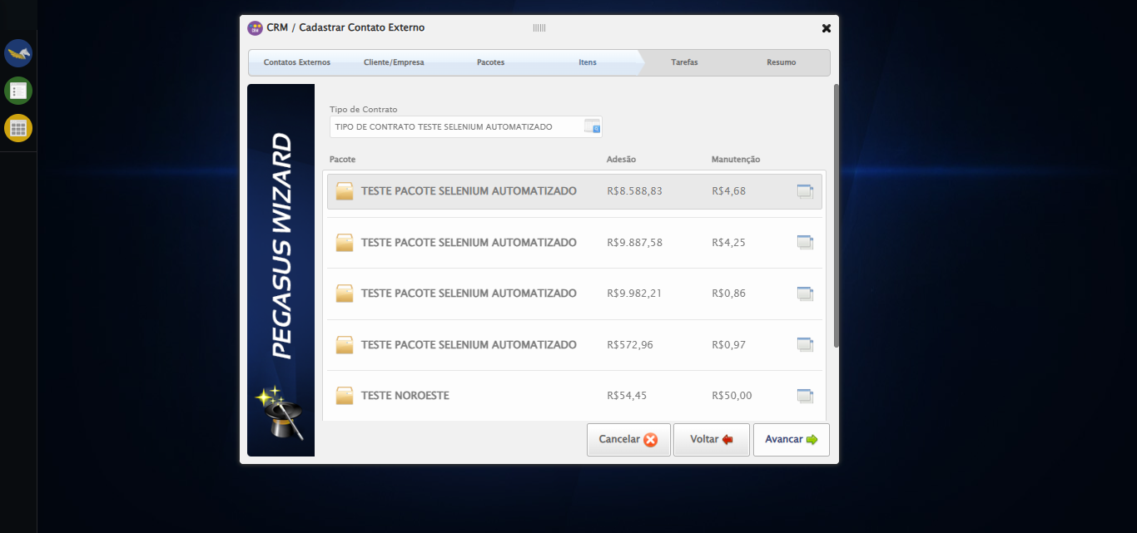

🔄 Selecionando Item...

✅ Selecionando Item realizada com sucesso.

Screenshot: selecionando item

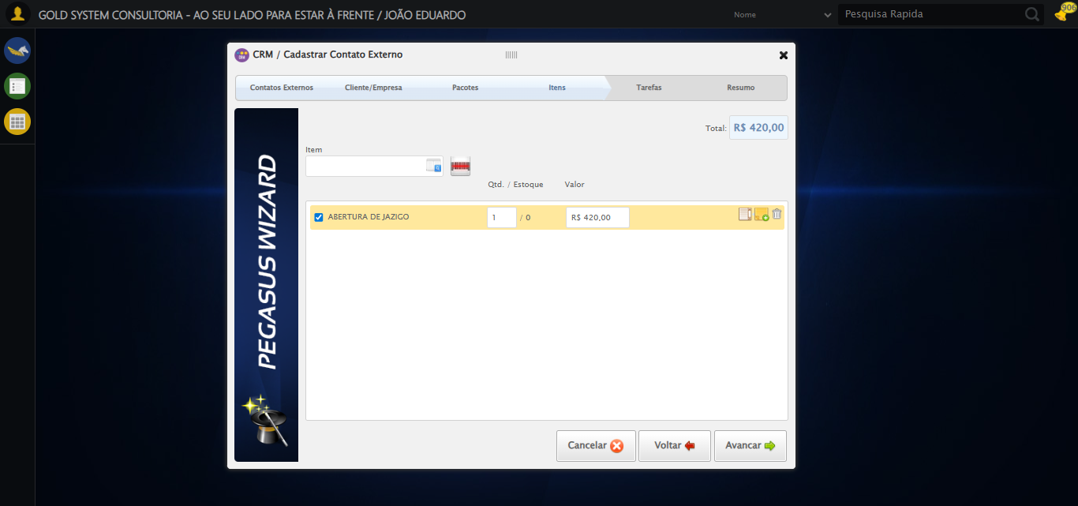

🔄 Avançando para aba: 'Tarefas'...

✅ Avançando para aba: 'Tarefas' realizada com sucesso.

Screenshot: avançando para aba_ _tarefas_

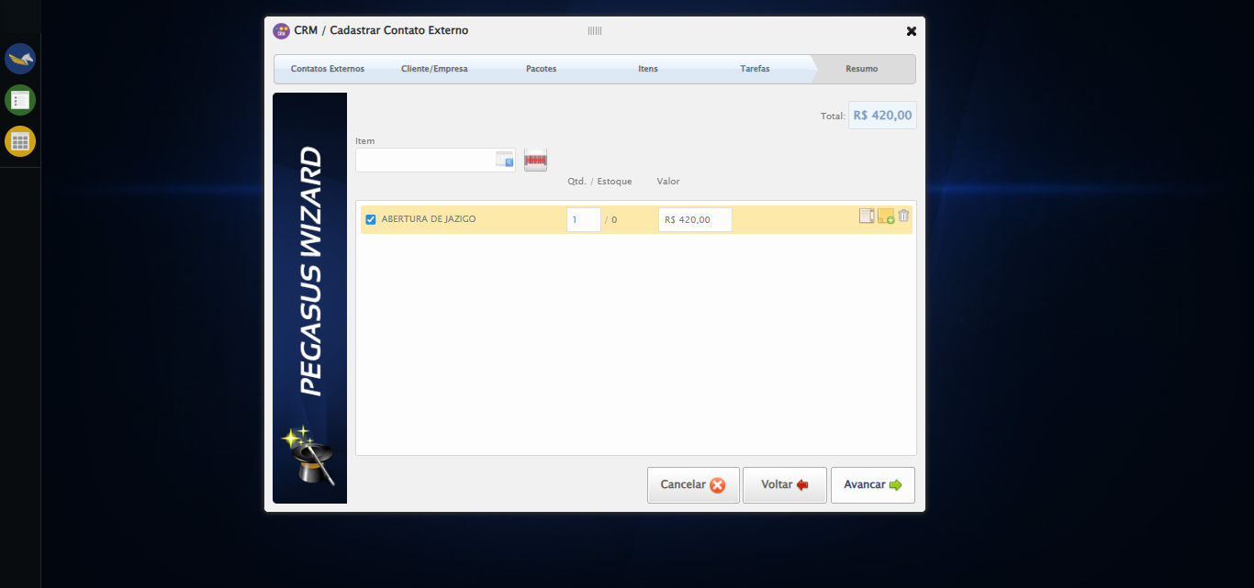

🔄 Selecionando Tipo de Tarefa...

✅ Selecionando Tipo de Tarefa realizada com sucesso.

Screenshot: selecionando tipo de tarefa

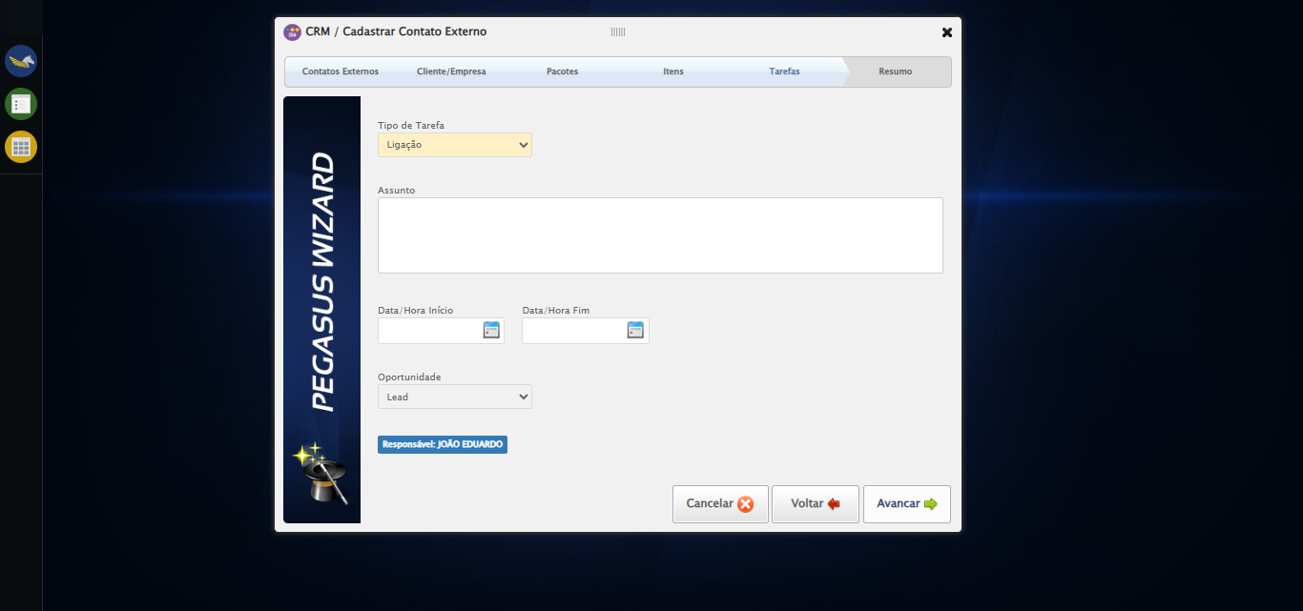

🔄 Preechendo Assunto...

✅ Preechendo Assunto realizada com sucesso.

Screenshot: preechendo assunto

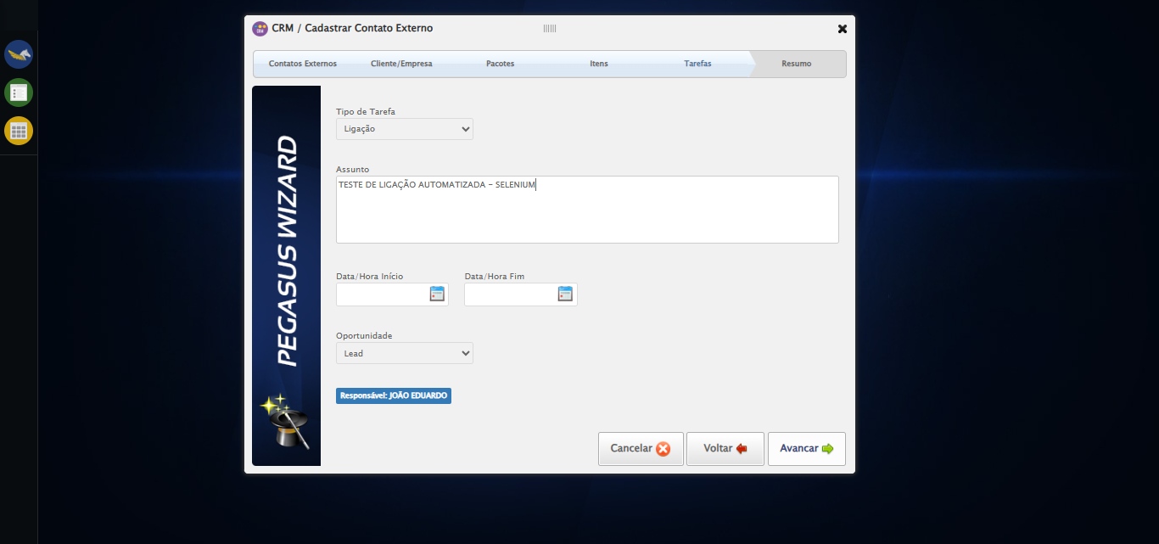

🔄 Data Início...

⚠️ Tentativa 1 falhou: Message: invalid selector: Unable to locate an element with the xpath expression //input[contains(@class,'hasDatepicker') and @type='text'])[1] because of the following error:  
SyntaxError: Failed to execute 'evaluate' on 'Document': The string '//input[contains(@class,'hasDatepicker') and @type='text'])[1]' is not a valid XPath expression.  
 (Session info: chrome=138.0.7204.185); For documentation on this error, please visit: https://www.selenium.dev/documentation/webdriver/troubleshooting/errors#invalid-selector-exception  
Stacktrace:  
 GetHandleVerifier [0x0x7fba83+63395]  
 GetHandleVerifier [0x0x7fbac4+63460]  
 (No symbol) [0x0x642113]  
 (No symbol) [0x0x6488e9]  
 (No symbol) [0x0x64ac7a]  
 (No symbol) [0x0x64acf7]  
 (No symbol) [0x0x68a0f4]  
 (No symbol) [0x0x68abfb]  
 (No symbol) [0x0x6d2f92]  
 (No symbol) [0x0x6af3f4]  
 (No symbol) [0x0x6d07ba]  
 (No symbol) [0x0x6af1a6]  
 (No symbol) [0x0x67e7b2]  
 (No symbol) [0x0x67f654]  
 GetHandleVerifier [0x0xa78883+2672035]  
 GetHandleVerifier [0x0xa73cba+2652634]  
 GetHandleVerifier [0x0x822bca+223466]  
 GetHandleVerifier [0x0x812cb8+158168]  
 GetHandleVerifier [0x0x81978d+185517]  
 GetHandleVerifier [0x0x803b78+96408]  
 GetHandleVerifier [0x0x803d02+96802]  
 GetHandleVerifier [0x0x7ee90a+9770]  
 BaseThreadInitThunk [0x0x773dfcc9+25]  
 RtlGetAppContainerNamedObjectPath [0x0x77ba82ae+286]  
 RtlGetAppContainerNamedObjectPath [0x0x77ba827e+238]

⚠️ Tentativa 2 falhou: Message: invalid selector: Unable to locate an element with the xpath expression //input[contains(@class,'hasDatepicker') and @type='text'])[1] because of the following error:  
SyntaxError: Failed to execute 'evaluate' on 'Document': The string '//input[contains(@class,'hasDatepicker') and @type='text'])[1]' is not a valid XPath expression.  
 (Session info: chrome=138.0.7204.185); For documentation on this error, please visit: https://www.selenium.dev/documentation/webdriver/troubleshooting/errors#invalid-selector-exception  
Stacktrace:  
 GetHandleVerifier [0x0x7fba83+63395]  
 GetHandleVerifier [0x0x7fbac4+63460]  
 (No symbol) [0x0x642113]  
 (No symbol) [0x0x6488e9]  
 (No symbol) [0x0x64ac7a]  
 (No symbol) [0x0x64acf7]  
 (No symbol) [0x0x68a0f4]  
 (No symbol) [0x0x68abfb]  
 (No symbol) [0x0x6d2f92]  
 (No symbol) [0x0x6af3f4]  
 (No symbol) [0x0x6d07ba]  
 (No symbol) [0x0x6af1a6]  
 (No symbol) [0x0x67e7b2]  
 (No symbol) [0x0x67f654]  
 GetHandleVerifier [0x0xa78883+2672035]  
 GetHandleVerifier [0x0xa73cba+2652634]  
 GetHandleVerifier [0x0x822bca+223466]  
 GetHandleVerifier [0x0x812cb8+158168]  
 GetHandleVerifier [0x0x81978d+185517]  
 GetHandleVerifier [0x0x803b78+96408]  
 GetHandleVerifier [0x0x803d02+96802]  
 GetHandleVerifier [0x0x7ee90a+9770]  
 BaseThreadInitThunk [0x0x773dfcc9+25]  
 RtlGetAppContainerNamedObjectPath [0x0x77ba82ae+286]  
 RtlGetAppContainerNamedObjectPath [0x0x77ba827e+238]

⚠️ Tentativa 3 falhou: Message: invalid selector: Unable to locate an element with the xpath expression //input[contains(@class,'hasDatepicker') and @type='text'])[1] because of the following error:  
SyntaxError: Failed to execute 'evaluate' on 'Document': The string '//input[contains(@class,'hasDatepicker') and @type='text'])[1]' is not a valid XPath expression.  
 (Session info: chrome=138.0.7204.185); For documentation on this error, please visit: https://www.selenium.dev/documentation/webdriver/troubleshooting/errors#invalid-selector-exception  
Stacktrace:  
 GetHandleVerifier [0x0x7fba83+63395]  
 GetHandleVerifier [0x0x7fbac4+63460]  
 (No symbol) [0x0x642113]  
 (No symbol) [0x0x6488e9]  
 (No symbol) [0x0x64ac7a]  
 (No symbol) [0x0x64acf7]  
 (No symbol) [0x0x68a0f4]  
 (No symbol) [0x0x68abfb]  
 (No symbol) [0x0x6d2f92]  
 (No symbol) [0x0x6af3f4]  
 (No symbol) [0x0x6d07ba]  
 (No symbol) [0x0x6af1a6]  
 (No symbol) [0x0x67e7b2]  
 (No symbol) [0x0x67f654]  
 GetHandleVerifier [0x0xa78883+2672035]  
 GetHandleVerifier [0x0xa73cba+2652634]  
 GetHandleVerifier [0x0x822bca+223466]  
 GetHandleVerifier [0x0x812cb8+158168]  
 GetHandleVerifier [0x0x81978d+185517]  
 GetHandleVerifier [0x0x803b78+96408]  
 GetHandleVerifier [0x0x803d02+96802]  
 GetHandleVerifier [0x0x7ee90a+9770]  
 BaseThreadInitThunk [0x0x773dfcc9+25]  
 RtlGetAppContainerNamedObjectPath [0x0x77ba82ae+286]  
 RtlGetAppContainerNamedObjectPath [0x0x77ba827e+238]

✅ Data Início realizada com sucesso.

Screenshot: data início

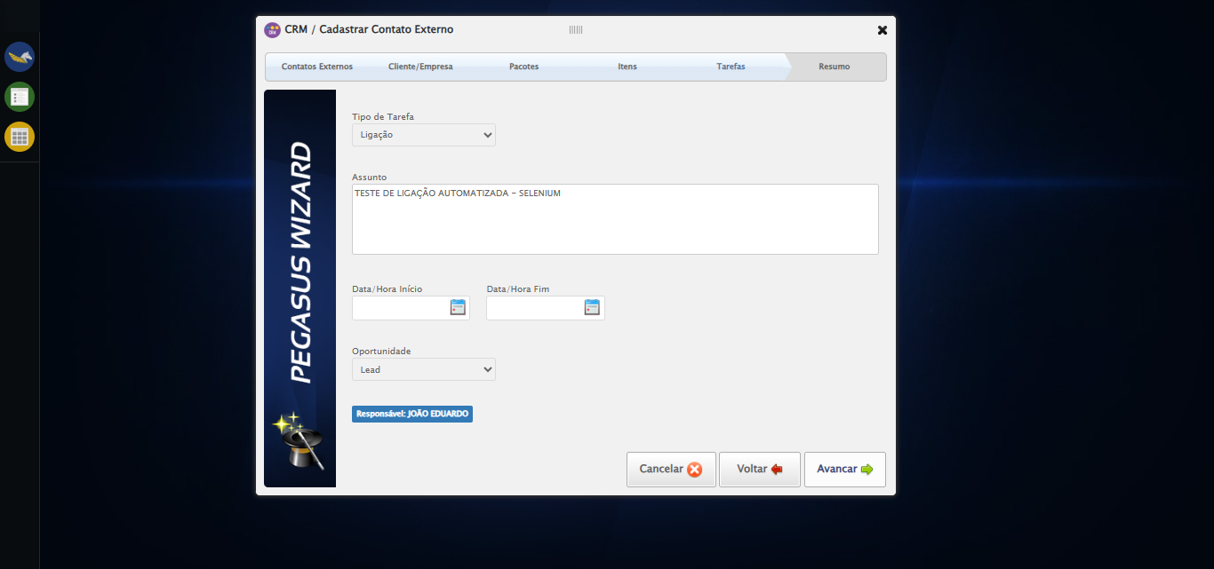

🔄 Data Fim...

⚠️ Tentativa 1 falhou: Message: invalid selector: Unable to locate an element with the xpath expression //input[contains(@class,'hasDatepicker') and @type='text'])[2] because of the following error:  
SyntaxError: Failed to execute 'evaluate' on 'Document': The string '//input[contains(@class,'hasDatepicker') and @type='text'])[2]' is not a valid XPath expression.  
 (Session info: chrome=138.0.7204.185); For documentation on this error, please visit: https://www.selenium.dev/documentation/webdriver/troubleshooting/errors#invalid-selector-exception  
Stacktrace:  
 GetHandleVerifier [0x0x7fba83+63395]  
 GetHandleVerifier [0x0x7fbac4+63460]  
 (No symbol) [0x0x642113]  
 (No symbol) [0x0x6488e9]  
 (No symbol) [0x0x64ac7a]  
 (No symbol) [0x0x64acf7]  
 (No symbol) [0x0x68a0f4]  
 (No symbol) [0x0x68abfb]  
 (No symbol) [0x0x6d2f92]  
 (No symbol) [0x0x6af3f4]  
 (No symbol) [0x0x6d07ba]  
 (No symbol) [0x0x6af1a6]  
 (No symbol) [0x0x67e7b2]  
 (No symbol) [0x0x67f654]  
 GetHandleVerifier [0x0xa78883+2672035]  
 GetHandleVerifier [0x0xa73cba+2652634]  
 GetHandleVerifier [0x0x822bca+223466]  
 GetHandleVerifier [0x0x812cb8+158168]  
 GetHandleVerifier [0x0x81978d+185517]  
 GetHandleVerifier [0x0x803b78+96408]  
 GetHandleVerifier [0x0x803d02+96802]  
 GetHandleVerifier [0x0x7ee90a+9770]  
 BaseThreadInitThunk [0x0x773dfcc9+25]  
 RtlGetAppContainerNamedObjectPath [0x0x77ba82ae+286]  
 RtlGetAppContainerNamedObjectPath [0x0x77ba827e+238]

⚠️ Tentativa 2 falhou: Message: invalid selector: Unable to locate an element with the xpath expression //input[contains(@class,'hasDatepicker') and @type='text'])[2] because of the following error:  
SyntaxError: Failed to execute 'evaluate' on 'Document': The string '//input[contains(@class,'hasDatepicker') and @type='text'])[2]' is not a valid XPath expression.  
 (Session info: chrome=138.0.7204.185); For documentation on this error, please visit: https://www.selenium.dev/documentation/webdriver/troubleshooting/errors#invalid-selector-exception  
Stacktrace:  
 GetHandleVerifier [0x0x7fba83+63395]  
 GetHandleVerifier [0x0x7fbac4+63460]  
 (No symbol) [0x0x642113]  
 (No symbol) [0x0x6488e9]  
 (No symbol) [0x0x64ac7a]  
 (No symbol) [0x0x64acf7]  
 (No symbol) [0x0x68a0f4]  
 (No symbol) [0x0x68abfb]  
 (No symbol) [0x0x6d2f92]  
 (No symbol) [0x0x6af3f4]  
 (No symbol) [0x0x6d07ba]  
 (No symbol) [0x0x6af1a6]  
 (No symbol) [0x0x67e7b2]  
 (No symbol) [0x0x67f654]  
 GetHandleVerifier [0x0xa78883+2672035]  
 GetHandleVerifier [0x0xa73cba+2652634]  
 GetHandleVerifier [0x0x822bca+223466]  
 GetHandleVerifier [0x0x812cb8+158168]  
 GetHandleVerifier [0x0x81978d+185517]  
 GetHandleVerifier [0x0x803b78+96408]  
 GetHandleVerifier [0x0x803d02+96802]  
 GetHandleVerifier [0x0x7ee90a+9770]  
 BaseThreadInitThunk [0x0x773dfcc9+25]  
 RtlGetAppContainerNamedObjectPath [0x0x77ba82ae+286]  
 RtlGetAppContainerNamedObjectPath [0x0x77ba827e+238]

⚠️ Tentativa 3 falhou: Message: invalid selector: Unable to locate an element with the xpath expression //input[contains(@class,'hasDatepicker') and @type='text'])[2] because of the following error:  
SyntaxError: Failed to execute 'evaluate' on 'Document': The string '//input[contains(@class,'hasDatepicker') and @type='text'])[2]' is not a valid XPath expression.  
 (Session info: chrome=138.0.7204.185); For documentation on this error, please visit: https://www.selenium.dev/documentation/webdriver/troubleshooting/errors#invalid-selector-exception  
Stacktrace:  
 GetHandleVerifier [0x0x7fba83+63395]  
 GetHandleVerifier [0x0x7fbac4+63460]  
 (No symbol) [0x0x642113]  
 (No symbol) [0x0x6488e9]  
 (No symbol) [0x0x64ac7a]  
 (No symbol) [0x0x64acf7]  
 (No symbol) [0x0x68a0f4]  
 (No symbol) [0x0x68abfb]  
 (No symbol) [0x0x6d2f92]  
 (No symbol) [0x0x6af3f4]  
 (No symbol) [0x0x6d07ba]  
 (No symbol) [0x0x6af1a6]  
 (No symbol) [0x0x67e7b2]  
 (No symbol) [0x0x67f654]  
 GetHandleVerifier [0x0xa78883+2672035]  
 GetHandleVerifier [0x0xa73cba+2652634]  
 GetHandleVerifier [0x0x822bca+223466]  
 GetHandleVerifier [0x0x812cb8+158168]  
 GetHandleVerifier [0x0x81978d+185517]  
 GetHandleVerifier [0x0x803b78+96408]  
 GetHandleVerifier [0x0x803d02+96802]  
 GetHandleVerifier [0x0x7ee90a+9770]  
 BaseThreadInitThunk [0x0x773dfcc9+25]  
 RtlGetAppContainerNamedObjectPath [0x0x77ba82ae+286]  
 RtlGetAppContainerNamedObjectPath [0x0x77ba827e+238]

✅ Data Fim realizada com sucesso.

Screenshot: data fim

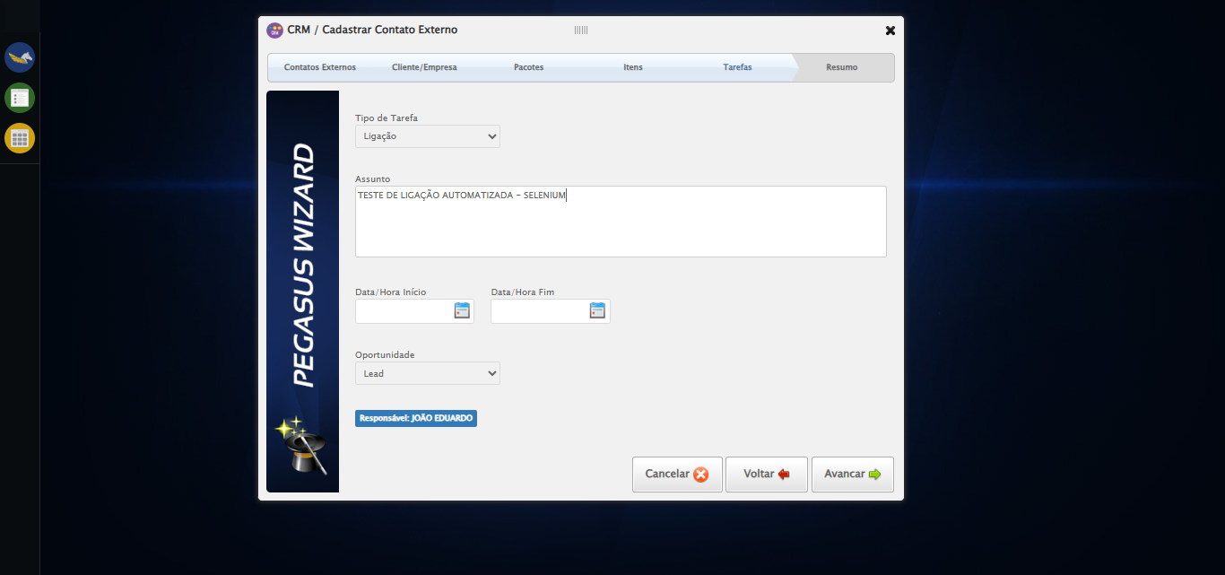

🔄 Avançando para aba: 'Resumo'...

❌ Erro inesperado ao avançando para aba: 'resumo': Message: invalid session id: session deleted as the browser has closed the connection  
from disconnected: not connected to DevTools  
 (Session info: chrome=138.0.7204.185)  
Stacktrace:  
 GetHandleVerifier [0x0x7fba83+63395]  
 GetHandleVerifier [0x0x7fbac4+63460]  
 (No symbol) [0x0x642113]  
 (No symbol) [0x0x631b20]  
 (No symbol) [0x0x64f922]  
 (No symbol) [0x0x6b5c9c]  
 (No symbol) [0x0x6d0099]  
 (No symbol) [0x0x6af1a6]  
 (No symbol) [0x0x67e7b2]  
 (No symbol) [0x0x67f654]  
 GetHandleVerifier [0x0xa78883+2672035]  
 GetHandleVerifier [0x0xa73cba+2652634]  
 GetHandleVerifier [0x0x822bca+223466]  
 GetHandleVerifier [0x0x812cb8+158168]  
 GetHandleVerifier [0x0x81978d+185517]  
 GetHandleVerifier [0x0x803b78+96408]  
 GetHandleVerifier [0x0x803d02+96802]  
 GetHandleVerifier [0x0x7ee90a+9770]  
 BaseThreadInitThunk [0x0x773dfcc9+25]  
 RtlGetAppContainerNamedObjectPath [0x0x77ba82ae+286]  
 RtlGetAppContainerNamedObjectPath [0x0x77ba827e+238]

⚠️ Erro ao tirar screenshot erro_avançando para aba_ _resumo_: Message: invalid session id  
Stacktrace:  
 GetHandleVerifier [0x0x7fba83+63395]  
 GetHandleVerifier [0x0x7fbac4+63460]  
 (No symbol) [0x0x641f70]  
 (No symbol) [0x0x67daa8]  
 (No symbol) [0x0x6af266]  
 (No symbol) [0x0x6aae65]  
 (No symbol) [0x0x6aa3e6]  
 (No symbol) [0x0x613a45]  
 (No symbol) [0x0x613f9e]  
 (No symbol) [0x0x61442d]  
 GetHandleVerifier [0x0xa78883+2672035]  
 GetHandleVerifier [0x0xa73cba+2652634]  
 GetHandleVerifier [0x0x822bca+223466]  
 GetHandleVerifier [0x0x812cb8+158168]  
 GetHandleVerifier [0x0x81978d+185517]  
 (No symbol) [0x0x613710]  
 (No symbol) [0x0x612f1d]  
 GetHandleVerifier [0x0xbadb9c+3938492]  
 BaseThreadInitThunk [0x0x773dfcc9+25]  
 RtlGetAppContainerNamedObjectPath [0x0x77ba82ae+286]  
 RtlGetAppContainerNamedObjectPath [0x0x77ba827e+238]

🔄 Finalizando cadastro...

❌ Erro inesperado ao finalizando cadastro: Message: invalid session id  
Stacktrace:  
 GetHandleVerifier [0x0x7fba83+63395]  
 GetHandleVerifier [0x0x7fbac4+63460]  
 (No symbol) [0x0x641f70]  
 (No symbol) [0x0x67daa8]  
 (No symbol) [0x0x6af266]  
 (No symbol) [0x0x6aae65]  
 (No symbol) [0x0x6aa3e6]  
 (No symbol) [0x0x613a45]  
 (No symbol) [0x0x613f9e]  
 (No symbol) [0x0x61442d]  
 GetHandleVerifier [0x0xa78883+2672035]  
 GetHandleVerifier [0x0xa73cba+2652634]  
 GetHandleVerifier [0x0x822bca+223466]  
 GetHandleVerifier [0x0x812cb8+158168]  
 GetHandleVerifier [0x0x81978d+185517]  
 (No symbol) [0x0x613710]  
 (No symbol) [0x0x612f1d]  
 GetHandleVerifier [0x0xbadb9c+3938492]  
 BaseThreadInitThunk [0x0x773dfcc9+25]  
 RtlGetAppContainerNamedObjectPath [0x0x77ba82ae+286]  
 RtlGetAppContainerNamedObjectPath [0x0x77ba827e+238]

⚠️ Erro ao tirar screenshot erro_finalizando cadastro: Message: invalid session id  
Stacktrace:  
 GetHandleVerifier [0x0x7fba83+63395]  
 GetHandleVerifier [0x0x7fbac4+63460]  
 (No symbol) [0x0x641f70]  
 (No symbol) [0x0x67daa8]  
 (No symbol) [0x0x6af266]  
 (No symbol) [0x0x6aae65]  
 (No symbol) [0x0x6aa3e6]  
 (No symbol) [0x0x613a45]  
 (No symbol) [0x0x613f9e]  
 (No symbol) [0x0x61442d]  
 GetHandleVerifier [0x0xa78883+2672035]  
 GetHandleVerifier [0x0xa73cba+2652634]  
 GetHandleVerifier [0x0x822bca+223466]  
 GetHandleVerifier [0x0x812cb8+158168]  
 GetHandleVerifier [0x0x81978d+185517]  
 (No symbol) [0x0x613710]  
 (No symbol) [0x0x612f1d]  
 GetHandleVerifier [0x0xbadb9c+3938492]  
 BaseThreadInitThunk [0x0x773dfcc9+25]  
 RtlGetAppContainerNamedObjectPath [0x0x77ba82ae+286]  
 RtlGetAppContainerNamedObjectPath [0x0x77ba827e+238]

🔄 Fechando modal após o salvamento...

❌ Erro ao clicar robusto: Message: invalid session id  
Stacktrace:  
 GetHandleVerifier [0x0x7fba83+63395]  
 GetHandleVerifier [0x0x7fbac4+63460]  
 (No symbol) [0x0x641f70]  
 (No symbol) [0x0x67daa8]  
 (No symbol) [0x0x6af266]  
 (No symbol) [0x0x6aae65]  
 (No symbol) [0x0x6aa3e6]  
 (No symbol) [0x0x613a45]  
 (No symbol) [0x0x613f9e]  
 (No symbol) [0x0x61442d]  
 GetHandleVerifier [0x0xa78883+2672035]  
 GetHandleVerifier [0x0xa73cba+2652634]  
 GetHandleVerifier [0x0x822bca+223466]  
 GetHandleVerifier [0x0x812cb8+158168]  
 GetHandleVerifier [0x0x81978d+185517]  
 (No symbol) [0x0x613710]  
 (No symbol) [0x0x612f1d]  
 GetHandleVerifier [0x0xbadb9c+3938492]  
 BaseThreadInitThunk [0x0x773dfcc9+25]  
 RtlGetAppContainerNamedObjectPath [0x0x77ba82ae+286]  
 RtlGetAppContainerNamedObjectPath [0x0x77ba827e+238]

✅ Fechando modal após o salvamento realizada com sucesso.

⚠️ Erro ao tirar screenshot fechando modal após o salvamento: Message: invalid session id  
Stacktrace:  
 GetHandleVerifier [0x0x7fba83+63395]  
 GetHandleVerifier [0x0x7fbac4+63460]  
 (No symbol) [0x0x641f70]  
 (No symbol) [0x0x67daa8]  
 (No symbol) [0x0x6af266]  
 (No symbol) [0x0x6aae65]  
 (No symbol) [0x0x6aa3e6]  
 (No symbol) [0x0x613a45]  
 (No symbol) [0x0x613f9e]  
 (No symbol) [0x0x61442d]  
 GetHandleVerifier [0x0xa78883+2672035]  
 GetHandleVerifier [0x0xa73cba+2652634]  
 GetHandleVerifier [0x0x822bca+223466]  
 GetHandleVerifier [0x0x812cb8+158168]  
 GetHandleVerifier [0x0x81978d+185517]  
 (No symbol) [0x0x613710]  
 (No symbol) [0x0x612f1d]  
 GetHandleVerifier [0x0xbadb9c+3938492]  
 BaseThreadInitThunk [0x0x773dfcc9+25]  
 RtlGetAppContainerNamedObjectPath [0x0x77ba82ae+286]  
 RtlGetAppContainerNamedObjectPath [0x0x77ba827e+238]

🔍 Verificando mensagens de alerta...

ℹ️ Nenhuma mensagem de alerta encontrada.

✅ Teste concluído.

✅ Teste executado com sucesso!