RELATÓRIO DO TESTE

Cadastro de Contrato Pet – Cenário 1: Preenchimento completo e salvamento.

Data do teste: 13/08/2025 17:20:33

🚀 Iniciando teste de cadastro de Contrato Pet

🔄 Acessando sistema...

✅ Acessando sistema realizada com sucesso.

Screenshot: acessando sistema

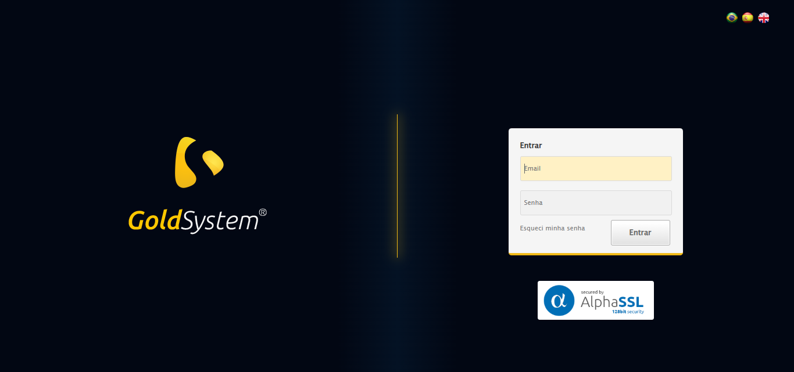

🔄 Realizando login...

✅ Realizando login realizada com sucesso.

Screenshot: realizando login

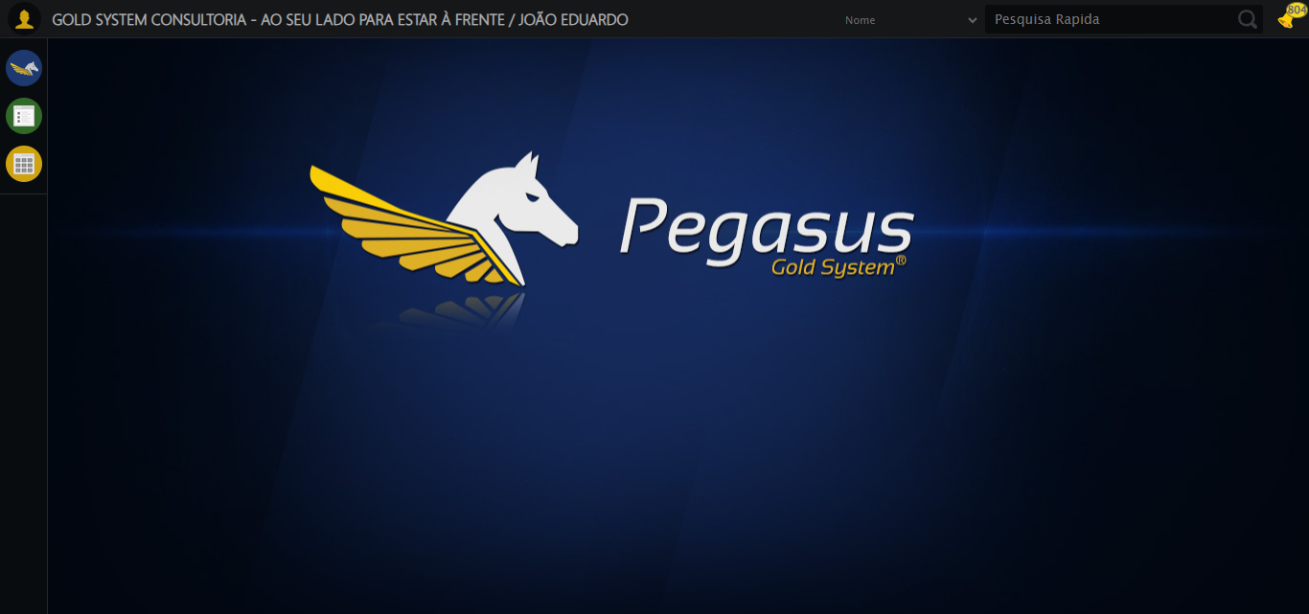

🔄 Ajustando zoom e abrindo menu...

🔍 Zoom ajustado para 90%.

✅ Ajustando zoom e abrindo menu realizada com sucesso.

Screenshot: ajustando zoom e abrindo menu

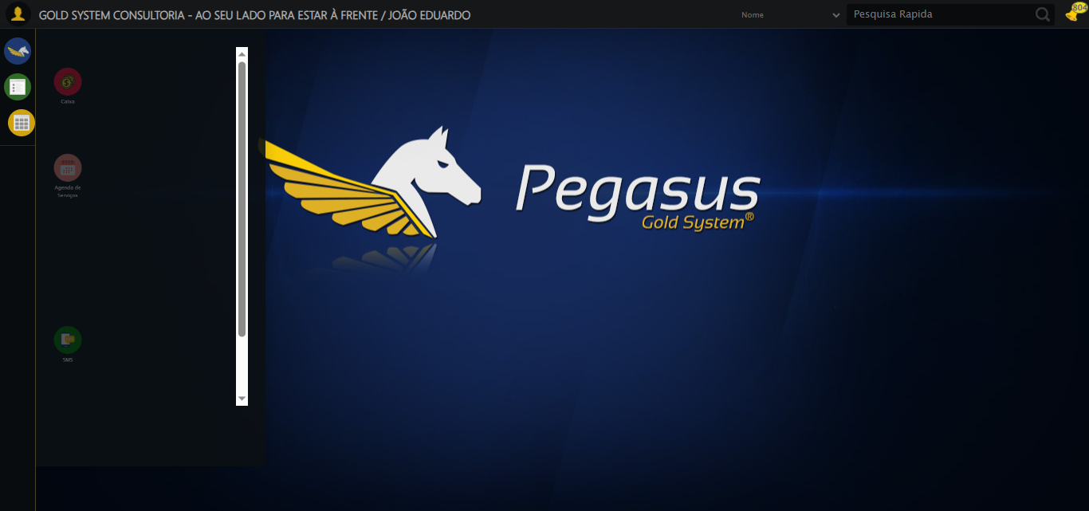

🔄 Acessando PET...

✅ Acessando PET realizada com sucesso.

Screenshot: acessando pet

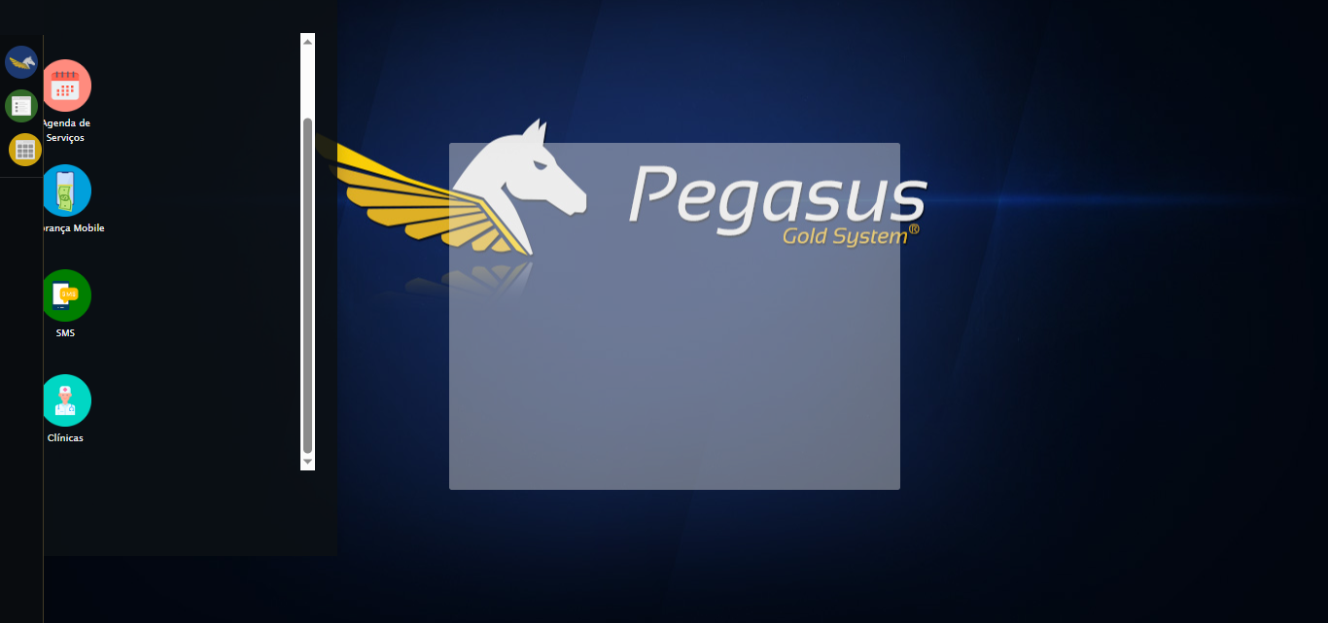

🔄 Clicando em Cadastrar Contrato...

✅ Clicando em Cadastrar Contrato realizada com sucesso.

Screenshot: clicando em cadastrar contrato

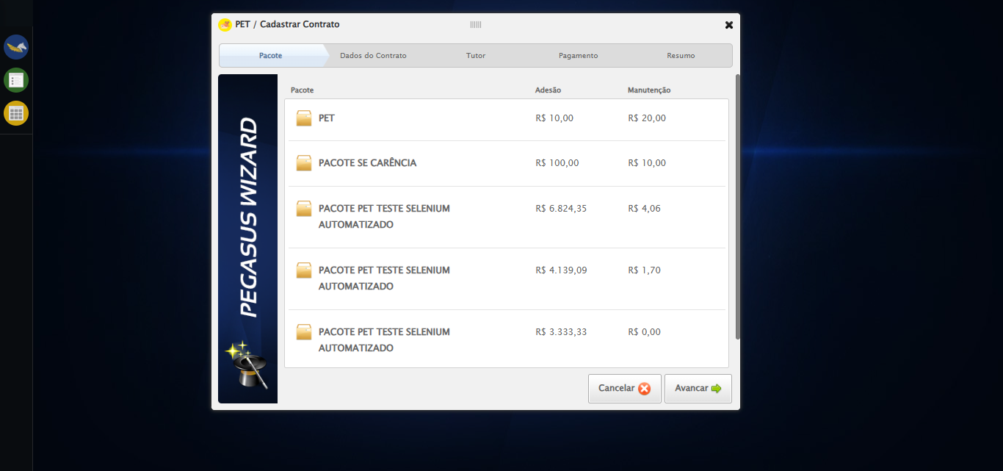

🔄 Selecionando Pacote...

✅ Selecionando Pacote realizada com sucesso.

Screenshot: selecionando pacote

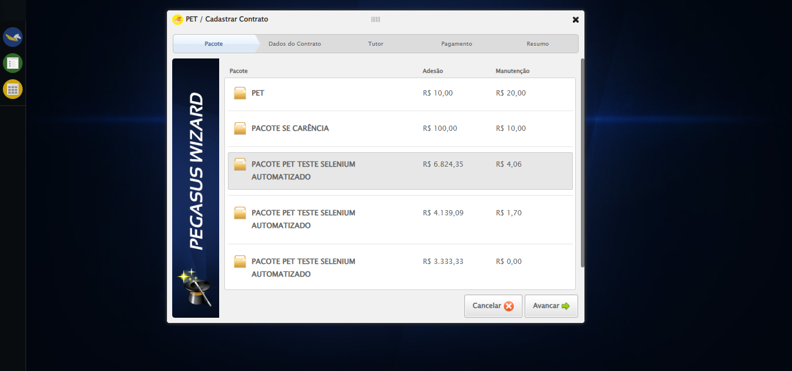

🔄 Avançando para aba: 'Dados do Contrato'...

✅ Avançando para aba: 'Dados do Contrato' realizada com sucesso.

Screenshot: avançando para aba_ _dados do contrato_

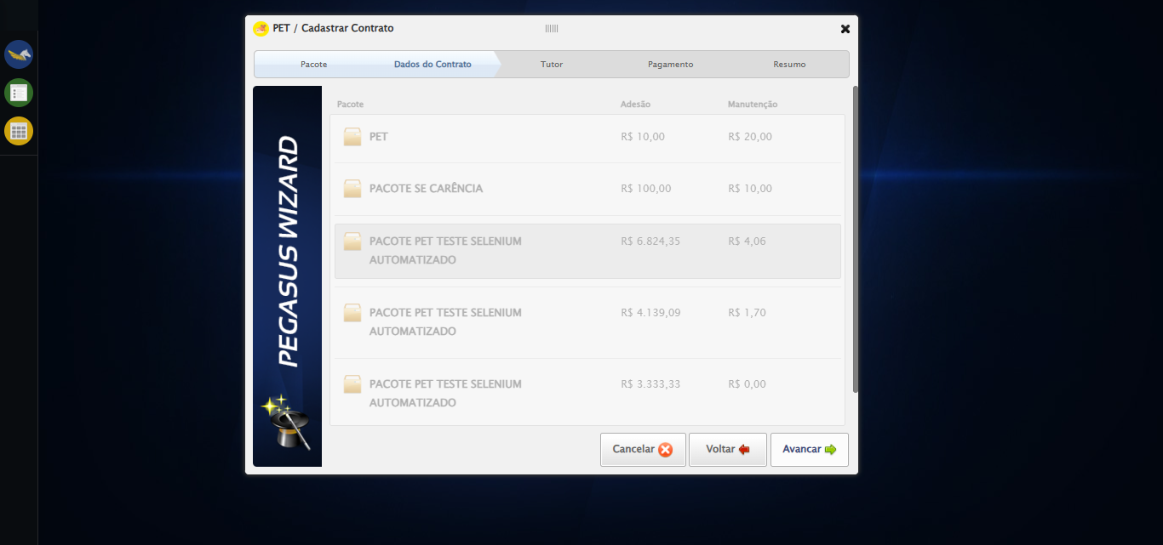

🔄 Selecionando Supervisor...

✅ Selecionando Supervisor realizada com sucesso.

Screenshot: selecionando supervisor

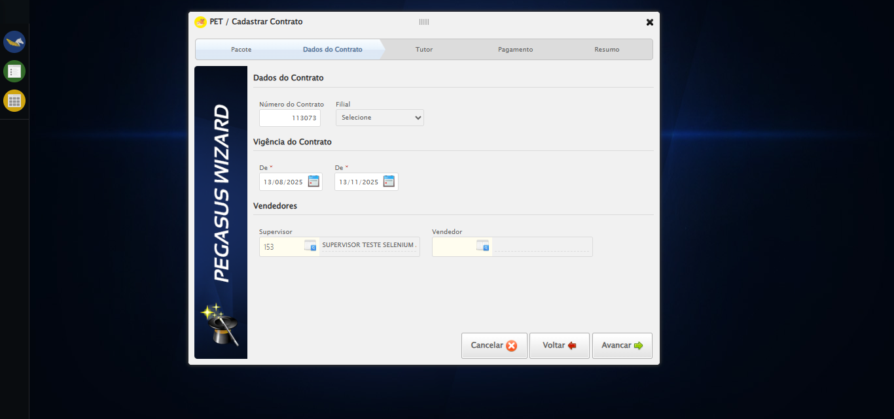

🔄 Selecionando Vendedor...

✅ Selecionando Vendedor realizada com sucesso.

Screenshot: selecionando vendedor

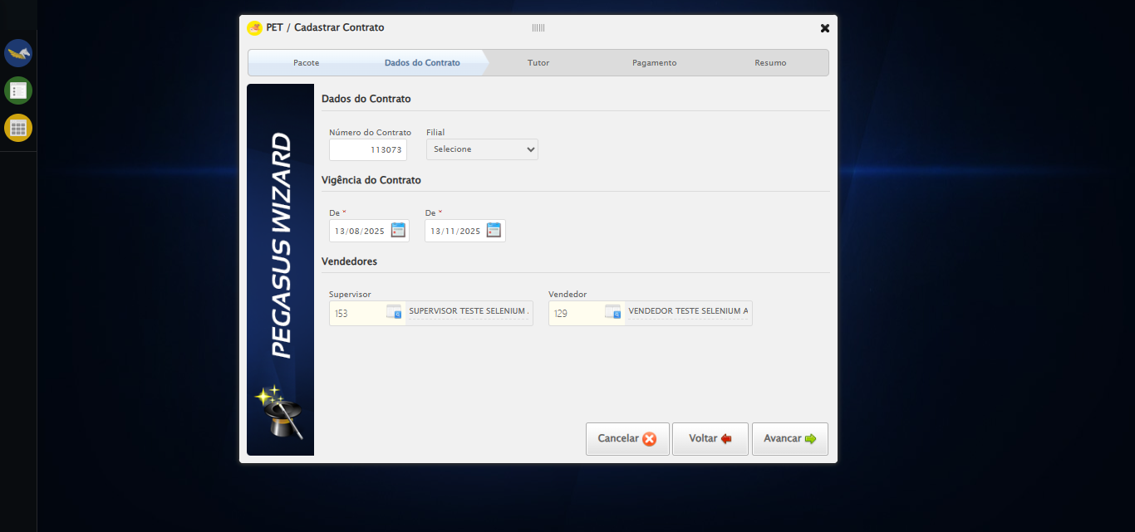

🔄 Avançando para aba: 'Tutor'...

✅ Avançando para aba: 'Tutor' realizada com sucesso.

Screenshot: avançando para aba_ _tutor_

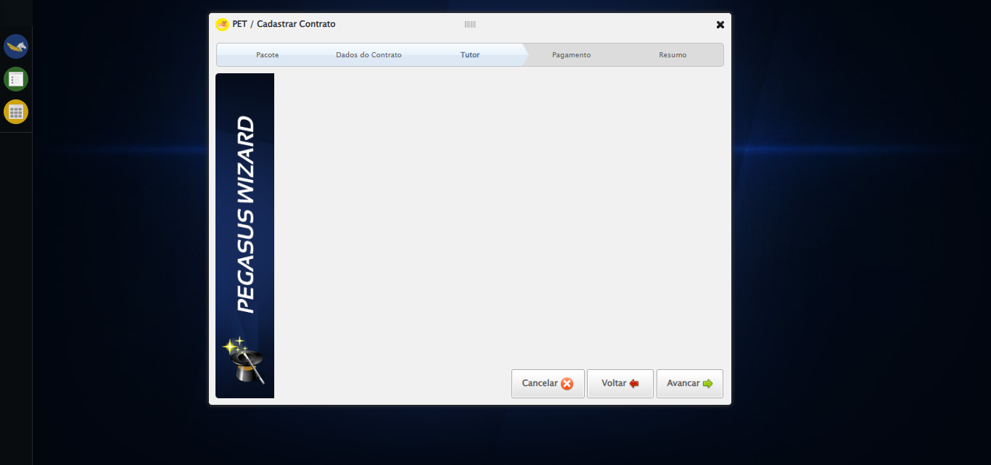

🔄 Selecionando Tutor...

❌ Erro ao interagir com elemento #ui-id-6 > div:nth-child(1) > div:nth-child(1) > div > a: Message:   
Stacktrace:  
 GetHandleVerifier [0x0xd0ba83+63395]  
 GetHandleVerifier [0x0xd0bac4+63460]  
 (No symbol) [0x0xb52113]  
 (No symbol) [0x0xb9a85e]  
 (No symbol) [0x0xb9abfb]  
 (No symbol) [0x0xbe2f92]  
 (No symbol) [0x0xbbf3f4]  
 (No symbol) [0x0xbe07ba]  
 (No symbol) [0x0xbbf1a6]  
 (No symbol) [0x0xb8e7b2]  
 (No symbol) [0x0xb8f654]  
 GetHandleVerifier [0x0xf88883+2672035]  
 GetHandleVerifier [0x0xf83cba+2652634]  
 GetHandleVerifier [0x0xd32bca+223466]  
 GetHandleVerifier [0x0xd22cb8+158168]  
 GetHandleVerifier [0x0xd2978d+185517]  
 GetHandleVerifier [0x0xd13b78+96408]  
 GetHandleVerifier [0x0xd13d02+96802]  
 GetHandleVerifier [0x0xcfe90a+9770]  
 BaseThreadInitThunk [0x0x7633fcc9+25]  
 RtlGetAppContainerNamedObjectPath [0x0x76f182ae+286]  
 RtlGetAppContainerNamedObjectPath [0x0x76f1827e+238]

❌ Erro inesperado ao selecionando tutor: Message: target frame detached  
 (failed to check if window was closed: disconnected: Unable to receive message from renderer)  
 (Session info: chrome=138.0.7204.185)  
Stacktrace:  
 GetHandleVerifier [0x0xd0ba83+63395]  
 GetHandleVerifier [0x0xd0bac4+63460]  
 (No symbol) [0x0xb51f70]  
 (No symbol) [0x0xb42b60]  
 (No symbol) [0x0xb41cd1]  
 (No symbol) [0x0xb5f922]  
 (No symbol) [0x0xbc5c9c]  
 (No symbol) [0x0xbe0099]  
 (No symbol) [0x0xbbf1a6]  
 (No symbol) [0x0xb8e7b2]  
 (No symbol) [0x0xb8f654]  
 GetHandleVerifier [0x0xf88883+2672035]  
 GetHandleVerifier [0x0xf83cba+2652634]  
 GetHandleVerifier [0x0xd32bca+223466]  
 GetHandleVerifier [0x0xd22cb8+158168]  
 GetHandleVerifier [0x0xd2978d+185517]  
 GetHandleVerifier [0x0xd13b78+96408]  
 GetHandleVerifier [0x0xd13d02+96802]  
 GetHandleVerifier [0x0xcfe90a+9770]  
 BaseThreadInitThunk [0x0x7633fcc9+25]  
 RtlGetAppContainerNamedObjectPath [0x0x76f182ae+286]  
 RtlGetAppContainerNamedObjectPath [0x0x76f1827e+238]

⚠️ Erro ao tirar screenshot erro_selecionando tutor: Message: invalid session id: session deleted as the browser has closed the connection  
from disconnected: not connected to DevTools  
 (Session info: chrome=138.0.7204.185); For documentation on this error, please visit: https://www.selenium.dev/documentation/webdriver/troubleshooting/errors#invalidsessionidexception  
Stacktrace:  
 GetHandleVerifier [0x0xd0ba83+63395]  
 GetHandleVerifier [0x0xd0bac4+63460]  
 (No symbol) [0x0xb52113]  
 (No symbol) [0x0xb41b20]  
 (No symbol) [0x0xb5f922]  
 (No symbol) [0x0xbc5c9c]  
 (No symbol) [0x0xbe0099]  
 (No symbol) [0x0xbbf1a6]  
 (No symbol) [0x0xb8e7b2]  
 (No symbol) [0x0xb8f654]  
 GetHandleVerifier [0x0xf88883+2672035]  
 GetHandleVerifier [0x0xf83cba+2652634]  
 GetHandleVerifier [0x0xd32bca+223466]  
 GetHandleVerifier [0x0xd22cb8+158168]  
 GetHandleVerifier [0x0xd2978d+185517]  
 GetHandleVerifier [0x0xd13b78+96408]  
 GetHandleVerifier [0x0xd13d02+96802]  
 GetHandleVerifier [0x0xcfe90a+9770]  
 BaseThreadInitThunk [0x0x7633fcc9+25]  
 RtlGetAppContainerNamedObjectPath [0x0x76f182ae+286]  
 RtlGetAppContainerNamedObjectPath [0x0x76f1827e+238]

🔄 Salvando Tutor...

❌ Erro ao clicar robusto: Message: invalid session id; For documentation on this error, please visit: https://www.selenium.dev/documentation/webdriver/troubleshooting/errors#invalidsessionidexception  
Stacktrace:  
 GetHandleVerifier [0x0xd0ba83+63395]  
 GetHandleVerifier [0x0xd0bac4+63460]  
 (No symbol) [0x0xb51f70]  
 (No symbol) [0x0xb8daa8]  
 (No symbol) [0x0xbbf266]  
 (No symbol) [0x0xbbae65]  
 (No symbol) [0x0xbba3e6]  
 (No symbol) [0x0xb23a45]  
 (No symbol) [0x0xb23f9e]  
 (No symbol) [0x0xb2442d]  
 GetHandleVerifier [0x0xf88883+2672035]  
 GetHandleVerifier [0x0xf83cba+2652634]  
 GetHandleVerifier [0x0xd32bca+223466]  
 GetHandleVerifier [0x0xd22cb8+158168]  
 GetHandleVerifier [0x0xd2978d+185517]  
 (No symbol) [0x0xb23710]  
 (No symbol) [0x0xb22f1d]  
 GetHandleVerifier [0x0x10bdb9c+3938492]  
 BaseThreadInitThunk [0x0x7633fcc9+25]  
 RtlGetAppContainerNamedObjectPath [0x0x76f182ae+286]  
 RtlGetAppContainerNamedObjectPath [0x0x76f1827e+238]

✅ Salvando Tutor realizada com sucesso.

⚠️ Erro ao tirar screenshot salvando tutor: Message: invalid session id; For documentation on this error, please visit: https://www.selenium.dev/documentation/webdriver/troubleshooting/errors#invalidsessionidexception  
Stacktrace:  
 GetHandleVerifier [0x0xd0ba83+63395]  
 GetHandleVerifier [0x0xd0bac4+63460]  
 (No symbol) [0x0xb51f70]  
 (No symbol) [0x0xb8daa8]  
 (No symbol) [0x0xbbf266]  
 (No symbol) [0x0xbbae65]  
 (No symbol) [0x0xbba3e6]  
 (No symbol) [0x0xb23a45]  
 (No symbol) [0x0xb23f9e]  
 (No symbol) [0x0xb2442d]  
 GetHandleVerifier [0x0xf88883+2672035]  
 GetHandleVerifier [0x0xf83cba+2652634]  
 GetHandleVerifier [0x0xd32bca+223466]  
 GetHandleVerifier [0x0xd22cb8+158168]  
 GetHandleVerifier [0x0xd2978d+185517]  
 (No symbol) [0x0xb23710]  
 (No symbol) [0x0xb22f1d]  
 GetHandleVerifier [0x0x10bdb9c+3938492]  
 BaseThreadInitThunk [0x0x7633fcc9+25]  
 RtlGetAppContainerNamedObjectPath [0x0x76f182ae+286]  
 RtlGetAppContainerNamedObjectPath [0x0x76f1827e+238]

🔄 Selecionando Pet...

❌ Erro ao interagir com elemento #gsPet > div.wdTelas > div.wdWizard.clearfix.telaConsulta > div.wizardHolder > div > div.stepTutor.step3 > div.blockHolder.titulares > ul > li > a: Message: invalid session id; For documentation on this error, please visit: https://www.selenium.dev/documentation/webdriver/troubleshooting/errors#invalidsessionidexception  
Stacktrace:  
 GetHandleVerifier [0x0xd0ba83+63395]  
 GetHandleVerifier [0x0xd0bac4+63460]  
 (No symbol) [0x0xb51f70]  
 (No symbol) [0x0xb8daa8]  
 (No symbol) [0x0xbbf266]  
 (No symbol) [0x0xbbae65]  
 (No symbol) [0x0xbba3e6]  
 (No symbol) [0x0xb23a45]  
 (No symbol) [0x0xb23f9e]  
 (No symbol) [0x0xb2442d]  
 GetHandleVerifier [0x0xf88883+2672035]  
 GetHandleVerifier [0x0xf83cba+2652634]  
 GetHandleVerifier [0x0xd32bca+223466]  
 GetHandleVerifier [0x0xd22cb8+158168]  
 GetHandleVerifier [0x0xd2978d+185517]  
 (No symbol) [0x0xb23710]  
 (No symbol) [0x0xb22f1d]  
 GetHandleVerifier [0x0x10bdb9c+3938492]  
 BaseThreadInitThunk [0x0x7633fcc9+25]  
 RtlGetAppContainerNamedObjectPath [0x0x76f182ae+286]  
 RtlGetAppContainerNamedObjectPath [0x0x76f1827e+238]

❌ Erro inesperado ao selecionando pet: Message: invalid session id; For documentation on this error, please visit: https://www.selenium.dev/documentation/webdriver/troubleshooting/errors#invalidsessionidexception  
Stacktrace:  
 GetHandleVerifier [0x0xd0ba83+63395]  
 GetHandleVerifier [0x0xd0bac4+63460]  
 (No symbol) [0x0xb51f70]  
 (No symbol) [0x0xb8daa8]  
 (No symbol) [0x0xbbf266]  
 (No symbol) [0x0xbbae65]  
 (No symbol) [0x0xbba3e6]  
 (No symbol) [0x0xb23a45]  
 (No symbol) [0x0xb23f9e]  
 (No symbol) [0x0xb2442d]  
 GetHandleVerifier [0x0xf88883+2672035]  
 GetHandleVerifier [0x0xf83cba+2652634]  
 GetHandleVerifier [0x0xd32bca+223466]  
 GetHandleVerifier [0x0xd22cb8+158168]  
 GetHandleVerifier [0x0xd2978d+185517]  
 (No symbol) [0x0xb23710]  
 (No symbol) [0x0xb22f1d]  
 GetHandleVerifier [0x0x10bdb9c+3938492]  
 BaseThreadInitThunk [0x0x7633fcc9+25]  
 RtlGetAppContainerNamedObjectPath [0x0x76f182ae+286]  
 RtlGetAppContainerNamedObjectPath [0x0x76f1827e+238]

⚠️ Erro ao tirar screenshot erro_selecionando pet: Message: invalid session id; For documentation on this error, please visit: https://www.selenium.dev/documentation/webdriver/troubleshooting/errors#invalidsessionidexception  
Stacktrace:  
 GetHandleVerifier [0x0xd0ba83+63395]  
 GetHandleVerifier [0x0xd0bac4+63460]  
 (No symbol) [0x0xb51f70]  
 (No symbol) [0x0xb8daa8]  
 (No symbol) [0x0xbbf266]  
 (No symbol) [0x0xbbae65]  
 (No symbol) [0x0xbba3e6]  
 (No symbol) [0x0xb23a45]  
 (No symbol) [0x0xb23f9e]  
 (No symbol) [0x0xb2442d]  
 GetHandleVerifier [0x0xf88883+2672035]  
 GetHandleVerifier [0x0xf83cba+2652634]  
 GetHandleVerifier [0x0xd32bca+223466]  
 GetHandleVerifier [0x0xd22cb8+158168]  
 GetHandleVerifier [0x0xd2978d+185517]  
 (No symbol) [0x0xb23710]  
 (No symbol) [0x0xb22f1d]  
 GetHandleVerifier [0x0x10bdb9c+3938492]  
 BaseThreadInitThunk [0x0x7633fcc9+25]  
 RtlGetAppContainerNamedObjectPath [0x0x76f182ae+286]  
 RtlGetAppContainerNamedObjectPath [0x0x76f1827e+238]

🔄 Avançando para aba: 'Pagamento'...

❌ Erro ao clicar robusto: Message: invalid session id; For documentation on this error, please visit: https://www.selenium.dev/documentation/webdriver/troubleshooting/errors#invalidsessionidexception  
Stacktrace:  
 GetHandleVerifier [0x0xd0ba83+63395]  
 GetHandleVerifier [0x0xd0bac4+63460]  
 (No symbol) [0x0xb51f70]  
 (No symbol) [0x0xb8daa8]  
 (No symbol) [0x0xbbf266]  
 (No symbol) [0x0xbbae65]  
 (No symbol) [0x0xbba3e6]  
 (No symbol) [0x0xb23a45]  
 (No symbol) [0x0xb23f9e]  
 (No symbol) [0x0xb2442d]  
 GetHandleVerifier [0x0xf88883+2672035]  
 GetHandleVerifier [0x0xf83cba+2652634]  
 GetHandleVerifier [0x0xd32bca+223466]  
 GetHandleVerifier [0x0xd22cb8+158168]  
 GetHandleVerifier [0x0xd2978d+185517]  
 (No symbol) [0x0xb23710]  
 (No symbol) [0x0xb22f1d]  
 GetHandleVerifier [0x0x10bdb9c+3938492]  
 BaseThreadInitThunk [0x0x7633fcc9+25]  
 RtlGetAppContainerNamedObjectPath [0x0x76f182ae+286]  
 RtlGetAppContainerNamedObjectPath [0x0x76f1827e+238]

✅ Avançando para aba: 'Pagamento' realizada com sucesso.

⚠️ Erro ao tirar screenshot avançando para aba_ _pagamento_: Message: invalid session id; For documentation on this error, please visit: https://www.selenium.dev/documentation/webdriver/troubleshooting/errors#invalidsessionidexception  
Stacktrace:  
 GetHandleVerifier [0x0xd0ba83+63395]  
 GetHandleVerifier [0x0xd0bac4+63460]  
 (No symbol) [0x0xb51f70]  
 (No symbol) [0x0xb8daa8]  
 (No symbol) [0x0xbbf266]  
 (No symbol) [0x0xbbae65]  
 (No symbol) [0x0xbba3e6]  
 (No symbol) [0x0xb23a45]  
 (No symbol) [0x0xb23f9e]  
 (No symbol) [0x0xb2442d]  
 GetHandleVerifier [0x0xf88883+2672035]  
 GetHandleVerifier [0x0xf83cba+2652634]  
 GetHandleVerifier [0x0xd32bca+223466]  
 GetHandleVerifier [0x0xd22cb8+158168]  
 GetHandleVerifier [0x0xd2978d+185517]  
 (No symbol) [0x0xb23710]  
 (No symbol) [0x0xb22f1d]  
 GetHandleVerifier [0x0x10bdb9c+3938492]  
 BaseThreadInitThunk [0x0x7633fcc9+25]  
 RtlGetAppContainerNamedObjectPath [0x0x76f182ae+286]  
 RtlGetAppContainerNamedObjectPath [0x0x76f1827e+238]

🔄 Avançando para aba: 'Resumo'...

❌ Erro ao clicar robusto: Message: invalid session id; For documentation on this error, please visit: https://www.selenium.dev/documentation/webdriver/troubleshooting/errors#invalidsessionidexception  
Stacktrace:  
 GetHandleVerifier [0x0xd0ba83+63395]  
 GetHandleVerifier [0x0xd0bac4+63460]  
 (No symbol) [0x0xb51f70]  
 (No symbol) [0x0xb8daa8]  
 (No symbol) [0x0xbbf266]  
 (No symbol) [0x0xbbae65]  
 (No symbol) [0x0xbba3e6]  
 (No symbol) [0x0xb23a45]  
 (No symbol) [0x0xb23f9e]  
 (No symbol) [0x0xb2442d]  
 GetHandleVerifier [0x0xf88883+2672035]  
 GetHandleVerifier [0x0xf83cba+2652634]  
 GetHandleVerifier [0x0xd32bca+223466]  
 GetHandleVerifier [0x0xd22cb8+158168]  
 GetHandleVerifier [0x0xd2978d+185517]  
 (No symbol) [0x0xb23710]  
 (No symbol) [0x0xb22f1d]  
 GetHandleVerifier [0x0x10bdb9c+3938492]  
 BaseThreadInitThunk [0x0x7633fcc9+25]  
 RtlGetAppContainerNamedObjectPath [0x0x76f182ae+286]  
 RtlGetAppContainerNamedObjectPath [0x0x76f1827e+238]

✅ Avançando para aba: 'Resumo' realizada com sucesso.

⚠️ Erro ao tirar screenshot avançando para aba_ _resumo_: Message: invalid session id; For documentation on this error, please visit: https://www.selenium.dev/documentation/webdriver/troubleshooting/errors#invalidsessionidexception  
Stacktrace:  
 GetHandleVerifier [0x0xd0ba83+63395]  
 GetHandleVerifier [0x0xd0bac4+63460]  
 (No symbol) [0x0xb51f70]  
 (No symbol) [0x0xb8daa8]  
 (No symbol) [0x0xbbf266]  
 (No symbol) [0x0xbbae65]  
 (No symbol) [0x0xbba3e6]  
 (No symbol) [0x0xb23a45]  
 (No symbol) [0x0xb23f9e]  
 (No symbol) [0x0xb2442d]  
 GetHandleVerifier [0x0xf88883+2672035]  
 GetHandleVerifier [0x0xf83cba+2652634]  
 GetHandleVerifier [0x0xd32bca+223466]  
 GetHandleVerifier [0x0xd22cb8+158168]  
 GetHandleVerifier [0x0xd2978d+185517]  
 (No symbol) [0x0xb23710]  
 (No symbol) [0x0xb22f1d]  
 GetHandleVerifier [0x0x10bdb9c+3938492]  
 BaseThreadInitThunk [0x0x7633fcc9+25]  
 RtlGetAppContainerNamedObjectPath [0x0x76f182ae+286]  
 RtlGetAppContainerNamedObjectPath [0x0x76f1827e+238]

🔄 Finalizando cadastro...

❌ Erro ao clicar robusto: Message: invalid session id; For documentation on this error, please visit: https://www.selenium.dev/documentation/webdriver/troubleshooting/errors#invalidsessionidexception  
Stacktrace:  
 GetHandleVerifier [0x0xd0ba83+63395]  
 GetHandleVerifier [0x0xd0bac4+63460]  
 (No symbol) [0x0xb51f70]  
 (No symbol) [0x0xb8daa8]  
 (No symbol) [0x0xbbf266]  
 (No symbol) [0x0xbbae65]  
 (No symbol) [0x0xbba3e6]  
 (No symbol) [0x0xb23a45]  
 (No symbol) [0x0xb23f9e]  
 (No symbol) [0x0xb2442d]  
 GetHandleVerifier [0x0xf88883+2672035]  
 GetHandleVerifier [0x0xf83cba+2652634]  
 GetHandleVerifier [0x0xd32bca+223466]  
 GetHandleVerifier [0x0xd22cb8+158168]  
 GetHandleVerifier [0x0xd2978d+185517]  
 (No symbol) [0x0xb23710]  
 (No symbol) [0x0xb22f1d]  
 GetHandleVerifier [0x0x10bdb9c+3938492]  
 BaseThreadInitThunk [0x0x7633fcc9+25]  
 RtlGetAppContainerNamedObjectPath [0x0x76f182ae+286]  
 RtlGetAppContainerNamedObjectPath [0x0x76f1827e+238]

✅ Finalizando cadastro realizada com sucesso.

⚠️ Erro ao tirar screenshot finalizando cadastro: Message: invalid session id; For documentation on this error, please visit: https://www.selenium.dev/documentation/webdriver/troubleshooting/errors#invalidsessionidexception  
Stacktrace:  
 GetHandleVerifier [0x0xd0ba83+63395]  
 GetHandleVerifier [0x0xd0bac4+63460]  
 (No symbol) [0x0xb51f70]  
 (No symbol) [0x0xb8daa8]  
 (No symbol) [0x0xbbf266]  
 (No symbol) [0x0xbbae65]  
 (No symbol) [0x0xbba3e6]  
 (No symbol) [0x0xb23a45]  
 (No symbol) [0x0xb23f9e]  
 (No symbol) [0x0xb2442d]  
 GetHandleVerifier [0x0xf88883+2672035]  
 GetHandleVerifier [0x0xf83cba+2652634]  
 GetHandleVerifier [0x0xd32bca+223466]  
 GetHandleVerifier [0x0xd22cb8+158168]  
 GetHandleVerifier [0x0xd2978d+185517]  
 (No symbol) [0x0xb23710]  
 (No symbol) [0x0xb22f1d]  
 GetHandleVerifier [0x0x10bdb9c+3938492]  
 BaseThreadInitThunk [0x0x7633fcc9+25]  
 RtlGetAppContainerNamedObjectPath [0x0x76f182ae+286]  
 RtlGetAppContainerNamedObjectPath [0x0x76f1827e+238]

🔄 Fechando modal após o salvamento...

❌ Erro ao clicar robusto: Message: invalid session id; For documentation on this error, please visit: https://www.selenium.dev/documentation/webdriver/troubleshooting/errors#invalidsessionidexception  
Stacktrace:  
 GetHandleVerifier [0x0xd0ba83+63395]  
 GetHandleVerifier [0x0xd0bac4+63460]  
 (No symbol) [0x0xb51f70]  
 (No symbol) [0x0xb8daa8]  
 (No symbol) [0x0xbbf266]  
 (No symbol) [0x0xbbae65]  
 (No symbol) [0x0xbba3e6]  
 (No symbol) [0x0xb23a45]  
 (No symbol) [0x0xb23f9e]  
 (No symbol) [0x0xb2442d]  
 GetHandleVerifier [0x0xf88883+2672035]  
 GetHandleVerifier [0x0xf83cba+2652634]  
 GetHandleVerifier [0x0xd32bca+223466]  
 GetHandleVerifier [0x0xd22cb8+158168]  
 GetHandleVerifier [0x0xd2978d+185517]  
 (No symbol) [0x0xb23710]  
 (No symbol) [0x0xb22f1d]  
 GetHandleVerifier [0x0x10bdb9c+3938492]  
 BaseThreadInitThunk [0x0x7633fcc9+25]  
 RtlGetAppContainerNamedObjectPath [0x0x76f182ae+286]  
 RtlGetAppContainerNamedObjectPath [0x0x76f1827e+238]

✅ Fechando modal após o salvamento realizada com sucesso.

⚠️ Erro ao tirar screenshot fechando modal após o salvamento: Message: invalid session id; For documentation on this error, please visit: https://www.selenium.dev/documentation/webdriver/troubleshooting/errors#invalidsessionidexception  
Stacktrace:  
 GetHandleVerifier [0x0xd0ba83+63395]  
 GetHandleVerifier [0x0xd0bac4+63460]  
 (No symbol) [0x0xb51f70]  
 (No symbol) [0x0xb8daa8]  
 (No symbol) [0x0xbbf266]  
 (No symbol) [0x0xbbae65]  
 (No symbol) [0x0xbba3e6]  
 (No symbol) [0x0xb23a45]  
 (No symbol) [0x0xb23f9e]  
 (No symbol) [0x0xb2442d]  
 GetHandleVerifier [0x0xf88883+2672035]  
 GetHandleVerifier [0x0xf83cba+2652634]  
 GetHandleVerifier [0x0xd32bca+223466]  
 GetHandleVerifier [0x0xd22cb8+158168]  
 GetHandleVerifier [0x0xd2978d+185517]  
 (No symbol) [0x0xb23710]  
 (No symbol) [0x0xb22f1d]  
 GetHandleVerifier [0x0x10bdb9c+3938492]  
 BaseThreadInitThunk [0x0x7633fcc9+25]  
 RtlGetAppContainerNamedObjectPath [0x0x76f182ae+286]  
 RtlGetAppContainerNamedObjectPath [0x0x76f1827e+238]

🔍 Verificando mensagens de alerta...

ℹ️ Nenhuma mensagem de alerta encontrada.

✅ Teste concluído.

✅ Teste executado com sucesso!