RELATÓRIO DO TESTE

Cadastro de Contrato Pet – Cenário 1: Preenchimento completo e salvamento.

Data do teste: 13/08/2025 17:24:14

🚀 Iniciando teste de cadastro de Contrato Pet

🔄 Acessando sistema...

✅ Acessando sistema realizada com sucesso.

Screenshot: acessando sistema

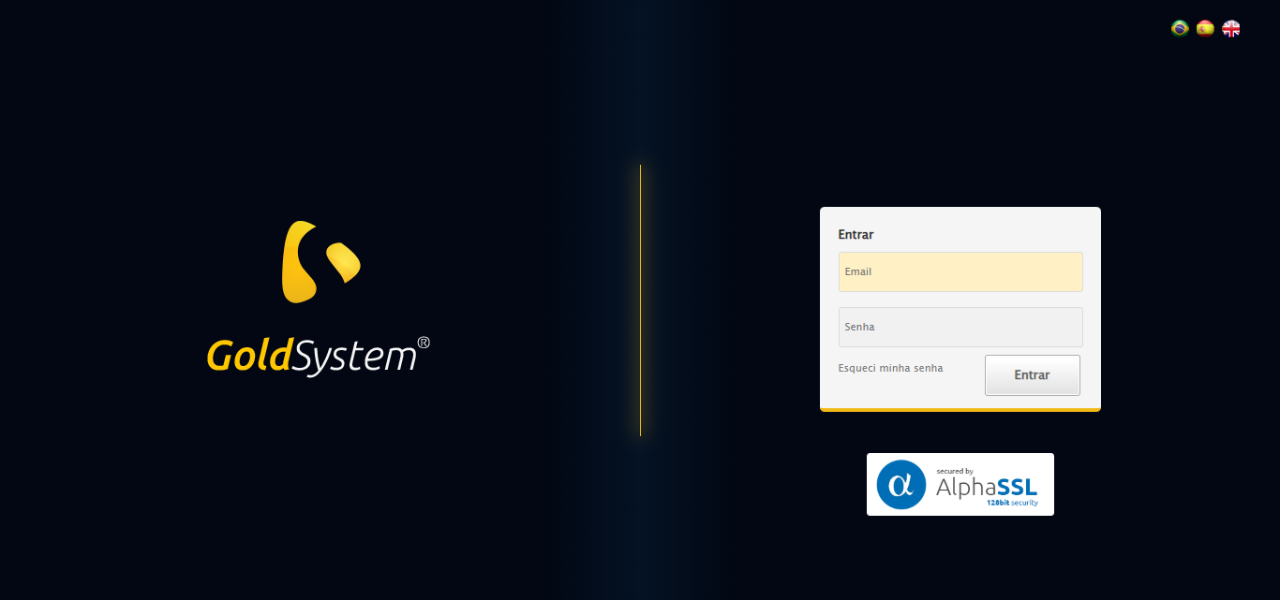

🔄 Realizando login...

✅ Realizando login realizada com sucesso.

Screenshot: realizando login

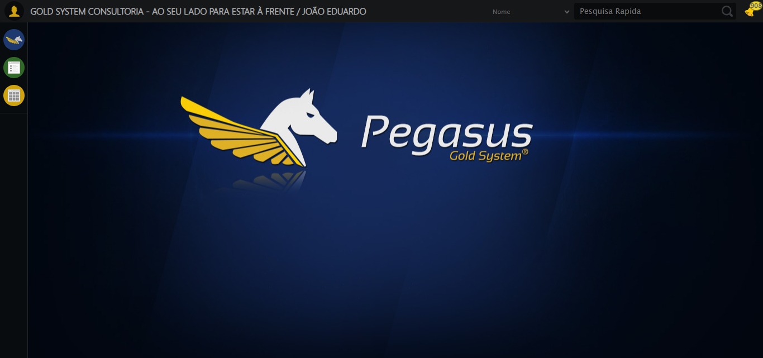

🔄 Ajustando zoom e abrindo menu...

🔍 Zoom ajustado para 90%.

✅ Ajustando zoom e abrindo menu realizada com sucesso.

Screenshot: ajustando zoom e abrindo menu

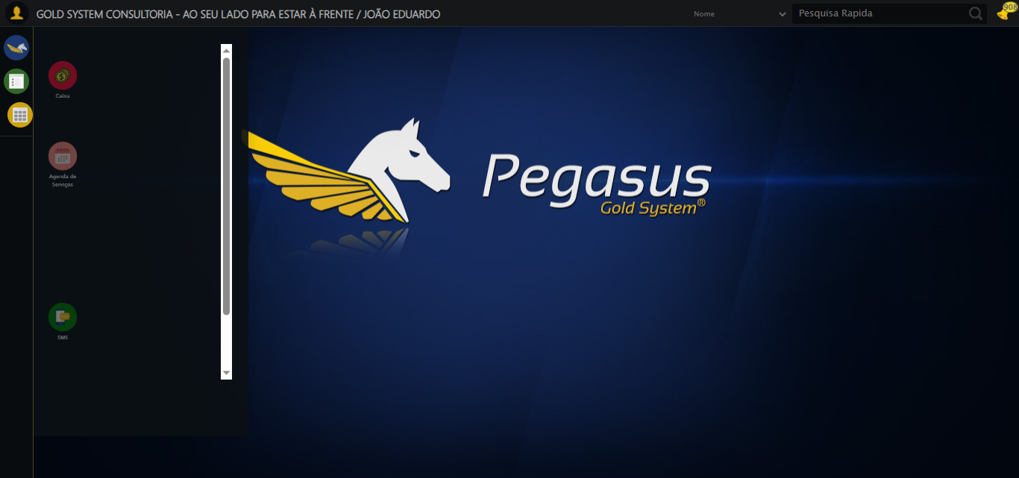

🔄 Acessando PET...

✅ Acessando PET realizada com sucesso.

Screenshot: acessando pet

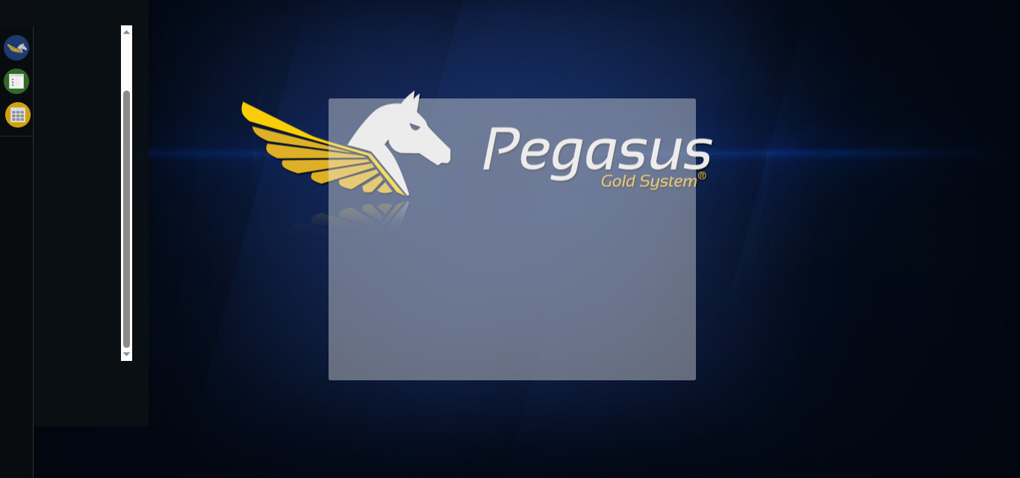

🔄 Clicando em Cadastrar Contrato...

✅ Clicando em Cadastrar Contrato realizada com sucesso.

Screenshot: clicando em cadastrar contrato

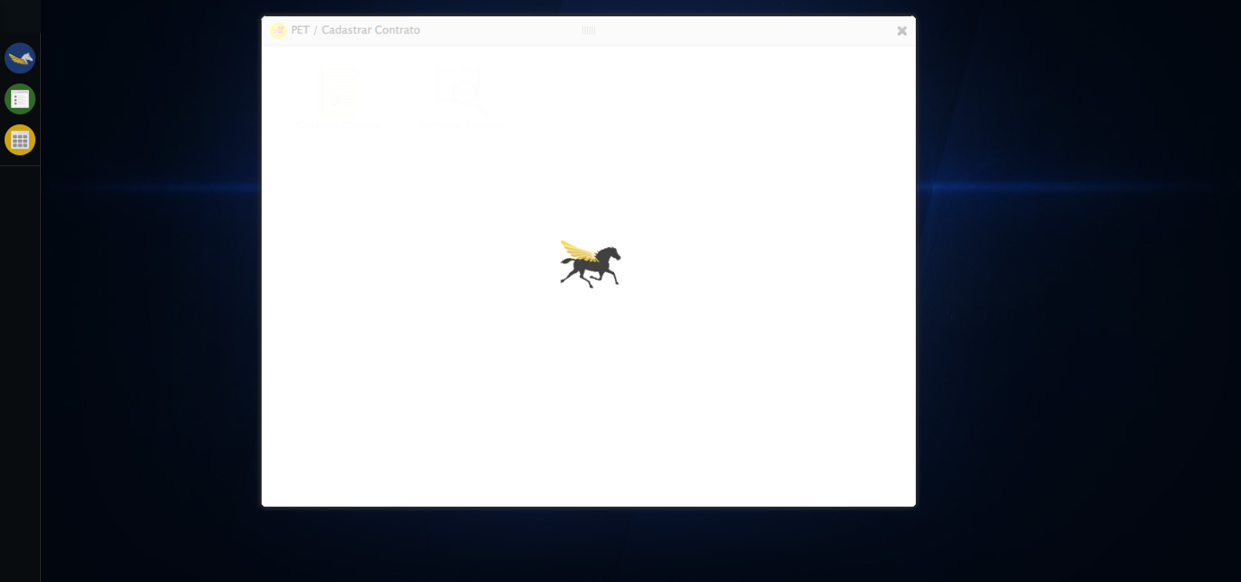

🔄 Selecionando Pacote...

✅ Selecionando Pacote realizada com sucesso.

Screenshot: selecionando pacote

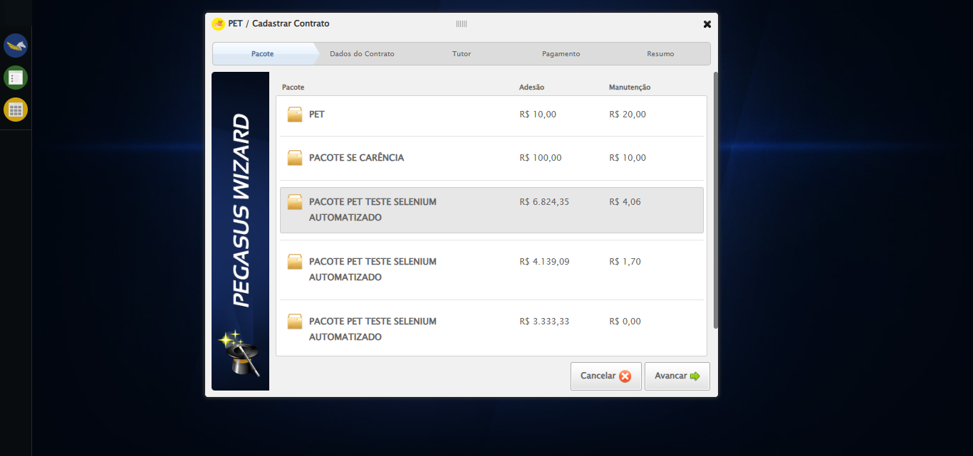

🔄 Avançando para aba: 'Dados do Contrato'...

✅ Avançando para aba: 'Dados do Contrato' realizada com sucesso.

Screenshot: avançando para aba_ _dados do contrato_

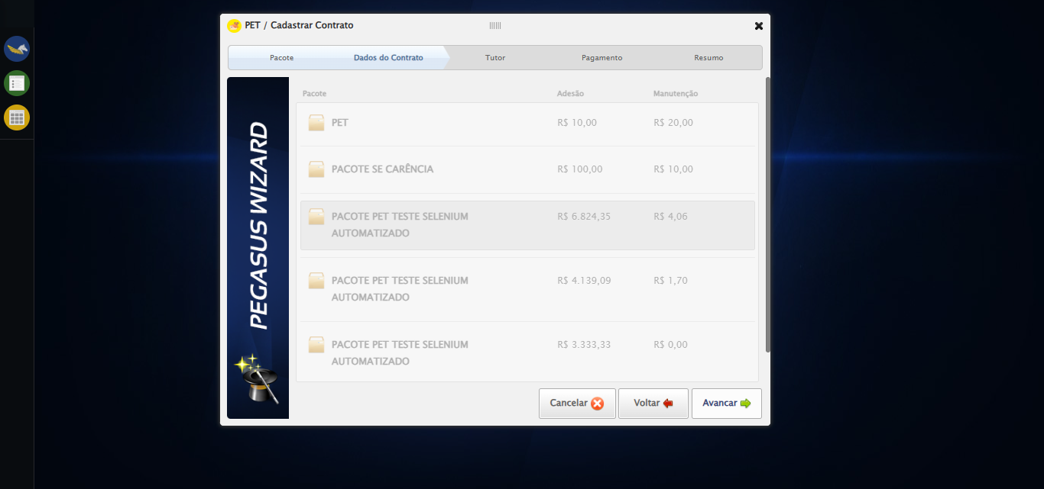

🔄 Selecionando Supervisor...

✅ Selecionando Supervisor realizada com sucesso.

Screenshot: selecionando supervisor

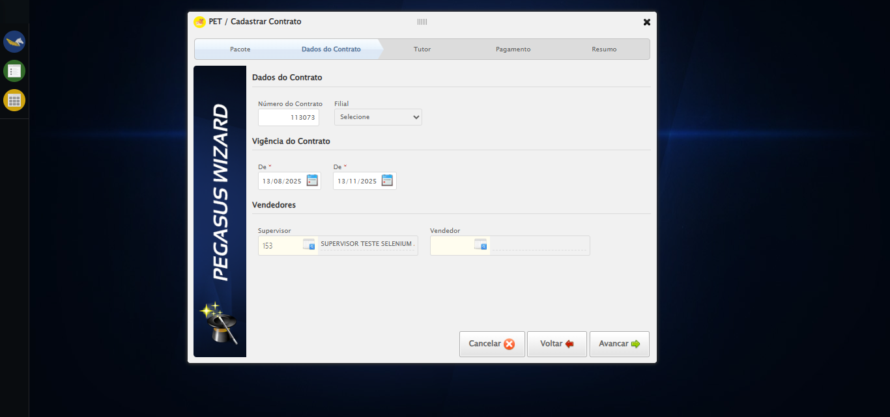

🔄 Selecionando Vendedor...

✅ Selecionando Vendedor realizada com sucesso.

Screenshot: selecionando vendedor

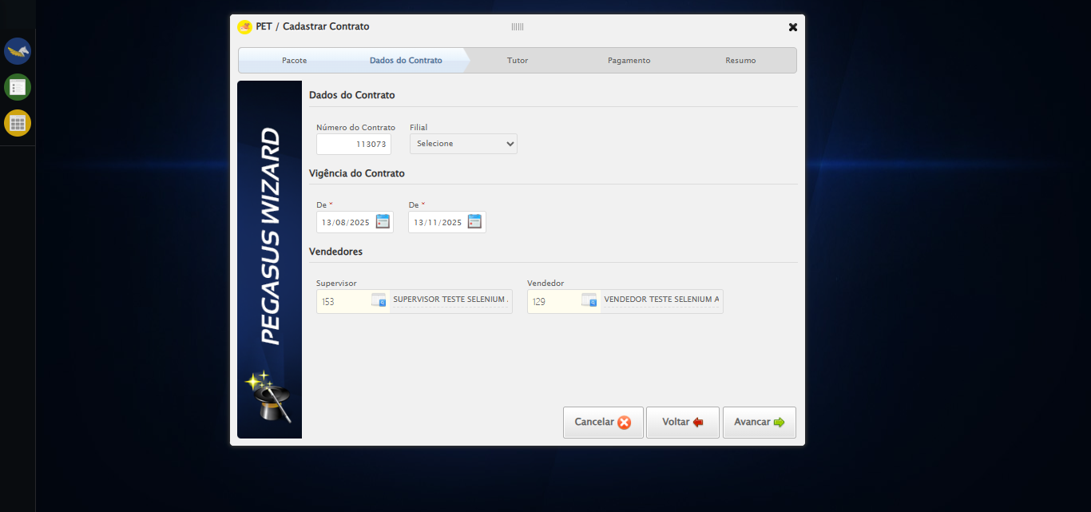

🔄 Avançando para aba: 'Tutor'...

✅ Avançando para aba: 'Tutor' realizada com sucesso.

Screenshot: avançando para aba_ _tutor_

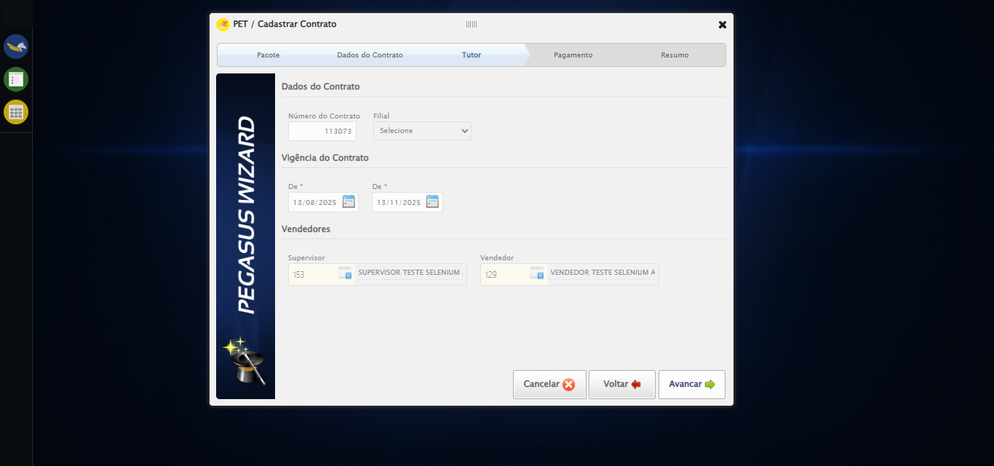

🔄 Selecionando Tutor...

✅ Selecionando Tutor realizada com sucesso.

Screenshot: selecionando tutor

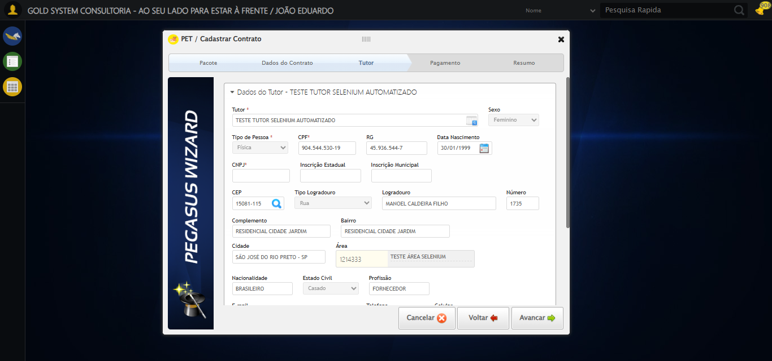

🔄 Salvando Tutor...

❌ Erro ao clicar robusto: Message:   
Stacktrace:  
 GetHandleVerifier [0x0x32ba83+63395]  
 GetHandleVerifier [0x0x32bac4+63460]  
 (No symbol) [0x0x172113]  
 (No symbol) [0x0x1ba85e]  
 (No symbol) [0x0x1babfb]  
 (No symbol) [0x0x202f92]  
 (No symbol) [0x0x1df3f4]  
 (No symbol) [0x0x2007ba]  
 (No symbol) [0x0x1df1a6]  
 (No symbol) [0x0x1ae7b2]  
 (No symbol) [0x0x1af654]  
 GetHandleVerifier [0x0x5a8883+2672035]  
 GetHandleVerifier [0x0x5a3cba+2652634]  
 GetHandleVerifier [0x0x352bca+223466]  
 GetHandleVerifier [0x0x342cb8+158168]  
 GetHandleVerifier [0x0x34978d+185517]  
 GetHandleVerifier [0x0x333b78+96408]  
 GetHandleVerifier [0x0x333d02+96802]  
 GetHandleVerifier [0x0x31e90a+9770]  
 BaseThreadInitThunk [0x0x7633fcc9+25]  
 RtlGetAppContainerNamedObjectPath [0x0x76f182ae+286]  
 RtlGetAppContainerNamedObjectPath [0x0x76f1827e+238]  
 (No symbol) [0x0]

✅ Salvando Tutor realizada com sucesso.

Screenshot: salvando tutor

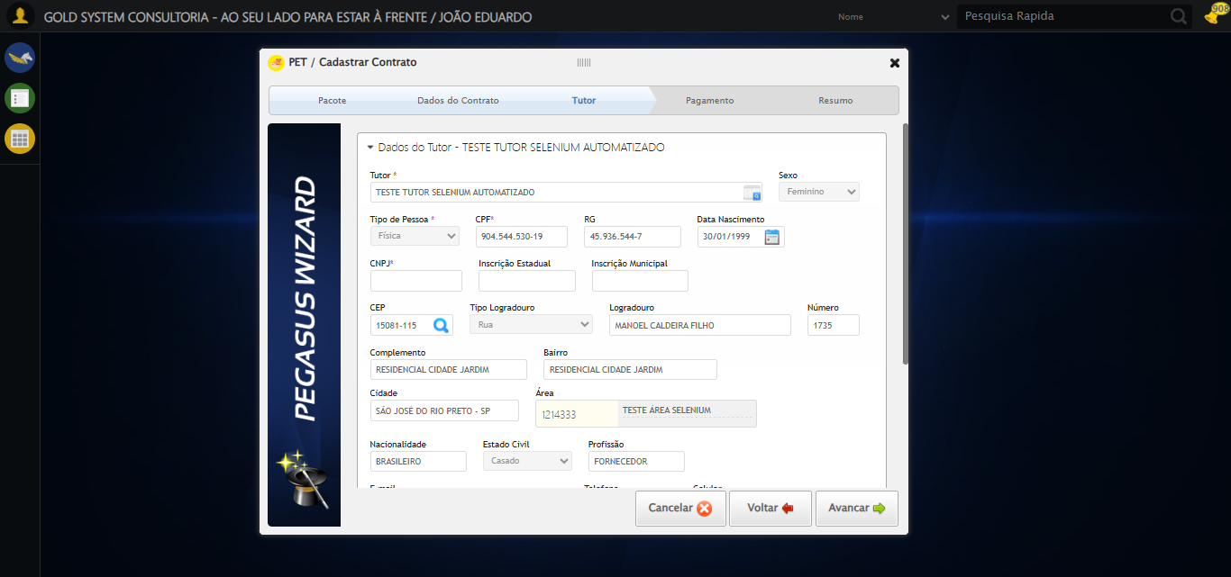

🔄 Selecionando Pet...

❌ Erro ao interagir com elemento #gsPet > div.wdTelas > div.wdWizard.clearfix.telaConsulta > div.wizardHolder > div > div.stepTutor.step3 > div.blockHolder.titulares > ul > li > a: Message:   
Stacktrace:  
 GetHandleVerifier [0x0x32ba83+63395]  
 GetHandleVerifier [0x0x32bac4+63460]  
 (No symbol) [0x0x172113]  
 (No symbol) [0x0x1ba85e]  
 (No symbol) [0x0x1babfb]  
 (No symbol) [0x0x202f92]  
 (No symbol) [0x0x1df3f4]  
 (No symbol) [0x0x2007ba]  
 (No symbol) [0x0x1df1a6]  
 (No symbol) [0x0x1ae7b2]  
 (No symbol) [0x0x1af654]  
 GetHandleVerifier [0x0x5a8883+2672035]  
 GetHandleVerifier [0x0x5a3cba+2652634]  
 GetHandleVerifier [0x0x352bca+223466]  
 GetHandleVerifier [0x0x342cb8+158168]  
 GetHandleVerifier [0x0x34978d+185517]  
 GetHandleVerifier [0x0x333b78+96408]  
 GetHandleVerifier [0x0x333d02+96802]  
 GetHandleVerifier [0x0x31e90a+9770]  
 BaseThreadInitThunk [0x0x7633fcc9+25]  
 RtlGetAppContainerNamedObjectPath [0x0x76f182ae+286]  
 RtlGetAppContainerNamedObjectPath [0x0x76f1827e+238]  
 (No symbol) [0x0]

⚠️ Tentativa 1 falhou para Selecionando Pet, tentando novamente...

🔄 Selecionando Pet... (Tentativa 2)

❌ Erro ao interagir com elemento #gsPet > div.wdTelas > div.wdWizard.clearfix.telaConsulta > div.wizardHolder > div > div.stepTutor.step3 > div.blockHolder.titulares > ul > li > a: Message:   
Stacktrace:  
 GetHandleVerifier [0x0x32ba83+63395]  
 GetHandleVerifier [0x0x32bac4+63460]  
 (No symbol) [0x0x172113]  
 (No symbol) [0x0x1ba85e]  
 (No symbol) [0x0x1babfb]  
 (No symbol) [0x0x202f92]  
 (No symbol) [0x0x1df3f4]  
 (No symbol) [0x0x2007ba]  
 (No symbol) [0x0x1df1a6]  
 (No symbol) [0x0x1ae7b2]  
 (No symbol) [0x0x1af654]  
 GetHandleVerifier [0x0x5a8883+2672035]  
 GetHandleVerifier [0x0x5a3cba+2652634]  
 GetHandleVerifier [0x0x352bca+223466]  
 GetHandleVerifier [0x0x342cb8+158168]  
 GetHandleVerifier [0x0x34978d+185517]  
 GetHandleVerifier [0x0x333b78+96408]  
 GetHandleVerifier [0x0x333d02+96802]  
 GetHandleVerifier [0x0x31e90a+9770]  
 BaseThreadInitThunk [0x0x7633fcc9+25]  
 RtlGetAppContainerNamedObjectPath [0x0x76f182ae+286]  
 RtlGetAppContainerNamedObjectPath [0x0x76f1827e+238]  
 (No symbol) [0x0]

⚠️ Tentativa 2 falhou para Selecionando Pet, tentando novamente...

🔄 Selecionando Pet... (Tentativa 3)

❌ Erro ao interagir com elemento #gsPet > div.wdTelas > div.wdWizard.clearfix.telaConsulta > div.wizardHolder > div > div.stepTutor.step3 > div.blockHolder.titulares > ul > li > a: Message:   
Stacktrace:  
 GetHandleVerifier [0x0x32ba83+63395]  
 GetHandleVerifier [0x0x32bac4+63460]  
 (No symbol) [0x0x172113]  
 (No symbol) [0x0x1ba85e]  
 (No symbol) [0x0x1babfb]  
 (No symbol) [0x0x202f92]  
 (No symbol) [0x0x1df3f4]  
 (No symbol) [0x0x2007ba]  
 (No symbol) [0x0x1df1a6]  
 (No symbol) [0x0x1ae7b2]  
 (No symbol) [0x0x1af654]  
 GetHandleVerifier [0x0x5a8883+2672035]  
 GetHandleVerifier [0x0x5a3cba+2652634]  
 GetHandleVerifier [0x0x352bca+223466]  
 GetHandleVerifier [0x0x342cb8+158168]  
 GetHandleVerifier [0x0x34978d+185517]  
 GetHandleVerifier [0x0x333b78+96408]  
 GetHandleVerifier [0x0x333d02+96802]  
 GetHandleVerifier [0x0x31e90a+9770]  
 BaseThreadInitThunk [0x0x7633fcc9+25]  
 RtlGetAppContainerNamedObjectPath [0x0x76f182ae+286]  
 RtlGetAppContainerNamedObjectPath [0x0x76f1827e+238]  
 (No symbol) [0x0]

❌ Erro ao selecionando pet após 3 tentativas: Message:   
Stacktrace:  
 GetHandleVerifier [0x0x32ba83+63395]  
 GetHandleVerifier [0x0x32bac4+63460]  
 (No symbol) [0x0x172113]  
 (No symbol) [0x0x1ba85e]  
 (No symbol) [0x0x1babfb]  
 (No symbol) [0x0x202f92]  
 (No symbol) [0x0x1df3f4]  
 (No symbol) [0x0x2007ba]  
 (No symbol) [0x0x1df1a6]  
 (No symbol) [0x0x1ae7b2]  
 (No symbol) [0x0x1af654]  
 GetHandleVerifier [0x0x5a8883+2672035]  
 GetHandleVerifier [0x0x5a3cba+2652634]  
 GetHandleVerifier [0x0x352bca+223466]  
 GetHandleVerifier [0x0x342cb8+158168]  
 GetHandleVerifier [0x0x34978d+185517]  
 GetHandleVerifier [0x0x333b78+96408]  
 GetHandleVerifier [0x0x333d02+96802]  
 GetHandleVerifier [0x0x31e90a+9770]  
 BaseThreadInitThunk [0x0x7633fcc9+25]  
 RtlGetAppContainerNamedObjectPath [0x0x76f182ae+286]  
 RtlGetAppContainerNamedObjectPath [0x0x76f1827e+238]  
 (No symbol) [0x0]

Screenshot: erro_selecionando pet

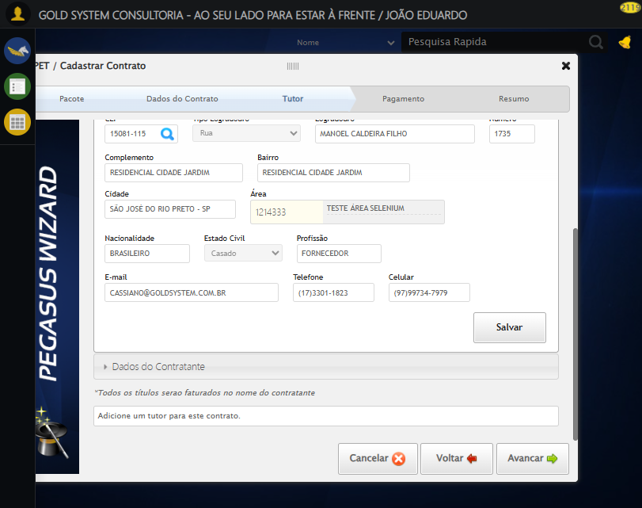

🔄 Avançando para aba: 'Pagamento'...

✅ Avançando para aba: 'Pagamento' realizada com sucesso.

Screenshot: avançando para aba_ _pagamento_

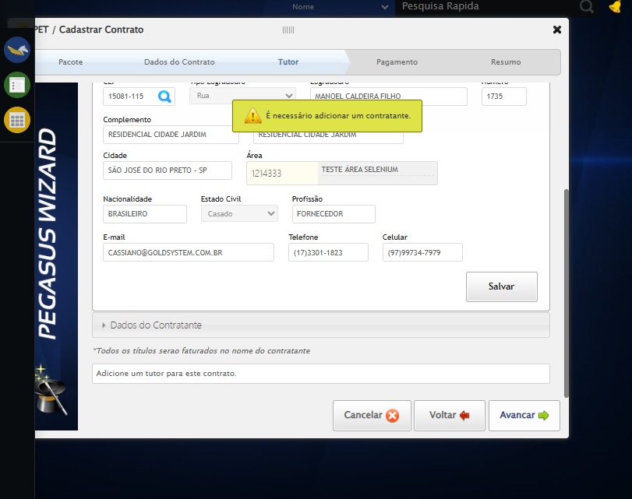

🔄 Avançando para aba: 'Resumo'...

✅ Avançando para aba: 'Resumo' realizada com sucesso.

Screenshot: avançando para aba_ _resumo_



🔄 Finalizando cadastro...

❌ Erro ao clicar robusto: Message: no such window: target window already closed  
from unknown error: web view not found  
 (Session info: chrome=138.0.7204.185)  
Stacktrace:  
 GetHandleVerifier [0x0x32ba83+63395]  
 GetHandleVerifier [0x0x32bac4+63460]  
 (No symbol) [0x0x172113]  
 (No symbol) [0x0x150fb9]  
 (No symbol) [0x0x1e5ace]  
 (No symbol) [0x0x200099]  
 (No symbol) [0x0x1df1a6]  
 (No symbol) [0x0x1ae7b2]  
 (No symbol) [0x0x1af654]  
 GetHandleVerifier [0x0x5a8883+2672035]  
 GetHandleVerifier [0x0x5a3cba+2652634]  
 GetHandleVerifier [0x0x352bca+223466]  
 GetHandleVerifier [0x0x342cb8+158168]  
 GetHandleVerifier [0x0x34978d+185517]  
 GetHandleVerifier [0x0x333b78+96408]  
 GetHandleVerifier [0x0x333d02+96802]  
 GetHandleVerifier [0x0x31e90a+9770]  
 BaseThreadInitThunk [0x0x7633fcc9+25]  
 RtlGetAppContainerNamedObjectPath [0x0x76f182ae+286]  
 RtlGetAppContainerNamedObjectPath [0x0x76f1827e+238]  
 (No symbol) [0x0]

✅ Finalizando cadastro realizada com sucesso.

⚠️ Erro ao tirar screenshot finalizando cadastro: Message: no such window: target window already closed  
from unknown error: web view not found  
 (Session info: chrome=138.0.7204.185)  
Stacktrace:  
 GetHandleVerifier [0x0x32ba83+63395]  
 GetHandleVerifier [0x0x32bac4+63460]  
 (No symbol) [0x0x172113]  
 (No symbol) [0x0x150fb9]  
 (No symbol) [0x0x1e5ace]  
 (No symbol) [0x0x200099]  
 (No symbol) [0x0x1df1a6]  
 (No symbol) [0x0x1ae7b2]  
 (No symbol) [0x0x1af654]  
 GetHandleVerifier [0x0x5a8883+2672035]  
 GetHandleVerifier [0x0x5a3cba+2652634]  
 GetHandleVerifier [0x0x352bca+223466]  
 GetHandleVerifier [0x0x342cb8+158168]  
 GetHandleVerifier [0x0x34978d+185517]  
 GetHandleVerifier [0x0x333b78+96408]  
 GetHandleVerifier [0x0x333d02+96802]  
 GetHandleVerifier [0x0x31e90a+9770]  
 BaseThreadInitThunk [0x0x7633fcc9+25]  
 RtlGetAppContainerNamedObjectPath [0x0x76f182ae+286]  
 RtlGetAppContainerNamedObjectPath [0x0x76f1827e+238]  
 (No symbol) [0x0]

🔄 Fechando modal após o salvamento...

❌ Erro ao clicar robusto: Message: no such window: target window already closed  
from unknown error: web view not found  
 (Session info: chrome=138.0.7204.185)  
Stacktrace:  
 GetHandleVerifier [0x0x32ba83+63395]  
 GetHandleVerifier [0x0x32bac4+63460]  
 (No symbol) [0x0x172113]  
 (No symbol) [0x0x150fb9]  
 (No symbol) [0x0x1e5ace]  
 (No symbol) [0x0x200099]  
 (No symbol) [0x0x1df1a6]  
 (No symbol) [0x0x1ae7b2]  
 (No symbol) [0x0x1af654]  
 GetHandleVerifier [0x0x5a8883+2672035]  
 GetHandleVerifier [0x0x5a3cba+2652634]  
 GetHandleVerifier [0x0x352bca+223466]  
 GetHandleVerifier [0x0x342cb8+158168]  
 GetHandleVerifier [0x0x34978d+185517]  
 GetHandleVerifier [0x0x333b78+96408]  
 GetHandleVerifier [0x0x333d02+96802]  
 GetHandleVerifier [0x0x31e90a+9770]  
 BaseThreadInitThunk [0x0x7633fcc9+25]  
 RtlGetAppContainerNamedObjectPath [0x0x76f182ae+286]  
 RtlGetAppContainerNamedObjectPath [0x0x76f1827e+238]  
 (No symbol) [0x0]

✅ Fechando modal após o salvamento realizada com sucesso.

⚠️ Erro ao tirar screenshot fechando modal após o salvamento: Message: no such window: target window already closed  
from unknown error: web view not found  
 (Session info: chrome=138.0.7204.185)  
Stacktrace:  
 GetHandleVerifier [0x0x32ba83+63395]  
 GetHandleVerifier [0x0x32bac4+63460]  
 (No symbol) [0x0x172113]  
 (No symbol) [0x0x150fb9]  
 (No symbol) [0x0x1e5ace]  
 (No symbol) [0x0x200099]  
 (No symbol) [0x0x1df1a6]  
 (No symbol) [0x0x1ae7b2]  
 (No symbol) [0x0x1af654]  
 GetHandleVerifier [0x0x5a8883+2672035]  
 GetHandleVerifier [0x0x5a3cba+2652634]  
 GetHandleVerifier [0x0x352bca+223466]  
 GetHandleVerifier [0x0x342cb8+158168]  
 GetHandleVerifier [0x0x34978d+185517]  
 GetHandleVerifier [0x0x333b78+96408]  
 GetHandleVerifier [0x0x333d02+96802]  
 GetHandleVerifier [0x0x31e90a+9770]  
 BaseThreadInitThunk [0x0x7633fcc9+25]  
 RtlGetAppContainerNamedObjectPath [0x0x76f182ae+286]  
 RtlGetAppContainerNamedObjectPath [0x0x76f1827e+238]  
 (No symbol) [0x0]

🔍 Verificando mensagens de alerta...

ℹ️ Nenhuma mensagem de alerta encontrada.

✅ Teste concluído.

✅ Teste executado com sucesso!