RELATÓRIO DO TESTE

Cadastro de Contrato Pet – Cenário 4: Não selecionará o Pacote do Contrato Pet, para verificar se o sistema está disparando a mensagem de alerta corretamente.

Data do teste: 14/08/2025 15:07:37

🚀 Iniciando teste de cadastro de Contrato Pet

🔄 Acessando sistema...

✅ Acessando sistema realizada com sucesso.

Screenshot: acessando_sistema

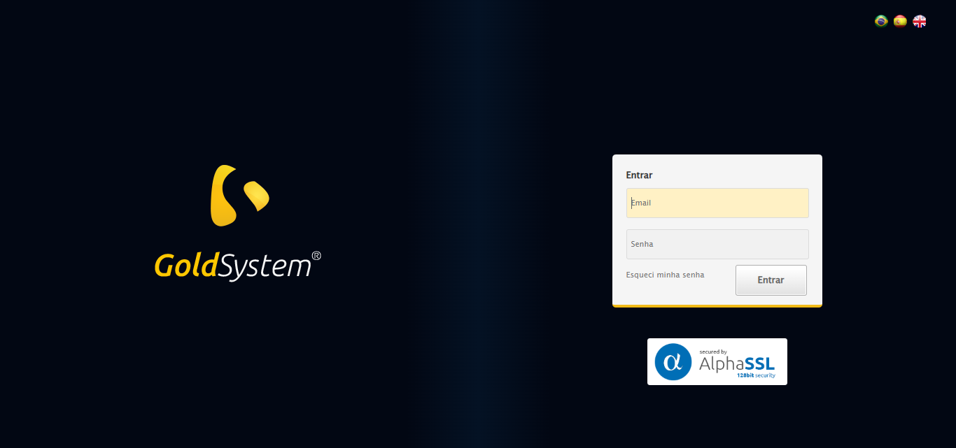

🔄 Realizando login...

✅ Realizando login realizada com sucesso.

Screenshot: realizando_login

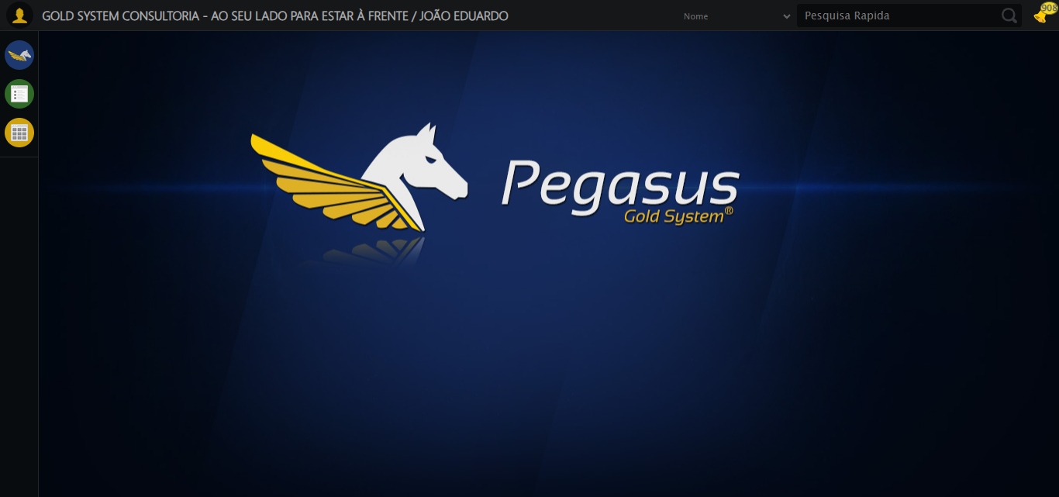

🔄 Ajustando zoom e abrindo menu...

🔍 Zoom ajustado para 90%.

✅ Ajustando zoom e abrindo menu realizada com sucesso.

Screenshot: ajustando_zoom_e_abrindo_menu

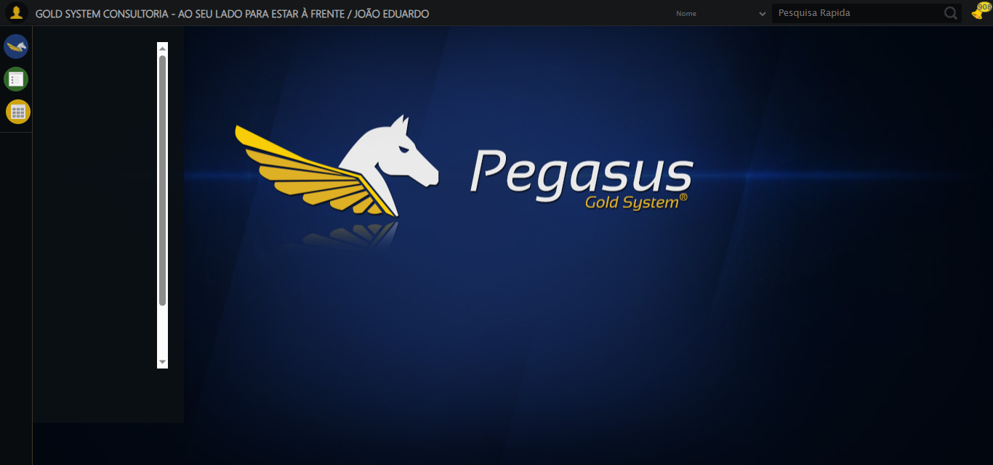

🔄 Acessando PET...

⚠️ Erro ao tirar screenshot erro_acessando_pet: Message: no such window: target window already closed  
from unknown error: web view not found  
 (Session info: chrome=138.0.7204.185)  
Stacktrace:  
 GetHandleVerifier [0x0x119ba83+63395]  
 GetHandleVerifier [0x0x119bac4+63460]  
 (No symbol) [0x0xfe2113]  
 (No symbol) [0x0xfc0fb9]  
 (No symbol) [0x0x1055ace]  
 (No symbol) [0x0x1070099]  
 (No symbol) [0x0x104f1a6]  
 (No symbol) [0x0x101e7b2]  
 (No symbol) [0x0x101f654]  
 GetHandleVerifier [0x0x1418883+2672035]  
 GetHandleVerifier [0x0x1413cba+2652634]  
 GetHandleVerifier [0x0x11c2bca+223466]  
 GetHandleVerifier [0x0x11b2cb8+158168]  
 GetHandleVerifier [0x0x11b978d+185517]  
 GetHandleVerifier [0x0x11a3b78+96408]  
 GetHandleVerifier [0x0x11a3d02+96802]  
 GetHandleVerifier [0x0x118e90a+9770]  
 BaseThreadInitThunk [0x0x7709fcc9+25]  
 RtlGetAppContainerNamedObjectPath [0x0x778882ae+286]  
 RtlGetAppContainerNamedObjectPath [0x0x7788827e+238]

❌ Acessando PET falhou: NoSuchWindowException: Message: no such window: target window already closed  
from unknown error: web view not found  
 (Session info: chrome=138.0.7204.185)  
Stacktrace:  
 GetHandleVerifier [0x0x119ba83+63395]  
 GetHandleVerifier [0x0x119bac4+63460]  
 (No symbol) [0x0xfe2113]  
 (No symbol) [0x0xfc0fb9]  
 (No symbol) [0x0x1055ace]  
 (No symbol) [0x0x1070099]  
 (No symbol) [0x0x104f1a6]  
 (No symbol) [0x0x101e7b2]  
 (No symbol) [0x0x101f654]  
 GetHandleVerifier [0x0x1418883+2672035]  
 GetHandleVerifier [0x0x1413cba+2652634]  
 GetHandleVerifier [0x0x11c2bca+223466]  
 GetHandleVerifier [0x0x11b2cb8+158168]  
 GetHandleVerifier [0x0x11b978d+185517]  
 GetHandleVerifier [0x0x11a3b78+96408]  
 GetHandleVerifier [0x0x11a3d02+96802]  
 GetHandleVerifier [0x0x118e90a+9770]  
 BaseThreadInitThunk [0x0x7709fcc9+25]  
 RtlGetAppContainerNamedObjectPath [0x0x778882ae+286]  
 RtlGetAppContainerNamedObjectPath [0x0x7788827e+238]

— stacktrace —

Traceback (most recent call last):  
 File "C:\RPASelenium\RPAsPegasusSelenium\cenariostestespegasus\Processos\CadastrosCenáriosPet\CadastrosCenáriosContrato\cadastrodecontratopet4ºcenario.py", line 151, in safe_action  
 func()  
 ~~~~^^  
 File "C:\RPASelenium\RPAsPegasusSelenium\cenariostestespegasus\Processos\CadastrosCenáriosPet\CadastrosCenáriosContrato\cadastrodecontratopet4ºcenario.py", line 594, in <lambda>  
 wait.until(EC.presence_of_element_located((By.XPATH, '/html/body/div[15]/ul/li[39]/img')))),  
 ~~~~~~~~~~^^^^^^^^^^^^^^^^^^^^^^^^^^^^^^^^^^^^^^^^^^^^^^^^^^^^^^^^^^^^^^^^^^^^^^^^^^^^^^^^  
 File "C:\RPASelenium\RPAsPegasusSelenium\venv\Lib\site-packages\selenium\webdriver\support\wait.py", line 129, in until  
 value = method(self._driver)  
 File "C:\RPASelenium\RPAsPegasusSelenium\venv\Lib\site-packages\selenium\webdriver\support\expected_conditions.py", line 104, in _predicate  
 return driver.find_element(*locator)  
 ~~~~~~~~~~~~~~~~~~~^^^^^^^^^^  
 File "C:\RPASelenium\RPAsPegasusSelenium\venv\Lib\site-packages\selenium\webdriver\remote\webdriver.py", line 926, in find_element  
 return self.execute(Command.FIND_ELEMENT, {"using": by, "value": value})["value"]  
 ~~~~~~~~~~~~^^^^^^^^^^^^^^^^^^^^^^^^^^^^^^^^^^^^^^^^^^^^^^^^^^^^^  
 File "C:\RPASelenium\RPAsPegasusSelenium\venv\Lib\site-packages\selenium\webdriver\remote\webdriver.py", line 458, in execute  
 self.error_handler.check_response(response)  
 ~~~~~~~~~~~~~~~~~~~~~~~~~~~~~~~~~^^^^^^^^^^  
 File "C:\RPASelenium\RPAsPegasusSelenium\venv\Lib\site-packages\selenium\webdriver\remote\errorhandler.py", line 232, in check_response  
 raise exception_class(message, screen, stacktrace)  
selenium.common.exceptions.NoSuchWindowException: Message: no such window: target window already closed  
from unknown error: web view not found  
 (Session info: chrome=138.0.7204.185)  
Stacktrace:  
 GetHandleVerifier [0x0x119ba83+63395]  
 GetHandleVerifier [0x0x119bac4+63460]  
 (No symbol) [0x0xfe2113]  
 (No symbol) [0x0xfc0fb9]  
 (No symbol) [0x0x1055ace]  
 (No symbol) [0x0x1070099]  
 (No symbol) [0x0x104f1a6]  
 (No symbol) [0x0x101e7b2]  
 (No symbol) [0x0x101f654]  
 GetHandleVerifier [0x0x1418883+2672035]  
 GetHandleVerifier [0x0x1413cba+2652634]  
 GetHandleVerifier [0x0x11c2bca+223466]  
 GetHandleVerifier [0x0x11b2cb8+158168]  
 GetHandleVerifier [0x0x11b978d+185517]  
 GetHandleVerifier [0x0x11a3b78+96408]  
 GetHandleVerifier [0x0x11a3d02+96802]  
 GetHandleVerifier [0x0x118e90a+9770]  
 BaseThreadInitThunk [0x0x7709fcc9+25]  
 RtlGetAppContainerNamedObjectPath [0x0x778882ae+286]  
 RtlGetAppContainerNamedObjectPath [0x0x7788827e+238]

🔄 Clicando em Cadastrar Contrato...

⚠️ Erro ao tirar screenshot erro_clicando_em_cadastrar_contrato: Message: no such window: target window already closed  
from unknown error: web view not found  
 (Session info: chrome=138.0.7204.185)  
Stacktrace:  
 GetHandleVerifier [0x0x119ba83+63395]  
 GetHandleVerifier [0x0x119bac4+63460]  
 (No symbol) [0x0xfe2113]  
 (No symbol) [0x0xfc0fb9]  
 (No symbol) [0x0x1055ace]  
 (No symbol) [0x0x1070099]  
 (No symbol) [0x0x104f1a6]  
 (No symbol) [0x0x101e7b2]  
 (No symbol) [0x0x101f654]  
 GetHandleVerifier [0x0x1418883+2672035]  
 GetHandleVerifier [0x0x1413cba+2652634]  
 GetHandleVerifier [0x0x11c2bca+223466]  
 GetHandleVerifier [0x0x11b2cb8+158168]  
 GetHandleVerifier [0x0x11b978d+185517]  
 GetHandleVerifier [0x0x11a3b78+96408]  
 GetHandleVerifier [0x0x11a3d02+96802]  
 GetHandleVerifier [0x0x118e90a+9770]  
 BaseThreadInitThunk [0x0x7709fcc9+25]  
 RtlGetAppContainerNamedObjectPath [0x0x778882ae+286]  
 RtlGetAppContainerNamedObjectPath [0x0x7788827e+238]

❌ Clicando em Cadastrar Contrato falhou: NoSuchWindowException: Message: no such window: target window already closed  
from unknown error: web view not found  
 (Session info: chrome=138.0.7204.185)  
Stacktrace:  
 GetHandleVerifier [0x0x119ba83+63395]  
 GetHandleVerifier [0x0x119bac4+63460]  
 (No symbol) [0x0xfe2113]  
 (No symbol) [0x0xfc0fb9]  
 (No symbol) [0x0x1055ace]  
 (No symbol) [0x0x1070099]  
 (No symbol) [0x0x104f1a6]  
 (No symbol) [0x0x101e7b2]  
 (No symbol) [0x0x101f654]  
 GetHandleVerifier [0x0x1418883+2672035]  
 GetHandleVerifier [0x0x1413cba+2652634]  
 GetHandleVerifier [0x0x11c2bca+223466]  
 GetHandleVerifier [0x0x11b2cb8+158168]  
 GetHandleVerifier [0x0x11b978d+185517]  
 GetHandleVerifier [0x0x11a3b78+96408]  
 GetHandleVerifier [0x0x11a3d02+96802]  
 GetHandleVerifier [0x0x118e90a+9770]  
 BaseThreadInitThunk [0x0x7709fcc9+25]  
 RtlGetAppContainerNamedObjectPath [0x0x778882ae+286]  
 RtlGetAppContainerNamedObjectPath [0x0x7788827e+238]

— stacktrace —

Traceback (most recent call last):  
 File "C:\RPASelenium\RPAsPegasusSelenium\cenariostestespegasus\Processos\CadastrosCenáriosPet\CadastrosCenáriosContrato\cadastrodecontratopet4ºcenario.py", line 151, in safe_action  
 func()  
 ~~~~^^  
 File "C:\RPASelenium\RPAsPegasusSelenium\cenariostestespegasus\Processos\CadastrosCenáriosPet\CadastrosCenáriosContrato\cadastrodecontratopet4ºcenario.py", line 599, in <lambda>  
 wait.until(EC.element_to_be_clickable((By.CSS_SELECTOR, '#gsPet > div.wdTelas > div > ul > li:nth-child(1) > a > span'))).click()  
 ~~~~~~~~~~^^^^^^^^^^^^^^^^^^^^^^^^^^^^^^^^^^^^^^^^^^^^^^^^^^^^^^^^^^^^^^^^^^^^^^^^^^^^^^^^^^^^^^^^^^^^^^^^^^^^^^^^^^^^^^^  
 File "C:\RPASelenium\RPAsPegasusSelenium\venv\Lib\site-packages\selenium\webdriver\support\wait.py", line 129, in until  
 value = method(self._driver)  
 File "C:\RPASelenium\RPAsPegasusSelenium\venv\Lib\site-packages\selenium\webdriver\support\expected_conditions.py", line 624, in _predicate  
 target = driver.find_element(*target) # grab element at locator  
 File "C:\RPASelenium\RPAsPegasusSelenium\venv\Lib\site-packages\selenium\webdriver\remote\webdriver.py", line 926, in find_element  
 return self.execute(Command.FIND_ELEMENT, {"using": by, "value": value})["value"]  
 ~~~~~~~~~~~~^^^^^^^^^^^^^^^^^^^^^^^^^^^^^^^^^^^^^^^^^^^^^^^^^^^^^  
 File "C:\RPASelenium\RPAsPegasusSelenium\venv\Lib\site-packages\selenium\webdriver\remote\webdriver.py", line 458, in execute  
 self.error_handler.check_response(response)  
 ~~~~~~~~~~~~~~~~~~~~~~~~~~~~~~~~~^^^^^^^^^^  
 File "C:\RPASelenium\RPAsPegasusSelenium\venv\Lib\site-packages\selenium\webdriver\remote\errorhandler.py", line 232, in check_response  
 raise exception_class(message, screen, stacktrace)  
selenium.common.exceptions.NoSuchWindowException: Message: no such window: target window already closed  
from unknown error: web view not found  
 (Session info: chrome=138.0.7204.185)  
Stacktrace:  
 GetHandleVerifier [0x0x119ba83+63395]  
 GetHandleVerifier [0x0x119bac4+63460]  
 (No symbol) [0x0xfe2113]  
 (No symbol) [0x0xfc0fb9]  
 (No symbol) [0x0x1055ace]  
 (No symbol) [0x0x1070099]  
 (No symbol) [0x0x104f1a6]  
 (No symbol) [0x0x101e7b2]  
 (No symbol) [0x0x101f654]  
 GetHandleVerifier [0x0x1418883+2672035]  
 GetHandleVerifier [0x0x1413cba+2652634]  
 GetHandleVerifier [0x0x11c2bca+223466]  
 GetHandleVerifier [0x0x11b2cb8+158168]  
 GetHandleVerifier [0x0x11b978d+185517]  
 GetHandleVerifier [0x0x11a3b78+96408]  
 GetHandleVerifier [0x0x11a3d02+96802]  
 GetHandleVerifier [0x0x118e90a+9770]  
 BaseThreadInitThunk [0x0x7709fcc9+25]  
 RtlGetAppContainerNamedObjectPath [0x0x778882ae+286]  
 RtlGetAppContainerNamedObjectPath [0x0x7788827e+238]