RELATÓRIO DO TESTE

Cadastro de PIMS - Gestor de Compras – Cenário 1: Preenchimento completo e salvamento

Data do teste: 06/10/2025 15:24:44

🚀 Iniciando teste de Cadastro de Locação de Equipamentos

🔄 Acessando sistema...

✅ Acessando sistema realizada com sucesso.

Screenshot: acessando sistema

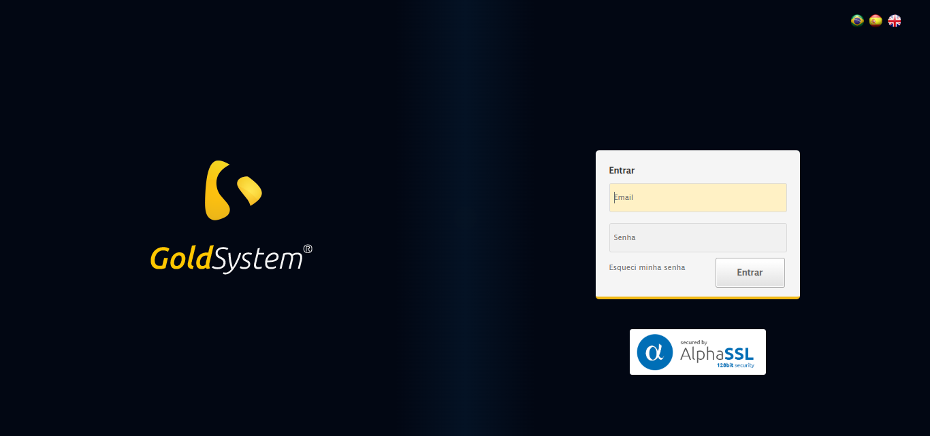

🔄 Realizando login...

✅ Realizando login realizada com sucesso.

Screenshot: realizando login

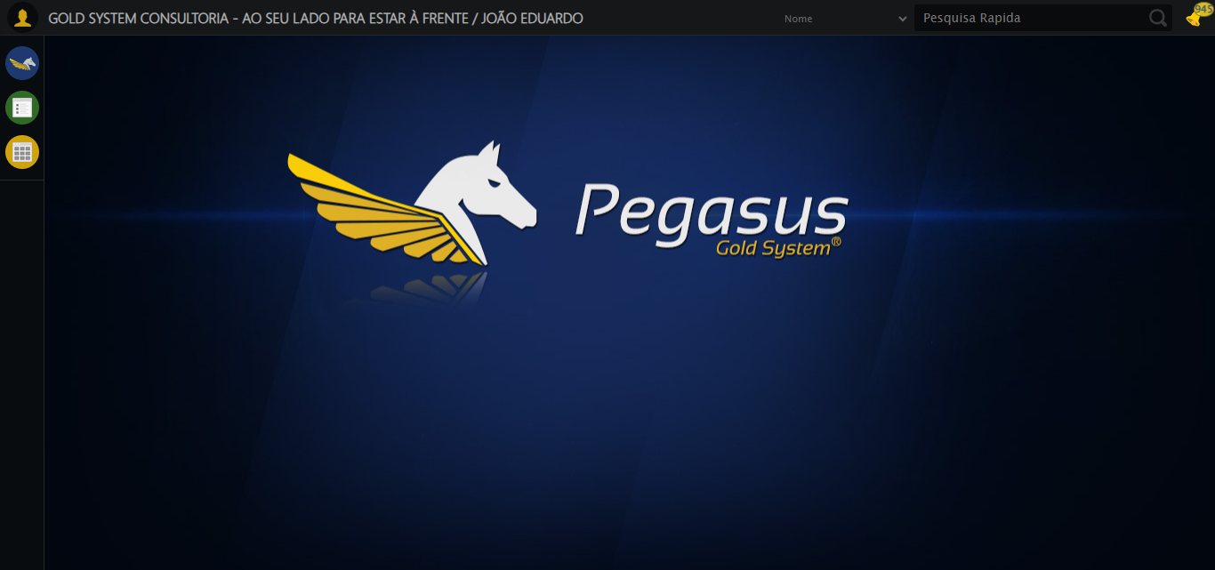

🔄 Ajustando zoom e abrindo menu...

🔍 Zoom ajustado para 90%.

✅ Ajustando zoom e abrindo menu realizada com sucesso.

Screenshot: ajustando zoom e abrindo menu

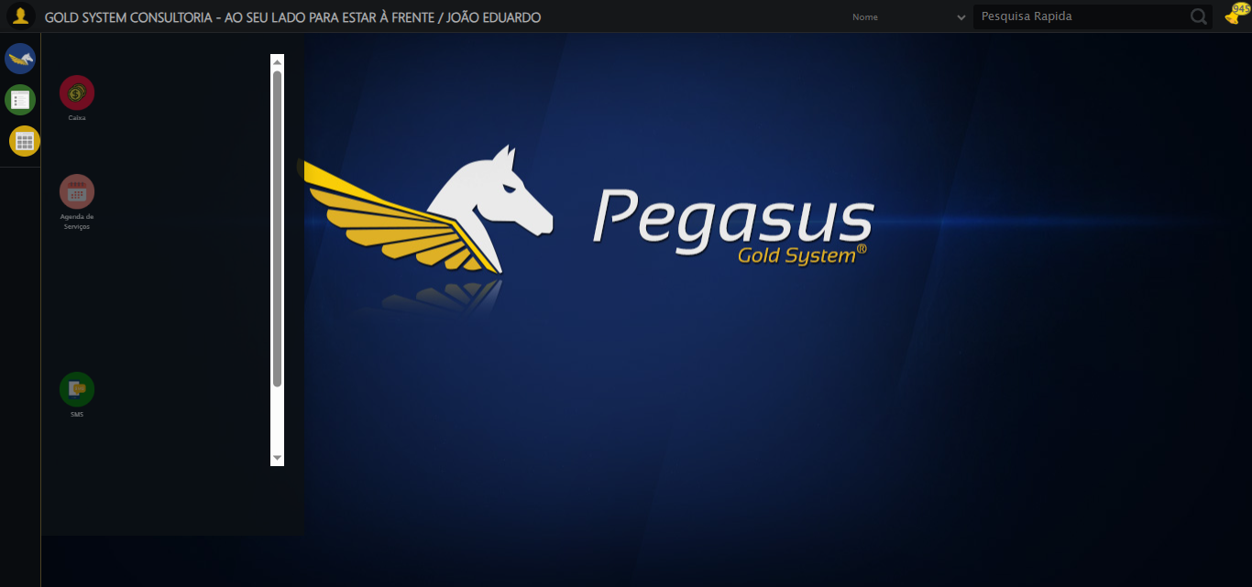

🔄 Acessando Gestor de Compras...

✅ Acessando Gestor de Compras realizada com sucesso.

Screenshot: acessando gestor de compras

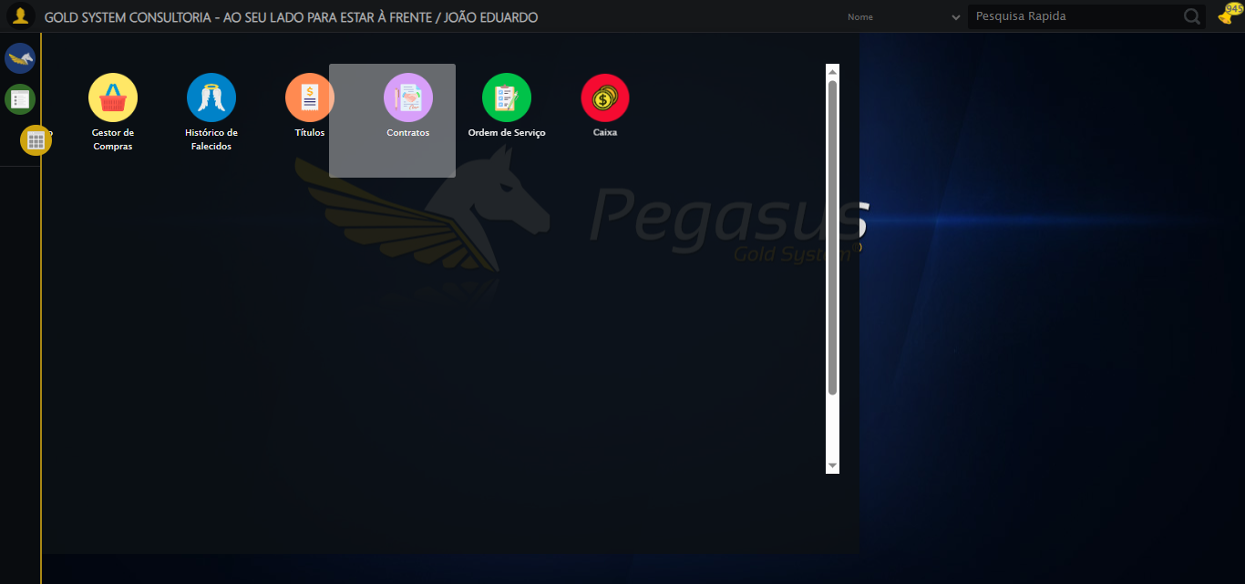

🔄 Clicando em Cadastro de PIMS...

✅ Clicando em Cadastro de PIMS realizada com sucesso.

Screenshot: clicando em cadastro de pims

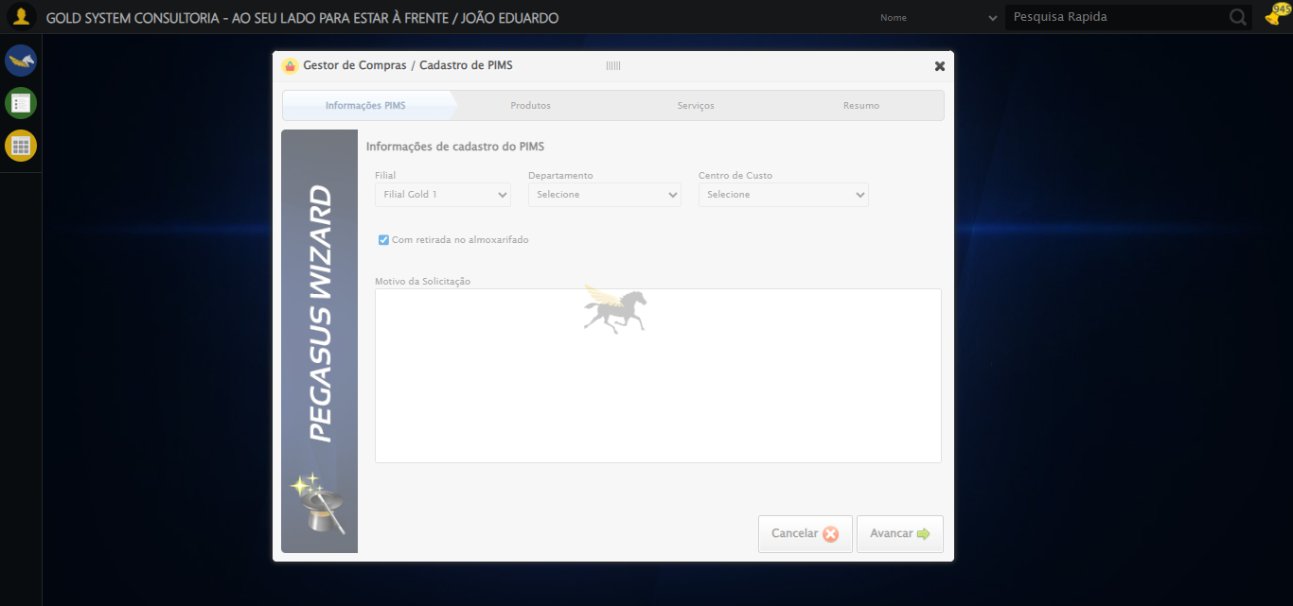

🔄 Selecionando Filial...

✅ Selecionando Filial realizada com sucesso.

Screenshot: selecionando filial

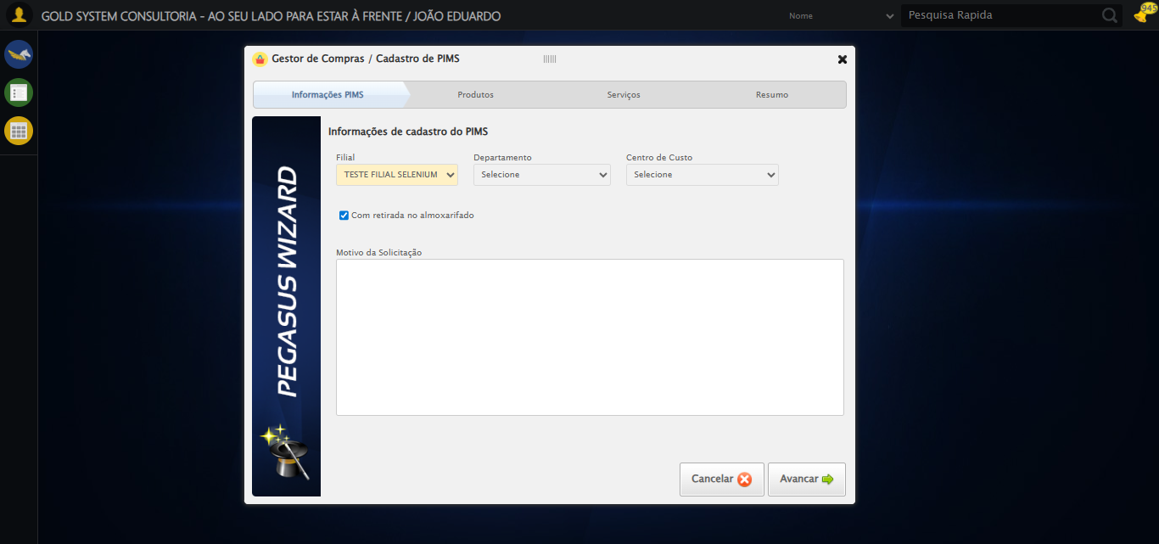

🔄 Selecionando Departamento...

✅ Selecionando Departamento realizada com sucesso.

Screenshot: selecionando departamento

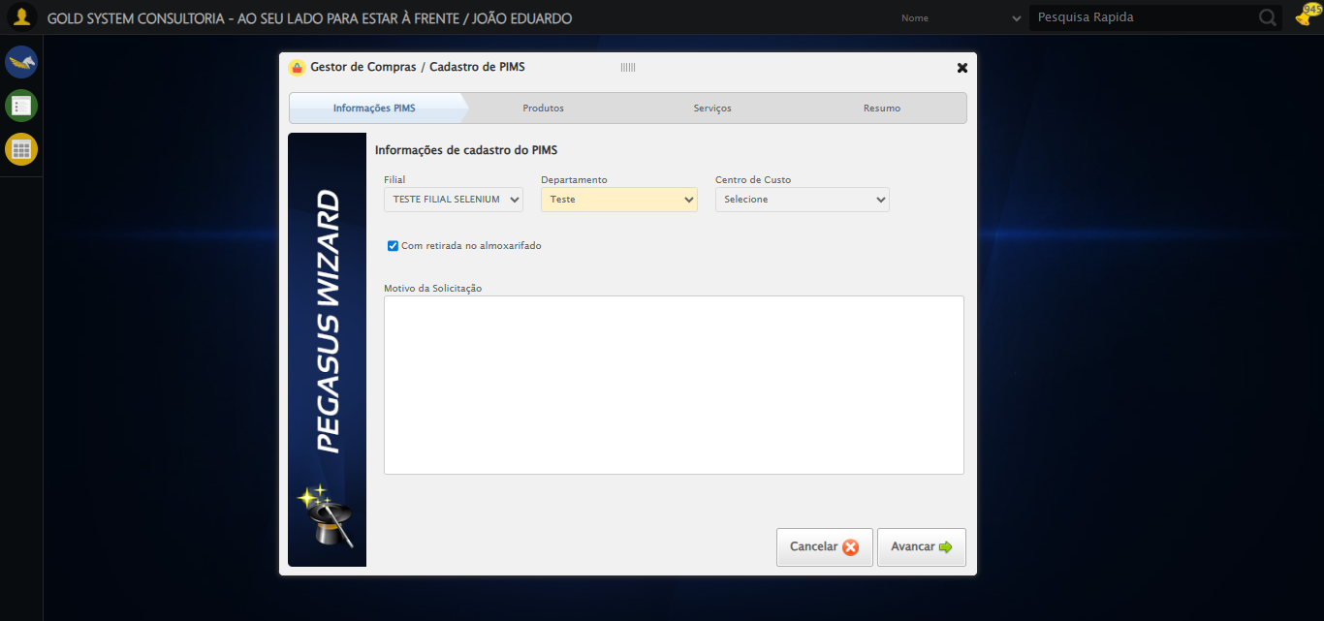

🔄 Selecionando Centro de Custo...

✅ Selecionando Centro de Custo realizada com sucesso.

Screenshot: selecionando centro de custo

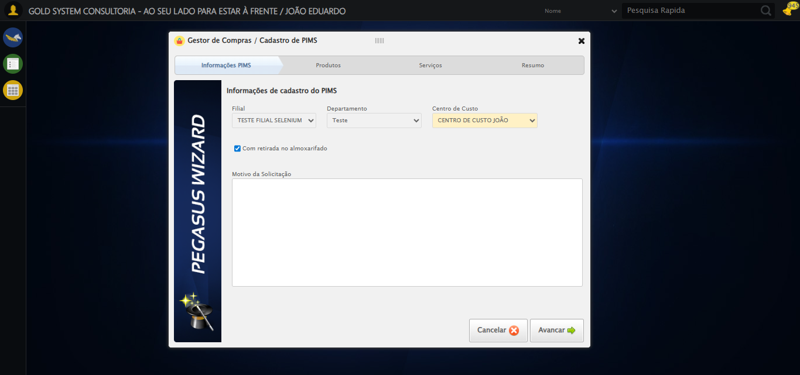

🔄 Preenchendo Motivo da Solicitação...

✅ Preenchendo Motivo da Solicitação realizada com sucesso.

Screenshot: preenchendo motivo da solicitação



🔄 Avançando para a aba: 'Produtos'...

✅ Avançando para a aba: 'Produtos' realizada com sucesso.

Screenshot: avançando para a aba_ _produtos_

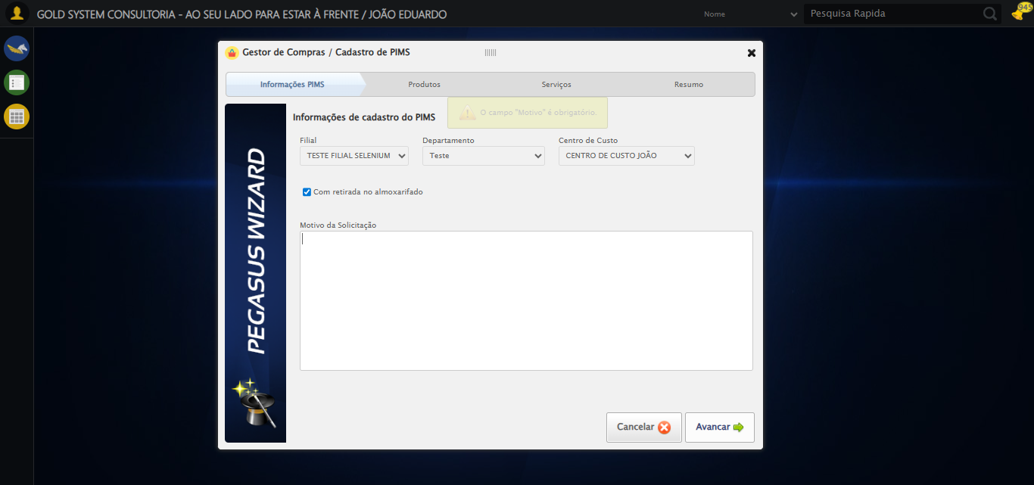

🔄 Abrindo Lov de Produtos...

⚠️ Tentativa 1 falhou para Abrindo Lov de Produtos, tentando novamente...

🔄 Abrindo Lov de Produtos... (Tentativa 2)

❌ Erro inesperado ao abrindo lov de produtos: 'NoneType' object has no attribute 'is_displayed'

⚠️ Erro ao tirar screenshot erro_abrindo lov de produtos: Message: no such window: target window already closed  
from unknown error: web view not found  
 (Session info: chrome=140.0.7339.208)  
Stacktrace:  
 GetHandleVerifier [0x0x3fc333+65459]  
 GetHandleVerifier [0x0x3fc374+65524]  
 (No symbol) [0x0x21d973]  
 (No symbol) [0x0x1fc19d]  
 (No symbol) [0x0x29059e]  
 (No symbol) [0x0x2aaef9]  
 (No symbol) [0x0x289bf6]  
 (No symbol) [0x0x25b38e]  
 (No symbol) [0x0x25c274]  
 GetHandleVerifier [0x0x67eda3+2697763]  
 GetHandleVerifier [0x0x679ec7+2677575]  
 GetHandleVerifier [0x0x424194+228884]  
 GetHandleVerifier [0x0x4149f8+165496]  
 GetHandleVerifier [0x0x41b18d+192013]  
 GetHandleVerifier [0x0x4047d8+99416]  
 GetHandleVerifier [0x0x404972+99826]  
 GetHandleVerifier [0x0x3eebea+10346]  
 BaseThreadInitThunk [0x0x755bfcc9+25]  
 RtlGetAppContainerNamedObjectPath [0x0x773a82ae+286]  
 RtlGetAppContainerNamedObjectPath [0x0x773a827e+238]

🔄 Preenchendo Nome...

⚠️ Tentativa 1 falhou: Message: no such window: target window already closed  
from unknown error: web view not found  
 (Session info: chrome=140.0.7339.208)  
Stacktrace:  
 GetHandleVerifier [0x0x3fc333+65459]  
 GetHandleVerifier [0x0x3fc374+65524]  
 (No symbol) [0x0x21d973]  
 (No symbol) [0x0x1fc19d]  
 (No symbol) [0x0x29059e]  
 (No symbol) [0x0x2aaef9]  
 (No symbol) [0x0x289bf6]  
 (No symbol) [0x0x25b38e]  
 (No symbol) [0x0x25c274]  
 GetHandleVerifier [0x0x67eda3+2697763]  
 GetHandleVerifier [0x0x679ec7+2677575]  
 GetHandleVerifier [0x0x424194+228884]  
 GetHandleVerifier [0x0x4149f8+165496]  
 GetHandleVerifier [0x0x41b18d+192013]  
 GetHandleVerifier [0x0x4047d8+99416]  
 GetHandleVerifier [0x0x404972+99826]  
 GetHandleVerifier [0x0x3eebea+10346]  
 BaseThreadInitThunk [0x0x755bfcc9+25]  
 RtlGetAppContainerNamedObjectPath [0x0x773a82ae+286]  
 RtlGetAppContainerNamedObjectPath [0x0x773a827e+238]

⚠️ Tentativa 2 falhou: Message: no such window: target window already closed  
from unknown error: web view not found  
 (Session info: chrome=140.0.7339.208)  
Stacktrace:  
 GetHandleVerifier [0x0x3fc333+65459]  
 GetHandleVerifier [0x0x3fc374+65524]  
 (No symbol) [0x0x21d973]  
 (No symbol) [0x0x1fc19d]  
 (No symbol) [0x0x29059e]  
 (No symbol) [0x0x2aaef9]  
 (No symbol) [0x0x289bf6]  
 (No symbol) [0x0x25b38e]  
 (No symbol) [0x0x25c274]  
 GetHandleVerifier [0x0x67eda3+2697763]  
 GetHandleVerifier [0x0x679ec7+2677575]  
 GetHandleVerifier [0x0x424194+228884]  
 GetHandleVerifier [0x0x4149f8+165496]  
 GetHandleVerifier [0x0x41b18d+192013]  
 GetHandleVerifier [0x0x4047d8+99416]  
 GetHandleVerifier [0x0x404972+99826]  
 GetHandleVerifier [0x0x3eebea+10346]  
 BaseThreadInitThunk [0x0x755bfcc9+25]  
 RtlGetAppContainerNamedObjectPath [0x0x773a82ae+286]  
 RtlGetAppContainerNamedObjectPath [0x0x773a827e+238]

⚠️ Tentativa 3 falhou: Message: no such window: target window already closed  
from unknown error: web view not found  
 (Session info: chrome=140.0.7339.208)  
Stacktrace:  
 GetHandleVerifier [0x0x3fc333+65459]  
 GetHandleVerifier [0x0x3fc374+65524]  
 (No symbol) [0x0x21d973]  
 (No symbol) [0x0x1fc19d]  
 (No symbol) [0x0x29059e]  
 (No symbol) [0x0x2aaef9]  
 (No symbol) [0x0x289bf6]  
 (No symbol) [0x0x25b38e]  
 (No symbol) [0x0x25c274]  
 GetHandleVerifier [0x0x67eda3+2697763]  
 GetHandleVerifier [0x0x679ec7+2677575]  
 GetHandleVerifier [0x0x424194+228884]  
 GetHandleVerifier [0x0x4149f8+165496]  
 GetHandleVerifier [0x0x41b18d+192013]  
 GetHandleVerifier [0x0x4047d8+99416]  
 GetHandleVerifier [0x0x404972+99826]  
 GetHandleVerifier [0x0x3eebea+10346]  
 BaseThreadInitThunk [0x0x755bfcc9+25]  
 RtlGetAppContainerNamedObjectPath [0x0x773a82ae+286]  
 RtlGetAppContainerNamedObjectPath [0x0x773a827e+238]

✅ Preenchendo Nome realizada com sucesso.

⚠️ Erro ao tirar screenshot preenchendo nome: Message: no such window: target window already closed  
from unknown error: web view not found  
 (Session info: chrome=140.0.7339.208)  
Stacktrace:  
 GetHandleVerifier [0x0x3fc333+65459]  
 GetHandleVerifier [0x0x3fc374+65524]  
 (No symbol) [0x0x21d973]  
 (No symbol) [0x0x1fc19d]  
 (No symbol) [0x0x29059e]  
 (No symbol) [0x0x2aaef9]  
 (No symbol) [0x0x289bf6]  
 (No symbol) [0x0x25b38e]  
 (No symbol) [0x0x25c274]  
 GetHandleVerifier [0x0x67eda3+2697763]  
 GetHandleVerifier [0x0x679ec7+2677575]  
 GetHandleVerifier [0x0x424194+228884]  
 GetHandleVerifier [0x0x4149f8+165496]  
 GetHandleVerifier [0x0x41b18d+192013]  
 GetHandleVerifier [0x0x4047d8+99416]  
 GetHandleVerifier [0x0x404972+99826]  
 GetHandleVerifier [0x0x3eebea+10346]  
 BaseThreadInitThunk [0x0x755bfcc9+25]  
 RtlGetAppContainerNamedObjectPath [0x0x773a82ae+286]  
 RtlGetAppContainerNamedObjectPath [0x0x773a827e+238]

🔄 Pesquisando Produto...

❌ Erro inesperado ao pesquisando produto: Message: no such window: target window already closed  
from unknown error: web view not found  
 (Session info: chrome=140.0.7339.208)  
Stacktrace:  
 GetHandleVerifier [0x0x3fc333+65459]  
 GetHandleVerifier [0x0x3fc374+65524]  
 (No symbol) [0x0x21d973]  
 (No symbol) [0x0x1fc19d]  
 (No symbol) [0x0x29059e]  
 (No symbol) [0x0x2aaef9]  
 (No symbol) [0x0x289bf6]  
 (No symbol) [0x0x25b38e]  
 (No symbol) [0x0x25c274]  
 GetHandleVerifier [0x0x67eda3+2697763]  
 GetHandleVerifier [0x0x679ec7+2677575]  
 GetHandleVerifier [0x0x424194+228884]  
 GetHandleVerifier [0x0x4149f8+165496]  
 GetHandleVerifier [0x0x41b18d+192013]  
 GetHandleVerifier [0x0x4047d8+99416]  
 GetHandleVerifier [0x0x404972+99826]  
 GetHandleVerifier [0x0x3eebea+10346]  
 BaseThreadInitThunk [0x0x755bfcc9+25]  
 RtlGetAppContainerNamedObjectPath [0x0x773a82ae+286]  
 RtlGetAppContainerNamedObjectPath [0x0x773a827e+238]

⚠️ Erro ao tirar screenshot erro_pesquisando produto: Message: no such window: target window already closed  
from unknown error: web view not found  
 (Session info: chrome=140.0.7339.208)  
Stacktrace:  
 GetHandleVerifier [0x0x3fc333+65459]  
 GetHandleVerifier [0x0x3fc374+65524]  
 (No symbol) [0x0x21d973]  
 (No symbol) [0x0x1fc19d]  
 (No symbol) [0x0x29059e]  
 (No symbol) [0x0x2aaef9]  
 (No symbol) [0x0x289bf6]  
 (No symbol) [0x0x25b38e]  
 (No symbol) [0x0x25c274]  
 GetHandleVerifier [0x0x67eda3+2697763]  
 GetHandleVerifier [0x0x679ec7+2677575]  
 GetHandleVerifier [0x0x424194+228884]  
 GetHandleVerifier [0x0x4149f8+165496]  
 GetHandleVerifier [0x0x41b18d+192013]  
 GetHandleVerifier [0x0x4047d8+99416]  
 GetHandleVerifier [0x0x404972+99826]  
 GetHandleVerifier [0x0x3eebea+10346]  
 BaseThreadInitThunk [0x0x755bfcc9+25]  
 RtlGetAppContainerNamedObjectPath [0x0x773a82ae+286]  
 RtlGetAppContainerNamedObjectPath [0x0x773a827e+238]

🔄 Selecionando Produto...

❌ Erro inesperado ao selecionando produto: Message: no such window: target window already closed  
from unknown error: web view not found  
 (Session info: chrome=140.0.7339.208)  
Stacktrace:  
 GetHandleVerifier [0x0x3fc333+65459]  
 GetHandleVerifier [0x0x3fc374+65524]  
 (No symbol) [0x0x21d973]  
 (No symbol) [0x0x1fc19d]  
 (No symbol) [0x0x29059e]  
 (No symbol) [0x0x2aaef9]  
 (No symbol) [0x0x289bf6]  
 (No symbol) [0x0x25b38e]  
 (No symbol) [0x0x25c274]  
 GetHandleVerifier [0x0x67eda3+2697763]  
 GetHandleVerifier [0x0x679ec7+2677575]  
 GetHandleVerifier [0x0x424194+228884]  
 GetHandleVerifier [0x0x4149f8+165496]  
 GetHandleVerifier [0x0x41b18d+192013]  
 GetHandleVerifier [0x0x4047d8+99416]  
 GetHandleVerifier [0x0x404972+99826]  
 GetHandleVerifier [0x0x3eebea+10346]  
 BaseThreadInitThunk [0x0x755bfcc9+25]  
 RtlGetAppContainerNamedObjectPath [0x0x773a82ae+286]  
 RtlGetAppContainerNamedObjectPath [0x0x773a827e+238]

⚠️ Erro ao tirar screenshot erro_selecionando produto: Message: no such window: target window already closed  
from unknown error: web view not found  
 (Session info: chrome=140.0.7339.208)  
Stacktrace:  
 GetHandleVerifier [0x0x3fc333+65459]  
 GetHandleVerifier [0x0x3fc374+65524]  
 (No symbol) [0x0x21d973]  
 (No symbol) [0x0x1fc19d]  
 (No symbol) [0x0x29059e]  
 (No symbol) [0x0x2aaef9]  
 (No symbol) [0x0x289bf6]  
 (No symbol) [0x0x25b38e]  
 (No symbol) [0x0x25c274]  
 GetHandleVerifier [0x0x67eda3+2697763]  
 GetHandleVerifier [0x0x679ec7+2677575]  
 GetHandleVerifier [0x0x424194+228884]  
 GetHandleVerifier [0x0x4149f8+165496]  
 GetHandleVerifier [0x0x41b18d+192013]  
 GetHandleVerifier [0x0x4047d8+99416]  
 GetHandleVerifier [0x0x404972+99826]  
 GetHandleVerifier [0x0x3eebea+10346]  
 BaseThreadInitThunk [0x0x755bfcc9+25]  
 RtlGetAppContainerNamedObjectPath [0x0x773a82ae+286]  
 RtlGetAppContainerNamedObjectPath [0x0x773a827e+238]

❌ ERRO FATAL: Message: no such window: target window already closed  
from unknown error: web view not found  
 (Session info: chrome=140.0.7339.208)  
Stacktrace:  
 GetHandleVerifier [0x0x3fc333+65459]  
 GetHandleVerifier [0x0x3fc374+65524]  
 (No symbol) [0x0x21d973]  
 (No symbol) [0x0x1fc19d]  
 (No symbol) [0x0x29059e]  
 (No symbol) [0x0x2aaef9]  
 (No symbol) [0x0x289bf6]  
 (No symbol) [0x0x25b38e]  
 (No symbol) [0x0x25c274]  
 GetHandleVerifier [0x0x67eda3+2697763]  
 GetHandleVerifier [0x0x679ec7+2677575]  
 GetHandleVerifier [0x0x424194+228884]  
 GetHandleVerifier [0x0x4149f8+165496]  
 GetHandleVerifier [0x0x41b18d+192013]  
 GetHandleVerifier [0x0x4047d8+99416]  
 GetHandleVerifier [0x0x404972+99826]  
 GetHandleVerifier [0x0x3eebea+10346]  
 BaseThreadInitThunk [0x0x755bfcc9+25]  
 RtlGetAppContainerNamedObjectPath [0x0x773a82ae+286]  
 RtlGetAppContainerNamedObjectPath [0x0x773a827e+238]

⚠️ Erro ao tirar screenshot erro_fatal: Message: no such window: target window already closed  
from unknown error: web view not found  
 (Session info: chrome=140.0.7339.208)  
Stacktrace:  
 GetHandleVerifier [0x0x3fc333+65459]  
 GetHandleVerifier [0x0x3fc374+65524]  
 (No symbol) [0x0x21d973]  
 (No symbol) [0x0x1fc19d]  
 (No symbol) [0x0x29059e]  
 (No symbol) [0x0x2aaef9]  
 (No symbol) [0x0x289bf6]  
 (No symbol) [0x0x25b38e]  
 (No symbol) [0x0x25c274]  
 GetHandleVerifier [0x0x67eda3+2697763]  
 GetHandleVerifier [0x0x679ec7+2677575]  
 GetHandleVerifier [0x0x424194+228884]  
 GetHandleVerifier [0x0x4149f8+165496]  
 GetHandleVerifier [0x0x41b18d+192013]  
 GetHandleVerifier [0x0x4047d8+99416]  
 GetHandleVerifier [0x0x404972+99826]  
 GetHandleVerifier [0x0x3eebea+10346]  
 BaseThreadInitThunk [0x0x755bfcc9+25]  
 RtlGetAppContainerNamedObjectPath [0x0x773a82ae+286]  
 RtlGetAppContainerNamedObjectPath [0x0x773a827e+238]

✅ Teste concluído.

❌ Teste finalizado com erros.