RELATÓRIO DO TESTE

Cadastro de Cotação - Gestor de Compras – Cenário 1: Preenchimento completo e salvamento

Data do teste: 08/10/2025 16:16:05

🚀 Iniciando teste de Cadastro de Cotação

🔄 Acessando sistema...

✅ Acessando sistema realizada com sucesso.

Screenshot: acessando sistema

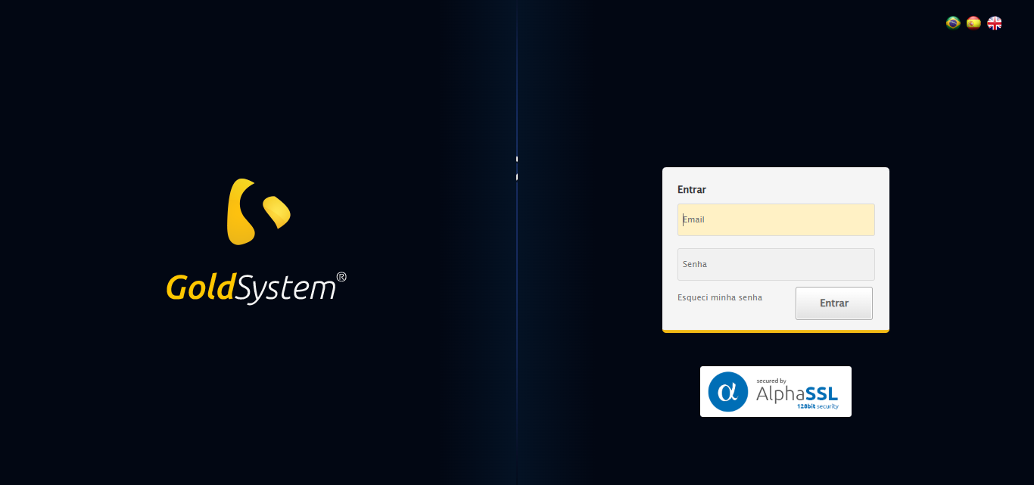

🔄 Realizando login...

✅ Realizando login realizada com sucesso.

Screenshot: realizando login

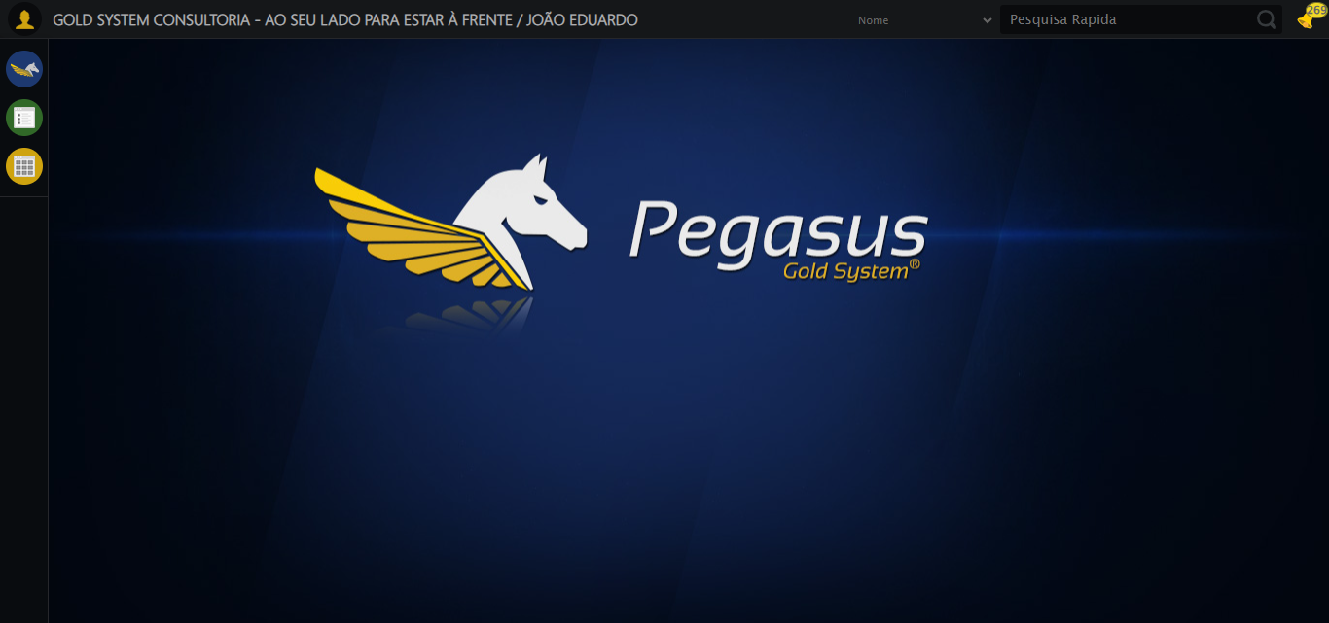

🔄 Ajustando zoom e abrindo menu...

🔍 Zoom ajustado para 90%.

✅ Ajustando zoom e abrindo menu realizada com sucesso.

Screenshot: ajustando zoom e abrindo menu

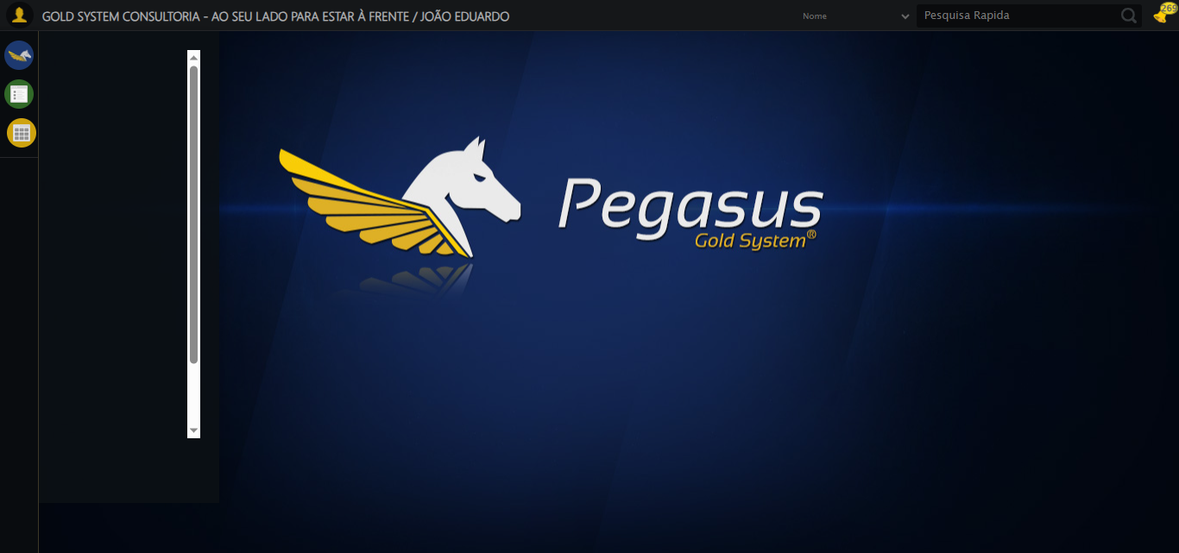

🔄 Acessando Gestor de Compras...

✅ Acessando Gestor de Compras realizada com sucesso.

Screenshot: acessando gestor de compras

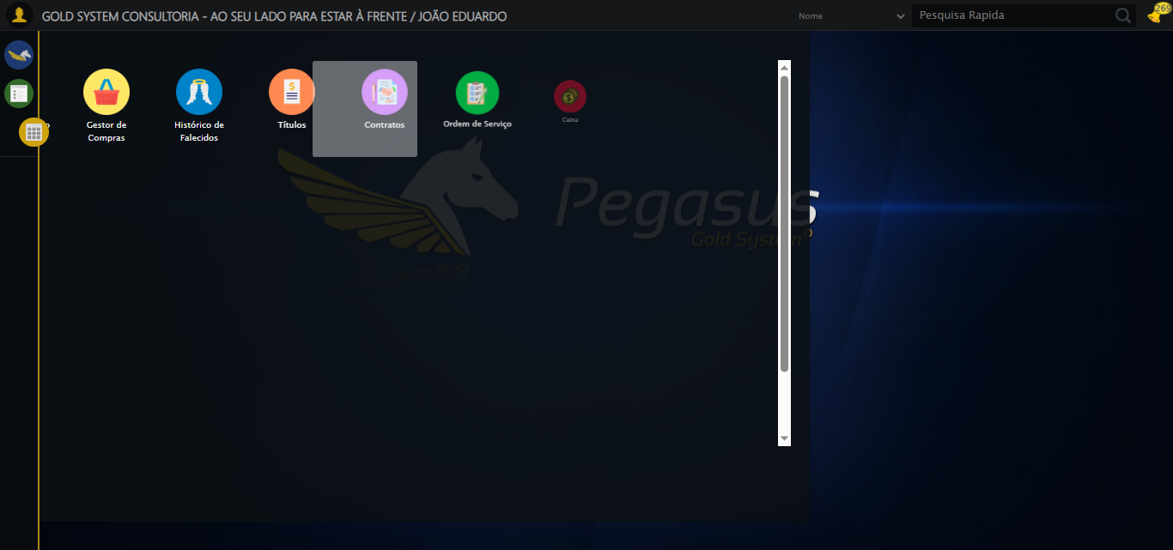

🔄 Clicando em Cotações...

✅ Clicando em Cotações realizada com sucesso.

Screenshot: clicando em cotações

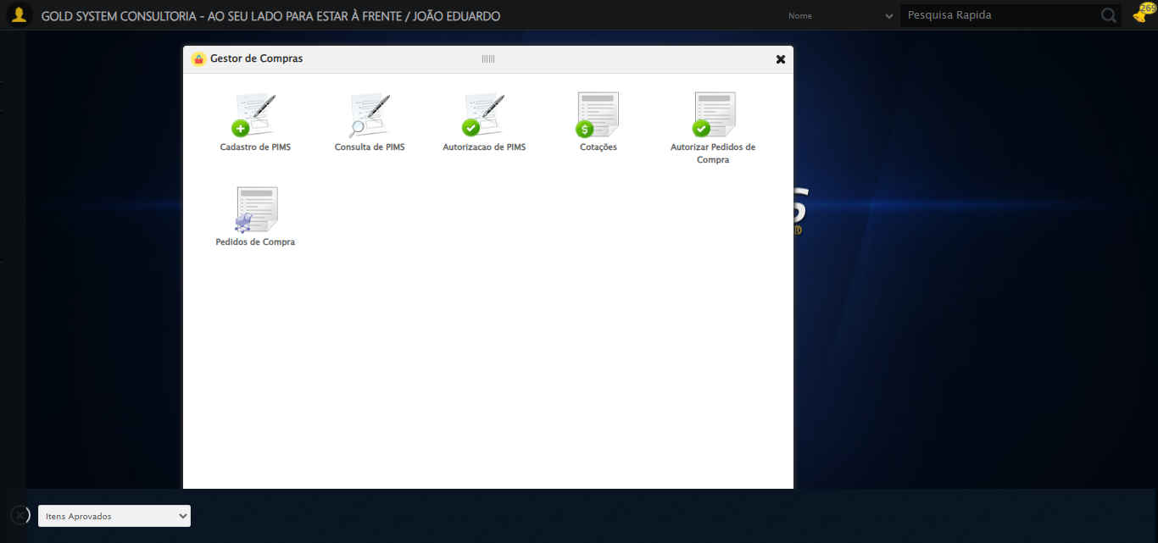

🔄 Preenchendo Data Aprovação inicial...

✅ Preenchendo Data Aprovação inicial realizada com sucesso.

Screenshot: preenchendo data aprovação inicial

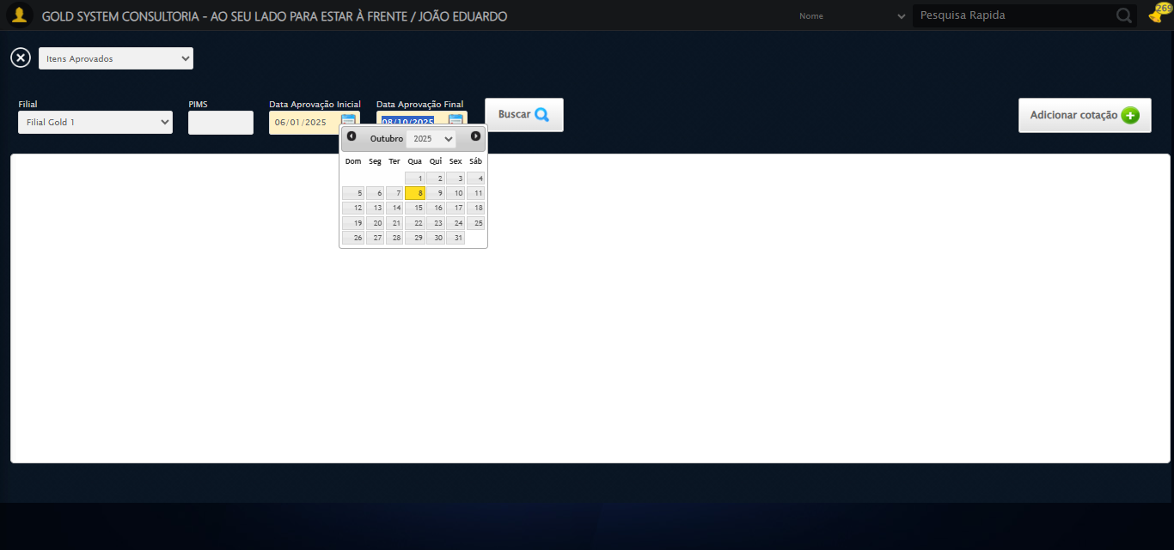

🔄 Buscando cotações...

✅ Buscando cotações realizada com sucesso.

Screenshot: buscando cotações

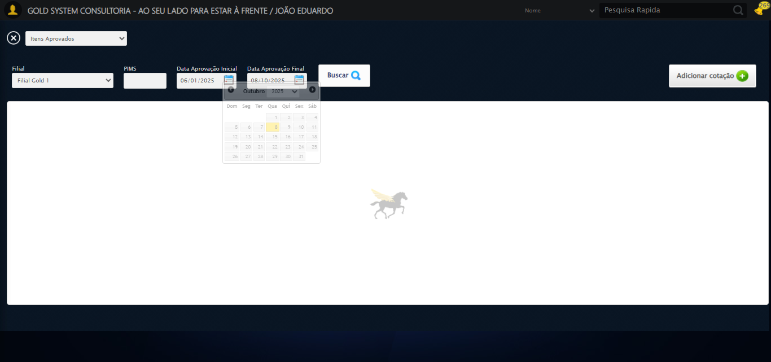

🔄 Verificando resultado da busca de cotações...

❌ Nenhuma Cotação encontrada

✅ Modal de Cotações fechado.

✅ Gestor de Compras fechado.

✅ Verificando resultado da busca de cotações realizada com sucesso.

Screenshot: verificando resultado da busca de cotações

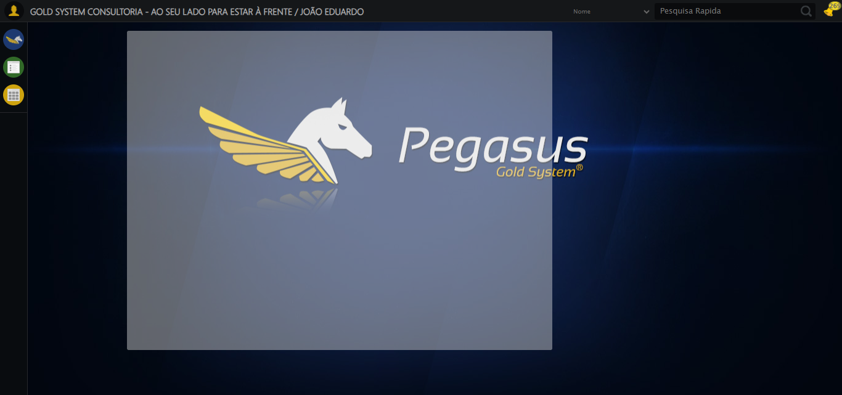

🔄 Adicionando Cotação...

❌ Erro inesperado ao adicionando cotação: Message: invalid session id: session deleted as the browser has closed the connection  
from disconnected: not connected to DevTools  
 (Session info: chrome=140.0.7339.208); For documentation on this error, please visit: https://www.selenium.dev/documentation/webdriver/troubleshooting/errors#invalidsessionidexception  
Stacktrace:  
 GetHandleVerifier [0x0xc5c333+65459]  
 GetHandleVerifier [0x0xc5c374+65524]  
 (No symbol) [0x0xa7d973]  
 (No symbol) [0x0xa6cdf0]  
 (No symbol) [0x0xa8b4af]  
 (No symbol) [0x0xaf0775]  
 (No symbol) [0x0xb0aef9]  
 (No symbol) [0x0xae9bf6]  
 (No symbol) [0x0xabb38e]  
 (No symbol) [0x0xabc274]  
 GetHandleVerifier [0x0xededa3+2697763]  
 GetHandleVerifier [0x0xed9ec7+2677575]  
 GetHandleVerifier [0x0xc84194+228884]  
 GetHandleVerifier [0x0xc749f8+165496]  
 GetHandleVerifier [0x0xc7b18d+192013]  
 GetHandleVerifier [0x0xc647d8+99416]  
 GetHandleVerifier [0x0xc64972+99826]  
 GetHandleVerifier [0x0xc4ebea+10346]  
 BaseThreadInitThunk [0x0x755bfcc9+25]  
 RtlGetAppContainerNamedObjectPath [0x0x773a82ae+286]  
 RtlGetAppContainerNamedObjectPath [0x0x773a827e+238]

⚠️ Erro ao tirar screenshot erro_adicionando cotação: Message: invalid session id; For documentation on this error, please visit: https://www.selenium.dev/documentation/webdriver/troubleshooting/errors#invalidsessionidexception  
Stacktrace:  
 GetHandleVerifier [0x0xc5c333+65459]  
 GetHandleVerifier [0x0xc5c374+65524]  
 (No symbol) [0x0xa7d7c0]  
 (No symbol) [0x0xaba663]  
 (No symbol) [0x0xae9cb6]  
 (No symbol) [0x0xae555e]  
 (No symbol) [0x0xae4ad3]  
 (No symbol) [0x0xa4e73d]  
 (No symbol) [0x0xa4ecbe]  
 (No symbol) [0x0xa4f15d]  
 GetHandleVerifier [0x0xededa3+2697763]  
 GetHandleVerifier [0x0xed9ec7+2677575]  
 GetHandleVerifier [0x0xc84194+228884]  
 GetHandleVerifier [0x0xc749f8+165496]  
 GetHandleVerifier [0x0xc7b18d+192013]  
 (No symbol) [0x0xa4e3f2]  
 (No symbol) [0x0xa4db72]  
 GetHandleVerifier [0x0x103340c+4092044]  
 BaseThreadInitThunk [0x0x755bfcc9+25]  
 RtlGetAppContainerNamedObjectPath [0x0x773a82ae+286]  
 RtlGetAppContainerNamedObjectPath [0x0x773a827e+238]

🔄 Selecionando Fornecedor...

🧭 Abrindo LOV pelo índice 1…

🔎 Tentativa 1: Localizando ícones LOV ('sp-openLov')...

⚠️ Tentativa 1/3 falhou: log() takes 2 positional arguments but 3 were given. Retentando…

🧭 Abrindo LOV pelo índice 1…

🔎 Tentativa 1: Localizando ícones LOV ('sp-openLov')...

⚠️ Tentativa 2/3 falhou: log() takes 2 positional arguments but 3 were given. Retentando…

🧭 Abrindo LOV pelo índice 1…

🔎 Tentativa 1: Localizando ícones LOV ('sp-openLov')...

❌ Erro inesperado ao selecionando fornecedor: log() takes 2 positional arguments but 3 were given

⚠️ Erro ao tirar screenshot erro_selecionando fornecedor: Message: invalid session id; For documentation on this error, please visit: https://www.selenium.dev/documentation/webdriver/troubleshooting/errors#invalidsessionidexception  
Stacktrace:  
 GetHandleVerifier [0x0xc5c333+65459]  
 GetHandleVerifier [0x0xc5c374+65524]  
 (No symbol) [0x0xa7d7c0]  
 (No symbol) [0x0xaba663]  
 (No symbol) [0x0xae9cb6]  
 (No symbol) [0x0xae555e]  
 (No symbol) [0x0xae4ad3]  
 (No symbol) [0x0xa4e73d]  
 (No symbol) [0x0xa4ecbe]  
 (No symbol) [0x0xa4f15d]  
 GetHandleVerifier [0x0xededa3+2697763]  
 GetHandleVerifier [0x0xed9ec7+2677575]  
 GetHandleVerifier [0x0xc84194+228884]  
 GetHandleVerifier [0x0xc749f8+165496]  
 GetHandleVerifier [0x0xc7b18d+192013]  
 (No symbol) [0x0xa4e3f2]  
 (No symbol) [0x0xa4db72]  
 GetHandleVerifier [0x0x103340c+4092044]  
 BaseThreadInitThunk [0x0x755bfcc9+25]  
 RtlGetAppContainerNamedObjectPath [0x0x773a82ae+286]  
 RtlGetAppContainerNamedObjectPath [0x0x773a827e+238]

🔍 Verificando mensagens de alerta...

ℹ️ Nenhuma mensagem de alerta encontrada.

🔄 Preenchendo Contato do Fornecedor...

⚠️ Tentativa 1 falhou: Message: invalid session id; For documentation on this error, please visit: https://www.selenium.dev/documentation/webdriver/troubleshooting/errors#invalidsessionidexception  
Stacktrace:  
 GetHandleVerifier [0x0xc5c333+65459]  
 GetHandleVerifier [0x0xc5c374+65524]  
 (No symbol) [0x0xa7d7c0]  
 (No symbol) [0x0xaba663]  
 (No symbol) [0x0xae9cb6]  
 (No symbol) [0x0xae555e]  
 (No symbol) [0x0xae4ad3]  
 (No symbol) [0x0xa4e73d]  
 (No symbol) [0x0xa4ecbe]  
 (No symbol) [0x0xa4f15d]  
 GetHandleVerifier [0x0xededa3+2697763]  
 GetHandleVerifier [0x0xed9ec7+2677575]  
 GetHandleVerifier [0x0xc84194+228884]  
 GetHandleVerifier [0x0xc749f8+165496]  
 GetHandleVerifier [0x0xc7b18d+192013]  
 (No symbol) [0x0xa4e3f2]  
 (No symbol) [0x0xa4db72]  
 GetHandleVerifier [0x0x103340c+4092044]  
 BaseThreadInitThunk [0x0x755bfcc9+25]  
 RtlGetAppContainerNamedObjectPath [0x0x773a82ae+286]  
 RtlGetAppContainerNamedObjectPath [0x0x773a827e+238]

⚠️ Tentativa 2 falhou: Message: invalid session id; For documentation on this error, please visit: https://www.selenium.dev/documentation/webdriver/troubleshooting/errors#invalidsessionidexception  
Stacktrace:  
 GetHandleVerifier [0x0xc5c333+65459]  
 GetHandleVerifier [0x0xc5c374+65524]  
 (No symbol) [0x0xa7d7c0]  
 (No symbol) [0x0xaba663]  
 (No symbol) [0x0xae9cb6]  
 (No symbol) [0x0xae555e]  
 (No symbol) [0x0xae4ad3]  
 (No symbol) [0x0xa4e73d]  
 (No symbol) [0x0xa4ecbe]  
 (No symbol) [0x0xa4f15d]  
 GetHandleVerifier [0x0xededa3+2697763]  
 GetHandleVerifier [0x0xed9ec7+2677575]  
 GetHandleVerifier [0x0xc84194+228884]  
 GetHandleVerifier [0x0xc749f8+165496]  
 GetHandleVerifier [0x0xc7b18d+192013]  
 (No symbol) [0x0xa4e3f2]  
 (No symbol) [0x0xa4db72]  
 GetHandleVerifier [0x0x103340c+4092044]  
 BaseThreadInitThunk [0x0x755bfcc9+25]  
 RtlGetAppContainerNamedObjectPath [0x0x773a82ae+286]  
 RtlGetAppContainerNamedObjectPath [0x0x773a827e+238]

⚠️ Tentativa 3 falhou: Message: invalid session id; For documentation on this error, please visit: https://www.selenium.dev/documentation/webdriver/troubleshooting/errors#invalidsessionidexception  
Stacktrace:  
 GetHandleVerifier [0x0xc5c333+65459]  
 GetHandleVerifier [0x0xc5c374+65524]  
 (No symbol) [0x0xa7d7c0]  
 (No symbol) [0x0xaba663]  
 (No symbol) [0x0xae9cb6]  
 (No symbol) [0x0xae555e]  
 (No symbol) [0x0xae4ad3]  
 (No symbol) [0x0xa4e73d]  
 (No symbol) [0x0xa4ecbe]  
 (No symbol) [0x0xa4f15d]  
 GetHandleVerifier [0x0xededa3+2697763]  
 GetHandleVerifier [0x0xed9ec7+2677575]  
 GetHandleVerifier [0x0xc84194+228884]  
 GetHandleVerifier [0x0xc749f8+165496]  
 GetHandleVerifier [0x0xc7b18d+192013]  
 (No symbol) [0x0xa4e3f2]  
 (No symbol) [0x0xa4db72]  
 GetHandleVerifier [0x0x103340c+4092044]  
 BaseThreadInitThunk [0x0x755bfcc9+25]  
 RtlGetAppContainerNamedObjectPath [0x0x773a82ae+286]  
 RtlGetAppContainerNamedObjectPath [0x0x773a827e+238]

✅ Preenchendo Contato do Fornecedor realizada com sucesso.

⚠️ Erro ao tirar screenshot preenchendo contato do fornecedor: Message: invalid session id; For documentation on this error, please visit: https://www.selenium.dev/documentation/webdriver/troubleshooting/errors#invalidsessionidexception  
Stacktrace:  
 GetHandleVerifier [0x0xc5c333+65459]  
 GetHandleVerifier [0x0xc5c374+65524]  
 (No symbol) [0x0xa7d7c0]  
 (No symbol) [0x0xaba663]  
 (No symbol) [0x0xae9cb6]  
 (No symbol) [0x0xae555e]  
 (No symbol) [0x0xae4ad3]  
 (No symbol) [0x0xa4e73d]  
 (No symbol) [0x0xa4ecbe]  
 (No symbol) [0x0xa4f15d]  
 GetHandleVerifier [0x0xededa3+2697763]  
 GetHandleVerifier [0x0xed9ec7+2677575]  
 GetHandleVerifier [0x0xc84194+228884]  
 GetHandleVerifier [0x0xc749f8+165496]  
 GetHandleVerifier [0x0xc7b18d+192013]  
 (No symbol) [0x0xa4e3f2]  
 (No symbol) [0x0xa4db72]  
 GetHandleVerifier [0x0x103340c+4092044]  
 BaseThreadInitThunk [0x0x755bfcc9+25]  
 RtlGetAppContainerNamedObjectPath [0x0x773a82ae+286]  
 RtlGetAppContainerNamedObjectPath [0x0x773a827e+238]

🔄 Preenchendo Telefone do Fornecedor...

⚠️ Tentativa 1 falhou: Message: invalid session id; For documentation on this error, please visit: https://www.selenium.dev/documentation/webdriver/troubleshooting/errors#invalidsessionidexception  
Stacktrace:  
 GetHandleVerifier [0x0xc5c333+65459]  
 GetHandleVerifier [0x0xc5c374+65524]  
 (No symbol) [0x0xa7d7c0]  
 (No symbol) [0x0xaba663]  
 (No symbol) [0x0xae9cb6]  
 (No symbol) [0x0xae555e]  
 (No symbol) [0x0xae4ad3]  
 (No symbol) [0x0xa4e73d]  
 (No symbol) [0x0xa4ecbe]  
 (No symbol) [0x0xa4f15d]  
 GetHandleVerifier [0x0xededa3+2697763]  
 GetHandleVerifier [0x0xed9ec7+2677575]  
 GetHandleVerifier [0x0xc84194+228884]  
 GetHandleVerifier [0x0xc749f8+165496]  
 GetHandleVerifier [0x0xc7b18d+192013]  
 (No symbol) [0x0xa4e3f2]  
 (No symbol) [0x0xa4db72]  
 GetHandleVerifier [0x0x103340c+4092044]  
 BaseThreadInitThunk [0x0x755bfcc9+25]  
 RtlGetAppContainerNamedObjectPath [0x0x773a82ae+286]  
 RtlGetAppContainerNamedObjectPath [0x0x773a827e+238]

⚠️ Tentativa 2 falhou: Message: invalid session id; For documentation on this error, please visit: https://www.selenium.dev/documentation/webdriver/troubleshooting/errors#invalidsessionidexception  
Stacktrace:  
 GetHandleVerifier [0x0xc5c333+65459]  
 GetHandleVerifier [0x0xc5c374+65524]  
 (No symbol) [0x0xa7d7c0]  
 (No symbol) [0x0xaba663]  
 (No symbol) [0x0xae9cb6]  
 (No symbol) [0x0xae555e]  
 (No symbol) [0x0xae4ad3]  
 (No symbol) [0x0xa4e73d]  
 (No symbol) [0x0xa4ecbe]  
 (No symbol) [0x0xa4f15d]  
 GetHandleVerifier [0x0xededa3+2697763]  
 GetHandleVerifier [0x0xed9ec7+2677575]  
 GetHandleVerifier [0x0xc84194+228884]  
 GetHandleVerifier [0x0xc749f8+165496]  
 GetHandleVerifier [0x0xc7b18d+192013]  
 (No symbol) [0x0xa4e3f2]  
 (No symbol) [0x0xa4db72]  
 GetHandleVerifier [0x0x103340c+4092044]  
 BaseThreadInitThunk [0x0x755bfcc9+25]  
 RtlGetAppContainerNamedObjectPath [0x0x773a82ae+286]  
 RtlGetAppContainerNamedObjectPath [0x0x773a827e+238]

⚠️ Tentativa 3 falhou: Message: invalid session id; For documentation on this error, please visit: https://www.selenium.dev/documentation/webdriver/troubleshooting/errors#invalidsessionidexception  
Stacktrace:  
 GetHandleVerifier [0x0xc5c333+65459]  
 GetHandleVerifier [0x0xc5c374+65524]  
 (No symbol) [0x0xa7d7c0]  
 (No symbol) [0x0xaba663]  
 (No symbol) [0x0xae9cb6]  
 (No symbol) [0x0xae555e]  
 (No symbol) [0x0xae4ad3]  
 (No symbol) [0x0xa4e73d]  
 (No symbol) [0x0xa4ecbe]  
 (No symbol) [0x0xa4f15d]  
 GetHandleVerifier [0x0xededa3+2697763]  
 GetHandleVerifier [0x0xed9ec7+2677575]  
 GetHandleVerifier [0x0xc84194+228884]  
 GetHandleVerifier [0x0xc749f8+165496]  
 GetHandleVerifier [0x0xc7b18d+192013]  
 (No symbol) [0x0xa4e3f2]  
 (No symbol) [0x0xa4db72]  
 GetHandleVerifier [0x0x103340c+4092044]  
 BaseThreadInitThunk [0x0x755bfcc9+25]  
 RtlGetAppContainerNamedObjectPath [0x0x773a82ae+286]  
 RtlGetAppContainerNamedObjectPath [0x0x773a827e+238]

✅ Preenchendo Telefone do Fornecedor realizada com sucesso.

⚠️ Erro ao tirar screenshot preenchendo telefone do fornecedor: Message: invalid session id; For documentation on this error, please visit: https://www.selenium.dev/documentation/webdriver/troubleshooting/errors#invalidsessionidexception  
Stacktrace:  
 GetHandleVerifier [0x0xc5c333+65459]  
 GetHandleVerifier [0x0xc5c374+65524]  
 (No symbol) [0x0xa7d7c0]  
 (No symbol) [0x0xaba663]  
 (No symbol) [0x0xae9cb6]  
 (No symbol) [0x0xae555e]  
 (No symbol) [0x0xae4ad3]  
 (No symbol) [0x0xa4e73d]  
 (No symbol) [0x0xa4ecbe]  
 (No symbol) [0x0xa4f15d]  
 GetHandleVerifier [0x0xededa3+2697763]  
 GetHandleVerifier [0x0xed9ec7+2677575]  
 GetHandleVerifier [0x0xc84194+228884]  
 GetHandleVerifier [0x0xc749f8+165496]  
 GetHandleVerifier [0x0xc7b18d+192013]  
 (No symbol) [0x0xa4e3f2]  
 (No symbol) [0x0xa4db72]  
 GetHandleVerifier [0x0x103340c+4092044]  
 BaseThreadInitThunk [0x0x755bfcc9+25]  
 RtlGetAppContainerNamedObjectPath [0x0x773a82ae+286]  
 RtlGetAppContainerNamedObjectPath [0x0x773a827e+238]

🔄 Preenchendo E-mail do Fornecedor...

⚠️ Tentativa 1 falhou: Message: invalid session id; For documentation on this error, please visit: https://www.selenium.dev/documentation/webdriver/troubleshooting/errors#invalidsessionidexception  
Stacktrace:  
 GetHandleVerifier [0x0xc5c333+65459]  
 GetHandleVerifier [0x0xc5c374+65524]  
 (No symbol) [0x0xa7d7c0]  
 (No symbol) [0x0xaba663]  
 (No symbol) [0x0xae9cb6]  
 (No symbol) [0x0xae555e]  
 (No symbol) [0x0xae4ad3]  
 (No symbol) [0x0xa4e73d]  
 (No symbol) [0x0xa4ecbe]  
 (No symbol) [0x0xa4f15d]  
 GetHandleVerifier [0x0xededa3+2697763]  
 GetHandleVerifier [0x0xed9ec7+2677575]  
 GetHandleVerifier [0x0xc84194+228884]  
 GetHandleVerifier [0x0xc749f8+165496]  
 GetHandleVerifier [0x0xc7b18d+192013]  
 (No symbol) [0x0xa4e3f2]  
 (No symbol) [0x0xa4db72]  
 GetHandleVerifier [0x0x103340c+4092044]  
 BaseThreadInitThunk [0x0x755bfcc9+25]  
 RtlGetAppContainerNamedObjectPath [0x0x773a82ae+286]  
 RtlGetAppContainerNamedObjectPath [0x0x773a827e+238]

⚠️ Tentativa 2 falhou: Message: invalid session id; For documentation on this error, please visit: https://www.selenium.dev/documentation/webdriver/troubleshooting/errors#invalidsessionidexception  
Stacktrace:  
 GetHandleVerifier [0x0xc5c333+65459]  
 GetHandleVerifier [0x0xc5c374+65524]  
 (No symbol) [0x0xa7d7c0]  
 (No symbol) [0x0xaba663]  
 (No symbol) [0x0xae9cb6]  
 (No symbol) [0x0xae555e]  
 (No symbol) [0x0xae4ad3]  
 (No symbol) [0x0xa4e73d]  
 (No symbol) [0x0xa4ecbe]  
 (No symbol) [0x0xa4f15d]  
 GetHandleVerifier [0x0xededa3+2697763]  
 GetHandleVerifier [0x0xed9ec7+2677575]  
 GetHandleVerifier [0x0xc84194+228884]  
 GetHandleVerifier [0x0xc749f8+165496]  
 GetHandleVerifier [0x0xc7b18d+192013]  
 (No symbol) [0x0xa4e3f2]  
 (No symbol) [0x0xa4db72]  
 GetHandleVerifier [0x0x103340c+4092044]  
 BaseThreadInitThunk [0x0x755bfcc9+25]  
 RtlGetAppContainerNamedObjectPath [0x0x773a82ae+286]  
 RtlGetAppContainerNamedObjectPath [0x0x773a827e+238]

⚠️ Tentativa 3 falhou: Message: invalid session id; For documentation on this error, please visit: https://www.selenium.dev/documentation/webdriver/troubleshooting/errors#invalidsessionidexception  
Stacktrace:  
 GetHandleVerifier [0x0xc5c333+65459]  
 GetHandleVerifier [0x0xc5c374+65524]  
 (No symbol) [0x0xa7d7c0]  
 (No symbol) [0x0xaba663]  
 (No symbol) [0x0xae9cb6]  
 (No symbol) [0x0xae555e]  
 (No symbol) [0x0xae4ad3]  
 (No symbol) [0x0xa4e73d]  
 (No symbol) [0x0xa4ecbe]  
 (No symbol) [0x0xa4f15d]  
 GetHandleVerifier [0x0xededa3+2697763]  
 GetHandleVerifier [0x0xed9ec7+2677575]  
 GetHandleVerifier [0x0xc84194+228884]  
 GetHandleVerifier [0x0xc749f8+165496]  
 GetHandleVerifier [0x0xc7b18d+192013]  
 (No symbol) [0x0xa4e3f2]  
 (No symbol) [0x0xa4db72]  
 GetHandleVerifier [0x0x103340c+4092044]  
 BaseThreadInitThunk [0x0x755bfcc9+25]  
 RtlGetAppContainerNamedObjectPath [0x0x773a82ae+286]  
 RtlGetAppContainerNamedObjectPath [0x0x773a827e+238]

✅ Preenchendo E-mail do Fornecedor realizada com sucesso.

⚠️ Erro ao tirar screenshot preenchendo e-mail do fornecedor: Message: invalid session id; For documentation on this error, please visit: https://www.selenium.dev/documentation/webdriver/troubleshooting/errors#invalidsessionidexception  
Stacktrace:  
 GetHandleVerifier [0x0xc5c333+65459]  
 GetHandleVerifier [0x0xc5c374+65524]  
 (No symbol) [0x0xa7d7c0]  
 (No symbol) [0x0xaba663]  
 (No symbol) [0x0xae9cb6]  
 (No symbol) [0x0xae555e]  
 (No symbol) [0x0xae4ad3]  
 (No symbol) [0x0xa4e73d]  
 (No symbol) [0x0xa4ecbe]  
 (No symbol) [0x0xa4f15d]  
 GetHandleVerifier [0x0xededa3+2697763]  
 GetHandleVerifier [0x0xed9ec7+2677575]  
 GetHandleVerifier [0x0xc84194+228884]  
 GetHandleVerifier [0x0xc749f8+165496]  
 GetHandleVerifier [0x0xc7b18d+192013]  
 (No symbol) [0x0xa4e3f2]  
 (No symbol) [0x0xa4db72]  
 GetHandleVerifier [0x0x103340c+4092044]  
 BaseThreadInitThunk [0x0x755bfcc9+25]  
 RtlGetAppContainerNamedObjectPath [0x0x773a82ae+286]  
 RtlGetAppContainerNamedObjectPath [0x0x773a827e+238]

🔄 Preenchendo Valor do frete...

⚠️ Tentativa 1 falhou: Message: invalid session id; For documentation on this error, please visit: https://www.selenium.dev/documentation/webdriver/troubleshooting/errors#invalidsessionidexception  
Stacktrace:  
 GetHandleVerifier [0x0xc5c333+65459]  
 GetHandleVerifier [0x0xc5c374+65524]  
 (No symbol) [0x0xa7d7c0]  
 (No symbol) [0x0xaba663]  
 (No symbol) [0x0xae9cb6]  
 (No symbol) [0x0xae555e]  
 (No symbol) [0x0xae4ad3]  
 (No symbol) [0x0xa4e73d]  
 (No symbol) [0x0xa4ecbe]  
 (No symbol) [0x0xa4f15d]  
 GetHandleVerifier [0x0xededa3+2697763]  
 GetHandleVerifier [0x0xed9ec7+2677575]  
 GetHandleVerifier [0x0xc84194+228884]  
 GetHandleVerifier [0x0xc749f8+165496]  
 GetHandleVerifier [0x0xc7b18d+192013]  
 (No symbol) [0x0xa4e3f2]  
 (No symbol) [0x0xa4db72]  
 GetHandleVerifier [0x0x103340c+4092044]  
 BaseThreadInitThunk [0x0x755bfcc9+25]  
 RtlGetAppContainerNamedObjectPath [0x0x773a82ae+286]  
 RtlGetAppContainerNamedObjectPath [0x0x773a827e+238]

⚠️ Tentativa 2 falhou: Message: invalid session id; For documentation on this error, please visit: https://www.selenium.dev/documentation/webdriver/troubleshooting/errors#invalidsessionidexception  
Stacktrace:  
 GetHandleVerifier [0x0xc5c333+65459]  
 GetHandleVerifier [0x0xc5c374+65524]  
 (No symbol) [0x0xa7d7c0]  
 (No symbol) [0x0xaba663]  
 (No symbol) [0x0xae9cb6]  
 (No symbol) [0x0xae555e]  
 (No symbol) [0x0xae4ad3]  
 (No symbol) [0x0xa4e73d]  
 (No symbol) [0x0xa4ecbe]  
 (No symbol) [0x0xa4f15d]  
 GetHandleVerifier [0x0xededa3+2697763]  
 GetHandleVerifier [0x0xed9ec7+2677575]  
 GetHandleVerifier [0x0xc84194+228884]  
 GetHandleVerifier [0x0xc749f8+165496]  
 GetHandleVerifier [0x0xc7b18d+192013]  
 (No symbol) [0x0xa4e3f2]  
 (No symbol) [0x0xa4db72]  
 GetHandleVerifier [0x0x103340c+4092044]  
 BaseThreadInitThunk [0x0x755bfcc9+25]  
 RtlGetAppContainerNamedObjectPath [0x0x773a82ae+286]  
 RtlGetAppContainerNamedObjectPath [0x0x773a827e+238]

⚠️ Tentativa 3 falhou: Message: invalid session id; For documentation on this error, please visit: https://www.selenium.dev/documentation/webdriver/troubleshooting/errors#invalidsessionidexception  
Stacktrace:  
 GetHandleVerifier [0x0xc5c333+65459]  
 GetHandleVerifier [0x0xc5c374+65524]  
 (No symbol) [0x0xa7d7c0]  
 (No symbol) [0x0xaba663]  
 (No symbol) [0x0xae9cb6]  
 (No symbol) [0x0xae555e]  
 (No symbol) [0x0xae4ad3]  
 (No symbol) [0x0xa4e73d]  
 (No symbol) [0x0xa4ecbe]  
 (No symbol) [0x0xa4f15d]  
 GetHandleVerifier [0x0xededa3+2697763]  
 GetHandleVerifier [0x0xed9ec7+2677575]  
 GetHandleVerifier [0x0xc84194+228884]  
 GetHandleVerifier [0x0xc749f8+165496]  
 GetHandleVerifier [0x0xc7b18d+192013]  
 (No symbol) [0x0xa4e3f2]  
 (No symbol) [0x0xa4db72]  
 GetHandleVerifier [0x0x103340c+4092044]  
 BaseThreadInitThunk [0x0x755bfcc9+25]  
 RtlGetAppContainerNamedObjectPath [0x0x773a82ae+286]  
 RtlGetAppContainerNamedObjectPath [0x0x773a827e+238]

✅ Preenchendo Valor do frete realizada com sucesso.

⚠️ Erro ao tirar screenshot preenchendo valor do frete: Message: invalid session id; For documentation on this error, please visit: https://www.selenium.dev/documentation/webdriver/troubleshooting/errors#invalidsessionidexception  
Stacktrace:  
 GetHandleVerifier [0x0xc5c333+65459]  
 GetHandleVerifier [0x0xc5c374+65524]  
 (No symbol) [0x0xa7d7c0]  
 (No symbol) [0x0xaba663]  
 (No symbol) [0x0xae9cb6]  
 (No symbol) [0x0xae555e]  
 (No symbol) [0x0xae4ad3]  
 (No symbol) [0x0xa4e73d]  
 (No symbol) [0x0xa4ecbe]  
 (No symbol) [0x0xa4f15d]  
 GetHandleVerifier [0x0xededa3+2697763]  
 GetHandleVerifier [0x0xed9ec7+2677575]  
 GetHandleVerifier [0x0xc84194+228884]  
 GetHandleVerifier [0x0xc749f8+165496]  
 GetHandleVerifier [0x0xc7b18d+192013]  
 (No symbol) [0x0xa4e3f2]  
 (No symbol) [0x0xa4db72]  
 GetHandleVerifier [0x0x103340c+4092044]  
 BaseThreadInitThunk [0x0x755bfcc9+25]  
 RtlGetAppContainerNamedObjectPath [0x0x773a82ae+286]  
 RtlGetAppContainerNamedObjectPath [0x0x773a827e+238]

🔄 Preenchendo Condição de Pagamento...

⚠️ Tentativa 1 falhou: Message: invalid session id; For documentation on this error, please visit: https://www.selenium.dev/documentation/webdriver/troubleshooting/errors#invalidsessionidexception  
Stacktrace:  
 GetHandleVerifier [0x0xc5c333+65459]  
 GetHandleVerifier [0x0xc5c374+65524]  
 (No symbol) [0x0xa7d7c0]  
 (No symbol) [0x0xaba663]  
 (No symbol) [0x0xae9cb6]  
 (No symbol) [0x0xae555e]  
 (No symbol) [0x0xae4ad3]  
 (No symbol) [0x0xa4e73d]  
 (No symbol) [0x0xa4ecbe]  
 (No symbol) [0x0xa4f15d]  
 GetHandleVerifier [0x0xededa3+2697763]  
 GetHandleVerifier [0x0xed9ec7+2677575]  
 GetHandleVerifier [0x0xc84194+228884]  
 GetHandleVerifier [0x0xc749f8+165496]  
 GetHandleVerifier [0x0xc7b18d+192013]  
 (No symbol) [0x0xa4e3f2]  
 (No symbol) [0x0xa4db72]  
 GetHandleVerifier [0x0x103340c+4092044]  
 BaseThreadInitThunk [0x0x755bfcc9+25]  
 RtlGetAppContainerNamedObjectPath [0x0x773a82ae+286]  
 RtlGetAppContainerNamedObjectPath [0x0x773a827e+238]

⚠️ Tentativa 2 falhou: Message: invalid session id; For documentation on this error, please visit: https://www.selenium.dev/documentation/webdriver/troubleshooting/errors#invalidsessionidexception  
Stacktrace:  
 GetHandleVerifier [0x0xc5c333+65459]  
 GetHandleVerifier [0x0xc5c374+65524]  
 (No symbol) [0x0xa7d7c0]  
 (No symbol) [0x0xaba663]  
 (No symbol) [0x0xae9cb6]  
 (No symbol) [0x0xae555e]  
 (No symbol) [0x0xae4ad3]  
 (No symbol) [0x0xa4e73d]  
 (No symbol) [0x0xa4ecbe]  
 (No symbol) [0x0xa4f15d]  
 GetHandleVerifier [0x0xededa3+2697763]  
 GetHandleVerifier [0x0xed9ec7+2677575]  
 GetHandleVerifier [0x0xc84194+228884]  
 GetHandleVerifier [0x0xc749f8+165496]  
 GetHandleVerifier [0x0xc7b18d+192013]  
 (No symbol) [0x0xa4e3f2]  
 (No symbol) [0x0xa4db72]  
 GetHandleVerifier [0x0x103340c+4092044]  
 BaseThreadInitThunk [0x0x755bfcc9+25]  
 RtlGetAppContainerNamedObjectPath [0x0x773a82ae+286]  
 RtlGetAppContainerNamedObjectPath [0x0x773a827e+238]

⚠️ Tentativa 3 falhou: Message: invalid session id; For documentation on this error, please visit: https://www.selenium.dev/documentation/webdriver/troubleshooting/errors#invalidsessionidexception  
Stacktrace:  
 GetHandleVerifier [0x0xc5c333+65459]  
 GetHandleVerifier [0x0xc5c374+65524]  
 (No symbol) [0x0xa7d7c0]  
 (No symbol) [0x0xaba663]  
 (No symbol) [0x0xae9cb6]  
 (No symbol) [0x0xae555e]  
 (No symbol) [0x0xae4ad3]  
 (No symbol) [0x0xa4e73d]  
 (No symbol) [0x0xa4ecbe]  
 (No symbol) [0x0xa4f15d]  
 GetHandleVerifier [0x0xededa3+2697763]  
 GetHandleVerifier [0x0xed9ec7+2677575]  
 GetHandleVerifier [0x0xc84194+228884]  
 GetHandleVerifier [0x0xc749f8+165496]  
 GetHandleVerifier [0x0xc7b18d+192013]  
 (No symbol) [0x0xa4e3f2]  
 (No symbol) [0x0xa4db72]  
 GetHandleVerifier [0x0x103340c+4092044]  
 BaseThreadInitThunk [0x0x755bfcc9+25]  
 RtlGetAppContainerNamedObjectPath [0x0x773a82ae+286]  
 RtlGetAppContainerNamedObjectPath [0x0x773a827e+238]

✅ Preenchendo Condição de Pagamento realizada com sucesso.

⚠️ Erro ao tirar screenshot preenchendo condição de pagamento: Message: invalid session id; For documentation on this error, please visit: https://www.selenium.dev/documentation/webdriver/troubleshooting/errors#invalidsessionidexception  
Stacktrace:  
 GetHandleVerifier [0x0xc5c333+65459]  
 GetHandleVerifier [0x0xc5c374+65524]  
 (No symbol) [0x0xa7d7c0]  
 (No symbol) [0x0xaba663]  
 (No symbol) [0x0xae9cb6]  
 (No symbol) [0x0xae555e]  
 (No symbol) [0x0xae4ad3]  
 (No symbol) [0x0xa4e73d]  
 (No symbol) [0x0xa4ecbe]  
 (No symbol) [0x0xa4f15d]  
 GetHandleVerifier [0x0xededa3+2697763]  
 GetHandleVerifier [0x0xed9ec7+2677575]  
 GetHandleVerifier [0x0xc84194+228884]  
 GetHandleVerifier [0x0xc749f8+165496]  
 GetHandleVerifier [0x0xc7b18d+192013]  
 (No symbol) [0x0xa4e3f2]  
 (No symbol) [0x0xa4db72]  
 GetHandleVerifier [0x0x103340c+4092044]  
 BaseThreadInitThunk [0x0x755bfcc9+25]  
 RtlGetAppContainerNamedObjectPath [0x0x773a82ae+286]  
 RtlGetAppContainerNamedObjectPath [0x0x773a827e+238]

🔄 Preenchendo Forma de Pagamento...

⚠️ Tentativa 1 falhou: Message: invalid session id; For documentation on this error, please visit: https://www.selenium.dev/documentation/webdriver/troubleshooting/errors#invalidsessionidexception  
Stacktrace:  
 GetHandleVerifier [0x0xc5c333+65459]  
 GetHandleVerifier [0x0xc5c374+65524]  
 (No symbol) [0x0xa7d7c0]  
 (No symbol) [0x0xaba663]  
 (No symbol) [0x0xae9cb6]  
 (No symbol) [0x0xae555e]  
 (No symbol) [0x0xae4ad3]  
 (No symbol) [0x0xa4e73d]  
 (No symbol) [0x0xa4ecbe]  
 (No symbol) [0x0xa4f15d]  
 GetHandleVerifier [0x0xededa3+2697763]  
 GetHandleVerifier [0x0xed9ec7+2677575]  
 GetHandleVerifier [0x0xc84194+228884]  
 GetHandleVerifier [0x0xc749f8+165496]  
 GetHandleVerifier [0x0xc7b18d+192013]  
 (No symbol) [0x0xa4e3f2]  
 (No symbol) [0x0xa4db72]  
 GetHandleVerifier [0x0x103340c+4092044]  
 BaseThreadInitThunk [0x0x755bfcc9+25]  
 RtlGetAppContainerNamedObjectPath [0x0x773a82ae+286]  
 RtlGetAppContainerNamedObjectPath [0x0x773a827e+238]

⚠️ Tentativa 2 falhou: Message: invalid session id; For documentation on this error, please visit: https://www.selenium.dev/documentation/webdriver/troubleshooting/errors#invalidsessionidexception  
Stacktrace:  
 GetHandleVerifier [0x0xc5c333+65459]  
 GetHandleVerifier [0x0xc5c374+65524]  
 (No symbol) [0x0xa7d7c0]  
 (No symbol) [0x0xaba663]  
 (No symbol) [0x0xae9cb6]  
 (No symbol) [0x0xae555e]  
 (No symbol) [0x0xae4ad3]  
 (No symbol) [0x0xa4e73d]  
 (No symbol) [0x0xa4ecbe]  
 (No symbol) [0x0xa4f15d]  
 GetHandleVerifier [0x0xededa3+2697763]  
 GetHandleVerifier [0x0xed9ec7+2677575]  
 GetHandleVerifier [0x0xc84194+228884]  
 GetHandleVerifier [0x0xc749f8+165496]  
 GetHandleVerifier [0x0xc7b18d+192013]  
 (No symbol) [0x0xa4e3f2]  
 (No symbol) [0x0xa4db72]  
 GetHandleVerifier [0x0x103340c+4092044]  
 BaseThreadInitThunk [0x0x755bfcc9+25]  
 RtlGetAppContainerNamedObjectPath [0x0x773a82ae+286]  
 RtlGetAppContainerNamedObjectPath [0x0x773a827e+238]

⚠️ Tentativa 3 falhou: Message: invalid session id; For documentation on this error, please visit: https://www.selenium.dev/documentation/webdriver/troubleshooting/errors#invalidsessionidexception  
Stacktrace:  
 GetHandleVerifier [0x0xc5c333+65459]  
 GetHandleVerifier [0x0xc5c374+65524]  
 (No symbol) [0x0xa7d7c0]  
 (No symbol) [0x0xaba663]  
 (No symbol) [0x0xae9cb6]  
 (No symbol) [0x0xae555e]  
 (No symbol) [0x0xae4ad3]  
 (No symbol) [0x0xa4e73d]  
 (No symbol) [0x0xa4ecbe]  
 (No symbol) [0x0xa4f15d]  
 GetHandleVerifier [0x0xededa3+2697763]  
 GetHandleVerifier [0x0xed9ec7+2677575]  
 GetHandleVerifier [0x0xc84194+228884]  
 GetHandleVerifier [0x0xc749f8+165496]  
 GetHandleVerifier [0x0xc7b18d+192013]  
 (No symbol) [0x0xa4e3f2]  
 (No symbol) [0x0xa4db72]  
 GetHandleVerifier [0x0x103340c+4092044]  
 BaseThreadInitThunk [0x0x755bfcc9+25]  
 RtlGetAppContainerNamedObjectPath [0x0x773a82ae+286]  
 RtlGetAppContainerNamedObjectPath [0x0x773a827e+238]

✅ Preenchendo Forma de Pagamento realizada com sucesso.

⚠️ Erro ao tirar screenshot preenchendo forma de pagamento: Message: invalid session id; For documentation on this error, please visit: https://www.selenium.dev/documentation/webdriver/troubleshooting/errors#invalidsessionidexception  
Stacktrace:  
 GetHandleVerifier [0x0xc5c333+65459]  
 GetHandleVerifier [0x0xc5c374+65524]  
 (No symbol) [0x0xa7d7c0]  
 (No symbol) [0x0xaba663]  
 (No symbol) [0x0xae9cb6]  
 (No symbol) [0x0xae555e]  
 (No symbol) [0x0xae4ad3]  
 (No symbol) [0x0xa4e73d]  
 (No symbol) [0x0xa4ecbe]  
 (No symbol) [0x0xa4f15d]  
 GetHandleVerifier [0x0xededa3+2697763]  
 GetHandleVerifier [0x0xed9ec7+2677575]  
 GetHandleVerifier [0x0xc84194+228884]  
 GetHandleVerifier [0x0xc749f8+165496]  
 GetHandleVerifier [0x0xc7b18d+192013]  
 (No symbol) [0x0xa4e3f2]  
 (No symbol) [0x0xa4db72]  
 GetHandleVerifier [0x0x103340c+4092044]  
 BaseThreadInitThunk [0x0x755bfcc9+25]  
 RtlGetAppContainerNamedObjectPath [0x0x773a82ae+286]  
 RtlGetAppContainerNamedObjectPath [0x0x773a827e+238]

🔄 Preenchendo todos os valores e quantidades (padrão)...

❌ Erro ao preencher todos os valores/quantidades: Message: invalid session id; For documentation on this error, please visit: https://www.selenium.dev/documentation/webdriver/troubleshooting/errors#invalidsessionidexception  
Stacktrace:  
 GetHandleVerifier [0x0xc5c333+65459]  
 GetHandleVerifier [0x0xc5c374+65524]  
 (No symbol) [0x0xa7d7c0]  
 (No symbol) [0x0xaba663]  
 (No symbol) [0x0xae9cb6]  
 (No symbol) [0x0xae555e]  
 (No symbol) [0x0xae4ad3]  
 (No symbol) [0x0xa4e73d]  
 (No symbol) [0x0xa4ecbe]  
 (No symbol) [0x0xa4f15d]  
 GetHandleVerifier [0x0xededa3+2697763]  
 GetHandleVerifier [0x0xed9ec7+2677575]  
 GetHandleVerifier [0x0xc84194+228884]  
 GetHandleVerifier [0x0xc749f8+165496]  
 GetHandleVerifier [0x0xc7b18d+192013]  
 (No symbol) [0x0xa4e3f2]  
 (No symbol) [0x0xa4db72]  
 GetHandleVerifier [0x0x103340c+4092044]  
 BaseThreadInitThunk [0x0x755bfcc9+25]  
 RtlGetAppContainerNamedObjectPath [0x0x773a82ae+286]  
 RtlGetAppContainerNamedObjectPath [0x0x773a827e+238]

✅ Preenchendo todos os valores e quantidades (padrão) realizada com sucesso.

⚠️ Erro ao tirar screenshot preenchendo todos os valores e quantidades (padrão): Message: invalid session id; For documentation on this error, please visit: https://www.selenium.dev/documentation/webdriver/troubleshooting/errors#invalidsessionidexception  
Stacktrace:  
 GetHandleVerifier [0x0xc5c333+65459]  
 GetHandleVerifier [0x0xc5c374+65524]  
 (No symbol) [0x0xa7d7c0]  
 (No symbol) [0x0xaba663]  
 (No symbol) [0x0xae9cb6]  
 (No symbol) [0x0xae555e]  
 (No symbol) [0x0xae4ad3]  
 (No symbol) [0x0xa4e73d]  
 (No symbol) [0x0xa4ecbe]  
 (No symbol) [0x0xa4f15d]  
 GetHandleVerifier [0x0xededa3+2697763]  
 GetHandleVerifier [0x0xed9ec7+2677575]  
 GetHandleVerifier [0x0xc84194+228884]  
 GetHandleVerifier [0x0xc749f8+165496]  
 GetHandleVerifier [0x0xc7b18d+192013]  
 (No symbol) [0x0xa4e3f2]  
 (No symbol) [0x0xa4db72]  
 GetHandleVerifier [0x0x103340c+4092044]  
 BaseThreadInitThunk [0x0x755bfcc9+25]  
 RtlGetAppContainerNamedObjectPath [0x0x773a82ae+286]  
 RtlGetAppContainerNamedObjectPath [0x0x773a827e+238]

🔄 Finalizando...

❌ Erro inesperado ao finalizando: Message: invalid session id; For documentation on this error, please visit: https://www.selenium.dev/documentation/webdriver/troubleshooting/errors#invalidsessionidexception  
Stacktrace:  
 GetHandleVerifier [0x0xc5c333+65459]  
 GetHandleVerifier [0x0xc5c374+65524]  
 (No symbol) [0x0xa7d7c0]  
 (No symbol) [0x0xaba663]  
 (No symbol) [0x0xae9cb6]  
 (No symbol) [0x0xae555e]  
 (No symbol) [0x0xae4ad3]  
 (No symbol) [0x0xa4e73d]  
 (No symbol) [0x0xa4ecbe]  
 (No symbol) [0x0xa4f15d]  
 GetHandleVerifier [0x0xededa3+2697763]  
 GetHandleVerifier [0x0xed9ec7+2677575]  
 GetHandleVerifier [0x0xc84194+228884]  
 GetHandleVerifier [0x0xc749f8+165496]  
 GetHandleVerifier [0x0xc7b18d+192013]  
 (No symbol) [0x0xa4e3f2]  
 (No symbol) [0x0xa4db72]  
 GetHandleVerifier [0x0x103340c+4092044]  
 BaseThreadInitThunk [0x0x755bfcc9+25]  
 RtlGetAppContainerNamedObjectPath [0x0x773a82ae+286]  
 RtlGetAppContainerNamedObjectPath [0x0x773a827e+238]

⚠️ Erro ao tirar screenshot erro_finalizando: Message: invalid session id; For documentation on this error, please visit: https://www.selenium.dev/documentation/webdriver/troubleshooting/errors#invalidsessionidexception  
Stacktrace:  
 GetHandleVerifier [0x0xc5c333+65459]  
 GetHandleVerifier [0x0xc5c374+65524]  
 (No symbol) [0x0xa7d7c0]  
 (No symbol) [0x0xaba663]  
 (No symbol) [0x0xae9cb6]  
 (No symbol) [0x0xae555e]  
 (No symbol) [0x0xae4ad3]  
 (No symbol) [0x0xa4e73d]  
 (No symbol) [0x0xa4ecbe]  
 (No symbol) [0x0xa4f15d]  
 GetHandleVerifier [0x0xededa3+2697763]  
 GetHandleVerifier [0x0xed9ec7+2677575]  
 GetHandleVerifier [0x0xc84194+228884]  
 GetHandleVerifier [0x0xc749f8+165496]  
 GetHandleVerifier [0x0xc7b18d+192013]  
 (No symbol) [0x0xa4e3f2]  
 (No symbol) [0x0xa4db72]  
 GetHandleVerifier [0x0x103340c+4092044]  
 BaseThreadInitThunk [0x0x755bfcc9+25]  
 RtlGetAppContainerNamedObjectPath [0x0x773a82ae+286]  
 RtlGetAppContainerNamedObjectPath [0x0x773a827e+238]

🔄 Fechando Modal de Cotações...

❌ Erro inesperado ao fechando modal de cotações: Message: invalid session id; For documentation on this error, please visit: https://www.selenium.dev/documentation/webdriver/troubleshooting/errors#invalidsessionidexception  
Stacktrace:  
 GetHandleVerifier [0x0xc5c333+65459]  
 GetHandleVerifier [0x0xc5c374+65524]  
 (No symbol) [0x0xa7d7c0]  
 (No symbol) [0x0xaba663]  
 (No symbol) [0x0xae9cb6]  
 (No symbol) [0x0xae555e]  
 (No symbol) [0x0xae4ad3]  
 (No symbol) [0x0xa4e73d]  
 (No symbol) [0x0xa4ecbe]  
 (No symbol) [0x0xa4f15d]  
 GetHandleVerifier [0x0xededa3+2697763]  
 GetHandleVerifier [0x0xed9ec7+2677575]  
 GetHandleVerifier [0x0xc84194+228884]  
 GetHandleVerifier [0x0xc749f8+165496]  
 GetHandleVerifier [0x0xc7b18d+192013]  
 (No symbol) [0x0xa4e3f2]  
 (No symbol) [0x0xa4db72]  
 GetHandleVerifier [0x0x103340c+4092044]  
 BaseThreadInitThunk [0x0x755bfcc9+25]  
 RtlGetAppContainerNamedObjectPath [0x0x773a82ae+286]  
 RtlGetAppContainerNamedObjectPath [0x0x773a827e+238]

⚠️ Erro ao tirar screenshot erro_fechando modal de cotações: Message: invalid session id; For documentation on this error, please visit: https://www.selenium.dev/documentation/webdriver/troubleshooting/errors#invalidsessionidexception  
Stacktrace:  
 GetHandleVerifier [0x0xc5c333+65459]  
 GetHandleVerifier [0x0xc5c374+65524]  
 (No symbol) [0x0xa7d7c0]  
 (No symbol) [0x0xaba663]  
 (No symbol) [0x0xae9cb6]  
 (No symbol) [0x0xae555e]  
 (No symbol) [0x0xae4ad3]  
 (No symbol) [0x0xa4e73d]  
 (No symbol) [0x0xa4ecbe]  
 (No symbol) [0x0xa4f15d]  
 GetHandleVerifier [0x0xededa3+2697763]  
 GetHandleVerifier [0x0xed9ec7+2677575]  
 GetHandleVerifier [0x0xc84194+228884]  
 GetHandleVerifier [0x0xc749f8+165496]  
 GetHandleVerifier [0x0xc7b18d+192013]  
 (No symbol) [0x0xa4e3f2]  
 (No symbol) [0x0xa4db72]  
 GetHandleVerifier [0x0x103340c+4092044]  
 BaseThreadInitThunk [0x0x755bfcc9+25]  
 RtlGetAppContainerNamedObjectPath [0x0x773a82ae+286]  
 RtlGetAppContainerNamedObjectPath [0x0x773a827e+238]

🔍 Verificando mensagens de alerta...

ℹ️ Nenhuma mensagem de alerta encontrada.

🔄 Fechando modal Gestor de Compras...

❌ Erro ao clicar robusto: Message: invalid session id; For documentation on this error, please visit: https://www.selenium.dev/documentation/webdriver/troubleshooting/errors#invalidsessionidexception  
Stacktrace:  
 GetHandleVerifier [0x0xc5c333+65459]  
 GetHandleVerifier [0x0xc5c374+65524]  
 (No symbol) [0x0xa7d7c0]  
 (No symbol) [0x0xaba663]  
 (No symbol) [0x0xae9cb6]  
 (No symbol) [0x0xae555e]  
 (No symbol) [0x0xae4ad3]  
 (No symbol) [0x0xa4e73d]  
 (No symbol) [0x0xa4ecbe]  
 (No symbol) [0x0xa4f15d]  
 GetHandleVerifier [0x0xededa3+2697763]  
 GetHandleVerifier [0x0xed9ec7+2677575]  
 GetHandleVerifier [0x0xc84194+228884]  
 GetHandleVerifier [0x0xc749f8+165496]  
 GetHandleVerifier [0x0xc7b18d+192013]  
 (No symbol) [0x0xa4e3f2]  
 (No symbol) [0x0xa4db72]  
 GetHandleVerifier [0x0x103340c+4092044]  
 BaseThreadInitThunk [0x0x755bfcc9+25]  
 RtlGetAppContainerNamedObjectPath [0x0x773a82ae+286]  
 RtlGetAppContainerNamedObjectPath [0x0x773a827e+238]

✅ Fechando modal Gestor de Compras realizada com sucesso.

⚠️ Erro ao tirar screenshot fechando modal gestor de compras: Message: invalid session id; For documentation on this error, please visit: https://www.selenium.dev/documentation/webdriver/troubleshooting/errors#invalidsessionidexception  
Stacktrace:  
 GetHandleVerifier [0x0xc5c333+65459]  
 GetHandleVerifier [0x0xc5c374+65524]  
 (No symbol) [0x0xa7d7c0]  
 (No symbol) [0x0xaba663]  
 (No symbol) [0x0xae9cb6]  
 (No symbol) [0x0xae555e]  
 (No symbol) [0x0xae4ad3]  
 (No symbol) [0x0xa4e73d]  
 (No symbol) [0x0xa4ecbe]  
 (No symbol) [0x0xa4f15d]  
 GetHandleVerifier [0x0xededa3+2697763]  
 GetHandleVerifier [0x0xed9ec7+2677575]  
 GetHandleVerifier [0x0xc84194+228884]  
 GetHandleVerifier [0x0xc749f8+165496]  
 GetHandleVerifier [0x0xc7b18d+192013]  
 (No symbol) [0x0xa4e3f2]  
 (No symbol) [0x0xa4db72]  
 GetHandleVerifier [0x0x103340c+4092044]  
 BaseThreadInitThunk [0x0x755bfcc9+25]  
 RtlGetAppContainerNamedObjectPath [0x0x773a82ae+286]  
 RtlGetAppContainerNamedObjectPath [0x0x773a827e+238]

✅ Teste concluído.

✅ Teste executado com sucesso!