RELATÓRIO DO TESTE

Cadastro de Cotação - Gestor de Compras – Cenário 4: Preenchimento completo e salvamento de várias cotações

Data do teste: 08/10/2025 17:11:26

🚀 Iniciando teste de Cadastro de Cotação

🔄 Acessando sistema...

✅ Acessando sistema realizada com sucesso.

Screenshot: acessando sistema

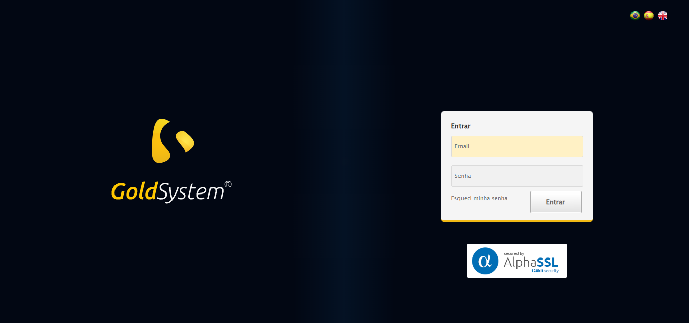

🔄 Realizando login...

✅ Realizando login realizada com sucesso.

Screenshot: realizando login

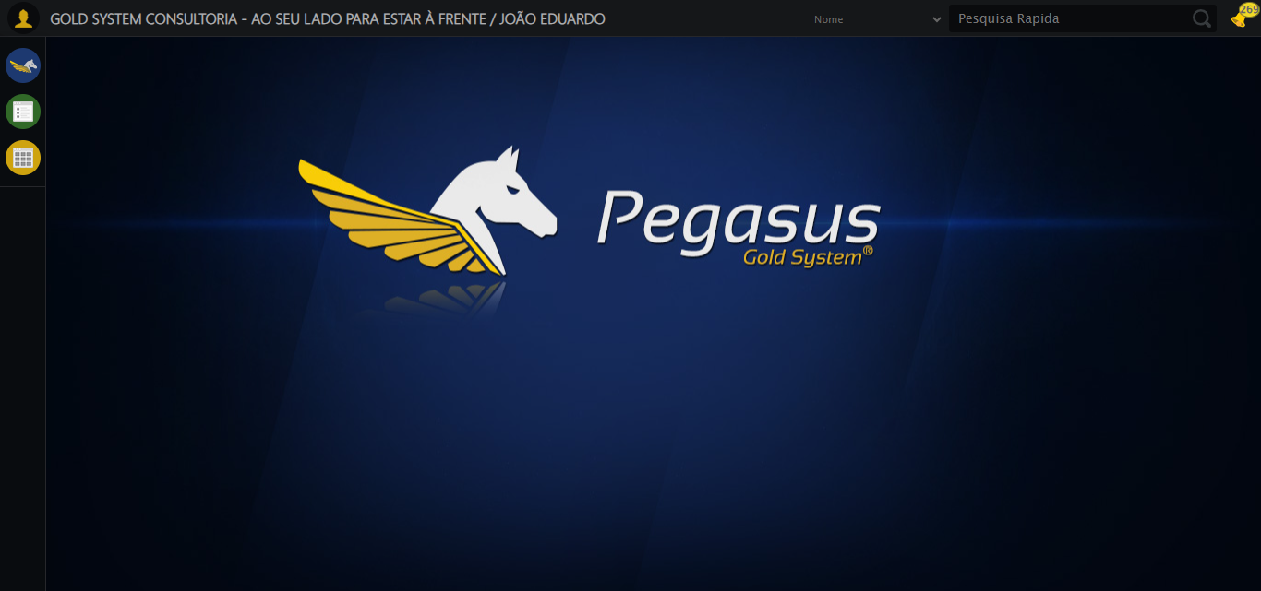

🔄 Ajustando zoom e abrindo menu...

🔍 Zoom ajustado para 90%.

✅ Ajustando zoom e abrindo menu realizada com sucesso.

Screenshot: ajustando zoom e abrindo menu

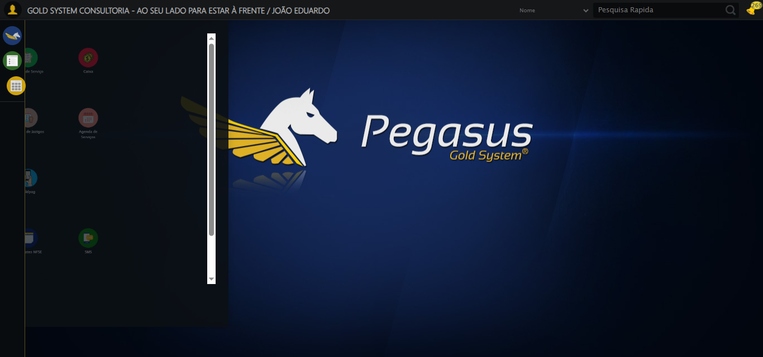

🔄 Acessando Gestor de Compras...

✅ Acessando Gestor de Compras realizada com sucesso.

Screenshot: acessando gestor de compras

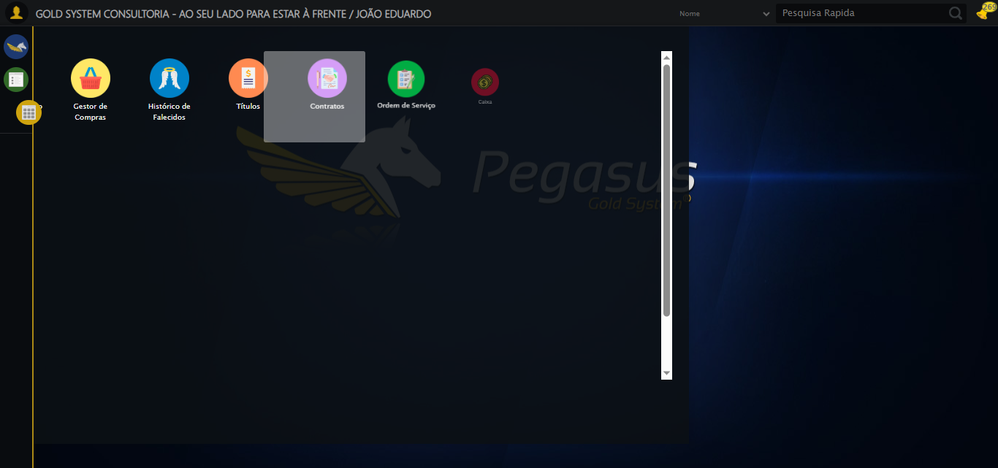

🔄 Clicando em Cotações...

✅ Clicando em Cotações realizada com sucesso.

Screenshot: clicando em cotações

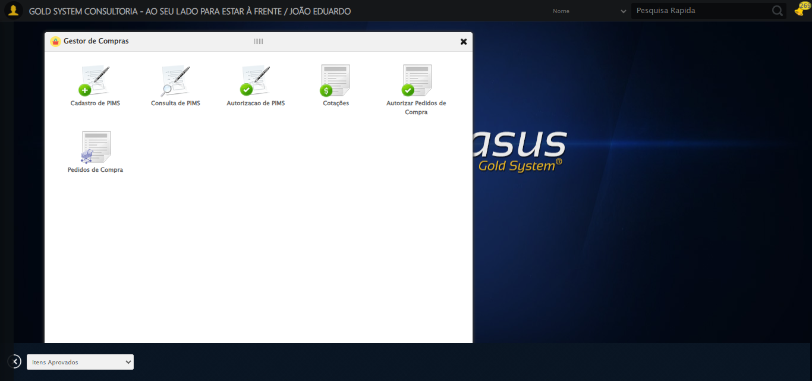

🔄 Preenchendo Data Aprovação inicial...

✅ Preenchendo Data Aprovação inicial realizada com sucesso.

Screenshot: preenchendo data aprovação inicial

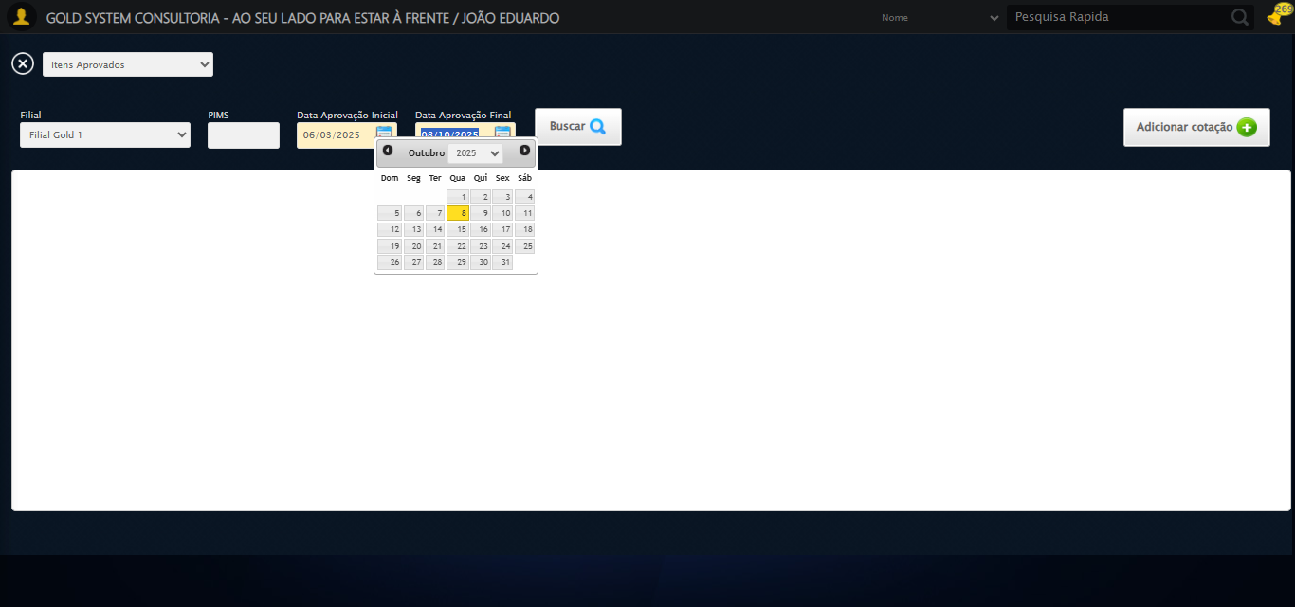

🔄 Buscando cotações...

✅ Buscando cotações realizada com sucesso.

Screenshot: buscando cotações

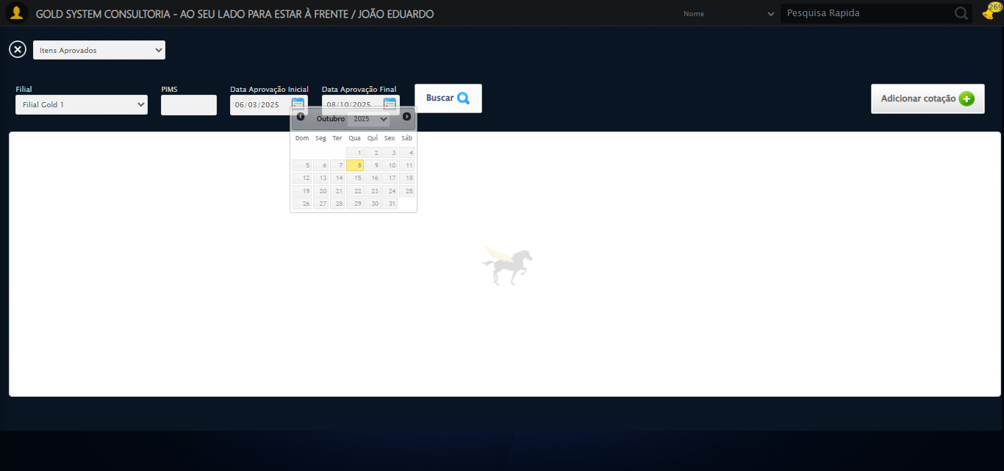

🔄 Verificando resultado da busca de cotações...

✅ Primeira cotação marcada (checkbox).

✅ Verificando resultado da busca de cotações realizada com sucesso.

Screenshot: verificando resultado da busca de cotações

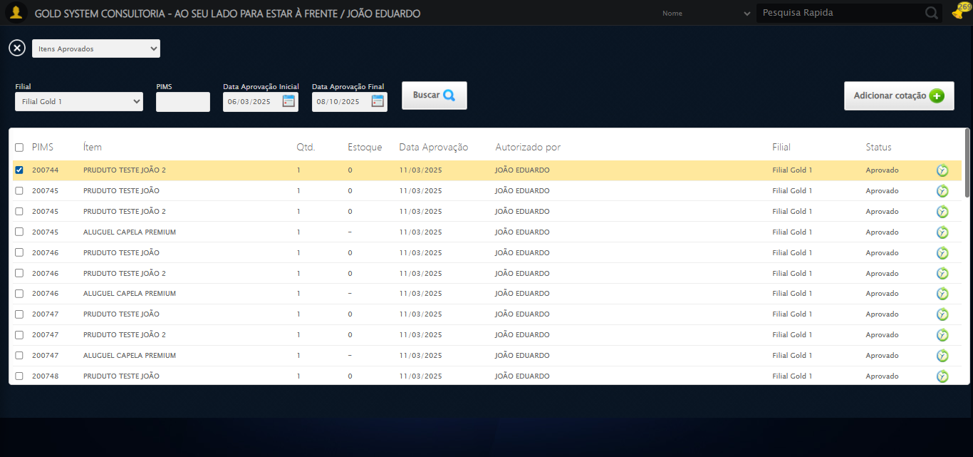

➡️ Cotação encontrada. Prosseguindo com as próximas ações...

🔄 Adicionando Cotação...

✅ Adicionando Cotação realizada com sucesso.

Screenshot: adicionando cotação

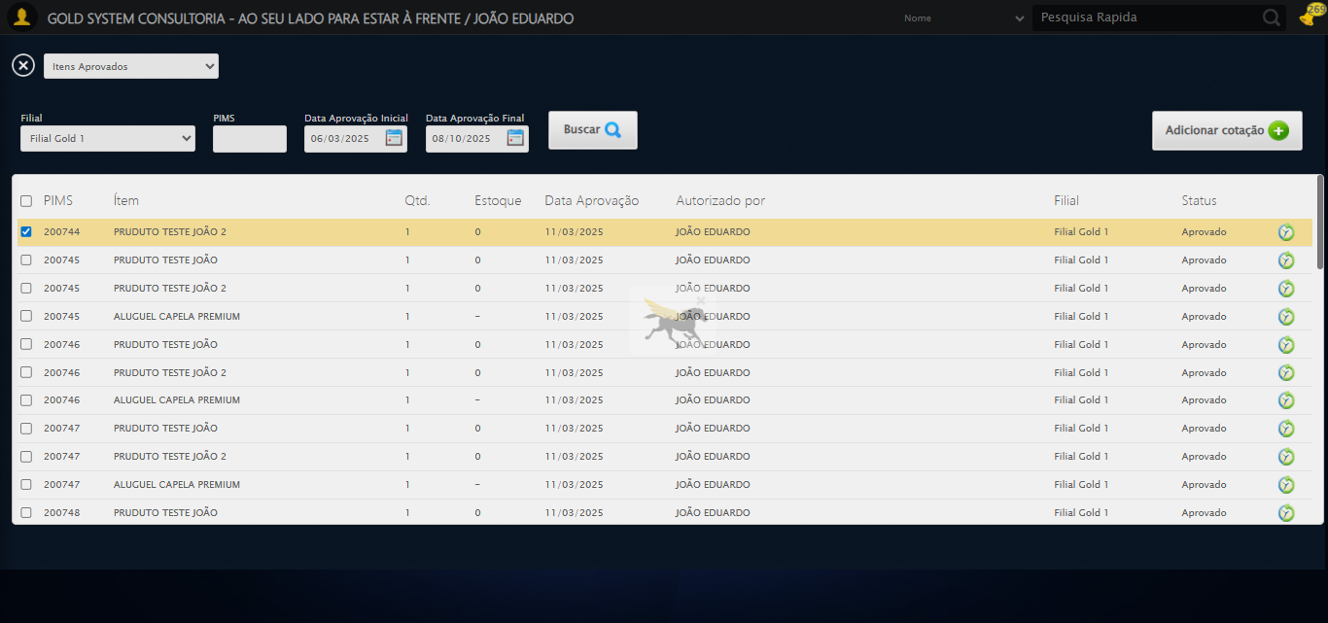

🔄 Selecionando Fornecedor...

🧭 Abrindo LOV pelo índice 0…

🔎 Tentativa 1: Localizando ícones LOV ('sp-openLov')...

🎯 Preparando clique no LOV de índice 0 (total: 1).

▶️ Estratégia 1 de clique no LOV...

✅ Clique no LOV (índice 0) realizado com sucesso (estratégia 1).

✅ Selecionando Fornecedor realizada com sucesso.

Screenshot: selecionando fornecedor

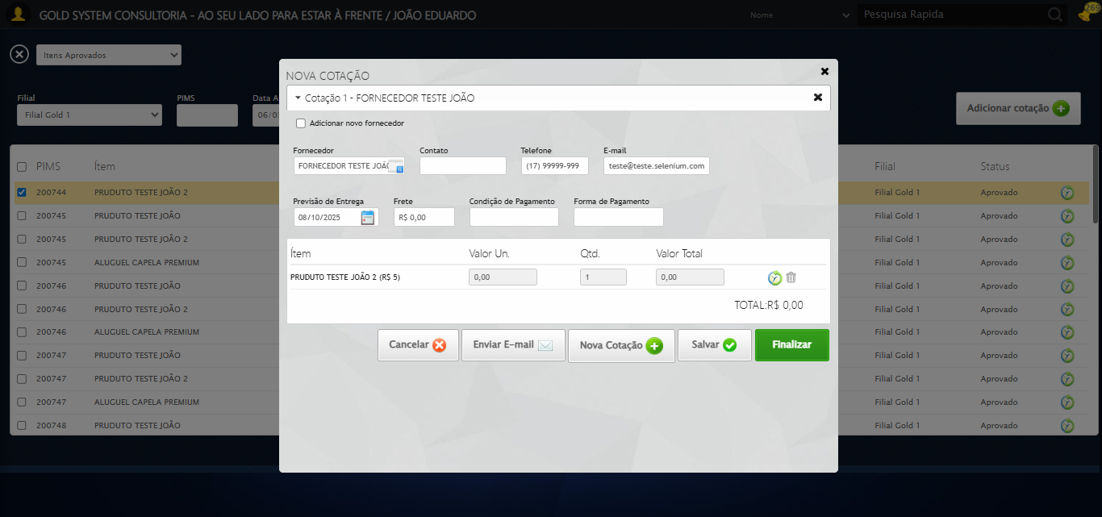

🔍 Verificando mensagens de alerta...

ℹ️ Nenhuma mensagem de alerta encontrada.

🔄 Preenchendo Contato do Fornecedor...

✅ Preenchendo Contato do Fornecedor realizada com sucesso.

Screenshot: preenchendo contato do fornecedor

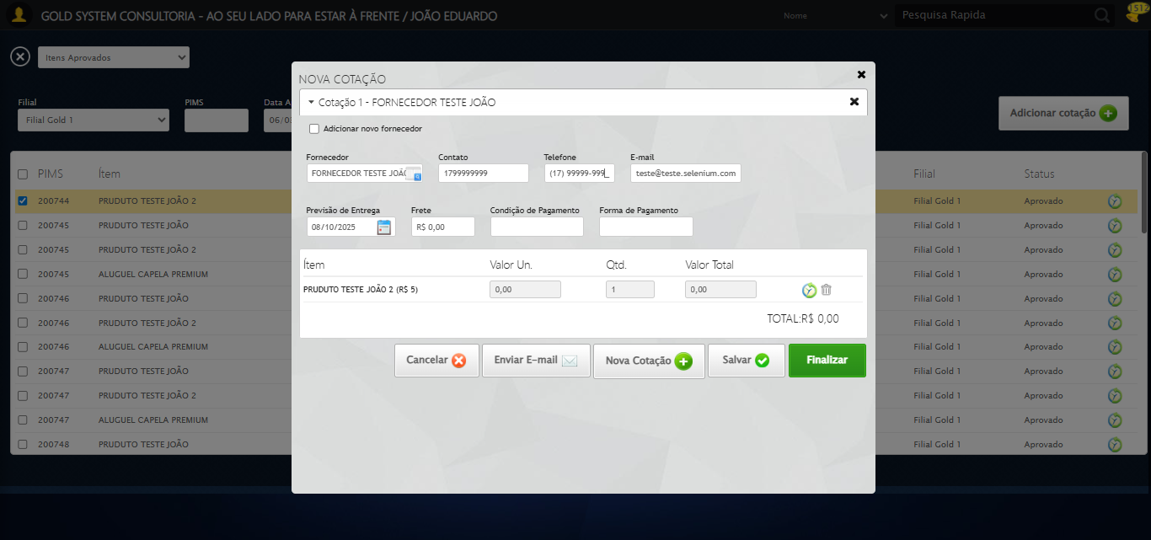

🔄 Preenchendo Telefone do Fornecedor...

✅ Preenchendo Telefone do Fornecedor realizada com sucesso.

Screenshot: preenchendo telefone do fornecedor

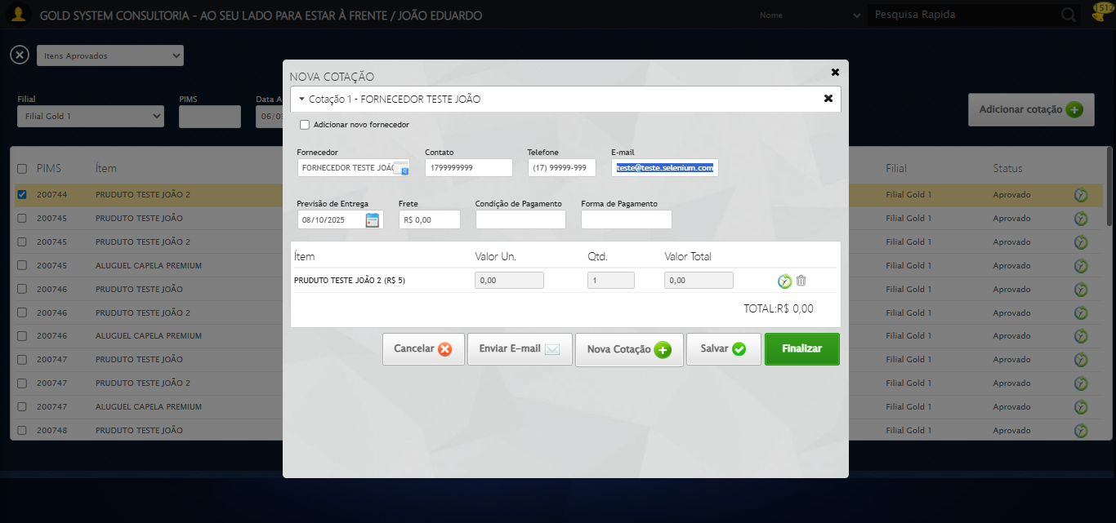

🔄 Preenchendo E-mail do Fornecedor...

✅ Preenchendo E-mail do Fornecedor realizada com sucesso.

Screenshot: preenchendo e-mail do fornecedor

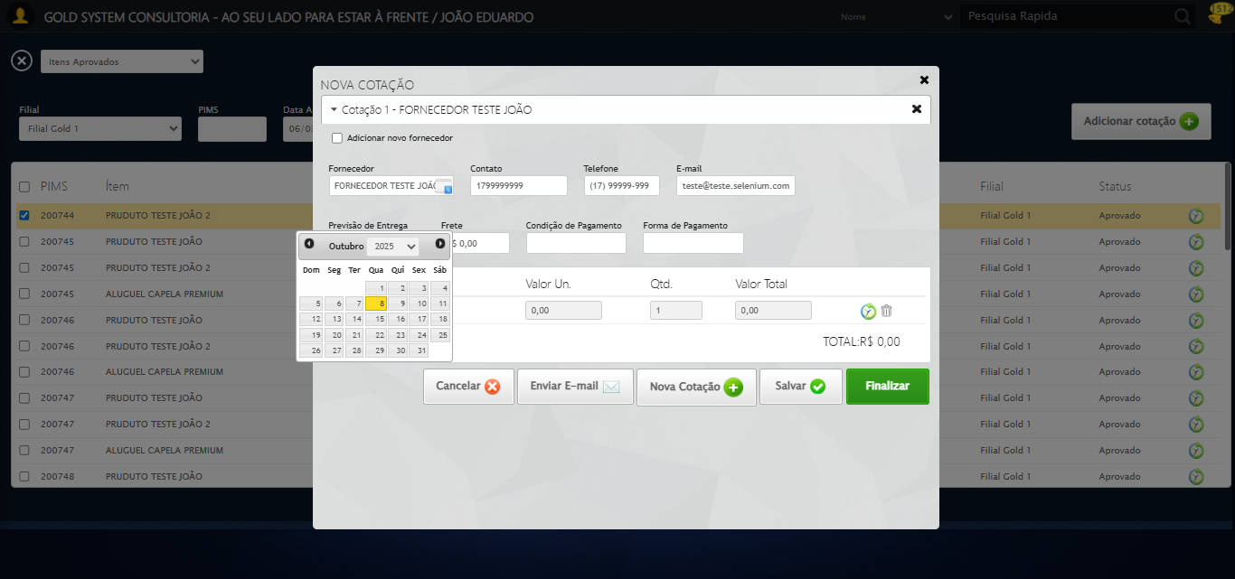

🔄 Preenchendo Condição de Pagamento...

✅ Preenchendo Condição de Pagamento realizada com sucesso.

Screenshot: preenchendo condição de pagamento

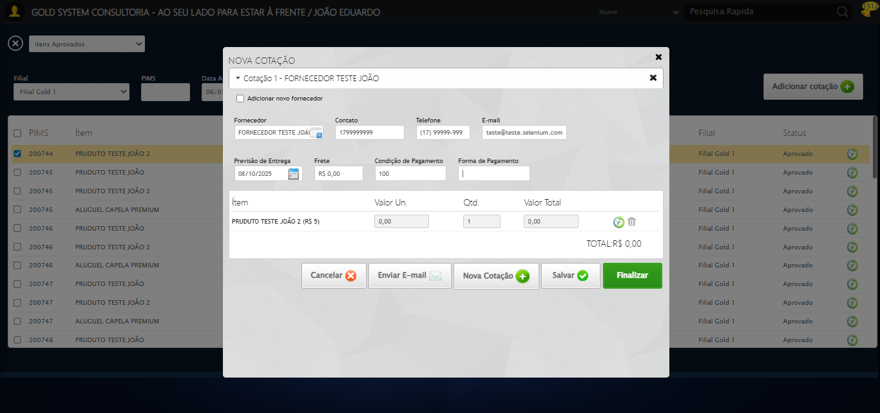

🔄 Preenchendo Forma de Pagamento...

✅ Preenchendo Forma de Pagamento realizada com sucesso.

Screenshot: preenchendo forma de pagamento

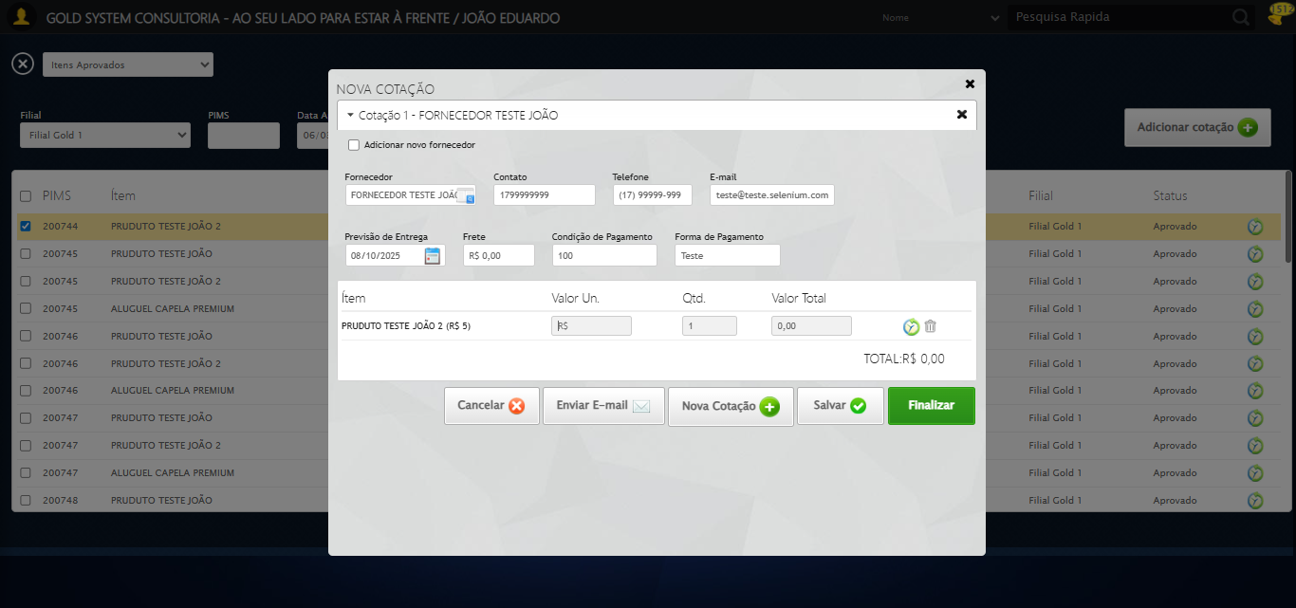

🔄 Preenchendo Forma de Pagamento...

⚠️ Tentativa 1 falhou: Message: invalid selector: Unable to locate an element with the xpath expression //input[contains(@class,'tipoPagamento') because of the following error:  
SyntaxError: Failed to execute 'evaluate' on 'Document': The string '//input[contains(@class,'tipoPagamento')' is not a valid XPath expression.  
 (Session info: chrome=140.0.7339.208); For documentation on this error, please visit: https://www.selenium.dev/documentation/webdriver/troubleshooting/errors#invalidselectorexception  
Stacktrace:  
 GetHandleVerifier [0x0x127c333+65459]  
 GetHandleVerifier [0x0x127c374+65524]  
 (No symbol) [0x0x109d973]  
 (No symbol) [0x0x10a4330]  
 (No symbol) [0x0x10a6734]  
 (No symbol) [0x0x10a67c8]  
 (No symbol) [0x0x10e6f74]  
 (No symbol) [0x0x10e7a8b]  
 (No symbol) [0x0x112dea2]  
 (No symbol) [0x0x1109e44]  
 (No symbol) [0x0x112b606]  
 (No symbol) [0x0x1109bf6]  
 (No symbol) [0x0x10db38e]  
 (No symbol) [0x0x10dc274]  
 GetHandleVerifier [0x0x14feda3+2697763]  
 GetHandleVerifier [0x0x14f9ec7+2677575]  
 GetHandleVerifier [0x0x12a4194+228884]  
 GetHandleVerifier [0x0x12949f8+165496]  
 GetHandleVerifier [0x0x129b18d+192013]  
 GetHandleVerifier [0x0x12847d8+99416]  
 GetHandleVerifier [0x0x1284972+99826]  
 GetHandleVerifier [0x0x126ebea+10346]  
 BaseThreadInitThunk [0x0x755bfcc9+25]  
 RtlGetAppContainerNamedObjectPath [0x0x773a82ae+286]  
 RtlGetAppContainerNamedObjectPath [0x0x773a827e+238]

⚠️ Tentativa 2 falhou: Message: invalid selector: Unable to locate an element with the xpath expression //input[contains(@class,'tipoPagamento') because of the following error:  
SyntaxError: Failed to execute 'evaluate' on 'Document': The string '//input[contains(@class,'tipoPagamento')' is not a valid XPath expression.  
 (Session info: chrome=140.0.7339.208); For documentation on this error, please visit: https://www.selenium.dev/documentation/webdriver/troubleshooting/errors#invalidselectorexception  
Stacktrace:  
 GetHandleVerifier [0x0x127c333+65459]  
 GetHandleVerifier [0x0x127c374+65524]  
 (No symbol) [0x0x109d973]  
 (No symbol) [0x0x10a4330]  
 (No symbol) [0x0x10a6734]  
 (No symbol) [0x0x10a67c8]  
 (No symbol) [0x0x10e6f74]  
 (No symbol) [0x0x10e7a8b]  
 (No symbol) [0x0x112dea2]  
 (No symbol) [0x0x1109e44]  
 (No symbol) [0x0x112b606]  
 (No symbol) [0x0x1109bf6]  
 (No symbol) [0x0x10db38e]  
 (No symbol) [0x0x10dc274]  
 GetHandleVerifier [0x0x14feda3+2697763]  
 GetHandleVerifier [0x0x14f9ec7+2677575]  
 GetHandleVerifier [0x0x12a4194+228884]  
 GetHandleVerifier [0x0x12949f8+165496]  
 GetHandleVerifier [0x0x129b18d+192013]  
 GetHandleVerifier [0x0x12847d8+99416]  
 GetHandleVerifier [0x0x1284972+99826]  
 GetHandleVerifier [0x0x126ebea+10346]  
 BaseThreadInitThunk [0x0x755bfcc9+25]  
 RtlGetAppContainerNamedObjectPath [0x0x773a82ae+286]  
 RtlGetAppContainerNamedObjectPath [0x0x773a827e+238]

⚠️ Tentativa 3 falhou: Message: invalid selector: Unable to locate an element with the xpath expression //input[contains(@class,'tipoPagamento') because of the following error:  
SyntaxError: Failed to execute 'evaluate' on 'Document': The string '//input[contains(@class,'tipoPagamento')' is not a valid XPath expression.  
 (Session info: chrome=140.0.7339.208); For documentation on this error, please visit: https://www.selenium.dev/documentation/webdriver/troubleshooting/errors#invalidselectorexception  
Stacktrace:  
 GetHandleVerifier [0x0x127c333+65459]  
 GetHandleVerifier [0x0x127c374+65524]  
 (No symbol) [0x0x109d973]  
 (No symbol) [0x0x10a4330]  
 (No symbol) [0x0x10a6734]  
 (No symbol) [0x0x10a67c8]  
 (No symbol) [0x0x10e6f74]  
 (No symbol) [0x0x10e7a8b]  
 (No symbol) [0x0x112dea2]  
 (No symbol) [0x0x1109e44]  
 (No symbol) [0x0x112b606]  
 (No symbol) [0x0x1109bf6]  
 (No symbol) [0x0x10db38e]  
 (No symbol) [0x0x10dc274]  
 GetHandleVerifier [0x0x14feda3+2697763]  
 GetHandleVerifier [0x0x14f9ec7+2677575]  
 GetHandleVerifier [0x0x12a4194+228884]  
 GetHandleVerifier [0x0x12949f8+165496]  
 GetHandleVerifier [0x0x129b18d+192013]  
 GetHandleVerifier [0x0x12847d8+99416]  
 GetHandleVerifier [0x0x1284972+99826]  
 GetHandleVerifier [0x0x126ebea+10346]  
 BaseThreadInitThunk [0x0x755bfcc9+25]  
 RtlGetAppContainerNamedObjectPath [0x0x773a82ae+286]  
 RtlGetAppContainerNamedObjectPath [0x0x773a827e+238]

✅ Preenchendo Forma de Pagamento realizada com sucesso.

🔄 Preenchendo todos os valores e quantidades (padrão)...

🔎 Encontrados 1 pares de campos input.vu e input.innerQtdField, preenchendo...

✅ Produto 1: Valor=10,00 | Quantidade=2

✅ Preenchendo todos os valores e quantidades (padrão) realizada com sucesso.

Screenshot: preenchendo todos os valores e quantidades (padrão)

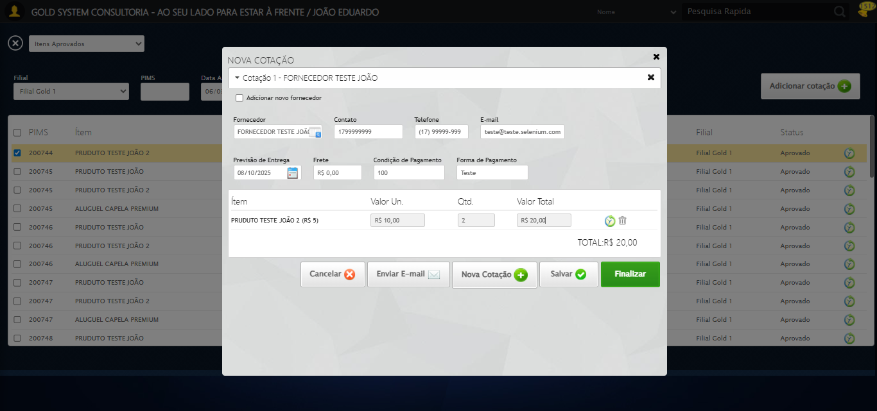

🔄 Adicionando Nova Cotação...

✅ Adicionando Nova Cotação realizada com sucesso.

Screenshot: adicionando nova cotação

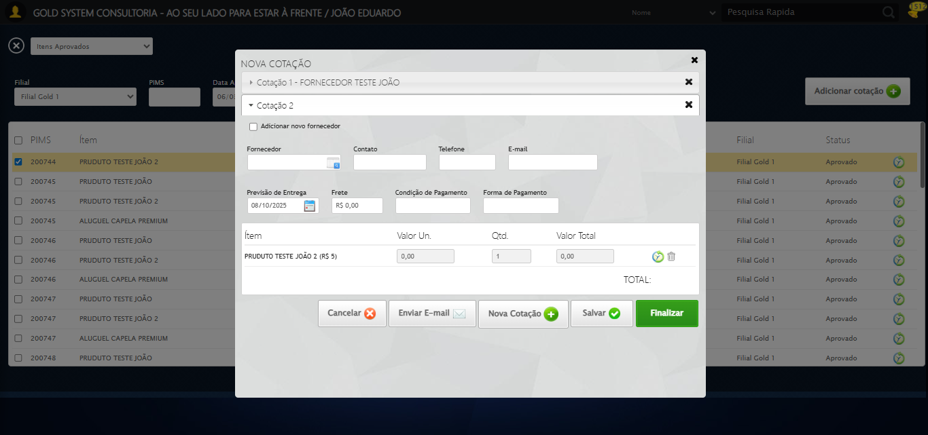

🔄 Selecionando Fornecedor...

🧭 Abrindo LOV pelo índice 1…

🔎 Tentativa 1: Localizando ícones LOV ('sp-openLov')...

🎯 Preparando clique no LOV de índice 1 (total: 2).

▶️ Estratégia 1 de clique no LOV...

✅ Clique no LOV (índice 1) realizado com sucesso (estratégia 1).

✅ Selecionando Fornecedor realizada com sucesso.

🔄 Preenchendo Contato do Fornecedor...

⚠️ Tentativa 1 falhou: Message:

⚠️ Tentativa 2 falhou: Message:

⚠️ Tentativa 3 falhou: Message:

✅ Preenchendo Contato do Fornecedor realizada com sucesso.

🔄 Preenchendo Telefone do Fornecedor...

⚠️ Tentativa 1 falhou: Message:

⚠️ Tentativa 2 falhou: Message:

⚠️ Tentativa 3 falhou: Message:

✅ Preenchendo Telefone do Fornecedor realizada com sucesso.

🔄 Preenchendo E-mail do Fornecedor...

⚠️ Tentativa 1 falhou: Message:

✅ Preenchendo E-mail do Fornecedor realizada com sucesso.

🔄 Preenchendo Condição de Pagamento...

✅ Preenchendo Condição de Pagamento realizada com sucesso.

🔄 Preenchendo Forma de Pagamento...

✅ Preenchendo Forma de Pagamento realizada com sucesso.

🔄 Preenchendo Forma de Pagamento...

⚠️ Tentativa 1 falhou: Message: invalid selector: Unable to locate an element with the xpath expression //input[contains(@class,'tipoPagamento') because of the following error:  
SyntaxError: Failed to execute 'evaluate' on 'Document': The string '//input[contains(@class,'tipoPagamento')' is not a valid XPath expression.  
 (Session info: chrome=140.0.7339.208); For documentation on this error, please visit: https://www.selenium.dev/documentation/webdriver/troubleshooting/errors#invalidselectorexception  
Stacktrace:  
 GetHandleVerifier [0x0x127c333+65459]  
 GetHandleVerifier [0x0x127c374+65524]  
 (No symbol) [0x0x109d973]  
 (No symbol) [0x0x10a4330]  
 (No symbol) [0x0x10a6734]  
 (No symbol) [0x0x10a67c8]  
 (No symbol) [0x0x10e6f74]  
 (No symbol) [0x0x10e7a8b]  
 (No symbol) [0x0x112dea2]  
 (No symbol) [0x0x1109e44]  
 (No symbol) [0x0x112b606]  
 (No symbol) [0x0x1109bf6]  
 (No symbol) [0x0x10db38e]  
 (No symbol) [0x0x10dc274]  
 GetHandleVerifier [0x0x14feda3+2697763]  
 GetHandleVerifier [0x0x14f9ec7+2677575]  
 GetHandleVerifier [0x0x12a4194+228884]  
 GetHandleVerifier [0x0x12949f8+165496]  
 GetHandleVerifier [0x0x129b18d+192013]  
 GetHandleVerifier [0x0x12847d8+99416]  
 GetHandleVerifier [0x0x1284972+99826]  
 GetHandleVerifier [0x0x126ebea+10346]  
 BaseThreadInitThunk [0x0x755bfcc9+25]  
 RtlGetAppContainerNamedObjectPath [0x0x773a82ae+286]  
 RtlGetAppContainerNamedObjectPath [0x0x773a827e+238]

⚠️ Tentativa 2 falhou: Message: invalid selector: Unable to locate an element with the xpath expression //input[contains(@class,'tipoPagamento') because of the following error:  
SyntaxError: Failed to execute 'evaluate' on 'Document': The string '//input[contains(@class,'tipoPagamento')' is not a valid XPath expression.  
 (Session info: chrome=140.0.7339.208); For documentation on this error, please visit: https://www.selenium.dev/documentation/webdriver/troubleshooting/errors#invalidselectorexception  
Stacktrace:  
 GetHandleVerifier [0x0x127c333+65459]  
 GetHandleVerifier [0x0x127c374+65524]  
 (No symbol) [0x0x109d973]  
 (No symbol) [0x0x10a4330]  
 (No symbol) [0x0x10a6734]  
 (No symbol) [0x0x10a67c8]  
 (No symbol) [0x0x10e6f74]  
 (No symbol) [0x0x10e7a8b]  
 (No symbol) [0x0x112dea2]  
 (No symbol) [0x0x1109e44]  
 (No symbol) [0x0x112b606]  
 (No symbol) [0x0x1109bf6]  
 (No symbol) [0x0x10db38e]  
 (No symbol) [0x0x10dc274]  
 GetHandleVerifier [0x0x14feda3+2697763]  
 GetHandleVerifier [0x0x14f9ec7+2677575]  
 GetHandleVerifier [0x0x12a4194+228884]  
 GetHandleVerifier [0x0x12949f8+165496]  
 GetHandleVerifier [0x0x129b18d+192013]  
 GetHandleVerifier [0x0x12847d8+99416]  
 GetHandleVerifier [0x0x1284972+99826]  
 GetHandleVerifier [0x0x126ebea+10346]  
 BaseThreadInitThunk [0x0x755bfcc9+25]  
 RtlGetAppContainerNamedObjectPath [0x0x773a82ae+286]  
 RtlGetAppContainerNamedObjectPath [0x0x773a827e+238]

⚠️ Tentativa 3 falhou: Message: invalid session id: session deleted as the browser has closed the connection  
from disconnected: not connected to DevTools  
 (Session info: chrome=140.0.7339.208); For documentation on this error, please visit: https://www.selenium.dev/documentation/webdriver/troubleshooting/errors#invalidsessionidexception  
Stacktrace:  
 GetHandleVerifier [0x0x127c333+65459]  
 GetHandleVerifier [0x0x127c374+65524]  
 (No symbol) [0x0x109d973]  
 (No symbol) [0x0x108cdf0]  
 (No symbol) [0x0x10ab4af]  
 (No symbol) [0x0x1110775]  
 (No symbol) [0x0x112aef9]  
 (No symbol) [0x0x1109bf6]  
 (No symbol) [0x0x10db38e]  
 (No symbol) [0x0x10dc274]  
 GetHandleVerifier [0x0x14feda3+2697763]  
 GetHandleVerifier [0x0x14f9ec7+2677575]  
 GetHandleVerifier [0x0x12a4194+228884]  
 GetHandleVerifier [0x0x12949f8+165496]  
 GetHandleVerifier [0x0x129b18d+192013]  
 GetHandleVerifier [0x0x12847d8+99416]  
 GetHandleVerifier [0x0x1284972+99826]  
 GetHandleVerifier [0x0x126ebea+10346]  
 BaseThreadInitThunk [0x0x755bfcc9+25]  
 RtlGetAppContainerNamedObjectPath [0x0x773a82ae+286]  
 RtlGetAppContainerNamedObjectPath [0x0x773a827e+238]

✅ Preenchendo Forma de Pagamento realizada com sucesso.

🔄 Preenchendo todos os valores e quantidades (padrão)...

❌ Erro ao preencher todos os valores/quantidades: Message: invalid session id; For documentation on this error, please visit: https://www.selenium.dev/documentation/webdriver/troubleshooting/errors#invalidsessionidexception  
Stacktrace:  
 GetHandleVerifier [0x0x127c333+65459]  
 GetHandleVerifier [0x0x127c374+65524]  
 (No symbol) [0x0x109d7c0]  
 (No symbol) [0x0x10da663]  
 (No symbol) [0x0x1109cb6]  
 (No symbol) [0x0x110555e]  
 (No symbol) [0x0x1104ad3]  
 (No symbol) [0x0x106e73d]  
 (No symbol) [0x0x106ecbe]  
 (No symbol) [0x0x106f15d]  
 GetHandleVerifier [0x0x14feda3+2697763]  
 GetHandleVerifier [0x0x14f9ec7+2677575]  
 GetHandleVerifier [0x0x12a4194+228884]  
 GetHandleVerifier [0x0x12949f8+165496]  
 GetHandleVerifier [0x0x129b18d+192013]  
 (No symbol) [0x0x106e3f2]  
 (No symbol) [0x0x106db72]  
 GetHandleVerifier [0x0x165340c+4092044]  
 BaseThreadInitThunk [0x0x755bfcc9+25]  
 RtlGetAppContainerNamedObjectPath [0x0x773a82ae+286]  
 RtlGetAppContainerNamedObjectPath [0x0x773a827e+238]

✅ Preenchendo todos os valores e quantidades (padrão) realizada com sucesso.

🔄 Adicionando Nova Cotação...

❌ Erro inesperado ao adicionando nova cotação: Message: invalid session id; For documentation on this error, please visit: https://www.selenium.dev/documentation/webdriver/troubleshooting/errors#invalidsessionidexception  
Stacktrace:  
 GetHandleVerifier [0x0x127c333+65459]  
 GetHandleVerifier [0x0x127c374+65524]  
 (No symbol) [0x0x109d7c0]  
 (No symbol) [0x0x10da663]  
 (No symbol) [0x0x1109cb6]  
 (No symbol) [0x0x110555e]  
 (No symbol) [0x0x1104ad3]  
 (No symbol) [0x0x106e73d]  
 (No symbol) [0x0x106ecbe]  
 (No symbol) [0x0x106f15d]  
 GetHandleVerifier [0x0x14feda3+2697763]  
 GetHandleVerifier [0x0x14f9ec7+2677575]  
 GetHandleVerifier [0x0x12a4194+228884]  
 GetHandleVerifier [0x0x12949f8+165496]  
 GetHandleVerifier [0x0x129b18d+192013]  
 (No symbol) [0x0x106e3f2]  
 (No symbol) [0x0x106db72]  
 GetHandleVerifier [0x0x165340c+4092044]  
 BaseThreadInitThunk [0x0x755bfcc9+25]  
 RtlGetAppContainerNamedObjectPath [0x0x773a82ae+286]  
 RtlGetAppContainerNamedObjectPath [0x0x773a827e+238]

⚠️ Erro ao tirar screenshot erro_adicionando nova cotação: Message: invalid session id; For documentation on this error, please visit: https://www.selenium.dev/documentation/webdriver/troubleshooting/errors#invalidsessionidexception  
Stacktrace:  
 GetHandleVerifier [0x0x127c333+65459]  
 GetHandleVerifier [0x0x127c374+65524]  
 (No symbol) [0x0x109d7c0]  
 (No symbol) [0x0x10da663]  
 (No symbol) [0x0x1109cb6]  
 (No symbol) [0x0x110555e]  
 (No symbol) [0x0x1104ad3]  
 (No symbol) [0x0x106e73d]  
 (No symbol) [0x0x106ecbe]  
 (No symbol) [0x0x106f15d]  
 GetHandleVerifier [0x0x14feda3+2697763]  
 GetHandleVerifier [0x0x14f9ec7+2677575]  
 GetHandleVerifier [0x0x12a4194+228884]  
 GetHandleVerifier [0x0x12949f8+165496]  
 GetHandleVerifier [0x0x129b18d+192013]  
 (No symbol) [0x0x106e3f2]  
 (No symbol) [0x0x106db72]  
 GetHandleVerifier [0x0x165340c+4092044]  
 BaseThreadInitThunk [0x0x755bfcc9+25]  
 RtlGetAppContainerNamedObjectPath [0x0x773a82ae+286]  
 RtlGetAppContainerNamedObjectPath [0x0x773a827e+238]

🔄 Selecionando Fornecedor...

🧭 Abrindo LOV pelo índice 2…

🔎 Tentativa 1: Localizando ícones LOV ('sp-openLov')...

⚠️ Tentativa 1/3 falhou: log() takes 2 positional arguments but 3 were given. Retentando…

🧭 Abrindo LOV pelo índice 2…

🔎 Tentativa 1: Localizando ícones LOV ('sp-openLov')...

⚠️ Tentativa 2/3 falhou: log() takes 2 positional arguments but 3 were given. Retentando…

🧭 Abrindo LOV pelo índice 2…

🔎 Tentativa 1: Localizando ícones LOV ('sp-openLov')...

❌ Erro inesperado ao selecionando fornecedor: log() takes 2 positional arguments but 3 were given

⚠️ Erro ao tirar screenshot erro_selecionando fornecedor: Message: invalid session id; For documentation on this error, please visit: https://www.selenium.dev/documentation/webdriver/troubleshooting/errors#invalidsessionidexception  
Stacktrace:  
 GetHandleVerifier [0x0x127c333+65459]  
 GetHandleVerifier [0x0x127c374+65524]  
 (No symbol) [0x0x109d7c0]  
 (No symbol) [0x0x10da663]  
 (No symbol) [0x0x1109cb6]  
 (No symbol) [0x0x110555e]  
 (No symbol) [0x0x1104ad3]  
 (No symbol) [0x0x106e73d]  
 (No symbol) [0x0x106ecbe]  
 (No symbol) [0x0x106f15d]  
 GetHandleVerifier [0x0x14feda3+2697763]  
 GetHandleVerifier [0x0x14f9ec7+2677575]  
 GetHandleVerifier [0x0x12a4194+228884]  
 GetHandleVerifier [0x0x12949f8+165496]  
 GetHandleVerifier [0x0x129b18d+192013]  
 (No symbol) [0x0x106e3f2]  
 (No symbol) [0x0x106db72]  
 GetHandleVerifier [0x0x165340c+4092044]  
 BaseThreadInitThunk [0x0x755bfcc9+25]  
 RtlGetAppContainerNamedObjectPath [0x0x773a82ae+286]  
 RtlGetAppContainerNamedObjectPath [0x0x773a827e+238]

🔍 Verificando mensagens de alerta...

ℹ️ Nenhuma mensagem de alerta encontrada.

🔄 Preenchendo Contato do Fornecedor...

⚠️ Tentativa 1 falhou: Message: invalid session id; For documentation on this error, please visit: https://www.selenium.dev/documentation/webdriver/troubleshooting/errors#invalidsessionidexception  
Stacktrace:  
 GetHandleVerifier [0x0x127c333+65459]  
 GetHandleVerifier [0x0x127c374+65524]  
 (No symbol) [0x0x109d7c0]  
 (No symbol) [0x0x10da663]  
 (No symbol) [0x0x1109cb6]  
 (No symbol) [0x0x110555e]  
 (No symbol) [0x0x1104ad3]  
 (No symbol) [0x0x106e73d]  
 (No symbol) [0x0x106ecbe]  
 (No symbol) [0x0x106f15d]  
 GetHandleVerifier [0x0x14feda3+2697763]  
 GetHandleVerifier [0x0x14f9ec7+2677575]  
 GetHandleVerifier [0x0x12a4194+228884]  
 GetHandleVerifier [0x0x12949f8+165496]  
 GetHandleVerifier [0x0x129b18d+192013]  
 (No symbol) [0x0x106e3f2]  
 (No symbol) [0x0x106db72]  
 GetHandleVerifier [0x0x165340c+4092044]  
 BaseThreadInitThunk [0x0x755bfcc9+25]  
 RtlGetAppContainerNamedObjectPath [0x0x773a82ae+286]  
 RtlGetAppContainerNamedObjectPath [0x0x773a827e+238]

⚠️ Tentativa 2 falhou: Message: invalid session id; For documentation on this error, please visit: https://www.selenium.dev/documentation/webdriver/troubleshooting/errors#invalidsessionidexception  
Stacktrace:  
 GetHandleVerifier [0x0x127c333+65459]  
 GetHandleVerifier [0x0x127c374+65524]  
 (No symbol) [0x0x109d7c0]  
 (No symbol) [0x0x10da663]  
 (No symbol) [0x0x1109cb6]  
 (No symbol) [0x0x110555e]  
 (No symbol) [0x0x1104ad3]  
 (No symbol) [0x0x106e73d]  
 (No symbol) [0x0x106ecbe]  
 (No symbol) [0x0x106f15d]  
 GetHandleVerifier [0x0x14feda3+2697763]  
 GetHandleVerifier [0x0x14f9ec7+2677575]  
 GetHandleVerifier [0x0x12a4194+228884]  
 GetHandleVerifier [0x0x12949f8+165496]  
 GetHandleVerifier [0x0x129b18d+192013]  
 (No symbol) [0x0x106e3f2]  
 (No symbol) [0x0x106db72]  
 GetHandleVerifier [0x0x165340c+4092044]  
 BaseThreadInitThunk [0x0x755bfcc9+25]  
 RtlGetAppContainerNamedObjectPath [0x0x773a82ae+286]  
 RtlGetAppContainerNamedObjectPath [0x0x773a827e+238]

⚠️ Tentativa 3 falhou: Message: invalid session id; For documentation on this error, please visit: https://www.selenium.dev/documentation/webdriver/troubleshooting/errors#invalidsessionidexception  
Stacktrace:  
 GetHandleVerifier [0x0x127c333+65459]  
 GetHandleVerifier [0x0x127c374+65524]  
 (No symbol) [0x0x109d7c0]  
 (No symbol) [0x0x10da663]  
 (No symbol) [0x0x1109cb6]  
 (No symbol) [0x0x110555e]  
 (No symbol) [0x0x1104ad3]  
 (No symbol) [0x0x106e73d]  
 (No symbol) [0x0x106ecbe]  
 (No symbol) [0x0x106f15d]  
 GetHandleVerifier [0x0x14feda3+2697763]  
 GetHandleVerifier [0x0x14f9ec7+2677575]  
 GetHandleVerifier [0x0x12a4194+228884]  
 GetHandleVerifier [0x0x12949f8+165496]  
 GetHandleVerifier [0x0x129b18d+192013]  
 (No symbol) [0x0x106e3f2]  
 (No symbol) [0x0x106db72]  
 GetHandleVerifier [0x0x165340c+4092044]  
 BaseThreadInitThunk [0x0x755bfcc9+25]  
 RtlGetAppContainerNamedObjectPath [0x0x773a82ae+286]  
 RtlGetAppContainerNamedObjectPath [0x0x773a827e+238]

✅ Preenchendo Contato do Fornecedor realizada com sucesso.

🔄 Preenchendo Telefone do Fornecedor...

⚠️ Tentativa 1 falhou: Message: invalid session id; For documentation on this error, please visit: https://www.selenium.dev/documentation/webdriver/troubleshooting/errors#invalidsessionidexception  
Stacktrace:  
 GetHandleVerifier [0x0x127c333+65459]  
 GetHandleVerifier [0x0x127c374+65524]  
 (No symbol) [0x0x109d7c0]  
 (No symbol) [0x0x10da663]  
 (No symbol) [0x0x1109cb6]  
 (No symbol) [0x0x110555e]  
 (No symbol) [0x0x1104ad3]  
 (No symbol) [0x0x106e73d]  
 (No symbol) [0x0x106ecbe]  
 (No symbol) [0x0x106f15d]  
 GetHandleVerifier [0x0x14feda3+2697763]  
 GetHandleVerifier [0x0x14f9ec7+2677575]  
 GetHandleVerifier [0x0x12a4194+228884]  
 GetHandleVerifier [0x0x12949f8+165496]  
 GetHandleVerifier [0x0x129b18d+192013]  
 (No symbol) [0x0x106e3f2]  
 (No symbol) [0x0x106db72]  
 GetHandleVerifier [0x0x165340c+4092044]  
 BaseThreadInitThunk [0x0x755bfcc9+25]  
 RtlGetAppContainerNamedObjectPath [0x0x773a82ae+286]  
 RtlGetAppContainerNamedObjectPath [0x0x773a827e+238]

⚠️ Tentativa 2 falhou: Message: invalid session id; For documentation on this error, please visit: https://www.selenium.dev/documentation/webdriver/troubleshooting/errors#invalidsessionidexception  
Stacktrace:  
 GetHandleVerifier [0x0x127c333+65459]  
 GetHandleVerifier [0x0x127c374+65524]  
 (No symbol) [0x0x109d7c0]  
 (No symbol) [0x0x10da663]  
 (No symbol) [0x0x1109cb6]  
 (No symbol) [0x0x110555e]  
 (No symbol) [0x0x1104ad3]  
 (No symbol) [0x0x106e73d]  
 (No symbol) [0x0x106ecbe]  
 (No symbol) [0x0x106f15d]  
 GetHandleVerifier [0x0x14feda3+2697763]  
 GetHandleVerifier [0x0x14f9ec7+2677575]  
 GetHandleVerifier [0x0x12a4194+228884]  
 GetHandleVerifier [0x0x12949f8+165496]  
 GetHandleVerifier [0x0x129b18d+192013]  
 (No symbol) [0x0x106e3f2]  
 (No symbol) [0x0x106db72]  
 GetHandleVerifier [0x0x165340c+4092044]  
 BaseThreadInitThunk [0x0x755bfcc9+25]  
 RtlGetAppContainerNamedObjectPath [0x0x773a82ae+286]  
 RtlGetAppContainerNamedObjectPath [0x0x773a827e+238]

⚠️ Tentativa 3 falhou: Message: invalid session id; For documentation on this error, please visit: https://www.selenium.dev/documentation/webdriver/troubleshooting/errors#invalidsessionidexception  
Stacktrace:  
 GetHandleVerifier [0x0x127c333+65459]  
 GetHandleVerifier [0x0x127c374+65524]  
 (No symbol) [0x0x109d7c0]  
 (No symbol) [0x0x10da663]  
 (No symbol) [0x0x1109cb6]  
 (No symbol) [0x0x110555e]  
 (No symbol) [0x0x1104ad3]  
 (No symbol) [0x0x106e73d]  
 (No symbol) [0x0x106ecbe]  
 (No symbol) [0x0x106f15d]  
 GetHandleVerifier [0x0x14feda3+2697763]  
 GetHandleVerifier [0x0x14f9ec7+2677575]  
 GetHandleVerifier [0x0x12a4194+228884]  
 GetHandleVerifier [0x0x12949f8+165496]  
 GetHandleVerifier [0x0x129b18d+192013]  
 (No symbol) [0x0x106e3f2]  
 (No symbol) [0x0x106db72]  
 GetHandleVerifier [0x0x165340c+4092044]  
 BaseThreadInitThunk [0x0x755bfcc9+25]  
 RtlGetAppContainerNamedObjectPath [0x0x773a82ae+286]  
 RtlGetAppContainerNamedObjectPath [0x0x773a827e+238]

✅ Preenchendo Telefone do Fornecedor realizada com sucesso.

🔄 Preenchendo E-mail do Fornecedor...

⚠️ Tentativa 1 falhou: Message: invalid session id; For documentation on this error, please visit: https://www.selenium.dev/documentation/webdriver/troubleshooting/errors#invalidsessionidexception  
Stacktrace:  
 GetHandleVerifier [0x0x127c333+65459]  
 GetHandleVerifier [0x0x127c374+65524]  
 (No symbol) [0x0x109d7c0]  
 (No symbol) [0x0x10da663]  
 (No symbol) [0x0x1109cb6]  
 (No symbol) [0x0x110555e]  
 (No symbol) [0x0x1104ad3]  
 (No symbol) [0x0x106e73d]  
 (No symbol) [0x0x106ecbe]  
 (No symbol) [0x0x106f15d]  
 GetHandleVerifier [0x0x14feda3+2697763]  
 GetHandleVerifier [0x0x14f9ec7+2677575]  
 GetHandleVerifier [0x0x12a4194+228884]  
 GetHandleVerifier [0x0x12949f8+165496]  
 GetHandleVerifier [0x0x129b18d+192013]  
 (No symbol) [0x0x106e3f2]  
 (No symbol) [0x0x106db72]  
 GetHandleVerifier [0x0x165340c+4092044]  
 BaseThreadInitThunk [0x0x755bfcc9+25]  
 RtlGetAppContainerNamedObjectPath [0x0x773a82ae+286]  
 RtlGetAppContainerNamedObjectPath [0x0x773a827e+238]

⚠️ Tentativa 2 falhou: Message: invalid session id; For documentation on this error, please visit: https://www.selenium.dev/documentation/webdriver/troubleshooting/errors#invalidsessionidexception  
Stacktrace:  
 GetHandleVerifier [0x0x127c333+65459]  
 GetHandleVerifier [0x0x127c374+65524]  
 (No symbol) [0x0x109d7c0]  
 (No symbol) [0x0x10da663]  
 (No symbol) [0x0x1109cb6]  
 (No symbol) [0x0x110555e]  
 (No symbol) [0x0x1104ad3]  
 (No symbol) [0x0x106e73d]  
 (No symbol) [0x0x106ecbe]  
 (No symbol) [0x0x106f15d]  
 GetHandleVerifier [0x0x14feda3+2697763]  
 GetHandleVerifier [0x0x14f9ec7+2677575]  
 GetHandleVerifier [0x0x12a4194+228884]  
 GetHandleVerifier [0x0x12949f8+165496]  
 GetHandleVerifier [0x0x129b18d+192013]  
 (No symbol) [0x0x106e3f2]  
 (No symbol) [0x0x106db72]  
 GetHandleVerifier [0x0x165340c+4092044]  
 BaseThreadInitThunk [0x0x755bfcc9+25]  
 RtlGetAppContainerNamedObjectPath [0x0x773a82ae+286]  
 RtlGetAppContainerNamedObjectPath [0x0x773a827e+238]

⚠️ Tentativa 3 falhou: Message: invalid session id; For documentation on this error, please visit: https://www.selenium.dev/documentation/webdriver/troubleshooting/errors#invalidsessionidexception  
Stacktrace:  
 GetHandleVerifier [0x0x127c333+65459]  
 GetHandleVerifier [0x0x127c374+65524]  
 (No symbol) [0x0x109d7c0]  
 (No symbol) [0x0x10da663]  
 (No symbol) [0x0x1109cb6]  
 (No symbol) [0x0x110555e]  
 (No symbol) [0x0x1104ad3]  
 (No symbol) [0x0x106e73d]  
 (No symbol) [0x0x106ecbe]  
 (No symbol) [0x0x106f15d]  
 GetHandleVerifier [0x0x14feda3+2697763]  
 GetHandleVerifier [0x0x14f9ec7+2677575]  
 GetHandleVerifier [0x0x12a4194+228884]  
 GetHandleVerifier [0x0x12949f8+165496]  
 GetHandleVerifier [0x0x129b18d+192013]  
 (No symbol) [0x0x106e3f2]  
 (No symbol) [0x0x106db72]  
 GetHandleVerifier [0x0x165340c+4092044]  
 BaseThreadInitThunk [0x0x755bfcc9+25]  
 RtlGetAppContainerNamedObjectPath [0x0x773a82ae+286]  
 RtlGetAppContainerNamedObjectPath [0x0x773a827e+238]

✅ Preenchendo E-mail do Fornecedor realizada com sucesso.

🔄 Preenchendo Condição de Pagamento...

⚠️ Tentativa 1 falhou: Message: invalid session id; For documentation on this error, please visit: https://www.selenium.dev/documentation/webdriver/troubleshooting/errors#invalidsessionidexception  
Stacktrace:  
 GetHandleVerifier [0x0x127c333+65459]  
 GetHandleVerifier [0x0x127c374+65524]  
 (No symbol) [0x0x109d7c0]  
 (No symbol) [0x0x10da663]  
 (No symbol) [0x0x1109cb6]  
 (No symbol) [0x0x110555e]  
 (No symbol) [0x0x1104ad3]  
 (No symbol) [0x0x106e73d]  
 (No symbol) [0x0x106ecbe]  
 (No symbol) [0x0x106f15d]  
 GetHandleVerifier [0x0x14feda3+2697763]  
 GetHandleVerifier [0x0x14f9ec7+2677575]  
 GetHandleVerifier [0x0x12a4194+228884]  
 GetHandleVerifier [0x0x12949f8+165496]  
 GetHandleVerifier [0x0x129b18d+192013]  
 (No symbol) [0x0x106e3f2]  
 (No symbol) [0x0x106db72]  
 GetHandleVerifier [0x0x165340c+4092044]  
 BaseThreadInitThunk [0x0x755bfcc9+25]  
 RtlGetAppContainerNamedObjectPath [0x0x773a82ae+286]  
 RtlGetAppContainerNamedObjectPath [0x0x773a827e+238]

⚠️ Tentativa 2 falhou: Message: invalid session id; For documentation on this error, please visit: https://www.selenium.dev/documentation/webdriver/troubleshooting/errors#invalidsessionidexception  
Stacktrace:  
 GetHandleVerifier [0x0x127c333+65459]  
 GetHandleVerifier [0x0x127c374+65524]  
 (No symbol) [0x0x109d7c0]  
 (No symbol) [0x0x10da663]  
 (No symbol) [0x0x1109cb6]  
 (No symbol) [0x0x110555e]  
 (No symbol) [0x0x1104ad3]  
 (No symbol) [0x0x106e73d]  
 (No symbol) [0x0x106ecbe]  
 (No symbol) [0x0x106f15d]  
 GetHandleVerifier [0x0x14feda3+2697763]  
 GetHandleVerifier [0x0x14f9ec7+2677575]  
 GetHandleVerifier [0x0x12a4194+228884]  
 GetHandleVerifier [0x0x12949f8+165496]  
 GetHandleVerifier [0x0x129b18d+192013]  
 (No symbol) [0x0x106e3f2]  
 (No symbol) [0x0x106db72]  
 GetHandleVerifier [0x0x165340c+4092044]  
 BaseThreadInitThunk [0x0x755bfcc9+25]  
 RtlGetAppContainerNamedObjectPath [0x0x773a82ae+286]  
 RtlGetAppContainerNamedObjectPath [0x0x773a827e+238]

⚠️ Tentativa 3 falhou: Message: invalid session id; For documentation on this error, please visit: https://www.selenium.dev/documentation/webdriver/troubleshooting/errors#invalidsessionidexception  
Stacktrace:  
 GetHandleVerifier [0x0x127c333+65459]  
 GetHandleVerifier [0x0x127c374+65524]  
 (No symbol) [0x0x109d7c0]  
 (No symbol) [0x0x10da663]  
 (No symbol) [0x0x1109cb6]  
 (No symbol) [0x0x110555e]  
 (No symbol) [0x0x1104ad3]  
 (No symbol) [0x0x106e73d]  
 (No symbol) [0x0x106ecbe]  
 (No symbol) [0x0x106f15d]  
 GetHandleVerifier [0x0x14feda3+2697763]  
 GetHandleVerifier [0x0x14f9ec7+2677575]  
 GetHandleVerifier [0x0x12a4194+228884]  
 GetHandleVerifier [0x0x12949f8+165496]  
 GetHandleVerifier [0x0x129b18d+192013]  
 (No symbol) [0x0x106e3f2]  
 (No symbol) [0x0x106db72]  
 GetHandleVerifier [0x0x165340c+4092044]  
 BaseThreadInitThunk [0x0x755bfcc9+25]  
 RtlGetAppContainerNamedObjectPath [0x0x773a82ae+286]  
 RtlGetAppContainerNamedObjectPath [0x0x773a827e+238]

✅ Preenchendo Condição de Pagamento realizada com sucesso.

🔄 Preenchendo Forma de Pagamento...

⚠️ Tentativa 1 falhou: Message: invalid session id; For documentation on this error, please visit: https://www.selenium.dev/documentation/webdriver/troubleshooting/errors#invalidsessionidexception  
Stacktrace:  
 GetHandleVerifier [0x0x127c333+65459]  
 GetHandleVerifier [0x0x127c374+65524]  
 (No symbol) [0x0x109d7c0]  
 (No symbol) [0x0x10da663]  
 (No symbol) [0x0x1109cb6]  
 (No symbol) [0x0x110555e]  
 (No symbol) [0x0x1104ad3]  
 (No symbol) [0x0x106e73d]  
 (No symbol) [0x0x106ecbe]  
 (No symbol) [0x0x106f15d]  
 GetHandleVerifier [0x0x14feda3+2697763]  
 GetHandleVerifier [0x0x14f9ec7+2677575]  
 GetHandleVerifier [0x0x12a4194+228884]  
 GetHandleVerifier [0x0x12949f8+165496]  
 GetHandleVerifier [0x0x129b18d+192013]  
 (No symbol) [0x0x106e3f2]  
 (No symbol) [0x0x106db72]  
 GetHandleVerifier [0x0x165340c+4092044]  
 BaseThreadInitThunk [0x0x755bfcc9+25]  
 RtlGetAppContainerNamedObjectPath [0x0x773a82ae+286]  
 RtlGetAppContainerNamedObjectPath [0x0x773a827e+238]

⚠️ Tentativa 2 falhou: Message: invalid session id; For documentation on this error, please visit: https://www.selenium.dev/documentation/webdriver/troubleshooting/errors#invalidsessionidexception  
Stacktrace:  
 GetHandleVerifier [0x0x127c333+65459]  
 GetHandleVerifier [0x0x127c374+65524]  
 (No symbol) [0x0x109d7c0]  
 (No symbol) [0x0x10da663]  
 (No symbol) [0x0x1109cb6]  
 (No symbol) [0x0x110555e]  
 (No symbol) [0x0x1104ad3]  
 (No symbol) [0x0x106e73d]  
 (No symbol) [0x0x106ecbe]  
 (No symbol) [0x0x106f15d]  
 GetHandleVerifier [0x0x14feda3+2697763]  
 GetHandleVerifier [0x0x14f9ec7+2677575]  
 GetHandleVerifier [0x0x12a4194+228884]  
 GetHandleVerifier [0x0x12949f8+165496]  
 GetHandleVerifier [0x0x129b18d+192013]  
 (No symbol) [0x0x106e3f2]  
 (No symbol) [0x0x106db72]  
 GetHandleVerifier [0x0x165340c+4092044]  
 BaseThreadInitThunk [0x0x755bfcc9+25]  
 RtlGetAppContainerNamedObjectPath [0x0x773a82ae+286]  
 RtlGetAppContainerNamedObjectPath [0x0x773a827e+238]

⚠️ Tentativa 3 falhou: Message: invalid session id; For documentation on this error, please visit: https://www.selenium.dev/documentation/webdriver/troubleshooting/errors#invalidsessionidexception  
Stacktrace:  
 GetHandleVerifier [0x0x127c333+65459]  
 GetHandleVerifier [0x0x127c374+65524]  
 (No symbol) [0x0x109d7c0]  
 (No symbol) [0x0x10da663]  
 (No symbol) [0x0x1109cb6]  
 (No symbol) [0x0x110555e]  
 (No symbol) [0x0x1104ad3]  
 (No symbol) [0x0x106e73d]  
 (No symbol) [0x0x106ecbe]  
 (No symbol) [0x0x106f15d]  
 GetHandleVerifier [0x0x14feda3+2697763]  
 GetHandleVerifier [0x0x14f9ec7+2677575]  
 GetHandleVerifier [0x0x12a4194+228884]  
 GetHandleVerifier [0x0x12949f8+165496]  
 GetHandleVerifier [0x0x129b18d+192013]  
 (No symbol) [0x0x106e3f2]  
 (No symbol) [0x0x106db72]  
 GetHandleVerifier [0x0x165340c+4092044]  
 BaseThreadInitThunk [0x0x755bfcc9+25]  
 RtlGetAppContainerNamedObjectPath [0x0x773a82ae+286]  
 RtlGetAppContainerNamedObjectPath [0x0x773a827e+238]

✅ Preenchendo Forma de Pagamento realizada com sucesso.

🔄 Preenchendo Forma de Pagamento...

⚠️ Tentativa 1 falhou: Message: invalid session id; For documentation on this error, please visit: https://www.selenium.dev/documentation/webdriver/troubleshooting/errors#invalidsessionidexception  
Stacktrace:  
 GetHandleVerifier [0x0x127c333+65459]  
 GetHandleVerifier [0x0x127c374+65524]  
 (No symbol) [0x0x109d7c0]  
 (No symbol) [0x0x10da663]  
 (No symbol) [0x0x1109cb6]  
 (No symbol) [0x0x110555e]  
 (No symbol) [0x0x1104ad3]  
 (No symbol) [0x0x106e73d]  
 (No symbol) [0x0x106ecbe]  
 (No symbol) [0x0x106f15d]  
 GetHandleVerifier [0x0x14feda3+2697763]  
 GetHandleVerifier [0x0x14f9ec7+2677575]  
 GetHandleVerifier [0x0x12a4194+228884]  
 GetHandleVerifier [0x0x12949f8+165496]  
 GetHandleVerifier [0x0x129b18d+192013]  
 (No symbol) [0x0x106e3f2]  
 (No symbol) [0x0x106db72]  
 GetHandleVerifier [0x0x165340c+4092044]  
 BaseThreadInitThunk [0x0x755bfcc9+25]  
 RtlGetAppContainerNamedObjectPath [0x0x773a82ae+286]  
 RtlGetAppContainerNamedObjectPath [0x0x773a827e+238]

⚠️ Tentativa 2 falhou: Message: invalid session id; For documentation on this error, please visit: https://www.selenium.dev/documentation/webdriver/troubleshooting/errors#invalidsessionidexception  
Stacktrace:  
 GetHandleVerifier [0x0x127c333+65459]  
 GetHandleVerifier [0x0x127c374+65524]  
 (No symbol) [0x0x109d7c0]  
 (No symbol) [0x0x10da663]  
 (No symbol) [0x0x1109cb6]  
 (No symbol) [0x0x110555e]  
 (No symbol) [0x0x1104ad3]  
 (No symbol) [0x0x106e73d]  
 (No symbol) [0x0x106ecbe]  
 (No symbol) [0x0x106f15d]  
 GetHandleVerifier [0x0x14feda3+2697763]  
 GetHandleVerifier [0x0x14f9ec7+2677575]  
 GetHandleVerifier [0x0x12a4194+228884]  
 GetHandleVerifier [0x0x12949f8+165496]  
 GetHandleVerifier [0x0x129b18d+192013]  
 (No symbol) [0x0x106e3f2]  
 (No symbol) [0x0x106db72]  
 GetHandleVerifier [0x0x165340c+4092044]  
 BaseThreadInitThunk [0x0x755bfcc9+25]  
 RtlGetAppContainerNamedObjectPath [0x0x773a82ae+286]  
 RtlGetAppContainerNamedObjectPath [0x0x773a827e+238]

⚠️ Tentativa 3 falhou: Message: invalid session id; For documentation on this error, please visit: https://www.selenium.dev/documentation/webdriver/troubleshooting/errors#invalidsessionidexception  
Stacktrace:  
 GetHandleVerifier [0x0x127c333+65459]  
 GetHandleVerifier [0x0x127c374+65524]  
 (No symbol) [0x0x109d7c0]  
 (No symbol) [0x0x10da663]  
 (No symbol) [0x0x1109cb6]  
 (No symbol) [0x0x110555e]  
 (No symbol) [0x0x1104ad3]  
 (No symbol) [0x0x106e73d]  
 (No symbol) [0x0x106ecbe]  
 (No symbol) [0x0x106f15d]  
 GetHandleVerifier [0x0x14feda3+2697763]  
 GetHandleVerifier [0x0x14f9ec7+2677575]  
 GetHandleVerifier [0x0x12a4194+228884]  
 GetHandleVerifier [0x0x12949f8+165496]  
 GetHandleVerifier [0x0x129b18d+192013]  
 (No symbol) [0x0x106e3f2]  
 (No symbol) [0x0x106db72]  
 GetHandleVerifier [0x0x165340c+4092044]  
 BaseThreadInitThunk [0x0x755bfcc9+25]  
 RtlGetAppContainerNamedObjectPath [0x0x773a82ae+286]  
 RtlGetAppContainerNamedObjectPath [0x0x773a827e+238]

✅ Preenchendo Forma de Pagamento realizada com sucesso.

🔄 Preenchendo todos os valores e quantidades (padrão)...

❌ Erro ao preencher todos os valores/quantidades: Message: invalid session id; For documentation on this error, please visit: https://www.selenium.dev/documentation/webdriver/troubleshooting/errors#invalidsessionidexception  
Stacktrace:  
 GetHandleVerifier [0x0x127c333+65459]  
 GetHandleVerifier [0x0x127c374+65524]  
 (No symbol) [0x0x109d7c0]  
 (No symbol) [0x0x10da663]  
 (No symbol) [0x0x1109cb6]  
 (No symbol) [0x0x110555e]  
 (No symbol) [0x0x1104ad3]  
 (No symbol) [0x0x106e73d]  
 (No symbol) [0x0x106ecbe]  
 (No symbol) [0x0x106f15d]  
 GetHandleVerifier [0x0x14feda3+2697763]  
 GetHandleVerifier [0x0x14f9ec7+2677575]  
 GetHandleVerifier [0x0x12a4194+228884]  
 GetHandleVerifier [0x0x12949f8+165496]  
 GetHandleVerifier [0x0x129b18d+192013]  
 (No symbol) [0x0x106e3f2]  
 (No symbol) [0x0x106db72]  
 GetHandleVerifier [0x0x165340c+4092044]  
 BaseThreadInitThunk [0x0x755bfcc9+25]  
 RtlGetAppContainerNamedObjectPath [0x0x773a82ae+286]  
 RtlGetAppContainerNamedObjectPath [0x0x773a827e+238]

✅ Preenchendo todos os valores e quantidades (padrão) realizada com sucesso.

🔄 Finalizando...

❌ Erro inesperado ao finalizando: Message: invalid session id; For documentation on this error, please visit: https://www.selenium.dev/documentation/webdriver/troubleshooting/errors#invalidsessionidexception  
Stacktrace:  
 GetHandleVerifier [0x0x127c333+65459]  
 GetHandleVerifier [0x0x127c374+65524]  
 (No symbol) [0x0x109d7c0]  
 (No symbol) [0x0x10da663]  
 (No symbol) [0x0x1109cb6]  
 (No symbol) [0x0x110555e]  
 (No symbol) [0x0x1104ad3]  
 (No symbol) [0x0x106e73d]  
 (No symbol) [0x0x106ecbe]  
 (No symbol) [0x0x106f15d]  
 GetHandleVerifier [0x0x14feda3+2697763]  
 GetHandleVerifier [0x0x14f9ec7+2677575]  
 GetHandleVerifier [0x0x12a4194+228884]  
 GetHandleVerifier [0x0x12949f8+165496]  
 GetHandleVerifier [0x0x129b18d+192013]  
 (No symbol) [0x0x106e3f2]  
 (No symbol) [0x0x106db72]  
 GetHandleVerifier [0x0x165340c+4092044]  
 BaseThreadInitThunk [0x0x755bfcc9+25]  
 RtlGetAppContainerNamedObjectPath [0x0x773a82ae+286]  
 RtlGetAppContainerNamedObjectPath [0x0x773a827e+238]

⚠️ Erro ao tirar screenshot erro_finalizando: Message: invalid session id; For documentation on this error, please visit: https://www.selenium.dev/documentation/webdriver/troubleshooting/errors#invalidsessionidexception  
Stacktrace:  
 GetHandleVerifier [0x0x127c333+65459]  
 GetHandleVerifier [0x0x127c374+65524]  
 (No symbol) [0x0x109d7c0]  
 (No symbol) [0x0x10da663]  
 (No symbol) [0x0x1109cb6]  
 (No symbol) [0x0x110555e]  
 (No symbol) [0x0x1104ad3]  
 (No symbol) [0x0x106e73d]  
 (No symbol) [0x0x106ecbe]  
 (No symbol) [0x0x106f15d]  
 GetHandleVerifier [0x0x14feda3+2697763]  
 GetHandleVerifier [0x0x14f9ec7+2677575]  
 GetHandleVerifier [0x0x12a4194+228884]  
 GetHandleVerifier [0x0x12949f8+165496]  
 GetHandleVerifier [0x0x129b18d+192013]  
 (No symbol) [0x0x106e3f2]  
 (No symbol) [0x0x106db72]  
 GetHandleVerifier [0x0x165340c+4092044]  
 BaseThreadInitThunk [0x0x755bfcc9+25]  
 RtlGetAppContainerNamedObjectPath [0x0x773a82ae+286]  
 RtlGetAppContainerNamedObjectPath [0x0x773a827e+238]

🔄 Fechando Modal de Cotações...

❌ Erro inesperado ao fechando modal de cotações: Message: invalid session id; For documentation on this error, please visit: https://www.selenium.dev/documentation/webdriver/troubleshooting/errors#invalidsessionidexception  
Stacktrace:  
 GetHandleVerifier [0x0x127c333+65459]  
 GetHandleVerifier [0x0x127c374+65524]  
 (No symbol) [0x0x109d7c0]  
 (No symbol) [0x0x10da663]  
 (No symbol) [0x0x1109cb6]  
 (No symbol) [0x0x110555e]  
 (No symbol) [0x0x1104ad3]  
 (No symbol) [0x0x106e73d]  
 (No symbol) [0x0x106ecbe]  
 (No symbol) [0x0x106f15d]  
 GetHandleVerifier [0x0x14feda3+2697763]  
 GetHandleVerifier [0x0x14f9ec7+2677575]  
 GetHandleVerifier [0x0x12a4194+228884]  
 GetHandleVerifier [0x0x12949f8+165496]  
 GetHandleVerifier [0x0x129b18d+192013]  
 (No symbol) [0x0x106e3f2]  
 (No symbol) [0x0x106db72]  
 GetHandleVerifier [0x0x165340c+4092044]  
 BaseThreadInitThunk [0x0x755bfcc9+25]  
 RtlGetAppContainerNamedObjectPath [0x0x773a82ae+286]  
 RtlGetAppContainerNamedObjectPath [0x0x773a827e+238]

⚠️ Erro ao tirar screenshot erro_fechando modal de cotações: Message: invalid session id; For documentation on this error, please visit: https://www.selenium.dev/documentation/webdriver/troubleshooting/errors#invalidsessionidexception  
Stacktrace:  
 GetHandleVerifier [0x0x127c333+65459]  
 GetHandleVerifier [0x0x127c374+65524]  
 (No symbol) [0x0x109d7c0]  
 (No symbol) [0x0x10da663]  
 (No symbol) [0x0x1109cb6]  
 (No symbol) [0x0x110555e]  
 (No symbol) [0x0x1104ad3]  
 (No symbol) [0x0x106e73d]  
 (No symbol) [0x0x106ecbe]  
 (No symbol) [0x0x106f15d]  
 GetHandleVerifier [0x0x14feda3+2697763]  
 GetHandleVerifier [0x0x14f9ec7+2677575]  
 GetHandleVerifier [0x0x12a4194+228884]  
 GetHandleVerifier [0x0x12949f8+165496]  
 GetHandleVerifier [0x0x129b18d+192013]  
 (No symbol) [0x0x106e3f2]  
 (No symbol) [0x0x106db72]  
 GetHandleVerifier [0x0x165340c+4092044]  
 BaseThreadInitThunk [0x0x755bfcc9+25]  
 RtlGetAppContainerNamedObjectPath [0x0x773a82ae+286]  
 RtlGetAppContainerNamedObjectPath [0x0x773a827e+238]

🔍 Verificando mensagens de alerta...

ℹ️ Nenhuma mensagem de alerta encontrada.

🔄 Fechando modal Gestor de Compras...

❌ Erro ao clicar robusto: Message: invalid session id; For documentation on this error, please visit: https://www.selenium.dev/documentation/webdriver/troubleshooting/errors#invalidsessionidexception  
Stacktrace:  
 GetHandleVerifier [0x0x127c333+65459]  
 GetHandleVerifier [0x0x127c374+65524]  
 (No symbol) [0x0x109d7c0]  
 (No symbol) [0x0x10da663]  
 (No symbol) [0x0x1109cb6]  
 (No symbol) [0x0x110555e]  
 (No symbol) [0x0x1104ad3]  
 (No symbol) [0x0x106e73d]  
 (No symbol) [0x0x106ecbe]  
 (No symbol) [0x0x106f15d]  
 GetHandleVerifier [0x0x14feda3+2697763]  
 GetHandleVerifier [0x0x14f9ec7+2677575]  
 GetHandleVerifier [0x0x12a4194+228884]  
 GetHandleVerifier [0x0x12949f8+165496]  
 GetHandleVerifier [0x0x129b18d+192013]  
 (No symbol) [0x0x106e3f2]  
 (No symbol) [0x0x106db72]  
 GetHandleVerifier [0x0x165340c+4092044]  
 BaseThreadInitThunk [0x0x755bfcc9+25]  
 RtlGetAppContainerNamedObjectPath [0x0x773a82ae+286]  
 RtlGetAppContainerNamedObjectPath [0x0x773a827e+238]

✅ Fechando modal Gestor de Compras realizada com sucesso.

⚠️ Erro ao tirar screenshot fechando modal gestor de compras: Message: invalid session id; For documentation on this error, please visit: https://www.selenium.dev/documentation/webdriver/troubleshooting/errors#invalidsessionidexception  
Stacktrace:  
 GetHandleVerifier [0x0x127c333+65459]  
 GetHandleVerifier [0x0x127c374+65524]  
 (No symbol) [0x0x109d7c0]  
 (No symbol) [0x0x10da663]  
 (No symbol) [0x0x1109cb6]  
 (No symbol) [0x0x110555e]  
 (No symbol) [0x0x1104ad3]  
 (No symbol) [0x0x106e73d]  
 (No symbol) [0x0x106ecbe]  
 (No symbol) [0x0x106f15d]  
 GetHandleVerifier [0x0x14feda3+2697763]  
 GetHandleVerifier [0x0x14f9ec7+2677575]  
 GetHandleVerifier [0x0x12a4194+228884]  
 GetHandleVerifier [0x0x12949f8+165496]  
 GetHandleVerifier [0x0x129b18d+192013]  
 (No symbol) [0x0x106e3f2]  
 (No symbol) [0x0x106db72]  
 GetHandleVerifier [0x0x165340c+4092044]  
 BaseThreadInitThunk [0x0x755bfcc9+25]  
 RtlGetAppContainerNamedObjectPath [0x0x773a82ae+286]  
 RtlGetAppContainerNamedObjectPath [0x0x773a827e+238]

✅ Teste concluído.

✅ Teste executado com sucesso!