RELATÓRIO DO TESTE

Funil de Vendas Pipeline (CRM) – Cenário 1: Consulta teste no Funil de Vendas Pipeline.

Data do teste: 12/08/2025 15:36:41

🚀 Iniciando teste de consulta do Funil de Vendas Pipeline...

🔄 Acessando sistema...

✅ Acessando sistema realizada com sucesso.

Screenshot: acessando sistema

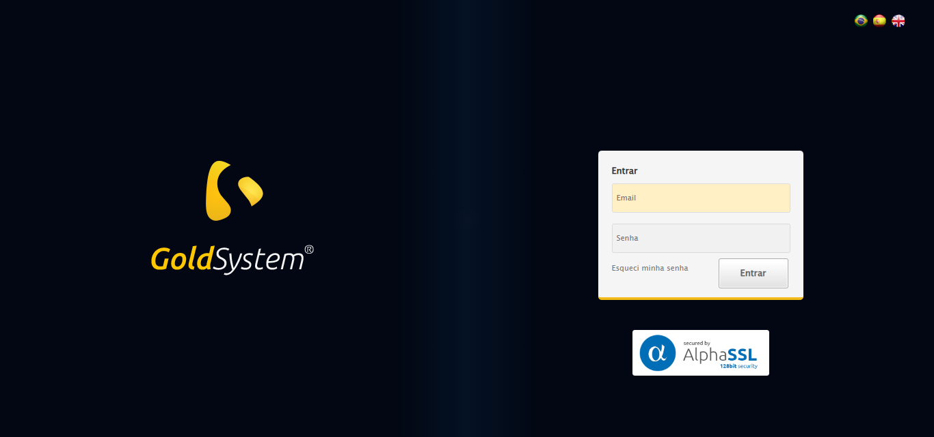

🔄 Realizando login...

✅ Realizando login realizada com sucesso.

Screenshot: realizando login

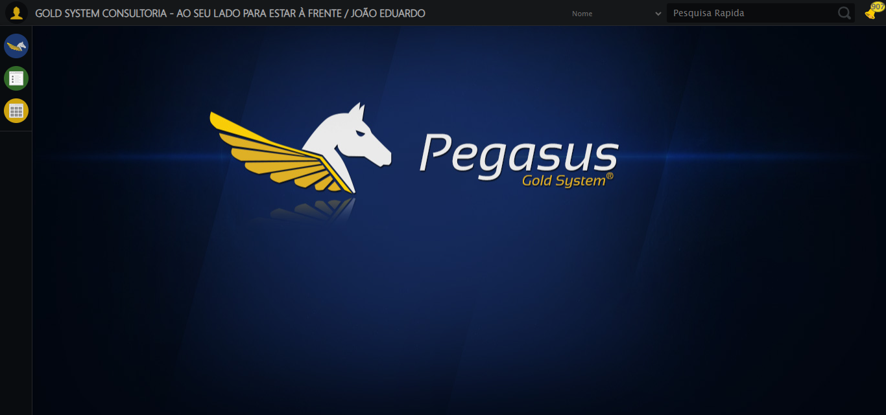

🔄 Ajustando zoom e abrindo menu...

🔍 Zoom ajustado para 90%.

✅ Ajustando zoom e abrindo menu realizada com sucesso.

Screenshot: ajustando zoom e abrindo menu

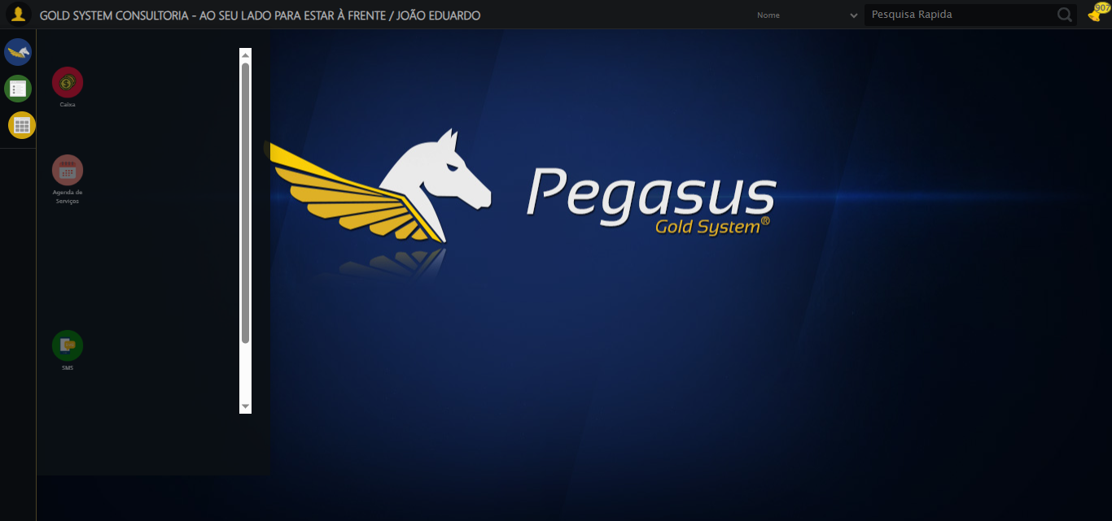

🔄 Acessando CRM...

✅ Acessando CRM realizada com sucesso.

Screenshot: acessando crm

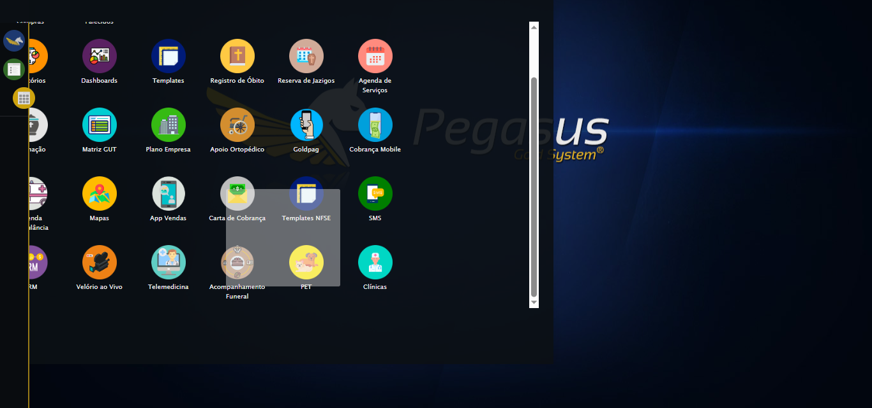

🔄 Clicando em Funil de Vendas/Pipeline...

✅ Clicando em Funil de Vendas/Pipeline realizada com sucesso.

Screenshot: clicando em funil de vendas_pipeline

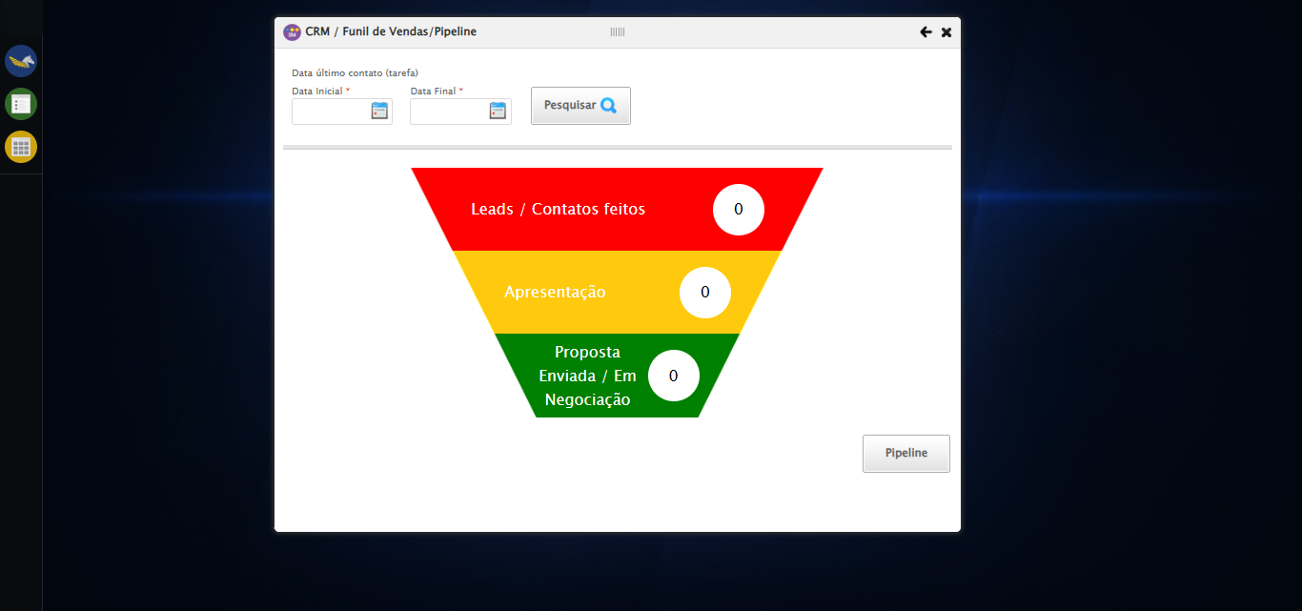

🔄 Preenchendo Data Início...

⚠️ Tentativa 1 falhou: ('Connection aborted.', ConnectionResetError(10054, 'Foi forçado o cancelamento de uma conexão existente pelo host remoto', None, 10054, None))

⚠️ Tentativa 2 falhou: HTTPConnectionPool(host='localhost', port=60145): Max retries exceeded with url: /session/06c9ee9ba7794746b409809b984dca10/element (Caused by NewConnectionError('<urllib3.connection.HTTPConnection object at 0x000002451A6A5E00>: Failed to establish a new connection: [WinError 10061] Nenhuma conexão pôde ser feita porque a máquina de destino as recusou ativamente'))

⚠️ Tentativa 3 falhou: HTTPConnectionPool(host='localhost', port=60145): Max retries exceeded with url: /session/06c9ee9ba7794746b409809b984dca10/element (Caused by NewConnectionError('<urllib3.connection.HTTPConnection object at 0x000002451AA718C0>: Failed to establish a new connection: [WinError 10061] Nenhuma conexão pôde ser feita porque a máquina de destino as recusou ativamente'))

✅ Preenchendo Data Início realizada com sucesso.

⚠️ Erro ao tirar screenshot preenchendo data início: HTTPConnectionPool(host='localhost', port=60145): Max retries exceeded with url: /session/06c9ee9ba7794746b409809b984dca10/screenshot (Caused by NewConnectionError('<urllib3.connection.HTTPConnection object at 0x000002451AA727A0>: Failed to establish a new connection: [WinError 10061] Nenhuma conexão pôde ser feita porque a máquina de destino as recusou ativamente'))

🔄 Preenchendo Data Fim...

⚠️ Tentativa 1 falhou: HTTPConnectionPool(host='localhost', port=60145): Max retries exceeded with url: /session/06c9ee9ba7794746b409809b984dca10/element (Caused by NewConnectionError('<urllib3.connection.HTTPConnection object at 0x000002451AA73570>: Failed to establish a new connection: [WinError 10061] Nenhuma conexão pôde ser feita porque a máquina de destino as recusou ativamente'))

⚠️ Tentativa 2 falhou: HTTPConnectionPool(host='localhost', port=60145): Max retries exceeded with url: /session/06c9ee9ba7794746b409809b984dca10/element (Caused by NewConnectionError('<urllib3.connection.HTTPConnection object at 0x000002451AA98490>: Failed to establish a new connection: [WinError 10061] Nenhuma conexão pôde ser feita porque a máquina de destino as recusou ativamente'))

⚠️ Tentativa 3 falhou: HTTPConnectionPool(host='localhost', port=60145): Max retries exceeded with url: /session/06c9ee9ba7794746b409809b984dca10/element (Caused by NewConnectionError('<urllib3.connection.HTTPConnection object at 0x000002451AA99370>: Failed to establish a new connection: [WinError 10061] Nenhuma conexão pôde ser feita porque a máquina de destino as recusou ativamente'))

✅ Preenchendo Data Fim realizada com sucesso.

⚠️ Erro ao tirar screenshot preenchendo data fim: HTTPConnectionPool(host='localhost', port=60145): Max retries exceeded with url: /session/06c9ee9ba7794746b409809b984dca10/screenshot (Caused by NewConnectionError('<urllib3.connection.HTTPConnection object at 0x000002451AA73DF0>: Failed to establish a new connection: [WinError 10061] Nenhuma conexão pôde ser feita porque a máquina de destino as recusou ativamente'))

🔄 Clicando no botão de pesquisa...

❌ Erro ao clicar robusto: HTTPConnectionPool(host='localhost', port=60145): Max retries exceeded with url: /session/06c9ee9ba7794746b409809b984dca10/element (Caused by NewConnectionError('<urllib3.connection.HTTPConnection object at 0x000002451AA72F10>: Failed to establish a new connection: [WinError 10061] Nenhuma conexão pôde ser feita porque a máquina de destino as recusou ativamente'))

✅ Clicando no botão de pesquisa realizada com sucesso.

⚠️ Erro ao tirar screenshot clicando no botão de pesquisa: HTTPConnectionPool(host='localhost', port=60145): Max retries exceeded with url: /session/06c9ee9ba7794746b409809b984dca10/screenshot (Caused by NewConnectionError('<urllib3.connection.HTTPConnection object at 0x000002451AA72360>: Failed to establish a new connection: [WinError 10061] Nenhuma conexão pôde ser feita porque a máquina de destino as recusou ativamente'))

🔄 Screenshot do Funil de Vendas/Pipeline...

⚠️ Erro ao tirar screenshot screenshot_funil_vendas: HTTPConnectionPool(host='localhost', port=60145): Max retries exceeded with url: /session/06c9ee9ba7794746b409809b984dca10/screenshot (Caused by NewConnectionError('<urllib3.connection.HTTPConnection object at 0x000002451AA71260>: Failed to establish a new connection: [WinError 10061] Nenhuma conexão pôde ser feita porque a máquina de destino as recusou ativamente'))

✅ Screenshot do Funil de Vendas/Pipeline realizada com sucesso.

⚠️ Erro ao tirar screenshot screenshot do funil de vendas_pipeline: HTTPConnectionPool(host='localhost', port=60145): Max retries exceeded with url: /session/06c9ee9ba7794746b409809b984dca10/screenshot (Caused by NewConnectionError('<urllib3.connection.HTTPConnection object at 0x000002451AA706B0>: Failed to establish a new connection: [WinError 10061] Nenhuma conexão pôde ser feita porque a máquina de destino as recusou ativamente'))

🔄 Fechando modal após a Consulta...

❌ Erro ao clicar robusto: HTTPConnectionPool(host='localhost', port=60145): Max retries exceeded with url: /session/06c9ee9ba7794746b409809b984dca10/element (Caused by NewConnectionError('<urllib3.connection.HTTPConnection object at 0x000002451AA99150>: Failed to establish a new connection: [WinError 10061] Nenhuma conexão pôde ser feita porque a máquina de destino as recusou ativamente'))

✅ Fechando modal após a Consulta realizada com sucesso.

⚠️ Erro ao tirar screenshot fechando modal após a consulta: HTTPConnectionPool(host='localhost', port=60145): Max retries exceeded with url: /session/06c9ee9ba7794746b409809b984dca10/screenshot (Caused by NewConnectionError('<urllib3.connection.HTTPConnection object at 0x000002451AA98270>: Failed to establish a new connection: [WinError 10061] Nenhuma conexão pôde ser feita porque a máquina de destino as recusou ativamente'))

⚠️ Erro ao capturar Leads/Contatos: HTTPConnectionPool(host='localhost', port=60145): Max retries exceeded with url: /session/06c9ee9ba7794746b409809b984dca10/element (Caused by NewConnectionError('<urllib3.connection.HTTPConnection object at 0x000002451AA9AE00>: Failed to establish a new connection: [WinError 10061] Nenhuma conexão pôde ser feita porque a máquina de destino as recusou ativamente'))

⚠️ Erro ao capturar Apresentação: HTTPConnectionPool(host='localhost', port=60145): Max retries exceeded with url: /session/06c9ee9ba7794746b409809b984dca10/element (Caused by NewConnectionError('<urllib3.connection.HTTPConnection object at 0x000002451AAC89E0>: Failed to establish a new connection: [WinError 10061] Nenhuma conexão pôde ser feita porque a máquina de destino as recusou ativamente'))

⚠️ Erro ao capturar Proposta enviada: HTTPConnectionPool(host='localhost', port=60145): Max retries exceeded with url: /session/06c9ee9ba7794746b409809b984dca10/element (Caused by NewConnectionError('<urllib3.connection.HTTPConnection object at 0x000002451AA9BAC0>: Failed to establish a new connection: [WinError 10061] Nenhuma conexão pôde ser feita porque a máquina de destino as recusou ativamente'))

# Informações do Funil de Vendas Pipeline:

Leads/Contatos feitos: N/A

Apresentação: N/A

Proposta enviada: N/A

🔍 Verificando mensagens de alerta...

ℹ️ Nenhuma mensagem de alerta encontrada.

✅ Teste concluído.

✅ Teste executado com sucesso!