RELATÓRIO DO TESTE

Controle de Caixa - Caixa – Cenário 1: Rotina parcial de Fluxo de Caixa

Data do teste: 28/10/2025 15:26:29

🚀 Iniciando teste de Fluxo de Caixa

======================================================================

✅ Driver inicializado com sucesso

🔄 Acessando sistema...

✅ Acessando sistema realizada com sucesso.

Screenshot: acessando sistema



🔄 Realizando login...

✅ Realizando login realizada com sucesso.

Screenshot: realizando login



🔄 Abrindo menu (F3)...

✅ Abrindo menu (F3) realizada com sucesso.

Screenshot: abrindo menu (f3)



🔄 Acessando Caixa...

🎯 Clique forçado em: /html/body/div[15]/ul/li[8]/img

✅ Clique bem-sucedido (estratégia 1)

✅ Acessando Caixa realizada com sucesso.

Screenshot: acessando caixa

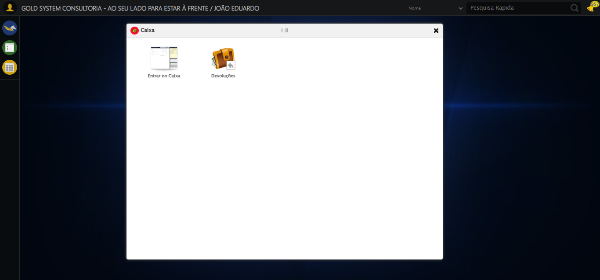

🔄 Clicando em 'Entrar no Caixa'...

🎯 Clique forçado em: #gsCaixa > div.wdTelas > div.telaInicial.clearfix.overflow.overflowY > ul > li:nth-child(1) > a > span

✅ Clique bem-sucedido (estratégia 1)

✅ Clicando em 'Entrar no Caixa' realizada com sucesso.

Screenshot: clicando em _entrar no caixa_

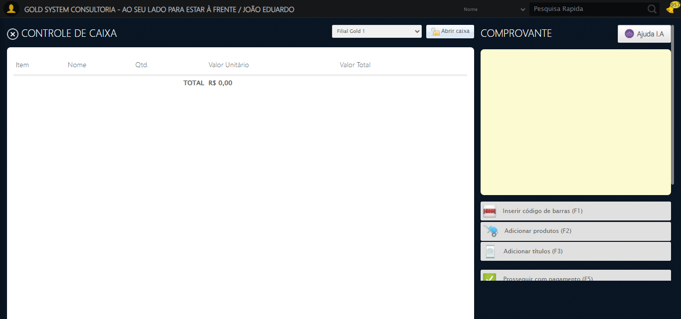

🔄 Verificando e abrindo caixa...

🔍 Verificando estado do caixa...

📦 Caixa fechado — iniciando abertura normal...

🔄 Clicando em 'Abrir Caixa'...

🎯 Clique forçado em: //a[contains(@class,'btAzulDegrade') and contains(@class,'btAbrirCaixa')]

✅ Clique bem-sucedido (estratégia 1)

✅ Clicando em 'Abrir Caixa' realizada com sucesso.

Screenshot: clicando em _abrir caixa_

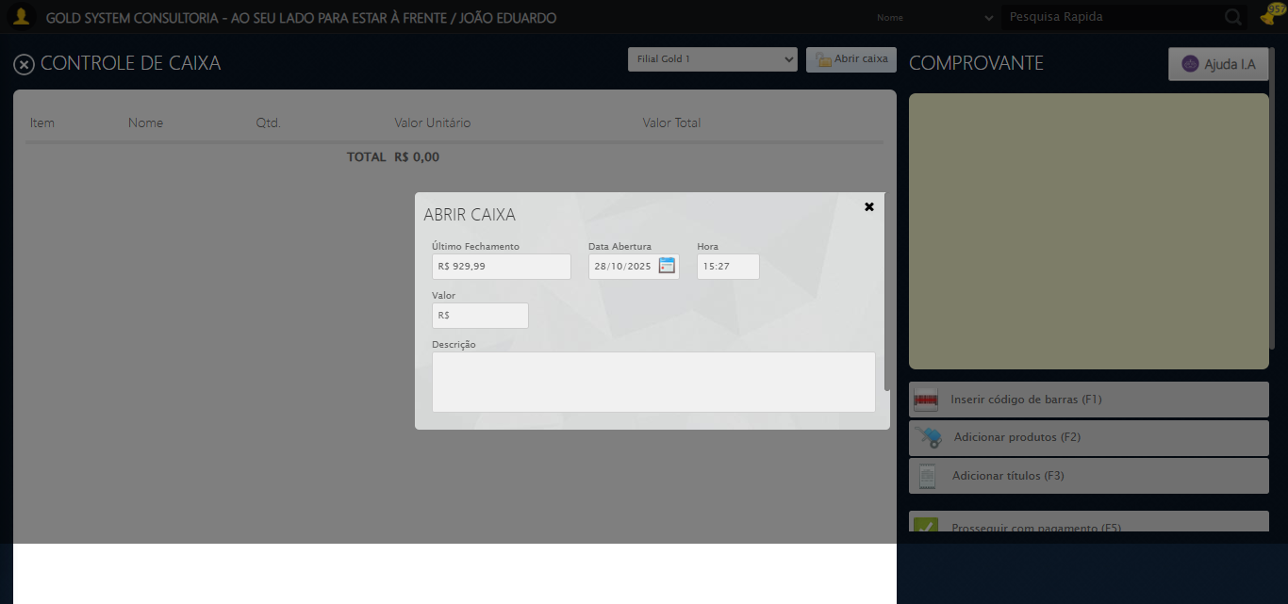

🔄 Preenchendo Valor Inicial...

✏️ Preenchimento forçado: //input[@type='text' and contains(@class,'valor') and contains(@placeholder,'R$')] = '1000,00'

✅ Campo preenchido (estratégia 1)

✅ Preenchendo Valor Inicial realizada com sucesso.

Screenshot: preenchendo valor inicial

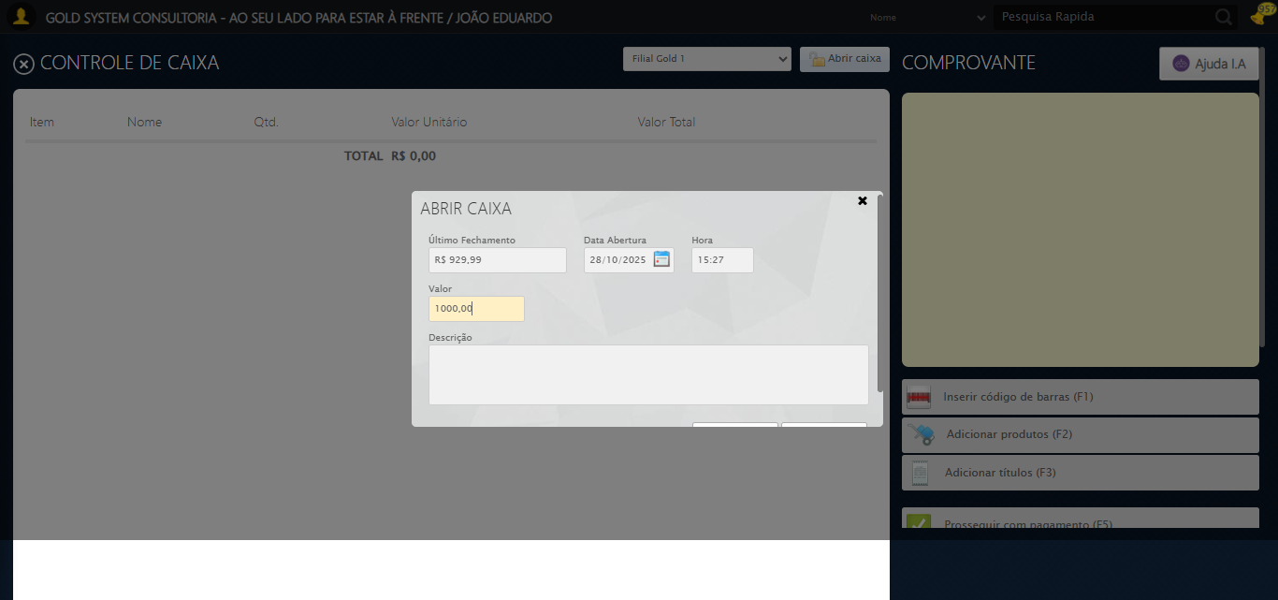

🔄 Preenchendo Descrição...

🎯 Tentativa 1: Preenchendo textarea 0 (ID: (sem id))

▶️ Estratégia 1…

✅ Preenchido com sucesso pela estratégia 1

✅ Preenchendo Descrição realizada com sucesso.

Screenshot: preenchendo descrição

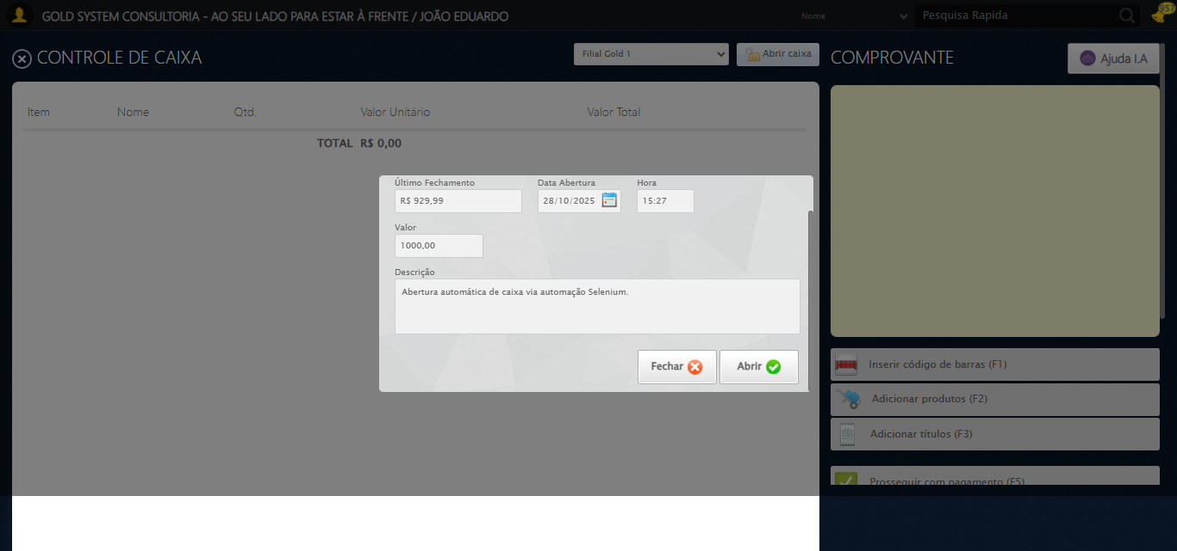

🔄 Confirmando Abertura...

🎯 Clique forçado em: //a[@class='btModel btGray btyes' and normalize-space()='Abrir']

✅ Clique bem-sucedido (estratégia 1)

✅ Confirmando Abertura realizada com sucesso.

Screenshot: confirmando abertura

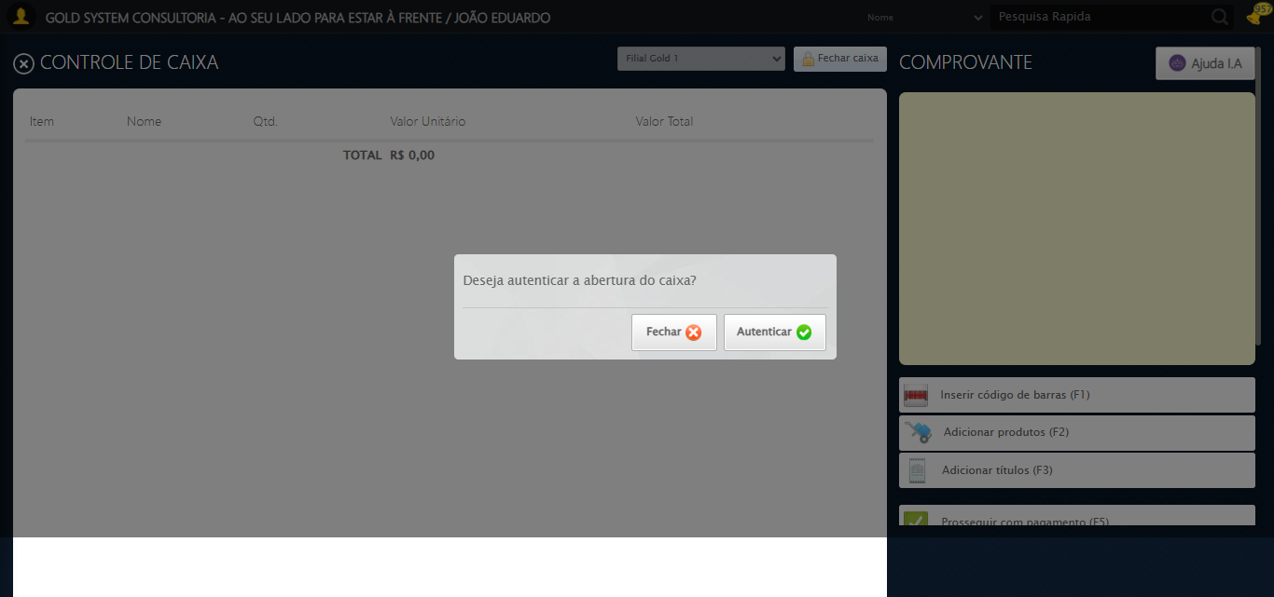

ℹ️ Nenhuma mensagem de alerta encontrada.

🔄 Autenticando Abertura...

🎯 Clique forçado em: //a[@class='btModel btGray btyes' and @id='BtYes' and normalize-space()='Autenticar' and span[@class='sprites sp-salvar']]

✅ Clique bem-sucedido (estratégia 1)

Timeout JavaScript (5s)

Tentativa 2/3

Timeout JavaScript (5s)

Tentativa 3/3

Timeout JavaScript (5s)

Usando valor fallback: True

✅ Autenticando Abertura realizada com sucesso.

Screenshot: autenticando abertura

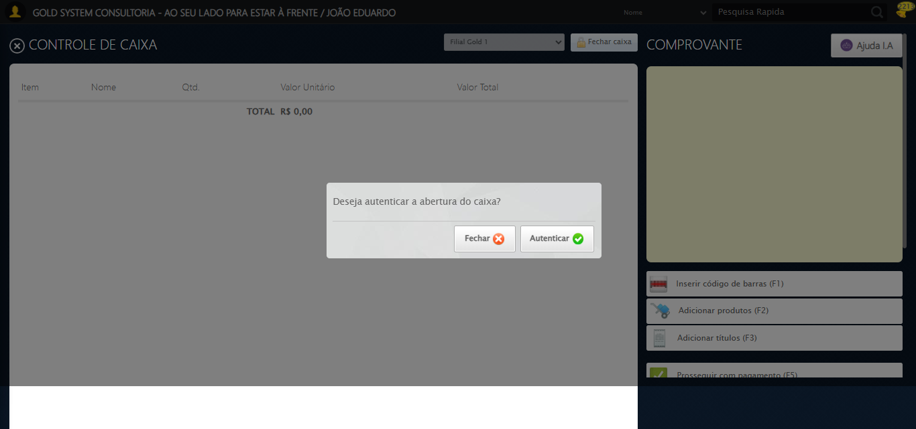

🔄 Fechando abas extras (impressão)...

🗑️ Aba extra fechada (1)

⚠️ Erro ao fechar aba: Message: no such window: target window already closed  
from unknown error: web view not found  
 (Session info: chrome=141.0.7390.123)  
Stacktrace:  
 GetHandleVerifier [0x0x74fe43+66515]  
 GetHandleVerifier [0x0x74fe84+66580]  
 (No symbol) [0x0x53dc48]  
 (No symbol) [0x0x51c18d]  
 (No symbol) [0x0x5b1a4e]  
 (No symbol) [0x0x5b98a9]  
 (No symbol) [0x0x5ab193]  
 (No symbol) [0x0x57c2ca]  
 (No symbol) [0x0x57d154]  
 GetHandleVerifier [0x0x9a7353+2521315]  
 GetHandleVerifier [0x0x9a22d3+2500707]  
 GetHandleVerifier [0x0x777c94+229924]  
 GetHandleVerifier [0x0x7681f8+165768]  
 GetHandleVerifier [0x0x76ecad+193085]  
 GetHandleVerifier [0x0x758158+100072]  
 GetHandleVerifier [0x0x7582f0+100480]  
 GetHandleVerifier [0x0x7425aa+11066]  
 BaseThreadInitThunk [0x0x774dfcc9+25]  
 RtlGetAppContainerNamedObjectPath [0x0x776282ae+286]  
 RtlGetAppContainerNamedObjectPath [0x0x7762827e+238]

✅ 1 aba(s) extra(s) fechada(s). Foco na aba principal.

✅ Fechando abas extras (impressão) realizada com sucesso.

Screenshot: fechando abas extras (impressão)



ℹ️ Nenhuma mensagem de alerta encontrada.

✅ Nenhum alerta detectado após fechar abas extras.

🔄 Fechando modal autenticação...

🎯 Clique forçado em: //a[@id='BtNo' and @class='btModel btGray btno' and normalize-space()='Fechar']

✅ Clique bem-sucedido (estratégia 1)

✅ Fechando modal autenticação realizada com sucesso.

Screenshot: fechando modal autenticação

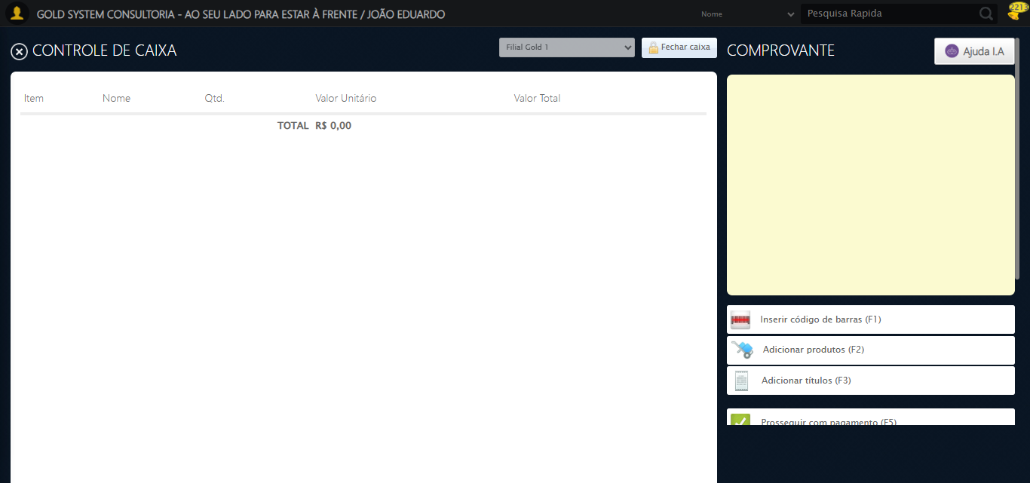

✅ Verificando e abrindo caixa realizada com sucesso.

Screenshot: verificando e abrindo caixa



🔄 Clicando em 'Adicionar Produtos'...

🎯 Clique forçado em: (//a[@class='btAddProd' and contains(normalize-space(.), 'Adicionar produtos')])[1]

✅ Clique bem-sucedido (estratégia 1)

✅ Clicando em 'Adicionar Produtos' realizada com sucesso.

Screenshot: clicando em _adicionar produtos_

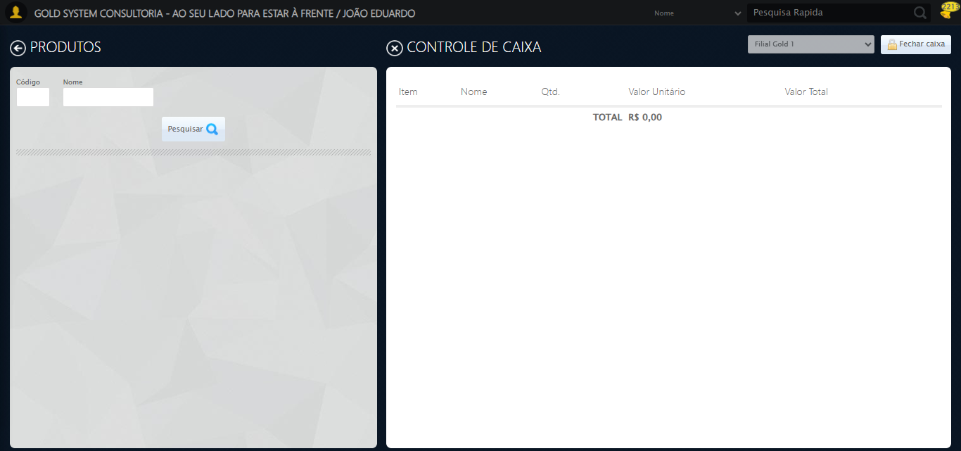

🔄 Preenchendo Nome do Produto...

✏️ Preenchimento forçado: //input[@class='nomeProd'] = 'PRUDUTO'

✅ Campo preenchido (estratégia 1)

✅ Preenchendo Nome do Produto realizada com sucesso.

Screenshot: preenchendo nome do produto

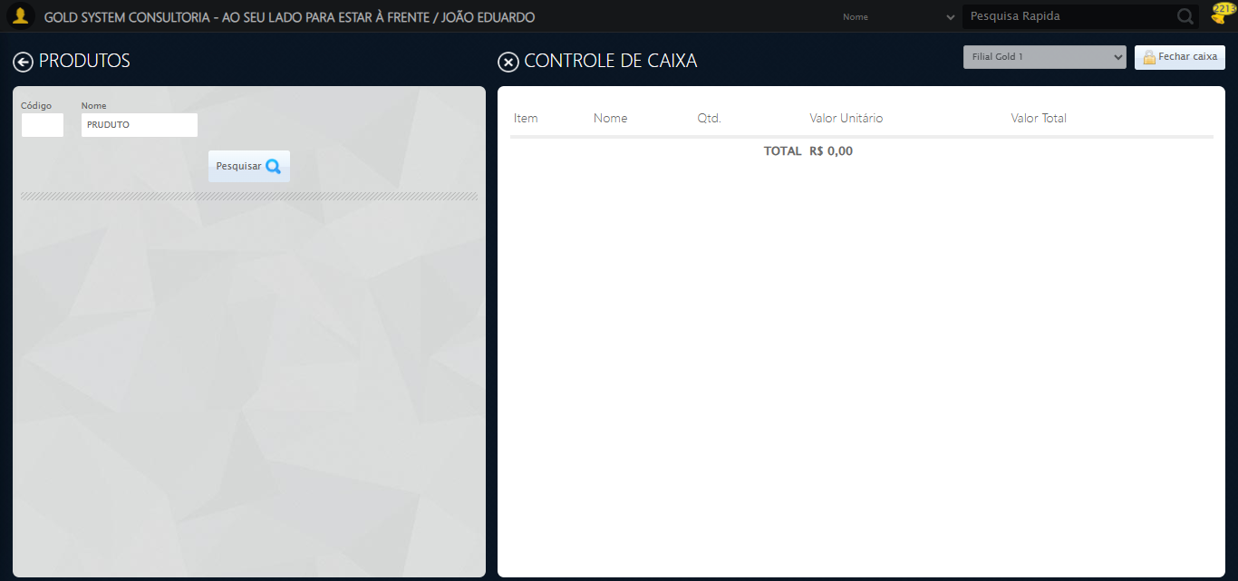

🔄 Clicando em Pesquisar...

🔍 Foram encontrados 6 botão(ões) 'Pesquisar' na tela.

🎯 Clicando no botão 'Pesquisar' (índice 2)...

🎯 Clique forçado em: (//a[contains(@class,'btPesquisar') and contains(normalize-space(.),'Pesquisar')])[2]

✅ Clique bem-sucedido (estratégia 1)

✅ Clique no botão 'Pesquisar' (índice 2) realizado com sucesso.

✅ Clicando em Pesquisar realizada com sucesso.

Screenshot: clicando em pesquisar

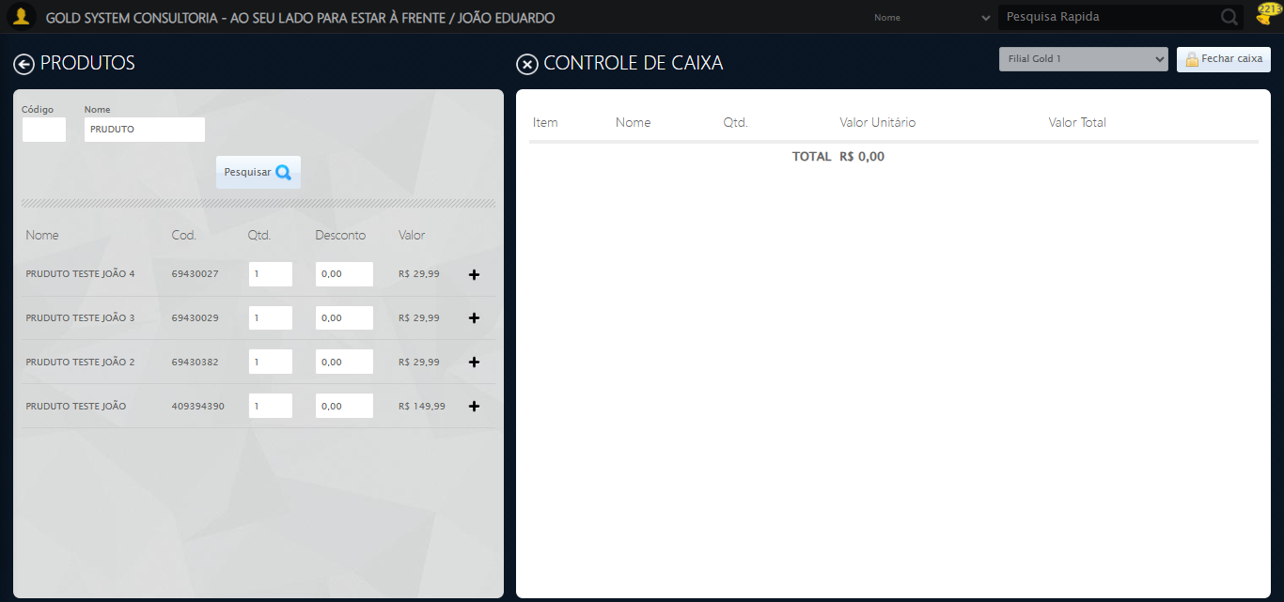

🔄 Adicionando primeiro produto...

🧩 Procurando o botão 'sp-add'...

🎯 Botão encontrado! Tentando clicar...

✅ Clique padrão realizado com sucesso.

✅ Adicionando primeiro produto realizada com sucesso.

Screenshot: adicionando primeiro produto

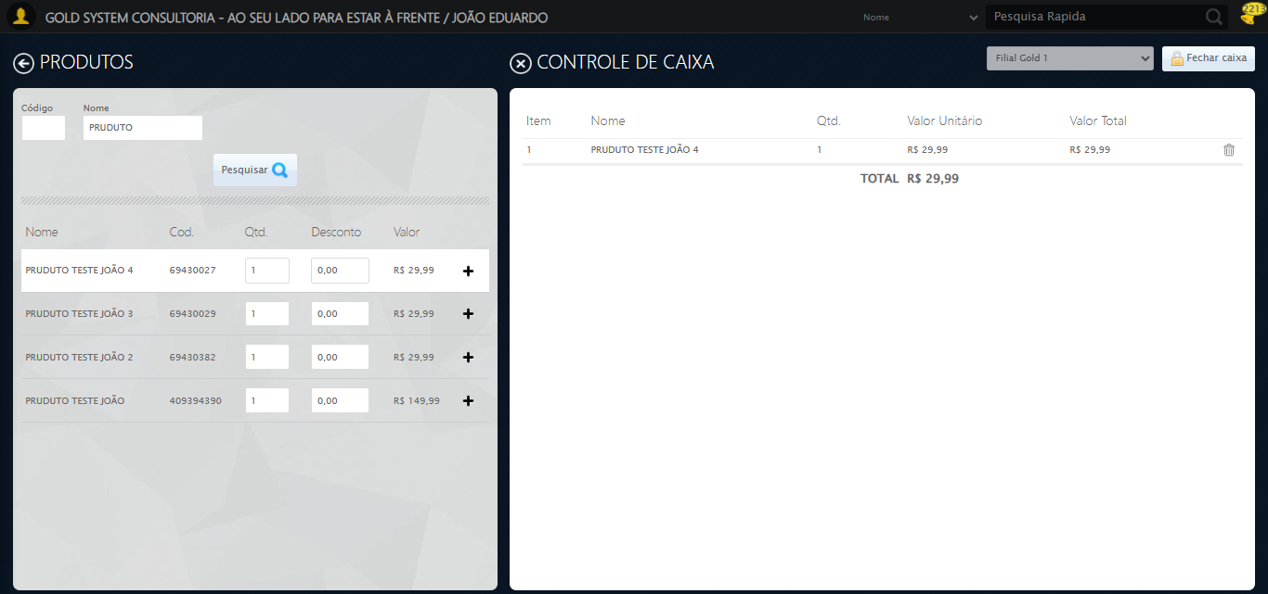

🔄 Retornando à aba principal...

↩️ Clicando no botão 'Voltar (ESC)' (índice 1)...

🎯 Clique forçado em: (//a[@class='sprites sp-voltarGrande' and @title='Voltar (ESC)'])[1]

✅ Clique bem-sucedido (estratégia 1)

✅ Clique no botão 'Voltar (ESC)' (índice 1) realizado com sucesso.

✅ Retornando à aba principal realizada com sucesso.

Screenshot: retornando à aba principal

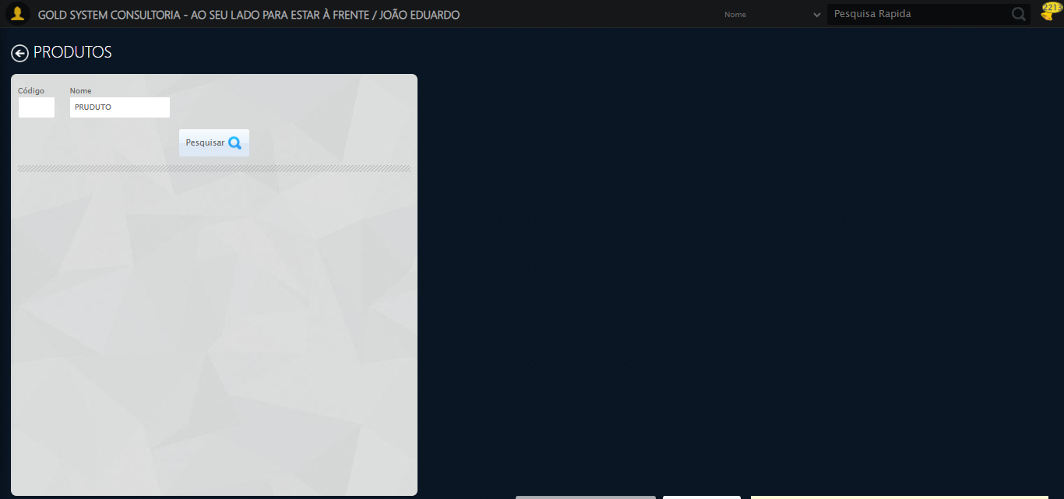

🔄 Clicando em 'Adicionar Títulos'...

🎯 Clique forçado em: (//a[@class='btAddTit' and contains(normalize-space(.), 'Adicionar títulos')])[1]

✅ Clique bem-sucedido (estratégia 1)

✅ Clicando em 'Adicionar Títulos' realizada com sucesso.

Screenshot: clicando em _adicionar títulos_

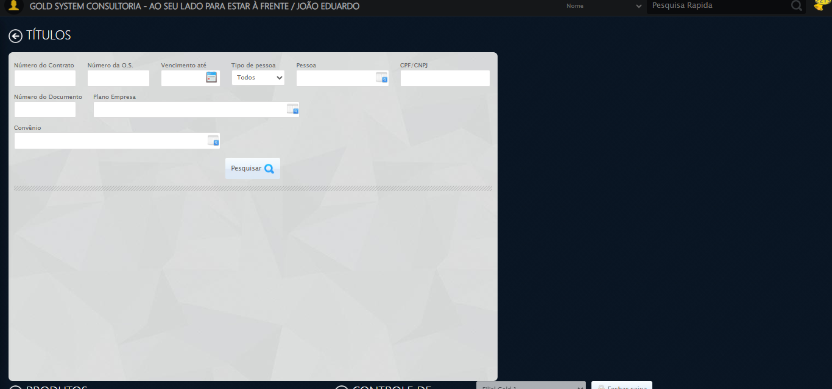

🔄 Selecionando Pessoa...

🔍 Processando LOV: 'JOÃO EDUARDO JUSTINO PASCHOAL' → 'JOÃO EDUARDO JUSTINO PASCHOAL'

📌 Abrindo LOV...

🎯 Clique forçado em: (//a[@class='sprites sp-openLov'])[1]

✅ Clique bem-sucedido (estratégia 1)

✏️ Pesquisando: 'JOÃO EDUARDO JUSTINO PASCHOAL'

✏️ Preenchimento forçado: //input[@id='txtPesquisa'] = 'JOÃO EDUARDO JUSTINO PASCHOAL'

✅ Campo preenchido (estratégia 1)

🔎 Executando pesquisa...

🎯 Clique forçado em: //a[contains(@class,'lpFind') and contains(normalize-space(.),'Pesquisar')]

✅ Clique bem-sucedido (estratégia 1)

🎯 Selecionando: 'JOÃO EDUARDO JUSTINO PASCHOAL'

🎯 Clique forçado em: //tr[td[contains(normalize-space(.), 'JOÃO EDUARDO JUSTINO PASCHOAL')]]

✅ Clique bem-sucedido (estratégia 1)

✅ LOV processado com sucesso!

✅ Selecionando Pessoa realizada com sucesso.

Screenshot: selecionando pessoa

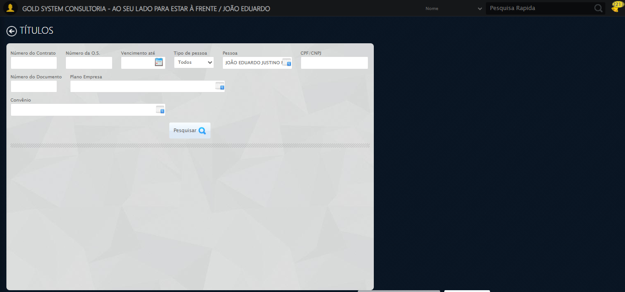

🔄 Clicando em Pesquisar...

🔍 Foram encontrados 6 botão(ões) 'Pesquisar' na tela.

🎯 Clicando no botão 'Pesquisar' (índice 5)...

🎯 Clique forçado em: (//a[contains(@class,'btPesquisar') and contains(normalize-space(.),'Pesquisar')])[5]

✅ Clique bem-sucedido (estratégia 1)

✅ Clique no botão 'Pesquisar' (índice 5) realizado com sucesso.

✅ Clicando em Pesquisar realizada com sucesso.

🔄 Adicionando primeiro título...

🧩 Procurando o botão 'sp-add'...

❌ Erro ao clicar no botão 'sp-add': Message: invalid session id: session deleted as the browser has closed the connection  
from disconnected: not connected to DevTools  
 (Session info: chrome=141.0.7390.123); For documentation on this error, please visit: https://www.selenium.dev/documentation/webdriver/troubleshooting/errors#invalidsessionidexception  
Stacktrace:  
 GetHandleVerifier [0x0x74fe43+66515]  
 GetHandleVerifier [0x0x74fe84+66580]  
 (No symbol) [0x0x53dc48]  
 (No symbol) [0x0x52ce80]  
 (No symbol) [0x0x54b81b]  
 (No symbol) [0x0x5b1c25]  
 (No symbol) [0x0x5cc4d9]  
 (No symbol) [0x0x5aafc6]  
 (No symbol) [0x0x57c2ca]  
 (No symbol) [0x0x57d154]  
 GetHandleVerifier [0x0x9a7353+2521315]  
 GetHandleVerifier [0x0x9a22d3+2500707]  
 GetHandleVerifier [0x0x777c94+229924]  
 GetHandleVerifier [0x0x7681f8+165768]  
 GetHandleVerifier [0x0x76ecad+193085]  
 GetHandleVerifier [0x0x758158+100072]  
 GetHandleVerifier [0x0x7582f0+100480]  
 GetHandleVerifier [0x0x7425aa+11066]  
 BaseThreadInitThunk [0x0x774dfcc9+25]  
 RtlGetAppContainerNamedObjectPath [0x0x776282ae+286]  
 RtlGetAppContainerNamedObjectPath [0x0x7762827e+238]

✅ Adicionando primeiro título realizada com sucesso.

⚠️ Erro ao tirar screenshot adicionando primeiro título: Message: invalid session id; For documentation on this error, please visit: https://www.selenium.dev/documentation/webdriver/troubleshooting/errors#invalidsessionidexception  
Stacktrace:  
 GetHandleVerifier [0x0x74fe43+66515]  
 GetHandleVerifier [0x0x74fe84+66580]  
 (No symbol) [0x0x53da6b]  
 (No symbol) [0x0x57b5ab]  
 (No symbol) [0x0x5ab086]  
 (No symbol) [0x0x5a667c]  
 (No symbol) [0x0x5a5bf3]  
 (No symbol) [0x0x50e72d]  
 (No symbol) [0x0x50ecae]  
 (No symbol) [0x0x50f14d]  
 GetHandleVerifier [0x0x9a7353+2521315]  
 GetHandleVerifier [0x0x9a22d3+2500707]  
 GetHandleVerifier [0x0x777c94+229924]  
 GetHandleVerifier [0x0x7681f8+165768]  
 GetHandleVerifier [0x0x76ecad+193085]  
 (No symbol) [0x0x50e3e3]  
 (No symbol) [0x0x50db60]  
 GetHandleVerifier [0x0xaec20f+3852191]  
 BaseThreadInitThunk [0x0x774dfcc9+25]  
 RtlGetAppContainerNamedObjectPath [0x0x776282ae+286]  
 RtlGetAppContainerNamedObjectPath [0x0x7762827e+238]

🔄 Retornando à aba principal...

↩️ Clicando no botão 'Voltar (ESC)' (índice 2)...

🎯 Clique forçado em: (//a[@class='sprites sp-voltarGrande' and @title='Voltar (ESC)'])[2]

Tentativa 1.2...

Estratégia 2 falhou: Message: invalid session id; For documentation on this error, please visit: http

Tentativa 1.3...

Estratégia 3 falhou: Message: invalid session id; For documentation on this error, please visit: http

Tentativa 1.4...

Estratégia 4 falhou: Message: invalid session id; For documentation on this error, please visit: http

Tentativa 1.5...

Estratégia 5 falhou: Message: invalid session id; For documentation on this error, please visit: http

Tentativa 2.1...

Estratégia 1 falhou: Message: invalid session id; For documentation on this error, please visit: http

Tentativa 2.2...

Estratégia 2 falhou: Message: invalid session id; For documentation on this error, please visit: http

Tentativa 2.3...

Estratégia 3 falhou: Message: invalid session id; For documentation on this error, please visit: http

Tentativa 2.4...

Estratégia 4 falhou: Message: invalid session id; For documentation on this error, please visit: http

Tentativa 2.5...

Estratégia 5 falhou: Message: invalid session id; For documentation on this error, please visit: http

Tentativa 3.1...

Estratégia 1 falhou: Message: invalid session id; For documentation on this error, please visit: http

Tentativa 3.2...

Estratégia 2 falhou: Message: invalid session id; For documentation on this error, please visit: http

Tentativa 3.3...

Estratégia 3 falhou: Message: invalid session id; For documentation on this error, please visit: http

Tentativa 3.4...

Estratégia 4 falhou: Message: invalid session id; For documentation on this error, please visit: http

Tentativa 3.5...

Estratégia 5 falhou: Message: invalid session id; For documentation on this error, please visit: http

Tentativa 4.1...

Estratégia 1 falhou: Message: invalid session id; For documentation on this error, please visit: http

Tentativa 4.2...

Estratégia 2 falhou: Message: invalid session id; For documentation on this error, please visit: http

Tentativa 4.3...

Estratégia 3 falhou: Message: invalid session id; For documentation on this error, please visit: http

Tentativa 4.4...

Estratégia 4 falhou: Message: invalid session id; For documentation on this error, please visit: http

Tentativa 4.5...

Estratégia 5 falhou: Message: invalid session id; For documentation on this error, please visit: http

Tentativa 5.1...

Estratégia 1 falhou: Message: invalid session id; For documentation on this error, please visit: http

Tentativa 5.2...

Estratégia 2 falhou: Message: invalid session id; For documentation on this error, please visit: http

Tentativa 5.3...

Estratégia 3 falhou: Message: invalid session id; For documentation on this error, please visit: http

Tentativa 5.4...

Estratégia 4 falhou: Message: invalid session id; For documentation on this error, please visit: http

Tentativa 5.5...

Estratégia 5 falhou: Message: invalid session id; For documentation on this error, please visit: http

⚠️ Falha ao clicar no botão 'Voltar (ESC)' (índice 2): Falha ao clicar após 5 tentativas: (//a[@class='sprites sp-voltarGrande' and @title='Voltar (ESC)'])[2]

✅ Retornando à aba principal realizada com sucesso.

🔄 Prosseguindo com o Pagamento...

🎯 Clique forçado em: //a[@class='btVenda' and normalize-space()='Prosseguir com pagamento (F5)']

Tentativa 1.2...

Estratégia 2 falhou: Message: invalid session id; For documentation on this error, please visit: http

Tentativa 1.3...

Estratégia 3 falhou: Message: invalid session id; For documentation on this error, please visit: http

Tentativa 1.4...

Estratégia 4 falhou: Message: invalid session id; For documentation on this error, please visit: http

Tentativa 1.5...

Estratégia 5 falhou: Message: invalid session id; For documentation on this error, please visit: http

Tentativa 2.1...

Estratégia 1 falhou: Message: invalid session id; For documentation on this error, please visit: http

Tentativa 2.2...

Estratégia 2 falhou: Message: invalid session id; For documentation on this error, please visit: http

Tentativa 2.3...

Estratégia 3 falhou: Message: invalid session id; For documentation on this error, please visit: http

Tentativa 2.4...

Estratégia 4 falhou: Message: invalid session id; For documentation on this error, please visit: http

Tentativa 2.5...

Estratégia 5 falhou: Message: invalid session id; For documentation on this error, please visit: http

Tentativa 3.1...

Estratégia 1 falhou: Message: invalid session id; For documentation on this error, please visit: http

Tentativa 3.2...

Estratégia 2 falhou: Message: invalid session id; For documentation on this error, please visit: http

Tentativa 3.3...

Estratégia 3 falhou: Message: invalid session id; For documentation on this error, please visit: http

Tentativa 3.4...

Estratégia 4 falhou: Message: invalid session id; For documentation on this error, please visit: http

Tentativa 3.5...

Estratégia 5 falhou: Message: invalid session id; For documentation on this error, please visit: http

Tentativa 4.1...

Estratégia 1 falhou: Message: invalid session id; For documentation on this error, please visit: http

Tentativa 4.2...

Estratégia 2 falhou: Message: invalid session id; For documentation on this error, please visit: http

Tentativa 4.3...

Estratégia 3 falhou: Message: invalid session id; For documentation on this error, please visit: http

Tentativa 4.4...

Estratégia 4 falhou: Message: invalid session id; For documentation on this error, please visit: http

Tentativa 4.5...

Estratégia 5 falhou: Message: invalid session id; For documentation on this error, please visit: http

Tentativa 5.1...

Estratégia 1 falhou: Message: invalid session id; For documentation on this error, please visit: http

Tentativa 5.2...

Estratégia 2 falhou: Message: invalid session id; For documentation on this error, please visit: http

Tentativa 5.3...

Estratégia 3 falhou: Message: invalid session id; For documentation on this error, please visit: http

Tentativa 5.4...

Estratégia 4 falhou: Message: invalid session id; For documentation on this error, please visit: http

Tentativa 5.5...

Estratégia 5 falhou: Message: invalid session id; For documentation on this error, please visit: http

⚠️ Tentativa 1 falhou, tentando novamente...

🔄 Prosseguindo com o Pagamento... (Tentativa 2)

🎯 Clique forçado em: //a[@class='btVenda' and normalize-space()='Prosseguir com pagamento (F5)']

Tentativa 1.2...

Estratégia 2 falhou: Message: invalid session id; For documentation on this error, please visit: http

Tentativa 1.3...

Estratégia 3 falhou: Message: invalid session id; For documentation on this error, please visit: http

Tentativa 1.4...

Estratégia 4 falhou: Message: invalid session id; For documentation on this error, please visit: http

Tentativa 1.5...

Estratégia 5 falhou: Message: invalid session id; For documentation on this error, please visit: http

Tentativa 2.1...

Estratégia 1 falhou: Message: invalid session id; For documentation on this error, please visit: http

Tentativa 2.2...

Estratégia 2 falhou: Message: invalid session id; For documentation on this error, please visit: http

Tentativa 2.3...

Estratégia 3 falhou: Message: invalid session id; For documentation on this error, please visit: http

Tentativa 2.4...

Estratégia 4 falhou: Message: invalid session id; For documentation on this error, please visit: http

Tentativa 2.5...

Estratégia 5 falhou: Message: invalid session id; For documentation on this error, please visit: http

Tentativa 3.1...

Estratégia 1 falhou: Message: invalid session id; For documentation on this error, please visit: http

Tentativa 3.2...

Estratégia 2 falhou: Message: invalid session id; For documentation on this error, please visit: http

Tentativa 3.3...

Estratégia 3 falhou: Message: invalid session id; For documentation on this error, please visit: http

Tentativa 3.4...

Estratégia 4 falhou: Message: invalid session id; For documentation on this error, please visit: http

Tentativa 3.5...

Estratégia 5 falhou: Message: invalid session id; For documentation on this error, please visit: http

Tentativa 4.1...

Estratégia 1 falhou: Message: invalid session id; For documentation on this error, please visit: http

Tentativa 4.2...

Estratégia 2 falhou: Message: invalid session id; For documentation on this error, please visit: http

Tentativa 4.3...

Estratégia 3 falhou: Message: invalid session id; For documentation on this error, please visit: http

Tentativa 4.4...

Estratégia 4 falhou: Message: invalid session id; For documentation on this error, please visit: http

Tentativa 4.5...

Estratégia 5 falhou: Message: invalid session id; For documentation on this error, please visit: http

Tentativa 5.1...

Estratégia 1 falhou: Message: invalid session id; For documentation on this error, please visit: http

Tentativa 5.2...

Estratégia 2 falhou: Message: invalid session id; For documentation on this error, please visit: http

Tentativa 5.3...

Estratégia 3 falhou: Message: invalid session id; For documentation on this error, please visit: http

Tentativa 5.4...

Estratégia 4 falhou: Message: invalid session id; For documentation on this error, please visit: http

Tentativa 5.5...

Estratégia 5 falhou: Message: invalid session id; For documentation on this error, please visit: http

⚠️ Tentativa 2 falhou, tentando novamente...

🔄 Prosseguindo com o Pagamento... (Tentativa 3)

🎯 Clique forçado em: //a[@class='btVenda' and normalize-space()='Prosseguir com pagamento (F5)']

Tentativa 1.2...

Estratégia 2 falhou: Message: invalid session id; For documentation on this error, please visit: http

Tentativa 1.3...

Estratégia 3 falhou: Message: invalid session id; For documentation on this error, please visit: http

Tentativa 1.4...

Estratégia 4 falhou: Message: invalid session id; For documentation on this error, please visit: http

Tentativa 1.5...

Estratégia 5 falhou: Message: invalid session id; For documentation on this error, please visit: http

Tentativa 2.1...

Estratégia 1 falhou: Message: invalid session id; For documentation on this error, please visit: http

Tentativa 2.2...

Estratégia 2 falhou: Message: invalid session id; For documentation on this error, please visit: http

Tentativa 2.3...

Estratégia 3 falhou: Message: invalid session id; For documentation on this error, please visit: http

Tentativa 2.4...

Estratégia 4 falhou: Message: invalid session id; For documentation on this error, please visit: http

Tentativa 2.5...

Estratégia 5 falhou: Message: invalid session id; For documentation on this error, please visit: http

Tentativa 3.1...

Estratégia 1 falhou: Message: invalid session id; For documentation on this error, please visit: http

Tentativa 3.2...

Estratégia 2 falhou: Message: invalid session id; For documentation on this error, please visit: http

Tentativa 3.3...

Estratégia 3 falhou: Message: invalid session id; For documentation on this error, please visit: http

Tentativa 3.4...

Estratégia 4 falhou: Message: invalid session id; For documentation on this error, please visit: http

Tentativa 3.5...

Estratégia 5 falhou: Message: invalid session id; For documentation on this error, please visit: http

Tentativa 4.1...

Estratégia 1 falhou: Message: invalid session id; For documentation on this error, please visit: http

Tentativa 4.2...

Estratégia 2 falhou: Message: invalid session id; For documentation on this error, please visit: http

Tentativa 4.3...

Estratégia 3 falhou: Message: invalid session id; For documentation on this error, please visit: http

Tentativa 4.4...

Estratégia 4 falhou: Message: invalid session id; For documentation on this error, please visit: http

Tentativa 4.5...

Estratégia 5 falhou: Message: invalid session id; For documentation on this error, please visit: http

Tentativa 5.1...

Estratégia 1 falhou: Message: invalid session id; For documentation on this error, please visit: http

Tentativa 5.2...

Estratégia 2 falhou: Message: invalid session id; For documentation on this error, please visit: http

Tentativa 5.3...

Estratégia 3 falhou: Message: invalid session id; For documentation on this error, please visit: http

Tentativa 5.4...

Estratégia 4 falhou: Message: invalid session id; For documentation on this error, please visit: http

Tentativa 5.5...

Estratégia 5 falhou: Message: invalid session id; For documentation on this error, please visit: http

❌ Erro após 3 tentativas: Falha ao clicar após 5 tentativas: //a[@class='btVenda' and normalize-space()='Prosseguir com pagamento (F5)']

⚠️ Erro ao tirar screenshot erro_prosseguindo com o pagamento: Message: invalid session id; For documentation on this error, please visit: https://www.selenium.dev/documentation/webdriver/troubleshooting/errors#invalidsessionidexception  
Stacktrace:  
 GetHandleVerifier [0x0x74fe43+66515]  
 GetHandleVerifier [0x0x74fe84+66580]  
 (No symbol) [0x0x53da6b]  
 (No symbol) [0x0x57b5ab]  
 (No symbol) [0x0x5ab086]  
 (No symbol) [0x0x5a667c]  
 (No symbol) [0x0x5a5bf3]  
 (No symbol) [0x0x50e72d]  
 (No symbol) [0x0x50ecae]  
 (No symbol) [0x0x50f14d]  
 GetHandleVerifier [0x0x9a7353+2521315]  
 GetHandleVerifier [0x0x9a22d3+2500707]  
 GetHandleVerifier [0x0x777c94+229924]  
 GetHandleVerifier [0x0x7681f8+165768]  
 GetHandleVerifier [0x0x76ecad+193085]  
 (No symbol) [0x0x50e3e3]  
 (No symbol) [0x0x50db60]  
 GetHandleVerifier [0x0xaec20f+3852191]  
 BaseThreadInitThunk [0x0x774dfcc9+25]  
 RtlGetAppContainerNamedObjectPath [0x0x776282ae+286]  
 RtlGetAppContainerNamedObjectPath [0x0x7762827e+238]

🔄 Preenchendo CNPJ do Cliente...

✏️ Preenchimento forçado: //input[@maxlength='14'] = '54.170.826/0001-28'

Tentativa 1.2...

Estratégia 2 falhou: Message: invalid session id; For documentation on this error, please visit: http

Tentativa 1.3...

Estratégia 3 falhou: Message: invalid session id; For documentation on this error, please visit: http

Tentativa 1.4...

Estratégia 4 falhou: Message: invalid session id; For documentation on this error, please visit: http

Tentativa 2.1...

Estratégia 1 falhou: Message: invalid session id; For documentation on this error, please visit: http

Tentativa 2.2...

Estratégia 2 falhou: Message: invalid session id; For documentation on this error, please visit: http

Tentativa 2.3...

Estratégia 3 falhou: Message: invalid session id; For documentation on this error, please visit: http

Tentativa 2.4...

Estratégia 4 falhou: Message: invalid session id; For documentation on this error, please visit: http

Tentativa 3.1...

Estratégia 1 falhou: Message: invalid session id; For documentation on this error, please visit: http

Tentativa 3.2...

Estratégia 2 falhou: Message: invalid session id; For documentation on this error, please visit: http

Tentativa 3.3...

Estratégia 3 falhou: Message: invalid session id; For documentation on this error, please visit: http

Tentativa 3.4...

Estratégia 4 falhou: Message: invalid session id; For documentation on this error, please visit: http

Tentativa 4.1...

Estratégia 1 falhou: Message: invalid session id; For documentation on this error, please visit: http

Tentativa 4.2...

Estratégia 2 falhou: Message: invalid session id; For documentation on this error, please visit: http

Tentativa 4.3...

Estratégia 3 falhou: Message: invalid session id; For documentation on this error, please visit: http

Tentativa 4.4...

Estratégia 4 falhou: Message: invalid session id; For documentation on this error, please visit: http

Tentativa 5.1...

Estratégia 1 falhou: Message: invalid session id; For documentation on this error, please visit: http

Tentativa 5.2...

Estratégia 2 falhou: Message: invalid session id; For documentation on this error, please visit: http

Tentativa 5.3...

Estratégia 3 falhou: Message: invalid session id; For documentation on this error, please visit: http

Tentativa 5.4...

Estratégia 4 falhou: Message: invalid session id; For documentation on this error, please visit: http

⚠️ Tentativa 1 falhou, tentando novamente...

🔄 Preenchendo CNPJ do Cliente... (Tentativa 2)

✏️ Preenchimento forçado: //input[@maxlength='14'] = '28.357.061/0001-20'

Tentativa 1.2...

Estratégia 2 falhou: Message: invalid session id; For documentation on this error, please visit: http

Tentativa 1.3...

Estratégia 3 falhou: Message: invalid session id; For documentation on this error, please visit: http

Tentativa 1.4...

Estratégia 4 falhou: Message: invalid session id; For documentation on this error, please visit: http

Tentativa 2.1...

Estratégia 1 falhou: Message: invalid session id; For documentation on this error, please visit: http

Tentativa 2.2...

Estratégia 2 falhou: Message: invalid session id; For documentation on this error, please visit: http

Tentativa 2.3...

Estratégia 3 falhou: Message: invalid session id; For documentation on this error, please visit: http

Tentativa 2.4...

Estratégia 4 falhou: Message: invalid session id; For documentation on this error, please visit: http

Tentativa 3.1...

Estratégia 1 falhou: Message: invalid session id; For documentation on this error, please visit: http

Tentativa 3.2...

Estratégia 2 falhou: Message: invalid session id; For documentation on this error, please visit: http

Tentativa 3.3...

Estratégia 3 falhou: Message: invalid session id; For documentation on this error, please visit: http

Tentativa 3.4...

Estratégia 4 falhou: Message: invalid session id; For documentation on this error, please visit: http

Tentativa 4.1...

Estratégia 1 falhou: Message: invalid session id; For documentation on this error, please visit: http

Tentativa 4.2...

Estratégia 2 falhou: Message: invalid session id; For documentation on this error, please visit: http

Tentativa 4.3...

Estratégia 3 falhou: Message: invalid session id; For documentation on this error, please visit: http

Tentativa 4.4...

Estratégia 4 falhou: Message: invalid session id; For documentation on this error, please visit: http

Tentativa 5.1...

Estratégia 1 falhou: Message: invalid session id; For documentation on this error, please visit: http

Tentativa 5.2...

Estratégia 2 falhou: Message: invalid session id; For documentation on this error, please visit: http

Tentativa 5.3...

Estratégia 3 falhou: Message: invalid session id; For documentation on this error, please visit: http

Tentativa 5.4...

Estratégia 4 falhou: Message: invalid session id; For documentation on this error, please visit: http

⚠️ Tentativa 2 falhou, tentando novamente...

🔄 Preenchendo CNPJ do Cliente... (Tentativa 3)

✏️ Preenchimento forçado: //input[@maxlength='14'] = '06.725.314/0001-38'

Tentativa 1.2...

Estratégia 2 falhou: Message: invalid session id; For documentation on this error, please visit: http

Tentativa 1.3...

Estratégia 3 falhou: Message: invalid session id; For documentation on this error, please visit: http

Tentativa 1.4...

Estratégia 4 falhou: Message: invalid session id; For documentation on this error, please visit: http

Tentativa 2.1...

Estratégia 1 falhou: Message: invalid session id; For documentation on this error, please visit: http

Tentativa 2.2...

Estratégia 2 falhou: Message: invalid session id; For documentation on this error, please visit: http

Tentativa 2.3...

Estratégia 3 falhou: Message: invalid session id; For documentation on this error, please visit: http

Tentativa 2.4...

Estratégia 4 falhou: Message: invalid session id; For documentation on this error, please visit: http

Tentativa 3.1...

Estratégia 1 falhou: Message: invalid session id; For documentation on this error, please visit: http

Tentativa 3.2...

Estratégia 2 falhou: Message: invalid session id; For documentation on this error, please visit: http

Tentativa 3.3...

Estratégia 3 falhou: Message: invalid session id; For documentation on this error, please visit: http

Tentativa 3.4...

Estratégia 4 falhou: Message: invalid session id; For documentation on this error, please visit: http

Tentativa 4.1...

Estratégia 1 falhou: Message: invalid session id; For documentation on this error, please visit: http

Tentativa 4.2...

Estratégia 2 falhou: Message: invalid session id; For documentation on this error, please visit: http

Tentativa 4.3...

Estratégia 3 falhou: Message: invalid session id; For documentation on this error, please visit: http

Tentativa 4.4...

Estratégia 4 falhou: Message: invalid session id; For documentation on this error, please visit: http

Tentativa 5.1...

Estratégia 1 falhou: Message: invalid session id; For documentation on this error, please visit: http

Tentativa 5.2...

Estratégia 2 falhou: Message: invalid session id; For documentation on this error, please visit: http

Tentativa 5.3...

Estratégia 3 falhou: Message: invalid session id; For documentation on this error, please visit: http

Tentativa 5.4...

Estratégia 4 falhou: Message: invalid session id; For documentation on this error, please visit: http

❌ Erro após 3 tentativas: Falha ao preencher após 5 tentativas: //input[@maxlength='14']

⚠️ Erro ao tirar screenshot erro_preenchendo cnpj do cliente: Message: invalid session id; For documentation on this error, please visit: https://www.selenium.dev/documentation/webdriver/troubleshooting/errors#invalidsessionidexception  
Stacktrace:  
 GetHandleVerifier [0x0x74fe43+66515]  
 GetHandleVerifier [0x0x74fe84+66580]  
 (No symbol) [0x0x53da6b]  
 (No symbol) [0x0x57b5ab]  
 (No symbol) [0x0x5ab086]  
 (No symbol) [0x0x5a667c]  
 (No symbol) [0x0x5a5bf3]  
 (No symbol) [0x0x50e72d]  
 (No symbol) [0x0x50ecae]  
 (No symbol) [0x0x50f14d]  
 GetHandleVerifier [0x0x9a7353+2521315]  
 GetHandleVerifier [0x0x9a22d3+2500707]  
 GetHandleVerifier [0x0x777c94+229924]  
 GetHandleVerifier [0x0x7681f8+165768]  
 GetHandleVerifier [0x0x76ecad+193085]  
 (No symbol) [0x0x50e3e3]  
 (No symbol) [0x0x50db60]  
 GetHandleVerifier [0x0xaec20f+3852191]  
 BaseThreadInitThunk [0x0x774dfcc9+25]  
 RtlGetAppContainerNamedObjectPath [0x0x776282ae+286]  
 RtlGetAppContainerNamedObjectPath [0x0x7762827e+238]

🔄 Preenchendo Nº NFe...

✏️ Preenchimento forçado: //input[@maxlength='20'] = '55.001.12345'

Tentativa 1.2...

Estratégia 2 falhou: Message: invalid session id; For documentation on this error, please visit: http

Tentativa 1.3...

Estratégia 3 falhou: Message: invalid session id; For documentation on this error, please visit: http

Tentativa 1.4...

Estratégia 4 falhou: Message: invalid session id; For documentation on this error, please visit: http

Tentativa 2.1...

Estratégia 1 falhou: Message: invalid session id; For documentation on this error, please visit: http

Tentativa 2.2...

Estratégia 2 falhou: Message: invalid session id; For documentation on this error, please visit: http

Tentativa 2.3...

Estratégia 3 falhou: Message: invalid session id; For documentation on this error, please visit: http

Tentativa 2.4...

Estratégia 4 falhou: Message: invalid session id; For documentation on this error, please visit: http

Tentativa 3.1...

Estratégia 1 falhou: Message: invalid session id; For documentation on this error, please visit: http

Tentativa 3.2...

Estratégia 2 falhou: Message: invalid session id; For documentation on this error, please visit: http

Tentativa 3.3...

Estratégia 3 falhou: Message: invalid session id; For documentation on this error, please visit: http

Tentativa 3.4...

Estratégia 4 falhou: Message: invalid session id; For documentation on this error, please visit: http

Tentativa 4.1...

Estratégia 1 falhou: Message: invalid session id; For documentation on this error, please visit: http

Tentativa 4.2...

Estratégia 2 falhou: Message: invalid session id; For documentation on this error, please visit: http

Tentativa 4.3...

Estratégia 3 falhou: Message: invalid session id; For documentation on this error, please visit: http

Tentativa 4.4...

Estratégia 4 falhou: Message: invalid session id; For documentation on this error, please visit: http

Tentativa 5.1...

Estratégia 1 falhou: Message: invalid session id; For documentation on this error, please visit: http

Tentativa 5.2...

Estratégia 2 falhou: Message: invalid session id; For documentation on this error, please visit: http

Tentativa 5.3...

Estratégia 3 falhou: Message: invalid session id; For documentation on this error, please visit: http

Tentativa 5.4...

Estratégia 4 falhou: Message: invalid session id; For documentation on this error, please visit: http

⚠️ Tentativa 1 falhou, tentando novamente...

🔄 Preenchendo Nº NFe... (Tentativa 2)

✏️ Preenchimento forçado: //input[@maxlength='20'] = '55.001.12345'

Tentativa 1.2...

Estratégia 2 falhou: Message: invalid session id; For documentation on this error, please visit: http

Tentativa 1.3...

Estratégia 3 falhou: Message: invalid session id; For documentation on this error, please visit: http

Tentativa 1.4...

Estratégia 4 falhou: Message: invalid session id; For documentation on this error, please visit: http

Tentativa 2.1...

Estratégia 1 falhou: Message: invalid session id; For documentation on this error, please visit: http

Tentativa 2.2...

Estratégia 2 falhou: Message: invalid session id; For documentation on this error, please visit: http

Tentativa 2.3...

Estratégia 3 falhou: Message: invalid session id; For documentation on this error, please visit: http

Tentativa 2.4...

Estratégia 4 falhou: Message: invalid session id; For documentation on this error, please visit: http

Tentativa 3.1...

Estratégia 1 falhou: Message: invalid session id; For documentation on this error, please visit: http

Tentativa 3.2...

Estratégia 2 falhou: Message: invalid session id; For documentation on this error, please visit: http

Tentativa 3.3...

Estratégia 3 falhou: Message: invalid session id; For documentation on this error, please visit: http

Tentativa 3.4...

Estratégia 4 falhou: Message: invalid session id; For documentation on this error, please visit: http

Tentativa 4.1...

Estratégia 1 falhou: Message: invalid session id; For documentation on this error, please visit: http

Tentativa 4.2...

Estratégia 2 falhou: Message: invalid session id; For documentation on this error, please visit: http

Tentativa 4.3...

Estratégia 3 falhou: Message: invalid session id; For documentation on this error, please visit: http

Tentativa 4.4...

Estratégia 4 falhou: Message: invalid session id; For documentation on this error, please visit: http

Tentativa 5.1...

Estratégia 1 falhou: Message: invalid session id; For documentation on this error, please visit: http

Tentativa 5.2...

Estratégia 2 falhou: Message: invalid session id; For documentation on this error, please visit: http

Tentativa 5.3...

Estratégia 3 falhou: Message: invalid session id; For documentation on this error, please visit: http

Tentativa 5.4...

Estratégia 4 falhou: Message: invalid session id; For documentation on this error, please visit: http

⚠️ Tentativa 2 falhou, tentando novamente...

🔄 Preenchendo Nº NFe... (Tentativa 3)

✏️ Preenchimento forçado: //input[@maxlength='20'] = '55.001.12345'

Tentativa 1.2...

Estratégia 2 falhou: Message: invalid session id; For documentation on this error, please visit: http

Tentativa 1.3...

Estratégia 3 falhou: Message: invalid session id; For documentation on this error, please visit: http

Tentativa 1.4...

Estratégia 4 falhou: Message: invalid session id; For documentation on this error, please visit: http

Tentativa 2.1...

Estratégia 1 falhou: Message: invalid session id; For documentation on this error, please visit: http

Tentativa 2.2...

Estratégia 2 falhou: Message: invalid session id; For documentation on this error, please visit: http

Tentativa 2.3...

Estratégia 3 falhou: Message: invalid session id; For documentation on this error, please visit: http

Tentativa 2.4...

Estratégia 4 falhou: Message: invalid session id; For documentation on this error, please visit: http

Tentativa 3.1...

Estratégia 1 falhou: Message: invalid session id; For documentation on this error, please visit: http

Tentativa 3.2...

Estratégia 2 falhou: Message: invalid session id; For documentation on this error, please visit: http

Tentativa 3.3...

Estratégia 3 falhou: Message: invalid session id; For documentation on this error, please visit: http

Tentativa 3.4...

Estratégia 4 falhou: Message: invalid session id; For documentation on this error, please visit: http

Tentativa 4.1...

Estratégia 1 falhou: Message: invalid session id; For documentation on this error, please visit: http

Tentativa 4.2...

Estratégia 2 falhou: Message: invalid session id; For documentation on this error, please visit: http

Tentativa 4.3...

Estratégia 3 falhou: Message: invalid session id; For documentation on this error, please visit: http

Tentativa 4.4...

Estratégia 4 falhou: Message: invalid session id; For documentation on this error, please visit: http

Tentativa 5.1...

Estratégia 1 falhou: Message: invalid session id; For documentation on this error, please visit: http

Tentativa 5.2...

Estratégia 2 falhou: Message: invalid session id; For documentation on this error, please visit: http

Tentativa 5.3...

Estratégia 3 falhou: Message: invalid session id; For documentation on this error, please visit: http

Tentativa 5.4...

Estratégia 4 falhou: Message: invalid session id; For documentation on this error, please visit: http

❌ Erro após 3 tentativas: Falha ao preencher após 5 tentativas: //input[@maxlength='20']

⚠️ Erro ao tirar screenshot erro_preenchendo nº nfe: Message: invalid session id; For documentation on this error, please visit: https://www.selenium.dev/documentation/webdriver/troubleshooting/errors#invalidsessionidexception  
Stacktrace:  
 GetHandleVerifier [0x0x74fe43+66515]  
 GetHandleVerifier [0x0x74fe84+66580]  
 (No symbol) [0x0x53da6b]  
 (No symbol) [0x0x57b5ab]  
 (No symbol) [0x0x5ab086]  
 (No symbol) [0x0x5a667c]  
 (No symbol) [0x0x5a5bf3]  
 (No symbol) [0x0x50e72d]  
 (No symbol) [0x0x50ecae]  
 (No symbol) [0x0x50f14d]  
 GetHandleVerifier [0x0x9a7353+2521315]  
 GetHandleVerifier [0x0x9a22d3+2500707]  
 GetHandleVerifier [0x0x777c94+229924]  
 GetHandleVerifier [0x0x7681f8+165768]  
 GetHandleVerifier [0x0x76ecad+193085]  
 (No symbol) [0x0x50e3e3]  
 (No symbol) [0x0x50db60]  
 GetHandleVerifier [0x0xaec20f+3852191]  
 BaseThreadInitThunk [0x0x774dfcc9+25]  
 RtlGetAppContainerNamedObjectPath [0x0x776282ae+286]  
 RtlGetAppContainerNamedObjectPath [0x0x7762827e+238]

🔄 Preenchendo Forma de Pagamento: Dinheiro...

✏️ Preenchimento forçado: //input[@class='valor vDinheiro'] = '100,00'

Tentativa 1.2...

Estratégia 2 falhou: Message: invalid session id; For documentation on this error, please visit: http

Tentativa 1.3...

Estratégia 3 falhou: Message: invalid session id; For documentation on this error, please visit: http

Tentativa 1.4...

Estratégia 4 falhou: Message: invalid session id; For documentation on this error, please visit: http

Tentativa 2.1...

Estratégia 1 falhou: Message: invalid session id; For documentation on this error, please visit: http

Tentativa 2.2...

Estratégia 2 falhou: Message: invalid session id; For documentation on this error, please visit: http

Tentativa 2.3...

Estratégia 3 falhou: Message: invalid session id; For documentation on this error, please visit: http

Tentativa 2.4...

Estratégia 4 falhou: Message: invalid session id; For documentation on this error, please visit: http

Tentativa 3.1...

Estratégia 1 falhou: Message: invalid session id; For documentation on this error, please visit: http

Tentativa 3.2...

Estratégia 2 falhou: Message: invalid session id; For documentation on this error, please visit: http

Tentativa 3.3...

Estratégia 3 falhou: Message: invalid session id; For documentation on this error, please visit: http

Tentativa 3.4...

Estratégia 4 falhou: Message: invalid session id; For documentation on this error, please visit: http

Tentativa 4.1...

Estratégia 1 falhou: Message: invalid session id; For documentation on this error, please visit: http

Tentativa 4.2...

Estratégia 2 falhou: Message: invalid session id; For documentation on this error, please visit: http

Tentativa 4.3...

Estratégia 3 falhou: Message: invalid session id; For documentation on this error, please visit: http

Tentativa 4.4...

Estratégia 4 falhou: Message: invalid session id; For documentation on this error, please visit: http

Tentativa 5.1...

Estratégia 1 falhou: Message: invalid session id; For documentation on this error, please visit: http

Tentativa 5.2...

Estratégia 2 falhou: Message: invalid session id; For documentation on this error, please visit: http

Tentativa 5.3...

Estratégia 3 falhou: Message: invalid session id; For documentation on this error, please visit: http

Tentativa 5.4...

Estratégia 4 falhou: Message: invalid session id; For documentation on this error, please visit: http

⚠️ Tentativa 1 falhou, tentando novamente...

🔄 Preenchendo Forma de Pagamento: Dinheiro... (Tentativa 2)

✏️ Preenchimento forçado: //input[@class='valor vDinheiro'] = '100,00'

Tentativa 1.2...

Estratégia 2 falhou: Message: invalid session id; For documentation on this error, please visit: http

Tentativa 1.3...

Estratégia 3 falhou: Message: invalid session id; For documentation on this error, please visit: http

Tentativa 1.4...

Estratégia 4 falhou: Message: invalid session id; For documentation on this error, please visit: http

Tentativa 2.1...

Estratégia 1 falhou: Message: invalid session id; For documentation on this error, please visit: http

Tentativa 2.2...

Estratégia 2 falhou: Message: invalid session id; For documentation on this error, please visit: http

Tentativa 2.3...

Estratégia 3 falhou: Message: invalid session id; For documentation on this error, please visit: http

Tentativa 2.4...

Estratégia 4 falhou: Message: invalid session id; For documentation on this error, please visit: http

Tentativa 3.1...

Estratégia 1 falhou: Message: invalid session id; For documentation on this error, please visit: http

Tentativa 3.2...

Estratégia 2 falhou: Message: invalid session id; For documentation on this error, please visit: http

Tentativa 3.3...

Estratégia 3 falhou: Message: invalid session id; For documentation on this error, please visit: http

Tentativa 3.4...

Estratégia 4 falhou: Message: invalid session id; For documentation on this error, please visit: http

Tentativa 4.1...

Estratégia 1 falhou: Message: invalid session id; For documentation on this error, please visit: http

Tentativa 4.2...

Estratégia 2 falhou: Message: invalid session id; For documentation on this error, please visit: http

Tentativa 4.3...

Estratégia 3 falhou: Message: invalid session id; For documentation on this error, please visit: http

Tentativa 4.4...

Estratégia 4 falhou: Message: invalid session id; For documentation on this error, please visit: http

Tentativa 5.1...

Estratégia 1 falhou: Message: invalid session id; For documentation on this error, please visit: http

Tentativa 5.2...

Estratégia 2 falhou: Message: invalid session id; For documentation on this error, please visit: http

Tentativa 5.3...

Estratégia 3 falhou: Message: invalid session id; For documentation on this error, please visit: http

Tentativa 5.4...

Estratégia 4 falhou: Message: invalid session id; For documentation on this error, please visit: http

⚠️ Tentativa 2 falhou, tentando novamente...

🔄 Preenchendo Forma de Pagamento: Dinheiro... (Tentativa 3)

✏️ Preenchimento forçado: //input[@class='valor vDinheiro'] = '100,00'

Tentativa 1.2...

Estratégia 2 falhou: Message: invalid session id; For documentation on this error, please visit: http

Tentativa 1.3...

Estratégia 3 falhou: Message: invalid session id; For documentation on this error, please visit: http

Tentativa 1.4...

Estratégia 4 falhou: Message: invalid session id; For documentation on this error, please visit: http

Tentativa 2.1...

Estratégia 1 falhou: Message: invalid session id; For documentation on this error, please visit: http

Tentativa 2.2...

Estratégia 2 falhou: Message: invalid session id; For documentation on this error, please visit: http

Tentativa 2.3...

Estratégia 3 falhou: Message: invalid session id; For documentation on this error, please visit: http

Tentativa 2.4...

Estratégia 4 falhou: Message: invalid session id; For documentation on this error, please visit: http

Tentativa 3.1...

Estratégia 1 falhou: Message: invalid session id; For documentation on this error, please visit: http

Tentativa 3.2...

Estratégia 2 falhou: Message: invalid session id; For documentation on this error, please visit: http

Tentativa 3.3...

Estratégia 3 falhou: Message: invalid session id; For documentation on this error, please visit: http

Tentativa 3.4...

Estratégia 4 falhou: Message: invalid session id; For documentation on this error, please visit: http

Tentativa 4.1...

Estratégia 1 falhou: Message: invalid session id; For documentation on this error, please visit: http

Tentativa 4.2...

Estratégia 2 falhou: Message: invalid session id; For documentation on this error, please visit: http

Tentativa 4.3...

Estratégia 3 falhou: Message: invalid session id; For documentation on this error, please visit: http

Tentativa 4.4...

Estratégia 4 falhou: Message: invalid session id; For documentation on this error, please visit: http

Tentativa 5.1...

Estratégia 1 falhou: Message: invalid session id; For documentation on this error, please visit: http

Tentativa 5.2...

Estratégia 2 falhou: Message: invalid session id; For documentation on this error, please visit: http

Tentativa 5.3...

Estratégia 3 falhou: Message: invalid session id; For documentation on this error, please visit: http

Tentativa 5.4...

Estratégia 4 falhou: Message: invalid session id; For documentation on this error, please visit: http

❌ Erro após 3 tentativas: Falha ao preencher após 5 tentativas: //input[@class='valor vDinheiro']

⚠️ Erro ao tirar screenshot erro_preenchendo forma de pagamento_ dinheiro: Message: invalid session id; For documentation on this error, please visit: https://www.selenium.dev/documentation/webdriver/troubleshooting/errors#invalidsessionidexception  
Stacktrace:  
 GetHandleVerifier [0x0x74fe43+66515]  
 GetHandleVerifier [0x0x74fe84+66580]  
 (No symbol) [0x0x53da6b]  
 (No symbol) [0x0x57b5ab]  
 (No symbol) [0x0x5ab086]  
 (No symbol) [0x0x5a667c]  
 (No symbol) [0x0x5a5bf3]  
 (No symbol) [0x0x50e72d]  
 (No symbol) [0x0x50ecae]  
 (No symbol) [0x0x50f14d]  
 GetHandleVerifier [0x0x9a7353+2521315]  
 GetHandleVerifier [0x0x9a22d3+2500707]  
 GetHandleVerifier [0x0x777c94+229924]  
 GetHandleVerifier [0x0x7681f8+165768]  
 GetHandleVerifier [0x0x76ecad+193085]  
 (No symbol) [0x0x50e3e3]  
 (No symbol) [0x0x50db60]  
 GetHandleVerifier [0x0xaec20f+3852191]  
 BaseThreadInitThunk [0x0x774dfcc9+25]  
 RtlGetAppContainerNamedObjectPath [0x0x776282ae+286]  
 RtlGetAppContainerNamedObjectPath [0x0x7762827e+238]

🔄 Preenchendo Forma de Pagamento: Boleto...

✏️ Preenchimento forçado: //input[@class='valor vBoleto'] = '100,00'

Tentativa 1.2...

Estratégia 2 falhou: Message: invalid session id; For documentation on this error, please visit: http

Tentativa 1.3...

Estratégia 3 falhou: Message: invalid session id; For documentation on this error, please visit: http

Tentativa 1.4...

Estratégia 4 falhou: Message: invalid session id; For documentation on this error, please visit: http

Tentativa 2.1...

Estratégia 1 falhou: Message: invalid session id; For documentation on this error, please visit: http

Tentativa 2.2...

Estratégia 2 falhou: Message: invalid session id; For documentation on this error, please visit: http

Tentativa 2.3...

Estratégia 3 falhou: Message: invalid session id; For documentation on this error, please visit: http

Tentativa 2.4...

Estratégia 4 falhou: Message: invalid session id; For documentation on this error, please visit: http

Tentativa 3.1...

Estratégia 1 falhou: Message: invalid session id; For documentation on this error, please visit: http

Tentativa 3.2...

Estratégia 2 falhou: Message: invalid session id; For documentation on this error, please visit: http

Tentativa 3.3...

Estratégia 3 falhou: Message: invalid session id; For documentation on this error, please visit: http

Tentativa 3.4...

Estratégia 4 falhou: Message: invalid session id; For documentation on this error, please visit: http

Tentativa 4.1...

Estratégia 1 falhou: Message: invalid session id; For documentation on this error, please visit: http

Tentativa 4.2...

Estratégia 2 falhou: Message: invalid session id; For documentation on this error, please visit: http

Tentativa 4.3...

Estratégia 3 falhou: Message: invalid session id; For documentation on this error, please visit: http

Tentativa 4.4...

Estratégia 4 falhou: Message: invalid session id; For documentation on this error, please visit: http

Tentativa 5.1...

Estratégia 1 falhou: Message: invalid session id; For documentation on this error, please visit: http

Tentativa 5.2...

Estratégia 2 falhou: Message: invalid session id; For documentation on this error, please visit: http

Tentativa 5.3...

Estratégia 3 falhou: Message: invalid session id; For documentation on this error, please visit: http

Tentativa 5.4...

Estratégia 4 falhou: Message: invalid session id; For documentation on this error, please visit: http

⚠️ Tentativa 1 falhou, tentando novamente...

🔄 Preenchendo Forma de Pagamento: Boleto... (Tentativa 2)

✏️ Preenchimento forçado: //input[@class='valor vBoleto'] = '100,00'

Tentativa 1.2...

Estratégia 2 falhou: Message: invalid session id; For documentation on this error, please visit: http

Tentativa 1.3...

Estratégia 3 falhou: Message: invalid session id; For documentation on this error, please visit: http

Tentativa 1.4...

Estratégia 4 falhou: Message: invalid session id; For documentation on this error, please visit: http

Tentativa 2.1...

Estratégia 1 falhou: Message: invalid session id; For documentation on this error, please visit: http

Tentativa 2.2...

Estratégia 2 falhou: Message: invalid session id; For documentation on this error, please visit: http

Tentativa 2.3...

Estratégia 3 falhou: Message: invalid session id; For documentation on this error, please visit: http

Tentativa 2.4...

Estratégia 4 falhou: Message: invalid session id; For documentation on this error, please visit: http

Tentativa 3.1...

Estratégia 1 falhou: Message: invalid session id; For documentation on this error, please visit: http

Tentativa 3.2...

Estratégia 2 falhou: Message: invalid session id; For documentation on this error, please visit: http

Tentativa 3.3...

Estratégia 3 falhou: Message: invalid session id; For documentation on this error, please visit: http

Tentativa 3.4...

Estratégia 4 falhou: Message: invalid session id; For documentation on this error, please visit: http

Tentativa 4.1...

Estratégia 1 falhou: Message: invalid session id; For documentation on this error, please visit: http

Tentativa 4.2...

Estratégia 2 falhou: Message: invalid session id; For documentation on this error, please visit: http

Tentativa 4.3...

Estratégia 3 falhou: Message: invalid session id; For documentation on this error, please visit: http

Tentativa 4.4...

Estratégia 4 falhou: Message: invalid session id; For documentation on this error, please visit: http

Tentativa 5.1...

Estratégia 1 falhou: Message: invalid session id; For documentation on this error, please visit: http

Tentativa 5.2...

Estratégia 2 falhou: Message: invalid session id; For documentation on this error, please visit: http

Tentativa 5.3...

Estratégia 3 falhou: Message: invalid session id; For documentation on this error, please visit: http

Tentativa 5.4...

Estratégia 4 falhou: Message: invalid session id; For documentation on this error, please visit: http

⚠️ Tentativa 2 falhou, tentando novamente...

🔄 Preenchendo Forma de Pagamento: Boleto... (Tentativa 3)

✏️ Preenchimento forçado: //input[@class='valor vBoleto'] = '100,00'

Tentativa 1.2...

Estratégia 2 falhou: Message: invalid session id; For documentation on this error, please visit: http

Tentativa 1.3...

Estratégia 3 falhou: Message: invalid session id; For documentation on this error, please visit: http

Tentativa 1.4...

Estratégia 4 falhou: Message: invalid session id; For documentation on this error, please visit: http

Tentativa 2.1...

Estratégia 1 falhou: Message: invalid session id; For documentation on this error, please visit: http

Tentativa 2.2...

Estratégia 2 falhou: Message: invalid session id; For documentation on this error, please visit: http

Tentativa 2.3...

Estratégia 3 falhou: Message: invalid session id; For documentation on this error, please visit: http

Tentativa 2.4...

Estratégia 4 falhou: Message: invalid session id; For documentation on this error, please visit: http

Tentativa 3.1...

Estratégia 1 falhou: Message: invalid session id; For documentation on this error, please visit: http

Tentativa 3.2...

Estratégia 2 falhou: Message: invalid session id; For documentation on this error, please visit: http

Tentativa 3.3...

Estratégia 3 falhou: Message: invalid session id; For documentation on this error, please visit: http

Tentativa 3.4...

Estratégia 4 falhou: Message: invalid session id; For documentation on this error, please visit: http

Tentativa 4.1...

Estratégia 1 falhou: Message: invalid session id; For documentation on this error, please visit: http

Tentativa 4.2...

Estratégia 2 falhou: Message: invalid session id; For documentation on this error, please visit: http

Tentativa 4.3...

Estratégia 3 falhou: Message: invalid session id; For documentation on this error, please visit: http

Tentativa 4.4...

Estratégia 4 falhou: Message: invalid session id; For documentation on this error, please visit: http

Tentativa 5.1...

Estratégia 1 falhou: Message: invalid session id; For documentation on this error, please visit: http

Tentativa 5.2...

Estratégia 2 falhou: Message: invalid session id; For documentation on this error, please visit: http

Tentativa 5.3...

Estratégia 3 falhou: Message: invalid session id; For documentation on this error, please visit: http

Tentativa 5.4...

Estratégia 4 falhou: Message: invalid session id; For documentation on this error, please visit: http

❌ Erro após 3 tentativas: Falha ao preencher após 5 tentativas: //input[@class='valor vBoleto']

⚠️ Erro ao tirar screenshot erro_preenchendo forma de pagamento_ boleto: Message: invalid session id; For documentation on this error, please visit: https://www.selenium.dev/documentation/webdriver/troubleshooting/errors#invalidsessionidexception  
Stacktrace:  
 GetHandleVerifier [0x0x74fe43+66515]  
 GetHandleVerifier [0x0x74fe84+66580]  
 (No symbol) [0x0x53da6b]  
 (No symbol) [0x0x57b5ab]  
 (No symbol) [0x0x5ab086]  
 (No symbol) [0x0x5a667c]  
 (No symbol) [0x0x5a5bf3]  
 (No symbol) [0x0x50e72d]  
 (No symbol) [0x0x50ecae]  
 (No symbol) [0x0x50f14d]  
 GetHandleVerifier [0x0x9a7353+2521315]  
 GetHandleVerifier [0x0x9a22d3+2500707]  
 GetHandleVerifier [0x0x777c94+229924]  
 GetHandleVerifier [0x0x7681f8+165768]  
 GetHandleVerifier [0x0x76ecad+193085]  
 (No symbol) [0x0x50e3e3]  
 (No symbol) [0x0x50db60]  
 GetHandleVerifier [0x0xaec20f+3852191]  
 BaseThreadInitThunk [0x0x774dfcc9+25]  
 RtlGetAppContainerNamedObjectPath [0x0x776282ae+286]  
 RtlGetAppContainerNamedObjectPath [0x0x7762827e+238]

🔄 Clicando em Finalizar...

🎯 Clique forçado em: //a[@class='btModel btGray btyes' and normalize-space()='Finalizar']

Tentativa 1.2...

Estratégia 2 falhou: Message: invalid session id; For documentation on this error, please visit: http

Tentativa 1.3...

Estratégia 3 falhou: Message: invalid session id; For documentation on this error, please visit: http

Tentativa 1.4...

Estratégia 4 falhou: Message: invalid session id; For documentation on this error, please visit: http

Tentativa 1.5...

Estratégia 5 falhou: Message: invalid session id; For documentation on this error, please visit: http

Tentativa 2.1...

Estratégia 1 falhou: Message: invalid session id; For documentation on this error, please visit: http

Tentativa 2.2...

Estratégia 2 falhou: Message: invalid session id; For documentation on this error, please visit: http

Tentativa 2.3...

Estratégia 3 falhou: Message: invalid session id; For documentation on this error, please visit: http

Tentativa 2.4...

Estratégia 4 falhou: Message: invalid session id; For documentation on this error, please visit: http

Tentativa 2.5...

Estratégia 5 falhou: Message: invalid session id; For documentation on this error, please visit: http

Tentativa 3.1...

Estratégia 1 falhou: Message: invalid session id; For documentation on this error, please visit: http

Tentativa 3.2...

Estratégia 2 falhou: Message: invalid session id; For documentation on this error, please visit: http

Tentativa 3.3...

Estratégia 3 falhou: Message: invalid session id; For documentation on this error, please visit: http

Tentativa 3.4...

Estratégia 4 falhou: Message: invalid session id; For documentation on this error, please visit: http

Tentativa 3.5...

Estratégia 5 falhou: Message: invalid session id; For documentation on this error, please visit: http

Tentativa 4.1...

Estratégia 1 falhou: Message: invalid session id; For documentation on this error, please visit: http

Tentativa 4.2...

Estratégia 2 falhou: Message: invalid session id; For documentation on this error, please visit: http

Tentativa 4.3...

Estratégia 3 falhou: Message: invalid session id; For documentation on this error, please visit: http

Tentativa 4.4...

Estratégia 4 falhou: Message: invalid session id; For documentation on this error, please visit: http

Tentativa 4.5...

Estratégia 5 falhou: Message: invalid session id; For documentation on this error, please visit: http

Tentativa 5.1...

Estratégia 1 falhou: Message: invalid session id; For documentation on this error, please visit: http

Tentativa 5.2...

Estratégia 2 falhou: Message: invalid session id; For documentation on this error, please visit: http

Tentativa 5.3...

Estratégia 3 falhou: Message: invalid session id; For documentation on this error, please visit: http

Tentativa 5.4...

Estratégia 4 falhou: Message: invalid session id; For documentation on this error, please visit: http

Tentativa 5.5...

Estratégia 5 falhou: Message: invalid session id; For documentation on this error, please visit: http

⚠️ Tentativa 1 falhou, tentando novamente...

🔄 Clicando em Finalizar... (Tentativa 2)

🎯 Clique forçado em: //a[@class='btModel btGray btyes' and normalize-space()='Finalizar']

Tentativa 1.2...

Estratégia 2 falhou: Message: invalid session id; For documentation on this error, please visit: http

Tentativa 1.3...

Estratégia 3 falhou: Message: invalid session id; For documentation on this error, please visit: http

Tentativa 1.4...

Estratégia 4 falhou: Message: invalid session id; For documentation on this error, please visit: http

Tentativa 1.5...

Estratégia 5 falhou: Message: invalid session id; For documentation on this error, please visit: http

Tentativa 2.1...

Estratégia 1 falhou: Message: invalid session id; For documentation on this error, please visit: http

Tentativa 2.2...

Estratégia 2 falhou: Message: invalid session id; For documentation on this error, please visit: http

Tentativa 2.3...

Estratégia 3 falhou: Message: invalid session id; For documentation on this error, please visit: http

Tentativa 2.4...

Estratégia 4 falhou: Message: invalid session id; For documentation on this error, please visit: http

Tentativa 2.5...

Estratégia 5 falhou: Message: invalid session id; For documentation on this error, please visit: http

Tentativa 3.1...

Estratégia 1 falhou: Message: invalid session id; For documentation on this error, please visit: http

Tentativa 3.2...

Estratégia 2 falhou: Message: invalid session id; For documentation on this error, please visit: http

Tentativa 3.3...

Estratégia 3 falhou: Message: invalid session id; For documentation on this error, please visit: http

Tentativa 3.4...

Estratégia 4 falhou: Message: invalid session id; For documentation on this error, please visit: http

Tentativa 3.5...

Estratégia 5 falhou: Message: invalid session id; For documentation on this error, please visit: http

Tentativa 4.1...

Estratégia 1 falhou: Message: invalid session id; For documentation on this error, please visit: http

Tentativa 4.2...

Estratégia 2 falhou: Message: invalid session id; For documentation on this error, please visit: http

Tentativa 4.3...

Estratégia 3 falhou: Message: invalid session id; For documentation on this error, please visit: http

Tentativa 4.4...

Estratégia 4 falhou: Message: invalid session id; For documentation on this error, please visit: http

Tentativa 4.5...

Estratégia 5 falhou: Message: invalid session id; For documentation on this error, please visit: http

Tentativa 5.1...

Estratégia 1 falhou: Message: invalid session id; For documentation on this error, please visit: http

Tentativa 5.2...

Estratégia 2 falhou: Message: invalid session id; For documentation on this error, please visit: http

Tentativa 5.3...

Estratégia 3 falhou: Message: invalid session id; For documentation on this error, please visit: http

Tentativa 5.4...

Estratégia 4 falhou: Message: invalid session id; For documentation on this error, please visit: http

Tentativa 5.5...

Estratégia 5 falhou: Message: invalid session id; For documentation on this error, please visit: http

⚠️ Tentativa 2 falhou, tentando novamente...

🔄 Clicando em Finalizar... (Tentativa 3)

🎯 Clique forçado em: //a[@class='btModel btGray btyes' and normalize-space()='Finalizar']

Tentativa 1.2...

Estratégia 2 falhou: Message: invalid session id; For documentation on this error, please visit: http

Tentativa 1.3...

Estratégia 3 falhou: Message: invalid session id; For documentation on this error, please visit: http

Tentativa 1.4...

Estratégia 4 falhou: Message: invalid session id; For documentation on this error, please visit: http

Tentativa 1.5...

Estratégia 5 falhou: Message: invalid session id; For documentation on this error, please visit: http

Tentativa 2.1...

Estratégia 1 falhou: Message: invalid session id; For documentation on this error, please visit: http

Tentativa 2.2...

Estratégia 2 falhou: Message: invalid session id; For documentation on this error, please visit: http

Tentativa 2.3...

Estratégia 3 falhou: Message: invalid session id; For documentation on this error, please visit: http

Tentativa 2.4...

Estratégia 4 falhou: Message: invalid session id; For documentation on this error, please visit: http

Tentativa 2.5...

Estratégia 5 falhou: Message: invalid session id; For documentation on this error, please visit: http

Tentativa 3.1...

Estratégia 1 falhou: Message: invalid session id; For documentation on this error, please visit: http

Tentativa 3.2...

Estratégia 2 falhou: Message: invalid session id; For documentation on this error, please visit: http

Tentativa 3.3...

Estratégia 3 falhou: Message: invalid session id; For documentation on this error, please visit: http

Tentativa 3.4...

Estratégia 4 falhou: Message: invalid session id; For documentation on this error, please visit: http

Tentativa 3.5...

Estratégia 5 falhou: Message: invalid session id; For documentation on this error, please visit: http

Tentativa 4.1...

Estratégia 1 falhou: Message: invalid session id; For documentation on this error, please visit: http

Tentativa 4.2...

Estratégia 2 falhou: Message: invalid session id; For documentation on this error, please visit: http

Tentativa 4.3...

Estratégia 3 falhou: Message: invalid session id; For documentation on this error, please visit: http

Tentativa 4.4...

Estratégia 4 falhou: Message: invalid session id; For documentation on this error, please visit: http

Tentativa 4.5...

Estratégia 5 falhou: Message: invalid session id; For documentation on this error, please visit: http

Tentativa 5.1...

Estratégia 1 falhou: Message: invalid session id; For documentation on this error, please visit: http

Tentativa 5.2...

Estratégia 2 falhou: Message: invalid session id; For documentation on this error, please visit: http

Tentativa 5.3...

Estratégia 3 falhou: Message: invalid session id; For documentation on this error, please visit: http

Tentativa 5.4...

Estratégia 4 falhou: Message: invalid session id; For documentation on this error, please visit: http

Tentativa 5.5...

Estratégia 5 falhou: Message: invalid session id; For documentation on this error, please visit: http

❌ Erro após 3 tentativas: Falha ao clicar após 5 tentativas: //a[@class='btModel btGray btyes' and normalize-space()='Finalizar']

⚠️ Erro ao tirar screenshot erro_clicando em finalizar: Message: invalid session id; For documentation on this error, please visit: https://www.selenium.dev/documentation/webdriver/troubleshooting/errors#invalidsessionidexception  
Stacktrace:  
 GetHandleVerifier [0x0x74fe43+66515]  
 GetHandleVerifier [0x0x74fe84+66580]  
 (No symbol) [0x0x53da6b]  
 (No symbol) [0x0x57b5ab]  
 (No symbol) [0x0x5ab086]  
 (No symbol) [0x0x5a667c]  
 (No symbol) [0x0x5a5bf3]  
 (No symbol) [0x0x50e72d]  
 (No symbol) [0x0x50ecae]  
 (No symbol) [0x0x50f14d]  
 GetHandleVerifier [0x0x9a7353+2521315]  
 GetHandleVerifier [0x0x9a22d3+2500707]  
 GetHandleVerifier [0x0x777c94+229924]  
 GetHandleVerifier [0x0x7681f8+165768]  
 GetHandleVerifier [0x0x76ecad+193085]  
 (No symbol) [0x0x50e3e3]  
 (No symbol) [0x0x50db60]  
 GetHandleVerifier [0x0xaec20f+3852191]  
 BaseThreadInitThunk [0x0x774dfcc9+25]  
 RtlGetAppContainerNamedObjectPath [0x0x776282ae+286]  
 RtlGetAppContainerNamedObjectPath [0x0x7762827e+238]

🔍 Verificando mensagens de alerta...

ℹ️ Nenhuma mensagem de alerta encontrada.

🔄 Clicando em 'Fechar Caixa'...

🎯 Clique forçado em: //a[contains(@class,'btAzulDegrade') and contains(@class,'btFecharCaixa')]

Tentativa 1.2...

Estratégia 2 falhou: Message: invalid session id; For documentation on this error, please visit: http

Tentativa 1.3...

Estratégia 3 falhou: Message: invalid session id; For documentation on this error, please visit: http

Tentativa 1.4...

Estratégia 4 falhou: Message: invalid session id; For documentation on this error, please visit: http

Tentativa 1.5...

Estratégia 5 falhou: Message: invalid session id; For documentation on this error, please visit: http

Tentativa 2.1...

Estratégia 1 falhou: Message: invalid session id; For documentation on this error, please visit: http

Tentativa 2.2...

Estratégia 2 falhou: Message: invalid session id; For documentation on this error, please visit: http

Tentativa 2.3...

Estratégia 3 falhou: Message: invalid session id; For documentation on this error, please visit: http

Tentativa 2.4...

Estratégia 4 falhou: Message: invalid session id; For documentation on this error, please visit: http

Tentativa 2.5...

Estratégia 5 falhou: Message: invalid session id; For documentation on this error, please visit: http

Tentativa 3.1...

Estratégia 1 falhou: Message: invalid session id; For documentation on this error, please visit: http

Tentativa 3.2...

Estratégia 2 falhou: Message: invalid session id; For documentation on this error, please visit: http

Tentativa 3.3...

Estratégia 3 falhou: Message: invalid session id; For documentation on this error, please visit: http

Tentativa 3.4...

Estratégia 4 falhou: Message: invalid session id; For documentation on this error, please visit: http

Tentativa 3.5...

Estratégia 5 falhou: Message: invalid session id; For documentation on this error, please visit: http

Tentativa 4.1...

Estratégia 1 falhou: Message: invalid session id; For documentation on this error, please visit: http

Tentativa 4.2...

Estratégia 2 falhou: Message: invalid session id; For documentation on this error, please visit: http

Tentativa 4.3...

Estratégia 3 falhou: Message: invalid session id; For documentation on this error, please visit: http

Tentativa 4.4...

Estratégia 4 falhou: Message: invalid session id; For documentation on this error, please visit: http

Tentativa 4.5...

Estratégia 5 falhou: Message: invalid session id; For documentation on this error, please visit: http

Tentativa 5.1...

Estratégia 1 falhou: Message: invalid session id; For documentation on this error, please visit: http

Tentativa 5.2...

Estratégia 2 falhou: Message: invalid session id; For documentation on this error, please visit: http

Tentativa 5.3...

Estratégia 3 falhou: Message: invalid session id; For documentation on this error, please visit: http

Tentativa 5.4...

Estratégia 4 falhou: Message: invalid session id; For documentation on this error, please visit: http

Tentativa 5.5...

Estratégia 5 falhou: Message: invalid session id; For documentation on this error, please visit: http

⚠️ Tentativa 1 falhou, tentando novamente...

🔄 Clicando em 'Fechar Caixa'... (Tentativa 2)

🎯 Clique forçado em: //a[contains(@class,'btAzulDegrade') and contains(@class,'btFecharCaixa')]

Tentativa 1.2...

Estratégia 2 falhou: Message: invalid session id; For documentation on this error, please visit: http

Tentativa 1.3...

Estratégia 3 falhou: Message: invalid session id; For documentation on this error, please visit: http

Tentativa 1.4...

Estratégia 4 falhou: Message: invalid session id; For documentation on this error, please visit: http

Tentativa 1.5...

Estratégia 5 falhou: Message: invalid session id; For documentation on this error, please visit: http

Tentativa 2.1...

Estratégia 1 falhou: Message: invalid session id; For documentation on this error, please visit: http

Tentativa 2.2...

Estratégia 2 falhou: Message: invalid session id; For documentation on this error, please visit: http

Tentativa 2.3...

Estratégia 3 falhou: Message: invalid session id; For documentation on this error, please visit: http

Tentativa 2.4...

Estratégia 4 falhou: Message: invalid session id; For documentation on this error, please visit: http

Tentativa 2.5...

Estratégia 5 falhou: Message: invalid session id; For documentation on this error, please visit: http

Tentativa 3.1...

Estratégia 1 falhou: Message: invalid session id; For documentation on this error, please visit: http

Tentativa 3.2...

Estratégia 2 falhou: Message: invalid session id; For documentation on this error, please visit: http

Tentativa 3.3...

Estratégia 3 falhou: Message: invalid session id; For documentation on this error, please visit: http

Tentativa 3.4...

Estratégia 4 falhou: Message: invalid session id; For documentation on this error, please visit: http

Tentativa 3.5...

Estratégia 5 falhou: Message: invalid session id; For documentation on this error, please visit: http

Tentativa 4.1...

Estratégia 1 falhou: Message: invalid session id; For documentation on this error, please visit: http

Tentativa 4.2...

Estratégia 2 falhou: Message: invalid session id; For documentation on this error, please visit: http

Tentativa 4.3...

Estratégia 3 falhou: Message: invalid session id; For documentation on this error, please visit: http

Tentativa 4.4...

Estratégia 4 falhou: Message: invalid session id; For documentation on this error, please visit: http

Tentativa 4.5...

Estratégia 5 falhou: Message: invalid session id; For documentation on this error, please visit: http

Tentativa 5.1...

Estratégia 1 falhou: Message: invalid session id; For documentation on this error, please visit: http

Tentativa 5.2...

Estratégia 2 falhou: Message: invalid session id; For documentation on this error, please visit: http

Tentativa 5.3...

Estratégia 3 falhou: Message: invalid session id; For documentation on this error, please visit: http

Tentativa 5.4...

Estratégia 4 falhou: Message: invalid session id; For documentation on this error, please visit: http

Tentativa 5.5...

Estratégia 5 falhou: Message: invalid session id; For documentation on this error, please visit: http

⚠️ Tentativa 2 falhou, tentando novamente...

🔄 Clicando em 'Fechar Caixa'... (Tentativa 3)

🎯 Clique forçado em: //a[contains(@class,'btAzulDegrade') and contains(@class,'btFecharCaixa')]

Tentativa 1.2...

Estratégia 2 falhou: Message: invalid session id; For documentation on this error, please visit: http

Tentativa 1.3...

Estratégia 3 falhou: Message: invalid session id; For documentation on this error, please visit: http

Tentativa 1.4...

Estratégia 4 falhou: Message: invalid session id; For documentation on this error, please visit: http

Tentativa 1.5...

Estratégia 5 falhou: Message: invalid session id; For documentation on this error, please visit: http

Tentativa 2.1...

Estratégia 1 falhou: Message: invalid session id; For documentation on this error, please visit: http

Tentativa 2.2...

Estratégia 2 falhou: Message: invalid session id; For documentation on this error, please visit: http

Tentativa 2.3...

Estratégia 3 falhou: Message: invalid session id; For documentation on this error, please visit: http

Tentativa 2.4...

Estratégia 4 falhou: Message: invalid session id; For documentation on this error, please visit: http

Tentativa 2.5...

Estratégia 5 falhou: Message: invalid session id; For documentation on this error, please visit: http

Tentativa 3.1...

Estratégia 1 falhou: Message: invalid session id; For documentation on this error, please visit: http

Tentativa 3.2...

Estratégia 2 falhou: Message: invalid session id; For documentation on this error, please visit: http

Tentativa 3.3...

Estratégia 3 falhou: Message: invalid session id; For documentation on this error, please visit: http

Tentativa 3.4...

Estratégia 4 falhou: Message: invalid session id; For documentation on this error, please visit: http

Tentativa 3.5...

Estratégia 5 falhou: Message: invalid session id; For documentation on this error, please visit: http

Tentativa 4.1...

Estratégia 1 falhou: Message: invalid session id; For documentation on this error, please visit: http

Tentativa 4.2...

Estratégia 2 falhou: Message: invalid session id; For documentation on this error, please visit: http

Tentativa 4.3...

Estratégia 3 falhou: Message: invalid session id; For documentation on this error, please visit: http

Tentativa 4.4...

Estratégia 4 falhou: Message: invalid session id; For documentation on this error, please visit: http

Tentativa 4.5...

Estratégia 5 falhou: Message: invalid session id; For documentation on this error, please visit: http

Tentativa 5.1...

Estratégia 1 falhou: Message: invalid session id; For documentation on this error, please visit: http

Tentativa 5.2...

Estratégia 2 falhou: Message: invalid session id; For documentation on this error, please visit: http

Tentativa 5.3...

Estratégia 3 falhou: Message: invalid session id; For documentation on this error, please visit: http

Tentativa 5.4...

Estratégia 4 falhou: Message: invalid session id; For documentation on this error, please visit: http

Tentativa 5.5...

Estratégia 5 falhou: Message: invalid session id; For documentation on this error, please visit: http

❌ Erro após 3 tentativas: Falha ao clicar após 5 tentativas: //a[contains(@class,'btAzulDegrade') and contains(@class,'btFecharCaixa')]

⚠️ Erro ao tirar screenshot erro_clicando em _fechar caixa_: Message: invalid session id; For documentation on this error, please visit: https://www.selenium.dev/documentation/webdriver/troubleshooting/errors#invalidsessionidexception  
Stacktrace:  
 GetHandleVerifier [0x0x74fe43+66515]  
 GetHandleVerifier [0x0x74fe84+66580]  
 (No symbol) [0x0x53da6b]  
 (No symbol) [0x0x57b5ab]  
 (No symbol) [0x0x5ab086]  
 (No symbol) [0x0x5a667c]  
 (No symbol) [0x0x5a5bf3]  
 (No symbol) [0x0x50e72d]  
 (No symbol) [0x0x50ecae]  
 (No symbol) [0x0x50f14d]  
 GetHandleVerifier [0x0x9a7353+2521315]  
 GetHandleVerifier [0x0x9a22d3+2500707]  
 GetHandleVerifier [0x0x777c94+229924]  
 GetHandleVerifier [0x0x7681f8+165768]  
 GetHandleVerifier [0x0x76ecad+193085]  
 (No symbol) [0x0x50e3e3]  
 (No symbol) [0x0x50db60]  
 GetHandleVerifier [0x0xaec20f+3852191]  
 BaseThreadInitThunk [0x0x774dfcc9+25]  
 RtlGetAppContainerNamedObjectPath [0x0x776282ae+286]  
 RtlGetAppContainerNamedObjectPath [0x0x7762827e+238]

🔄 Fechando Caixa...

🎯 Clique forçado em: //a[@class='btModel btGray btyes' and normalize-space()='Fechar Caixa' and .//span[contains(@class,'sp-salvar')]]

Tentativa 1.2...

Estratégia 2 falhou: Message: invalid session id; For documentation on this error, please visit: http

Tentativa 1.3...

Estratégia 3 falhou: Message: invalid session id; For documentation on this error, please visit: http

Tentativa 1.4...

Estratégia 4 falhou: Message: invalid session id; For documentation on this error, please visit: http

Tentativa 1.5...

Estratégia 5 falhou: Message: invalid session id; For documentation on this error, please visit: http

Tentativa 2.1...

Estratégia 1 falhou: Message: invalid session id; For documentation on this error, please visit: http

Tentativa 2.2...

Estratégia 2 falhou: Message: invalid session id; For documentation on this error, please visit: http

Tentativa 2.3...

Estratégia 3 falhou: Message: invalid session id; For documentation on this error, please visit: http

Tentativa 2.4...

Estratégia 4 falhou: Message: invalid session id; For documentation on this error, please visit: http

Tentativa 2.5...

Estratégia 5 falhou: Message: invalid session id; For documentation on this error, please visit: http

Tentativa 3.1...

Estratégia 1 falhou: Message: invalid session id; For documentation on this error, please visit: http

Tentativa 3.2...

Estratégia 2 falhou: Message: invalid session id; For documentation on this error, please visit: http

Tentativa 3.3...

Estratégia 3 falhou: Message: invalid session id; For documentation on this error, please visit: http

Tentativa 3.4...

Estratégia 4 falhou: Message: invalid session id; For documentation on this error, please visit: http

Tentativa 3.5...

Estratégia 5 falhou: Message: invalid session id; For documentation on this error, please visit: http

Tentativa 4.1...

Estratégia 1 falhou: Message: invalid session id; For documentation on this error, please visit: http

Tentativa 4.2...

Estratégia 2 falhou: Message: invalid session id; For documentation on this error, please visit: http

Tentativa 4.3...

Estratégia 3 falhou: Message: invalid session id; For documentation on this error, please visit: http

Tentativa 4.4...

Estratégia 4 falhou: Message: invalid session id; For documentation on this error, please visit: http

Tentativa 4.5...

Estratégia 5 falhou: Message: invalid session id; For documentation on this error, please visit: http

Tentativa 5.1...

Estratégia 1 falhou: Message: invalid session id; For documentation on this error, please visit: http

Tentativa 5.2...

Estratégia 2 falhou: Message: invalid session id; For documentation on this error, please visit: http

Tentativa 5.3...

Estratégia 3 falhou: Message: invalid session id; For documentation on this error, please visit: http

Tentativa 5.4...

Estratégia 4 falhou: Message: invalid session id; For documentation on this error, please visit: http

Tentativa 5.5...

Estratégia 5 falhou: Message: invalid session id; For documentation on this error, please visit: http

⚠️ Tentativa 1 falhou, tentando novamente...

🔄 Fechando Caixa... (Tentativa 2)

🎯 Clique forçado em: //a[@class='btModel btGray btyes' and normalize-space()='Fechar Caixa' and .//span[contains(@class,'sp-salvar')]]

Tentativa 1.2...

Estratégia 2 falhou: Message: invalid session id; For documentation on this error, please visit: http

Tentativa 1.3...

Estratégia 3 falhou: Message: invalid session id; For documentation on this error, please visit: http

Tentativa 1.4...

Estratégia 4 falhou: Message: invalid session id; For documentation on this error, please visit: http

Tentativa 1.5...

Estratégia 5 falhou: Message: invalid session id; For documentation on this error, please visit: http

Tentativa 2.1...

Estratégia 1 falhou: Message: invalid session id; For documentation on this error, please visit: http

Tentativa 2.2...

Estratégia 2 falhou: Message: invalid session id; For documentation on this error, please visit: http

Tentativa 2.3...

Estratégia 3 falhou: Message: invalid session id; For documentation on this error, please visit: http

Tentativa 2.4...

Estratégia 4 falhou: Message: invalid session id; For documentation on this error, please visit: http

Tentativa 2.5...

Estratégia 5 falhou: Message: invalid session id; For documentation on this error, please visit: http

Tentativa 3.1...

Estratégia 1 falhou: Message: invalid session id; For documentation on this error, please visit: http

Tentativa 3.2...

Estratégia 2 falhou: Message: invalid session id; For documentation on this error, please visit: http

Tentativa 3.3...

Estratégia 3 falhou: Message: invalid session id; For documentation on this error, please visit: http

Tentativa 3.4...

Estratégia 4 falhou: Message: invalid session id; For documentation on this error, please visit: http

Tentativa 3.5...

Estratégia 5 falhou: Message: invalid session id; For documentation on this error, please visit: http

Tentativa 4.1...

Estratégia 1 falhou: Message: invalid session id; For documentation on this error, please visit: http

Tentativa 4.2...

Estratégia 2 falhou: Message: invalid session id; For documentation on this error, please visit: http

Tentativa 4.3...

Estratégia 3 falhou: Message: invalid session id; For documentation on this error, please visit: http

Tentativa 4.4...

Estratégia 4 falhou: Message: invalid session id; For documentation on this error, please visit: http

Tentativa 4.5...

Estratégia 5 falhou: Message: invalid session id; For documentation on this error, please visit: http

Tentativa 5.1...

Estratégia 1 falhou: Message: invalid session id; For documentation on this error, please visit: http

Tentativa 5.2...

Estratégia 2 falhou: Message: invalid session id; For documentation on this error, please visit: http

Tentativa 5.3...

Estratégia 3 falhou: Message: invalid session id; For documentation on this error, please visit: http

Tentativa 5.4...

Estratégia 4 falhou: Message: invalid session id; For documentation on this error, please visit: http

Tentativa 5.5...

Estratégia 5 falhou: Message: invalid session id; For documentation on this error, please visit: http

⚠️ Tentativa 2 falhou, tentando novamente...

🔄 Fechando Caixa... (Tentativa 3)

🎯 Clique forçado em: //a[@class='btModel btGray btyes' and normalize-space()='Fechar Caixa' and .//span[contains(@class,'sp-salvar')]]

Tentativa 1.2...

Estratégia 2 falhou: Message: invalid session id; For documentation on this error, please visit: http

Tentativa 1.3...

Estratégia 3 falhou: Message: invalid session id; For documentation on this error, please visit: http

Tentativa 1.4...

Estratégia 4 falhou: Message: invalid session id; For documentation on this error, please visit: http

Tentativa 1.5...

Estratégia 5 falhou: Message: invalid session id; For documentation on this error, please visit: http

Tentativa 2.1...

Estratégia 1 falhou: Message: invalid session id; For documentation on this error, please visit: http

Tentativa 2.2...

Estratégia 2 falhou: Message: invalid session id; For documentation on this error, please visit: http

Tentativa 2.3...

Estratégia 3 falhou: Message: invalid session id; For documentation on this error, please visit: http

Tentativa 2.4...

Estratégia 4 falhou: Message: invalid session id; For documentation on this error, please visit: http

Tentativa 2.5...

Estratégia 5 falhou: Message: invalid session id; For documentation on this error, please visit: http

Tentativa 3.1...

Estratégia 1 falhou: Message: invalid session id; For documentation on this error, please visit: http

Tentativa 3.2...

Estratégia 2 falhou: Message: invalid session id; For documentation on this error, please visit: http

Tentativa 3.3...

Estratégia 3 falhou: Message: invalid session id; For documentation on this error, please visit: http

Tentativa 3.4...

Estratégia 4 falhou: Message: invalid session id; For documentation on this error, please visit: http

Tentativa 3.5...

Estratégia 5 falhou: Message: invalid session id; For documentation on this error, please visit: http

Tentativa 4.1...

Estratégia 1 falhou: Message: invalid session id; For documentation on this error, please visit: http

Tentativa 4.2...

Estratégia 2 falhou: Message: invalid session id; For documentation on this error, please visit: http

Tentativa 4.3...

Estratégia 3 falhou: Message: invalid session id; For documentation on this error, please visit: http

Tentativa 4.4...

Estratégia 4 falhou: Message: invalid session id; For documentation on this error, please visit: http

Tentativa 4.5...

Estratégia 5 falhou: Message: invalid session id; For documentation on this error, please visit: http

Tentativa 5.1...

Estratégia 1 falhou: Message: invalid session id; For documentation on this error, please visit: http

Tentativa 5.2...

Estratégia 2 falhou: Message: invalid session id; For documentation on this error, please visit: http

Tentativa 5.3...

Estratégia 3 falhou: Message: invalid session id; For documentation on this error, please visit: http

Tentativa 5.4...

Estratégia 4 falhou: Message: invalid session id; For documentation on this error, please visit: http

Tentativa 5.5...

Estratégia 5 falhou: Message: invalid session id; For documentation on this error, please visit: http

❌ Erro após 3 tentativas: Falha ao clicar após 5 tentativas: //a[@class='btModel btGray btyes' and normalize-space()='Fechar Caixa' and .//span[contains(@class,'sp-salvar')]]

⚠️ Erro ao tirar screenshot erro_fechando caixa: Message: invalid session id; For documentation on this error, please visit: https://www.selenium.dev/documentation/webdriver/troubleshooting/errors#invalidsessionidexception  
Stacktrace:  
 GetHandleVerifier [0x0x74fe43+66515]  
 GetHandleVerifier [0x0x74fe84+66580]  
 (No symbol) [0x0x53da6b]  
 (No symbol) [0x0x57b5ab]  
 (No symbol) [0x0x5ab086]  
 (No symbol) [0x0x5a667c]  
 (No symbol) [0x0x5a5bf3]  
 (No symbol) [0x0x50e72d]  
 (No symbol) [0x0x50ecae]  
 (No symbol) [0x0x50f14d]  
 GetHandleVerifier [0x0x9a7353+2521315]  
 GetHandleVerifier [0x0x9a22d3+2500707]  
 GetHandleVerifier [0x0x777c94+229924]  
 GetHandleVerifier [0x0x7681f8+165768]  
 GetHandleVerifier [0x0x76ecad+193085]  
 (No symbol) [0x0x50e3e3]  
 (No symbol) [0x0x50db60]  
 GetHandleVerifier [0x0xaec20f+3852191]  
 BaseThreadInitThunk [0x0x774dfcc9+25]  
 RtlGetAppContainerNamedObjectPath [0x0x776282ae+286]  
 RtlGetAppContainerNamedObjectPath [0x0x7762827e+238]

🔄 Fechando abas extras (impressão)...

❌ Erro ao fechar abas extras: Message: invalid session id; For documentation on this error, please visit: https://www.selenium.dev/documentation/webdriver/troubleshooting/errors#invalidsessionidexception  
Stacktrace:  
 GetHandleVerifier [0x0x74fe43+66515]  
 GetHandleVerifier [0x0x74fe84+66580]  
 (No symbol) [0x0x53da6b]  
 (No symbol) [0x0x57b5ab]  
 (No symbol) [0x0x5ab086]  
 (No symbol) [0x0x5a667c]  
 (No symbol) [0x0x5a5bf3]  
 (No symbol) [0x0x50e72d]  
 (No symbol) [0x0x50ecae]  
 (No symbol) [0x0x50f14d]  
 GetHandleVerifier [0x0x9a7353+2521315]  
 GetHandleVerifier [0x0x9a22d3+2500707]  
 GetHandleVerifier [0x0x777c94+229924]  
 GetHandleVerifier [0x0x7681f8+165768]  
 GetHandleVerifier [0x0x76ecad+193085]  
 (No symbol) [0x0x50e3e3]  
 (No symbol) [0x0x50db60]  
 GetHandleVerifier [0x0xaec20f+3852191]  
 BaseThreadInitThunk [0x0x774dfcc9+25]  
 RtlGetAppContainerNamedObjectPath [0x0x776282ae+286]  
 RtlGetAppContainerNamedObjectPath [0x0x7762827e+238]

✅ Fechando abas extras (impressão) realizada com sucesso.

ℹ️ Nenhuma mensagem de alerta encontrada.

✅ Nenhum alerta detectado após fechar abas extras.

🔄 Gerando Relatório...

🎯 Clique forçado em: //a[@id='BtYes' and @class='btModel btGray btyes' and normalize-space()='Autenticar']

Tentativa 1.2...

Estratégia 2 falhou: Message: invalid session id; For documentation on this error, please visit: http

Tentativa 1.3...

Estratégia 3 falhou: Message: invalid session id; For documentation on this error, please visit: http

Tentativa 1.4...

Estratégia 4 falhou: Message: invalid session id; For documentation on this error, please visit: http

Tentativa 1.5...

Estratégia 5 falhou: Message: invalid session id; For documentation on this error, please visit: http

Tentativa 2.1...

Estratégia 1 falhou: Message: invalid session id; For documentation on this error, please visit: http

Tentativa 2.2...

Estratégia 2 falhou: Message: invalid session id; For documentation on this error, please visit: http

Tentativa 2.3...

Estratégia 3 falhou: Message: invalid session id; For documentation on this error, please visit: http

Tentativa 2.4...

Estratégia 4 falhou: Message: invalid session id; For documentation on this error, please visit: http

Tentativa 2.5...

Estratégia 5 falhou: Message: invalid session id; For documentation on this error, please visit: http

Tentativa 3.1...

Estratégia 1 falhou: Message: invalid session id; For documentation on this error, please visit: http

Tentativa 3.2...

Estratégia 2 falhou: Message: invalid session id; For documentation on this error, please visit: http

Tentativa 3.3...

Estratégia 3 falhou: Message: invalid session id; For documentation on this error, please visit: http

Tentativa 3.4...

Estratégia 4 falhou: Message: invalid session id; For documentation on this error, please visit: http

Tentativa 3.5...

Estratégia 5 falhou: Message: invalid session id; For documentation on this error, please visit: http

Tentativa 4.1...

Estratégia 1 falhou: Message: invalid session id; For documentation on this error, please visit: http

Tentativa 4.2...

Estratégia 2 falhou: Message: invalid session id; For documentation on this error, please visit: http

Tentativa 4.3...

Estratégia 3 falhou: Message: invalid session id; For documentation on this error, please visit: http

Tentativa 4.4...

Estratégia 4 falhou: Message: invalid session id; For documentation on this error, please visit: http

Tentativa 4.5...

Estratégia 5 falhou: Message: invalid session id; For documentation on this error, please visit: http

Tentativa 5.1...

Estratégia 1 falhou: Message: invalid session id; For documentation on this error, please visit: http

Tentativa 5.2...

Estratégia 2 falhou: Message: invalid session id; For documentation on this error, please visit: http

Tentativa 5.3...

Estratégia 3 falhou: Message: invalid session id; For documentation on this error, please visit: http

Tentativa 5.4...

Estratégia 4 falhou: Message: invalid session id; For documentation on this error, please visit: http

Tentativa 5.5...

Estratégia 5 falhou: Message: invalid session id; For documentation on this error, please visit: http

⚠️ Tentativa 1 falhou, tentando novamente...

🔄 Gerando Relatório... (Tentativa 2)

🎯 Clique forçado em: //a[@id='BtYes' and @class='btModel btGray btyes' and normalize-space()='Autenticar']

Tentativa 1.2...

Estratégia 2 falhou: Message: invalid session id; For documentation on this error, please visit: http

Tentativa 1.3...

Estratégia 3 falhou: Message: invalid session id; For documentation on this error, please visit: http

Tentativa 1.4...

Estratégia 4 falhou: Message: invalid session id; For documentation on this error, please visit: http

Tentativa 1.5...

Estratégia 5 falhou: Message: invalid session id; For documentation on this error, please visit: http

Tentativa 2.1...

Estratégia 1 falhou: Message: invalid session id; For documentation on this error, please visit: http

Tentativa 2.2...

Estratégia 2 falhou: Message: invalid session id; For documentation on this error, please visit: http

Tentativa 2.3...

Estratégia 3 falhou: Message: invalid session id; For documentation on this error, please visit: http

Tentativa 2.4...

Estratégia 4 falhou: Message: invalid session id; For documentation on this error, please visit: http

Tentativa 2.5...

Estratégia 5 falhou: Message: invalid session id; For documentation on this error, please visit: http

Tentativa 3.1...

Estratégia 1 falhou: Message: invalid session id; For documentation on this error, please visit: http

Tentativa 3.2...

Estratégia 2 falhou: Message: invalid session id; For documentation on this error, please visit: http

Tentativa 3.3...

Estratégia 3 falhou: Message: invalid session id; For documentation on this error, please visit: http

Tentativa 3.4...

Estratégia 4 falhou: Message: invalid session id; For documentation on this error, please visit: http

Tentativa 3.5...

Estratégia 5 falhou: Message: invalid session id; For documentation on this error, please visit: http

Tentativa 4.1...

Estratégia 1 falhou: Message: invalid session id; For documentation on this error, please visit: http

Tentativa 4.2...

Estratégia 2 falhou: Message: invalid session id; For documentation on this error, please visit: http

Tentativa 4.3...

Estratégia 3 falhou: Message: invalid session id; For documentation on this error, please visit: http

Tentativa 4.4...

Estratégia 4 falhou: Message: invalid session id; For documentation on this error, please visit: http

Tentativa 4.5...

Estratégia 5 falhou: Message: invalid session id; For documentation on this error, please visit: http

Tentativa 5.1...

Estratégia 1 falhou: Message: invalid session id; For documentation on this error, please visit: http

Tentativa 5.2...

Estratégia 2 falhou: Message: invalid session id; For documentation on this error, please visit: http

Tentativa 5.3...

Estratégia 3 falhou: Message: invalid session id; For documentation on this error, please visit: http

Tentativa 5.4...

Estratégia 4 falhou: Message: invalid session id; For documentation on this error, please visit: http

Tentativa 5.5...

Estratégia 5 falhou: Message: invalid session id; For documentation on this error, please visit: http

⚠️ Tentativa 2 falhou, tentando novamente...

🔄 Gerando Relatório... (Tentativa 3)

🎯 Clique forçado em: //a[@id='BtYes' and @class='btModel btGray btyes' and normalize-space()='Autenticar']

Tentativa 1.2...

Estratégia 2 falhou: Message: invalid session id; For documentation on this error, please visit: http

Tentativa 1.3...

Estratégia 3 falhou: Message: invalid session id; For documentation on this error, please visit: http

Tentativa 1.4...

Estratégia 4 falhou: Message: invalid session id; For documentation on this error, please visit: http

Tentativa 1.5...

Estratégia 5 falhou: Message: invalid session id; For documentation on this error, please visit: http

Tentativa 2.1...

Estratégia 1 falhou: Message: invalid session id; For documentation on this error, please visit: http

Tentativa 2.2...

Estratégia 2 falhou: Message: invalid session id; For documentation on this error, please visit: http

Tentativa 2.3...

Estratégia 3 falhou: Message: invalid session id; For documentation on this error, please visit: http

Tentativa 2.4...

Estratégia 4 falhou: Message: invalid session id; For documentation on this error, please visit: http

Tentativa 2.5...

Estratégia 5 falhou: Message: invalid session id; For documentation on this error, please visit: http

Tentativa 3.1...

Estratégia 1 falhou: Message: invalid session id; For documentation on this error, please visit: http

Tentativa 3.2...

Estratégia 2 falhou: Message: invalid session id; For documentation on this error, please visit: http

Tentativa 3.3...

Estratégia 3 falhou: Message: invalid session id; For documentation on this error, please visit: http

Tentativa 3.4...

Estratégia 4 falhou: Message: invalid session id; For documentation on this error, please visit: http

Tentativa 3.5...

Estratégia 5 falhou: Message: invalid session id; For documentation on this error, please visit: http

Tentativa 4.1...

Estratégia 1 falhou: Message: invalid session id; For documentation on this error, please visit: http

Tentativa 4.2...

Estratégia 2 falhou: Message: invalid session id; For documentation on this error, please visit: http

Tentativa 4.3...

Estratégia 3 falhou: Message: invalid session id; For documentation on this error, please visit: http

Tentativa 4.4...

Estratégia 4 falhou: Message: invalid session id; For documentation on this error, please visit: http

Tentativa 4.5...

Estratégia 5 falhou: Message: invalid session id; For documentation on this error, please visit: http

Tentativa 5.1...

Estratégia 1 falhou: Message: invalid session id; For documentation on this error, please visit: http

Tentativa 5.2...

Estratégia 2 falhou: Message: invalid session id; For documentation on this error, please visit: http

Tentativa 5.3...

Estratégia 3 falhou: Message: invalid session id; For documentation on this error, please visit: http

Tentativa 5.4...

Estratégia 4 falhou: Message: invalid session id; For documentation on this error, please visit: http

Tentativa 5.5...

Estratégia 5 falhou: Message: invalid session id; For documentation on this error, please visit: http

❌ Erro após 3 tentativas: Falha ao clicar após 5 tentativas: //a[@id='BtYes' and @class='btModel btGray btyes' and normalize-space()='Autenticar']

⚠️ Erro ao tirar screenshot erro_gerando relatório: Message: invalid session id; For documentation on this error, please visit: https://www.selenium.dev/documentation/webdriver/troubleshooting/errors#invalidsessionidexception  
Stacktrace:  
 GetHandleVerifier [0x0x74fe43+66515]  
 GetHandleVerifier [0x0x74fe84+66580]  
 (No symbol) [0x0x53da6b]  
 (No symbol) [0x0x57b5ab]  
 (No symbol) [0x0x5ab086]  
 (No symbol) [0x0x5a667c]  
 (No symbol) [0x0x5a5bf3]  
 (No symbol) [0x0x50e72d]  
 (No symbol) [0x0x50ecae]  
 (No symbol) [0x0x50f14d]  
 GetHandleVerifier [0x0x9a7353+2521315]  
 GetHandleVerifier [0x0x9a22d3+2500707]  
 GetHandleVerifier [0x0x777c94+229924]  
 GetHandleVerifier [0x0x7681f8+165768]  
 GetHandleVerifier [0x0x76ecad+193085]  
 (No symbol) [0x0x50e3e3]  
 (No symbol) [0x0x50db60]  
 GetHandleVerifier [0x0xaec20f+3852191]  
 BaseThreadInitThunk [0x0x774dfcc9+25]  
 RtlGetAppContainerNamedObjectPath [0x0x776282ae+286]  
 RtlGetAppContainerNamedObjectPath [0x0x7762827e+238]

🔄 Fechando abas extras (impressão)...

❌ Erro ao fechar abas extras: Message: invalid session id; For documentation on this error, please visit: https://www.selenium.dev/documentation/webdriver/troubleshooting/errors#invalidsessionidexception  
Stacktrace:  
 GetHandleVerifier [0x0x74fe43+66515]  
 GetHandleVerifier [0x0x74fe84+66580]  
 (No symbol) [0x0x53da6b]  
 (No symbol) [0x0x57b5ab]  
 (No symbol) [0x0x5ab086]  
 (No symbol) [0x0x5a667c]  
 (No symbol) [0x0x5a5bf3]  
 (No symbol) [0x0x50e72d]  
 (No symbol) [0x0x50ecae]  
 (No symbol) [0x0x50f14d]  
 GetHandleVerifier [0x0x9a7353+2521315]  
 GetHandleVerifier [0x0x9a22d3+2500707]  
 GetHandleVerifier [0x0x777c94+229924]  
 GetHandleVerifier [0x0x7681f8+165768]  
 GetHandleVerifier [0x0x76ecad+193085]  
 (No symbol) [0x0x50e3e3]  
 (No symbol) [0x0x50db60]  
 GetHandleVerifier [0x0xaec20f+3852191]  
 BaseThreadInitThunk [0x0x774dfcc9+25]  
 RtlGetAppContainerNamedObjectPath [0x0x776282ae+286]  
 RtlGetAppContainerNamedObjectPath [0x0x7762827e+238]

✅ Fechando abas extras (impressão) realizada com sucesso.

ℹ️ Nenhuma mensagem de alerta encontrada.

✅ Nenhum alerta detectado após fechar abas extras.

🔄 Fechando modal autenticação...

🎯 Clique forçado em: //a[@id='BtNo' and @class='btModel btGray btno' and normalize-space()='Fechar']

Tentativa 1.2...

Estratégia 2 falhou: Message: invalid session id; For documentation on this error, please visit: http

Tentativa 1.3...

Estratégia 3 falhou: Message: invalid session id; For documentation on this error, please visit: http

Tentativa 1.4...

Estratégia 4 falhou: Message: invalid session id; For documentation on this error, please visit: http

Tentativa 1.5...

Estratégia 5 falhou: Message: invalid session id; For documentation on this error, please visit: http

Tentativa 2.1...

Estratégia 1 falhou: Message: invalid session id; For documentation on this error, please visit: http

Tentativa 2.2...

Estratégia 2 falhou: Message: invalid session id; For documentation on this error, please visit: http

Tentativa 2.3...

Estratégia 3 falhou: Message: invalid session id; For documentation on this error, please visit: http

Tentativa 2.4...

Estratégia 4 falhou: Message: invalid session id; For documentation on this error, please visit: http

Tentativa 2.5...

Estratégia 5 falhou: Message: invalid session id; For documentation on this error, please visit: http

Tentativa 3.1...

Estratégia 1 falhou: Message: invalid session id; For documentation on this error, please visit: http

Tentativa 3.2...

Estratégia 2 falhou: Message: invalid session id; For documentation on this error, please visit: http

Tentativa 3.3...

Estratégia 3 falhou: Message: invalid session id; For documentation on this error, please visit: http

Tentativa 3.4...

Estratégia 4 falhou: Message: invalid session id; For documentation on this error, please visit: http

Tentativa 3.5...

Estratégia 5 falhou: Message: invalid session id; For documentation on this error, please visit: http

Tentativa 4.1...

Estratégia 1 falhou: Message: invalid session id; For documentation on this error, please visit: http

Tentativa 4.2...

Estratégia 2 falhou: Message: invalid session id; For documentation on this error, please visit: http

Tentativa 4.3...

Estratégia 3 falhou: Message: invalid session id; For documentation on this error, please visit: http

Tentativa 4.4...

Estratégia 4 falhou: Message: invalid session id; For documentation on this error, please visit: http

Tentativa 4.5...

Estratégia 5 falhou: Message: invalid session id; For documentation on this error, please visit: http

Tentativa 5.1...

Estratégia 1 falhou: Message: invalid session id; For documentation on this error, please visit: http

Tentativa 5.2...

Estratégia 2 falhou: Message: invalid session id; For documentation on this error, please visit: http

Tentativa 5.3...

Estratégia 3 falhou: Message: invalid session id; For documentation on this error, please visit: http

Tentativa 5.4...

Estratégia 4 falhou: Message: invalid session id; For documentation on this error, please visit: http

Tentativa 5.5...

Estratégia 5 falhou: Message: invalid session id; For documentation on this error, please visit: http

⚠️ Tentativa 1 falhou, tentando novamente...

🔄 Fechando modal autenticação... (Tentativa 2)

🎯 Clique forçado em: //a[@id='BtNo' and @class='btModel btGray btno' and normalize-space()='Fechar']

Tentativa 1.2...

Estratégia 2 falhou: Message: invalid session id; For documentation on this error, please visit: http

Tentativa 1.3...

Estratégia 3 falhou: Message: invalid session id; For documentation on this error, please visit: http

Tentativa 1.4...

Estratégia 4 falhou: Message: invalid session id; For documentation on this error, please visit: http

Tentativa 1.5...

Estratégia 5 falhou: Message: invalid session id; For documentation on this error, please visit: http

Tentativa 2.1...

Estratégia 1 falhou: Message: invalid session id; For documentation on this error, please visit: http

Tentativa 2.2...

Estratégia 2 falhou: Message: invalid session id; For documentation on this error, please visit: http

Tentativa 2.3...

Estratégia 3 falhou: Message: invalid session id; For documentation on this error, please visit: http

Tentativa 2.4...

Estratégia 4 falhou: Message: invalid session id; For documentation on this error, please visit: http

Tentativa 2.5...

Estratégia 5 falhou: Message: invalid session id; For documentation on this error, please visit: http

Tentativa 3.1...

Estratégia 1 falhou: Message: invalid session id; For documentation on this error, please visit: http

Tentativa 3.2...

Estratégia 2 falhou: Message: invalid session id; For documentation on this error, please visit: http

Tentativa 3.3...

Estratégia 3 falhou: Message: invalid session id; For documentation on this error, please visit: http

Tentativa 3.4...

Estratégia 4 falhou: Message: invalid session id; For documentation on this error, please visit: http

Tentativa 3.5...

Estratégia 5 falhou: Message: invalid session id; For documentation on this error, please visit: http

Tentativa 4.1...

Estratégia 1 falhou: Message: invalid session id; For documentation on this error, please visit: http

Tentativa 4.2...

Estratégia 2 falhou: Message: invalid session id; For documentation on this error, please visit: http

Tentativa 4.3...

Estratégia 3 falhou: Message: invalid session id; For documentation on this error, please visit: http

Tentativa 4.4...

Estratégia 4 falhou: Message: invalid session id; For documentation on this error, please visit: http

Tentativa 4.5...

Estratégia 5 falhou: Message: invalid session id; For documentation on this error, please visit: http

Tentativa 5.1...

Estratégia 1 falhou: Message: invalid session id; For documentation on this error, please visit: http

Tentativa 5.2...

Estratégia 2 falhou: Message: invalid session id; For documentation on this error, please visit: http

Tentativa 5.3...

Estratégia 3 falhou: Message: invalid session id; For documentation on this error, please visit: http

Tentativa 5.4...

Estratégia 4 falhou: Message: invalid session id; For documentation on this error, please visit: http

Tentativa 5.5...

Estratégia 5 falhou: Message: invalid session id; For documentation on this error, please visit: http

⚠️ Tentativa 2 falhou, tentando novamente...

🔄 Fechando modal autenticação... (Tentativa 3)

🎯 Clique forçado em: //a[@id='BtNo' and @class='btModel btGray btno' and normalize-space()='Fechar']

Tentativa 1.2...

Estratégia 2 falhou: Message: invalid session id; For documentation on this error, please visit: http

Tentativa 1.3...

Estratégia 3 falhou: Message: invalid session id; For documentation on this error, please visit: http

Tentativa 1.4...

Estratégia 4 falhou: Message: invalid session id; For documentation on this error, please visit: http

Tentativa 1.5...

Estratégia 5 falhou: Message: invalid session id; For documentation on this error, please visit: http

Tentativa 2.1...

Estratégia 1 falhou: Message: invalid session id; For documentation on this error, please visit: http

Tentativa 2.2...

Estratégia 2 falhou: Message: invalid session id; For documentation on this error, please visit: http

Tentativa 2.3...

Estratégia 3 falhou: Message: invalid session id; For documentation on this error, please visit: http

Tentativa 2.4...

Estratégia 4 falhou: Message: invalid session id; For documentation on this error, please visit: http

Tentativa 2.5...

Estratégia 5 falhou: Message: invalid session id; For documentation on this error, please visit: http

Tentativa 3.1...

Estratégia 1 falhou: Message: invalid session id; For documentation on this error, please visit: http

Tentativa 3.2...

Estratégia 2 falhou: Message: invalid session id; For documentation on this error, please visit: http

Tentativa 3.3...

Estratégia 3 falhou: Message: invalid session id; For documentation on this error, please visit: http

Tentativa 3.4...

Estratégia 4 falhou: Message: invalid session id; For documentation on this error, please visit: http

Tentativa 3.5...

Estratégia 5 falhou: Message: invalid session id; For documentation on this error, please visit: http

Tentativa 4.1...

Estratégia 1 falhou: Message: invalid session id; For documentation on this error, please visit: http

Tentativa 4.2...

Estratégia 2 falhou: Message: invalid session id; For documentation on this error, please visit: http

Tentativa 4.3...

Estratégia 3 falhou: Message: invalid session id; For documentation on this error, please visit: http

Tentativa 4.4...

Estratégia 4 falhou: Message: invalid session id; For documentation on this error, please visit: http

Tentativa 4.5...

Estratégia 5 falhou: Message: invalid session id; For documentation on this error, please visit: http

Tentativa 5.1...

Estratégia 1 falhou: Message: invalid session id; For documentation on this error, please visit: http

Tentativa 5.2...

Estratégia 2 falhou: Message: invalid session id; For documentation on this error, please visit: http

Tentativa 5.3...

Estratégia 3 falhou: Message: invalid session id; For documentation on this error, please visit: http

Tentativa 5.4...

Estratégia 4 falhou: Message: invalid session id; For documentation on this error, please visit: http

Tentativa 5.5...

Estratégia 5 falhou: Message: invalid session id; For documentation on this error, please visit: http

❌ Erro após 3 tentativas: Falha ao clicar após 5 tentativas: //a[@id='BtNo' and @class='btModel btGray btno' and normalize-space()='Fechar']

⚠️ Erro ao tirar screenshot erro_fechando modal autenticação: Message: invalid session id; For documentation on this error, please visit: https://www.selenium.dev/documentation/webdriver/troubleshooting/errors#invalidsessionidexception  
Stacktrace:  
 GetHandleVerifier [0x0x74fe43+66515]  
 GetHandleVerifier [0x0x74fe84+66580]  
 (No symbol) [0x0x53da6b]  
 (No symbol) [0x0x57b5ab]  
 (No symbol) [0x0x5ab086]  
 (No symbol) [0x0x5a667c]  
 (No symbol) [0x0x5a5bf3]  
 (No symbol) [0x0x50e72d]  
 (No symbol) [0x0x50ecae]  
 (No symbol) [0x0x50f14d]  
 GetHandleVerifier [0x0x9a7353+2521315]  
 GetHandleVerifier [0x0x9a22d3+2500707]  
 GetHandleVerifier [0x0x777c94+229924]  
 GetHandleVerifier [0x0x7681f8+165768]  
 GetHandleVerifier [0x0x76ecad+193085]  
 (No symbol) [0x0x50e3e3]  
 (No symbol) [0x0x50db60]  
 GetHandleVerifier [0x0xaec20f+3852191]  
 BaseThreadInitThunk [0x0x774dfcc9+25]  
 RtlGetAppContainerNamedObjectPath [0x0x776282ae+286]  
 RtlGetAppContainerNamedObjectPath [0x0x7762827e+238]

🔄 Fechando modal do Controle de Caixa...

🎯 Clique forçado em: //a[@class='sprites sp-fecharGrande' and @title='Sair']

Tentativa 1.2...

Estratégia 2 falhou: Message: invalid session id; For documentation on this error, please visit: http

Tentativa 1.3...

Estratégia 3 falhou: Message: invalid session id; For documentation on this error, please visit: http

Tentativa 1.4...

Estratégia 4 falhou: Message: invalid session id; For documentation on this error, please visit: http

Tentativa 1.5...

Estratégia 5 falhou: Message: invalid session id; For documentation on this error, please visit: http

Tentativa 2.1...

Estratégia 1 falhou: Message: invalid session id; For documentation on this error, please visit: http

Tentativa 2.2...

Estratégia 2 falhou: Message: invalid session id; For documentation on this error, please visit: http

Tentativa 2.3...

Estratégia 3 falhou: Message: invalid session id; For documentation on this error, please visit: http

Tentativa 2.4...

Estratégia 4 falhou: Message: invalid session id; For documentation on this error, please visit: http

Tentativa 2.5...

Estratégia 5 falhou: Message: invalid session id; For documentation on this error, please visit: http

Tentativa 3.1...

Estratégia 1 falhou: Message: invalid session id; For documentation on this error, please visit: http

Tentativa 3.2...

Estratégia 2 falhou: Message: invalid session id; For documentation on this error, please visit: http

Tentativa 3.3...

Estratégia 3 falhou: Message: invalid session id; For documentation on this error, please visit: http

Tentativa 3.4...

Estratégia 4 falhou: Message: invalid session id; For documentation on this error, please visit: http

Tentativa 3.5...

Estratégia 5 falhou: Message: invalid session id; For documentation on this error, please visit: http

Tentativa 4.1...

Estratégia 1 falhou: Message: invalid session id; For documentation on this error, please visit: http

Tentativa 4.2...

Estratégia 2 falhou: Message: invalid session id; For documentation on this error, please visit: http

Tentativa 4.3...

Estratégia 3 falhou: Message: invalid session id; For documentation on this error, please visit: http

Tentativa 4.4...

Estratégia 4 falhou: Message: invalid session id; For documentation on this error, please visit: http

Tentativa 4.5...

Estratégia 5 falhou: Message: invalid session id; For documentation on this error, please visit: http

Tentativa 5.1...

Estratégia 1 falhou: Message: invalid session id; For documentation on this error, please visit: http

Tentativa 5.2...

Estratégia 2 falhou: Message: invalid session id; For documentation on this error, please visit: http

Tentativa 5.3...

Estratégia 3 falhou: Message: invalid session id; For documentation on this error, please visit: http

Tentativa 5.4...

Estratégia 4 falhou: Message: invalid session id; For documentation on this error, please visit: http

Tentativa 5.5...

Estratégia 5 falhou: Message: invalid session id; For documentation on this error, please visit: http

⚠️ Tentativa 1 falhou, tentando novamente...

🔄 Fechando modal do Controle de Caixa... (Tentativa 2)

🎯 Clique forçado em: //a[@class='sprites sp-fecharGrande' and @title='Sair']

Tentativa 1.2...

Estratégia 2 falhou: Message: invalid session id; For documentation on this error, please visit: http

Tentativa 1.3...

Estratégia 3 falhou: Message: invalid session id; For documentation on this error, please visit: http

Tentativa 1.4...

Estratégia 4 falhou: Message: invalid session id; For documentation on this error, please visit: http

Tentativa 1.5...

Estratégia 5 falhou: Message: invalid session id; For documentation on this error, please visit: http

Tentativa 2.1...

Estratégia 1 falhou: Message: invalid session id; For documentation on this error, please visit: http

Tentativa 2.2...

Estratégia 2 falhou: Message: invalid session id; For documentation on this error, please visit: http

Tentativa 2.3...

Estratégia 3 falhou: Message: invalid session id; For documentation on this error, please visit: http

Tentativa 2.4...

Estratégia 4 falhou: Message: invalid session id; For documentation on this error, please visit: http

Tentativa 2.5...

Estratégia 5 falhou: Message: invalid session id; For documentation on this error, please visit: http

Tentativa 3.1...

Estratégia 1 falhou: Message: invalid session id; For documentation on this error, please visit: http

Tentativa 3.2...

Estratégia 2 falhou: Message: invalid session id; For documentation on this error, please visit: http

Tentativa 3.3...

Estratégia 3 falhou: Message: invalid session id; For documentation on this error, please visit: http

Tentativa 3.4...

Estratégia 4 falhou: Message: invalid session id; For documentation on this error, please visit: http

Tentativa 3.5...

Estratégia 5 falhou: Message: invalid session id; For documentation on this error, please visit: http

Tentativa 4.1...

Estratégia 1 falhou: Message: invalid session id; For documentation on this error, please visit: http

Tentativa 4.2...

Estratégia 2 falhou: Message: invalid session id; For documentation on this error, please visit: http

Tentativa 4.3...

Estratégia 3 falhou: Message: invalid session id; For documentation on this error, please visit: http

Tentativa 4.4...

Estratégia 4 falhou: Message: invalid session id; For documentation on this error, please visit: http

Tentativa 4.5...

Estratégia 5 falhou: Message: invalid session id; For documentation on this error, please visit: http

Tentativa 5.1...

Estratégia 1 falhou: Message: invalid session id; For documentation on this error, please visit: http

Tentativa 5.2...

Estratégia 2 falhou: Message: invalid session id; For documentation on this error, please visit: http

Tentativa 5.3...

Estratégia 3 falhou: Message: invalid session id; For documentation on this error, please visit: http

Tentativa 5.4...

Estratégia 4 falhou: Message: invalid session id; For documentation on this error, please visit: http

Tentativa 5.5...

Estratégia 5 falhou: Message: invalid session id; For documentation on this error, please visit: http

⚠️ Tentativa 2 falhou, tentando novamente...

🔄 Fechando modal do Controle de Caixa... (Tentativa 3)

🎯 Clique forçado em: //a[@class='sprites sp-fecharGrande' and @title='Sair']

Tentativa 1.2...

Estratégia 2 falhou: Message: invalid session id; For documentation on this error, please visit: http

Tentativa 1.3...

Estratégia 3 falhou: Message: invalid session id; For documentation on this error, please visit: http

Tentativa 1.4...

Estratégia 4 falhou: Message: invalid session id; For documentation on this error, please visit: http

Tentativa 1.5...

Estratégia 5 falhou: Message: invalid session id; For documentation on this error, please visit: http

Tentativa 2.1...

Estratégia 1 falhou: Message: invalid session id; For documentation on this error, please visit: http

Tentativa 2.2...

Estratégia 2 falhou: Message: invalid session id; For documentation on this error, please visit: http

Tentativa 2.3...

Estratégia 3 falhou: Message: invalid session id; For documentation on this error, please visit: http

Tentativa 2.4...

Estratégia 4 falhou: Message: invalid session id; For documentation on this error, please visit: http

Tentativa 2.5...

Estratégia 5 falhou: Message: invalid session id; For documentation on this error, please visit: http

Tentativa 3.1...

Estratégia 1 falhou: Message: invalid session id; For documentation on this error, please visit: http

Tentativa 3.2...

Estratégia 2 falhou: Message: invalid session id; For documentation on this error, please visit: http

Tentativa 3.3...

Estratégia 3 falhou: Message: invalid session id; For documentation on this error, please visit: http

Tentativa 3.4...

Estratégia 4 falhou: Message: invalid session id; For documentation on this error, please visit: http

Tentativa 3.5...

Estratégia 5 falhou: Message: invalid session id; For documentation on this error, please visit: http

Tentativa 4.1...

Estratégia 1 falhou: Message: invalid session id; For documentation on this error, please visit: http

Tentativa 4.2...

Estratégia 2 falhou: Message: invalid session id; For documentation on this error, please visit: http

Tentativa 4.3...

Estratégia 3 falhou: Message: invalid session id; For documentation on this error, please visit: http

Tentativa 4.4...

Estratégia 4 falhou: Message: invalid session id; For documentation on this error, please visit: http

Tentativa 4.5...

Estratégia 5 falhou: Message: invalid session id; For documentation on this error, please visit: http

Tentativa 5.1...

Estratégia 1 falhou: Message: invalid session id; For documentation on this error, please visit: http

Tentativa 5.2...

Estratégia 2 falhou: Message: invalid session id; For documentation on this error, please visit: http

Tentativa 5.3...

Estratégia 3 falhou: Message: invalid session id; For documentation on this error, please visit: http

Tentativa 5.4...

Estratégia 4 falhou: Message: invalid session id; For documentation on this error, please visit: http

Tentativa 5.5...

Estratégia 5 falhou: Message: invalid session id; For documentation on this error, please visit: http

❌ Erro após 3 tentativas: Falha ao clicar após 5 tentativas: //a[@class='sprites sp-fecharGrande' and @title='Sair']

⚠️ Erro ao tirar screenshot erro_fechando modal do controle de caixa: Message: invalid session id; For documentation on this error, please visit: https://www.selenium.dev/documentation/webdriver/troubleshooting/errors#invalidsessionidexception  
Stacktrace:  
 GetHandleVerifier [0x0x74fe43+66515]  
 GetHandleVerifier [0x0x74fe84+66580]  
 (No symbol) [0x0x53da6b]  
 (No symbol) [0x0x57b5ab]  
 (No symbol) [0x0x5ab086]  
 (No symbol) [0x0x5a667c]  
 (No symbol) [0x0x5a5bf3]  
 (No symbol) [0x0x50e72d]  
 (No symbol) [0x0x50ecae]  
 (No symbol) [0x0x50f14d]  
 GetHandleVerifier [0x0x9a7353+2521315]  
 GetHandleVerifier [0x0x9a22d3+2500707]  
 GetHandleVerifier [0x0x777c94+229924]  
 GetHandleVerifier [0x0x7681f8+165768]  
 GetHandleVerifier [0x0x76ecad+193085]  
 (No symbol) [0x0x50e3e3]  
 (No symbol) [0x0x50db60]  
 GetHandleVerifier [0x0xaec20f+3852191]  
 BaseThreadInitThunk [0x0x774dfcc9+25]  
 RtlGetAppContainerNamedObjectPath [0x0x776282ae+286]  
 RtlGetAppContainerNamedObjectPath [0x0x7762827e+238]

🔄 Fechando modal do Caixa...

🎯 Clique forçado em: #gsCaixa > div.wdTop.ui-draggable-handle > div > a

Tentativa 1.2...

Estratégia 2 falhou: Message: invalid session id; For documentation on this error, please visit: http

Tentativa 1.3...

Estratégia 3 falhou: Message: invalid session id; For documentation on this error, please visit: http

Tentativa 1.4...

Estratégia 4 falhou: Message: invalid session id; For documentation on this error, please visit: http

Tentativa 1.5...

Estratégia 5 falhou: Message: invalid session id; For documentation on this error, please visit: http

Tentativa 2.1...

Estratégia 1 falhou: Message: invalid session id; For documentation on this error, please visit: http

Tentativa 2.2...

Estratégia 2 falhou: Message: invalid session id; For documentation on this error, please visit: http

Tentativa 2.3...

Estratégia 3 falhou: Message: invalid session id; For documentation on this error, please visit: http

Tentativa 2.4...

Estratégia 4 falhou: Message: invalid session id; For documentation on this error, please visit: http

Tentativa 2.5...

Estratégia 5 falhou: Message: invalid session id; For documentation on this error, please visit: http

Tentativa 3.1...

Estratégia 1 falhou: Message: invalid session id; For documentation on this error, please visit: http

Tentativa 3.2...

Estratégia 2 falhou: Message: invalid session id; For documentation on this error, please visit: http

Tentativa 3.3...

Estratégia 3 falhou: Message: invalid session id; For documentation on this error, please visit: http

Tentativa 3.4...

Estratégia 4 falhou: Message: invalid session id; For documentation on this error, please visit: http

Tentativa 3.5...

Estratégia 5 falhou: Message: invalid session id; For documentation on this error, please visit: http

Tentativa 4.1...

Estratégia 1 falhou: Message: invalid session id; For documentation on this error, please visit: http

Tentativa 4.2...

Estratégia 2 falhou: Message: invalid session id; For documentation on this error, please visit: http

Tentativa 4.3...

Estratégia 3 falhou: Message: invalid session id; For documentation on this error, please visit: http

Tentativa 4.4...

Estratégia 4 falhou: Message: invalid session id; For documentation on this error, please visit: http

Tentativa 4.5...

Estratégia 5 falhou: Message: invalid session id; For documentation on this error, please visit: http

Tentativa 5.1...

Estratégia 1 falhou: Message: invalid session id; For documentation on this error, please visit: http

Tentativa 5.2...

Estratégia 2 falhou: Message: invalid session id; For documentation on this error, please visit: http

Tentativa 5.3...

Estratégia 3 falhou: Message: invalid session id; For documentation on this error, please visit: http

Tentativa 5.4...

Estratégia 4 falhou: Message: invalid session id; For documentation on this error, please visit: http

Tentativa 5.5...

Estratégia 5 falhou: Message: invalid session id; For documentation on this error, please visit: http

⚠️ Tentativa 1 falhou, tentando novamente...

🔄 Fechando modal do Caixa... (Tentativa 2)

🎯 Clique forçado em: #gsCaixa > div.wdTop.ui-draggable-handle > div > a

Tentativa 1.2...

Estratégia 2 falhou: Message: invalid session id; For documentation on this error, please visit: http

Tentativa 1.3...

Estratégia 3 falhou: Message: invalid session id; For documentation on this error, please visit: http

Tentativa 1.4...

Estratégia 4 falhou: Message: invalid session id; For documentation on this error, please visit: http

Tentativa 1.5...

Estratégia 5 falhou: Message: invalid session id; For documentation on this error, please visit: http

Tentativa 2.1...

Estratégia 1 falhou: Message: invalid session id; For documentation on this error, please visit: http

Tentativa 2.2...

Estratégia 2 falhou: Message: invalid session id; For documentation on this error, please visit: http

Tentativa 2.3...

Estratégia 3 falhou: Message: invalid session id; For documentation on this error, please visit: http

Tentativa 2.4...

Estratégia 4 falhou: Message: invalid session id; For documentation on this error, please visit: http

Tentativa 2.5...

Estratégia 5 falhou: Message: invalid session id; For documentation on this error, please visit: http

Tentativa 3.1...

Estratégia 1 falhou: Message: invalid session id; For documentation on this error, please visit: http

Tentativa 3.2...

Estratégia 2 falhou: Message: invalid session id; For documentation on this error, please visit: http

Tentativa 3.3...

Estratégia 3 falhou: Message: invalid session id; For documentation on this error, please visit: http

Tentativa 3.4...

Estratégia 4 falhou: Message: invalid session id; For documentation on this error, please visit: http

Tentativa 3.5...

Estratégia 5 falhou: Message: invalid session id; For documentation on this error, please visit: http

Tentativa 4.1...

Estratégia 1 falhou: Message: invalid session id; For documentation on this error, please visit: http

Tentativa 4.2...

Estratégia 2 falhou: Message: invalid session id; For documentation on this error, please visit: http

Tentativa 4.3...

Estratégia 3 falhou: Message: invalid session id; For documentation on this error, please visit: http

Tentativa 4.4...

Estratégia 4 falhou: Message: invalid session id; For documentation on this error, please visit: http

Tentativa 4.5...

Estratégia 5 falhou: Message: invalid session id; For documentation on this error, please visit: http

Tentativa 5.1...

Estratégia 1 falhou: Message: invalid session id; For documentation on this error, please visit: http

Tentativa 5.2...

Estratégia 2 falhou: Message: invalid session id; For documentation on this error, please visit: http

Tentativa 5.3...

Estratégia 3 falhou: Message: invalid session id; For documentation on this error, please visit: http

Tentativa 5.4...

Estratégia 4 falhou: Message: invalid session id; For documentation on this error, please visit: http

Tentativa 5.5...

Estratégia 5 falhou: Message: invalid session id; For documentation on this error, please visit: http

⚠️ Tentativa 2 falhou, tentando novamente...

🔄 Fechando modal do Caixa... (Tentativa 3)

🎯 Clique forçado em: #gsCaixa > div.wdTop.ui-draggable-handle > div > a

Tentativa 1.2...

Estratégia 2 falhou: Message: invalid session id; For documentation on this error, please visit: http

Tentativa 1.3...

Estratégia 3 falhou: Message: invalid session id; For documentation on this error, please visit: http

Tentativa 1.4...

Estratégia 4 falhou: Message: invalid session id; For documentation on this error, please visit: http

Tentativa 1.5...

Estratégia 5 falhou: Message: invalid session id; For documentation on this error, please visit: http

Tentativa 2.1...

Estratégia 1 falhou: Message: invalid session id; For documentation on this error, please visit: http

Tentativa 2.2...

Estratégia 2 falhou: Message: invalid session id; For documentation on this error, please visit: http

Tentativa 2.3...

Estratégia 3 falhou: Message: invalid session id; For documentation on this error, please visit: http

Tentativa 2.4...

Estratégia 4 falhou: Message: invalid session id; For documentation on this error, please visit: http

Tentativa 2.5...

Estratégia 5 falhou: Message: invalid session id; For documentation on this error, please visit: http

Tentativa 3.1...

Estratégia 1 falhou: Message: invalid session id; For documentation on this error, please visit: http

Tentativa 3.2...

Estratégia 2 falhou: Message: invalid session id; For documentation on this error, please visit: http

Tentativa 3.3...

Estratégia 3 falhou: Message: invalid session id; For documentation on this error, please visit: http

Tentativa 3.4...

Estratégia 4 falhou: Message: invalid session id; For documentation on this error, please visit: http

Tentativa 3.5...

Estratégia 5 falhou: Message: invalid session id; For documentation on this error, please visit: http

Tentativa 4.1...

Estratégia 1 falhou: Message: invalid session id; For documentation on this error, please visit: http

Tentativa 4.2...

Estratégia 2 falhou: Message: invalid session id; For documentation on this error, please visit: http

Tentativa 4.3...

Estratégia 3 falhou: Message: invalid session id; For documentation on this error, please visit: http

Tentativa 4.4...

Estratégia 4 falhou: Message: invalid session id; For documentation on this error, please visit: http

Tentativa 4.5...

Estratégia 5 falhou: Message: invalid session id; For documentation on this error, please visit: http

Tentativa 5.1...

Estratégia 1 falhou: Message: invalid session id; For documentation on this error, please visit: http

Tentativa 5.2...

Estratégia 2 falhou: Message: invalid session id; For documentation on this error, please visit: http

Tentativa 5.3...

Estratégia 3 falhou: Message: invalid session id; For documentation on this error, please visit: http

Tentativa 5.4...

Estratégia 4 falhou: Message: invalid session id; For documentation on this error, please visit: http

Tentativa 5.5...

Estratégia 5 falhou: Message: invalid session id; For documentation on this error, please visit: http

❌ Erro após 3 tentativas: Falha ao clicar após 5 tentativas: #gsCaixa > div.wdTop.ui-draggable-handle > div > a

⚠️ Erro ao tirar screenshot erro_fechando modal do caixa: Message: invalid session id; For documentation on this error, please visit: https://www.selenium.dev/documentation/webdriver/troubleshooting/errors#invalidsessionidexception  
Stacktrace:  
 GetHandleVerifier [0x0x74fe43+66515]  
 GetHandleVerifier [0x0x74fe84+66580]  
 (No symbol) [0x0x53da6b]  
 (No symbol) [0x0x57b5ab]  
 (No symbol) [0x0x5ab086]  
 (No symbol) [0x0x5a667c]  
 (No symbol) [0x0x5a5bf3]  
 (No symbol) [0x0x50e72d]  
 (No symbol) [0x0x50ecae]  
 (No symbol) [0x0x50f14d]  
 GetHandleVerifier [0x0x9a7353+2521315]  
 GetHandleVerifier [0x0x9a22d3+2500707]  
 GetHandleVerifier [0x0x777c94+229924]  
 GetHandleVerifier [0x0x7681f8+165768]  
 GetHandleVerifier [0x0x76ecad+193085]  
 (No symbol) [0x0x50e3e3]  
 (No symbol) [0x0x50db60]  
 GetHandleVerifier [0x0xaec20f+3852191]  
 BaseThreadInitThunk [0x0x774dfcc9+25]  
 RtlGetAppContainerNamedObjectPath [0x0x776282ae+286]  
 RtlGetAppContainerNamedObjectPath [0x0x7762827e+238]

🎉 Teste concluído com sucesso!

======================================================================

✅ TESTE EXECUTADO COM SUCESSO!