RELATÓRIO DO TESTE

Consulta de Registro de Chamadas - Callcenter – Cenário 1: Realização da consulta de Registro de Chamadas

Data do teste: 19/08/2025 15:46:49

[15:46:49] 🚀 INICIANDO TESTE DE CONSULTA DE REGISTRO DE CHAMADAS DO CALLCENTER

[15:46:49] ============================================================

[15:46:49] 🚀 Inicializando driver do Chrome...

[15:46:55] ✅ Driver inicializado com sucesso

[15:46:55] 🎯 Iniciando execução do teste de consulta de contrato Pet

[15:46:55] 🔄 Acessando sistema...

[15:46:59] ✅ Acessando sistema realizada com sucesso.

[15:47:00] 📸 Screenshot capturada: acessando_sistema

Screenshot: acessando_sistema

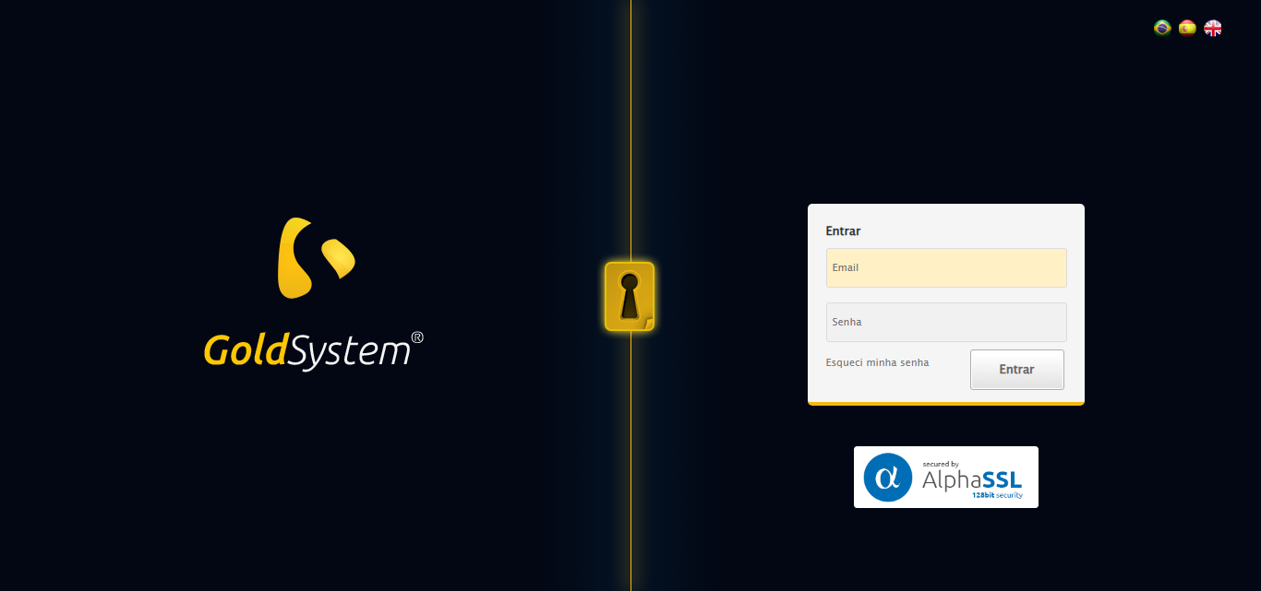

[15:47:00] 🔄 Realizando login...

[15:47:06] ✅ Realizando login realizada com sucesso.

[15:47:08] 📸 Screenshot capturada: realizando_login

Screenshot: realizando_login

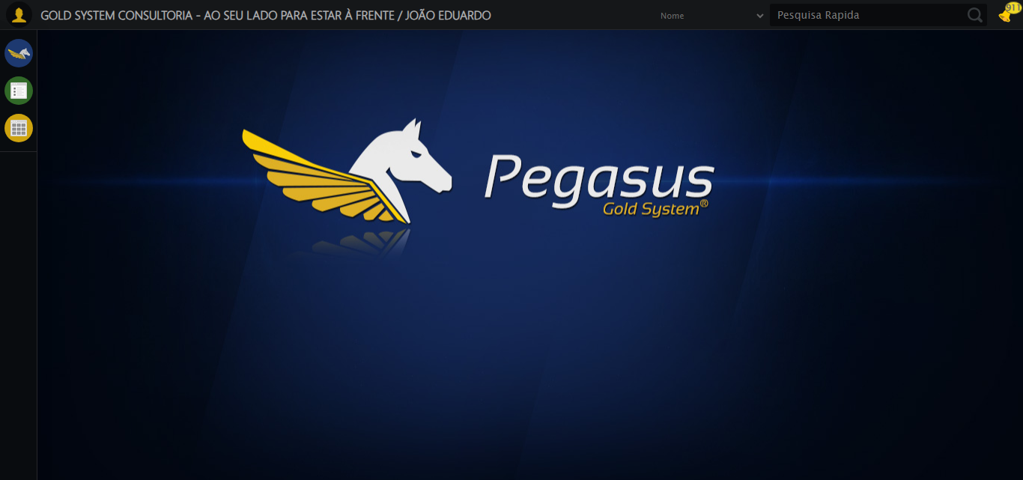

[15:47:08] 🔄 Configurando ambiente...

[15:47:08] 🔍 Zoom ajustado para 90%.

[15:47:10] ✅ Configurando ambiente realizada com sucesso.

[15:47:12] 📸 Screenshot capturada: configurando_ambiente

Screenshot: configurando_ambiente

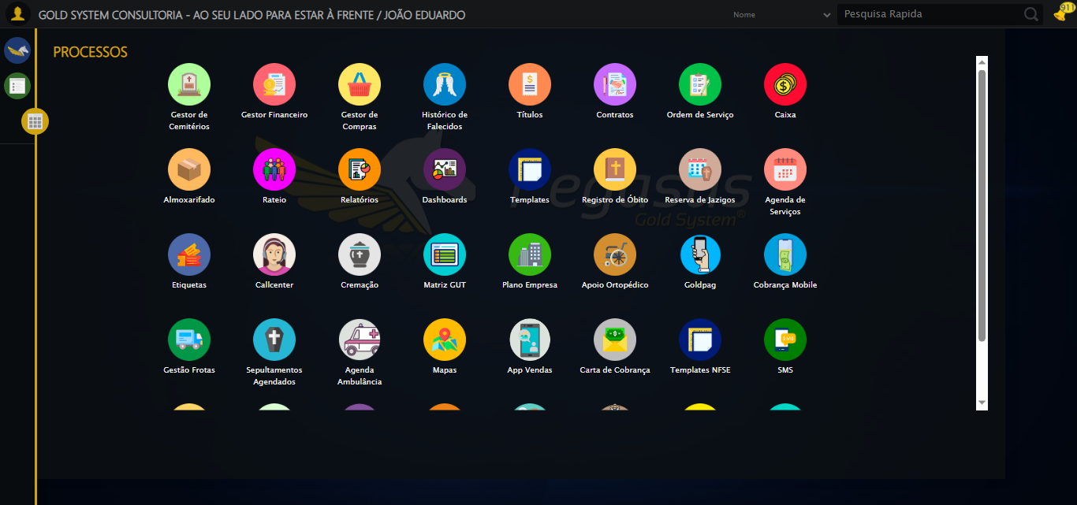

[15:47:12] 🔄 Acessando módulo Callcenter...

[15:47:12] Tentando estratégia de scroll 1...

[15:47:12] ✅ Scroll realizado com estratégia 1

[15:47:14] Tentando estratégia de clique 1 para módulo PET...

[15:47:16] ✅ Clique no módulo PET realizado com estratégia 1

[15:47:16] ✅ Acessando módulo Callcenter realizada com sucesso.

[15:47:17] 📸 Screenshot capturada: acessando_módulo_callcenter

Screenshot: acessando_módulo_callcenter

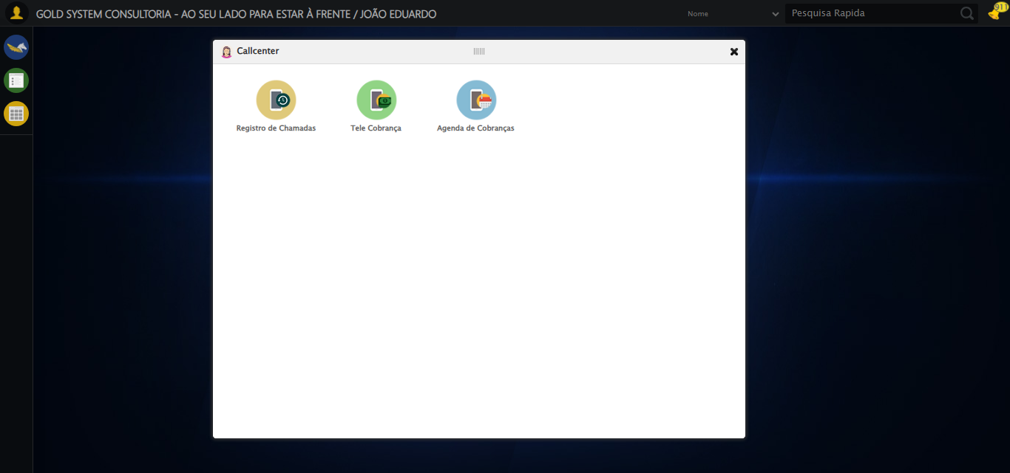

[15:47:17] 🔄 Abrindo Registro de Chamadas...

[15:47:20] ✅ Abrindo Registro de Chamadas realizada com sucesso.

[15:47:21] 📸 Screenshot capturada: abrindo_registro_de_chamadas

Screenshot: abrindo_registro_de_chamadas

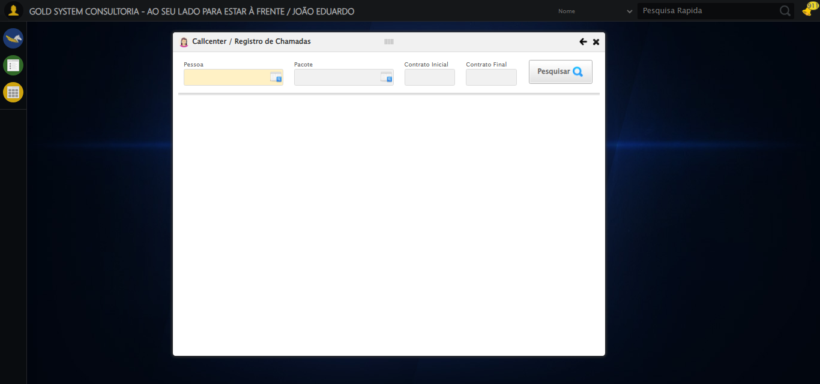

[15:47:21] 🔄 Selecionando Pessoa...

[15:47:21] 🔘 Abrindo modal com botão: #gsCallCenter > div.wdTelas > div.telaRegistroChamadas.telaConsulta.relative > div.formRow.formLastLine > div:nth-child(1) > div > a

[15:47:21] Tentando estratégia de scroll 1...

[15:47:22] ✅ Scroll realizado com estratégia 1

[15:47:24] 🔍 Preenchendo pesquisa com: TESTE TITULAR 233

[15:47:25] 🔍 Executando pesquisa...

[15:47:28] 🎯 Selecionando resultado: //td[contains(text(), 'TESTE TITULAR 233')]

[15:47:28] Tentando estratégia de scroll 1...

[15:47:29] ✅ Scroll realizado com estratégia 1

[15:47:31] ✅ Seleção no modal concluída

[15:47:31] ✅ Selecionando Pessoa realizada com sucesso.

[15:47:32] 📸 Screenshot capturada: selecionando_pessoa

Screenshot: selecionando_pessoa

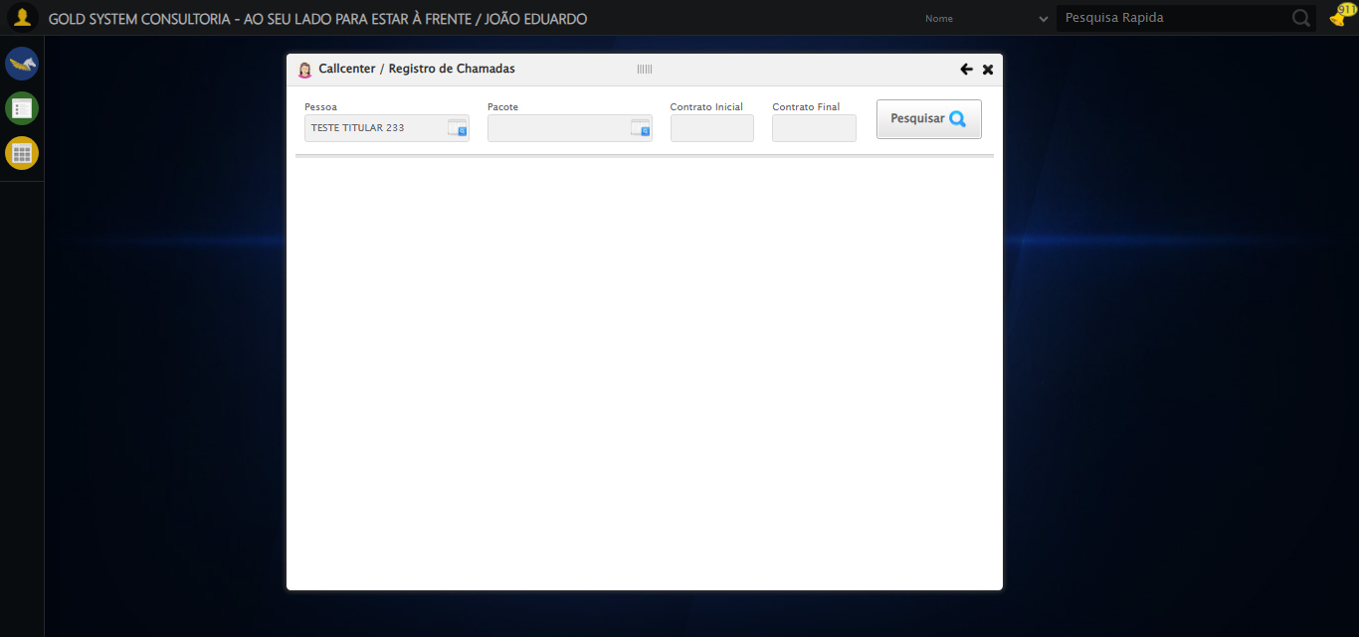

[15:47:32] 🔄 Selecionando Pacote...

[15:47:32] 🔘 Abrindo modal com botão: #gsCallCenter > div.wdTelas > div.telaRegistroChamadas.telaConsulta.relative > div.formRow.formLastLine > div:nth-child(2) > div > a

[15:47:32] Tentando estratégia de scroll 1...

[15:47:33] ✅ Scroll realizado com estratégia 1

[15:47:35] 🔍 Preenchendo pesquisa com: PRO MAX TITANIUM

[15:47:36] 🔍 Executando pesquisa...

[15:47:39] 🎯 Selecionando resultado: //td[contains(text(), 'PRO MAX TITANIUM')]

[15:47:39] Tentando estratégia de scroll 1...

[15:47:40] ✅ Scroll realizado com estratégia 1

[15:47:42] ✅ Seleção no modal concluída

[15:47:42] ✅ Selecionando Pacote realizada com sucesso.

[15:47:43] 📸 Screenshot capturada: selecionando_pacote

Screenshot: selecionando_pacote

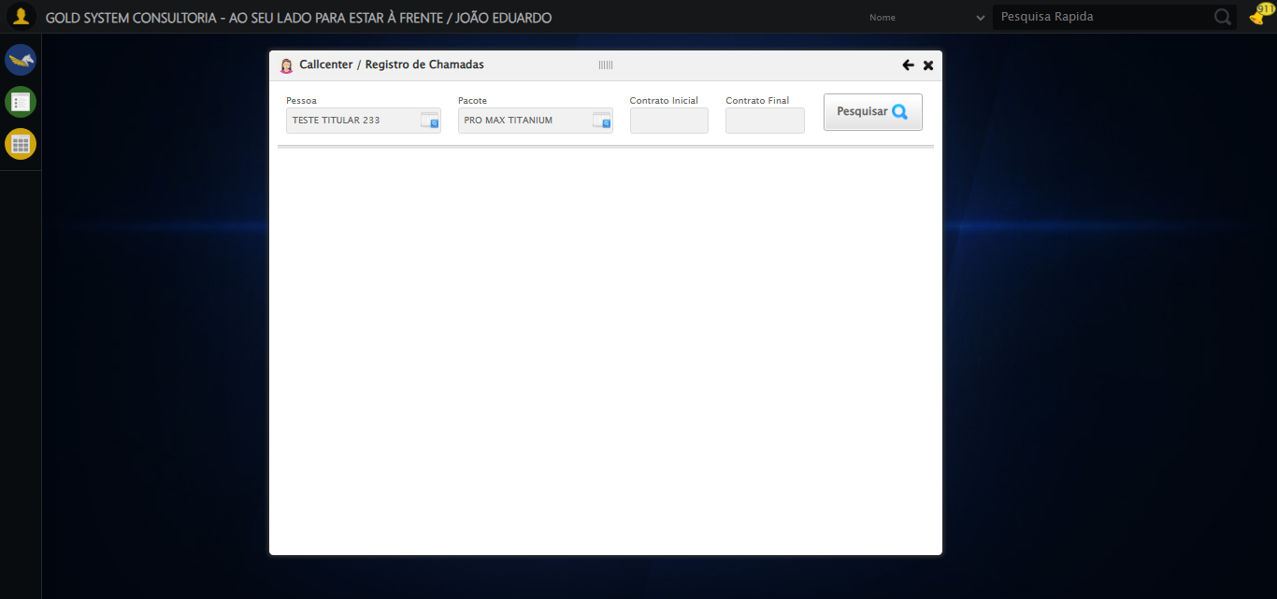

[15:47:43] 🔄 Preenchendo Número do Contrato Inicial...

[15:47:43] Tentando estratégia de scroll 1...

[15:47:44] ✅ Scroll realizado com estratégia 1

[15:47:45] ✅ Campo preenchido com estratégia 1: '113060'

[15:47:45] ✅ Preenchendo Número do Contrato Inicial realizada com sucesso.

[15:47:46] 📸 Screenshot capturada: preenchendo_número_do_contrato_inicial

Screenshot: preenchendo_número_do_contrato_inicial

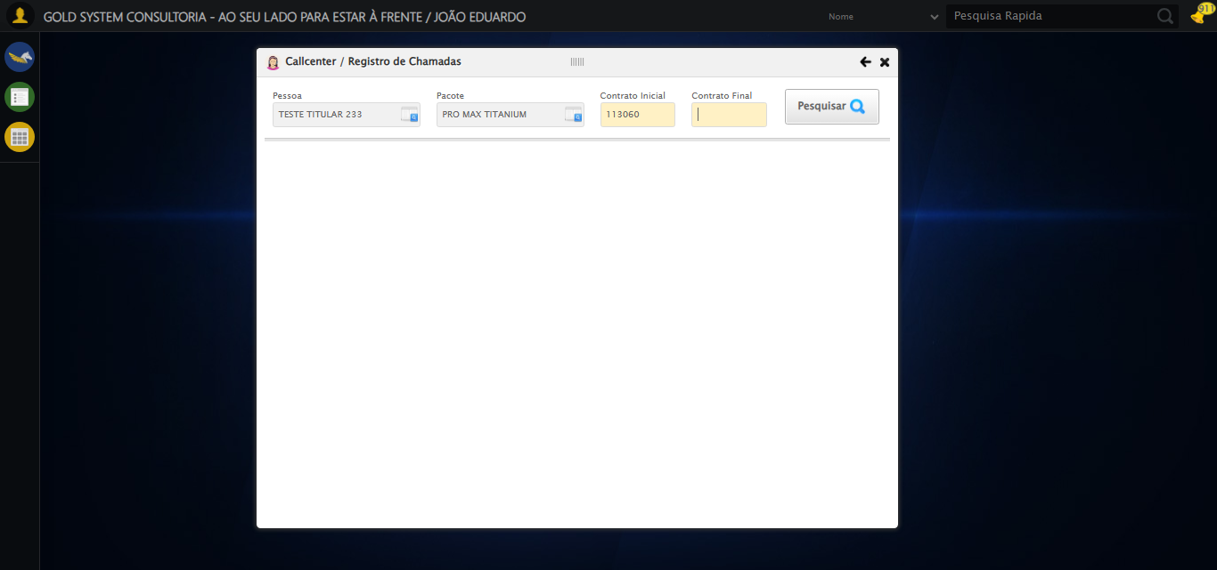

[15:47:46] 🔄 Preenchendo Número do Contrato Final...

[15:47:46] Tentando estratégia de scroll 1...

[15:47:47] ✅ Scroll realizado com estratégia 1

[15:47:48] ✅ Campo preenchido com estratégia 1: '113060'

[15:47:48] ✅ Preenchendo Número do Contrato Final realizada com sucesso.

[15:47:49] 📸 Screenshot capturada: preenchendo_número_do_contrato_final

Screenshot: preenchendo_número_do_contrato_final

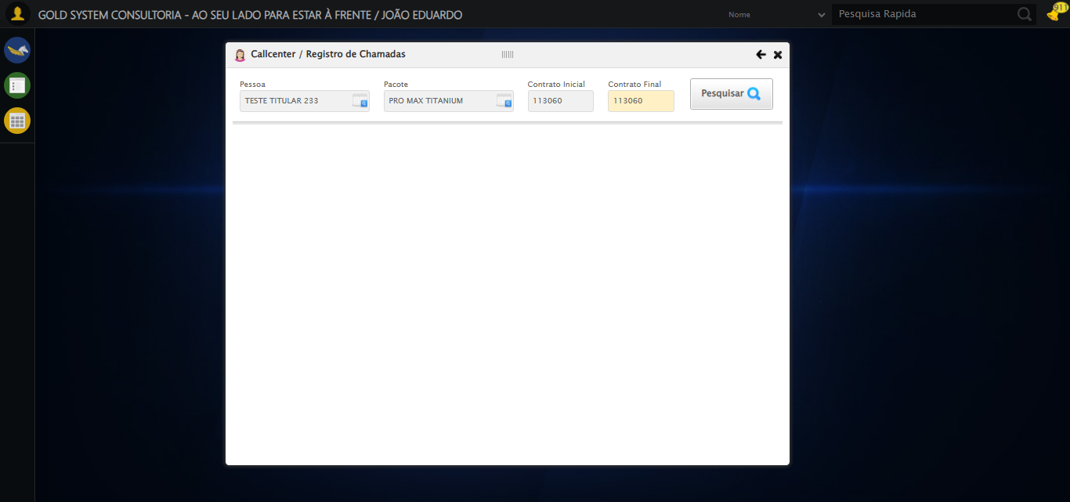

[15:47:49] 🔄 Realizando consulta...

[15:47:50] Tentando estratégia de scroll 1...

[15:47:50] ✅ Scroll realizado com estratégia 1

[15:47:52] ✅ Consulta executada

[15:47:52] ✅ Realizando consulta realizada com sucesso.

[15:47:54] 📸 Screenshot capturada: realizando_consulta

Screenshot: realizando_consulta

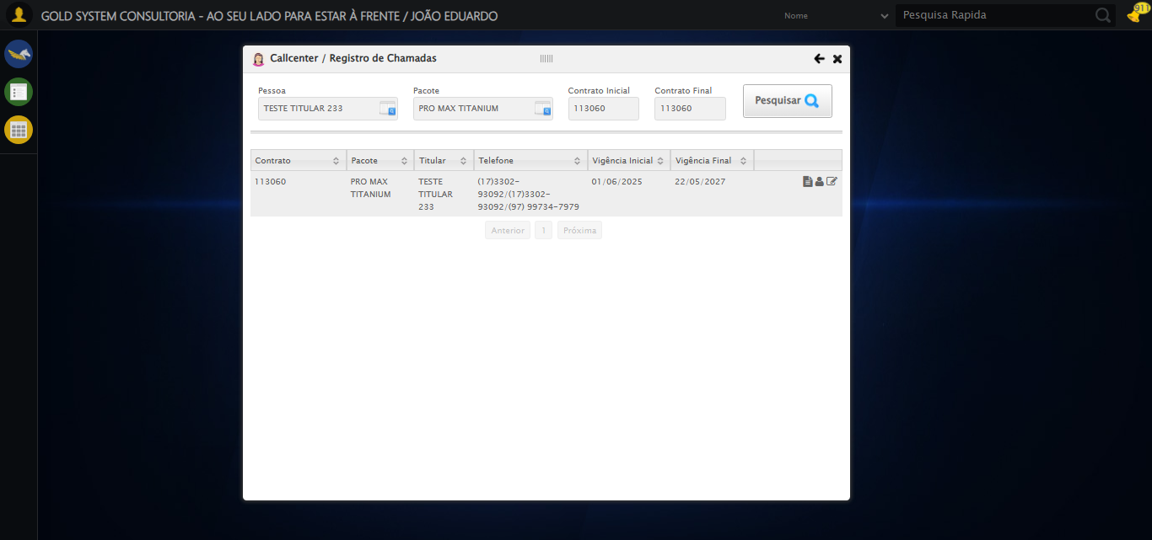

[15:47:54] 🔄 Validando resultados da consulta...

[15:47:54] 🔍 Iniciando validação de registros...

[15:47:59] ✅ Tabela encontrada: #DataTables_Table_2

[15:47:59] ✅ Encontradas 1 linhas válidas com tbody tr:not(.dataTables_empty):not([class*="no-data"])

[15:47:59] ✅ 1 registro(s) encontrado(s)

[15:47:59] Registro 1: 113060 pro max titanium teste titular 233 (17)3302-93092/(17)3302-93092/(97) 99734-7979 01/06/2025 2...

[15:47:59] ✅ Validando resultados da consulta realizada com sucesso.

[15:48:00] 📸 Screenshot capturada: validando_resultados_da_consulta

Screenshot: validando_resultados_da_consulta



[15:48:00] ✅ Processando 1 registro(s) encontrado(s)

[15:48:00] 🔄 Visualizando dados do Contrato...

[15:48:30] ❌ Timeout aguardando elemento: //*[@id="DataTables_Table_10"]/tbody/tr/td[7]/span[1] (condição: present, timeout: 30s)

[15:48:30] ❌ Falha ao clicar em //*[@id="DataTables_Table_10"]/tbody/tr/td[7]/span[1]: Message: Elemento não encontrado: //*[@id="DataTables_Table_10"]/tbody/tr/td[7]/span[1] (condição: present)

[15:48:30] 📸 Screenshot capturada: erro_visualizando_dados_do_contrato

Screenshot: erro_visualizando_dados_do_contrato

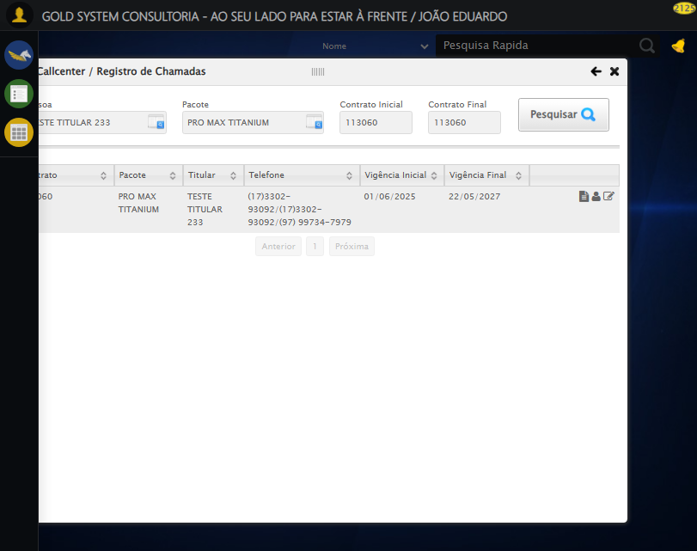

[15:48:30] ❌ Visualizando dados do Contrato falhou: TimeoutException: Message: Elemento não encontrado: //*[@id="DataTables_Table_10"]/tbody/tr/td[7]/span[1] (condição: present)

[15:48:30] ⚠️ Continuando execução apesar do erro em: Visualizando dados do Contrato

[15:48:30] 🔄 Capturando tela de dados...

[15:48:33] 📸 Screenshot capturada: dados_contrato_pet

Screenshot: dados_contrato_pet

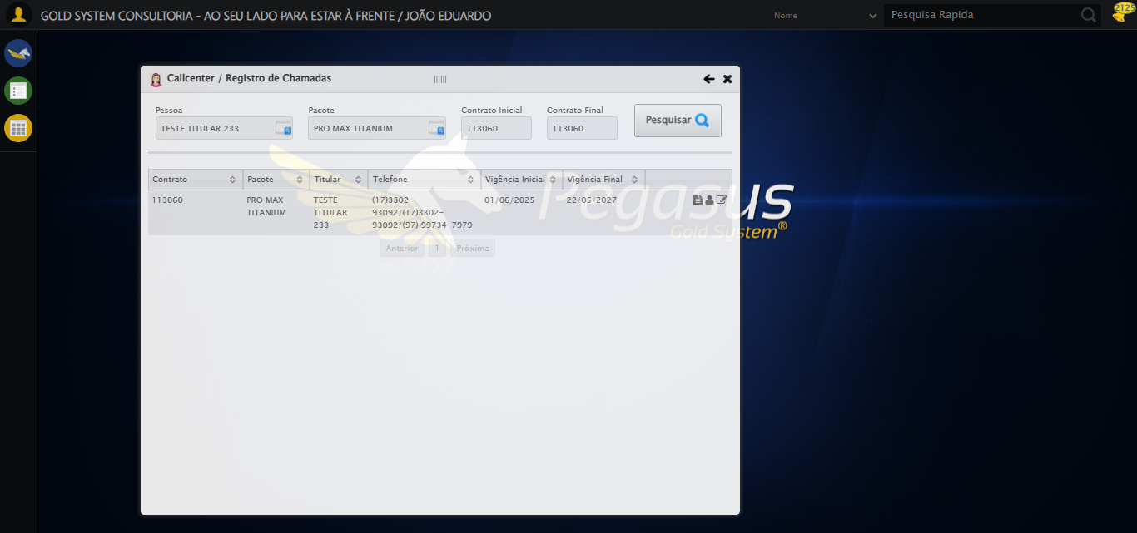

[15:48:33] ✅ Capturando tela de dados realizada com sucesso.

[15:48:35] 📸 Screenshot capturada: capturando_tela_de_dados

Screenshot: capturando_tela_de_dados

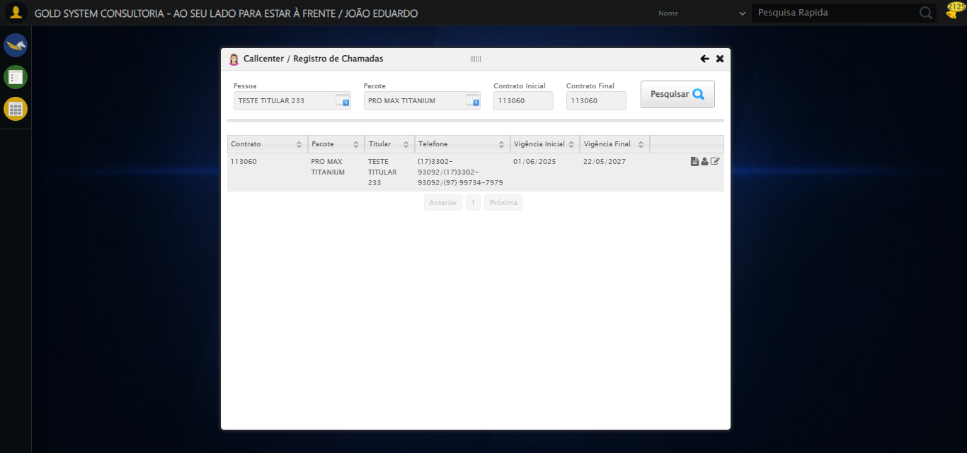

[15:48:35] 🔄 Abrindo mensagens do Contrato...

[15:49:05] ❌ Timeout aguardando elemento: body > div.modalHolder > div.modal.overflow.fullscreen.bgBlur > div.detalhesContrato > div > div > div.aba.detalhes > div.row > div.col-sm-4.rAlign > button:nth-child(1) (condição: present, timeout: 30s)

[15:49:05] ❌ Falha ao clicar em body > div.modalHolder > div.modal.overflow.fullscreen.bgBlur > div.detalhesContrato > div > div > div.aba.detalhes > div.row > div.col-sm-4.rAlign > button:nth-child(1): Message: Elemento não encontrado: body > div.modalHolder > div.modal.overflow.fullscreen.bgBlur > div.detalhesContrato > div > div > div.aba.detalhes > div.row > div.col-sm-4.rAlign > button:nth-child(1) (condição: present)

[15:49:05] 📸 Screenshot capturada: erro_abrindo_mensagens_do_contrato

Screenshot: erro_abrindo_mensagens_do_contrato



[15:49:05] ❌ Abrindo mensagens do Contrato falhou: TimeoutException: Message: Elemento não encontrado: body > div.modalHolder > div.modal.overflow.fullscreen.bgBlur > div.detalhesContrato > div > div > div.aba.detalhes > div.row > div.col-sm-4.rAlign > button:nth-child(1) (condição: present)

[15:49:05] ⚠️ Continuando execução apesar do erro em: Abrindo mensagens do Contrato

[15:49:05] 🔄 Capturando mensagens...

[15:49:08] 📸 Screenshot capturada: mensagens_contrato_pet

Screenshot: mensagens_contrato_pet



[15:49:08] ✅ Capturando mensagens realizada com sucesso.

[15:49:09] 📸 Screenshot capturada: capturando_mensagens

Screenshot: capturando_mensagens



[15:49:09] 🔄 Adicionando nova mensagem...

[15:49:39] ❌ Timeout aguardando elemento: /html/body/div[21]/div[2]/div[1]/div[1]/div/a (condição: present, timeout: 30s)

[15:49:39] ❌ Falha ao clicar em /html/body/div[21]/div[2]/div[1]/div[1]/div/a: Message: Elemento não encontrado: /html/body/div[21]/div[2]/div[1]/div[1]/div/a (condição: present)

[15:49:39] 📸 Screenshot capturada: erro_adicionando_nova_mensagem

Screenshot: erro_adicionando_nova_mensagem



[15:49:39] ❌ Adicionando nova mensagem falhou: TimeoutException: Message: Elemento não encontrado: /html/body/div[21]/div[2]/div[1]/div[1]/div/a (condição: present)

[15:49:39] ⚠️ Continuando execução apesar do erro em: Adicionando nova mensagem

[15:49:39] 🔄 Preenchendo descrição da mensagem...

[15:49:39] ⚠️ Nenhuma <textarea> encontrada (tentativa 1/5)

[15:49:41] ⚠️ Nenhuma <textarea> encontrada (tentativa 2/5)

[15:49:43] ⚠️ Nenhuma <textarea> encontrada (tentativa 3/5)

[15:49:44] ⚠️ Nenhuma <textarea> encontrada (tentativa 4/5)

[15:49:46] 📸 Screenshot capturada: erro_preenchendo_descrição_da_mensagem

Screenshot: erro_preenchendo_descrição_da_mensagem



[15:49:46] ❌ Preenchendo descrição da mensagem falhou: Exception: Nenhuma <textarea> foi encontrada na página.

[15:49:46] ⚠️ Continuando execução apesar do erro em: Preenchendo descrição da mensagem

[15:49:46] 🔄 Definindo período de exibição - Data Inicial...

[15:49:46] 📊 Encontrados 0 campos datepicker

[15:49:46] ⚠️ Nenhum campo datepicker encontrado, tentativa 1/5

[15:49:48] 📊 Encontrados 0 campos datepicker

[15:49:48] ⚠️ Nenhum campo datepicker encontrado, tentativa 2/5

[15:49:50] 📊 Encontrados 0 campos datepicker

[15:49:50] ⚠️ Nenhum campo datepicker encontrado, tentativa 3/5

[15:49:52] 📊 Encontrados 0 campos datepicker

[15:49:52] ⚠️ Nenhum campo datepicker encontrado, tentativa 4/5

[15:49:54] 📊 Encontrados 0 campos datepicker

[15:49:55] 📸 Screenshot capturada: erro_definindo_período_de_exibição_-_data_inicial

Screenshot: erro_definindo_período_de_exibição_-_data_inicial



[15:49:55] ❌ Definindo período de exibição - Data Inicial falhou: Exception: Nenhum campo datepicker encontrado na página

[15:49:55] ⚠️ Continuando execução apesar do erro em: Definindo período de exibição - Data Inicial

[15:49:55] 🔄 Definindo período de exibição - Data Final...

[15:49:55] 📊 Encontrados 0 campos datepicker

[15:49:55] ⚠️ Nenhum campo datepicker encontrado, tentativa 1/5

[15:49:57] 📊 Encontrados 0 campos datepicker

[15:49:57] ⚠️ Nenhum campo datepicker encontrado, tentativa 2/5

[15:49:59] 📊 Encontrados 0 campos datepicker

[15:49:59] ⚠️ Nenhum campo datepicker encontrado, tentativa 3/5

[15:50:01] 📊 Encontrados 0 campos datepicker

[15:50:01] ⚠️ Nenhum campo datepicker encontrado, tentativa 4/5

[15:50:03] 📊 Encontrados 0 campos datepicker

[15:50:03] 📸 Screenshot capturada: erro_definindo_período_de_exibição_-_data_final

Screenshot: erro_definindo_período_de_exibição_-_data_final



[15:50:03] ❌ Definindo período de exibição - Data Final falhou: Exception: Nenhum campo datepicker encontrado na página

[15:50:03] ⚠️ Continuando execução apesar do erro em: Definindo período de exibição - Data Final

[15:50:03] 🔄 Confirmando mensagem...

[15:50:33] ❌ Timeout aguardando elemento: /html/body/div[22]/div[2]/div[1]/div[3]/a[2] (condição: present, timeout: 30s)

[15:50:33] ❌ Falha ao clicar em /html/body/div[22]/div[2]/div[1]/div[3]/a[2]: Message: Elemento não encontrado: /html/body/div[22]/div[2]/div[1]/div[3]/a[2] (condição: present)

[15:50:33] 📸 Screenshot capturada: erro_confirmando_mensagem

Screenshot: erro_confirmando_mensagem



[15:50:33] ❌ Confirmando mensagem falhou: TimeoutException: Message: Elemento não encontrado: /html/body/div[22]/div[2]/div[1]/div[3]/a[2] (condição: present)

[15:50:33] ⚠️ Continuando execução apesar do erro em: Confirmando mensagem

[15:50:33] 🔍 Verificando mensagens de alerta...

[15:50:33] 🔄 Fechando aba de mensagens...

[15:51:04] ❌ Timeout aguardando elemento: /html/body/div[21]/div[2]/a (condição: present, timeout: 30s)

[15:51:04] ❌ Falha ao clicar em /html/body/div[21]/div[2]/a: Message: Elemento não encontrado: /html/body/div[21]/div[2]/a (condição: present)

[15:51:04] 📸 Screenshot capturada: erro_fechando_aba_de_mensagens

Screenshot: erro_fechando_aba_de_mensagens



[15:51:04] ❌ Fechando aba de mensagens falhou: TimeoutException: Message: Elemento não encontrado: /html/body/div[21]/div[2]/a (condição: present)

[15:51:04] ⚠️ Continuando execução apesar do erro em: Fechando aba de mensagens

[15:51:04] 🔄 Visualizando títulos do Contrato...

[15:51:34] ❌ Timeout aguardando elemento: //button[@class='btModel btGray' and .//i[contains(@class, 'sprites sp-pesquisar')] and normalize-space(text())='Ver Títulos'] (condição: present, timeout: 30s)

[15:51:34] ❌ Falha ao clicar em //button[@class='btModel btGray' and .//i[contains(@class, 'sprites sp-pesquisar')] and normalize-space(text())='Ver Títulos']: Message: Elemento não encontrado: //button[@class='btModel btGray' and .//i[contains(@class, 'sprites sp-pesquisar')] and normalize-space(text())='Ver Títulos'] (condição: present)

[15:51:35] 📸 Screenshot capturada: erro_visualizando_títulos_do_contrato

Screenshot: erro_visualizando_títulos_do_contrato



[15:51:35] ❌ Visualizando títulos do Contrato falhou: TimeoutException: Message: Elemento não encontrado: //button[@class='btModel btGray' and .//i[contains(@class, 'sprites sp-pesquisar')] and normalize-space(text())='Ver Títulos'] (condição: present)

[15:51:35] ⚠️ Continuando execução apesar do erro em: Visualizando títulos do Contrato

[15:51:35] 🔄 Aguardando carregamento de títulos e capturando Screenshot...

[15:52:05] 📸 Screenshot capturada: titulos_contrato_pet

Screenshot: titulos_contrato_pet



[15:52:05] ✅ Aguardando carregamento de títulos e capturando Screenshot realizada com sucesso.

[15:52:06] 📸 Screenshot capturada: aguardando_carregamento_de_títulos_e_capturando_screenshot

Screenshot: aguardando_carregamento_de_títulos_e_capturando_screenshot



[15:52:06] 🔄 Fechando aba de títulos...

[15:52:36] ❌ Timeout aguardando elemento: //a[@title='Sair' and contains(@class, 'sp-fecharGrande')] (condição: present, timeout: 30s)

[15:52:36] ❌ Falha ao clicar em //a[@title='Sair' and contains(@class, 'sp-fecharGrande')]: Message: Elemento não encontrado: //a[@title='Sair' and contains(@class, 'sp-fecharGrande')] (condição: present)

[15:52:36] 📸 Screenshot capturada: erro_fechando_aba_de_títulos

Screenshot: erro_fechando_aba_de_títulos

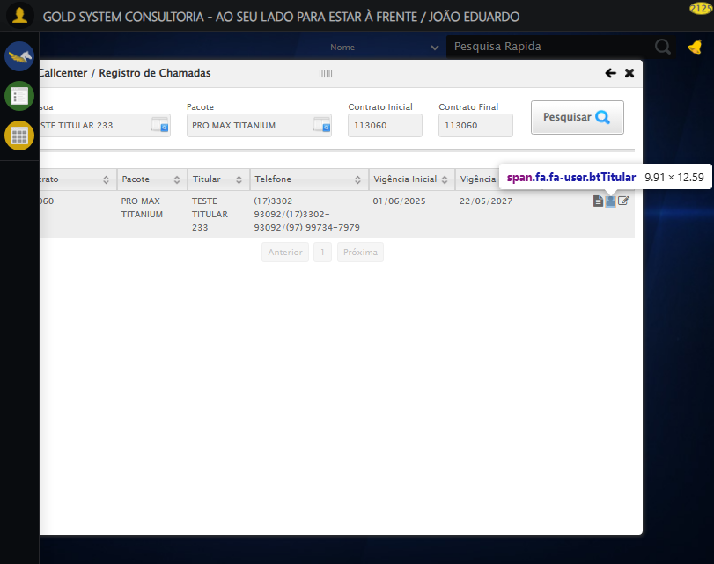

[15:52:36] ❌ Fechando aba de títulos falhou: TimeoutException: Message: Elemento não encontrado: //a[@title='Sair' and contains(@class, 'sp-fecharGrande')] (condição: present)

[15:52:36] ⚠️ Continuando execução apesar do erro em: Fechando aba de títulos

[15:52:36] 🔄 Abrindo Dados Cadastrais do Titular e capturando Screenshot da aba 'Dados Pessoais'...

[15:53:07] ❌ Timeout aguardando elemento: //a[contains(@class,'materializacaoPeglink') and @ref='1|21582908'] (condição: present, timeout: 30s)

[15:53:07] ❌ Falha ao clicar em //a[contains(@class,'materializacaoPeglink') and @ref='1|21582908']: Message: Elemento não encontrado: //a[contains(@class,'materializacaoPeglink') and @ref='1|21582908'] (condição: present)

[15:53:07] 📸 Screenshot capturada: erro_abrindo_dados_cadastrais_do_titular_e_capturando_screenshot_da_aba_dados_pessoais_

Screenshot: erro_abrindo_dados_cadastrais_do_titular_e_capturando_screenshot_da_aba_dados_pessoais_

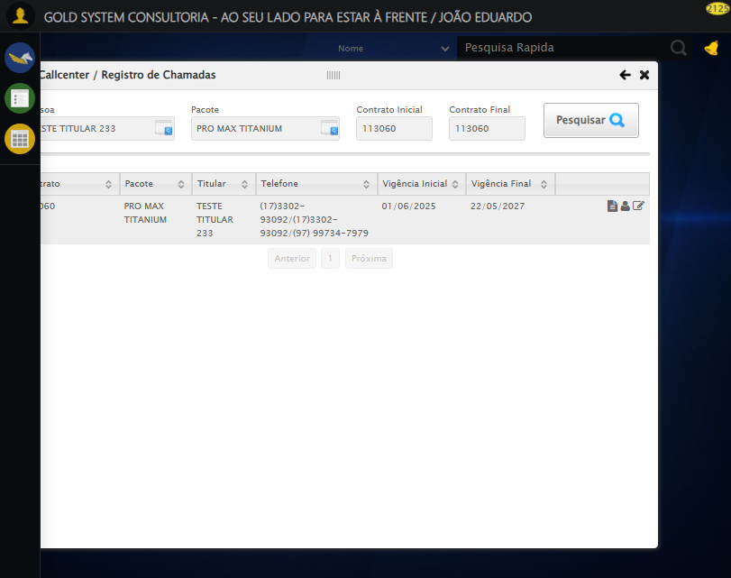

[15:53:07] ❌ Abrindo Dados Cadastrais do Titular e capturando Screenshot da aba 'Dados Pessoais' falhou: TimeoutException: Message: Elemento não encontrado: //a[contains(@class,'materializacaoPeglink') and @ref='1|21582908'] (condição: present)

[15:53:07] ⚠️ Continuando execução apesar do erro em: Abrindo Dados Cadastrais do Titular e capturando Screenshot da aba 'Dados Pessoais'

[15:53:07] 🔄 Clicando na aba 'Dados Complementares' e capturando Screenshot...

[15:53:11] ❌ Erro aguardando elemento //a[@class='dadosComplementares' and normalize-space(text())='Dados Complementares']: Message: invalid session id: session deleted as the browser has closed the connection  
from disconnected: not connected to DevTools  
 (Session info: chrome=138.0.7204.185)  
Stacktrace:  
 GetHandleVerifier [0x0x62ba83+63395]  
 GetHandleVerifier [0x0x62bac4+63460]  
 (No symbol) [0x0x472113]  
 (No symbol) [0x0x461b20]  
 (No symbol) [0x0x47f922]  
 (No symbol) [0x0x4e5c9c]  
 (No symbol) [0x0x500099]  
 (No symbol) [0x0x4df1a6]  
 (No symbol) [0x0x4ae7b2]  
 (No symbol) [0x0x4af654]  
 GetHandleVerifier [0x0x8a8883+2672035]  
 GetHandleVerifier [0x0x8a3cba+2652634]  
 GetHandleVerifier [0x0x652bca+223466]  
 GetHandleVerifier [0x0x642cb8+158168]  
 GetHandleVerifier [0x0x64978d+185517]  
 GetHandleVerifier [0x0x633b78+96408]  
 GetHandleVerifier [0x0x633d02+96802]  
 GetHandleVerifier [0x0x61e90a+9770]  
 BaseThreadInitThunk [0x0x75abfcc9+25]  
 RtlGetAppContainerNamedObjectPath [0x0x776d82ae+286]  
 RtlGetAppContainerNamedObjectPath [0x0x776d827e+238]

[15:53:11] ❌ Falha ao clicar em //a[@class='dadosComplementares' and normalize-space(text())='Dados Complementares']: Message: invalid session id: session deleted as the browser has closed the connection  
from disconnected: not connected to DevTools  
 (Session info: chrome=138.0.7204.185)  
Stacktrace:  
 GetHandleVerifier [0x0x62ba83+63395]  
 GetHandleVerifier [0x0x62bac4+63460]  
 (No symbol) [0x0x472113]  
 (No symbol) [0x0x461b20]  
 (No symbol) [0x0x47f922]  
 (No symbol) [0x0x4e5c9c]  
 (No symbol) [0x0x500099]  
 (No symbol) [0x0x4df1a6]  
 (No symbol) [0x0x4ae7b2]  
 (No symbol) [0x0x4af654]  
 GetHandleVerifier [0x0x8a8883+2672035]  
 GetHandleVerifier [0x0x8a3cba+2652634]  
 GetHandleVerifier [0x0x652bca+223466]  
 GetHandleVerifier [0x0x642cb8+158168]  
 GetHandleVerifier [0x0x64978d+185517]  
 GetHandleVerifier [0x0x633b78+96408]  
 GetHandleVerifier [0x0x633d02+96802]  
 GetHandleVerifier [0x0x61e90a+9770]  
 BaseThreadInitThunk [0x0x75abfcc9+25]  
 RtlGetAppContainerNamedObjectPath [0x0x776d82ae+286]  
 RtlGetAppContainerNamedObjectPath [0x0x776d827e+238]

[15:53:11] ⚠️ Erro ao tirar screenshot erro_clicando_na_aba_dados_complementares_e_capturando_screenshot: Message: invalid session id  
Stacktrace:  
 GetHandleVerifier [0x0x62ba83+63395]  
 GetHandleVerifier [0x0x62bac4+63460]  
 (No symbol) [0x0x471f70]  
 (No symbol) [0x0x4adaa8]  
 (No symbol) [0x0x4df266]  
 (No symbol) [0x0x4dae65]  
 (No symbol) [0x0x4da3e6]  
 (No symbol) [0x0x443a45]  
 (No symbol) [0x0x443f9e]  
 (No symbol) [0x0x44442d]  
 GetHandleVerifier [0x0x8a8883+2672035]  
 GetHandleVerifier [0x0x8a3cba+2652634]  
 GetHandleVerifier [0x0x652bca+223466]  
 GetHandleVerifier [0x0x642cb8+158168]  
 GetHandleVerifier [0x0x64978d+185517]  
 (No symbol) [0x0x443710]  
 (No symbol) [0x0x442f1d]  
 GetHandleVerifier [0x0x9ddb9c+3938492]  
 BaseThreadInitThunk [0x0x75abfcc9+25]  
 RtlGetAppContainerNamedObjectPath [0x0x776d82ae+286]  
 RtlGetAppContainerNamedObjectPath [0x0x776d827e+238]

[15:53:11] ❌ Clicando na aba 'Dados Complementares' e capturando Screenshot falhou: InvalidSessionIdException: Message: invalid session id: session deleted as the browser has closed the connection  
from disconnected: not connected to DevTools  
 (Session info: chrome=138.0.7204.185)  
Stacktrace:  
 GetHandleVerifier [0x0x62ba83+63395]  
 GetHandleVerifier [0x0x62bac4+63460]  
 (No symbol) [0x0x472113]  
 (No symbol) [0x0x461b20]  
 (No symbol) [0x0x47f922]  
 (No symbol) [0x0x4e5c9c]  
 (No symbol) [0x0x500099]  
 (No symbol) [0x0x4df1a6]  
 (No symbol) [0x0x4ae7b2]  
 (No symbol) [0x0x4af654]  
 GetHandleVerifier [0x0x8a8883+2672035]  
 GetHandleVerifier [0x0x8a3cba+2652634]  
 GetHandleVerifier [0x0x652bca+223466]  
 GetHandleVerifier [0x0x642cb8+158168]  
 GetHandleVerifier [0x0x64978d+185517]  
 GetHandleVerifier [0x0x633b78+96408]  
 GetHandleVerifier [0x0x633d02+96802]  
 GetHandleVerifier [0x0x61e90a+9770]  
 BaseThreadInitThunk [0x0x75abfcc9+25]  
 RtlGetAppContainerNamedObjectPath [0x0x776d82ae+286]  
 RtlGetAppContainerNamedObjectPath [0x0x776d827e+238]

[15:53:11] ⚠️ Continuando execução apesar do erro em: Clicando na aba 'Dados Complementares' e capturando Screenshot

[15:53:11] 🔄 Clicando na aba 'Endereços da Pessoa' e capturando Screenshot'...

[15:53:11] ❌ Erro aguardando elemento //a[@class='enderecos' and normalize-space(text())='Endereços da Pessoa']: Message: invalid session id  
Stacktrace:  
 GetHandleVerifier [0x0x62ba83+63395]  
 GetHandleVerifier [0x0x62bac4+63460]  
 (No symbol) [0x0x471f70]  
 (No symbol) [0x0x4adaa8]  
 (No symbol) [0x0x4df266]  
 (No symbol) [0x0x4dae65]  
 (No symbol) [0x0x4da3e6]  
 (No symbol) [0x0x443a45]  
 (No symbol) [0x0x443f9e]  
 (No symbol) [0x0x44442d]  
 GetHandleVerifier [0x0x8a8883+2672035]  
 GetHandleVerifier [0x0x8a3cba+2652634]  
 GetHandleVerifier [0x0x652bca+223466]  
 GetHandleVerifier [0x0x642cb8+158168]  
 GetHandleVerifier [0x0x64978d+185517]  
 (No symbol) [0x0x443710]  
 (No symbol) [0x0x442f1d]  
 GetHandleVerifier [0x0x9ddb9c+3938492]  
 BaseThreadInitThunk [0x0x75abfcc9+25]  
 RtlGetAppContainerNamedObjectPath [0x0x776d82ae+286]  
 RtlGetAppContainerNamedObjectPath [0x0x776d827e+238]

[15:53:11] ❌ Falha ao clicar em //a[@class='enderecos' and normalize-space(text())='Endereços da Pessoa']: Message: invalid session id  
Stacktrace:  
 GetHandleVerifier [0x0x62ba83+63395]  
 GetHandleVerifier [0x0x62bac4+63460]  
 (No symbol) [0x0x471f70]  
 (No symbol) [0x0x4adaa8]  
 (No symbol) [0x0x4df266]  
 (No symbol) [0x0x4dae65]  
 (No symbol) [0x0x4da3e6]  
 (No symbol) [0x0x443a45]  
 (No symbol) [0x0x443f9e]  
 (No symbol) [0x0x44442d]  
 GetHandleVerifier [0x0x8a8883+2672035]  
 GetHandleVerifier [0x0x8a3cba+2652634]  
 GetHandleVerifier [0x0x652bca+223466]  
 GetHandleVerifier [0x0x642cb8+158168]  
 GetHandleVerifier [0x0x64978d+185517]  
 (No symbol) [0x0x443710]  
 (No symbol) [0x0x442f1d]  
 GetHandleVerifier [0x0x9ddb9c+3938492]  
 BaseThreadInitThunk [0x0x75abfcc9+25]  
 RtlGetAppContainerNamedObjectPath [0x0x776d82ae+286]  
 RtlGetAppContainerNamedObjectPath [0x0x776d827e+238]

[15:53:11] ⚠️ Erro ao tirar screenshot erro_clicando_na_aba_endereços_da_pessoa_e_capturando_screenshot_: Message: invalid session id  
Stacktrace:  
 GetHandleVerifier [0x0x62ba83+63395]  
 GetHandleVerifier [0x0x62bac4+63460]  
 (No symbol) [0x0x471f70]  
 (No symbol) [0x0x4adaa8]  
 (No symbol) [0x0x4df266]  
 (No symbol) [0x0x4dae65]  
 (No symbol) [0x0x4da3e6]  
 (No symbol) [0x0x443a45]  
 (No symbol) [0x0x443f9e]  
 (No symbol) [0x0x44442d]  
 GetHandleVerifier [0x0x8a8883+2672035]  
 GetHandleVerifier [0x0x8a3cba+2652634]  
 GetHandleVerifier [0x0x652bca+223466]  
 GetHandleVerifier [0x0x642cb8+158168]  
 GetHandleVerifier [0x0x64978d+185517]  
 (No symbol) [0x0x443710]  
 (No symbol) [0x0x442f1d]  
 GetHandleVerifier [0x0x9ddb9c+3938492]  
 BaseThreadInitThunk [0x0x75abfcc9+25]  
 RtlGetAppContainerNamedObjectPath [0x0x776d82ae+286]  
 RtlGetAppContainerNamedObjectPath [0x0x776d827e+238]

[15:53:11] ❌ Clicando na aba 'Endereços da Pessoa' e capturando Screenshot' falhou: InvalidSessionIdException: Message: invalid session id  
Stacktrace:  
 GetHandleVerifier [0x0x62ba83+63395]  
 GetHandleVerifier [0x0x62bac4+63460]  
 (No symbol) [0x0x471f70]  
 (No symbol) [0x0x4adaa8]  
 (No symbol) [0x0x4df266]  
 (No symbol) [0x0x4dae65]  
 (No symbol) [0x0x4da3e6]  
 (No symbol) [0x0x443a45]  
 (No symbol) [0x0x443f9e]  
 (No symbol) [0x0x44442d]  
 GetHandleVerifier [0x0x8a8883+2672035]  
 GetHandleVerifier [0x0x8a3cba+2652634]  
 GetHandleVerifier [0x0x652bca+223466]  
 GetHandleVerifier [0x0x642cb8+158168]  
 GetHandleVerifier [0x0x64978d+185517]  
 (No symbol) [0x0x443710]  
 (No symbol) [0x0x442f1d]  
 GetHandleVerifier [0x0x9ddb9c+3938492]  
 BaseThreadInitThunk [0x0x75abfcc9+25]  
 RtlGetAppContainerNamedObjectPath [0x0x776d82ae+286]  
 RtlGetAppContainerNamedObjectPath [0x0x776d827e+238]

[15:53:11] ⚠️ Continuando execução apesar do erro em: Clicando na aba 'Endereços da Pessoa' e capturando Screenshot'

[15:53:11] 🔄 Salvando Titular...

[15:53:11] ❌ Erro aguardando elemento //a[contains(@class,'btsave') and contains(normalize-space(.),'Salvar')]: Message: invalid session id  
Stacktrace:  
 GetHandleVerifier [0x0x62ba83+63395]  
 GetHandleVerifier [0x0x62bac4+63460]  
 (No symbol) [0x0x471f70]  
 (No symbol) [0x0x4adaa8]  
 (No symbol) [0x0x4df266]  
 (No symbol) [0x0x4dae65]  
 (No symbol) [0x0x4da3e6]  
 (No symbol) [0x0x443a45]  
 (No symbol) [0x0x443f9e]  
 (No symbol) [0x0x44442d]  
 GetHandleVerifier [0x0x8a8883+2672035]  
 GetHandleVerifier [0x0x8a3cba+2652634]  
 GetHandleVerifier [0x0x652bca+223466]  
 GetHandleVerifier [0x0x642cb8+158168]  
 GetHandleVerifier [0x0x64978d+185517]  
 (No symbol) [0x0x443710]  
 (No symbol) [0x0x442f1d]  
 GetHandleVerifier [0x0x9ddb9c+3938492]  
 BaseThreadInitThunk [0x0x75abfcc9+25]  
 RtlGetAppContainerNamedObjectPath [0x0x776d82ae+286]  
 RtlGetAppContainerNamedObjectPath [0x0x776d827e+238]

[15:53:11] ❌ Falha ao clicar em //a[contains(@class,'btsave') and contains(normalize-space(.),'Salvar')]: Message: invalid session id  
Stacktrace:  
 GetHandleVerifier [0x0x62ba83+63395]  
 GetHandleVerifier [0x0x62bac4+63460]  
 (No symbol) [0x0x471f70]  
 (No symbol) [0x0x4adaa8]  
 (No symbol) [0x0x4df266]  
 (No symbol) [0x0x4dae65]  
 (No symbol) [0x0x4da3e6]  
 (No symbol) [0x0x443a45]  
 (No symbol) [0x0x443f9e]  
 (No symbol) [0x0x44442d]  
 GetHandleVerifier [0x0x8a8883+2672035]  
 GetHandleVerifier [0x0x8a3cba+2652634]  
 GetHandleVerifier [0x0x652bca+223466]  
 GetHandleVerifier [0x0x642cb8+158168]  
 GetHandleVerifier [0x0x64978d+185517]  
 (No symbol) [0x0x443710]  
 (No symbol) [0x0x442f1d]  
 GetHandleVerifier [0x0x9ddb9c+3938492]  
 BaseThreadInitThunk [0x0x75abfcc9+25]  
 RtlGetAppContainerNamedObjectPath [0x0x776d82ae+286]  
 RtlGetAppContainerNamedObjectPath [0x0x776d827e+238]

[15:53:12] ⚠️ Erro ao tirar screenshot erro_salvando_titular: Message: invalid session id  
Stacktrace:  
 GetHandleVerifier [0x0x62ba83+63395]  
 GetHandleVerifier [0x0x62bac4+63460]  
 (No symbol) [0x0x471f70]  
 (No symbol) [0x0x4adaa8]  
 (No symbol) [0x0x4df266]  
 (No symbol) [0x0x4dae65]  
 (No symbol) [0x0x4da3e6]  
 (No symbol) [0x0x443a45]  
 (No symbol) [0x0x443f9e]  
 (No symbol) [0x0x44442d]  
 GetHandleVerifier [0x0x8a8883+2672035]  
 GetHandleVerifier [0x0x8a3cba+2652634]  
 GetHandleVerifier [0x0x652bca+223466]  
 GetHandleVerifier [0x0x642cb8+158168]  
 GetHandleVerifier [0x0x64978d+185517]  
 (No symbol) [0x0x443710]  
 (No symbol) [0x0x442f1d]  
 GetHandleVerifier [0x0x9ddb9c+3938492]  
 BaseThreadInitThunk [0x0x75abfcc9+25]  
 RtlGetAppContainerNamedObjectPath [0x0x776d82ae+286]  
 RtlGetAppContainerNamedObjectPath [0x0x776d827e+238]

[15:53:12] ❌ Salvando Titular falhou: InvalidSessionIdException: Message: invalid session id  
Stacktrace:  
 GetHandleVerifier [0x0x62ba83+63395]  
 GetHandleVerifier [0x0x62bac4+63460]  
 (No symbol) [0x0x471f70]  
 (No symbol) [0x0x4adaa8]  
 (No symbol) [0x0x4df266]  
 (No symbol) [0x0x4dae65]  
 (No symbol) [0x0x4da3e6]  
 (No symbol) [0x0x443a45]  
 (No symbol) [0x0x443f9e]  
 (No symbol) [0x0x44442d]  
 GetHandleVerifier [0x0x8a8883+2672035]  
 GetHandleVerifier [0x0x8a3cba+2652634]  
 GetHandleVerifier [0x0x652bca+223466]  
 GetHandleVerifier [0x0x642cb8+158168]  
 GetHandleVerifier [0x0x64978d+185517]  
 (No symbol) [0x0x443710]  
 (No symbol) [0x0x442f1d]  
 GetHandleVerifier [0x0x9ddb9c+3938492]  
 BaseThreadInitThunk [0x0x75abfcc9+25]  
 RtlGetAppContainerNamedObjectPath [0x0x776d82ae+286]  
 RtlGetAppContainerNamedObjectPath [0x0x776d827e+238]

[15:53:12] ⚠️ Continuando execução apesar do erro em: Salvando Titular

[15:53:12] 🔍 Verificando mensagens de alerta após salvar titular...

[15:53:12] ⚠️ Erro ao buscar alerta .alerts.salvo: Message: invalid session id  
Stacktrace:  
 GetHandleVerifier [0x0x62ba83+63395]  
 GetHandleVerifier [0x0x62bac4+63460]  
 (No symbol) [0x0x471f70]  
 (No symbol) [0x0x4adaa8]  
 (No symbol) [0x0x4df266]  
 (No symbol) [0x0x4dae65]  
 (No symbol) [0x0x4da3e6]  
 (No symbol) [0x0x443a45]  
 (No symbol) [0x0x443f9e]  
 (No symbol) [0x0x44442d]  
 GetHandleVerifier [0x0x8a8883+2672035]  
 GetHandleVerifier [0x0x8a3cba+2652634]  
 GetHandleVerifier [0x0x652bca+223466]  
 GetHandleVerifier [0x0x642cb8+158168]  
 GetHandleVerifier [0x0x64978d+185517]  
 (No symbol) [0x0x443710]  
 (No symbol) [0x0x442f1d]  
 GetHandleVerifier [0x0x9ddb9c+3938492]  
 BaseThreadInitThunk [0x0x75abfcc9+25]  
 RtlGetAppContainerNamedObjectPath [0x0x776d82ae+286]  
 RtlGetAppContainerNamedObjectPath [0x0x776d827e+238]

[15:53:12] ⚠️ Erro ao buscar alerta .alerts.alerta: Message: invalid session id  
Stacktrace:  
 GetHandleVerifier [0x0x62ba83+63395]  
 GetHandleVerifier [0x0x62bac4+63460]  
 (No symbol) [0x0x471f70]  
 (No symbol) [0x0x4adaa8]  
 (No symbol) [0x0x4df266]  
 (No symbol) [0x0x4dae65]  
 (No symbol) [0x0x4da3e6]  
 (No symbol) [0x0x443a45]  
 (No symbol) [0x0x443f9e]  
 (No symbol) [0x0x44442d]  
 GetHandleVerifier [0x0x8a8883+2672035]  
 GetHandleVerifier [0x0x8a3cba+2652634]  
 GetHandleVerifier [0x0x652bca+223466]  
 GetHandleVerifier [0x0x642cb8+158168]  
 GetHandleVerifier [0x0x64978d+185517]  
 (No symbol) [0x0x443710]  
 (No symbol) [0x0x442f1d]  
 GetHandleVerifier [0x0x9ddb9c+3938492]  
 BaseThreadInitThunk [0x0x75abfcc9+25]  
 RtlGetAppContainerNamedObjectPath [0x0x776d82ae+286]  
 RtlGetAppContainerNamedObjectPath [0x0x776d827e+238]

[15:53:12] ⚠️ Erro ao buscar alerta .alerts.erro: Message: invalid session id  
Stacktrace:  
 GetHandleVerifier [0x0x62ba83+63395]  
 GetHandleVerifier [0x0x62bac4+63460]  
 (No symbol) [0x0x471f70]  
 (No symbol) [0x0x4adaa8]  
 (No symbol) [0x0x4df266]  
 (No symbol) [0x0x4dae65]  
 (No symbol) [0x0x4da3e6]  
 (No symbol) [0x0x443a45]  
 (No symbol) [0x0x443f9e]  
 (No symbol) [0x0x44442d]  
 GetHandleVerifier [0x0x8a8883+2672035]  
 GetHandleVerifier [0x0x8a3cba+2652634]  
 GetHandleVerifier [0x0x652bca+223466]  
 GetHandleVerifier [0x0x642cb8+158168]  
 GetHandleVerifier [0x0x64978d+185517]  
 (No symbol) [0x0x443710]  
 (No symbol) [0x0x442f1d]  
 GetHandleVerifier [0x0x9ddb9c+3938492]  
 BaseThreadInitThunk [0x0x75abfcc9+25]  
 RtlGetAppContainerNamedObjectPath [0x0x776d82ae+286]  
 RtlGetAppContainerNamedObjectPath [0x0x776d827e+238]

[15:53:12] ⚠️ Erro ao buscar alerta .alert-success: Message: invalid session id  
Stacktrace:  
 GetHandleVerifier [0x0x62ba83+63395]  
 GetHandleVerifier [0x0x62bac4+63460]  
 (No symbol) [0x0x471f70]  
 (No symbol) [0x0x4adaa8]  
 (No symbol) [0x0x4df266]  
 (No symbol) [0x0x4dae65]  
 (No symbol) [0x0x4da3e6]  
 (No symbol) [0x0x443a45]  
 (No symbol) [0x0x443f9e]  
 (No symbol) [0x0x44442d]  
 GetHandleVerifier [0x0x8a8883+2672035]  
 GetHandleVerifier [0x0x8a3cba+2652634]  
 GetHandleVerifier [0x0x652bca+223466]  
 GetHandleVerifier [0x0x642cb8+158168]  
 GetHandleVerifier [0x0x64978d+185517]  
 (No symbol) [0x0x443710]  
 (No symbol) [0x0x442f1d]  
 GetHandleVerifier [0x0x9ddb9c+3938492]  
 BaseThreadInitThunk [0x0x75abfcc9+25]  
 RtlGetAppContainerNamedObjectPath [0x0x776d82ae+286]  
 RtlGetAppContainerNamedObjectPath [0x0x776d827e+238]

[15:53:12] ⚠️ Erro ao buscar alerta .alert-warning: Message: invalid session id  
Stacktrace:  
 GetHandleVerifier [0x0x62ba83+63395]  
 GetHandleVerifier [0x0x62bac4+63460]  
 (No symbol) [0x0x471f70]  
 (No symbol) [0x0x4adaa8]  
 (No symbol) [0x0x4df266]  
 (No symbol) [0x0x4dae65]  
 (No symbol) [0x0x4da3e6]  
 (No symbol) [0x0x443a45]  
 (No symbol) [0x0x443f9e]  
 (No symbol) [0x0x44442d]  
 GetHandleVerifier [0x0x8a8883+2672035]  
 GetHandleVerifier [0x0x8a3cba+2652634]  
 GetHandleVerifier [0x0x652bca+223466]  
 GetHandleVerifier [0x0x642cb8+158168]  
 GetHandleVerifier [0x0x64978d+185517]  
 (No symbol) [0x0x443710]  
 (No symbol) [0x0x442f1d]  
 GetHandleVerifier [0x0x9ddb9c+3938492]  
 BaseThreadInitThunk [0x0x75abfcc9+25]  
 RtlGetAppContainerNamedObjectPath [0x0x776d82ae+286]  
 RtlGetAppContainerNamedObjectPath [0x0x776d827e+238]

[15:53:12] ⚠️ Erro ao buscar alerta .alert-danger: Message: invalid session id  
Stacktrace:  
 GetHandleVerifier [0x0x62ba83+63395]  
 GetHandleVerifier [0x0x62bac4+63460]  
 (No symbol) [0x0x471f70]  
 (No symbol) [0x0x4adaa8]  
 (No symbol) [0x0x4df266]  
 (No symbol) [0x0x4dae65]  
 (No symbol) [0x0x4da3e6]  
 (No symbol) [0x0x443a45]  
 (No symbol) [0x0x443f9e]  
 (No symbol) [0x0x44442d]  
 GetHandleVerifier [0x0x8a8883+2672035]  
 GetHandleVerifier [0x0x8a3cba+2652634]  
 GetHandleVerifier [0x0x652bca+223466]  
 GetHandleVerifier [0x0x642cb8+158168]  
 GetHandleVerifier [0x0x64978d+185517]  
 (No symbol) [0x0x443710]  
 (No symbol) [0x0x442f1d]  
 GetHandleVerifier [0x0x9ddb9c+3938492]  
 BaseThreadInitThunk [0x0x75abfcc9+25]  
 RtlGetAppContainerNamedObjectPath [0x0x776d82ae+286]  
 RtlGetAppContainerNamedObjectPath [0x0x776d827e+238]

[15:53:12] ⚠️ Erro ao buscar alerta [class*='toast']: Message: invalid session id  
Stacktrace:  
 GetHandleVerifier [0x0x62ba83+63395]  
 GetHandleVerifier [0x0x62bac4+63460]  
 (No symbol) [0x0x471f70]  
 (No symbol) [0x0x4adaa8]  
 (No symbol) [0x0x4df266]  
 (No symbol) [0x0x4dae65]  
 (No symbol) [0x0x4da3e6]  
 (No symbol) [0x0x443a45]  
 (No symbol) [0x0x443f9e]  
 (No symbol) [0x0x44442d]  
 GetHandleVerifier [0x0x8a8883+2672035]  
 GetHandleVerifier [0x0x8a3cba+2652634]  
 GetHandleVerifier [0x0x652bca+223466]  
 GetHandleVerifier [0x0x642cb8+158168]  
 GetHandleVerifier [0x0x64978d+185517]  
 (No symbol) [0x0x443710]  
 (No symbol) [0x0x442f1d]  
 GetHandleVerifier [0x0x9ddb9c+3938492]  
 BaseThreadInitThunk [0x0x75abfcc9+25]  
 RtlGetAppContainerNamedObjectPath [0x0x776d82ae+286]  
 RtlGetAppContainerNamedObjectPath [0x0x776d827e+238]

[15:53:12] 🔄 Clicando na aba 'Contratos' e capturando Screenshot...

[15:53:12] ❌ Erro aguardando elemento //a[@ref='contratos' and normalize-space(text())='Contratos']: Message: invalid session id  
Stacktrace:  
 GetHandleVerifier [0x0x62ba83+63395]  
 GetHandleVerifier [0x0x62bac4+63460]  
 (No symbol) [0x0x471f70]  
 (No symbol) [0x0x4adaa8]  
 (No symbol) [0x0x4df266]  
 (No symbol) [0x0x4dae65]  
 (No symbol) [0x0x4da3e6]  
 (No symbol) [0x0x443a45]  
 (No symbol) [0x0x443f9e]  
 (No symbol) [0x0x44442d]  
 GetHandleVerifier [0x0x8a8883+2672035]  
 GetHandleVerifier [0x0x8a3cba+2652634]  
 GetHandleVerifier [0x0x652bca+223466]  
 GetHandleVerifier [0x0x642cb8+158168]  
 GetHandleVerifier [0x0x64978d+185517]  
 (No symbol) [0x0x443710]  
 (No symbol) [0x0x442f1d]  
 GetHandleVerifier [0x0x9ddb9c+3938492]  
 BaseThreadInitThunk [0x0x75abfcc9+25]  
 RtlGetAppContainerNamedObjectPath [0x0x776d82ae+286]  
 RtlGetAppContainerNamedObjectPath [0x0x776d827e+238]

[15:53:12] ❌ Falha ao clicar em //a[@ref='contratos' and normalize-space(text())='Contratos']: Message: invalid session id  
Stacktrace:  
 GetHandleVerifier [0x0x62ba83+63395]  
 GetHandleVerifier [0x0x62bac4+63460]  
 (No symbol) [0x0x471f70]  
 (No symbol) [0x0x4adaa8]  
 (No symbol) [0x0x4df266]  
 (No symbol) [0x0x4dae65]  
 (No symbol) [0x0x4da3e6]  
 (No symbol) [0x0x443a45]  
 (No symbol) [0x0x443f9e]  
 (No symbol) [0x0x44442d]  
 GetHandleVerifier [0x0x8a8883+2672035]  
 GetHandleVerifier [0x0x8a3cba+2652634]  
 GetHandleVerifier [0x0x652bca+223466]  
 GetHandleVerifier [0x0x642cb8+158168]  
 GetHandleVerifier [0x0x64978d+185517]  
 (No symbol) [0x0x443710]  
 (No symbol) [0x0x442f1d]  
 GetHandleVerifier [0x0x9ddb9c+3938492]  
 BaseThreadInitThunk [0x0x75abfcc9+25]  
 RtlGetAppContainerNamedObjectPath [0x0x776d82ae+286]  
 RtlGetAppContainerNamedObjectPath [0x0x776d827e+238]

[15:53:12] ⚠️ Erro ao tirar screenshot erro_clicando_na_aba_contratos_e_capturando_screenshot: Message: invalid session id  
Stacktrace:  
 GetHandleVerifier [0x0x62ba83+63395]  
 GetHandleVerifier [0x0x62bac4+63460]  
 (No symbol) [0x0x471f70]  
 (No symbol) [0x0x4adaa8]  
 (No symbol) [0x0x4df266]  
 (No symbol) [0x0x4dae65]  
 (No symbol) [0x0x4da3e6]  
 (No symbol) [0x0x443a45]  
 (No symbol) [0x0x443f9e]  
 (No symbol) [0x0x44442d]  
 GetHandleVerifier [0x0x8a8883+2672035]  
 GetHandleVerifier [0x0x8a3cba+2652634]  
 GetHandleVerifier [0x0x652bca+223466]  
 GetHandleVerifier [0x0x642cb8+158168]  
 GetHandleVerifier [0x0x64978d+185517]  
 (No symbol) [0x0x443710]  
 (No symbol) [0x0x442f1d]  
 GetHandleVerifier [0x0x9ddb9c+3938492]  
 BaseThreadInitThunk [0x0x75abfcc9+25]  
 RtlGetAppContainerNamedObjectPath [0x0x776d82ae+286]  
 RtlGetAppContainerNamedObjectPath [0x0x776d827e+238]

[15:53:12] ❌ Clicando na aba 'Contratos' e capturando Screenshot falhou: InvalidSessionIdException: Message: invalid session id  
Stacktrace:  
 GetHandleVerifier [0x0x62ba83+63395]  
 GetHandleVerifier [0x0x62bac4+63460]  
 (No symbol) [0x0x471f70]  
 (No symbol) [0x0x4adaa8]  
 (No symbol) [0x0x4df266]  
 (No symbol) [0x0x4dae65]  
 (No symbol) [0x0x4da3e6]  
 (No symbol) [0x0x443a45]  
 (No symbol) [0x0x443f9e]  
 (No symbol) [0x0x44442d]  
 GetHandleVerifier [0x0x8a8883+2672035]  
 GetHandleVerifier [0x0x8a3cba+2652634]  
 GetHandleVerifier [0x0x652bca+223466]  
 GetHandleVerifier [0x0x642cb8+158168]  
 GetHandleVerifier [0x0x64978d+185517]  
 (No symbol) [0x0x443710]  
 (No symbol) [0x0x442f1d]  
 GetHandleVerifier [0x0x9ddb9c+3938492]  
 BaseThreadInitThunk [0x0x75abfcc9+25]  
 RtlGetAppContainerNamedObjectPath [0x0x776d82ae+286]  
 RtlGetAppContainerNamedObjectPath [0x0x776d827e+238]

[15:53:12] ⚠️ Continuando execução apesar do erro em: Clicando na aba 'Contratos' e capturando Screenshot

[15:53:12] 🔄 Clicando na aba 'Itens Locados' e capturando Screenshot...

[15:53:12] ❌ Erro aguardando elemento //a[@ref='itensLocados' and normalize-space(text())='Itens Locados']: Message: invalid session id  
Stacktrace:  
 GetHandleVerifier [0x0x62ba83+63395]  
 GetHandleVerifier [0x0x62bac4+63460]  
 (No symbol) [0x0x471f70]  
 (No symbol) [0x0x4adaa8]  
 (No symbol) [0x0x4df266]  
 (No symbol) [0x0x4dae65]  
 (No symbol) [0x0x4da3e6]  
 (No symbol) [0x0x443a45]  
 (No symbol) [0x0x443f9e]  
 (No symbol) [0x0x44442d]  
 GetHandleVerifier [0x0x8a8883+2672035]  
 GetHandleVerifier [0x0x8a3cba+2652634]  
 GetHandleVerifier [0x0x652bca+223466]  
 GetHandleVerifier [0x0x642cb8+158168]  
 GetHandleVerifier [0x0x64978d+185517]  
 (No symbol) [0x0x443710]  
 (No symbol) [0x0x442f1d]  
 GetHandleVerifier [0x0x9ddb9c+3938492]  
 BaseThreadInitThunk [0x0x75abfcc9+25]  
 RtlGetAppContainerNamedObjectPath [0x0x776d82ae+286]  
 RtlGetAppContainerNamedObjectPath [0x0x776d827e+238]

[15:53:12] ❌ Falha ao clicar em //a[@ref='itensLocados' and normalize-space(text())='Itens Locados']: Message: invalid session id  
Stacktrace:  
 GetHandleVerifier [0x0x62ba83+63395]  
 GetHandleVerifier [0x0x62bac4+63460]  
 (No symbol) [0x0x471f70]  
 (No symbol) [0x0x4adaa8]  
 (No symbol) [0x0x4df266]  
 (No symbol) [0x0x4dae65]  
 (No symbol) [0x0x4da3e6]  
 (No symbol) [0x0x443a45]  
 (No symbol) [0x0x443f9e]  
 (No symbol) [0x0x44442d]  
 GetHandleVerifier [0x0x8a8883+2672035]  
 GetHandleVerifier [0x0x8a3cba+2652634]  
 GetHandleVerifier [0x0x652bca+223466]  
 GetHandleVerifier [0x0x642cb8+158168]  
 GetHandleVerifier [0x0x64978d+185517]  
 (No symbol) [0x0x443710]  
 (No symbol) [0x0x442f1d]  
 GetHandleVerifier [0x0x9ddb9c+3938492]  
 BaseThreadInitThunk [0x0x75abfcc9+25]  
 RtlGetAppContainerNamedObjectPath [0x0x776d82ae+286]  
 RtlGetAppContainerNamedObjectPath [0x0x776d827e+238]

[15:53:12] ⚠️ Erro ao tirar screenshot erro_clicando_na_aba_itens_locados_e_capturando_screenshot: Message: invalid session id  
Stacktrace:  
 GetHandleVerifier [0x0x62ba83+63395]  
 GetHandleVerifier [0x0x62bac4+63460]  
 (No symbol) [0x0x471f70]  
 (No symbol) [0x0x4adaa8]  
 (No symbol) [0x0x4df266]  
 (No symbol) [0x0x4dae65]  
 (No symbol) [0x0x4da3e6]  
 (No symbol) [0x0x443a45]  
 (No symbol) [0x0x443f9e]  
 (No symbol) [0x0x44442d]  
 GetHandleVerifier [0x0x8a8883+2672035]  
 GetHandleVerifier [0x0x8a3cba+2652634]  
 GetHandleVerifier [0x0x652bca+223466]  
 GetHandleVerifier [0x0x642cb8+158168]  
 GetHandleVerifier [0x0x64978d+185517]  
 (No symbol) [0x0x443710]  
 (No symbol) [0x0x442f1d]  
 GetHandleVerifier [0x0x9ddb9c+3938492]  
 BaseThreadInitThunk [0x0x75abfcc9+25]  
 RtlGetAppContainerNamedObjectPath [0x0x776d82ae+286]  
 RtlGetAppContainerNamedObjectPath [0x0x776d827e+238]

[15:53:12] ❌ Clicando na aba 'Itens Locados' e capturando Screenshot falhou: InvalidSessionIdException: Message: invalid session id  
Stacktrace:  
 GetHandleVerifier [0x0x62ba83+63395]  
 GetHandleVerifier [0x0x62bac4+63460]  
 (No symbol) [0x0x471f70]  
 (No symbol) [0x0x4adaa8]  
 (No symbol) [0x0x4df266]  
 (No symbol) [0x0x4dae65]  
 (No symbol) [0x0x4da3e6]  
 (No symbol) [0x0x443a45]  
 (No symbol) [0x0x443f9e]  
 (No symbol) [0x0x44442d]  
 GetHandleVerifier [0x0x8a8883+2672035]  
 GetHandleVerifier [0x0x8a3cba+2652634]  
 GetHandleVerifier [0x0x652bca+223466]  
 GetHandleVerifier [0x0x642cb8+158168]  
 GetHandleVerifier [0x0x64978d+185517]  
 (No symbol) [0x0x443710]  
 (No symbol) [0x0x442f1d]  
 GetHandleVerifier [0x0x9ddb9c+3938492]  
 BaseThreadInitThunk [0x0x75abfcc9+25]  
 RtlGetAppContainerNamedObjectPath [0x0x776d82ae+286]  
 RtlGetAppContainerNamedObjectPath [0x0x776d827e+238]

[15:53:12] ⚠️ Continuando execução apesar do erro em: Clicando na aba 'Itens Locados' e capturando Screenshot

[15:53:12] 🔄 Fechando aba de Busca Rápida...

[15:53:12] ❌ Erro aguardando elemento //a[contains(@class,'sp-close') and normalize-space(text())='X']: Message: invalid session id  
Stacktrace:  
 GetHandleVerifier [0x0x62ba83+63395]  
 GetHandleVerifier [0x0x62bac4+63460]  
 (No symbol) [0x0x471f70]  
 (No symbol) [0x0x4adaa8]  
 (No symbol) [0x0x4df266]  
 (No symbol) [0x0x4dae65]  
 (No symbol) [0x0x4da3e6]  
 (No symbol) [0x0x443a45]  
 (No symbol) [0x0x443f9e]  
 (No symbol) [0x0x44442d]  
 GetHandleVerifier [0x0x8a8883+2672035]  
 GetHandleVerifier [0x0x8a3cba+2652634]  
 GetHandleVerifier [0x0x652bca+223466]  
 GetHandleVerifier [0x0x642cb8+158168]  
 GetHandleVerifier [0x0x64978d+185517]  
 (No symbol) [0x0x443710]  
 (No symbol) [0x0x442f1d]  
 GetHandleVerifier [0x0x9ddb9c+3938492]  
 BaseThreadInitThunk [0x0x75abfcc9+25]  
 RtlGetAppContainerNamedObjectPath [0x0x776d82ae+286]  
 RtlGetAppContainerNamedObjectPath [0x0x776d827e+238]

[15:53:12] ❌ Falha ao clicar em //a[contains(@class,'sp-close') and normalize-space(text())='X']: Message: invalid session id  
Stacktrace:  
 GetHandleVerifier [0x0x62ba83+63395]  
 GetHandleVerifier [0x0x62bac4+63460]  
 (No symbol) [0x0x471f70]  
 (No symbol) [0x0x4adaa8]  
 (No symbol) [0x0x4df266]  
 (No symbol) [0x0x4dae65]  
 (No symbol) [0x0x4da3e6]  
 (No symbol) [0x0x443a45]  
 (No symbol) [0x0x443f9e]  
 (No symbol) [0x0x44442d]  
 GetHandleVerifier [0x0x8a8883+2672035]  
 GetHandleVerifier [0x0x8a3cba+2652634]  
 GetHandleVerifier [0x0x652bca+223466]  
 GetHandleVerifier [0x0x642cb8+158168]  
 GetHandleVerifier [0x0x64978d+185517]  
 (No symbol) [0x0x443710]  
 (No symbol) [0x0x442f1d]  
 GetHandleVerifier [0x0x9ddb9c+3938492]  
 BaseThreadInitThunk [0x0x75abfcc9+25]  
 RtlGetAppContainerNamedObjectPath [0x0x776d82ae+286]  
 RtlGetAppContainerNamedObjectPath [0x0x776d827e+238]

[15:53:12] ⚠️ Erro ao tirar screenshot erro_fechando_aba_de_busca_rápida: Message: invalid session id  
Stacktrace:  
 GetHandleVerifier [0x0x62ba83+63395]  
 GetHandleVerifier [0x0x62bac4+63460]  
 (No symbol) [0x0x471f70]  
 (No symbol) [0x0x4adaa8]  
 (No symbol) [0x0x4df266]  
 (No symbol) [0x0x4dae65]  
 (No symbol) [0x0x4da3e6]  
 (No symbol) [0x0x443a45]  
 (No symbol) [0x0x443f9e]  
 (No symbol) [0x0x44442d]  
 GetHandleVerifier [0x0x8a8883+2672035]  
 GetHandleVerifier [0x0x8a3cba+2652634]  
 GetHandleVerifier [0x0x652bca+223466]  
 GetHandleVerifier [0x0x642cb8+158168]  
 GetHandleVerifier [0x0x64978d+185517]  
 (No symbol) [0x0x443710]  
 (No symbol) [0x0x442f1d]  
 GetHandleVerifier [0x0x9ddb9c+3938492]  
 BaseThreadInitThunk [0x0x75abfcc9+25]  
 RtlGetAppContainerNamedObjectPath [0x0x776d82ae+286]  
 RtlGetAppContainerNamedObjectPath [0x0x776d827e+238]

[15:53:12] ❌ Fechando aba de Busca Rápida falhou: InvalidSessionIdException: Message: invalid session id  
Stacktrace:  
 GetHandleVerifier [0x0x62ba83+63395]  
 GetHandleVerifier [0x0x62bac4+63460]  
 (No symbol) [0x0x471f70]  
 (No symbol) [0x0x4adaa8]  
 (No symbol) [0x0x4df266]  
 (No symbol) [0x0x4dae65]  
 (No symbol) [0x0x4da3e6]  
 (No symbol) [0x0x443a45]  
 (No symbol) [0x0x443f9e]  
 (No symbol) [0x0x44442d]  
 GetHandleVerifier [0x0x8a8883+2672035]  
 GetHandleVerifier [0x0x8a3cba+2652634]  
 GetHandleVerifier [0x0x652bca+223466]  
 GetHandleVerifier [0x0x642cb8+158168]  
 GetHandleVerifier [0x0x64978d+185517]  
 (No symbol) [0x0x443710]  
 (No symbol) [0x0x442f1d]  
 GetHandleVerifier [0x0x9ddb9c+3938492]  
 BaseThreadInitThunk [0x0x75abfcc9+25]  
 RtlGetAppContainerNamedObjectPath [0x0x776d82ae+286]  
 RtlGetAppContainerNamedObjectPath [0x0x776d827e+238]

[15:53:12] ⚠️ Continuando execução apesar do erro em: Fechando aba de Busca Rápida

[15:53:12] 🔄 Clicando em Adicionar Contato...

[15:53:12] ❌ Erro aguardando elemento //span[contains(@class,'btEdit') and @title='Adicionar contato']: Message: invalid session id  
Stacktrace:  
 GetHandleVerifier [0x0x62ba83+63395]  
 GetHandleVerifier [0x0x62bac4+63460]  
 (No symbol) [0x0x471f70]  
 (No symbol) [0x0x4adaa8]  
 (No symbol) [0x0x4df266]  
 (No symbol) [0x0x4dae65]  
 (No symbol) [0x0x4da3e6]  
 (No symbol) [0x0x443a45]  
 (No symbol) [0x0x443f9e]  
 (No symbol) [0x0x44442d]  
 GetHandleVerifier [0x0x8a8883+2672035]  
 GetHandleVerifier [0x0x8a3cba+2652634]  
 GetHandleVerifier [0x0x652bca+223466]  
 GetHandleVerifier [0x0x642cb8+158168]  
 GetHandleVerifier [0x0x64978d+185517]  
 (No symbol) [0x0x443710]  
 (No symbol) [0x0x442f1d]  
 GetHandleVerifier [0x0x9ddb9c+3938492]  
 BaseThreadInitThunk [0x0x75abfcc9+25]  
 RtlGetAppContainerNamedObjectPath [0x0x776d82ae+286]  
 RtlGetAppContainerNamedObjectPath [0x0x776d827e+238]

[15:53:12] ❌ Falha ao clicar em //span[contains(@class,'btEdit') and @title='Adicionar contato']: Message: invalid session id  
Stacktrace:  
 GetHandleVerifier [0x0x62ba83+63395]  
 GetHandleVerifier [0x0x62bac4+63460]  
 (No symbol) [0x0x471f70]  
 (No symbol) [0x0x4adaa8]  
 (No symbol) [0x0x4df266]  
 (No symbol) [0x0x4dae65]  
 (No symbol) [0x0x4da3e6]  
 (No symbol) [0x0x443a45]  
 (No symbol) [0x0x443f9e]  
 (No symbol) [0x0x44442d]  
 GetHandleVerifier [0x0x8a8883+2672035]  
 GetHandleVerifier [0x0x8a3cba+2652634]  
 GetHandleVerifier [0x0x652bca+223466]  
 GetHandleVerifier [0x0x642cb8+158168]  
 GetHandleVerifier [0x0x64978d+185517]  
 (No symbol) [0x0x443710]  
 (No symbol) [0x0x442f1d]  
 GetHandleVerifier [0x0x9ddb9c+3938492]  
 BaseThreadInitThunk [0x0x75abfcc9+25]  
 RtlGetAppContainerNamedObjectPath [0x0x776d82ae+286]  
 RtlGetAppContainerNamedObjectPath [0x0x776d827e+238]

[15:53:12] ⚠️ Erro ao tirar screenshot erro_clicando_em_adicionar_contato: Message: invalid session id  
Stacktrace:  
 GetHandleVerifier [0x0x62ba83+63395]  
 GetHandleVerifier [0x0x62bac4+63460]  
 (No symbol) [0x0x471f70]  
 (No symbol) [0x0x4adaa8]  
 (No symbol) [0x0x4df266]  
 (No symbol) [0x0x4dae65]  
 (No symbol) [0x0x4da3e6]  
 (No symbol) [0x0x443a45]  
 (No symbol) [0x0x443f9e]  
 (No symbol) [0x0x44442d]  
 GetHandleVerifier [0x0x8a8883+2672035]  
 GetHandleVerifier [0x0x8a3cba+2652634]  
 GetHandleVerifier [0x0x652bca+223466]  
 GetHandleVerifier [0x0x642cb8+158168]  
 GetHandleVerifier [0x0x64978d+185517]  
 (No symbol) [0x0x443710]  
 (No symbol) [0x0x442f1d]  
 GetHandleVerifier [0x0x9ddb9c+3938492]  
 BaseThreadInitThunk [0x0x75abfcc9+25]  
 RtlGetAppContainerNamedObjectPath [0x0x776d82ae+286]  
 RtlGetAppContainerNamedObjectPath [0x0x776d827e+238]

[15:53:12] ❌ Clicando em Adicionar Contato falhou: InvalidSessionIdException: Message: invalid session id  
Stacktrace:  
 GetHandleVerifier [0x0x62ba83+63395]  
 GetHandleVerifier [0x0x62bac4+63460]  
 (No symbol) [0x0x471f70]  
 (No symbol) [0x0x4adaa8]  
 (No symbol) [0x0x4df266]  
 (No symbol) [0x0x4dae65]  
 (No symbol) [0x0x4da3e6]  
 (No symbol) [0x0x443a45]  
 (No symbol) [0x0x443f9e]  
 (No symbol) [0x0x44442d]  
 GetHandleVerifier [0x0x8a8883+2672035]  
 GetHandleVerifier [0x0x8a3cba+2652634]  
 GetHandleVerifier [0x0x652bca+223466]  
 GetHandleVerifier [0x0x642cb8+158168]  
 GetHandleVerifier [0x0x64978d+185517]  
 (No symbol) [0x0x443710]  
 (No symbol) [0x0x442f1d]  
 GetHandleVerifier [0x0x9ddb9c+3938492]  
 BaseThreadInitThunk [0x0x75abfcc9+25]  
 RtlGetAppContainerNamedObjectPath [0x0x776d82ae+286]  
 RtlGetAppContainerNamedObjectPath [0x0x776d827e+238]

[15:53:12] ⚠️ Continuando execução apesar do erro em: Clicando em Adicionar Contato

[15:53:12] 🔄 Preenchendo registro de contato...

[15:53:12] ⚠️ Nenhuma <textarea> encontrada (tentativa 1/5)

[15:53:13] ⚠️ Nenhuma <textarea> encontrada (tentativa 2/5)

[15:53:15] ⚠️ Nenhuma <textarea> encontrada (tentativa 3/5)

[15:53:16] ⚠️ Nenhuma <textarea> encontrada (tentativa 4/5)

[15:53:18] ⚠️ Erro ao tirar screenshot erro_preenchendo_registro_de_contato: Message: invalid session id  
Stacktrace:  
 GetHandleVerifier [0x0x62ba83+63395]  
 GetHandleVerifier [0x0x62bac4+63460]  
 (No symbol) [0x0x471f70]  
 (No symbol) [0x0x4adaa8]  
 (No symbol) [0x0x4df266]  
 (No symbol) [0x0x4dae65]  
 (No symbol) [0x0x4da3e6]  
 (No symbol) [0x0x443a45]  
 (No symbol) [0x0x443f9e]  
 (No symbol) [0x0x44442d]  
 GetHandleVerifier [0x0x8a8883+2672035]  
 GetHandleVerifier [0x0x8a3cba+2652634]  
 GetHandleVerifier [0x0x652bca+223466]  
 GetHandleVerifier [0x0x642cb8+158168]  
 GetHandleVerifier [0x0x64978d+185517]  
 (No symbol) [0x0x443710]  
 (No symbol) [0x0x442f1d]  
 GetHandleVerifier [0x0x9ddb9c+3938492]  
 BaseThreadInitThunk [0x0x75abfcc9+25]  
 RtlGetAppContainerNamedObjectPath [0x0x776d82ae+286]  
 RtlGetAppContainerNamedObjectPath [0x0x776d827e+238]

[15:53:18] ❌ Preenchendo registro de contato falhou: Exception: Nenhuma <textarea> foi encontrada na página.

[15:53:18] ⚠️ Continuando execução apesar do erro em: Preenchendo registro de contato

[15:53:18] 🔄 Salvando Contato...

[15:53:18] ❌ Erro aguardando elemento //button[contains(@class,'btGray') and contains(normalize-space(.),'Salvar')]: Message: invalid session id  
Stacktrace:  
 GetHandleVerifier [0x0x62ba83+63395]  
 GetHandleVerifier [0x0x62bac4+63460]  
 (No symbol) [0x0x471f70]  
 (No symbol) [0x0x4adaa8]  
 (No symbol) [0x0x4df266]  
 (No symbol) [0x0x4dae65]  
 (No symbol) [0x0x4da3e6]  
 (No symbol) [0x0x443a45]  
 (No symbol) [0x0x443f9e]  
 (No symbol) [0x0x44442d]  
 GetHandleVerifier [0x0x8a8883+2672035]  
 GetHandleVerifier [0x0x8a3cba+2652634]  
 GetHandleVerifier [0x0x652bca+223466]  
 GetHandleVerifier [0x0x642cb8+158168]  
 GetHandleVerifier [0x0x64978d+185517]  
 (No symbol) [0x0x443710]  
 (No symbol) [0x0x442f1d]  
 GetHandleVerifier [0x0x9ddb9c+3938492]  
 BaseThreadInitThunk [0x0x75abfcc9+25]  
 RtlGetAppContainerNamedObjectPath [0x0x776d82ae+286]  
 RtlGetAppContainerNamedObjectPath [0x0x776d827e+238]

[15:53:18] ❌ Falha ao clicar em //button[contains(@class,'btGray') and contains(normalize-space(.),'Salvar')]: Message: invalid session id  
Stacktrace:  
 GetHandleVerifier [0x0x62ba83+63395]  
 GetHandleVerifier [0x0x62bac4+63460]  
 (No symbol) [0x0x471f70]  
 (No symbol) [0x0x4adaa8]  
 (No symbol) [0x0x4df266]  
 (No symbol) [0x0x4dae65]  
 (No symbol) [0x0x4da3e6]  
 (No symbol) [0x0x443a45]  
 (No symbol) [0x0x443f9e]  
 (No symbol) [0x0x44442d]  
 GetHandleVerifier [0x0x8a8883+2672035]  
 GetHandleVerifier [0x0x8a3cba+2652634]  
 GetHandleVerifier [0x0x652bca+223466]  
 GetHandleVerifier [0x0x642cb8+158168]  
 GetHandleVerifier [0x0x64978d+185517]  
 (No symbol) [0x0x443710]  
 (No symbol) [0x0x442f1d]  
 GetHandleVerifier [0x0x9ddb9c+3938492]  
 BaseThreadInitThunk [0x0x75abfcc9+25]  
 RtlGetAppContainerNamedObjectPath [0x0x776d82ae+286]  
 RtlGetAppContainerNamedObjectPath [0x0x776d827e+238]

[15:53:18] ⚠️ Erro ao tirar screenshot erro_salvando_contato: Message: invalid session id  
Stacktrace:  
 GetHandleVerifier [0x0x62ba83+63395]  
 GetHandleVerifier [0x0x62bac4+63460]  
 (No symbol) [0x0x471f70]  
 (No symbol) [0x0x4adaa8]  
 (No symbol) [0x0x4df266]  
 (No symbol) [0x0x4dae65]  
 (No symbol) [0x0x4da3e6]  
 (No symbol) [0x0x443a45]  
 (No symbol) [0x0x443f9e]  
 (No symbol) [0x0x44442d]  
 GetHandleVerifier [0x0x8a8883+2672035]  
 GetHandleVerifier [0x0x8a3cba+2652634]  
 GetHandleVerifier [0x0x652bca+223466]  
 GetHandleVerifier [0x0x642cb8+158168]  
 GetHandleVerifier [0x0x64978d+185517]  
 (No symbol) [0x0x443710]  
 (No symbol) [0x0x442f1d]  
 GetHandleVerifier [0x0x9ddb9c+3938492]  
 BaseThreadInitThunk [0x0x75abfcc9+25]  
 RtlGetAppContainerNamedObjectPath [0x0x776d82ae+286]  
 RtlGetAppContainerNamedObjectPath [0x0x776d827e+238]

[15:53:18] ❌ Salvando Contato falhou: InvalidSessionIdException: Message: invalid session id  
Stacktrace:  
 GetHandleVerifier [0x0x62ba83+63395]  
 GetHandleVerifier [0x0x62bac4+63460]  
 (No symbol) [0x0x471f70]  
 (No symbol) [0x0x4adaa8]  
 (No symbol) [0x0x4df266]  
 (No symbol) [0x0x4dae65]  
 (No symbol) [0x0x4da3e6]  
 (No symbol) [0x0x443a45]  
 (No symbol) [0x0x443f9e]  
 (No symbol) [0x0x44442d]  
 GetHandleVerifier [0x0x8a8883+2672035]  
 GetHandleVerifier [0x0x8a3cba+2652634]  
 GetHandleVerifier [0x0x652bca+223466]  
 GetHandleVerifier [0x0x642cb8+158168]  
 GetHandleVerifier [0x0x64978d+185517]  
 (No symbol) [0x0x443710]  
 (No symbol) [0x0x442f1d]  
 GetHandleVerifier [0x0x9ddb9c+3938492]  
 BaseThreadInitThunk [0x0x75abfcc9+25]  
 RtlGetAppContainerNamedObjectPath [0x0x776d82ae+286]  
 RtlGetAppContainerNamedObjectPath [0x0x776d827e+238]

[15:53:18] ⚠️ Continuando execução apesar do erro em: Salvando Contato

[15:53:18] 🔍 Verificando mensagens de alerta após salvar Contato...

[15:53:18] ⚠️ Erro ao buscar alerta .alerts.salvo: Message: invalid session id  
Stacktrace:  
 GetHandleVerifier [0x0x62ba83+63395]  
 GetHandleVerifier [0x0x62bac4+63460]  
 (No symbol) [0x0x471f70]  
 (No symbol) [0x0x4adaa8]  
 (No symbol) [0x0x4df266]  
 (No symbol) [0x0x4dae65]  
 (No symbol) [0x0x4da3e6]  
 (No symbol) [0x0x443a45]  
 (No symbol) [0x0x443f9e]  
 (No symbol) [0x0x44442d]  
 GetHandleVerifier [0x0x8a8883+2672035]  
 GetHandleVerifier [0x0x8a3cba+2652634]  
 GetHandleVerifier [0x0x652bca+223466]  
 GetHandleVerifier [0x0x642cb8+158168]  
 GetHandleVerifier [0x0x64978d+185517]  
 (No symbol) [0x0x443710]  
 (No symbol) [0x0x442f1d]  
 GetHandleVerifier [0x0x9ddb9c+3938492]  
 BaseThreadInitThunk [0x0x75abfcc9+25]  
 RtlGetAppContainerNamedObjectPath [0x0x776d82ae+286]  
 RtlGetAppContainerNamedObjectPath [0x0x776d827e+238]

[15:53:18] ⚠️ Erro ao buscar alerta .alerts.alerta: Message: invalid session id  
Stacktrace:  
 GetHandleVerifier [0x0x62ba83+63395]  
 GetHandleVerifier [0x0x62bac4+63460]  
 (No symbol) [0x0x471f70]  
 (No symbol) [0x0x4adaa8]  
 (No symbol) [0x0x4df266]  
 (No symbol) [0x0x4dae65]  
 (No symbol) [0x0x4da3e6]  
 (No symbol) [0x0x443a45]  
 (No symbol) [0x0x443f9e]  
 (No symbol) [0x0x44442d]  
 GetHandleVerifier [0x0x8a8883+2672035]  
 GetHandleVerifier [0x0x8a3cba+2652634]  
 GetHandleVerifier [0x0x652bca+223466]  
 GetHandleVerifier [0x0x642cb8+158168]  
 GetHandleVerifier [0x0x64978d+185517]  
 (No symbol) [0x0x443710]  
 (No symbol) [0x0x442f1d]  
 GetHandleVerifier [0x0x9ddb9c+3938492]  
 BaseThreadInitThunk [0x0x75abfcc9+25]  
 RtlGetAppContainerNamedObjectPath [0x0x776d82ae+286]  
 RtlGetAppContainerNamedObjectPath [0x0x776d827e+238]

[15:53:18] ⚠️ Erro ao buscar alerta .alerts.erro: Message: invalid session id  
Stacktrace:  
 GetHandleVerifier [0x0x62ba83+63395]  
 GetHandleVerifier [0x0x62bac4+63460]  
 (No symbol) [0x0x471f70]  
 (No symbol) [0x0x4adaa8]  
 (No symbol) [0x0x4df266]  
 (No symbol) [0x0x4dae65]  
 (No symbol) [0x0x4da3e6]  
 (No symbol) [0x0x443a45]  
 (No symbol) [0x0x443f9e]  
 (No symbol) [0x0x44442d]  
 GetHandleVerifier [0x0x8a8883+2672035]  
 GetHandleVerifier [0x0x8a3cba+2652634]  
 GetHandleVerifier [0x0x652bca+223466]  
 GetHandleVerifier [0x0x642cb8+158168]  
 GetHandleVerifier [0x0x64978d+185517]  
 (No symbol) [0x0x443710]  
 (No symbol) [0x0x442f1d]  
 GetHandleVerifier [0x0x9ddb9c+3938492]  
 BaseThreadInitThunk [0x0x75abfcc9+25]  
 RtlGetAppContainerNamedObjectPath [0x0x776d82ae+286]  
 RtlGetAppContainerNamedObjectPath [0x0x776d827e+238]

[15:53:18] ⚠️ Erro ao buscar alerta .alert-success: Message: invalid session id  
Stacktrace:  
 GetHandleVerifier [0x0x62ba83+63395]  
 GetHandleVerifier [0x0x62bac4+63460]  
 (No symbol) [0x0x471f70]  
 (No symbol) [0x0x4adaa8]  
 (No symbol) [0x0x4df266]  
 (No symbol) [0x0x4dae65]  
 (No symbol) [0x0x4da3e6]  
 (No symbol) [0x0x443a45]  
 (No symbol) [0x0x443f9e]  
 (No symbol) [0x0x44442d]  
 GetHandleVerifier [0x0x8a8883+2672035]  
 GetHandleVerifier [0x0x8a3cba+2652634]  
 GetHandleVerifier [0x0x652bca+223466]  
 GetHandleVerifier [0x0x642cb8+158168]  
 GetHandleVerifier [0x0x64978d+185517]  
 (No symbol) [0x0x443710]  
 (No symbol) [0x0x442f1d]  
 GetHandleVerifier [0x0x9ddb9c+3938492]  
 BaseThreadInitThunk [0x0x75abfcc9+25]  
 RtlGetAppContainerNamedObjectPath [0x0x776d82ae+286]  
 RtlGetAppContainerNamedObjectPath [0x0x776d827e+238]

[15:53:18] ⚠️ Erro ao buscar alerta .alert-warning: Message: invalid session id  
Stacktrace:  
 GetHandleVerifier [0x0x62ba83+63395]  
 GetHandleVerifier [0x0x62bac4+63460]  
 (No symbol) [0x0x471f70]  
 (No symbol) [0x0x4adaa8]  
 (No symbol) [0x0x4df266]  
 (No symbol) [0x0x4dae65]  
 (No symbol) [0x0x4da3e6]  
 (No symbol) [0x0x443a45]  
 (No symbol) [0x0x443f9e]  
 (No symbol) [0x0x44442d]  
 GetHandleVerifier [0x0x8a8883+2672035]  
 GetHandleVerifier [0x0x8a3cba+2652634]  
 GetHandleVerifier [0x0x652bca+223466]  
 GetHandleVerifier [0x0x642cb8+158168]  
 GetHandleVerifier [0x0x64978d+185517]  
 (No symbol) [0x0x443710]  
 (No symbol) [0x0x442f1d]  
 GetHandleVerifier [0x0x9ddb9c+3938492]  
 BaseThreadInitThunk [0x0x75abfcc9+25]  
 RtlGetAppContainerNamedObjectPath [0x0x776d82ae+286]  
 RtlGetAppContainerNamedObjectPath [0x0x776d827e+238]

[15:53:18] ⚠️ Erro ao buscar alerta .alert-danger: Message: invalid session id  
Stacktrace:  
 GetHandleVerifier [0x0x62ba83+63395]  
 GetHandleVerifier [0x0x62bac4+63460]  
 (No symbol) [0x0x471f70]  
 (No symbol) [0x0x4adaa8]  
 (No symbol) [0x0x4df266]  
 (No symbol) [0x0x4dae65]  
 (No symbol) [0x0x4da3e6]  
 (No symbol) [0x0x443a45]  
 (No symbol) [0x0x443f9e]  
 (No symbol) [0x0x44442d]  
 GetHandleVerifier [0x0x8a8883+2672035]  
 GetHandleVerifier [0x0x8a3cba+2652634]  
 GetHandleVerifier [0x0x652bca+223466]  
 GetHandleVerifier [0x0x642cb8+158168]  
 GetHandleVerifier [0x0x64978d+185517]  
 (No symbol) [0x0x443710]  
 (No symbol) [0x0x442f1d]  
 GetHandleVerifier [0x0x9ddb9c+3938492]  
 BaseThreadInitThunk [0x0x75abfcc9+25]  
 RtlGetAppContainerNamedObjectPath [0x0x776d82ae+286]  
 RtlGetAppContainerNamedObjectPath [0x0x776d827e+238]

[15:53:18] ⚠️ Erro ao buscar alerta [class*='toast']: Message: invalid session id  
Stacktrace:  
 GetHandleVerifier [0x0x62ba83+63395]  
 GetHandleVerifier [0x0x62bac4+63460]  
 (No symbol) [0x0x471f70]  
 (No symbol) [0x0x4adaa8]  
 (No symbol) [0x0x4df266]  
 (No symbol) [0x0x4dae65]  
 (No symbol) [0x0x4da3e6]  
 (No symbol) [0x0x443a45]  
 (No symbol) [0x0x443f9e]  
 (No symbol) [0x0x44442d]  
 GetHandleVerifier [0x0x8a8883+2672035]  
 GetHandleVerifier [0x0x8a3cba+2652634]  
 GetHandleVerifier [0x0x652bca+223466]  
 GetHandleVerifier [0x0x642cb8+158168]  
 GetHandleVerifier [0x0x64978d+185517]  
 (No symbol) [0x0x443710]  
 (No symbol) [0x0x442f1d]  
 GetHandleVerifier [0x0x9ddb9c+3938492]  
 BaseThreadInitThunk [0x0x75abfcc9+25]  
 RtlGetAppContainerNamedObjectPath [0x0x776d82ae+286]  
 RtlGetAppContainerNamedObjectPath [0x0x776d827e+238]

[15:53:18] 🔄 Fechando tela de consulta...

[15:53:18] ❌ Erro aguardando elemento #gsCallCenter > div.wdTop.ui-draggable-handle > div.wdClose > a: Message: invalid session id  
Stacktrace:  
 GetHandleVerifier [0x0x62ba83+63395]  
 GetHandleVerifier [0x0x62bac4+63460]  
 (No symbol) [0x0x471f70]  
 (No symbol) [0x0x4adaa8]  
 (No symbol) [0x0x4df266]  
 (No symbol) [0x0x4dae65]  
 (No symbol) [0x0x4da3e6]  
 (No symbol) [0x0x443a45]  
 (No symbol) [0x0x443f9e]  
 (No symbol) [0x0x44442d]  
 GetHandleVerifier [0x0x8a8883+2672035]  
 GetHandleVerifier [0x0x8a3cba+2652634]  
 GetHandleVerifier [0x0x652bca+223466]  
 GetHandleVerifier [0x0x642cb8+158168]  
 GetHandleVerifier [0x0x64978d+185517]  
 (No symbol) [0x0x443710]  
 (No symbol) [0x0x442f1d]  
 GetHandleVerifier [0x0x9ddb9c+3938492]  
 BaseThreadInitThunk [0x0x75abfcc9+25]  
 RtlGetAppContainerNamedObjectPath [0x0x776d82ae+286]  
 RtlGetAppContainerNamedObjectPath [0x0x776d827e+238]

[15:53:18] ❌ Falha ao clicar em #gsCallCenter > div.wdTop.ui-draggable-handle > div.wdClose > a: Message: invalid session id  
Stacktrace:  
 GetHandleVerifier [0x0x62ba83+63395]  
 GetHandleVerifier [0x0x62bac4+63460]  
 (No symbol) [0x0x471f70]  
 (No symbol) [0x0x4adaa8]  
 (No symbol) [0x0x4df266]  
 (No symbol) [0x0x4dae65]  
 (No symbol) [0x0x4da3e6]  
 (No symbol) [0x0x443a45]  
 (No symbol) [0x0x443f9e]  
 (No symbol) [0x0x44442d]  
 GetHandleVerifier [0x0x8a8883+2672035]  
 GetHandleVerifier [0x0x8a3cba+2652634]  
 GetHandleVerifier [0x0x652bca+223466]  
 GetHandleVerifier [0x0x642cb8+158168]  
 GetHandleVerifier [0x0x64978d+185517]  
 (No symbol) [0x0x443710]  
 (No symbol) [0x0x442f1d]  
 GetHandleVerifier [0x0x9ddb9c+3938492]  
 BaseThreadInitThunk [0x0x75abfcc9+25]  
 RtlGetAppContainerNamedObjectPath [0x0x776d82ae+286]  
 RtlGetAppContainerNamedObjectPath [0x0x776d827e+238]

[15:53:18] ⚠️ Erro ao tirar screenshot erro_fechando_tela_de_consulta: Message: invalid session id  
Stacktrace:  
 GetHandleVerifier [0x0x62ba83+63395]  
 GetHandleVerifier [0x0x62bac4+63460]  
 (No symbol) [0x0x471f70]  
 (No symbol) [0x0x4adaa8]  
 (No symbol) [0x0x4df266]  
 (No symbol) [0x0x4dae65]  
 (No symbol) [0x0x4da3e6]  
 (No symbol) [0x0x443a45]  
 (No symbol) [0x0x443f9e]  
 (No symbol) [0x0x44442d]  
 GetHandleVerifier [0x0x8a8883+2672035]  
 GetHandleVerifier [0x0x8a3cba+2652634]  
 GetHandleVerifier [0x0x652bca+223466]  
 GetHandleVerifier [0x0x642cb8+158168]  
 GetHandleVerifier [0x0x64978d+185517]  
 (No symbol) [0x0x443710]  
 (No symbol) [0x0x442f1d]  
 GetHandleVerifier [0x0x9ddb9c+3938492]  
 BaseThreadInitThunk [0x0x75abfcc9+25]  
 RtlGetAppContainerNamedObjectPath [0x0x776d82ae+286]  
 RtlGetAppContainerNamedObjectPath [0x0x776d827e+238]

[15:53:18] ❌ Fechando tela de consulta falhou: InvalidSessionIdException: Message: invalid session id  
Stacktrace:  
 GetHandleVerifier [0x0x62ba83+63395]  
 GetHandleVerifier [0x0x62bac4+63460]  
 (No symbol) [0x0x471f70]  
 (No symbol) [0x0x4adaa8]  
 (No symbol) [0x0x4df266]  
 (No symbol) [0x0x4dae65]  
 (No symbol) [0x0x4da3e6]  
 (No symbol) [0x0x443a45]  
 (No symbol) [0x0x443f9e]  
 (No symbol) [0x0x44442d]  
 GetHandleVerifier [0x0x8a8883+2672035]  
 GetHandleVerifier [0x0x8a3cba+2652634]  
 GetHandleVerifier [0x0x652bca+223466]  
 GetHandleVerifier [0x0x642cb8+158168]  
 GetHandleVerifier [0x0x64978d+185517]  
 (No symbol) [0x0x443710]  
 (No symbol) [0x0x442f1d]  
 GetHandleVerifier [0x0x9ddb9c+3938492]  
 BaseThreadInitThunk [0x0x75abfcc9+25]  
 RtlGetAppContainerNamedObjectPath [0x0x776d82ae+286]  
 RtlGetAppContainerNamedObjectPath [0x0x776d827e+238]

[15:53:18] ⚠️ Continuando execução apesar do erro em: Fechando tela de consulta

[15:53:18] ✅ Teste executado com sucesso completo!

[15:53:18] 🏁 Finalizando teste...

[15:53:18] ✅ TESTE CONCLUÍDO COM SUCESSO!

[15:53:18] ============================================================

==================================================

RESUMO FINAL DO TESTE

==================================================

Teste finalizado em: 19/08/2025 15:53:18

Total de screenshots capturadas: 28