RELATÓRIO DO TESTE

Consulta de Registro de Chamadas - Callcenter – Cenário 1: Realização da consulta de Registro de Chamadas

Data do teste: 19/08/2025 15:53:32

[15:53:32] 🚀 INICIANDO TESTE DE CONSULTA DE REGISTRO DE CHAMADAS DO CALLCENTER

[15:53:32] ============================================================

[15:53:32] 🚀 Inicializando driver do Chrome...

[15:53:39] ✅ Driver inicializado com sucesso

[15:53:39] 🎯 Iniciando execução do teste de consulta de contrato Pet

[15:53:39] 🔄 Acessando sistema...

[15:53:43] ✅ Acessando sistema realizada com sucesso.

[15:53:44] 📸 Screenshot capturada: acessando_sistema

Screenshot: acessando_sistema

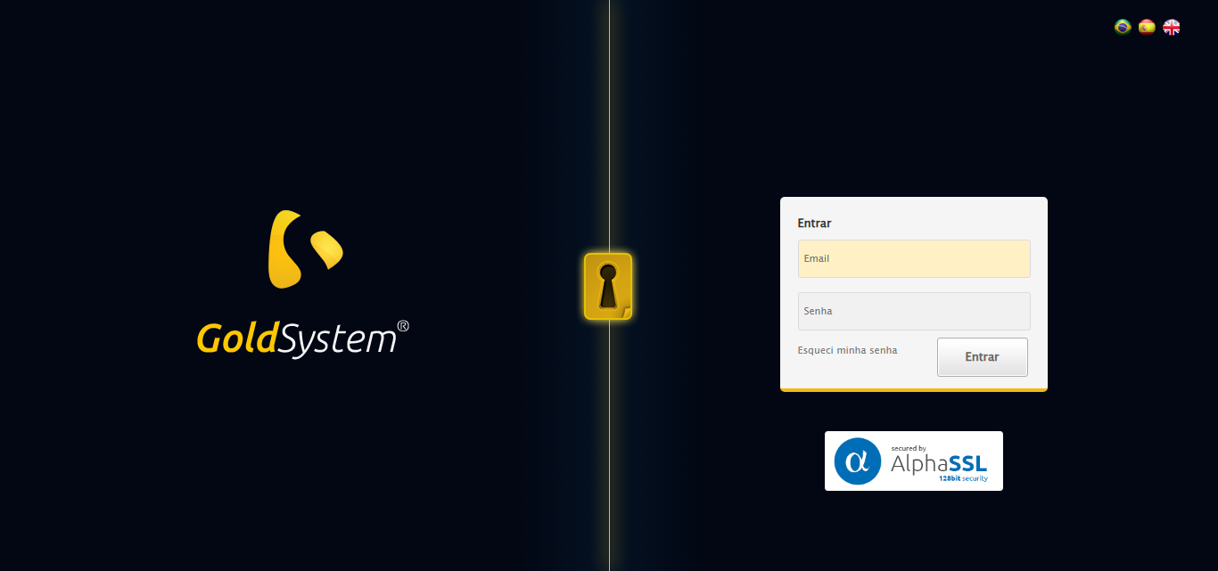

[15:53:44] 🔄 Realizando login...

[15:53:50] ✅ Realizando login realizada com sucesso.

[15:53:52] 📸 Screenshot capturada: realizando_login

Screenshot: realizando_login

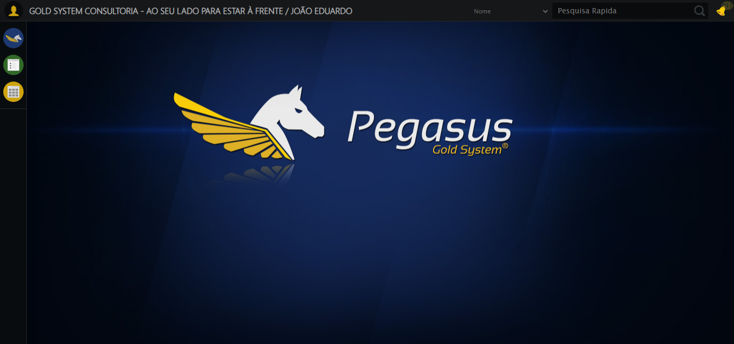

[15:53:52] 🔄 Configurando ambiente...

[15:53:52] 🔍 Zoom ajustado para 90%.

[15:53:54] ✅ Configurando ambiente realizada com sucesso.

[15:53:56] 📸 Screenshot capturada: configurando_ambiente

Screenshot: configurando_ambiente

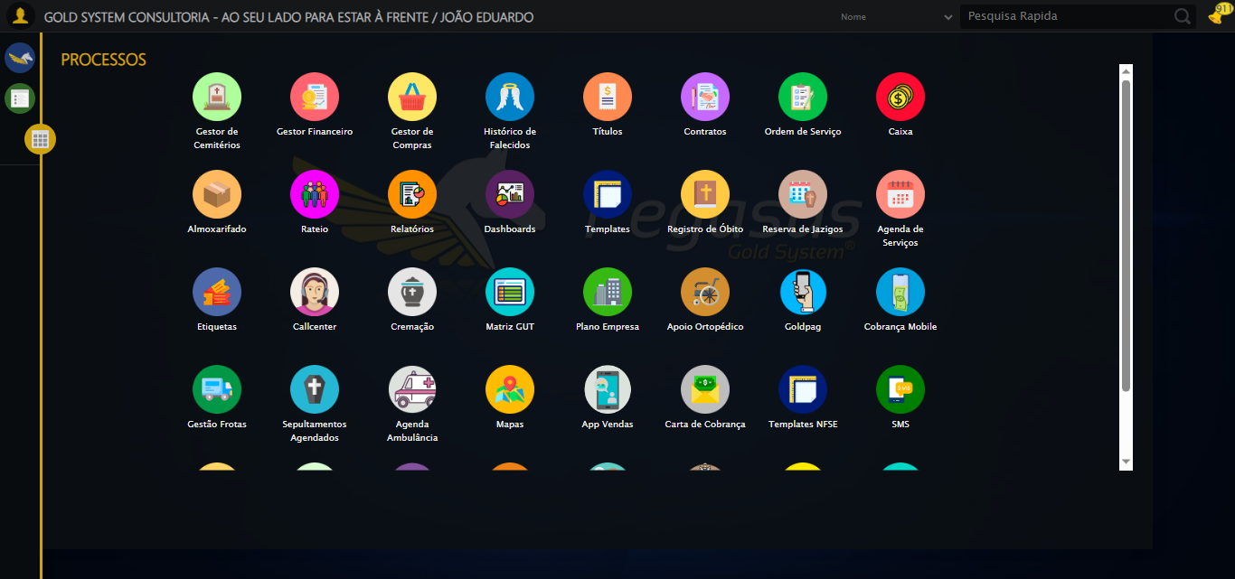

[15:53:56] 🔄 Acessando módulo Callcenter...

[15:53:56] Tentando estratégia de scroll 1...

[15:53:56] ✅ Scroll realizado com estratégia 1

[15:53:58] Tentando estratégia de clique 1 para módulo PET...

[15:54:00] ✅ Clique no módulo PET realizado com estratégia 1

[15:54:00] ✅ Acessando módulo Callcenter realizada com sucesso.

[15:54:01] 📸 Screenshot capturada: acessando_módulo_callcenter

Screenshot: acessando_módulo_callcenter

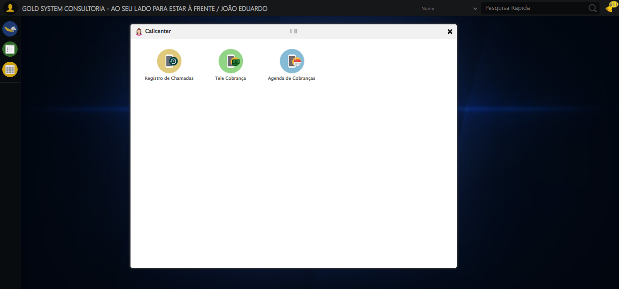

[15:54:01] 🔄 Abrindo Registro de Chamadas...

[15:54:04] ✅ Abrindo Registro de Chamadas realizada com sucesso.

[15:54:05] 📸 Screenshot capturada: abrindo_registro_de_chamadas

Screenshot: abrindo_registro_de_chamadas

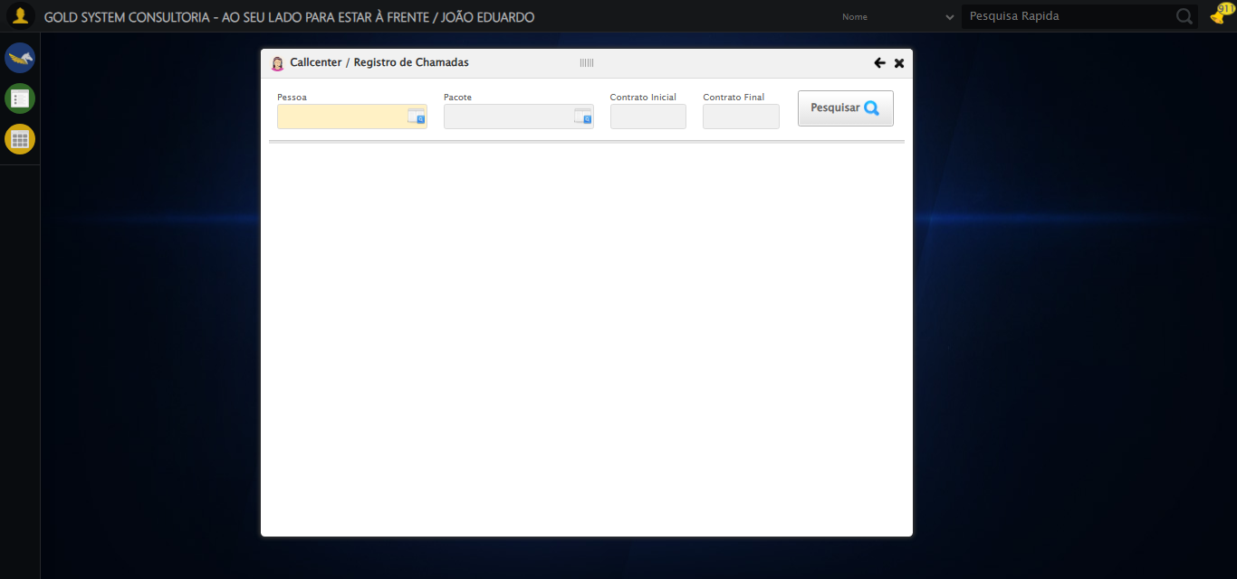

[15:54:05] 🔄 Selecionando Pessoa...

[15:54:05] 🔘 Abrindo modal com botão: #gsCallCenter > div.wdTelas > div.telaRegistroChamadas.telaConsulta.relative > div.formRow.formLastLine > div:nth-child(1) > div > a

[15:54:05] Tentando estratégia de scroll 1...

[15:54:06] ✅ Scroll realizado com estratégia 1

[15:54:08] 🔍 Preenchendo pesquisa com: TESTE TITULAR 233

[15:54:09] 🔍 Executando pesquisa...

[15:54:12] 🎯 Selecionando resultado: //td[contains(text(), 'TESTE TITULAR 233')]

[15:54:12] Tentando estratégia de scroll 1...

[15:54:13] ✅ Scroll realizado com estratégia 1

[15:54:15] ✅ Seleção no modal concluída

[15:54:15] ✅ Selecionando Pessoa realizada com sucesso.

[15:54:16] 📸 Screenshot capturada: selecionando_pessoa

Screenshot: selecionando_pessoa

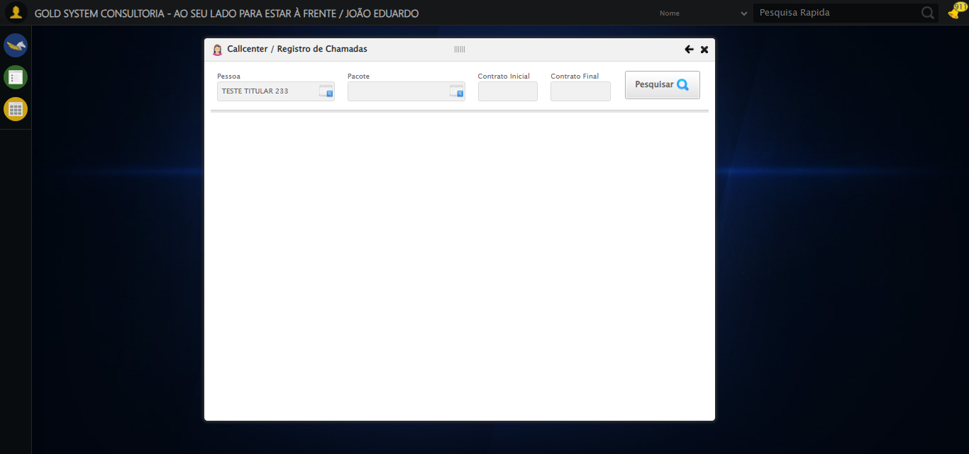

[15:54:16] 🔄 Selecionando Pacote...

[15:54:16] 🔘 Abrindo modal com botão: #gsCallCenter > div.wdTelas > div.telaRegistroChamadas.telaConsulta.relative > div.formRow.formLastLine > div:nth-child(2) > div > a

[15:54:16] Tentando estratégia de scroll 1...

[15:54:17] ✅ Scroll realizado com estratégia 1

[15:54:19] 🔍 Preenchendo pesquisa com: PRO MAX TITANIUM

[15:54:20] 🔍 Executando pesquisa...

[15:54:23] 🎯 Selecionando resultado: //td[contains(text(), 'PRO MAX TITANIUM')]

[15:54:23] Tentando estratégia de scroll 1...

[15:54:24] ✅ Scroll realizado com estratégia 1

[15:54:26] ✅ Seleção no modal concluída

[15:54:26] ✅ Selecionando Pacote realizada com sucesso.

[15:54:27] 📸 Screenshot capturada: selecionando_pacote

Screenshot: selecionando_pacote

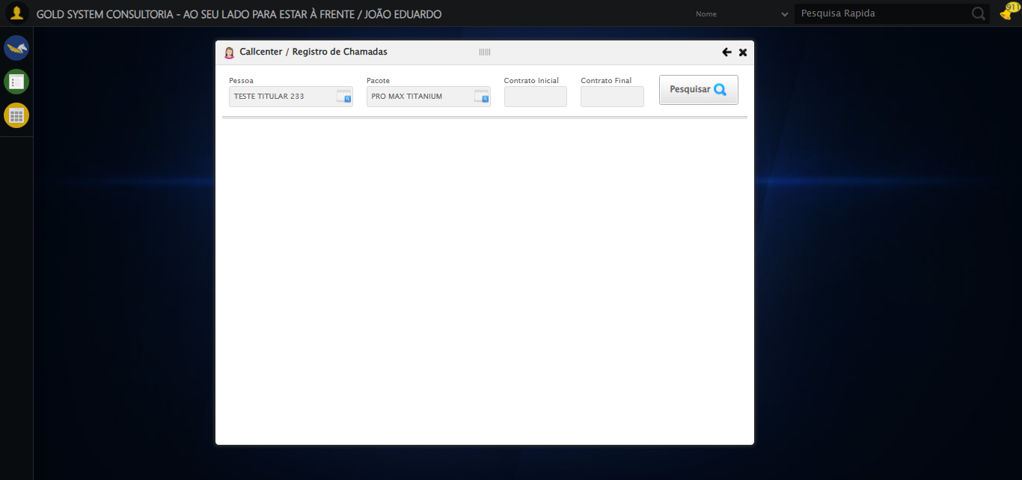

[15:54:27] 🔄 Preenchendo Número do Contrato Inicial...

[15:54:27] Tentando estratégia de scroll 1...

[15:54:28] ✅ Scroll realizado com estratégia 1

[15:54:29] ✅ Campo preenchido com estratégia 1: '113060'

[15:54:29] ✅ Preenchendo Número do Contrato Inicial realizada com sucesso.

[15:54:30] 📸 Screenshot capturada: preenchendo_número_do_contrato_inicial

Screenshot: preenchendo_número_do_contrato_inicial

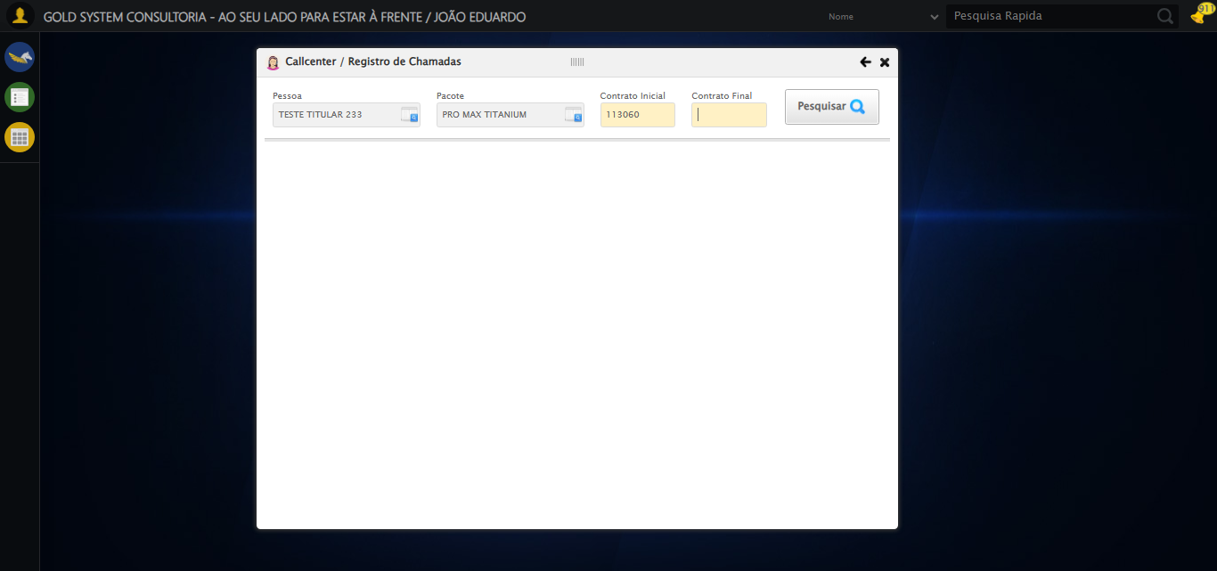

[15:54:30] 🔄 Preenchendo Número do Contrato Final...

[15:54:30] Tentando estratégia de scroll 1...

[15:54:31] ✅ Scroll realizado com estratégia 1

[15:54:32] ✅ Campo preenchido com estratégia 1: '113060'

[15:54:32] ✅ Preenchendo Número do Contrato Final realizada com sucesso.

[15:54:33] 📸 Screenshot capturada: preenchendo_número_do_contrato_final

Screenshot: preenchendo_número_do_contrato_final

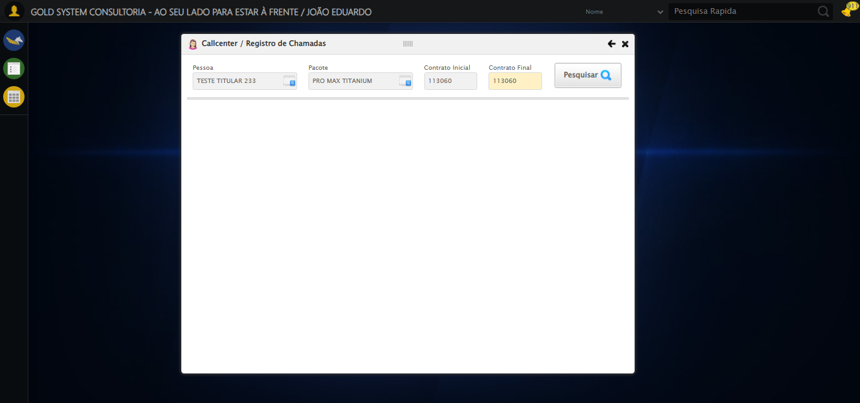

[15:54:33] 🔄 Realizando consulta...

[15:54:33] Tentando estratégia de scroll 1...

[15:54:34] ✅ Scroll realizado com estratégia 1

[15:54:36] ✅ Consulta executada

[15:54:36] ✅ Realizando consulta realizada com sucesso.

[15:54:38] 📸 Screenshot capturada: realizando_consulta

Screenshot: realizando_consulta

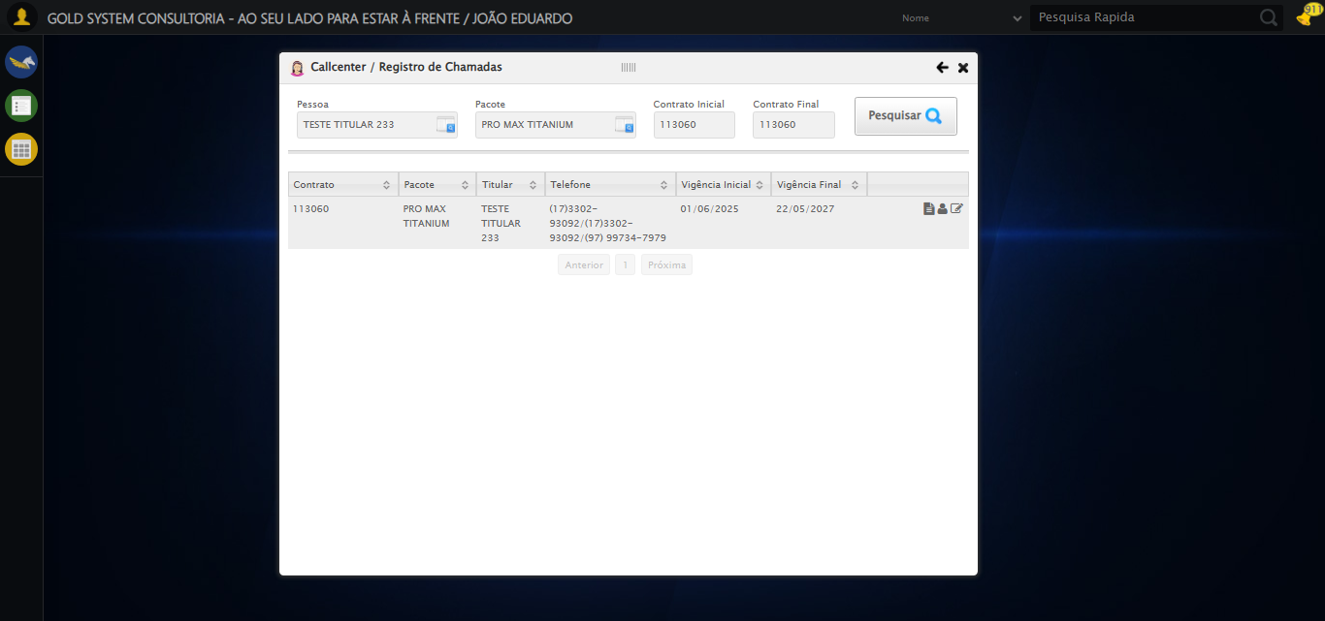

[15:54:38] 🔄 Validando resultados da consulta...

[15:54:38] 🔍 Iniciando validação de registros...

[15:54:43] ✅ Tabela encontrada: #DataTables_Table_2

[15:54:43] ✅ Encontradas 1 linhas válidas com tbody tr:not(.dataTables_empty):not([class*="no-data"])

[15:54:43] ✅ 1 registro(s) encontrado(s)

[15:54:43] Registro 1: 113060 pro max titanium teste titular 233 (17)3302-93092/(17)3302-93092/(97) 99734-7979 01/06/2025 2...

[15:54:43] ✅ Validando resultados da consulta realizada com sucesso.

[15:54:44] 📸 Screenshot capturada: validando_resultados_da_consulta

Screenshot: validando_resultados_da_consulta



[15:54:44] ✅ Processando 1 registro(s) encontrado(s)

[15:54:44] 🔄 Visualizando dados do Contrato...

[15:54:44] Tentando estratégia de scroll 1...

[15:54:45] ✅ Scroll realizado com estratégia 1

[15:54:46] ✅ Clique realizado com estratégia 1

[15:54:46] ✅ Visualizando dados do Contrato realizada com sucesso.

[15:54:47] 📸 Screenshot capturada: visualizando_dados_do_contrato

Screenshot: visualizando_dados_do_contrato

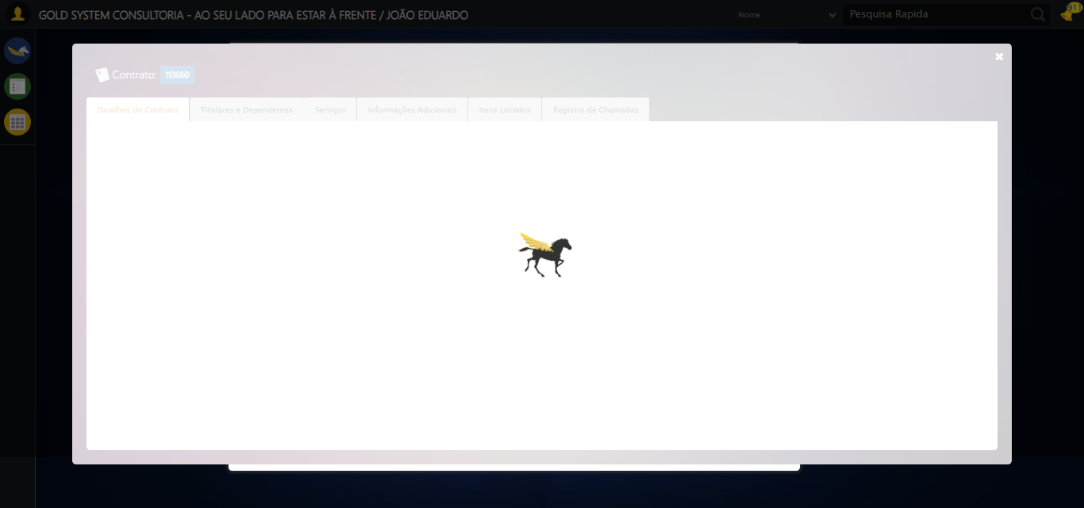

[15:54:47] 🔄 Capturando tela de dados...

[15:54:50] 📸 Screenshot capturada: dados_contrato_pet

Screenshot: dados_contrato_pet

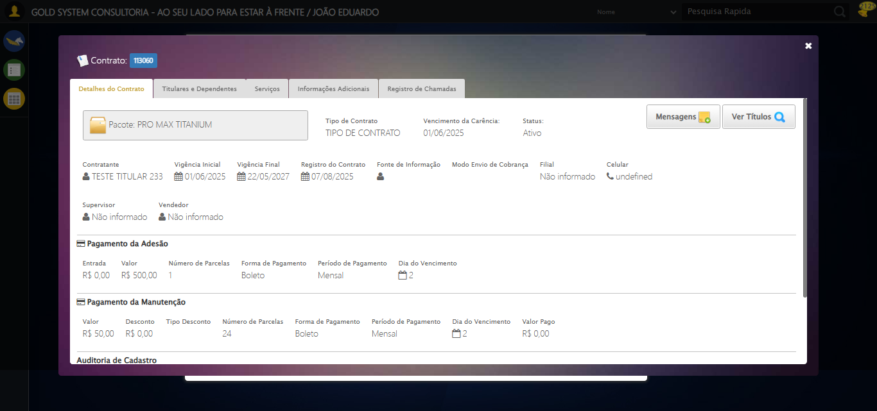

[15:54:50] ✅ Capturando tela de dados realizada com sucesso.

[15:54:51] 📸 Screenshot capturada: capturando_tela_de_dados

Screenshot: capturando_tela_de_dados



[15:54:51] 🔄 Abrindo mensagens do Contrato...

[15:54:51] Tentando estratégia de scroll 1...

[15:54:52] ✅ Scroll realizado com estratégia 1

[15:54:53] ✅ Clique realizado com estratégia 1

[15:54:53] ✅ Abrindo mensagens do Contrato realizada com sucesso.

[15:54:54] 📸 Screenshot capturada: abrindo_mensagens_do_contrato

Screenshot: abrindo_mensagens_do_contrato

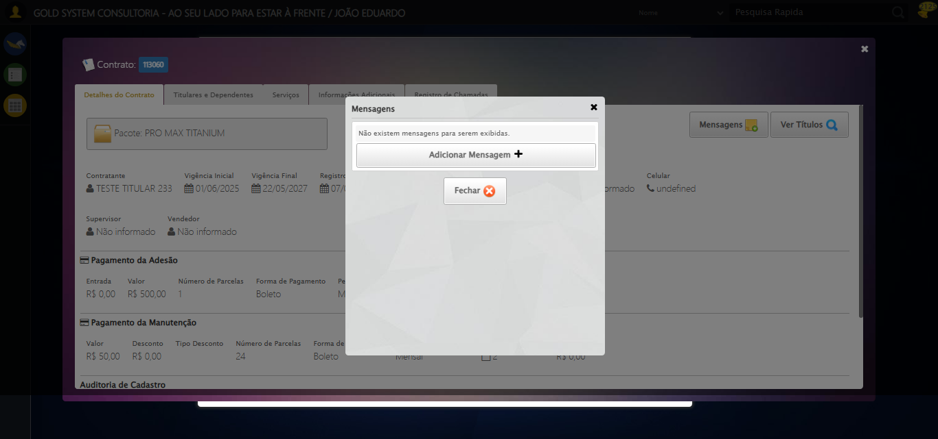

[15:54:54] 🔄 Capturando mensagens...

[15:54:56] 📸 Screenshot capturada: mensagens_contrato_pet

Screenshot: mensagens_contrato_pet



[15:54:56] ✅ Capturando mensagens realizada com sucesso.

[15:54:57] 📸 Screenshot capturada: capturando_mensagens

Screenshot: capturando_mensagens



[15:54:57] 🔄 Adicionando nova mensagem...

[15:55:27] ❌ Timeout aguardando elemento: /html/body/div[21]/div[2]/div[1]/div[1]/div/a (condição: present, timeout: 30s)

[15:55:27] ❌ Falha ao clicar em /html/body/div[21]/div[2]/div[1]/div[1]/div/a: Message: Elemento não encontrado: /html/body/div[21]/div[2]/div[1]/div[1]/div/a (condição: present)

[15:55:27] 📸 Screenshot capturada: erro_adicionando_nova_mensagem

Screenshot: erro_adicionando_nova_mensagem

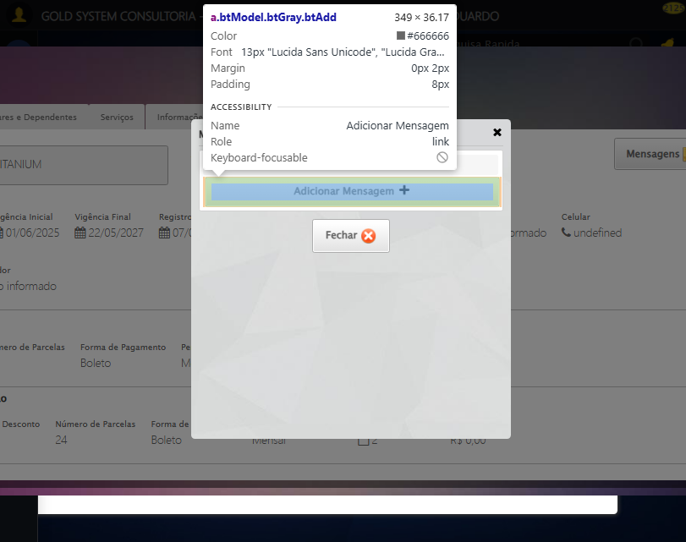

[15:55:27] ❌ Adicionando nova mensagem falhou: TimeoutException: Message: Elemento não encontrado: /html/body/div[21]/div[2]/div[1]/div[1]/div/a (condição: present)

[15:55:27] ⚠️ Continuando execução apesar do erro em: Adicionando nova mensagem

[15:55:27] 🔄 Preenchendo descrição da mensagem...

[15:55:27] ⚠️ Nenhuma <textarea> encontrada (tentativa 1/5)

[15:55:29] ⚠️ Nenhuma <textarea> encontrada (tentativa 2/5)

[15:55:30] ⚠️ Nenhuma <textarea> encontrada (tentativa 3/5)

[15:55:32] ⚠️ Nenhuma <textarea> encontrada (tentativa 4/5)

[15:55:34] 📸 Screenshot capturada: erro_preenchendo_descrição_da_mensagem

Screenshot: erro_preenchendo_descrição_da_mensagem

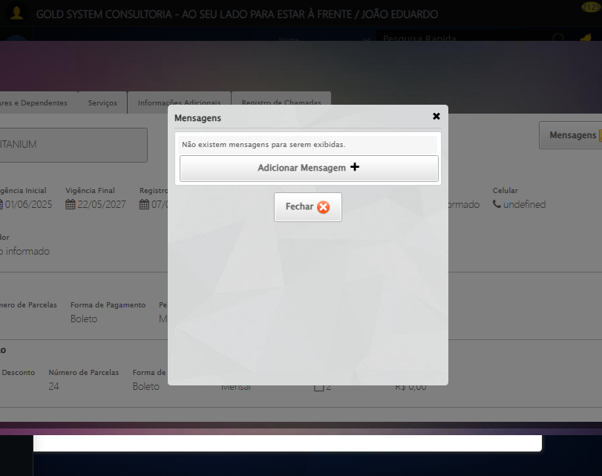

[15:55:34] ❌ Preenchendo descrição da mensagem falhou: Exception: Nenhuma <textarea> foi encontrada na página.

[15:55:34] ⚠️ Continuando execução apesar do erro em: Preenchendo descrição da mensagem

[15:55:34] 🔄 Definindo período de exibição - Data Inicial...

[15:55:34] 📊 Encontrados 0 campos datepicker

[15:55:34] ⚠️ Nenhum campo datepicker encontrado, tentativa 1/5

[15:55:36] 📊 Encontrados 0 campos datepicker

[15:55:36] ⚠️ Nenhum campo datepicker encontrado, tentativa 2/5

[15:55:39] 📊 Encontrados 0 campos datepicker

[15:55:39] ⚠️ Nenhum campo datepicker encontrado, tentativa 3/5

[15:55:41] 📊 Encontrados 0 campos datepicker

[15:55:41] ⚠️ Nenhum campo datepicker encontrado, tentativa 4/5

[15:55:43] 📊 Encontrados 0 campos datepicker

[15:55:43] 📸 Screenshot capturada: erro_definindo_período_de_exibição_-_data_inicial

Screenshot: erro_definindo_período_de_exibição_-_data_inicial



[15:55:43] ❌ Definindo período de exibição - Data Inicial falhou: Exception: Nenhum campo datepicker encontrado na página

[15:55:43] ⚠️ Continuando execução apesar do erro em: Definindo período de exibição - Data Inicial

[15:55:43] 🔄 Definindo período de exibição - Data Final...

[15:55:43] 📊 Encontrados 0 campos datepicker

[15:55:43] ⚠️ Nenhum campo datepicker encontrado, tentativa 1/5

[15:55:45] 📊 Encontrados 0 campos datepicker

[15:55:45] ⚠️ Nenhum campo datepicker encontrado, tentativa 2/5

[15:55:48] 📊 Encontrados 0 campos datepicker

[15:55:48] ⚠️ Nenhum campo datepicker encontrado, tentativa 3/5

[15:55:50] 📊 Encontrados 0 campos datepicker

[15:55:50] ⚠️ Nenhum campo datepicker encontrado, tentativa 4/5

[15:55:52] 📊 Encontrados 0 campos datepicker

[15:55:53] 📸 Screenshot capturada: erro_definindo_período_de_exibição_-_data_final

Screenshot: erro_definindo_período_de_exibição_-_data_final

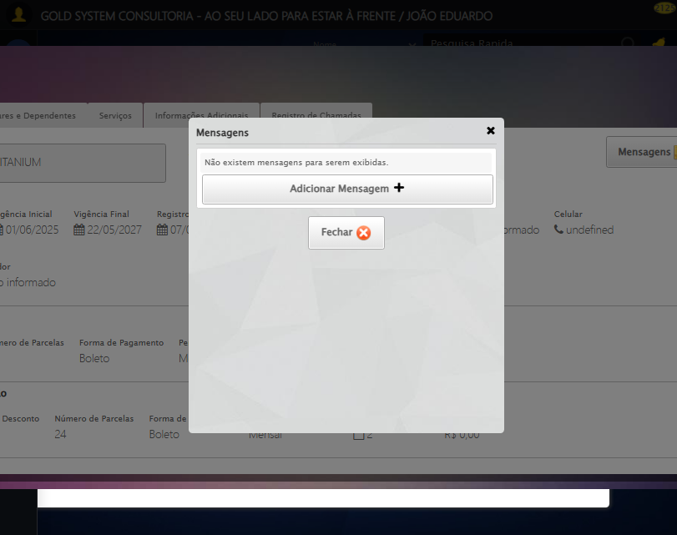

[15:55:53] ❌ Definindo período de exibição - Data Final falhou: Exception: Nenhum campo datepicker encontrado na página

[15:55:53] ⚠️ Continuando execução apesar do erro em: Definindo período de exibição - Data Final

[15:55:53] 🔄 Confirmando mensagem...

[15:56:23] ❌ Timeout aguardando elemento: /html/body/div[22]/div[2]/div[1]/div[3]/a[2] (condição: present, timeout: 30s)

[15:56:23] ❌ Falha ao clicar em /html/body/div[22]/div[2]/div[1]/div[3]/a[2]: Message: Elemento não encontrado: /html/body/div[22]/div[2]/div[1]/div[3]/a[2] (condição: present)

[15:56:23] 📸 Screenshot capturada: erro_confirmando_mensagem

Screenshot: erro_confirmando_mensagem

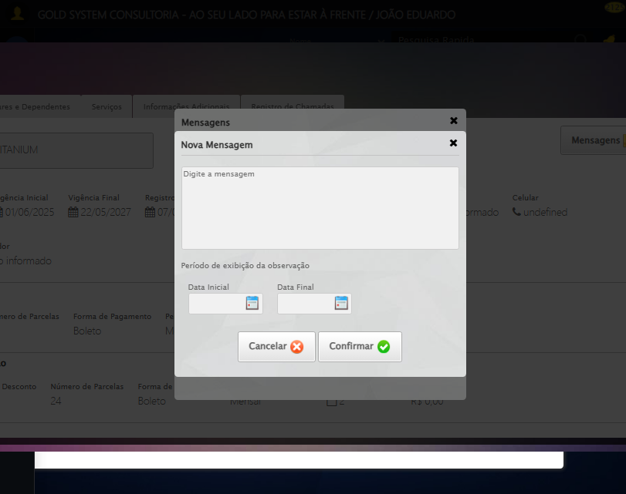

[15:56:23] ❌ Confirmando mensagem falhou: TimeoutException: Message: Elemento não encontrado: /html/body/div[22]/div[2]/div[1]/div[3]/a[2] (condição: present)

[15:56:23] ⚠️ Continuando execução apesar do erro em: Confirmando mensagem

[15:56:23] 🔍 Verificando mensagens de alerta...

[15:56:23] 🔄 Fechando aba de mensagens...

[15:56:23] Tentando estratégia de scroll 1...

[15:56:24] ✅ Scroll realizado com estratégia 1

[15:56:25] ✅ Clique realizado com estratégia 1

[15:56:25] ✅ Fechando aba de mensagens realizada com sucesso.

[15:56:27] 📸 Screenshot capturada: fechando_aba_de_mensagens

Screenshot: fechando_aba_de_mensagens

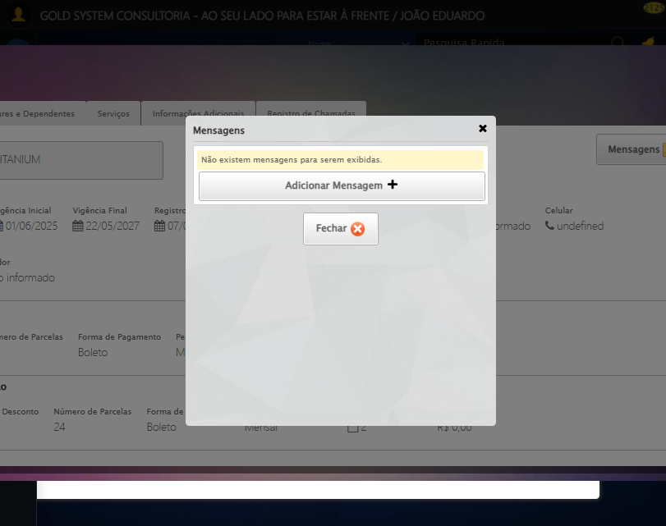

[15:56:27] 🔄 Visualizando títulos do Contrato...

[15:56:27] ⚠️ Elemento não está visível para scroll

[15:56:27] ⚠️ Problemas com scroll, continuando mesmo assim: //button[@class='btModel btGray' and .//i[contains(@class, 'sprites sp-pesquisar')] and normalize-space(text())='Ver Títulos']

[15:56:32] ❌ Timeout aguardando elemento: //button[@class='btModel btGray' and .//i[contains(@class, 'sprites sp-pesquisar')] and normalize-space(text())='Ver Títulos'] (condição: clickable, timeout: 5s)

[15:56:32] ⚠️ Elemento não ficou clicável, tentando mesmo assim: //button[@class='btModel btGray' and .//i[contains(@class, 'sprites sp-pesquisar')] and normalize-space(text())='Ver Títulos']

[15:56:32] ⚠️ Estratégia 1 de clique falhou: Message: element not interactable  
 (Session info: chrome=138.0.7204.185); For documentation on this error, please visit: https://www.selenium.dev/documentation/webdriver/troubleshooting/errors#elementnotinteractableexception  
Stacktrace:  
 GetHandleVerifier [0x0x62ba83+63395]  
 GetHandleVerifier [0x0x62bac4+63460]  
 (No symbol) [0x0x471f70]  
 (No symbol) [0x0x4bb9f4]  
 (No symbol) [0x0x4b0515]  
 (No symbol) [0x0x4df3ac]  
 (No symbol) [0x0x4affa4]  
 (No symbol) [0x0x4df624]  
 (No symbol) [0x0x5007ba]  
 (No symbol) [0x0x4df1a6]  
 (No symbol) [0x0x4ae7b2]  
 (No symbol) [0x0x4af654]  
 GetHandleVerifier [0x0x8a8883+2672035]  
 GetHandleVerifier [0x0x8a3cba+2652634]  
 GetHandleVerifier [0x0x652bca+223466]  
 GetHandleVerifier [0x0x642cb8+158168]  
 GetHandleVerifier [0x0x64978d+185517]  
 GetHandleVerifier [0x0x633b78+96408]  
 GetHandleVerifier [0x0x633d02+96802]  
 GetHandleVerifier [0x0x61e90a+9770]  
 BaseThreadInitThunk [0x0x75abfcc9+25]  
 RtlGetAppContainerNamedObjectPath [0x0x776d82ae+286]  
 RtlGetAppContainerNamedObjectPath [0x0x776d827e+238]

[15:56:33] ⚠️ Estratégia 2 de clique falhou: Message: move target out of bounds  
 (Session info: chrome=138.0.7204.185)  
Stacktrace:  
 GetHandleVerifier [0x0x62ba83+63395]  
 GetHandleVerifier [0x0x62bac4+63460]  
 (No symbol) [0x0x471f70]  
 (No symbol) [0x0x508e98]  
 (No symbol) [0x0x4df3ac]  
 (No symbol) [0x0x5007ba]  
 (No symbol) [0x0x4df1a6]  
 (No symbol) [0x0x4ae7b2]  
 (No symbol) [0x0x4af654]  
 GetHandleVerifier [0x0x8a8883+2672035]  
 GetHandleVerifier [0x0x8a3cba+2652634]  
 GetHandleVerifier [0x0x652bca+223466]  
 GetHandleVerifier [0x0x642cb8+158168]  
 GetHandleVerifier [0x0x64978d+185517]  
 GetHandleVerifier [0x0x633b78+96408]  
 GetHandleVerifier [0x0x633d02+96802]  
 GetHandleVerifier [0x0x61e90a+9770]  
 BaseThreadInitThunk [0x0x75abfcc9+25]  
 RtlGetAppContainerNamedObjectPath [0x0x776d82ae+286]  
 RtlGetAppContainerNamedObjectPath [0x0x776d827e+238]

[15:56:34] ✅ Clique realizado com estratégia 3

[15:56:34] ✅ Visualizando títulos do Contrato realizada com sucesso.

[15:56:36] 📸 Screenshot capturada: visualizando_títulos_do_contrato

Screenshot: visualizando_títulos_do_contrato

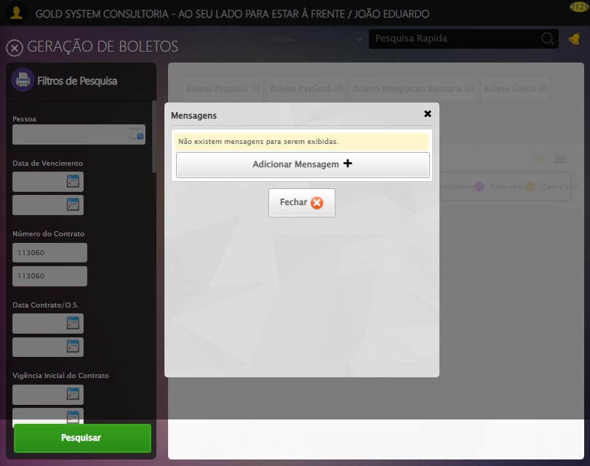

[15:56:36] 🔄 Aguardando carregamento de títulos e capturando Screenshot...

[15:57:06] 📸 Screenshot capturada: titulos_contrato_pet

Screenshot: titulos_contrato_pet

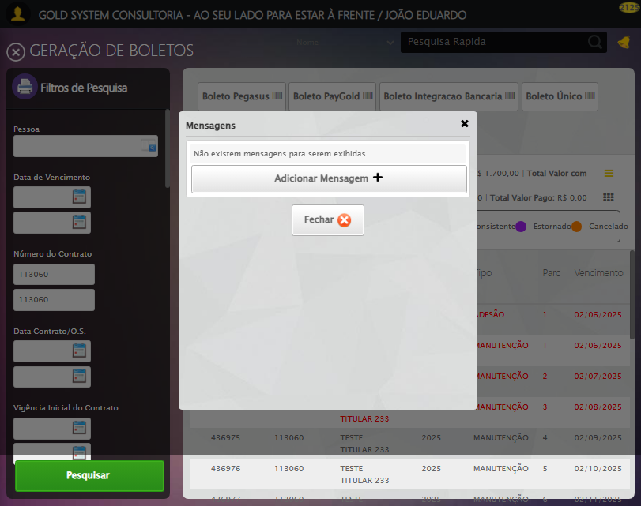

[15:57:06] ✅ Aguardando carregamento de títulos e capturando Screenshot realizada com sucesso.

[15:57:07] 📸 Screenshot capturada: aguardando_carregamento_de_títulos_e_capturando_screenshot

Screenshot: aguardando_carregamento_de_títulos_e_capturando_screenshot

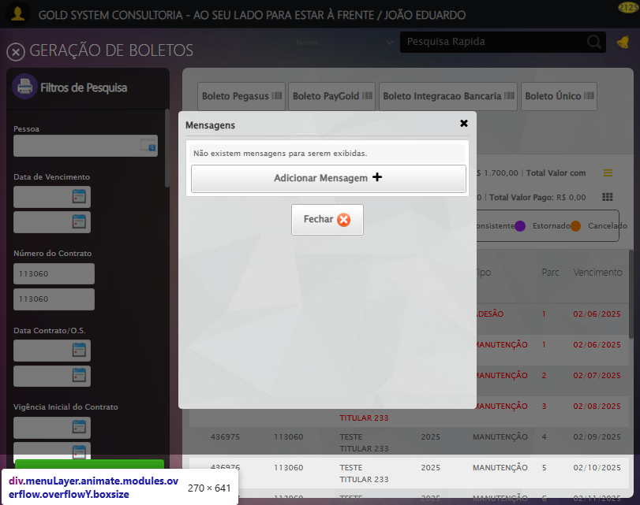

[15:57:07] 🔄 Fechando aba de títulos...

[15:57:07] Tentando estratégia de scroll 1...

[15:57:08] ✅ Scroll realizado com estratégia 1

[15:57:09] ⚠️ Estratégia 1 de clique falhou: Message: element click intercepted: Element <a class="sprites sp-fecharGrande" title="Sair"></a> is not clickable at point (19, 65). Other element would receive the click: <div class="blockScreen" style="height: 641px; z-index: 10003; opacity: 0.5;"></div>  
 (Session info: chrome=138.0.7204.185); For documentation on this error, please visit: https://www.selenium.dev/documentation/webdriver/troubleshooting/errors#elementclickinterceptedexception  
Stacktrace:  
 GetHandleVerifier [0x0x62ba83+63395]  
 GetHandleVerifier [0x0x62bac4+63460]  
 (No symbol) [0x0x472113]  
 (No symbol) [0x0x4c0ba0]  
 (No symbol) [0x0x4bef5a]  
 (No symbol) [0x0x4bcab7]  
 (No symbol) [0x0x4bbd6d]  
 (No symbol) [0x0x4b0515]  
 (No symbol) [0x0x4df3ac]  
 (No symbol) [0x0x4affa4]  
 (No symbol) [0x0x4df624]  
 (No symbol) [0x0x5007ba]  
 (No symbol) [0x0x4df1a6]  
 (No symbol) [0x0x4ae7b2]  
 (No symbol) [0x0x4af654]  
 GetHandleVerifier [0x0x8a8883+2672035]  
 GetHandleVerifier [0x0x8a3cba+2652634]  
 GetHandleVerifier [0x0x652bca+223466]  
 GetHandleVerifier [0x0x642cb8+158168]  
 GetHandleVerifier [0x0x64978d+185517]  
 GetHandleVerifier [0x0x633b78+96408]  
 GetHandleVerifier [0x0x633d02+96802]  
 GetHandleVerifier [0x0x61e90a+9770]  
 BaseThreadInitThunk [0x0x75abfcc9+25]  
 RtlGetAppContainerNamedObjectPath [0x0x776d82ae+286]  
 RtlGetAppContainerNamedObjectPath [0x0x776d827e+238]

[15:57:10] ✅ Clique realizado com estratégia 2

[15:57:10] ✅ Fechando aba de títulos realizada com sucesso.

[15:57:11] 📸 Screenshot capturada: fechando_aba_de_títulos

Screenshot: fechando_aba_de_títulos

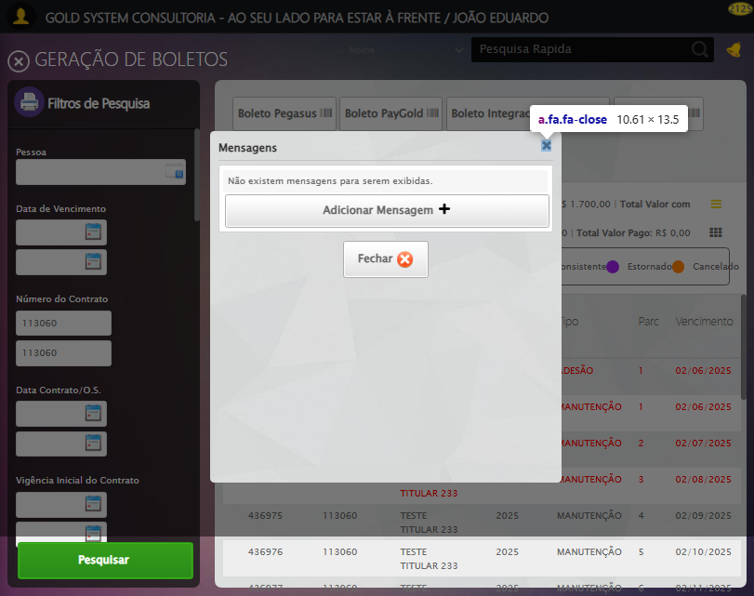

[15:57:11] 🔄 Abrindo Dados do Titular...

[15:57:12] ⚠️ Elemento não está visível para scroll

[15:57:12] ⚠️ Problemas com scroll, continuando mesmo assim: //span[contains(@class,'btTitular') and @title='Dados do Titular']

[15:57:17] ❌ Timeout aguardando elemento: //span[contains(@class,'btTitular') and @title='Dados do Titular'] (condição: clickable, timeout: 5s)

[15:57:17] ⚠️ Elemento não ficou clicável, tentando mesmo assim: //span[contains(@class,'btTitular') and @title='Dados do Titular']

[15:57:17] ⚠️ Estratégia 1 de clique falhou: Message: element not interactable  
 (Session info: chrome=138.0.7204.185); For documentation on this error, please visit: https://www.selenium.dev/documentation/webdriver/troubleshooting/errors#elementnotinteractableexception  
Stacktrace:  
 GetHandleVerifier [0x0x62ba83+63395]  
 GetHandleVerifier [0x0x62bac4+63460]  
 (No symbol) [0x0x471f70]  
 (No symbol) [0x0x4bb9f4]  
 (No symbol) [0x0x4b0515]  
 (No symbol) [0x0x4df3ac]  
 (No symbol) [0x0x4affa4]  
 (No symbol) [0x0x4df624]  
 (No symbol) [0x0x5007ba]  
 (No symbol) [0x0x4df1a6]  
 (No symbol) [0x0x4ae7b2]  
 (No symbol) [0x0x4af654]  
 GetHandleVerifier [0x0x8a8883+2672035]  
 GetHandleVerifier [0x0x8a3cba+2652634]  
 GetHandleVerifier [0x0x652bca+223466]  
 GetHandleVerifier [0x0x642cb8+158168]  
 GetHandleVerifier [0x0x64978d+185517]  
 GetHandleVerifier [0x0x633b78+96408]  
 GetHandleVerifier [0x0x633d02+96802]  
 GetHandleVerifier [0x0x61e90a+9770]  
 BaseThreadInitThunk [0x0x75abfcc9+25]  
 RtlGetAppContainerNamedObjectPath [0x0x776d82ae+286]  
 RtlGetAppContainerNamedObjectPath [0x0x776d827e+238]

[15:57:17] ⚠️ Estratégia 2 de clique falhou: Message: element not interactable: [object HTMLSpanElement] has no size and location  
 (Session info: chrome=138.0.7204.185); For documentation on this error, please visit: https://www.selenium.dev/documentation/webdriver/troubleshooting/errors#elementnotinteractableexception  
Stacktrace:  
 GetHandleVerifier [0x0x62ba83+63395]  
 GetHandleVerifier [0x0x62bac4+63460]  
 (No symbol) [0x0x472113]  
 (No symbol) [0x0x4788e9]  
 (No symbol) [0x0x47ac7a]  
 (No symbol) [0x0x47acf7]  
 (No symbol) [0x0x4c02b4]  
 (No symbol) [0x0x4bf827]  
 (No symbol) [0x0x50917f]  
 (No symbol) [0x0x4df3ac]  
 (No symbol) [0x0x5007ba]  
 (No symbol) [0x0x4df1a6]  
 (No symbol) [0x0x4ae7b2]  
 (No symbol) [0x0x4af654]  
 GetHandleVerifier [0x0x8a8883+2672035]  
 GetHandleVerifier [0x0x8a3cba+2652634]  
 GetHandleVerifier [0x0x652bca+223466]  
 GetHandleVerifier [0x0x642cb8+158168]  
 GetHandleVerifier [0x0x64978d+185517]  
 GetHandleVerifier [0x0x633b78+96408]  
 GetHandleVerifier [0x0x633d02+96802]  
 GetHandleVerifier [0x0x61e90a+9770]  
 BaseThreadInitThunk [0x0x75abfcc9+25]  
 RtlGetAppContainerNamedObjectPath [0x0x776d82ae+286]  
 RtlGetAppContainerNamedObjectPath [0x0x776d827e+238]

[15:57:18] ✅ Clique realizado com estratégia 3

[15:57:18] ✅ Abrindo Dados do Titular realizada com sucesso.

[15:57:39] 📸 Screenshot capturada: abrindo_dados_do_titular

Screenshot: abrindo_dados_do_titular

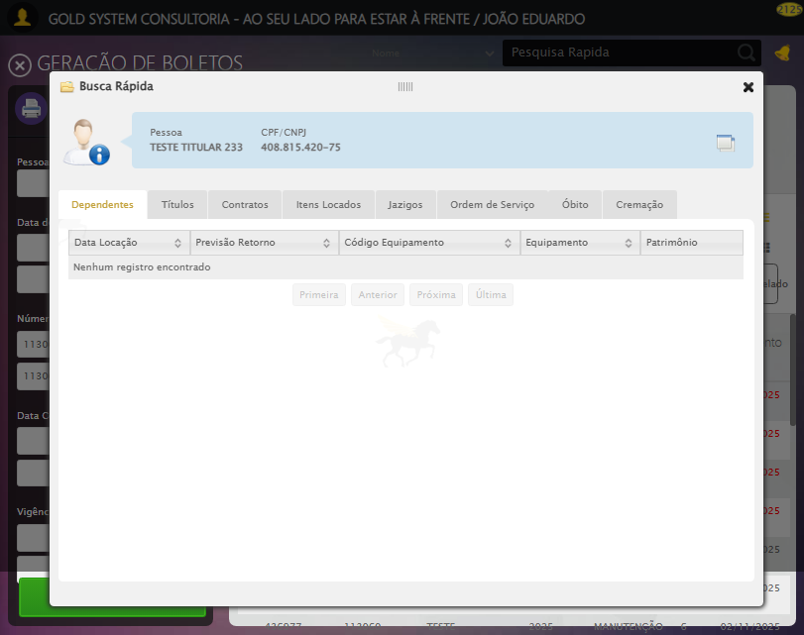

[15:57:39] 🔄 Abrindo Dados Cadastrais do Titular e capturando Screenshot da aba 'Dados Pessoais'...

[15:57:39] Tentando estratégia de scroll 1...

[15:57:40] ✅ Scroll realizado com estratégia 1

[15:57:40] ✅ Clique realizado com estratégia 1

[15:57:40] ✅ Abrindo Dados Cadastrais do Titular e capturando Screenshot da aba 'Dados Pessoais' realizada com sucesso.

[15:57:42] 📸 Screenshot capturada: abrindo_dados_cadastrais_do_titular_e_capturando_screenshot_da_aba_dados_pessoais_

Screenshot: abrindo_dados_cadastrais_do_titular_e_capturando_screenshot_da_aba_dados_pessoais_

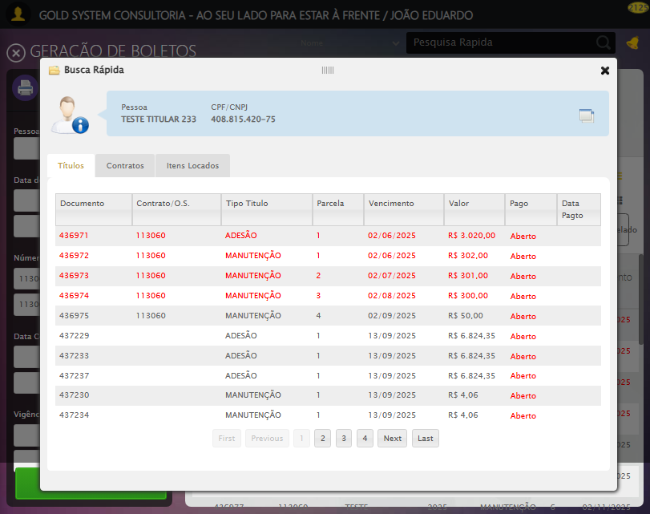

[15:57:42] 🔄 Clicando na aba 'Dados Complementares' e capturando Screenshot...

[15:57:42] Tentando estratégia de scroll 1...

[15:57:43] ✅ Scroll realizado com estratégia 1

[15:57:44] ✅ Clique realizado com estratégia 1

[15:57:44] ✅ Clicando na aba 'Dados Complementares' e capturando Screenshot realizada com sucesso.

[15:57:45] 📸 Screenshot capturada: clicando_na_aba_dados_complementares_e_capturando_screenshot

Screenshot: clicando_na_aba_dados_complementares_e_capturando_screenshot

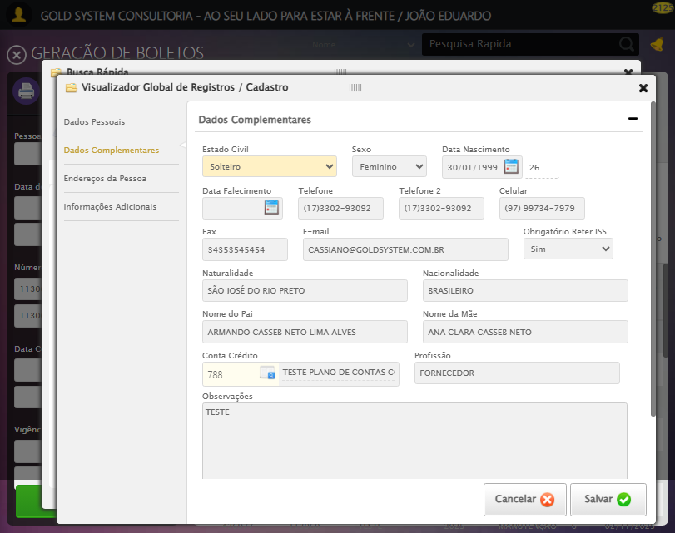

[15:57:45] 🔄 Clicando na aba 'Endereços da Pessoa' e capturando Screenshot'...

[15:57:45] Tentando estratégia de scroll 1...

[15:57:46] ✅ Scroll realizado com estratégia 1

[15:57:46] ✅ Clique realizado com estratégia 1

[15:57:46] ✅ Clicando na aba 'Endereços da Pessoa' e capturando Screenshot' realizada com sucesso.

[15:57:48] 📸 Screenshot capturada: clicando_na_aba_endereços_da_pessoa_e_capturando_screenshot_

Screenshot: clicando_na_aba_endereços_da_pessoa_e_capturando_screenshot_

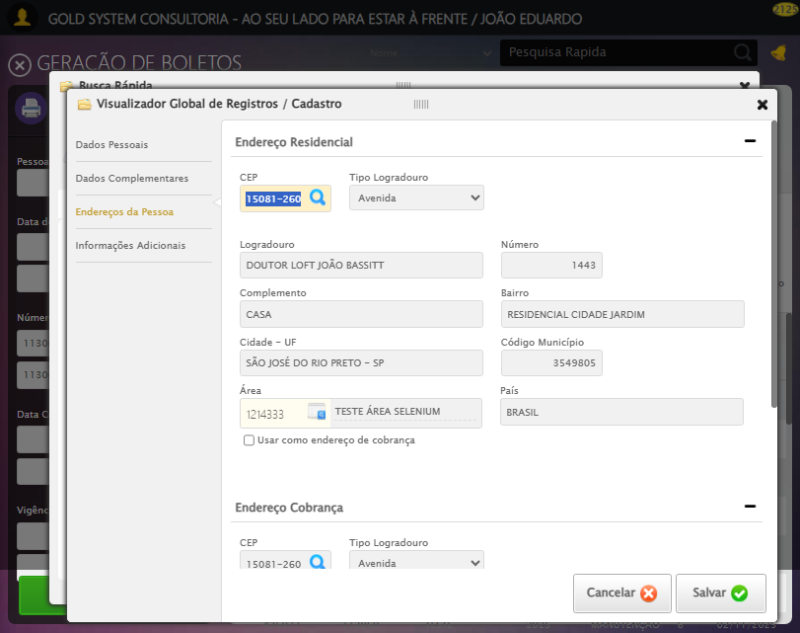

[15:57:48] 🔄 Salvando Titular...

[15:57:48] Tentando estratégia de scroll 1...

[15:57:49] ✅ Scroll realizado com estratégia 1

[15:57:49] ✅ Clique realizado com estratégia 1

[15:57:49] ✅ Salvando Titular realizada com sucesso.

[15:57:50] 📸 Screenshot capturada: salvando_titular

Screenshot: salvando_titular

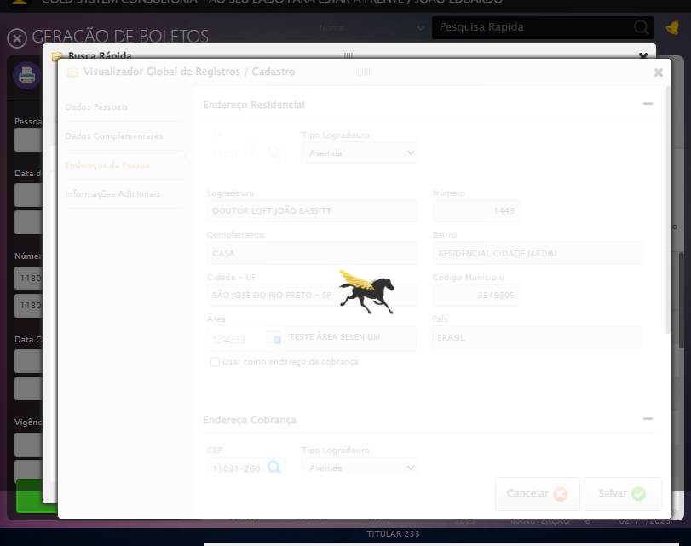

[15:57:50] 🔍 Verificando mensagens de alerta após salvar titular...

[15:57:51] 🔄 Clicando na aba 'Contratos' e capturando Screenshot...

[15:57:52] Tentando estratégia de scroll 1...

[15:57:53] ✅ Scroll realizado com estratégia 1

[15:57:54] ✅ Clique realizado com estratégia 1

[15:57:54] ✅ Clicando na aba 'Contratos' e capturando Screenshot realizada com sucesso.

[15:57:55] 📸 Screenshot capturada: clicando_na_aba_contratos_e_capturando_screenshot

Screenshot: clicando_na_aba_contratos_e_capturando_screenshot

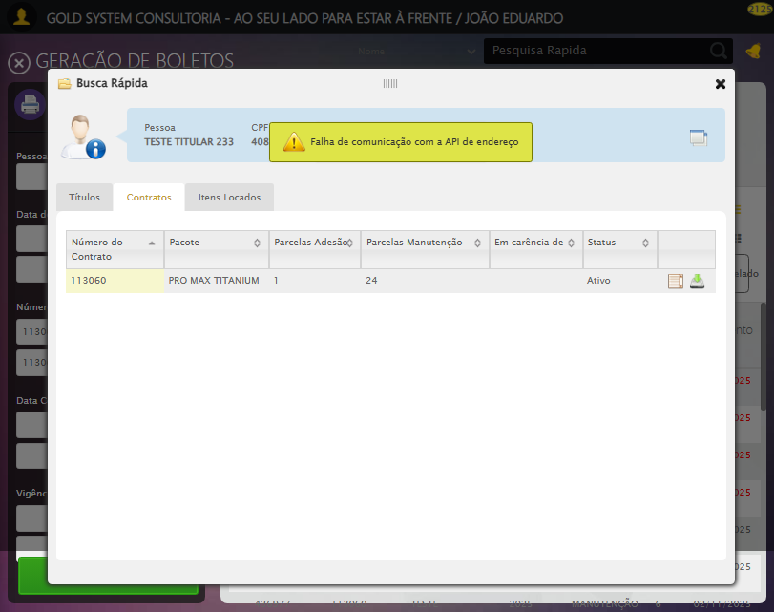

[15:57:55] 🔄 Clicando na aba 'Itens Locados' e capturando Screenshot...

[15:57:55] Tentando estratégia de scroll 1...

[15:57:56] ✅ Scroll realizado com estratégia 1

[15:57:57] ✅ Clique realizado com estratégia 1

[15:57:57] ✅ Clicando na aba 'Itens Locados' e capturando Screenshot realizada com sucesso.

[15:57:59] 📸 Screenshot capturada: clicando_na_aba_itens_locados_e_capturando_screenshot

Screenshot: clicando_na_aba_itens_locados_e_capturando_screenshot

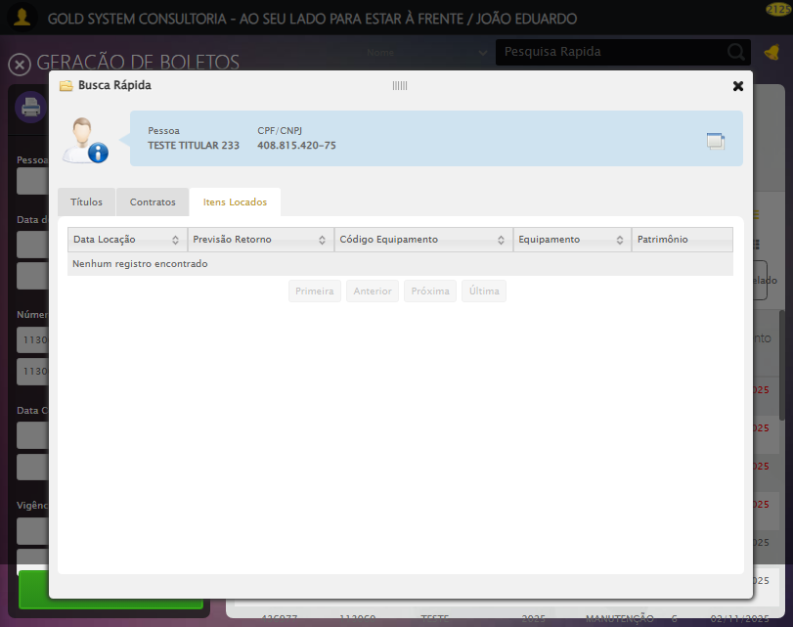

[15:57:59] 🔄 Fechando aba de Busca Rápida...

[15:57:59] ⚠️ Elemento não está visível para scroll

[15:57:59] ⚠️ Problemas com scroll, continuando mesmo assim: //a[contains(@class,'sp-close') and normalize-space(text())='X']

[15:58:04] ❌ Timeout aguardando elemento: //a[contains(@class,'sp-close') and normalize-space(text())='X'] (condição: clickable, timeout: 5s)

[15:58:04] ⚠️ Elemento não ficou clicável, tentando mesmo assim: //a[contains(@class,'sp-close') and normalize-space(text())='X']

[15:58:04] ⚠️ Estratégia 1 de clique falhou: Message: element not interactable  
 (Session info: chrome=138.0.7204.185); For documentation on this error, please visit: https://www.selenium.dev/documentation/webdriver/troubleshooting/errors#elementnotinteractableexception  
Stacktrace:  
 GetHandleVerifier [0x0x62ba83+63395]  
 GetHandleVerifier [0x0x62bac4+63460]  
 (No symbol) [0x0x471f70]  
 (No symbol) [0x0x4bb9f4]  
 (No symbol) [0x0x4b0515]  
 (No symbol) [0x0x4df3ac]  
 (No symbol) [0x0x4affa4]  
 (No symbol) [0x0x4df624]  
 (No symbol) [0x0x5007ba]  
 (No symbol) [0x0x4df1a6]  
 (No symbol) [0x0x4ae7b2]  
 (No symbol) [0x0x4af654]  
 GetHandleVerifier [0x0x8a8883+2672035]  
 GetHandleVerifier [0x0x8a3cba+2652634]  
 GetHandleVerifier [0x0x652bca+223466]  
 GetHandleVerifier [0x0x642cb8+158168]  
 GetHandleVerifier [0x0x64978d+185517]  
 GetHandleVerifier [0x0x633b78+96408]  
 GetHandleVerifier [0x0x633d02+96802]  
 GetHandleVerifier [0x0x61e90a+9770]  
 BaseThreadInitThunk [0x0x75abfcc9+25]  
 RtlGetAppContainerNamedObjectPath [0x0x776d82ae+286]  
 RtlGetAppContainerNamedObjectPath [0x0x776d827e+238]

[15:58:04] ⚠️ Estratégia 2 de clique falhou: Message: element not interactable: has no size and location  
 (Session info: chrome=138.0.7204.185); For documentation on this error, please visit: https://www.selenium.dev/documentation/webdriver/troubleshooting/errors#elementnotinteractableexception  
Stacktrace:  
 GetHandleVerifier [0x0x62ba83+63395]  
 GetHandleVerifier [0x0x62bac4+63460]  
 (No symbol) [0x0x472113]  
 (No symbol) [0x0x4788e9]  
 (No symbol) [0x0x47ac7a]  
 (No symbol) [0x0x47acf7]  
 (No symbol) [0x0x4c02b4]  
 (No symbol) [0x0x4bf827]  
 (No symbol) [0x0x50917f]  
 (No symbol) [0x0x4df3ac]  
 (No symbol) [0x0x5007ba]  
 (No symbol) [0x0x4df1a6]  
 (No symbol) [0x0x4ae7b2]  
 (No symbol) [0x0x4af654]  
 GetHandleVerifier [0x0x8a8883+2672035]  
 GetHandleVerifier [0x0x8a3cba+2652634]  
 GetHandleVerifier [0x0x652bca+223466]  
 GetHandleVerifier [0x0x642cb8+158168]  
 GetHandleVerifier [0x0x64978d+185517]  
 GetHandleVerifier [0x0x633b78+96408]  
 GetHandleVerifier [0x0x633d02+96802]  
 GetHandleVerifier [0x0x61e90a+9770]  
 BaseThreadInitThunk [0x0x75abfcc9+25]  
 RtlGetAppContainerNamedObjectPath [0x0x776d82ae+286]  
 RtlGetAppContainerNamedObjectPath [0x0x776d827e+238]

[15:58:05] ✅ Clique realizado com estratégia 3

[15:58:05] ✅ Fechando aba de Busca Rápida realizada com sucesso.

[15:58:06] 📸 Screenshot capturada: fechando_aba_de_busca_rápida

Screenshot: fechando_aba_de_busca_rápida

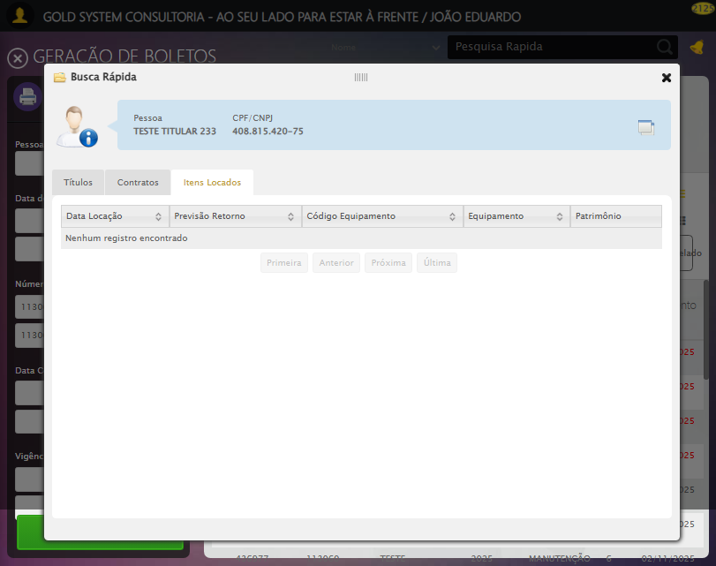

[15:58:06] 🔄 Clicando em Adicionar Contato...

[15:58:06] ⚠️ Elemento não está visível para scroll

[15:58:06] ⚠️ Problemas com scroll, continuando mesmo assim: //span[contains(@class,'btEdit') and @title='Adicionar contato']

[15:58:08] ❌ Erro aguardando elemento //span[contains(@class,'btEdit') and @title='Adicionar contato']: Message: invalid session id: session deleted as the browser has closed the connection  
from disconnected: not connected to DevTools  
 (Session info: chrome=138.0.7204.185); For documentation on this error, please visit: https://www.selenium.dev/documentation/webdriver/troubleshooting/errors#invalidsessionidexception  
Stacktrace:  
 GetHandleVerifier [0x0x62ba83+63395]  
 GetHandleVerifier [0x0x62bac4+63460]  
 (No symbol) [0x0x472113]  
 (No symbol) [0x0x461b20]  
 (No symbol) [0x0x47f922]  
 (No symbol) [0x0x4e5c9c]  
 (No symbol) [0x0x500099]  
 (No symbol) [0x0x4df1a6]  
 (No symbol) [0x0x4ae7b2]  
 (No symbol) [0x0x4af654]  
 GetHandleVerifier [0x0x8a8883+2672035]  
 GetHandleVerifier [0x0x8a3cba+2652634]  
 GetHandleVerifier [0x0x652bca+223466]  
 GetHandleVerifier [0x0x642cb8+158168]  
 GetHandleVerifier [0x0x64978d+185517]  
 GetHandleVerifier [0x0x633b78+96408]  
 GetHandleVerifier [0x0x633d02+96802]  
 GetHandleVerifier [0x0x61e90a+9770]  
 BaseThreadInitThunk [0x0x75abfcc9+25]  
 RtlGetAppContainerNamedObjectPath [0x0x776d82ae+286]  
 RtlGetAppContainerNamedObjectPath [0x0x776d827e+238]

[15:58:08] ❌ Falha ao clicar em //span[contains(@class,'btEdit') and @title='Adicionar contato']: Message: invalid session id: session deleted as the browser has closed the connection  
from disconnected: not connected to DevTools  
 (Session info: chrome=138.0.7204.185); For documentation on this error, please visit: https://www.selenium.dev/documentation/webdriver/troubleshooting/errors#invalidsessionidexception  
Stacktrace:  
 GetHandleVerifier [0x0x62ba83+63395]  
 GetHandleVerifier [0x0x62bac4+63460]  
 (No symbol) [0x0x472113]  
 (No symbol) [0x0x461b20]  
 (No symbol) [0x0x47f922]  
 (No symbol) [0x0x4e5c9c]  
 (No symbol) [0x0x500099]  
 (No symbol) [0x0x4df1a6]  
 (No symbol) [0x0x4ae7b2]  
 (No symbol) [0x0x4af654]  
 GetHandleVerifier [0x0x8a8883+2672035]  
 GetHandleVerifier [0x0x8a3cba+2652634]  
 GetHandleVerifier [0x0x652bca+223466]  
 GetHandleVerifier [0x0x642cb8+158168]  
 GetHandleVerifier [0x0x64978d+185517]  
 GetHandleVerifier [0x0x633b78+96408]  
 GetHandleVerifier [0x0x633d02+96802]  
 GetHandleVerifier [0x0x61e90a+9770]  
 BaseThreadInitThunk [0x0x75abfcc9+25]  
 RtlGetAppContainerNamedObjectPath [0x0x776d82ae+286]  
 RtlGetAppContainerNamedObjectPath [0x0x776d827e+238]

[15:58:08] ⚠️ Erro ao tirar screenshot erro_clicando_em_adicionar_contato: Message: invalid session id; For documentation on this error, please visit: https://www.selenium.dev/documentation/webdriver/troubleshooting/errors#invalidsessionidexception  
Stacktrace:  
 GetHandleVerifier [0x0x62ba83+63395]  
 GetHandleVerifier [0x0x62bac4+63460]  
 (No symbol) [0x0x471f70]  
 (No symbol) [0x0x4adaa8]  
 (No symbol) [0x0x4df266]  
 (No symbol) [0x0x4dae65]  
 (No symbol) [0x0x4da3e6]  
 (No symbol) [0x0x443a45]  
 (No symbol) [0x0x443f9e]  
 (No symbol) [0x0x44442d]  
 GetHandleVerifier [0x0x8a8883+2672035]  
 GetHandleVerifier [0x0x8a3cba+2652634]  
 GetHandleVerifier [0x0x652bca+223466]  
 GetHandleVerifier [0x0x642cb8+158168]  
 GetHandleVerifier [0x0x64978d+185517]  
 (No symbol) [0x0x443710]  
 (No symbol) [0x0x442f1d]  
 GetHandleVerifier [0x0x9ddb9c+3938492]  
 BaseThreadInitThunk [0x0x75abfcc9+25]  
 RtlGetAppContainerNamedObjectPath [0x0x776d82ae+286]  
 RtlGetAppContainerNamedObjectPath [0x0x776d827e+238]

[15:58:08] ❌ Clicando em Adicionar Contato falhou: InvalidSessionIdException: Message: invalid session id: session deleted as the browser has closed the connection  
from disconnected: not connected to DevTools  
 (Session info: chrome=138.0.7204.185); For documentation on this error, please visit: https://www.selenium.dev/documentation/webdriver/troubleshooting/errors#invalidsessionidexception  
Stacktrace:  
 GetHandleVerifier [0x0x62ba83+63395]  
 GetHandleVerifier [0x0x62bac4+63460]  
 (No symbol) [0x0x472113]  
 (No symbol) [0x0x461b20]  
 (No symbol) [0x0x47f922]  
 (No symbol) [0x0x4e5c9c]  
 (No symbol) [0x0x500099]  
 (No symbol) [0x0x4df1a6]  
 (No symbol) [0x0x4ae7b2]  
 (No symbol) [0x0x4af654]  
 GetHandleVerifier [0x0x8a8883+2672035]  
 GetHandleVerifier [0x0x8a3cba+2652634]  
 GetHandleVerifier [0x0x652bca+223466]  
 GetHandleVerifier [0x0x642cb8+158168]  
 GetHandleVerifier [0x0x64978d+185517]  
 GetHandleVerifier [0x0x633b78+96408]  
 GetHandleVerifier [0x0x633d02+96802]  
 GetHandleVerifier [0x0x61e90a+9770]  
 BaseThreadInitThunk [0x0x75abfcc9+25]  
 RtlGetAppContainerNamedObjectPath [0x0x776d82ae+286]  
 RtlGetAppContainerNamedObjectPath [0x0x776d827e+238]

[15:58:08] ⚠️ Continuando execução apesar do erro em: Clicando em Adicionar Contato

[15:58:08] 🔄 Preenchendo registro de contato...

[15:58:08] ⚠️ Nenhuma <textarea> encontrada (tentativa 1/5)

[15:58:10] ⚠️ Nenhuma <textarea> encontrada (tentativa 2/5)

[15:58:11] ⚠️ Nenhuma <textarea> encontrada (tentativa 3/5)

[15:58:13] ⚠️ Nenhuma <textarea> encontrada (tentativa 4/5)

[15:58:14] ⚠️ Erro ao tirar screenshot erro_preenchendo_registro_de_contato: Message: invalid session id; For documentation on this error, please visit: https://www.selenium.dev/documentation/webdriver/troubleshooting/errors#invalidsessionidexception  
Stacktrace:  
 GetHandleVerifier [0x0x62ba83+63395]  
 GetHandleVerifier [0x0x62bac4+63460]  
 (No symbol) [0x0x471f70]  
 (No symbol) [0x0x4adaa8]  
 (No symbol) [0x0x4df266]  
 (No symbol) [0x0x4dae65]  
 (No symbol) [0x0x4da3e6]  
 (No symbol) [0x0x443a45]  
 (No symbol) [0x0x443f9e]  
 (No symbol) [0x0x44442d]  
 GetHandleVerifier [0x0x8a8883+2672035]  
 GetHandleVerifier [0x0x8a3cba+2652634]  
 GetHandleVerifier [0x0x652bca+223466]  
 GetHandleVerifier [0x0x642cb8+158168]  
 GetHandleVerifier [0x0x64978d+185517]  
 (No symbol) [0x0x443710]  
 (No symbol) [0x0x442f1d]  
 GetHandleVerifier [0x0x9ddb9c+3938492]  
 BaseThreadInitThunk [0x0x75abfcc9+25]  
 RtlGetAppContainerNamedObjectPath [0x0x776d82ae+286]  
 RtlGetAppContainerNamedObjectPath [0x0x776d827e+238]

[15:58:14] ❌ Preenchendo registro de contato falhou: Exception: Nenhuma <textarea> foi encontrada na página.

[15:58:14] ⚠️ Continuando execução apesar do erro em: Preenchendo registro de contato

[15:58:14] 🔄 Salvando Contato...

[15:58:14] ❌ Erro aguardando elemento //button[contains(@class,'btGray') and contains(normalize-space(.),'Salvar')]: Message: invalid session id; For documentation on this error, please visit: https://www.selenium.dev/documentation/webdriver/troubleshooting/errors#invalidsessionidexception  
Stacktrace:  
 GetHandleVerifier [0x0x62ba83+63395]  
 GetHandleVerifier [0x0x62bac4+63460]  
 (No symbol) [0x0x471f70]  
 (No symbol) [0x0x4adaa8]  
 (No symbol) [0x0x4df266]  
 (No symbol) [0x0x4dae65]  
 (No symbol) [0x0x4da3e6]  
 (No symbol) [0x0x443a45]  
 (No symbol) [0x0x443f9e]  
 (No symbol) [0x0x44442d]  
 GetHandleVerifier [0x0x8a8883+2672035]  
 GetHandleVerifier [0x0x8a3cba+2652634]  
 GetHandleVerifier [0x0x652bca+223466]  
 GetHandleVerifier [0x0x642cb8+158168]  
 GetHandleVerifier [0x0x64978d+185517]  
 (No symbol) [0x0x443710]  
 (No symbol) [0x0x442f1d]  
 GetHandleVerifier [0x0x9ddb9c+3938492]  
 BaseThreadInitThunk [0x0x75abfcc9+25]  
 RtlGetAppContainerNamedObjectPath [0x0x776d82ae+286]  
 RtlGetAppContainerNamedObjectPath [0x0x776d827e+238]

[15:58:14] ❌ Falha ao clicar em //button[contains(@class,'btGray') and contains(normalize-space(.),'Salvar')]: Message: invalid session id; For documentation on this error, please visit: https://www.selenium.dev/documentation/webdriver/troubleshooting/errors#invalidsessionidexception  
Stacktrace:  
 GetHandleVerifier [0x0x62ba83+63395]  
 GetHandleVerifier [0x0x62bac4+63460]  
 (No symbol) [0x0x471f70]  
 (No symbol) [0x0x4adaa8]  
 (No symbol) [0x0x4df266]  
 (No symbol) [0x0x4dae65]  
 (No symbol) [0x0x4da3e6]  
 (No symbol) [0x0x443a45]  
 (No symbol) [0x0x443f9e]  
 (No symbol) [0x0x44442d]  
 GetHandleVerifier [0x0x8a8883+2672035]  
 GetHandleVerifier [0x0x8a3cba+2652634]  
 GetHandleVerifier [0x0x652bca+223466]  
 GetHandleVerifier [0x0x642cb8+158168]  
 GetHandleVerifier [0x0x64978d+185517]  
 (No symbol) [0x0x443710]  
 (No symbol) [0x0x442f1d]  
 GetHandleVerifier [0x0x9ddb9c+3938492]  
 BaseThreadInitThunk [0x0x75abfcc9+25]  
 RtlGetAppContainerNamedObjectPath [0x0x776d82ae+286]  
 RtlGetAppContainerNamedObjectPath [0x0x776d827e+238]

[15:58:14] ⚠️ Erro ao tirar screenshot erro_salvando_contato: Message: invalid session id; For documentation on this error, please visit: https://www.selenium.dev/documentation/webdriver/troubleshooting/errors#invalidsessionidexception  
Stacktrace:  
 GetHandleVerifier [0x0x62ba83+63395]  
 GetHandleVerifier [0x0x62bac4+63460]  
 (No symbol) [0x0x471f70]  
 (No symbol) [0x0x4adaa8]  
 (No symbol) [0x0x4df266]  
 (No symbol) [0x0x4dae65]  
 (No symbol) [0x0x4da3e6]  
 (No symbol) [0x0x443a45]  
 (No symbol) [0x0x443f9e]  
 (No symbol) [0x0x44442d]  
 GetHandleVerifier [0x0x8a8883+2672035]  
 GetHandleVerifier [0x0x8a3cba+2652634]  
 GetHandleVerifier [0x0x652bca+223466]  
 GetHandleVerifier [0x0x642cb8+158168]  
 GetHandleVerifier [0x0x64978d+185517]  
 (No symbol) [0x0x443710]  
 (No symbol) [0x0x442f1d]  
 GetHandleVerifier [0x0x9ddb9c+3938492]  
 BaseThreadInitThunk [0x0x75abfcc9+25]  
 RtlGetAppContainerNamedObjectPath [0x0x776d82ae+286]  
 RtlGetAppContainerNamedObjectPath [0x0x776d827e+238]

[15:58:15] ❌ Salvando Contato falhou: InvalidSessionIdException: Message: invalid session id; For documentation on this error, please visit: https://www.selenium.dev/documentation/webdriver/troubleshooting/errors#invalidsessionidexception  
Stacktrace:  
 GetHandleVerifier [0x0x62ba83+63395]  
 GetHandleVerifier [0x0x62bac4+63460]  
 (No symbol) [0x0x471f70]  
 (No symbol) [0x0x4adaa8]  
 (No symbol) [0x0x4df266]  
 (No symbol) [0x0x4dae65]  
 (No symbol) [0x0x4da3e6]  
 (No symbol) [0x0x443a45]  
 (No symbol) [0x0x443f9e]  
 (No symbol) [0x0x44442d]  
 GetHandleVerifier [0x0x8a8883+2672035]  
 GetHandleVerifier [0x0x8a3cba+2652634]  
 GetHandleVerifier [0x0x652bca+223466]  
 GetHandleVerifier [0x0x642cb8+158168]  
 GetHandleVerifier [0x0x64978d+185517]  
 (No symbol) [0x0x443710]  
 (No symbol) [0x0x442f1d]  
 GetHandleVerifier [0x0x9ddb9c+3938492]  
 BaseThreadInitThunk [0x0x75abfcc9+25]  
 RtlGetAppContainerNamedObjectPath [0x0x776d82ae+286]  
 RtlGetAppContainerNamedObjectPath [0x0x776d827e+238]

[15:58:15] ⚠️ Continuando execução apesar do erro em: Salvando Contato

[15:58:15] 🔍 Verificando mensagens de alerta após salvar Contato...

[15:58:15] ⚠️ Erro ao buscar alerta .alerts.salvo: Message: invalid session id; For documentation on this error, please visit: https://www.selenium.dev/documentation/webdriver/troubleshooting/errors#invalidsessionidexception  
Stacktrace:  
 GetHandleVerifier [0x0x62ba83+63395]  
 GetHandleVerifier [0x0x62bac4+63460]  
 (No symbol) [0x0x471f70]  
 (No symbol) [0x0x4adaa8]  
 (No symbol) [0x0x4df266]  
 (No symbol) [0x0x4dae65]  
 (No symbol) [0x0x4da3e6]  
 (No symbol) [0x0x443a45]  
 (No symbol) [0x0x443f9e]  
 (No symbol) [0x0x44442d]  
 GetHandleVerifier [0x0x8a8883+2672035]  
 GetHandleVerifier [0x0x8a3cba+2652634]  
 GetHandleVerifier [0x0x652bca+223466]  
 GetHandleVerifier [0x0x642cb8+158168]  
 GetHandleVerifier [0x0x64978d+185517]  
 (No symbol) [0x0x443710]  
 (No symbol) [0x0x442f1d]  
 GetHandleVerifier [0x0x9ddb9c+3938492]  
 BaseThreadInitThunk [0x0x75abfcc9+25]  
 RtlGetAppContainerNamedObjectPath [0x0x776d82ae+286]  
 RtlGetAppContainerNamedObjectPath [0x0x776d827e+238]

[15:58:15] ⚠️ Erro ao buscar alerta .alerts.alerta: Message: invalid session id; For documentation on this error, please visit: https://www.selenium.dev/documentation/webdriver/troubleshooting/errors#invalidsessionidexception  
Stacktrace:  
 GetHandleVerifier [0x0x62ba83+63395]  
 GetHandleVerifier [0x0x62bac4+63460]  
 (No symbol) [0x0x471f70]  
 (No symbol) [0x0x4adaa8]  
 (No symbol) [0x0x4df266]  
 (No symbol) [0x0x4dae65]  
 (No symbol) [0x0x4da3e6]  
 (No symbol) [0x0x443a45]  
 (No symbol) [0x0x443f9e]  
 (No symbol) [0x0x44442d]  
 GetHandleVerifier [0x0x8a8883+2672035]  
 GetHandleVerifier [0x0x8a3cba+2652634]  
 GetHandleVerifier [0x0x652bca+223466]  
 GetHandleVerifier [0x0x642cb8+158168]  
 GetHandleVerifier [0x0x64978d+185517]  
 (No symbol) [0x0x443710]  
 (No symbol) [0x0x442f1d]  
 GetHandleVerifier [0x0x9ddb9c+3938492]  
 BaseThreadInitThunk [0x0x75abfcc9+25]  
 RtlGetAppContainerNamedObjectPath [0x0x776d82ae+286]  
 RtlGetAppContainerNamedObjectPath [0x0x776d827e+238]

[15:58:15] ⚠️ Erro ao buscar alerta .alerts.erro: Message: invalid session id; For documentation on this error, please visit: https://www.selenium.dev/documentation/webdriver/troubleshooting/errors#invalidsessionidexception  
Stacktrace:  
 GetHandleVerifier [0x0x62ba83+63395]  
 GetHandleVerifier [0x0x62bac4+63460]  
 (No symbol) [0x0x471f70]  
 (No symbol) [0x0x4adaa8]  
 (No symbol) [0x0x4df266]  
 (No symbol) [0x0x4dae65]  
 (No symbol) [0x0x4da3e6]  
 (No symbol) [0x0x443a45]  
 (No symbol) [0x0x443f9e]  
 (No symbol) [0x0x44442d]  
 GetHandleVerifier [0x0x8a8883+2672035]  
 GetHandleVerifier [0x0x8a3cba+2652634]  
 GetHandleVerifier [0x0x652bca+223466]  
 GetHandleVerifier [0x0x642cb8+158168]  
 GetHandleVerifier [0x0x64978d+185517]  
 (No symbol) [0x0x443710]  
 (No symbol) [0x0x442f1d]  
 GetHandleVerifier [0x0x9ddb9c+3938492]  
 BaseThreadInitThunk [0x0x75abfcc9+25]  
 RtlGetAppContainerNamedObjectPath [0x0x776d82ae+286]  
 RtlGetAppContainerNamedObjectPath [0x0x776d827e+238]

[15:58:15] ⚠️ Erro ao buscar alerta .alert-success: Message: invalid session id; For documentation on this error, please visit: https://www.selenium.dev/documentation/webdriver/troubleshooting/errors#invalidsessionidexception  
Stacktrace:  
 GetHandleVerifier [0x0x62ba83+63395]  
 GetHandleVerifier [0x0x62bac4+63460]  
 (No symbol) [0x0x471f70]  
 (No symbol) [0x0x4adaa8]  
 (No symbol) [0x0x4df266]  
 (No symbol) [0x0x4dae65]  
 (No symbol) [0x0x4da3e6]  
 (No symbol) [0x0x443a45]  
 (No symbol) [0x0x443f9e]  
 (No symbol) [0x0x44442d]  
 GetHandleVerifier [0x0x8a8883+2672035]  
 GetHandleVerifier [0x0x8a3cba+2652634]  
 GetHandleVerifier [0x0x652bca+223466]  
 GetHandleVerifier [0x0x642cb8+158168]  
 GetHandleVerifier [0x0x64978d+185517]  
 (No symbol) [0x0x443710]  
 (No symbol) [0x0x442f1d]  
 GetHandleVerifier [0x0x9ddb9c+3938492]  
 BaseThreadInitThunk [0x0x75abfcc9+25]  
 RtlGetAppContainerNamedObjectPath [0x0x776d82ae+286]  
 RtlGetAppContainerNamedObjectPath [0x0x776d827e+238]

[15:58:15] ⚠️ Erro ao buscar alerta .alert-warning: Message: invalid session id; For documentation on this error, please visit: https://www.selenium.dev/documentation/webdriver/troubleshooting/errors#invalidsessionidexception  
Stacktrace:  
 GetHandleVerifier [0x0x62ba83+63395]  
 GetHandleVerifier [0x0x62bac4+63460]  
 (No symbol) [0x0x471f70]  
 (No symbol) [0x0x4adaa8]  
 (No symbol) [0x0x4df266]  
 (No symbol) [0x0x4dae65]  
 (No symbol) [0x0x4da3e6]  
 (No symbol) [0x0x443a45]  
 (No symbol) [0x0x443f9e]  
 (No symbol) [0x0x44442d]  
 GetHandleVerifier [0x0x8a8883+2672035]  
 GetHandleVerifier [0x0x8a3cba+2652634]  
 GetHandleVerifier [0x0x652bca+223466]  
 GetHandleVerifier [0x0x642cb8+158168]  
 GetHandleVerifier [0x0x64978d+185517]  
 (No symbol) [0x0x443710]  
 (No symbol) [0x0x442f1d]  
 GetHandleVerifier [0x0x9ddb9c+3938492]  
 BaseThreadInitThunk [0x0x75abfcc9+25]  
 RtlGetAppContainerNamedObjectPath [0x0x776d82ae+286]  
 RtlGetAppContainerNamedObjectPath [0x0x776d827e+238]

[15:58:15] ⚠️ Erro ao buscar alerta .alert-danger: Message: invalid session id; For documentation on this error, please visit: https://www.selenium.dev/documentation/webdriver/troubleshooting/errors#invalidsessionidexception  
Stacktrace:  
 GetHandleVerifier [0x0x62ba83+63395]  
 GetHandleVerifier [0x0x62bac4+63460]  
 (No symbol) [0x0x471f70]  
 (No symbol) [0x0x4adaa8]  
 (No symbol) [0x0x4df266]  
 (No symbol) [0x0x4dae65]  
 (No symbol) [0x0x4da3e6]  
 (No symbol) [0x0x443a45]  
 (No symbol) [0x0x443f9e]  
 (No symbol) [0x0x44442d]  
 GetHandleVerifier [0x0x8a8883+2672035]  
 GetHandleVerifier [0x0x8a3cba+2652634]  
 GetHandleVerifier [0x0x652bca+223466]  
 GetHandleVerifier [0x0x642cb8+158168]  
 GetHandleVerifier [0x0x64978d+185517]  
 (No symbol) [0x0x443710]  
 (No symbol) [0x0x442f1d]  
 GetHandleVerifier [0x0x9ddb9c+3938492]  
 BaseThreadInitThunk [0x0x75abfcc9+25]  
 RtlGetAppContainerNamedObjectPath [0x0x776d82ae+286]  
 RtlGetAppContainerNamedObjectPath [0x0x776d827e+238]

[15:58:15] ⚠️ Erro ao buscar alerta [class*='toast']: Message: invalid session id; For documentation on this error, please visit: https://www.selenium.dev/documentation/webdriver/troubleshooting/errors#invalidsessionidexception  
Stacktrace:  
 GetHandleVerifier [0x0x62ba83+63395]  
 GetHandleVerifier [0x0x62bac4+63460]  
 (No symbol) [0x0x471f70]  
 (No symbol) [0x0x4adaa8]  
 (No symbol) [0x0x4df266]  
 (No symbol) [0x0x4dae65]  
 (No symbol) [0x0x4da3e6]  
 (No symbol) [0x0x443a45]  
 (No symbol) [0x0x443f9e]  
 (No symbol) [0x0x44442d]  
 GetHandleVerifier [0x0x8a8883+2672035]  
 GetHandleVerifier [0x0x8a3cba+2652634]  
 GetHandleVerifier [0x0x652bca+223466]  
 GetHandleVerifier [0x0x642cb8+158168]  
 GetHandleVerifier [0x0x64978d+185517]  
 (No symbol) [0x0x443710]  
 (No symbol) [0x0x442f1d]  
 GetHandleVerifier [0x0x9ddb9c+3938492]  
 BaseThreadInitThunk [0x0x75abfcc9+25]  
 RtlGetAppContainerNamedObjectPath [0x0x776d82ae+286]  
 RtlGetAppContainerNamedObjectPath [0x0x776d827e+238]

[15:58:15] 🔄 Fechando tela de consulta...

[15:58:15] ❌ Erro aguardando elemento #gsCallCenter > div.wdTop.ui-draggable-handle > div.wdClose > a: Message: invalid session id; For documentation on this error, please visit: https://www.selenium.dev/documentation/webdriver/troubleshooting/errors#invalidsessionidexception  
Stacktrace:  
 GetHandleVerifier [0x0x62ba83+63395]  
 GetHandleVerifier [0x0x62bac4+63460]  
 (No symbol) [0x0x471f70]  
 (No symbol) [0x0x4adaa8]  
 (No symbol) [0x0x4df266]  
 (No symbol) [0x0x4dae65]  
 (No symbol) [0x0x4da3e6]  
 (No symbol) [0x0x443a45]  
 (No symbol) [0x0x443f9e]  
 (No symbol) [0x0x44442d]  
 GetHandleVerifier [0x0x8a8883+2672035]  
 GetHandleVerifier [0x0x8a3cba+2652634]  
 GetHandleVerifier [0x0x652bca+223466]  
 GetHandleVerifier [0x0x642cb8+158168]  
 GetHandleVerifier [0x0x64978d+185517]  
 (No symbol) [0x0x443710]  
 (No symbol) [0x0x442f1d]  
 GetHandleVerifier [0x0x9ddb9c+3938492]  
 BaseThreadInitThunk [0x0x75abfcc9+25]  
 RtlGetAppContainerNamedObjectPath [0x0x776d82ae+286]  
 RtlGetAppContainerNamedObjectPath [0x0x776d827e+238]

[15:58:15] ❌ Falha ao clicar em #gsCallCenter > div.wdTop.ui-draggable-handle > div.wdClose > a: Message: invalid session id; For documentation on this error, please visit: https://www.selenium.dev/documentation/webdriver/troubleshooting/errors#invalidsessionidexception  
Stacktrace:  
 GetHandleVerifier [0x0x62ba83+63395]  
 GetHandleVerifier [0x0x62bac4+63460]  
 (No symbol) [0x0x471f70]  
 (No symbol) [0x0x4adaa8]  
 (No symbol) [0x0x4df266]  
 (No symbol) [0x0x4dae65]  
 (No symbol) [0x0x4da3e6]  
 (No symbol) [0x0x443a45]  
 (No symbol) [0x0x443f9e]  
 (No symbol) [0x0x44442d]  
 GetHandleVerifier [0x0x8a8883+2672035]  
 GetHandleVerifier [0x0x8a3cba+2652634]  
 GetHandleVerifier [0x0x652bca+223466]  
 GetHandleVerifier [0x0x642cb8+158168]  
 GetHandleVerifier [0x0x64978d+185517]  
 (No symbol) [0x0x443710]  
 (No symbol) [0x0x442f1d]  
 GetHandleVerifier [0x0x9ddb9c+3938492]  
 BaseThreadInitThunk [0x0x75abfcc9+25]  
 RtlGetAppContainerNamedObjectPath [0x0x776d82ae+286]  
 RtlGetAppContainerNamedObjectPath [0x0x776d827e+238]

[15:58:15] ⚠️ Erro ao tirar screenshot erro_fechando_tela_de_consulta: Message: invalid session id; For documentation on this error, please visit: https://www.selenium.dev/documentation/webdriver/troubleshooting/errors#invalidsessionidexception  
Stacktrace:  
 GetHandleVerifier [0x0x62ba83+63395]  
 GetHandleVerifier [0x0x62bac4+63460]  
 (No symbol) [0x0x471f70]  
 (No symbol) [0x0x4adaa8]  
 (No symbol) [0x0x4df266]  
 (No symbol) [0x0x4dae65]  
 (No symbol) [0x0x4da3e6]  
 (No symbol) [0x0x443a45]  
 (No symbol) [0x0x443f9e]  
 (No symbol) [0x0x44442d]  
 GetHandleVerifier [0x0x8a8883+2672035]  
 GetHandleVerifier [0x0x8a3cba+2652634]  
 GetHandleVerifier [0x0x652bca+223466]  
 GetHandleVerifier [0x0x642cb8+158168]  
 GetHandleVerifier [0x0x64978d+185517]  
 (No symbol) [0x0x443710]  
 (No symbol) [0x0x442f1d]  
 GetHandleVerifier [0x0x9ddb9c+3938492]  
 BaseThreadInitThunk [0x0x75abfcc9+25]  
 RtlGetAppContainerNamedObjectPath [0x0x776d82ae+286]  
 RtlGetAppContainerNamedObjectPath [0x0x776d827e+238]

[15:58:15] ❌ Fechando tela de consulta falhou: InvalidSessionIdException: Message: invalid session id; For documentation on this error, please visit: https://www.selenium.dev/documentation/webdriver/troubleshooting/errors#invalidsessionidexception  
Stacktrace:  
 GetHandleVerifier [0x0x62ba83+63395]  
 GetHandleVerifier [0x0x62bac4+63460]  
 (No symbol) [0x0x471f70]  
 (No symbol) [0x0x4adaa8]  
 (No symbol) [0x0x4df266]  
 (No symbol) [0x0x4dae65]  
 (No symbol) [0x0x4da3e6]  
 (No symbol) [0x0x443a45]  
 (No symbol) [0x0x443f9e]  
 (No symbol) [0x0x44442d]  
 GetHandleVerifier [0x0x8a8883+2672035]  
 GetHandleVerifier [0x0x8a3cba+2652634]  
 GetHandleVerifier [0x0x652bca+223466]  
 GetHandleVerifier [0x0x642cb8+158168]  
 GetHandleVerifier [0x0x64978d+185517]  
 (No symbol) [0x0x443710]  
 (No symbol) [0x0x442f1d]  
 GetHandleVerifier [0x0x9ddb9c+3938492]  
 BaseThreadInitThunk [0x0x75abfcc9+25]  
 RtlGetAppContainerNamedObjectPath [0x0x776d82ae+286]  
 RtlGetAppContainerNamedObjectPath [0x0x776d827e+238]

[15:58:15] ⚠️ Continuando execução apesar do erro em: Fechando tela de consulta

[15:58:15] ✅ Teste executado com sucesso completo!

[15:58:15] 🏁 Finalizando teste...

[15:58:15] ✅ TESTE CONCLUÍDO COM SUCESSO!

[15:58:15] ============================================================

==================================================

RESUMO FINAL DO TESTE

==================================================

Teste finalizado em: 19/08/2025 15:58:15

Total de screenshots capturadas: 35