RELATÓRIO DO TESTE

Consulta de Registro de Chamadas - Callcenter – Cenário 1: Realização da consulta de Registro de Chamadas

Data do teste: 19/08/2025 15:58:27

[15:58:27] 🚀 INICIANDO TESTE DE CONSULTA DE REGISTRO DE CHAMADAS DO CALLCENTER

[15:58:27] ============================================================

[15:58:27] 🚀 Inicializando driver do Chrome...

[15:58:34] ✅ Driver inicializado com sucesso

[15:58:34] 🎯 Iniciando execução do teste de consulta de contrato Pet

[15:58:34] 🔄 Acessando sistema...

[15:58:38] ✅ Acessando sistema realizada com sucesso.

[15:58:39] 📸 Screenshot capturada: acessando_sistema

Screenshot: acessando_sistema

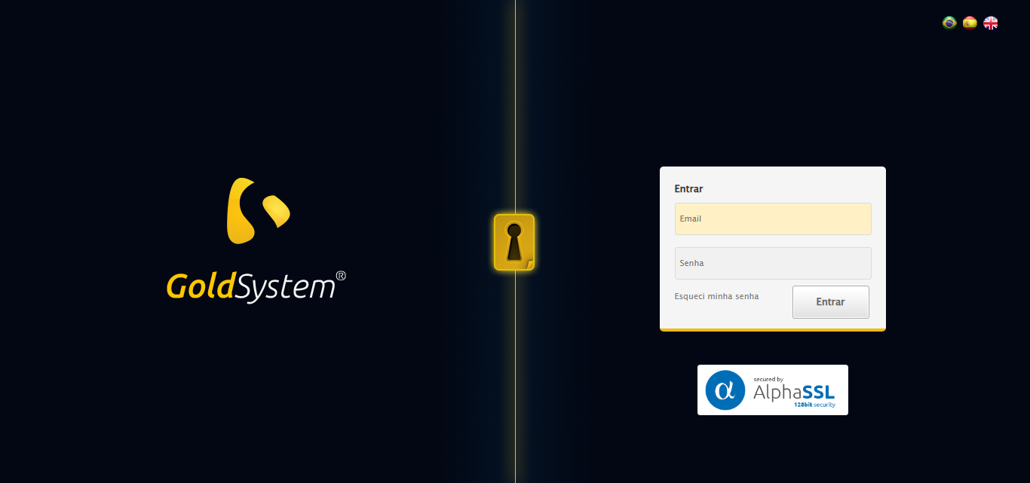

[15:58:39] 🔄 Realizando login...

[15:58:44] ✅ Realizando login realizada com sucesso.

[15:58:46] 📸 Screenshot capturada: realizando_login

Screenshot: realizando_login

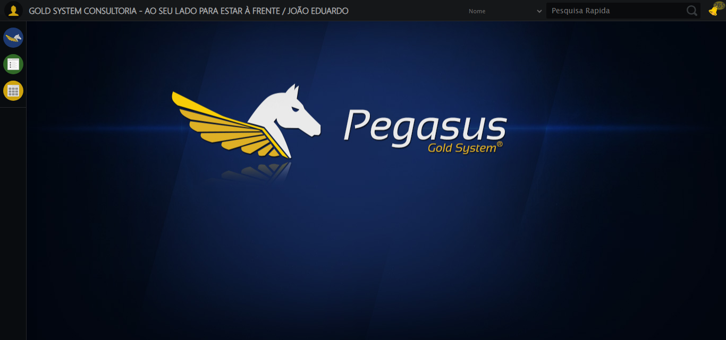

[15:58:46] 🔄 Configurando ambiente...

[15:58:46] 🔍 Zoom ajustado para 90%.

[15:58:49] ✅ Configurando ambiente realizada com sucesso.

[15:58:50] 📸 Screenshot capturada: configurando_ambiente

Screenshot: configurando_ambiente

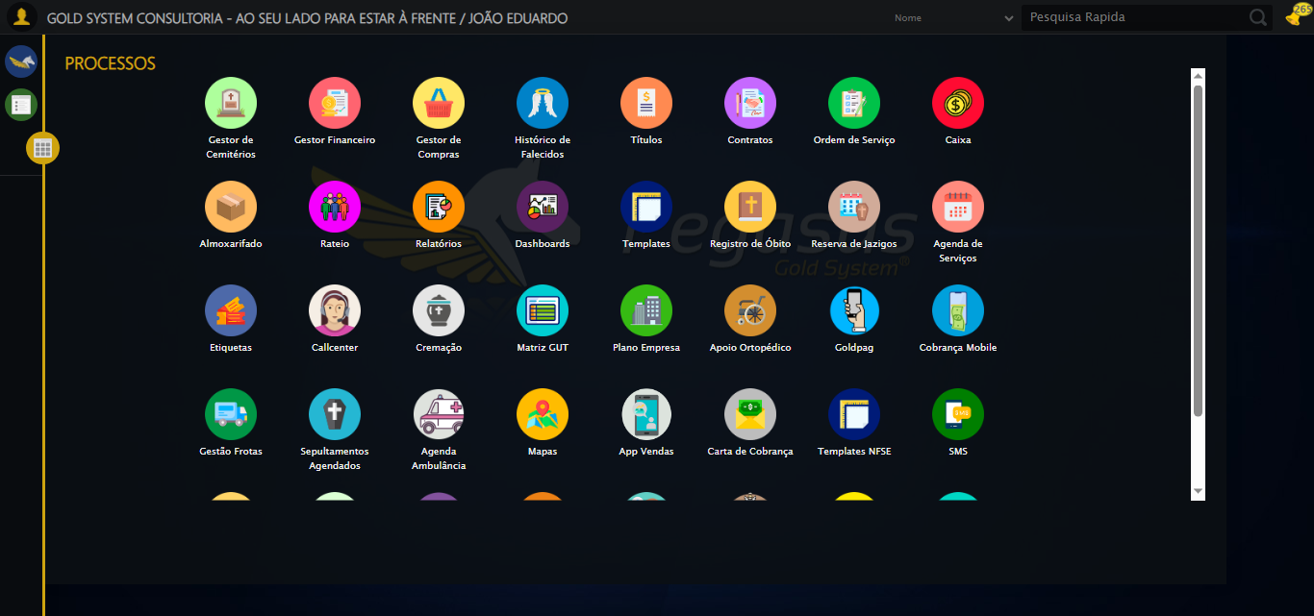

[15:58:50] 🔄 Acessando módulo Callcenter...

[15:58:50] Tentando estratégia de scroll 1...

[15:58:51] ✅ Scroll realizado com estratégia 1

[15:58:52] Tentando estratégia de clique 1 para módulo PET...

[15:58:54] ✅ Clique no módulo PET realizado com estratégia 1

[15:58:54] ✅ Acessando módulo Callcenter realizada com sucesso.

[15:58:55] 📸 Screenshot capturada: acessando_módulo_callcenter

Screenshot: acessando_módulo_callcenter

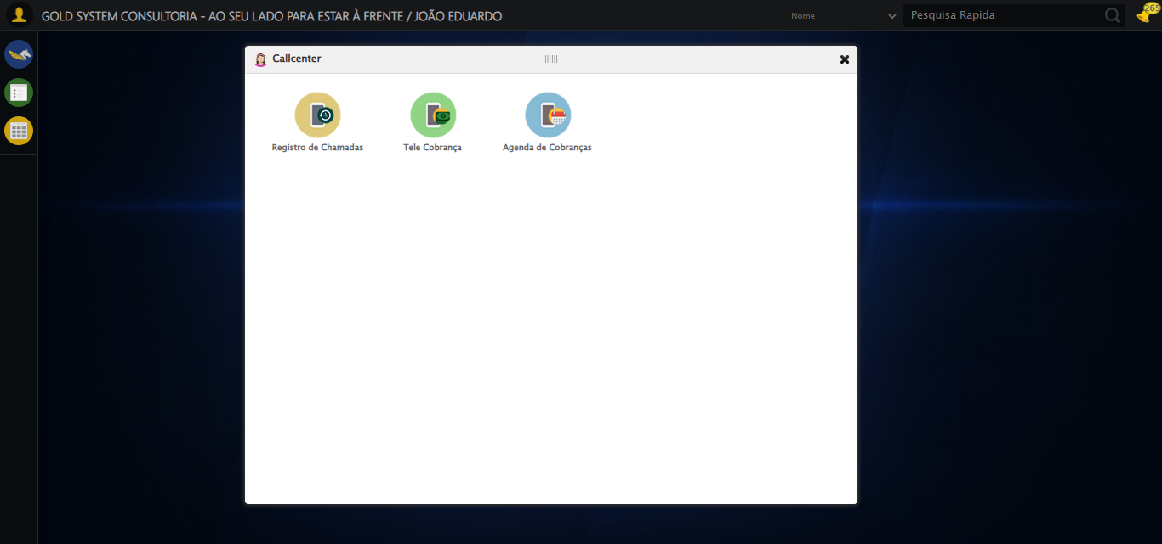

[15:58:55] 🔄 Abrindo Registro de Chamadas...

[15:58:58] ✅ Abrindo Registro de Chamadas realizada com sucesso.

[15:59:00] 📸 Screenshot capturada: abrindo_registro_de_chamadas

Screenshot: abrindo_registro_de_chamadas

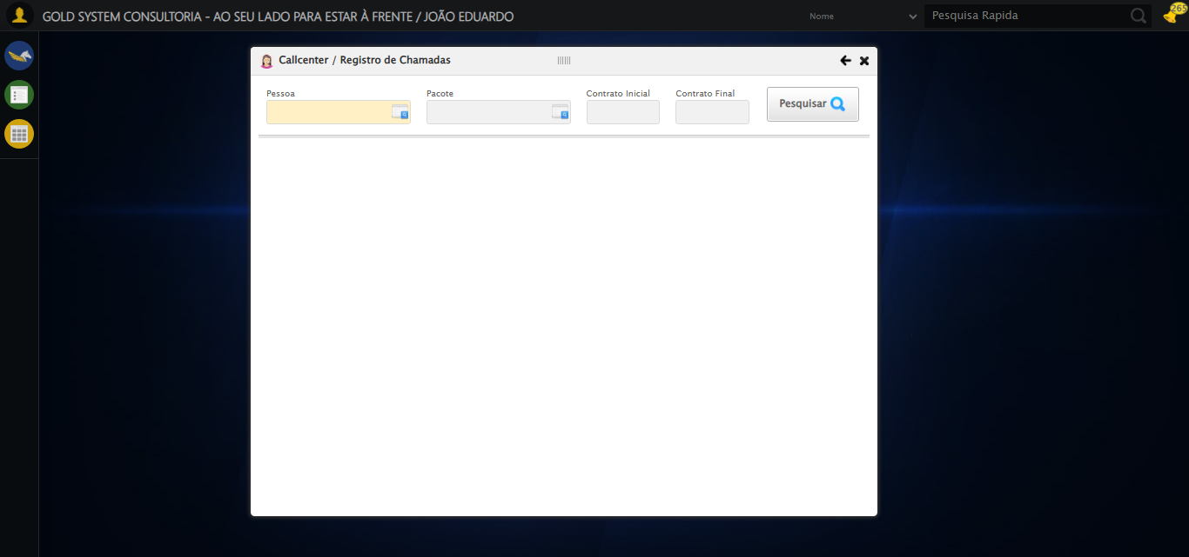

[15:59:00] 🔄 Selecionando Pessoa...

[15:59:00] 🔘 Abrindo modal com botão: #gsCallCenter > div.wdTelas > div.telaRegistroChamadas.telaConsulta.relative > div.formRow.formLastLine > div:nth-child(1) > div > a

[15:59:00] Tentando estratégia de scroll 1...

[15:59:00] ✅ Scroll realizado com estratégia 1

[15:59:03] 🔍 Preenchendo pesquisa com: TESTE TITULAR 233

[15:59:04] 🔍 Executando pesquisa...

[15:59:07] 🎯 Selecionando resultado: //td[contains(text(), 'TESTE TITULAR 233')]

[15:59:07] Tentando estratégia de scroll 1...

[15:59:08] ✅ Scroll realizado com estratégia 1

[15:59:09] ✅ Seleção no modal concluída

[15:59:09] ✅ Selecionando Pessoa realizada com sucesso.

[15:59:11] 📸 Screenshot capturada: selecionando_pessoa

Screenshot: selecionando_pessoa

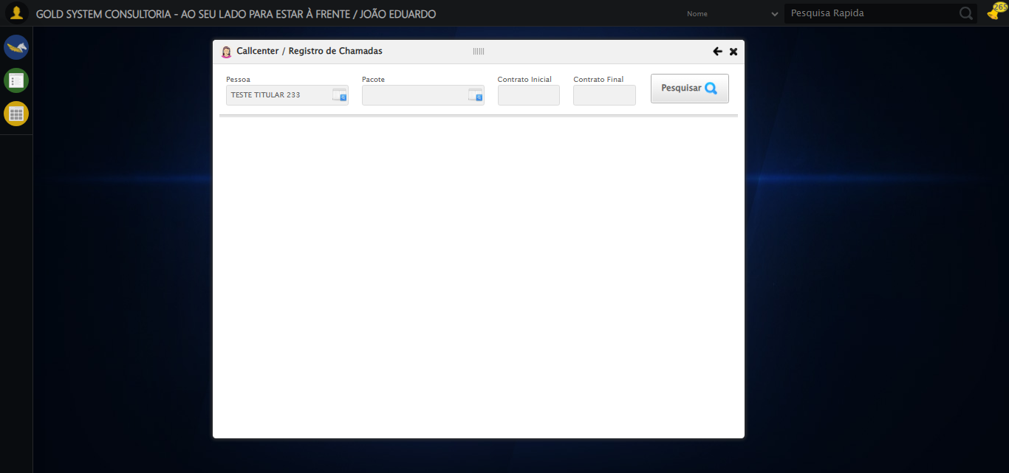

[15:59:11] 🔄 Selecionando Pacote...

[15:59:11] 🔘 Abrindo modal com botão: #gsCallCenter > div.wdTelas > div.telaRegistroChamadas.telaConsulta.relative > div.formRow.formLastLine > div:nth-child(2) > div > a

[15:59:11] Tentando estratégia de scroll 1...

[15:59:11] ✅ Scroll realizado com estratégia 1

[15:59:14] 🔍 Preenchendo pesquisa com: PRO MAX TITANIUM

[15:59:15] 🔍 Executando pesquisa...

[15:59:18] 🎯 Selecionando resultado: //td[contains(text(), 'PRO MAX TITANIUM')]

[15:59:18] Tentando estratégia de scroll 1...

[15:59:19] ✅ Scroll realizado com estratégia 1

[15:59:20] ✅ Seleção no modal concluída

[15:59:20] ✅ Selecionando Pacote realizada com sucesso.

[15:59:21] 📸 Screenshot capturada: selecionando_pacote

Screenshot: selecionando_pacote

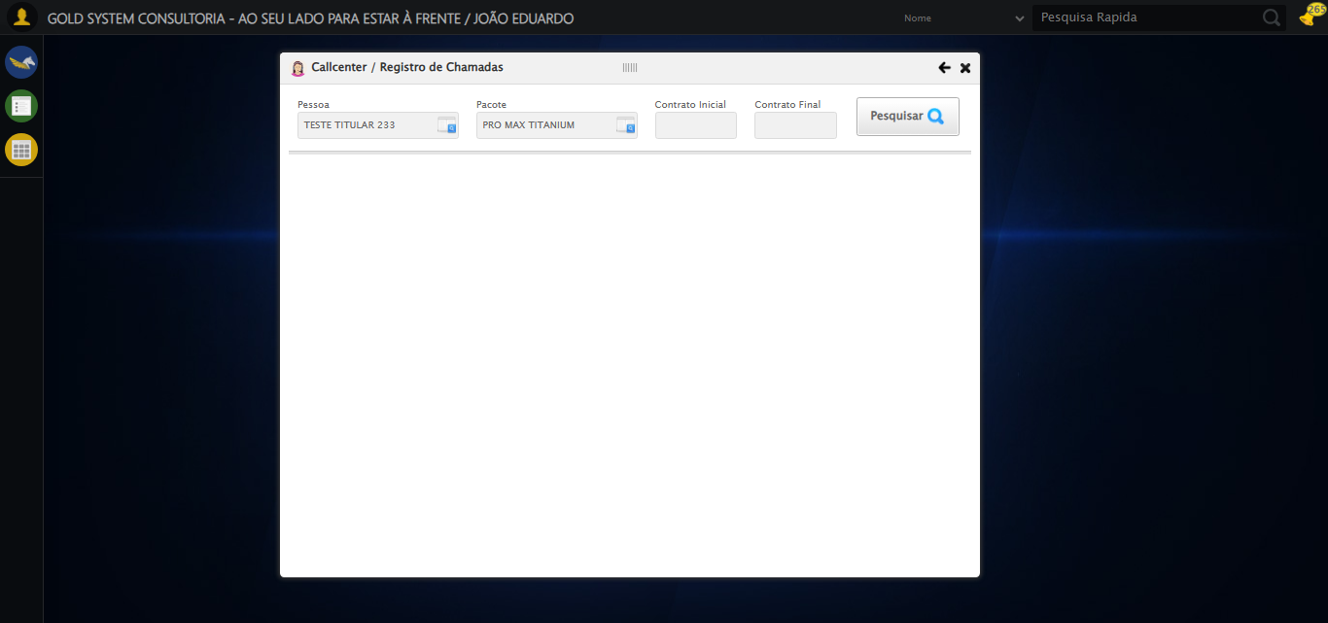

[15:59:21] 🔄 Preenchendo Número do Contrato Inicial...

[15:59:21] Tentando estratégia de scroll 1...

[15:59:22] ✅ Scroll realizado com estratégia 1

[15:59:24] ✅ Campo preenchido com estratégia 1: '113060'

[15:59:24] ✅ Preenchendo Número do Contrato Inicial realizada com sucesso.

[15:59:25] 📸 Screenshot capturada: preenchendo_número_do_contrato_inicial

Screenshot: preenchendo_número_do_contrato_inicial

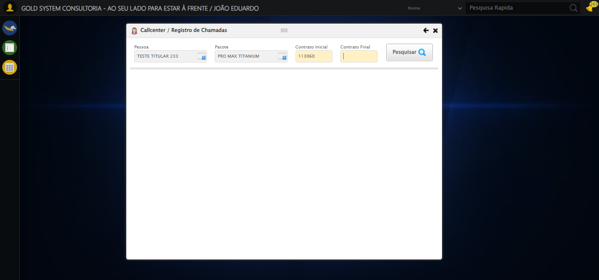

[15:59:25] 🔄 Preenchendo Número do Contrato Final...

[15:59:25] Tentando estratégia de scroll 1...

[15:59:26] ✅ Scroll realizado com estratégia 1

[15:59:27] ✅ Campo preenchido com estratégia 1: '113060'

[15:59:27] ✅ Preenchendo Número do Contrato Final realizada com sucesso.

[15:59:28] 📸 Screenshot capturada: preenchendo_número_do_contrato_final

Screenshot: preenchendo_número_do_contrato_final

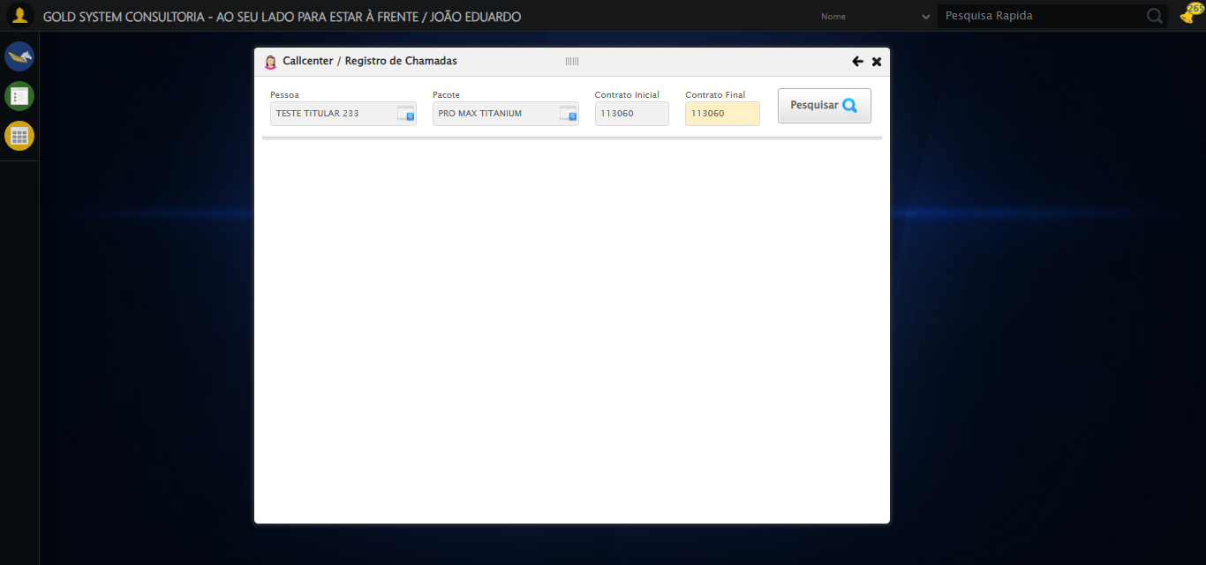

[15:59:28] 🔄 Realizando consulta...

[15:59:28] Tentando estratégia de scroll 1...

[15:59:29] ✅ Scroll realizado com estratégia 1

[15:59:31] ✅ Consulta executada

[15:59:31] ✅ Realizando consulta realizada com sucesso.

[15:59:32] 📸 Screenshot capturada: realizando_consulta

Screenshot: realizando_consulta

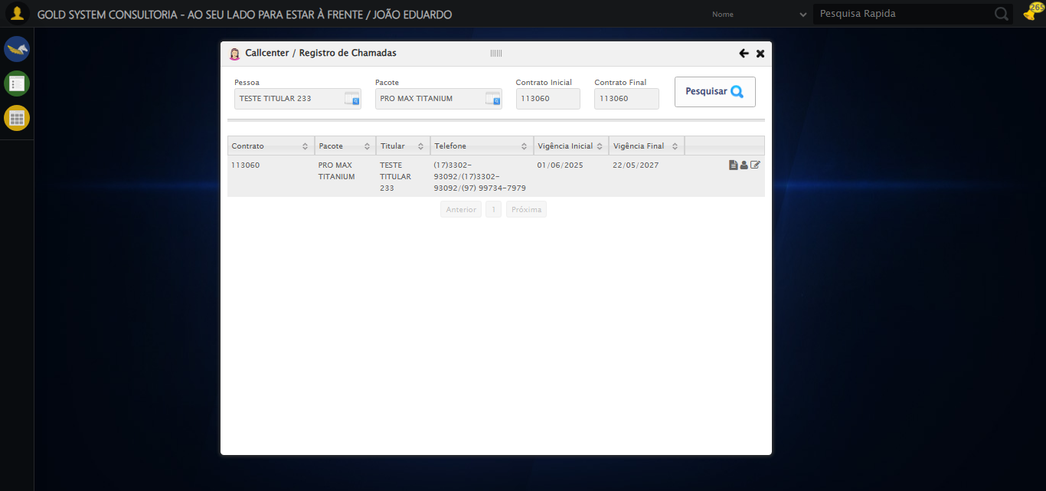

[15:59:32] 🔄 Validando resultados da consulta...

[15:59:32] 🔍 Iniciando validação de registros...

[15:59:37] ✅ Tabela encontrada: #DataTables_Table_2

[15:59:37] ✅ Encontradas 1 linhas válidas com tbody tr:not(.dataTables_empty):not([class*="no-data"])

[15:59:37] ✅ 1 registro(s) encontrado(s)

[15:59:37] Registro 1: 113060 pro max titanium teste titular 233 (17)3302-93092/(17)3302-93092/(97) 99734-7979 01/06/2025 2...

[15:59:38] ✅ Validando resultados da consulta realizada com sucesso.

[15:59:39] 📸 Screenshot capturada: validando_resultados_da_consulta

Screenshot: validando_resultados_da_consulta



[15:59:39] ✅ Processando 1 registro(s) encontrado(s)

[15:59:39] 🔄 Visualizando dados do Contrato...

[15:59:39] Tentando estratégia de scroll 1...

[15:59:40] ✅ Scroll realizado com estratégia 1

[15:59:40] ✅ Clique realizado com estratégia 1

[15:59:40] ✅ Visualizando dados do Contrato realizada com sucesso.

[15:59:41] 📸 Screenshot capturada: visualizando_dados_do_contrato

Screenshot: visualizando_dados_do_contrato

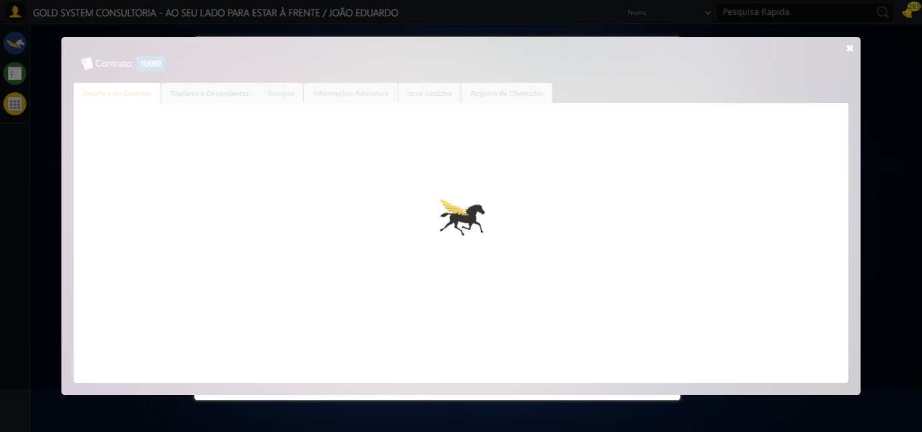

[15:59:41] 🔄 Capturando tela de dados...

[15:59:44] 📸 Screenshot capturada: dados_contrato_pet

Screenshot: dados_contrato_pet

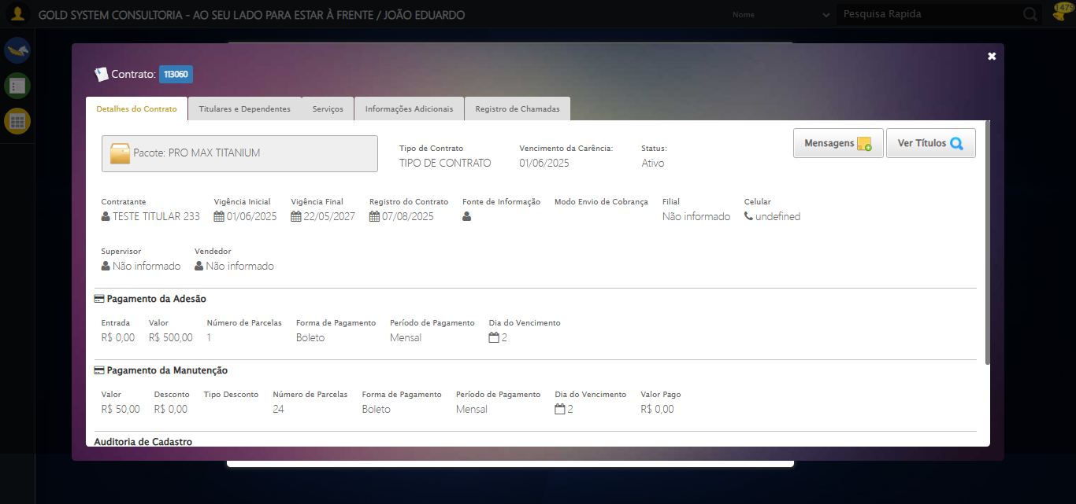

[15:59:45] ✅ Capturando tela de dados realizada com sucesso.

[15:59:46] 📸 Screenshot capturada: capturando_tela_de_dados

Screenshot: capturando_tela_de_dados



[15:59:46] 🔄 Abrindo mensagens do Contrato...

[15:59:46] Tentando estratégia de scroll 1...

[15:59:47] ✅ Scroll realizado com estratégia 1

[15:59:47] ✅ Clique realizado com estratégia 1

[15:59:47] ✅ Abrindo mensagens do Contrato realizada com sucesso.

[15:59:48] 📸 Screenshot capturada: abrindo_mensagens_do_contrato

Screenshot: abrindo_mensagens_do_contrato

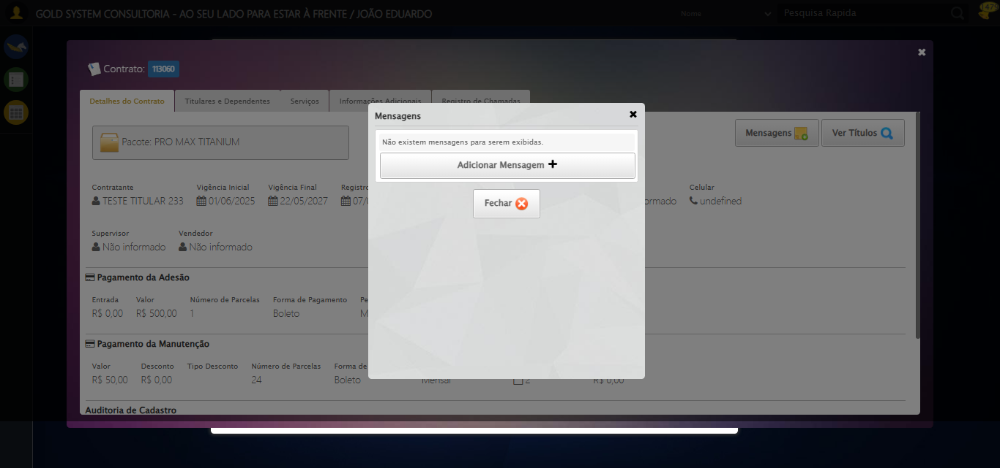

[15:59:48] 🔄 Capturando mensagens...

[15:59:50] 📸 Screenshot capturada: mensagens_contrato_pet

Screenshot: mensagens_contrato_pet



[15:59:50] ✅ Capturando mensagens realizada com sucesso.

[15:59:52] 📸 Screenshot capturada: capturando_mensagens

Screenshot: capturando_mensagens



[15:59:52] 🔄 Adicionando nova mensagem...

[15:59:52] Tentando estratégia de scroll 1...

[15:59:53] ✅ Scroll realizado com estratégia 1

[15:59:53] ✅ Clique realizado com estratégia 1

[15:59:53] ✅ Adicionando nova mensagem realizada com sucesso.

[15:59:54] 📸 Screenshot capturada: adicionando_nova_mensagem

Screenshot: adicionando_nova_mensagem

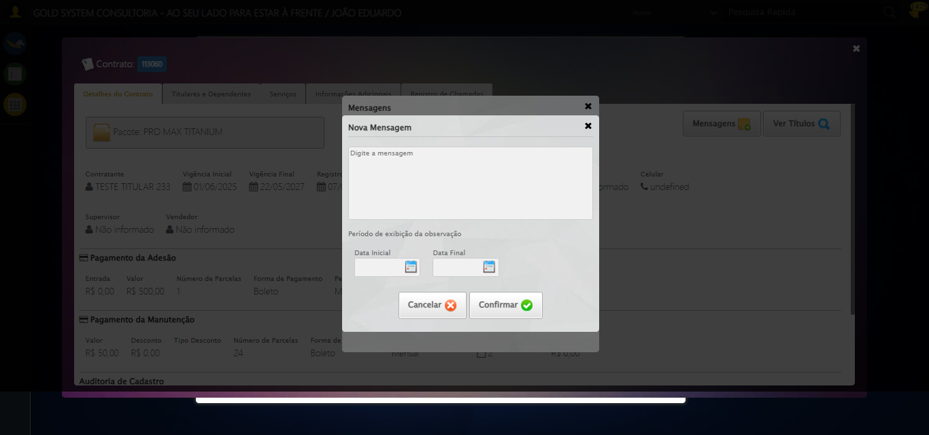

[15:59:54] 🔄 Preenchendo descrição da mensagem...

[15:59:54] 🎯 Tentativa 1: Preenchendo textarea 0 (ID: (sem id), name: (sem name)) com 107 caracteres

[15:59:54] ▶️ Estratégia 1…

[15:59:56] ✅ Preenchido com sucesso pela estratégia 1: 'TESTE DESCRIÇÃO DA MENSAGEM SELENIUM AUTOMATIZADO (Automação…'

[15:59:56] ✅ Preenchendo descrição da mensagem realizada com sucesso.

[15:59:57] 📸 Screenshot capturada: preenchendo_descrição_da_mensagem

Screenshot: preenchendo_descrição_da_mensagem

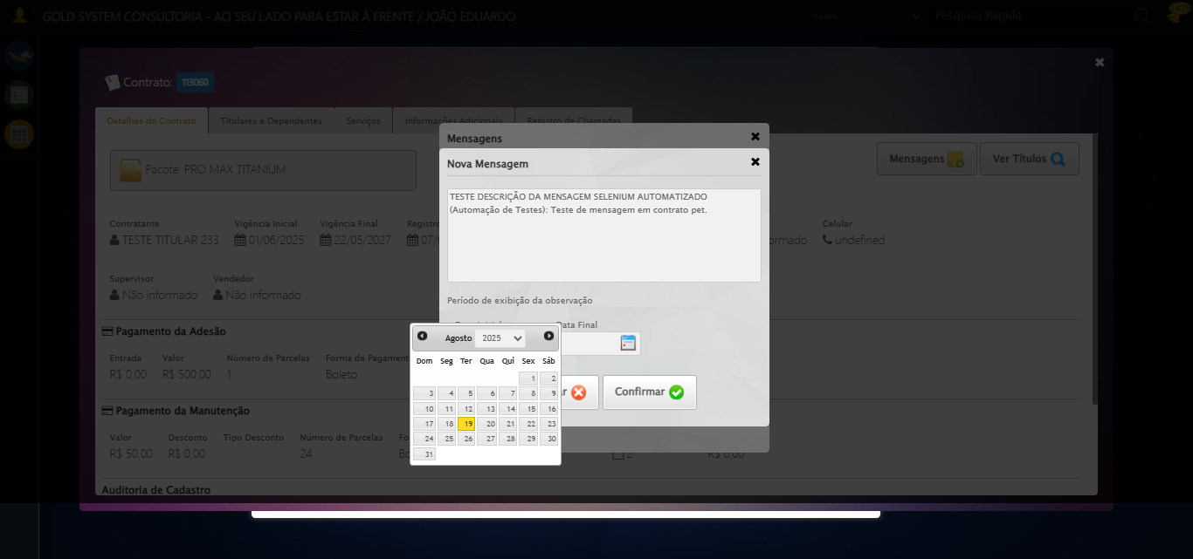

[15:59:57] 🔄 Definindo período de exibição - Data Inicial...

[15:59:57] 📊 Encontrados 2 campos datepicker

[15:59:57] ⚠️ Erro na tentativa 1: Índice 4 inválido. Encontrados 2 campos, tentando novamente...

[16:00:00] 📊 Encontrados 2 campos datepicker

[16:00:00] ⚠️ Erro na tentativa 2: Índice 4 inválido. Encontrados 2 campos, tentando novamente...

[16:00:03] 📊 Encontrados 2 campos datepicker

[16:00:03] ⚠️ Erro na tentativa 3: Índice 4 inválido. Encontrados 2 campos, tentando novamente...

[16:00:05] 📊 Encontrados 2 campos datepicker

[16:00:05] ⚠️ Erro na tentativa 4: Índice 4 inválido. Encontrados 2 campos, tentando novamente...

[16:00:08] 📊 Encontrados 2 campos datepicker

[16:00:08] 📸 Screenshot capturada: erro_definindo_período_de_exibição_-_data_inicial

Screenshot: erro_definindo_período_de_exibição_-_data_inicial



[16:00:08] ❌ Definindo período de exibição - Data Inicial falhou: Exception: Índice 4 inválido. Encontrados 2 campos

[16:00:08] ⚠️ Continuando execução apesar do erro em: Definindo período de exibição - Data Inicial

[16:00:08] 🔄 Definindo período de exibição - Data Final...

[16:00:08] 📊 Encontrados 2 campos datepicker

[16:00:08] ⚠️ Erro na tentativa 1: Índice 5 inválido. Encontrados 2 campos, tentando novamente...

[16:00:11] 📊 Encontrados 2 campos datepicker

[16:00:11] ⚠️ Erro na tentativa 2: Índice 5 inválido. Encontrados 2 campos, tentando novamente...

[16:00:13] 📊 Encontrados 2 campos datepicker

[16:00:13] ⚠️ Erro na tentativa 3: Índice 5 inválido. Encontrados 2 campos, tentando novamente...

[16:00:16] 📊 Encontrados 2 campos datepicker

[16:00:16] ⚠️ Erro na tentativa 4: Índice 5 inválido. Encontrados 2 campos, tentando novamente...

[16:00:19] 📊 Encontrados 2 campos datepicker

[16:00:19] 📸 Screenshot capturada: erro_definindo_período_de_exibição_-_data_final

Screenshot: erro_definindo_período_de_exibição_-_data_final



[16:00:19] ❌ Definindo período de exibição - Data Final falhou: Exception: Índice 5 inválido. Encontrados 2 campos

[16:00:19] ⚠️ Continuando execução apesar do erro em: Definindo período de exibição - Data Final

[16:00:19] 🔄 Confirmando mensagem...

[16:00:19] Tentando estratégia de scroll 1...

[16:00:20] ✅ Scroll realizado com estratégia 1

[16:00:21] ✅ Clique realizado com estratégia 1

[16:00:21] ✅ Confirmando mensagem realizada com sucesso.

[16:00:22] 📸 Screenshot capturada: confirmando_mensagem

Screenshot: confirmando_mensagem

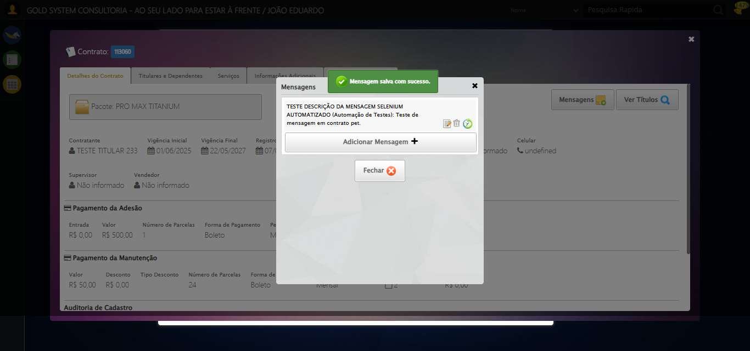

[16:00:22] 🔍 Verificando mensagens de alerta...

[16:00:22] 📢 ✅ Sucesso: Mensagem salva com sucesso.

[16:00:22] 🔄 Fechando aba de mensagens...

[16:00:22] Tentando estratégia de scroll 1...

[16:00:23] ✅ Scroll realizado com estratégia 1

[16:00:24] ⚠️ Estratégia 1 de clique falhou: Message: element click intercepted: Element <a class="fa fa-close"></a> is not clickable at point (1259, 72). Other element would receive the click: <div class="blockScreen" style="height: 641px; z-index: 10003; opacity: 0.5;"></div>  
 (Session info: chrome=138.0.7204.185); For documentation on this error, please visit: https://www.selenium.dev/documentation/webdriver/troubleshooting/errors#elementclickinterceptedexception  
Stacktrace:  
 GetHandleVerifier [0x0x62ba83+63395]  
 GetHandleVerifier [0x0x62bac4+63460]  
 (No symbol) [0x0x472113]  
 (No symbol) [0x0x4c0ba0]  
 (No symbol) [0x0x4bef5a]  
 (No symbol) [0x0x4bcab7]  
 (No symbol) [0x0x4bbd6d]  
 (No symbol) [0x0x4b0515]  
 (No symbol) [0x0x4df3ac]  
 (No symbol) [0x0x4affa4]  
 (No symbol) [0x0x4df624]  
 (No symbol) [0x0x5007ba]  
 (No symbol) [0x0x4df1a6]  
 (No symbol) [0x0x4ae7b2]  
 (No symbol) [0x0x4af654]  
 GetHandleVerifier [0x0x8a8883+2672035]  
 GetHandleVerifier [0x0x8a3cba+2652634]  
 GetHandleVerifier [0x0x652bca+223466]  
 GetHandleVerifier [0x0x642cb8+158168]  
 GetHandleVerifier [0x0x64978d+185517]  
 GetHandleVerifier [0x0x633b78+96408]  
 GetHandleVerifier [0x0x633d02+96802]  
 GetHandleVerifier [0x0x61e90a+9770]  
 BaseThreadInitThunk [0x0x75abfcc9+25]  
 RtlGetAppContainerNamedObjectPath [0x0x776d82ae+286]  
 RtlGetAppContainerNamedObjectPath [0x0x776d827e+238]

[16:00:25] ✅ Clique realizado com estratégia 2

[16:00:25] ✅ Fechando aba de mensagens realizada com sucesso.

[16:00:26] 📸 Screenshot capturada: fechando_aba_de_mensagens

Screenshot: fechando_aba_de_mensagens

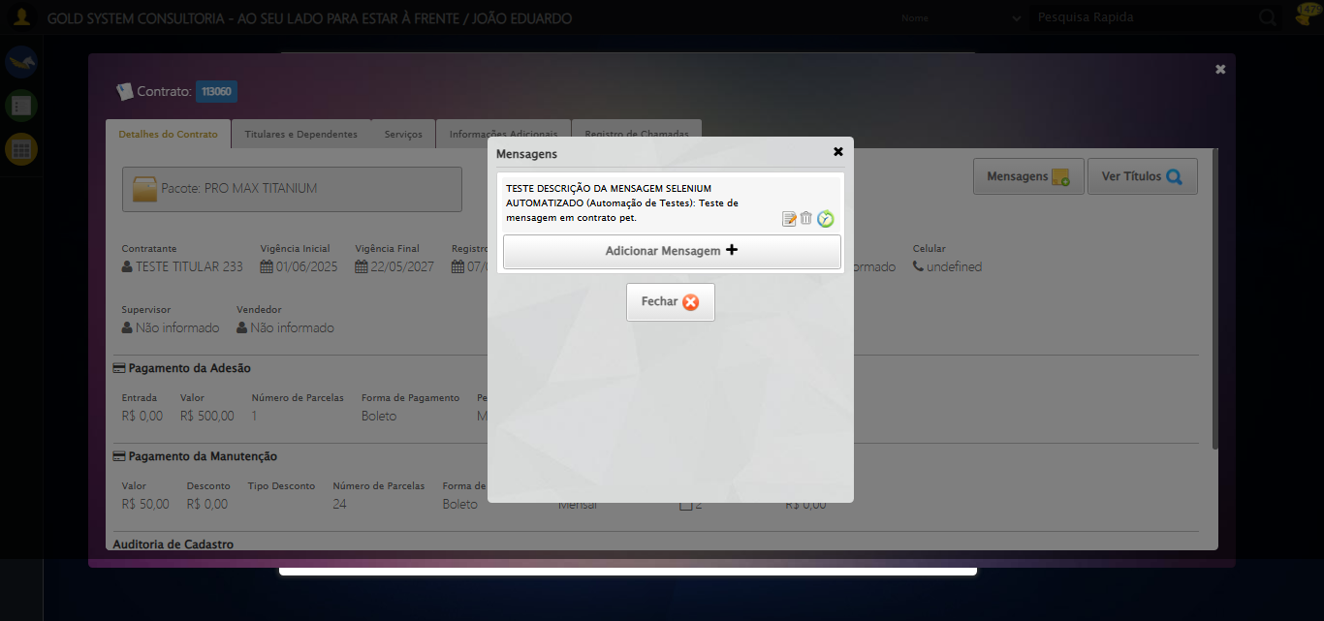

[16:00:26] 🔄 Visualizando títulos do Contrato...

[16:00:26] Tentando estratégia de scroll 1...

[16:00:27] ✅ Scroll realizado com estratégia 1

[16:00:28] ⚠️ Estratégia 1 de clique falhou: Message: element click intercepted: Element <button class="btModel btGray">...</button> is not clickable at point (1178, 182). Other element would receive the click: <div class="blockScreen" style="height: 641px; z-index: 10003; opacity: 0.5;"></div>  
 (Session info: chrome=138.0.7204.185); For documentation on this error, please visit: https://www.selenium.dev/documentation/webdriver/troubleshooting/errors#elementclickinterceptedexception  
Stacktrace:  
 GetHandleVerifier [0x0x62ba83+63395]  
 GetHandleVerifier [0x0x62bac4+63460]  
 (No symbol) [0x0x472113]  
 (No symbol) [0x0x4c0ba0]  
 (No symbol) [0x0x4bef5a]  
 (No symbol) [0x0x4bcab7]  
 (No symbol) [0x0x4bbd6d]  
 (No symbol) [0x0x4b0515]  
 (No symbol) [0x0x4df3ac]  
 (No symbol) [0x0x4affa4]  
 (No symbol) [0x0x4df624]  
 (No symbol) [0x0x5007ba]  
 (No symbol) [0x0x4df1a6]  
 (No symbol) [0x0x4ae7b2]  
 (No symbol) [0x0x4af654]  
 GetHandleVerifier [0x0x8a8883+2672035]  
 GetHandleVerifier [0x0x8a3cba+2652634]  
 GetHandleVerifier [0x0x652bca+223466]  
 GetHandleVerifier [0x0x642cb8+158168]  
 GetHandleVerifier [0x0x64978d+185517]  
 GetHandleVerifier [0x0x633b78+96408]  
 GetHandleVerifier [0x0x633d02+96802]  
 GetHandleVerifier [0x0x61e90a+9770]  
 BaseThreadInitThunk [0x0x75abfcc9+25]  
 RtlGetAppContainerNamedObjectPath [0x0x776d82ae+286]  
 RtlGetAppContainerNamedObjectPath [0x0x776d827e+238]

[16:00:29] ✅ Clique realizado com estratégia 2

[16:00:29] ✅ Visualizando títulos do Contrato realizada com sucesso.

[16:00:30] 📸 Screenshot capturada: visualizando_títulos_do_contrato

Screenshot: visualizando_títulos_do_contrato



[16:00:30] 🔄 Aguardando carregamento de títulos e capturando Screenshot...

[16:01:00] 📸 Screenshot capturada: titulos_contrato_pet

Screenshot: titulos_contrato_pet

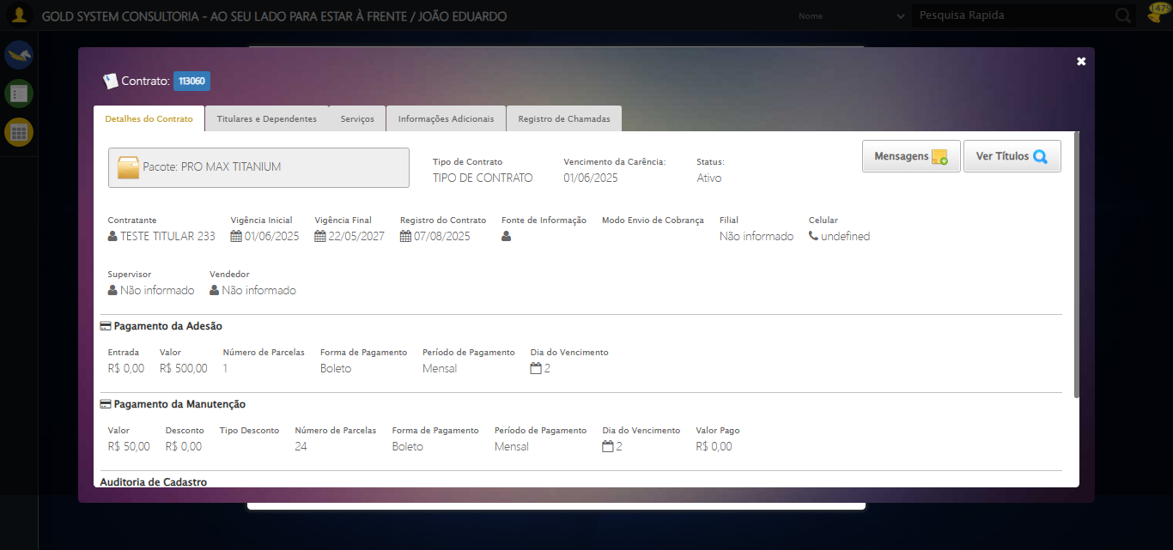

[16:01:00] ✅ Aguardando carregamento de títulos e capturando Screenshot realizada com sucesso.

[16:01:02] 📸 Screenshot capturada: aguardando_carregamento_de_títulos_e_capturando_screenshot

Screenshot: aguardando_carregamento_de_títulos_e_capturando_screenshot



[16:01:02] 🔄 Fechando aba de títulos...

[16:01:14] ❌ Erro aguardando elemento //a[@title='Sair' and contains(@class, 'sp-fecharGrande')]: Message: invalid session id: session deleted as the browser has closed the connection  
from disconnected: not connected to DevTools  
 (Session info: chrome=138.0.7204.185); For documentation on this error, please visit: https://www.selenium.dev/documentation/webdriver/troubleshooting/errors#invalidsessionidexception  
Stacktrace:  
 GetHandleVerifier [0x0x62ba83+63395]  
 GetHandleVerifier [0x0x62bac4+63460]  
 (No symbol) [0x0x472113]  
 (No symbol) [0x0x461b20]  
 (No symbol) [0x0x47f922]  
 (No symbol) [0x0x4e5c9c]  
 (No symbol) [0x0x500099]  
 (No symbol) [0x0x4df1a6]  
 (No symbol) [0x0x4ae7b2]  
 (No symbol) [0x0x4af654]  
 GetHandleVerifier [0x0x8a8883+2672035]  
 GetHandleVerifier [0x0x8a3cba+2652634]  
 GetHandleVerifier [0x0x652bca+223466]  
 GetHandleVerifier [0x0x642cb8+158168]  
 GetHandleVerifier [0x0x64978d+185517]  
 GetHandleVerifier [0x0x633b78+96408]  
 GetHandleVerifier [0x0x633d02+96802]  
 GetHandleVerifier [0x0x61e90a+9770]  
 BaseThreadInitThunk [0x0x75abfcc9+25]  
 RtlGetAppContainerNamedObjectPath [0x0x776d82ae+286]  
 RtlGetAppContainerNamedObjectPath [0x0x776d827e+238]

[16:01:14] ❌ Falha ao clicar em //a[@title='Sair' and contains(@class, 'sp-fecharGrande')]: Message: invalid session id: session deleted as the browser has closed the connection  
from disconnected: not connected to DevTools  
 (Session info: chrome=138.0.7204.185); For documentation on this error, please visit: https://www.selenium.dev/documentation/webdriver/troubleshooting/errors#invalidsessionidexception  
Stacktrace:  
 GetHandleVerifier [0x0x62ba83+63395]  
 GetHandleVerifier [0x0x62bac4+63460]  
 (No symbol) [0x0x472113]  
 (No symbol) [0x0x461b20]  
 (No symbol) [0x0x47f922]  
 (No symbol) [0x0x4e5c9c]  
 (No symbol) [0x0x500099]  
 (No symbol) [0x0x4df1a6]  
 (No symbol) [0x0x4ae7b2]  
 (No symbol) [0x0x4af654]  
 GetHandleVerifier [0x0x8a8883+2672035]  
 GetHandleVerifier [0x0x8a3cba+2652634]  
 GetHandleVerifier [0x0x652bca+223466]  
 GetHandleVerifier [0x0x642cb8+158168]  
 GetHandleVerifier [0x0x64978d+185517]  
 GetHandleVerifier [0x0x633b78+96408]  
 GetHandleVerifier [0x0x633d02+96802]  
 GetHandleVerifier [0x0x61e90a+9770]  
 BaseThreadInitThunk [0x0x75abfcc9+25]  
 RtlGetAppContainerNamedObjectPath [0x0x776d82ae+286]  
 RtlGetAppContainerNamedObjectPath [0x0x776d827e+238]

[16:01:15] ⚠️ Erro ao tirar screenshot erro_fechando_aba_de_títulos: Message: invalid session id; For documentation on this error, please visit: https://www.selenium.dev/documentation/webdriver/troubleshooting/errors#invalidsessionidexception  
Stacktrace:  
 GetHandleVerifier [0x0x62ba83+63395]  
 GetHandleVerifier [0x0x62bac4+63460]  
 (No symbol) [0x0x471f70]  
 (No symbol) [0x0x4adaa8]  
 (No symbol) [0x0x4df266]  
 (No symbol) [0x0x4dae65]  
 (No symbol) [0x0x4da3e6]  
 (No symbol) [0x0x443a45]  
 (No symbol) [0x0x443f9e]  
 (No symbol) [0x0x44442d]  
 GetHandleVerifier [0x0x8a8883+2672035]  
 GetHandleVerifier [0x0x8a3cba+2652634]  
 GetHandleVerifier [0x0x652bca+223466]  
 GetHandleVerifier [0x0x642cb8+158168]  
 GetHandleVerifier [0x0x64978d+185517]  
 (No symbol) [0x0x443710]  
 (No symbol) [0x0x442f1d]  
 GetHandleVerifier [0x0x9ddb9c+3938492]  
 BaseThreadInitThunk [0x0x75abfcc9+25]  
 RtlGetAppContainerNamedObjectPath [0x0x776d82ae+286]  
 RtlGetAppContainerNamedObjectPath [0x0x776d827e+238]

[16:01:15] ❌ Fechando aba de títulos falhou: InvalidSessionIdException: Message: invalid session id: session deleted as the browser has closed the connection  
from disconnected: not connected to DevTools  
 (Session info: chrome=138.0.7204.185); For documentation on this error, please visit: https://www.selenium.dev/documentation/webdriver/troubleshooting/errors#invalidsessionidexception  
Stacktrace:  
 GetHandleVerifier [0x0x62ba83+63395]  
 GetHandleVerifier [0x0x62bac4+63460]  
 (No symbol) [0x0x472113]  
 (No symbol) [0x0x461b20]  
 (No symbol) [0x0x47f922]  
 (No symbol) [0x0x4e5c9c]  
 (No symbol) [0x0x500099]  
 (No symbol) [0x0x4df1a6]  
 (No symbol) [0x0x4ae7b2]  
 (No symbol) [0x0x4af654]  
 GetHandleVerifier [0x0x8a8883+2672035]  
 GetHandleVerifier [0x0x8a3cba+2652634]  
 GetHandleVerifier [0x0x652bca+223466]  
 GetHandleVerifier [0x0x642cb8+158168]  
 GetHandleVerifier [0x0x64978d+185517]  
 GetHandleVerifier [0x0x633b78+96408]  
 GetHandleVerifier [0x0x633d02+96802]  
 GetHandleVerifier [0x0x61e90a+9770]  
 BaseThreadInitThunk [0x0x75abfcc9+25]  
 RtlGetAppContainerNamedObjectPath [0x0x776d82ae+286]  
 RtlGetAppContainerNamedObjectPath [0x0x776d827e+238]

[16:01:15] ⚠️ Continuando execução apesar do erro em: Fechando aba de títulos

[16:01:15] 🔄 Abrindo Dados do Titular...

[16:01:15] ❌ Erro aguardando elemento //span[contains(@class,'btTitular') and @title='Dados do Titular']: Message: invalid session id; For documentation on this error, please visit: https://www.selenium.dev/documentation/webdriver/troubleshooting/errors#invalidsessionidexception  
Stacktrace:  
 GetHandleVerifier [0x0x62ba83+63395]  
 GetHandleVerifier [0x0x62bac4+63460]  
 (No symbol) [0x0x471f70]  
 (No symbol) [0x0x4adaa8]  
 (No symbol) [0x0x4df266]  
 (No symbol) [0x0x4dae65]  
 (No symbol) [0x0x4da3e6]  
 (No symbol) [0x0x443a45]  
 (No symbol) [0x0x443f9e]  
 (No symbol) [0x0x44442d]  
 GetHandleVerifier [0x0x8a8883+2672035]  
 GetHandleVerifier [0x0x8a3cba+2652634]  
 GetHandleVerifier [0x0x652bca+223466]  
 GetHandleVerifier [0x0x642cb8+158168]  
 GetHandleVerifier [0x0x64978d+185517]  
 (No symbol) [0x0x443710]  
 (No symbol) [0x0x442f1d]  
 GetHandleVerifier [0x0x9ddb9c+3938492]  
 BaseThreadInitThunk [0x0x75abfcc9+25]  
 RtlGetAppContainerNamedObjectPath [0x0x776d82ae+286]  
 RtlGetAppContainerNamedObjectPath [0x0x776d827e+238]

[16:01:15] ❌ Falha ao clicar em //span[contains(@class,'btTitular') and @title='Dados do Titular']: Message: invalid session id; For documentation on this error, please visit: https://www.selenium.dev/documentation/webdriver/troubleshooting/errors#invalidsessionidexception  
Stacktrace:  
 GetHandleVerifier [0x0x62ba83+63395]  
 GetHandleVerifier [0x0x62bac4+63460]  
 (No symbol) [0x0x471f70]  
 (No symbol) [0x0x4adaa8]  
 (No symbol) [0x0x4df266]  
 (No symbol) [0x0x4dae65]  
 (No symbol) [0x0x4da3e6]  
 (No symbol) [0x0x443a45]  
 (No symbol) [0x0x443f9e]  
 (No symbol) [0x0x44442d]  
 GetHandleVerifier [0x0x8a8883+2672035]  
 GetHandleVerifier [0x0x8a3cba+2652634]  
 GetHandleVerifier [0x0x652bca+223466]  
 GetHandleVerifier [0x0x642cb8+158168]  
 GetHandleVerifier [0x0x64978d+185517]  
 (No symbol) [0x0x443710]  
 (No symbol) [0x0x442f1d]  
 GetHandleVerifier [0x0x9ddb9c+3938492]  
 BaseThreadInitThunk [0x0x75abfcc9+25]  
 RtlGetAppContainerNamedObjectPath [0x0x776d82ae+286]  
 RtlGetAppContainerNamedObjectPath [0x0x776d827e+238]

[16:01:15] ⚠️ Erro ao tirar screenshot erro_abrindo_dados_do_titular: Message: invalid session id; For documentation on this error, please visit: https://www.selenium.dev/documentation/webdriver/troubleshooting/errors#invalidsessionidexception  
Stacktrace:  
 GetHandleVerifier [0x0x62ba83+63395]  
 GetHandleVerifier [0x0x62bac4+63460]  
 (No symbol) [0x0x471f70]  
 (No symbol) [0x0x4adaa8]  
 (No symbol) [0x0x4df266]  
 (No symbol) [0x0x4dae65]  
 (No symbol) [0x0x4da3e6]  
 (No symbol) [0x0x443a45]  
 (No symbol) [0x0x443f9e]  
 (No symbol) [0x0x44442d]  
 GetHandleVerifier [0x0x8a8883+2672035]  
 GetHandleVerifier [0x0x8a3cba+2652634]  
 GetHandleVerifier [0x0x652bca+223466]  
 GetHandleVerifier [0x0x642cb8+158168]  
 GetHandleVerifier [0x0x64978d+185517]  
 (No symbol) [0x0x443710]  
 (No symbol) [0x0x442f1d]  
 GetHandleVerifier [0x0x9ddb9c+3938492]  
 BaseThreadInitThunk [0x0x75abfcc9+25]  
 RtlGetAppContainerNamedObjectPath [0x0x776d82ae+286]  
 RtlGetAppContainerNamedObjectPath [0x0x776d827e+238]

[16:01:15] ❌ Abrindo Dados do Titular falhou: InvalidSessionIdException: Message: invalid session id; For documentation on this error, please visit: https://www.selenium.dev/documentation/webdriver/troubleshooting/errors#invalidsessionidexception  
Stacktrace:  
 GetHandleVerifier [0x0x62ba83+63395]  
 GetHandleVerifier [0x0x62bac4+63460]  
 (No symbol) [0x0x471f70]  
 (No symbol) [0x0x4adaa8]  
 (No symbol) [0x0x4df266]  
 (No symbol) [0x0x4dae65]  
 (No symbol) [0x0x4da3e6]  
 (No symbol) [0x0x443a45]  
 (No symbol) [0x0x443f9e]  
 (No symbol) [0x0x44442d]  
 GetHandleVerifier [0x0x8a8883+2672035]  
 GetHandleVerifier [0x0x8a3cba+2652634]  
 GetHandleVerifier [0x0x652bca+223466]  
 GetHandleVerifier [0x0x642cb8+158168]  
 GetHandleVerifier [0x0x64978d+185517]  
 (No symbol) [0x0x443710]  
 (No symbol) [0x0x442f1d]  
 GetHandleVerifier [0x0x9ddb9c+3938492]  
 BaseThreadInitThunk [0x0x75abfcc9+25]  
 RtlGetAppContainerNamedObjectPath [0x0x776d82ae+286]  
 RtlGetAppContainerNamedObjectPath [0x0x776d827e+238]

[16:01:15] ⚠️ Continuando execução apesar do erro em: Abrindo Dados do Titular

[16:01:15] 🔄 Abrindo Dados Cadastrais do Titular e capturando Screenshot da aba 'Dados Pessoais'...

[16:01:15] ❌ Erro aguardando elemento //a[contains(@class,'materializacaoPeglink') and @ref='1|21582908']: Message: invalid session id; For documentation on this error, please visit: https://www.selenium.dev/documentation/webdriver/troubleshooting/errors#invalidsessionidexception  
Stacktrace:  
 GetHandleVerifier [0x0x62ba83+63395]  
 GetHandleVerifier [0x0x62bac4+63460]  
 (No symbol) [0x0x471f70]  
 (No symbol) [0x0x4adaa8]  
 (No symbol) [0x0x4df266]  
 (No symbol) [0x0x4dae65]  
 (No symbol) [0x0x4da3e6]  
 (No symbol) [0x0x443a45]  
 (No symbol) [0x0x443f9e]  
 (No symbol) [0x0x44442d]  
 GetHandleVerifier [0x0x8a8883+2672035]  
 GetHandleVerifier [0x0x8a3cba+2652634]  
 GetHandleVerifier [0x0x652bca+223466]  
 GetHandleVerifier [0x0x642cb8+158168]  
 GetHandleVerifier [0x0x64978d+185517]  
 (No symbol) [0x0x443710]  
 (No symbol) [0x0x442f1d]  
 GetHandleVerifier [0x0x9ddb9c+3938492]  
 BaseThreadInitThunk [0x0x75abfcc9+25]  
 RtlGetAppContainerNamedObjectPath [0x0x776d82ae+286]  
 RtlGetAppContainerNamedObjectPath [0x0x776d827e+238]

[16:01:15] ❌ Falha ao clicar em //a[contains(@class,'materializacaoPeglink') and @ref='1|21582908']: Message: invalid session id; For documentation on this error, please visit: https://www.selenium.dev/documentation/webdriver/troubleshooting/errors#invalidsessionidexception  
Stacktrace:  
 GetHandleVerifier [0x0x62ba83+63395]  
 GetHandleVerifier [0x0x62bac4+63460]  
 (No symbol) [0x0x471f70]  
 (No symbol) [0x0x4adaa8]  
 (No symbol) [0x0x4df266]  
 (No symbol) [0x0x4dae65]  
 (No symbol) [0x0x4da3e6]  
 (No symbol) [0x0x443a45]  
 (No symbol) [0x0x443f9e]  
 (No symbol) [0x0x44442d]  
 GetHandleVerifier [0x0x8a8883+2672035]  
 GetHandleVerifier [0x0x8a3cba+2652634]  
 GetHandleVerifier [0x0x652bca+223466]  
 GetHandleVerifier [0x0x642cb8+158168]  
 GetHandleVerifier [0x0x64978d+185517]  
 (No symbol) [0x0x443710]  
 (No symbol) [0x0x442f1d]  
 GetHandleVerifier [0x0x9ddb9c+3938492]  
 BaseThreadInitThunk [0x0x75abfcc9+25]  
 RtlGetAppContainerNamedObjectPath [0x0x776d82ae+286]  
 RtlGetAppContainerNamedObjectPath [0x0x776d827e+238]

[16:01:15] ⚠️ Erro ao tirar screenshot erro_abrindo_dados_cadastrais_do_titular_e_capturando_screenshot_da_aba_dados_pessoais_: Message: invalid session id; For documentation on this error, please visit: https://www.selenium.dev/documentation/webdriver/troubleshooting/errors#invalidsessionidexception  
Stacktrace:  
 GetHandleVerifier [0x0x62ba83+63395]  
 GetHandleVerifier [0x0x62bac4+63460]  
 (No symbol) [0x0x471f70]  
 (No symbol) [0x0x4adaa8]  
 (No symbol) [0x0x4df266]  
 (No symbol) [0x0x4dae65]  
 (No symbol) [0x0x4da3e6]  
 (No symbol) [0x0x443a45]  
 (No symbol) [0x0x443f9e]  
 (No symbol) [0x0x44442d]  
 GetHandleVerifier [0x0x8a8883+2672035]  
 GetHandleVerifier [0x0x8a3cba+2652634]  
 GetHandleVerifier [0x0x652bca+223466]  
 GetHandleVerifier [0x0x642cb8+158168]  
 GetHandleVerifier [0x0x64978d+185517]  
 (No symbol) [0x0x443710]  
 (No symbol) [0x0x442f1d]  
 GetHandleVerifier [0x0x9ddb9c+3938492]  
 BaseThreadInitThunk [0x0x75abfcc9+25]  
 RtlGetAppContainerNamedObjectPath [0x0x776d82ae+286]  
 RtlGetAppContainerNamedObjectPath [0x0x776d827e+238]

[16:01:15] ❌ Abrindo Dados Cadastrais do Titular e capturando Screenshot da aba 'Dados Pessoais' falhou: InvalidSessionIdException: Message: invalid session id; For documentation on this error, please visit: https://www.selenium.dev/documentation/webdriver/troubleshooting/errors#invalidsessionidexception  
Stacktrace:  
 GetHandleVerifier [0x0x62ba83+63395]  
 GetHandleVerifier [0x0x62bac4+63460]  
 (No symbol) [0x0x471f70]  
 (No symbol) [0x0x4adaa8]  
 (No symbol) [0x0x4df266]  
 (No symbol) [0x0x4dae65]  
 (No symbol) [0x0x4da3e6]  
 (No symbol) [0x0x443a45]  
 (No symbol) [0x0x443f9e]  
 (No symbol) [0x0x44442d]  
 GetHandleVerifier [0x0x8a8883+2672035]  
 GetHandleVerifier [0x0x8a3cba+2652634]  
 GetHandleVerifier [0x0x652bca+223466]  
 GetHandleVerifier [0x0x642cb8+158168]  
 GetHandleVerifier [0x0x64978d+185517]  
 (No symbol) [0x0x443710]  
 (No symbol) [0x0x442f1d]  
 GetHandleVerifier [0x0x9ddb9c+3938492]  
 BaseThreadInitThunk [0x0x75abfcc9+25]  
 RtlGetAppContainerNamedObjectPath [0x0x776d82ae+286]  
 RtlGetAppContainerNamedObjectPath [0x0x776d827e+238]

[16:01:15] ⚠️ Continuando execução apesar do erro em: Abrindo Dados Cadastrais do Titular e capturando Screenshot da aba 'Dados Pessoais'

[16:01:15] 🔄 Clicando na aba 'Dados Complementares' e capturando Screenshot...

[16:01:15] ❌ Erro aguardando elemento //a[@class='dadosComplementares' and normalize-space(text())='Dados Complementares']: Message: invalid session id; For documentation on this error, please visit: https://www.selenium.dev/documentation/webdriver/troubleshooting/errors#invalidsessionidexception  
Stacktrace:  
 GetHandleVerifier [0x0x62ba83+63395]  
 GetHandleVerifier [0x0x62bac4+63460]  
 (No symbol) [0x0x471f70]  
 (No symbol) [0x0x4adaa8]  
 (No symbol) [0x0x4df266]  
 (No symbol) [0x0x4dae65]  
 (No symbol) [0x0x4da3e6]  
 (No symbol) [0x0x443a45]  
 (No symbol) [0x0x443f9e]  
 (No symbol) [0x0x44442d]  
 GetHandleVerifier [0x0x8a8883+2672035]  
 GetHandleVerifier [0x0x8a3cba+2652634]  
 GetHandleVerifier [0x0x652bca+223466]  
 GetHandleVerifier [0x0x642cb8+158168]  
 GetHandleVerifier [0x0x64978d+185517]  
 (No symbol) [0x0x443710]  
 (No symbol) [0x0x442f1d]  
 GetHandleVerifier [0x0x9ddb9c+3938492]  
 BaseThreadInitThunk [0x0x75abfcc9+25]  
 RtlGetAppContainerNamedObjectPath [0x0x776d82ae+286]  
 RtlGetAppContainerNamedObjectPath [0x0x776d827e+238]

[16:01:15] ❌ Falha ao clicar em //a[@class='dadosComplementares' and normalize-space(text())='Dados Complementares']: Message: invalid session id; For documentation on this error, please visit: https://www.selenium.dev/documentation/webdriver/troubleshooting/errors#invalidsessionidexception  
Stacktrace:  
 GetHandleVerifier [0x0x62ba83+63395]  
 GetHandleVerifier [0x0x62bac4+63460]  
 (No symbol) [0x0x471f70]  
 (No symbol) [0x0x4adaa8]  
 (No symbol) [0x0x4df266]  
 (No symbol) [0x0x4dae65]  
 (No symbol) [0x0x4da3e6]  
 (No symbol) [0x0x443a45]  
 (No symbol) [0x0x443f9e]  
 (No symbol) [0x0x44442d]  
 GetHandleVerifier [0x0x8a8883+2672035]  
 GetHandleVerifier [0x0x8a3cba+2652634]  
 GetHandleVerifier [0x0x652bca+223466]  
 GetHandleVerifier [0x0x642cb8+158168]  
 GetHandleVerifier [0x0x64978d+185517]  
 (No symbol) [0x0x443710]  
 (No symbol) [0x0x442f1d]  
 GetHandleVerifier [0x0x9ddb9c+3938492]  
 BaseThreadInitThunk [0x0x75abfcc9+25]  
 RtlGetAppContainerNamedObjectPath [0x0x776d82ae+286]  
 RtlGetAppContainerNamedObjectPath [0x0x776d827e+238]

[16:01:15] ⚠️ Erro ao tirar screenshot erro_clicando_na_aba_dados_complementares_e_capturando_screenshot: Message: invalid session id; For documentation on this error, please visit: https://www.selenium.dev/documentation/webdriver/troubleshooting/errors#invalidsessionidexception  
Stacktrace:  
 GetHandleVerifier [0x0x62ba83+63395]  
 GetHandleVerifier [0x0x62bac4+63460]  
 (No symbol) [0x0x471f70]  
 (No symbol) [0x0x4adaa8]  
 (No symbol) [0x0x4df266]  
 (No symbol) [0x0x4dae65]  
 (No symbol) [0x0x4da3e6]  
 (No symbol) [0x0x443a45]  
 (No symbol) [0x0x443f9e]  
 (No symbol) [0x0x44442d]  
 GetHandleVerifier [0x0x8a8883+2672035]  
 GetHandleVerifier [0x0x8a3cba+2652634]  
 GetHandleVerifier [0x0x652bca+223466]  
 GetHandleVerifier [0x0x642cb8+158168]  
 GetHandleVerifier [0x0x64978d+185517]  
 (No symbol) [0x0x443710]  
 (No symbol) [0x0x442f1d]  
 GetHandleVerifier [0x0x9ddb9c+3938492]  
 BaseThreadInitThunk [0x0x75abfcc9+25]  
 RtlGetAppContainerNamedObjectPath [0x0x776d82ae+286]  
 RtlGetAppContainerNamedObjectPath [0x0x776d827e+238]

[16:01:15] ❌ Clicando na aba 'Dados Complementares' e capturando Screenshot falhou: InvalidSessionIdException: Message: invalid session id; For documentation on this error, please visit: https://www.selenium.dev/documentation/webdriver/troubleshooting/errors#invalidsessionidexception  
Stacktrace:  
 GetHandleVerifier [0x0x62ba83+63395]  
 GetHandleVerifier [0x0x62bac4+63460]  
 (No symbol) [0x0x471f70]  
 (No symbol) [0x0x4adaa8]  
 (No symbol) [0x0x4df266]  
 (No symbol) [0x0x4dae65]  
 (No symbol) [0x0x4da3e6]  
 (No symbol) [0x0x443a45]  
 (No symbol) [0x0x443f9e]  
 (No symbol) [0x0x44442d]  
 GetHandleVerifier [0x0x8a8883+2672035]  
 GetHandleVerifier [0x0x8a3cba+2652634]  
 GetHandleVerifier [0x0x652bca+223466]  
 GetHandleVerifier [0x0x642cb8+158168]  
 GetHandleVerifier [0x0x64978d+185517]  
 (No symbol) [0x0x443710]  
 (No symbol) [0x0x442f1d]  
 GetHandleVerifier [0x0x9ddb9c+3938492]  
 BaseThreadInitThunk [0x0x75abfcc9+25]  
 RtlGetAppContainerNamedObjectPath [0x0x776d82ae+286]  
 RtlGetAppContainerNamedObjectPath [0x0x776d827e+238]

[16:01:15] ⚠️ Continuando execução apesar do erro em: Clicando na aba 'Dados Complementares' e capturando Screenshot

[16:01:15] 🔄 Clicando na aba 'Endereços da Pessoa' e capturando Screenshot'...

[16:01:15] ❌ Erro aguardando elemento //a[@class='enderecos' and normalize-space(text())='Endereços da Pessoa']: Message: invalid session id; For documentation on this error, please visit: https://www.selenium.dev/documentation/webdriver/troubleshooting/errors#invalidsessionidexception  
Stacktrace:  
 GetHandleVerifier [0x0x62ba83+63395]  
 GetHandleVerifier [0x0x62bac4+63460]  
 (No symbol) [0x0x471f70]  
 (No symbol) [0x0x4adaa8]  
 (No symbol) [0x0x4df266]  
 (No symbol) [0x0x4dae65]  
 (No symbol) [0x0x4da3e6]  
 (No symbol) [0x0x443a45]  
 (No symbol) [0x0x443f9e]  
 (No symbol) [0x0x44442d]  
 GetHandleVerifier [0x0x8a8883+2672035]  
 GetHandleVerifier [0x0x8a3cba+2652634]  
 GetHandleVerifier [0x0x652bca+223466]  
 GetHandleVerifier [0x0x642cb8+158168]  
 GetHandleVerifier [0x0x64978d+185517]  
 (No symbol) [0x0x443710]  
 (No symbol) [0x0x442f1d]  
 GetHandleVerifier [0x0x9ddb9c+3938492]  
 BaseThreadInitThunk [0x0x75abfcc9+25]  
 RtlGetAppContainerNamedObjectPath [0x0x776d82ae+286]  
 RtlGetAppContainerNamedObjectPath [0x0x776d827e+238]

[16:01:15] ❌ Falha ao clicar em //a[@class='enderecos' and normalize-space(text())='Endereços da Pessoa']: Message: invalid session id; For documentation on this error, please visit: https://www.selenium.dev/documentation/webdriver/troubleshooting/errors#invalidsessionidexception  
Stacktrace:  
 GetHandleVerifier [0x0x62ba83+63395]  
 GetHandleVerifier [0x0x62bac4+63460]  
 (No symbol) [0x0x471f70]  
 (No symbol) [0x0x4adaa8]  
 (No symbol) [0x0x4df266]  
 (No symbol) [0x0x4dae65]  
 (No symbol) [0x0x4da3e6]  
 (No symbol) [0x0x443a45]  
 (No symbol) [0x0x443f9e]  
 (No symbol) [0x0x44442d]  
 GetHandleVerifier [0x0x8a8883+2672035]  
 GetHandleVerifier [0x0x8a3cba+2652634]  
 GetHandleVerifier [0x0x652bca+223466]  
 GetHandleVerifier [0x0x642cb8+158168]  
 GetHandleVerifier [0x0x64978d+185517]  
 (No symbol) [0x0x443710]  
 (No symbol) [0x0x442f1d]  
 GetHandleVerifier [0x0x9ddb9c+3938492]  
 BaseThreadInitThunk [0x0x75abfcc9+25]  
 RtlGetAppContainerNamedObjectPath [0x0x776d82ae+286]  
 RtlGetAppContainerNamedObjectPath [0x0x776d827e+238]

[16:01:15] ⚠️ Erro ao tirar screenshot erro_clicando_na_aba_endereços_da_pessoa_e_capturando_screenshot_: Message: invalid session id; For documentation on this error, please visit: https://www.selenium.dev/documentation/webdriver/troubleshooting/errors#invalidsessionidexception  
Stacktrace:  
 GetHandleVerifier [0x0x62ba83+63395]  
 GetHandleVerifier [0x0x62bac4+63460]  
 (No symbol) [0x0x471f70]  
 (No symbol) [0x0x4adaa8]  
 (No symbol) [0x0x4df266]  
 (No symbol) [0x0x4dae65]  
 (No symbol) [0x0x4da3e6]  
 (No symbol) [0x0x443a45]  
 (No symbol) [0x0x443f9e]  
 (No symbol) [0x0x44442d]  
 GetHandleVerifier [0x0x8a8883+2672035]  
 GetHandleVerifier [0x0x8a3cba+2652634]  
 GetHandleVerifier [0x0x652bca+223466]  
 GetHandleVerifier [0x0x642cb8+158168]  
 GetHandleVerifier [0x0x64978d+185517]  
 (No symbol) [0x0x443710]  
 (No symbol) [0x0x442f1d]  
 GetHandleVerifier [0x0x9ddb9c+3938492]  
 BaseThreadInitThunk [0x0x75abfcc9+25]  
 RtlGetAppContainerNamedObjectPath [0x0x776d82ae+286]  
 RtlGetAppContainerNamedObjectPath [0x0x776d827e+238]

[16:01:15] ❌ Clicando na aba 'Endereços da Pessoa' e capturando Screenshot' falhou: InvalidSessionIdException: Message: invalid session id; For documentation on this error, please visit: https://www.selenium.dev/documentation/webdriver/troubleshooting/errors#invalidsessionidexception  
Stacktrace:  
 GetHandleVerifier [0x0x62ba83+63395]  
 GetHandleVerifier [0x0x62bac4+63460]  
 (No symbol) [0x0x471f70]  
 (No symbol) [0x0x4adaa8]  
 (No symbol) [0x0x4df266]  
 (No symbol) [0x0x4dae65]  
 (No symbol) [0x0x4da3e6]  
 (No symbol) [0x0x443a45]  
 (No symbol) [0x0x443f9e]  
 (No symbol) [0x0x44442d]  
 GetHandleVerifier [0x0x8a8883+2672035]  
 GetHandleVerifier [0x0x8a3cba+2652634]  
 GetHandleVerifier [0x0x652bca+223466]  
 GetHandleVerifier [0x0x642cb8+158168]  
 GetHandleVerifier [0x0x64978d+185517]  
 (No symbol) [0x0x443710]  
 (No symbol) [0x0x442f1d]  
 GetHandleVerifier [0x0x9ddb9c+3938492]  
 BaseThreadInitThunk [0x0x75abfcc9+25]  
 RtlGetAppContainerNamedObjectPath [0x0x776d82ae+286]  
 RtlGetAppContainerNamedObjectPath [0x0x776d827e+238]

[16:01:15] ⚠️ Continuando execução apesar do erro em: Clicando na aba 'Endereços da Pessoa' e capturando Screenshot'

[16:01:15] 🔄 Salvando Titular...

[16:01:15] ❌ Erro aguardando elemento //a[contains(@class,'btsave') and contains(normalize-space(.),'Salvar')]: Message: invalid session id; For documentation on this error, please visit: https://www.selenium.dev/documentation/webdriver/troubleshooting/errors#invalidsessionidexception  
Stacktrace:  
 GetHandleVerifier [0x0x62ba83+63395]  
 GetHandleVerifier [0x0x62bac4+63460]  
 (No symbol) [0x0x471f70]  
 (No symbol) [0x0x4adaa8]  
 (No symbol) [0x0x4df266]  
 (No symbol) [0x0x4dae65]  
 (No symbol) [0x0x4da3e6]  
 (No symbol) [0x0x443a45]  
 (No symbol) [0x0x443f9e]  
 (No symbol) [0x0x44442d]  
 GetHandleVerifier [0x0x8a8883+2672035]  
 GetHandleVerifier [0x0x8a3cba+2652634]  
 GetHandleVerifier [0x0x652bca+223466]  
 GetHandleVerifier [0x0x642cb8+158168]  
 GetHandleVerifier [0x0x64978d+185517]  
 (No symbol) [0x0x443710]  
 (No symbol) [0x0x442f1d]  
 GetHandleVerifier [0x0x9ddb9c+3938492]  
 BaseThreadInitThunk [0x0x75abfcc9+25]  
 RtlGetAppContainerNamedObjectPath [0x0x776d82ae+286]  
 RtlGetAppContainerNamedObjectPath [0x0x776d827e+238]

[16:01:15] ❌ Falha ao clicar em //a[contains(@class,'btsave') and contains(normalize-space(.),'Salvar')]: Message: invalid session id; For documentation on this error, please visit: https://www.selenium.dev/documentation/webdriver/troubleshooting/errors#invalidsessionidexception  
Stacktrace:  
 GetHandleVerifier [0x0x62ba83+63395]  
 GetHandleVerifier [0x0x62bac4+63460]  
 (No symbol) [0x0x471f70]  
 (No symbol) [0x0x4adaa8]  
 (No symbol) [0x0x4df266]  
 (No symbol) [0x0x4dae65]  
 (No symbol) [0x0x4da3e6]  
 (No symbol) [0x0x443a45]  
 (No symbol) [0x0x443f9e]  
 (No symbol) [0x0x44442d]  
 GetHandleVerifier [0x0x8a8883+2672035]  
 GetHandleVerifier [0x0x8a3cba+2652634]  
 GetHandleVerifier [0x0x652bca+223466]  
 GetHandleVerifier [0x0x642cb8+158168]  
 GetHandleVerifier [0x0x64978d+185517]  
 (No symbol) [0x0x443710]  
 (No symbol) [0x0x442f1d]  
 GetHandleVerifier [0x0x9ddb9c+3938492]  
 BaseThreadInitThunk [0x0x75abfcc9+25]  
 RtlGetAppContainerNamedObjectPath [0x0x776d82ae+286]  
 RtlGetAppContainerNamedObjectPath [0x0x776d827e+238]

[16:01:15] ⚠️ Erro ao tirar screenshot erro_salvando_titular: Message: invalid session id; For documentation on this error, please visit: https://www.selenium.dev/documentation/webdriver/troubleshooting/errors#invalidsessionidexception  
Stacktrace:  
 GetHandleVerifier [0x0x62ba83+63395]  
 GetHandleVerifier [0x0x62bac4+63460]  
 (No symbol) [0x0x471f70]  
 (No symbol) [0x0x4adaa8]  
 (No symbol) [0x0x4df266]  
 (No symbol) [0x0x4dae65]  
 (No symbol) [0x0x4da3e6]  
 (No symbol) [0x0x443a45]  
 (No symbol) [0x0x443f9e]  
 (No symbol) [0x0x44442d]  
 GetHandleVerifier [0x0x8a8883+2672035]  
 GetHandleVerifier [0x0x8a3cba+2652634]  
 GetHandleVerifier [0x0x652bca+223466]  
 GetHandleVerifier [0x0x642cb8+158168]  
 GetHandleVerifier [0x0x64978d+185517]  
 (No symbol) [0x0x443710]  
 (No symbol) [0x0x442f1d]  
 GetHandleVerifier [0x0x9ddb9c+3938492]  
 BaseThreadInitThunk [0x0x75abfcc9+25]  
 RtlGetAppContainerNamedObjectPath [0x0x776d82ae+286]  
 RtlGetAppContainerNamedObjectPath [0x0x776d827e+238]

[16:01:15] ❌ Salvando Titular falhou: InvalidSessionIdException: Message: invalid session id; For documentation on this error, please visit: https://www.selenium.dev/documentation/webdriver/troubleshooting/errors#invalidsessionidexception  
Stacktrace:  
 GetHandleVerifier [0x0x62ba83+63395]  
 GetHandleVerifier [0x0x62bac4+63460]  
 (No symbol) [0x0x471f70]  
 (No symbol) [0x0x4adaa8]  
 (No symbol) [0x0x4df266]  
 (No symbol) [0x0x4dae65]  
 (No symbol) [0x0x4da3e6]  
 (No symbol) [0x0x443a45]  
 (No symbol) [0x0x443f9e]  
 (No symbol) [0x0x44442d]  
 GetHandleVerifier [0x0x8a8883+2672035]  
 GetHandleVerifier [0x0x8a3cba+2652634]  
 GetHandleVerifier [0x0x652bca+223466]  
 GetHandleVerifier [0x0x642cb8+158168]  
 GetHandleVerifier [0x0x64978d+185517]  
 (No symbol) [0x0x443710]  
 (No symbol) [0x0x442f1d]  
 GetHandleVerifier [0x0x9ddb9c+3938492]  
 BaseThreadInitThunk [0x0x75abfcc9+25]  
 RtlGetAppContainerNamedObjectPath [0x0x776d82ae+286]  
 RtlGetAppContainerNamedObjectPath [0x0x776d827e+238]

[16:01:15] ⚠️ Continuando execução apesar do erro em: Salvando Titular

[16:01:15] 🔍 Verificando mensagens de alerta após salvar titular...

[16:01:15] ⚠️ Erro ao buscar alerta .alerts.salvo: Message: invalid session id; For documentation on this error, please visit: https://www.selenium.dev/documentation/webdriver/troubleshooting/errors#invalidsessionidexception  
Stacktrace:  
 GetHandleVerifier [0x0x62ba83+63395]  
 GetHandleVerifier [0x0x62bac4+63460]  
 (No symbol) [0x0x471f70]  
 (No symbol) [0x0x4adaa8]  
 (No symbol) [0x0x4df266]  
 (No symbol) [0x0x4dae65]  
 (No symbol) [0x0x4da3e6]  
 (No symbol) [0x0x443a45]  
 (No symbol) [0x0x443f9e]  
 (No symbol) [0x0x44442d]  
 GetHandleVerifier [0x0x8a8883+2672035]  
 GetHandleVerifier [0x0x8a3cba+2652634]  
 GetHandleVerifier [0x0x652bca+223466]  
 GetHandleVerifier [0x0x642cb8+158168]  
 GetHandleVerifier [0x0x64978d+185517]  
 (No symbol) [0x0x443710]  
 (No symbol) [0x0x442f1d]  
 GetHandleVerifier [0x0x9ddb9c+3938492]  
 BaseThreadInitThunk [0x0x75abfcc9+25]  
 RtlGetAppContainerNamedObjectPath [0x0x776d82ae+286]  
 RtlGetAppContainerNamedObjectPath [0x0x776d827e+238]

[16:01:15] ⚠️ Erro ao buscar alerta .alerts.alerta: Message: invalid session id; For documentation on this error, please visit: https://www.selenium.dev/documentation/webdriver/troubleshooting/errors#invalidsessionidexception  
Stacktrace:  
 GetHandleVerifier [0x0x62ba83+63395]  
 GetHandleVerifier [0x0x62bac4+63460]  
 (No symbol) [0x0x471f70]  
 (No symbol) [0x0x4adaa8]  
 (No symbol) [0x0x4df266]  
 (No symbol) [0x0x4dae65]  
 (No symbol) [0x0x4da3e6]  
 (No symbol) [0x0x443a45]  
 (No symbol) [0x0x443f9e]  
 (No symbol) [0x0x44442d]  
 GetHandleVerifier [0x0x8a8883+2672035]  
 GetHandleVerifier [0x0x8a3cba+2652634]  
 GetHandleVerifier [0x0x652bca+223466]  
 GetHandleVerifier [0x0x642cb8+158168]  
 GetHandleVerifier [0x0x64978d+185517]  
 (No symbol) [0x0x443710]  
 (No symbol) [0x0x442f1d]  
 GetHandleVerifier [0x0x9ddb9c+3938492]  
 BaseThreadInitThunk [0x0x75abfcc9+25]  
 RtlGetAppContainerNamedObjectPath [0x0x776d82ae+286]  
 RtlGetAppContainerNamedObjectPath [0x0x776d827e+238]

[16:01:15] ⚠️ Erro ao buscar alerta .alerts.erro: Message: invalid session id; For documentation on this error, please visit: https://www.selenium.dev/documentation/webdriver/troubleshooting/errors#invalidsessionidexception  
Stacktrace:  
 GetHandleVerifier [0x0x62ba83+63395]  
 GetHandleVerifier [0x0x62bac4+63460]  
 (No symbol) [0x0x471f70]  
 (No symbol) [0x0x4adaa8]  
 (No symbol) [0x0x4df266]  
 (No symbol) [0x0x4dae65]  
 (No symbol) [0x0x4da3e6]  
 (No symbol) [0x0x443a45]  
 (No symbol) [0x0x443f9e]  
 (No symbol) [0x0x44442d]  
 GetHandleVerifier [0x0x8a8883+2672035]  
 GetHandleVerifier [0x0x8a3cba+2652634]  
 GetHandleVerifier [0x0x652bca+223466]  
 GetHandleVerifier [0x0x642cb8+158168]  
 GetHandleVerifier [0x0x64978d+185517]  
 (No symbol) [0x0x443710]  
 (No symbol) [0x0x442f1d]  
 GetHandleVerifier [0x0x9ddb9c+3938492]  
 BaseThreadInitThunk [0x0x75abfcc9+25]  
 RtlGetAppContainerNamedObjectPath [0x0x776d82ae+286]  
 RtlGetAppContainerNamedObjectPath [0x0x776d827e+238]

[16:01:15] ⚠️ Erro ao buscar alerta .alert-success: Message: invalid session id; For documentation on this error, please visit: https://www.selenium.dev/documentation/webdriver/troubleshooting/errors#invalidsessionidexception  
Stacktrace:  
 GetHandleVerifier [0x0x62ba83+63395]  
 GetHandleVerifier [0x0x62bac4+63460]  
 (No symbol) [0x0x471f70]  
 (No symbol) [0x0x4adaa8]  
 (No symbol) [0x0x4df266]  
 (No symbol) [0x0x4dae65]  
 (No symbol) [0x0x4da3e6]  
 (No symbol) [0x0x443a45]  
 (No symbol) [0x0x443f9e]  
 (No symbol) [0x0x44442d]  
 GetHandleVerifier [0x0x8a8883+2672035]  
 GetHandleVerifier [0x0x8a3cba+2652634]  
 GetHandleVerifier [0x0x652bca+223466]  
 GetHandleVerifier [0x0x642cb8+158168]  
 GetHandleVerifier [0x0x64978d+185517]  
 (No symbol) [0x0x443710]  
 (No symbol) [0x0x442f1d]  
 GetHandleVerifier [0x0x9ddb9c+3938492]  
 BaseThreadInitThunk [0x0x75abfcc9+25]  
 RtlGetAppContainerNamedObjectPath [0x0x776d82ae+286]  
 RtlGetAppContainerNamedObjectPath [0x0x776d827e+238]

[16:01:15] ⚠️ Erro ao buscar alerta .alert-warning: Message: invalid session id; For documentation on this error, please visit: https://www.selenium.dev/documentation/webdriver/troubleshooting/errors#invalidsessionidexception  
Stacktrace:  
 GetHandleVerifier [0x0x62ba83+63395]  
 GetHandleVerifier [0x0x62bac4+63460]  
 (No symbol) [0x0x471f70]  
 (No symbol) [0x0x4adaa8]  
 (No symbol) [0x0x4df266]  
 (No symbol) [0x0x4dae65]  
 (No symbol) [0x0x4da3e6]  
 (No symbol) [0x0x443a45]  
 (No symbol) [0x0x443f9e]  
 (No symbol) [0x0x44442d]  
 GetHandleVerifier [0x0x8a8883+2672035]  
 GetHandleVerifier [0x0x8a3cba+2652634]  
 GetHandleVerifier [0x0x652bca+223466]  
 GetHandleVerifier [0x0x642cb8+158168]  
 GetHandleVerifier [0x0x64978d+185517]  
 (No symbol) [0x0x443710]  
 (No symbol) [0x0x442f1d]  
 GetHandleVerifier [0x0x9ddb9c+3938492]  
 BaseThreadInitThunk [0x0x75abfcc9+25]  
 RtlGetAppContainerNamedObjectPath [0x0x776d82ae+286]  
 RtlGetAppContainerNamedObjectPath [0x0x776d827e+238]

[16:01:15] ⚠️ Erro ao buscar alerta .alert-danger: Message: invalid session id; For documentation on this error, please visit: https://www.selenium.dev/documentation/webdriver/troubleshooting/errors#invalidsessionidexception  
Stacktrace:  
 GetHandleVerifier [0x0x62ba83+63395]  
 GetHandleVerifier [0x0x62bac4+63460]  
 (No symbol) [0x0x471f70]  
 (No symbol) [0x0x4adaa8]  
 (No symbol) [0x0x4df266]  
 (No symbol) [0x0x4dae65]  
 (No symbol) [0x0x4da3e6]  
 (No symbol) [0x0x443a45]  
 (No symbol) [0x0x443f9e]  
 (No symbol) [0x0x44442d]  
 GetHandleVerifier [0x0x8a8883+2672035]  
 GetHandleVerifier [0x0x8a3cba+2652634]  
 GetHandleVerifier [0x0x652bca+223466]  
 GetHandleVerifier [0x0x642cb8+158168]  
 GetHandleVerifier [0x0x64978d+185517]  
 (No symbol) [0x0x443710]  
 (No symbol) [0x0x442f1d]  
 GetHandleVerifier [0x0x9ddb9c+3938492]  
 BaseThreadInitThunk [0x0x75abfcc9+25]  
 RtlGetAppContainerNamedObjectPath [0x0x776d82ae+286]  
 RtlGetAppContainerNamedObjectPath [0x0x776d827e+238]

[16:01:16] ⚠️ Erro ao buscar alerta [class*='toast']: Message: invalid session id; For documentation on this error, please visit: https://www.selenium.dev/documentation/webdriver/troubleshooting/errors#invalidsessionidexception  
Stacktrace:  
 GetHandleVerifier [0x0x62ba83+63395]  
 GetHandleVerifier [0x0x62bac4+63460]  
 (No symbol) [0x0x471f70]  
 (No symbol) [0x0x4adaa8]  
 (No symbol) [0x0x4df266]  
 (No symbol) [0x0x4dae65]  
 (No symbol) [0x0x4da3e6]  
 (No symbol) [0x0x443a45]  
 (No symbol) [0x0x443f9e]  
 (No symbol) [0x0x44442d]  
 GetHandleVerifier [0x0x8a8883+2672035]  
 GetHandleVerifier [0x0x8a3cba+2652634]  
 GetHandleVerifier [0x0x652bca+223466]  
 GetHandleVerifier [0x0x642cb8+158168]  
 GetHandleVerifier [0x0x64978d+185517]  
 (No symbol) [0x0x443710]  
 (No symbol) [0x0x442f1d]  
 GetHandleVerifier [0x0x9ddb9c+3938492]  
 BaseThreadInitThunk [0x0x75abfcc9+25]  
 RtlGetAppContainerNamedObjectPath [0x0x776d82ae+286]  
 RtlGetAppContainerNamedObjectPath [0x0x776d827e+238]

[16:01:16] 🔄 Clicando na aba 'Contratos' e capturando Screenshot...

[16:01:16] ❌ Erro aguardando elemento //a[@ref='contratos' and normalize-space(text())='Contratos']: Message: invalid session id; For documentation on this error, please visit: https://www.selenium.dev/documentation/webdriver/troubleshooting/errors#invalidsessionidexception  
Stacktrace:  
 GetHandleVerifier [0x0x62ba83+63395]  
 GetHandleVerifier [0x0x62bac4+63460]  
 (No symbol) [0x0x471f70]  
 (No symbol) [0x0x4adaa8]  
 (No symbol) [0x0x4df266]  
 (No symbol) [0x0x4dae65]  
 (No symbol) [0x0x4da3e6]  
 (No symbol) [0x0x443a45]  
 (No symbol) [0x0x443f9e]  
 (No symbol) [0x0x44442d]  
 GetHandleVerifier [0x0x8a8883+2672035]  
 GetHandleVerifier [0x0x8a3cba+2652634]  
 GetHandleVerifier [0x0x652bca+223466]  
 GetHandleVerifier [0x0x642cb8+158168]  
 GetHandleVerifier [0x0x64978d+185517]  
 (No symbol) [0x0x443710]  
 (No symbol) [0x0x442f1d]  
 GetHandleVerifier [0x0x9ddb9c+3938492]  
 BaseThreadInitThunk [0x0x75abfcc9+25]  
 RtlGetAppContainerNamedObjectPath [0x0x776d82ae+286]  
 RtlGetAppContainerNamedObjectPath [0x0x776d827e+238]

[16:01:16] ❌ Falha ao clicar em //a[@ref='contratos' and normalize-space(text())='Contratos']: Message: invalid session id; For documentation on this error, please visit: https://www.selenium.dev/documentation/webdriver/troubleshooting/errors#invalidsessionidexception  
Stacktrace:  
 GetHandleVerifier [0x0x62ba83+63395]  
 GetHandleVerifier [0x0x62bac4+63460]  
 (No symbol) [0x0x471f70]  
 (No symbol) [0x0x4adaa8]  
 (No symbol) [0x0x4df266]  
 (No symbol) [0x0x4dae65]  
 (No symbol) [0x0x4da3e6]  
 (No symbol) [0x0x443a45]  
 (No symbol) [0x0x443f9e]  
 (No symbol) [0x0x44442d]  
 GetHandleVerifier [0x0x8a8883+2672035]  
 GetHandleVerifier [0x0x8a3cba+2652634]  
 GetHandleVerifier [0x0x652bca+223466]  
 GetHandleVerifier [0x0x642cb8+158168]  
 GetHandleVerifier [0x0x64978d+185517]  
 (No symbol) [0x0x443710]  
 (No symbol) [0x0x442f1d]  
 GetHandleVerifier [0x0x9ddb9c+3938492]  
 BaseThreadInitThunk [0x0x75abfcc9+25]  
 RtlGetAppContainerNamedObjectPath [0x0x776d82ae+286]  
 RtlGetAppContainerNamedObjectPath [0x0x776d827e+238]

[16:01:16] ⚠️ Erro ao tirar screenshot erro_clicando_na_aba_contratos_e_capturando_screenshot: Message: invalid session id; For documentation on this error, please visit: https://www.selenium.dev/documentation/webdriver/troubleshooting/errors#invalidsessionidexception  
Stacktrace:  
 GetHandleVerifier [0x0x62ba83+63395]  
 GetHandleVerifier [0x0x62bac4+63460]  
 (No symbol) [0x0x471f70]  
 (No symbol) [0x0x4adaa8]  
 (No symbol) [0x0x4df266]  
 (No symbol) [0x0x4dae65]  
 (No symbol) [0x0x4da3e6]  
 (No symbol) [0x0x443a45]  
 (No symbol) [0x0x443f9e]  
 (No symbol) [0x0x44442d]  
 GetHandleVerifier [0x0x8a8883+2672035]  
 GetHandleVerifier [0x0x8a3cba+2652634]  
 GetHandleVerifier [0x0x652bca+223466]  
 GetHandleVerifier [0x0x642cb8+158168]  
 GetHandleVerifier [0x0x64978d+185517]  
 (No symbol) [0x0x443710]  
 (No symbol) [0x0x442f1d]  
 GetHandleVerifier [0x0x9ddb9c+3938492]  
 BaseThreadInitThunk [0x0x75abfcc9+25]  
 RtlGetAppContainerNamedObjectPath [0x0x776d82ae+286]  
 RtlGetAppContainerNamedObjectPath [0x0x776d827e+238]

[16:01:16] ❌ Clicando na aba 'Contratos' e capturando Screenshot falhou: InvalidSessionIdException: Message: invalid session id; For documentation on this error, please visit: https://www.selenium.dev/documentation/webdriver/troubleshooting/errors#invalidsessionidexception  
Stacktrace:  
 GetHandleVerifier [0x0x62ba83+63395]  
 GetHandleVerifier [0x0x62bac4+63460]  
 (No symbol) [0x0x471f70]  
 (No symbol) [0x0x4adaa8]  
 (No symbol) [0x0x4df266]  
 (No symbol) [0x0x4dae65]  
 (No symbol) [0x0x4da3e6]  
 (No symbol) [0x0x443a45]  
 (No symbol) [0x0x443f9e]  
 (No symbol) [0x0x44442d]  
 GetHandleVerifier [0x0x8a8883+2672035]  
 GetHandleVerifier [0x0x8a3cba+2652634]  
 GetHandleVerifier [0x0x652bca+223466]  
 GetHandleVerifier [0x0x642cb8+158168]  
 GetHandleVerifier [0x0x64978d+185517]  
 (No symbol) [0x0x443710]  
 (No symbol) [0x0x442f1d]  
 GetHandleVerifier [0x0x9ddb9c+3938492]  
 BaseThreadInitThunk [0x0x75abfcc9+25]  
 RtlGetAppContainerNamedObjectPath [0x0x776d82ae+286]  
 RtlGetAppContainerNamedObjectPath [0x0x776d827e+238]

[16:01:16] ⚠️ Continuando execução apesar do erro em: Clicando na aba 'Contratos' e capturando Screenshot

[16:01:16] 🔄 Clicando na aba 'Itens Locados' e capturando Screenshot...

[16:01:16] ❌ Erro aguardando elemento //a[@ref='itensLocados' and normalize-space(text())='Itens Locados']: Message: invalid session id; For documentation on this error, please visit: https://www.selenium.dev/documentation/webdriver/troubleshooting/errors#invalidsessionidexception  
Stacktrace:  
 GetHandleVerifier [0x0x62ba83+63395]  
 GetHandleVerifier [0x0x62bac4+63460]  
 (No symbol) [0x0x471f70]  
 (No symbol) [0x0x4adaa8]  
 (No symbol) [0x0x4df266]  
 (No symbol) [0x0x4dae65]  
 (No symbol) [0x0x4da3e6]  
 (No symbol) [0x0x443a45]  
 (No symbol) [0x0x443f9e]  
 (No symbol) [0x0x44442d]  
 GetHandleVerifier [0x0x8a8883+2672035]  
 GetHandleVerifier [0x0x8a3cba+2652634]  
 GetHandleVerifier [0x0x652bca+223466]  
 GetHandleVerifier [0x0x642cb8+158168]  
 GetHandleVerifier [0x0x64978d+185517]  
 (No symbol) [0x0x443710]  
 (No symbol) [0x0x442f1d]  
 GetHandleVerifier [0x0x9ddb9c+3938492]  
 BaseThreadInitThunk [0x0x75abfcc9+25]  
 RtlGetAppContainerNamedObjectPath [0x0x776d82ae+286]  
 RtlGetAppContainerNamedObjectPath [0x0x776d827e+238]

[16:01:16] ❌ Falha ao clicar em //a[@ref='itensLocados' and normalize-space(text())='Itens Locados']: Message: invalid session id; For documentation on this error, please visit: https://www.selenium.dev/documentation/webdriver/troubleshooting/errors#invalidsessionidexception  
Stacktrace:  
 GetHandleVerifier [0x0x62ba83+63395]  
 GetHandleVerifier [0x0x62bac4+63460]  
 (No symbol) [0x0x471f70]  
 (No symbol) [0x0x4adaa8]  
 (No symbol) [0x0x4df266]  
 (No symbol) [0x0x4dae65]  
 (No symbol) [0x0x4da3e6]  
 (No symbol) [0x0x443a45]  
 (No symbol) [0x0x443f9e]  
 (No symbol) [0x0x44442d]  
 GetHandleVerifier [0x0x8a8883+2672035]  
 GetHandleVerifier [0x0x8a3cba+2652634]  
 GetHandleVerifier [0x0x652bca+223466]  
 GetHandleVerifier [0x0x642cb8+158168]  
 GetHandleVerifier [0x0x64978d+185517]  
 (No symbol) [0x0x443710]  
 (No symbol) [0x0x442f1d]  
 GetHandleVerifier [0x0x9ddb9c+3938492]  
 BaseThreadInitThunk [0x0x75abfcc9+25]  
 RtlGetAppContainerNamedObjectPath [0x0x776d82ae+286]  
 RtlGetAppContainerNamedObjectPath [0x0x776d827e+238]

[16:01:16] ⚠️ Erro ao tirar screenshot erro_clicando_na_aba_itens_locados_e_capturando_screenshot: Message: invalid session id; For documentation on this error, please visit: https://www.selenium.dev/documentation/webdriver/troubleshooting/errors#invalidsessionidexception  
Stacktrace:  
 GetHandleVerifier [0x0x62ba83+63395]  
 GetHandleVerifier [0x0x62bac4+63460]  
 (No symbol) [0x0x471f70]  
 (No symbol) [0x0x4adaa8]  
 (No symbol) [0x0x4df266]  
 (No symbol) [0x0x4dae65]  
 (No symbol) [0x0x4da3e6]  
 (No symbol) [0x0x443a45]  
 (No symbol) [0x0x443f9e]  
 (No symbol) [0x0x44442d]  
 GetHandleVerifier [0x0x8a8883+2672035]  
 GetHandleVerifier [0x0x8a3cba+2652634]  
 GetHandleVerifier [0x0x652bca+223466]  
 GetHandleVerifier [0x0x642cb8+158168]  
 GetHandleVerifier [0x0x64978d+185517]  
 (No symbol) [0x0x443710]  
 (No symbol) [0x0x442f1d]  
 GetHandleVerifier [0x0x9ddb9c+3938492]  
 BaseThreadInitThunk [0x0x75abfcc9+25]  
 RtlGetAppContainerNamedObjectPath [0x0x776d82ae+286]  
 RtlGetAppContainerNamedObjectPath [0x0x776d827e+238]

[16:01:16] ❌ Clicando na aba 'Itens Locados' e capturando Screenshot falhou: InvalidSessionIdException: Message: invalid session id; For documentation on this error, please visit: https://www.selenium.dev/documentation/webdriver/troubleshooting/errors#invalidsessionidexception  
Stacktrace:  
 GetHandleVerifier [0x0x62ba83+63395]  
 GetHandleVerifier [0x0x62bac4+63460]  
 (No symbol) [0x0x471f70]  
 (No symbol) [0x0x4adaa8]  
 (No symbol) [0x0x4df266]  
 (No symbol) [0x0x4dae65]  
 (No symbol) [0x0x4da3e6]  
 (No symbol) [0x0x443a45]  
 (No symbol) [0x0x443f9e]  
 (No symbol) [0x0x44442d]  
 GetHandleVerifier [0x0x8a8883+2672035]  
 GetHandleVerifier [0x0x8a3cba+2652634]  
 GetHandleVerifier [0x0x652bca+223466]  
 GetHandleVerifier [0x0x642cb8+158168]  
 GetHandleVerifier [0x0x64978d+185517]  
 (No symbol) [0x0x443710]  
 (No symbol) [0x0x442f1d]  
 GetHandleVerifier [0x0x9ddb9c+3938492]  
 BaseThreadInitThunk [0x0x75abfcc9+25]  
 RtlGetAppContainerNamedObjectPath [0x0x776d82ae+286]  
 RtlGetAppContainerNamedObjectPath [0x0x776d827e+238]

[16:01:16] ⚠️ Continuando execução apesar do erro em: Clicando na aba 'Itens Locados' e capturando Screenshot

[16:01:16] 🔄 Fechando aba de Busca Rápida...

[16:01:16] ❌ Erro aguardando elemento //a[contains(@class,'sp-close') and normalize-space(text())='X']: Message: invalid session id; For documentation on this error, please visit: https://www.selenium.dev/documentation/webdriver/troubleshooting/errors#invalidsessionidexception  
Stacktrace:  
 GetHandleVerifier [0x0x62ba83+63395]  
 GetHandleVerifier [0x0x62bac4+63460]  
 (No symbol) [0x0x471f70]  
 (No symbol) [0x0x4adaa8]  
 (No symbol) [0x0x4df266]  
 (No symbol) [0x0x4dae65]  
 (No symbol) [0x0x4da3e6]  
 (No symbol) [0x0x443a45]  
 (No symbol) [0x0x443f9e]  
 (No symbol) [0x0x44442d]  
 GetHandleVerifier [0x0x8a8883+2672035]  
 GetHandleVerifier [0x0x8a3cba+2652634]  
 GetHandleVerifier [0x0x652bca+223466]  
 GetHandleVerifier [0x0x642cb8+158168]  
 GetHandleVerifier [0x0x64978d+185517]  
 (No symbol) [0x0x443710]  
 (No symbol) [0x0x442f1d]  
 GetHandleVerifier [0x0x9ddb9c+3938492]  
 BaseThreadInitThunk [0x0x75abfcc9+25]  
 RtlGetAppContainerNamedObjectPath [0x0x776d82ae+286]  
 RtlGetAppContainerNamedObjectPath [0x0x776d827e+238]

[16:01:16] ❌ Falha ao clicar em //a[contains(@class,'sp-close') and normalize-space(text())='X']: Message: invalid session id; For documentation on this error, please visit: https://www.selenium.dev/documentation/webdriver/troubleshooting/errors#invalidsessionidexception  
Stacktrace:  
 GetHandleVerifier [0x0x62ba83+63395]  
 GetHandleVerifier [0x0x62bac4+63460]  
 (No symbol) [0x0x471f70]  
 (No symbol) [0x0x4adaa8]  
 (No symbol) [0x0x4df266]  
 (No symbol) [0x0x4dae65]  
 (No symbol) [0x0x4da3e6]  
 (No symbol) [0x0x443a45]  
 (No symbol) [0x0x443f9e]  
 (No symbol) [0x0x44442d]  
 GetHandleVerifier [0x0x8a8883+2672035]  
 GetHandleVerifier [0x0x8a3cba+2652634]  
 GetHandleVerifier [0x0x652bca+223466]  
 GetHandleVerifier [0x0x642cb8+158168]  
 GetHandleVerifier [0x0x64978d+185517]  
 (No symbol) [0x0x443710]  
 (No symbol) [0x0x442f1d]  
 GetHandleVerifier [0x0x9ddb9c+3938492]  
 BaseThreadInitThunk [0x0x75abfcc9+25]  
 RtlGetAppContainerNamedObjectPath [0x0x776d82ae+286]  
 RtlGetAppContainerNamedObjectPath [0x0x776d827e+238]

[16:01:16] ⚠️ Erro ao tirar screenshot erro_fechando_aba_de_busca_rápida: Message: invalid session id; For documentation on this error, please visit: https://www.selenium.dev/documentation/webdriver/troubleshooting/errors#invalidsessionidexception  
Stacktrace:  
 GetHandleVerifier [0x0x62ba83+63395]  
 GetHandleVerifier [0x0x62bac4+63460]  
 (No symbol) [0x0x471f70]  
 (No symbol) [0x0x4adaa8]  
 (No symbol) [0x0x4df266]  
 (No symbol) [0x0x4dae65]  
 (No symbol) [0x0x4da3e6]  
 (No symbol) [0x0x443a45]  
 (No symbol) [0x0x443f9e]  
 (No symbol) [0x0x44442d]  
 GetHandleVerifier [0x0x8a8883+2672035]  
 GetHandleVerifier [0x0x8a3cba+2652634]  
 GetHandleVerifier [0x0x652bca+223466]  
 GetHandleVerifier [0x0x642cb8+158168]  
 GetHandleVerifier [0x0x64978d+185517]  
 (No symbol) [0x0x443710]  
 (No symbol) [0x0x442f1d]  
 GetHandleVerifier [0x0x9ddb9c+3938492]  
 BaseThreadInitThunk [0x0x75abfcc9+25]  
 RtlGetAppContainerNamedObjectPath [0x0x776d82ae+286]  
 RtlGetAppContainerNamedObjectPath [0x0x776d827e+238]

[16:01:16] ❌ Fechando aba de Busca Rápida falhou: InvalidSessionIdException: Message: invalid session id; For documentation on this error, please visit: https://www.selenium.dev/documentation/webdriver/troubleshooting/errors#invalidsessionidexception  
Stacktrace:  
 GetHandleVerifier [0x0x62ba83+63395]  
 GetHandleVerifier [0x0x62bac4+63460]  
 (No symbol) [0x0x471f70]  
 (No symbol) [0x0x4adaa8]  
 (No symbol) [0x0x4df266]  
 (No symbol) [0x0x4dae65]  
 (No symbol) [0x0x4da3e6]  
 (No symbol) [0x0x443a45]  
 (No symbol) [0x0x443f9e]  
 (No symbol) [0x0x44442d]  
 GetHandleVerifier [0x0x8a8883+2672035]  
 GetHandleVerifier [0x0x8a3cba+2652634]  
 GetHandleVerifier [0x0x652bca+223466]  
 GetHandleVerifier [0x0x642cb8+158168]  
 GetHandleVerifier [0x0x64978d+185517]  
 (No symbol) [0x0x443710]  
 (No symbol) [0x0x442f1d]  
 GetHandleVerifier [0x0x9ddb9c+3938492]  
 BaseThreadInitThunk [0x0x75abfcc9+25]  
 RtlGetAppContainerNamedObjectPath [0x0x776d82ae+286]  
 RtlGetAppContainerNamedObjectPath [0x0x776d827e+238]

[16:01:16] ⚠️ Continuando execução apesar do erro em: Fechando aba de Busca Rápida

[16:01:16] 🔄 Clicando em Adicionar Contato...

[16:01:16] ❌ Erro aguardando elemento //span[contains(@class,'btEdit') and @title='Adicionar contato']: Message: invalid session id; For documentation on this error, please visit: https://www.selenium.dev/documentation/webdriver/troubleshooting/errors#invalidsessionidexception  
Stacktrace:  
 GetHandleVerifier [0x0x62ba83+63395]  
 GetHandleVerifier [0x0x62bac4+63460]  
 (No symbol) [0x0x471f70]  
 (No symbol) [0x0x4adaa8]  
 (No symbol) [0x0x4df266]  
 (No symbol) [0x0x4dae65]  
 (No symbol) [0x0x4da3e6]  
 (No symbol) [0x0x443a45]  
 (No symbol) [0x0x443f9e]  
 (No symbol) [0x0x44442d]  
 GetHandleVerifier [0x0x8a8883+2672035]  
 GetHandleVerifier [0x0x8a3cba+2652634]  
 GetHandleVerifier [0x0x652bca+223466]  
 GetHandleVerifier [0x0x642cb8+158168]  
 GetHandleVerifier [0x0x64978d+185517]  
 (No symbol) [0x0x443710]  
 (No symbol) [0x0x442f1d]  
 GetHandleVerifier [0x0x9ddb9c+3938492]  
 BaseThreadInitThunk [0x0x75abfcc9+25]  
 RtlGetAppContainerNamedObjectPath [0x0x776d82ae+286]  
 RtlGetAppContainerNamedObjectPath [0x0x776d827e+238]

[16:01:16] ❌ Falha ao clicar em //span[contains(@class,'btEdit') and @title='Adicionar contato']: Message: invalid session id; For documentation on this error, please visit: https://www.selenium.dev/documentation/webdriver/troubleshooting/errors#invalidsessionidexception  
Stacktrace:  
 GetHandleVerifier [0x0x62ba83+63395]  
 GetHandleVerifier [0x0x62bac4+63460]  
 (No symbol) [0x0x471f70]  
 (No symbol) [0x0x4adaa8]  
 (No symbol) [0x0x4df266]  
 (No symbol) [0x0x4dae65]  
 (No symbol) [0x0x4da3e6]  
 (No symbol) [0x0x443a45]  
 (No symbol) [0x0x443f9e]  
 (No symbol) [0x0x44442d]  
 GetHandleVerifier [0x0x8a8883+2672035]  
 GetHandleVerifier [0x0x8a3cba+2652634]  
 GetHandleVerifier [0x0x652bca+223466]  
 GetHandleVerifier [0x0x642cb8+158168]  
 GetHandleVerifier [0x0x64978d+185517]  
 (No symbol) [0x0x443710]  
 (No symbol) [0x0x442f1d]  
 GetHandleVerifier [0x0x9ddb9c+3938492]  
 BaseThreadInitThunk [0x0x75abfcc9+25]  
 RtlGetAppContainerNamedObjectPath [0x0x776d82ae+286]  
 RtlGetAppContainerNamedObjectPath [0x0x776d827e+238]

[16:01:16] ⚠️ Erro ao tirar screenshot erro_clicando_em_adicionar_contato: Message: invalid session id; For documentation on this error, please visit: https://www.selenium.dev/documentation/webdriver/troubleshooting/errors#invalidsessionidexception  
Stacktrace:  
 GetHandleVerifier [0x0x62ba83+63395]  
 GetHandleVerifier [0x0x62bac4+63460]  
 (No symbol) [0x0x471f70]  
 (No symbol) [0x0x4adaa8]  
 (No symbol) [0x0x4df266]  
 (No symbol) [0x0x4dae65]  
 (No symbol) [0x0x4da3e6]  
 (No symbol) [0x0x443a45]  
 (No symbol) [0x0x443f9e]  
 (No symbol) [0x0x44442d]  
 GetHandleVerifier [0x0x8a8883+2672035]  
 GetHandleVerifier [0x0x8a3cba+2652634]  
 GetHandleVerifier [0x0x652bca+223466]  
 GetHandleVerifier [0x0x642cb8+158168]  
 GetHandleVerifier [0x0x64978d+185517]  
 (No symbol) [0x0x443710]  
 (No symbol) [0x0x442f1d]  
 GetHandleVerifier [0x0x9ddb9c+3938492]  
 BaseThreadInitThunk [0x0x75abfcc9+25]  
 RtlGetAppContainerNamedObjectPath [0x0x776d82ae+286]  
 RtlGetAppContainerNamedObjectPath [0x0x776d827e+238]

[16:01:16] ❌ Clicando em Adicionar Contato falhou: InvalidSessionIdException: Message: invalid session id; For documentation on this error, please visit: https://www.selenium.dev/documentation/webdriver/troubleshooting/errors#invalidsessionidexception  
Stacktrace:  
 GetHandleVerifier [0x0x62ba83+63395]  
 GetHandleVerifier [0x0x62bac4+63460]  
 (No symbol) [0x0x471f70]  
 (No symbol) [0x0x4adaa8]  
 (No symbol) [0x0x4df266]  
 (No symbol) [0x0x4dae65]  
 (No symbol) [0x0x4da3e6]  
 (No symbol) [0x0x443a45]  
 (No symbol) [0x0x443f9e]  
 (No symbol) [0x0x44442d]  
 GetHandleVerifier [0x0x8a8883+2672035]  
 GetHandleVerifier [0x0x8a3cba+2652634]  
 GetHandleVerifier [0x0x652bca+223466]  
 GetHandleVerifier [0x0x642cb8+158168]  
 GetHandleVerifier [0x0x64978d+185517]  
 (No symbol) [0x0x443710]  
 (No symbol) [0x0x442f1d]  
 GetHandleVerifier [0x0x9ddb9c+3938492]  
 BaseThreadInitThunk [0x0x75abfcc9+25]  
 RtlGetAppContainerNamedObjectPath [0x0x776d82ae+286]  
 RtlGetAppContainerNamedObjectPath [0x0x776d827e+238]

[16:01:16] ⚠️ Continuando execução apesar do erro em: Clicando em Adicionar Contato

[16:01:16] 🔄 Preenchendo registro de contato...

[16:01:16] ⚠️ Nenhuma <textarea> encontrada (tentativa 1/5)

[16:01:17] ⚠️ Nenhuma <textarea> encontrada (tentativa 2/5)

[16:01:19] ⚠️ Nenhuma <textarea> encontrada (tentativa 3/5)

[16:01:20] ⚠️ Nenhuma <textarea> encontrada (tentativa 4/5)

[16:01:22] ⚠️ Erro ao tirar screenshot erro_preenchendo_registro_de_contato: Message: invalid session id; For documentation on this error, please visit: https://www.selenium.dev/documentation/webdriver/troubleshooting/errors#invalidsessionidexception  
Stacktrace:  
 GetHandleVerifier [0x0x62ba83+63395]  
 GetHandleVerifier [0x0x62bac4+63460]  
 (No symbol) [0x0x471f70]  
 (No symbol) [0x0x4adaa8]  
 (No symbol) [0x0x4df266]  
 (No symbol) [0x0x4dae65]  
 (No symbol) [0x0x4da3e6]  
 (No symbol) [0x0x443a45]  
 (No symbol) [0x0x443f9e]  
 (No symbol) [0x0x44442d]  
 GetHandleVerifier [0x0x8a8883+2672035]  
 GetHandleVerifier [0x0x8a3cba+2652634]  
 GetHandleVerifier [0x0x652bca+223466]  
 GetHandleVerifier [0x0x642cb8+158168]  
 GetHandleVerifier [0x0x64978d+185517]  
 (No symbol) [0x0x443710]  
 (No symbol) [0x0x442f1d]  
 GetHandleVerifier [0x0x9ddb9c+3938492]  
 BaseThreadInitThunk [0x0x75abfcc9+25]  
 RtlGetAppContainerNamedObjectPath [0x0x776d82ae+286]  
 RtlGetAppContainerNamedObjectPath [0x0x776d827e+238]

[16:01:22] ❌ Preenchendo registro de contato falhou: Exception: Nenhuma <textarea> foi encontrada na página.

[16:01:22] ⚠️ Continuando execução apesar do erro em: Preenchendo registro de contato

[16:01:22] 🔄 Salvando Contato...

[16:01:22] ❌ Erro aguardando elemento //button[contains(@class,'btGray') and contains(normalize-space(.),'Salvar')]: Message: invalid session id; For documentation on this error, please visit: https://www.selenium.dev/documentation/webdriver/troubleshooting/errors#invalidsessionidexception  
Stacktrace:  
 GetHandleVerifier [0x0x62ba83+63395]  
 GetHandleVerifier [0x0x62bac4+63460]  
 (No symbol) [0x0x471f70]  
 (No symbol) [0x0x4adaa8]  
 (No symbol) [0x0x4df266]  
 (No symbol) [0x0x4dae65]  
 (No symbol) [0x0x4da3e6]  
 (No symbol) [0x0x443a45]  
 (No symbol) [0x0x443f9e]  
 (No symbol) [0x0x44442d]  
 GetHandleVerifier [0x0x8a8883+2672035]  
 GetHandleVerifier [0x0x8a3cba+2652634]  
 GetHandleVerifier [0x0x652bca+223466]  
 GetHandleVerifier [0x0x642cb8+158168]  
 GetHandleVerifier [0x0x64978d+185517]  
 (No symbol) [0x0x443710]  
 (No symbol) [0x0x442f1d]  
 GetHandleVerifier [0x0x9ddb9c+3938492]  
 BaseThreadInitThunk [0x0x75abfcc9+25]  
 RtlGetAppContainerNamedObjectPath [0x0x776d82ae+286]  
 RtlGetAppContainerNamedObjectPath [0x0x776d827e+238]

[16:01:22] ❌ Falha ao clicar em //button[contains(@class,'btGray') and contains(normalize-space(.),'Salvar')]: Message: invalid session id; For documentation on this error, please visit: https://www.selenium.dev/documentation/webdriver/troubleshooting/errors#invalidsessionidexception  
Stacktrace:  
 GetHandleVerifier [0x0x62ba83+63395]  
 GetHandleVerifier [0x0x62bac4+63460]  
 (No symbol) [0x0x471f70]  
 (No symbol) [0x0x4adaa8]  
 (No symbol) [0x0x4df266]  
 (No symbol) [0x0x4dae65]  
 (No symbol) [0x0x4da3e6]  
 (No symbol) [0x0x443a45]  
 (No symbol) [0x0x443f9e]  
 (No symbol) [0x0x44442d]  
 GetHandleVerifier [0x0x8a8883+2672035]  
 GetHandleVerifier [0x0x8a3cba+2652634]  
 GetHandleVerifier [0x0x652bca+223466]  
 GetHandleVerifier [0x0x642cb8+158168]  
 GetHandleVerifier [0x0x64978d+185517]  
 (No symbol) [0x0x443710]  
 (No symbol) [0x0x442f1d]  
 GetHandleVerifier [0x0x9ddb9c+3938492]  
 BaseThreadInitThunk [0x0x75abfcc9+25]  
 RtlGetAppContainerNamedObjectPath [0x0x776d82ae+286]  
 RtlGetAppContainerNamedObjectPath [0x0x776d827e+238]

[16:01:22] ⚠️ Erro ao tirar screenshot erro_salvando_contato: Message: invalid session id; For documentation on this error, please visit: https://www.selenium.dev/documentation/webdriver/troubleshooting/errors#invalidsessionidexception  
Stacktrace:  
 GetHandleVerifier [0x0x62ba83+63395]  
 GetHandleVerifier [0x0x62bac4+63460]  
 (No symbol) [0x0x471f70]  
 (No symbol) [0x0x4adaa8]  
 (No symbol) [0x0x4df266]  
 (No symbol) [0x0x4dae65]  
 (No symbol) [0x0x4da3e6]  
 (No symbol) [0x0x443a45]  
 (No symbol) [0x0x443f9e]  
 (No symbol) [0x0x44442d]  
 GetHandleVerifier [0x0x8a8883+2672035]  
 GetHandleVerifier [0x0x8a3cba+2652634]  
 GetHandleVerifier [0x0x652bca+223466]  
 GetHandleVerifier [0x0x642cb8+158168]  
 GetHandleVerifier [0x0x64978d+185517]  
 (No symbol) [0x0x443710]  
 (No symbol) [0x0x442f1d]  
 GetHandleVerifier [0x0x9ddb9c+3938492]  
 BaseThreadInitThunk [0x0x75abfcc9+25]  
 RtlGetAppContainerNamedObjectPath [0x0x776d82ae+286]  
 RtlGetAppContainerNamedObjectPath [0x0x776d827e+238]

[16:01:22] ❌ Salvando Contato falhou: InvalidSessionIdException: Message: invalid session id; For documentation on this error, please visit: https://www.selenium.dev/documentation/webdriver/troubleshooting/errors#invalidsessionidexception  
Stacktrace:  
 GetHandleVerifier [0x0x62ba83+63395]  
 GetHandleVerifier [0x0x62bac4+63460]  
 (No symbol) [0x0x471f70]  
 (No symbol) [0x0x4adaa8]  
 (No symbol) [0x0x4df266]  
 (No symbol) [0x0x4dae65]  
 (No symbol) [0x0x4da3e6]  
 (No symbol) [0x0x443a45]  
 (No symbol) [0x0x443f9e]  
 (No symbol) [0x0x44442d]  
 GetHandleVerifier [0x0x8a8883+2672035]  
 GetHandleVerifier [0x0x8a3cba+2652634]  
 GetHandleVerifier [0x0x652bca+223466]  
 GetHandleVerifier [0x0x642cb8+158168]  
 GetHandleVerifier [0x0x64978d+185517]  
 (No symbol) [0x0x443710]  
 (No symbol) [0x0x442f1d]  
 GetHandleVerifier [0x0x9ddb9c+3938492]  
 BaseThreadInitThunk [0x0x75abfcc9+25]  
 RtlGetAppContainerNamedObjectPath [0x0x776d82ae+286]  
 RtlGetAppContainerNamedObjectPath [0x0x776d827e+238]

[16:01:22] ⚠️ Continuando execução apesar do erro em: Salvando Contato

[16:01:22] 🔍 Verificando mensagens de alerta após salvar Contato...

[16:01:22] ⚠️ Erro ao buscar alerta .alerts.salvo: Message: invalid session id; For documentation on this error, please visit: https://www.selenium.dev/documentation/webdriver/troubleshooting/errors#invalidsessionidexception  
Stacktrace:  
 GetHandleVerifier [0x0x62ba83+63395]  
 GetHandleVerifier [0x0x62bac4+63460]  
 (No symbol) [0x0x471f70]  
 (No symbol) [0x0x4adaa8]  
 (No symbol) [0x0x4df266]  
 (No symbol) [0x0x4dae65]  
 (No symbol) [0x0x4da3e6]  
 (No symbol) [0x0x443a45]  
 (No symbol) [0x0x443f9e]  
 (No symbol) [0x0x44442d]  
 GetHandleVerifier [0x0x8a8883+2672035]  
 GetHandleVerifier [0x0x8a3cba+2652634]  
 GetHandleVerifier [0x0x652bca+223466]  
 GetHandleVerifier [0x0x642cb8+158168]  
 GetHandleVerifier [0x0x64978d+185517]  
 (No symbol) [0x0x443710]  
 (No symbol) [0x0x442f1d]  
 GetHandleVerifier [0x0x9ddb9c+3938492]  
 BaseThreadInitThunk [0x0x75abfcc9+25]  
 RtlGetAppContainerNamedObjectPath [0x0x776d82ae+286]  
 RtlGetAppContainerNamedObjectPath [0x0x776d827e+238]

[16:01:22] ⚠️ Erro ao buscar alerta .alerts.alerta: Message: invalid session id; For documentation on this error, please visit: https://www.selenium.dev/documentation/webdriver/troubleshooting/errors#invalidsessionidexception  
Stacktrace:  
 GetHandleVerifier [0x0x62ba83+63395]  
 GetHandleVerifier [0x0x62bac4+63460]  
 (No symbol) [0x0x471f70]  
 (No symbol) [0x0x4adaa8]  
 (No symbol) [0x0x4df266]  
 (No symbol) [0x0x4dae65]  
 (No symbol) [0x0x4da3e6]  
 (No symbol) [0x0x443a45]  
 (No symbol) [0x0x443f9e]  
 (No symbol) [0x0x44442d]  
 GetHandleVerifier [0x0x8a8883+2672035]  
 GetHandleVerifier [0x0x8a3cba+2652634]  
 GetHandleVerifier [0x0x652bca+223466]  
 GetHandleVerifier [0x0x642cb8+158168]  
 GetHandleVerifier [0x0x64978d+185517]  
 (No symbol) [0x0x443710]  
 (No symbol) [0x0x442f1d]  
 GetHandleVerifier [0x0x9ddb9c+3938492]  
 BaseThreadInitThunk [0x0x75abfcc9+25]  
 RtlGetAppContainerNamedObjectPath [0x0x776d82ae+286]  
 RtlGetAppContainerNamedObjectPath [0x0x776d827e+238]

[16:01:22] ⚠️ Erro ao buscar alerta .alerts.erro: Message: invalid session id; For documentation on this error, please visit: https://www.selenium.dev/documentation/webdriver/troubleshooting/errors#invalidsessionidexception  
Stacktrace:  
 GetHandleVerifier [0x0x62ba83+63395]  
 GetHandleVerifier [0x0x62bac4+63460]  
 (No symbol) [0x0x471f70]  
 (No symbol) [0x0x4adaa8]  
 (No symbol) [0x0x4df266]  
 (No symbol) [0x0x4dae65]  
 (No symbol) [0x0x4da3e6]  
 (No symbol) [0x0x443a45]  
 (No symbol) [0x0x443f9e]  
 (No symbol) [0x0x44442d]  
 GetHandleVerifier [0x0x8a8883+2672035]  
 GetHandleVerifier [0x0x8a3cba+2652634]  
 GetHandleVerifier [0x0x652bca+223466]  
 GetHandleVerifier [0x0x642cb8+158168]  
 GetHandleVerifier [0x0x64978d+185517]  
 (No symbol) [0x0x443710]  
 (No symbol) [0x0x442f1d]  
 GetHandleVerifier [0x0x9ddb9c+3938492]  
 BaseThreadInitThunk [0x0x75abfcc9+25]  
 RtlGetAppContainerNamedObjectPath [0x0x776d82ae+286]  
 RtlGetAppContainerNamedObjectPath [0x0x776d827e+238]

[16:01:22] ⚠️ Erro ao buscar alerta .alert-success: Message: invalid session id; For documentation on this error, please visit: https://www.selenium.dev/documentation/webdriver/troubleshooting/errors#invalidsessionidexception  
Stacktrace:  
 GetHandleVerifier [0x0x62ba83+63395]  
 GetHandleVerifier [0x0x62bac4+63460]  
 (No symbol) [0x0x471f70]  
 (No symbol) [0x0x4adaa8]  
 (No symbol) [0x0x4df266]  
 (No symbol) [0x0x4dae65]  
 (No symbol) [0x0x4da3e6]  
 (No symbol) [0x0x443a45]  
 (No symbol) [0x0x443f9e]  
 (No symbol) [0x0x44442d]  
 GetHandleVerifier [0x0x8a8883+2672035]  
 GetHandleVerifier [0x0x8a3cba+2652634]  
 GetHandleVerifier [0x0x652bca+223466]  
 GetHandleVerifier [0x0x642cb8+158168]  
 GetHandleVerifier [0x0x64978d+185517]  
 (No symbol) [0x0x443710]  
 (No symbol) [0x0x442f1d]  
 GetHandleVerifier [0x0x9ddb9c+3938492]  
 BaseThreadInitThunk [0x0x75abfcc9+25]  
 RtlGetAppContainerNamedObjectPath [0x0x776d82ae+286]  
 RtlGetAppContainerNamedObjectPath [0x0x776d827e+238]

[16:01:22] ⚠️ Erro ao buscar alerta .alert-warning: Message: invalid session id; For documentation on this error, please visit: https://www.selenium.dev/documentation/webdriver/troubleshooting/errors#invalidsessionidexception  
Stacktrace:  
 GetHandleVerifier [0x0x62ba83+63395]  
 GetHandleVerifier [0x0x62bac4+63460]  
 (No symbol) [0x0x471f70]  
 (No symbol) [0x0x4adaa8]  
 (No symbol) [0x0x4df266]  
 (No symbol) [0x0x4dae65]  
 (No symbol) [0x0x4da3e6]  
 (No symbol) [0x0x443a45]  
 (No symbol) [0x0x443f9e]  
 (No symbol) [0x0x44442d]  
 GetHandleVerifier [0x0x8a8883+2672035]  
 GetHandleVerifier [0x0x8a3cba+2652634]  
 GetHandleVerifier [0x0x652bca+223466]  
 GetHandleVerifier [0x0x642cb8+158168]  
 GetHandleVerifier [0x0x64978d+185517]  
 (No symbol) [0x0x443710]  
 (No symbol) [0x0x442f1d]  
 GetHandleVerifier [0x0x9ddb9c+3938492]  
 BaseThreadInitThunk [0x0x75abfcc9+25]  
 RtlGetAppContainerNamedObjectPath [0x0x776d82ae+286]  
 RtlGetAppContainerNamedObjectPath [0x0x776d827e+238]

[16:01:22] ⚠️ Erro ao buscar alerta .alert-danger: Message: invalid session id; For documentation on this error, please visit: https://www.selenium.dev/documentation/webdriver/troubleshooting/errors#invalidsessionidexception  
Stacktrace:  
 GetHandleVerifier [0x0x62ba83+63395]  
 GetHandleVerifier [0x0x62bac4+63460]  
 (No symbol) [0x0x471f70]  
 (No symbol) [0x0x4adaa8]  
 (No symbol) [0x0x4df266]  
 (No symbol) [0x0x4dae65]  
 (No symbol) [0x0x4da3e6]  
 (No symbol) [0x0x443a45]  
 (No symbol) [0x0x443f9e]  
 (No symbol) [0x0x44442d]  
 GetHandleVerifier [0x0x8a8883+2672035]  
 GetHandleVerifier [0x0x8a3cba+2652634]  
 GetHandleVerifier [0x0x652bca+223466]  
 GetHandleVerifier [0x0x642cb8+158168]  
 GetHandleVerifier [0x0x64978d+185517]  
 (No symbol) [0x0x443710]  
 (No symbol) [0x0x442f1d]  
 GetHandleVerifier [0x0x9ddb9c+3938492]  
 BaseThreadInitThunk [0x0x75abfcc9+25]  
 RtlGetAppContainerNamedObjectPath [0x0x776d82ae+286]  
 RtlGetAppContainerNamedObjectPath [0x0x776d827e+238]

[16:01:22] ⚠️ Erro ao buscar alerta [class*='toast']: Message: invalid session id; For documentation on this error, please visit: https://www.selenium.dev/documentation/webdriver/troubleshooting/errors#invalidsessionidexception  
Stacktrace:  
 GetHandleVerifier [0x0x62ba83+63395]  
 GetHandleVerifier [0x0x62bac4+63460]  
 (No symbol) [0x0x471f70]  
 (No symbol) [0x0x4adaa8]  
 (No symbol) [0x0x4df266]  
 (No symbol) [0x0x4dae65]  
 (No symbol) [0x0x4da3e6]  
 (No symbol) [0x0x443a45]  
 (No symbol) [0x0x443f9e]  
 (No symbol) [0x0x44442d]  
 GetHandleVerifier [0x0x8a8883+2672035]  
 GetHandleVerifier [0x0x8a3cba+2652634]  
 GetHandleVerifier [0x0x652bca+223466]  
 GetHandleVerifier [0x0x642cb8+158168]  
 GetHandleVerifier [0x0x64978d+185517]  
 (No symbol) [0x0x443710]  
 (No symbol) [0x0x442f1d]  
 GetHandleVerifier [0x0x9ddb9c+3938492]  
 BaseThreadInitThunk [0x0x75abfcc9+25]  
 RtlGetAppContainerNamedObjectPath [0x0x776d82ae+286]  
 RtlGetAppContainerNamedObjectPath [0x0x776d827e+238]

[16:01:22] 🔄 Fechando tela de consulta...

[16:01:22] ❌ Erro aguardando elemento #gsCallCenter > div.wdTop.ui-draggable-handle > div.wdClose > a: Message: invalid session id; For documentation on this error, please visit: https://www.selenium.dev/documentation/webdriver/troubleshooting/errors#invalidsessionidexception  
Stacktrace:  
 GetHandleVerifier [0x0x62ba83+63395]  
 GetHandleVerifier [0x0x62bac4+63460]  
 (No symbol) [0x0x471f70]  
 (No symbol) [0x0x4adaa8]  
 (No symbol) [0x0x4df266]  
 (No symbol) [0x0x4dae65]  
 (No symbol) [0x0x4da3e6]  
 (No symbol) [0x0x443a45]  
 (No symbol) [0x0x443f9e]  
 (No symbol) [0x0x44442d]  
 GetHandleVerifier [0x0x8a8883+2672035]  
 GetHandleVerifier [0x0x8a3cba+2652634]  
 GetHandleVerifier [0x0x652bca+223466]  
 GetHandleVerifier [0x0x642cb8+158168]  
 GetHandleVerifier [0x0x64978d+185517]  
 (No symbol) [0x0x443710]  
 (No symbol) [0x0x442f1d]  
 GetHandleVerifier [0x0x9ddb9c+3938492]  
 BaseThreadInitThunk [0x0x75abfcc9+25]  
 RtlGetAppContainerNamedObjectPath [0x0x776d82ae+286]  
 RtlGetAppContainerNamedObjectPath [0x0x776d827e+238]

[16:01:22] ❌ Falha ao clicar em #gsCallCenter > div.wdTop.ui-draggable-handle > div.wdClose > a: Message: invalid session id; For documentation on this error, please visit: https://www.selenium.dev/documentation/webdriver/troubleshooting/errors#invalidsessionidexception  
Stacktrace:  
 GetHandleVerifier [0x0x62ba83+63395]  
 GetHandleVerifier [0x0x62bac4+63460]  
 (No symbol) [0x0x471f70]  
 (No symbol) [0x0x4adaa8]  
 (No symbol) [0x0x4df266]  
 (No symbol) [0x0x4dae65]  
 (No symbol) [0x0x4da3e6]  
 (No symbol) [0x0x443a45]  
 (No symbol) [0x0x443f9e]  
 (No symbol) [0x0x44442d]  
 GetHandleVerifier [0x0x8a8883+2672035]  
 GetHandleVerifier [0x0x8a3cba+2652634]  
 GetHandleVerifier [0x0x652bca+223466]  
 GetHandleVerifier [0x0x642cb8+158168]  
 GetHandleVerifier [0x0x64978d+185517]  
 (No symbol) [0x0x443710]  
 (No symbol) [0x0x442f1d]  
 GetHandleVerifier [0x0x9ddb9c+3938492]  
 BaseThreadInitThunk [0x0x75abfcc9+25]  
 RtlGetAppContainerNamedObjectPath [0x0x776d82ae+286]  
 RtlGetAppContainerNamedObjectPath [0x0x776d827e+238]

[16:01:22] ⚠️ Erro ao tirar screenshot erro_fechando_tela_de_consulta: Message: invalid session id; For documentation on this error, please visit: https://www.selenium.dev/documentation/webdriver/troubleshooting/errors#invalidsessionidexception  
Stacktrace:  
 GetHandleVerifier [0x0x62ba83+63395]  
 GetHandleVerifier [0x0x62bac4+63460]  
 (No symbol) [0x0x471f70]  
 (No symbol) [0x0x4adaa8]  
 (No symbol) [0x0x4df266]  
 (No symbol) [0x0x4dae65]  
 (No symbol) [0x0x4da3e6]  
 (No symbol) [0x0x443a45]  
 (No symbol) [0x0x443f9e]  
 (No symbol) [0x0x44442d]  
 GetHandleVerifier [0x0x8a8883+2672035]  
 GetHandleVerifier [0x0x8a3cba+2652634]  
 GetHandleVerifier [0x0x652bca+223466]  
 GetHandleVerifier [0x0x642cb8+158168]  
 GetHandleVerifier [0x0x64978d+185517]  
 (No symbol) [0x0x443710]  
 (No symbol) [0x0x442f1d]  
 GetHandleVerifier [0x0x9ddb9c+3938492]  
 BaseThreadInitThunk [0x0x75abfcc9+25]  
 RtlGetAppContainerNamedObjectPath [0x0x776d82ae+286]  
 RtlGetAppContainerNamedObjectPath [0x0x776d827e+238]

[16:01:22] ❌ Fechando tela de consulta falhou: InvalidSessionIdException: Message: invalid session id; For documentation on this error, please visit: https://www.selenium.dev/documentation/webdriver/troubleshooting/errors#invalidsessionidexception  
Stacktrace:  
 GetHandleVerifier [0x0x62ba83+63395]  
 GetHandleVerifier [0x0x62bac4+63460]  
 (No symbol) [0x0x471f70]  
 (No symbol) [0x0x4adaa8]  
 (No symbol) [0x0x4df266]  
 (No symbol) [0x0x4dae65]  
 (No symbol) [0x0x4da3e6]  
 (No symbol) [0x0x443a45]  
 (No symbol) [0x0x443f9e]  
 (No symbol) [0x0x44442d]  
 GetHandleVerifier [0x0x8a8883+2672035]  
 GetHandleVerifier [0x0x8a3cba+2652634]  
 GetHandleVerifier [0x0x652bca+223466]  
 GetHandleVerifier [0x0x642cb8+158168]  
 GetHandleVerifier [0x0x64978d+185517]  
 (No symbol) [0x0x443710]  
 (No symbol) [0x0x442f1d]  
 GetHandleVerifier [0x0x9ddb9c+3938492]  
 BaseThreadInitThunk [0x0x75abfcc9+25]  
 RtlGetAppContainerNamedObjectPath [0x0x776d82ae+286]  
 RtlGetAppContainerNamedObjectPath [0x0x776d827e+238]

[16:01:22] ⚠️ Continuando execução apesar do erro em: Fechando tela de consulta

[16:01:22] ✅ Teste executado com sucesso completo!

[16:01:22] 🏁 Finalizando teste...

[16:01:22] ✅ TESTE CONCLUÍDO COM SUCESSO!

[16:01:22] ============================================================

==================================================

RESUMO FINAL DO TESTE

==================================================

Teste finalizado em: 19/08/2025 16:01:22

Total de screenshots capturadas: 26