RELATÓRIO DO TESTE

Consulta de Registro de Chamadas - Callcenter – Cenário 1: Realização da consulta de Registro de Chamadas

Data do teste: 19/08/2025 16:28:35

[16:28:35] 🚀 INICIANDO TESTE DE CONSULTA DE REGISTRO DE CHAMADAS DO CALLCENTER

[16:28:35] ============================================================

[16:28:35] 🚀 Inicializando driver do Chrome...

[16:28:42] ✅ Driver inicializado com sucesso

[16:28:42] 🎯 Iniciando execução do teste de consulta de contrato Pet

[16:28:42] 🔄 Acessando sistema...

[16:28:46] ✅ Acessando sistema realizada com sucesso.

[16:28:47] 📸 Screenshot capturada: acessando_sistema

Screenshot: acessando_sistema

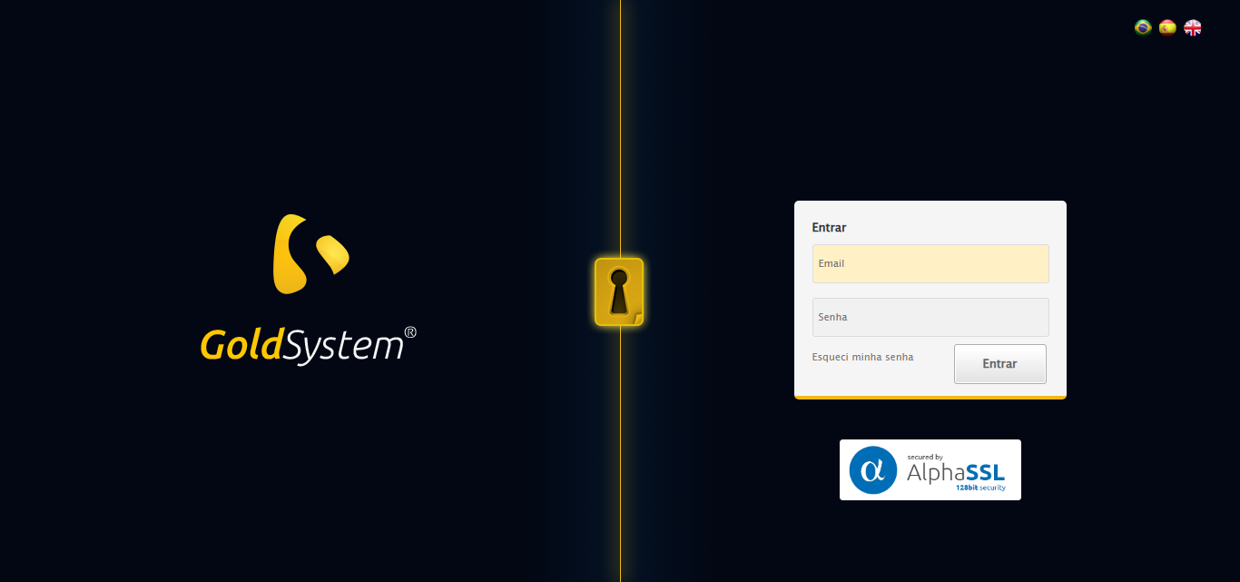

[16:28:47] 🔄 Realizando login...

[16:28:52] ✅ Realizando login realizada com sucesso.

[16:28:55] 📸 Screenshot capturada: realizando_login

Screenshot: realizando_login

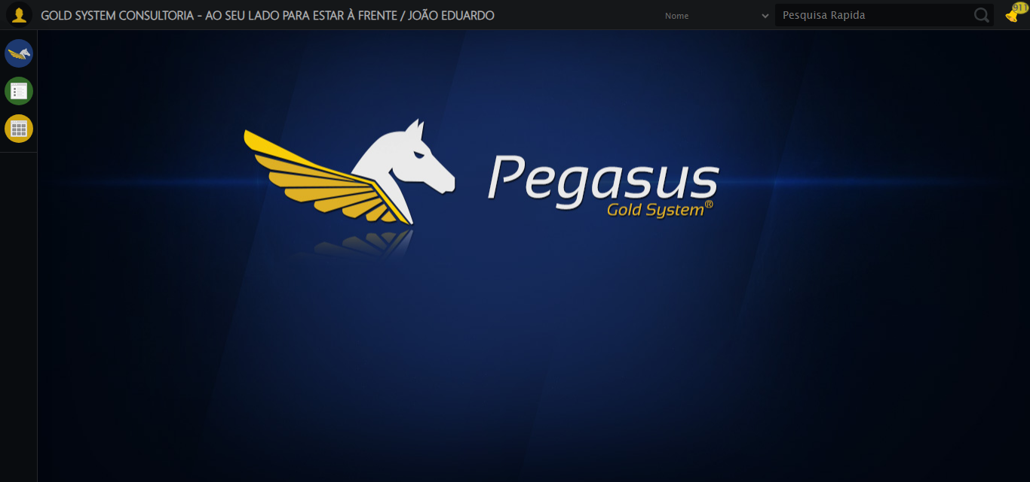

[16:28:55] 🔄 Configurando ambiente...

[16:28:55] 🔍 Zoom ajustado para 90%.

[16:28:57] ✅ Configurando ambiente realizada com sucesso.

[16:28:58] 📸 Screenshot capturada: configurando_ambiente

Screenshot: configurando_ambiente

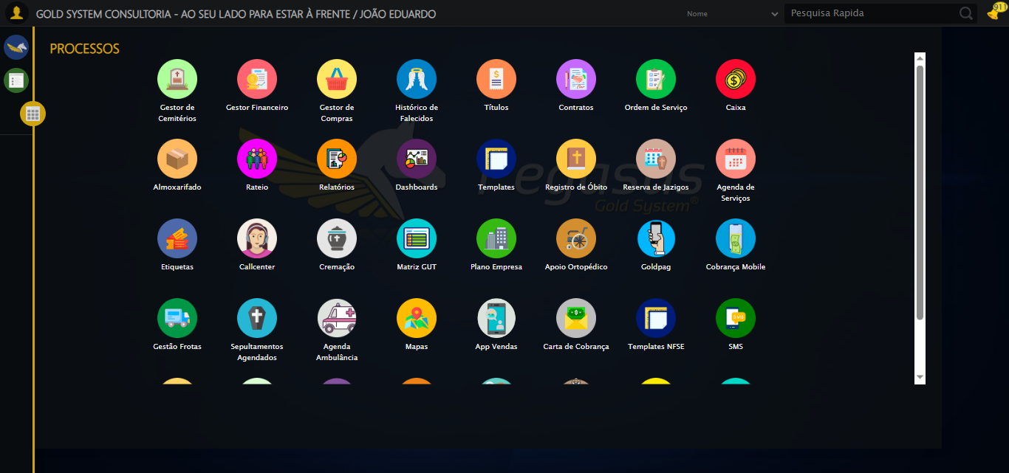

[16:28:58] 🔄 Acessando módulo Callcenter...

[16:28:58] Tentando estratégia de scroll 1...

[16:28:59] ✅ Scroll realizado com estratégia 1

[16:29:00] Tentando estratégia de clique 1 para módulo PET...

[16:29:02] ✅ Clique no módulo PET realizado com estratégia 1

[16:29:02] ✅ Acessando módulo Callcenter realizada com sucesso.

[16:29:03] 📸 Screenshot capturada: acessando_módulo_callcenter

Screenshot: acessando_módulo_callcenter

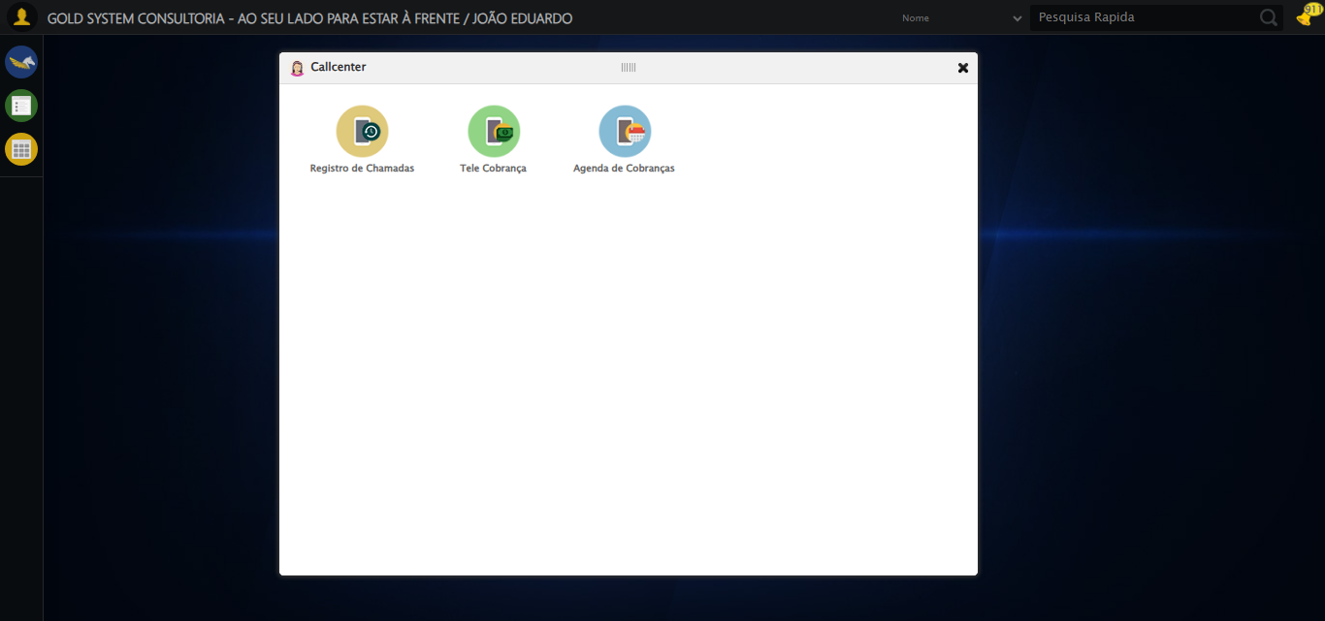

[16:29:03] 🔄 Abrindo Registro de Chamadas...

[16:29:06] ✅ Abrindo Registro de Chamadas realizada com sucesso.

[16:29:07] 📸 Screenshot capturada: abrindo_registro_de_chamadas

Screenshot: abrindo_registro_de_chamadas

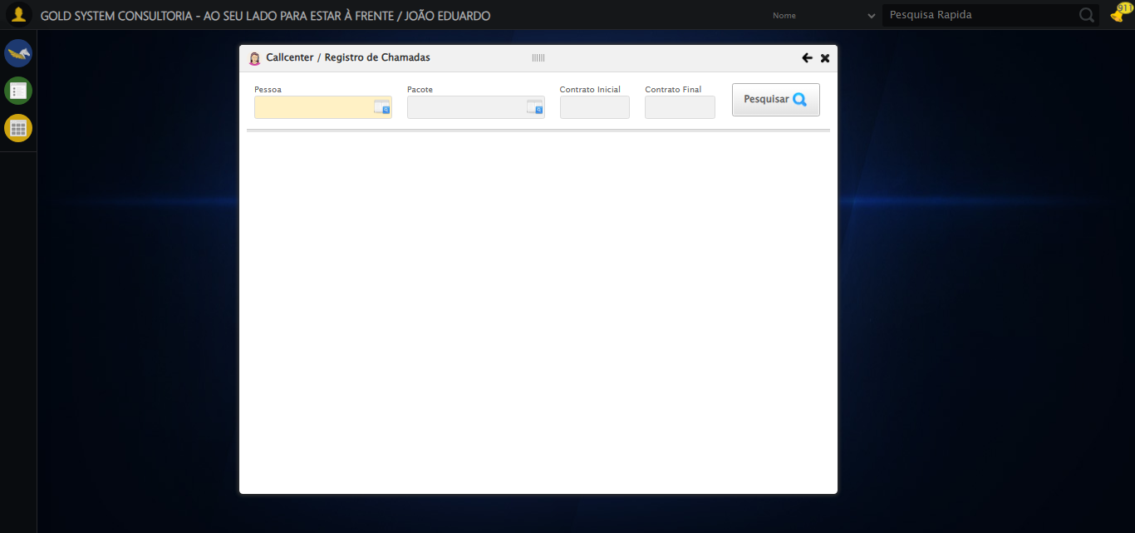

[16:29:07] 🔄 Selecionando Pessoa...

[16:29:07] 🔘 Abrindo modal com botão: #gsCallCenter > div.wdTelas > div.telaRegistroChamadas.telaConsulta.relative > div.formRow.formLastLine > div:nth-child(1) > div > a

[16:29:07] Tentando estratégia de scroll 1...

[16:29:08] ✅ Scroll realizado com estratégia 1

[16:29:10] 🔍 Preenchendo pesquisa com: TESTE TITULAR 233

[16:29:12] 🔍 Executando pesquisa...

[16:29:15] 🎯 Selecionando resultado: //td[contains(text(), 'TESTE TITULAR 233')]

[16:29:15] Tentando estratégia de scroll 1...

[16:29:16] ✅ Scroll realizado com estratégia 1

[16:29:17] ✅ Seleção no modal concluída

[16:29:17] ✅ Selecionando Pessoa realizada com sucesso.

[16:29:18] 📸 Screenshot capturada: selecionando_pessoa

Screenshot: selecionando_pessoa

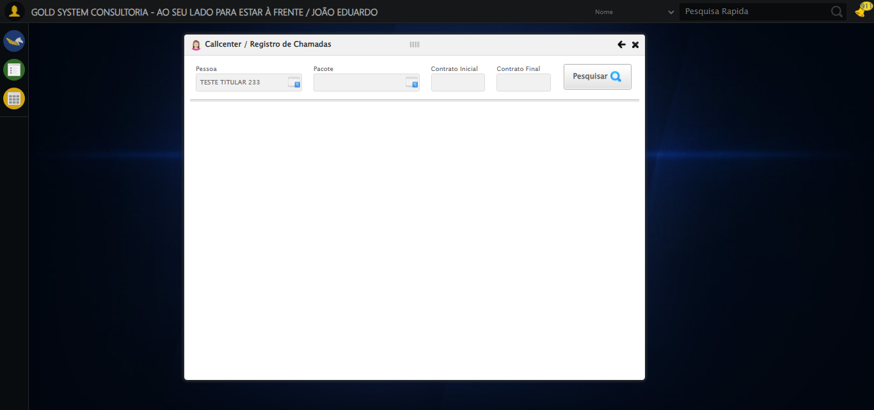

[16:29:18] 🔄 Selecionando Pacote...

[16:29:18] 🔘 Abrindo modal com botão: #gsCallCenter > div.wdTelas > div.telaRegistroChamadas.telaConsulta.relative > div.formRow.formLastLine > div:nth-child(2) > div > a

[16:29:18] Tentando estratégia de scroll 1...

[16:29:19] ✅ Scroll realizado com estratégia 1

[16:29:21] 🔍 Preenchendo pesquisa com: PRO MAX TITANIUM

[16:29:22] 🔍 Executando pesquisa...

[16:29:26] 🎯 Selecionando resultado: //td[contains(text(), 'PRO MAX TITANIUM')]

[16:29:26] Tentando estratégia de scroll 1...

[16:29:27] ✅ Scroll realizado com estratégia 1

[16:29:28] ✅ Seleção no modal concluída

[16:29:28] ✅ Selecionando Pacote realizada com sucesso.

[16:29:29] 📸 Screenshot capturada: selecionando_pacote

Screenshot: selecionando_pacote

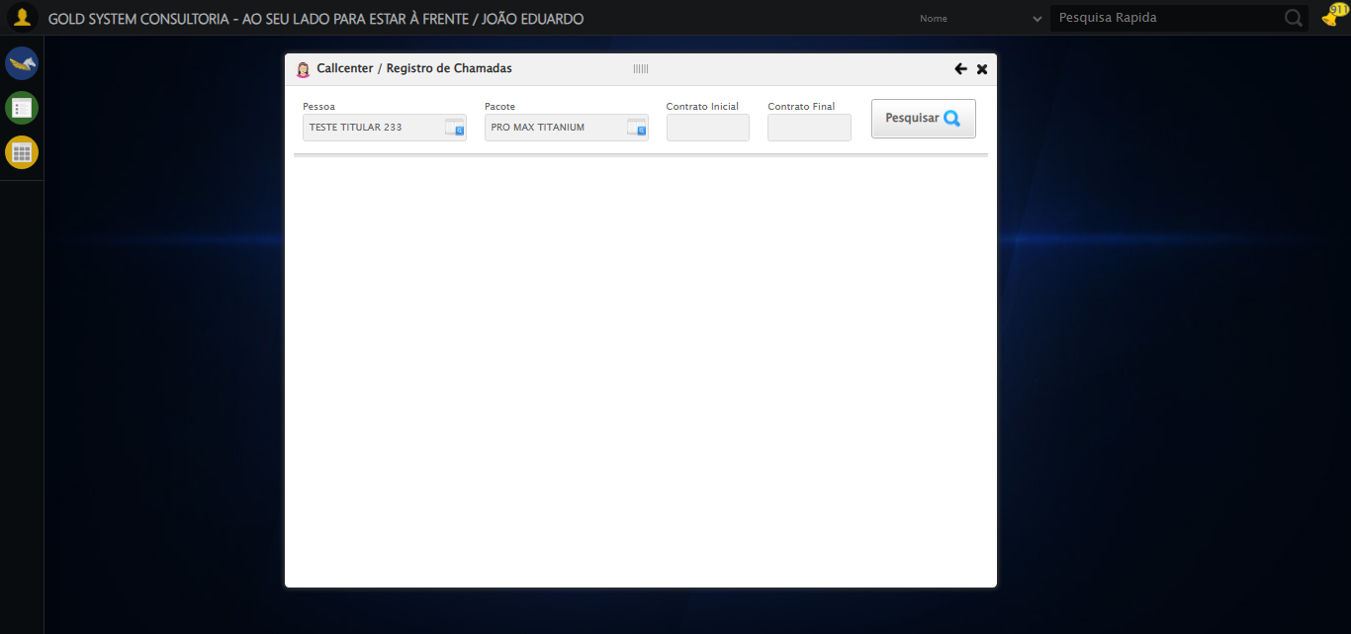

[16:29:29] 🔄 Preenchendo Número do Contrato Inicial...

[16:29:29] Tentando estratégia de scroll 1...

[16:29:30] ✅ Scroll realizado com estratégia 1

[16:29:31] ✅ Campo preenchido com estratégia 1: '113060'

[16:29:31] ✅ Preenchendo Número do Contrato Inicial realizada com sucesso.

[16:29:32] 📸 Screenshot capturada: preenchendo_número_do_contrato_inicial

Screenshot: preenchendo_número_do_contrato_inicial

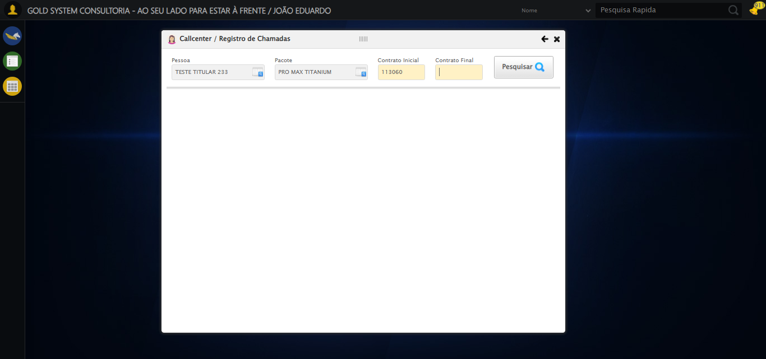

[16:29:33] 🔄 Preenchendo Número do Contrato Final...

[16:29:33] Tentando estratégia de scroll 1...

[16:29:33] ✅ Scroll realizado com estratégia 1

[16:29:35] ✅ Campo preenchido com estratégia 1: '113060'

[16:29:35] ✅ Preenchendo Número do Contrato Final realizada com sucesso.

[16:29:36] 📸 Screenshot capturada: preenchendo_número_do_contrato_final

Screenshot: preenchendo_número_do_contrato_final

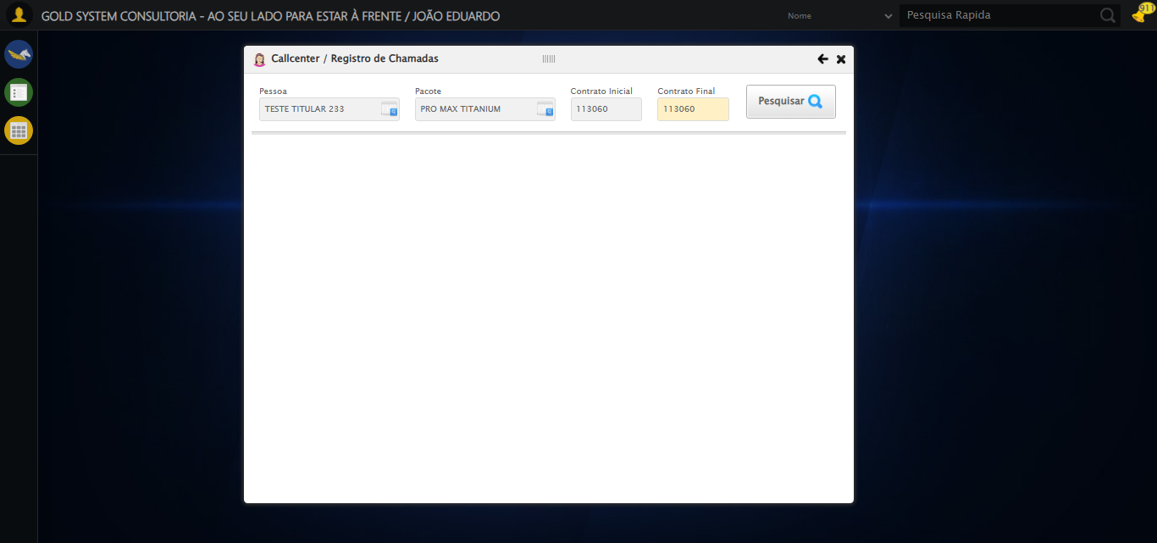

[16:29:36] 🔄 Realizando consulta...

[16:29:36] Tentando estratégia de scroll 1...

[16:29:37] ✅ Scroll realizado com estratégia 1

[16:29:39] ✅ Consulta executada

[16:29:39] ✅ Realizando consulta realizada com sucesso.

[16:29:40] 📸 Screenshot capturada: realizando_consulta

Screenshot: realizando_consulta

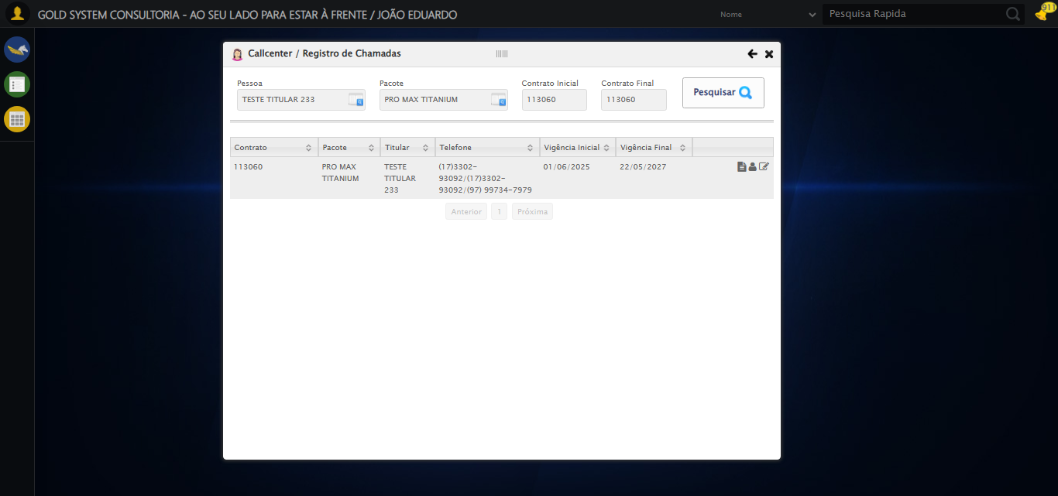

[16:29:40] 🔄 Validando resultados da consulta...

[16:29:40] 🔍 Iniciando validação de registros...

[16:29:45] ✅ Tabela encontrada: #DataTables_Table_2

[16:29:45] ✅ Encontradas 1 linhas válidas com tbody tr:not(.dataTables_empty):not([class*="no-data"])

[16:29:45] ✅ 1 registro(s) encontrado(s)

[16:29:45] Registro 1: 113060 pro max titanium teste titular 233 (17)3302-93092/(17)3302-93092/(97) 99734-7979 01/06/2025 2...

[16:29:45] ✅ Validando resultados da consulta realizada com sucesso.

[16:29:46] 📸 Screenshot capturada: validando_resultados_da_consulta

Screenshot: validando_resultados_da_consulta

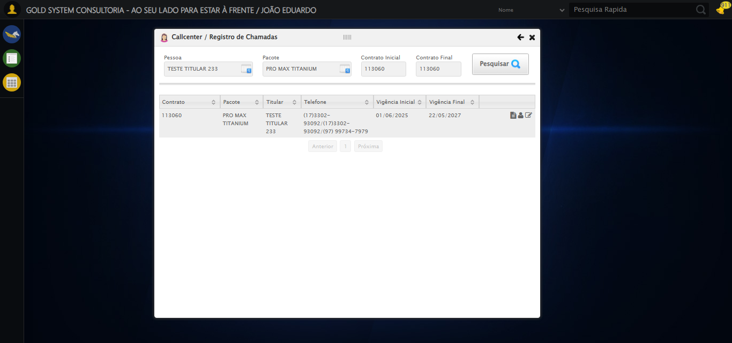

[16:29:46] ✅ Processando 1 registro(s) encontrado(s)

[16:29:46] 🔄 Visualizando dados do Contrato...

[16:29:46] Tentando estratégia de scroll 1...

[16:29:47] ✅ Scroll realizado com estratégia 1

[16:29:48] ✅ Clique realizado com estratégia 1

[16:29:48] ✅ Visualizando dados do Contrato realizada com sucesso.

[16:29:51] 📸 Screenshot capturada: visualizando_dados_do_contrato

Screenshot: visualizando_dados_do_contrato

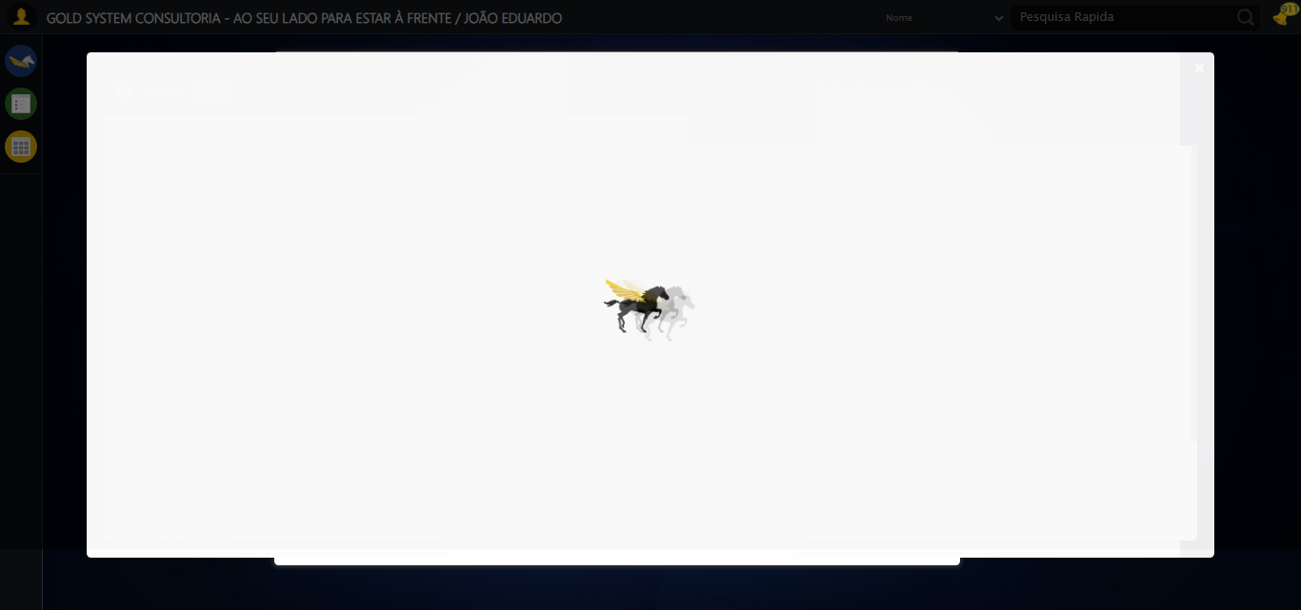

[16:29:51] 🔄 Capturando tela de dados...

[16:29:54] 📸 Screenshot capturada: dados_contrato_pet

Screenshot: dados_contrato_pet

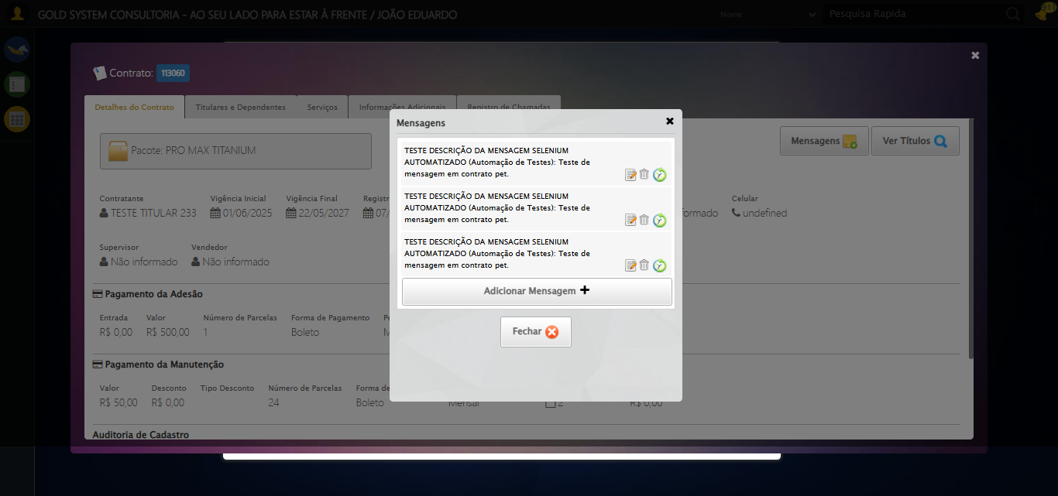

[16:29:54] ✅ Capturando tela de dados realizada com sucesso.

[16:29:55] 📸 Screenshot capturada: capturando_tela_de_dados

Screenshot: capturando_tela_de_dados



[16:29:55] 🔄 Abrindo mensagens do Contrato...

[16:29:55] Tentando estratégia de scroll 1...

[16:29:56] ✅ Scroll realizado com estratégia 1

[16:29:57] ⚠️ Estratégia 1 de clique falhou: Message: element click intercepted: Element <button class="btModel btGray">...</button> is not clickable at point (1061, 182). Other element would receive the click: <div class="blockScreen" style="height: 641px; z-index: 10003; opacity: 0.5;"></div>  
 (Session info: chrome=138.0.7204.185); For documentation on this error, please visit: https://www.selenium.dev/documentation/webdriver/troubleshooting/errors#elementclickinterceptedexception  
Stacktrace:  
 GetHandleVerifier [0x0x5dba83+63395]  
 GetHandleVerifier [0x0x5dbac4+63460]  
 (No symbol) [0x0x422113]  
 (No symbol) [0x0x470ba0]  
 (No symbol) [0x0x46ef5a]  
 (No symbol) [0x0x46cab7]  
 (No symbol) [0x0x46bd6d]  
 (No symbol) [0x0x460515]  
 (No symbol) [0x0x48f3ac]  
 (No symbol) [0x0x45ffa4]  
 (No symbol) [0x0x48f624]  
 (No symbol) [0x0x4b07ba]  
 (No symbol) [0x0x48f1a6]  
 (No symbol) [0x0x45e7b2]  
 (No symbol) [0x0x45f654]  
 GetHandleVerifier [0x0x858883+2672035]  
 GetHandleVerifier [0x0x853cba+2652634]  
 GetHandleVerifier [0x0x602bca+223466]  
 GetHandleVerifier [0x0x5f2cb8+158168]  
 GetHandleVerifier [0x0x5f978d+185517]  
 GetHandleVerifier [0x0x5e3b78+96408]  
 GetHandleVerifier [0x0x5e3d02+96802]  
 GetHandleVerifier [0x0x5ce90a+9770]  
 BaseThreadInitThunk [0x0x75abfcc9+25]  
 RtlGetAppContainerNamedObjectPath [0x0x776d82ae+286]  
 RtlGetAppContainerNamedObjectPath [0x0x776d827e+238]

[16:29:58] ✅ Clique realizado com estratégia 2

[16:29:58] ✅ Abrindo mensagens do Contrato realizada com sucesso.

[16:29:59] 📸 Screenshot capturada: abrindo_mensagens_do_contrato

Screenshot: abrindo_mensagens_do_contrato

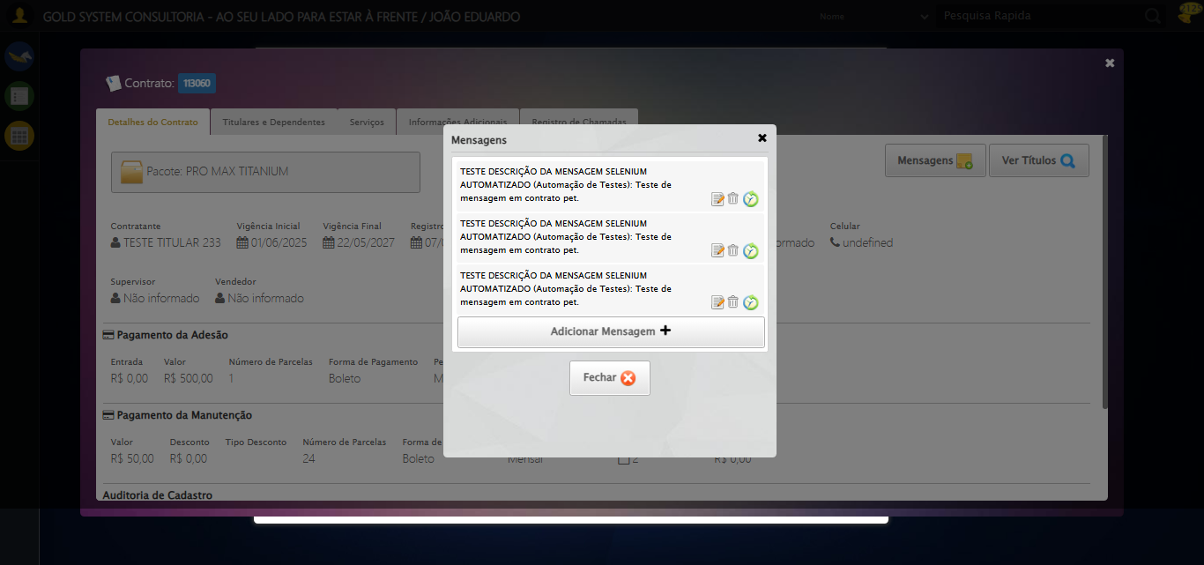

[16:29:59] 🔄 Capturando mensagens...

[16:30:01] 📸 Screenshot capturada: mensagens_contrato_pet

Screenshot: mensagens_contrato_pet

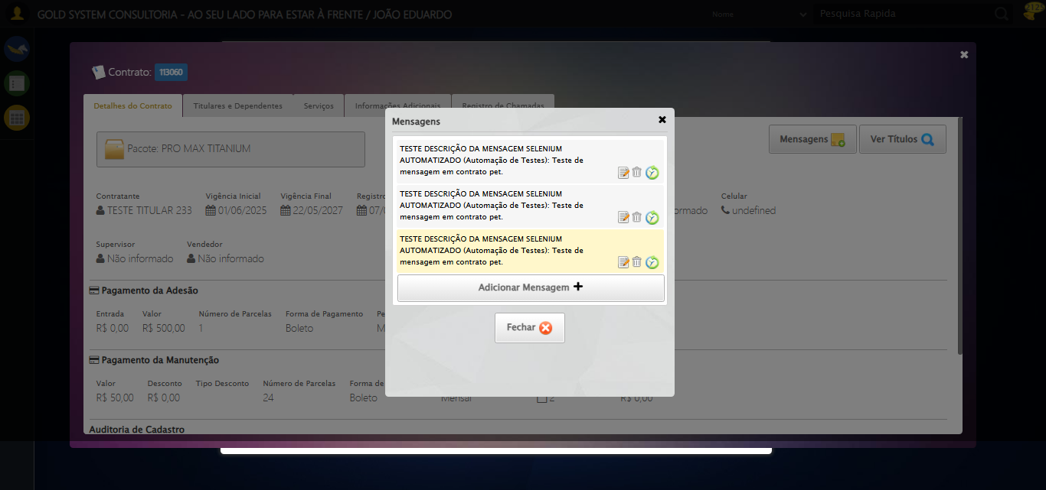

[16:30:01] ✅ Capturando mensagens realizada com sucesso.

[16:30:03] 📸 Screenshot capturada: capturando_mensagens

Screenshot: capturando_mensagens

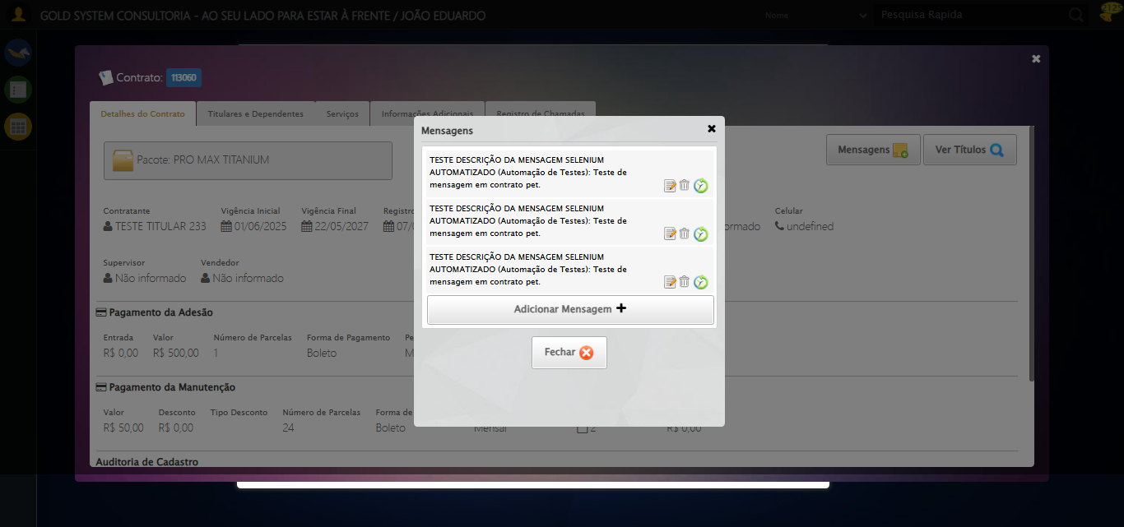

[16:30:03] 🔄 Adicionando nova mensagem...

[16:30:03] Tentando estratégia de scroll 1...

[16:30:03] ✅ Scroll realizado com estratégia 1

[16:30:04] ✅ Clique realizado com estratégia 1

[16:30:04] ✅ Adicionando nova mensagem realizada com sucesso.

[16:30:05] 📸 Screenshot capturada: adicionando_nova_mensagem

Screenshot: adicionando_nova_mensagem

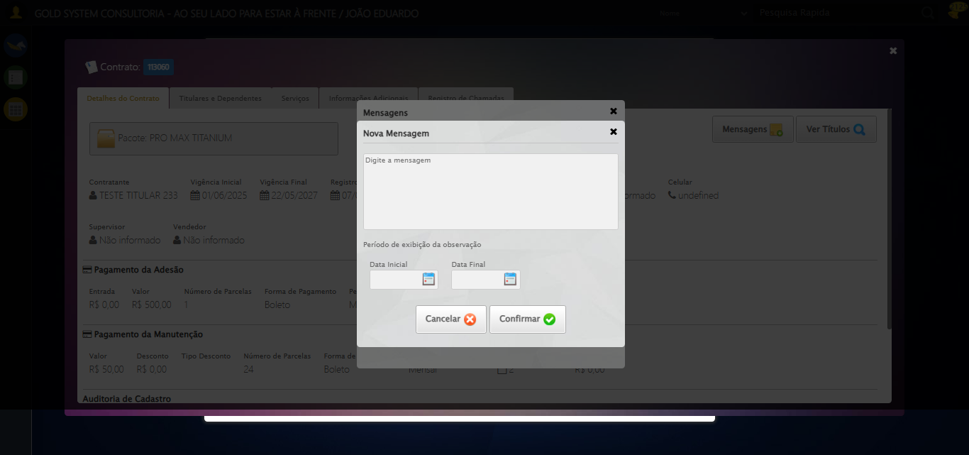

[16:30:05] 🔄 Preenchendo descrição da mensagem...

[16:30:05] 🎯 Tentativa 1: Preenchendo textarea 0 (ID: (sem id), name: (sem name)) com 107 caracteres

[16:30:05] ▶️ Estratégia 1…

[16:30:07] ✅ Preenchido com sucesso pela estratégia 1: 'TESTE DESCRIÇÃO DA MENSAGEM SELENIUM AUTOMATIZADO (Automação…'

[16:30:07] ✅ Preenchendo descrição da mensagem realizada com sucesso.

[16:30:08] 📸 Screenshot capturada: preenchendo_descrição_da_mensagem

Screenshot: preenchendo_descrição_da_mensagem

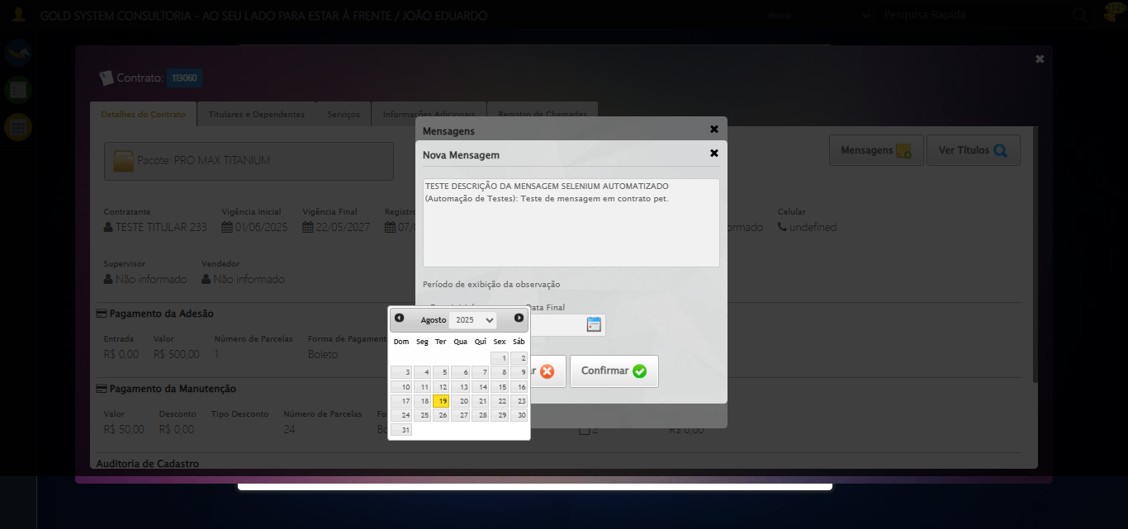

[16:30:08] 🔄 Definindo período de exibição - Data Inicial...

[16:30:08] 📊 Encontrados 2 campos datepicker

[16:30:08] 🎯 Tentativa 1: Preenchendo datepicker 0 (ID: dp1755631730613) com '14/08/2025'

[16:30:08] Aplicando estratégia 1 para datepicker...

[16:30:09] ✅ Datepicker preenchido com estratégia 1: '14/08/2025'

[16:30:09] ✅ Definindo período de exibição - Data Inicial realizada com sucesso.

[16:30:11] 📸 Screenshot capturada: definindo_período_de_exibição_-_data_inicial

Screenshot: definindo_período_de_exibição_-_data_inicial

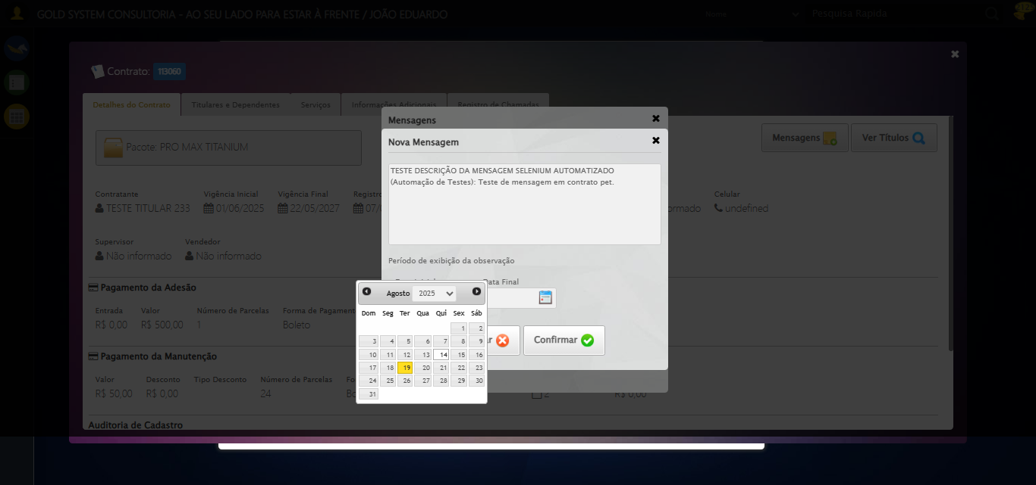

[16:30:11] 🔄 Definindo período de exibição - Data Final...

[16:30:11] 📊 Encontrados 2 campos datepicker

[16:30:11] 🎯 Tentativa 1: Preenchendo datepicker 1 (ID: dp1755631730614) com '24/11/2025'

[16:30:11] Aplicando estratégia 1 para datepicker...

[16:30:12] ✅ Datepicker preenchido com estratégia 1: '24/11/2025'

[16:30:12] ✅ Definindo período de exibição - Data Final realizada com sucesso.

[16:30:13] 📸 Screenshot capturada: definindo_período_de_exibição_-_data_final

Screenshot: definindo_período_de_exibição_-_data_final

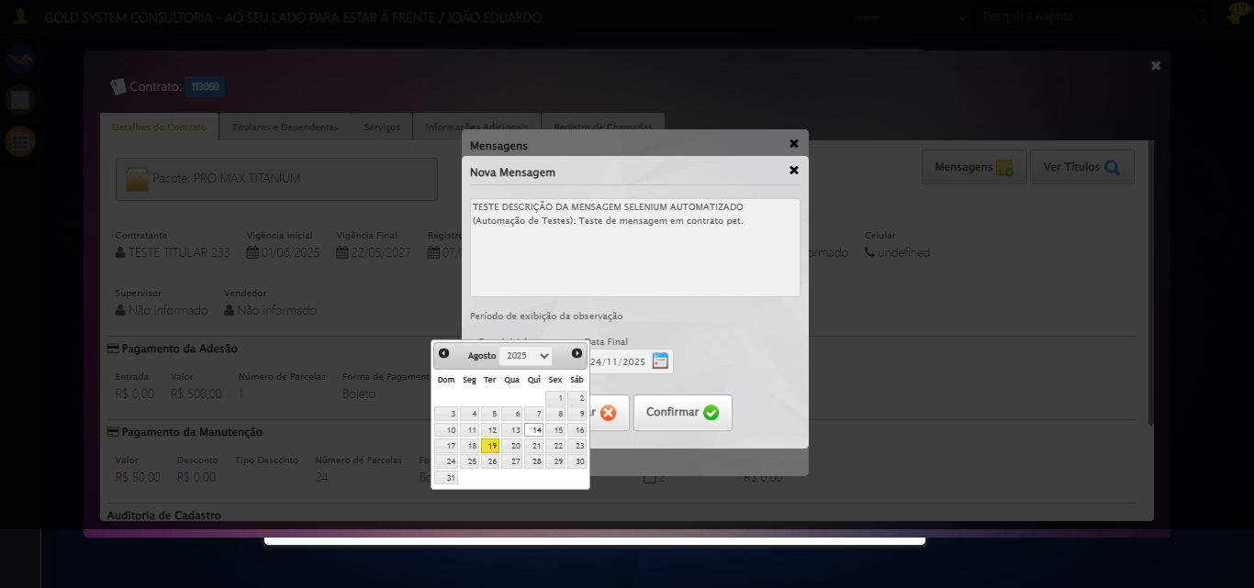

[16:30:13] 🔄 Confirmando mensagem...

[16:30:13] Tentando estratégia de scroll 1...

[16:30:14] ✅ Scroll realizado com estratégia 1

[16:30:15] ✅ Clique realizado com estratégia 1

[16:30:15] ✅ Confirmando mensagem realizada com sucesso.

[16:30:16] 📸 Screenshot capturada: confirmando_mensagem

Screenshot: confirmando_mensagem

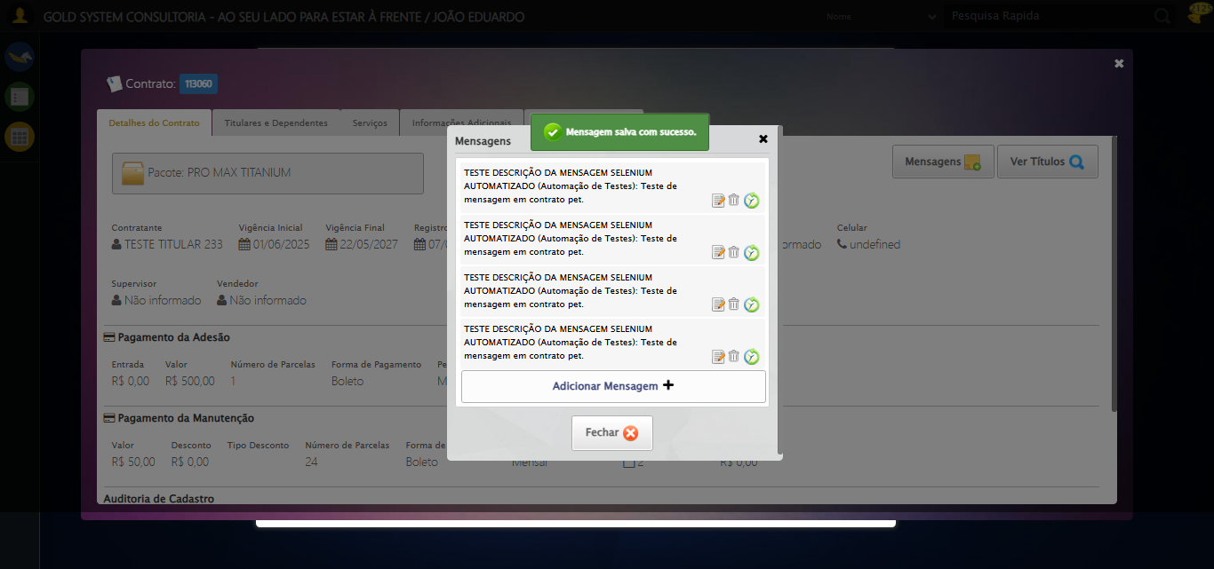

[16:30:16] 🔍 Verificando mensagens de alerta...

[16:30:16] 📢 ✅ Sucesso: Mensagem salva com sucesso.

[16:30:16] 🔄 Fechando aba de mensagens...

[16:30:46] ❌ Timeout aguardando elemento: /html/body/div[21]/div[2]/a (condição: present, timeout: 30s)

[16:30:46] ❌ Falha ao clicar em /html/body/div[21]/div[2]/a: Message: Elemento não encontrado: /html/body/div[21]/div[2]/a (condição: present)

[16:30:46] 📸 Screenshot capturada: erro_fechando_aba_de_mensagens

Screenshot: erro_fechando_aba_de_mensagens

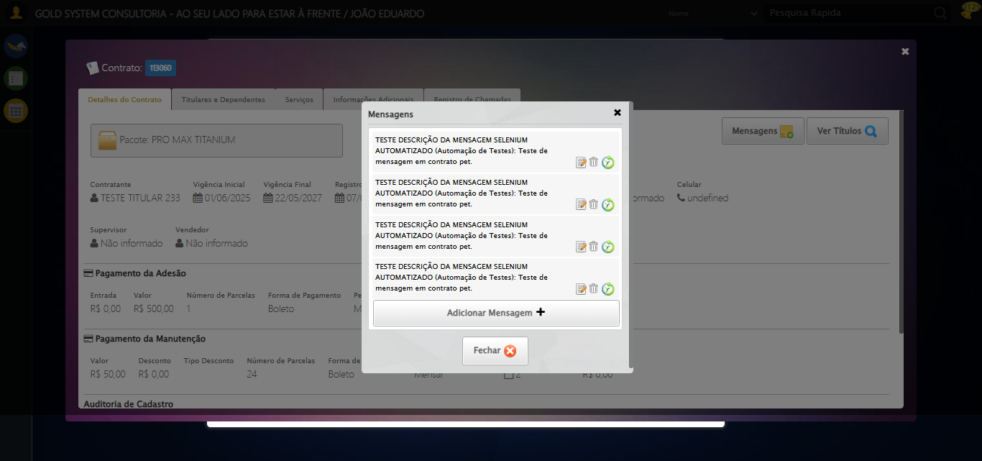

[16:30:46] ❌ Fechando aba de mensagens falhou: TimeoutException: Message: Elemento não encontrado: /html/body/div[21]/div[2]/a (condição: present)

[16:30:46] ⚠️ Continuando execução apesar do erro em: Fechando aba de mensagens

[16:30:46] 🔄 Visualizando títulos do Contrato...

[16:30:46] Tentando estratégia de scroll 1...

[16:30:47] ✅ Scroll realizado com estratégia 1

[16:30:48] ⚠️ Estratégia 1 de clique falhou: Message: element click intercepted: Element <button class="btModel btGray">...</button> is not clickable at point (1178, 182). Other element would receive the click: <div class="blockScreen" style="height: 641px; z-index: 10003; opacity: 0.5;"></div>  
 (Session info: chrome=138.0.7204.185); For documentation on this error, please visit: https://www.selenium.dev/documentation/webdriver/troubleshooting/errors#elementclickinterceptedexception  
Stacktrace:  
 GetHandleVerifier [0x0x5dba83+63395]  
 GetHandleVerifier [0x0x5dbac4+63460]  
 (No symbol) [0x0x422113]  
 (No symbol) [0x0x470ba0]  
 (No symbol) [0x0x46ef5a]  
 (No symbol) [0x0x46cab7]  
 (No symbol) [0x0x46bd6d]  
 (No symbol) [0x0x460515]  
 (No symbol) [0x0x48f3ac]  
 (No symbol) [0x0x45ffa4]  
 (No symbol) [0x0x48f624]  
 (No symbol) [0x0x4b07ba]  
 (No symbol) [0x0x48f1a6]  
 (No symbol) [0x0x45e7b2]  
 (No symbol) [0x0x45f654]  
 GetHandleVerifier [0x0x858883+2672035]  
 GetHandleVerifier [0x0x853cba+2652634]  
 GetHandleVerifier [0x0x602bca+223466]  
 GetHandleVerifier [0x0x5f2cb8+158168]  
 GetHandleVerifier [0x0x5f978d+185517]  
 GetHandleVerifier [0x0x5e3b78+96408]  
 GetHandleVerifier [0x0x5e3d02+96802]  
 GetHandleVerifier [0x0x5ce90a+9770]  
 BaseThreadInitThunk [0x0x75abfcc9+25]  
 RtlGetAppContainerNamedObjectPath [0x0x776d82ae+286]  
 RtlGetAppContainerNamedObjectPath [0x0x776d827e+238]

[16:30:49] ✅ Clique realizado com estratégia 2

[16:30:49] ✅ Visualizando títulos do Contrato realizada com sucesso.

[16:30:50] 📸 Screenshot capturada: visualizando_títulos_do_contrato

Screenshot: visualizando_títulos_do_contrato

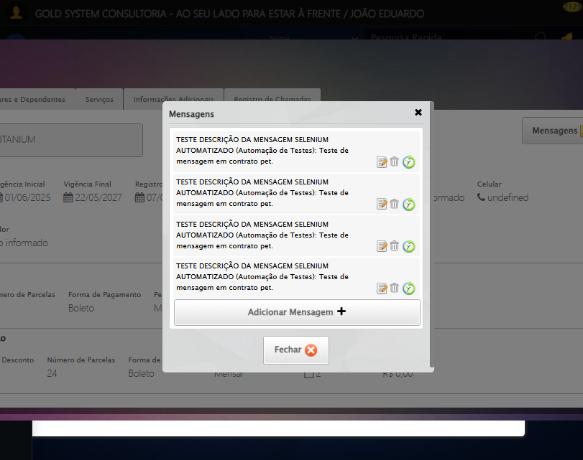

[16:30:50] 🔄 Aguardando carregamento de títulos e capturando Screenshot...

[16:31:20] 📸 Screenshot capturada: titulos_contrato_pet

Screenshot: titulos_contrato_pet



[16:31:20] ✅ Aguardando carregamento de títulos e capturando Screenshot realizada com sucesso.

[16:31:22] 📸 Screenshot capturada: aguardando_carregamento_de_títulos_e_capturando_screenshot

Screenshot: aguardando_carregamento_de_títulos_e_capturando_screenshot

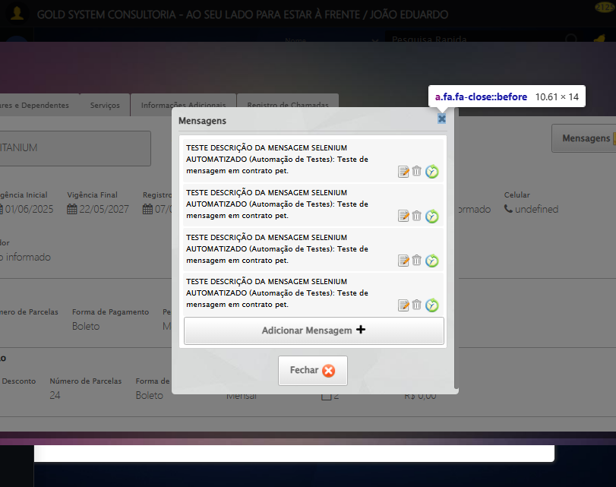

[16:31:22] 🔄 Fechando aba de títulos...

[16:31:37] ❌ Erro aguardando elemento //a[@title='Sair' and contains(@class, 'sp-fecharGrande')]: Message: no such window: target window already closed  
from unknown error: web view not found  
 (Session info: chrome=138.0.7204.185)  
Stacktrace:  
 GetHandleVerifier [0x0x5dba83+63395]  
 GetHandleVerifier [0x0x5dbac4+63460]  
 (No symbol) [0x0x422113]  
 (No symbol) [0x0x400fb9]  
 (No symbol) [0x0x495ace]  
 (No symbol) [0x0x4b0099]  
 (No symbol) [0x0x48f1a6]  
 (No symbol) [0x0x45e7b2]  
 (No symbol) [0x0x45f654]  
 GetHandleVerifier [0x0x858883+2672035]  
 GetHandleVerifier [0x0x853cba+2652634]  
 GetHandleVerifier [0x0x602bca+223466]  
 GetHandleVerifier [0x0x5f2cb8+158168]  
 GetHandleVerifier [0x0x5f978d+185517]  
 GetHandleVerifier [0x0x5e3b78+96408]  
 GetHandleVerifier [0x0x5e3d02+96802]  
 GetHandleVerifier [0x0x5ce90a+9770]  
 BaseThreadInitThunk [0x0x75abfcc9+25]  
 RtlGetAppContainerNamedObjectPath [0x0x776d82ae+286]  
 RtlGetAppContainerNamedObjectPath [0x0x776d827e+238]

[16:31:37] ❌ Falha ao clicar em //a[@title='Sair' and contains(@class, 'sp-fecharGrande')]: Message: no such window: target window already closed  
from unknown error: web view not found  
 (Session info: chrome=138.0.7204.185)  
Stacktrace:  
 GetHandleVerifier [0x0x5dba83+63395]  
 GetHandleVerifier [0x0x5dbac4+63460]  
 (No symbol) [0x0x422113]  
 (No symbol) [0x0x400fb9]  
 (No symbol) [0x0x495ace]  
 (No symbol) [0x0x4b0099]  
 (No symbol) [0x0x48f1a6]  
 (No symbol) [0x0x45e7b2]  
 (No symbol) [0x0x45f654]  
 GetHandleVerifier [0x0x858883+2672035]  
 GetHandleVerifier [0x0x853cba+2652634]  
 GetHandleVerifier [0x0x602bca+223466]  
 GetHandleVerifier [0x0x5f2cb8+158168]  
 GetHandleVerifier [0x0x5f978d+185517]  
 GetHandleVerifier [0x0x5e3b78+96408]  
 GetHandleVerifier [0x0x5e3d02+96802]  
 GetHandleVerifier [0x0x5ce90a+9770]  
 BaseThreadInitThunk [0x0x75abfcc9+25]  
 RtlGetAppContainerNamedObjectPath [0x0x776d82ae+286]  
 RtlGetAppContainerNamedObjectPath [0x0x776d827e+238]

[16:31:37] ⚠️ Erro ao tirar screenshot erro_fechando_aba_de_títulos: Message: no such window: target window already closed  
from unknown error: web view not found  
 (Session info: chrome=138.0.7204.185)  
Stacktrace:  
 GetHandleVerifier [0x0x5dba83+63395]  
 GetHandleVerifier [0x0x5dbac4+63460]  
 (No symbol) [0x0x422113]  
 (No symbol) [0x0x400fb9]  
 (No symbol) [0x0x495ace]  
 (No symbol) [0x0x4b0099]  
 (No symbol) [0x0x48f1a6]  
 (No symbol) [0x0x45e7b2]  
 (No symbol) [0x0x45f654]  
 GetHandleVerifier [0x0x858883+2672035]  
 GetHandleVerifier [0x0x853cba+2652634]  
 GetHandleVerifier [0x0x602bca+223466]  
 GetHandleVerifier [0x0x5f2cb8+158168]  
 GetHandleVerifier [0x0x5f978d+185517]  
 GetHandleVerifier [0x0x5e3b78+96408]  
 GetHandleVerifier [0x0x5e3d02+96802]  
 GetHandleVerifier [0x0x5ce90a+9770]  
 BaseThreadInitThunk [0x0x75abfcc9+25]  
 RtlGetAppContainerNamedObjectPath [0x0x776d82ae+286]  
 RtlGetAppContainerNamedObjectPath [0x0x776d827e+238]

[16:31:37] ❌ Fechando aba de títulos falhou: NoSuchWindowException: Message: no such window: target window already closed  
from unknown error: web view not found  
 (Session info: chrome=138.0.7204.185)  
Stacktrace:  
 GetHandleVerifier [0x0x5dba83+63395]  
 GetHandleVerifier [0x0x5dbac4+63460]  
 (No symbol) [0x0x422113]  
 (No symbol) [0x0x400fb9]  
 (No symbol) [0x0x495ace]  
 (No symbol) [0x0x4b0099]  
 (No symbol) [0x0x48f1a6]  
 (No symbol) [0x0x45e7b2]  
 (No symbol) [0x0x45f654]  
 GetHandleVerifier [0x0x858883+2672035]  
 GetHandleVerifier [0x0x853cba+2652634]  
 GetHandleVerifier [0x0x602bca+223466]  
 GetHandleVerifier [0x0x5f2cb8+158168]  
 GetHandleVerifier [0x0x5f978d+185517]  
 GetHandleVerifier [0x0x5e3b78+96408]  
 GetHandleVerifier [0x0x5e3d02+96802]  
 GetHandleVerifier [0x0x5ce90a+9770]  
 BaseThreadInitThunk [0x0x75abfcc9+25]  
 RtlGetAppContainerNamedObjectPath [0x0x776d82ae+286]  
 RtlGetAppContainerNamedObjectPath [0x0x776d827e+238]

[16:31:37] ⚠️ Continuando execução apesar do erro em: Fechando aba de títulos

[16:31:37] 🔄 Abrindo Dados do Titular...

[16:31:37] ❌ Erro aguardando elemento //span[contains(@class,'btTitular') and @title='Dados do Titular']: Message: no such window: target window already closed  
from unknown error: web view not found  
 (Session info: chrome=138.0.7204.185)  
Stacktrace:  
 GetHandleVerifier [0x0x5dba83+63395]  
 GetHandleVerifier [0x0x5dbac4+63460]  
 (No symbol) [0x0x422113]  
 (No symbol) [0x0x400fb9]  
 (No symbol) [0x0x495ace]  
 (No symbol) [0x0x4b0099]  
 (No symbol) [0x0x48f1a6]  
 (No symbol) [0x0x45e7b2]  
 (No symbol) [0x0x45f654]  
 GetHandleVerifier [0x0x858883+2672035]  
 GetHandleVerifier [0x0x853cba+2652634]  
 GetHandleVerifier [0x0x602bca+223466]  
 GetHandleVerifier [0x0x5f2cb8+158168]  
 GetHandleVerifier [0x0x5f978d+185517]  
 GetHandleVerifier [0x0x5e3b78+96408]  
 GetHandleVerifier [0x0x5e3d02+96802]  
 GetHandleVerifier [0x0x5ce90a+9770]  
 BaseThreadInitThunk [0x0x75abfcc9+25]  
 RtlGetAppContainerNamedObjectPath [0x0x776d82ae+286]  
 RtlGetAppContainerNamedObjectPath [0x0x776d827e+238]

[16:31:37] ❌ Falha ao clicar em //span[contains(@class,'btTitular') and @title='Dados do Titular']: Message: no such window: target window already closed  
from unknown error: web view not found  
 (Session info: chrome=138.0.7204.185)  
Stacktrace:  
 GetHandleVerifier [0x0x5dba83+63395]  
 GetHandleVerifier [0x0x5dbac4+63460]  
 (No symbol) [0x0x422113]  
 (No symbol) [0x0x400fb9]  
 (No symbol) [0x0x495ace]  
 (No symbol) [0x0x4b0099]  
 (No symbol) [0x0x48f1a6]  
 (No symbol) [0x0x45e7b2]  
 (No symbol) [0x0x45f654]  
 GetHandleVerifier [0x0x858883+2672035]  
 GetHandleVerifier [0x0x853cba+2652634]  
 GetHandleVerifier [0x0x602bca+223466]  
 GetHandleVerifier [0x0x5f2cb8+158168]  
 GetHandleVerifier [0x0x5f978d+185517]  
 GetHandleVerifier [0x0x5e3b78+96408]  
 GetHandleVerifier [0x0x5e3d02+96802]  
 GetHandleVerifier [0x0x5ce90a+9770]  
 BaseThreadInitThunk [0x0x75abfcc9+25]  
 RtlGetAppContainerNamedObjectPath [0x0x776d82ae+286]  
 RtlGetAppContainerNamedObjectPath [0x0x776d827e+238]

[16:31:37] ⚠️ Erro ao tirar screenshot erro_abrindo_dados_do_titular: Message: no such window: target window already closed  
from unknown error: web view not found  
 (Session info: chrome=138.0.7204.185)  
Stacktrace:  
 GetHandleVerifier [0x0x5dba83+63395]  
 GetHandleVerifier [0x0x5dbac4+63460]  
 (No symbol) [0x0x422113]  
 (No symbol) [0x0x400fb9]  
 (No symbol) [0x0x495ace]  
 (No symbol) [0x0x4b0099]  
 (No symbol) [0x0x48f1a6]  
 (No symbol) [0x0x45e7b2]  
 (No symbol) [0x0x45f654]  
 GetHandleVerifier [0x0x858883+2672035]  
 GetHandleVerifier [0x0x853cba+2652634]  
 GetHandleVerifier [0x0x602bca+223466]  
 GetHandleVerifier [0x0x5f2cb8+158168]  
 GetHandleVerifier [0x0x5f978d+185517]  
 GetHandleVerifier [0x0x5e3b78+96408]  
 GetHandleVerifier [0x0x5e3d02+96802]  
 GetHandleVerifier [0x0x5ce90a+9770]  
 BaseThreadInitThunk [0x0x75abfcc9+25]  
 RtlGetAppContainerNamedObjectPath [0x0x776d82ae+286]  
 RtlGetAppContainerNamedObjectPath [0x0x776d827e+238]

[16:31:37] ❌ Abrindo Dados do Titular falhou: NoSuchWindowException: Message: no such window: target window already closed  
from unknown error: web view not found  
 (Session info: chrome=138.0.7204.185)  
Stacktrace:  
 GetHandleVerifier [0x0x5dba83+63395]  
 GetHandleVerifier [0x0x5dbac4+63460]  
 (No symbol) [0x0x422113]  
 (No symbol) [0x0x400fb9]  
 (No symbol) [0x0x495ace]  
 (No symbol) [0x0x4b0099]  
 (No symbol) [0x0x48f1a6]  
 (No symbol) [0x0x45e7b2]  
 (No symbol) [0x0x45f654]  
 GetHandleVerifier [0x0x858883+2672035]  
 GetHandleVerifier [0x0x853cba+2652634]  
 GetHandleVerifier [0x0x602bca+223466]  
 GetHandleVerifier [0x0x5f2cb8+158168]  
 GetHandleVerifier [0x0x5f978d+185517]  
 GetHandleVerifier [0x0x5e3b78+96408]  
 GetHandleVerifier [0x0x5e3d02+96802]  
 GetHandleVerifier [0x0x5ce90a+9770]  
 BaseThreadInitThunk [0x0x75abfcc9+25]  
 RtlGetAppContainerNamedObjectPath [0x0x776d82ae+286]  
 RtlGetAppContainerNamedObjectPath [0x0x776d827e+238]

[16:31:37] ⚠️ Continuando execução apesar do erro em: Abrindo Dados do Titular

[16:31:37] 🔄 Abrindo Dados Cadastrais do Titular e capturando Screenshot da aba 'Dados Pessoais'...

[16:31:37] ❌ Erro aguardando elemento //a[contains(@class,'materializacaoPeglink') and @ref='1|21582908']: Message: no such window: target window already closed  
from unknown error: web view not found  
 (Session info: chrome=138.0.7204.185)  
Stacktrace:  
 GetHandleVerifier [0x0x5dba83+63395]  
 GetHandleVerifier [0x0x5dbac4+63460]  
 (No symbol) [0x0x422113]  
 (No symbol) [0x0x400fb9]  
 (No symbol) [0x0x495ace]  
 (No symbol) [0x0x4b0099]  
 (No symbol) [0x0x48f1a6]  
 (No symbol) [0x0x45e7b2]  
 (No symbol) [0x0x45f654]  
 GetHandleVerifier [0x0x858883+2672035]  
 GetHandleVerifier [0x0x853cba+2652634]  
 GetHandleVerifier [0x0x602bca+223466]  
 GetHandleVerifier [0x0x5f2cb8+158168]  
 GetHandleVerifier [0x0x5f978d+185517]  
 GetHandleVerifier [0x0x5e3b78+96408]  
 GetHandleVerifier [0x0x5e3d02+96802]  
 GetHandleVerifier [0x0x5ce90a+9770]  
 BaseThreadInitThunk [0x0x75abfcc9+25]  
 RtlGetAppContainerNamedObjectPath [0x0x776d82ae+286]  
 RtlGetAppContainerNamedObjectPath [0x0x776d827e+238]

[16:31:37] ❌ Falha ao clicar em //a[contains(@class,'materializacaoPeglink') and @ref='1|21582908']: Message: no such window: target window already closed  
from unknown error: web view not found  
 (Session info: chrome=138.0.7204.185)  
Stacktrace:  
 GetHandleVerifier [0x0x5dba83+63395]  
 GetHandleVerifier [0x0x5dbac4+63460]  
 (No symbol) [0x0x422113]  
 (No symbol) [0x0x400fb9]  
 (No symbol) [0x0x495ace]  
 (No symbol) [0x0x4b0099]  
 (No symbol) [0x0x48f1a6]  
 (No symbol) [0x0x45e7b2]  
 (No symbol) [0x0x45f654]  
 GetHandleVerifier [0x0x858883+2672035]  
 GetHandleVerifier [0x0x853cba+2652634]  
 GetHandleVerifier [0x0x602bca+223466]  
 GetHandleVerifier [0x0x5f2cb8+158168]  
 GetHandleVerifier [0x0x5f978d+185517]  
 GetHandleVerifier [0x0x5e3b78+96408]  
 GetHandleVerifier [0x0x5e3d02+96802]  
 GetHandleVerifier [0x0x5ce90a+9770]  
 BaseThreadInitThunk [0x0x75abfcc9+25]  
 RtlGetAppContainerNamedObjectPath [0x0x776d82ae+286]  
 RtlGetAppContainerNamedObjectPath [0x0x776d827e+238]

[16:31:37] ⚠️ Erro ao tirar screenshot erro_abrindo_dados_cadastrais_do_titular_e_capturando_screenshot_da_aba_dados_pessoais_: Message: no such window: target window already closed  
from unknown error: web view not found  
 (Session info: chrome=138.0.7204.185)  
Stacktrace:  
 GetHandleVerifier [0x0x5dba83+63395]  
 GetHandleVerifier [0x0x5dbac4+63460]  
 (No symbol) [0x0x422113]  
 (No symbol) [0x0x400fb9]  
 (No symbol) [0x0x495ace]  
 (No symbol) [0x0x4b0099]  
 (No symbol) [0x0x48f1a6]  
 (No symbol) [0x0x45e7b2]  
 (No symbol) [0x0x45f654]  
 GetHandleVerifier [0x0x858883+2672035]  
 GetHandleVerifier [0x0x853cba+2652634]  
 GetHandleVerifier [0x0x602bca+223466]  
 GetHandleVerifier [0x0x5f2cb8+158168]  
 GetHandleVerifier [0x0x5f978d+185517]  
 GetHandleVerifier [0x0x5e3b78+96408]  
 GetHandleVerifier [0x0x5e3d02+96802]  
 GetHandleVerifier [0x0x5ce90a+9770]  
 BaseThreadInitThunk [0x0x75abfcc9+25]  
 RtlGetAppContainerNamedObjectPath [0x0x776d82ae+286]  
 RtlGetAppContainerNamedObjectPath [0x0x776d827e+238]

[16:31:37] ❌ Abrindo Dados Cadastrais do Titular e capturando Screenshot da aba 'Dados Pessoais' falhou: NoSuchWindowException: Message: no such window: target window already closed  
from unknown error: web view not found  
 (Session info: chrome=138.0.7204.185)  
Stacktrace:  
 GetHandleVerifier [0x0x5dba83+63395]  
 GetHandleVerifier [0x0x5dbac4+63460]  
 (No symbol) [0x0x422113]  
 (No symbol) [0x0x400fb9]  
 (No symbol) [0x0x495ace]  
 (No symbol) [0x0x4b0099]  
 (No symbol) [0x0x48f1a6]  
 (No symbol) [0x0x45e7b2]  
 (No symbol) [0x0x45f654]  
 GetHandleVerifier [0x0x858883+2672035]  
 GetHandleVerifier [0x0x853cba+2652634]  
 GetHandleVerifier [0x0x602bca+223466]  
 GetHandleVerifier [0x0x5f2cb8+158168]  
 GetHandleVerifier [0x0x5f978d+185517]  
 GetHandleVerifier [0x0x5e3b78+96408]  
 GetHandleVerifier [0x0x5e3d02+96802]  
 GetHandleVerifier [0x0x5ce90a+9770]  
 BaseThreadInitThunk [0x0x75abfcc9+25]  
 RtlGetAppContainerNamedObjectPath [0x0x776d82ae+286]  
 RtlGetAppContainerNamedObjectPath [0x0x776d827e+238]

[16:31:37] ⚠️ Continuando execução apesar do erro em: Abrindo Dados Cadastrais do Titular e capturando Screenshot da aba 'Dados Pessoais'

[16:31:37] 🔄 Clicando na aba 'Dados Complementares' e capturando Screenshot...

[16:31:37] ❌ Erro aguardando elemento //a[@class='dadosComplementares' and normalize-space(text())='Dados Complementares']: Message: no such window: target window already closed  
from unknown error: web view not found  
 (Session info: chrome=138.0.7204.185)  
Stacktrace:  
 GetHandleVerifier [0x0x5dba83+63395]  
 GetHandleVerifier [0x0x5dbac4+63460]  
 (No symbol) [0x0x422113]  
 (No symbol) [0x0x400fb9]  
 (No symbol) [0x0x495ace]  
 (No symbol) [0x0x4b0099]  
 (No symbol) [0x0x48f1a6]  
 (No symbol) [0x0x45e7b2]  
 (No symbol) [0x0x45f654]  
 GetHandleVerifier [0x0x858883+2672035]  
 GetHandleVerifier [0x0x853cba+2652634]  
 GetHandleVerifier [0x0x602bca+223466]  
 GetHandleVerifier [0x0x5f2cb8+158168]  
 GetHandleVerifier [0x0x5f978d+185517]  
 GetHandleVerifier [0x0x5e3b78+96408]  
 GetHandleVerifier [0x0x5e3d02+96802]  
 GetHandleVerifier [0x0x5ce90a+9770]  
 BaseThreadInitThunk [0x0x75abfcc9+25]  
 RtlGetAppContainerNamedObjectPath [0x0x776d82ae+286]  
 RtlGetAppContainerNamedObjectPath [0x0x776d827e+238]

[16:31:37] ❌ Falha ao clicar em //a[@class='dadosComplementares' and normalize-space(text())='Dados Complementares']: Message: no such window: target window already closed  
from unknown error: web view not found  
 (Session info: chrome=138.0.7204.185)  
Stacktrace:  
 GetHandleVerifier [0x0x5dba83+63395]  
 GetHandleVerifier [0x0x5dbac4+63460]  
 (No symbol) [0x0x422113]  
 (No symbol) [0x0x400fb9]  
 (No symbol) [0x0x495ace]  
 (No symbol) [0x0x4b0099]  
 (No symbol) [0x0x48f1a6]  
 (No symbol) [0x0x45e7b2]  
 (No symbol) [0x0x45f654]  
 GetHandleVerifier [0x0x858883+2672035]  
 GetHandleVerifier [0x0x853cba+2652634]  
 GetHandleVerifier [0x0x602bca+223466]  
 GetHandleVerifier [0x0x5f2cb8+158168]  
 GetHandleVerifier [0x0x5f978d+185517]  
 GetHandleVerifier [0x0x5e3b78+96408]  
 GetHandleVerifier [0x0x5e3d02+96802]  
 GetHandleVerifier [0x0x5ce90a+9770]  
 BaseThreadInitThunk [0x0x75abfcc9+25]  
 RtlGetAppContainerNamedObjectPath [0x0x776d82ae+286]  
 RtlGetAppContainerNamedObjectPath [0x0x776d827e+238]

[16:31:37] ⚠️ Erro ao tirar screenshot erro_clicando_na_aba_dados_complementares_e_capturando_screenshot: Message: no such window: target window already closed  
from unknown error: web view not found  
 (Session info: chrome=138.0.7204.185)  
Stacktrace:  
 GetHandleVerifier [0x0x5dba83+63395]  
 GetHandleVerifier [0x0x5dbac4+63460]  
 (No symbol) [0x0x422113]  
 (No symbol) [0x0x400fb9]  
 (No symbol) [0x0x495ace]  
 (No symbol) [0x0x4b0099]  
 (No symbol) [0x0x48f1a6]  
 (No symbol) [0x0x45e7b2]  
 (No symbol) [0x0x45f654]  
 GetHandleVerifier [0x0x858883+2672035]  
 GetHandleVerifier [0x0x853cba+2652634]  
 GetHandleVerifier [0x0x602bca+223466]  
 GetHandleVerifier [0x0x5f2cb8+158168]  
 GetHandleVerifier [0x0x5f978d+185517]  
 GetHandleVerifier [0x0x5e3b78+96408]  
 GetHandleVerifier [0x0x5e3d02+96802]  
 GetHandleVerifier [0x0x5ce90a+9770]  
 BaseThreadInitThunk [0x0x75abfcc9+25]  
 RtlGetAppContainerNamedObjectPath [0x0x776d82ae+286]  
 RtlGetAppContainerNamedObjectPath [0x0x776d827e+238]

[16:31:37] ❌ Clicando na aba 'Dados Complementares' e capturando Screenshot falhou: NoSuchWindowException: Message: no such window: target window already closed  
from unknown error: web view not found  
 (Session info: chrome=138.0.7204.185)  
Stacktrace:  
 GetHandleVerifier [0x0x5dba83+63395]  
 GetHandleVerifier [0x0x5dbac4+63460]  
 (No symbol) [0x0x422113]  
 (No symbol) [0x0x400fb9]  
 (No symbol) [0x0x495ace]  
 (No symbol) [0x0x4b0099]  
 (No symbol) [0x0x48f1a6]  
 (No symbol) [0x0x45e7b2]  
 (No symbol) [0x0x45f654]  
 GetHandleVerifier [0x0x858883+2672035]  
 GetHandleVerifier [0x0x853cba+2652634]  
 GetHandleVerifier [0x0x602bca+223466]  
 GetHandleVerifier [0x0x5f2cb8+158168]  
 GetHandleVerifier [0x0x5f978d+185517]  
 GetHandleVerifier [0x0x5e3b78+96408]  
 GetHandleVerifier [0x0x5e3d02+96802]  
 GetHandleVerifier [0x0x5ce90a+9770]  
 BaseThreadInitThunk [0x0x75abfcc9+25]  
 RtlGetAppContainerNamedObjectPath [0x0x776d82ae+286]  
 RtlGetAppContainerNamedObjectPath [0x0x776d827e+238]

[16:31:37] ⚠️ Continuando execução apesar do erro em: Clicando na aba 'Dados Complementares' e capturando Screenshot

[16:31:37] 🔄 Clicando na aba 'Endereços da Pessoa' e capturando Screenshot'...

[16:31:37] ❌ Erro aguardando elemento //a[@class='enderecos' and normalize-space(text())='Endereços da Pessoa']: Message: no such window: target window already closed  
from unknown error: web view not found  
 (Session info: chrome=138.0.7204.185)  
Stacktrace:  
 GetHandleVerifier [0x0x5dba83+63395]  
 GetHandleVerifier [0x0x5dbac4+63460]  
 (No symbol) [0x0x422113]  
 (No symbol) [0x0x400fb9]  
 (No symbol) [0x0x495ace]  
 (No symbol) [0x0x4b0099]  
 (No symbol) [0x0x48f1a6]  
 (No symbol) [0x0x45e7b2]  
 (No symbol) [0x0x45f654]  
 GetHandleVerifier [0x0x858883+2672035]  
 GetHandleVerifier [0x0x853cba+2652634]  
 GetHandleVerifier [0x0x602bca+223466]  
 GetHandleVerifier [0x0x5f2cb8+158168]  
 GetHandleVerifier [0x0x5f978d+185517]  
 GetHandleVerifier [0x0x5e3b78+96408]  
 GetHandleVerifier [0x0x5e3d02+96802]  
 GetHandleVerifier [0x0x5ce90a+9770]  
 BaseThreadInitThunk [0x0x75abfcc9+25]  
 RtlGetAppContainerNamedObjectPath [0x0x776d82ae+286]  
 RtlGetAppContainerNamedObjectPath [0x0x776d827e+238]

[16:31:37] ❌ Falha ao clicar em //a[@class='enderecos' and normalize-space(text())='Endereços da Pessoa']: Message: no such window: target window already closed  
from unknown error: web view not found  
 (Session info: chrome=138.0.7204.185)  
Stacktrace:  
 GetHandleVerifier [0x0x5dba83+63395]  
 GetHandleVerifier [0x0x5dbac4+63460]  
 (No symbol) [0x0x422113]  
 (No symbol) [0x0x400fb9]  
 (No symbol) [0x0x495ace]  
 (No symbol) [0x0x4b0099]  
 (No symbol) [0x0x48f1a6]  
 (No symbol) [0x0x45e7b2]  
 (No symbol) [0x0x45f654]  
 GetHandleVerifier [0x0x858883+2672035]  
 GetHandleVerifier [0x0x853cba+2652634]  
 GetHandleVerifier [0x0x602bca+223466]  
 GetHandleVerifier [0x0x5f2cb8+158168]  
 GetHandleVerifier [0x0x5f978d+185517]  
 GetHandleVerifier [0x0x5e3b78+96408]  
 GetHandleVerifier [0x0x5e3d02+96802]  
 GetHandleVerifier [0x0x5ce90a+9770]  
 BaseThreadInitThunk [0x0x75abfcc9+25]  
 RtlGetAppContainerNamedObjectPath [0x0x776d82ae+286]  
 RtlGetAppContainerNamedObjectPath [0x0x776d827e+238]

[16:31:37] ⚠️ Erro ao tirar screenshot erro_clicando_na_aba_endereços_da_pessoa_e_capturando_screenshot_: Message: no such window: target window already closed  
from unknown error: web view not found  
 (Session info: chrome=138.0.7204.185)  
Stacktrace:  
 GetHandleVerifier [0x0x5dba83+63395]  
 GetHandleVerifier [0x0x5dbac4+63460]  
 (No symbol) [0x0x422113]  
 (No symbol) [0x0x400fb9]  
 (No symbol) [0x0x495ace]  
 (No symbol) [0x0x4b0099]  
 (No symbol) [0x0x48f1a6]  
 (No symbol) [0x0x45e7b2]  
 (No symbol) [0x0x45f654]  
 GetHandleVerifier [0x0x858883+2672035]  
 GetHandleVerifier [0x0x853cba+2652634]  
 GetHandleVerifier [0x0x602bca+223466]  
 GetHandleVerifier [0x0x5f2cb8+158168]  
 GetHandleVerifier [0x0x5f978d+185517]  
 GetHandleVerifier [0x0x5e3b78+96408]  
 GetHandleVerifier [0x0x5e3d02+96802]  
 GetHandleVerifier [0x0x5ce90a+9770]  
 BaseThreadInitThunk [0x0x75abfcc9+25]  
 RtlGetAppContainerNamedObjectPath [0x0x776d82ae+286]  
 RtlGetAppContainerNamedObjectPath [0x0x776d827e+238]

[16:31:37] ❌ Clicando na aba 'Endereços da Pessoa' e capturando Screenshot' falhou: NoSuchWindowException: Message: no such window: target window already closed  
from unknown error: web view not found  
 (Session info: chrome=138.0.7204.185)  
Stacktrace:  
 GetHandleVerifier [0x0x5dba83+63395]  
 GetHandleVerifier [0x0x5dbac4+63460]  
 (No symbol) [0x0x422113]  
 (No symbol) [0x0x400fb9]  
 (No symbol) [0x0x495ace]  
 (No symbol) [0x0x4b0099]  
 (No symbol) [0x0x48f1a6]  
 (No symbol) [0x0x45e7b2]  
 (No symbol) [0x0x45f654]  
 GetHandleVerifier [0x0x858883+2672035]  
 GetHandleVerifier [0x0x853cba+2652634]  
 GetHandleVerifier [0x0x602bca+223466]  
 GetHandleVerifier [0x0x5f2cb8+158168]  
 GetHandleVerifier [0x0x5f978d+185517]  
 GetHandleVerifier [0x0x5e3b78+96408]  
 GetHandleVerifier [0x0x5e3d02+96802]  
 GetHandleVerifier [0x0x5ce90a+9770]  
 BaseThreadInitThunk [0x0x75abfcc9+25]  
 RtlGetAppContainerNamedObjectPath [0x0x776d82ae+286]  
 RtlGetAppContainerNamedObjectPath [0x0x776d827e+238]

[16:31:37] ⚠️ Continuando execução apesar do erro em: Clicando na aba 'Endereços da Pessoa' e capturando Screenshot'

[16:31:37] 🔄 Salvando Titular...

[16:31:37] ❌ Erro aguardando elemento //a[contains(@class,'btsave') and contains(normalize-space(.),'Salvar')]: Message: no such window: target window already closed  
from unknown error: web view not found  
 (Session info: chrome=138.0.7204.185)  
Stacktrace:  
 GetHandleVerifier [0x0x5dba83+63395]  
 GetHandleVerifier [0x0x5dbac4+63460]  
 (No symbol) [0x0x422113]  
 (No symbol) [0x0x400fb9]  
 (No symbol) [0x0x495ace]  
 (No symbol) [0x0x4b0099]  
 (No symbol) [0x0x48f1a6]  
 (No symbol) [0x0x45e7b2]  
 (No symbol) [0x0x45f654]  
 GetHandleVerifier [0x0x858883+2672035]  
 GetHandleVerifier [0x0x853cba+2652634]  
 GetHandleVerifier [0x0x602bca+223466]  
 GetHandleVerifier [0x0x5f2cb8+158168]  
 GetHandleVerifier [0x0x5f978d+185517]  
 GetHandleVerifier [0x0x5e3b78+96408]  
 GetHandleVerifier [0x0x5e3d02+96802]  
 GetHandleVerifier [0x0x5ce90a+9770]  
 BaseThreadInitThunk [0x0x75abfcc9+25]  
 RtlGetAppContainerNamedObjectPath [0x0x776d82ae+286]  
 RtlGetAppContainerNamedObjectPath [0x0x776d827e+238]

[16:31:37] ❌ Falha ao clicar em //a[contains(@class,'btsave') and contains(normalize-space(.),'Salvar')]: Message: no such window: target window already closed  
from unknown error: web view not found  
 (Session info: chrome=138.0.7204.185)  
Stacktrace:  
 GetHandleVerifier [0x0x5dba83+63395]  
 GetHandleVerifier [0x0x5dbac4+63460]  
 (No symbol) [0x0x422113]  
 (No symbol) [0x0x400fb9]  
 (No symbol) [0x0x495ace]  
 (No symbol) [0x0x4b0099]  
 (No symbol) [0x0x48f1a6]  
 (No symbol) [0x0x45e7b2]  
 (No symbol) [0x0x45f654]  
 GetHandleVerifier [0x0x858883+2672035]  
 GetHandleVerifier [0x0x853cba+2652634]  
 GetHandleVerifier [0x0x602bca+223466]  
 GetHandleVerifier [0x0x5f2cb8+158168]  
 GetHandleVerifier [0x0x5f978d+185517]  
 GetHandleVerifier [0x0x5e3b78+96408]  
 GetHandleVerifier [0x0x5e3d02+96802]  
 GetHandleVerifier [0x0x5ce90a+9770]  
 BaseThreadInitThunk [0x0x75abfcc9+25]  
 RtlGetAppContainerNamedObjectPath [0x0x776d82ae+286]  
 RtlGetAppContainerNamedObjectPath [0x0x776d827e+238]

[16:31:37] ⚠️ Erro ao tirar screenshot erro_salvando_titular: Message: no such window: target window already closed  
from unknown error: web view not found  
 (Session info: chrome=138.0.7204.185)  
Stacktrace:  
 GetHandleVerifier [0x0x5dba83+63395]  
 GetHandleVerifier [0x0x5dbac4+63460]  
 (No symbol) [0x0x422113]  
 (No symbol) [0x0x400fb9]  
 (No symbol) [0x0x495ace]  
 (No symbol) [0x0x4b0099]  
 (No symbol) [0x0x48f1a6]  
 (No symbol) [0x0x45e7b2]  
 (No symbol) [0x0x45f654]  
 GetHandleVerifier [0x0x858883+2672035]  
 GetHandleVerifier [0x0x853cba+2652634]  
 GetHandleVerifier [0x0x602bca+223466]  
 GetHandleVerifier [0x0x5f2cb8+158168]  
 GetHandleVerifier [0x0x5f978d+185517]  
 GetHandleVerifier [0x0x5e3b78+96408]  
 GetHandleVerifier [0x0x5e3d02+96802]  
 GetHandleVerifier [0x0x5ce90a+9770]  
 BaseThreadInitThunk [0x0x75abfcc9+25]  
 RtlGetAppContainerNamedObjectPath [0x0x776d82ae+286]  
 RtlGetAppContainerNamedObjectPath [0x0x776d827e+238]

[16:31:37] ❌ Salvando Titular falhou: NoSuchWindowException: Message: no such window: target window already closed  
from unknown error: web view not found  
 (Session info: chrome=138.0.7204.185)  
Stacktrace:  
 GetHandleVerifier [0x0x5dba83+63395]  
 GetHandleVerifier [0x0x5dbac4+63460]  
 (No symbol) [0x0x422113]  
 (No symbol) [0x0x400fb9]  
 (No symbol) [0x0x495ace]  
 (No symbol) [0x0x4b0099]  
 (No symbol) [0x0x48f1a6]  
 (No symbol) [0x0x45e7b2]  
 (No symbol) [0x0x45f654]  
 GetHandleVerifier [0x0x858883+2672035]  
 GetHandleVerifier [0x0x853cba+2652634]  
 GetHandleVerifier [0x0x602bca+223466]  
 GetHandleVerifier [0x0x5f2cb8+158168]  
 GetHandleVerifier [0x0x5f978d+185517]  
 GetHandleVerifier [0x0x5e3b78+96408]  
 GetHandleVerifier [0x0x5e3d02+96802]  
 GetHandleVerifier [0x0x5ce90a+9770]  
 BaseThreadInitThunk [0x0x75abfcc9+25]  
 RtlGetAppContainerNamedObjectPath [0x0x776d82ae+286]  
 RtlGetAppContainerNamedObjectPath [0x0x776d827e+238]

[16:31:37] ⚠️ Continuando execução apesar do erro em: Salvando Titular

[16:31:37] 🔍 Verificando mensagens de alerta após salvar titular...

[16:31:37] ⚠️ Erro ao buscar alerta .alerts.salvo: Message: no such window: target window already closed  
from unknown error: web view not found  
 (Session info: chrome=138.0.7204.185)  
Stacktrace:  
 GetHandleVerifier [0x0x5dba83+63395]  
 GetHandleVerifier [0x0x5dbac4+63460]  
 (No symbol) [0x0x422113]  
 (No symbol) [0x0x400fb9]  
 (No symbol) [0x0x495ace]  
 (No symbol) [0x0x4b0099]  
 (No symbol) [0x0x48f1a6]  
 (No symbol) [0x0x45e7b2]  
 (No symbol) [0x0x45f654]  
 GetHandleVerifier [0x0x858883+2672035]  
 GetHandleVerifier [0x0x853cba+2652634]  
 GetHandleVerifier [0x0x602bca+223466]  
 GetHandleVerifier [0x0x5f2cb8+158168]  
 GetHandleVerifier [0x0x5f978d+185517]  
 GetHandleVerifier [0x0x5e3b78+96408]  
 GetHandleVerifier [0x0x5e3d02+96802]  
 GetHandleVerifier [0x0x5ce90a+9770]  
 BaseThreadInitThunk [0x0x75abfcc9+25]  
 RtlGetAppContainerNamedObjectPath [0x0x776d82ae+286]  
 RtlGetAppContainerNamedObjectPath [0x0x776d827e+238]

[16:31:37] ⚠️ Erro ao buscar alerta .alerts.alerta: Message: no such window: target window already closed  
from unknown error: web view not found  
 (Session info: chrome=138.0.7204.185)  
Stacktrace:  
 GetHandleVerifier [0x0x5dba83+63395]  
 GetHandleVerifier [0x0x5dbac4+63460]  
 (No symbol) [0x0x422113]  
 (No symbol) [0x0x400fb9]  
 (No symbol) [0x0x495ace]  
 (No symbol) [0x0x4b0099]  
 (No symbol) [0x0x48f1a6]  
 (No symbol) [0x0x45e7b2]  
 (No symbol) [0x0x45f654]  
 GetHandleVerifier [0x0x858883+2672035]  
 GetHandleVerifier [0x0x853cba+2652634]  
 GetHandleVerifier [0x0x602bca+223466]  
 GetHandleVerifier [0x0x5f2cb8+158168]  
 GetHandleVerifier [0x0x5f978d+185517]  
 GetHandleVerifier [0x0x5e3b78+96408]  
 GetHandleVerifier [0x0x5e3d02+96802]  
 GetHandleVerifier [0x0x5ce90a+9770]  
 BaseThreadInitThunk [0x0x75abfcc9+25]  
 RtlGetAppContainerNamedObjectPath [0x0x776d82ae+286]  
 RtlGetAppContainerNamedObjectPath [0x0x776d827e+238]

[16:31:37] ⚠️ Erro ao buscar alerta .alerts.erro: Message: no such window: target window already closed  
from unknown error: web view not found  
 (Session info: chrome=138.0.7204.185)  
Stacktrace:  
 GetHandleVerifier [0x0x5dba83+63395]  
 GetHandleVerifier [0x0x5dbac4+63460]  
 (No symbol) [0x0x422113]  
 (No symbol) [0x0x400fb9]  
 (No symbol) [0x0x495ace]  
 (No symbol) [0x0x4b0099]  
 (No symbol) [0x0x48f1a6]  
 (No symbol) [0x0x45e7b2]  
 (No symbol) [0x0x45f654]  
 GetHandleVerifier [0x0x858883+2672035]  
 GetHandleVerifier [0x0x853cba+2652634]  
 GetHandleVerifier [0x0x602bca+223466]  
 GetHandleVerifier [0x0x5f2cb8+158168]  
 GetHandleVerifier [0x0x5f978d+185517]  
 GetHandleVerifier [0x0x5e3b78+96408]  
 GetHandleVerifier [0x0x5e3d02+96802]  
 GetHandleVerifier [0x0x5ce90a+9770]  
 BaseThreadInitThunk [0x0x75abfcc9+25]  
 RtlGetAppContainerNamedObjectPath [0x0x776d82ae+286]  
 RtlGetAppContainerNamedObjectPath [0x0x776d827e+238]

[16:31:37] ⚠️ Erro ao buscar alerta .alert-success: Message: no such window: target window already closed  
from unknown error: web view not found  
 (Session info: chrome=138.0.7204.185)  
Stacktrace:  
 GetHandleVerifier [0x0x5dba83+63395]  
 GetHandleVerifier [0x0x5dbac4+63460]  
 (No symbol) [0x0x422113]  
 (No symbol) [0x0x400fb9]  
 (No symbol) [0x0x495ace]  
 (No symbol) [0x0x4b0099]  
 (No symbol) [0x0x48f1a6]  
 (No symbol) [0x0x45e7b2]  
 (No symbol) [0x0x45f654]  
 GetHandleVerifier [0x0x858883+2672035]  
 GetHandleVerifier [0x0x853cba+2652634]  
 GetHandleVerifier [0x0x602bca+223466]  
 GetHandleVerifier [0x0x5f2cb8+158168]  
 GetHandleVerifier [0x0x5f978d+185517]  
 GetHandleVerifier [0x0x5e3b78+96408]  
 GetHandleVerifier [0x0x5e3d02+96802]  
 GetHandleVerifier [0x0x5ce90a+9770]  
 BaseThreadInitThunk [0x0x75abfcc9+25]  
 RtlGetAppContainerNamedObjectPath [0x0x776d82ae+286]  
 RtlGetAppContainerNamedObjectPath [0x0x776d827e+238]

[16:31:37] ⚠️ Erro ao buscar alerta .alert-warning: Message: no such window: target window already closed  
from unknown error: web view not found  
 (Session info: chrome=138.0.7204.185)  
Stacktrace:  
 GetHandleVerifier [0x0x5dba83+63395]  
 GetHandleVerifier [0x0x5dbac4+63460]  
 (No symbol) [0x0x422113]  
 (No symbol) [0x0x400fb9]  
 (No symbol) [0x0x495ace]  
 (No symbol) [0x0x4b0099]  
 (No symbol) [0x0x48f1a6]  
 (No symbol) [0x0x45e7b2]  
 (No symbol) [0x0x45f654]  
 GetHandleVerifier [0x0x858883+2672035]  
 GetHandleVerifier [0x0x853cba+2652634]  
 GetHandleVerifier [0x0x602bca+223466]  
 GetHandleVerifier [0x0x5f2cb8+158168]  
 GetHandleVerifier [0x0x5f978d+185517]  
 GetHandleVerifier [0x0x5e3b78+96408]  
 GetHandleVerifier [0x0x5e3d02+96802]  
 GetHandleVerifier [0x0x5ce90a+9770]  
 BaseThreadInitThunk [0x0x75abfcc9+25]  
 RtlGetAppContainerNamedObjectPath [0x0x776d82ae+286]  
 RtlGetAppContainerNamedObjectPath [0x0x776d827e+238]

[16:31:37] ⚠️ Erro ao buscar alerta .alert-danger: Message: no such window: target window already closed  
from unknown error: web view not found  
 (Session info: chrome=138.0.7204.185)  
Stacktrace:  
 GetHandleVerifier [0x0x5dba83+63395]  
 GetHandleVerifier [0x0x5dbac4+63460]  
 (No symbol) [0x0x422113]  
 (No symbol) [0x0x400fb9]  
 (No symbol) [0x0x495ace]  
 (No symbol) [0x0x4b0099]  
 (No symbol) [0x0x48f1a6]  
 (No symbol) [0x0x45e7b2]  
 (No symbol) [0x0x45f654]  
 GetHandleVerifier [0x0x858883+2672035]  
 GetHandleVerifier [0x0x853cba+2652634]  
 GetHandleVerifier [0x0x602bca+223466]  
 GetHandleVerifier [0x0x5f2cb8+158168]  
 GetHandleVerifier [0x0x5f978d+185517]  
 GetHandleVerifier [0x0x5e3b78+96408]  
 GetHandleVerifier [0x0x5e3d02+96802]  
 GetHandleVerifier [0x0x5ce90a+9770]  
 BaseThreadInitThunk [0x0x75abfcc9+25]  
 RtlGetAppContainerNamedObjectPath [0x0x776d82ae+286]  
 RtlGetAppContainerNamedObjectPath [0x0x776d827e+238]

[16:31:37] ⚠️ Erro ao buscar alerta [class*='toast']: Message: no such window: target window already closed  
from unknown error: web view not found  
 (Session info: chrome=138.0.7204.185)  
Stacktrace:  
 GetHandleVerifier [0x0x5dba83+63395]  
 GetHandleVerifier [0x0x5dbac4+63460]  
 (No symbol) [0x0x422113]  
 (No symbol) [0x0x400fb9]  
 (No symbol) [0x0x495ace]  
 (No symbol) [0x0x4b0099]  
 (No symbol) [0x0x48f1a6]  
 (No symbol) [0x0x45e7b2]  
 (No symbol) [0x0x45f654]  
 GetHandleVerifier [0x0x858883+2672035]  
 GetHandleVerifier [0x0x853cba+2652634]  
 GetHandleVerifier [0x0x602bca+223466]  
 GetHandleVerifier [0x0x5f2cb8+158168]  
 GetHandleVerifier [0x0x5f978d+185517]  
 GetHandleVerifier [0x0x5e3b78+96408]  
 GetHandleVerifier [0x0x5e3d02+96802]  
 GetHandleVerifier [0x0x5ce90a+9770]  
 BaseThreadInitThunk [0x0x75abfcc9+25]  
 RtlGetAppContainerNamedObjectPath [0x0x776d82ae+286]  
 RtlGetAppContainerNamedObjectPath [0x0x776d827e+238]

[16:31:37] 🔄 Clicando na aba 'Contratos' e capturando Screenshot...

[16:31:37] ❌ Erro aguardando elemento //a[@ref='contratos' and normalize-space(text())='Contratos']: Message: no such window: target window already closed  
from unknown error: web view not found  
 (Session info: chrome=138.0.7204.185)  
Stacktrace:  
 GetHandleVerifier [0x0x5dba83+63395]  
 GetHandleVerifier [0x0x5dbac4+63460]  
 (No symbol) [0x0x422113]  
 (No symbol) [0x0x400fb9]  
 (No symbol) [0x0x495ace]  
 (No symbol) [0x0x4b0099]  
 (No symbol) [0x0x48f1a6]  
 (No symbol) [0x0x45e7b2]  
 (No symbol) [0x0x45f654]  
 GetHandleVerifier [0x0x858883+2672035]  
 GetHandleVerifier [0x0x853cba+2652634]  
 GetHandleVerifier [0x0x602bca+223466]  
 GetHandleVerifier [0x0x5f2cb8+158168]  
 GetHandleVerifier [0x0x5f978d+185517]  
 GetHandleVerifier [0x0x5e3b78+96408]  
 GetHandleVerifier [0x0x5e3d02+96802]  
 GetHandleVerifier [0x0x5ce90a+9770]  
 BaseThreadInitThunk [0x0x75abfcc9+25]  
 RtlGetAppContainerNamedObjectPath [0x0x776d82ae+286]  
 RtlGetAppContainerNamedObjectPath [0x0x776d827e+238]

[16:31:37] ❌ Falha ao clicar em //a[@ref='contratos' and normalize-space(text())='Contratos']: Message: no such window: target window already closed  
from unknown error: web view not found  
 (Session info: chrome=138.0.7204.185)  
Stacktrace:  
 GetHandleVerifier [0x0x5dba83+63395]  
 GetHandleVerifier [0x0x5dbac4+63460]  
 (No symbol) [0x0x422113]  
 (No symbol) [0x0x400fb9]  
 (No symbol) [0x0x495ace]  
 (No symbol) [0x0x4b0099]  
 (No symbol) [0x0x48f1a6]  
 (No symbol) [0x0x45e7b2]  
 (No symbol) [0x0x45f654]  
 GetHandleVerifier [0x0x858883+2672035]  
 GetHandleVerifier [0x0x853cba+2652634]  
 GetHandleVerifier [0x0x602bca+223466]  
 GetHandleVerifier [0x0x5f2cb8+158168]  
 GetHandleVerifier [0x0x5f978d+185517]  
 GetHandleVerifier [0x0x5e3b78+96408]  
 GetHandleVerifier [0x0x5e3d02+96802]  
 GetHandleVerifier [0x0x5ce90a+9770]  
 BaseThreadInitThunk [0x0x75abfcc9+25]  
 RtlGetAppContainerNamedObjectPath [0x0x776d82ae+286]  
 RtlGetAppContainerNamedObjectPath [0x0x776d827e+238]

[16:31:37] ⚠️ Erro ao tirar screenshot erro_clicando_na_aba_contratos_e_capturando_screenshot: Message: no such window: target window already closed  
from unknown error: web view not found  
 (Session info: chrome=138.0.7204.185)  
Stacktrace:  
 GetHandleVerifier [0x0x5dba83+63395]  
 GetHandleVerifier [0x0x5dbac4+63460]  
 (No symbol) [0x0x422113]  
 (No symbol) [0x0x400fb9]  
 (No symbol) [0x0x495ace]  
 (No symbol) [0x0x4b0099]  
 (No symbol) [0x0x48f1a6]  
 (No symbol) [0x0x45e7b2]  
 (No symbol) [0x0x45f654]  
 GetHandleVerifier [0x0x858883+2672035]  
 GetHandleVerifier [0x0x853cba+2652634]  
 GetHandleVerifier [0x0x602bca+223466]  
 GetHandleVerifier [0x0x5f2cb8+158168]  
 GetHandleVerifier [0x0x5f978d+185517]  
 GetHandleVerifier [0x0x5e3b78+96408]  
 GetHandleVerifier [0x0x5e3d02+96802]  
 GetHandleVerifier [0x0x5ce90a+9770]  
 BaseThreadInitThunk [0x0x75abfcc9+25]  
 RtlGetAppContainerNamedObjectPath [0x0x776d82ae+286]  
 RtlGetAppContainerNamedObjectPath [0x0x776d827e+238]

[16:31:37] ❌ Clicando na aba 'Contratos' e capturando Screenshot falhou: NoSuchWindowException: Message: no such window: target window already closed  
from unknown error: web view not found  
 (Session info: chrome=138.0.7204.185)  
Stacktrace:  
 GetHandleVerifier [0x0x5dba83+63395]  
 GetHandleVerifier [0x0x5dbac4+63460]  
 (No symbol) [0x0x422113]  
 (No symbol) [0x0x400fb9]  
 (No symbol) [0x0x495ace]  
 (No symbol) [0x0x4b0099]  
 (No symbol) [0x0x48f1a6]  
 (No symbol) [0x0x45e7b2]  
 (No symbol) [0x0x45f654]  
 GetHandleVerifier [0x0x858883+2672035]  
 GetHandleVerifier [0x0x853cba+2652634]  
 GetHandleVerifier [0x0x602bca+223466]  
 GetHandleVerifier [0x0x5f2cb8+158168]  
 GetHandleVerifier [0x0x5f978d+185517]  
 GetHandleVerifier [0x0x5e3b78+96408]  
 GetHandleVerifier [0x0x5e3d02+96802]  
 GetHandleVerifier [0x0x5ce90a+9770]  
 BaseThreadInitThunk [0x0x75abfcc9+25]  
 RtlGetAppContainerNamedObjectPath [0x0x776d82ae+286]  
 RtlGetAppContainerNamedObjectPath [0x0x776d827e+238]

[16:31:37] ⚠️ Continuando execução apesar do erro em: Clicando na aba 'Contratos' e capturando Screenshot

[16:31:37] 🔄 Clicando na aba 'Itens Locados' e capturando Screenshot...

[16:31:37] ❌ Erro aguardando elemento //a[@ref='itensLocados' and normalize-space(text())='Itens Locados']: Message: no such window: target window already closed  
from unknown error: web view not found  
 (Session info: chrome=138.0.7204.185)  
Stacktrace:  
 GetHandleVerifier [0x0x5dba83+63395]  
 GetHandleVerifier [0x0x5dbac4+63460]  
 (No symbol) [0x0x422113]  
 (No symbol) [0x0x400fb9]  
 (No symbol) [0x0x495ace]  
 (No symbol) [0x0x4b0099]  
 (No symbol) [0x0x48f1a6]  
 (No symbol) [0x0x45e7b2]  
 (No symbol) [0x0x45f654]  
 GetHandleVerifier [0x0x858883+2672035]  
 GetHandleVerifier [0x0x853cba+2652634]  
 GetHandleVerifier [0x0x602bca+223466]  
 GetHandleVerifier [0x0x5f2cb8+158168]  
 GetHandleVerifier [0x0x5f978d+185517]  
 GetHandleVerifier [0x0x5e3b78+96408]  
 GetHandleVerifier [0x0x5e3d02+96802]  
 GetHandleVerifier [0x0x5ce90a+9770]  
 BaseThreadInitThunk [0x0x75abfcc9+25]  
 RtlGetAppContainerNamedObjectPath [0x0x776d82ae+286]  
 RtlGetAppContainerNamedObjectPath [0x0x776d827e+238]

[16:31:37] ❌ Falha ao clicar em //a[@ref='itensLocados' and normalize-space(text())='Itens Locados']: Message: no such window: target window already closed  
from unknown error: web view not found  
 (Session info: chrome=138.0.7204.185)  
Stacktrace:  
 GetHandleVerifier [0x0x5dba83+63395]  
 GetHandleVerifier [0x0x5dbac4+63460]  
 (No symbol) [0x0x422113]  
 (No symbol) [0x0x400fb9]  
 (No symbol) [0x0x495ace]  
 (No symbol) [0x0x4b0099]  
 (No symbol) [0x0x48f1a6]  
 (No symbol) [0x0x45e7b2]  
 (No symbol) [0x0x45f654]  
 GetHandleVerifier [0x0x858883+2672035]  
 GetHandleVerifier [0x0x853cba+2652634]  
 GetHandleVerifier [0x0x602bca+223466]  
 GetHandleVerifier [0x0x5f2cb8+158168]  
 GetHandleVerifier [0x0x5f978d+185517]  
 GetHandleVerifier [0x0x5e3b78+96408]  
 GetHandleVerifier [0x0x5e3d02+96802]  
 GetHandleVerifier [0x0x5ce90a+9770]  
 BaseThreadInitThunk [0x0x75abfcc9+25]  
 RtlGetAppContainerNamedObjectPath [0x0x776d82ae+286]  
 RtlGetAppContainerNamedObjectPath [0x0x776d827e+238]

[16:31:37] ⚠️ Erro ao tirar screenshot erro_clicando_na_aba_itens_locados_e_capturando_screenshot: Message: no such window: target window already closed  
from unknown error: web view not found  
 (Session info: chrome=138.0.7204.185)  
Stacktrace:  
 GetHandleVerifier [0x0x5dba83+63395]  
 GetHandleVerifier [0x0x5dbac4+63460]  
 (No symbol) [0x0x422113]  
 (No symbol) [0x0x400fb9]  
 (No symbol) [0x0x495ace]  
 (No symbol) [0x0x4b0099]  
 (No symbol) [0x0x48f1a6]  
 (No symbol) [0x0x45e7b2]  
 (No symbol) [0x0x45f654]  
 GetHandleVerifier [0x0x858883+2672035]  
 GetHandleVerifier [0x0x853cba+2652634]  
 GetHandleVerifier [0x0x602bca+223466]  
 GetHandleVerifier [0x0x5f2cb8+158168]  
 GetHandleVerifier [0x0x5f978d+185517]  
 GetHandleVerifier [0x0x5e3b78+96408]  
 GetHandleVerifier [0x0x5e3d02+96802]  
 GetHandleVerifier [0x0x5ce90a+9770]  
 BaseThreadInitThunk [0x0x75abfcc9+25]  
 RtlGetAppContainerNamedObjectPath [0x0x776d82ae+286]  
 RtlGetAppContainerNamedObjectPath [0x0x776d827e+238]

[16:31:37] ❌ Clicando na aba 'Itens Locados' e capturando Screenshot falhou: NoSuchWindowException: Message: no such window: target window already closed  
from unknown error: web view not found  
 (Session info: chrome=138.0.7204.185)  
Stacktrace:  
 GetHandleVerifier [0x0x5dba83+63395]  
 GetHandleVerifier [0x0x5dbac4+63460]  
 (No symbol) [0x0x422113]  
 (No symbol) [0x0x400fb9]  
 (No symbol) [0x0x495ace]  
 (No symbol) [0x0x4b0099]  
 (No symbol) [0x0x48f1a6]  
 (No symbol) [0x0x45e7b2]  
 (No symbol) [0x0x45f654]  
 GetHandleVerifier [0x0x858883+2672035]  
 GetHandleVerifier [0x0x853cba+2652634]  
 GetHandleVerifier [0x0x602bca+223466]  
 GetHandleVerifier [0x0x5f2cb8+158168]  
 GetHandleVerifier [0x0x5f978d+185517]  
 GetHandleVerifier [0x0x5e3b78+96408]  
 GetHandleVerifier [0x0x5e3d02+96802]  
 GetHandleVerifier [0x0x5ce90a+9770]  
 BaseThreadInitThunk [0x0x75abfcc9+25]  
 RtlGetAppContainerNamedObjectPath [0x0x776d82ae+286]  
 RtlGetAppContainerNamedObjectPath [0x0x776d827e+238]

[16:31:37] ⚠️ Continuando execução apesar do erro em: Clicando na aba 'Itens Locados' e capturando Screenshot

[16:31:37] 🔄 Fechando aba de Busca Rápida...

[16:31:37] ❌ Erro aguardando elemento //a[contains(@class,'sp-close') and normalize-space(text())='X']: Message: no such window: target window already closed  
from unknown error: web view not found  
 (Session info: chrome=138.0.7204.185)  
Stacktrace:  
 GetHandleVerifier [0x0x5dba83+63395]  
 GetHandleVerifier [0x0x5dbac4+63460]  
 (No symbol) [0x0x422113]  
 (No symbol) [0x0x400fb9]  
 (No symbol) [0x0x495ace]  
 (No symbol) [0x0x4b0099]  
 (No symbol) [0x0x48f1a6]  
 (No symbol) [0x0x45e7b2]  
 (No symbol) [0x0x45f654]  
 GetHandleVerifier [0x0x858883+2672035]  
 GetHandleVerifier [0x0x853cba+2652634]  
 GetHandleVerifier [0x0x602bca+223466]  
 GetHandleVerifier [0x0x5f2cb8+158168]  
 GetHandleVerifier [0x0x5f978d+185517]  
 GetHandleVerifier [0x0x5e3b78+96408]  
 GetHandleVerifier [0x0x5e3d02+96802]  
 GetHandleVerifier [0x0x5ce90a+9770]  
 BaseThreadInitThunk [0x0x75abfcc9+25]  
 RtlGetAppContainerNamedObjectPath [0x0x776d82ae+286]  
 RtlGetAppContainerNamedObjectPath [0x0x776d827e+238]

[16:31:37] ❌ Falha ao clicar em //a[contains(@class,'sp-close') and normalize-space(text())='X']: Message: no such window: target window already closed  
from unknown error: web view not found  
 (Session info: chrome=138.0.7204.185)  
Stacktrace:  
 GetHandleVerifier [0x0x5dba83+63395]  
 GetHandleVerifier [0x0x5dbac4+63460]  
 (No symbol) [0x0x422113]  
 (No symbol) [0x0x400fb9]  
 (No symbol) [0x0x495ace]  
 (No symbol) [0x0x4b0099]  
 (No symbol) [0x0x48f1a6]  
 (No symbol) [0x0x45e7b2]  
 (No symbol) [0x0x45f654]  
 GetHandleVerifier [0x0x858883+2672035]  
 GetHandleVerifier [0x0x853cba+2652634]  
 GetHandleVerifier [0x0x602bca+223466]  
 GetHandleVerifier [0x0x5f2cb8+158168]  
 GetHandleVerifier [0x0x5f978d+185517]  
 GetHandleVerifier [0x0x5e3b78+96408]  
 GetHandleVerifier [0x0x5e3d02+96802]  
 GetHandleVerifier [0x0x5ce90a+9770]  
 BaseThreadInitThunk [0x0x75abfcc9+25]  
 RtlGetAppContainerNamedObjectPath [0x0x776d82ae+286]  
 RtlGetAppContainerNamedObjectPath [0x0x776d827e+238]

[16:31:37] ⚠️ Erro ao tirar screenshot erro_fechando_aba_de_busca_rápida: Message: no such window: target window already closed  
from unknown error: web view not found  
 (Session info: chrome=138.0.7204.185)  
Stacktrace:  
 GetHandleVerifier [0x0x5dba83+63395]  
 GetHandleVerifier [0x0x5dbac4+63460]  
 (No symbol) [0x0x422113]  
 (No symbol) [0x0x400fb9]  
 (No symbol) [0x0x495ace]  
 (No symbol) [0x0x4b0099]  
 (No symbol) [0x0x48f1a6]  
 (No symbol) [0x0x45e7b2]  
 (No symbol) [0x0x45f654]  
 GetHandleVerifier [0x0x858883+2672035]  
 GetHandleVerifier [0x0x853cba+2652634]  
 GetHandleVerifier [0x0x602bca+223466]  
 GetHandleVerifier [0x0x5f2cb8+158168]  
 GetHandleVerifier [0x0x5f978d+185517]  
 GetHandleVerifier [0x0x5e3b78+96408]  
 GetHandleVerifier [0x0x5e3d02+96802]  
 GetHandleVerifier [0x0x5ce90a+9770]  
 BaseThreadInitThunk [0x0x75abfcc9+25]  
 RtlGetAppContainerNamedObjectPath [0x0x776d82ae+286]  
 RtlGetAppContainerNamedObjectPath [0x0x776d827e+238]

[16:31:37] ❌ Fechando aba de Busca Rápida falhou: NoSuchWindowException: Message: no such window: target window already closed  
from unknown error: web view not found  
 (Session info: chrome=138.0.7204.185)  
Stacktrace:  
 GetHandleVerifier [0x0x5dba83+63395]  
 GetHandleVerifier [0x0x5dbac4+63460]  
 (No symbol) [0x0x422113]  
 (No symbol) [0x0x400fb9]  
 (No symbol) [0x0x495ace]  
 (No symbol) [0x0x4b0099]  
 (No symbol) [0x0x48f1a6]  
 (No symbol) [0x0x45e7b2]  
 (No symbol) [0x0x45f654]  
 GetHandleVerifier [0x0x858883+2672035]  
 GetHandleVerifier [0x0x853cba+2652634]  
 GetHandleVerifier [0x0x602bca+223466]  
 GetHandleVerifier [0x0x5f2cb8+158168]  
 GetHandleVerifier [0x0x5f978d+185517]  
 GetHandleVerifier [0x0x5e3b78+96408]  
 GetHandleVerifier [0x0x5e3d02+96802]  
 GetHandleVerifier [0x0x5ce90a+9770]  
 BaseThreadInitThunk [0x0x75abfcc9+25]  
 RtlGetAppContainerNamedObjectPath [0x0x776d82ae+286]  
 RtlGetAppContainerNamedObjectPath [0x0x776d827e+238]

[16:31:37] ⚠️ Continuando execução apesar do erro em: Fechando aba de Busca Rápida

[16:31:37] 🔄 Clicando em Adicionar Contato...

[16:31:37] ❌ Erro aguardando elemento //span[contains(@class,'btEdit') and @title='Adicionar contato']: Message: no such window: target window already closed  
from unknown error: web view not found  
 (Session info: chrome=138.0.7204.185)  
Stacktrace:  
 GetHandleVerifier [0x0x5dba83+63395]  
 GetHandleVerifier [0x0x5dbac4+63460]  
 (No symbol) [0x0x422113]  
 (No symbol) [0x0x400fb9]  
 (No symbol) [0x0x495ace]  
 (No symbol) [0x0x4b0099]  
 (No symbol) [0x0x48f1a6]  
 (No symbol) [0x0x45e7b2]  
 (No symbol) [0x0x45f654]  
 GetHandleVerifier [0x0x858883+2672035]  
 GetHandleVerifier [0x0x853cba+2652634]  
 GetHandleVerifier [0x0x602bca+223466]  
 GetHandleVerifier [0x0x5f2cb8+158168]  
 GetHandleVerifier [0x0x5f978d+185517]  
 GetHandleVerifier [0x0x5e3b78+96408]  
 GetHandleVerifier [0x0x5e3d02+96802]  
 GetHandleVerifier [0x0x5ce90a+9770]  
 BaseThreadInitThunk [0x0x75abfcc9+25]  
 RtlGetAppContainerNamedObjectPath [0x0x776d82ae+286]  
 RtlGetAppContainerNamedObjectPath [0x0x776d827e+238]

[16:31:37] ❌ Falha ao clicar em //span[contains(@class,'btEdit') and @title='Adicionar contato']: Message: no such window: target window already closed  
from unknown error: web view not found  
 (Session info: chrome=138.0.7204.185)  
Stacktrace:  
 GetHandleVerifier [0x0x5dba83+63395]  
 GetHandleVerifier [0x0x5dbac4+63460]  
 (No symbol) [0x0x422113]  
 (No symbol) [0x0x400fb9]  
 (No symbol) [0x0x495ace]  
 (No symbol) [0x0x4b0099]  
 (No symbol) [0x0x48f1a6]  
 (No symbol) [0x0x45e7b2]  
 (No symbol) [0x0x45f654]  
 GetHandleVerifier [0x0x858883+2672035]  
 GetHandleVerifier [0x0x853cba+2652634]  
 GetHandleVerifier [0x0x602bca+223466]  
 GetHandleVerifier [0x0x5f2cb8+158168]  
 GetHandleVerifier [0x0x5f978d+185517]  
 GetHandleVerifier [0x0x5e3b78+96408]  
 GetHandleVerifier [0x0x5e3d02+96802]  
 GetHandleVerifier [0x0x5ce90a+9770]  
 BaseThreadInitThunk [0x0x75abfcc9+25]  
 RtlGetAppContainerNamedObjectPath [0x0x776d82ae+286]  
 RtlGetAppContainerNamedObjectPath [0x0x776d827e+238]

[16:31:37] ⚠️ Erro ao tirar screenshot erro_clicando_em_adicionar_contato: Message: no such window: target window already closed  
from unknown error: web view not found  
 (Session info: chrome=138.0.7204.185)  
Stacktrace:  
 GetHandleVerifier [0x0x5dba83+63395]  
 GetHandleVerifier [0x0x5dbac4+63460]  
 (No symbol) [0x0x422113]  
 (No symbol) [0x0x400fb9]  
 (No symbol) [0x0x495ace]  
 (No symbol) [0x0x4b0099]  
 (No symbol) [0x0x48f1a6]  
 (No symbol) [0x0x45e7b2]  
 (No symbol) [0x0x45f654]  
 GetHandleVerifier [0x0x858883+2672035]  
 GetHandleVerifier [0x0x853cba+2652634]  
 GetHandleVerifier [0x0x602bca+223466]  
 GetHandleVerifier [0x0x5f2cb8+158168]  
 GetHandleVerifier [0x0x5f978d+185517]  
 GetHandleVerifier [0x0x5e3b78+96408]  
 GetHandleVerifier [0x0x5e3d02+96802]  
 GetHandleVerifier [0x0x5ce90a+9770]  
 BaseThreadInitThunk [0x0x75abfcc9+25]  
 RtlGetAppContainerNamedObjectPath [0x0x776d82ae+286]  
 RtlGetAppContainerNamedObjectPath [0x0x776d827e+238]

[16:31:37] ❌ Clicando em Adicionar Contato falhou: NoSuchWindowException: Message: no such window: target window already closed  
from unknown error: web view not found  
 (Session info: chrome=138.0.7204.185)  
Stacktrace:  
 GetHandleVerifier [0x0x5dba83+63395]  
 GetHandleVerifier [0x0x5dbac4+63460]  
 (No symbol) [0x0x422113]  
 (No symbol) [0x0x400fb9]  
 (No symbol) [0x0x495ace]  
 (No symbol) [0x0x4b0099]  
 (No symbol) [0x0x48f1a6]  
 (No symbol) [0x0x45e7b2]  
 (No symbol) [0x0x45f654]  
 GetHandleVerifier [0x0x858883+2672035]  
 GetHandleVerifier [0x0x853cba+2652634]  
 GetHandleVerifier [0x0x602bca+223466]  
 GetHandleVerifier [0x0x5f2cb8+158168]  
 GetHandleVerifier [0x0x5f978d+185517]  
 GetHandleVerifier [0x0x5e3b78+96408]  
 GetHandleVerifier [0x0x5e3d02+96802]  
 GetHandleVerifier [0x0x5ce90a+9770]  
 BaseThreadInitThunk [0x0x75abfcc9+25]  
 RtlGetAppContainerNamedObjectPath [0x0x776d82ae+286]  
 RtlGetAppContainerNamedObjectPath [0x0x776d827e+238]

[16:31:37] ⚠️ Continuando execução apesar do erro em: Clicando em Adicionar Contato

[16:31:37] 🔄 Preenchendo registro de contato...

[16:31:37] ⚠️ Nenhuma <textarea> encontrada (tentativa 1/5)

[16:31:39] ⚠️ Nenhuma <textarea> encontrada (tentativa 2/5)

[16:31:40] ⚠️ Nenhuma <textarea> encontrada (tentativa 3/5)

[16:31:42] ⚠️ Nenhuma <textarea> encontrada (tentativa 4/5)

[16:31:43] ⚠️ Erro ao tirar screenshot erro_preenchendo_registro_de_contato: Message: no such window: target window already closed  
from unknown error: web view not found  
 (Session info: chrome=138.0.7204.185)  
Stacktrace:  
 GetHandleVerifier [0x0x5dba83+63395]  
 GetHandleVerifier [0x0x5dbac4+63460]  
 (No symbol) [0x0x422113]  
 (No symbol) [0x0x400fb9]  
 (No symbol) [0x0x495ace]  
 (No symbol) [0x0x4b0099]  
 (No symbol) [0x0x48f1a6]  
 (No symbol) [0x0x45e7b2]  
 (No symbol) [0x0x45f654]  
 GetHandleVerifier [0x0x858883+2672035]  
 GetHandleVerifier [0x0x853cba+2652634]  
 GetHandleVerifier [0x0x602bca+223466]  
 GetHandleVerifier [0x0x5f2cb8+158168]  
 GetHandleVerifier [0x0x5f978d+185517]  
 GetHandleVerifier [0x0x5e3b78+96408]  
 GetHandleVerifier [0x0x5e3d02+96802]  
 GetHandleVerifier [0x0x5ce90a+9770]  
 BaseThreadInitThunk [0x0x75abfcc9+25]  
 RtlGetAppContainerNamedObjectPath [0x0x776d82ae+286]  
 RtlGetAppContainerNamedObjectPath [0x0x776d827e+238]

[16:31:43] ❌ Preenchendo registro de contato falhou: Exception: Nenhuma <textarea> foi encontrada na página.

[16:31:43] ⚠️ Continuando execução apesar do erro em: Preenchendo registro de contato

[16:31:43] 🔄 Salvando Contato...

[16:31:43] ❌ Erro aguardando elemento //button[contains(@class,'btGray') and contains(normalize-space(.),'Salvar')]: Message: no such window: target window already closed  
from unknown error: web view not found  
 (Session info: chrome=138.0.7204.185)  
Stacktrace:  
 GetHandleVerifier [0x0x5dba83+63395]  
 GetHandleVerifier [0x0x5dbac4+63460]  
 (No symbol) [0x0x422113]  
 (No symbol) [0x0x400fb9]  
 (No symbol) [0x0x495ace]  
 (No symbol) [0x0x4b0099]  
 (No symbol) [0x0x48f1a6]  
 (No symbol) [0x0x45e7b2]  
 (No symbol) [0x0x45f654]  
 GetHandleVerifier [0x0x858883+2672035]  
 GetHandleVerifier [0x0x853cba+2652634]  
 GetHandleVerifier [0x0x602bca+223466]  
 GetHandleVerifier [0x0x5f2cb8+158168]  
 GetHandleVerifier [0x0x5f978d+185517]  
 GetHandleVerifier [0x0x5e3b78+96408]  
 GetHandleVerifier [0x0x5e3d02+96802]  
 GetHandleVerifier [0x0x5ce90a+9770]  
 BaseThreadInitThunk [0x0x75abfcc9+25]  
 RtlGetAppContainerNamedObjectPath [0x0x776d82ae+286]  
 RtlGetAppContainerNamedObjectPath [0x0x776d827e+238]

[16:31:44] ❌ Falha ao clicar em //button[contains(@class,'btGray') and contains(normalize-space(.),'Salvar')]: Message: no such window: target window already closed  
from unknown error: web view not found  
 (Session info: chrome=138.0.7204.185)  
Stacktrace:  
 GetHandleVerifier [0x0x5dba83+63395]  
 GetHandleVerifier [0x0x5dbac4+63460]  
 (No symbol) [0x0x422113]  
 (No symbol) [0x0x400fb9]  
 (No symbol) [0x0x495ace]  
 (No symbol) [0x0x4b0099]  
 (No symbol) [0x0x48f1a6]  
 (No symbol) [0x0x45e7b2]  
 (No symbol) [0x0x45f654]  
 GetHandleVerifier [0x0x858883+2672035]  
 GetHandleVerifier [0x0x853cba+2652634]  
 GetHandleVerifier [0x0x602bca+223466]  
 GetHandleVerifier [0x0x5f2cb8+158168]  
 GetHandleVerifier [0x0x5f978d+185517]  
 GetHandleVerifier [0x0x5e3b78+96408]  
 GetHandleVerifier [0x0x5e3d02+96802]  
 GetHandleVerifier [0x0x5ce90a+9770]  
 BaseThreadInitThunk [0x0x75abfcc9+25]  
 RtlGetAppContainerNamedObjectPath [0x0x776d82ae+286]  
 RtlGetAppContainerNamedObjectPath [0x0x776d827e+238]

[16:31:44] ⚠️ Erro ao tirar screenshot erro_salvando_contato: Message: no such window: target window already closed  
from unknown error: web view not found  
 (Session info: chrome=138.0.7204.185)  
Stacktrace:  
 GetHandleVerifier [0x0x5dba83+63395]  
 GetHandleVerifier [0x0x5dbac4+63460]  
 (No symbol) [0x0x422113]  
 (No symbol) [0x0x400fb9]  
 (No symbol) [0x0x495ace]  
 (No symbol) [0x0x4b0099]  
 (No symbol) [0x0x48f1a6]  
 (No symbol) [0x0x45e7b2]  
 (No symbol) [0x0x45f654]  
 GetHandleVerifier [0x0x858883+2672035]  
 GetHandleVerifier [0x0x853cba+2652634]  
 GetHandleVerifier [0x0x602bca+223466]  
 GetHandleVerifier [0x0x5f2cb8+158168]  
 GetHandleVerifier [0x0x5f978d+185517]  
 GetHandleVerifier [0x0x5e3b78+96408]  
 GetHandleVerifier [0x0x5e3d02+96802]  
 GetHandleVerifier [0x0x5ce90a+9770]  
 BaseThreadInitThunk [0x0x75abfcc9+25]  
 RtlGetAppContainerNamedObjectPath [0x0x776d82ae+286]  
 RtlGetAppContainerNamedObjectPath [0x0x776d827e+238]

[16:31:44] ❌ Salvando Contato falhou: NoSuchWindowException: Message: no such window: target window already closed  
from unknown error: web view not found  
 (Session info: chrome=138.0.7204.185)  
Stacktrace:  
 GetHandleVerifier [0x0x5dba83+63395]  
 GetHandleVerifier [0x0x5dbac4+63460]  
 (No symbol) [0x0x422113]  
 (No symbol) [0x0x400fb9]  
 (No symbol) [0x0x495ace]  
 (No symbol) [0x0x4b0099]  
 (No symbol) [0x0x48f1a6]  
 (No symbol) [0x0x45e7b2]  
 (No symbol) [0x0x45f654]  
 GetHandleVerifier [0x0x858883+2672035]  
 GetHandleVerifier [0x0x853cba+2652634]  
 GetHandleVerifier [0x0x602bca+223466]  
 GetHandleVerifier [0x0x5f2cb8+158168]  
 GetHandleVerifier [0x0x5f978d+185517]  
 GetHandleVerifier [0x0x5e3b78+96408]  
 GetHandleVerifier [0x0x5e3d02+96802]  
 GetHandleVerifier [0x0x5ce90a+9770]  
 BaseThreadInitThunk [0x0x75abfcc9+25]  
 RtlGetAppContainerNamedObjectPath [0x0x776d82ae+286]  
 RtlGetAppContainerNamedObjectPath [0x0x776d827e+238]

[16:31:44] ⚠️ Continuando execução apesar do erro em: Salvando Contato

[16:31:44] 🔍 Verificando mensagens de alerta após salvar Contato...

[16:31:44] ⚠️ Erro ao buscar alerta .alerts.salvo: Message: no such window: target window already closed  
from unknown error: web view not found  
 (Session info: chrome=138.0.7204.185)  
Stacktrace:  
 GetHandleVerifier [0x0x5dba83+63395]  
 GetHandleVerifier [0x0x5dbac4+63460]  
 (No symbol) [0x0x422113]  
 (No symbol) [0x0x400fb9]  
 (No symbol) [0x0x495ace]  
 (No symbol) [0x0x4b0099]  
 (No symbol) [0x0x48f1a6]  
 (No symbol) [0x0x45e7b2]  
 (No symbol) [0x0x45f654]  
 GetHandleVerifier [0x0x858883+2672035]  
 GetHandleVerifier [0x0x853cba+2652634]  
 GetHandleVerifier [0x0x602bca+223466]  
 GetHandleVerifier [0x0x5f2cb8+158168]  
 GetHandleVerifier [0x0x5f978d+185517]  
 GetHandleVerifier [0x0x5e3b78+96408]  
 GetHandleVerifier [0x0x5e3d02+96802]  
 GetHandleVerifier [0x0x5ce90a+9770]  
 BaseThreadInitThunk [0x0x75abfcc9+25]  
 RtlGetAppContainerNamedObjectPath [0x0x776d82ae+286]  
 RtlGetAppContainerNamedObjectPath [0x0x776d827e+238]

[16:31:44] ⚠️ Erro ao buscar alerta .alerts.alerta: Message: no such window: target window already closed  
from unknown error: web view not found  
 (Session info: chrome=138.0.7204.185)  
Stacktrace:  
 GetHandleVerifier [0x0x5dba83+63395]  
 GetHandleVerifier [0x0x5dbac4+63460]  
 (No symbol) [0x0x422113]  
 (No symbol) [0x0x400fb9]  
 (No symbol) [0x0x495ace]  
 (No symbol) [0x0x4b0099]  
 (No symbol) [0x0x48f1a6]  
 (No symbol) [0x0x45e7b2]  
 (No symbol) [0x0x45f654]  
 GetHandleVerifier [0x0x858883+2672035]  
 GetHandleVerifier [0x0x853cba+2652634]  
 GetHandleVerifier [0x0x602bca+223466]  
 GetHandleVerifier [0x0x5f2cb8+158168]  
 GetHandleVerifier [0x0x5f978d+185517]  
 GetHandleVerifier [0x0x5e3b78+96408]  
 GetHandleVerifier [0x0x5e3d02+96802]  
 GetHandleVerifier [0x0x5ce90a+9770]  
 BaseThreadInitThunk [0x0x75abfcc9+25]  
 RtlGetAppContainerNamedObjectPath [0x0x776d82ae+286]  
 RtlGetAppContainerNamedObjectPath [0x0x776d827e+238]

[16:31:44] ⚠️ Erro ao buscar alerta .alerts.erro: Message: no such window: target window already closed  
from unknown error: web view not found  
 (Session info: chrome=138.0.7204.185)  
Stacktrace:  
 GetHandleVerifier [0x0x5dba83+63395]  
 GetHandleVerifier [0x0x5dbac4+63460]  
 (No symbol) [0x0x422113]  
 (No symbol) [0x0x400fb9]  
 (No symbol) [0x0x495ace]  
 (No symbol) [0x0x4b0099]  
 (No symbol) [0x0x48f1a6]  
 (No symbol) [0x0x45e7b2]  
 (No symbol) [0x0x45f654]  
 GetHandleVerifier [0x0x858883+2672035]  
 GetHandleVerifier [0x0x853cba+2652634]  
 GetHandleVerifier [0x0x602bca+223466]  
 GetHandleVerifier [0x0x5f2cb8+158168]  
 GetHandleVerifier [0x0x5f978d+185517]  
 GetHandleVerifier [0x0x5e3b78+96408]  
 GetHandleVerifier [0x0x5e3d02+96802]  
 GetHandleVerifier [0x0x5ce90a+9770]  
 BaseThreadInitThunk [0x0x75abfcc9+25]  
 RtlGetAppContainerNamedObjectPath [0x0x776d82ae+286]  
 RtlGetAppContainerNamedObjectPath [0x0x776d827e+238]

[16:31:44] ⚠️ Erro ao buscar alerta .alert-success: Message: no such window: target window already closed  
from unknown error: web view not found  
 (Session info: chrome=138.0.7204.185)  
Stacktrace:  
 GetHandleVerifier [0x0x5dba83+63395]  
 GetHandleVerifier [0x0x5dbac4+63460]  
 (No symbol) [0x0x422113]  
 (No symbol) [0x0x400fb9]  
 (No symbol) [0x0x495ace]  
 (No symbol) [0x0x4b0099]  
 (No symbol) [0x0x48f1a6]  
 (No symbol) [0x0x45e7b2]  
 (No symbol) [0x0x45f654]  
 GetHandleVerifier [0x0x858883+2672035]  
 GetHandleVerifier [0x0x853cba+2652634]  
 GetHandleVerifier [0x0x602bca+223466]  
 GetHandleVerifier [0x0x5f2cb8+158168]  
 GetHandleVerifier [0x0x5f978d+185517]  
 GetHandleVerifier [0x0x5e3b78+96408]  
 GetHandleVerifier [0x0x5e3d02+96802]  
 GetHandleVerifier [0x0x5ce90a+9770]  
 BaseThreadInitThunk [0x0x75abfcc9+25]  
 RtlGetAppContainerNamedObjectPath [0x0x776d82ae+286]  
 RtlGetAppContainerNamedObjectPath [0x0x776d827e+238]

[16:31:44] ⚠️ Erro ao buscar alerta .alert-warning: Message: no such window: target window already closed  
from unknown error: web view not found  
 (Session info: chrome=138.0.7204.185)  
Stacktrace:  
 GetHandleVerifier [0x0x5dba83+63395]  
 GetHandleVerifier [0x0x5dbac4+63460]  
 (No symbol) [0x0x422113]  
 (No symbol) [0x0x400fb9]  
 (No symbol) [0x0x495ace]  
 (No symbol) [0x0x4b0099]  
 (No symbol) [0x0x48f1a6]  
 (No symbol) [0x0x45e7b2]  
 (No symbol) [0x0x45f654]  
 GetHandleVerifier [0x0x858883+2672035]  
 GetHandleVerifier [0x0x853cba+2652634]  
 GetHandleVerifier [0x0x602bca+223466]  
 GetHandleVerifier [0x0x5f2cb8+158168]  
 GetHandleVerifier [0x0x5f978d+185517]  
 GetHandleVerifier [0x0x5e3b78+96408]  
 GetHandleVerifier [0x0x5e3d02+96802]  
 GetHandleVerifier [0x0x5ce90a+9770]  
 BaseThreadInitThunk [0x0x75abfcc9+25]  
 RtlGetAppContainerNamedObjectPath [0x0x776d82ae+286]  
 RtlGetAppContainerNamedObjectPath [0x0x776d827e+238]

[16:31:44] ⚠️ Erro ao buscar alerta .alert-danger: Message: no such window: target window already closed  
from unknown error: web view not found  
 (Session info: chrome=138.0.7204.185)  
Stacktrace:  
 GetHandleVerifier [0x0x5dba83+63395]  
 GetHandleVerifier [0x0x5dbac4+63460]  
 (No symbol) [0x0x422113]  
 (No symbol) [0x0x400fb9]  
 (No symbol) [0x0x495ace]  
 (No symbol) [0x0x4b0099]  
 (No symbol) [0x0x48f1a6]  
 (No symbol) [0x0x45e7b2]  
 (No symbol) [0x0x45f654]  
 GetHandleVerifier [0x0x858883+2672035]  
 GetHandleVerifier [0x0x853cba+2652634]  
 GetHandleVerifier [0x0x602bca+223466]  
 GetHandleVerifier [0x0x5f2cb8+158168]  
 GetHandleVerifier [0x0x5f978d+185517]  
 GetHandleVerifier [0x0x5e3b78+96408]  
 GetHandleVerifier [0x0x5e3d02+96802]  
 GetHandleVerifier [0x0x5ce90a+9770]  
 BaseThreadInitThunk [0x0x75abfcc9+25]  
 RtlGetAppContainerNamedObjectPath [0x0x776d82ae+286]  
 RtlGetAppContainerNamedObjectPath [0x0x776d827e+238]

[16:31:44] ⚠️ Erro ao buscar alerta [class*='toast']: Message: no such window: target window already closed  
from unknown error: web view not found  
 (Session info: chrome=138.0.7204.185)  
Stacktrace:  
 GetHandleVerifier [0x0x5dba83+63395]  
 GetHandleVerifier [0x0x5dbac4+63460]  
 (No symbol) [0x0x422113]  
 (No symbol) [0x0x400fb9]  
 (No symbol) [0x0x495ace]  
 (No symbol) [0x0x4b0099]  
 (No symbol) [0x0x48f1a6]  
 (No symbol) [0x0x45e7b2]  
 (No symbol) [0x0x45f654]  
 GetHandleVerifier [0x0x858883+2672035]  
 GetHandleVerifier [0x0x853cba+2652634]  
 GetHandleVerifier [0x0x602bca+223466]  
 GetHandleVerifier [0x0x5f2cb8+158168]  
 GetHandleVerifier [0x0x5f978d+185517]  
 GetHandleVerifier [0x0x5e3b78+96408]  
 GetHandleVerifier [0x0x5e3d02+96802]  
 GetHandleVerifier [0x0x5ce90a+9770]  
 BaseThreadInitThunk [0x0x75abfcc9+25]  
 RtlGetAppContainerNamedObjectPath [0x0x776d82ae+286]  
 RtlGetAppContainerNamedObjectPath [0x0x776d827e+238]

[16:31:44] 🔄 Fechando tela de consulta...

[16:31:44] ❌ Erro aguardando elemento #gsCallCenter > div.wdTop.ui-draggable-handle > div.wdClose > a: Message: no such window: target window already closed  
from unknown error: web view not found  
 (Session info: chrome=138.0.7204.185)  
Stacktrace:  
 GetHandleVerifier [0x0x5dba83+63395]  
 GetHandleVerifier [0x0x5dbac4+63460]  
 (No symbol) [0x0x422113]  
 (No symbol) [0x0x400fb9]  
 (No symbol) [0x0x495ace]  
 (No symbol) [0x0x4b0099]  
 (No symbol) [0x0x48f1a6]  
 (No symbol) [0x0x45e7b2]  
 (No symbol) [0x0x45f654]  
 GetHandleVerifier [0x0x858883+2672035]  
 GetHandleVerifier [0x0x853cba+2652634]  
 GetHandleVerifier [0x0x602bca+223466]  
 GetHandleVerifier [0x0x5f2cb8+158168]  
 GetHandleVerifier [0x0x5f978d+185517]  
 GetHandleVerifier [0x0x5e3b78+96408]  
 GetHandleVerifier [0x0x5e3d02+96802]  
 GetHandleVerifier [0x0x5ce90a+9770]  
 BaseThreadInitThunk [0x0x75abfcc9+25]  
 RtlGetAppContainerNamedObjectPath [0x0x776d82ae+286]  
 RtlGetAppContainerNamedObjectPath [0x0x776d827e+238]

[16:31:44] ❌ Falha ao clicar em #gsCallCenter > div.wdTop.ui-draggable-handle > div.wdClose > a: Message: no such window: target window already closed  
from unknown error: web view not found  
 (Session info: chrome=138.0.7204.185)  
Stacktrace:  
 GetHandleVerifier [0x0x5dba83+63395]  
 GetHandleVerifier [0x0x5dbac4+63460]  
 (No symbol) [0x0x422113]  
 (No symbol) [0x0x400fb9]  
 (No symbol) [0x0x495ace]  
 (No symbol) [0x0x4b0099]  
 (No symbol) [0x0x48f1a6]  
 (No symbol) [0x0x45e7b2]  
 (No symbol) [0x0x45f654]  
 GetHandleVerifier [0x0x858883+2672035]  
 GetHandleVerifier [0x0x853cba+2652634]  
 GetHandleVerifier [0x0x602bca+223466]  
 GetHandleVerifier [0x0x5f2cb8+158168]  
 GetHandleVerifier [0x0x5f978d+185517]  
 GetHandleVerifier [0x0x5e3b78+96408]  
 GetHandleVerifier [0x0x5e3d02+96802]  
 GetHandleVerifier [0x0x5ce90a+9770]  
 BaseThreadInitThunk [0x0x75abfcc9+25]  
 RtlGetAppContainerNamedObjectPath [0x0x776d82ae+286]  
 RtlGetAppContainerNamedObjectPath [0x0x776d827e+238]

[16:31:44] ⚠️ Erro ao tirar screenshot erro_fechando_tela_de_consulta: Message: no such window: target window already closed  
from unknown error: web view not found  
 (Session info: chrome=138.0.7204.185)  
Stacktrace:  
 GetHandleVerifier [0x0x5dba83+63395]  
 GetHandleVerifier [0x0x5dbac4+63460]  
 (No symbol) [0x0x422113]  
 (No symbol) [0x0x400fb9]  
 (No symbol) [0x0x495ace]  
 (No symbol) [0x0x4b0099]  
 (No symbol) [0x0x48f1a6]  
 (No symbol) [0x0x45e7b2]  
 (No symbol) [0x0x45f654]  
 GetHandleVerifier [0x0x858883+2672035]  
 GetHandleVerifier [0x0x853cba+2652634]  
 GetHandleVerifier [0x0x602bca+223466]  
 GetHandleVerifier [0x0x5f2cb8+158168]  
 GetHandleVerifier [0x0x5f978d+185517]  
 GetHandleVerifier [0x0x5e3b78+96408]  
 GetHandleVerifier [0x0x5e3d02+96802]  
 GetHandleVerifier [0x0x5ce90a+9770]  
 BaseThreadInitThunk [0x0x75abfcc9+25]  
 RtlGetAppContainerNamedObjectPath [0x0x776d82ae+286]  
 RtlGetAppContainerNamedObjectPath [0x0x776d827e+238]

[16:31:44] ❌ Fechando tela de consulta falhou: NoSuchWindowException: Message: no such window: target window already closed  
from unknown error: web view not found  
 (Session info: chrome=138.0.7204.185)  
Stacktrace:  
 GetHandleVerifier [0x0x5dba83+63395]  
 GetHandleVerifier [0x0x5dbac4+63460]  
 (No symbol) [0x0x422113]  
 (No symbol) [0x0x400fb9]  
 (No symbol) [0x0x495ace]  
 (No symbol) [0x0x4b0099]  
 (No symbol) [0x0x48f1a6]  
 (No symbol) [0x0x45e7b2]  
 (No symbol) [0x0x45f654]  
 GetHandleVerifier [0x0x858883+2672035]  
 GetHandleVerifier [0x0x853cba+2652634]  
 GetHandleVerifier [0x0x602bca+223466]  
 GetHandleVerifier [0x0x5f2cb8+158168]  
 GetHandleVerifier [0x0x5f978d+185517]  
 GetHandleVerifier [0x0x5e3b78+96408]  
 GetHandleVerifier [0x0x5e3d02+96802]  
 GetHandleVerifier [0x0x5ce90a+9770]  
 BaseThreadInitThunk [0x0x75abfcc9+25]  
 RtlGetAppContainerNamedObjectPath [0x0x776d82ae+286]  
 RtlGetAppContainerNamedObjectPath [0x0x776d827e+238]

[16:31:44] ⚠️ Continuando execução apesar do erro em: Fechando tela de consulta

[16:31:44] ✅ Teste executado com sucesso completo!

[16:31:44] 🏁 Finalizando teste...

[16:31:44] ✅ TESTE CONCLUÍDO COM SUCESSO!

[16:31:44] ============================================================

==================================================

RESUMO FINAL DO TESTE

==================================================

Teste finalizado em: 19/08/2025 16:31:44

Total de screenshots capturadas: 26