RELATÓRIO DO TESTE

Consulta de Registro de Chamadas - Callcenter – Cenário 1: Realização da consulta de Registro de Chamadas

Data do teste: 19/08/2025 16:45:59

[16:45:59] 🚀 INICIANDO TESTE DE CONSULTA DE REGISTRO DE CHAMADAS DO CALLCENTER

[16:45:59] ============================================================

[16:45:59] 🚀 Inicializando driver do Chrome...

[16:46:09] ✅ Driver inicializado com sucesso

[16:46:09] 🎯 Iniciando execução do teste de consulta de contrato Pet

[16:46:09] 🔄 Acessando sistema...

[16:46:12] ✅ Acessando sistema realizada com sucesso.

[16:46:13] 📸 Screenshot capturada: acessando_sistema

Screenshot: acessando_sistema

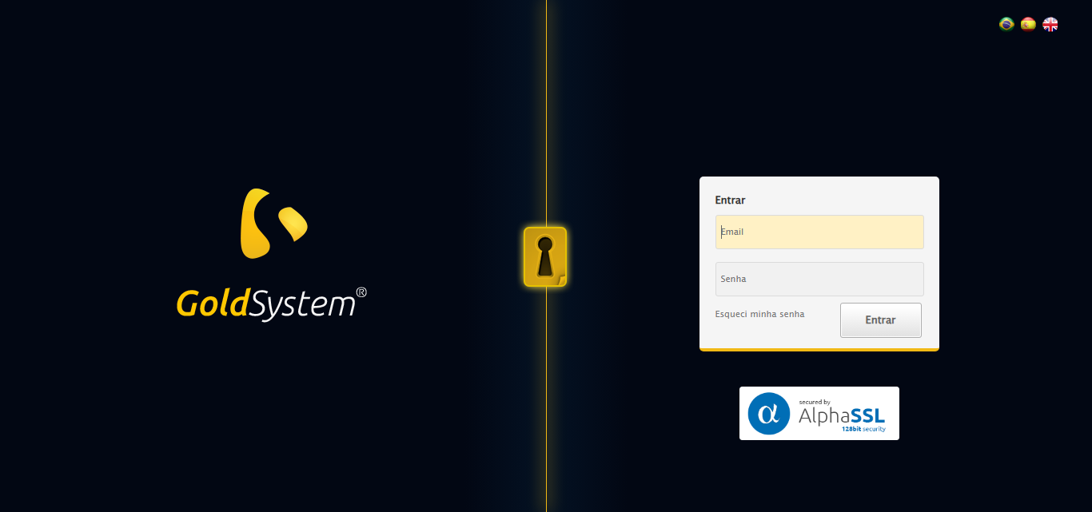

[16:46:13] 🔄 Realizando login...

[16:46:18] ✅ Realizando login realizada com sucesso.

[16:46:20] 📸 Screenshot capturada: realizando_login

Screenshot: realizando_login

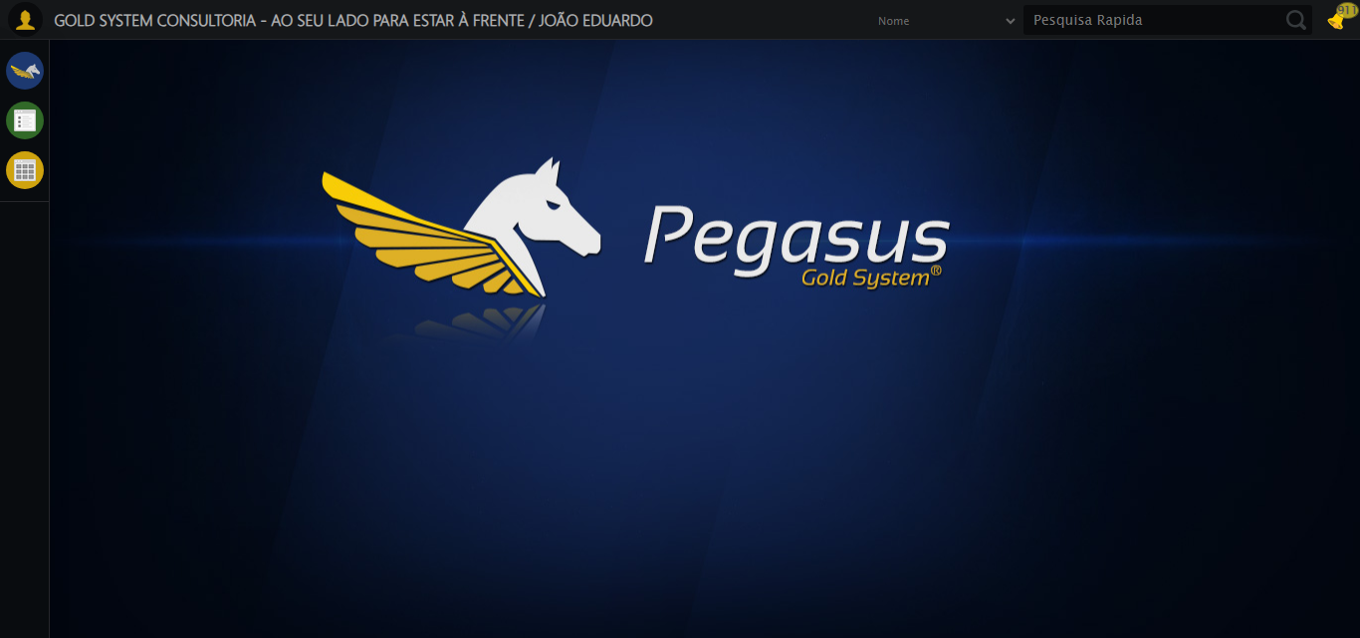

[16:46:20] 🔄 Configurando ambiente...

[16:46:21] ⚠️ Erro ao ajustar zoom: Message: no such window: target window already closed  
from unknown error: web view not found  
 (Session info: chrome=138.0.7204.185)  
Stacktrace:  
 GetHandleVerifier [0x0x5dba83+63395]  
 GetHandleVerifier [0x0x5dbac4+63460]  
 (No symbol) [0x0x422113]  
 (No symbol) [0x0x400fb9]  
 (No symbol) [0x0x495ace]  
 (No symbol) [0x0x4b0099]  
 (No symbol) [0x0x48f1a6]  
 (No symbol) [0x0x45e7b2]  
 (No symbol) [0x0x45f654]  
 GetHandleVerifier [0x0x858883+2672035]  
 GetHandleVerifier [0x0x853cba+2652634]  
 GetHandleVerifier [0x0x602bca+223466]  
 GetHandleVerifier [0x0x5f2cb8+158168]  
 GetHandleVerifier [0x0x5f978d+185517]  
 GetHandleVerifier [0x0x5e3b78+96408]  
 GetHandleVerifier [0x0x5e3d02+96802]  
 GetHandleVerifier [0x0x5ce90a+9770]  
 BaseThreadInitThunk [0x0x75abfcc9+25]  
 RtlGetAppContainerNamedObjectPath [0x0x776d82ae+286]  
 RtlGetAppContainerNamedObjectPath [0x0x776d827e+238]

[16:46:21] ⚠️ Erro ao tirar screenshot erro_configurando_ambiente: Message: no such window: target window already closed  
from unknown error: web view not found  
 (Session info: chrome=138.0.7204.185)  
Stacktrace:  
 GetHandleVerifier [0x0x5dba83+63395]  
 GetHandleVerifier [0x0x5dbac4+63460]  
 (No symbol) [0x0x422113]  
 (No symbol) [0x0x400fb9]  
 (No symbol) [0x0x495ace]  
 (No symbol) [0x0x4b0099]  
 (No symbol) [0x0x48f1a6]  
 (No symbol) [0x0x45e7b2]  
 (No symbol) [0x0x45f654]  
 GetHandleVerifier [0x0x858883+2672035]  
 GetHandleVerifier [0x0x853cba+2652634]  
 GetHandleVerifier [0x0x602bca+223466]  
 GetHandleVerifier [0x0x5f2cb8+158168]  
 GetHandleVerifier [0x0x5f978d+185517]  
 GetHandleVerifier [0x0x5e3b78+96408]  
 GetHandleVerifier [0x0x5e3d02+96802]  
 GetHandleVerifier [0x0x5ce90a+9770]  
 BaseThreadInitThunk [0x0x75abfcc9+25]  
 RtlGetAppContainerNamedObjectPath [0x0x776d82ae+286]  
 RtlGetAppContainerNamedObjectPath [0x0x776d827e+238]

[16:46:21] ❌ Configurando ambiente falhou: NoSuchWindowException: Message: no such window: target window already closed  
from unknown error: web view not found  
 (Session info: chrome=138.0.7204.185)  
Stacktrace:  
 GetHandleVerifier [0x0x5dba83+63395]  
 GetHandleVerifier [0x0x5dbac4+63460]  
 (No symbol) [0x0x422113]  
 (No symbol) [0x0x400fb9]  
 (No symbol) [0x0x495ace]  
 (No symbol) [0x0x4b0099]  
 (No symbol) [0x0x48f1a6]  
 (No symbol) [0x0x45e7b2]  
 (No symbol) [0x0x45f654]  
 GetHandleVerifier [0x0x858883+2672035]  
 GetHandleVerifier [0x0x853cba+2652634]  
 GetHandleVerifier [0x0x602bca+223466]  
 GetHandleVerifier [0x0x5f2cb8+158168]  
 GetHandleVerifier [0x0x5f978d+185517]  
 GetHandleVerifier [0x0x5e3b78+96408]  
 GetHandleVerifier [0x0x5e3d02+96802]  
 GetHandleVerifier [0x0x5ce90a+9770]  
 BaseThreadInitThunk [0x0x75abfcc9+25]  
 RtlGetAppContainerNamedObjectPath [0x0x776d82ae+286]  
 RtlGetAppContainerNamedObjectPath [0x0x776d827e+238]

[16:46:21] ⚠️ Continuando execução apesar do erro em: Configurando ambiente

[16:46:21] 🔄 Acessando módulo Callcenter...

[16:46:21] ❌ Erro aguardando elemento /html/body/div[15]/ul/li[18]/img: Message: no such window: target window already closed  
from unknown error: web view not found  
 (Session info: chrome=138.0.7204.185)  
Stacktrace:  
 GetHandleVerifier [0x0x5dba83+63395]  
 GetHandleVerifier [0x0x5dbac4+63460]  
 (No symbol) [0x0x422113]  
 (No symbol) [0x0x400fb9]  
 (No symbol) [0x0x495ace]  
 (No symbol) [0x0x4b0099]  
 (No symbol) [0x0x48f1a6]  
 (No symbol) [0x0x45e7b2]  
 (No symbol) [0x0x45f654]  
 GetHandleVerifier [0x0x858883+2672035]  
 GetHandleVerifier [0x0x853cba+2652634]  
 GetHandleVerifier [0x0x602bca+223466]  
 GetHandleVerifier [0x0x5f2cb8+158168]  
 GetHandleVerifier [0x0x5f978d+185517]  
 GetHandleVerifier [0x0x5e3b78+96408]  
 GetHandleVerifier [0x0x5e3d02+96802]  
 GetHandleVerifier [0x0x5ce90a+9770]  
 BaseThreadInitThunk [0x0x75abfcc9+25]  
 RtlGetAppContainerNamedObjectPath [0x0x776d82ae+286]  
 RtlGetAppContainerNamedObjectPath [0x0x776d827e+238]

[16:46:21] ❌ Erro ao acessar módulo PET: Message: no such window: target window already closed  
from unknown error: web view not found  
 (Session info: chrome=138.0.7204.185)  
Stacktrace:  
 GetHandleVerifier [0x0x5dba83+63395]  
 GetHandleVerifier [0x0x5dbac4+63460]  
 (No symbol) [0x0x422113]  
 (No symbol) [0x0x400fb9]  
 (No symbol) [0x0x495ace]  
 (No symbol) [0x0x4b0099]  
 (No symbol) [0x0x48f1a6]  
 (No symbol) [0x0x45e7b2]  
 (No symbol) [0x0x45f654]  
 GetHandleVerifier [0x0x858883+2672035]  
 GetHandleVerifier [0x0x853cba+2652634]  
 GetHandleVerifier [0x0x602bca+223466]  
 GetHandleVerifier [0x0x5f2cb8+158168]  
 GetHandleVerifier [0x0x5f978d+185517]  
 GetHandleVerifier [0x0x5e3b78+96408]  
 GetHandleVerifier [0x0x5e3d02+96802]  
 GetHandleVerifier [0x0x5ce90a+9770]  
 BaseThreadInitThunk [0x0x75abfcc9+25]  
 RtlGetAppContainerNamedObjectPath [0x0x776d82ae+286]  
 RtlGetAppContainerNamedObjectPath [0x0x776d827e+238]

[16:46:21] ⚠️ Erro ao tirar screenshot erro_acessando_módulo_callcenter: Message: no such window: target window already closed  
from unknown error: web view not found  
 (Session info: chrome=138.0.7204.185)  
Stacktrace:  
 GetHandleVerifier [0x0x5dba83+63395]  
 GetHandleVerifier [0x0x5dbac4+63460]  
 (No symbol) [0x0x422113]  
 (No symbol) [0x0x400fb9]  
 (No symbol) [0x0x495ace]  
 (No symbol) [0x0x4b0099]  
 (No symbol) [0x0x48f1a6]  
 (No symbol) [0x0x45e7b2]  
 (No symbol) [0x0x45f654]  
 GetHandleVerifier [0x0x858883+2672035]  
 GetHandleVerifier [0x0x853cba+2652634]  
 GetHandleVerifier [0x0x602bca+223466]  
 GetHandleVerifier [0x0x5f2cb8+158168]  
 GetHandleVerifier [0x0x5f978d+185517]  
 GetHandleVerifier [0x0x5e3b78+96408]  
 GetHandleVerifier [0x0x5e3d02+96802]  
 GetHandleVerifier [0x0x5ce90a+9770]  
 BaseThreadInitThunk [0x0x75abfcc9+25]  
 RtlGetAppContainerNamedObjectPath [0x0x776d82ae+286]  
 RtlGetAppContainerNamedObjectPath [0x0x776d827e+238]

[16:46:21] ❌ Acessando módulo Callcenter falhou: NoSuchWindowException: Message: no such window: target window already closed  
from unknown error: web view not found  
 (Session info: chrome=138.0.7204.185)  
Stacktrace:  
 GetHandleVerifier [0x0x5dba83+63395]  
 GetHandleVerifier [0x0x5dbac4+63460]  
 (No symbol) [0x0x422113]  
 (No symbol) [0x0x400fb9]  
 (No symbol) [0x0x495ace]  
 (No symbol) [0x0x4b0099]  
 (No symbol) [0x0x48f1a6]  
 (No symbol) [0x0x45e7b2]  
 (No symbol) [0x0x45f654]  
 GetHandleVerifier [0x0x858883+2672035]  
 GetHandleVerifier [0x0x853cba+2652634]  
 GetHandleVerifier [0x0x602bca+223466]  
 GetHandleVerifier [0x0x5f2cb8+158168]  
 GetHandleVerifier [0x0x5f978d+185517]  
 GetHandleVerifier [0x0x5e3b78+96408]  
 GetHandleVerifier [0x0x5e3d02+96802]  
 GetHandleVerifier [0x0x5ce90a+9770]  
 BaseThreadInitThunk [0x0x75abfcc9+25]  
 RtlGetAppContainerNamedObjectPath [0x0x776d82ae+286]  
 RtlGetAppContainerNamedObjectPath [0x0x776d827e+238]

[16:46:21] — stacktrace —

[16:46:21] Traceback (most recent call last):  
 File "C:\RPASelenium\RPAsPegasusSelenium\cenariostestespegasus\Processos\CadastrosCenáriosCallcenter\ConsultaCenáriosRegistrodeChamadas\consultaregistrodechamadas1ºcenario.py", line 157, in safe_action  
 resultado = func()  
 File "C:\RPASelenium\RPAsPegasusSelenium\cenariostestespegasus\Processos\CadastrosCenáriosCallcenter\ConsultaCenáriosRegistrodeChamadas\consultaregistrodechamadas1ºcenario.py", line 1480, in acao  
 elemento = aguardar_elemento(xpath_callcenter, TIMEOUT_DEFAULT, 'present', By.XPATH)  
 File "C:\RPASelenium\RPAsPegasusSelenium\cenariostestespegasus\Processos\CadastrosCenáriosCallcenter\ConsultaCenáriosRegistrodeChamadas\consultaregistrodechamadas1ºcenario.py", line 203, in aguardar_elemento  
 elemento = wait_obj.until(condicoes[condicao]((by_type, seletor)))  
 File "C:\RPASelenium\RPAsPegasusSelenium\venv\Lib\site-packages\selenium\webdriver\support\wait.py", line 129, in until  
 value = method(self._driver)  
 File "C:\RPASelenium\RPAsPegasusSelenium\venv\Lib\site-packages\selenium\webdriver\support\expected_conditions.py", line 104, in _predicate  
 return driver.find_element(*locator)  
 ~~~~~~~~~~~~~~~~~~~^^^^^^^^^^  
 File "C:\RPASelenium\RPAsPegasusSelenium\venv\Lib\site-packages\selenium\webdriver\remote\webdriver.py", line 926, in find_element  
 return self.execute(Command.FIND_ELEMENT, {"using": by, "value": value})["value"]  
 ~~~~~~~~~~~~^^^^^^^^^^^^^^^^^^^^^^^^^^^^^^^^^^^^^^^^^^^^^^^^^^^^^  
 File "C:\RPASelenium\RPAsPegasusSelenium\venv\Lib\site-packages\selenium\webdriver\remote\webdriver.py", line 458, in execute  
 self.error_handler.check_response(response)  
 ~~~~~~~~~~~~~~~~~~~~~~~~~~~~~~~~~^^^^^^^^^^  
 File "C:\RPASelenium\RPAsPegasusSelenium\venv\Lib\site-packages\selenium\webdriver\remote\errorhandler.py", line 232, in check_response  
 raise exception_class(message, screen, stacktrace)  
selenium.common.exceptions.NoSuchWindowException: Message: no such window: target window already closed  
from unknown error: web view not found  
 (Session info: chrome=138.0.7204.185)  
Stacktrace:  
 GetHandleVerifier [0x0x5dba83+63395]  
 GetHandleVerifier [0x0x5dbac4+63460]  
 (No symbol) [0x0x422113]  
 (No symbol) [0x0x400fb9]  
 (No symbol) [0x0x495ace]  
 (No symbol) [0x0x4b0099]  
 (No symbol) [0x0x48f1a6]  
 (No symbol) [0x0x45e7b2]  
 (No symbol) [0x0x45f654]  
 GetHandleVerifier [0x0x858883+2672035]  
 GetHandleVerifier [0x0x853cba+2652634]  
 GetHandleVerifier [0x0x602bca+223466]  
 GetHandleVerifier [0x0x5f2cb8+158168]  
 GetHandleVerifier [0x0x5f978d+185517]  
 GetHandleVerifier [0x0x5e3b78+96408]  
 GetHandleVerifier [0x0x5e3d02+96802]  
 GetHandleVerifier [0x0x5ce90a+9770]  
 BaseThreadInitThunk [0x0x75abfcc9+25]  
 RtlGetAppContainerNamedObjectPath [0x0x776d82ae+286]  
 RtlGetAppContainerNamedObjectPath [0x0x776d827e+238]

[16:46:21] ❌ ERRO CRÍTICO NO TESTE: Message: no such window: target window already closed  
from unknown error: web view not found  
 (Session info: chrome=138.0.7204.185)  
Stacktrace:  
 GetHandleVerifier [0x0x5dba83+63395]  
 GetHandleVerifier [0x0x5dbac4+63460]  
 (No symbol) [0x0x422113]  
 (No symbol) [0x0x400fb9]  
 (No symbol) [0x0x495ace]  
 (No symbol) [0x0x4b0099]  
 (No symbol) [0x0x48f1a6]  
 (No symbol) [0x0x45e7b2]  
 (No symbol) [0x0x45f654]  
 GetHandleVerifier [0x0x858883+2672035]  
 GetHandleVerifier [0x0x853cba+2652634]  
 GetHandleVerifier [0x0x602bca+223466]  
 GetHandleVerifier [0x0x5f2cb8+158168]  
 GetHandleVerifier [0x0x5f978d+185517]  
 GetHandleVerifier [0x0x5e3b78+96408]  
 GetHandleVerifier [0x0x5e3d02+96802]  
 GetHandleVerifier [0x0x5ce90a+9770]  
 BaseThreadInitThunk [0x0x75abfcc9+25]  
 RtlGetAppContainerNamedObjectPath [0x0x776d82ae+286]  
 RtlGetAppContainerNamedObjectPath [0x0x776d827e+238]

[16:46:21] — stacktrace —

[16:46:21] Traceback (most recent call last):  
 File "C:\RPASelenium\RPAsPegasusSelenium\cenariostestespegasus\Processos\CadastrosCenáriosCallcenter\ConsultaCenáriosRegistrodeChamadas\consultaregistrodechamadas1ºcenario.py", line 1568, in executar_teste  
 safe_action(doc, "Acessando módulo Callcenter", acessar_modulo_callcenter(), critico=True)  
 ~~~~~~~~~~~^^^^^^^^^^^^^^^^^^^^^^^^^^^^^^^^^^^^^^^^^^^^^^^^^^^^^^^^^^^^^^^^^^^^^^^^^^^^^^^  
 File "C:\RPASelenium\RPAsPegasusSelenium\cenariostestespegasus\Processos\CadastrosCenáriosCallcenter\ConsultaCenáriosRegistrodeChamadas\consultaregistrodechamadas1ºcenario.py", line 157, in safe_action  
 resultado = func()  
 File "C:\RPASelenium\RPAsPegasusSelenium\cenariostestespegasus\Processos\CadastrosCenáriosCallcenter\ConsultaCenáriosRegistrodeChamadas\consultaregistrodechamadas1ºcenario.py", line 1480, in acao  
 elemento = aguardar_elemento(xpath_callcenter, TIMEOUT_DEFAULT, 'present', By.XPATH)  
 File "C:\RPASelenium\RPAsPegasusSelenium\cenariostestespegasus\Processos\CadastrosCenáriosCallcenter\ConsultaCenáriosRegistrodeChamadas\consultaregistrodechamadas1ºcenario.py", line 203, in aguardar_elemento  
 elemento = wait_obj.until(condicoes[condicao]((by_type, seletor)))  
 File "C:\RPASelenium\RPAsPegasusSelenium\venv\Lib\site-packages\selenium\webdriver\support\wait.py", line 129, in until  
 value = method(self._driver)  
 File "C:\RPASelenium\RPAsPegasusSelenium\venv\Lib\site-packages\selenium\webdriver\support\expected_conditions.py", line 104, in _predicate  
 return driver.find_element(*locator)  
 ~~~~~~~~~~~~~~~~~~~^^^^^^^^^^  
 File "C:\RPASelenium\RPAsPegasusSelenium\venv\Lib\site-packages\selenium\webdriver\remote\webdriver.py", line 926, in find_element  
 return self.execute(Command.FIND_ELEMENT, {"using": by, "value": value})["value"]  
 ~~~~~~~~~~~~^^^^^^^^^^^^^^^^^^^^^^^^^^^^^^^^^^^^^^^^^^^^^^^^^^^^^  
 File "C:\RPASelenium\RPAsPegasusSelenium\venv\Lib\site-packages\selenium\webdriver\remote\webdriver.py", line 458, in execute  
 self.error_handler.check_response(response)  
 ~~~~~~~~~~~~~~~~~~~~~~~~~~~~~~~~~^^^^^^^^^^  
 File "C:\RPASelenium\RPAsPegasusSelenium\venv\Lib\site-packages\selenium\webdriver\remote\errorhandler.py", line 232, in check_response  
 raise exception_class(message, screen, stacktrace)  
selenium.common.exceptions.NoSuchWindowException: Message: no such window: target window already closed  
from unknown error: web view not found  
 (Session info: chrome=138.0.7204.185)  
Stacktrace:  
 GetHandleVerifier [0x0x5dba83+63395]  
 GetHandleVerifier [0x0x5dbac4+63460]  
 (No symbol) [0x0x422113]  
 (No symbol) [0x0x400fb9]  
 (No symbol) [0x0x495ace]  
 (No symbol) [0x0x4b0099]  
 (No symbol) [0x0x48f1a6]  
 (No symbol) [0x0x45e7b2]  
 (No symbol) [0x0x45f654]  
 GetHandleVerifier [0x0x858883+2672035]  
 GetHandleVerifier [0x0x853cba+2652634]  
 GetHandleVerifier [0x0x602bca+223466]  
 GetHandleVerifier [0x0x5f2cb8+158168]  
 GetHandleVerifier [0x0x5f978d+185517]  
 GetHandleVerifier [0x0x5e3b78+96408]  
 GetHandleVerifier [0x0x5e3d02+96802]  
 GetHandleVerifier [0x0x5ce90a+9770]  
 BaseThreadInitThunk [0x0x75abfcc9+25]  
 RtlGetAppContainerNamedObjectPath [0x0x776d82ae+286]  
 RtlGetAppContainerNamedObjectPath [0x0x776d827e+238]

[16:46:21] ⚠️ Erro ao tirar screenshot erro_critico_final: Message: no such window: target window already closed  
from unknown error: web view not found  
 (Session info: chrome=138.0.7204.185)  
Stacktrace:  
 GetHandleVerifier [0x0x5dba83+63395]  
 GetHandleVerifier [0x0x5dbac4+63460]  
 (No symbol) [0x0x422113]  
 (No symbol) [0x0x400fb9]  
 (No symbol) [0x0x495ace]  
 (No symbol) [0x0x4b0099]  
 (No symbol) [0x0x48f1a6]  
 (No symbol) [0x0x45e7b2]  
 (No symbol) [0x0x45f654]  
 GetHandleVerifier [0x0x858883+2672035]  
 GetHandleVerifier [0x0x853cba+2652634]  
 GetHandleVerifier [0x0x602bca+223466]  
 GetHandleVerifier [0x0x5f2cb8+158168]  
 GetHandleVerifier [0x0x5f978d+185517]  
 GetHandleVerifier [0x0x5e3b78+96408]  
 GetHandleVerifier [0x0x5e3d02+96802]  
 GetHandleVerifier [0x0x5ce90a+9770]  
 BaseThreadInitThunk [0x0x75abfcc9+25]  
 RtlGetAppContainerNamedObjectPath [0x0x776d82ae+286]  
 RtlGetAppContainerNamedObjectPath [0x0x776d827e+238]

[16:46:21] 🏁 Finalizando teste...

[16:46:21] ❌ TESTE FINALIZADO COM ERROS.

[16:46:21] ============================================================

==================================================

RESUMO FINAL DO TESTE

==================================================

Teste finalizado em: 19/08/2025 16:46:21

Total de screenshots capturadas: 2