RELATÓRIO DO TESTE

Consulta de Registro de Chamadas - Callcenter – Cenário 1: Nesse teste, o usuário irá realizar a consulta de um Registro de Chamadas sem preencher nenhum campo para verificar se o sistema efetua o disparo das mensagens de alerta corretamente.

Data do teste: 19/08/2025 17:15:10

[17:15:10] 🚀 INICIANDO TESTE DE CONSULTA DE REGISTRO DE CHAMADAS DO CALLCENTER

[17:15:10] ============================================================

[17:15:10] 🚀 Inicializando driver do Chrome...

[17:15:17] ✅ Driver inicializado com sucesso

[17:15:17] 🎯 Iniciando execução do teste de consulta de contrato Pet

[17:15:17] 🔄 Acessando sistema...

[17:15:20] ✅ Acessando sistema realizada com sucesso.

[17:15:21] 📸 Screenshot capturada: acessando_sistema

Screenshot: acessando_sistema

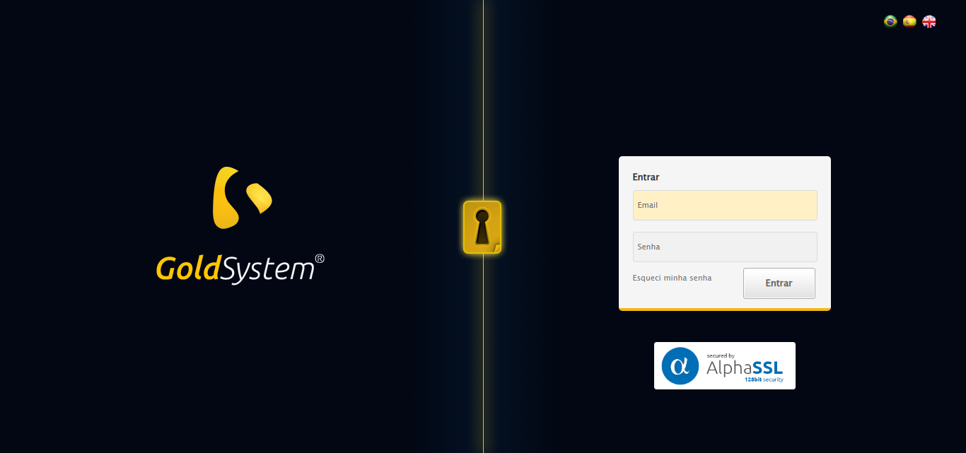

[17:15:21] 🔄 Realizando login...

[17:15:27] ✅ Realizando login realizada com sucesso.

[17:15:28] 📸 Screenshot capturada: realizando_login

Screenshot: realizando_login

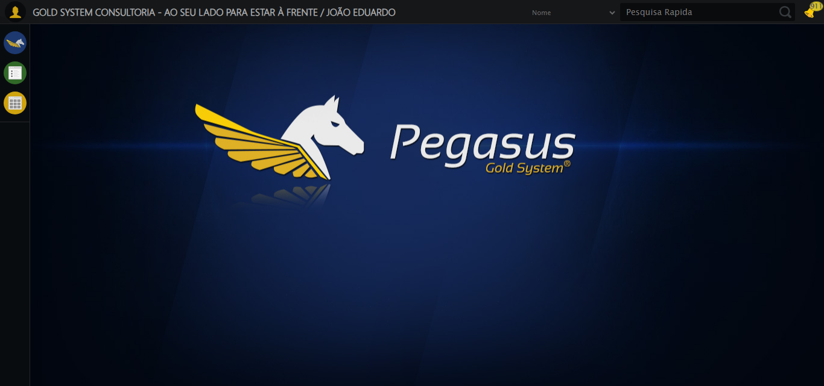

[17:15:28] 🔄 Configurando ambiente...

[17:15:29] 🔍 Zoom ajustado para 90%.

[17:15:31] ✅ Configurando ambiente realizada com sucesso.

[17:15:32] 📸 Screenshot capturada: configurando_ambiente

Screenshot: configurando_ambiente

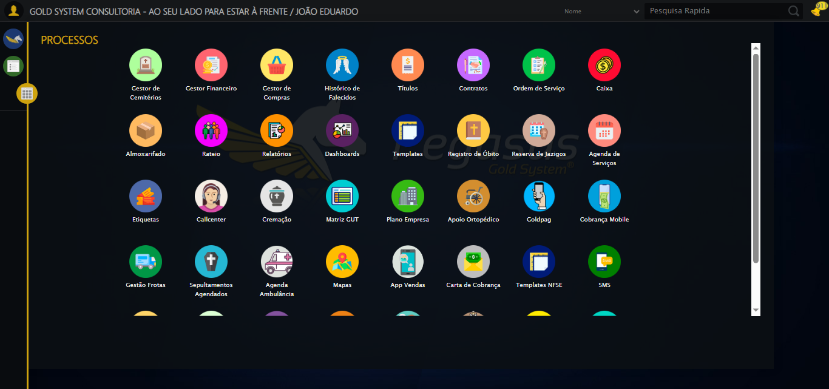

[17:15:32] 🔄 Acessando módulo Callcenter...

[17:15:32] Tentando estratégia de scroll 1...

[17:15:33] ✅ Scroll realizado com estratégia 1

[17:15:34] Tentando estratégia de clique 1 para módulo PET...

[17:15:36] ✅ Clique no módulo PET realizado com estratégia 1

[17:15:36] ✅ Acessando módulo Callcenter realizada com sucesso.

[17:15:37] 📸 Screenshot capturada: acessando_módulo_callcenter

Screenshot: acessando_módulo_callcenter

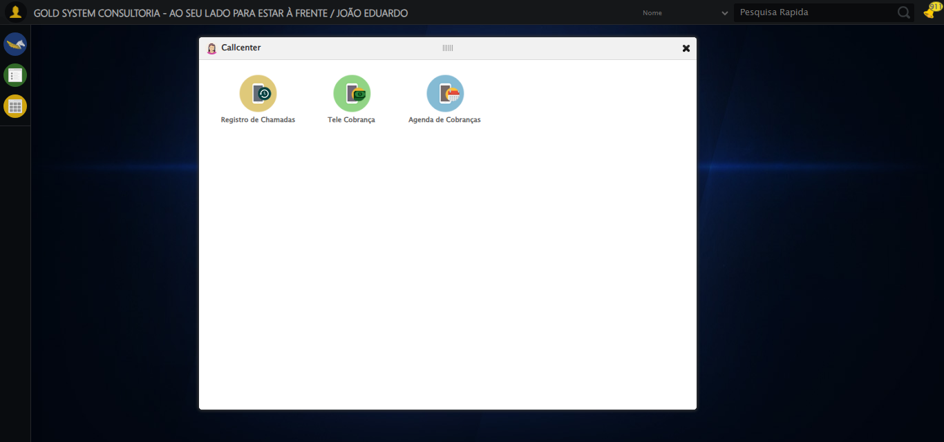

[17:15:37] 🔄 Abrindo Registro de Chamadas...

[17:15:40] ✅ Abrindo Registro de Chamadas realizada com sucesso.

[17:15:41] 📸 Screenshot capturada: abrindo_registro_de_chamadas

Screenshot: abrindo_registro_de_chamadas

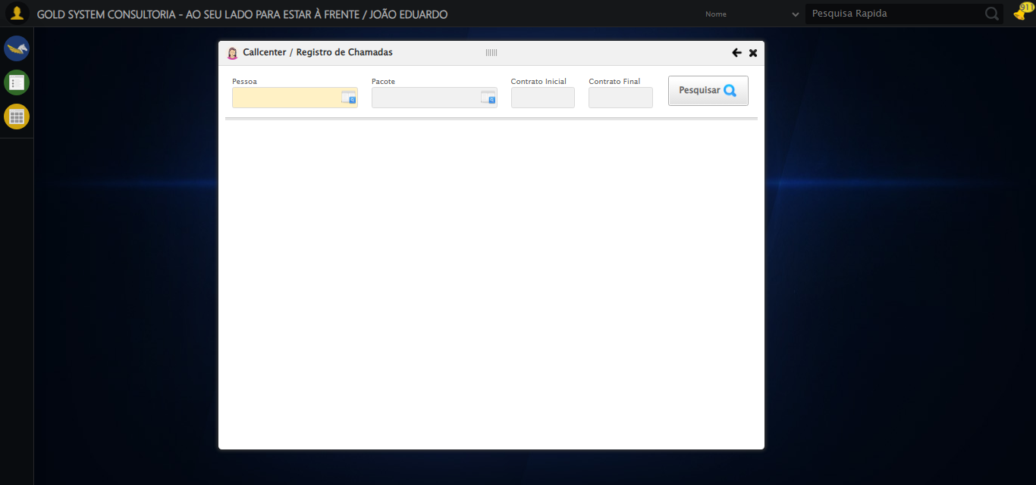

[17:15:41] 🔄 Realizando consulta sem preencher os campos, para verificar disparo de mensagens...

[17:15:41] Tentando estratégia de scroll 1...

[17:15:42] ✅ Scroll realizado com estratégia 1

[17:15:44] ✅ Consulta executada

[17:15:44] ✅ Realizando consulta sem preencher os campos, para verificar disparo de mensagens realizada com sucesso.

[17:15:45] 📸 Screenshot capturada: realizando_consulta_sem_preencher_os_campos,_para_verificar_disparo_de_mensagens

Screenshot: realizando_consulta_sem_preencher_os_campos,_para_verificar_disparo_de_mensagens

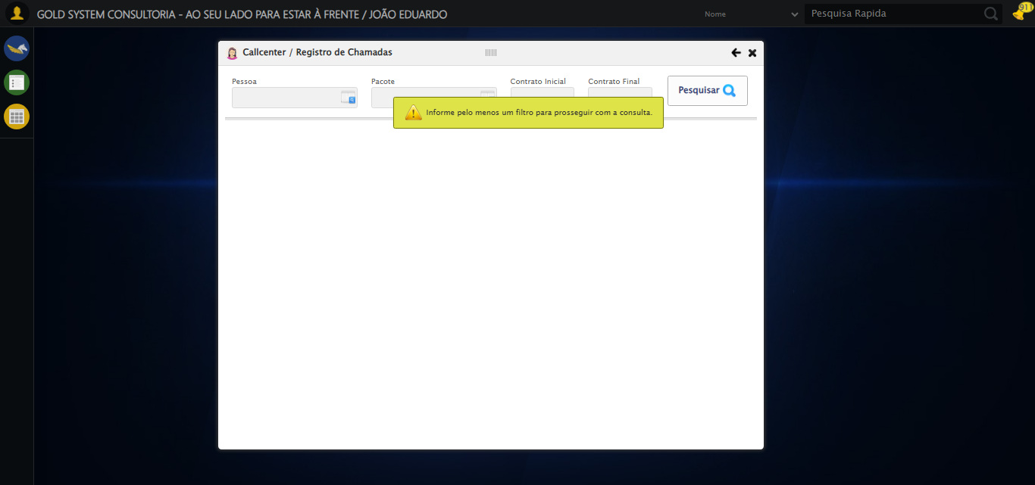

[17:15:45] 🔍Verificando mensagens de alerta...

[17:15:45] 📢 ⚠️ Alerta: Informe pelo menos um filtro para prosseguir com a consulta.

[17:15:46] 📢 ⚠️ Alerta: Informe pelo menos um filtro para prosseguir com a consulta.

[17:15:46] 🔄 Selecionando Pessoa...

[17:15:46] 🔘 Abrindo modal com botão: #gsCallCenter > div.wdTelas > div.telaRegistroChamadas.telaConsulta.relative > div.formRow.formLastLine > div:nth-child(1) > div > a

[17:15:46] Tentando estratégia de scroll 1...

[17:15:46] ✅ Scroll realizado com estratégia 1

[17:15:49] 🔍 Preenchendo pesquisa com: TESTE TITULAR 233

[17:15:50] 🔍 Executando pesquisa...

[17:15:53] 🎯 Selecionando resultado: //td[contains(text(), 'TESTE TITULAR 233')]

[17:15:53] Tentando estratégia de scroll 1...

[17:15:54] ✅ Scroll realizado com estratégia 1

[17:15:55] ✅ Seleção no modal concluída

[17:15:55] ✅ Selecionando Pessoa realizada com sucesso.

[17:15:56] 📸 Screenshot capturada: selecionando_pessoa

Screenshot: selecionando_pessoa

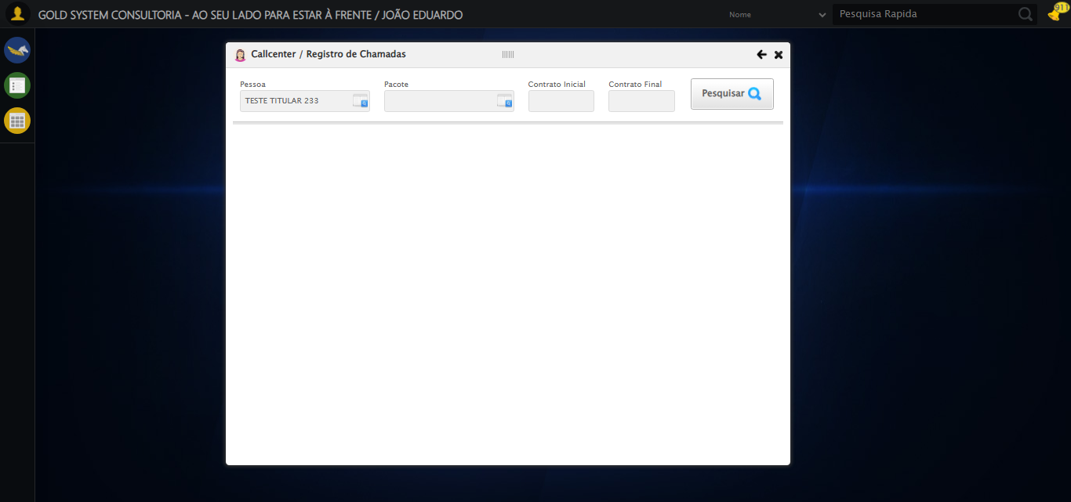

[17:15:56] 🔄 Selecionando Pacote...

[17:15:56] 🔘 Abrindo modal com botão: #gsCallCenter > div.wdTelas > div.telaRegistroChamadas.telaConsulta.relative > div.formRow.formLastLine > div:nth-child(2) > div > a

[17:15:56] Tentando estratégia de scroll 1...

[17:15:57] ✅ Scroll realizado com estratégia 1

[17:15:59] 🔍 Preenchendo pesquisa com: PRO MAX TITANIUM

[17:16:00] 🔍 Executando pesquisa...

[17:16:03] 🎯 Selecionando resultado: //td[contains(text(), 'PRO MAX TITANIUM')]

[17:16:03] Tentando estratégia de scroll 1...

[17:16:04] ✅ Scroll realizado com estratégia 1

[17:16:06] ✅ Seleção no modal concluída

[17:16:06] ✅ Selecionando Pacote realizada com sucesso.

[17:16:07] 📸 Screenshot capturada: selecionando_pacote

Screenshot: selecionando_pacote

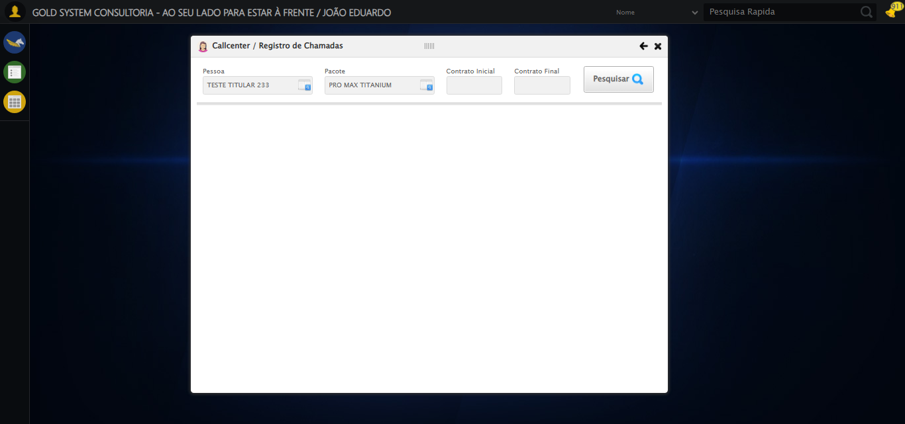

[17:16:07] 🔄 Preenchendo Número do Contrato Inicial...

[17:16:07] Tentando estratégia de scroll 1...

[17:16:08] ✅ Scroll realizado com estratégia 1

[17:16:09] ✅ Campo preenchido com estratégia 1: '113060'

[17:16:09] ✅ Preenchendo Número do Contrato Inicial realizada com sucesso.

[17:16:10] 📸 Screenshot capturada: preenchendo_número_do_contrato_inicial

Screenshot: preenchendo_número_do_contrato_inicial

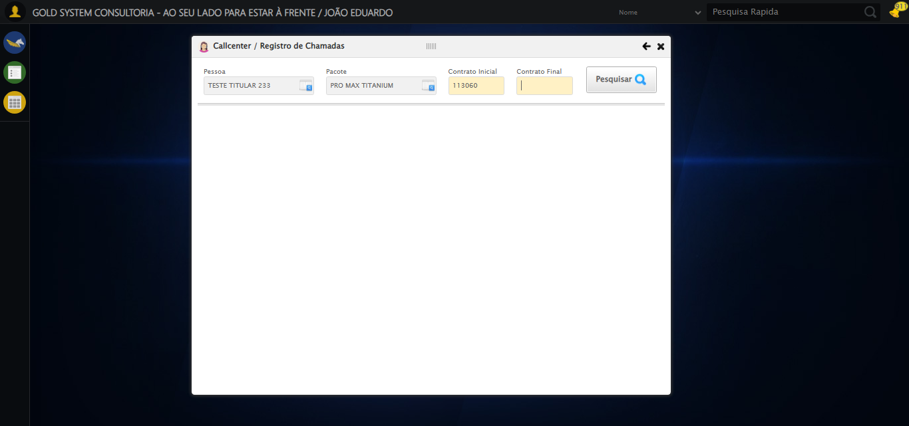

[17:16:10] 🔄 Preenchendo Número do Contrato Final...

[17:16:10] Tentando estratégia de scroll 1...

[17:16:11] ✅ Scroll realizado com estratégia 1

[17:16:12] ✅ Campo preenchido com estratégia 1: '113060'

[17:16:12] ✅ Preenchendo Número do Contrato Final realizada com sucesso.

[17:16:13] 📸 Screenshot capturada: preenchendo_número_do_contrato_final

Screenshot: preenchendo_número_do_contrato_final

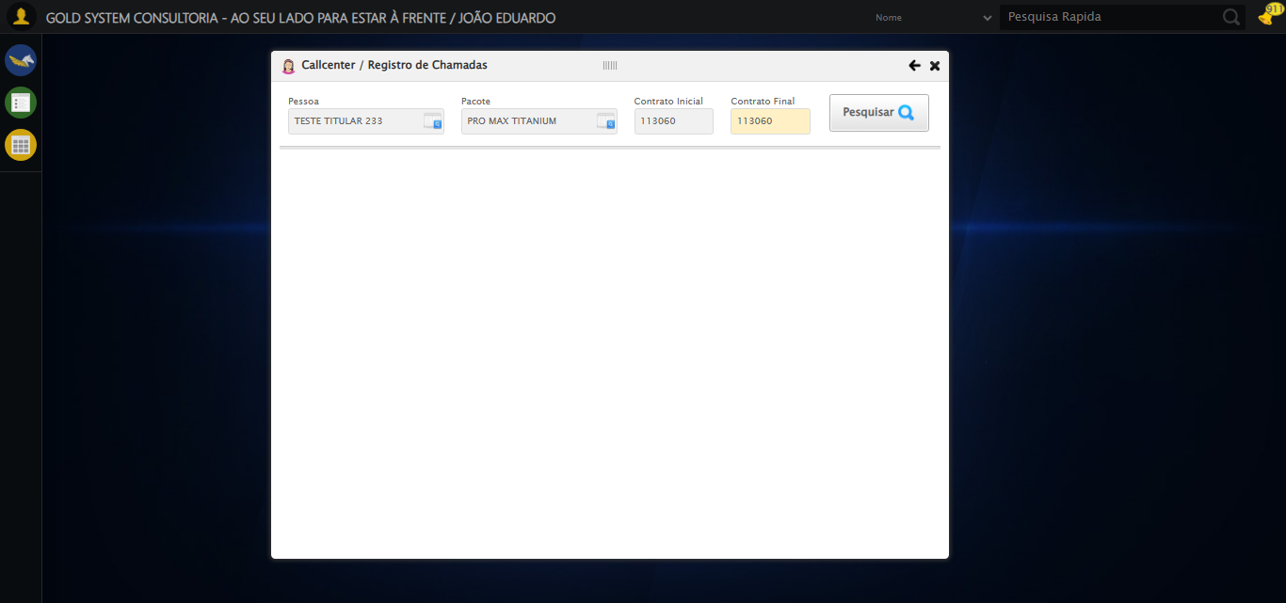

[17:16:13] 🔄 Realizando consulta...

[17:16:13] Tentando estratégia de scroll 1...

[17:16:14] ✅ Scroll realizado com estratégia 1

[17:16:16] ✅ Consulta executada

[17:16:16] ✅ Realizando consulta realizada com sucesso.

[17:16:17] 📸 Screenshot capturada: realizando_consulta

Screenshot: realizando_consulta

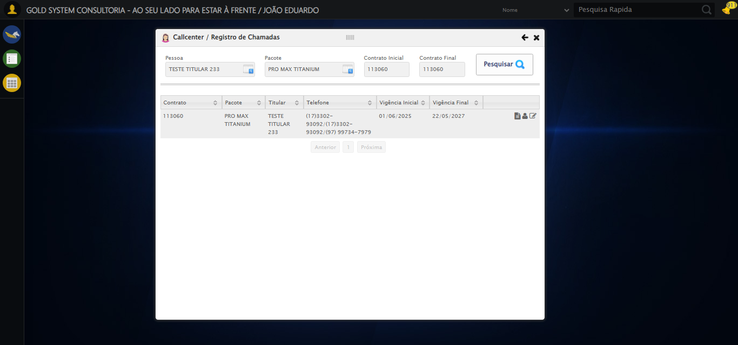

[17:16:17] 🔄 Validando resultados da consulta...

[17:16:17] 🔍 Iniciando validação de registros...

[17:16:22] ✅ Tabela encontrada: #DataTables_Table_2

[17:16:22] ✅ Encontradas 1 linhas válidas com tbody tr:not(.dataTables_empty):not([class*="no-data"])

[17:16:22] ✅ 1 registro(s) encontrado(s)

[17:16:22] Registro 1: 113060 pro max titanium teste titular 233 (17)3302-93092/(17)3302-93092/(97) 99734-7979 01/06/2025 2...

[17:16:23] ✅ Validando resultados da consulta realizada com sucesso.

[17:16:24] 📸 Screenshot capturada: validando_resultados_da_consulta

Screenshot: validando_resultados_da_consulta

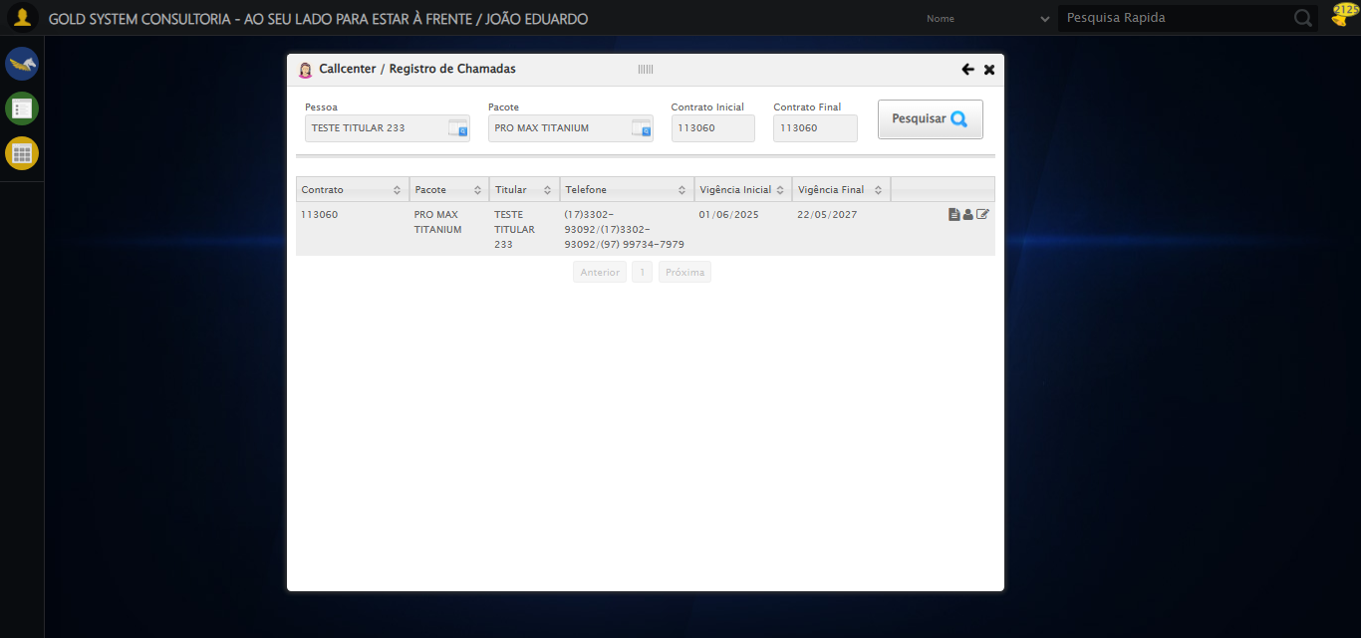

[17:16:24] ✅ Processando 1 registro(s) encontrado(s)

[17:16:24] 🔄 Visualizando dados do Contrato...

[17:16:24] Tentando estratégia de scroll 1...

[17:16:25] ✅ Scroll realizado com estratégia 1

[17:16:25] ✅ Clique realizado com estratégia 1

[17:16:25] ✅ Visualizando dados do Contrato realizada com sucesso.

[17:16:26] 📸 Screenshot capturada: visualizando_dados_do_contrato

Screenshot: visualizando_dados_do_contrato

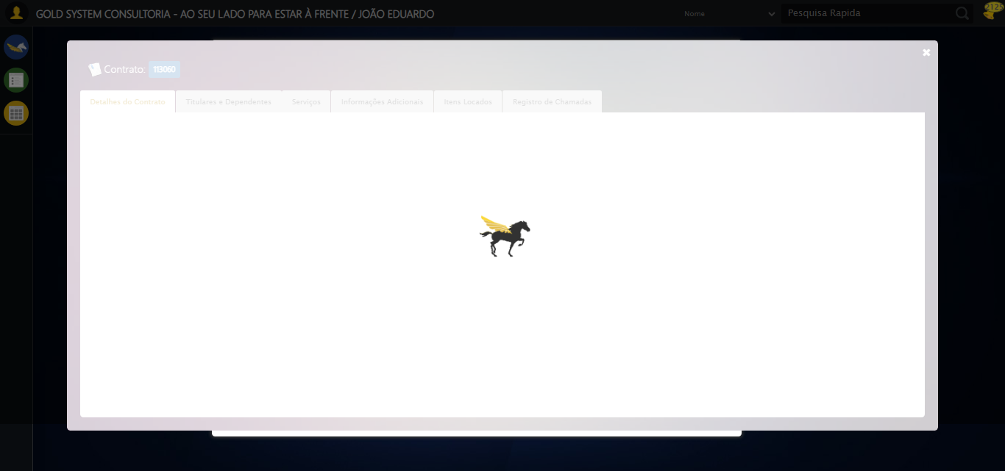

[17:16:26] 🔄 Capturando tela de dados...

[17:16:29] 📸 Screenshot capturada: dados_contrato

Screenshot: dados_contrato

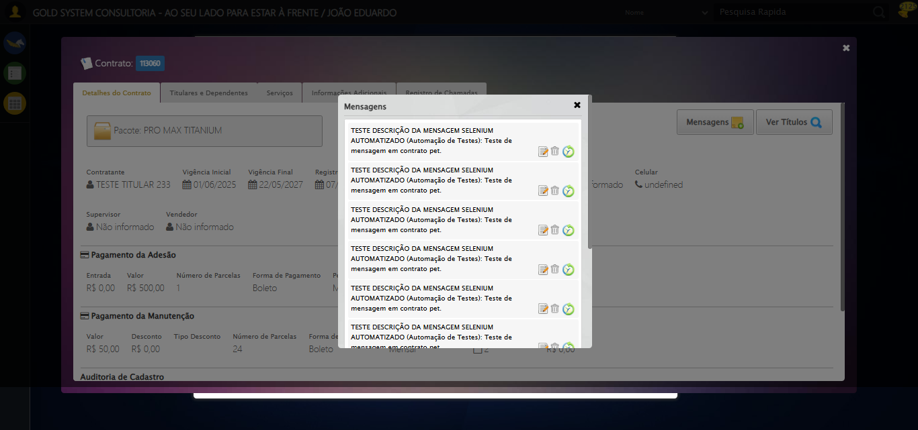

[17:16:29] ✅ Capturando tela de dados realizada com sucesso.

[17:16:31] 📸 Screenshot capturada: capturando_tela_de_dados

Screenshot: capturando_tela_de_dados



[17:16:31] 🔄 Abrindo mensagens do Contrato...

[17:16:31] Tentando estratégia de scroll 1...

[17:16:31] ✅ Scroll realizado com estratégia 1

[17:16:33] ⚠️ Estratégia 1 de clique falhou: Message: element click intercepted: Element <button class="btModel btGray">...</button> is not clickable at point (1061, 182). Other element would receive the click: <div class="blockScreen" style="height: 641px; z-index: 10003; opacity: 0.5;"></div>  
 (Session info: chrome=138.0.7204.185); For documentation on this error, please visit: https://www.selenium.dev/documentation/webdriver/troubleshooting/errors#elementclickinterceptedexception  
Stacktrace:  
 GetHandleVerifier [0x0x5dba83+63395]  
 GetHandleVerifier [0x0x5dbac4+63460]  
 (No symbol) [0x0x422113]  
 (No symbol) [0x0x470ba0]  
 (No symbol) [0x0x46ef5a]  
 (No symbol) [0x0x46cab7]  
 (No symbol) [0x0x46bd6d]  
 (No symbol) [0x0x460515]  
 (No symbol) [0x0x48f3ac]  
 (No symbol) [0x0x45ffa4]  
 (No symbol) [0x0x48f624]  
 (No symbol) [0x0x4b07ba]  
 (No symbol) [0x0x48f1a6]  
 (No symbol) [0x0x45e7b2]  
 (No symbol) [0x0x45f654]  
 GetHandleVerifier [0x0x858883+2672035]  
 GetHandleVerifier [0x0x853cba+2652634]  
 GetHandleVerifier [0x0x602bca+223466]  
 GetHandleVerifier [0x0x5f2cb8+158168]  
 GetHandleVerifier [0x0x5f978d+185517]  
 GetHandleVerifier [0x0x5e3b78+96408]  
 GetHandleVerifier [0x0x5e3d02+96802]  
 GetHandleVerifier [0x0x5ce90a+9770]  
 BaseThreadInitThunk [0x0x75abfcc9+25]  
 RtlGetAppContainerNamedObjectPath [0x0x776d82ae+286]  
 RtlGetAppContainerNamedObjectPath [0x0x776d827e+238]

[17:16:33] ✅ Clique realizado com estratégia 2

[17:16:33] ✅ Abrindo mensagens do Contrato realizada com sucesso.

[17:16:35] 📸 Screenshot capturada: abrindo_mensagens_do_contrato

Screenshot: abrindo_mensagens_do_contrato

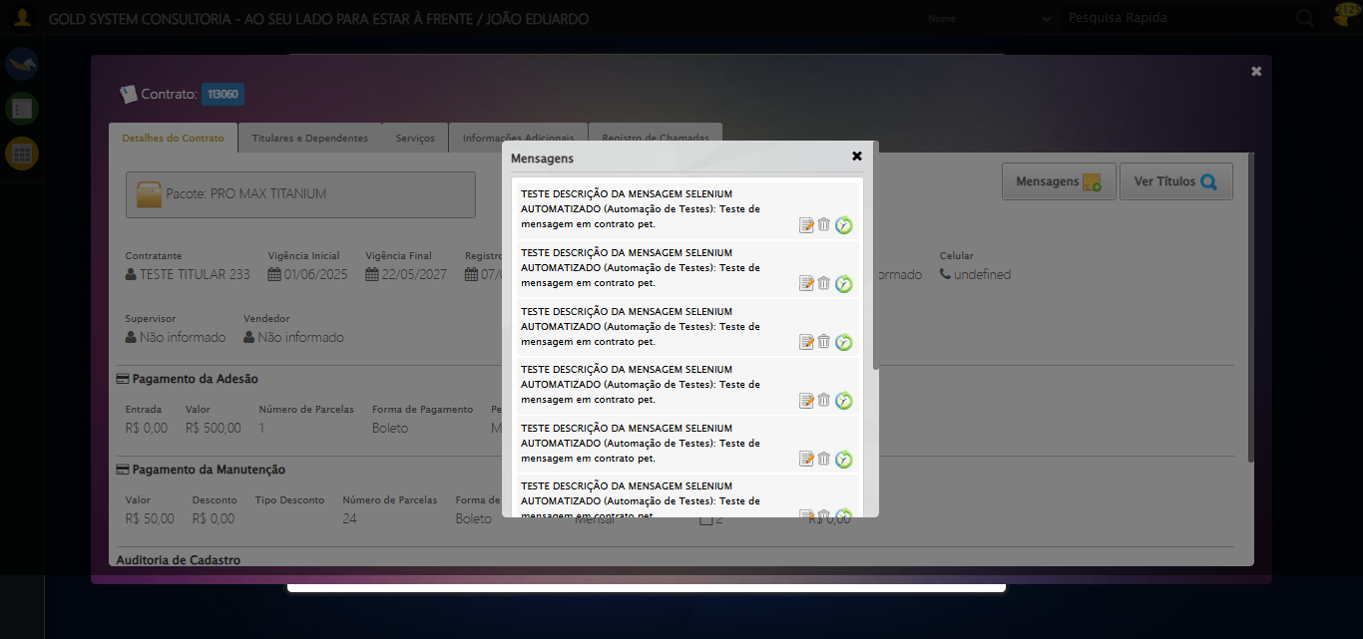

[17:16:35] 🔄 Capturando mensagens...

[17:16:37] 📸 Screenshot capturada: mensagens_contrato

Screenshot: mensagens_contrato



[17:16:37] ✅ Capturando mensagens realizada com sucesso.

[17:16:38] 📸 Screenshot capturada: capturando_mensagens

Screenshot: capturando_mensagens



[17:16:38] 🔄 Adicionando nova mensagem...

[17:16:38] Tentando estratégia de scroll 1...

[17:16:39] ✅ Scroll realizado com estratégia 1

[17:16:39] ✅ Clique realizado com estratégia 1

[17:16:39] ✅ Adicionando nova mensagem realizada com sucesso.

[17:16:40] 📸 Screenshot capturada: adicionando_nova_mensagem

Screenshot: adicionando_nova_mensagem

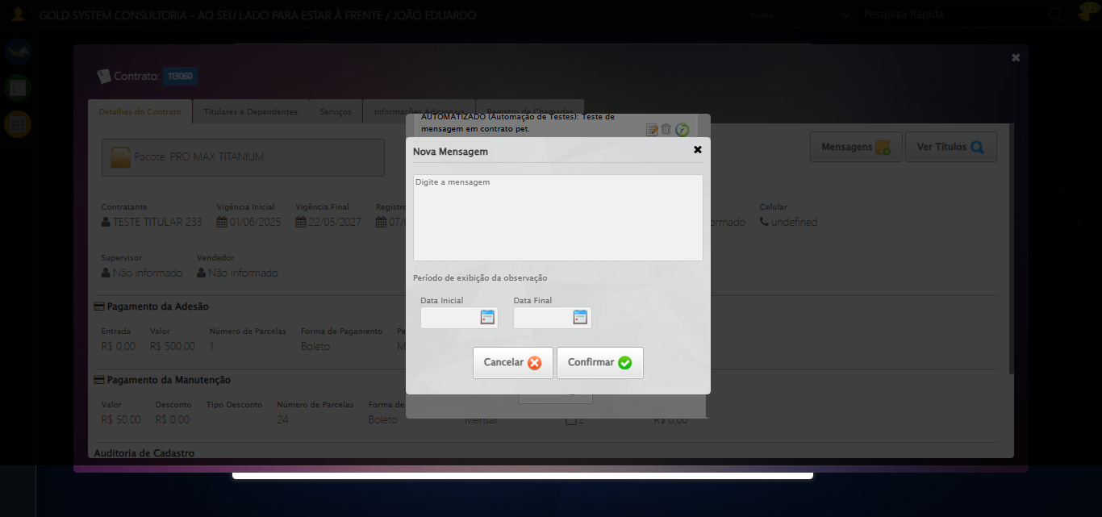

[17:16:40] 🔄 Confirmando mensagem (Teste de disparo)...

[17:16:41] Tentando estratégia de scroll 1...

[17:16:41] ✅ Scroll realizado com estratégia 1

[17:16:42] ✅ Clique realizado com estratégia 1

[17:16:42] ✅ Confirmando mensagem (Teste de disparo) realizada com sucesso.

[17:16:43] 📸 Screenshot capturada: confirmando_mensagem_(teste_de_disparo)

Screenshot: confirmando_mensagem_(teste_de_disparo)

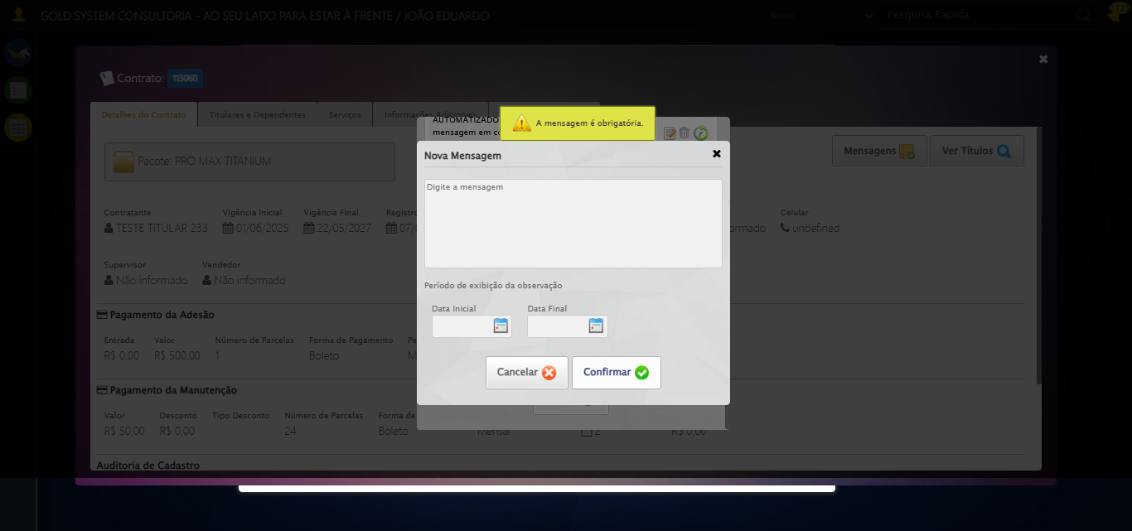

[17:16:43] 🔍 Verificando mensagens de alerta...

[17:16:43] 📢 ⚠️ Alerta: A mensagem é obrigatória.

[17:16:43] 🔄 Fechando aba de cadastro de mensagens...

[17:17:13] ❌ Timeout aguardando elemento: /html/body/div[22]/div[2]/a (condição: present, timeout: 30s)

[17:17:13] ❌ Falha ao clicar em /html/body/div[22]/div[2]/a: Message: Elemento não encontrado: /html/body/div[22]/div[2]/a (condição: present)

[17:17:14] 📸 Screenshot capturada: erro_fechando_aba_de_cadastro_de_mensagens

Screenshot: erro_fechando_aba_de_cadastro_de_mensagens

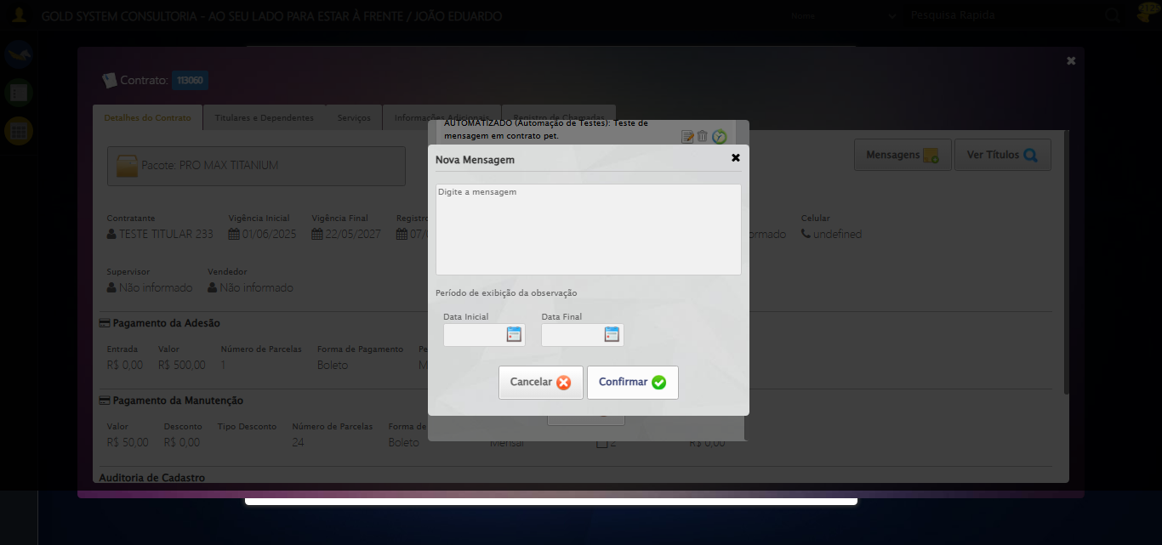

[17:17:14] ❌ Fechando aba de cadastro de mensagens falhou: TimeoutException: Message: Elemento não encontrado: /html/body/div[22]/div[2]/a (condição: present)

[17:17:14] ⚠️ Continuando execução apesar do erro em: Fechando aba de cadastro de mensagens

[17:17:14] 🔄 Fechando aba de mensagens...

[17:17:14] Tentando estratégia de scroll 1...

[17:17:14] ✅ Scroll realizado com estratégia 1

[17:17:16] ⚠️ Estratégia 1 de clique falhou: Message: element click intercepted: Element <a class="fa fa-close"></a> is not clickable at point (858, 156). Other element would receive the click: <div class="blockScreen" style="height: 641px; z-index: 10005; opacity: 0.5;"></div>  
 (Session info: chrome=138.0.7204.185); For documentation on this error, please visit: https://www.selenium.dev/documentation/webdriver/troubleshooting/errors#elementclickinterceptedexception  
Stacktrace:  
 GetHandleVerifier [0x0x5dba83+63395]  
 GetHandleVerifier [0x0x5dbac4+63460]  
 (No symbol) [0x0x422113]  
 (No symbol) [0x0x470ba0]  
 (No symbol) [0x0x46ef5a]  
 (No symbol) [0x0x46cab7]  
 (No symbol) [0x0x46bd6d]  
 (No symbol) [0x0x460515]  
 (No symbol) [0x0x48f3ac]  
 (No symbol) [0x0x45ffa4]  
 (No symbol) [0x0x48f624]  
 (No symbol) [0x0x4b07ba]  
 (No symbol) [0x0x48f1a6]  
 (No symbol) [0x0x45e7b2]  
 (No symbol) [0x0x45f654]  
 GetHandleVerifier [0x0x858883+2672035]  
 GetHandleVerifier [0x0x853cba+2652634]  
 GetHandleVerifier [0x0x602bca+223466]  
 GetHandleVerifier [0x0x5f2cb8+158168]  
 GetHandleVerifier [0x0x5f978d+185517]  
 GetHandleVerifier [0x0x5e3b78+96408]  
 GetHandleVerifier [0x0x5e3d02+96802]  
 GetHandleVerifier [0x0x5ce90a+9770]  
 BaseThreadInitThunk [0x0x75abfcc9+25]  
 RtlGetAppContainerNamedObjectPath [0x0x776d82ae+286]  
 RtlGetAppContainerNamedObjectPath [0x0x776d827e+238]

[17:17:16] ✅ Clique realizado com estratégia 2

[17:17:16] ✅ Fechando aba de mensagens realizada com sucesso.

[17:17:17] 📸 Screenshot capturada: fechando_aba_de_mensagens

Screenshot: fechando_aba_de_mensagens

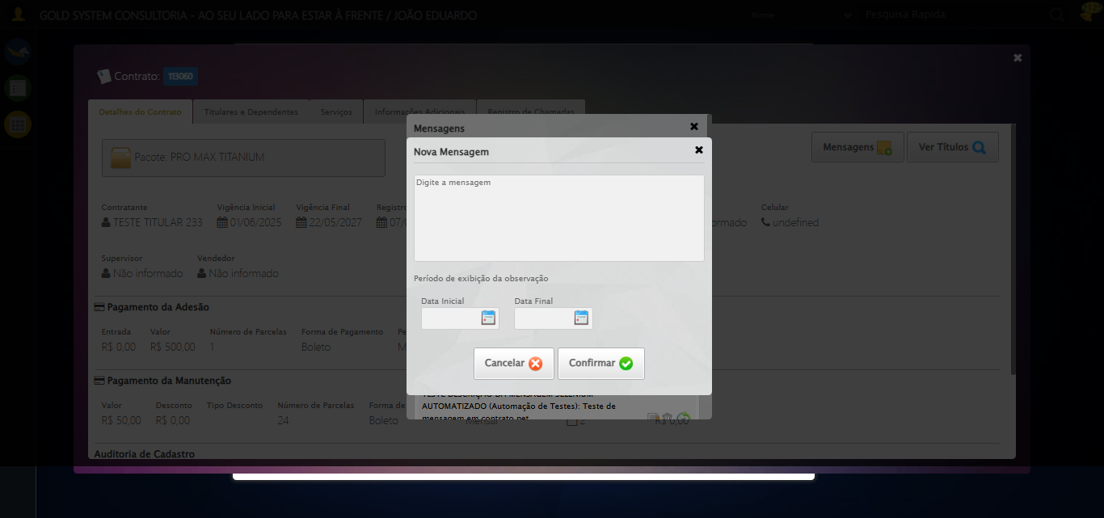

[17:17:18] 🔄 Visualizando títulos do Contrato...

[17:17:18] Tentando estratégia de scroll 1...

[17:17:18] ✅ Scroll realizado com estratégia 1

[17:17:19] ⚠️ Estratégia 1 de clique falhou: Message: element click intercepted: Element <button class="btModel btGray">...</button> is not clickable at point (1178, 182). Other element would receive the click: <div class="blockScreen" style="height: 641px; z-index: 10005; opacity: 0.5;"></div>  
 (Session info: chrome=138.0.7204.185); For documentation on this error, please visit: https://www.selenium.dev/documentation/webdriver/troubleshooting/errors#elementclickinterceptedexception  
Stacktrace:  
 GetHandleVerifier [0x0x5dba83+63395]  
 GetHandleVerifier [0x0x5dbac4+63460]  
 (No symbol) [0x0x422113]  
 (No symbol) [0x0x470ba0]  
 (No symbol) [0x0x46ef5a]  
 (No symbol) [0x0x46cab7]  
 (No symbol) [0x0x46bd6d]  
 (No symbol) [0x0x460515]  
 (No symbol) [0x0x48f3ac]  
 (No symbol) [0x0x45ffa4]  
 (No symbol) [0x0x48f624]  
 (No symbol) [0x0x4b07ba]  
 (No symbol) [0x0x48f1a6]  
 (No symbol) [0x0x45e7b2]  
 (No symbol) [0x0x45f654]  
 GetHandleVerifier [0x0x858883+2672035]  
 GetHandleVerifier [0x0x853cba+2652634]  
 GetHandleVerifier [0x0x602bca+223466]  
 GetHandleVerifier [0x0x5f2cb8+158168]  
 GetHandleVerifier [0x0x5f978d+185517]  
 GetHandleVerifier [0x0x5e3b78+96408]  
 GetHandleVerifier [0x0x5e3d02+96802]  
 GetHandleVerifier [0x0x5ce90a+9770]  
 BaseThreadInitThunk [0x0x75abfcc9+25]  
 RtlGetAppContainerNamedObjectPath [0x0x776d82ae+286]  
 RtlGetAppContainerNamedObjectPath [0x0x776d827e+238]

[17:17:20] ✅ Clique realizado com estratégia 2

[17:17:20] ✅ Visualizando títulos do Contrato realizada com sucesso.

[17:17:21] 📸 Screenshot capturada: visualizando_títulos_do_contrato

Screenshot: visualizando_títulos_do_contrato



[17:17:21] 🔄 Aguardando carregamento de títulos e capturando Screenshot...

[17:17:52] 📸 Screenshot capturada: titulos_contrato

Screenshot: titulos_contrato



[17:17:52] ✅ Aguardando carregamento de títulos e capturando Screenshot realizada com sucesso.

[17:17:53] 📸 Screenshot capturada: aguardando_carregamento_de_títulos_e_capturando_screenshot

Screenshot: aguardando_carregamento_de_títulos_e_capturando_screenshot



[17:17:53] 🔄 Fechando aba de títulos...

[17:18:23] ❌ Timeout aguardando elemento: //a[@title='Sair' and contains(@class, 'sp-fecharGrande')] (condição: present, timeout: 30s)

[17:18:23] ❌ Falha ao clicar em //a[@title='Sair' and contains(@class, 'sp-fecharGrande')]: Message: Elemento não encontrado: //a[@title='Sair' and contains(@class, 'sp-fecharGrande')] (condição: present)

[17:18:23] 📸 Screenshot capturada: erro_fechando_aba_de_títulos

Screenshot: erro_fechando_aba_de_títulos

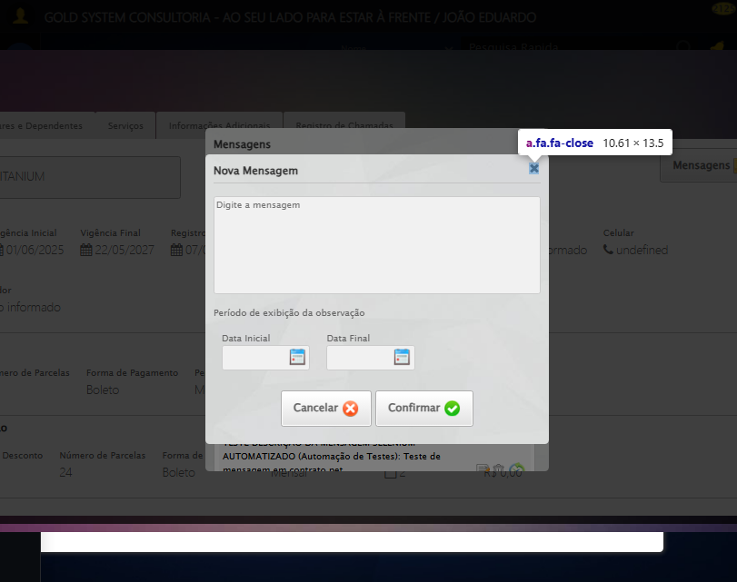

[17:18:23] ❌ Fechando aba de títulos falhou: TimeoutException: Message: Elemento não encontrado: //a[@title='Sair' and contains(@class, 'sp-fecharGrande')] (condição: present)

[17:18:23] ⚠️ Continuando execução apesar do erro em: Fechando aba de títulos

[17:18:23] 🔄 Abrindo Dados do Titular...

[17:18:24] Tentando estratégia de scroll 1...

[17:18:24] ✅ Scroll realizado com estratégia 1

[17:18:26] ⚠️ Estratégia 1 de clique falhou: Message: element click intercepted: Element <span class="fa fa-user btTitular" title="Dados do Titular"></span> is not clickable at point (693, 229). Other element would receive the click: <div class="blockScreen" style="height: 641px; z-index: 10005; opacity: 0.5;"></div>  
 (Session info: chrome=138.0.7204.185); For documentation on this error, please visit: https://www.selenium.dev/documentation/webdriver/troubleshooting/errors#elementclickinterceptedexception  
Stacktrace:  
 GetHandleVerifier [0x0x5dba83+63395]  
 GetHandleVerifier [0x0x5dbac4+63460]  
 (No symbol) [0x0x422113]  
 (No symbol) [0x0x470ba0]  
 (No symbol) [0x0x46ef5a]  
 (No symbol) [0x0x46cab7]  
 (No symbol) [0x0x46bd6d]  
 (No symbol) [0x0x460515]  
 (No symbol) [0x0x48f3ac]  
 (No symbol) [0x0x45ffa4]  
 (No symbol) [0x0x48f624]  
 (No symbol) [0x0x4b07ba]  
 (No symbol) [0x0x48f1a6]  
 (No symbol) [0x0x45e7b2]  
 (No symbol) [0x0x45f654]  
 GetHandleVerifier [0x0x858883+2672035]  
 GetHandleVerifier [0x0x853cba+2652634]  
 GetHandleVerifier [0x0x602bca+223466]  
 GetHandleVerifier [0x0x5f2cb8+158168]  
 GetHandleVerifier [0x0x5f978d+185517]  
 GetHandleVerifier [0x0x5e3b78+96408]  
 GetHandleVerifier [0x0x5e3d02+96802]  
 GetHandleVerifier [0x0x5ce90a+9770]  
 BaseThreadInitThunk [0x0x75abfcc9+25]  
 RtlGetAppContainerNamedObjectPath [0x0x776d82ae+286]  
 RtlGetAppContainerNamedObjectPath [0x0x776d827e+238]

[17:18:26] ✅ Clique realizado com estratégia 2

[17:18:26] ✅ Abrindo Dados do Titular realizada com sucesso.

[17:18:28] 📸 Screenshot capturada: abrindo_dados_do_titular

Screenshot: abrindo_dados_do_titular

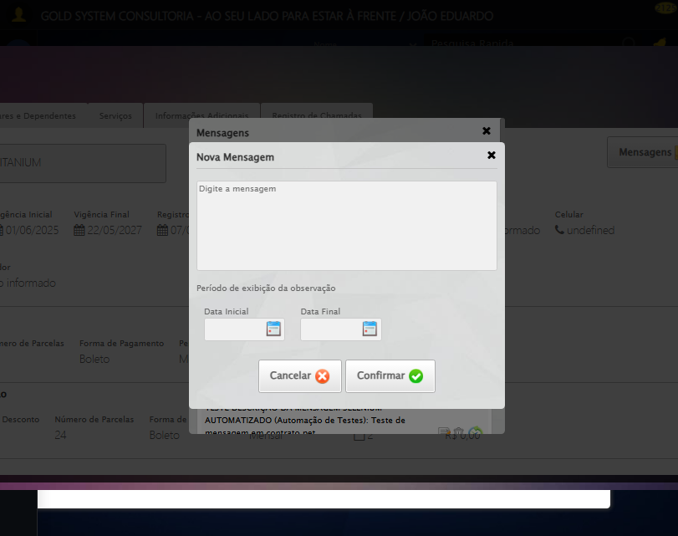

[17:18:28] 🔄 Abrindo Dados Cadastrais do Titular e capturando Screenshot da aba 'Dados Pessoais'...

[17:18:28] ⚠️ Elemento não está visível para scroll

[17:18:28] ⚠️ Problemas com scroll, continuando mesmo assim: //a[contains(@class,'materializacaoPeglink') and @ref='1|21582908']

[17:18:33] ❌ Timeout aguardando elemento: //a[contains(@class,'materializacaoPeglink') and @ref='1|21582908'] (condição: clickable, timeout: 5s)

[17:18:33] ⚠️ Elemento não ficou clicável, tentando mesmo assim: //a[contains(@class,'materializacaoPeglink') and @ref='1|21582908']

[17:18:33] ⚠️ Estratégia 1 de clique falhou: Message: element not interactable  
 (Session info: chrome=138.0.7204.185); For documentation on this error, please visit: https://www.selenium.dev/documentation/webdriver/troubleshooting/errors#elementnotinteractableexception  
Stacktrace:  
 GetHandleVerifier [0x0x5dba83+63395]  
 GetHandleVerifier [0x0x5dbac4+63460]  
 (No symbol) [0x0x421f70]  
 (No symbol) [0x0x46b9f4]  
 (No symbol) [0x0x460515]  
 (No symbol) [0x0x48f3ac]  
 (No symbol) [0x0x45ffa4]  
 (No symbol) [0x0x48f624]  
 (No symbol) [0x0x4b07ba]  
 (No symbol) [0x0x48f1a6]  
 (No symbol) [0x0x45e7b2]  
 (No symbol) [0x0x45f654]  
 GetHandleVerifier [0x0x858883+2672035]  
 GetHandleVerifier [0x0x853cba+2652634]  
 GetHandleVerifier [0x0x602bca+223466]  
 GetHandleVerifier [0x0x5f2cb8+158168]  
 GetHandleVerifier [0x0x5f978d+185517]  
 GetHandleVerifier [0x0x5e3b78+96408]  
 GetHandleVerifier [0x0x5e3d02+96802]  
 GetHandleVerifier [0x0x5ce90a+9770]  
 BaseThreadInitThunk [0x0x75abfcc9+25]  
 RtlGetAppContainerNamedObjectPath [0x0x776d82ae+286]  
 RtlGetAppContainerNamedObjectPath [0x0x776d827e+238]

[17:18:33] ⚠️ Estratégia 2 de clique falhou: Message: move target out of bounds  
 (Session info: chrome=138.0.7204.185)  
Stacktrace:  
 GetHandleVerifier [0x0x5dba83+63395]  
 GetHandleVerifier [0x0x5dbac4+63460]  
 (No symbol) [0x0x421f70]  
 (No symbol) [0x0x4b8e98]  
 (No symbol) [0x0x48f3ac]  
 (No symbol) [0x0x4b07ba]  
 (No symbol) [0x0x48f1a6]  
 (No symbol) [0x0x45e7b2]  
 (No symbol) [0x0x45f654]  
 GetHandleVerifier [0x0x858883+2672035]  
 GetHandleVerifier [0x0x853cba+2652634]  
 GetHandleVerifier [0x0x602bca+223466]  
 GetHandleVerifier [0x0x5f2cb8+158168]  
 GetHandleVerifier [0x0x5f978d+185517]  
 GetHandleVerifier [0x0x5e3b78+96408]  
 GetHandleVerifier [0x0x5e3d02+96802]  
 GetHandleVerifier [0x0x5ce90a+9770]  
 BaseThreadInitThunk [0x0x75abfcc9+25]  
 RtlGetAppContainerNamedObjectPath [0x0x776d82ae+286]  
 RtlGetAppContainerNamedObjectPath [0x0x776d827e+238]

[17:18:34] ✅ Clique realizado com estratégia 3

[17:18:34] ✅ Abrindo Dados Cadastrais do Titular e capturando Screenshot da aba 'Dados Pessoais' realizada com sucesso.

[17:18:35] 📸 Screenshot capturada: abrindo_dados_cadastrais_do_titular_e_capturando_screenshot_da_aba_dados_pessoais_

Screenshot: abrindo_dados_cadastrais_do_titular_e_capturando_screenshot_da_aba_dados_pessoais_



[17:18:35] 🔄 Clicando na aba 'Dados Complementares' e capturando Screenshot...

[17:18:35] ⚠️ Elemento não está visível para scroll

[17:18:35] ⚠️ Problemas com scroll, continuando mesmo assim: //a[@class='dadosComplementares' and normalize-space(text())='Dados Complementares']

[17:18:37] ⚠️ Estratégia 1 de clique falhou: Message: element click intercepted: Element <a class="dadosComplementares">...</a> is not clickable at point (127, 126). Other element would receive the click: <div class="blockScreen" style="height: 641px; z-index: 10005; opacity: 0.5;"></div>  
 (Session info: chrome=138.0.7204.185); For documentation on this error, please visit: https://www.selenium.dev/documentation/webdriver/troubleshooting/errors#elementclickinterceptedexception  
Stacktrace:  
 GetHandleVerifier [0x0x5dba83+63395]  
 GetHandleVerifier [0x0x5dbac4+63460]  
 (No symbol) [0x0x422113]  
 (No symbol) [0x0x470ba0]  
 (No symbol) [0x0x46ef5a]  
 (No symbol) [0x0x46cab7]  
 (No symbol) [0x0x46bd6d]  
 (No symbol) [0x0x460515]  
 (No symbol) [0x0x48f3ac]  
 (No symbol) [0x0x45ffa4]  
 (No symbol) [0x0x48f624]  
 (No symbol) [0x0x4b07ba]  
 (No symbol) [0x0x48f1a6]  
 (No symbol) [0x0x45e7b2]  
 (No symbol) [0x0x45f654]  
 GetHandleVerifier [0x0x858883+2672035]  
 GetHandleVerifier [0x0x853cba+2652634]  
 GetHandleVerifier [0x0x602bca+223466]  
 GetHandleVerifier [0x0x5f2cb8+158168]  
 GetHandleVerifier [0x0x5f978d+185517]  
 GetHandleVerifier [0x0x5e3b78+96408]  
 GetHandleVerifier [0x0x5e3d02+96802]  
 GetHandleVerifier [0x0x5ce90a+9770]  
 BaseThreadInitThunk [0x0x75abfcc9+25]  
 RtlGetAppContainerNamedObjectPath [0x0x776d82ae+286]  
 RtlGetAppContainerNamedObjectPath [0x0x776d827e+238]

[17:18:38] ✅ Clique realizado com estratégia 2

[17:18:38] ✅ Clicando na aba 'Dados Complementares' e capturando Screenshot realizada com sucesso.

[17:18:39] 📸 Screenshot capturada: clicando_na_aba_dados_complementares_e_capturando_screenshot

Screenshot: clicando_na_aba_dados_complementares_e_capturando_screenshot

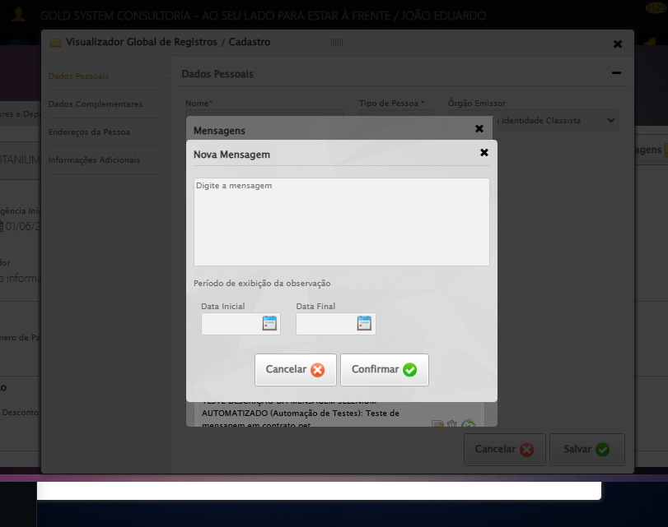

[17:18:39] 🔄 Clicando na aba 'Endereços da Pessoa' e capturando Screenshot'...

[17:18:39] Tentando estratégia de scroll 1...

[17:18:40] ✅ Scroll realizado com estratégia 1

[17:18:41] ⚠️ Estratégia 1 de clique falhou: Message: element click intercepted: Element <a class="enderecos">...</a> is not clickable at point (127, 160). Other element would receive the click: <div class="blockScreen" style="height: 641px; z-index: 10005; opacity: 0.5;"></div>  
 (Session info: chrome=138.0.7204.185); For documentation on this error, please visit: https://www.selenium.dev/documentation/webdriver/troubleshooting/errors#elementclickinterceptedexception  
Stacktrace:  
 GetHandleVerifier [0x0x5dba83+63395]  
 GetHandleVerifier [0x0x5dbac4+63460]  
 (No symbol) [0x0x422113]  
 (No symbol) [0x0x470ba0]  
 (No symbol) [0x0x46ef5a]  
 (No symbol) [0x0x46cab7]  
 (No symbol) [0x0x46bd6d]  
 (No symbol) [0x0x460515]  
 (No symbol) [0x0x48f3ac]  
 (No symbol) [0x0x45ffa4]  
 (No symbol) [0x0x48f624]  
 (No symbol) [0x0x4b07ba]  
 (No symbol) [0x0x48f1a6]  
 (No symbol) [0x0x45e7b2]  
 (No symbol) [0x0x45f654]  
 GetHandleVerifier [0x0x858883+2672035]  
 GetHandleVerifier [0x0x853cba+2652634]  
 GetHandleVerifier [0x0x602bca+223466]  
 GetHandleVerifier [0x0x5f2cb8+158168]  
 GetHandleVerifier [0x0x5f978d+185517]  
 GetHandleVerifier [0x0x5e3b78+96408]  
 GetHandleVerifier [0x0x5e3d02+96802]  
 GetHandleVerifier [0x0x5ce90a+9770]  
 BaseThreadInitThunk [0x0x75abfcc9+25]  
 RtlGetAppContainerNamedObjectPath [0x0x776d82ae+286]  
 RtlGetAppContainerNamedObjectPath [0x0x776d827e+238]

[17:18:42] ✅ Clique realizado com estratégia 2

[17:18:42] ✅ Clicando na aba 'Endereços da Pessoa' e capturando Screenshot' realizada com sucesso.

[17:18:43] 📸 Screenshot capturada: clicando_na_aba_endereços_da_pessoa_e_capturando_screenshot_

Screenshot: clicando_na_aba_endereços_da_pessoa_e_capturando_screenshot_



[17:18:43] 🔄 Salvando Titular...

[17:18:43] Tentando estratégia de scroll 1...

[17:18:44] ✅ Scroll realizado com estratégia 1

[17:18:46] ⚠️ Estratégia 1 de clique falhou: Message: element click intercepted: Element <a class="btModel btGray btsave">...</a> is not clickable at point (712, 547). Other element would receive the click: <div class="blockScreen" style="height: 641px; z-index: 10005; opacity: 0.5;"></div>  
 (Session info: chrome=138.0.7204.185); For documentation on this error, please visit: https://www.selenium.dev/documentation/webdriver/troubleshooting/errors#elementclickinterceptedexception  
Stacktrace:  
 GetHandleVerifier [0x0x5dba83+63395]  
 GetHandleVerifier [0x0x5dbac4+63460]  
 (No symbol) [0x0x422113]  
 (No symbol) [0x0x470ba0]  
 (No symbol) [0x0x46ef5a]  
 (No symbol) [0x0x46cab7]  
 (No symbol) [0x0x46bd6d]  
 (No symbol) [0x0x460515]  
 (No symbol) [0x0x48f3ac]  
 (No symbol) [0x0x45ffa4]  
 (No symbol) [0x0x48f624]  
 (No symbol) [0x0x4b07ba]  
 (No symbol) [0x0x48f1a6]  
 (No symbol) [0x0x45e7b2]  
 (No symbol) [0x0x45f654]  
 GetHandleVerifier [0x0x858883+2672035]  
 GetHandleVerifier [0x0x853cba+2652634]  
 GetHandleVerifier [0x0x602bca+223466]  
 GetHandleVerifier [0x0x5f2cb8+158168]  
 GetHandleVerifier [0x0x5f978d+185517]  
 GetHandleVerifier [0x0x5e3b78+96408]  
 GetHandleVerifier [0x0x5e3d02+96802]  
 GetHandleVerifier [0x0x5ce90a+9770]  
 BaseThreadInitThunk [0x0x75abfcc9+25]  
 RtlGetAppContainerNamedObjectPath [0x0x776d82ae+286]  
 RtlGetAppContainerNamedObjectPath [0x0x776d827e+238]

[17:18:47] ✅ Clique realizado com estratégia 2

[17:18:47] ✅ Salvando Titular realizada com sucesso.

[17:18:48] 📸 Screenshot capturada: salvando_titular

Screenshot: salvando_titular



[17:18:48] 🔍 Verificando mensagens de alerta após salvar titular...

[17:18:50] 🔄 Clicando na aba 'Contratos' e capturando Screenshot...

[17:19:16] ❌ Erro aguardando elemento //a[@ref='contratos' and normalize-space(text())='Contratos']: Message: no such window: target window already closed  
from unknown error: web view not found  
 (Session info: chrome=138.0.7204.185)  
Stacktrace:  
 GetHandleVerifier [0x0x5dba83+63395]  
 GetHandleVerifier [0x0x5dbac4+63460]  
 (No symbol) [0x0x422113]  
 (No symbol) [0x0x400fb9]  
 (No symbol) [0x0x495ace]  
 (No symbol) [0x0x4b0099]  
 (No symbol) [0x0x48f1a6]  
 (No symbol) [0x0x45e7b2]  
 (No symbol) [0x0x45f654]  
 GetHandleVerifier [0x0x858883+2672035]  
 GetHandleVerifier [0x0x853cba+2652634]  
 GetHandleVerifier [0x0x602bca+223466]  
 GetHandleVerifier [0x0x5f2cb8+158168]  
 GetHandleVerifier [0x0x5f978d+185517]  
 GetHandleVerifier [0x0x5e3b78+96408]  
 GetHandleVerifier [0x0x5e3d02+96802]  
 GetHandleVerifier [0x0x5ce90a+9770]  
 BaseThreadInitThunk [0x0x75abfcc9+25]  
 RtlGetAppContainerNamedObjectPath [0x0x776d82ae+286]  
 RtlGetAppContainerNamedObjectPath [0x0x776d827e+238]

[17:19:16] ❌ Falha ao clicar em //a[@ref='contratos' and normalize-space(text())='Contratos']: Message: no such window: target window already closed  
from unknown error: web view not found  
 (Session info: chrome=138.0.7204.185)  
Stacktrace:  
 GetHandleVerifier [0x0x5dba83+63395]  
 GetHandleVerifier [0x0x5dbac4+63460]  
 (No symbol) [0x0x422113]  
 (No symbol) [0x0x400fb9]  
 (No symbol) [0x0x495ace]  
 (No symbol) [0x0x4b0099]  
 (No symbol) [0x0x48f1a6]  
 (No symbol) [0x0x45e7b2]  
 (No symbol) [0x0x45f654]  
 GetHandleVerifier [0x0x858883+2672035]  
 GetHandleVerifier [0x0x853cba+2652634]  
 GetHandleVerifier [0x0x602bca+223466]  
 GetHandleVerifier [0x0x5f2cb8+158168]  
 GetHandleVerifier [0x0x5f978d+185517]  
 GetHandleVerifier [0x0x5e3b78+96408]  
 GetHandleVerifier [0x0x5e3d02+96802]  
 GetHandleVerifier [0x0x5ce90a+9770]  
 BaseThreadInitThunk [0x0x75abfcc9+25]  
 RtlGetAppContainerNamedObjectPath [0x0x776d82ae+286]  
 RtlGetAppContainerNamedObjectPath [0x0x776d827e+238]

[17:19:16] ⚠️ Erro ao tirar screenshot erro_clicando_na_aba_contratos_e_capturando_screenshot: Message: no such window: target window already closed  
from unknown error: web view not found  
 (Session info: chrome=138.0.7204.185)  
Stacktrace:  
 GetHandleVerifier [0x0x5dba83+63395]  
 GetHandleVerifier [0x0x5dbac4+63460]  
 (No symbol) [0x0x422113]  
 (No symbol) [0x0x400fb9]  
 (No symbol) [0x0x495ace]  
 (No symbol) [0x0x4b0099]  
 (No symbol) [0x0x48f1a6]  
 (No symbol) [0x0x45e7b2]  
 (No symbol) [0x0x45f654]  
 GetHandleVerifier [0x0x858883+2672035]  
 GetHandleVerifier [0x0x853cba+2652634]  
 GetHandleVerifier [0x0x602bca+223466]  
 GetHandleVerifier [0x0x5f2cb8+158168]  
 GetHandleVerifier [0x0x5f978d+185517]  
 GetHandleVerifier [0x0x5e3b78+96408]  
 GetHandleVerifier [0x0x5e3d02+96802]  
 GetHandleVerifier [0x0x5ce90a+9770]  
 BaseThreadInitThunk [0x0x75abfcc9+25]  
 RtlGetAppContainerNamedObjectPath [0x0x776d82ae+286]  
 RtlGetAppContainerNamedObjectPath [0x0x776d827e+238]

[17:19:16] ❌ Clicando na aba 'Contratos' e capturando Screenshot falhou: NoSuchWindowException: Message: no such window: target window already closed  
from unknown error: web view not found  
 (Session info: chrome=138.0.7204.185)  
Stacktrace:  
 GetHandleVerifier [0x0x5dba83+63395]  
 GetHandleVerifier [0x0x5dbac4+63460]  
 (No symbol) [0x0x422113]  
 (No symbol) [0x0x400fb9]  
 (No symbol) [0x0x495ace]  
 (No symbol) [0x0x4b0099]  
 (No symbol) [0x0x48f1a6]  
 (No symbol) [0x0x45e7b2]  
 (No symbol) [0x0x45f654]  
 GetHandleVerifier [0x0x858883+2672035]  
 GetHandleVerifier [0x0x853cba+2652634]  
 GetHandleVerifier [0x0x602bca+223466]  
 GetHandleVerifier [0x0x5f2cb8+158168]  
 GetHandleVerifier [0x0x5f978d+185517]  
 GetHandleVerifier [0x0x5e3b78+96408]  
 GetHandleVerifier [0x0x5e3d02+96802]  
 GetHandleVerifier [0x0x5ce90a+9770]  
 BaseThreadInitThunk [0x0x75abfcc9+25]  
 RtlGetAppContainerNamedObjectPath [0x0x776d82ae+286]  
 RtlGetAppContainerNamedObjectPath [0x0x776d827e+238]

[17:19:16] ⚠️ Continuando execução apesar do erro em: Clicando na aba 'Contratos' e capturando Screenshot

[17:19:16] 🔄 Clicando na aba 'Itens Locados' e capturando Screenshot...

[17:19:16] ❌ Erro aguardando elemento //a[@ref='itensLocados' and normalize-space(text())='Itens Locados']: Message: no such window: target window already closed  
from unknown error: web view not found  
 (Session info: chrome=138.0.7204.185)  
Stacktrace:  
 GetHandleVerifier [0x0x5dba83+63395]  
 GetHandleVerifier [0x0x5dbac4+63460]  
 (No symbol) [0x0x422113]  
 (No symbol) [0x0x400fb9]  
 (No symbol) [0x0x495ace]  
 (No symbol) [0x0x4b0099]  
 (No symbol) [0x0x48f1a6]  
 (No symbol) [0x0x45e7b2]  
 (No symbol) [0x0x45f654]  
 GetHandleVerifier [0x0x858883+2672035]  
 GetHandleVerifier [0x0x853cba+2652634]  
 GetHandleVerifier [0x0x602bca+223466]  
 GetHandleVerifier [0x0x5f2cb8+158168]  
 GetHandleVerifier [0x0x5f978d+185517]  
 GetHandleVerifier [0x0x5e3b78+96408]  
 GetHandleVerifier [0x0x5e3d02+96802]  
 GetHandleVerifier [0x0x5ce90a+9770]  
 BaseThreadInitThunk [0x0x75abfcc9+25]  
 RtlGetAppContainerNamedObjectPath [0x0x776d82ae+286]  
 RtlGetAppContainerNamedObjectPath [0x0x776d827e+238]

[17:19:16] ❌ Falha ao clicar em //a[@ref='itensLocados' and normalize-space(text())='Itens Locados']: Message: no such window: target window already closed  
from unknown error: web view not found  
 (Session info: chrome=138.0.7204.185)  
Stacktrace:  
 GetHandleVerifier [0x0x5dba83+63395]  
 GetHandleVerifier [0x0x5dbac4+63460]  
 (No symbol) [0x0x422113]  
 (No symbol) [0x0x400fb9]  
 (No symbol) [0x0x495ace]  
 (No symbol) [0x0x4b0099]  
 (No symbol) [0x0x48f1a6]  
 (No symbol) [0x0x45e7b2]  
 (No symbol) [0x0x45f654]  
 GetHandleVerifier [0x0x858883+2672035]  
 GetHandleVerifier [0x0x853cba+2652634]  
 GetHandleVerifier [0x0x602bca+223466]  
 GetHandleVerifier [0x0x5f2cb8+158168]  
 GetHandleVerifier [0x0x5f978d+185517]  
 GetHandleVerifier [0x0x5e3b78+96408]  
 GetHandleVerifier [0x0x5e3d02+96802]  
 GetHandleVerifier [0x0x5ce90a+9770]  
 BaseThreadInitThunk [0x0x75abfcc9+25]  
 RtlGetAppContainerNamedObjectPath [0x0x776d82ae+286]  
 RtlGetAppContainerNamedObjectPath [0x0x776d827e+238]

[17:19:16] ⚠️ Erro ao tirar screenshot erro_clicando_na_aba_itens_locados_e_capturando_screenshot: Message: no such window: target window already closed  
from unknown error: web view not found  
 (Session info: chrome=138.0.7204.185)  
Stacktrace:  
 GetHandleVerifier [0x0x5dba83+63395]  
 GetHandleVerifier [0x0x5dbac4+63460]  
 (No symbol) [0x0x422113]  
 (No symbol) [0x0x400fb9]  
 (No symbol) [0x0x495ace]  
 (No symbol) [0x0x4b0099]  
 (No symbol) [0x0x48f1a6]  
 (No symbol) [0x0x45e7b2]  
 (No symbol) [0x0x45f654]  
 GetHandleVerifier [0x0x858883+2672035]  
 GetHandleVerifier [0x0x853cba+2652634]  
 GetHandleVerifier [0x0x602bca+223466]  
 GetHandleVerifier [0x0x5f2cb8+158168]  
 GetHandleVerifier [0x0x5f978d+185517]  
 GetHandleVerifier [0x0x5e3b78+96408]  
 GetHandleVerifier [0x0x5e3d02+96802]  
 GetHandleVerifier [0x0x5ce90a+9770]  
 BaseThreadInitThunk [0x0x75abfcc9+25]  
 RtlGetAppContainerNamedObjectPath [0x0x776d82ae+286]  
 RtlGetAppContainerNamedObjectPath [0x0x776d827e+238]

[17:19:16] ❌ Clicando na aba 'Itens Locados' e capturando Screenshot falhou: NoSuchWindowException: Message: no such window: target window already closed  
from unknown error: web view not found  
 (Session info: chrome=138.0.7204.185)  
Stacktrace:  
 GetHandleVerifier [0x0x5dba83+63395]  
 GetHandleVerifier [0x0x5dbac4+63460]  
 (No symbol) [0x0x422113]  
 (No symbol) [0x0x400fb9]  
 (No symbol) [0x0x495ace]  
 (No symbol) [0x0x4b0099]  
 (No symbol) [0x0x48f1a6]  
 (No symbol) [0x0x45e7b2]  
 (No symbol) [0x0x45f654]  
 GetHandleVerifier [0x0x858883+2672035]  
 GetHandleVerifier [0x0x853cba+2652634]  
 GetHandleVerifier [0x0x602bca+223466]  
 GetHandleVerifier [0x0x5f2cb8+158168]  
 GetHandleVerifier [0x0x5f978d+185517]  
 GetHandleVerifier [0x0x5e3b78+96408]  
 GetHandleVerifier [0x0x5e3d02+96802]  
 GetHandleVerifier [0x0x5ce90a+9770]  
 BaseThreadInitThunk [0x0x75abfcc9+25]  
 RtlGetAppContainerNamedObjectPath [0x0x776d82ae+286]  
 RtlGetAppContainerNamedObjectPath [0x0x776d827e+238]

[17:19:16] ⚠️ Continuando execução apesar do erro em: Clicando na aba 'Itens Locados' e capturando Screenshot

[17:19:16] 🔄 Fechando aba de Busca Rápida...

[17:19:16] ❌ Erro aguardando elemento #gsViewer_21582908 > div.wdTop.ui-draggable-handle > div > a: Message: no such window: target window already closed  
from unknown error: web view not found  
 (Session info: chrome=138.0.7204.185)  
Stacktrace:  
 GetHandleVerifier [0x0x5dba83+63395]  
 GetHandleVerifier [0x0x5dbac4+63460]  
 (No symbol) [0x0x422113]  
 (No symbol) [0x0x400fb9]  
 (No symbol) [0x0x495ace]  
 (No symbol) [0x0x4b0099]  
 (No symbol) [0x0x48f1a6]  
 (No symbol) [0x0x45e7b2]  
 (No symbol) [0x0x45f654]  
 GetHandleVerifier [0x0x858883+2672035]  
 GetHandleVerifier [0x0x853cba+2652634]  
 GetHandleVerifier [0x0x602bca+223466]  
 GetHandleVerifier [0x0x5f2cb8+158168]  
 GetHandleVerifier [0x0x5f978d+185517]  
 GetHandleVerifier [0x0x5e3b78+96408]  
 GetHandleVerifier [0x0x5e3d02+96802]  
 GetHandleVerifier [0x0x5ce90a+9770]  
 BaseThreadInitThunk [0x0x75abfcc9+25]  
 RtlGetAppContainerNamedObjectPath [0x0x776d82ae+286]  
 RtlGetAppContainerNamedObjectPath [0x0x776d827e+238]

[17:19:16] ❌ Falha ao clicar em #gsViewer_21582908 > div.wdTop.ui-draggable-handle > div > a: Message: no such window: target window already closed  
from unknown error: web view not found  
 (Session info: chrome=138.0.7204.185)  
Stacktrace:  
 GetHandleVerifier [0x0x5dba83+63395]  
 GetHandleVerifier [0x0x5dbac4+63460]  
 (No symbol) [0x0x422113]  
 (No symbol) [0x0x400fb9]  
 (No symbol) [0x0x495ace]  
 (No symbol) [0x0x4b0099]  
 (No symbol) [0x0x48f1a6]  
 (No symbol) [0x0x45e7b2]  
 (No symbol) [0x0x45f654]  
 GetHandleVerifier [0x0x858883+2672035]  
 GetHandleVerifier [0x0x853cba+2652634]  
 GetHandleVerifier [0x0x602bca+223466]  
 GetHandleVerifier [0x0x5f2cb8+158168]  
 GetHandleVerifier [0x0x5f978d+185517]  
 GetHandleVerifier [0x0x5e3b78+96408]  
 GetHandleVerifier [0x0x5e3d02+96802]  
 GetHandleVerifier [0x0x5ce90a+9770]  
 BaseThreadInitThunk [0x0x75abfcc9+25]  
 RtlGetAppContainerNamedObjectPath [0x0x776d82ae+286]  
 RtlGetAppContainerNamedObjectPath [0x0x776d827e+238]

[17:19:16] ⚠️ Erro ao tirar screenshot erro_fechando_aba_de_busca_rápida: Message: no such window: target window already closed  
from unknown error: web view not found  
 (Session info: chrome=138.0.7204.185)  
Stacktrace:  
 GetHandleVerifier [0x0x5dba83+63395]  
 GetHandleVerifier [0x0x5dbac4+63460]  
 (No symbol) [0x0x422113]  
 (No symbol) [0x0x400fb9]  
 (No symbol) [0x0x495ace]  
 (No symbol) [0x0x4b0099]  
 (No symbol) [0x0x48f1a6]  
 (No symbol) [0x0x45e7b2]  
 (No symbol) [0x0x45f654]  
 GetHandleVerifier [0x0x858883+2672035]  
 GetHandleVerifier [0x0x853cba+2652634]  
 GetHandleVerifier [0x0x602bca+223466]  
 GetHandleVerifier [0x0x5f2cb8+158168]  
 GetHandleVerifier [0x0x5f978d+185517]  
 GetHandleVerifier [0x0x5e3b78+96408]  
 GetHandleVerifier [0x0x5e3d02+96802]  
 GetHandleVerifier [0x0x5ce90a+9770]  
 BaseThreadInitThunk [0x0x75abfcc9+25]  
 RtlGetAppContainerNamedObjectPath [0x0x776d82ae+286]  
 RtlGetAppContainerNamedObjectPath [0x0x776d827e+238]

[17:19:16] ❌ Fechando aba de Busca Rápida falhou: NoSuchWindowException: Message: no such window: target window already closed  
from unknown error: web view not found  
 (Session info: chrome=138.0.7204.185)  
Stacktrace:  
 GetHandleVerifier [0x0x5dba83+63395]  
 GetHandleVerifier [0x0x5dbac4+63460]  
 (No symbol) [0x0x422113]  
 (No symbol) [0x0x400fb9]  
 (No symbol) [0x0x495ace]  
 (No symbol) [0x0x4b0099]  
 (No symbol) [0x0x48f1a6]  
 (No symbol) [0x0x45e7b2]  
 (No symbol) [0x0x45f654]  
 GetHandleVerifier [0x0x858883+2672035]  
 GetHandleVerifier [0x0x853cba+2652634]  
 GetHandleVerifier [0x0x602bca+223466]  
 GetHandleVerifier [0x0x5f2cb8+158168]  
 GetHandleVerifier [0x0x5f978d+185517]  
 GetHandleVerifier [0x0x5e3b78+96408]  
 GetHandleVerifier [0x0x5e3d02+96802]  
 GetHandleVerifier [0x0x5ce90a+9770]  
 BaseThreadInitThunk [0x0x75abfcc9+25]  
 RtlGetAppContainerNamedObjectPath [0x0x776d82ae+286]  
 RtlGetAppContainerNamedObjectPath [0x0x776d827e+238]

[17:19:16] ⚠️ Continuando execução apesar do erro em: Fechando aba de Busca Rápida

[17:19:16] 🔄 Clicando em Adicionar Contato...

[17:19:16] ❌ Erro aguardando elemento //span[contains(@class,'btEdit') and @title='Adicionar contato']: Message: no such window: target window already closed  
from unknown error: web view not found  
 (Session info: chrome=138.0.7204.185)  
Stacktrace:  
 GetHandleVerifier [0x0x5dba83+63395]  
 GetHandleVerifier [0x0x5dbac4+63460]  
 (No symbol) [0x0x422113]  
 (No symbol) [0x0x400fb9]  
 (No symbol) [0x0x495ace]  
 (No symbol) [0x0x4b0099]  
 (No symbol) [0x0x48f1a6]  
 (No symbol) [0x0x45e7b2]  
 (No symbol) [0x0x45f654]  
 GetHandleVerifier [0x0x858883+2672035]  
 GetHandleVerifier [0x0x853cba+2652634]  
 GetHandleVerifier [0x0x602bca+223466]  
 GetHandleVerifier [0x0x5f2cb8+158168]  
 GetHandleVerifier [0x0x5f978d+185517]  
 GetHandleVerifier [0x0x5e3b78+96408]  
 GetHandleVerifier [0x0x5e3d02+96802]  
 GetHandleVerifier [0x0x5ce90a+9770]  
 BaseThreadInitThunk [0x0x75abfcc9+25]  
 RtlGetAppContainerNamedObjectPath [0x0x776d82ae+286]  
 RtlGetAppContainerNamedObjectPath [0x0x776d827e+238]

[17:19:16] ❌ Falha ao clicar em //span[contains(@class,'btEdit') and @title='Adicionar contato']: Message: no such window: target window already closed  
from unknown error: web view not found  
 (Session info: chrome=138.0.7204.185)  
Stacktrace:  
 GetHandleVerifier [0x0x5dba83+63395]  
 GetHandleVerifier [0x0x5dbac4+63460]  
 (No symbol) [0x0x422113]  
 (No symbol) [0x0x400fb9]  
 (No symbol) [0x0x495ace]  
 (No symbol) [0x0x4b0099]  
 (No symbol) [0x0x48f1a6]  
 (No symbol) [0x0x45e7b2]  
 (No symbol) [0x0x45f654]  
 GetHandleVerifier [0x0x858883+2672035]  
 GetHandleVerifier [0x0x853cba+2652634]  
 GetHandleVerifier [0x0x602bca+223466]  
 GetHandleVerifier [0x0x5f2cb8+158168]  
 GetHandleVerifier [0x0x5f978d+185517]  
 GetHandleVerifier [0x0x5e3b78+96408]  
 GetHandleVerifier [0x0x5e3d02+96802]  
 GetHandleVerifier [0x0x5ce90a+9770]  
 BaseThreadInitThunk [0x0x75abfcc9+25]  
 RtlGetAppContainerNamedObjectPath [0x0x776d82ae+286]  
 RtlGetAppContainerNamedObjectPath [0x0x776d827e+238]

[17:19:16] ⚠️ Erro ao tirar screenshot erro_clicando_em_adicionar_contato: Message: no such window: target window already closed  
from unknown error: web view not found  
 (Session info: chrome=138.0.7204.185)  
Stacktrace:  
 GetHandleVerifier [0x0x5dba83+63395]  
 GetHandleVerifier [0x0x5dbac4+63460]  
 (No symbol) [0x0x422113]  
 (No symbol) [0x0x400fb9]  
 (No symbol) [0x0x495ace]  
 (No symbol) [0x0x4b0099]  
 (No symbol) [0x0x48f1a6]  
 (No symbol) [0x0x45e7b2]  
 (No symbol) [0x0x45f654]  
 GetHandleVerifier [0x0x858883+2672035]  
 GetHandleVerifier [0x0x853cba+2652634]  
 GetHandleVerifier [0x0x602bca+223466]  
 GetHandleVerifier [0x0x5f2cb8+158168]  
 GetHandleVerifier [0x0x5f978d+185517]  
 GetHandleVerifier [0x0x5e3b78+96408]  
 GetHandleVerifier [0x0x5e3d02+96802]  
 GetHandleVerifier [0x0x5ce90a+9770]  
 BaseThreadInitThunk [0x0x75abfcc9+25]  
 RtlGetAppContainerNamedObjectPath [0x0x776d82ae+286]  
 RtlGetAppContainerNamedObjectPath [0x0x776d827e+238]

[17:19:16] ❌ Clicando em Adicionar Contato falhou: NoSuchWindowException: Message: no such window: target window already closed  
from unknown error: web view not found  
 (Session info: chrome=138.0.7204.185)  
Stacktrace:  
 GetHandleVerifier [0x0x5dba83+63395]  
 GetHandleVerifier [0x0x5dbac4+63460]  
 (No symbol) [0x0x422113]  
 (No symbol) [0x0x400fb9]  
 (No symbol) [0x0x495ace]  
 (No symbol) [0x0x4b0099]  
 (No symbol) [0x0x48f1a6]  
 (No symbol) [0x0x45e7b2]  
 (No symbol) [0x0x45f654]  
 GetHandleVerifier [0x0x858883+2672035]  
 GetHandleVerifier [0x0x853cba+2652634]  
 GetHandleVerifier [0x0x602bca+223466]  
 GetHandleVerifier [0x0x5f2cb8+158168]  
 GetHandleVerifier [0x0x5f978d+185517]  
 GetHandleVerifier [0x0x5e3b78+96408]  
 GetHandleVerifier [0x0x5e3d02+96802]  
 GetHandleVerifier [0x0x5ce90a+9770]  
 BaseThreadInitThunk [0x0x75abfcc9+25]  
 RtlGetAppContainerNamedObjectPath [0x0x776d82ae+286]  
 RtlGetAppContainerNamedObjectPath [0x0x776d827e+238]

[17:19:16] ⚠️ Continuando execução apesar do erro em: Clicando em Adicionar Contato

[17:19:16] 🔄 Salvando Contato sem preencher os campos, para verificação de mensagens de alerta...

[17:19:16] ❌ Erro aguardando elemento //button[contains(@class,'btGray') and contains(normalize-space(.),'Salvar')]: Message: no such window: target window already closed  
from unknown error: web view not found  
 (Session info: chrome=138.0.7204.185)  
Stacktrace:  
 GetHandleVerifier [0x0x5dba83+63395]  
 GetHandleVerifier [0x0x5dbac4+63460]  
 (No symbol) [0x0x422113]  
 (No symbol) [0x0x400fb9]  
 (No symbol) [0x0x495ace]  
 (No symbol) [0x0x4b0099]  
 (No symbol) [0x0x48f1a6]  
 (No symbol) [0x0x45e7b2]  
 (No symbol) [0x0x45f654]  
 GetHandleVerifier [0x0x858883+2672035]  
 GetHandleVerifier [0x0x853cba+2652634]  
 GetHandleVerifier [0x0x602bca+223466]  
 GetHandleVerifier [0x0x5f2cb8+158168]  
 GetHandleVerifier [0x0x5f978d+185517]  
 GetHandleVerifier [0x0x5e3b78+96408]  
 GetHandleVerifier [0x0x5e3d02+96802]  
 GetHandleVerifier [0x0x5ce90a+9770]  
 BaseThreadInitThunk [0x0x75abfcc9+25]  
 RtlGetAppContainerNamedObjectPath [0x0x776d82ae+286]  
 RtlGetAppContainerNamedObjectPath [0x0x776d827e+238]

[17:19:16] ❌ Falha ao clicar em //button[contains(@class,'btGray') and contains(normalize-space(.),'Salvar')]: Message: no such window: target window already closed  
from unknown error: web view not found  
 (Session info: chrome=138.0.7204.185)  
Stacktrace:  
 GetHandleVerifier [0x0x5dba83+63395]  
 GetHandleVerifier [0x0x5dbac4+63460]  
 (No symbol) [0x0x422113]  
 (No symbol) [0x0x400fb9]  
 (No symbol) [0x0x495ace]  
 (No symbol) [0x0x4b0099]  
 (No symbol) [0x0x48f1a6]  
 (No symbol) [0x0x45e7b2]  
 (No symbol) [0x0x45f654]  
 GetHandleVerifier [0x0x858883+2672035]  
 GetHandleVerifier [0x0x853cba+2652634]  
 GetHandleVerifier [0x0x602bca+223466]  
 GetHandleVerifier [0x0x5f2cb8+158168]  
 GetHandleVerifier [0x0x5f978d+185517]  
 GetHandleVerifier [0x0x5e3b78+96408]  
 GetHandleVerifier [0x0x5e3d02+96802]  
 GetHandleVerifier [0x0x5ce90a+9770]  
 BaseThreadInitThunk [0x0x75abfcc9+25]  
 RtlGetAppContainerNamedObjectPath [0x0x776d82ae+286]  
 RtlGetAppContainerNamedObjectPath [0x0x776d827e+238]

[17:19:16] ⚠️ Erro ao tirar screenshot erro_salvando_contato_sem_preencher_os_campos,_para_verificação_de_mensagens_de_alerta: Message: no such window: target window already closed  
from unknown error: web view not found  
 (Session info: chrome=138.0.7204.185)  
Stacktrace:  
 GetHandleVerifier [0x0x5dba83+63395]  
 GetHandleVerifier [0x0x5dbac4+63460]  
 (No symbol) [0x0x422113]  
 (No symbol) [0x0x400fb9]  
 (No symbol) [0x0x495ace]  
 (No symbol) [0x0x4b0099]  
 (No symbol) [0x0x48f1a6]  
 (No symbol) [0x0x45e7b2]  
 (No symbol) [0x0x45f654]  
 GetHandleVerifier [0x0x858883+2672035]  
 GetHandleVerifier [0x0x853cba+2652634]  
 GetHandleVerifier [0x0x602bca+223466]  
 GetHandleVerifier [0x0x5f2cb8+158168]  
 GetHandleVerifier [0x0x5f978d+185517]  
 GetHandleVerifier [0x0x5e3b78+96408]  
 GetHandleVerifier [0x0x5e3d02+96802]  
 GetHandleVerifier [0x0x5ce90a+9770]  
 BaseThreadInitThunk [0x0x75abfcc9+25]  
 RtlGetAppContainerNamedObjectPath [0x0x776d82ae+286]  
 RtlGetAppContainerNamedObjectPath [0x0x776d827e+238]

[17:19:16] ❌ Salvando Contato sem preencher os campos, para verificação de mensagens de alerta falhou: NoSuchWindowException: Message: no such window: target window already closed  
from unknown error: web view not found  
 (Session info: chrome=138.0.7204.185)  
Stacktrace:  
 GetHandleVerifier [0x0x5dba83+63395]  
 GetHandleVerifier [0x0x5dbac4+63460]  
 (No symbol) [0x0x422113]  
 (No symbol) [0x0x400fb9]  
 (No symbol) [0x0x495ace]  
 (No symbol) [0x0x4b0099]  
 (No symbol) [0x0x48f1a6]  
 (No symbol) [0x0x45e7b2]  
 (No symbol) [0x0x45f654]  
 GetHandleVerifier [0x0x858883+2672035]  
 GetHandleVerifier [0x0x853cba+2652634]  
 GetHandleVerifier [0x0x602bca+223466]  
 GetHandleVerifier [0x0x5f2cb8+158168]  
 GetHandleVerifier [0x0x5f978d+185517]  
 GetHandleVerifier [0x0x5e3b78+96408]  
 GetHandleVerifier [0x0x5e3d02+96802]  
 GetHandleVerifier [0x0x5ce90a+9770]  
 BaseThreadInitThunk [0x0x75abfcc9+25]  
 RtlGetAppContainerNamedObjectPath [0x0x776d82ae+286]  
 RtlGetAppContainerNamedObjectPath [0x0x776d827e+238]

[17:19:16] ⚠️ Continuando execução apesar do erro em: Salvando Contato sem preencher os campos, para verificação de mensagens de alerta

[17:19:16] 🔍 Verificando mensagens de alerta após salvar Contato...

[17:19:16] ⚠️ Erro ao buscar alerta .alerts.salvo: Message: no such window: target window already closed  
from unknown error: web view not found  
 (Session info: chrome=138.0.7204.185)  
Stacktrace:  
 GetHandleVerifier [0x0x5dba83+63395]  
 GetHandleVerifier [0x0x5dbac4+63460]  
 (No symbol) [0x0x422113]  
 (No symbol) [0x0x400fb9]  
 (No symbol) [0x0x495ace]  
 (No symbol) [0x0x4b0099]  
 (No symbol) [0x0x48f1a6]  
 (No symbol) [0x0x45e7b2]  
 (No symbol) [0x0x45f654]  
 GetHandleVerifier [0x0x858883+2672035]  
 GetHandleVerifier [0x0x853cba+2652634]  
 GetHandleVerifier [0x0x602bca+223466]  
 GetHandleVerifier [0x0x5f2cb8+158168]  
 GetHandleVerifier [0x0x5f978d+185517]  
 GetHandleVerifier [0x0x5e3b78+96408]  
 GetHandleVerifier [0x0x5e3d02+96802]  
 GetHandleVerifier [0x0x5ce90a+9770]  
 BaseThreadInitThunk [0x0x75abfcc9+25]  
 RtlGetAppContainerNamedObjectPath [0x0x776d82ae+286]  
 RtlGetAppContainerNamedObjectPath [0x0x776d827e+238]

[17:19:16] ⚠️ Erro ao buscar alerta .alerts.alerta: Message: no such window: target window already closed  
from unknown error: web view not found  
 (Session info: chrome=138.0.7204.185)  
Stacktrace:  
 GetHandleVerifier [0x0x5dba83+63395]  
 GetHandleVerifier [0x0x5dbac4+63460]  
 (No symbol) [0x0x422113]  
 (No symbol) [0x0x400fb9]  
 (No symbol) [0x0x495ace]  
 (No symbol) [0x0x4b0099]  
 (No symbol) [0x0x48f1a6]  
 (No symbol) [0x0x45e7b2]  
 (No symbol) [0x0x45f654]  
 GetHandleVerifier [0x0x858883+2672035]  
 GetHandleVerifier [0x0x853cba+2652634]  
 GetHandleVerifier [0x0x602bca+223466]  
 GetHandleVerifier [0x0x5f2cb8+158168]  
 GetHandleVerifier [0x0x5f978d+185517]  
 GetHandleVerifier [0x0x5e3b78+96408]  
 GetHandleVerifier [0x0x5e3d02+96802]  
 GetHandleVerifier [0x0x5ce90a+9770]  
 BaseThreadInitThunk [0x0x75abfcc9+25]  
 RtlGetAppContainerNamedObjectPath [0x0x776d82ae+286]  
 RtlGetAppContainerNamedObjectPath [0x0x776d827e+238]

[17:19:16] ⚠️ Erro ao buscar alerta .alerts.erro: Message: no such window: target window already closed  
from unknown error: web view not found  
 (Session info: chrome=138.0.7204.185)  
Stacktrace:  
 GetHandleVerifier [0x0x5dba83+63395]  
 GetHandleVerifier [0x0x5dbac4+63460]  
 (No symbol) [0x0x422113]  
 (No symbol) [0x0x400fb9]  
 (No symbol) [0x0x495ace]  
 (No symbol) [0x0x4b0099]  
 (No symbol) [0x0x48f1a6]  
 (No symbol) [0x0x45e7b2]  
 (No symbol) [0x0x45f654]  
 GetHandleVerifier [0x0x858883+2672035]  
 GetHandleVerifier [0x0x853cba+2652634]  
 GetHandleVerifier [0x0x602bca+223466]  
 GetHandleVerifier [0x0x5f2cb8+158168]  
 GetHandleVerifier [0x0x5f978d+185517]  
 GetHandleVerifier [0x0x5e3b78+96408]  
 GetHandleVerifier [0x0x5e3d02+96802]  
 GetHandleVerifier [0x0x5ce90a+9770]  
 BaseThreadInitThunk [0x0x75abfcc9+25]  
 RtlGetAppContainerNamedObjectPath [0x0x776d82ae+286]  
 RtlGetAppContainerNamedObjectPath [0x0x776d827e+238]

[17:19:16] ⚠️ Erro ao buscar alerta .alert-success: Message: no such window: target window already closed  
from unknown error: web view not found  
 (Session info: chrome=138.0.7204.185)  
Stacktrace:  
 GetHandleVerifier [0x0x5dba83+63395]  
 GetHandleVerifier [0x0x5dbac4+63460]  
 (No symbol) [0x0x422113]  
 (No symbol) [0x0x400fb9]  
 (No symbol) [0x0x495ace]  
 (No symbol) [0x0x4b0099]  
 (No symbol) [0x0x48f1a6]  
 (No symbol) [0x0x45e7b2]  
 (No symbol) [0x0x45f654]  
 GetHandleVerifier [0x0x858883+2672035]  
 GetHandleVerifier [0x0x853cba+2652634]  
 GetHandleVerifier [0x0x602bca+223466]  
 GetHandleVerifier [0x0x5f2cb8+158168]  
 GetHandleVerifier [0x0x5f978d+185517]  
 GetHandleVerifier [0x0x5e3b78+96408]  
 GetHandleVerifier [0x0x5e3d02+96802]  
 GetHandleVerifier [0x0x5ce90a+9770]  
 BaseThreadInitThunk [0x0x75abfcc9+25]  
 RtlGetAppContainerNamedObjectPath [0x0x776d82ae+286]  
 RtlGetAppContainerNamedObjectPath [0x0x776d827e+238]

[17:19:16] ⚠️ Erro ao buscar alerta .alert-warning: Message: no such window: target window already closed  
from unknown error: web view not found  
 (Session info: chrome=138.0.7204.185)  
Stacktrace:  
 GetHandleVerifier [0x0x5dba83+63395]  
 GetHandleVerifier [0x0x5dbac4+63460]  
 (No symbol) [0x0x422113]  
 (No symbol) [0x0x400fb9]  
 (No symbol) [0x0x495ace]  
 (No symbol) [0x0x4b0099]  
 (No symbol) [0x0x48f1a6]  
 (No symbol) [0x0x45e7b2]  
 (No symbol) [0x0x45f654]  
 GetHandleVerifier [0x0x858883+2672035]  
 GetHandleVerifier [0x0x853cba+2652634]  
 GetHandleVerifier [0x0x602bca+223466]  
 GetHandleVerifier [0x0x5f2cb8+158168]  
 GetHandleVerifier [0x0x5f978d+185517]  
 GetHandleVerifier [0x0x5e3b78+96408]  
 GetHandleVerifier [0x0x5e3d02+96802]  
 GetHandleVerifier [0x0x5ce90a+9770]  
 BaseThreadInitThunk [0x0x75abfcc9+25]  
 RtlGetAppContainerNamedObjectPath [0x0x776d82ae+286]  
 RtlGetAppContainerNamedObjectPath [0x0x776d827e+238]

[17:19:16] ⚠️ Erro ao buscar alerta .alert-danger: Message: no such window: target window already closed  
from unknown error: web view not found  
 (Session info: chrome=138.0.7204.185)  
Stacktrace:  
 GetHandleVerifier [0x0x5dba83+63395]  
 GetHandleVerifier [0x0x5dbac4+63460]  
 (No symbol) [0x0x422113]  
 (No symbol) [0x0x400fb9]  
 (No symbol) [0x0x495ace]  
 (No symbol) [0x0x4b0099]  
 (No symbol) [0x0x48f1a6]  
 (No symbol) [0x0x45e7b2]  
 (No symbol) [0x0x45f654]  
 GetHandleVerifier [0x0x858883+2672035]  
 GetHandleVerifier [0x0x853cba+2652634]  
 GetHandleVerifier [0x0x602bca+223466]  
 GetHandleVerifier [0x0x5f2cb8+158168]  
 GetHandleVerifier [0x0x5f978d+185517]  
 GetHandleVerifier [0x0x5e3b78+96408]  
 GetHandleVerifier [0x0x5e3d02+96802]  
 GetHandleVerifier [0x0x5ce90a+9770]  
 BaseThreadInitThunk [0x0x75abfcc9+25]  
 RtlGetAppContainerNamedObjectPath [0x0x776d82ae+286]  
 RtlGetAppContainerNamedObjectPath [0x0x776d827e+238]

[17:19:16] ⚠️ Erro ao buscar alerta [class*='toast']: Message: no such window: target window already closed  
from unknown error: web view not found  
 (Session info: chrome=138.0.7204.185)  
Stacktrace:  
 GetHandleVerifier [0x0x5dba83+63395]  
 GetHandleVerifier [0x0x5dbac4+63460]  
 (No symbol) [0x0x422113]  
 (No symbol) [0x0x400fb9]  
 (No symbol) [0x0x495ace]  
 (No symbol) [0x0x4b0099]  
 (No symbol) [0x0x48f1a6]  
 (No symbol) [0x0x45e7b2]  
 (No symbol) [0x0x45f654]  
 GetHandleVerifier [0x0x858883+2672035]  
 GetHandleVerifier [0x0x853cba+2652634]  
 GetHandleVerifier [0x0x602bca+223466]  
 GetHandleVerifier [0x0x5f2cb8+158168]  
 GetHandleVerifier [0x0x5f978d+185517]  
 GetHandleVerifier [0x0x5e3b78+96408]  
 GetHandleVerifier [0x0x5e3d02+96802]  
 GetHandleVerifier [0x0x5ce90a+9770]  
 BaseThreadInitThunk [0x0x75abfcc9+25]  
 RtlGetAppContainerNamedObjectPath [0x0x776d82ae+286]  
 RtlGetAppContainerNamedObjectPath [0x0x776d827e+238]

[17:19:16] 🔄 Fechando aba de Contatos...

[17:19:16] ❌ Erro aguardando elemento /html/body/div[19]/div[2]/a: Message: no such window: target window already closed  
from unknown error: web view not found  
 (Session info: chrome=138.0.7204.185)  
Stacktrace:  
 GetHandleVerifier [0x0x5dba83+63395]  
 GetHandleVerifier [0x0x5dbac4+63460]  
 (No symbol) [0x0x422113]  
 (No symbol) [0x0x400fb9]  
 (No symbol) [0x0x495ace]  
 (No symbol) [0x0x4b0099]  
 (No symbol) [0x0x48f1a6]  
 (No symbol) [0x0x45e7b2]  
 (No symbol) [0x0x45f654]  
 GetHandleVerifier [0x0x858883+2672035]  
 GetHandleVerifier [0x0x853cba+2652634]  
 GetHandleVerifier [0x0x602bca+223466]  
 GetHandleVerifier [0x0x5f2cb8+158168]  
 GetHandleVerifier [0x0x5f978d+185517]  
 GetHandleVerifier [0x0x5e3b78+96408]  
 GetHandleVerifier [0x0x5e3d02+96802]  
 GetHandleVerifier [0x0x5ce90a+9770]  
 BaseThreadInitThunk [0x0x75abfcc9+25]  
 RtlGetAppContainerNamedObjectPath [0x0x776d82ae+286]  
 RtlGetAppContainerNamedObjectPath [0x0x776d827e+238]

[17:19:16] ❌ Falha ao clicar em /html/body/div[19]/div[2]/a: Message: no such window: target window already closed  
from unknown error: web view not found  
 (Session info: chrome=138.0.7204.185)  
Stacktrace:  
 GetHandleVerifier [0x0x5dba83+63395]  
 GetHandleVerifier [0x0x5dbac4+63460]  
 (No symbol) [0x0x422113]  
 (No symbol) [0x0x400fb9]  
 (No symbol) [0x0x495ace]  
 (No symbol) [0x0x4b0099]  
 (No symbol) [0x0x48f1a6]  
 (No symbol) [0x0x45e7b2]  
 (No symbol) [0x0x45f654]  
 GetHandleVerifier [0x0x858883+2672035]  
 GetHandleVerifier [0x0x853cba+2652634]  
 GetHandleVerifier [0x0x602bca+223466]  
 GetHandleVerifier [0x0x5f2cb8+158168]  
 GetHandleVerifier [0x0x5f978d+185517]  
 GetHandleVerifier [0x0x5e3b78+96408]  
 GetHandleVerifier [0x0x5e3d02+96802]  
 GetHandleVerifier [0x0x5ce90a+9770]  
 BaseThreadInitThunk [0x0x75abfcc9+25]  
 RtlGetAppContainerNamedObjectPath [0x0x776d82ae+286]  
 RtlGetAppContainerNamedObjectPath [0x0x776d827e+238]

[17:19:16] ⚠️ Erro ao tirar screenshot erro_fechando_aba_de_contatos: Message: no such window: target window already closed  
from unknown error: web view not found  
 (Session info: chrome=138.0.7204.185)  
Stacktrace:  
 GetHandleVerifier [0x0x5dba83+63395]  
 GetHandleVerifier [0x0x5dbac4+63460]  
 (No symbol) [0x0x422113]  
 (No symbol) [0x0x400fb9]  
 (No symbol) [0x0x495ace]  
 (No symbol) [0x0x4b0099]  
 (No symbol) [0x0x48f1a6]  
 (No symbol) [0x0x45e7b2]  
 (No symbol) [0x0x45f654]  
 GetHandleVerifier [0x0x858883+2672035]  
 GetHandleVerifier [0x0x853cba+2652634]  
 GetHandleVerifier [0x0x602bca+223466]  
 GetHandleVerifier [0x0x5f2cb8+158168]  
 GetHandleVerifier [0x0x5f978d+185517]  
 GetHandleVerifier [0x0x5e3b78+96408]  
 GetHandleVerifier [0x0x5e3d02+96802]  
 GetHandleVerifier [0x0x5ce90a+9770]  
 BaseThreadInitThunk [0x0x75abfcc9+25]  
 RtlGetAppContainerNamedObjectPath [0x0x776d82ae+286]  
 RtlGetAppContainerNamedObjectPath [0x0x776d827e+238]

[17:19:16] ❌ Fechando aba de Contatos falhou: NoSuchWindowException: Message: no such window: target window already closed  
from unknown error: web view not found  
 (Session info: chrome=138.0.7204.185)  
Stacktrace:  
 GetHandleVerifier [0x0x5dba83+63395]  
 GetHandleVerifier [0x0x5dbac4+63460]  
 (No symbol) [0x0x422113]  
 (No symbol) [0x0x400fb9]  
 (No symbol) [0x0x495ace]  
 (No symbol) [0x0x4b0099]  
 (No symbol) [0x0x48f1a6]  
 (No symbol) [0x0x45e7b2]  
 (No symbol) [0x0x45f654]  
 GetHandleVerifier [0x0x858883+2672035]  
 GetHandleVerifier [0x0x853cba+2652634]  
 GetHandleVerifier [0x0x602bca+223466]  
 GetHandleVerifier [0x0x5f2cb8+158168]  
 GetHandleVerifier [0x0x5f978d+185517]  
 GetHandleVerifier [0x0x5e3b78+96408]  
 GetHandleVerifier [0x0x5e3d02+96802]  
 GetHandleVerifier [0x0x5ce90a+9770]  
 BaseThreadInitThunk [0x0x75abfcc9+25]  
 RtlGetAppContainerNamedObjectPath [0x0x776d82ae+286]  
 RtlGetAppContainerNamedObjectPath [0x0x776d827e+238]

[17:19:16] ⚠️ Continuando execução apesar do erro em: Fechando aba de Contatos

[17:19:16] 🔄 Fechando tela de consulta...

[17:19:16] ❌ Erro aguardando elemento #gsCallCenter > div.wdTop.ui-draggable-handle > div.wdClose > a: Message: no such window: target window already closed  
from unknown error: web view not found  
 (Session info: chrome=138.0.7204.185)  
Stacktrace:  
 GetHandleVerifier [0x0x5dba83+63395]  
 GetHandleVerifier [0x0x5dbac4+63460]  
 (No symbol) [0x0x422113]  
 (No symbol) [0x0x400fb9]  
 (No symbol) [0x0x495ace]  
 (No symbol) [0x0x4b0099]  
 (No symbol) [0x0x48f1a6]  
 (No symbol) [0x0x45e7b2]  
 (No symbol) [0x0x45f654]  
 GetHandleVerifier [0x0x858883+2672035]  
 GetHandleVerifier [0x0x853cba+2652634]  
 GetHandleVerifier [0x0x602bca+223466]  
 GetHandleVerifier [0x0x5f2cb8+158168]  
 GetHandleVerifier [0x0x5f978d+185517]  
 GetHandleVerifier [0x0x5e3b78+96408]  
 GetHandleVerifier [0x0x5e3d02+96802]  
 GetHandleVerifier [0x0x5ce90a+9770]  
 BaseThreadInitThunk [0x0x75abfcc9+25]  
 RtlGetAppContainerNamedObjectPath [0x0x776d82ae+286]  
 RtlGetAppContainerNamedObjectPath [0x0x776d827e+238]

[17:19:16] ❌ Falha ao clicar em #gsCallCenter > div.wdTop.ui-draggable-handle > div.wdClose > a: Message: no such window: target window already closed  
from unknown error: web view not found  
 (Session info: chrome=138.0.7204.185)  
Stacktrace:  
 GetHandleVerifier [0x0x5dba83+63395]  
 GetHandleVerifier [0x0x5dbac4+63460]  
 (No symbol) [0x0x422113]  
 (No symbol) [0x0x400fb9]  
 (No symbol) [0x0x495ace]  
 (No symbol) [0x0x4b0099]  
 (No symbol) [0x0x48f1a6]  
 (No symbol) [0x0x45e7b2]  
 (No symbol) [0x0x45f654]  
 GetHandleVerifier [0x0x858883+2672035]  
 GetHandleVerifier [0x0x853cba+2652634]  
 GetHandleVerifier [0x0x602bca+223466]  
 GetHandleVerifier [0x0x5f2cb8+158168]  
 GetHandleVerifier [0x0x5f978d+185517]  
 GetHandleVerifier [0x0x5e3b78+96408]  
 GetHandleVerifier [0x0x5e3d02+96802]  
 GetHandleVerifier [0x0x5ce90a+9770]  
 BaseThreadInitThunk [0x0x75abfcc9+25]  
 RtlGetAppContainerNamedObjectPath [0x0x776d82ae+286]  
 RtlGetAppContainerNamedObjectPath [0x0x776d827e+238]

[17:19:16] ⚠️ Erro ao tirar screenshot erro_fechando_tela_de_consulta: Message: no such window: target window already closed  
from unknown error: web view not found  
 (Session info: chrome=138.0.7204.185)  
Stacktrace:  
 GetHandleVerifier [0x0x5dba83+63395]  
 GetHandleVerifier [0x0x5dbac4+63460]  
 (No symbol) [0x0x422113]  
 (No symbol) [0x0x400fb9]  
 (No symbol) [0x0x495ace]  
 (No symbol) [0x0x4b0099]  
 (No symbol) [0x0x48f1a6]  
 (No symbol) [0x0x45e7b2]  
 (No symbol) [0x0x45f654]  
 GetHandleVerifier [0x0x858883+2672035]  
 GetHandleVerifier [0x0x853cba+2652634]  
 GetHandleVerifier [0x0x602bca+223466]  
 GetHandleVerifier [0x0x5f2cb8+158168]  
 GetHandleVerifier [0x0x5f978d+185517]  
 GetHandleVerifier [0x0x5e3b78+96408]  
 GetHandleVerifier [0x0x5e3d02+96802]  
 GetHandleVerifier [0x0x5ce90a+9770]  
 BaseThreadInitThunk [0x0x75abfcc9+25]  
 RtlGetAppContainerNamedObjectPath [0x0x776d82ae+286]  
 RtlGetAppContainerNamedObjectPath [0x0x776d827e+238]

[17:19:16] ❌ Fechando tela de consulta falhou: NoSuchWindowException: Message: no such window: target window already closed  
from unknown error: web view not found  
 (Session info: chrome=138.0.7204.185)  
Stacktrace:  
 GetHandleVerifier [0x0x5dba83+63395]  
 GetHandleVerifier [0x0x5dbac4+63460]  
 (No symbol) [0x0x422113]  
 (No symbol) [0x0x400fb9]  
 (No symbol) [0x0x495ace]  
 (No symbol) [0x0x4b0099]  
 (No symbol) [0x0x48f1a6]  
 (No symbol) [0x0x45e7b2]  
 (No symbol) [0x0x45f654]  
 GetHandleVerifier [0x0x858883+2672035]  
 GetHandleVerifier [0x0x853cba+2652634]  
 GetHandleVerifier [0x0x602bca+223466]  
 GetHandleVerifier [0x0x5f2cb8+158168]  
 GetHandleVerifier [0x0x5f978d+185517]  
 GetHandleVerifier [0x0x5e3b78+96408]  
 GetHandleVerifier [0x0x5e3d02+96802]  
 GetHandleVerifier [0x0x5ce90a+9770]  
 BaseThreadInitThunk [0x0x75abfcc9+25]  
 RtlGetAppContainerNamedObjectPath [0x0x776d82ae+286]  
 RtlGetAppContainerNamedObjectPath [0x0x776d827e+238]

[17:19:16] ⚠️ Continuando execução apesar do erro em: Fechando tela de consulta

[17:19:16] ✅ Teste executado com sucesso completo!

[17:19:16] 🏁 Finalizando teste...

[17:19:16] ✅ TESTE CONCLUÍDO COM SUCESSO!

[17:19:16] ============================================================

==================================================

RESUMO FINAL DO TESTE

==================================================

Teste finalizado em: 19/08/2025 17:19:16

Total de screenshots capturadas: 31