RELATÓRIO DO TESTE

Consulta de Telecobrança - Callcenter – Cenário 1: Realização da consulta de Telecobrança

Data do teste: 20/08/2025 15:34:24

[15:34:24] 🚀 INICIANDO TESTE DE CONSULTA DE TELECOBRANÇA DO CALLCENTER

[15:34:24] ============================================================

[15:34:24] 🚀 Inicializando driver do Chrome...

[15:34:36] ✅ Driver inicializado com sucesso

[15:34:36] 🎯 Iniciando execução do teste de consulta de Telecobrança

[15:34:36] 🔄 Acessando sistema...

[15:34:40] ✅ Acessando sistema realizada com sucesso.

[15:34:41] 📸 Screenshot capturada: acessando_sistema

Screenshot: acessando_sistema

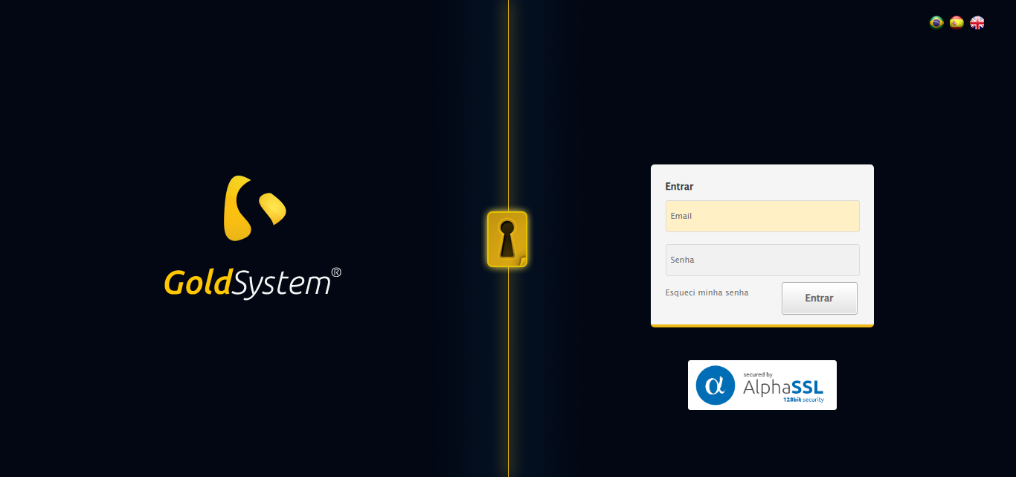

[15:34:41] 🔄 Realizando login...

[15:34:46] ✅ Realizando login realizada com sucesso.

[15:34:48] 📸 Screenshot capturada: realizando_login

Screenshot: realizando_login

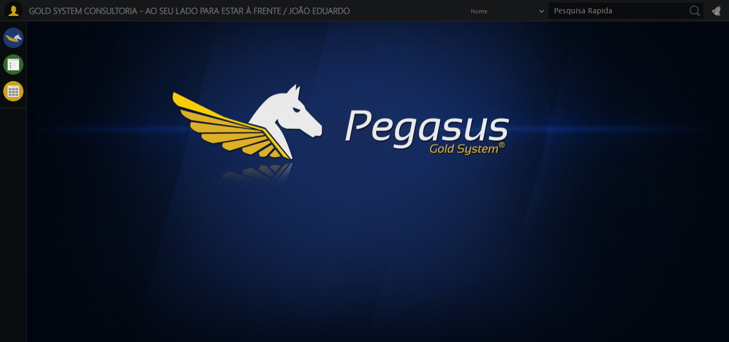

[15:34:48] 🔄 Configurando ambiente...

[15:34:48] 🔍 Zoom ajustado para 90%.

[15:34:50] ✅ Configurando ambiente realizada com sucesso.

[15:34:51] 📸 Screenshot capturada: configurando_ambiente

Screenshot: configurando_ambiente

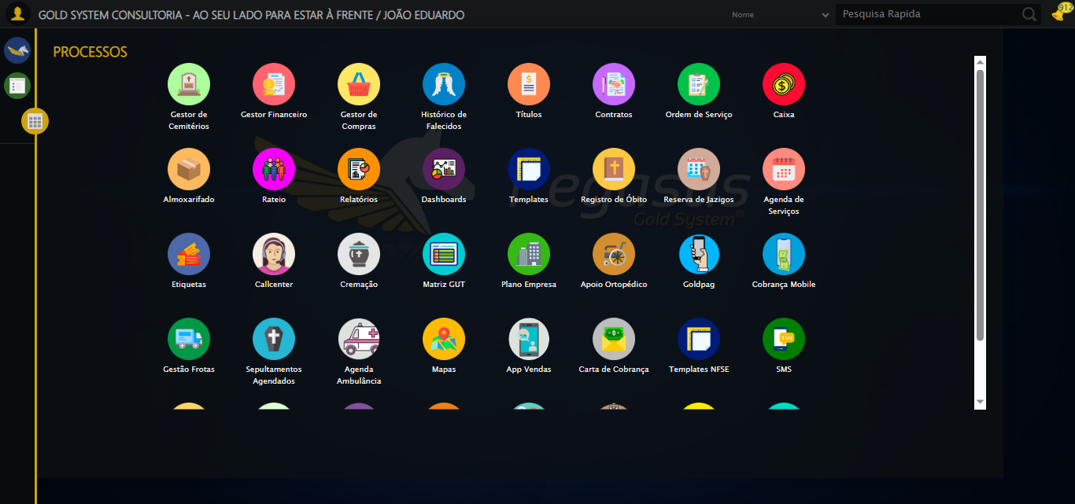

[15:34:51] 🔄 Acessando módulo Callcenter...

[15:34:51] Tentando estratégia de scroll 1...

[15:34:52] ✅ Scroll realizado com estratégia 1

[15:34:53] Tentando estratégia de clique 1 para módulo PET...

[15:34:55] ✅ Clique no módulo PET realizado com estratégia 1

[15:34:55] ✅ Acessando módulo Callcenter realizada com sucesso.

[15:34:56] 📸 Screenshot capturada: acessando_módulo_callcenter

Screenshot: acessando_módulo_callcenter

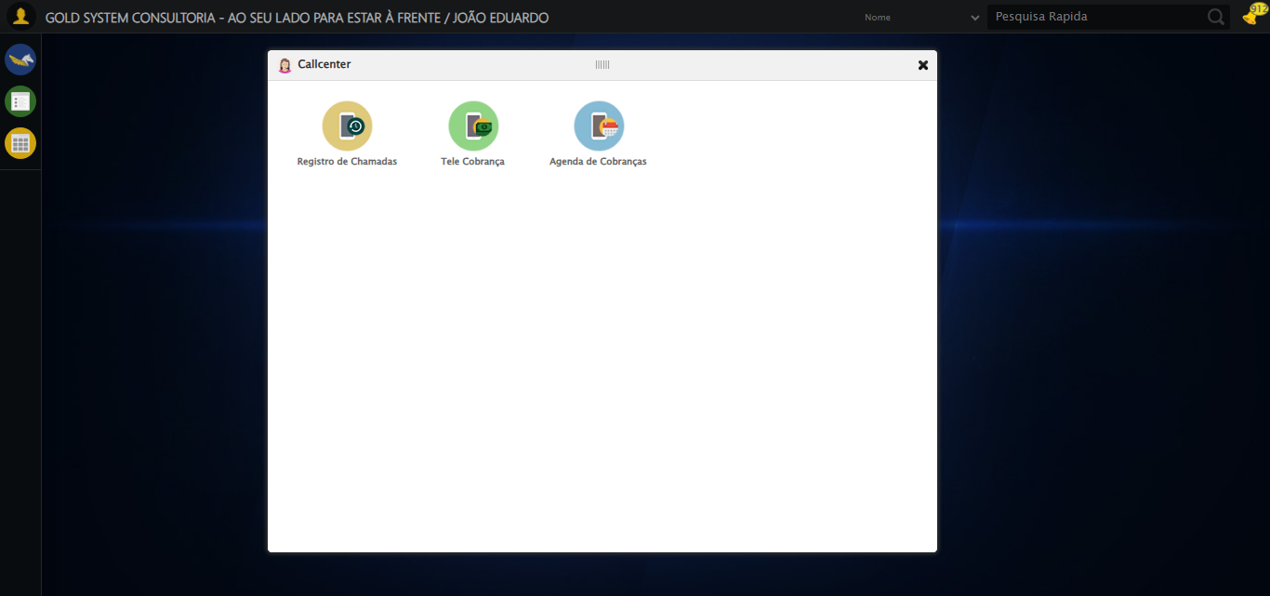

[15:34:56] 🔄 Abrindo Telecobrança...

[15:34:59] ✅ Abrindo Telecobrança realizada com sucesso.

[15:35:01] 📸 Screenshot capturada: abrindo_telecobrança

Screenshot: abrindo_telecobrança

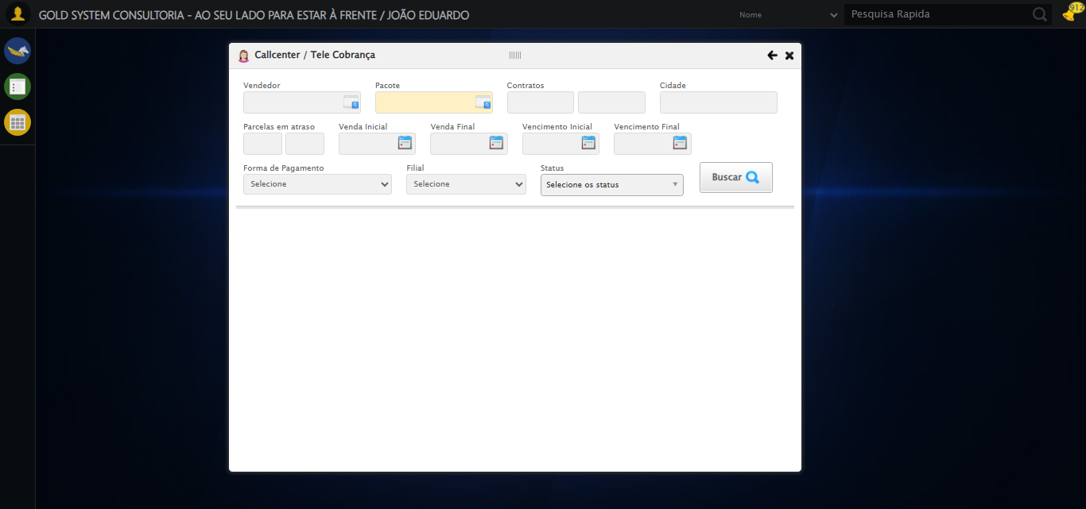

[15:35:01] 🔄 Selecionando Vendedor...

[15:35:01] 🔘 Abrindo modal com botão: #gsCallCenter > div.wdTelas > div.telaCobranca.telaConsulta.relative > div.formRow.formLastLine > div:nth-child(1) > div > a

[15:35:01] Tentando estratégia de scroll 1...

[15:35:01] ✅ Scroll realizado com estratégia 1

[15:35:04] 🔍 Preenchendo pesquisa com: JOSÉ DA SILVA

[15:35:05] 🔍 Executando pesquisa...

[15:35:08] 🎯 Selecionando resultado: //td[contains(text(), 'JOSÉ DA SILVA')]

[15:35:08] Tentando estratégia de scroll 1...

[15:35:09] ✅ Scroll realizado com estratégia 1

[15:35:10] ✅ Seleção no modal concluída

[15:35:10] ✅ Selecionando Vendedor realizada com sucesso.

[15:35:11] 📸 Screenshot capturada: selecionando_vendedor

Screenshot: selecionando_vendedor

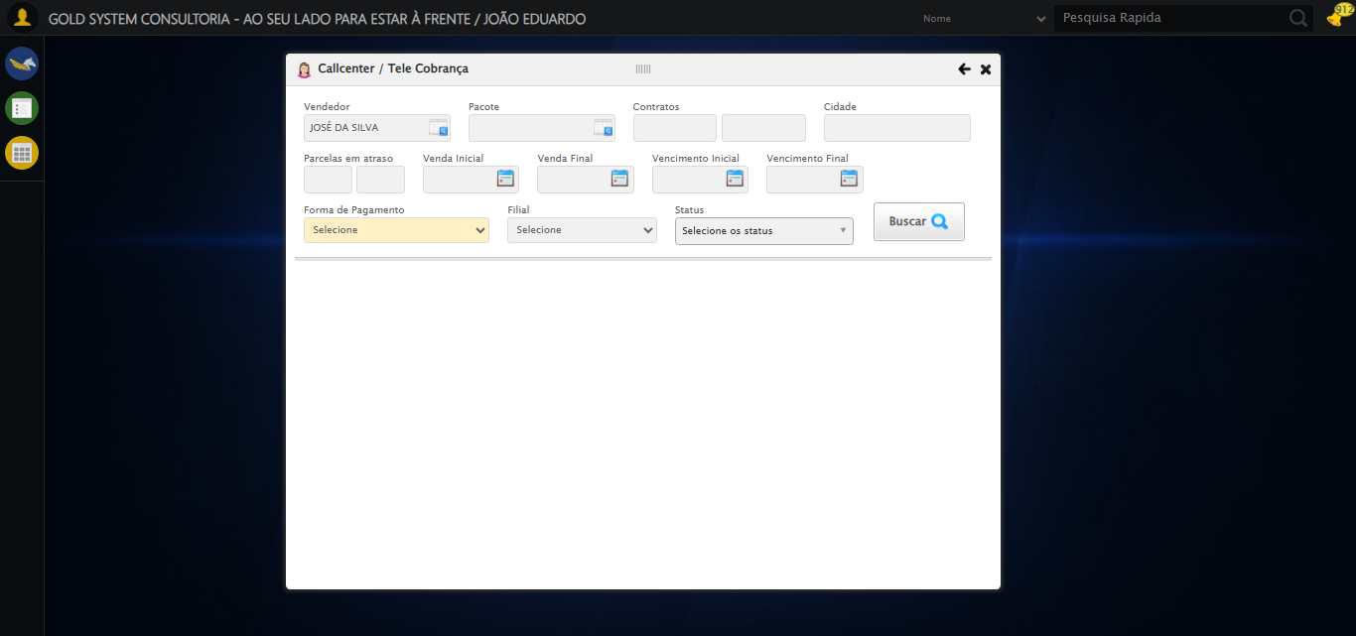

[15:35:11] 🔄 Selecionando Pacote...

[15:35:11] 🔘 Abrindo modal com botão: #gsCallCenter > div.wdTelas > div.telaCobranca.telaConsulta.relative > div.formRow.formLastLine > div:nth-child(2) > div > a

[15:35:12] Tentando estratégia de scroll 1...

[15:35:12] ✅ Scroll realizado com estratégia 1

[15:35:15] 🔍 Preenchendo pesquisa com: PACOTE TESTE JP

[15:35:16] 🔍 Executando pesquisa...

[15:35:19] 🎯 Selecionando resultado: //td[contains(text(), 'PACOTE TESTE JP')]

[15:35:19] Tentando estratégia de scroll 1...

[15:35:20] ✅ Scroll realizado com estratégia 1

[15:35:21] ✅ Seleção no modal concluída

[15:35:21] ✅ Selecionando Pacote realizada com sucesso.

[15:35:22] 📸 Screenshot capturada: selecionando_pacote

Screenshot: selecionando_pacote

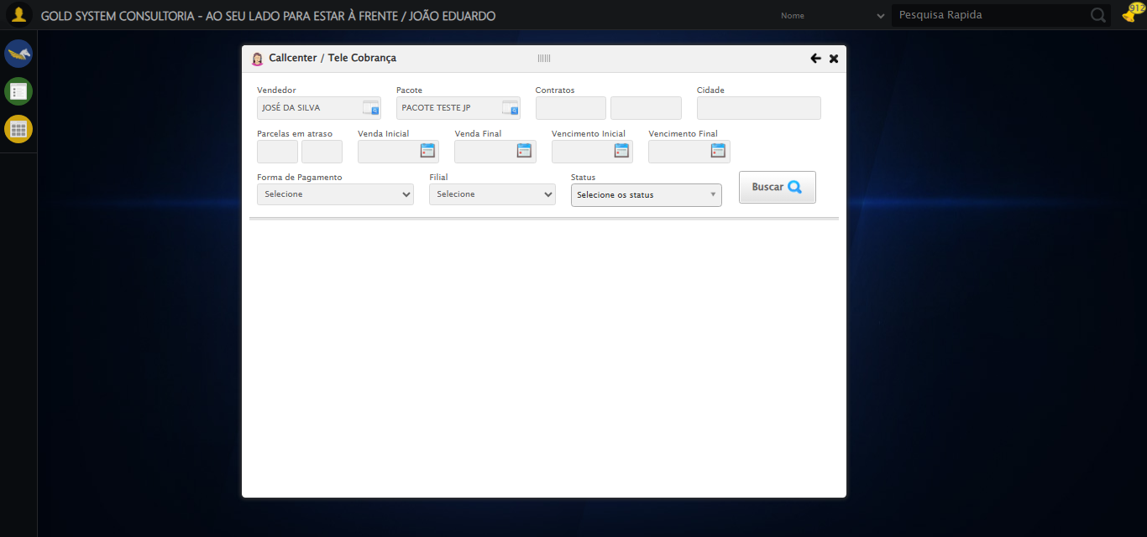

[15:35:22] 🔄 Preenchendo Números do Contrato...

[15:35:22] Tentando estratégia de scroll 1...

[15:35:23] ✅ Scroll realizado com estratégia 1

[15:35:25] ✅ Campo preenchido com estratégia 1: '112106'

[15:35:25] ✅ Preenchendo Números do Contrato realizada com sucesso.

[15:35:26] 📸 Screenshot capturada: preenchendo_números_do_contrato

Screenshot: preenchendo_números_do_contrato

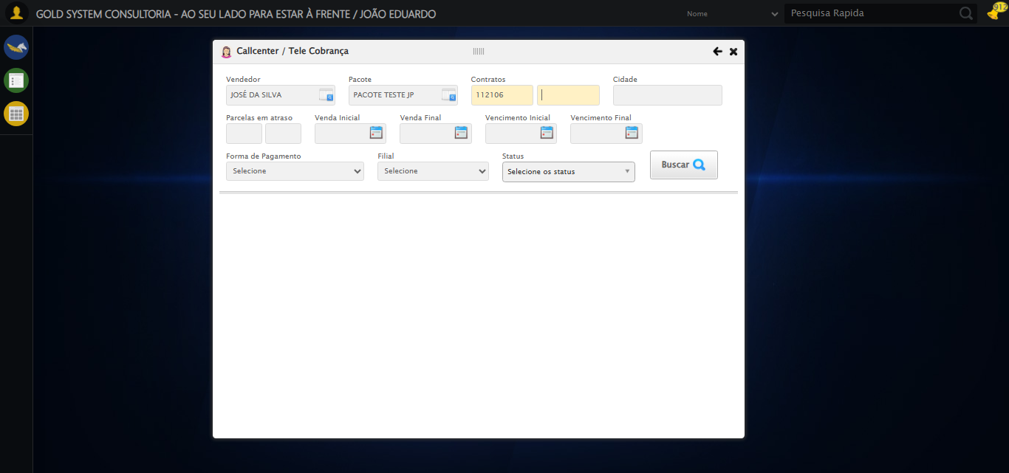

[15:35:26] 🔄 Preenchendo Cidade...

[15:35:26] Tentando estratégia de scroll 1...

[15:35:27] ✅ Scroll realizado com estratégia 1

[15:35:28] ✅ Campo preenchido com estratégia 1: 'São José do Rio Preto - SP'

[15:35:28] ✅ Preenchendo Cidade realizada com sucesso.

[15:35:29] 📸 Screenshot capturada: preenchendo_cidade

Screenshot: preenchendo_cidade

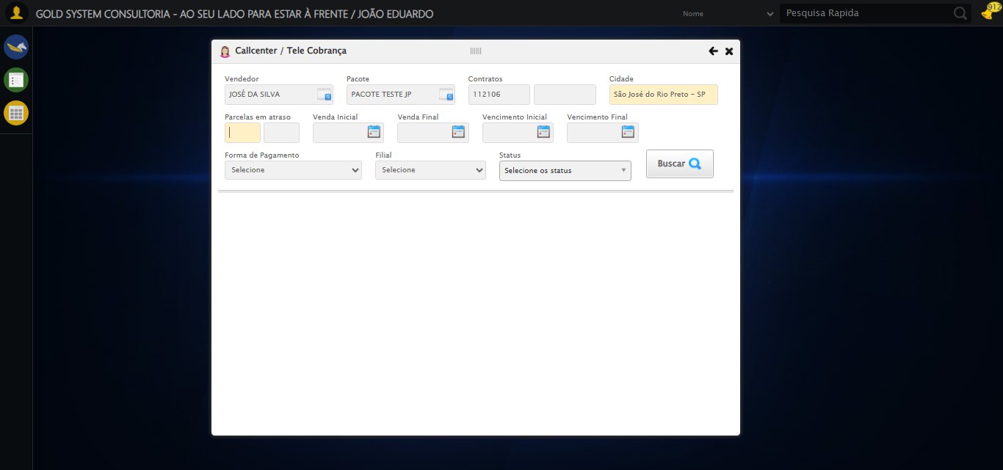

[15:35:29] 🔄 Preenchendo quntidade de Parcelas em atraso...

[15:35:29] Tentando estratégia de scroll 1...

[15:35:30] ✅ Scroll realizado com estratégia 1

[15:35:31] ✅ Campo preenchido com estratégia 1: '1'

[15:35:31] ✅ Preenchendo quntidade de Parcelas em atraso realizada com sucesso.

[15:35:32] 📸 Screenshot capturada: preenchendo_quntidade_de_parcelas_em_atraso

Screenshot: preenchendo_quntidade_de_parcelas_em_atraso

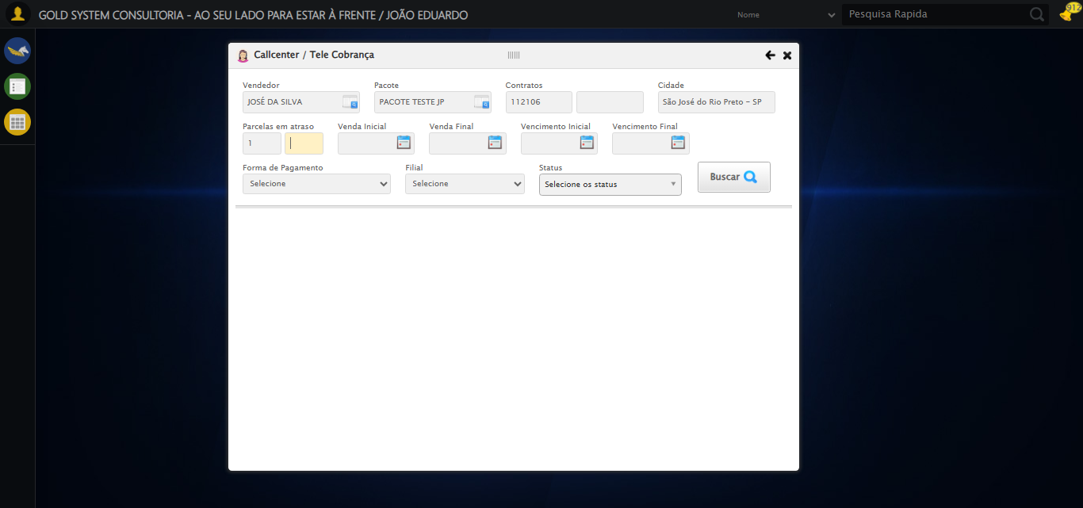

[15:35:32] 🔄 Preenchendo Data da Venda Inicial...

[15:35:33] 📊 Encontrados 4 campos datepicker

[15:35:33] 🎯 Tentativa 1: Preenchendo datepicker 0 (ID: dp1755714884407) com '14/08/2010'

[15:35:33] Aplicando estratégia 1 para datepicker...

[15:35:34] ✅ Datepicker preenchido com estratégia 1: '14/08/2010'

[15:35:34] ✅ Preenchendo Data da Venda Inicial realizada com sucesso.

[15:35:35] 📸 Screenshot capturada: preenchendo_data_da_venda_inicial

Screenshot: preenchendo_data_da_venda_inicial

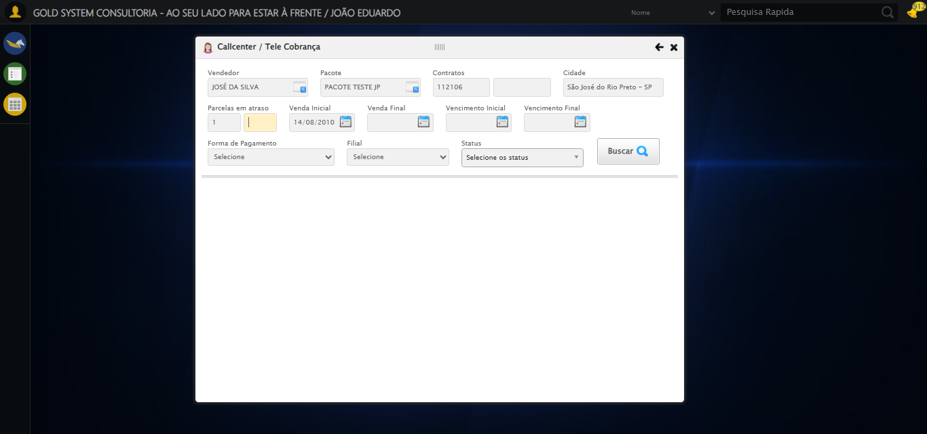

[15:35:35] 🔄 Preenchendo Data da Venda Final...

[15:35:36] 📊 Encontrados 4 campos datepicker

[15:35:36] 🎯 Tentativa 1: Preenchendo datepicker 1 (ID: dp1755714884408) com '24/11/2025'

[15:35:36] Aplicando estratégia 1 para datepicker...

[15:35:37] ✅ Datepicker preenchido com estratégia 1: '24/11/2025'

[15:35:37] ✅ Preenchendo Data da Venda Final realizada com sucesso.

[15:35:38] 📸 Screenshot capturada: preenchendo_data_da_venda_final

Screenshot: preenchendo_data_da_venda_final

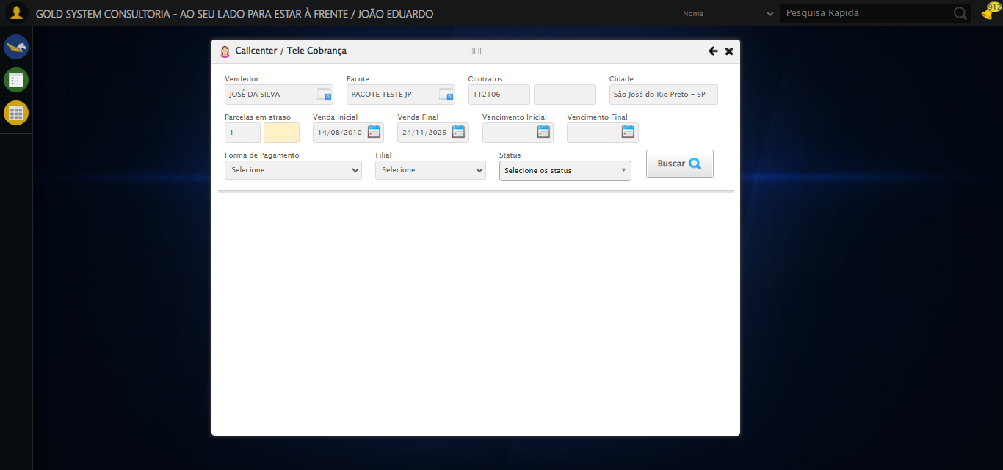

[15:35:39] 🔄 Preenchendo Data de Vencimento Inicial...

[15:35:39] 📊 Encontrados 4 campos datepicker

[15:35:39] 🎯 Tentativa 1: Preenchendo datepicker 2 (ID: dp1755714884409) com '14/08/2010'

[15:35:39] Aplicando estratégia 1 para datepicker...

[15:35:40] ✅ Datepicker preenchido com estratégia 1: '14/08/2010'

[15:35:40] ✅ Preenchendo Data de Vencimento Inicial realizada com sucesso.

[15:35:42] 📸 Screenshot capturada: preenchendo_data_de_vencimento_inicial

Screenshot: preenchendo_data_de_vencimento_inicial

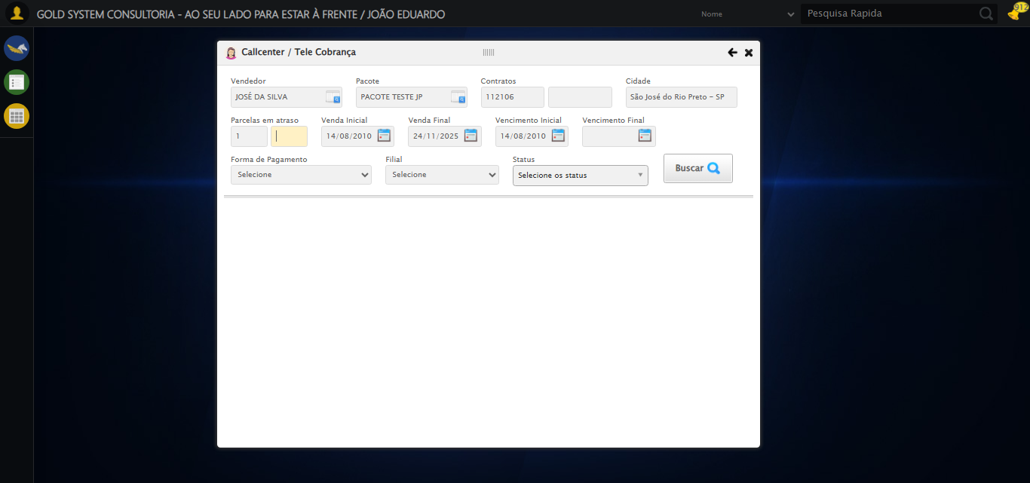

[15:35:42] 🔄 Preenchendo Data de Vencimento Final...

[15:35:42] 📊 Encontrados 4 campos datepicker

[15:35:42] 🎯 Tentativa 1: Preenchendo datepicker 3 (ID: dp1755714884410) com '24/11/2025'

[15:35:43] Aplicando estratégia 1 para datepicker...

[15:35:44] ✅ Datepicker preenchido com estratégia 1: '24/11/2025'

[15:35:44] ✅ Preenchendo Data de Vencimento Final realizada com sucesso.

[15:35:45] 📸 Screenshot capturada: preenchendo_data_de_vencimento_final

Screenshot: preenchendo_data_de_vencimento_final

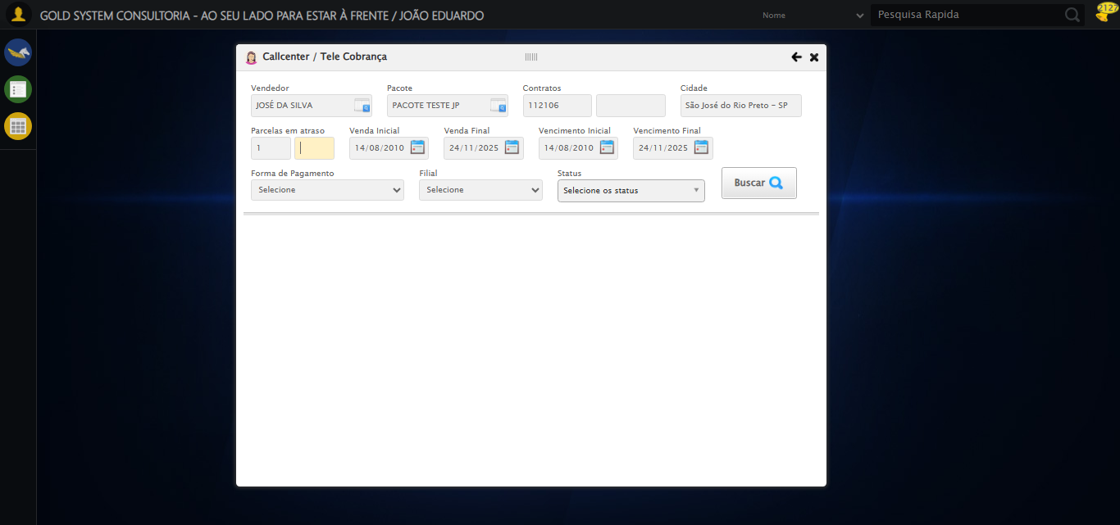

[15:35:45] 🔄 Selecionando Forma de Pagamento...

[15:35:45] ✅ Selecionando Forma de Pagamento realizada com sucesso.

[15:35:46] 📸 Screenshot capturada: selecionando_forma_de_pagamento

Screenshot: selecionando_forma_de_pagamento

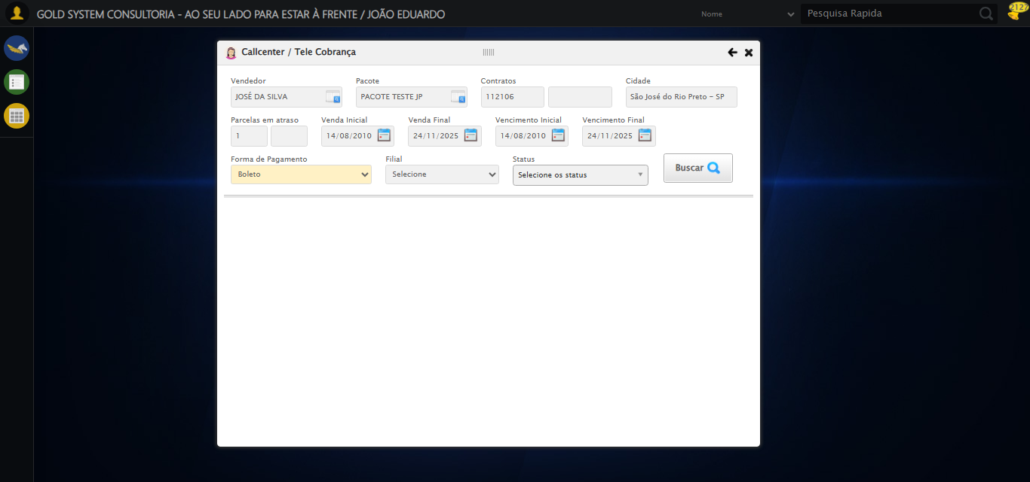

[15:35:46] 🔄 Selecionando Filial...

[15:35:46] ✅ Selecionando Filial realizada com sucesso.

[15:35:47] 📸 Screenshot capturada: selecionando_filial

Screenshot: selecionando_filial

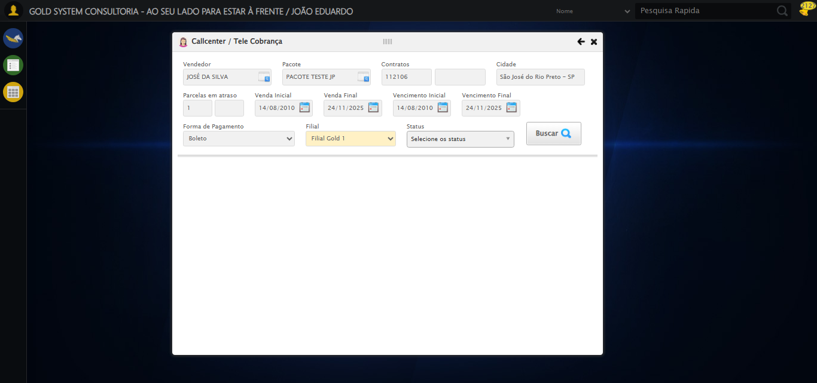

[15:35:47] 🔄 Realizando consulta...

[15:35:47] Tentando estratégia de scroll 1...

[15:35:48] ✅ Scroll realizado com estratégia 1

[15:35:50] ✅ Consulta executada

[15:35:50] ✅ Realizando consulta realizada com sucesso.

[15:35:51] 📸 Screenshot capturada: realizando_consulta

Screenshot: realizando_consulta

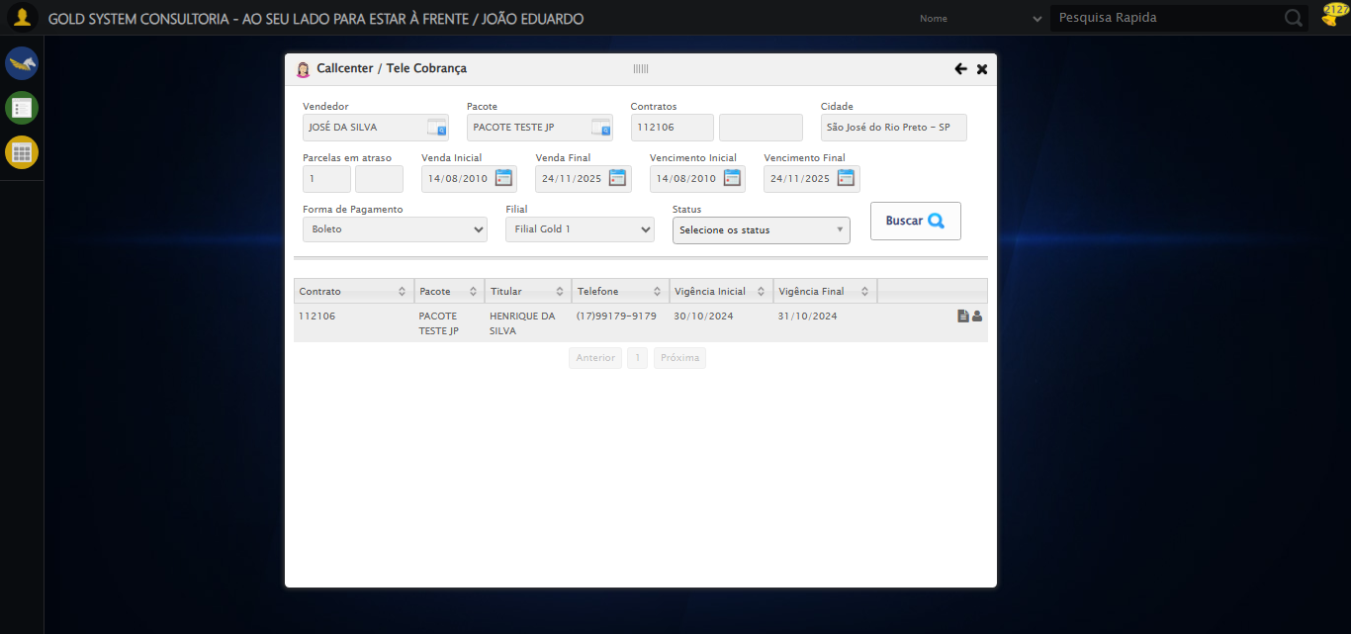

[15:35:51] 🔄 Validando resultados da consulta...

[15:35:51] 🔍 Iniciando validação de registros...

[15:35:57] ✅ Tabela encontrada: table[id*="DataTables"]

[15:35:57] ✅ Encontradas 1 linhas válidas com tbody tr:not(.dataTables_empty):not([class*="no-data"])

[15:35:57] ✅ 1 registro(s) encontrado(s)

[15:35:57] Registro 1: 112106 pacote teste jp henrique da silva (17)99179-9179 30/10/2024 31/10/2024

[15:35:57] ✅ Validando resultados da consulta realizada com sucesso.

[15:35:58] 📸 Screenshot capturada: validando_resultados_da_consulta

Screenshot: validando_resultados_da_consulta



[15:35:58] ✅ Processando 1 registro(s) encontrado(s)

[15:35:58] 🔄 Visualizando dados do Contrato...

[15:35:58] Tentando estratégia de scroll 1...

[15:35:59] ✅ Scroll realizado com estratégia 1

[15:35:59] ✅ Clique realizado com estratégia 1

[15:35:59] ✅ Visualizando dados do Contrato realizada com sucesso.

[15:36:01] 📸 Screenshot capturada: visualizando_dados_do_contrato

Screenshot: visualizando_dados_do_contrato

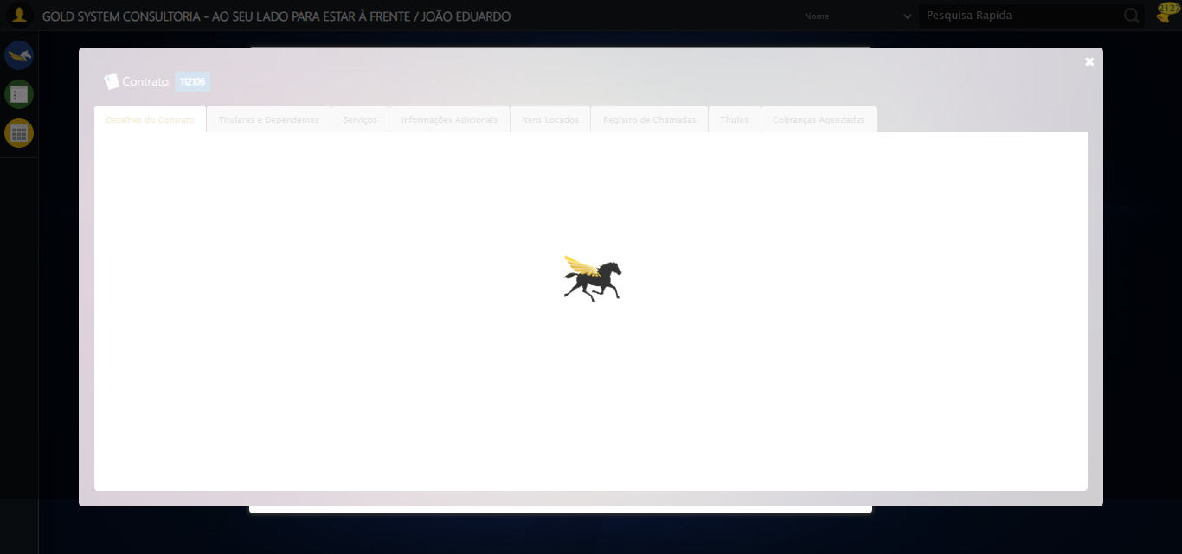

[15:36:01] 🔄 Capturando tela de dados...

[15:36:11] 📸 Screenshot capturada: dados_contrato

Screenshot: dados_contrato

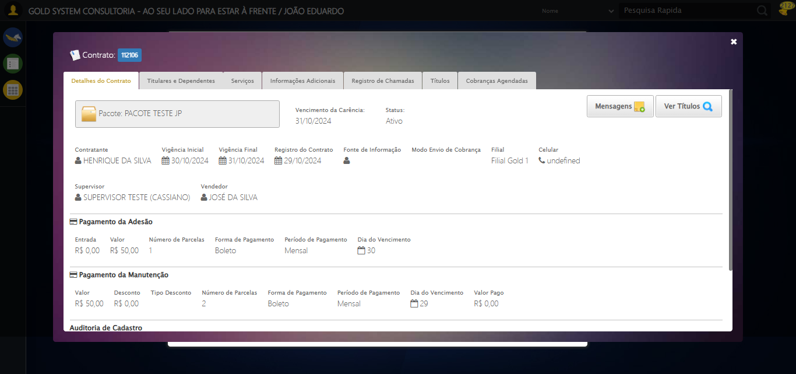

[15:36:11] ✅ Capturando tela de dados realizada com sucesso.

[15:36:12] 📸 Screenshot capturada: capturando_tela_de_dados

Screenshot: capturando_tela_de_dados



[15:36:12] 🔄 Abrindo mensagens do Contrato...

[15:36:12] Tentando estratégia de scroll 1...

[15:36:13] ✅ Scroll realizado com estratégia 1

[15:36:13] ✅ Clique realizado com estratégia 1

[15:36:13] ✅ Abrindo mensagens do Contrato realizada com sucesso.

[15:36:15] 📸 Screenshot capturada: abrindo_mensagens_do_contrato

Screenshot: abrindo_mensagens_do_contrato

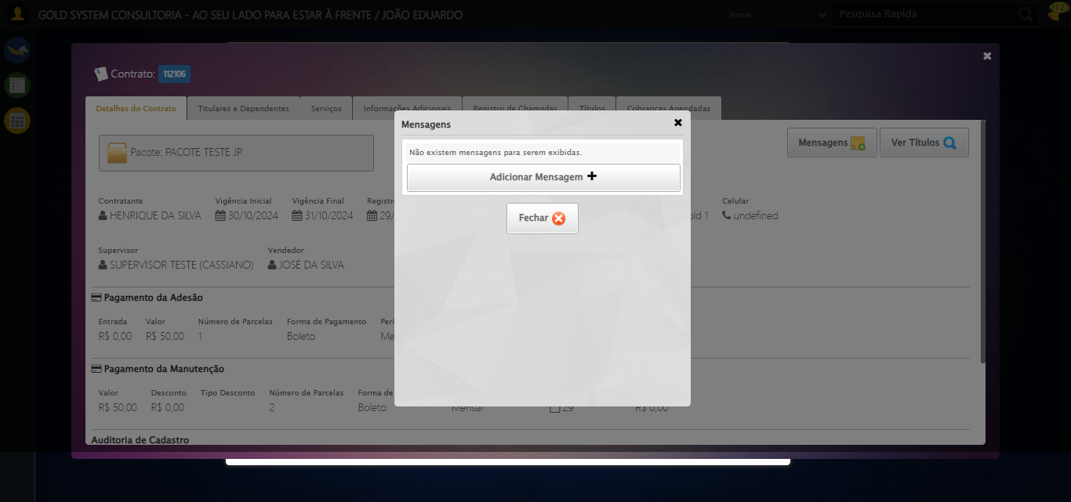

[15:36:15] 🔄 Capturando mensagens...

[15:36:17] 📸 Screenshot capturada: mensagens_contrato

Screenshot: mensagens_contrato



[15:36:17] ✅ Capturando mensagens realizada com sucesso.

[15:36:18] 📸 Screenshot capturada: capturando_mensagens

Screenshot: capturando_mensagens



[15:36:18] 🔄 Adicionando nova mensagem...

[15:36:18] Tentando estratégia de scroll 1...

[15:36:19] ✅ Scroll realizado com estratégia 1

[15:36:19] ✅ Clique realizado com estratégia 1

[15:36:19] ✅ Adicionando nova mensagem realizada com sucesso.

[15:36:21] 📸 Screenshot capturada: adicionando_nova_mensagem

Screenshot: adicionando_nova_mensagem

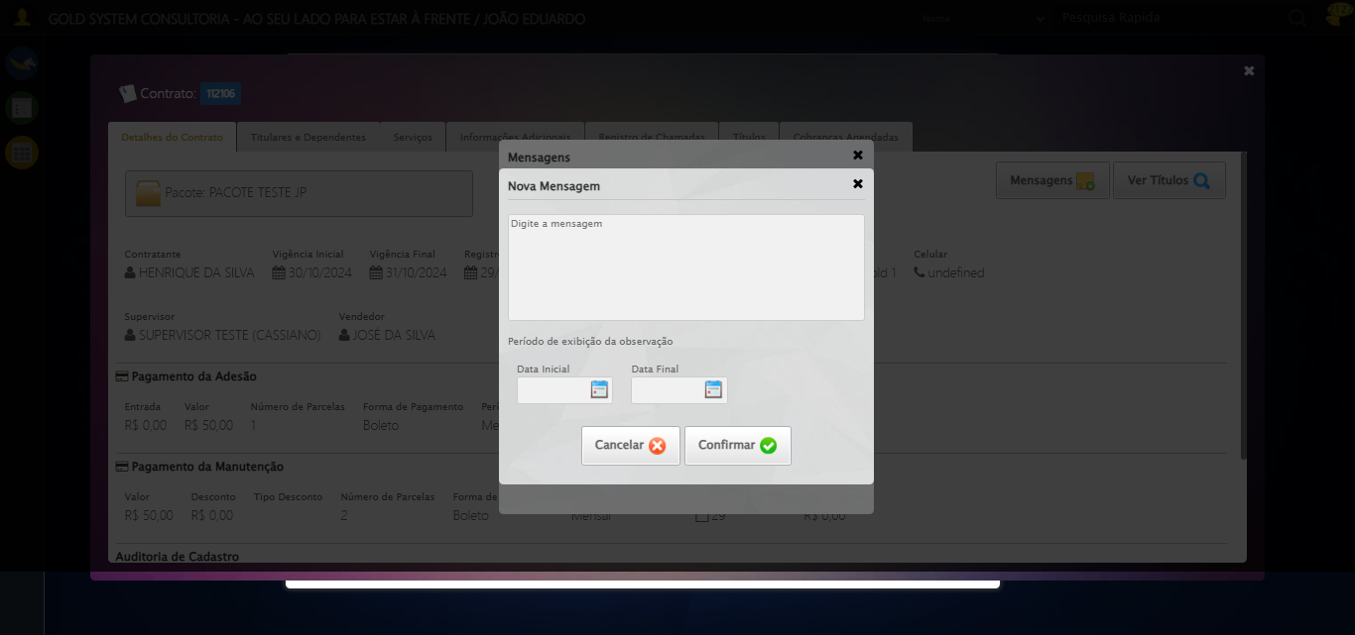

[15:36:21] 🔄 Preenchendo descrição da mensagem...

[15:36:21] 🎯 Tentativa 1: Preenchendo textarea 0 (ID: (sem id), name: (sem name)) com 107 caracteres

[15:36:21] ▶️ Estratégia 1…

[15:36:23] ✅ Preenchido com sucesso pela estratégia 1: 'TESTE DESCRIÇÃO DA MENSAGEM SELENIUM AUTOMATIZADO (Automação…'

[15:36:23] ✅ Preenchendo descrição da mensagem realizada com sucesso.

[15:36:24] 📸 Screenshot capturada: preenchendo_descrição_da_mensagem

Screenshot: preenchendo_descrição_da_mensagem

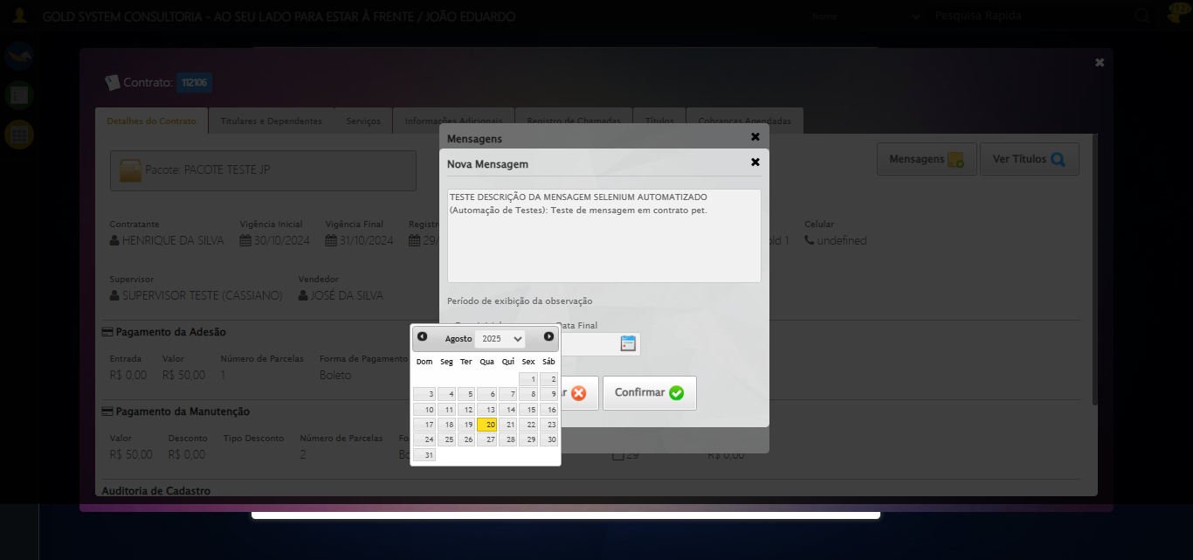

[15:36:24] 🔄 Definindo período de exibição - Data Inicial...

[15:36:25] 📊 Encontrados 6 campos datepicker

[15:36:25] 🎯 Tentativa 1: Preenchendo datepicker 0 (ID: dp1755714884407) com '14/08/2025'

[15:36:25] Aplicando estratégia 1 para datepicker...

[15:36:26] ✅ Datepicker preenchido com estratégia 1: '14/08/2025'

[15:36:26] ✅ Definindo período de exibição - Data Inicial realizada com sucesso.

[15:36:27] 📸 Screenshot capturada: definindo_período_de_exibição_-_data_inicial

Screenshot: definindo_período_de_exibição_-_data_inicial

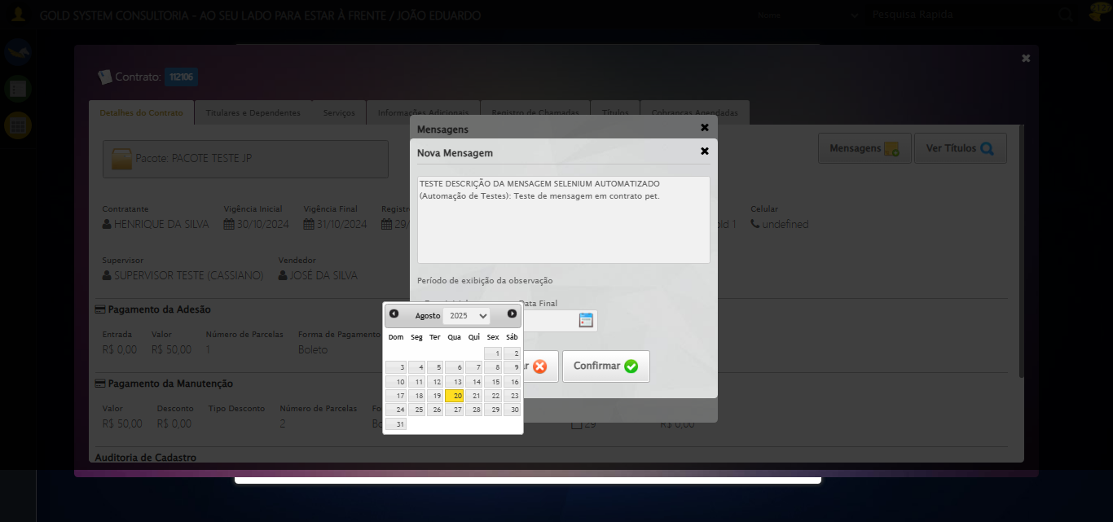

[15:36:27] 🔄 Definindo período de exibição - Data Final...

[15:36:29] 📊 Encontrados 6 campos datepicker

[15:36:29] 🎯 Tentativa 1: Preenchendo datepicker 1 (ID: dp1755714884408) com '24/11/2025'

[15:36:29] ✅ Campo 1 já está preenchido corretamente!

[15:36:29] ✅ Definindo período de exibição - Data Final realizada com sucesso.

[15:36:30] 📸 Screenshot capturada: definindo_período_de_exibição_-_data_final

Screenshot: definindo_período_de_exibição_-_data_final



[15:36:30] 🔄 Confirmando mensagem...

[15:36:30] Tentando estratégia de scroll 1...

[15:36:31] ✅ Scroll realizado com estratégia 1

[15:36:32] ✅ Clique realizado com estratégia 1

[15:36:32] ✅ Confirmando mensagem realizada com sucesso.

[15:36:33] 📸 Screenshot capturada: confirmando_mensagem

Screenshot: confirmando_mensagem

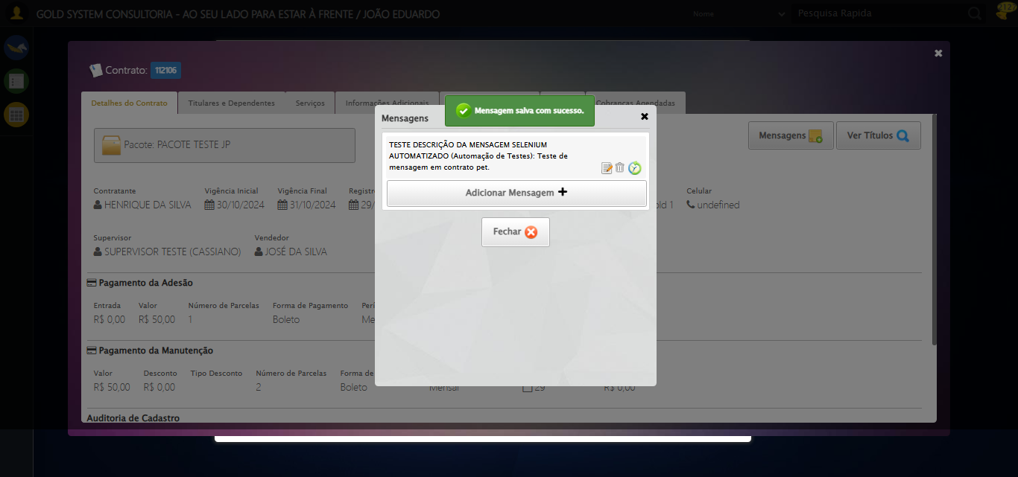

[15:36:33] 🔍 Verificando mensagens de alerta...

[15:36:33] 📢 ✅ Sucesso: Mensagem salva com sucesso.

[15:36:33] 🔄 Fechando aba de mensagens...

[15:37:04] ❌ Timeout aguardando elemento: /html/body/div[21]/div[2]/a (condição: present, timeout: 30s)

[15:37:04] ❌ Falha ao clicar em /html/body/div[21]/div[2]/a: Message: Elemento não encontrado: /html/body/div[21]/div[2]/a (condição: present)

[15:37:04] 📸 Screenshot capturada: erro_fechando_aba_de_mensagens

Screenshot: erro_fechando_aba_de_mensagens

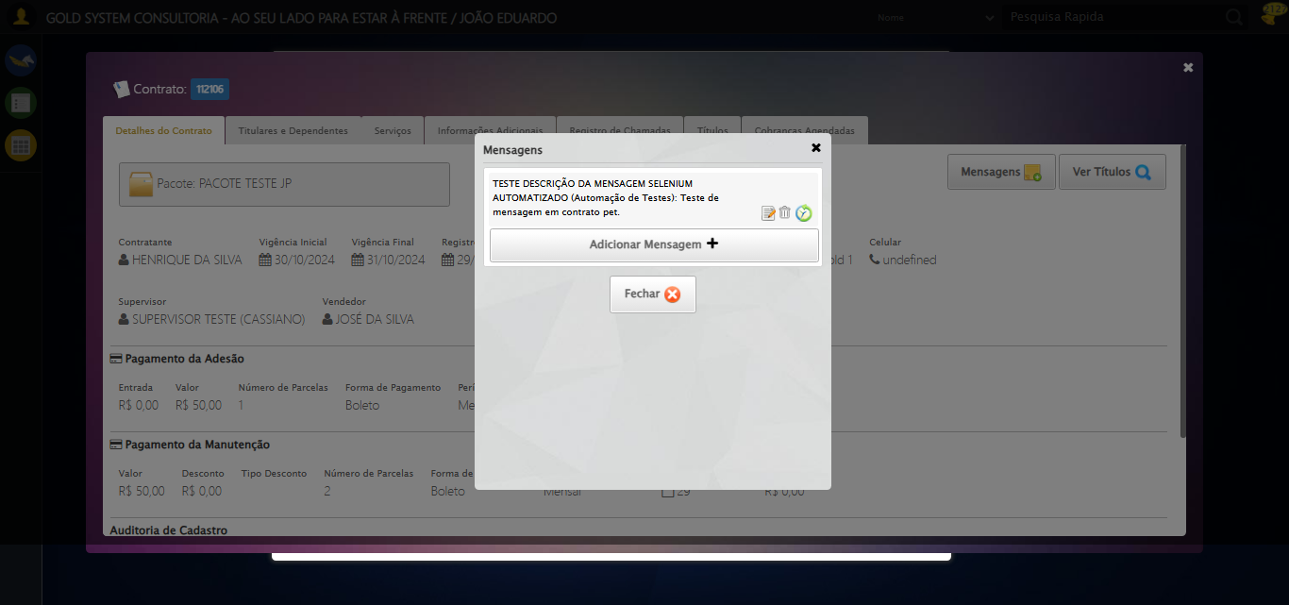

[15:37:04] ❌ Fechando aba de mensagens falhou: TimeoutException: Message: Elemento não encontrado: /html/body/div[21]/div[2]/a (condição: present)

[15:37:04] ⚠️ Continuando execução apesar do erro em: Fechando aba de mensagens

[15:37:04] 🔄 Visualizando títulos do Contrato...

[15:37:04] Tentando estratégia de scroll 1...

[15:37:05] ✅ Scroll realizado com estratégia 1

[15:37:06] ⚠️ Estratégia 1 de clique falhou: Message: element click intercepted: Element <button class="btModel btGray">...</button> is not clickable at point (1178, 182). Other element would receive the click: <div class="blockScreen" style="height: 641px; z-index: 10003; opacity: 0.5;"></div>  
 (Session info: chrome=139.0.7258.128); For documentation on this error, please visit: https://www.selenium.dev/documentation/webdriver/troubleshooting/errors#elementclickinterceptedexception  
Stacktrace:  
 GetHandleVerifier [0x0x88ffc3+65331]  
 GetHandleVerifier [0x0x890004+65396]  
 (No symbol) [0x0x683f63]  
 (No symbol) [0x0x6d2ce0]  
 (No symbol) [0x0x6d109a]  
 (No symbol) [0x0x6cebf2]  
 (No symbol) [0x0x6cdee1]  
 (No symbol) [0x0x6c2645]  
 (No symbol) [0x0x6f14dc]  
 (No symbol) [0x0x6c20d4]  
 (No symbol) [0x0x6f1754]  
 (No symbol) [0x0x712bcb]  
 (No symbol) [0x0x6f12d6]  
 (No symbol) [0x0x6c0910]  
 (No symbol) [0x0x6c1784]  
 GetHandleVerifier [0x0xad38b3+2439203]  
 GetHandleVerifier [0x0xaceae2+2419282]  
 GetHandleVerifier [0x0x8b712a+225434]  
 GetHandleVerifier [0x0x8a6e08+159096]  
 GetHandleVerifier [0x0x8add5d+187597]  
 GetHandleVerifier [0x0x897ad8+96840]  
 GetHandleVerifier [0x0x897c62+97234]  
 GetHandleVerifier [0x0x88277a+9962]  
 BaseThreadInitThunk [0x0x75abfcc9+25]  
 RtlGetAppContainerNamedObjectPath [0x0x776d82ae+286]  
 RtlGetAppContainerNamedObjectPath [0x0x776d827e+238]

[15:37:07] ✅ Clique realizado com estratégia 2

[15:37:07] ✅ Visualizando títulos do Contrato realizada com sucesso.

[15:37:08] 📸 Screenshot capturada: visualizando_títulos_do_contrato

Screenshot: visualizando_títulos_do_contrato

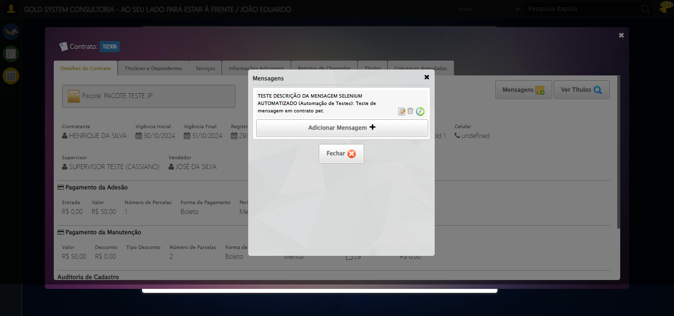

[15:37:08] 🔄 Aguardando carregamento de títulos e capturando Screenshot...

[15:37:38] 📸 Screenshot capturada: titulos_contrato

Screenshot: titulos_contrato



[15:37:38] ✅ Aguardando carregamento de títulos e capturando Screenshot realizada com sucesso.

[15:37:39] 📸 Screenshot capturada: aguardando_carregamento_de_títulos_e_capturando_screenshot

Screenshot: aguardando_carregamento_de_títulos_e_capturando_screenshot



[15:37:39] 🔄 Fechando aba de títulos...

[15:38:09] ❌ Timeout aguardando elemento: //a[@title='Sair' and contains(@class, 'sp-fecharGrande')] (condição: present, timeout: 30s)

[15:38:09] ❌ Falha ao clicar em //a[@title='Sair' and contains(@class, 'sp-fecharGrande')]: Message: Elemento não encontrado: //a[@title='Sair' and contains(@class, 'sp-fecharGrande')] (condição: present)

[15:38:09] 📸 Screenshot capturada: erro_fechando_aba_de_títulos

Screenshot: erro_fechando_aba_de_títulos

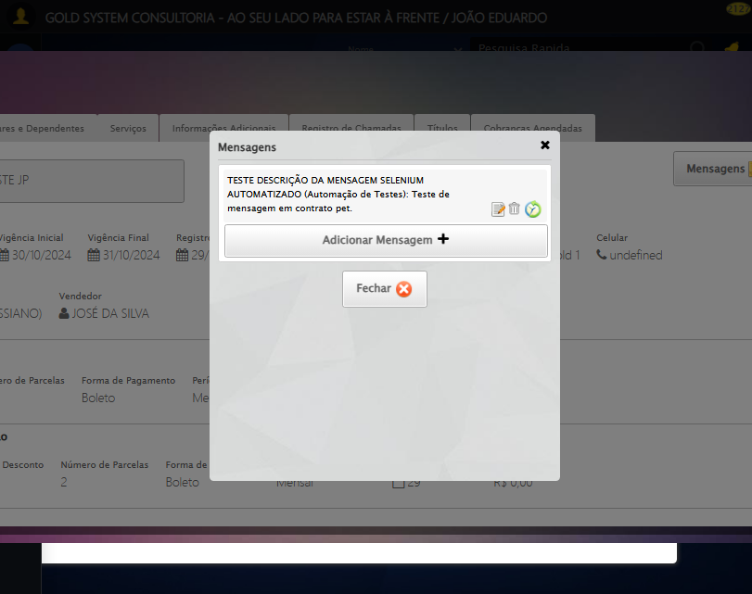

[15:38:09] ❌ Fechando aba de títulos falhou: TimeoutException: Message: Elemento não encontrado: //a[@title='Sair' and contains(@class, 'sp-fecharGrande')] (condição: present)

[15:38:10] ⚠️ Continuando execução apesar do erro em: Fechando aba de títulos

[15:38:10] 🔄 Abrindo Dados do Titular...

[15:38:10] Tentando estratégia de scroll 1...

[15:38:11] ✅ Scroll realizado com estratégia 1

[15:38:12] ⚠️ Estratégia 1 de clique falhou: Message: element click intercepted: Element <span class="fa fa-user btTitular" title="Dados do Titular"></span> is not clickable at point (709, 320). Other element would receive the click: <div class="blockScreen" style="height: 641px; z-index: 10003; opacity: 0.5;"></div>  
 (Session info: chrome=139.0.7258.128); For documentation on this error, please visit: https://www.selenium.dev/documentation/webdriver/troubleshooting/errors#elementclickinterceptedexception  
Stacktrace:  
 GetHandleVerifier [0x0x88ffc3+65331]  
 GetHandleVerifier [0x0x890004+65396]  
 (No symbol) [0x0x683f63]  
 (No symbol) [0x0x6d2ce0]  
 (No symbol) [0x0x6d109a]  
 (No symbol) [0x0x6cebf2]  
 (No symbol) [0x0x6cdee1]  
 (No symbol) [0x0x6c2645]  
 (No symbol) [0x0x6f14dc]  
 (No symbol) [0x0x6c20d4]  
 (No symbol) [0x0x6f1754]  
 (No symbol) [0x0x712bcb]  
 (No symbol) [0x0x6f12d6]  
 (No symbol) [0x0x6c0910]  
 (No symbol) [0x0x6c1784]  
 GetHandleVerifier [0x0xad38b3+2439203]  
 GetHandleVerifier [0x0xaceae2+2419282]  
 GetHandleVerifier [0x0x8b712a+225434]  
 GetHandleVerifier [0x0x8a6e08+159096]  
 GetHandleVerifier [0x0x8add5d+187597]  
 GetHandleVerifier [0x0x897ad8+96840]  
 GetHandleVerifier [0x0x897c62+97234]  
 GetHandleVerifier [0x0x88277a+9962]  
 BaseThreadInitThunk [0x0x75abfcc9+25]  
 RtlGetAppContainerNamedObjectPath [0x0x776d82ae+286]  
 RtlGetAppContainerNamedObjectPath [0x0x776d827e+238]

[15:38:13] ✅ Clique realizado com estratégia 2

[15:38:13] ✅ Abrindo Dados do Titular realizada com sucesso.

[15:38:14] 📸 Screenshot capturada: abrindo_dados_do_titular

Screenshot: abrindo_dados_do_titular

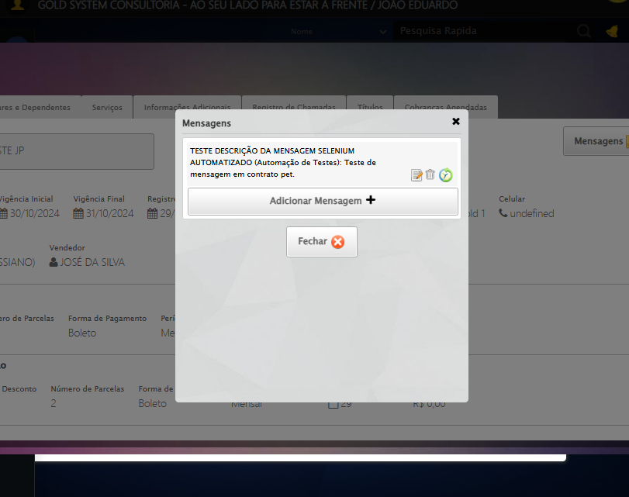

[15:38:14] 🔄 Abrindo Dados Cadastrais do Titular e capturando Screenshot da aba 'Dados Pessoais'...

[15:38:44] ❌ Timeout aguardando elemento: //a[contains(@class,'materializacaoPeglink') and @ref='1|21582908'] (condição: present, timeout: 30s)

[15:38:44] ❌ Falha ao clicar em //a[contains(@class,'materializacaoPeglink') and @ref='1|21582908']: Message: Elemento não encontrado: //a[contains(@class,'materializacaoPeglink') and @ref='1|21582908'] (condição: present)

[15:38:45] 📸 Screenshot capturada: erro_abrindo_dados_cadastrais_do_titular_e_capturando_screenshot_da_aba_dados_pessoais_

Screenshot: erro_abrindo_dados_cadastrais_do_titular_e_capturando_screenshot_da_aba_dados_pessoais_



[15:38:45] ❌ Abrindo Dados Cadastrais do Titular e capturando Screenshot da aba 'Dados Pessoais' falhou: TimeoutException: Message: Elemento não encontrado: //a[contains(@class,'materializacaoPeglink') and @ref='1|21582908'] (condição: present)

[15:38:45] ⚠️ Continuando execução apesar do erro em: Abrindo Dados Cadastrais do Titular e capturando Screenshot da aba 'Dados Pessoais'

[15:38:45] 🔄 Clicando na aba 'Dados Complementares' e capturando Screenshot...

[15:39:15] ❌ Timeout aguardando elemento: //a[@class='dadosComplementares' and normalize-space(text())='Dados Complementares'] (condição: present, timeout: 30s)

[15:39:15] ❌ Falha ao clicar em //a[@class='dadosComplementares' and normalize-space(text())='Dados Complementares']: Message: Elemento não encontrado: //a[@class='dadosComplementares' and normalize-space(text())='Dados Complementares'] (condição: present)

[15:39:15] 📸 Screenshot capturada: erro_clicando_na_aba_dados_complementares_e_capturando_screenshot

Screenshot: erro_clicando_na_aba_dados_complementares_e_capturando_screenshot

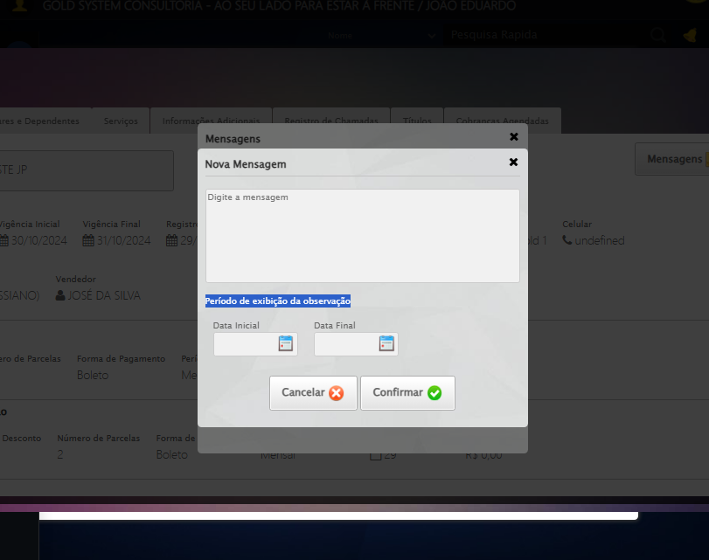

[15:39:15] ❌ Clicando na aba 'Dados Complementares' e capturando Screenshot falhou: TimeoutException: Message: Elemento não encontrado: //a[@class='dadosComplementares' and normalize-space(text())='Dados Complementares'] (condição: present)

[15:39:15] ⚠️ Continuando execução apesar do erro em: Clicando na aba 'Dados Complementares' e capturando Screenshot

[15:39:15] 🔄 Clicando na aba 'Endereços da Pessoa' e capturando Screenshot'...

[15:39:18] ❌ Erro aguardando elemento //a[@class='enderecos' and normalize-space(text())='Endereços da Pessoa']: Message: invalid session id: session deleted as the browser has closed the connection  
from disconnected: not connected to DevTools  
 (Session info: chrome=139.0.7258.128); For documentation on this error, please visit: https://www.selenium.dev/documentation/webdriver/troubleshooting/errors#invalidsessionidexception  
Stacktrace:  
 GetHandleVerifier [0x0x88ffc3+65331]  
 GetHandleVerifier [0x0x890004+65396]  
 (No symbol) [0x0x683f63]  
 (No symbol) [0x0x6738e0]  
 (No symbol) [0x0x691709]  
 (No symbol) [0x0x6f7e4c]  
 (No symbol) [0x0x7124d9]  
 (No symbol) [0x0x6f12d6]  
 (No symbol) [0x0x6c0910]  
 (No symbol) [0x0x6c1784]  
 GetHandleVerifier [0x0xad38b3+2439203]  
 GetHandleVerifier [0x0xaceae2+2419282]  
 GetHandleVerifier [0x0x8b712a+225434]  
 GetHandleVerifier [0x0x8a6e08+159096]  
 GetHandleVerifier [0x0x8add5d+187597]  
 GetHandleVerifier [0x0x897ad8+96840]  
 GetHandleVerifier [0x0x897c62+97234]  
 GetHandleVerifier [0x0x88277a+9962]  
 BaseThreadInitThunk [0x0x75abfcc9+25]  
 RtlGetAppContainerNamedObjectPath [0x0x776d82ae+286]  
 RtlGetAppContainerNamedObjectPath [0x0x776d827e+238]

[15:39:18] ❌ Falha ao clicar em //a[@class='enderecos' and normalize-space(text())='Endereços da Pessoa']: Message: invalid session id: session deleted as the browser has closed the connection  
from disconnected: not connected to DevTools  
 (Session info: chrome=139.0.7258.128); For documentation on this error, please visit: https://www.selenium.dev/documentation/webdriver/troubleshooting/errors#invalidsessionidexception  
Stacktrace:  
 GetHandleVerifier [0x0x88ffc3+65331]  
 GetHandleVerifier [0x0x890004+65396]  
 (No symbol) [0x0x683f63]  
 (No symbol) [0x0x6738e0]  
 (No symbol) [0x0x691709]  
 (No symbol) [0x0x6f7e4c]  
 (No symbol) [0x0x7124d9]  
 (No symbol) [0x0x6f12d6]  
 (No symbol) [0x0x6c0910]  
 (No symbol) [0x0x6c1784]  
 GetHandleVerifier [0x0xad38b3+2439203]  
 GetHandleVerifier [0x0xaceae2+2419282]  
 GetHandleVerifier [0x0x8b712a+225434]  
 GetHandleVerifier [0x0x8a6e08+159096]  
 GetHandleVerifier [0x0x8add5d+187597]  
 GetHandleVerifier [0x0x897ad8+96840]  
 GetHandleVerifier [0x0x897c62+97234]  
 GetHandleVerifier [0x0x88277a+9962]  
 BaseThreadInitThunk [0x0x75abfcc9+25]  
 RtlGetAppContainerNamedObjectPath [0x0x776d82ae+286]  
 RtlGetAppContainerNamedObjectPath [0x0x776d827e+238]

[15:39:20] ⚠️ Erro ao tirar screenshot erro_clicando_na_aba_endereços_da_pessoa_e_capturando_screenshot_: Message: invalid session id; For documentation on this error, please visit: https://www.selenium.dev/documentation/webdriver/troubleshooting/errors#invalidsessionidexception  
Stacktrace:  
 GetHandleVerifier [0x0x88ffc3+65331]  
 GetHandleVerifier [0x0x890004+65396]  
 (No symbol) [0x0x683dc0]  
 (No symbol) [0x0x6bfbd8]  
 (No symbol) [0x0x6f1396]  
 (No symbol) [0x0x6ecf70]  
 (No symbol) [0x0x6ec4f6]  
 (No symbol) [0x0x6559b5]  
 (No symbol) [0x0x655f0e]  
 (No symbol) [0x0x65639d]  
 GetHandleVerifier [0x0xad38b3+2439203]  
 GetHandleVerifier [0x0xaceae2+2419282]  
 GetHandleVerifier [0x0x8b712a+225434]  
 GetHandleVerifier [0x0x8a6e08+159096]  
 GetHandleVerifier [0x0x8add5d+187597]  
 (No symbol) [0x0x655680]  
 (No symbol) [0x0x654e8e]  
 GetHandleVerifier [0x0xbea2ec+3580508]  
 BaseThreadInitThunk [0x0x75abfcc9+25]  
 RtlGetAppContainerNamedObjectPath [0x0x776d82ae+286]  
 RtlGetAppContainerNamedObjectPath [0x0x776d827e+238]

[15:39:20] ❌ Clicando na aba 'Endereços da Pessoa' e capturando Screenshot' falhou: InvalidSessionIdException: Message: invalid session id: session deleted as the browser has closed the connection  
from disconnected: not connected to DevTools  
 (Session info: chrome=139.0.7258.128); For documentation on this error, please visit: https://www.selenium.dev/documentation/webdriver/troubleshooting/errors#invalidsessionidexception  
Stacktrace:  
 GetHandleVerifier [0x0x88ffc3+65331]  
 GetHandleVerifier [0x0x890004+65396]  
 (No symbol) [0x0x683f63]  
 (No symbol) [0x0x6738e0]  
 (No symbol) [0x0x691709]  
 (No symbol) [0x0x6f7e4c]  
 (No symbol) [0x0x7124d9]  
 (No symbol) [0x0x6f12d6]  
 (No symbol) [0x0x6c0910]  
 (No symbol) [0x0x6c1784]  
 GetHandleVerifier [0x0xad38b3+2439203]  
 GetHandleVerifier [0x0xaceae2+2419282]  
 GetHandleVerifier [0x0x8b712a+225434]  
 GetHandleVerifier [0x0x8a6e08+159096]  
 GetHandleVerifier [0x0x8add5d+187597]  
 GetHandleVerifier [0x0x897ad8+96840]  
 GetHandleVerifier [0x0x897c62+97234]  
 GetHandleVerifier [0x0x88277a+9962]  
 BaseThreadInitThunk [0x0x75abfcc9+25]  
 RtlGetAppContainerNamedObjectPath [0x0x776d82ae+286]  
 RtlGetAppContainerNamedObjectPath [0x0x776d827e+238]

[15:39:20] ⚠️ Continuando execução apesar do erro em: Clicando na aba 'Endereços da Pessoa' e capturando Screenshot'

[15:39:20] 🔄 Salvando Titular...

[15:39:20] ❌ Erro aguardando elemento //a[contains(@class,'btsave') and contains(normalize-space(.),'Salvar')]: Message: invalid session id; For documentation on this error, please visit: https://www.selenium.dev/documentation/webdriver/troubleshooting/errors#invalidsessionidexception  
Stacktrace:  
 GetHandleVerifier [0x0x88ffc3+65331]  
 GetHandleVerifier [0x0x890004+65396]  
 (No symbol) [0x0x683dc0]  
 (No symbol) [0x0x6bfbd8]  
 (No symbol) [0x0x6f1396]  
 (No symbol) [0x0x6ecf70]  
 (No symbol) [0x0x6ec4f6]  
 (No symbol) [0x0x6559b5]  
 (No symbol) [0x0x655f0e]  
 (No symbol) [0x0x65639d]  
 GetHandleVerifier [0x0xad38b3+2439203]  
 GetHandleVerifier [0x0xaceae2+2419282]  
 GetHandleVerifier [0x0x8b712a+225434]  
 GetHandleVerifier [0x0x8a6e08+159096]  
 GetHandleVerifier [0x0x8add5d+187597]  
 (No symbol) [0x0x655680]  
 (No symbol) [0x0x654e8e]  
 GetHandleVerifier [0x0xbea2ec+3580508]  
 BaseThreadInitThunk [0x0x75abfcc9+25]  
 RtlGetAppContainerNamedObjectPath [0x0x776d82ae+286]  
 RtlGetAppContainerNamedObjectPath [0x0x776d827e+238]

[15:39:20] ❌ Falha ao clicar em //a[contains(@class,'btsave') and contains(normalize-space(.),'Salvar')]: Message: invalid session id; For documentation on this error, please visit: https://www.selenium.dev/documentation/webdriver/troubleshooting/errors#invalidsessionidexception  
Stacktrace:  
 GetHandleVerifier [0x0x88ffc3+65331]  
 GetHandleVerifier [0x0x890004+65396]  
 (No symbol) [0x0x683dc0]  
 (No symbol) [0x0x6bfbd8]  
 (No symbol) [0x0x6f1396]  
 (No symbol) [0x0x6ecf70]  
 (No symbol) [0x0x6ec4f6]  
 (No symbol) [0x0x6559b5]  
 (No symbol) [0x0x655f0e]  
 (No symbol) [0x0x65639d]  
 GetHandleVerifier [0x0xad38b3+2439203]  
 GetHandleVerifier [0x0xaceae2+2419282]  
 GetHandleVerifier [0x0x8b712a+225434]  
 GetHandleVerifier [0x0x8a6e08+159096]  
 GetHandleVerifier [0x0x8add5d+187597]  
 (No symbol) [0x0x655680]  
 (No symbol) [0x0x654e8e]  
 GetHandleVerifier [0x0xbea2ec+3580508]  
 BaseThreadInitThunk [0x0x75abfcc9+25]  
 RtlGetAppContainerNamedObjectPath [0x0x776d82ae+286]  
 RtlGetAppContainerNamedObjectPath [0x0x776d827e+238]

[15:39:20] ⚠️ Erro ao tirar screenshot erro_salvando_titular: Message: invalid session id; For documentation on this error, please visit: https://www.selenium.dev/documentation/webdriver/troubleshooting/errors#invalidsessionidexception  
Stacktrace:  
 GetHandleVerifier [0x0x88ffc3+65331]  
 GetHandleVerifier [0x0x890004+65396]  
 (No symbol) [0x0x683dc0]  
 (No symbol) [0x0x6bfbd8]  
 (No symbol) [0x0x6f1396]  
 (No symbol) [0x0x6ecf70]  
 (No symbol) [0x0x6ec4f6]  
 (No symbol) [0x0x6559b5]  
 (No symbol) [0x0x655f0e]  
 (No symbol) [0x0x65639d]  
 GetHandleVerifier [0x0xad38b3+2439203]  
 GetHandleVerifier [0x0xaceae2+2419282]  
 GetHandleVerifier [0x0x8b712a+225434]  
 GetHandleVerifier [0x0x8a6e08+159096]  
 GetHandleVerifier [0x0x8add5d+187597]  
 (No symbol) [0x0x655680]  
 (No symbol) [0x0x654e8e]  
 GetHandleVerifier [0x0xbea2ec+3580508]  
 BaseThreadInitThunk [0x0x75abfcc9+25]  
 RtlGetAppContainerNamedObjectPath [0x0x776d82ae+286]  
 RtlGetAppContainerNamedObjectPath [0x0x776d827e+238]

[15:39:20] ❌ Salvando Titular falhou: InvalidSessionIdException: Message: invalid session id; For documentation on this error, please visit: https://www.selenium.dev/documentation/webdriver/troubleshooting/errors#invalidsessionidexception  
Stacktrace:  
 GetHandleVerifier [0x0x88ffc3+65331]  
 GetHandleVerifier [0x0x890004+65396]  
 (No symbol) [0x0x683dc0]  
 (No symbol) [0x0x6bfbd8]  
 (No symbol) [0x0x6f1396]  
 (No symbol) [0x0x6ecf70]  
 (No symbol) [0x0x6ec4f6]  
 (No symbol) [0x0x6559b5]  
 (No symbol) [0x0x655f0e]  
 (No symbol) [0x0x65639d]  
 GetHandleVerifier [0x0xad38b3+2439203]  
 GetHandleVerifier [0x0xaceae2+2419282]  
 GetHandleVerifier [0x0x8b712a+225434]  
 GetHandleVerifier [0x0x8a6e08+159096]  
 GetHandleVerifier [0x0x8add5d+187597]  
 (No symbol) [0x0x655680]  
 (No symbol) [0x0x654e8e]  
 GetHandleVerifier [0x0xbea2ec+3580508]  
 BaseThreadInitThunk [0x0x75abfcc9+25]  
 RtlGetAppContainerNamedObjectPath [0x0x776d82ae+286]  
 RtlGetAppContainerNamedObjectPath [0x0x776d827e+238]

[15:39:20] ⚠️ Continuando execução apesar do erro em: Salvando Titular

[15:39:20] 🔍 Verificando mensagens de alerta após salvar titular...

[15:39:20] ⚠️ Erro ao buscar alerta .alerts.salvo: Message: invalid session id; For documentation on this error, please visit: https://www.selenium.dev/documentation/webdriver/troubleshooting/errors#invalidsessionidexception  
Stacktrace:  
 GetHandleVerifier [0x0x88ffc3+65331]  
 GetHandleVerifier [0x0x890004+65396]  
 (No symbol) [0x0x683dc0]  
 (No symbol) [0x0x6bfbd8]  
 (No symbol) [0x0x6f1396]  
 (No symbol) [0x0x6ecf70]  
 (No symbol) [0x0x6ec4f6]  
 (No symbol) [0x0x6559b5]  
 (No symbol) [0x0x655f0e]  
 (No symbol) [0x0x65639d]  
 GetHandleVerifier [0x0xad38b3+2439203]  
 GetHandleVerifier [0x0xaceae2+2419282]  
 GetHandleVerifier [0x0x8b712a+225434]  
 GetHandleVerifier [0x0x8a6e08+159096]  
 GetHandleVerifier [0x0x8add5d+187597]  
 (No symbol) [0x0x655680]  
 (No symbol) [0x0x654e8e]  
 GetHandleVerifier [0x0xbea2ec+3580508]  
 BaseThreadInitThunk [0x0x75abfcc9+25]  
 RtlGetAppContainerNamedObjectPath [0x0x776d82ae+286]  
 RtlGetAppContainerNamedObjectPath [0x0x776d827e+238]

[15:39:20] ⚠️ Erro ao buscar alerta .alerts.alerta: Message: invalid session id; For documentation on this error, please visit: https://www.selenium.dev/documentation/webdriver/troubleshooting/errors#invalidsessionidexception  
Stacktrace:  
 GetHandleVerifier [0x0x88ffc3+65331]  
 GetHandleVerifier [0x0x890004+65396]  
 (No symbol) [0x0x683dc0]  
 (No symbol) [0x0x6bfbd8]  
 (No symbol) [0x0x6f1396]  
 (No symbol) [0x0x6ecf70]  
 (No symbol) [0x0x6ec4f6]  
 (No symbol) [0x0x6559b5]  
 (No symbol) [0x0x655f0e]  
 (No symbol) [0x0x65639d]  
 GetHandleVerifier [0x0xad38b3+2439203]  
 GetHandleVerifier [0x0xaceae2+2419282]  
 GetHandleVerifier [0x0x8b712a+225434]  
 GetHandleVerifier [0x0x8a6e08+159096]  
 GetHandleVerifier [0x0x8add5d+187597]  
 (No symbol) [0x0x655680]  
 (No symbol) [0x0x654e8e]  
 GetHandleVerifier [0x0xbea2ec+3580508]  
 BaseThreadInitThunk [0x0x75abfcc9+25]  
 RtlGetAppContainerNamedObjectPath [0x0x776d82ae+286]  
 RtlGetAppContainerNamedObjectPath [0x0x776d827e+238]

[15:39:20] ⚠️ Erro ao buscar alerta .alerts.erro: Message: invalid session id; For documentation on this error, please visit: https://www.selenium.dev/documentation/webdriver/troubleshooting/errors#invalidsessionidexception  
Stacktrace:  
 GetHandleVerifier [0x0x88ffc3+65331]  
 GetHandleVerifier [0x0x890004+65396]  
 (No symbol) [0x0x683dc0]  
 (No symbol) [0x0x6bfbd8]  
 (No symbol) [0x0x6f1396]  
 (No symbol) [0x0x6ecf70]  
 (No symbol) [0x0x6ec4f6]  
 (No symbol) [0x0x6559b5]  
 (No symbol) [0x0x655f0e]  
 (No symbol) [0x0x65639d]  
 GetHandleVerifier [0x0xad38b3+2439203]  
 GetHandleVerifier [0x0xaceae2+2419282]  
 GetHandleVerifier [0x0x8b712a+225434]  
 GetHandleVerifier [0x0x8a6e08+159096]  
 GetHandleVerifier [0x0x8add5d+187597]  
 (No symbol) [0x0x655680]  
 (No symbol) [0x0x654e8e]  
 GetHandleVerifier [0x0xbea2ec+3580508]  
 BaseThreadInitThunk [0x0x75abfcc9+25]  
 RtlGetAppContainerNamedObjectPath [0x0x776d82ae+286]  
 RtlGetAppContainerNamedObjectPath [0x0x776d827e+238]

[15:39:20] ⚠️ Erro ao buscar alerta .alert-success: Message: invalid session id; For documentation on this error, please visit: https://www.selenium.dev/documentation/webdriver/troubleshooting/errors#invalidsessionidexception  
Stacktrace:  
 GetHandleVerifier [0x0x88ffc3+65331]  
 GetHandleVerifier [0x0x890004+65396]  
 (No symbol) [0x0x683dc0]  
 (No symbol) [0x0x6bfbd8]  
 (No symbol) [0x0x6f1396]  
 (No symbol) [0x0x6ecf70]  
 (No symbol) [0x0x6ec4f6]  
 (No symbol) [0x0x6559b5]  
 (No symbol) [0x0x655f0e]  
 (No symbol) [0x0x65639d]  
 GetHandleVerifier [0x0xad38b3+2439203]  
 GetHandleVerifier [0x0xaceae2+2419282]  
 GetHandleVerifier [0x0x8b712a+225434]  
 GetHandleVerifier [0x0x8a6e08+159096]  
 GetHandleVerifier [0x0x8add5d+187597]  
 (No symbol) [0x0x655680]  
 (No symbol) [0x0x654e8e]  
 GetHandleVerifier [0x0xbea2ec+3580508]  
 BaseThreadInitThunk [0x0x75abfcc9+25]  
 RtlGetAppContainerNamedObjectPath [0x0x776d82ae+286]  
 RtlGetAppContainerNamedObjectPath [0x0x776d827e+238]

[15:39:20] ⚠️ Erro ao buscar alerta .alert-warning: Message: invalid session id; For documentation on this error, please visit: https://www.selenium.dev/documentation/webdriver/troubleshooting/errors#invalidsessionidexception  
Stacktrace:  
 GetHandleVerifier [0x0x88ffc3+65331]  
 GetHandleVerifier [0x0x890004+65396]  
 (No symbol) [0x0x683dc0]  
 (No symbol) [0x0x6bfbd8]  
 (No symbol) [0x0x6f1396]  
 (No symbol) [0x0x6ecf70]  
 (No symbol) [0x0x6ec4f6]  
 (No symbol) [0x0x6559b5]  
 (No symbol) [0x0x655f0e]  
 (No symbol) [0x0x65639d]  
 GetHandleVerifier [0x0xad38b3+2439203]  
 GetHandleVerifier [0x0xaceae2+2419282]  
 GetHandleVerifier [0x0x8b712a+225434]  
 GetHandleVerifier [0x0x8a6e08+159096]  
 GetHandleVerifier [0x0x8add5d+187597]  
 (No symbol) [0x0x655680]  
 (No symbol) [0x0x654e8e]  
 GetHandleVerifier [0x0xbea2ec+3580508]  
 BaseThreadInitThunk [0x0x75abfcc9+25]  
 RtlGetAppContainerNamedObjectPath [0x0x776d82ae+286]  
 RtlGetAppContainerNamedObjectPath [0x0x776d827e+238]

[15:39:20] ⚠️ Erro ao buscar alerta .alert-danger: Message: invalid session id; For documentation on this error, please visit: https://www.selenium.dev/documentation/webdriver/troubleshooting/errors#invalidsessionidexception  
Stacktrace:  
 GetHandleVerifier [0x0x88ffc3+65331]  
 GetHandleVerifier [0x0x890004+65396]  
 (No symbol) [0x0x683dc0]  
 (No symbol) [0x0x6bfbd8]  
 (No symbol) [0x0x6f1396]  
 (No symbol) [0x0x6ecf70]  
 (No symbol) [0x0x6ec4f6]  
 (No symbol) [0x0x6559b5]  
 (No symbol) [0x0x655f0e]  
 (No symbol) [0x0x65639d]  
 GetHandleVerifier [0x0xad38b3+2439203]  
 GetHandleVerifier [0x0xaceae2+2419282]  
 GetHandleVerifier [0x0x8b712a+225434]  
 GetHandleVerifier [0x0x8a6e08+159096]  
 GetHandleVerifier [0x0x8add5d+187597]  
 (No symbol) [0x0x655680]  
 (No symbol) [0x0x654e8e]  
 GetHandleVerifier [0x0xbea2ec+3580508]  
 BaseThreadInitThunk [0x0x75abfcc9+25]  
 RtlGetAppContainerNamedObjectPath [0x0x776d82ae+286]  
 RtlGetAppContainerNamedObjectPath [0x0x776d827e+238]

[15:39:20] ⚠️ Erro ao buscar alerta [class*='toast']: Message: invalid session id; For documentation on this error, please visit: https://www.selenium.dev/documentation/webdriver/troubleshooting/errors#invalidsessionidexception  
Stacktrace:  
 GetHandleVerifier [0x0x88ffc3+65331]  
 GetHandleVerifier [0x0x890004+65396]  
 (No symbol) [0x0x683dc0]  
 (No symbol) [0x0x6bfbd8]  
 (No symbol) [0x0x6f1396]  
 (No symbol) [0x0x6ecf70]  
 (No symbol) [0x0x6ec4f6]  
 (No symbol) [0x0x6559b5]  
 (No symbol) [0x0x655f0e]  
 (No symbol) [0x0x65639d]  
 GetHandleVerifier [0x0xad38b3+2439203]  
 GetHandleVerifier [0x0xaceae2+2419282]  
 GetHandleVerifier [0x0x8b712a+225434]  
 GetHandleVerifier [0x0x8a6e08+159096]  
 GetHandleVerifier [0x0x8add5d+187597]  
 (No symbol) [0x0x655680]  
 (No symbol) [0x0x654e8e]  
 GetHandleVerifier [0x0xbea2ec+3580508]  
 BaseThreadInitThunk [0x0x75abfcc9+25]  
 RtlGetAppContainerNamedObjectPath [0x0x776d82ae+286]  
 RtlGetAppContainerNamedObjectPath [0x0x776d827e+238]

[15:39:20] 🔄 Clicando na aba 'Contratos' e capturando Screenshot...

[15:39:20] ❌ Erro aguardando elemento //a[@ref='contratos' and normalize-space(text())='Contratos']: Message: invalid session id; For documentation on this error, please visit: https://www.selenium.dev/documentation/webdriver/troubleshooting/errors#invalidsessionidexception  
Stacktrace:  
 GetHandleVerifier [0x0x88ffc3+65331]  
 GetHandleVerifier [0x0x890004+65396]  
 (No symbol) [0x0x683dc0]  
 (No symbol) [0x0x6bfbd8]  
 (No symbol) [0x0x6f1396]  
 (No symbol) [0x0x6ecf70]  
 (No symbol) [0x0x6ec4f6]  
 (No symbol) [0x0x6559b5]  
 (No symbol) [0x0x655f0e]  
 (No symbol) [0x0x65639d]  
 GetHandleVerifier [0x0xad38b3+2439203]  
 GetHandleVerifier [0x0xaceae2+2419282]  
 GetHandleVerifier [0x0x8b712a+225434]  
 GetHandleVerifier [0x0x8a6e08+159096]  
 GetHandleVerifier [0x0x8add5d+187597]  
 (No symbol) [0x0x655680]  
 (No symbol) [0x0x654e8e]  
 GetHandleVerifier [0x0xbea2ec+3580508]  
 BaseThreadInitThunk [0x0x75abfcc9+25]  
 RtlGetAppContainerNamedObjectPath [0x0x776d82ae+286]  
 RtlGetAppContainerNamedObjectPath [0x0x776d827e+238]

[15:39:20] ❌ Falha ao clicar em //a[@ref='contratos' and normalize-space(text())='Contratos']: Message: invalid session id; For documentation on this error, please visit: https://www.selenium.dev/documentation/webdriver/troubleshooting/errors#invalidsessionidexception  
Stacktrace:  
 GetHandleVerifier [0x0x88ffc3+65331]  
 GetHandleVerifier [0x0x890004+65396]  
 (No symbol) [0x0x683dc0]  
 (No symbol) [0x0x6bfbd8]  
 (No symbol) [0x0x6f1396]  
 (No symbol) [0x0x6ecf70]  
 (No symbol) [0x0x6ec4f6]  
 (No symbol) [0x0x6559b5]  
 (No symbol) [0x0x655f0e]  
 (No symbol) [0x0x65639d]  
 GetHandleVerifier [0x0xad38b3+2439203]  
 GetHandleVerifier [0x0xaceae2+2419282]  
 GetHandleVerifier [0x0x8b712a+225434]  
 GetHandleVerifier [0x0x8a6e08+159096]  
 GetHandleVerifier [0x0x8add5d+187597]  
 (No symbol) [0x0x655680]  
 (No symbol) [0x0x654e8e]  
 GetHandleVerifier [0x0xbea2ec+3580508]  
 BaseThreadInitThunk [0x0x75abfcc9+25]  
 RtlGetAppContainerNamedObjectPath [0x0x776d82ae+286]  
 RtlGetAppContainerNamedObjectPath [0x0x776d827e+238]

[15:39:20] ⚠️ Erro ao tirar screenshot erro_clicando_na_aba_contratos_e_capturando_screenshot: Message: invalid session id; For documentation on this error, please visit: https://www.selenium.dev/documentation/webdriver/troubleshooting/errors#invalidsessionidexception  
Stacktrace:  
 GetHandleVerifier [0x0x88ffc3+65331]  
 GetHandleVerifier [0x0x890004+65396]  
 (No symbol) [0x0x683dc0]  
 (No symbol) [0x0x6bfbd8]  
 (No symbol) [0x0x6f1396]  
 (No symbol) [0x0x6ecf70]  
 (No symbol) [0x0x6ec4f6]  
 (No symbol) [0x0x6559b5]  
 (No symbol) [0x0x655f0e]  
 (No symbol) [0x0x65639d]  
 GetHandleVerifier [0x0xad38b3+2439203]  
 GetHandleVerifier [0x0xaceae2+2419282]  
 GetHandleVerifier [0x0x8b712a+225434]  
 GetHandleVerifier [0x0x8a6e08+159096]  
 GetHandleVerifier [0x0x8add5d+187597]  
 (No symbol) [0x0x655680]  
 (No symbol) [0x0x654e8e]  
 GetHandleVerifier [0x0xbea2ec+3580508]  
 BaseThreadInitThunk [0x0x75abfcc9+25]  
 RtlGetAppContainerNamedObjectPath [0x0x776d82ae+286]  
 RtlGetAppContainerNamedObjectPath [0x0x776d827e+238]

[15:39:20] ❌ Clicando na aba 'Contratos' e capturando Screenshot falhou: InvalidSessionIdException: Message: invalid session id; For documentation on this error, please visit: https://www.selenium.dev/documentation/webdriver/troubleshooting/errors#invalidsessionidexception  
Stacktrace:  
 GetHandleVerifier [0x0x88ffc3+65331]  
 GetHandleVerifier [0x0x890004+65396]  
 (No symbol) [0x0x683dc0]  
 (No symbol) [0x0x6bfbd8]  
 (No symbol) [0x0x6f1396]  
 (No symbol) [0x0x6ecf70]  
 (No symbol) [0x0x6ec4f6]  
 (No symbol) [0x0x6559b5]  
 (No symbol) [0x0x655f0e]  
 (No symbol) [0x0x65639d]  
 GetHandleVerifier [0x0xad38b3+2439203]  
 GetHandleVerifier [0x0xaceae2+2419282]  
 GetHandleVerifier [0x0x8b712a+225434]  
 GetHandleVerifier [0x0x8a6e08+159096]  
 GetHandleVerifier [0x0x8add5d+187597]  
 (No symbol) [0x0x655680]  
 (No symbol) [0x0x654e8e]  
 GetHandleVerifier [0x0xbea2ec+3580508]  
 BaseThreadInitThunk [0x0x75abfcc9+25]  
 RtlGetAppContainerNamedObjectPath [0x0x776d82ae+286]  
 RtlGetAppContainerNamedObjectPath [0x0x776d827e+238]

[15:39:20] ⚠️ Continuando execução apesar do erro em: Clicando na aba 'Contratos' e capturando Screenshot

[15:39:20] 🔄 Clicando na aba 'Itens Locados' e capturando Screenshot...

[15:39:21] ❌ Erro aguardando elemento //a[@ref='itensLocados' and normalize-space(text())='Itens Locados']: Message: invalid session id; For documentation on this error, please visit: https://www.selenium.dev/documentation/webdriver/troubleshooting/errors#invalidsessionidexception  
Stacktrace:  
 GetHandleVerifier [0x0x88ffc3+65331]  
 GetHandleVerifier [0x0x890004+65396]  
 (No symbol) [0x0x683dc0]  
 (No symbol) [0x0x6bfbd8]  
 (No symbol) [0x0x6f1396]  
 (No symbol) [0x0x6ecf70]  
 (No symbol) [0x0x6ec4f6]  
 (No symbol) [0x0x6559b5]  
 (No symbol) [0x0x655f0e]  
 (No symbol) [0x0x65639d]  
 GetHandleVerifier [0x0xad38b3+2439203]  
 GetHandleVerifier [0x0xaceae2+2419282]  
 GetHandleVerifier [0x0x8b712a+225434]  
 GetHandleVerifier [0x0x8a6e08+159096]  
 GetHandleVerifier [0x0x8add5d+187597]  
 (No symbol) [0x0x655680]  
 (No symbol) [0x0x654e8e]  
 GetHandleVerifier [0x0xbea2ec+3580508]  
 BaseThreadInitThunk [0x0x75abfcc9+25]  
 RtlGetAppContainerNamedObjectPath [0x0x776d82ae+286]  
 RtlGetAppContainerNamedObjectPath [0x0x776d827e+238]

[15:39:21] ❌ Falha ao clicar em //a[@ref='itensLocados' and normalize-space(text())='Itens Locados']: Message: invalid session id; For documentation on this error, please visit: https://www.selenium.dev/documentation/webdriver/troubleshooting/errors#invalidsessionidexception  
Stacktrace:  
 GetHandleVerifier [0x0x88ffc3+65331]  
 GetHandleVerifier [0x0x890004+65396]  
 (No symbol) [0x0x683dc0]  
 (No symbol) [0x0x6bfbd8]  
 (No symbol) [0x0x6f1396]  
 (No symbol) [0x0x6ecf70]  
 (No symbol) [0x0x6ec4f6]  
 (No symbol) [0x0x6559b5]  
 (No symbol) [0x0x655f0e]  
 (No symbol) [0x0x65639d]  
 GetHandleVerifier [0x0xad38b3+2439203]  
 GetHandleVerifier [0x0xaceae2+2419282]  
 GetHandleVerifier [0x0x8b712a+225434]  
 GetHandleVerifier [0x0x8a6e08+159096]  
 GetHandleVerifier [0x0x8add5d+187597]  
 (No symbol) [0x0x655680]  
 (No symbol) [0x0x654e8e]  
 GetHandleVerifier [0x0xbea2ec+3580508]  
 BaseThreadInitThunk [0x0x75abfcc9+25]  
 RtlGetAppContainerNamedObjectPath [0x0x776d82ae+286]  
 RtlGetAppContainerNamedObjectPath [0x0x776d827e+238]

[15:39:21] ⚠️ Erro ao tirar screenshot erro_clicando_na_aba_itens_locados_e_capturando_screenshot: Message: invalid session id; For documentation on this error, please visit: https://www.selenium.dev/documentation/webdriver/troubleshooting/errors#invalidsessionidexception  
Stacktrace:  
 GetHandleVerifier [0x0x88ffc3+65331]  
 GetHandleVerifier [0x0x890004+65396]  
 (No symbol) [0x0x683dc0]  
 (No symbol) [0x0x6bfbd8]  
 (No symbol) [0x0x6f1396]  
 (No symbol) [0x0x6ecf70]  
 (No symbol) [0x0x6ec4f6]  
 (No symbol) [0x0x6559b5]  
 (No symbol) [0x0x655f0e]  
 (No symbol) [0x0x65639d]  
 GetHandleVerifier [0x0xad38b3+2439203]  
 GetHandleVerifier [0x0xaceae2+2419282]  
 GetHandleVerifier [0x0x8b712a+225434]  
 GetHandleVerifier [0x0x8a6e08+159096]  
 GetHandleVerifier [0x0x8add5d+187597]  
 (No symbol) [0x0x655680]  
 (No symbol) [0x0x654e8e]  
 GetHandleVerifier [0x0xbea2ec+3580508]  
 BaseThreadInitThunk [0x0x75abfcc9+25]  
 RtlGetAppContainerNamedObjectPath [0x0x776d82ae+286]  
 RtlGetAppContainerNamedObjectPath [0x0x776d827e+238]

[15:39:21] ❌ Clicando na aba 'Itens Locados' e capturando Screenshot falhou: InvalidSessionIdException: Message: invalid session id; For documentation on this error, please visit: https://www.selenium.dev/documentation/webdriver/troubleshooting/errors#invalidsessionidexception  
Stacktrace:  
 GetHandleVerifier [0x0x88ffc3+65331]  
 GetHandleVerifier [0x0x890004+65396]  
 (No symbol) [0x0x683dc0]  
 (No symbol) [0x0x6bfbd8]  
 (No symbol) [0x0x6f1396]  
 (No symbol) [0x0x6ecf70]  
 (No symbol) [0x0x6ec4f6]  
 (No symbol) [0x0x6559b5]  
 (No symbol) [0x0x655f0e]  
 (No symbol) [0x0x65639d]  
 GetHandleVerifier [0x0xad38b3+2439203]  
 GetHandleVerifier [0x0xaceae2+2419282]  
 GetHandleVerifier [0x0x8b712a+225434]  
 GetHandleVerifier [0x0x8a6e08+159096]  
 GetHandleVerifier [0x0x8add5d+187597]  
 (No symbol) [0x0x655680]  
 (No symbol) [0x0x654e8e]  
 GetHandleVerifier [0x0xbea2ec+3580508]  
 BaseThreadInitThunk [0x0x75abfcc9+25]  
 RtlGetAppContainerNamedObjectPath [0x0x776d82ae+286]  
 RtlGetAppContainerNamedObjectPath [0x0x776d827e+238]

[15:39:21] ⚠️ Continuando execução apesar do erro em: Clicando na aba 'Itens Locados' e capturando Screenshot

[15:39:21] 🔄 Fechando aba de Busca Rápida...

[15:39:21] ❌ Erro aguardando elemento #gsViewer_21582908 > div.wdTop.ui-draggable-handle > div > a: Message: invalid session id; For documentation on this error, please visit: https://www.selenium.dev/documentation/webdriver/troubleshooting/errors#invalidsessionidexception  
Stacktrace:  
 GetHandleVerifier [0x0x88ffc3+65331]  
 GetHandleVerifier [0x0x890004+65396]  
 (No symbol) [0x0x683dc0]  
 (No symbol) [0x0x6bfbd8]  
 (No symbol) [0x0x6f1396]  
 (No symbol) [0x0x6ecf70]  
 (No symbol) [0x0x6ec4f6]  
 (No symbol) [0x0x6559b5]  
 (No symbol) [0x0x655f0e]  
 (No symbol) [0x0x65639d]  
 GetHandleVerifier [0x0xad38b3+2439203]  
 GetHandleVerifier [0x0xaceae2+2419282]  
 GetHandleVerifier [0x0x8b712a+225434]  
 GetHandleVerifier [0x0x8a6e08+159096]  
 GetHandleVerifier [0x0x8add5d+187597]  
 (No symbol) [0x0x655680]  
 (No symbol) [0x0x654e8e]  
 GetHandleVerifier [0x0xbea2ec+3580508]  
 BaseThreadInitThunk [0x0x75abfcc9+25]  
 RtlGetAppContainerNamedObjectPath [0x0x776d82ae+286]  
 RtlGetAppContainerNamedObjectPath [0x0x776d827e+238]

[15:39:21] ❌ Falha ao clicar em #gsViewer_21582908 > div.wdTop.ui-draggable-handle > div > a: Message: invalid session id; For documentation on this error, please visit: https://www.selenium.dev/documentation/webdriver/troubleshooting/errors#invalidsessionidexception  
Stacktrace:  
 GetHandleVerifier [0x0x88ffc3+65331]  
 GetHandleVerifier [0x0x890004+65396]  
 (No symbol) [0x0x683dc0]  
 (No symbol) [0x0x6bfbd8]  
 (No symbol) [0x0x6f1396]  
 (No symbol) [0x0x6ecf70]  
 (No symbol) [0x0x6ec4f6]  
 (No symbol) [0x0x6559b5]  
 (No symbol) [0x0x655f0e]  
 (No symbol) [0x0x65639d]  
 GetHandleVerifier [0x0xad38b3+2439203]  
 GetHandleVerifier [0x0xaceae2+2419282]  
 GetHandleVerifier [0x0x8b712a+225434]  
 GetHandleVerifier [0x0x8a6e08+159096]  
 GetHandleVerifier [0x0x8add5d+187597]  
 (No symbol) [0x0x655680]  
 (No symbol) [0x0x654e8e]  
 GetHandleVerifier [0x0xbea2ec+3580508]  
 BaseThreadInitThunk [0x0x75abfcc9+25]  
 RtlGetAppContainerNamedObjectPath [0x0x776d82ae+286]  
 RtlGetAppContainerNamedObjectPath [0x0x776d827e+238]

[15:39:21] ⚠️ Erro ao tirar screenshot erro_fechando_aba_de_busca_rápida: Message: invalid session id; For documentation on this error, please visit: https://www.selenium.dev/documentation/webdriver/troubleshooting/errors#invalidsessionidexception  
Stacktrace:  
 GetHandleVerifier [0x0x88ffc3+65331]  
 GetHandleVerifier [0x0x890004+65396]  
 (No symbol) [0x0x683dc0]  
 (No symbol) [0x0x6bfbd8]  
 (No symbol) [0x0x6f1396]  
 (No symbol) [0x0x6ecf70]  
 (No symbol) [0x0x6ec4f6]  
 (No symbol) [0x0x6559b5]  
 (No symbol) [0x0x655f0e]  
 (No symbol) [0x0x65639d]  
 GetHandleVerifier [0x0xad38b3+2439203]  
 GetHandleVerifier [0x0xaceae2+2419282]  
 GetHandleVerifier [0x0x8b712a+225434]  
 GetHandleVerifier [0x0x8a6e08+159096]  
 GetHandleVerifier [0x0x8add5d+187597]  
 (No symbol) [0x0x655680]  
 (No symbol) [0x0x654e8e]  
 GetHandleVerifier [0x0xbea2ec+3580508]  
 BaseThreadInitThunk [0x0x75abfcc9+25]  
 RtlGetAppContainerNamedObjectPath [0x0x776d82ae+286]  
 RtlGetAppContainerNamedObjectPath [0x0x776d827e+238]

[15:39:21] ❌ Fechando aba de Busca Rápida falhou: InvalidSessionIdException: Message: invalid session id; For documentation on this error, please visit: https://www.selenium.dev/documentation/webdriver/troubleshooting/errors#invalidsessionidexception  
Stacktrace:  
 GetHandleVerifier [0x0x88ffc3+65331]  
 GetHandleVerifier [0x0x890004+65396]  
 (No symbol) [0x0x683dc0]  
 (No symbol) [0x0x6bfbd8]  
 (No symbol) [0x0x6f1396]  
 (No symbol) [0x0x6ecf70]  
 (No symbol) [0x0x6ec4f6]  
 (No symbol) [0x0x6559b5]  
 (No symbol) [0x0x655f0e]  
 (No symbol) [0x0x65639d]  
 GetHandleVerifier [0x0xad38b3+2439203]  
 GetHandleVerifier [0x0xaceae2+2419282]  
 GetHandleVerifier [0x0x8b712a+225434]  
 GetHandleVerifier [0x0x8a6e08+159096]  
 GetHandleVerifier [0x0x8add5d+187597]  
 (No symbol) [0x0x655680]  
 (No symbol) [0x0x654e8e]  
 GetHandleVerifier [0x0xbea2ec+3580508]  
 BaseThreadInitThunk [0x0x75abfcc9+25]  
 RtlGetAppContainerNamedObjectPath [0x0x776d82ae+286]  
 RtlGetAppContainerNamedObjectPath [0x0x776d827e+238]

[15:39:21] ⚠️ Continuando execução apesar do erro em: Fechando aba de Busca Rápida

[15:39:21] 🔄 Fechando tela de consulta...

[15:39:21] ❌ Erro aguardando elemento #gsCallCenter > div.wdTop.ui-draggable-handle > div.wdClose > a: Message: invalid session id; For documentation on this error, please visit: https://www.selenium.dev/documentation/webdriver/troubleshooting/errors#invalidsessionidexception  
Stacktrace:  
 GetHandleVerifier [0x0x88ffc3+65331]  
 GetHandleVerifier [0x0x890004+65396]  
 (No symbol) [0x0x683dc0]  
 (No symbol) [0x0x6bfbd8]  
 (No symbol) [0x0x6f1396]  
 (No symbol) [0x0x6ecf70]  
 (No symbol) [0x0x6ec4f6]  
 (No symbol) [0x0x6559b5]  
 (No symbol) [0x0x655f0e]  
 (No symbol) [0x0x65639d]  
 GetHandleVerifier [0x0xad38b3+2439203]  
 GetHandleVerifier [0x0xaceae2+2419282]  
 GetHandleVerifier [0x0x8b712a+225434]  
 GetHandleVerifier [0x0x8a6e08+159096]  
 GetHandleVerifier [0x0x8add5d+187597]  
 (No symbol) [0x0x655680]  
 (No symbol) [0x0x654e8e]  
 GetHandleVerifier [0x0xbea2ec+3580508]  
 BaseThreadInitThunk [0x0x75abfcc9+25]  
 RtlGetAppContainerNamedObjectPath [0x0x776d82ae+286]  
 RtlGetAppContainerNamedObjectPath [0x0x776d827e+238]

[15:39:21] ❌ Falha ao clicar em #gsCallCenter > div.wdTop.ui-draggable-handle > div.wdClose > a: Message: invalid session id; For documentation on this error, please visit: https://www.selenium.dev/documentation/webdriver/troubleshooting/errors#invalidsessionidexception  
Stacktrace:  
 GetHandleVerifier [0x0x88ffc3+65331]  
 GetHandleVerifier [0x0x890004+65396]  
 (No symbol) [0x0x683dc0]  
 (No symbol) [0x0x6bfbd8]  
 (No symbol) [0x0x6f1396]  
 (No symbol) [0x0x6ecf70]  
 (No symbol) [0x0x6ec4f6]  
 (No symbol) [0x0x6559b5]  
 (No symbol) [0x0x655f0e]  
 (No symbol) [0x0x65639d]  
 GetHandleVerifier [0x0xad38b3+2439203]  
 GetHandleVerifier [0x0xaceae2+2419282]  
 GetHandleVerifier [0x0x8b712a+225434]  
 GetHandleVerifier [0x0x8a6e08+159096]  
 GetHandleVerifier [0x0x8add5d+187597]  
 (No symbol) [0x0x655680]  
 (No symbol) [0x0x654e8e]  
 GetHandleVerifier [0x0xbea2ec+3580508]  
 BaseThreadInitThunk [0x0x75abfcc9+25]  
 RtlGetAppContainerNamedObjectPath [0x0x776d82ae+286]  
 RtlGetAppContainerNamedObjectPath [0x0x776d827e+238]

[15:39:21] ⚠️ Erro ao tirar screenshot erro_fechando_tela_de_consulta: Message: invalid session id; For documentation on this error, please visit: https://www.selenium.dev/documentation/webdriver/troubleshooting/errors#invalidsessionidexception  
Stacktrace:  
 GetHandleVerifier [0x0x88ffc3+65331]  
 GetHandleVerifier [0x0x890004+65396]  
 (No symbol) [0x0x683dc0]  
 (No symbol) [0x0x6bfbd8]  
 (No symbol) [0x0x6f1396]  
 (No symbol) [0x0x6ecf70]  
 (No symbol) [0x0x6ec4f6]  
 (No symbol) [0x0x6559b5]  
 (No symbol) [0x0x655f0e]  
 (No symbol) [0x0x65639d]  
 GetHandleVerifier [0x0xad38b3+2439203]  
 GetHandleVerifier [0x0xaceae2+2419282]  
 GetHandleVerifier [0x0x8b712a+225434]  
 GetHandleVerifier [0x0x8a6e08+159096]  
 GetHandleVerifier [0x0x8add5d+187597]  
 (No symbol) [0x0x655680]  
 (No symbol) [0x0x654e8e]  
 GetHandleVerifier [0x0xbea2ec+3580508]  
 BaseThreadInitThunk [0x0x75abfcc9+25]  
 RtlGetAppContainerNamedObjectPath [0x0x776d82ae+286]  
 RtlGetAppContainerNamedObjectPath [0x0x776d827e+238]

[15:39:21] ❌ Fechando tela de consulta falhou: InvalidSessionIdException: Message: invalid session id; For documentation on this error, please visit: https://www.selenium.dev/documentation/webdriver/troubleshooting/errors#invalidsessionidexception  
Stacktrace:  
 GetHandleVerifier [0x0x88ffc3+65331]  
 GetHandleVerifier [0x0x890004+65396]  
 (No symbol) [0x0x683dc0]  
 (No symbol) [0x0x6bfbd8]  
 (No symbol) [0x0x6f1396]  
 (No symbol) [0x0x6ecf70]  
 (No symbol) [0x0x6ec4f6]  
 (No symbol) [0x0x6559b5]  
 (No symbol) [0x0x655f0e]  
 (No symbol) [0x0x65639d]  
 GetHandleVerifier [0x0xad38b3+2439203]  
 GetHandleVerifier [0x0xaceae2+2419282]  
 GetHandleVerifier [0x0x8b712a+225434]  
 GetHandleVerifier [0x0x8a6e08+159096]  
 GetHandleVerifier [0x0x8add5d+187597]  
 (No symbol) [0x0x655680]  
 (No symbol) [0x0x654e8e]  
 GetHandleVerifier [0x0xbea2ec+3580508]  
 BaseThreadInitThunk [0x0x75abfcc9+25]  
 RtlGetAppContainerNamedObjectPath [0x0x776d82ae+286]  
 RtlGetAppContainerNamedObjectPath [0x0x776d827e+238]

[15:39:21] ⚠️ Continuando execução apesar do erro em: Fechando tela de consulta

[15:39:21] ✅ Teste executado com sucesso completo!

[15:39:21] 🏁 Finalizando teste...

[15:39:21] ✅ TESTE CONCLUÍDO COM SUCESSO!

[15:39:21] ============================================================

==================================================

RESUMO FINAL DO TESTE

==================================================

Teste finalizado em: 20/08/2025 15:39:21

Total de screenshots capturadas: 37