RELATÓRIO DO TESTE

Consulta de Telecobrança - Callcenter – Cenário 1: Realização da consulta de Telecobrança

Data do teste: 20/08/2025 15:19:50

[15:19:50] 🚀 INICIANDO TESTE DE CONSULTA DE TELECOBRANÇA DO CALLCENTER

[15:19:50] ============================================================

[15:19:50] 🚀 Inicializando driver do Chrome...

[15:19:57] ✅ Driver inicializado com sucesso

[15:19:57] 🎯 Iniciando execução do teste de consulta de Telecobrança

[15:19:57] 🔄 Acessando sistema...

[15:20:00] ✅ Acessando sistema realizada com sucesso.

[15:20:02] 📸 Screenshot capturada: acessando_sistema

Screenshot: acessando_sistema

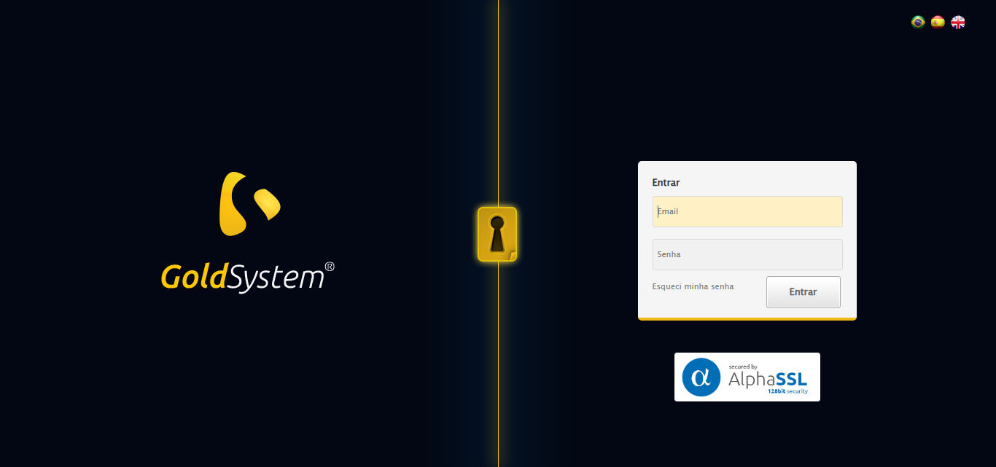

[15:20:02] 🔄 Realizando login...

[15:20:08] ✅ Realizando login realizada com sucesso.

[15:20:12] 📸 Screenshot capturada: realizando_login

Screenshot: realizando_login

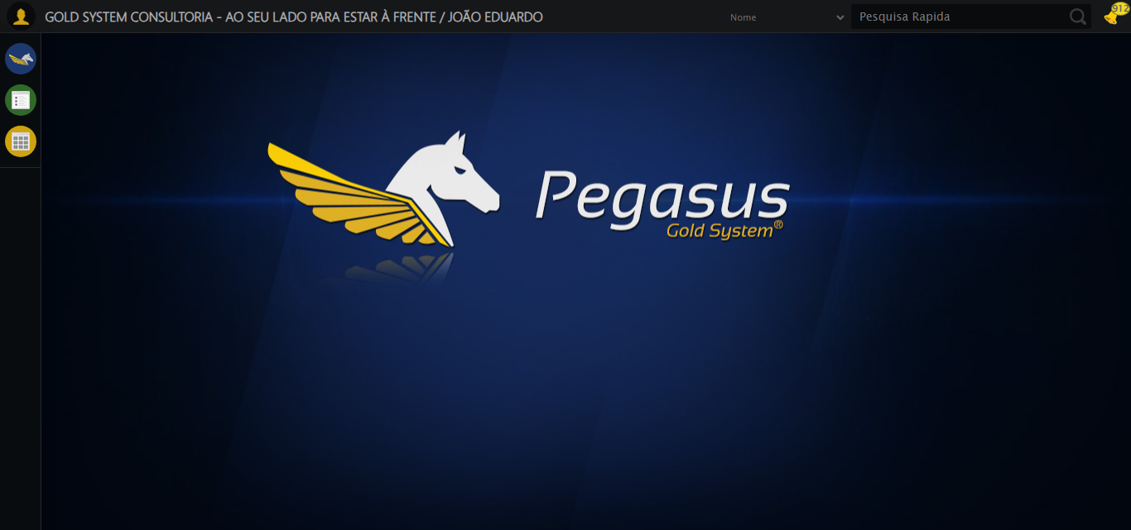

[15:20:12] 🔄 Configurando ambiente...

[15:20:12] 🔍 Zoom ajustado para 90%.

[15:20:14] ✅ Configurando ambiente realizada com sucesso.

[15:20:15] 📸 Screenshot capturada: configurando_ambiente

Screenshot: configurando_ambiente

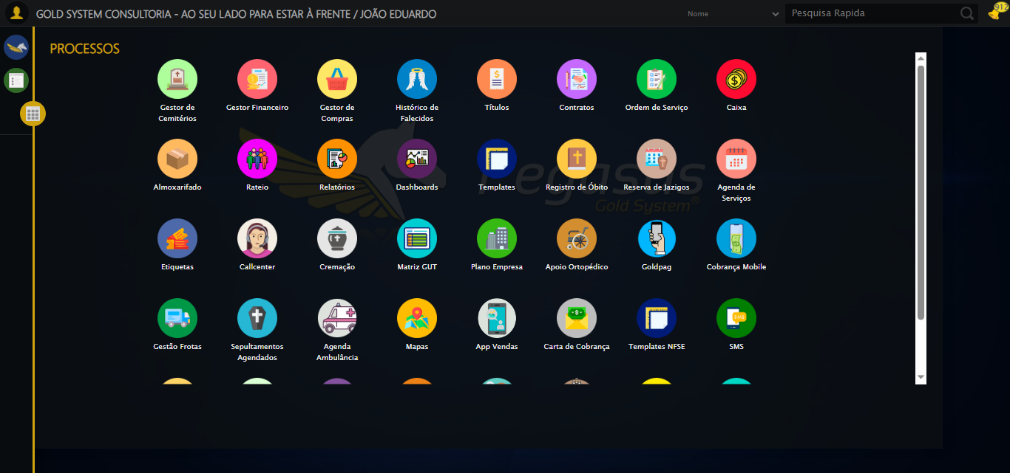

[15:20:15] 🔄 Acessando módulo Callcenter...

[15:20:15] Tentando estratégia de scroll 1...

[15:20:16] ✅ Scroll realizado com estratégia 1

[15:20:17] Tentando estratégia de clique 1 para módulo PET...

[15:20:19] ✅ Clique no módulo PET realizado com estratégia 1

[15:20:19] ✅ Acessando módulo Callcenter realizada com sucesso.

[15:20:21] 📸 Screenshot capturada: acessando_módulo_callcenter

Screenshot: acessando_módulo_callcenter

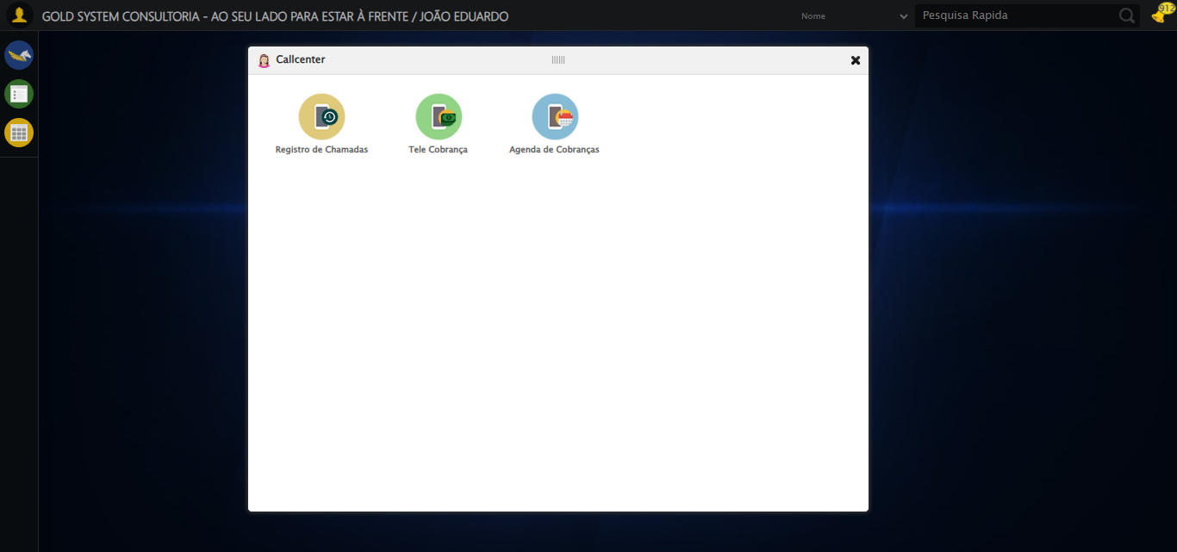

[15:20:21] 🔄 Abrindo Telecobrança...

[15:20:24] ✅ Abrindo Telecobrança realizada com sucesso.

[15:20:25] 📸 Screenshot capturada: abrindo_telecobrança

Screenshot: abrindo_telecobrança

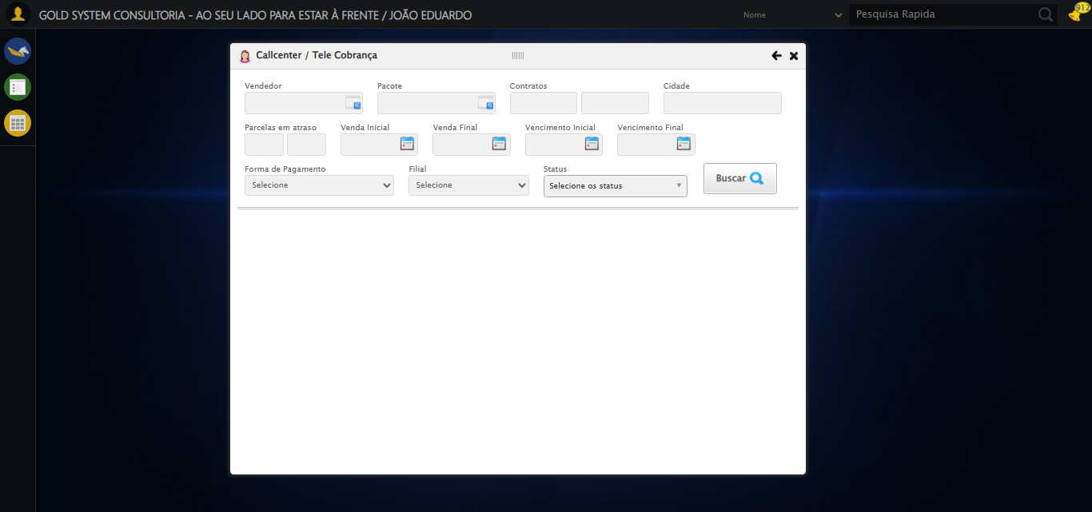

[15:40:25] 🔄 Selecionando Vendedor...

[15:40:25] 🔘 Abrindo modal com botão: #gsCallCenter > div.wdTelas > div.telaCobranca.telaConsulta.relative > div.formRow.formLastLine > div:nth-child(1) > div > a

[15:40:25] ❌ Erro aguardando elemento #gsCallCenter > div.wdTelas > div.telaCobranca.telaConsulta.relative > div.formRow.formLastLine > div:nth-child(1) > div > a: Message: invalid session id: session deleted as the browser has closed the connection  
from disconnected: not connected to DevTools  
 (Session info: chrome=139.0.7258.128)  
Stacktrace:  
 GetHandleVerifier [0x0x88ffc3+65331]  
 GetHandleVerifier [0x0x890004+65396]  
 (No symbol) [0x0x683f63]  
 (No symbol) [0x0x6738e0]  
 (No symbol) [0x0x691709]  
 (No symbol) [0x0x6f7e4c]  
 (No symbol) [0x0x7124d9]  
 (No symbol) [0x0x6f12d6]  
 (No symbol) [0x0x6c0910]  
 (No symbol) [0x0x6c1784]  
 GetHandleVerifier [0x0xad38b3+2439203]  
 GetHandleVerifier [0x0xaceae2+2419282]  
 GetHandleVerifier [0x0x8b712a+225434]  
 GetHandleVerifier [0x0x8a6e08+159096]  
 GetHandleVerifier [0x0x8add5d+187597]  
 GetHandleVerifier [0x0x897ad8+96840]  
 GetHandleVerifier [0x0x897c62+97234]  
 GetHandleVerifier [0x0x88277a+9962]  
 BaseThreadInitThunk [0x0x75abfcc9+25]  
 RtlGetAppContainerNamedObjectPath [0x0x776d82ae+286]  
 RtlGetAppContainerNamedObjectPath [0x0x776d827e+238]

[15:40:25] ❌ Erro no modal: Message: invalid session id: session deleted as the browser has closed the connection  
from disconnected: not connected to DevTools  
 (Session info: chrome=139.0.7258.128)  
Stacktrace:  
 GetHandleVerifier [0x0x88ffc3+65331]  
 GetHandleVerifier [0x0x890004+65396]  
 (No symbol) [0x0x683f63]  
 (No symbol) [0x0x6738e0]  
 (No symbol) [0x0x691709]  
 (No symbol) [0x0x6f7e4c]  
 (No symbol) [0x0x7124d9]  
 (No symbol) [0x0x6f12d6]  
 (No symbol) [0x0x6c0910]  
 (No symbol) [0x0x6c1784]  
 GetHandleVerifier [0x0xad38b3+2439203]  
 GetHandleVerifier [0x0xaceae2+2419282]  
 GetHandleVerifier [0x0x8b712a+225434]  
 GetHandleVerifier [0x0x8a6e08+159096]  
 GetHandleVerifier [0x0x8add5d+187597]  
 GetHandleVerifier [0x0x897ad8+96840]  
 GetHandleVerifier [0x0x897c62+97234]  
 GetHandleVerifier [0x0x88277a+9962]  
 BaseThreadInitThunk [0x0x75abfcc9+25]  
 RtlGetAppContainerNamedObjectPath [0x0x776d82ae+286]  
 RtlGetAppContainerNamedObjectPath [0x0x776d827e+238]

[15:40:25] ⚠️ Erro ao tirar screenshot erro_selecionando_vendedor: Message: invalid session id  
Stacktrace:  
 GetHandleVerifier [0x0x88ffc3+65331]  
 GetHandleVerifier [0x0x890004+65396]  
 (No symbol) [0x0x683dc0]  
 (No symbol) [0x0x6bfbd8]  
 (No symbol) [0x0x6f1396]  
 (No symbol) [0x0x6ecf70]  
 (No symbol) [0x0x6ec4f6]  
 (No symbol) [0x0x6559b5]  
 (No symbol) [0x0x655f0e]  
 (No symbol) [0x0x65639d]  
 GetHandleVerifier [0x0xad38b3+2439203]  
 GetHandleVerifier [0x0xaceae2+2419282]  
 GetHandleVerifier [0x0x8b712a+225434]  
 GetHandleVerifier [0x0x8a6e08+159096]  
 GetHandleVerifier [0x0x8add5d+187597]  
 (No symbol) [0x0x655680]  
 (No symbol) [0x0x654e8e]  
 GetHandleVerifier [0x0xbea2ec+3580508]  
 BaseThreadInitThunk [0x0x75abfcc9+25]  
 RtlGetAppContainerNamedObjectPath [0x0x776d82ae+286]  
 RtlGetAppContainerNamedObjectPath [0x0x776d827e+238]

[15:40:25] ❌ Selecionando Vendedor falhou: InvalidSessionIdException: Message: invalid session id: session deleted as the browser has closed the connection  
from disconnected: not connected to DevTools  
 (Session info: chrome=139.0.7258.128)  
Stacktrace:  
 GetHandleVerifier [0x0x88ffc3+65331]  
 GetHandleVerifier [0x0x890004+65396]  
 (No symbol) [0x0x683f63]  
 (No symbol) [0x0x6738e0]  
 (No symbol) [0x0x691709]  
 (No symbol) [0x0x6f7e4c]  
 (No symbol) [0x0x7124d9]  
 (No symbol) [0x0x6f12d6]  
 (No symbol) [0x0x6c0910]  
 (No symbol) [0x0x6c1784]  
 GetHandleVerifier [0x0xad38b3+2439203]  
 GetHandleVerifier [0x0xaceae2+2419282]  
 GetHandleVerifier [0x0x8b712a+225434]  
 GetHandleVerifier [0x0x8a6e08+159096]  
 GetHandleVerifier [0x0x8add5d+187597]  
 GetHandleVerifier [0x0x897ad8+96840]  
 GetHandleVerifier [0x0x897c62+97234]  
 GetHandleVerifier [0x0x88277a+9962]  
 BaseThreadInitThunk [0x0x75abfcc9+25]  
 RtlGetAppContainerNamedObjectPath [0x0x776d82ae+286]  
 RtlGetAppContainerNamedObjectPath [0x0x776d827e+238]

[15:40:25] ⚠️ Continuando execução apesar do erro em: Selecionando Vendedor

[15:40:25] 🔄 Selecionando Pacote...

[15:40:25] 🔘 Abrindo modal com botão: #gsCallCenter > div.wdTelas > div.telaCobranca.telaConsulta.relative > div.formRow.formLastLine > div:nth-child(2) > div > a

[15:40:25] ❌ Erro aguardando elemento #gsCallCenter > div.wdTelas > div.telaCobranca.telaConsulta.relative > div.formRow.formLastLine > div:nth-child(2) > div > a: Message: invalid session id  
Stacktrace:  
 GetHandleVerifier [0x0x88ffc3+65331]  
 GetHandleVerifier [0x0x890004+65396]  
 (No symbol) [0x0x683dc0]  
 (No symbol) [0x0x6bfbd8]  
 (No symbol) [0x0x6f1396]  
 (No symbol) [0x0x6ecf70]  
 (No symbol) [0x0x6ec4f6]  
 (No symbol) [0x0x6559b5]  
 (No symbol) [0x0x655f0e]  
 (No symbol) [0x0x65639d]  
 GetHandleVerifier [0x0xad38b3+2439203]  
 GetHandleVerifier [0x0xaceae2+2419282]  
 GetHandleVerifier [0x0x8b712a+225434]  
 GetHandleVerifier [0x0x8a6e08+159096]  
 GetHandleVerifier [0x0x8add5d+187597]  
 (No symbol) [0x0x655680]  
 (No symbol) [0x0x654e8e]  
 GetHandleVerifier [0x0xbea2ec+3580508]  
 BaseThreadInitThunk [0x0x75abfcc9+25]  
 RtlGetAppContainerNamedObjectPath [0x0x776d82ae+286]  
 RtlGetAppContainerNamedObjectPath [0x0x776d827e+238]

[15:40:25] ❌ Erro no modal: Message: invalid session id  
Stacktrace:  
 GetHandleVerifier [0x0x88ffc3+65331]  
 GetHandleVerifier [0x0x890004+65396]  
 (No symbol) [0x0x683dc0]  
 (No symbol) [0x0x6bfbd8]  
 (No symbol) [0x0x6f1396]  
 (No symbol) [0x0x6ecf70]  
 (No symbol) [0x0x6ec4f6]  
 (No symbol) [0x0x6559b5]  
 (No symbol) [0x0x655f0e]  
 (No symbol) [0x0x65639d]  
 GetHandleVerifier [0x0xad38b3+2439203]  
 GetHandleVerifier [0x0xaceae2+2419282]  
 GetHandleVerifier [0x0x8b712a+225434]  
 GetHandleVerifier [0x0x8a6e08+159096]  
 GetHandleVerifier [0x0x8add5d+187597]  
 (No symbol) [0x0x655680]  
 (No symbol) [0x0x654e8e]  
 GetHandleVerifier [0x0xbea2ec+3580508]  
 BaseThreadInitThunk [0x0x75abfcc9+25]  
 RtlGetAppContainerNamedObjectPath [0x0x776d82ae+286]  
 RtlGetAppContainerNamedObjectPath [0x0x776d827e+238]

[15:40:25] ⚠️ Erro ao tirar screenshot erro_selecionando_pacote: Message: invalid session id  
Stacktrace:  
 GetHandleVerifier [0x0x88ffc3+65331]  
 GetHandleVerifier [0x0x890004+65396]  
 (No symbol) [0x0x683dc0]  
 (No symbol) [0x0x6bfbd8]  
 (No symbol) [0x0x6f1396]  
 (No symbol) [0x0x6ecf70]  
 (No symbol) [0x0x6ec4f6]  
 (No symbol) [0x0x6559b5]  
 (No symbol) [0x0x655f0e]  
 (No symbol) [0x0x65639d]  
 GetHandleVerifier [0x0xad38b3+2439203]  
 GetHandleVerifier [0x0xaceae2+2419282]  
 GetHandleVerifier [0x0x8b712a+225434]  
 GetHandleVerifier [0x0x8a6e08+159096]  
 GetHandleVerifier [0x0x8add5d+187597]  
 (No symbol) [0x0x655680]  
 (No symbol) [0x0x654e8e]  
 GetHandleVerifier [0x0xbea2ec+3580508]  
 BaseThreadInitThunk [0x0x75abfcc9+25]  
 RtlGetAppContainerNamedObjectPath [0x0x776d82ae+286]  
 RtlGetAppContainerNamedObjectPath [0x0x776d827e+238]

[15:40:25] ❌ Selecionando Pacote falhou: InvalidSessionIdException: Message: invalid session id  
Stacktrace:  
 GetHandleVerifier [0x0x88ffc3+65331]  
 GetHandleVerifier [0x0x890004+65396]  
 (No symbol) [0x0x683dc0]  
 (No symbol) [0x0x6bfbd8]  
 (No symbol) [0x0x6f1396]  
 (No symbol) [0x0x6ecf70]  
 (No symbol) [0x0x6ec4f6]  
 (No symbol) [0x0x6559b5]  
 (No symbol) [0x0x655f0e]  
 (No symbol) [0x0x65639d]  
 GetHandleVerifier [0x0xad38b3+2439203]  
 GetHandleVerifier [0x0xaceae2+2419282]  
 GetHandleVerifier [0x0x8b712a+225434]  
 GetHandleVerifier [0x0x8a6e08+159096]  
 GetHandleVerifier [0x0x8add5d+187597]  
 (No symbol) [0x0x655680]  
 (No symbol) [0x0x654e8e]  
 GetHandleVerifier [0x0xbea2ec+3580508]  
 BaseThreadInitThunk [0x0x75abfcc9+25]  
 RtlGetAppContainerNamedObjectPath [0x0x776d82ae+286]  
 RtlGetAppContainerNamedObjectPath [0x0x776d827e+238]

[15:40:25] ⚠️ Continuando execução apesar do erro em: Selecionando Pacote

[15:40:25] 🔄 Preenchendo Números do Contrato...

[15:40:25] ❌ Erro aguardando elemento #gsCallCenter > div.wdTelas > div.telaCobranca.telaConsulta.relative > div.formRow.formLastLine > div:nth-child(3) > input[type=text]:nth-child(2): Message: invalid session id  
Stacktrace:  
 GetHandleVerifier [0x0x88ffc3+65331]  
 GetHandleVerifier [0x0x890004+65396]  
 (No symbol) [0x0x683dc0]  
 (No symbol) [0x0x6bfbd8]  
 (No symbol) [0x0x6f1396]  
 (No symbol) [0x0x6ecf70]  
 (No symbol) [0x0x6ec4f6]  
 (No symbol) [0x0x6559b5]  
 (No symbol) [0x0x655f0e]  
 (No symbol) [0x0x65639d]  
 GetHandleVerifier [0x0xad38b3+2439203]  
 GetHandleVerifier [0x0xaceae2+2419282]  
 GetHandleVerifier [0x0x8b712a+225434]  
 GetHandleVerifier [0x0x8a6e08+159096]  
 GetHandleVerifier [0x0x8add5d+187597]  
 (No symbol) [0x0x655680]  
 (No symbol) [0x0x654e8e]  
 GetHandleVerifier [0x0xbea2ec+3580508]  
 BaseThreadInitThunk [0x0x75abfcc9+25]  
 RtlGetAppContainerNamedObjectPath [0x0x776d82ae+286]  
 RtlGetAppContainerNamedObjectPath [0x0x776d827e+238]

[15:40:25] ⚠️ Erro ao tirar screenshot erro_preenchendo_números_do_contrato: Message: invalid session id  
Stacktrace:  
 GetHandleVerifier [0x0x88ffc3+65331]  
 GetHandleVerifier [0x0x890004+65396]  
 (No symbol) [0x0x683dc0]  
 (No symbol) [0x0x6bfbd8]  
 (No symbol) [0x0x6f1396]  
 (No symbol) [0x0x6ecf70]  
 (No symbol) [0x0x6ec4f6]  
 (No symbol) [0x0x6559b5]  
 (No symbol) [0x0x655f0e]  
 (No symbol) [0x0x65639d]  
 GetHandleVerifier [0x0xad38b3+2439203]  
 GetHandleVerifier [0x0xaceae2+2419282]  
 GetHandleVerifier [0x0x8b712a+225434]  
 GetHandleVerifier [0x0x8a6e08+159096]  
 GetHandleVerifier [0x0x8add5d+187597]  
 (No symbol) [0x0x655680]  
 (No symbol) [0x0x654e8e]  
 GetHandleVerifier [0x0xbea2ec+3580508]  
 BaseThreadInitThunk [0x0x75abfcc9+25]  
 RtlGetAppContainerNamedObjectPath [0x0x776d82ae+286]  
 RtlGetAppContainerNamedObjectPath [0x0x776d827e+238]

[15:40:25] ❌ Preenchendo Números do Contrato falhou: InvalidSessionIdException: Message: invalid session id  
Stacktrace:  
 GetHandleVerifier [0x0x88ffc3+65331]  
 GetHandleVerifier [0x0x890004+65396]  
 (No symbol) [0x0x683dc0]  
 (No symbol) [0x0x6bfbd8]  
 (No symbol) [0x0x6f1396]  
 (No symbol) [0x0x6ecf70]  
 (No symbol) [0x0x6ec4f6]  
 (No symbol) [0x0x6559b5]  
 (No symbol) [0x0x655f0e]  
 (No symbol) [0x0x65639d]  
 GetHandleVerifier [0x0xad38b3+2439203]  
 GetHandleVerifier [0x0xaceae2+2419282]  
 GetHandleVerifier [0x0x8b712a+225434]  
 GetHandleVerifier [0x0x8a6e08+159096]  
 GetHandleVerifier [0x0x8add5d+187597]  
 (No symbol) [0x0x655680]  
 (No symbol) [0x0x654e8e]  
 GetHandleVerifier [0x0xbea2ec+3580508]  
 BaseThreadInitThunk [0x0x75abfcc9+25]  
 RtlGetAppContainerNamedObjectPath [0x0x776d82ae+286]  
 RtlGetAppContainerNamedObjectPath [0x0x776d827e+238]

[15:40:25] — stacktrace —

[15:40:25] Traceback (most recent call last):  
 File "C:\RPASelenium\RPAsPegasusSelenium\cenariostestespegasus\Processos\CadastrosCenáriosCallcenter\ConsultaCenáriosTeleCobrança\consultatelecobrança1ºcenario.py", line 157, in safe_action  
 resultado = func()  
 File "C:\RPASelenium\RPAsPegasusSelenium\cenariostestespegasus\Processos\CadastrosCenáriosCallcenter\ConsultaCenáriosTeleCobrança\consultatelecobrança1ºcenario.py", line 526, in acao  
 elemento = aguardar_elemento(seletor, timeout, 'clickable')  
 File "C:\RPASelenium\RPAsPegasusSelenium\cenariostestespegasus\Processos\CadastrosCenáriosCallcenter\ConsultaCenáriosTeleCobrança\consultatelecobrança1ºcenario.py", line 203, in aguardar_elemento  
 elemento = wait_obj.until(condicoes[condicao]((by_type, seletor)))  
 File "C:\Python313\Lib\site-packages\selenium\webdriver\support\wait.py", line 137, in until  
 value = method(self._driver)  
 File "C:\Python313\Lib\site-packages\selenium\webdriver\support\expected_conditions.py", line 631, in _predicate  
 target = driver.find_element(*target) # grab element at locator  
 File "C:\Python313\Lib\site-packages\selenium\webdriver\remote\webdriver.py", line 898, in find_element  
 return self.execute(Command.FIND_ELEMENT, {"using": by, "value": value})["value"]  
 ~~~~~~~~~~~~^^^^^^^^^^^^^^^^^^^^^^^^^^^^^^^^^^^^^^^^^^^^^^^^^^^^^  
 File "C:\Python313\Lib\site-packages\selenium\webdriver\remote\webdriver.py", line 429, in execute  
 self.error_handler.check_response(response)  
 ~~~~~~~~~~~~~~~~~~~~~~~~~~~~~~~~~^^^^^^^^^^  
 File "C:\Python313\Lib\site-packages\selenium\webdriver\remote\errorhandler.py", line 232, in check_response  
 raise exception_class(message, screen, stacktrace)  
selenium.common.exceptions.InvalidSessionIdException: Message: invalid session id  
Stacktrace:  
 GetHandleVerifier [0x0x88ffc3+65331]  
 GetHandleVerifier [0x0x890004+65396]  
 (No symbol) [0x0x683dc0]  
 (No symbol) [0x0x6bfbd8]  
 (No symbol) [0x0x6f1396]  
 (No symbol) [0x0x6ecf70]  
 (No symbol) [0x0x6ec4f6]  
 (No symbol) [0x0x6559b5]  
 (No symbol) [0x0x655f0e]  
 (No symbol) [0x0x65639d]  
 GetHandleVerifier [0x0xad38b3+2439203]  
 GetHandleVerifier [0x0xaceae2+2419282]  
 GetHandleVerifier [0x0x8b712a+225434]  
 GetHandleVerifier [0x0x8a6e08+159096]  
 GetHandleVerifier [0x0x8add5d+187597]  
 (No symbol) [0x0x655680]  
 (No symbol) [0x0x654e8e]  
 GetHandleVerifier [0x0xbea2ec+3580508]  
 BaseThreadInitThunk [0x0x75abfcc9+25]  
 RtlGetAppContainerNamedObjectPath [0x0x776d82ae+286]  
 RtlGetAppContainerNamedObjectPath [0x0x776d827e+238]

[15:40:25] ❌ ERRO CRÍTICO NO TESTE: Message: invalid session id  
Stacktrace:  
 GetHandleVerifier [0x0x88ffc3+65331]  
 GetHandleVerifier [0x0x890004+65396]  
 (No symbol) [0x0x683dc0]  
 (No symbol) [0x0x6bfbd8]  
 (No symbol) [0x0x6f1396]  
 (No symbol) [0x0x6ecf70]  
 (No symbol) [0x0x6ec4f6]  
 (No symbol) [0x0x6559b5]  
 (No symbol) [0x0x655f0e]  
 (No symbol) [0x0x65639d]  
 GetHandleVerifier [0x0xad38b3+2439203]  
 GetHandleVerifier [0x0xaceae2+2419282]  
 GetHandleVerifier [0x0x8b712a+225434]  
 GetHandleVerifier [0x0x8a6e08+159096]  
 GetHandleVerifier [0x0x8add5d+187597]  
 (No symbol) [0x0x655680]  
 (No symbol) [0x0x654e8e]  
 GetHandleVerifier [0x0xbea2ec+3580508]  
 BaseThreadInitThunk [0x0x75abfcc9+25]  
 RtlGetAppContainerNamedObjectPath [0x0x776d82ae+286]  
 RtlGetAppContainerNamedObjectPath [0x0x776d827e+238]

[15:40:25] — stacktrace —

[15:40:25] Traceback (most recent call last):  
 File "C:\RPASelenium\RPAsPegasusSelenium\cenariostestespegasus\Processos\CadastrosCenáriosCallcenter\ConsultaCenáriosTeleCobrança\consultatelecobrança1ºcenario.py", line 1606, in executar_teste  
 preencher_campo_robusto('#gsCallCenter > div.wdTelas > div.telaCobranca.telaConsulta.relative > div.formRow.formLastLine > div:nth-child(3) > input.marginLeft5', '112106'),  
 ...<2 lines>...  
   
 File "C:\RPASelenium\RPAsPegasusSelenium\cenariostestespegasus\Processos\CadastrosCenáriosCallcenter\ConsultaCenáriosTeleCobrança\consultatelecobrança1ºcenario.py", line 157, in safe_action  
 resultado = func()  
 File "C:\RPASelenium\RPAsPegasusSelenium\cenariostestespegasus\Processos\CadastrosCenáriosCallcenter\ConsultaCenáriosTeleCobrança\consultatelecobrança1ºcenario.py", line 526, in acao  
 elemento = aguardar_elemento(seletor, timeout, 'clickable')  
 File "C:\RPASelenium\RPAsPegasusSelenium\cenariostestespegasus\Processos\CadastrosCenáriosCallcenter\ConsultaCenáriosTeleCobrança\consultatelecobrança1ºcenario.py", line 203, in aguardar_elemento  
 elemento = wait_obj.until(condicoes[condicao]((by_type, seletor)))  
 File "C:\Python313\Lib\site-packages\selenium\webdriver\support\wait.py", line 137, in until  
 value = method(self._driver)  
 File "C:\Python313\Lib\site-packages\selenium\webdriver\support\expected_conditions.py", line 631, in _predicate  
 target = driver.find_element(*target) # grab element at locator  
 File "C:\Python313\Lib\site-packages\selenium\webdriver\remote\webdriver.py", line 898, in find_element  
 return self.execute(Command.FIND_ELEMENT, {"using": by, "value": value})["value"]  
 ~~~~~~~~~~~~^^^^^^^^^^^^^^^^^^^^^^^^^^^^^^^^^^^^^^^^^^^^^^^^^^^^^  
 File "C:\Python313\Lib\site-packages\selenium\webdriver\remote\webdriver.py", line 429, in execute  
 self.error_handler.check_response(response)  
 ~~~~~~~~~~~~~~~~~~~~~~~~~~~~~~~~~^^^^^^^^^^  
 File "C:\Python313\Lib\site-packages\selenium\webdriver\remote\errorhandler.py", line 232, in check_response  
 raise exception_class(message, screen, stacktrace)  
selenium.common.exceptions.InvalidSessionIdException: Message: invalid session id  
Stacktrace:  
 GetHandleVerifier [0x0x88ffc3+65331]  
 GetHandleVerifier [0x0x890004+65396]  
 (No symbol) [0x0x683dc0]  
 (No symbol) [0x0x6bfbd8]  
 (No symbol) [0x0x6f1396]  
 (No symbol) [0x0x6ecf70]  
 (No symbol) [0x0x6ec4f6]  
 (No symbol) [0x0x6559b5]  
 (No symbol) [0x0x655f0e]  
 (No symbol) [0x0x65639d]  
 GetHandleVerifier [0x0xad38b3+2439203]  
 GetHandleVerifier [0x0xaceae2+2419282]  
 GetHandleVerifier [0x0x8b712a+225434]  
 GetHandleVerifier [0x0x8a6e08+159096]  
 GetHandleVerifier [0x0x8add5d+187597]  
 (No symbol) [0x0x655680]  
 (No symbol) [0x0x654e8e]  
 GetHandleVerifier [0x0xbea2ec+3580508]  
 BaseThreadInitThunk [0x0x75abfcc9+25]  
 RtlGetAppContainerNamedObjectPath [0x0x776d82ae+286]  
 RtlGetAppContainerNamedObjectPath [0x0x776d827e+238]

[15:40:25] ⚠️ Erro ao tirar screenshot erro_critico_final: Message: invalid session id  
Stacktrace:  
 GetHandleVerifier [0x0x88ffc3+65331]  
 GetHandleVerifier [0x0x890004+65396]  
 (No symbol) [0x0x683dc0]  
 (No symbol) [0x0x6bfbd8]  
 (No symbol) [0x0x6f1396]  
 (No symbol) [0x0x6ecf70]  
 (No symbol) [0x0x6ec4f6]  
 (No symbol) [0x0x6559b5]  
 (No symbol) [0x0x655f0e]  
 (No symbol) [0x0x65639d]  
 GetHandleVerifier [0x0xad38b3+2439203]  
 GetHandleVerifier [0x0xaceae2+2419282]  
 GetHandleVerifier [0x0x8b712a+225434]  
 GetHandleVerifier [0x0x8a6e08+159096]  
 GetHandleVerifier [0x0x8add5d+187597]  
 (No symbol) [0x0x655680]  
 (No symbol) [0x0x654e8e]  
 GetHandleVerifier [0x0xbea2ec+3580508]  
 BaseThreadInitThunk [0x0x75abfcc9+25]  
 RtlGetAppContainerNamedObjectPath [0x0x776d82ae+286]  
 RtlGetAppContainerNamedObjectPath [0x0x776d827e+238]

[15:40:25] 🏁 Finalizando teste...

[15:40:25] ❌ TESTE FINALIZADO COM ERROS.

[15:40:25] ============================================================

==================================================

RESUMO FINAL DO TESTE

==================================================

Teste finalizado em: 20/08/2025 15:40:25

Total de screenshots capturadas: 5