RELATÓRIO DO TESTE

Consulta de Agenda de Cobrança - Callcenter – Cenário 1: Realização da consulta de Agenda de Cobrança

Data do teste: 21/08/2025 14:31:52

[14:31:52] 🚀 INICIANDO TESTE DE CONSULTA DE REGISTRO DE CHAMADAS DO CALLCENTER

[14:31:52] ============================================================

[14:31:52] 🚀 Inicializando driver do Chrome...

[14:32:02] ✅ Driver inicializado com sucesso

[14:32:02] 🎯 Iniciando execução do teste de consulta de Registro de Chamadas

[14:32:02] 🔄 Acessando sistema...

[14:32:07] ✅ Acessando sistema realizada com sucesso.

[14:32:08] 📸 Screenshot capturada: acessando_sistema

Screenshot: acessando_sistema

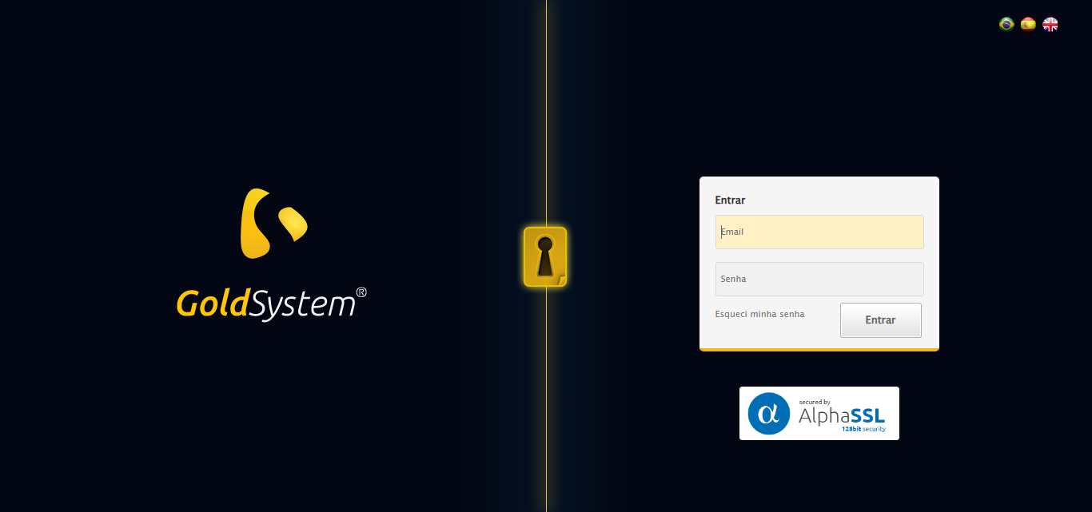

[14:32:08] 🔄 Realizando login...

[14:32:14] ✅ Realizando login realizada com sucesso.

[14:32:17] 📸 Screenshot capturada: realizando_login

Screenshot: realizando_login

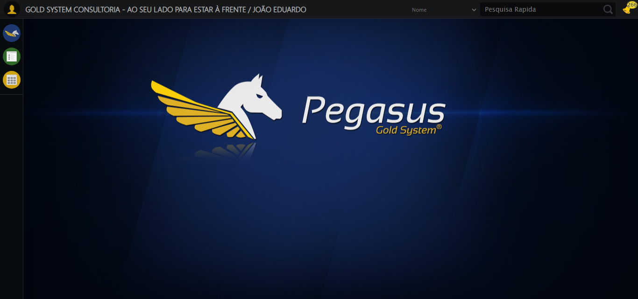

[14:32:17] 🔄 Configurando ambiente...

[14:32:17] 🔍 Zoom ajustado para 90%.

[14:32:20] ✅ Configurando ambiente realizada com sucesso.

[14:32:21] 📸 Screenshot capturada: configurando_ambiente

Screenshot: configurando_ambiente

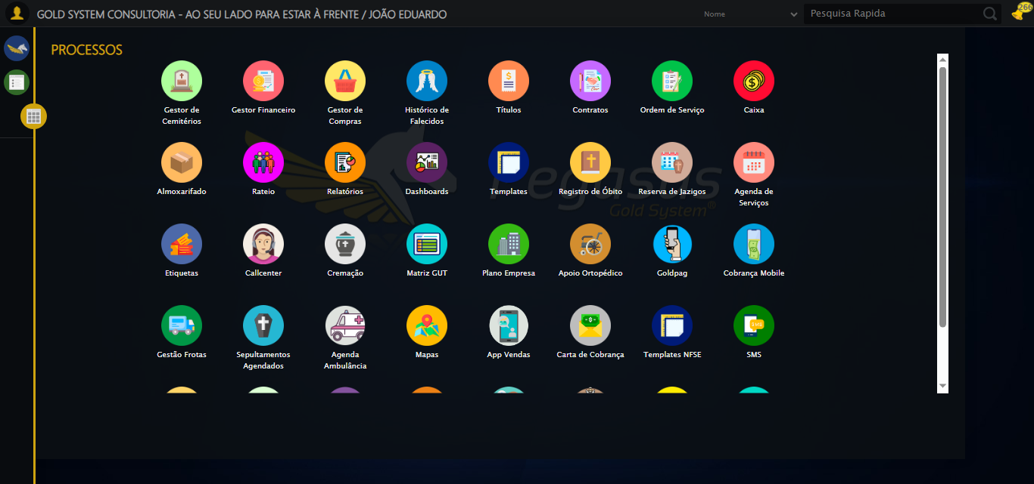

[14:32:21] 🔄 Acessando módulo Callcenter...

[14:32:22] Tentando estratégia de scroll 1...

[14:32:24] ✅ Scroll realizado com estratégia 1

[14:32:25] Tentando estratégia de clique 1 para módulo PET...

[14:32:27] ✅ Clique no módulo PET realizado com estratégia 1

[14:32:27] ✅ Acessando módulo Callcenter realizada com sucesso.

[14:32:28] 📸 Screenshot capturada: acessando_módulo_callcenter

Screenshot: acessando_módulo_callcenter

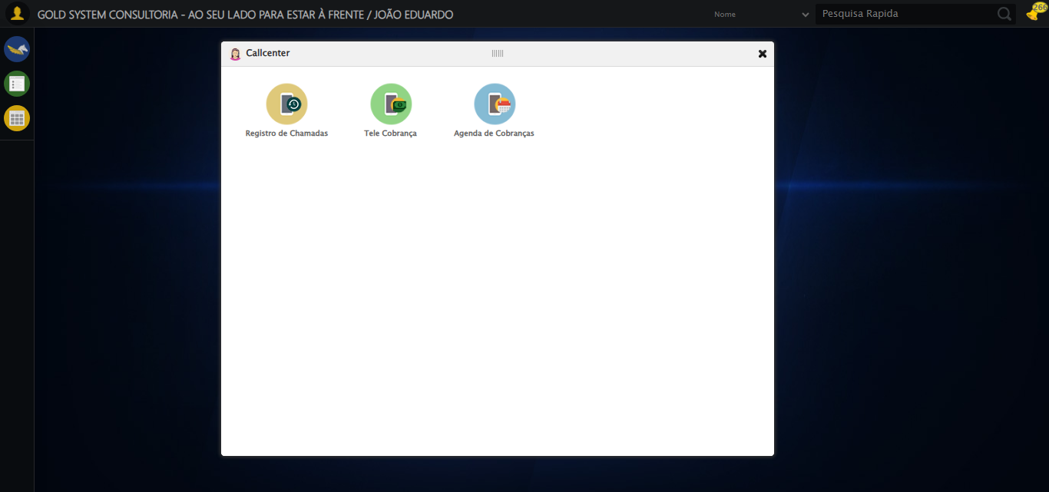

[14:32:28] 🔄 Abrindo Agenda de Cobranças...

[14:32:32] ✅ Abrindo Agenda de Cobranças realizada com sucesso.

[14:32:33] 📸 Screenshot capturada: abrindo_agenda_de_cobranças

Screenshot: abrindo_agenda_de_cobranças

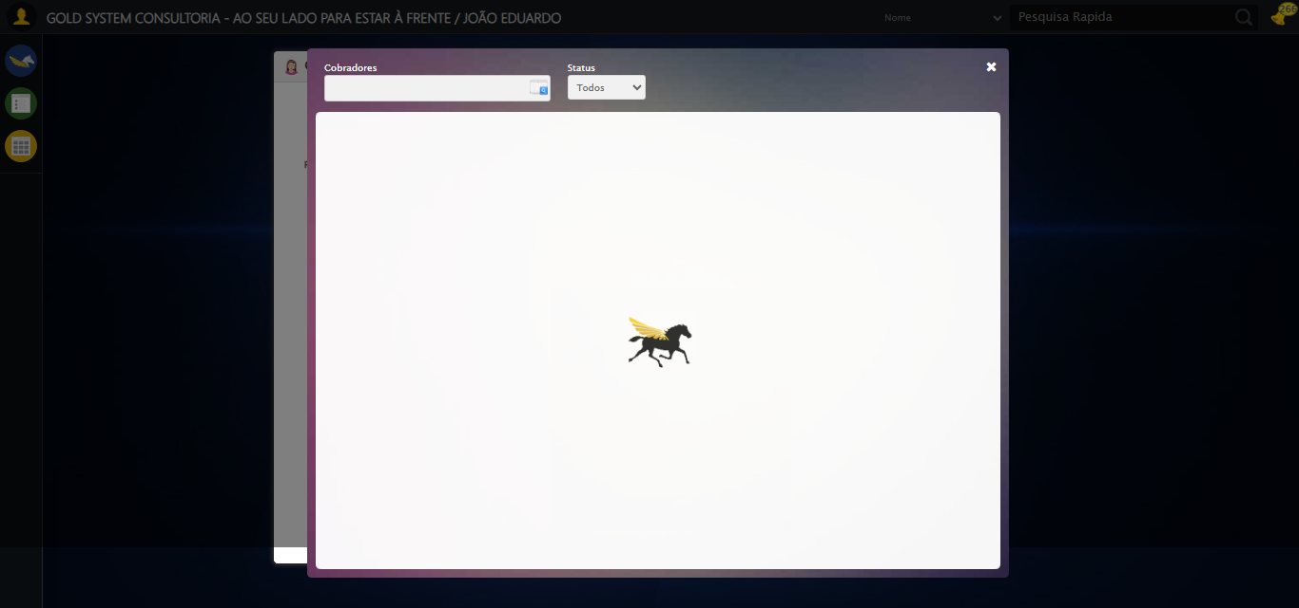

[14:32:35] 🔄 Abrindo o Lov de Cobradores...

[14:32:35] Tentando estratégia de scroll 1...

[14:32:36] ✅ Scroll realizado com estratégia 1

[14:32:36] ✅ Clique realizado com estratégia 1

[14:32:36] ✅ Abrindo o Lov de Cobradores realizada com sucesso.

[14:32:38] 📸 Screenshot capturada: abrindo_o_lov_de_cobradores

Screenshot: abrindo_o_lov_de_cobradores

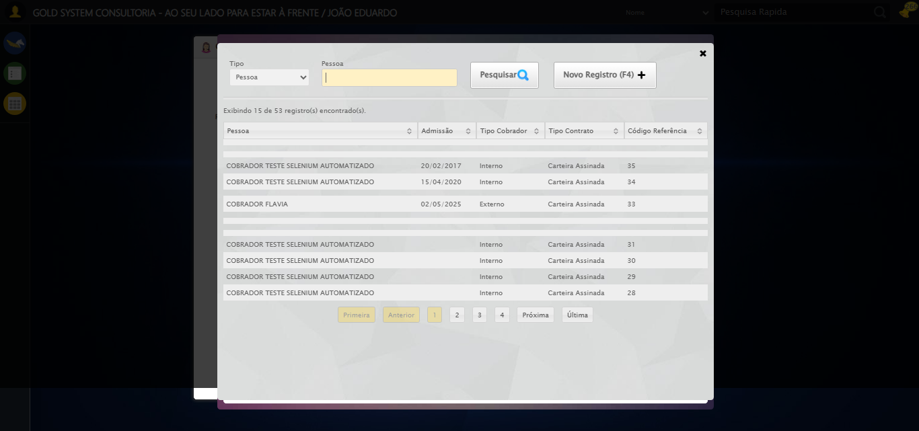

[14:32:38] 🔄 Preenchendo campo de pesquisa...

[14:32:38] Tentando estratégia de scroll 1...

[14:32:39] ✅ Scroll realizado com estratégia 1

[14:32:41] ✅ Campo (xpath) preenchido com estratégia 1: 'COBRADOR TESTE SELENIUM AUTOMATIZADO'

[14:32:41] ✅ Preenchendo campo de pesquisa realizada com sucesso.

[14:32:42] 📸 Screenshot capturada: preenchendo_campo_de_pesquisa

Screenshot: preenchendo_campo_de_pesquisa

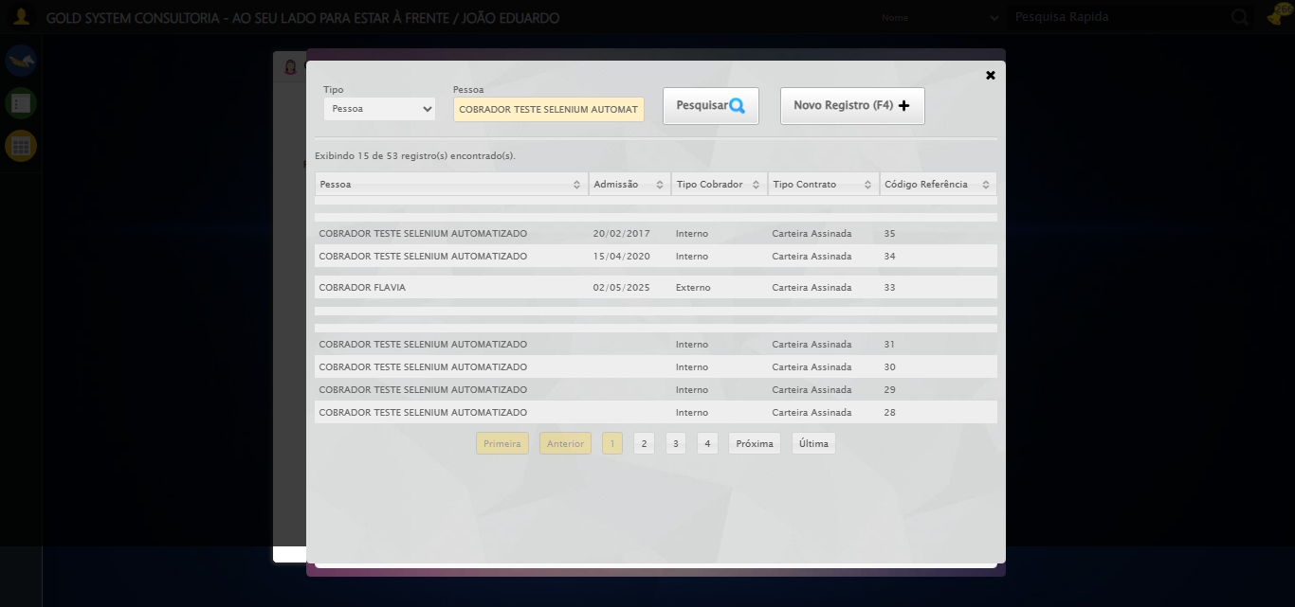

[14:32:42] 🔄 Pesquisando Cobrador no Lov...

[14:32:42] Tentando estratégia de scroll 1...

[14:32:43] ✅ Scroll realizado com estratégia 1

[14:32:44] ✅ Clique realizado com estratégia 1

[14:32:44] ✅ Pesquisando Cobrador no Lov realizada com sucesso.

[14:32:45] 📸 Screenshot capturada: pesquisando_cobrador_no_lov

Screenshot: pesquisando_cobrador_no_lov

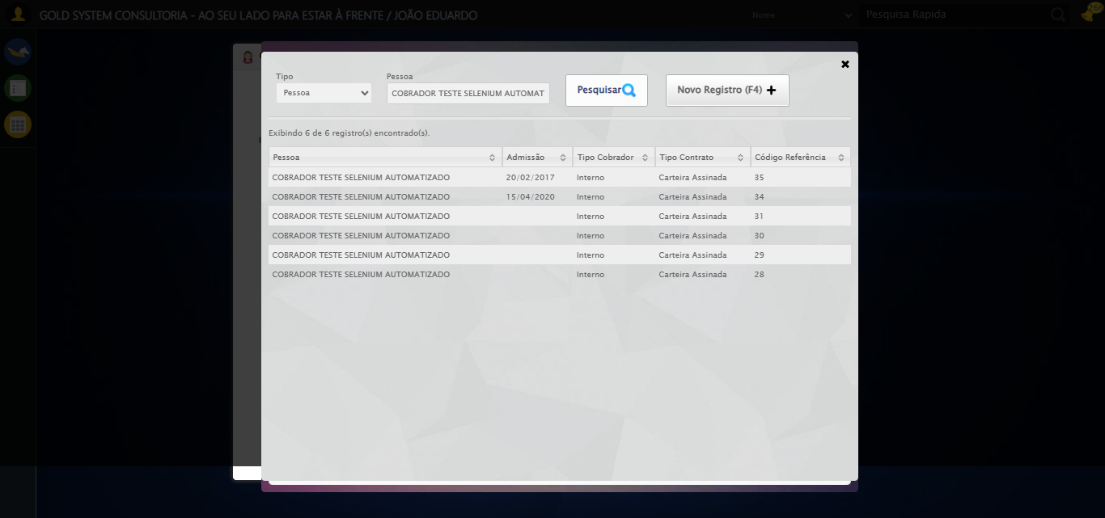

[14:32:45] 🔄 Selecionando Cobrador no Lov...

[14:32:45] Tentando estratégia de scroll 1...

[14:32:46] ✅ Scroll realizado com estratégia 1

[14:32:47] ✅ Clique realizado com estratégia 1

[14:32:47] ✅ Selecionando Cobrador no Lov realizada com sucesso.

[14:32:48] 📸 Screenshot capturada: selecionando_cobrador_no_lov

Screenshot: selecionando_cobrador_no_lov

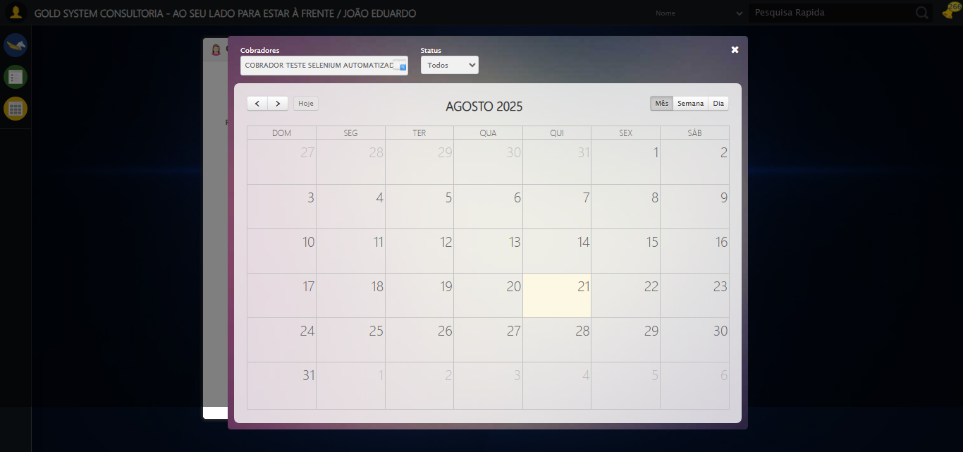

[14:32:58] 🔄 Procurando compromissos na Agenda...

[14:37:40] ⚠️ Erro ao tirar screenshot erro_procurando_compromissos_na_agenda: Message: invalid session id  
Stacktrace:  
 GetHandleVerifier [0x0xacffc3+65331]  
 GetHandleVerifier [0x0xad0004+65396]  
 (No symbol) [0x0x8c3dc0]  
 (No symbol) [0x0x8ffbd8]  
 (No symbol) [0x0x931396]  
 (No symbol) [0x0x92cf70]  
 (No symbol) [0x0x92c4f6]  
 (No symbol) [0x0x8959b5]  
 (No symbol) [0x0x895f0e]  
 (No symbol) [0x0x89639d]  
 GetHandleVerifier [0x0xd138b3+2439203]  
 GetHandleVerifier [0x0xd0eae2+2419282]  
 GetHandleVerifier [0x0xaf712a+225434]  
 GetHandleVerifier [0x0xae6e08+159096]  
 GetHandleVerifier [0x0xaedd5d+187597]  
 (No symbol) [0x0x895680]  
 (No symbol) [0x0x894e8e]  
 GetHandleVerifier [0x0xe2a2ec+3580508]  
 BaseThreadInitThunk [0x0x75abfcc9+25]  
 RtlGetAppContainerNamedObjectPath [0x0x776d82ae+286]  
 RtlGetAppContainerNamedObjectPath [0x0x776d827e+238]

[14:37:40] ❌ Procurando compromissos na Agenda falhou: InvalidSessionIdException: Message: invalid session id: session deleted as the browser has closed the connection  
from disconnected: not connected to DevTools  
 (Session info: chrome=139.0.7258.128)  
Stacktrace:  
 GetHandleVerifier [0x0xacffc3+65331]  
 GetHandleVerifier [0x0xad0004+65396]  
 (No symbol) [0x0x8c3f63]  
 (No symbol) [0x0x8b38e0]  
 (No symbol) [0x0x8d1709]  
 (No symbol) [0x0x937e4c]  
 (No symbol) [0x0x9524d9]  
 (No symbol) [0x0x9312d6]  
 (No symbol) [0x0x900910]  
 (No symbol) [0x0x901784]  
 GetHandleVerifier [0x0xd138b3+2439203]  
 GetHandleVerifier [0x0xd0eae2+2419282]  
 GetHandleVerifier [0x0xaf712a+225434]  
 GetHandleVerifier [0x0xae6e08+159096]  
 GetHandleVerifier [0x0xaedd5d+187597]  
 GetHandleVerifier [0x0xad7ad8+96840]  
 GetHandleVerifier [0x0xad7c62+97234]  
 GetHandleVerifier [0x0xac277a+9962]  
 BaseThreadInitThunk [0x0x75abfcc9+25]  
 RtlGetAppContainerNamedObjectPath [0x0x776d82ae+286]  
 RtlGetAppContainerNamedObjectPath [0x0x776d827e+238]

[14:37:40] ⚠️ Continuando execução apesar do erro em: Procurando compromissos na Agenda

[14:37:40] 🔄 Fechando aba do contrato...

[14:37:40] ❌ Erro aguardando elemento /html/body/div[20]/div[2]/a: Message: invalid session id  
Stacktrace:  
 GetHandleVerifier [0x0xacffc3+65331]  
 GetHandleVerifier [0x0xad0004+65396]  
 (No symbol) [0x0x8c3dc0]  
 (No symbol) [0x0x8ffbd8]  
 (No symbol) [0x0x931396]  
 (No symbol) [0x0x92cf70]  
 (No symbol) [0x0x92c4f6]  
 (No symbol) [0x0x8959b5]  
 (No symbol) [0x0x895f0e]  
 (No symbol) [0x0x89639d]  
 GetHandleVerifier [0x0xd138b3+2439203]  
 GetHandleVerifier [0x0xd0eae2+2419282]  
 GetHandleVerifier [0x0xaf712a+225434]  
 GetHandleVerifier [0x0xae6e08+159096]  
 GetHandleVerifier [0x0xaedd5d+187597]  
 (No symbol) [0x0x895680]  
 (No symbol) [0x0x894e8e]  
 GetHandleVerifier [0x0xe2a2ec+3580508]  
 BaseThreadInitThunk [0x0x75abfcc9+25]  
 RtlGetAppContainerNamedObjectPath [0x0x776d82ae+286]  
 RtlGetAppContainerNamedObjectPath [0x0x776d827e+238]

[14:37:40] ❌ Falha ao clicar em /html/body/div[20]/div[2]/a: Message: invalid session id  
Stacktrace:  
 GetHandleVerifier [0x0xacffc3+65331]  
 GetHandleVerifier [0x0xad0004+65396]  
 (No symbol) [0x0x8c3dc0]  
 (No symbol) [0x0x8ffbd8]  
 (No symbol) [0x0x931396]  
 (No symbol) [0x0x92cf70]  
 (No symbol) [0x0x92c4f6]  
 (No symbol) [0x0x8959b5]  
 (No symbol) [0x0x895f0e]  
 (No symbol) [0x0x89639d]  
 GetHandleVerifier [0x0xd138b3+2439203]  
 GetHandleVerifier [0x0xd0eae2+2419282]  
 GetHandleVerifier [0x0xaf712a+225434]  
 GetHandleVerifier [0x0xae6e08+159096]  
 GetHandleVerifier [0x0xaedd5d+187597]  
 (No symbol) [0x0x895680]  
 (No symbol) [0x0x894e8e]  
 GetHandleVerifier [0x0xe2a2ec+3580508]  
 BaseThreadInitThunk [0x0x75abfcc9+25]  
 RtlGetAppContainerNamedObjectPath [0x0x776d82ae+286]  
 RtlGetAppContainerNamedObjectPath [0x0x776d827e+238]

[14:37:40] ⚠️ Erro ao tirar screenshot erro_fechando_aba_do_contrato: Message: invalid session id  
Stacktrace:  
 GetHandleVerifier [0x0xacffc3+65331]  
 GetHandleVerifier [0x0xad0004+65396]  
 (No symbol) [0x0x8c3dc0]  
 (No symbol) [0x0x8ffbd8]  
 (No symbol) [0x0x931396]  
 (No symbol) [0x0x92cf70]  
 (No symbol) [0x0x92c4f6]  
 (No symbol) [0x0x8959b5]  
 (No symbol) [0x0x895f0e]  
 (No symbol) [0x0x89639d]  
 GetHandleVerifier [0x0xd138b3+2439203]  
 GetHandleVerifier [0x0xd0eae2+2419282]  
 GetHandleVerifier [0x0xaf712a+225434]  
 GetHandleVerifier [0x0xae6e08+159096]  
 GetHandleVerifier [0x0xaedd5d+187597]  
 (No symbol) [0x0x895680]  
 (No symbol) [0x0x894e8e]  
 GetHandleVerifier [0x0xe2a2ec+3580508]  
 BaseThreadInitThunk [0x0x75abfcc9+25]  
 RtlGetAppContainerNamedObjectPath [0x0x776d82ae+286]  
 RtlGetAppContainerNamedObjectPath [0x0x776d827e+238]

[14:37:40] ❌ Fechando aba do contrato falhou: InvalidSessionIdException: Message: invalid session id  
Stacktrace:  
 GetHandleVerifier [0x0xacffc3+65331]  
 GetHandleVerifier [0x0xad0004+65396]  
 (No symbol) [0x0x8c3dc0]  
 (No symbol) [0x0x8ffbd8]  
 (No symbol) [0x0x931396]  
 (No symbol) [0x0x92cf70]  
 (No symbol) [0x0x92c4f6]  
 (No symbol) [0x0x8959b5]  
 (No symbol) [0x0x895f0e]  
 (No symbol) [0x0x89639d]  
 GetHandleVerifier [0x0xd138b3+2439203]  
 GetHandleVerifier [0x0xd0eae2+2419282]  
 GetHandleVerifier [0x0xaf712a+225434]  
 GetHandleVerifier [0x0xae6e08+159096]  
 GetHandleVerifier [0x0xaedd5d+187597]  
 (No symbol) [0x0x895680]  
 (No symbol) [0x0x894e8e]  
 GetHandleVerifier [0x0xe2a2ec+3580508]  
 BaseThreadInitThunk [0x0x75abfcc9+25]  
 RtlGetAppContainerNamedObjectPath [0x0x776d82ae+286]  
 RtlGetAppContainerNamedObjectPath [0x0x776d827e+238]

[14:37:40] ⚠️ Continuando execução apesar do erro em: Fechando aba do contrato

[14:37:40] 🔄 Fechando Agenda de Cobranças...

[14:37:40] ❌ Erro aguardando elemento //a[@class='fa fa-close' and @style='top: 15px; right: 15px;']: Message: invalid session id  
Stacktrace:  
 GetHandleVerifier [0x0xacffc3+65331]  
 GetHandleVerifier [0x0xad0004+65396]  
 (No symbol) [0x0x8c3dc0]  
 (No symbol) [0x0x8ffbd8]  
 (No symbol) [0x0x931396]  
 (No symbol) [0x0x92cf70]  
 (No symbol) [0x0x92c4f6]  
 (No symbol) [0x0x8959b5]  
 (No symbol) [0x0x895f0e]  
 (No symbol) [0x0x89639d]  
 GetHandleVerifier [0x0xd138b3+2439203]  
 GetHandleVerifier [0x0xd0eae2+2419282]  
 GetHandleVerifier [0x0xaf712a+225434]  
 GetHandleVerifier [0x0xae6e08+159096]  
 GetHandleVerifier [0x0xaedd5d+187597]  
 (No symbol) [0x0x895680]  
 (No symbol) [0x0x894e8e]  
 GetHandleVerifier [0x0xe2a2ec+3580508]  
 BaseThreadInitThunk [0x0x75abfcc9+25]  
 RtlGetAppContainerNamedObjectPath [0x0x776d82ae+286]  
 RtlGetAppContainerNamedObjectPath [0x0x776d827e+238]

[14:37:40] ❌ Falha ao clicar em //a[@class='fa fa-close' and @style='top: 15px; right: 15px;']: Message: invalid session id  
Stacktrace:  
 GetHandleVerifier [0x0xacffc3+65331]  
 GetHandleVerifier [0x0xad0004+65396]  
 (No symbol) [0x0x8c3dc0]  
 (No symbol) [0x0x8ffbd8]  
 (No symbol) [0x0x931396]  
 (No symbol) [0x0x92cf70]  
 (No symbol) [0x0x92c4f6]  
 (No symbol) [0x0x8959b5]  
 (No symbol) [0x0x895f0e]  
 (No symbol) [0x0x89639d]  
 GetHandleVerifier [0x0xd138b3+2439203]  
 GetHandleVerifier [0x0xd0eae2+2419282]  
 GetHandleVerifier [0x0xaf712a+225434]  
 GetHandleVerifier [0x0xae6e08+159096]  
 GetHandleVerifier [0x0xaedd5d+187597]  
 (No symbol) [0x0x895680]  
 (No symbol) [0x0x894e8e]  
 GetHandleVerifier [0x0xe2a2ec+3580508]  
 BaseThreadInitThunk [0x0x75abfcc9+25]  
 RtlGetAppContainerNamedObjectPath [0x0x776d82ae+286]  
 RtlGetAppContainerNamedObjectPath [0x0x776d827e+238]

[14:37:40] ⚠️ Erro ao tirar screenshot erro_fechando_agenda_de_cobranças: Message: invalid session id  
Stacktrace:  
 GetHandleVerifier [0x0xacffc3+65331]  
 GetHandleVerifier [0x0xad0004+65396]  
 (No symbol) [0x0x8c3dc0]  
 (No symbol) [0x0x8ffbd8]  
 (No symbol) [0x0x931396]  
 (No symbol) [0x0x92cf70]  
 (No symbol) [0x0x92c4f6]  
 (No symbol) [0x0x8959b5]  
 (No symbol) [0x0x895f0e]  
 (No symbol) [0x0x89639d]  
 GetHandleVerifier [0x0xd138b3+2439203]  
 GetHandleVerifier [0x0xd0eae2+2419282]  
 GetHandleVerifier [0x0xaf712a+225434]  
 GetHandleVerifier [0x0xae6e08+159096]  
 GetHandleVerifier [0x0xaedd5d+187597]  
 (No symbol) [0x0x895680]  
 (No symbol) [0x0x894e8e]  
 GetHandleVerifier [0x0xe2a2ec+3580508]  
 BaseThreadInitThunk [0x0x75abfcc9+25]  
 RtlGetAppContainerNamedObjectPath [0x0x776d82ae+286]  
 RtlGetAppContainerNamedObjectPath [0x0x776d827e+238]

[14:37:40] ❌ Fechando Agenda de Cobranças falhou: InvalidSessionIdException: Message: invalid session id  
Stacktrace:  
 GetHandleVerifier [0x0xacffc3+65331]  
 GetHandleVerifier [0x0xad0004+65396]  
 (No symbol) [0x0x8c3dc0]  
 (No symbol) [0x0x8ffbd8]  
 (No symbol) [0x0x931396]  
 (No symbol) [0x0x92cf70]  
 (No symbol) [0x0x92c4f6]  
 (No symbol) [0x0x8959b5]  
 (No symbol) [0x0x895f0e]  
 (No symbol) [0x0x89639d]  
 GetHandleVerifier [0x0xd138b3+2439203]  
 GetHandleVerifier [0x0xd0eae2+2419282]  
 GetHandleVerifier [0x0xaf712a+225434]  
 GetHandleVerifier [0x0xae6e08+159096]  
 GetHandleVerifier [0x0xaedd5d+187597]  
 (No symbol) [0x0x895680]  
 (No symbol) [0x0x894e8e]  
 GetHandleVerifier [0x0xe2a2ec+3580508]  
 BaseThreadInitThunk [0x0x75abfcc9+25]  
 RtlGetAppContainerNamedObjectPath [0x0x776d82ae+286]  
 RtlGetAppContainerNamedObjectPath [0x0x776d827e+238]

[14:37:40] ⚠️ Continuando execução apesar do erro em: Fechando Agenda de Cobranças

[14:37:40] 🔄 Fechando tela de consulta...

[14:37:40] ❌ Erro aguardando elemento #gsCallCenter > div.wdTop.ui-draggable-handle > div.wdClose > a: Message: invalid session id  
Stacktrace:  
 GetHandleVerifier [0x0xacffc3+65331]  
 GetHandleVerifier [0x0xad0004+65396]  
 (No symbol) [0x0x8c3dc0]  
 (No symbol) [0x0x8ffbd8]  
 (No symbol) [0x0x931396]  
 (No symbol) [0x0x92cf70]  
 (No symbol) [0x0x92c4f6]  
 (No symbol) [0x0x8959b5]  
 (No symbol) [0x0x895f0e]  
 (No symbol) [0x0x89639d]  
 GetHandleVerifier [0x0xd138b3+2439203]  
 GetHandleVerifier [0x0xd0eae2+2419282]  
 GetHandleVerifier [0x0xaf712a+225434]  
 GetHandleVerifier [0x0xae6e08+159096]  
 GetHandleVerifier [0x0xaedd5d+187597]  
 (No symbol) [0x0x895680]  
 (No symbol) [0x0x894e8e]  
 GetHandleVerifier [0x0xe2a2ec+3580508]  
 BaseThreadInitThunk [0x0x75abfcc9+25]  
 RtlGetAppContainerNamedObjectPath [0x0x776d82ae+286]  
 RtlGetAppContainerNamedObjectPath [0x0x776d827e+238]

[14:37:40] ❌ Falha ao clicar em #gsCallCenter > div.wdTop.ui-draggable-handle > div.wdClose > a: Message: invalid session id  
Stacktrace:  
 GetHandleVerifier [0x0xacffc3+65331]  
 GetHandleVerifier [0x0xad0004+65396]  
 (No symbol) [0x0x8c3dc0]  
 (No symbol) [0x0x8ffbd8]  
 (No symbol) [0x0x931396]  
 (No symbol) [0x0x92cf70]  
 (No symbol) [0x0x92c4f6]  
 (No symbol) [0x0x8959b5]  
 (No symbol) [0x0x895f0e]  
 (No symbol) [0x0x89639d]  
 GetHandleVerifier [0x0xd138b3+2439203]  
 GetHandleVerifier [0x0xd0eae2+2419282]  
 GetHandleVerifier [0x0xaf712a+225434]  
 GetHandleVerifier [0x0xae6e08+159096]  
 GetHandleVerifier [0x0xaedd5d+187597]  
 (No symbol) [0x0x895680]  
 (No symbol) [0x0x894e8e]  
 GetHandleVerifier [0x0xe2a2ec+3580508]  
 BaseThreadInitThunk [0x0x75abfcc9+25]  
 RtlGetAppContainerNamedObjectPath [0x0x776d82ae+286]  
 RtlGetAppContainerNamedObjectPath [0x0x776d827e+238]

[14:37:40] ⚠️ Erro ao tirar screenshot erro_fechando_tela_de_consulta: Message: invalid session id  
Stacktrace:  
 GetHandleVerifier [0x0xacffc3+65331]  
 GetHandleVerifier [0x0xad0004+65396]  
 (No symbol) [0x0x8c3dc0]  
 (No symbol) [0x0x8ffbd8]  
 (No symbol) [0x0x931396]  
 (No symbol) [0x0x92cf70]  
 (No symbol) [0x0x92c4f6]  
 (No symbol) [0x0x8959b5]  
 (No symbol) [0x0x895f0e]  
 (No symbol) [0x0x89639d]  
 GetHandleVerifier [0x0xd138b3+2439203]  
 GetHandleVerifier [0x0xd0eae2+2419282]  
 GetHandleVerifier [0x0xaf712a+225434]  
 GetHandleVerifier [0x0xae6e08+159096]  
 GetHandleVerifier [0x0xaedd5d+187597]  
 (No symbol) [0x0x895680]  
 (No symbol) [0x0x894e8e]  
 GetHandleVerifier [0x0xe2a2ec+3580508]  
 BaseThreadInitThunk [0x0x75abfcc9+25]  
 RtlGetAppContainerNamedObjectPath [0x0x776d82ae+286]  
 RtlGetAppContainerNamedObjectPath [0x0x776d827e+238]

[14:37:40] ❌ Fechando tela de consulta falhou: InvalidSessionIdException: Message: invalid session id  
Stacktrace:  
 GetHandleVerifier [0x0xacffc3+65331]  
 GetHandleVerifier [0x0xad0004+65396]  
 (No symbol) [0x0x8c3dc0]  
 (No symbol) [0x0x8ffbd8]  
 (No symbol) [0x0x931396]  
 (No symbol) [0x0x92cf70]  
 (No symbol) [0x0x92c4f6]  
 (No symbol) [0x0x8959b5]  
 (No symbol) [0x0x895f0e]  
 (No symbol) [0x0x89639d]  
 GetHandleVerifier [0x0xd138b3+2439203]  
 GetHandleVerifier [0x0xd0eae2+2419282]  
 GetHandleVerifier [0x0xaf712a+225434]  
 GetHandleVerifier [0x0xae6e08+159096]  
 GetHandleVerifier [0x0xaedd5d+187597]  
 (No symbol) [0x0x895680]  
 (No symbol) [0x0x894e8e]  
 GetHandleVerifier [0x0xe2a2ec+3580508]  
 BaseThreadInitThunk [0x0x75abfcc9+25]  
 RtlGetAppContainerNamedObjectPath [0x0x776d82ae+286]  
 RtlGetAppContainerNamedObjectPath [0x0x776d827e+238]

[14:37:40] ⚠️ Continuando execução apesar do erro em: Fechando tela de consulta

[14:37:40] ✅ Teste executado com sucesso completo!

[14:37:40] 🏁 Finalizando teste...

[14:37:40] ✅ TESTE CONCLUÍDO COM SUCESSO!

[14:37:40] ============================================================

==================================================

RESUMO FINAL DO TESTE

==================================================

Teste finalizado em: 21/08/2025 14:37:40

Total de screenshots capturadas: 9