RELATÓRIO DO TESTE

Consulta de Agenda de Cobrança - Callcenter – Cenário 1: Realização da consulta de Agenda de Cobrança

Data do teste: 21/08/2025 14:42:36

[14:42:36] 🚀 INICIANDO TESTE DE CONSULTA DE REGISTRO DE CHAMADAS DO CALLCENTER

[14:42:36] ============================================================

[14:42:36] 🚀 Inicializando driver do Chrome...

[14:42:46] ✅ Driver inicializado com sucesso

[14:42:46] 🎯 Iniciando execução do teste de consulta de Registro de Chamadas

[14:42:46] 🔄 Acessando sistema...

[14:42:50] ✅ Acessando sistema realizada com sucesso.

[14:42:51] 📸 Screenshot capturada: acessando_sistema

Screenshot: acessando_sistema

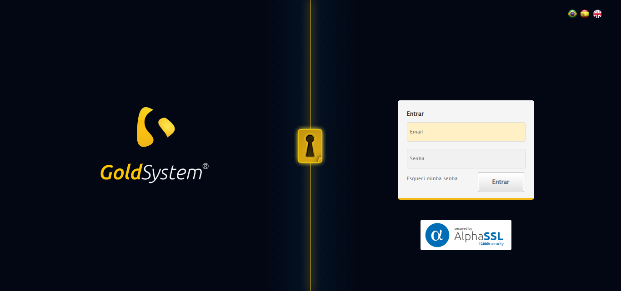

[14:42:51] 🔄 Realizando login...

[14:42:56] ✅ Realizando login realizada com sucesso.

[14:43:01] 📸 Screenshot capturada: realizando_login

Screenshot: realizando_login

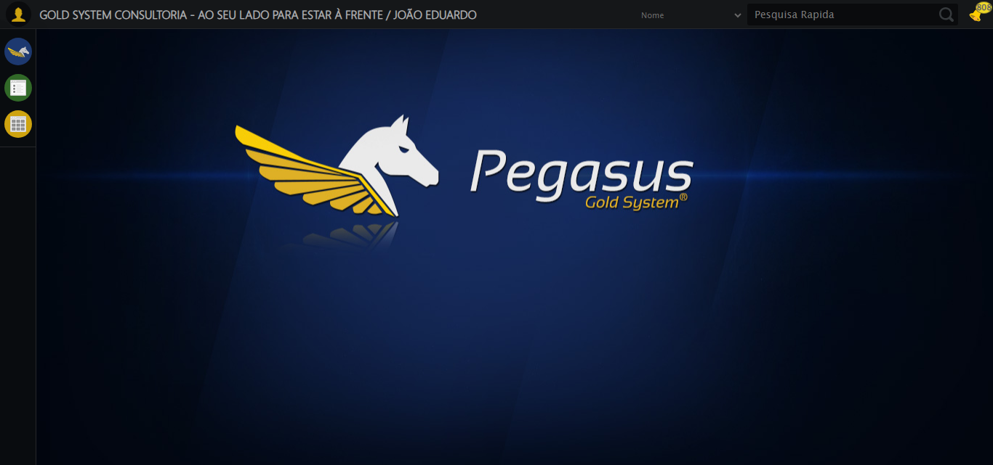

[14:43:01] 🔄 Configurando ambiente...

[14:43:01] 🔍 Zoom ajustado para 90%.

[14:43:03] ✅ Configurando ambiente realizada com sucesso.

[14:43:05] 📸 Screenshot capturada: configurando_ambiente

Screenshot: configurando_ambiente

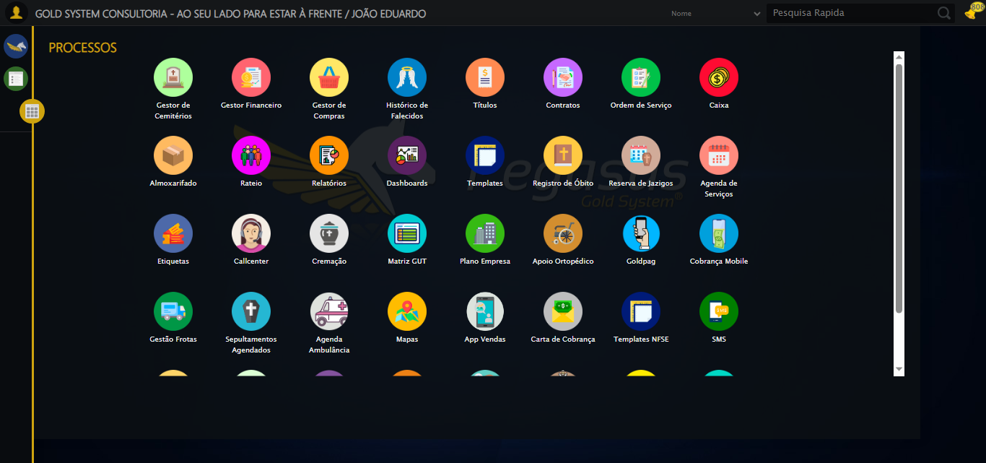

[14:43:05] 🔄 Acessando módulo Callcenter...

[14:43:05] Tentando estratégia de scroll 1...

[14:43:06] ✅ Scroll realizado com estratégia 1

[14:43:07] Tentando estratégia de clique 1 para módulo PET...

[14:43:10] ✅ Clique no módulo PET realizado com estratégia 1

[14:43:10] ✅ Acessando módulo Callcenter realizada com sucesso.

[14:43:11] 📸 Screenshot capturada: acessando_módulo_callcenter

Screenshot: acessando_módulo_callcenter

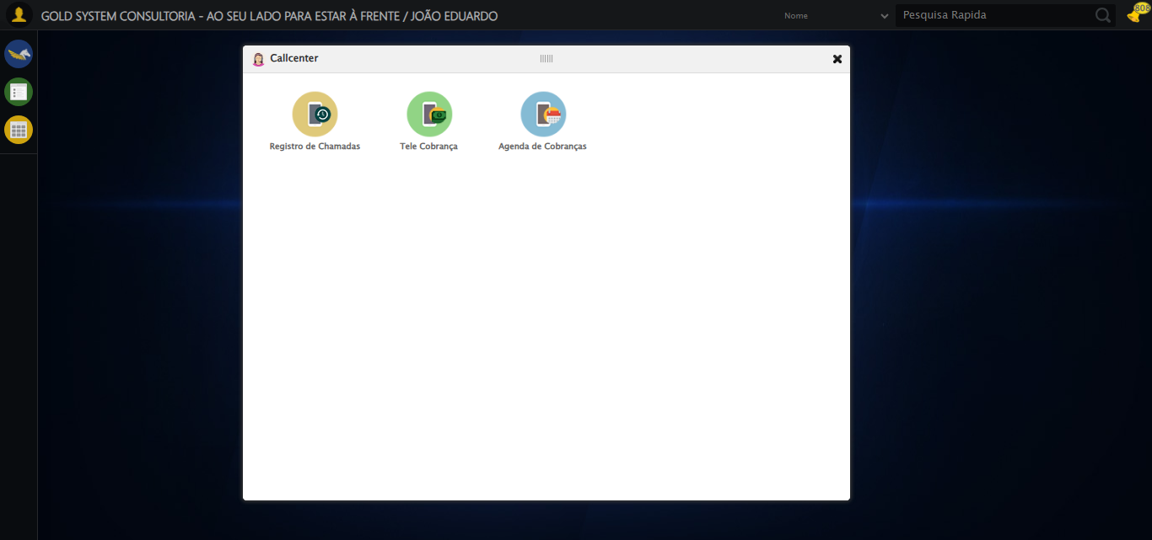

[14:43:11] 🔄 Abrindo Agenda de Cobranças...

[14:43:14] ✅ Abrindo Agenda de Cobranças realizada com sucesso.

[14:43:16] 📸 Screenshot capturada: abrindo_agenda_de_cobranças

Screenshot: abrindo_agenda_de_cobranças

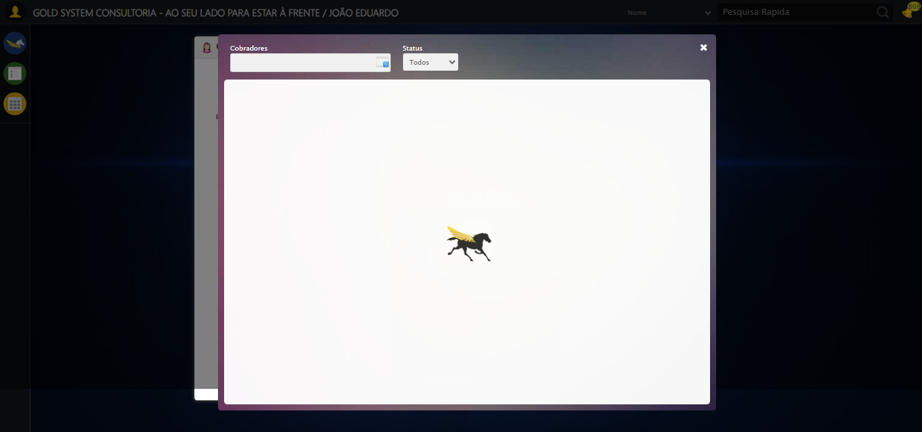

[14:43:18] 🔄 Abrindo o Lov de Cobradores...

[14:43:18] Tentando estratégia de scroll 1...

[14:43:19] ✅ Scroll realizado com estratégia 1

[14:43:20] ✅ Clique realizado com estratégia 1

[14:43:20] ✅ Abrindo o Lov de Cobradores realizada com sucesso.

[14:43:21] 📸 Screenshot capturada: abrindo_o_lov_de_cobradores

Screenshot: abrindo_o_lov_de_cobradores

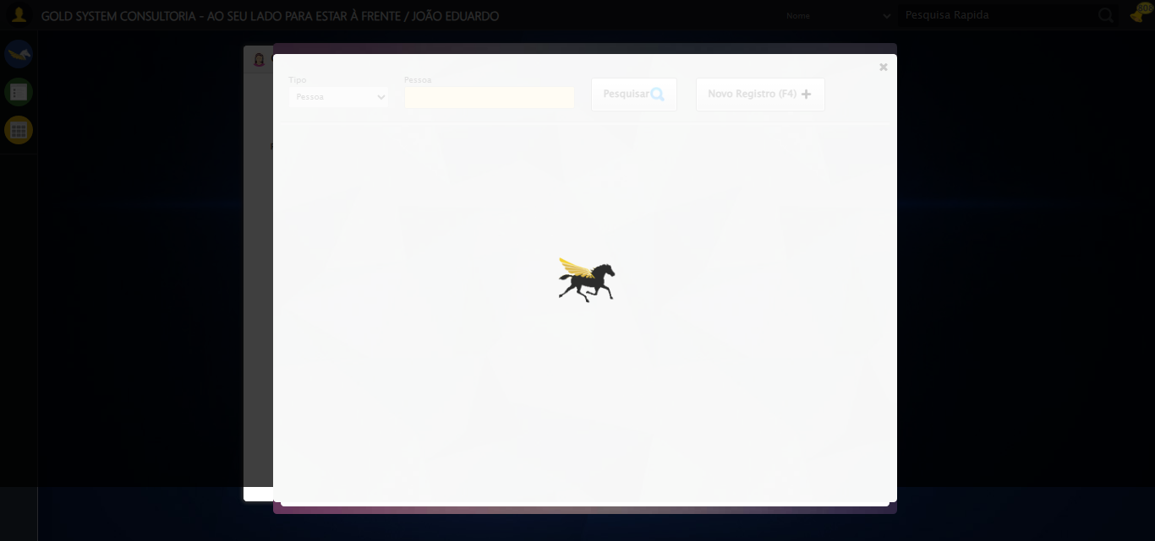

[14:43:21] 🔄 Selecionando para filtrar por Código Referência...

[14:43:21] 📸 Screenshot capturada: erro_selecionando_para_filtrar_por_código_referência

Screenshot: erro_selecionando_para_filtrar_por_código_referência

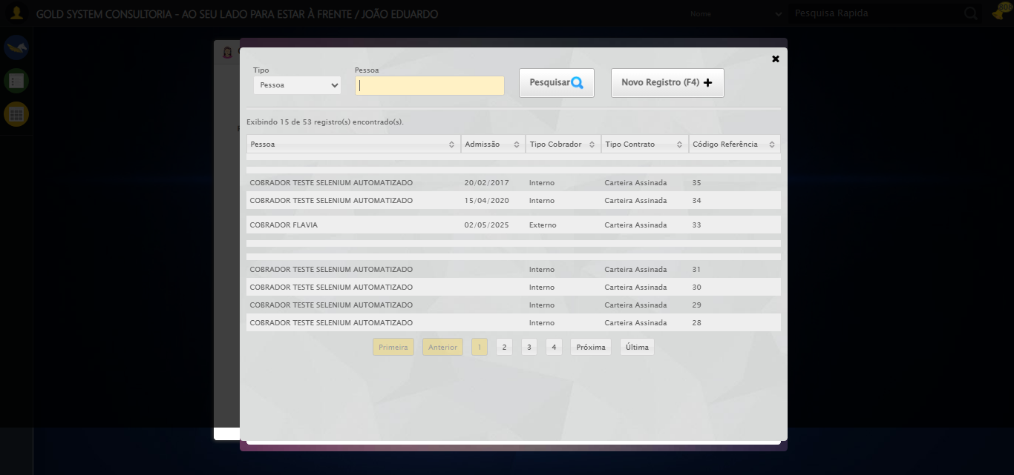

[14:43:21] ❌ Selecionando para filtrar por Código Referência falhou: InvalidSelectorException: Message: invalid selector: An invalid or illegal selector was specified  
 (Session info: chrome=139.0.7258.128); For documentation on this error, please visit: https://www.selenium.dev/documentation/webdriver/troubleshooting/errors#invalid-selector-exception  
Stacktrace:  
 GetHandleVerifier [0x0xacffc3+65331]  
 GetHandleVerifier [0x0xad0004+65396]  
 (No symbol) [0x0x8c3f63]  
 (No symbol) [0x0x8ca750]  
 (No symbol) [0x0x8cca7a]  
 (No symbol) [0x0x8ccaf7]  
 (No symbol) [0x0x90c234]  
 (No symbol) [0x0x90cd3b]  
 (No symbol) [0x0x9553d2]  
 (No symbol) [0x0x931524]  
 (No symbol) [0x0x952bcb]  
 (No symbol) [0x0x9312d6]  
 (No symbol) [0x0x900910]  
 (No symbol) [0x0x901784]  
 GetHandleVerifier [0x0xd138b3+2439203]  
 GetHandleVerifier [0x0xd0eae2+2419282]  
 GetHandleVerifier [0x0xaf712a+225434]  
 GetHandleVerifier [0x0xae6e08+159096]  
 GetHandleVerifier [0x0xaedd5d+187597]  
 GetHandleVerifier [0x0xad7ad8+96840]  
 GetHandleVerifier [0x0xad7c62+97234]  
 GetHandleVerifier [0x0xac277a+9962]  
 BaseThreadInitThunk [0x0x75abfcc9+25]  
 RtlGetAppContainerNamedObjectPath [0x0x776d82ae+286]  
 RtlGetAppContainerNamedObjectPath [0x0x776d827e+238]

[14:43:21] ⚠️ Continuando execução apesar do erro em: Selecionando para filtrar por Código Referência

[14:43:21] 🔄 Preenchendo campo de pesquisa como Código Referência do Vendedor...

[14:43:22] Tentando estratégia de scroll 1...

[14:43:23] ✅ Scroll realizado com estratégia 1

[14:43:24] ✅ Campo (xpath) preenchido com estratégia 1: '31'

[14:43:24] ✅ Preenchendo campo de pesquisa como Código Referência do Vendedor realizada com sucesso.

[14:43:25] 📸 Screenshot capturada: preenchendo_campo_de_pesquisa_como_código_referência_do_vendedor

Screenshot: preenchendo_campo_de_pesquisa_como_código_referência_do_vendedor

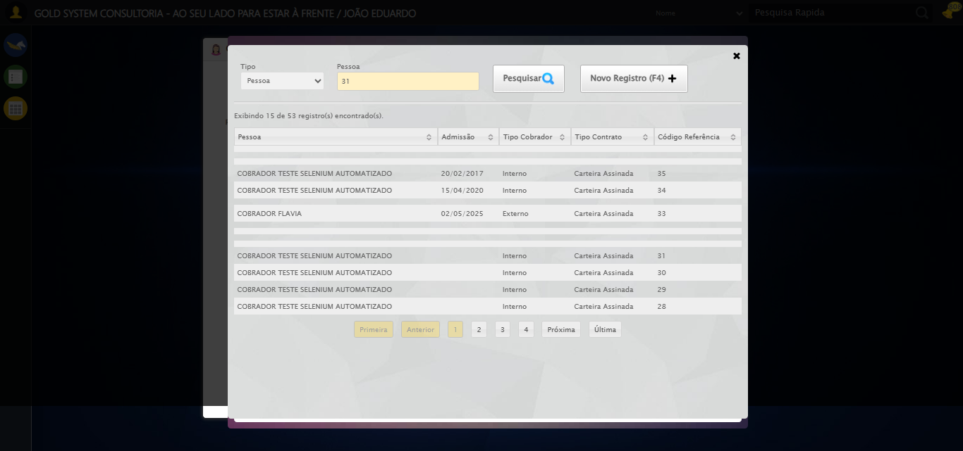

[14:43:25] 🔄 Pesquisando Cobrador no Lov...

[14:43:25] Tentando estratégia de scroll 1...

[14:43:26] ✅ Scroll realizado com estratégia 1

[14:43:27] ✅ Clique realizado com estratégia 1

[14:43:27] ✅ Pesquisando Cobrador no Lov realizada com sucesso.

[14:43:28] 📸 Screenshot capturada: pesquisando_cobrador_no_lov

Screenshot: pesquisando_cobrador_no_lov

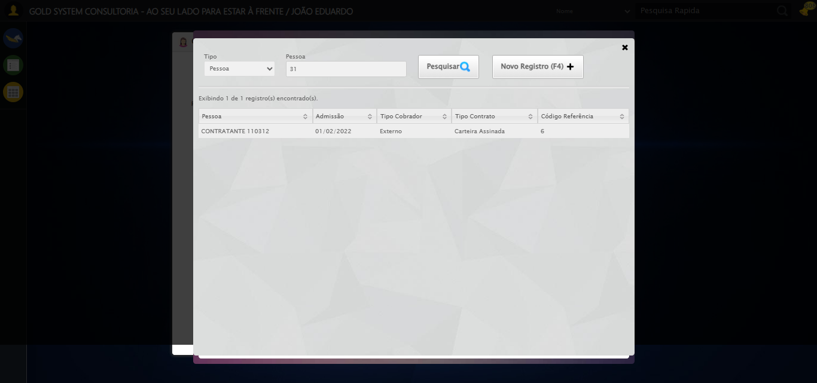

[14:43:28] 🔄 Selecionando Cobrador no Lov...

[14:43:59] ❌ Timeout aguardando elemento: //td[contains(text(), 'COBRADOR TESTE SELENIUM AUTOMATIZADO')] (condição: present, timeout: 30s)

[14:43:59] ❌ Falha ao clicar em //td[contains(text(), 'COBRADOR TESTE SELENIUM AUTOMATIZADO')]: Message: Elemento não encontrado: //td[contains(text(), 'COBRADOR TESTE SELENIUM AUTOMATIZADO')] (condição: present)

[14:43:59] 📸 Screenshot capturada: erro_selecionando_cobrador_no_lov

Screenshot: erro_selecionando_cobrador_no_lov

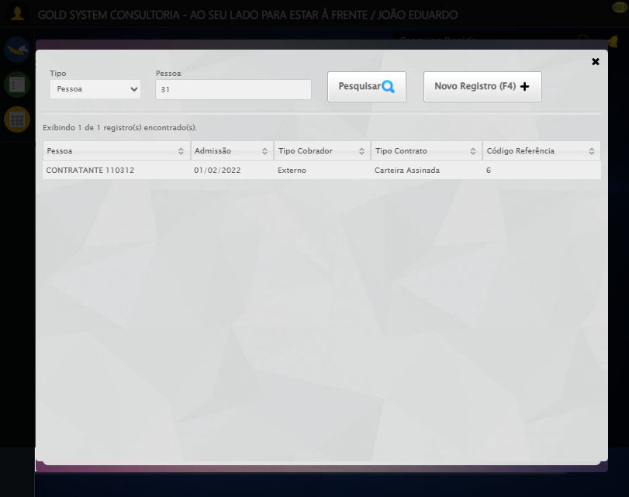

[14:43:59] ❌ Selecionando Cobrador no Lov falhou: TimeoutException: Message: Elemento não encontrado: //td[contains(text(), 'COBRADOR TESTE SELENIUM AUTOMATIZADO')] (condição: present)

[14:43:59] ⚠️ Continuando execução apesar do erro em: Selecionando Cobrador no Lov

[14:44:09] 🔄 Procurando compromissos na Agenda...

[14:44:41] 📸 Screenshot capturada: erro_procurando_compromissos_na_agenda

Screenshot: erro_procurando_compromissos_na_agenda

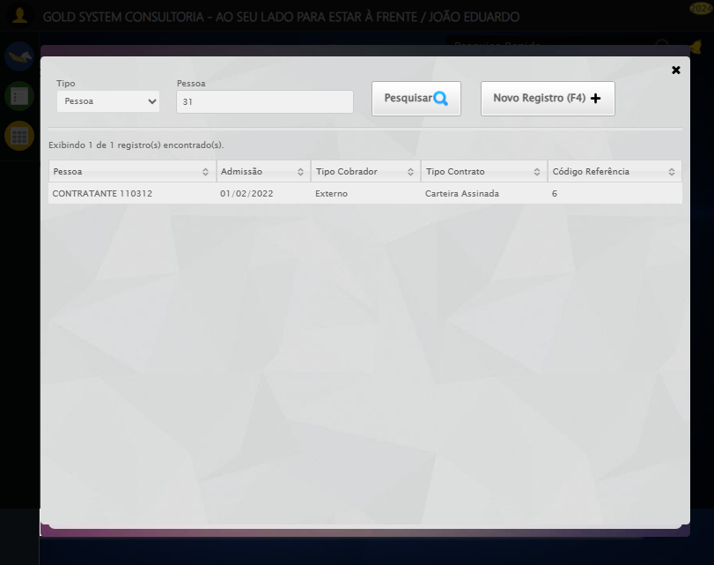

[14:44:41] ❌ Procurando compromissos na Agenda falhou: ElementClickInterceptedException: Message: element click intercepted: Element <button type="button" class="fc-prev-button fc-button fc-state-default fc-corner-left">...</button> is not clickable at point (87, 146). Other element would receive the click: <div class="formRow formLastLine" style="margin:0">...</div>  
 (Session info: chrome=139.0.7258.128)  
Stacktrace:  
 GetHandleVerifier [0x0xacffc3+65331]  
 GetHandleVerifier [0x0xad0004+65396]  
 (No symbol) [0x0x8c3f63]  
 (No symbol) [0x0x912ce0]  
 (No symbol) [0x0x91109a]  
 (No symbol) [0x0x90ebf2]  
 (No symbol) [0x0x90dee1]  
 (No symbol) [0x0x902645]  
 (No symbol) [0x0x9314dc]  
 (No symbol) [0x0x9020d4]  
 (No symbol) [0x0x931754]  
 (No symbol) [0x0x952bcb]  
 (No symbol) [0x0x9312d6]  
 (No symbol) [0x0x900910]  
 (No symbol) [0x0x901784]  
 GetHandleVerifier [0x0xd138b3+2439203]  
 GetHandleVerifier [0x0xd0eae2+2419282]  
 GetHandleVerifier [0x0xaf712a+225434]  
 GetHandleVerifier [0x0xae6e08+159096]  
 GetHandleVerifier [0x0xaedd5d+187597]  
 GetHandleVerifier [0x0xad7ad8+96840]  
 GetHandleVerifier [0x0xad7c62+97234]  
 GetHandleVerifier [0x0xac277a+9962]  
 BaseThreadInitThunk [0x0x75abfcc9+25]  
 RtlGetAppContainerNamedObjectPath [0x0x776d82ae+286]  
 RtlGetAppContainerNamedObjectPath [0x0x776d827e+238]

[14:44:41] ⚠️ Continuando execução apesar do erro em: Procurando compromissos na Agenda

[14:44:41] 🔄 Fechando aba do contrato...

[14:45:10] ❌ Erro aguardando elemento /html/body/div[20]/div[2]/a: Message: target frame detached  
 (failed to check if window was closed: disconnected: unable to send message to renderer)  
 (Session info: chrome=139.0.7258.128)  
Stacktrace:  
 GetHandleVerifier [0x0xacffc3+65331]  
 GetHandleVerifier [0x0xad0004+65396]  
 (No symbol) [0x0x8c3dc0]  
 (No symbol) [0x0x8b4920]  
 (No symbol) [0x0x8b3a91]  
 (No symbol) [0x0x8d1709]  
 (No symbol) [0x0x937e4c]  
 (No symbol) [0x0x9524d9]  
 (No symbol) [0x0x9312d6]  
 (No symbol) [0x0x900910]  
 (No symbol) [0x0x901784]  
 GetHandleVerifier [0x0xd138b3+2439203]  
 GetHandleVerifier [0x0xd0eae2+2419282]  
 GetHandleVerifier [0x0xaf712a+225434]  
 GetHandleVerifier [0x0xae6e08+159096]  
 GetHandleVerifier [0x0xaedd5d+187597]  
 GetHandleVerifier [0x0xad7ad8+96840]  
 GetHandleVerifier [0x0xad7c62+97234]  
 GetHandleVerifier [0x0xac277a+9962]  
 BaseThreadInitThunk [0x0x75abfcc9+25]  
 RtlGetAppContainerNamedObjectPath [0x0x776d82ae+286]  
 RtlGetAppContainerNamedObjectPath [0x0x776d827e+238]

[14:45:10] ❌ Falha ao clicar em /html/body/div[20]/div[2]/a: Message: target frame detached  
 (failed to check if window was closed: disconnected: unable to send message to renderer)  
 (Session info: chrome=139.0.7258.128)  
Stacktrace:  
 GetHandleVerifier [0x0xacffc3+65331]  
 GetHandleVerifier [0x0xad0004+65396]  
 (No symbol) [0x0x8c3dc0]  
 (No symbol) [0x0x8b4920]  
 (No symbol) [0x0x8b3a91]  
 (No symbol) [0x0x8d1709]  
 (No symbol) [0x0x937e4c]  
 (No symbol) [0x0x9524d9]  
 (No symbol) [0x0x9312d6]  
 (No symbol) [0x0x900910]  
 (No symbol) [0x0x901784]  
 GetHandleVerifier [0x0xd138b3+2439203]  
 GetHandleVerifier [0x0xd0eae2+2419282]  
 GetHandleVerifier [0x0xaf712a+225434]  
 GetHandleVerifier [0x0xae6e08+159096]  
 GetHandleVerifier [0x0xaedd5d+187597]  
 GetHandleVerifier [0x0xad7ad8+96840]  
 GetHandleVerifier [0x0xad7c62+97234]  
 GetHandleVerifier [0x0xac277a+9962]  
 BaseThreadInitThunk [0x0x75abfcc9+25]  
 RtlGetAppContainerNamedObjectPath [0x0x776d82ae+286]  
 RtlGetAppContainerNamedObjectPath [0x0x776d827e+238]

[14:45:12] ⚠️ Erro ao tirar screenshot erro_fechando_aba_do_contrato: Message: invalid session id: session deleted as the browser has closed the connection  
from disconnected: not connected to DevTools  
 (Session info: chrome=139.0.7258.128)  
Stacktrace:  
 GetHandleVerifier [0x0xacffc3+65331]  
 GetHandleVerifier [0x0xad0004+65396]  
 (No symbol) [0x0x8c3f63]  
 (No symbol) [0x0x8b38e0]  
 (No symbol) [0x0x8d1709]  
 (No symbol) [0x0x937e4c]  
 (No symbol) [0x0x9524d9]  
 (No symbol) [0x0x9312d6]  
 (No symbol) [0x0x900910]  
 (No symbol) [0x0x901784]  
 GetHandleVerifier [0x0xd138b3+2439203]  
 GetHandleVerifier [0x0xd0eae2+2419282]  
 GetHandleVerifier [0x0xaf712a+225434]  
 GetHandleVerifier [0x0xae6e08+159096]  
 GetHandleVerifier [0x0xaedd5d+187597]  
 GetHandleVerifier [0x0xad7ad8+96840]  
 GetHandleVerifier [0x0xad7c62+97234]  
 GetHandleVerifier [0x0xac277a+9962]  
 BaseThreadInitThunk [0x0x75abfcc9+25]  
 RtlGetAppContainerNamedObjectPath [0x0x776d82ae+286]  
 RtlGetAppContainerNamedObjectPath [0x0x776d827e+238]

[14:45:12] ❌ Fechando aba do contrato falhou: WebDriverException: Message: target frame detached  
 (failed to check if window was closed: disconnected: unable to send message to renderer)  
 (Session info: chrome=139.0.7258.128)  
Stacktrace:  
 GetHandleVerifier [0x0xacffc3+65331]  
 GetHandleVerifier [0x0xad0004+65396]  
 (No symbol) [0x0x8c3dc0]  
 (No symbol) [0x0x8b4920]  
 (No symbol) [0x0x8b3a91]  
 (No symbol) [0x0x8d1709]  
 (No symbol) [0x0x937e4c]  
 (No symbol) [0x0x9524d9]  
 (No symbol) [0x0x9312d6]  
 (No symbol) [0x0x900910]  
 (No symbol) [0x0x901784]  
 GetHandleVerifier [0x0xd138b3+2439203]  
 GetHandleVerifier [0x0xd0eae2+2419282]  
 GetHandleVerifier [0x0xaf712a+225434]  
 GetHandleVerifier [0x0xae6e08+159096]  
 GetHandleVerifier [0x0xaedd5d+187597]  
 GetHandleVerifier [0x0xad7ad8+96840]  
 GetHandleVerifier [0x0xad7c62+97234]  
 GetHandleVerifier [0x0xac277a+9962]  
 BaseThreadInitThunk [0x0x75abfcc9+25]  
 RtlGetAppContainerNamedObjectPath [0x0x776d82ae+286]  
 RtlGetAppContainerNamedObjectPath [0x0x776d827e+238]

[14:45:12] ⚠️ Continuando execução apesar do erro em: Fechando aba do contrato

[14:45:12] 🔄 Fechando Agenda de Cobranças...

[14:45:13] ❌ Erro aguardando elemento //a[@class='fa fa-close' and @style='top: 15px; right: 15px;']: Message: invalid session id  
Stacktrace:  
 GetHandleVerifier [0x0xacffc3+65331]  
 GetHandleVerifier [0x0xad0004+65396]  
 (No symbol) [0x0x8c3dc0]  
 (No symbol) [0x0x8ffbd8]  
 (No symbol) [0x0x931396]  
 (No symbol) [0x0x92cf70]  
 (No symbol) [0x0x92c4f6]  
 (No symbol) [0x0x8959b5]  
 (No symbol) [0x0x895f0e]  
 (No symbol) [0x0x89639d]  
 GetHandleVerifier [0x0xd138b3+2439203]  
 GetHandleVerifier [0x0xd0eae2+2419282]  
 GetHandleVerifier [0x0xaf712a+225434]  
 GetHandleVerifier [0x0xae6e08+159096]  
 GetHandleVerifier [0x0xaedd5d+187597]  
 (No symbol) [0x0x895680]  
 (No symbol) [0x0x894e8e]  
 GetHandleVerifier [0x0xe2a2ec+3580508]  
 BaseThreadInitThunk [0x0x75abfcc9+25]  
 RtlGetAppContainerNamedObjectPath [0x0x776d82ae+286]  
 RtlGetAppContainerNamedObjectPath [0x0x776d827e+238]

[14:45:13] ❌ Falha ao clicar em //a[@class='fa fa-close' and @style='top: 15px; right: 15px;']: Message: invalid session id  
Stacktrace:  
 GetHandleVerifier [0x0xacffc3+65331]  
 GetHandleVerifier [0x0xad0004+65396]  
 (No symbol) [0x0x8c3dc0]  
 (No symbol) [0x0x8ffbd8]  
 (No symbol) [0x0x931396]  
 (No symbol) [0x0x92cf70]  
 (No symbol) [0x0x92c4f6]  
 (No symbol) [0x0x8959b5]  
 (No symbol) [0x0x895f0e]  
 (No symbol) [0x0x89639d]  
 GetHandleVerifier [0x0xd138b3+2439203]  
 GetHandleVerifier [0x0xd0eae2+2419282]  
 GetHandleVerifier [0x0xaf712a+225434]  
 GetHandleVerifier [0x0xae6e08+159096]  
 GetHandleVerifier [0x0xaedd5d+187597]  
 (No symbol) [0x0x895680]  
 (No symbol) [0x0x894e8e]  
 GetHandleVerifier [0x0xe2a2ec+3580508]  
 BaseThreadInitThunk [0x0x75abfcc9+25]  
 RtlGetAppContainerNamedObjectPath [0x0x776d82ae+286]  
 RtlGetAppContainerNamedObjectPath [0x0x776d827e+238]

[14:45:13] ⚠️ Erro ao tirar screenshot erro_fechando_agenda_de_cobranças: Message: invalid session id  
Stacktrace:  
 GetHandleVerifier [0x0xacffc3+65331]  
 GetHandleVerifier [0x0xad0004+65396]  
 (No symbol) [0x0x8c3dc0]  
 (No symbol) [0x0x8ffbd8]  
 (No symbol) [0x0x931396]  
 (No symbol) [0x0x92cf70]  
 (No symbol) [0x0x92c4f6]  
 (No symbol) [0x0x8959b5]  
 (No symbol) [0x0x895f0e]  
 (No symbol) [0x0x89639d]  
 GetHandleVerifier [0x0xd138b3+2439203]  
 GetHandleVerifier [0x0xd0eae2+2419282]  
 GetHandleVerifier [0x0xaf712a+225434]  
 GetHandleVerifier [0x0xae6e08+159096]  
 GetHandleVerifier [0x0xaedd5d+187597]  
 (No symbol) [0x0x895680]  
 (No symbol) [0x0x894e8e]  
 GetHandleVerifier [0x0xe2a2ec+3580508]  
 BaseThreadInitThunk [0x0x75abfcc9+25]  
 RtlGetAppContainerNamedObjectPath [0x0x776d82ae+286]  
 RtlGetAppContainerNamedObjectPath [0x0x776d827e+238]

[14:45:13] ❌ Fechando Agenda de Cobranças falhou: InvalidSessionIdException: Message: invalid session id  
Stacktrace:  
 GetHandleVerifier [0x0xacffc3+65331]  
 GetHandleVerifier [0x0xad0004+65396]  
 (No symbol) [0x0x8c3dc0]  
 (No symbol) [0x0x8ffbd8]  
 (No symbol) [0x0x931396]  
 (No symbol) [0x0x92cf70]  
 (No symbol) [0x0x92c4f6]  
 (No symbol) [0x0x8959b5]  
 (No symbol) [0x0x895f0e]  
 (No symbol) [0x0x89639d]  
 GetHandleVerifier [0x0xd138b3+2439203]  
 GetHandleVerifier [0x0xd0eae2+2419282]  
 GetHandleVerifier [0x0xaf712a+225434]  
 GetHandleVerifier [0x0xae6e08+159096]  
 GetHandleVerifier [0x0xaedd5d+187597]  
 (No symbol) [0x0x895680]  
 (No symbol) [0x0x894e8e]  
 GetHandleVerifier [0x0xe2a2ec+3580508]  
 BaseThreadInitThunk [0x0x75abfcc9+25]  
 RtlGetAppContainerNamedObjectPath [0x0x776d82ae+286]  
 RtlGetAppContainerNamedObjectPath [0x0x776d827e+238]

[14:45:13] ⚠️ Continuando execução apesar do erro em: Fechando Agenda de Cobranças

[14:45:13] 🔄 Fechando tela de consulta...

[14:45:13] ❌ Erro aguardando elemento #gsCallCenter > div.wdTop.ui-draggable-handle > div.wdClose > a: Message: invalid session id  
Stacktrace:  
 GetHandleVerifier [0x0xacffc3+65331]  
 GetHandleVerifier [0x0xad0004+65396]  
 (No symbol) [0x0x8c3dc0]  
 (No symbol) [0x0x8ffbd8]  
 (No symbol) [0x0x931396]  
 (No symbol) [0x0x92cf70]  
 (No symbol) [0x0x92c4f6]  
 (No symbol) [0x0x8959b5]  
 (No symbol) [0x0x895f0e]  
 (No symbol) [0x0x89639d]  
 GetHandleVerifier [0x0xd138b3+2439203]  
 GetHandleVerifier [0x0xd0eae2+2419282]  
 GetHandleVerifier [0x0xaf712a+225434]  
 GetHandleVerifier [0x0xae6e08+159096]  
 GetHandleVerifier [0x0xaedd5d+187597]  
 (No symbol) [0x0x895680]  
 (No symbol) [0x0x894e8e]  
 GetHandleVerifier [0x0xe2a2ec+3580508]  
 BaseThreadInitThunk [0x0x75abfcc9+25]  
 RtlGetAppContainerNamedObjectPath [0x0x776d82ae+286]  
 RtlGetAppContainerNamedObjectPath [0x0x776d827e+238]

[14:45:13] ❌ Falha ao clicar em #gsCallCenter > div.wdTop.ui-draggable-handle > div.wdClose > a: Message: invalid session id  
Stacktrace:  
 GetHandleVerifier [0x0xacffc3+65331]  
 GetHandleVerifier [0x0xad0004+65396]  
 (No symbol) [0x0x8c3dc0]  
 (No symbol) [0x0x8ffbd8]  
 (No symbol) [0x0x931396]  
 (No symbol) [0x0x92cf70]  
 (No symbol) [0x0x92c4f6]  
 (No symbol) [0x0x8959b5]  
 (No symbol) [0x0x895f0e]  
 (No symbol) [0x0x89639d]  
 GetHandleVerifier [0x0xd138b3+2439203]  
 GetHandleVerifier [0x0xd0eae2+2419282]  
 GetHandleVerifier [0x0xaf712a+225434]  
 GetHandleVerifier [0x0xae6e08+159096]  
 GetHandleVerifier [0x0xaedd5d+187597]  
 (No symbol) [0x0x895680]  
 (No symbol) [0x0x894e8e]  
 GetHandleVerifier [0x0xe2a2ec+3580508]  
 BaseThreadInitThunk [0x0x75abfcc9+25]  
 RtlGetAppContainerNamedObjectPath [0x0x776d82ae+286]  
 RtlGetAppContainerNamedObjectPath [0x0x776d827e+238]

[14:45:13] ⚠️ Erro ao tirar screenshot erro_fechando_tela_de_consulta: Message: invalid session id  
Stacktrace:  
 GetHandleVerifier [0x0xacffc3+65331]  
 GetHandleVerifier [0x0xad0004+65396]  
 (No symbol) [0x0x8c3dc0]  
 (No symbol) [0x0x8ffbd8]  
 (No symbol) [0x0x931396]  
 (No symbol) [0x0x92cf70]  
 (No symbol) [0x0x92c4f6]  
 (No symbol) [0x0x8959b5]  
 (No symbol) [0x0x895f0e]  
 (No symbol) [0x0x89639d]  
 GetHandleVerifier [0x0xd138b3+2439203]  
 GetHandleVerifier [0x0xd0eae2+2419282]  
 GetHandleVerifier [0x0xaf712a+225434]  
 GetHandleVerifier [0x0xae6e08+159096]  
 GetHandleVerifier [0x0xaedd5d+187597]  
 (No symbol) [0x0x895680]  
 (No symbol) [0x0x894e8e]  
 GetHandleVerifier [0x0xe2a2ec+3580508]  
 BaseThreadInitThunk [0x0x75abfcc9+25]  
 RtlGetAppContainerNamedObjectPath [0x0x776d82ae+286]  
 RtlGetAppContainerNamedObjectPath [0x0x776d827e+238]

[14:45:13] ❌ Fechando tela de consulta falhou: InvalidSessionIdException: Message: invalid session id  
Stacktrace:  
 GetHandleVerifier [0x0xacffc3+65331]  
 GetHandleVerifier [0x0xad0004+65396]  
 (No symbol) [0x0x8c3dc0]  
 (No symbol) [0x0x8ffbd8]  
 (No symbol) [0x0x931396]  
 (No symbol) [0x0x92cf70]  
 (No symbol) [0x0x92c4f6]  
 (No symbol) [0x0x8959b5]  
 (No symbol) [0x0x895f0e]  
 (No symbol) [0x0x89639d]  
 GetHandleVerifier [0x0xd138b3+2439203]  
 GetHandleVerifier [0x0xd0eae2+2419282]  
 GetHandleVerifier [0x0xaf712a+225434]  
 GetHandleVerifier [0x0xae6e08+159096]  
 GetHandleVerifier [0x0xaedd5d+187597]  
 (No symbol) [0x0x895680]  
 (No symbol) [0x0x894e8e]  
 GetHandleVerifier [0x0xe2a2ec+3580508]  
 BaseThreadInitThunk [0x0x75abfcc9+25]  
 RtlGetAppContainerNamedObjectPath [0x0x776d82ae+286]  
 RtlGetAppContainerNamedObjectPath [0x0x776d827e+238]

[14:45:13] ⚠️ Continuando execução apesar do erro em: Fechando tela de consulta

[14:45:13] ✅ Teste executado com sucesso completo!

[14:45:13] 🏁 Finalizando teste...

[14:45:13] ✅ TESTE CONCLUÍDO COM SUCESSO!

[14:45:13] ============================================================

==================================================

RESUMO FINAL DO TESTE

==================================================

Teste finalizado em: 21/08/2025 14:45:13

Total de screenshots capturadas: 11