RELATÓRIO DO TESTE

Consulta de Agenda de Ambulância – Cenário 1: Preenchimento e realização da consulta

Data do teste: 07/08/2025 15:20:58

🚀 Iniciando teste de Consulta de Agenda de Ambulância...

🔄 Acessando sistema...

✅ Acessando sistema realizada com sucesso.

Screenshot: acessando_sistema

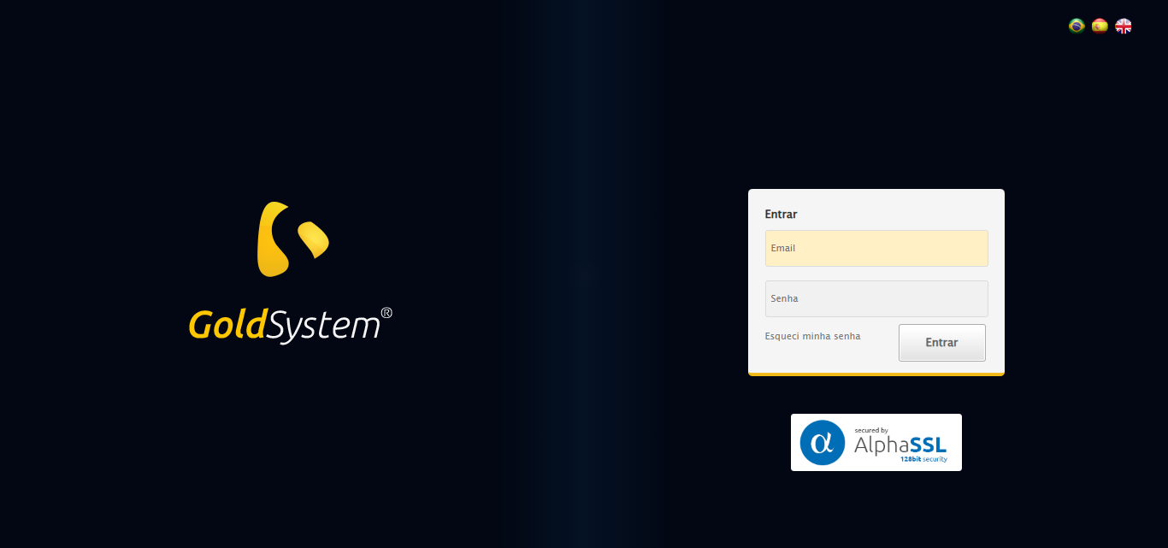

🔄 Realizando login...

✅ Realizando login realizada com sucesso.

Screenshot: realizando_login

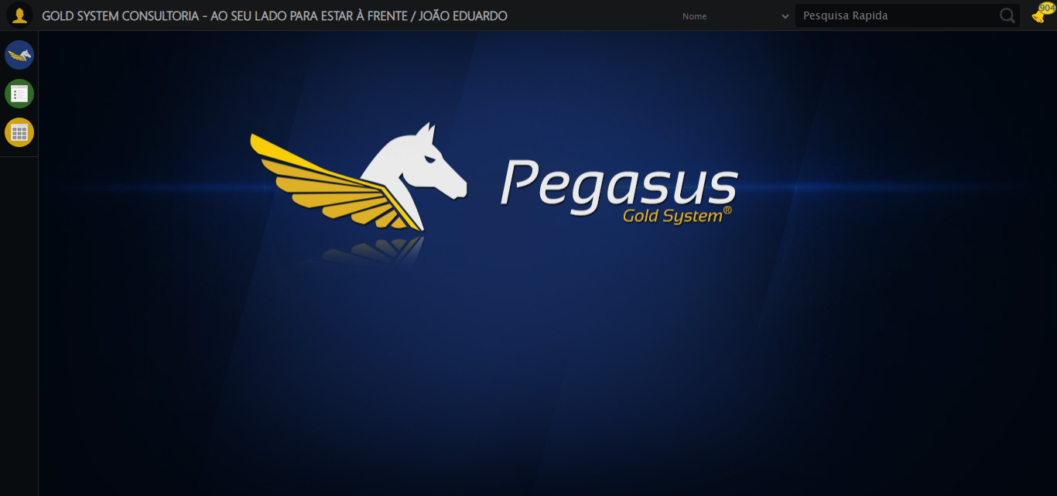

🔄 Ajustando zoom e abrindo menu...

🔍 Zoom ajustado para 90%.

✅ Ajustando zoom e abrindo menu realizada com sucesso.

Screenshot: ajustando_zoom_e_abrindo_menu

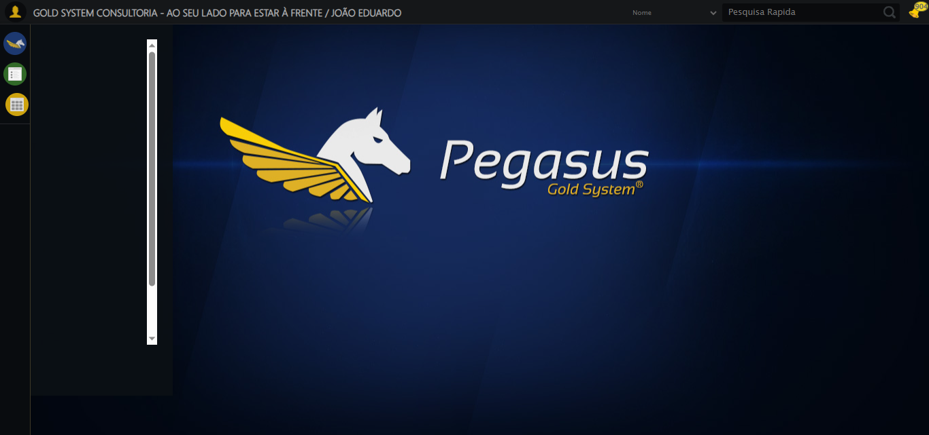

🔄 Acessando Agenda Ambulância...

✅ Acessando Agenda Ambulância realizada com sucesso.

Screenshot: acessando_agenda_ambulância

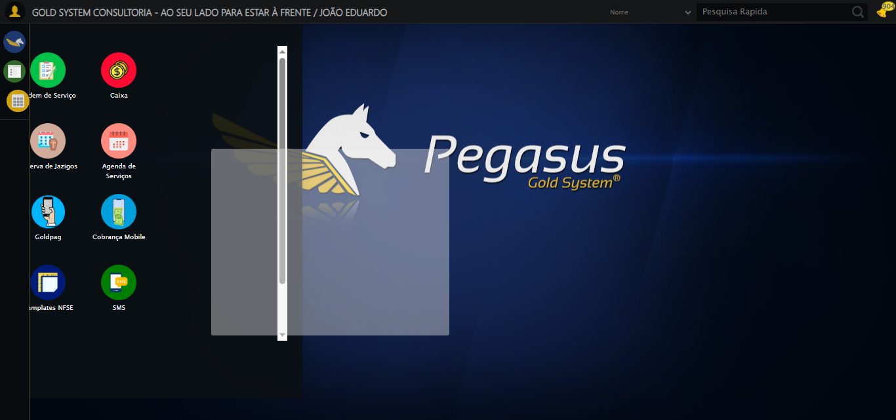

🔄 Clicando em Consultar...

✅ Clicando em Consultar realizada com sucesso.

Screenshot: clicando_em_consultar

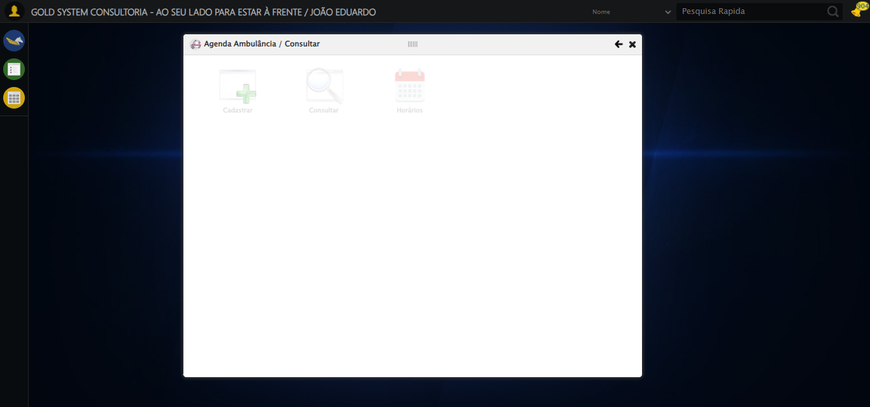

🔄 Preenchendo o Número da Agenda...

✅ Preenchendo o Número da Agenda realizada com sucesso.

Screenshot: preenchendo_o_número_da_agenda

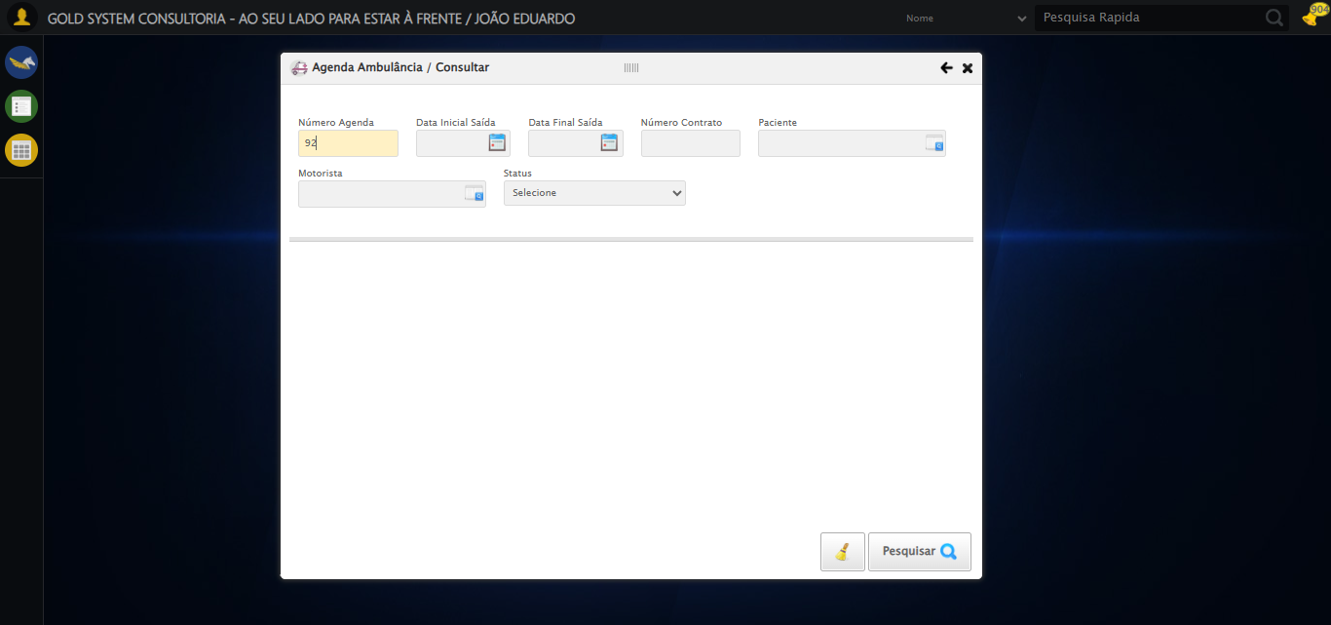

🔄 Preenchendo Data Inicial Saída...

⚠️ Tentativa 1 falhou: Message: invalid selector: An invalid or illegal selector was specified  
 (Session info: chrome=138.0.7204.185); For documentation on this error, please visit: https://www.selenium.dev/documentation/webdriver/troubleshooting/errors#invalid-selector-exception  
Stacktrace:  
 GetHandleVerifier [0x0x38ba83+63395]  
 GetHandleVerifier [0x0x38bac4+63460]  
 (No symbol) [0x0x1d2113]  
 (No symbol) [0x0x1d88e9]  
 (No symbol) [0x0x1dac7a]  
 (No symbol) [0x0x1dacf7]  
 (No symbol) [0x0x21a0f4]  
 (No symbol) [0x0x21abfb]  
 (No symbol) [0x0x262f92]  
 (No symbol) [0x0x23f3f4]  
 (No symbol) [0x0x2607ba]  
 (No symbol) [0x0x23f1a6]  
 (No symbol) [0x0x20e7b2]  
 (No symbol) [0x0x20f654]  
 GetHandleVerifier [0x0x608883+2672035]  
 GetHandleVerifier [0x0x603cba+2652634]  
 GetHandleVerifier [0x0x3b2bca+223466]  
 GetHandleVerifier [0x0x3a2cb8+158168]  
 GetHandleVerifier [0x0x3a978d+185517]  
 GetHandleVerifier [0x0x393b78+96408]  
 GetHandleVerifier [0x0x393d02+96802]  
 GetHandleVerifier [0x0x37e90a+9770]  
 BaseThreadInitThunk [0x0x773dfcc9+25]  
 RtlGetAppContainerNamedObjectPath [0x0x77ba82ae+286]  
 RtlGetAppContainerNamedObjectPath [0x0x77ba827e+238]

⚠️ Tentativa 2 falhou: Message: invalid selector: An invalid or illegal selector was specified  
 (Session info: chrome=138.0.7204.185); For documentation on this error, please visit: https://www.selenium.dev/documentation/webdriver/troubleshooting/errors#invalid-selector-exception  
Stacktrace:  
 GetHandleVerifier [0x0x38ba83+63395]  
 GetHandleVerifier [0x0x38bac4+63460]  
 (No symbol) [0x0x1d2113]  
 (No symbol) [0x0x1d88e9]  
 (No symbol) [0x0x1dac7a]  
 (No symbol) [0x0x1dacf7]  
 (No symbol) [0x0x21a0f4]  
 (No symbol) [0x0x21abfb]  
 (No symbol) [0x0x262f92]  
 (No symbol) [0x0x23f3f4]  
 (No symbol) [0x0x2607ba]  
 (No symbol) [0x0x23f1a6]  
 (No symbol) [0x0x20e7b2]  
 (No symbol) [0x0x20f654]  
 GetHandleVerifier [0x0x608883+2672035]  
 GetHandleVerifier [0x0x603cba+2652634]  
 GetHandleVerifier [0x0x3b2bca+223466]  
 GetHandleVerifier [0x0x3a2cb8+158168]  
 GetHandleVerifier [0x0x3a978d+185517]  
 GetHandleVerifier [0x0x393b78+96408]  
 GetHandleVerifier [0x0x393d02+96802]  
 GetHandleVerifier [0x0x37e90a+9770]  
 BaseThreadInitThunk [0x0x773dfcc9+25]  
 RtlGetAppContainerNamedObjectPath [0x0x77ba82ae+286]  
 RtlGetAppContainerNamedObjectPath [0x0x77ba827e+238]

⚠️ Tentativa 3 falhou: Message: invalid selector: An invalid or illegal selector was specified  
 (Session info: chrome=138.0.7204.185); For documentation on this error, please visit: https://www.selenium.dev/documentation/webdriver/troubleshooting/errors#invalid-selector-exception  
Stacktrace:  
 GetHandleVerifier [0x0x38ba83+63395]  
 GetHandleVerifier [0x0x38bac4+63460]  
 (No symbol) [0x0x1d2113]  
 (No symbol) [0x0x1d88e9]  
 (No symbol) [0x0x1dac7a]  
 (No symbol) [0x0x1dacf7]  
 (No symbol) [0x0x21a0f4]  
 (No symbol) [0x0x21abfb]  
 (No symbol) [0x0x262f92]  
 (No symbol) [0x0x23f3f4]  
 (No symbol) [0x0x2607ba]  
 (No symbol) [0x0x23f1a6]  
 (No symbol) [0x0x20e7b2]  
 (No symbol) [0x0x20f654]  
 GetHandleVerifier [0x0x608883+2672035]  
 GetHandleVerifier [0x0x603cba+2652634]  
 GetHandleVerifier [0x0x3b2bca+223466]  
 GetHandleVerifier [0x0x3a2cb8+158168]  
 GetHandleVerifier [0x0x3a978d+185517]  
 GetHandleVerifier [0x0x393b78+96408]  
 GetHandleVerifier [0x0x393d02+96802]  
 GetHandleVerifier [0x0x37e90a+9770]  
 BaseThreadInitThunk [0x0x773dfcc9+25]  
 RtlGetAppContainerNamedObjectPath [0x0x77ba82ae+286]  
 RtlGetAppContainerNamedObjectPath [0x0x77ba827e+238]

✅ Preenchendo Data Inicial Saída realizada com sucesso.

Screenshot: preenchendo_data_inicial_saída



🔄 Preenchendo Data Final Saída...

⚠️ Tentativa 1 falhou: Message: invalid selector: An invalid or illegal selector was specified  
 (Session info: chrome=138.0.7204.185); For documentation on this error, please visit: https://www.selenium.dev/documentation/webdriver/troubleshooting/errors#invalid-selector-exception  
Stacktrace:  
 GetHandleVerifier [0x0x38ba83+63395]  
 GetHandleVerifier [0x0x38bac4+63460]  
 (No symbol) [0x0x1d2113]  
 (No symbol) [0x0x1d88e9]  
 (No symbol) [0x0x1dac7a]  
 (No symbol) [0x0x1dacf7]  
 (No symbol) [0x0x21a0f4]  
 (No symbol) [0x0x21abfb]  
 (No symbol) [0x0x262f92]  
 (No symbol) [0x0x23f3f4]  
 (No symbol) [0x0x2607ba]  
 (No symbol) [0x0x23f1a6]  
 (No symbol) [0x0x20e7b2]  
 (No symbol) [0x0x20f654]  
 GetHandleVerifier [0x0x608883+2672035]  
 GetHandleVerifier [0x0x603cba+2652634]  
 GetHandleVerifier [0x0x3b2bca+223466]  
 GetHandleVerifier [0x0x3a2cb8+158168]  
 GetHandleVerifier [0x0x3a978d+185517]  
 GetHandleVerifier [0x0x393b78+96408]  
 GetHandleVerifier [0x0x393d02+96802]  
 GetHandleVerifier [0x0x37e90a+9770]  
 BaseThreadInitThunk [0x0x773dfcc9+25]  
 RtlGetAppContainerNamedObjectPath [0x0x77ba82ae+286]  
 RtlGetAppContainerNamedObjectPath [0x0x77ba827e+238]

⚠️ Tentativa 2 falhou: Message: invalid selector: An invalid or illegal selector was specified  
 (Session info: chrome=138.0.7204.185); For documentation on this error, please visit: https://www.selenium.dev/documentation/webdriver/troubleshooting/errors#invalid-selector-exception  
Stacktrace:  
 GetHandleVerifier [0x0x38ba83+63395]  
 GetHandleVerifier [0x0x38bac4+63460]  
 (No symbol) [0x0x1d2113]  
 (No symbol) [0x0x1d88e9]  
 (No symbol) [0x0x1dac7a]  
 (No symbol) [0x0x1dacf7]  
 (No symbol) [0x0x21a0f4]  
 (No symbol) [0x0x21abfb]  
 (No symbol) [0x0x262f92]  
 (No symbol) [0x0x23f3f4]  
 (No symbol) [0x0x2607ba]  
 (No symbol) [0x0x23f1a6]  
 (No symbol) [0x0x20e7b2]  
 (No symbol) [0x0x20f654]  
 GetHandleVerifier [0x0x608883+2672035]  
 GetHandleVerifier [0x0x603cba+2652634]  
 GetHandleVerifier [0x0x3b2bca+223466]  
 GetHandleVerifier [0x0x3a2cb8+158168]  
 GetHandleVerifier [0x0x3a978d+185517]  
 GetHandleVerifier [0x0x393b78+96408]  
 GetHandleVerifier [0x0x393d02+96802]  
 GetHandleVerifier [0x0x37e90a+9770]  
 BaseThreadInitThunk [0x0x773dfcc9+25]  
 RtlGetAppContainerNamedObjectPath [0x0x77ba82ae+286]  
 RtlGetAppContainerNamedObjectPath [0x0x77ba827e+238]

⚠️ Tentativa 3 falhou: Message: invalid selector: An invalid or illegal selector was specified  
 (Session info: chrome=138.0.7204.185); For documentation on this error, please visit: https://www.selenium.dev/documentation/webdriver/troubleshooting/errors#invalid-selector-exception  
Stacktrace:  
 GetHandleVerifier [0x0x38ba83+63395]  
 GetHandleVerifier [0x0x38bac4+63460]  
 (No symbol) [0x0x1d2113]  
 (No symbol) [0x0x1d88e9]  
 (No symbol) [0x0x1dac7a]  
 (No symbol) [0x0x1dacf7]  
 (No symbol) [0x0x21a0f4]  
 (No symbol) [0x0x21abfb]  
 (No symbol) [0x0x262f92]  
 (No symbol) [0x0x23f3f4]  
 (No symbol) [0x0x2607ba]  
 (No symbol) [0x0x23f1a6]  
 (No symbol) [0x0x20e7b2]  
 (No symbol) [0x0x20f654]  
 GetHandleVerifier [0x0x608883+2672035]  
 GetHandleVerifier [0x0x603cba+2652634]  
 GetHandleVerifier [0x0x3b2bca+223466]  
 GetHandleVerifier [0x0x3a2cb8+158168]  
 GetHandleVerifier [0x0x3a978d+185517]  
 GetHandleVerifier [0x0x393b78+96408]  
 GetHandleVerifier [0x0x393d02+96802]  
 GetHandleVerifier [0x0x37e90a+9770]  
 BaseThreadInitThunk [0x0x773dfcc9+25]  
 RtlGetAppContainerNamedObjectPath [0x0x77ba82ae+286]  
 RtlGetAppContainerNamedObjectPath [0x0x77ba827e+238]

✅ Preenchendo Data Final Saída realizada com sucesso.

Screenshot: preenchendo_data_final_saída



🔄 Preenchendo o Número do Contrato...

✅ Preenchendo o Número do Contrato realizada com sucesso.

Screenshot: preenchendo_o_número_do_contrato

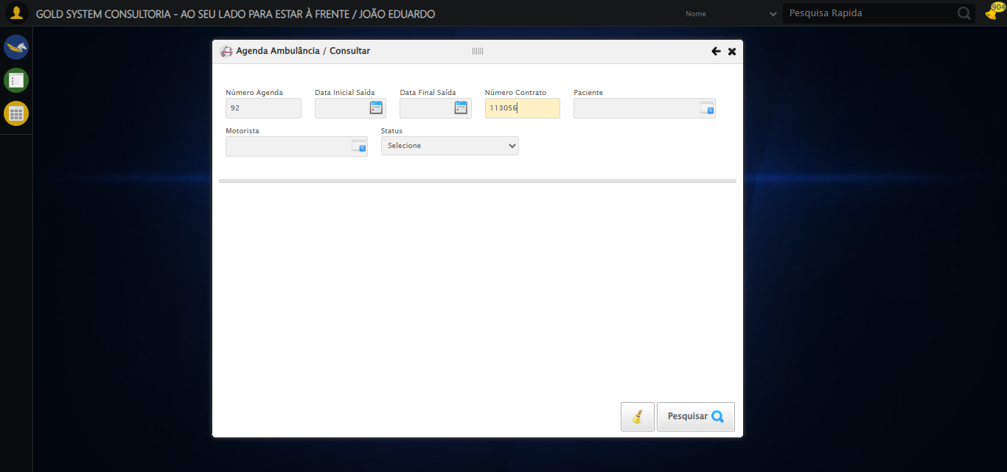

🔄 Selecionando Paciente...

✅ Selecionando Paciente realizada com sucesso.

Screenshot: selecionando_paciente

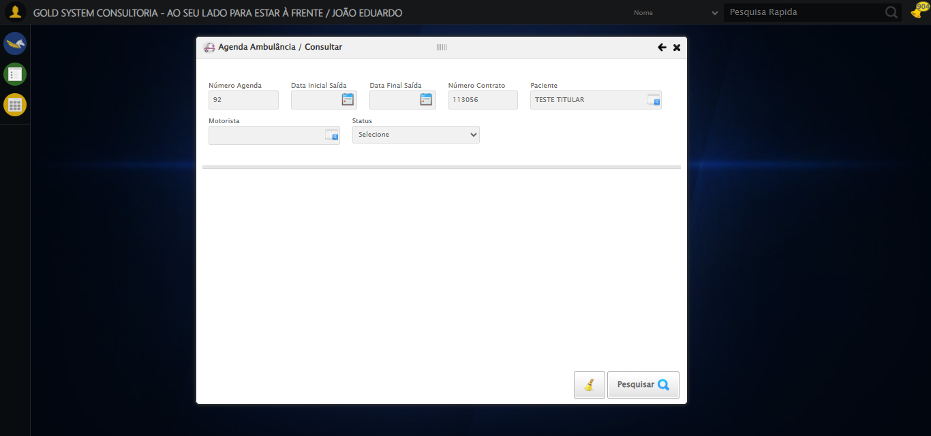

🔄 Selecionando Motorista...

✅ Selecionando Motorista realizada com sucesso.

Screenshot: selecionando_motorista

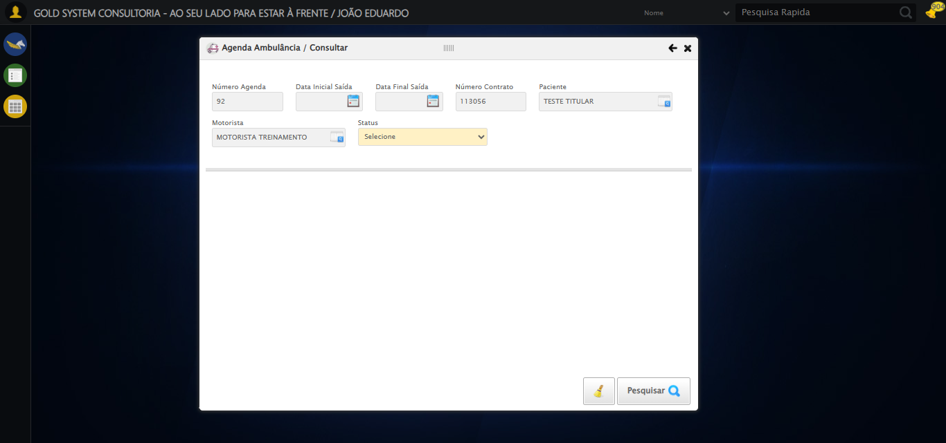

🔄 Selecionando Status...

✅ Selecionando Status realizada com sucesso.

Screenshot: selecionando_status

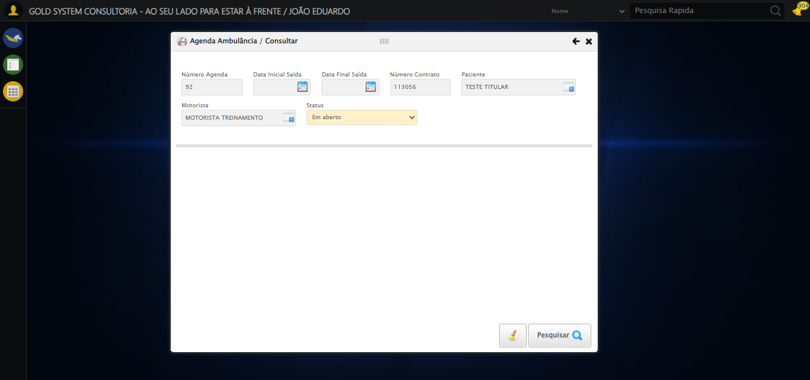

🔄 Realizando Consulta......

✅ Realizando Consulta... realizada com sucesso.

Screenshot: realizando_consulta...

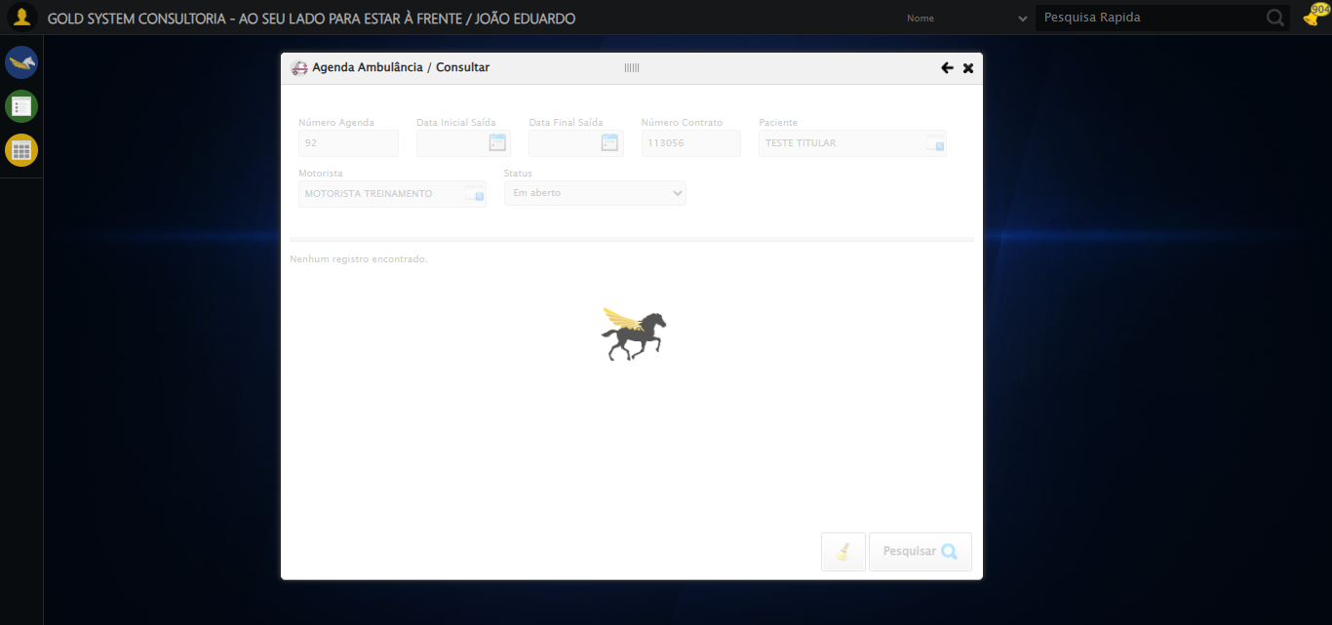

🔄 Realizando a limpeza dos campos...

✅ Realizando a limpeza dos campos realizada com sucesso.

Screenshot: realizando_a_limpeza_dos_campos

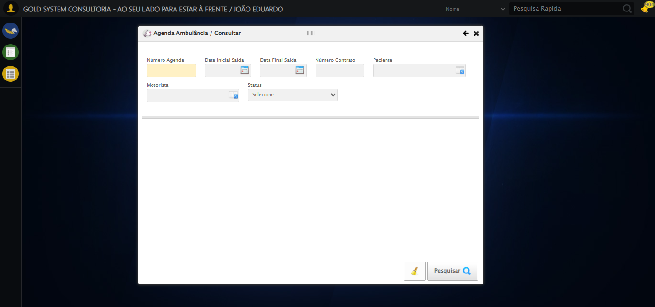

🔄 Fechando modal após a consulta...

✅ Fechando modal após a consulta realizada com sucesso.

Screenshot: fechando_modal_após_a_consulta

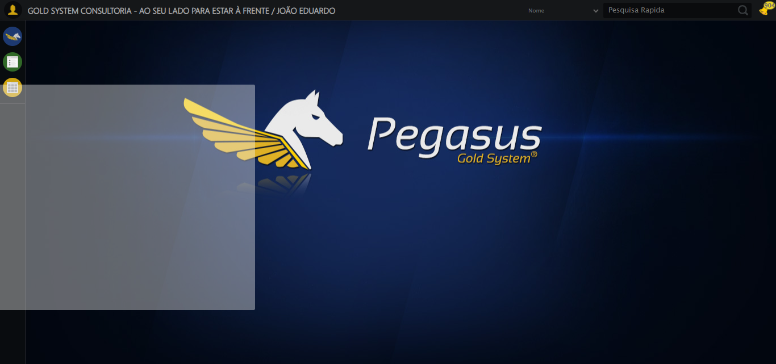

✅ Teste concluído.

✅ Teste executado com sucesso!