RELATÓRIO DO TESTE

Consulta de Agenda de Ambulância – Cenário 1: Preenchimento e realização da consulta

Data do teste: 07/08/2025 15:26:03

🚀 Iniciando teste de Consulta de Agenda de Ambulância...

🔄 Acessando sistema...

✅ Acessando sistema realizada com sucesso.

Screenshot: acessando_sistema

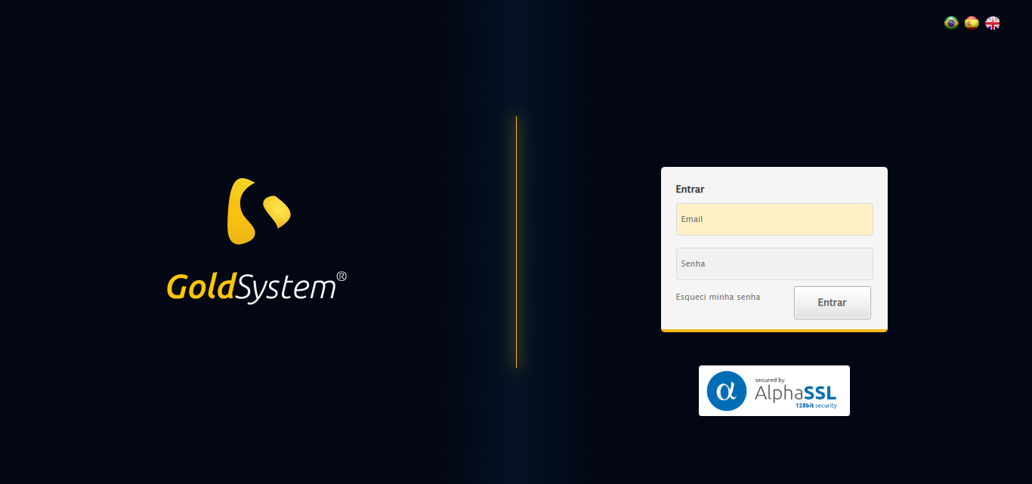

🔄 Realizando login...

✅ Realizando login realizada com sucesso.

Screenshot: realizando_login

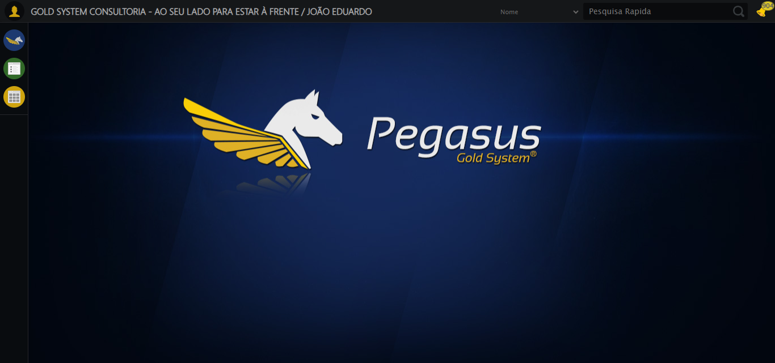

🔄 Ajustando zoom e abrindo menu...

🔍 Zoom ajustado para 90%.

✅ Ajustando zoom e abrindo menu realizada com sucesso.

Screenshot: ajustando_zoom_e_abrindo_menu

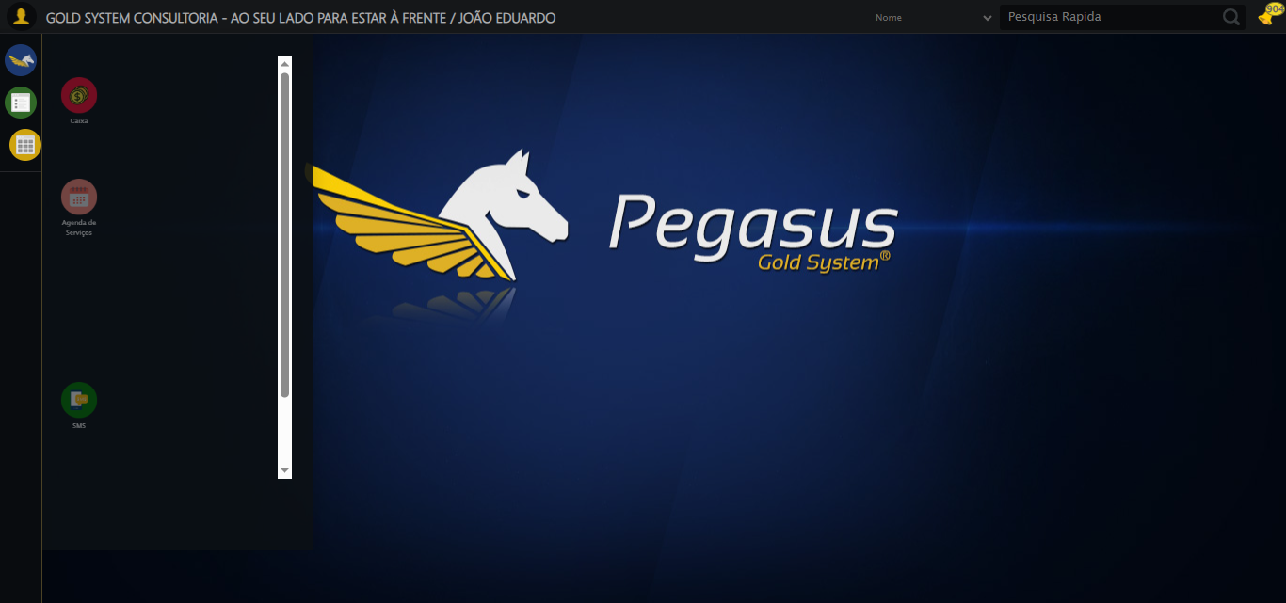

🔄 Acessando Agenda Ambulância...

✅ Acessando Agenda Ambulância realizada com sucesso.

Screenshot: acessando_agenda_ambulância

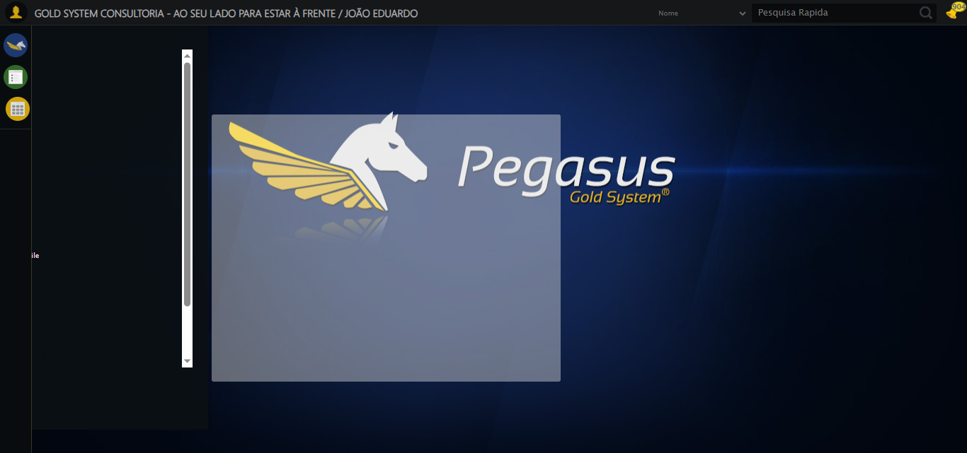

🔄 Clicando em Consultar...

✅ Clicando em Consultar realizada com sucesso.

Screenshot: clicando_em_consultar

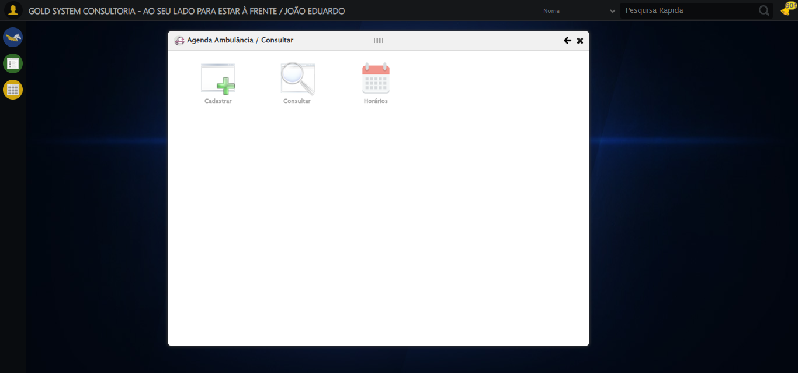

🔄 Preenchendo o Número da Agenda...

✅ Preenchendo o Número da Agenda realizada com sucesso.

Screenshot: preenchendo_o_número_da_agenda

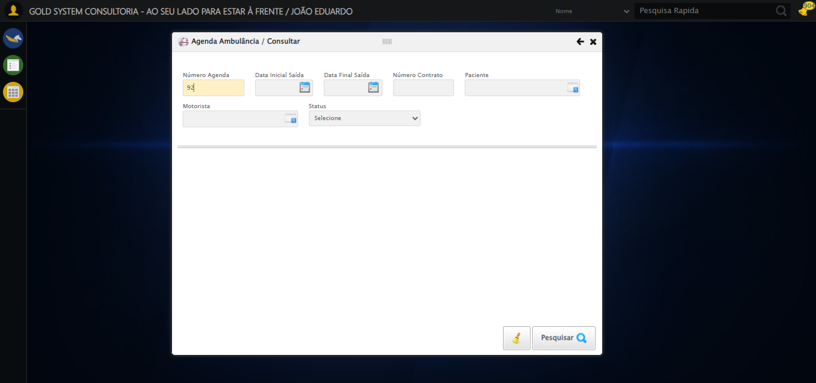

🔄 Preenchendo Data Inicial Saída...

⚠️ Tentativa 1 falhou: Message:   
Stacktrace:  
 GetHandleVerifier [0x0xe5ba83+63395]  
 GetHandleVerifier [0x0xe5bac4+63460]  
 (No symbol) [0x0xca2113]  
 (No symbol) [0x0xcea85e]  
 (No symbol) [0x0xceabfb]  
 (No symbol) [0x0xd32f92]  
 (No symbol) [0x0xd0f3f4]  
 (No symbol) [0x0xd307ba]  
 (No symbol) [0x0xd0f1a6]  
 (No symbol) [0x0xcde7b2]  
 (No symbol) [0x0xcdf654]  
 GetHandleVerifier [0x0x10d8883+2672035]  
 GetHandleVerifier [0x0x10d3cba+2652634]  
 GetHandleVerifier [0x0xe82bca+223466]  
 GetHandleVerifier [0x0xe72cb8+158168]  
 GetHandleVerifier [0x0xe7978d+185517]  
 GetHandleVerifier [0x0xe63b78+96408]  
 GetHandleVerifier [0x0xe63d02+96802]  
 GetHandleVerifier [0x0xe4e90a+9770]  
 BaseThreadInitThunk [0x0x773dfcc9+25]  
 RtlGetAppContainerNamedObjectPath [0x0x77ba82ae+286]  
 RtlGetAppContainerNamedObjectPath [0x0x77ba827e+238]

⚠️ Tentativa 2 falhou: Message:   
Stacktrace:  
 GetHandleVerifier [0x0xe5ba83+63395]  
 GetHandleVerifier [0x0xe5bac4+63460]  
 (No symbol) [0x0xca2113]  
 (No symbol) [0x0xcea85e]  
 (No symbol) [0x0xceabfb]  
 (No symbol) [0x0xd32f92]  
 (No symbol) [0x0xd0f3f4]  
 (No symbol) [0x0xd307ba]  
 (No symbol) [0x0xd0f1a6]  
 (No symbol) [0x0xcde7b2]  
 (No symbol) [0x0xcdf654]  
 GetHandleVerifier [0x0x10d8883+2672035]  
 GetHandleVerifier [0x0x10d3cba+2652634]  
 GetHandleVerifier [0x0xe82bca+223466]  
 GetHandleVerifier [0x0xe72cb8+158168]  
 GetHandleVerifier [0x0xe7978d+185517]  
 GetHandleVerifier [0x0xe63b78+96408]  
 GetHandleVerifier [0x0xe63d02+96802]  
 GetHandleVerifier [0x0xe4e90a+9770]  
 BaseThreadInitThunk [0x0x773dfcc9+25]  
 RtlGetAppContainerNamedObjectPath [0x0x77ba82ae+286]  
 RtlGetAppContainerNamedObjectPath [0x0x77ba827e+238]

⚠️ Tentativa 3 falhou: Message:   
Stacktrace:  
 GetHandleVerifier [0x0xe5ba83+63395]  
 GetHandleVerifier [0x0xe5bac4+63460]  
 (No symbol) [0x0xca2113]  
 (No symbol) [0x0xcea85e]  
 (No symbol) [0x0xceabfb]  
 (No symbol) [0x0xd32f92]  
 (No symbol) [0x0xd0f3f4]  
 (No symbol) [0x0xd307ba]  
 (No symbol) [0x0xd0f1a6]  
 (No symbol) [0x0xcde7b2]  
 (No symbol) [0x0xcdf654]  
 GetHandleVerifier [0x0x10d8883+2672035]  
 GetHandleVerifier [0x0x10d3cba+2652634]  
 GetHandleVerifier [0x0xe82bca+223466]  
 GetHandleVerifier [0x0xe72cb8+158168]  
 GetHandleVerifier [0x0xe7978d+185517]  
 GetHandleVerifier [0x0xe63b78+96408]  
 GetHandleVerifier [0x0xe63d02+96802]  
 GetHandleVerifier [0x0xe4e90a+9770]  
 BaseThreadInitThunk [0x0x773dfcc9+25]  
 RtlGetAppContainerNamedObjectPath [0x0x77ba82ae+286]  
 RtlGetAppContainerNamedObjectPath [0x0x77ba827e+238]

✅ Preenchendo Data Inicial Saída realizada com sucesso.

Screenshot: preenchendo_data_inicial_saída

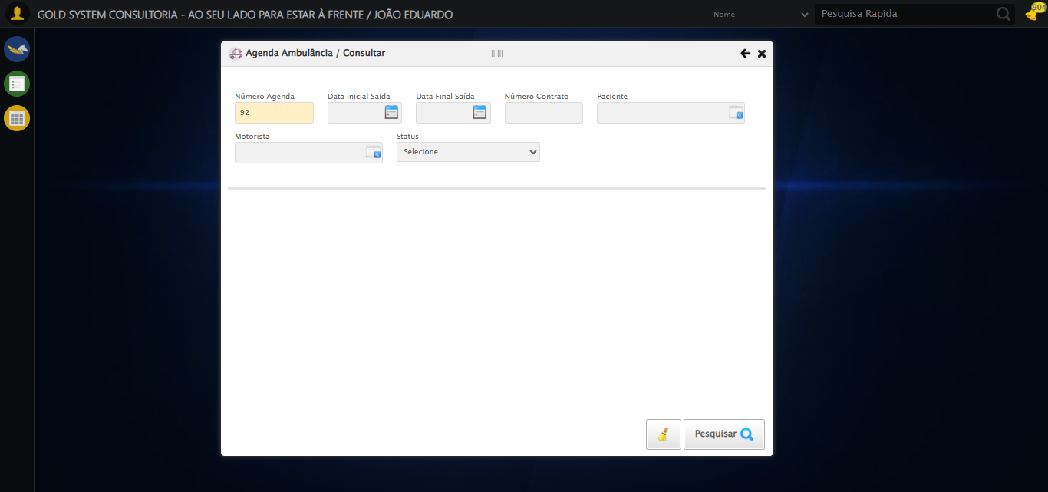

🔄 Preenchendo Data Final Saída...

⚠️ Tentativa 1 falhou: Message:   
Stacktrace:  
 GetHandleVerifier [0x0xe5ba83+63395]  
 GetHandleVerifier [0x0xe5bac4+63460]  
 (No symbol) [0x0xca2113]  
 (No symbol) [0x0xcea85e]  
 (No symbol) [0x0xceabfb]  
 (No symbol) [0x0xd32f92]  
 (No symbol) [0x0xd0f3f4]  
 (No symbol) [0x0xd307ba]  
 (No symbol) [0x0xd0f1a6]  
 (No symbol) [0x0xcde7b2]  
 (No symbol) [0x0xcdf654]  
 GetHandleVerifier [0x0x10d8883+2672035]  
 GetHandleVerifier [0x0x10d3cba+2652634]  
 GetHandleVerifier [0x0xe82bca+223466]  
 GetHandleVerifier [0x0xe72cb8+158168]  
 GetHandleVerifier [0x0xe7978d+185517]  
 GetHandleVerifier [0x0xe63b78+96408]  
 GetHandleVerifier [0x0xe63d02+96802]  
 GetHandleVerifier [0x0xe4e90a+9770]  
 BaseThreadInitThunk [0x0x773dfcc9+25]  
 RtlGetAppContainerNamedObjectPath [0x0x77ba82ae+286]  
 RtlGetAppContainerNamedObjectPath [0x0x77ba827e+238]

⚠️ Tentativa 2 falhou: Message:   
Stacktrace:  
 GetHandleVerifier [0x0xe5ba83+63395]  
 GetHandleVerifier [0x0xe5bac4+63460]  
 (No symbol) [0x0xca2113]  
 (No symbol) [0x0xcea85e]  
 (No symbol) [0x0xceabfb]  
 (No symbol) [0x0xd32f92]  
 (No symbol) [0x0xd0f3f4]  
 (No symbol) [0x0xd307ba]  
 (No symbol) [0x0xd0f1a6]  
 (No symbol) [0x0xcde7b2]  
 (No symbol) [0x0xcdf654]  
 GetHandleVerifier [0x0x10d8883+2672035]  
 GetHandleVerifier [0x0x10d3cba+2652634]  
 GetHandleVerifier [0x0xe82bca+223466]  
 GetHandleVerifier [0x0xe72cb8+158168]  
 GetHandleVerifier [0x0xe7978d+185517]  
 GetHandleVerifier [0x0xe63b78+96408]  
 GetHandleVerifier [0x0xe63d02+96802]  
 GetHandleVerifier [0x0xe4e90a+9770]  
 BaseThreadInitThunk [0x0x773dfcc9+25]  
 RtlGetAppContainerNamedObjectPath [0x0x77ba82ae+286]  
 RtlGetAppContainerNamedObjectPath [0x0x77ba827e+238]

⚠️ Tentativa 3 falhou: Message:   
Stacktrace:  
 GetHandleVerifier [0x0xe5ba83+63395]  
 GetHandleVerifier [0x0xe5bac4+63460]  
 (No symbol) [0x0xca2113]  
 (No symbol) [0x0xcea85e]  
 (No symbol) [0x0xceabfb]  
 (No symbol) [0x0xd32f92]  
 (No symbol) [0x0xd0f3f4]  
 (No symbol) [0x0xd307ba]  
 (No symbol) [0x0xd0f1a6]  
 (No symbol) [0x0xcde7b2]  
 (No symbol) [0x0xcdf654]  
 GetHandleVerifier [0x0x10d8883+2672035]  
 GetHandleVerifier [0x0x10d3cba+2652634]  
 GetHandleVerifier [0x0xe82bca+223466]  
 GetHandleVerifier [0x0xe72cb8+158168]  
 GetHandleVerifier [0x0xe7978d+185517]  
 GetHandleVerifier [0x0xe63b78+96408]  
 GetHandleVerifier [0x0xe63d02+96802]  
 GetHandleVerifier [0x0xe4e90a+9770]  
 BaseThreadInitThunk [0x0x773dfcc9+25]  
 RtlGetAppContainerNamedObjectPath [0x0x77ba82ae+286]  
 RtlGetAppContainerNamedObjectPath [0x0x77ba827e+238]

✅ Preenchendo Data Final Saída realizada com sucesso.

Screenshot: preenchendo_data_final_saída

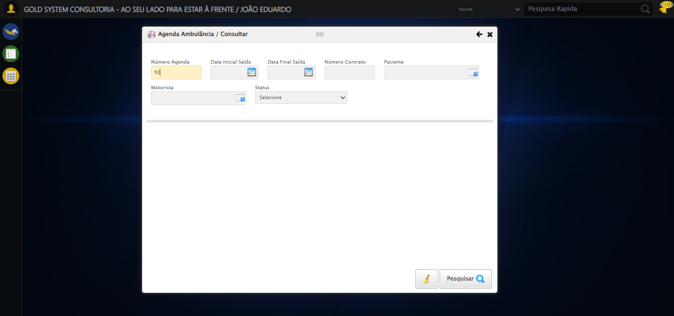

🔄 Preenchendo o Número do Contrato...

✅ Preenchendo o Número do Contrato realizada com sucesso.

Screenshot: preenchendo_o_número_do_contrato

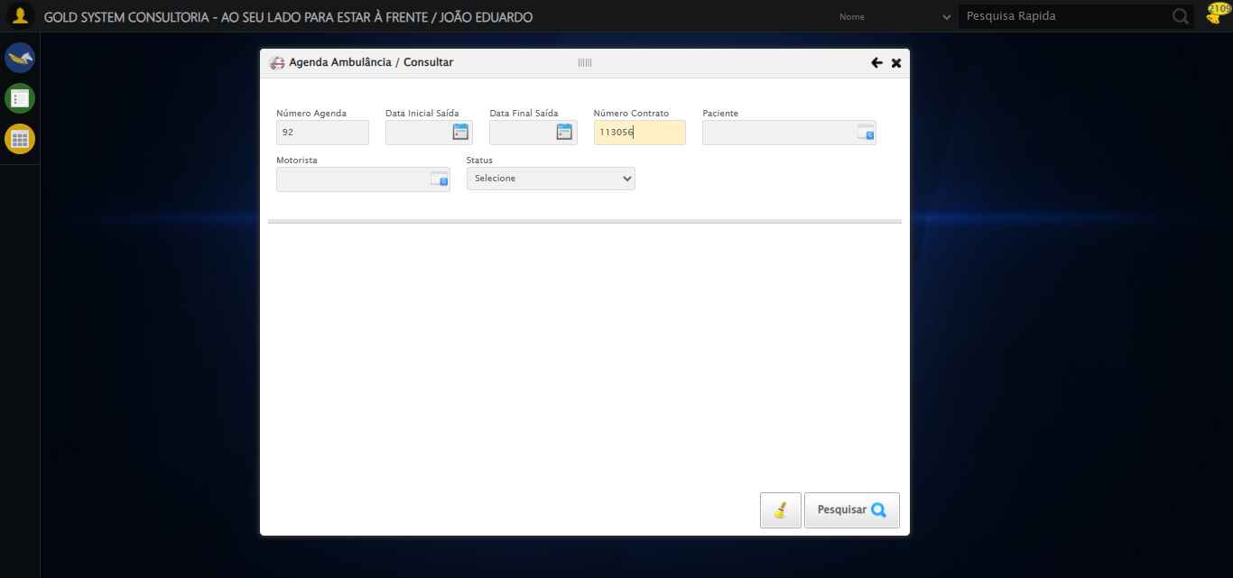

🔄 Selecionando Paciente...

❌ Erro inesperado ao selecionando paciente: Message: invalid session id: session deleted as the browser has closed the connection  
from disconnected: not connected to DevTools  
 (Session info: chrome=138.0.7204.185)  
Stacktrace:  
 GetHandleVerifier [0x0xe5ba83+63395]  
 GetHandleVerifier [0x0xe5bac4+63460]  
 (No symbol) [0x0xca2113]  
 (No symbol) [0x0xc91b20]  
 (No symbol) [0x0xcaf922]  
 (No symbol) [0x0xd15c9c]  
 (No symbol) [0x0xd30099]  
 (No symbol) [0x0xd0f1a6]  
 (No symbol) [0x0xcde7b2]  
 (No symbol) [0x0xcdf654]  
 GetHandleVerifier [0x0x10d8883+2672035]  
 GetHandleVerifier [0x0x10d3cba+2652634]  
 GetHandleVerifier [0x0xe82bca+223466]  
 GetHandleVerifier [0x0xe72cb8+158168]  
 GetHandleVerifier [0x0xe7978d+185517]  
 GetHandleVerifier [0x0xe63b78+96408]  
 GetHandleVerifier [0x0xe63d02+96802]  
 GetHandleVerifier [0x0xe4e90a+9770]  
 BaseThreadInitThunk [0x0x773dfcc9+25]  
 RtlGetAppContainerNamedObjectPath [0x0x77ba82ae+286]  
 RtlGetAppContainerNamedObjectPath [0x0x77ba827e+238]

⚠️ Erro ao tirar screenshot erro_selecionando_paciente: Message: invalid session id  
Stacktrace:  
 GetHandleVerifier [0x0xe5ba83+63395]  
 GetHandleVerifier [0x0xe5bac4+63460]  
 (No symbol) [0x0xca1f70]  
 (No symbol) [0x0xcddaa8]  
 (No symbol) [0x0xd0f266]  
 (No symbol) [0x0xd0ae65]  
 (No symbol) [0x0xd0a3e6]  
 (No symbol) [0x0xc73a45]  
 (No symbol) [0x0xc73f9e]  
 (No symbol) [0x0xc7442d]  
 GetHandleVerifier [0x0x10d8883+2672035]  
 GetHandleVerifier [0x0x10d3cba+2652634]  
 GetHandleVerifier [0x0xe82bca+223466]  
 GetHandleVerifier [0x0xe72cb8+158168]  
 GetHandleVerifier [0x0xe7978d+185517]  
 (No symbol) [0x0xc73710]  
 (No symbol) [0x0xc72f1d]  
 GetHandleVerifier [0x0x120db9c+3938492]  
 BaseThreadInitThunk [0x0x773dfcc9+25]  
 RtlGetAppContainerNamedObjectPath [0x0x77ba82ae+286]  
 RtlGetAppContainerNamedObjectPath [0x0x77ba827e+238]

🔄 Selecionando Motorista...

❌ Erro ao interagir com elemento #gsAgendaAmbulancia > div.wdTelas > div.telaConsulta.telaConsultaAgendaAmbulancia > div > div.formRow.filtrosConsulta > div > div:nth-child(6) > div > a: Message: invalid session id  
Stacktrace:  
 GetHandleVerifier [0x0xe5ba83+63395]  
 GetHandleVerifier [0x0xe5bac4+63460]  
 (No symbol) [0x0xca1f70]  
 (No symbol) [0x0xcddaa8]  
 (No symbol) [0x0xd0f266]  
 (No symbol) [0x0xd0ae65]  
 (No symbol) [0x0xd0a3e6]  
 (No symbol) [0x0xc73a45]  
 (No symbol) [0x0xc73f9e]  
 (No symbol) [0x0xc7442d]  
 GetHandleVerifier [0x0x10d8883+2672035]  
 GetHandleVerifier [0x0x10d3cba+2652634]  
 GetHandleVerifier [0x0xe82bca+223466]  
 GetHandleVerifier [0x0xe72cb8+158168]  
 GetHandleVerifier [0x0xe7978d+185517]  
 (No symbol) [0x0xc73710]  
 (No symbol) [0x0xc72f1d]  
 GetHandleVerifier [0x0x120db9c+3938492]  
 BaseThreadInitThunk [0x0x773dfcc9+25]  
 RtlGetAppContainerNamedObjectPath [0x0x77ba82ae+286]  
 RtlGetAppContainerNamedObjectPath [0x0x77ba827e+238]

❌ Erro inesperado ao selecionando motorista: Message: invalid session id  
Stacktrace:  
 GetHandleVerifier [0x0xe5ba83+63395]  
 GetHandleVerifier [0x0xe5bac4+63460]  
 (No symbol) [0x0xca1f70]  
 (No symbol) [0x0xcddaa8]  
 (No symbol) [0x0xd0f266]  
 (No symbol) [0x0xd0ae65]  
 (No symbol) [0x0xd0a3e6]  
 (No symbol) [0x0xc73a45]  
 (No symbol) [0x0xc73f9e]  
 (No symbol) [0x0xc7442d]  
 GetHandleVerifier [0x0x10d8883+2672035]  
 GetHandleVerifier [0x0x10d3cba+2652634]  
 GetHandleVerifier [0x0xe82bca+223466]  
 GetHandleVerifier [0x0xe72cb8+158168]  
 GetHandleVerifier [0x0xe7978d+185517]  
 (No symbol) [0x0xc73710]  
 (No symbol) [0x0xc72f1d]  
 GetHandleVerifier [0x0x120db9c+3938492]  
 BaseThreadInitThunk [0x0x773dfcc9+25]  
 RtlGetAppContainerNamedObjectPath [0x0x77ba82ae+286]  
 RtlGetAppContainerNamedObjectPath [0x0x77ba827e+238]

⚠️ Erro ao tirar screenshot erro_selecionando_motorista: Message: invalid session id  
Stacktrace:  
 GetHandleVerifier [0x0xe5ba83+63395]  
 GetHandleVerifier [0x0xe5bac4+63460]  
 (No symbol) [0x0xca1f70]  
 (No symbol) [0x0xcddaa8]  
 (No symbol) [0x0xd0f266]  
 (No symbol) [0x0xd0ae65]  
 (No symbol) [0x0xd0a3e6]  
 (No symbol) [0x0xc73a45]  
 (No symbol) [0x0xc73f9e]  
 (No symbol) [0x0xc7442d]  
 GetHandleVerifier [0x0x10d8883+2672035]  
 GetHandleVerifier [0x0x10d3cba+2652634]  
 GetHandleVerifier [0x0xe82bca+223466]  
 GetHandleVerifier [0x0xe72cb8+158168]  
 GetHandleVerifier [0x0xe7978d+185517]  
 (No symbol) [0x0xc73710]  
 (No symbol) [0x0xc72f1d]  
 GetHandleVerifier [0x0x120db9c+3938492]  
 BaseThreadInitThunk [0x0x773dfcc9+25]  
 RtlGetAppContainerNamedObjectPath [0x0x77ba82ae+286]  
 RtlGetAppContainerNamedObjectPath [0x0x77ba827e+238]

🔄 Selecionando Status...

❌ Erro ao interagir com elemento #gsAgendaAmbulancia > div.wdTelas > div.telaConsulta.telaConsultaAgendaAmbulancia > div > div.formRow.filtrosConsulta > div > div:nth-child(7) > select: Message: invalid session id  
Stacktrace:  
 GetHandleVerifier [0x0xe5ba83+63395]  
 GetHandleVerifier [0x0xe5bac4+63460]  
 (No symbol) [0x0xca1f70]  
 (No symbol) [0x0xcddaa8]  
 (No symbol) [0x0xd0f266]  
 (No symbol) [0x0xd0ae65]  
 (No symbol) [0x0xd0a3e6]  
 (No symbol) [0x0xc73a45]  
 (No symbol) [0x0xc73f9e]  
 (No symbol) [0x0xc7442d]  
 GetHandleVerifier [0x0x10d8883+2672035]  
 GetHandleVerifier [0x0x10d3cba+2652634]  
 GetHandleVerifier [0x0xe82bca+223466]  
 GetHandleVerifier [0x0xe72cb8+158168]  
 GetHandleVerifier [0x0xe7978d+185517]  
 (No symbol) [0x0xc73710]  
 (No symbol) [0x0xc72f1d]  
 GetHandleVerifier [0x0x120db9c+3938492]  
 BaseThreadInitThunk [0x0x773dfcc9+25]  
 RtlGetAppContainerNamedObjectPath [0x0x77ba82ae+286]  
 RtlGetAppContainerNamedObjectPath [0x0x77ba827e+238]

❌ Erro inesperado ao selecionando status: Não foi possível encontrar o select: #gsAgendaAmbulancia > div.wdTelas > div.telaConsulta.telaConsultaAgendaAmbulancia > div > div.formRow.filtrosConsulta > div > div:nth-child(7) > select

⚠️ Erro ao tirar screenshot erro_selecionando_status: Message: invalid session id  
Stacktrace:  
 GetHandleVerifier [0x0xe5ba83+63395]  
 GetHandleVerifier [0x0xe5bac4+63460]  
 (No symbol) [0x0xca1f70]  
 (No symbol) [0x0xcddaa8]  
 (No symbol) [0x0xd0f266]  
 (No symbol) [0x0xd0ae65]  
 (No symbol) [0x0xd0a3e6]  
 (No symbol) [0x0xc73a45]  
 (No symbol) [0x0xc73f9e]  
 (No symbol) [0x0xc7442d]  
 GetHandleVerifier [0x0x10d8883+2672035]  
 GetHandleVerifier [0x0x10d3cba+2652634]  
 GetHandleVerifier [0x0xe82bca+223466]  
 GetHandleVerifier [0x0xe72cb8+158168]  
 GetHandleVerifier [0x0xe7978d+185517]  
 (No symbol) [0x0xc73710]  
 (No symbol) [0x0xc72f1d]  
 GetHandleVerifier [0x0x120db9c+3938492]  
 BaseThreadInitThunk [0x0x773dfcc9+25]  
 RtlGetAppContainerNamedObjectPath [0x0x77ba82ae+286]  
 RtlGetAppContainerNamedObjectPath [0x0x77ba827e+238]

🔄 Realizando Consulta......

❌ Erro inesperado ao realizando consulta...: Message: invalid session id  
Stacktrace:  
 GetHandleVerifier [0x0xe5ba83+63395]  
 GetHandleVerifier [0x0xe5bac4+63460]  
 (No symbol) [0x0xca1f70]  
 (No symbol) [0x0xcddaa8]  
 (No symbol) [0x0xd0f266]  
 (No symbol) [0x0xd0ae65]  
 (No symbol) [0x0xd0a3e6]  
 (No symbol) [0x0xc73a45]  
 (No symbol) [0x0xc73f9e]  
 (No symbol) [0x0xc7442d]  
 GetHandleVerifier [0x0x10d8883+2672035]  
 GetHandleVerifier [0x0x10d3cba+2652634]  
 GetHandleVerifier [0x0xe82bca+223466]  
 GetHandleVerifier [0x0xe72cb8+158168]  
 GetHandleVerifier [0x0xe7978d+185517]  
 (No symbol) [0x0xc73710]  
 (No symbol) [0x0xc72f1d]  
 GetHandleVerifier [0x0x120db9c+3938492]  
 BaseThreadInitThunk [0x0x773dfcc9+25]  
 RtlGetAppContainerNamedObjectPath [0x0x77ba82ae+286]  
 RtlGetAppContainerNamedObjectPath [0x0x77ba827e+238]

⚠️ Erro ao tirar screenshot erro_realizando_consulta...: Message: invalid session id  
Stacktrace:  
 GetHandleVerifier [0x0xe5ba83+63395]  
 GetHandleVerifier [0x0xe5bac4+63460]  
 (No symbol) [0x0xca1f70]  
 (No symbol) [0x0xcddaa8]  
 (No symbol) [0x0xd0f266]  
 (No symbol) [0x0xd0ae65]  
 (No symbol) [0x0xd0a3e6]  
 (No symbol) [0x0xc73a45]  
 (No symbol) [0x0xc73f9e]  
 (No symbol) [0x0xc7442d]  
 GetHandleVerifier [0x0x10d8883+2672035]  
 GetHandleVerifier [0x0x10d3cba+2652634]  
 GetHandleVerifier [0x0xe82bca+223466]  
 GetHandleVerifier [0x0xe72cb8+158168]  
 GetHandleVerifier [0x0xe7978d+185517]  
 (No symbol) [0x0xc73710]  
 (No symbol) [0x0xc72f1d]  
 GetHandleVerifier [0x0x120db9c+3938492]  
 BaseThreadInitThunk [0x0x773dfcc9+25]  
 RtlGetAppContainerNamedObjectPath [0x0x77ba82ae+286]  
 RtlGetAppContainerNamedObjectPath [0x0x77ba827e+238]

🔄 Realizando a limpeza dos campos...

❌ Erro inesperado ao realizando a limpeza dos campos: Message: invalid session id  
Stacktrace:  
 GetHandleVerifier [0x0xe5ba83+63395]  
 GetHandleVerifier [0x0xe5bac4+63460]  
 (No symbol) [0x0xca1f70]  
 (No symbol) [0x0xcddaa8]  
 (No symbol) [0x0xd0f266]  
 (No symbol) [0x0xd0ae65]  
 (No symbol) [0x0xd0a3e6]  
 (No symbol) [0x0xc73a45]  
 (No symbol) [0x0xc73f9e]  
 (No symbol) [0x0xc7442d]  
 GetHandleVerifier [0x0x10d8883+2672035]  
 GetHandleVerifier [0x0x10d3cba+2652634]  
 GetHandleVerifier [0x0xe82bca+223466]  
 GetHandleVerifier [0x0xe72cb8+158168]  
 GetHandleVerifier [0x0xe7978d+185517]  
 (No symbol) [0x0xc73710]  
 (No symbol) [0x0xc72f1d]  
 GetHandleVerifier [0x0x120db9c+3938492]  
 BaseThreadInitThunk [0x0x773dfcc9+25]  
 RtlGetAppContainerNamedObjectPath [0x0x77ba82ae+286]  
 RtlGetAppContainerNamedObjectPath [0x0x77ba827e+238]

⚠️ Erro ao tirar screenshot erro_realizando_a_limpeza_dos_campos: Message: invalid session id  
Stacktrace:  
 GetHandleVerifier [0x0xe5ba83+63395]  
 GetHandleVerifier [0x0xe5bac4+63460]  
 (No symbol) [0x0xca1f70]  
 (No symbol) [0x0xcddaa8]  
 (No symbol) [0x0xd0f266]  
 (No symbol) [0x0xd0ae65]  
 (No symbol) [0x0xd0a3e6]  
 (No symbol) [0x0xc73a45]  
 (No symbol) [0x0xc73f9e]  
 (No symbol) [0x0xc7442d]  
 GetHandleVerifier [0x0x10d8883+2672035]  
 GetHandleVerifier [0x0x10d3cba+2652634]  
 GetHandleVerifier [0x0xe82bca+223466]  
 GetHandleVerifier [0x0xe72cb8+158168]  
 GetHandleVerifier [0x0xe7978d+185517]  
 (No symbol) [0x0xc73710]  
 (No symbol) [0x0xc72f1d]  
 GetHandleVerifier [0x0x120db9c+3938492]  
 BaseThreadInitThunk [0x0x773dfcc9+25]  
 RtlGetAppContainerNamedObjectPath [0x0x77ba82ae+286]  
 RtlGetAppContainerNamedObjectPath [0x0x77ba827e+238]

🔄 Fechando modal após a consulta...

❌ Erro inesperado ao fechando modal após a consulta: Message: invalid session id  
Stacktrace:  
 GetHandleVerifier [0x0xe5ba83+63395]  
 GetHandleVerifier [0x0xe5bac4+63460]  
 (No symbol) [0x0xca1f70]  
 (No symbol) [0x0xcddaa8]  
 (No symbol) [0x0xd0f266]  
 (No symbol) [0x0xd0ae65]  
 (No symbol) [0x0xd0a3e6]  
 (No symbol) [0x0xc73a45]  
 (No symbol) [0x0xc73f9e]  
 (No symbol) [0x0xc7442d]  
 GetHandleVerifier [0x0x10d8883+2672035]  
 GetHandleVerifier [0x0x10d3cba+2652634]  
 GetHandleVerifier [0x0xe82bca+223466]  
 GetHandleVerifier [0x0xe72cb8+158168]  
 GetHandleVerifier [0x0xe7978d+185517]  
 (No symbol) [0x0xc73710]  
 (No symbol) [0x0xc72f1d]  
 GetHandleVerifier [0x0x120db9c+3938492]  
 BaseThreadInitThunk [0x0x773dfcc9+25]  
 RtlGetAppContainerNamedObjectPath [0x0x77ba82ae+286]  
 RtlGetAppContainerNamedObjectPath [0x0x77ba827e+238]

⚠️ Erro ao tirar screenshot erro_fechando_modal_após_a_consulta: Message: invalid session id  
Stacktrace:  
 GetHandleVerifier [0x0xe5ba83+63395]  
 GetHandleVerifier [0x0xe5bac4+63460]  
 (No symbol) [0x0xca1f70]  
 (No symbol) [0x0xcddaa8]  
 (No symbol) [0x0xd0f266]  
 (No symbol) [0x0xd0ae65]  
 (No symbol) [0x0xd0a3e6]  
 (No symbol) [0x0xc73a45]  
 (No symbol) [0x0xc73f9e]  
 (No symbol) [0x0xc7442d]  
 GetHandleVerifier [0x0x10d8883+2672035]  
 GetHandleVerifier [0x0x10d3cba+2652634]  
 GetHandleVerifier [0x0xe82bca+223466]  
 GetHandleVerifier [0x0xe72cb8+158168]  
 GetHandleVerifier [0x0xe7978d+185517]  
 (No symbol) [0x0xc73710]  
 (No symbol) [0x0xc72f1d]  
 GetHandleVerifier [0x0x120db9c+3938492]  
 BaseThreadInitThunk [0x0x773dfcc9+25]  
 RtlGetAppContainerNamedObjectPath [0x0x77ba82ae+286]  
 RtlGetAppContainerNamedObjectPath [0x0x77ba827e+238]

✅ Teste concluído.

✅ Teste executado com sucesso!