RELATÓRIO DO TESTE

Consulta de Agenda de Ambulância – Cenário 1: Preenchimento e realização da consulta

Data do teste: 07/08/2025 16:04:01

🚀 Iniciando teste de Consulta de Agenda de Ambulância...

🔄 Acessando sistema...

✅ Acessando sistema realizada com sucesso.

Screenshot: acessando_sistema

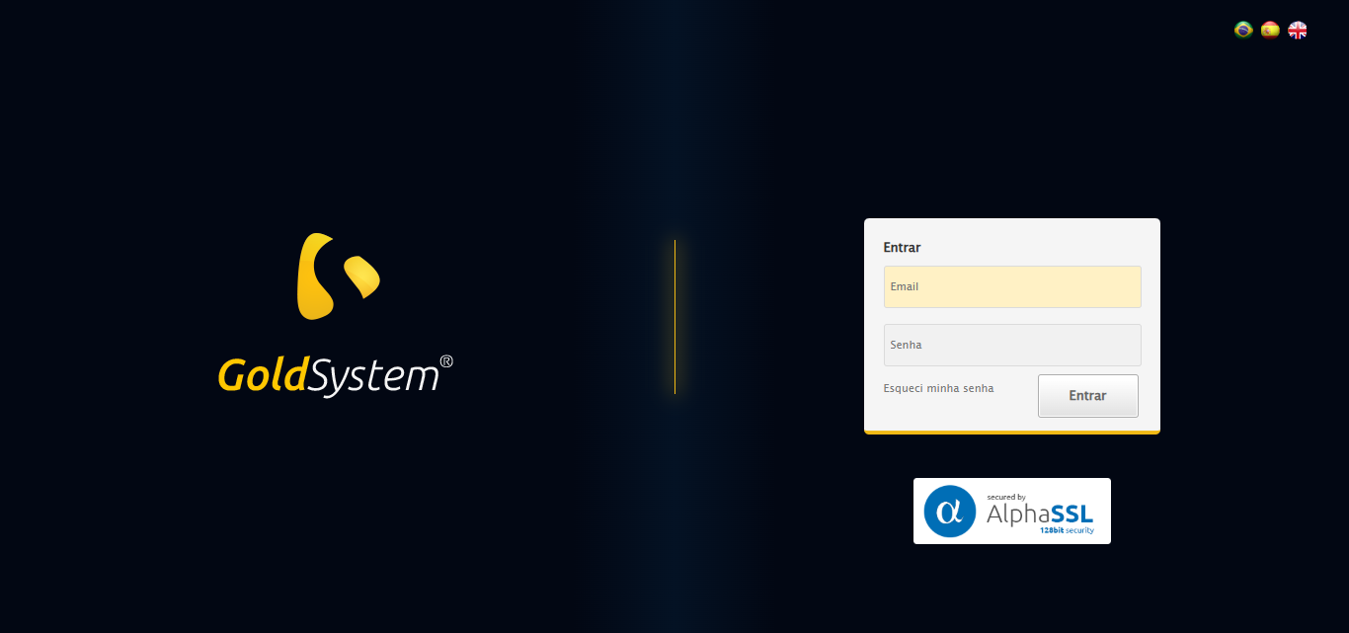

🔄 Realizando login...

✅ Realizando login realizada com sucesso.

Screenshot: realizando_login

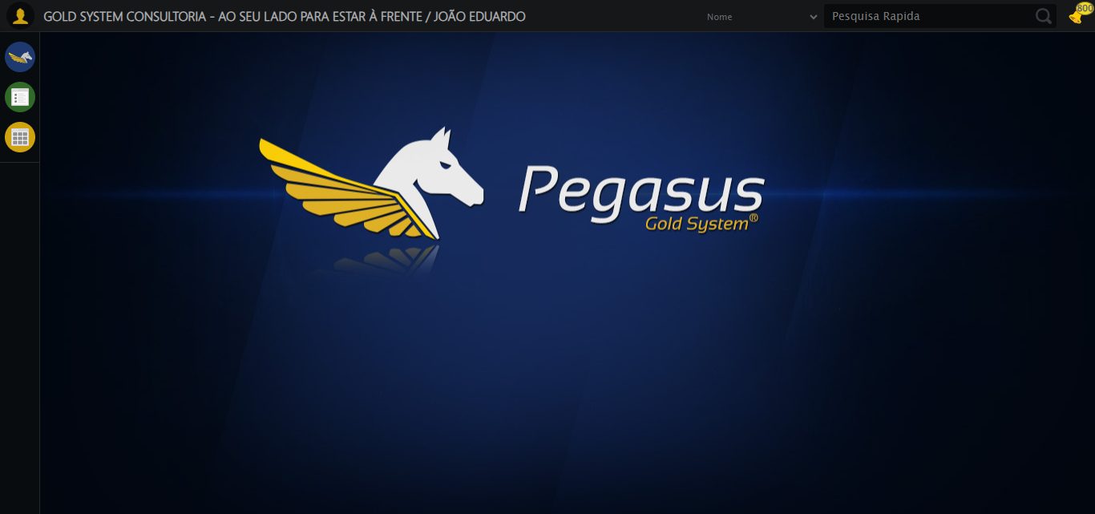

🔄 Ajustando zoom e abrindo menu...

🔍 Zoom ajustado para 90%.

✅ Ajustando zoom e abrindo menu realizada com sucesso.

Screenshot: ajustando_zoom_e_abrindo_menu

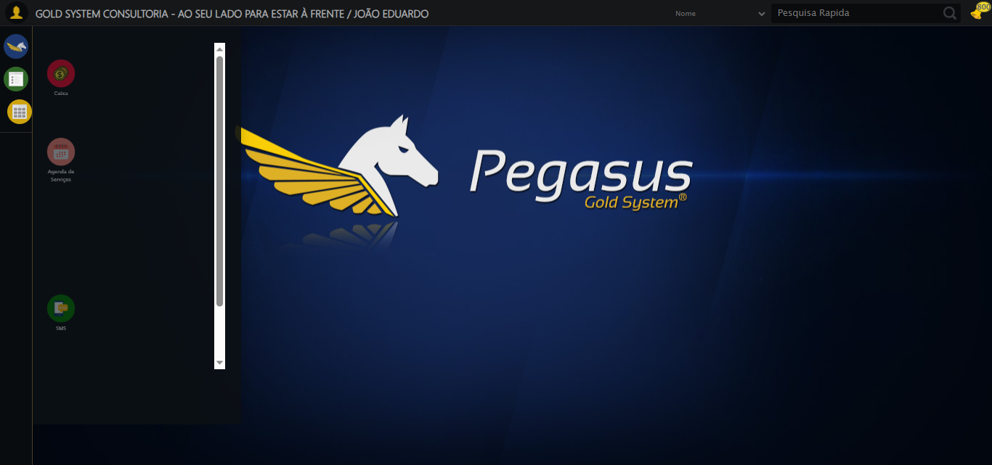

🔄 Acessando Agenda Ambulância...

✅ Acessando Agenda Ambulância realizada com sucesso.

Screenshot: acessando_agenda_ambulância

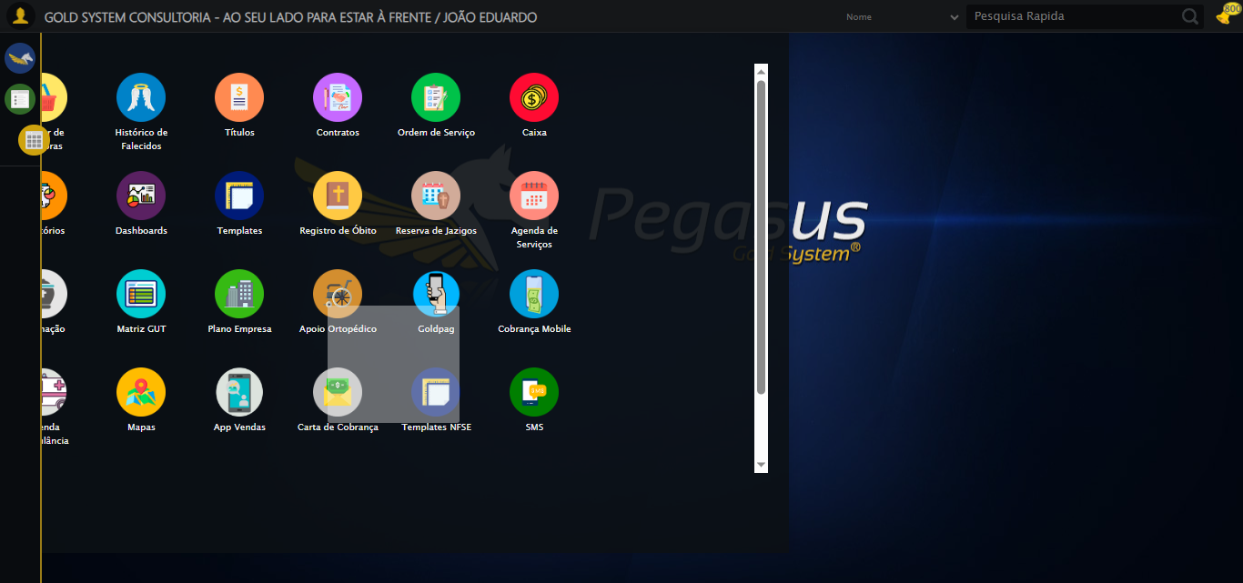

🔄 Clicando em Consultar...

✅ Clicando em Consultar realizada com sucesso.

Screenshot: clicando_em_consultar

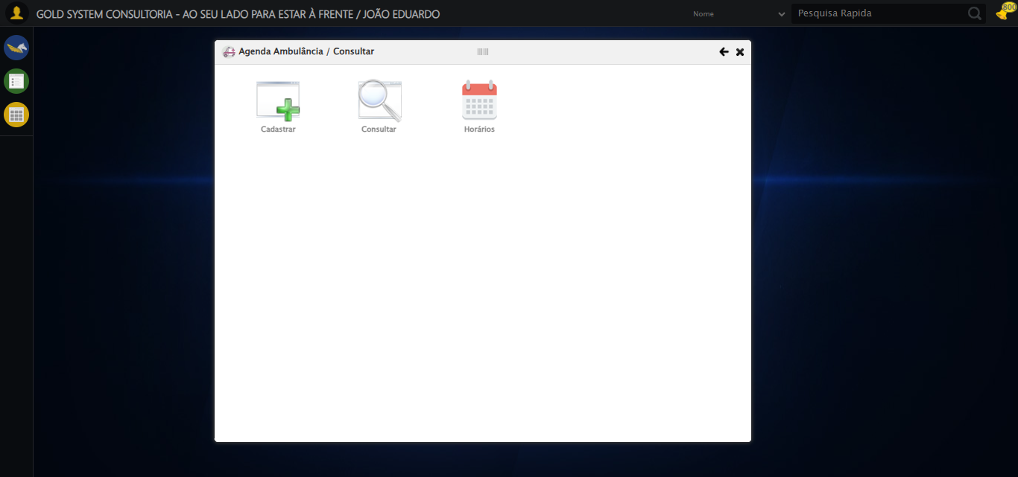

🔄 Preenchendo o Número da Agenda...

✅ Preenchendo o Número da Agenda realizada com sucesso.

Screenshot: preenchendo_o_número_da_agenda

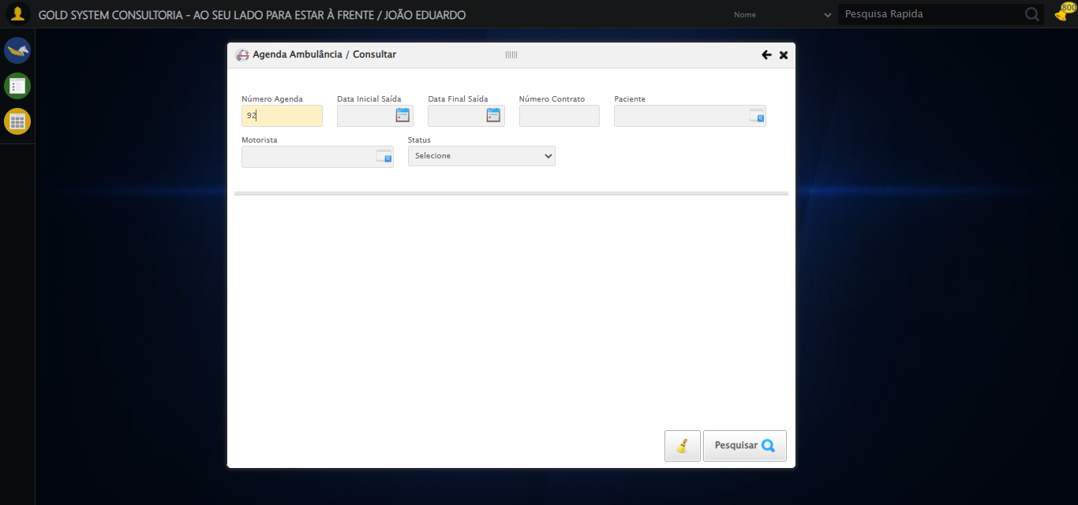

🔄 Preenchendo Data Inicial Saída...

⚠️ Tentativa 1 falhou: Message:   
Stacktrace:  
 GetHandleVerifier [0x0xe5ba83+63395]  
 GetHandleVerifier [0x0xe5bac4+63460]  
 (No symbol) [0x0xca2113]  
 (No symbol) [0x0xcea85e]  
 (No symbol) [0x0xceabfb]  
 (No symbol) [0x0xd32f92]  
 (No symbol) [0x0xd0f3f4]  
 (No symbol) [0x0xd307ba]  
 (No symbol) [0x0xd0f1a6]  
 (No symbol) [0x0xcde7b2]  
 (No symbol) [0x0xcdf654]  
 GetHandleVerifier [0x0x10d8883+2672035]  
 GetHandleVerifier [0x0x10d3cba+2652634]  
 GetHandleVerifier [0x0xe82bca+223466]  
 GetHandleVerifier [0x0xe72cb8+158168]  
 GetHandleVerifier [0x0xe7978d+185517]  
 GetHandleVerifier [0x0xe63b78+96408]  
 GetHandleVerifier [0x0xe63d02+96802]  
 GetHandleVerifier [0x0xe4e90a+9770]  
 BaseThreadInitThunk [0x0x773dfcc9+25]  
 RtlGetAppContainerNamedObjectPath [0x0x77ba82ae+286]  
 RtlGetAppContainerNamedObjectPath [0x0x77ba827e+238]

⚠️ Tentativa 2 falhou: Message:   
Stacktrace:  
 GetHandleVerifier [0x0xe5ba83+63395]  
 GetHandleVerifier [0x0xe5bac4+63460]  
 (No symbol) [0x0xca2113]  
 (No symbol) [0x0xcea85e]  
 (No symbol) [0x0xceabfb]  
 (No symbol) [0x0xd32f92]  
 (No symbol) [0x0xd0f3f4]  
 (No symbol) [0x0xd307ba]  
 (No symbol) [0x0xd0f1a6]  
 (No symbol) [0x0xcde7b2]  
 (No symbol) [0x0xcdf654]  
 GetHandleVerifier [0x0x10d8883+2672035]  
 GetHandleVerifier [0x0x10d3cba+2652634]  
 GetHandleVerifier [0x0xe82bca+223466]  
 GetHandleVerifier [0x0xe72cb8+158168]  
 GetHandleVerifier [0x0xe7978d+185517]  
 GetHandleVerifier [0x0xe63b78+96408]  
 GetHandleVerifier [0x0xe63d02+96802]  
 GetHandleVerifier [0x0xe4e90a+9770]  
 BaseThreadInitThunk [0x0x773dfcc9+25]  
 RtlGetAppContainerNamedObjectPath [0x0x77ba82ae+286]  
 RtlGetAppContainerNamedObjectPath [0x0x77ba827e+238]

⚠️ Tentativa 3 falhou: Message:   
Stacktrace:  
 GetHandleVerifier [0x0xe5ba83+63395]  
 GetHandleVerifier [0x0xe5bac4+63460]  
 (No symbol) [0x0xca2113]  
 (No symbol) [0x0xcea85e]  
 (No symbol) [0x0xceabfb]  
 (No symbol) [0x0xd32f92]  
 (No symbol) [0x0xd0f3f4]  
 (No symbol) [0x0xd307ba]  
 (No symbol) [0x0xd0f1a6]  
 (No symbol) [0x0xcde7b2]  
 (No symbol) [0x0xcdf654]  
 GetHandleVerifier [0x0x10d8883+2672035]  
 GetHandleVerifier [0x0x10d3cba+2652634]  
 GetHandleVerifier [0x0xe82bca+223466]  
 GetHandleVerifier [0x0xe72cb8+158168]  
 GetHandleVerifier [0x0xe7978d+185517]  
 GetHandleVerifier [0x0xe63b78+96408]  
 GetHandleVerifier [0x0xe63d02+96802]  
 GetHandleVerifier [0x0xe4e90a+9770]  
 BaseThreadInitThunk [0x0x773dfcc9+25]  
 RtlGetAppContainerNamedObjectPath [0x0x77ba82ae+286]  
 RtlGetAppContainerNamedObjectPath [0x0x77ba827e+238]

✅ Preenchendo Data Inicial Saída realizada com sucesso.

Screenshot: preenchendo_data_inicial_saída



🔄 Preenchendo Data Final Saída...

⚠️ Tentativa 1 falhou: Message:   
Stacktrace:  
 GetHandleVerifier [0x0xe5ba83+63395]  
 GetHandleVerifier [0x0xe5bac4+63460]  
 (No symbol) [0x0xca2113]  
 (No symbol) [0x0xcea85e]  
 (No symbol) [0x0xceabfb]  
 (No symbol) [0x0xd32f92]  
 (No symbol) [0x0xd0f3f4]  
 (No symbol) [0x0xd307ba]  
 (No symbol) [0x0xd0f1a6]  
 (No symbol) [0x0xcde7b2]  
 (No symbol) [0x0xcdf654]  
 GetHandleVerifier [0x0x10d8883+2672035]  
 GetHandleVerifier [0x0x10d3cba+2652634]  
 GetHandleVerifier [0x0xe82bca+223466]  
 GetHandleVerifier [0x0xe72cb8+158168]  
 GetHandleVerifier [0x0xe7978d+185517]  
 GetHandleVerifier [0x0xe63b78+96408]  
 GetHandleVerifier [0x0xe63d02+96802]  
 GetHandleVerifier [0x0xe4e90a+9770]  
 BaseThreadInitThunk [0x0x773dfcc9+25]  
 RtlGetAppContainerNamedObjectPath [0x0x77ba82ae+286]  
 RtlGetAppContainerNamedObjectPath [0x0x77ba827e+238]

⚠️ Tentativa 2 falhou: Message:   
Stacktrace:  
 GetHandleVerifier [0x0xe5ba83+63395]  
 GetHandleVerifier [0x0xe5bac4+63460]  
 (No symbol) [0x0xca2113]  
 (No symbol) [0x0xcea85e]  
 (No symbol) [0x0xceabfb]  
 (No symbol) [0x0xd32f92]  
 (No symbol) [0x0xd0f3f4]  
 (No symbol) [0x0xd307ba]  
 (No symbol) [0x0xd0f1a6]  
 (No symbol) [0x0xcde7b2]  
 (No symbol) [0x0xcdf654]  
 GetHandleVerifier [0x0x10d8883+2672035]  
 GetHandleVerifier [0x0x10d3cba+2652634]  
 GetHandleVerifier [0x0xe82bca+223466]  
 GetHandleVerifier [0x0xe72cb8+158168]  
 GetHandleVerifier [0x0xe7978d+185517]  
 GetHandleVerifier [0x0xe63b78+96408]  
 GetHandleVerifier [0x0xe63d02+96802]  
 GetHandleVerifier [0x0xe4e90a+9770]  
 BaseThreadInitThunk [0x0x773dfcc9+25]  
 RtlGetAppContainerNamedObjectPath [0x0x77ba82ae+286]  
 RtlGetAppContainerNamedObjectPath [0x0x77ba827e+238]

⚠️ Tentativa 3 falhou: Message:   
Stacktrace:  
 GetHandleVerifier [0x0xe5ba83+63395]  
 GetHandleVerifier [0x0xe5bac4+63460]  
 (No symbol) [0x0xca2113]  
 (No symbol) [0x0xcea85e]  
 (No symbol) [0x0xceabfb]  
 (No symbol) [0x0xd32f92]  
 (No symbol) [0x0xd0f3f4]  
 (No symbol) [0x0xd307ba]  
 (No symbol) [0x0xd0f1a6]  
 (No symbol) [0x0xcde7b2]  
 (No symbol) [0x0xcdf654]  
 GetHandleVerifier [0x0x10d8883+2672035]  
 GetHandleVerifier [0x0x10d3cba+2652634]  
 GetHandleVerifier [0x0xe82bca+223466]  
 GetHandleVerifier [0x0xe72cb8+158168]  
 GetHandleVerifier [0x0xe7978d+185517]  
 GetHandleVerifier [0x0xe63b78+96408]  
 GetHandleVerifier [0x0xe63d02+96802]  
 GetHandleVerifier [0x0xe4e90a+9770]  
 BaseThreadInitThunk [0x0x773dfcc9+25]  
 RtlGetAppContainerNamedObjectPath [0x0x77ba82ae+286]  
 RtlGetAppContainerNamedObjectPath [0x0x77ba827e+238]

✅ Preenchendo Data Final Saída realizada com sucesso.

Screenshot: preenchendo_data_final_saída

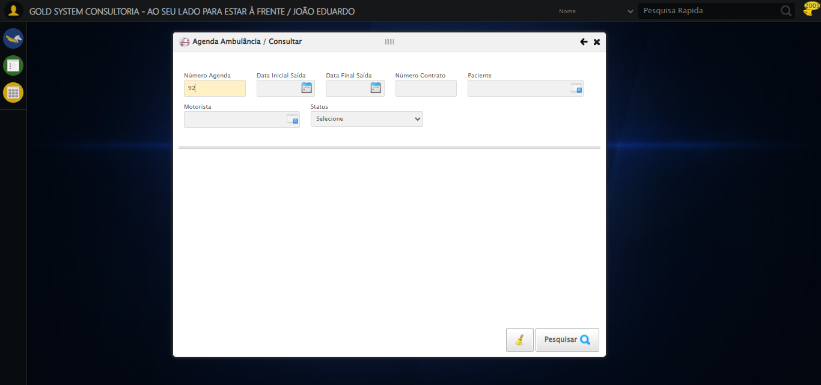

🔄 Preenchendo o Número do Contrato...

✅ Preenchendo o Número do Contrato realizada com sucesso.

Screenshot: preenchendo_o_número_do_contrato

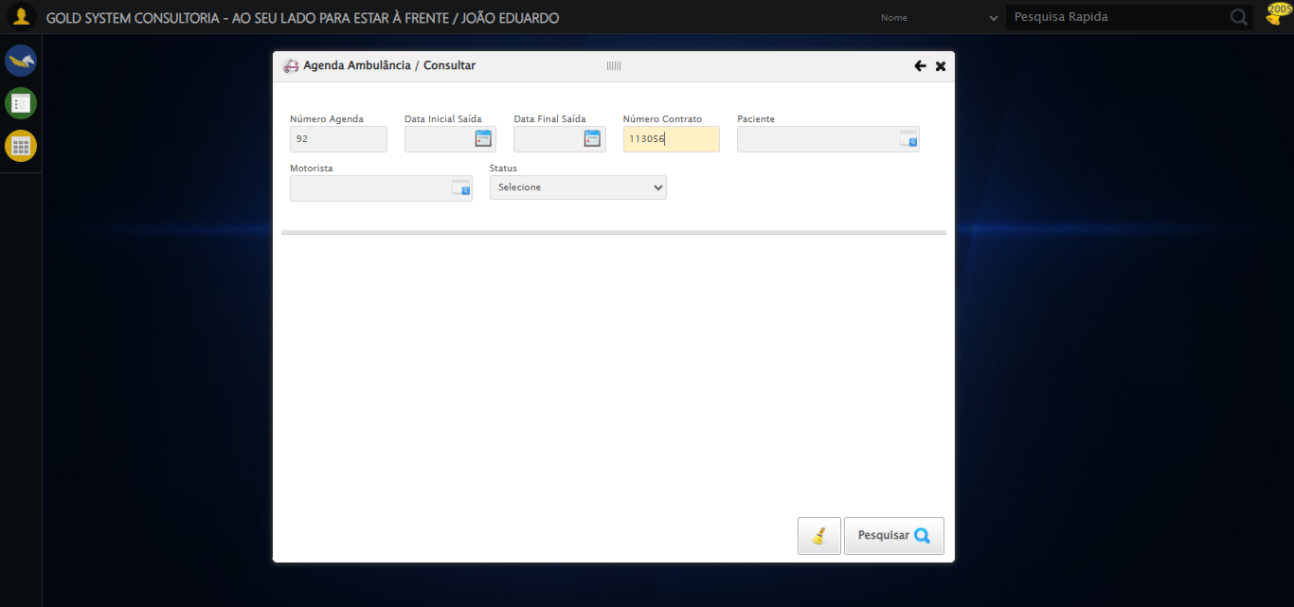

🔄 Selecionando Paciente...

✅ Selecionando Paciente realizada com sucesso.

Screenshot: selecionando_paciente

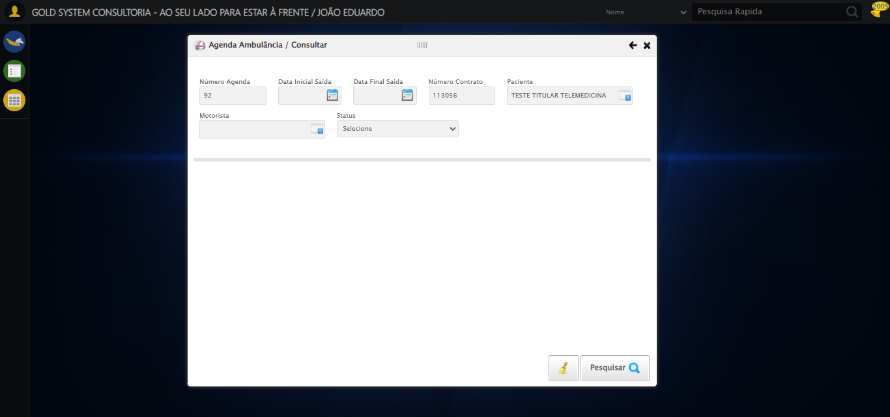

🔄 Selecionando Motorista...

✅ Selecionando Motorista realizada com sucesso.

Screenshot: selecionando_motorista

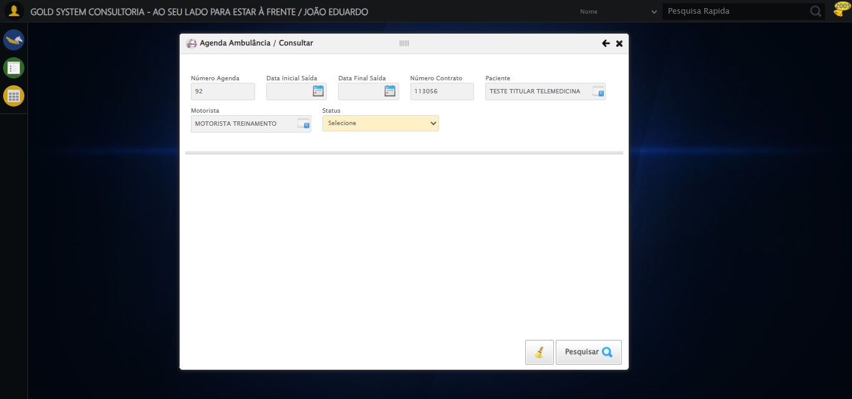

🔄 Selecionando Status...

✅ Selecionando Status realizada com sucesso.

Screenshot: selecionando_status

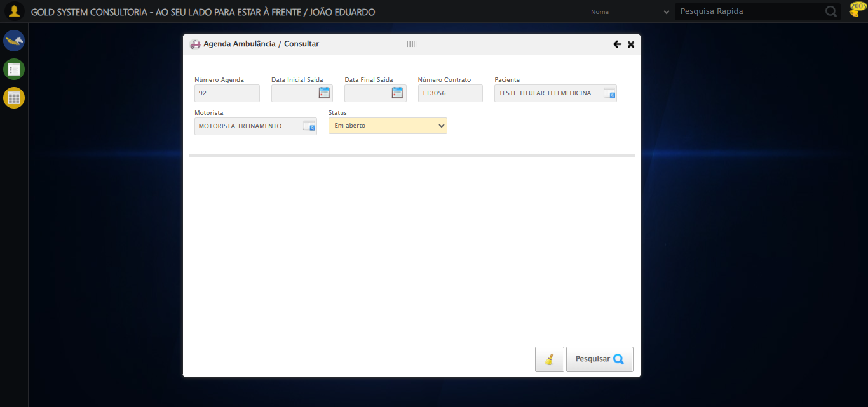

🔄 Realizando Consulta...

✅ Realizando Consulta realizada com sucesso.

Screenshot: realizando_consulta

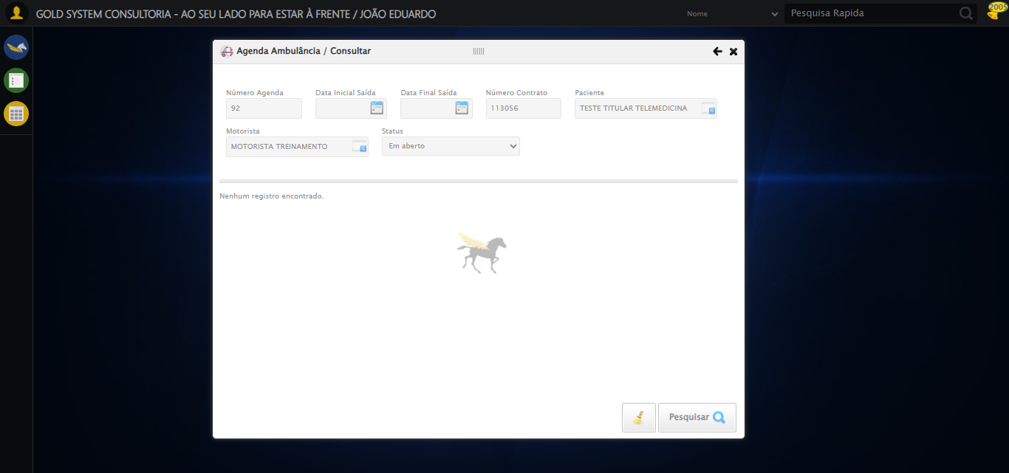

🔄 Validando resultados da consulta...

🔍 Validando se registros foram encontrados...

⏳ Aguardando mais tempo para carregamento dos resultados...

⚠️ Não foi possível localizar tabela de resultados

ℹ️ Nenhuma mensagem de alerta encontrada.

✅ Validando resultados da consulta realizada com sucesso.

⚠️ Erro ao tirar screenshot validando_resultados_da_consulta: Message: invalid session id  
Stacktrace:  
 GetHandleVerifier [0x0xe5ba83+63395]  
 GetHandleVerifier [0x0xe5bac4+63460]  
 (No symbol) [0x0xca1f70]  
 (No symbol) [0x0xcddaa8]  
 (No symbol) [0x0xd0f266]  
 (No symbol) [0x0xd0ae65]  
 (No symbol) [0x0xd0a3e6]  
 (No symbol) [0x0xc73a45]  
 (No symbol) [0x0xc73f9e]  
 (No symbol) [0x0xc7442d]  
 GetHandleVerifier [0x0x10d8883+2672035]  
 GetHandleVerifier [0x0x10d3cba+2652634]  
 GetHandleVerifier [0x0xe82bca+223466]  
 GetHandleVerifier [0x0xe72cb8+158168]  
 GetHandleVerifier [0x0xe7978d+185517]  
 (No symbol) [0x0xc73710]  
 (No symbol) [0x0xc72f1d]  
 GetHandleVerifier [0x0x120db9c+3938492]  
 BaseThreadInitThunk [0x0x773dfcc9+25]  
 RtlGetAppContainerNamedObjectPath [0x0x77ba82ae+286]  
 RtlGetAppContainerNamedObjectPath [0x0x77ba827e+238]

🔄 Limpando os campos...

❌ Erro inesperado ao limpando os campos: Message: invalid session id  
Stacktrace:  
 GetHandleVerifier [0x0xe5ba83+63395]  
 GetHandleVerifier [0x0xe5bac4+63460]  
 (No symbol) [0x0xca1f70]  
 (No symbol) [0x0xcddaa8]  
 (No symbol) [0x0xd0f266]  
 (No symbol) [0x0xd0ae65]  
 (No symbol) [0x0xd0a3e6]  
 (No symbol) [0x0xc73a45]  
 (No symbol) [0x0xc73f9e]  
 (No symbol) [0x0xc7442d]  
 GetHandleVerifier [0x0x10d8883+2672035]  
 GetHandleVerifier [0x0x10d3cba+2652634]  
 GetHandleVerifier [0x0xe82bca+223466]  
 GetHandleVerifier [0x0xe72cb8+158168]  
 GetHandleVerifier [0x0xe7978d+185517]  
 (No symbol) [0x0xc73710]  
 (No symbol) [0x0xc72f1d]  
 GetHandleVerifier [0x0x120db9c+3938492]  
 BaseThreadInitThunk [0x0x773dfcc9+25]  
 RtlGetAppContainerNamedObjectPath [0x0x77ba82ae+286]  
 RtlGetAppContainerNamedObjectPath [0x0x77ba827e+238]

⚠️ Erro ao tirar screenshot erro_limpando_os_campos: Message: invalid session id  
Stacktrace:  
 GetHandleVerifier [0x0xe5ba83+63395]  
 GetHandleVerifier [0x0xe5bac4+63460]  
 (No symbol) [0x0xca1f70]  
 (No symbol) [0x0xcddaa8]  
 (No symbol) [0x0xd0f266]  
 (No symbol) [0x0xd0ae65]  
 (No symbol) [0x0xd0a3e6]  
 (No symbol) [0x0xc73a45]  
 (No symbol) [0x0xc73f9e]  
 (No symbol) [0x0xc7442d]  
 GetHandleVerifier [0x0x10d8883+2672035]  
 GetHandleVerifier [0x0x10d3cba+2652634]  
 GetHandleVerifier [0x0xe82bca+223466]  
 GetHandleVerifier [0x0xe72cb8+158168]  
 GetHandleVerifier [0x0xe7978d+185517]  
 (No symbol) [0x0xc73710]  
 (No symbol) [0x0xc72f1d]  
 GetHandleVerifier [0x0x120db9c+3938492]  
 BaseThreadInitThunk [0x0x773dfcc9+25]  
 RtlGetAppContainerNamedObjectPath [0x0x77ba82ae+286]  
 RtlGetAppContainerNamedObjectPath [0x0x77ba827e+238]

🔄 Fechando modal...

❌ Erro inesperado ao fechando modal: Message: invalid session id  
Stacktrace:  
 GetHandleVerifier [0x0xe5ba83+63395]  
 GetHandleVerifier [0x0xe5bac4+63460]  
 (No symbol) [0x0xca1f70]  
 (No symbol) [0x0xcddaa8]  
 (No symbol) [0x0xd0f266]  
 (No symbol) [0x0xd0ae65]  
 (No symbol) [0x0xd0a3e6]  
 (No symbol) [0x0xc73a45]  
 (No symbol) [0x0xc73f9e]  
 (No symbol) [0x0xc7442d]  
 GetHandleVerifier [0x0x10d8883+2672035]  
 GetHandleVerifier [0x0x10d3cba+2652634]  
 GetHandleVerifier [0x0xe82bca+223466]  
 GetHandleVerifier [0x0xe72cb8+158168]  
 GetHandleVerifier [0x0xe7978d+185517]  
 (No symbol) [0x0xc73710]  
 (No symbol) [0x0xc72f1d]  
 GetHandleVerifier [0x0x120db9c+3938492]  
 BaseThreadInitThunk [0x0x773dfcc9+25]  
 RtlGetAppContainerNamedObjectPath [0x0x77ba82ae+286]  
 RtlGetAppContainerNamedObjectPath [0x0x77ba827e+238]

⚠️ Erro ao tirar screenshot erro_fechando_modal: Message: invalid session id  
Stacktrace:  
 GetHandleVerifier [0x0xe5ba83+63395]  
 GetHandleVerifier [0x0xe5bac4+63460]  
 (No symbol) [0x0xca1f70]  
 (No symbol) [0x0xcddaa8]  
 (No symbol) [0x0xd0f266]  
 (No symbol) [0x0xd0ae65]  
 (No symbol) [0x0xd0a3e6]  
 (No symbol) [0x0xc73a45]  
 (No symbol) [0x0xc73f9e]  
 (No symbol) [0x0xc7442d]  
 GetHandleVerifier [0x0x10d8883+2672035]  
 GetHandleVerifier [0x0x10d3cba+2652634]  
 GetHandleVerifier [0x0xe82bca+223466]  
 GetHandleVerifier [0x0xe72cb8+158168]  
 GetHandleVerifier [0x0xe7978d+185517]  
 (No symbol) [0x0xc73710]  
 (No symbol) [0x0xc72f1d]  
 GetHandleVerifier [0x0x120db9c+3938492]  
 BaseThreadInitThunk [0x0x773dfcc9+25]  
 RtlGetAppContainerNamedObjectPath [0x0x77ba82ae+286]  
 RtlGetAppContainerNamedObjectPath [0x0x77ba827e+238]

✅ Teste concluído.

✅ Teste executado com sucesso!