RELATÓRIO DO TESTE

Consulta de Agenda de Ambulância – Cenário 1: Preenchimento e realização da consulta

Data do teste: 07/08/2025 16:17:54

🚀 Iniciando teste de Consulta de Agenda de Ambulância...

🔄 Acessando sistema...

✅ Acessando sistema realizada com sucesso.

Screenshot: acessando_sistema

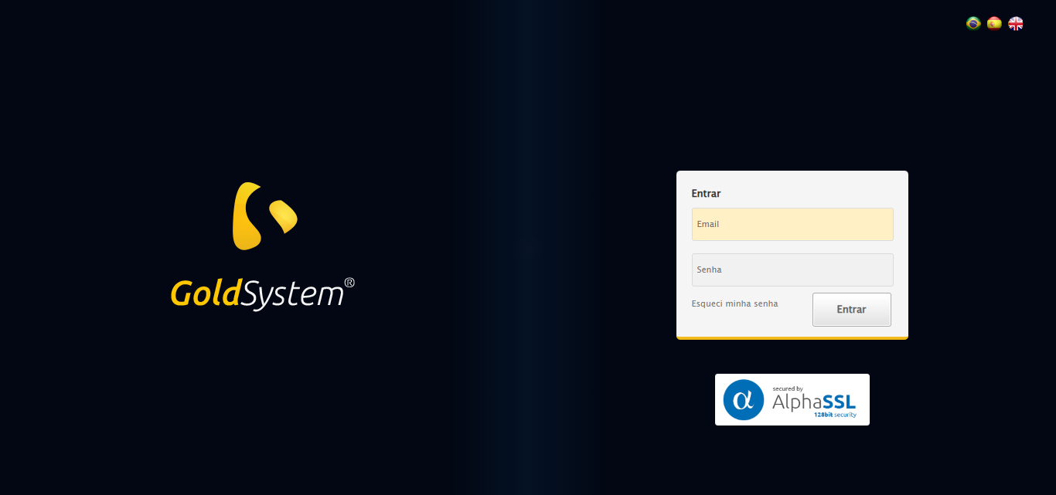

🔄 Realizando login...

✅ Realizando login realizada com sucesso.

Screenshot: realizando_login

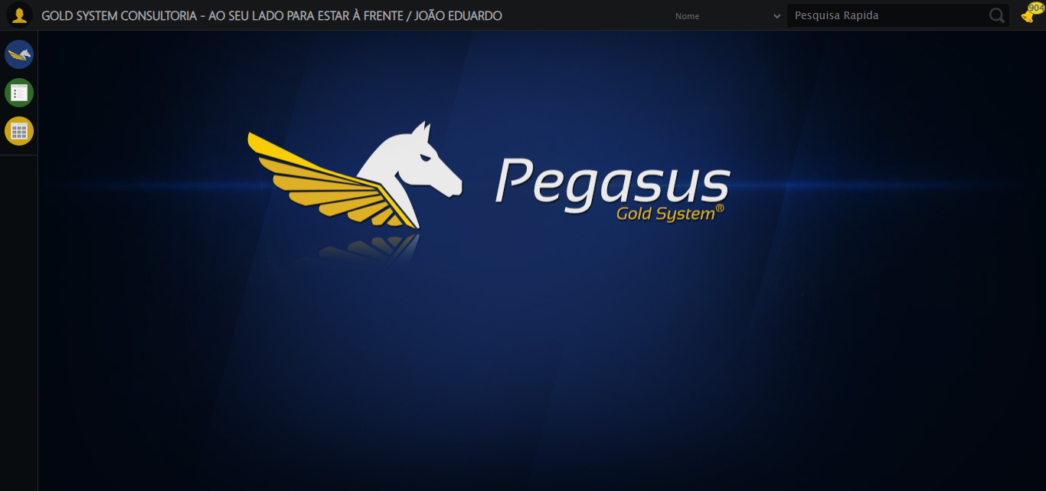

🔄 Ajustando zoom e abrindo menu...

🔍 Zoom ajustado para 90%.

✅ Ajustando zoom e abrindo menu realizada com sucesso.

Screenshot: ajustando_zoom_e_abrindo_menu

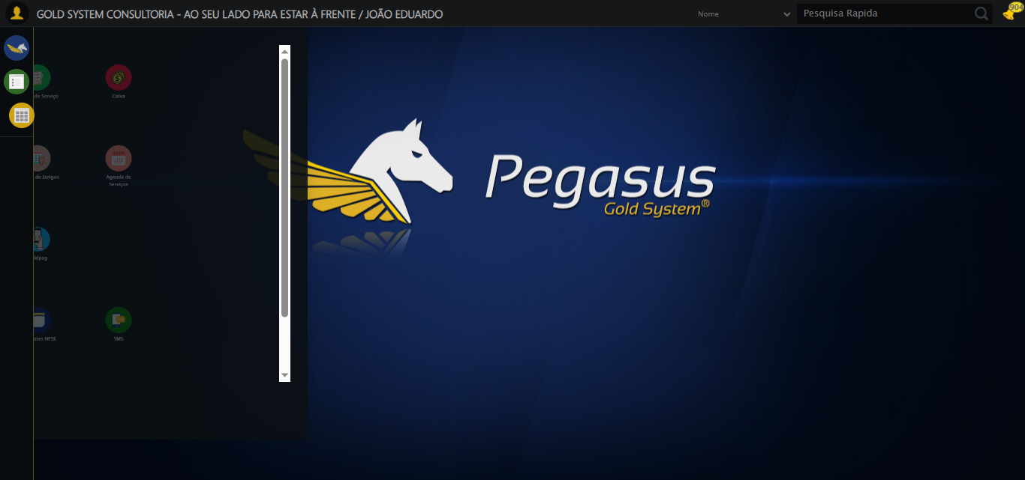

🔄 Acessando Agenda Ambulância...

✅ Acessando Agenda Ambulância realizada com sucesso.

Screenshot: acessando_agenda_ambulância

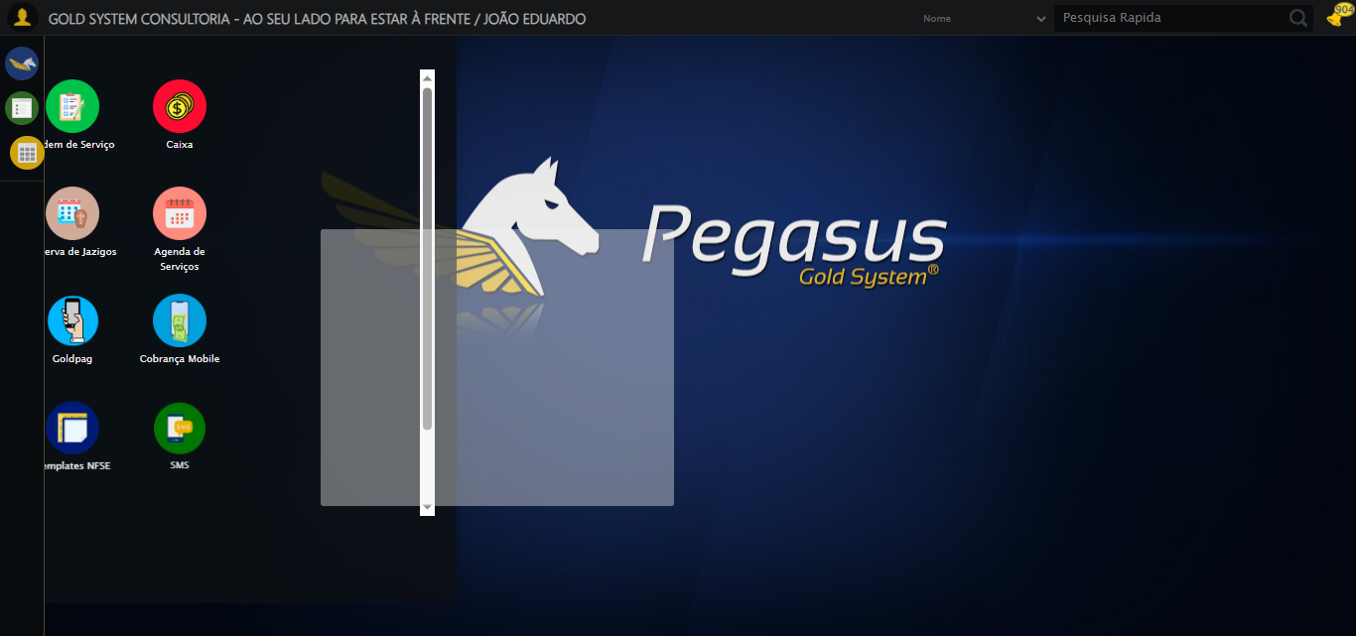

🔄 Clicando em Consultar...

✅ Clicando em Consultar realizada com sucesso.

Screenshot: clicando_em_consultar

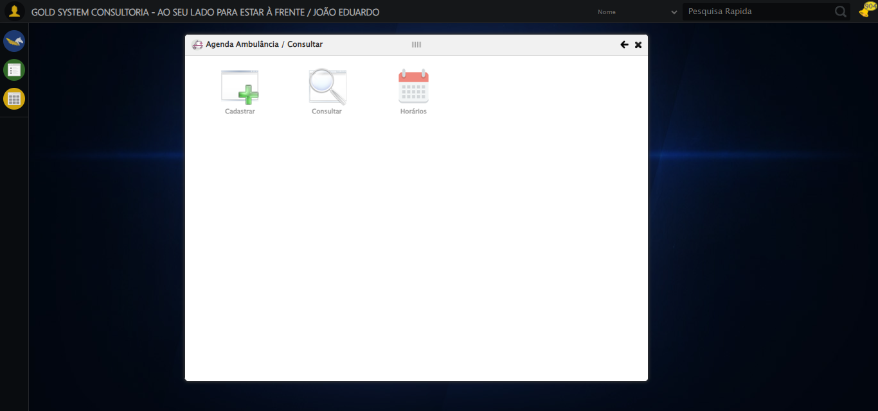

🔄 Preenchendo o Número da Agenda...

✅ Preenchendo o Número da Agenda realizada com sucesso.

Screenshot: preenchendo_o_número_da_agenda

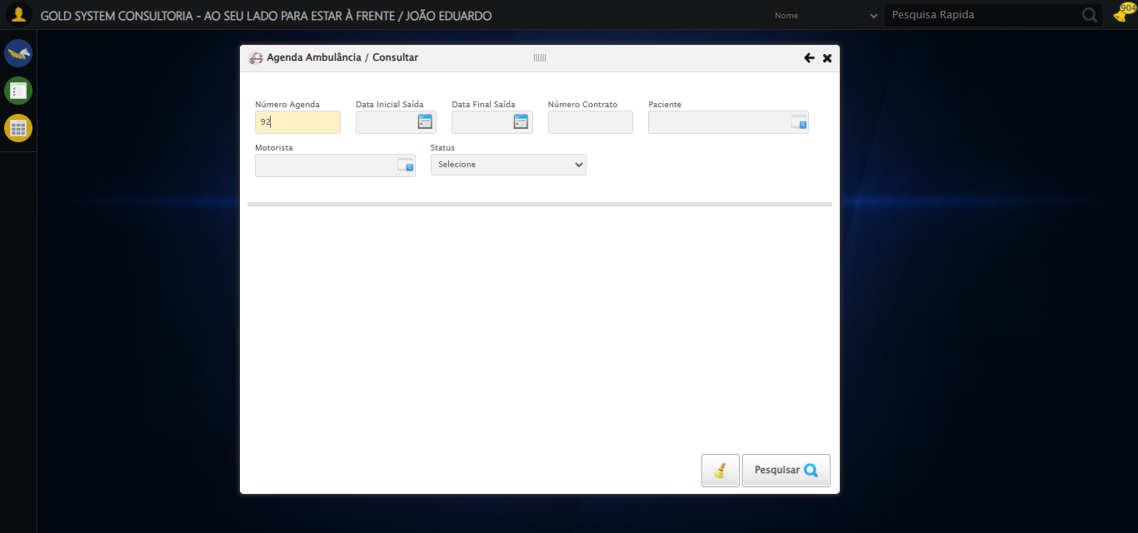

🔄 Preenchendo Data Inicial Saída...

🔍 Iniciando preenchimento do campo dp1754589783682 com valor '07/08/2025'

🔄 Tentativa 1 de 5

❌ Nenhum seletor funcionou para encontrar o campo

🔄 Tentativa 2 de 5

❌ Nenhum seletor funcionou para encontrar o campo

🔄 Tentativa 3 de 5

❌ Nenhum seletor funcionou para encontrar o campo

🔄 Tentativa 4 de 5

❌ Nenhum seletor funcionou para encontrar o campo

🔄 Tentativa 5 de 5

❌ Nenhum seletor funcionou para encontrar o campo

✅ Preenchendo Data Inicial Saída realizada com sucesso.

⚠️ Erro ao tirar screenshot preenchendo_data_inicial_saída: Message: invalid session id  
Stacktrace:  
 GetHandleVerifier [0x0xe5ba83+63395]  
 GetHandleVerifier [0x0xe5bac4+63460]  
 (No symbol) [0x0xca1f70]  
 (No symbol) [0x0xcddaa8]  
 (No symbol) [0x0xd0f266]  
 (No symbol) [0x0xd0ae65]  
 (No symbol) [0x0xd0a3e6]  
 (No symbol) [0x0xc73a45]  
 (No symbol) [0x0xc73f9e]  
 (No symbol) [0x0xc7442d]  
 GetHandleVerifier [0x0x10d8883+2672035]  
 GetHandleVerifier [0x0x10d3cba+2652634]  
 GetHandleVerifier [0x0xe82bca+223466]  
 GetHandleVerifier [0x0xe72cb8+158168]  
 GetHandleVerifier [0x0xe7978d+185517]  
 (No symbol) [0x0xc73710]  
 (No symbol) [0x0xc72f1d]  
 GetHandleVerifier [0x0x120db9c+3938492]  
 BaseThreadInitThunk [0x0x773dfcc9+25]  
 RtlGetAppContainerNamedObjectPath [0x0x77ba82ae+286]  
 RtlGetAppContainerNamedObjectPath [0x0x77ba827e+238]

🔄 Preenchendo Data Final Saída...

🔍 Iniciando preenchimento do campo dp1754589783683 com valor '07/08/2025'

🔄 Tentativa 1 de 5

❌ Nenhum seletor funcionou para encontrar o campo

🔄 Tentativa 2 de 5

❌ Nenhum seletor funcionou para encontrar o campo

🔄 Tentativa 3 de 5

❌ Nenhum seletor funcionou para encontrar o campo

🔄 Tentativa 4 de 5

❌ Nenhum seletor funcionou para encontrar o campo

🔄 Tentativa 5 de 5

❌ Nenhum seletor funcionou para encontrar o campo

✅ Preenchendo Data Final Saída realizada com sucesso.

⚠️ Erro ao tirar screenshot preenchendo_data_final_saída: Message: invalid session id  
Stacktrace:  
 GetHandleVerifier [0x0xe5ba83+63395]  
 GetHandleVerifier [0x0xe5bac4+63460]  
 (No symbol) [0x0xca1f70]  
 (No symbol) [0x0xcddaa8]  
 (No symbol) [0x0xd0f266]  
 (No symbol) [0x0xd0ae65]  
 (No symbol) [0x0xd0a3e6]  
 (No symbol) [0x0xc73a45]  
 (No symbol) [0x0xc73f9e]  
 (No symbol) [0x0xc7442d]  
 GetHandleVerifier [0x0x10d8883+2672035]  
 GetHandleVerifier [0x0x10d3cba+2652634]  
 GetHandleVerifier [0x0xe82bca+223466]  
 GetHandleVerifier [0x0xe72cb8+158168]  
 GetHandleVerifier [0x0xe7978d+185517]  
 (No symbol) [0x0xc73710]  
 (No symbol) [0x0xc72f1d]  
 GetHandleVerifier [0x0x120db9c+3938492]  
 BaseThreadInitThunk [0x0x773dfcc9+25]  
 RtlGetAppContainerNamedObjectPath [0x0x77ba82ae+286]  
 RtlGetAppContainerNamedObjectPath [0x0x77ba827e+238]

🔄 Preenchendo o Número do Contrato...

❌ Erro ao interagir com elemento #gsAgendaAmbulancia > div.wdTelas > div.telaConsulta.telaConsultaAgendaAmbulancia > div > div.formRow.filtrosConsulta > div > div:nth-child(4) > input: Message: invalid session id  
Stacktrace:  
 GetHandleVerifier [0x0xe5ba83+63395]  
 GetHandleVerifier [0x0xe5bac4+63460]  
 (No symbol) [0x0xca1f70]  
 (No symbol) [0x0xcddaa8]  
 (No symbol) [0x0xd0f266]  
 (No symbol) [0x0xd0ae65]  
 (No symbol) [0x0xd0a3e6]  
 (No symbol) [0x0xc73a45]  
 (No symbol) [0x0xc73f9e]  
 (No symbol) [0x0xc7442d]  
 GetHandleVerifier [0x0x10d8883+2672035]  
 GetHandleVerifier [0x0x10d3cba+2652634]  
 GetHandleVerifier [0x0xe82bca+223466]  
 GetHandleVerifier [0x0xe72cb8+158168]  
 GetHandleVerifier [0x0xe7978d+185517]  
 (No symbol) [0x0xc73710]  
 (No symbol) [0x0xc72f1d]  
 GetHandleVerifier [0x0x120db9c+3938492]  
 BaseThreadInitThunk [0x0x773dfcc9+25]  
 RtlGetAppContainerNamedObjectPath [0x0x77ba82ae+286]  
 RtlGetAppContainerNamedObjectPath [0x0x77ba827e+238]

❌ Erro inesperado ao preenchendo o número do contrato: Não foi possível encontrar o elemento: #gsAgendaAmbulancia > div.wdTelas > div.telaConsulta.telaConsultaAgendaAmbulancia > div > div.formRow.filtrosConsulta > div > div:nth-child(4) > input

⚠️ Erro ao tirar screenshot erro_preenchendo_o_número_do_contrato: Message: invalid session id  
Stacktrace:  
 GetHandleVerifier [0x0xe5ba83+63395]  
 GetHandleVerifier [0x0xe5bac4+63460]  
 (No symbol) [0x0xca1f70]  
 (No symbol) [0x0xcddaa8]  
 (No symbol) [0x0xd0f266]  
 (No symbol) [0x0xd0ae65]  
 (No symbol) [0x0xd0a3e6]  
 (No symbol) [0x0xc73a45]  
 (No symbol) [0x0xc73f9e]  
 (No symbol) [0x0xc7442d]  
 GetHandleVerifier [0x0x10d8883+2672035]  
 GetHandleVerifier [0x0x10d3cba+2652634]  
 GetHandleVerifier [0x0xe82bca+223466]  
 GetHandleVerifier [0x0xe72cb8+158168]  
 GetHandleVerifier [0x0xe7978d+185517]  
 (No symbol) [0x0xc73710]  
 (No symbol) [0x0xc72f1d]  
 GetHandleVerifier [0x0x120db9c+3938492]  
 BaseThreadInitThunk [0x0x773dfcc9+25]  
 RtlGetAppContainerNamedObjectPath [0x0x77ba82ae+286]  
 RtlGetAppContainerNamedObjectPath [0x0x77ba827e+238]

🔄 Selecionando Paciente...

❌ Erro ao interagir com elemento #gsAgendaAmbulancia > div.wdTelas > div.telaConsulta.telaConsultaAgendaAmbulancia > div > div.formRow.filtrosConsulta > div > div:nth-child(5) > div > a: Message: invalid session id  
Stacktrace:  
 GetHandleVerifier [0x0xe5ba83+63395]  
 GetHandleVerifier [0x0xe5bac4+63460]  
 (No symbol) [0x0xca1f70]  
 (No symbol) [0x0xcddaa8]  
 (No symbol) [0x0xd0f266]  
 (No symbol) [0x0xd0ae65]  
 (No symbol) [0x0xd0a3e6]  
 (No symbol) [0x0xc73a45]  
 (No symbol) [0x0xc73f9e]  
 (No symbol) [0x0xc7442d]  
 GetHandleVerifier [0x0x10d8883+2672035]  
 GetHandleVerifier [0x0x10d3cba+2652634]  
 GetHandleVerifier [0x0xe82bca+223466]  
 GetHandleVerifier [0x0xe72cb8+158168]  
 GetHandleVerifier [0x0xe7978d+185517]  
 (No symbol) [0x0xc73710]  
 (No symbol) [0x0xc72f1d]  
 GetHandleVerifier [0x0x120db9c+3938492]  
 BaseThreadInitThunk [0x0x773dfcc9+25]  
 RtlGetAppContainerNamedObjectPath [0x0x77ba82ae+286]  
 RtlGetAppContainerNamedObjectPath [0x0x77ba827e+238]

❌ Erro inesperado ao selecionando paciente: Message: invalid session id  
Stacktrace:  
 GetHandleVerifier [0x0xe5ba83+63395]  
 GetHandleVerifier [0x0xe5bac4+63460]  
 (No symbol) [0x0xca1f70]  
 (No symbol) [0x0xcddaa8]  
 (No symbol) [0x0xd0f266]  
 (No symbol) [0x0xd0ae65]  
 (No symbol) [0x0xd0a3e6]  
 (No symbol) [0x0xc73a45]  
 (No symbol) [0x0xc73f9e]  
 (No symbol) [0x0xc7442d]  
 GetHandleVerifier [0x0x10d8883+2672035]  
 GetHandleVerifier [0x0x10d3cba+2652634]  
 GetHandleVerifier [0x0xe82bca+223466]  
 GetHandleVerifier [0x0xe72cb8+158168]  
 GetHandleVerifier [0x0xe7978d+185517]  
 (No symbol) [0x0xc73710]  
 (No symbol) [0x0xc72f1d]  
 GetHandleVerifier [0x0x120db9c+3938492]  
 BaseThreadInitThunk [0x0x773dfcc9+25]  
 RtlGetAppContainerNamedObjectPath [0x0x77ba82ae+286]  
 RtlGetAppContainerNamedObjectPath [0x0x77ba827e+238]

⚠️ Erro ao tirar screenshot erro_selecionando_paciente: Message: invalid session id  
Stacktrace:  
 GetHandleVerifier [0x0xe5ba83+63395]  
 GetHandleVerifier [0x0xe5bac4+63460]  
 (No symbol) [0x0xca1f70]  
 (No symbol) [0x0xcddaa8]  
 (No symbol) [0x0xd0f266]  
 (No symbol) [0x0xd0ae65]  
 (No symbol) [0x0xd0a3e6]  
 (No symbol) [0x0xc73a45]  
 (No symbol) [0x0xc73f9e]  
 (No symbol) [0x0xc7442d]  
 GetHandleVerifier [0x0x10d8883+2672035]  
 GetHandleVerifier [0x0x10d3cba+2652634]  
 GetHandleVerifier [0x0xe82bca+223466]  
 GetHandleVerifier [0x0xe72cb8+158168]  
 GetHandleVerifier [0x0xe7978d+185517]  
 (No symbol) [0x0xc73710]  
 (No symbol) [0x0xc72f1d]  
 GetHandleVerifier [0x0x120db9c+3938492]  
 BaseThreadInitThunk [0x0x773dfcc9+25]  
 RtlGetAppContainerNamedObjectPath [0x0x77ba82ae+286]  
 RtlGetAppContainerNamedObjectPath [0x0x77ba827e+238]

🔄 Selecionando Motorista...

❌ Erro ao interagir com elemento #gsAgendaAmbulancia > div.wdTelas > div.telaConsulta.telaConsultaAgendaAmbulancia > div > div.formRow.filtrosConsulta > div > div:nth-child(6) > div > a: Message: invalid session id  
Stacktrace:  
 GetHandleVerifier [0x0xe5ba83+63395]  
 GetHandleVerifier [0x0xe5bac4+63460]  
 (No symbol) [0x0xca1f70]  
 (No symbol) [0x0xcddaa8]  
 (No symbol) [0x0xd0f266]  
 (No symbol) [0x0xd0ae65]  
 (No symbol) [0x0xd0a3e6]  
 (No symbol) [0x0xc73a45]  
 (No symbol) [0x0xc73f9e]  
 (No symbol) [0x0xc7442d]  
 GetHandleVerifier [0x0x10d8883+2672035]  
 GetHandleVerifier [0x0x10d3cba+2652634]  
 GetHandleVerifier [0x0xe82bca+223466]  
 GetHandleVerifier [0x0xe72cb8+158168]  
 GetHandleVerifier [0x0xe7978d+185517]  
 (No symbol) [0x0xc73710]  
 (No symbol) [0x0xc72f1d]  
 GetHandleVerifier [0x0x120db9c+3938492]  
 BaseThreadInitThunk [0x0x773dfcc9+25]  
 RtlGetAppContainerNamedObjectPath [0x0x77ba82ae+286]  
 RtlGetAppContainerNamedObjectPath [0x0x77ba827e+238]

❌ Erro inesperado ao selecionando motorista: Message: invalid session id  
Stacktrace:  
 GetHandleVerifier [0x0xe5ba83+63395]  
 GetHandleVerifier [0x0xe5bac4+63460]  
 (No symbol) [0x0xca1f70]  
 (No symbol) [0x0xcddaa8]  
 (No symbol) [0x0xd0f266]  
 (No symbol) [0x0xd0ae65]  
 (No symbol) [0x0xd0a3e6]  
 (No symbol) [0x0xc73a45]  
 (No symbol) [0x0xc73f9e]  
 (No symbol) [0x0xc7442d]  
 GetHandleVerifier [0x0x10d8883+2672035]  
 GetHandleVerifier [0x0x10d3cba+2652634]  
 GetHandleVerifier [0x0xe82bca+223466]  
 GetHandleVerifier [0x0xe72cb8+158168]  
 GetHandleVerifier [0x0xe7978d+185517]  
 (No symbol) [0x0xc73710]  
 (No symbol) [0x0xc72f1d]  
 GetHandleVerifier [0x0x120db9c+3938492]  
 BaseThreadInitThunk [0x0x773dfcc9+25]  
 RtlGetAppContainerNamedObjectPath [0x0x77ba82ae+286]  
 RtlGetAppContainerNamedObjectPath [0x0x77ba827e+238]

⚠️ Erro ao tirar screenshot erro_selecionando_motorista: Message: invalid session id  
Stacktrace:  
 GetHandleVerifier [0x0xe5ba83+63395]  
 GetHandleVerifier [0x0xe5bac4+63460]  
 (No symbol) [0x0xca1f70]  
 (No symbol) [0x0xcddaa8]  
 (No symbol) [0x0xd0f266]  
 (No symbol) [0x0xd0ae65]  
 (No symbol) [0x0xd0a3e6]  
 (No symbol) [0x0xc73a45]  
 (No symbol) [0x0xc73f9e]  
 (No symbol) [0x0xc7442d]  
 GetHandleVerifier [0x0x10d8883+2672035]  
 GetHandleVerifier [0x0x10d3cba+2652634]  
 GetHandleVerifier [0x0xe82bca+223466]  
 GetHandleVerifier [0x0xe72cb8+158168]  
 GetHandleVerifier [0x0xe7978d+185517]  
 (No symbol) [0x0xc73710]  
 (No symbol) [0x0xc72f1d]  
 GetHandleVerifier [0x0x120db9c+3938492]  
 BaseThreadInitThunk [0x0x773dfcc9+25]  
 RtlGetAppContainerNamedObjectPath [0x0x77ba82ae+286]  
 RtlGetAppContainerNamedObjectPath [0x0x77ba827e+238]

🔄 Selecionando Status...

❌ Erro ao interagir com elemento #gsAgendaAmbulancia > div.wdTelas > div.telaConsulta.telaConsultaAgendaAmbulancia > div > div.formRow.filtrosConsulta > div > div:nth-child(7) > select: Message: invalid session id  
Stacktrace:  
 GetHandleVerifier [0x0xe5ba83+63395]  
 GetHandleVerifier [0x0xe5bac4+63460]  
 (No symbol) [0x0xca1f70]  
 (No symbol) [0x0xcddaa8]  
 (No symbol) [0x0xd0f266]  
 (No symbol) [0x0xd0ae65]  
 (No symbol) [0x0xd0a3e6]  
 (No symbol) [0x0xc73a45]  
 (No symbol) [0x0xc73f9e]  
 (No symbol) [0x0xc7442d]  
 GetHandleVerifier [0x0x10d8883+2672035]  
 GetHandleVerifier [0x0x10d3cba+2652634]  
 GetHandleVerifier [0x0xe82bca+223466]  
 GetHandleVerifier [0x0xe72cb8+158168]  
 GetHandleVerifier [0x0xe7978d+185517]  
 (No symbol) [0x0xc73710]  
 (No symbol) [0x0xc72f1d]  
 GetHandleVerifier [0x0x120db9c+3938492]  
 BaseThreadInitThunk [0x0x773dfcc9+25]  
 RtlGetAppContainerNamedObjectPath [0x0x77ba82ae+286]  
 RtlGetAppContainerNamedObjectPath [0x0x77ba827e+238]

❌ Erro inesperado ao selecionando status: Não foi possível encontrar o select: #gsAgendaAmbulancia > div.wdTelas > div.telaConsulta.telaConsultaAgendaAmbulancia > div > div.formRow.filtrosConsulta > div > div:nth-child(7) > select

⚠️ Erro ao tirar screenshot erro_selecionando_status: Message: invalid session id  
Stacktrace:  
 GetHandleVerifier [0x0xe5ba83+63395]  
 GetHandleVerifier [0x0xe5bac4+63460]  
 (No symbol) [0x0xca1f70]  
 (No symbol) [0x0xcddaa8]  
 (No symbol) [0x0xd0f266]  
 (No symbol) [0x0xd0ae65]  
 (No symbol) [0x0xd0a3e6]  
 (No symbol) [0x0xc73a45]  
 (No symbol) [0x0xc73f9e]  
 (No symbol) [0x0xc7442d]  
 GetHandleVerifier [0x0x10d8883+2672035]  
 GetHandleVerifier [0x0x10d3cba+2652634]  
 GetHandleVerifier [0x0xe82bca+223466]  
 GetHandleVerifier [0x0xe72cb8+158168]  
 GetHandleVerifier [0x0xe7978d+185517]  
 (No symbol) [0x0xc73710]  
 (No symbol) [0x0xc72f1d]  
 GetHandleVerifier [0x0x120db9c+3938492]  
 BaseThreadInitThunk [0x0x773dfcc9+25]  
 RtlGetAppContainerNamedObjectPath [0x0x77ba82ae+286]  
 RtlGetAppContainerNamedObjectPath [0x0x77ba827e+238]

🔄 Realizando Consulta...

❌ Erro inesperado ao realizando consulta: Message: invalid session id  
Stacktrace:  
 GetHandleVerifier [0x0xe5ba83+63395]  
 GetHandleVerifier [0x0xe5bac4+63460]  
 (No symbol) [0x0xca1f70]  
 (No symbol) [0x0xcddaa8]  
 (No symbol) [0x0xd0f266]  
 (No symbol) [0x0xd0ae65]  
 (No symbol) [0x0xd0a3e6]  
 (No symbol) [0x0xc73a45]  
 (No symbol) [0x0xc73f9e]  
 (No symbol) [0x0xc7442d]  
 GetHandleVerifier [0x0x10d8883+2672035]  
 GetHandleVerifier [0x0x10d3cba+2652634]  
 GetHandleVerifier [0x0xe82bca+223466]  
 GetHandleVerifier [0x0xe72cb8+158168]  
 GetHandleVerifier [0x0xe7978d+185517]  
 (No symbol) [0x0xc73710]  
 (No symbol) [0x0xc72f1d]  
 GetHandleVerifier [0x0x120db9c+3938492]  
 BaseThreadInitThunk [0x0x773dfcc9+25]  
 RtlGetAppContainerNamedObjectPath [0x0x77ba82ae+286]  
 RtlGetAppContainerNamedObjectPath [0x0x77ba827e+238]

⚠️ Erro ao tirar screenshot erro_realizando_consulta: Message: invalid session id  
Stacktrace:  
 GetHandleVerifier [0x0xe5ba83+63395]  
 GetHandleVerifier [0x0xe5bac4+63460]  
 (No symbol) [0x0xca1f70]  
 (No symbol) [0x0xcddaa8]  
 (No symbol) [0x0xd0f266]  
 (No symbol) [0x0xd0ae65]  
 (No symbol) [0x0xd0a3e6]  
 (No symbol) [0x0xc73a45]  
 (No symbol) [0x0xc73f9e]  
 (No symbol) [0x0xc7442d]  
 GetHandleVerifier [0x0x10d8883+2672035]  
 GetHandleVerifier [0x0x10d3cba+2652634]  
 GetHandleVerifier [0x0xe82bca+223466]  
 GetHandleVerifier [0x0xe72cb8+158168]  
 GetHandleVerifier [0x0xe7978d+185517]  
 (No symbol) [0x0xc73710]  
 (No symbol) [0x0xc72f1d]  
 GetHandleVerifier [0x0x120db9c+3938492]  
 BaseThreadInitThunk [0x0x773dfcc9+25]  
 RtlGetAppContainerNamedObjectPath [0x0x77ba82ae+286]  
 RtlGetAppContainerNamedObjectPath [0x0x77ba827e+238]

🔄 Validando resultados da consulta...

🔍 Validando se registros foram encontrados...

⏳ Aguardando mais tempo para carregamento dos resultados...

⚠️ Não foi possível localizar tabela de resultados

ℹ️ Nenhuma mensagem de alerta encontrada.

✅ Validando resultados da consulta realizada com sucesso.

⚠️ Erro ao tirar screenshot validando_resultados_da_consulta: Message: invalid session id  
Stacktrace:  
 GetHandleVerifier [0x0xe5ba83+63395]  
 GetHandleVerifier [0x0xe5bac4+63460]  
 (No symbol) [0x0xca1f70]  
 (No symbol) [0x0xcddaa8]  
 (No symbol) [0x0xd0f266]  
 (No symbol) [0x0xd0ae65]  
 (No symbol) [0x0xd0a3e6]  
 (No symbol) [0x0xc73a45]  
 (No symbol) [0x0xc73f9e]  
 (No symbol) [0x0xc7442d]  
 GetHandleVerifier [0x0x10d8883+2672035]  
 GetHandleVerifier [0x0x10d3cba+2652634]  
 GetHandleVerifier [0x0xe82bca+223466]  
 GetHandleVerifier [0x0xe72cb8+158168]  
 GetHandleVerifier [0x0xe7978d+185517]  
 (No symbol) [0x0xc73710]  
 (No symbol) [0x0xc72f1d]  
 GetHandleVerifier [0x0x120db9c+3938492]  
 BaseThreadInitThunk [0x0x773dfcc9+25]  
 RtlGetAppContainerNamedObjectPath [0x0x77ba82ae+286]  
 RtlGetAppContainerNamedObjectPath [0x0x77ba827e+238]

🔄 Limpando os campos...

❌ Erro inesperado ao limpando os campos: Message: invalid session id  
Stacktrace:  
 GetHandleVerifier [0x0xe5ba83+63395]  
 GetHandleVerifier [0x0xe5bac4+63460]  
 (No symbol) [0x0xca1f70]  
 (No symbol) [0x0xcddaa8]  
 (No symbol) [0x0xd0f266]  
 (No symbol) [0x0xd0ae65]  
 (No symbol) [0x0xd0a3e6]  
 (No symbol) [0x0xc73a45]  
 (No symbol) [0x0xc73f9e]  
 (No symbol) [0x0xc7442d]  
 GetHandleVerifier [0x0x10d8883+2672035]  
 GetHandleVerifier [0x0x10d3cba+2652634]  
 GetHandleVerifier [0x0xe82bca+223466]  
 GetHandleVerifier [0x0xe72cb8+158168]  
 GetHandleVerifier [0x0xe7978d+185517]  
 (No symbol) [0x0xc73710]  
 (No symbol) [0x0xc72f1d]  
 GetHandleVerifier [0x0x120db9c+3938492]  
 BaseThreadInitThunk [0x0x773dfcc9+25]  
 RtlGetAppContainerNamedObjectPath [0x0x77ba82ae+286]  
 RtlGetAppContainerNamedObjectPath [0x0x77ba827e+238]

⚠️ Erro ao tirar screenshot erro_limpando_os_campos: Message: invalid session id  
Stacktrace:  
 GetHandleVerifier [0x0xe5ba83+63395]  
 GetHandleVerifier [0x0xe5bac4+63460]  
 (No symbol) [0x0xca1f70]  
 (No symbol) [0x0xcddaa8]  
 (No symbol) [0x0xd0f266]  
 (No symbol) [0x0xd0ae65]  
 (No symbol) [0x0xd0a3e6]  
 (No symbol) [0x0xc73a45]  
 (No symbol) [0x0xc73f9e]  
 (No symbol) [0x0xc7442d]  
 GetHandleVerifier [0x0x10d8883+2672035]  
 GetHandleVerifier [0x0x10d3cba+2652634]  
 GetHandleVerifier [0x0xe82bca+223466]  
 GetHandleVerifier [0x0xe72cb8+158168]  
 GetHandleVerifier [0x0xe7978d+185517]  
 (No symbol) [0x0xc73710]  
 (No symbol) [0x0xc72f1d]  
 GetHandleVerifier [0x0x120db9c+3938492]  
 BaseThreadInitThunk [0x0x773dfcc9+25]  
 RtlGetAppContainerNamedObjectPath [0x0x77ba82ae+286]  
 RtlGetAppContainerNamedObjectPath [0x0x77ba827e+238]

🔄 Fechando modal...

❌ Erro inesperado ao fechando modal: Message: invalid session id  
Stacktrace:  
 GetHandleVerifier [0x0xe5ba83+63395]  
 GetHandleVerifier [0x0xe5bac4+63460]  
 (No symbol) [0x0xca1f70]  
 (No symbol) [0x0xcddaa8]  
 (No symbol) [0x0xd0f266]  
 (No symbol) [0x0xd0ae65]  
 (No symbol) [0x0xd0a3e6]  
 (No symbol) [0x0xc73a45]  
 (No symbol) [0x0xc73f9e]  
 (No symbol) [0x0xc7442d]  
 GetHandleVerifier [0x0x10d8883+2672035]  
 GetHandleVerifier [0x0x10d3cba+2652634]  
 GetHandleVerifier [0x0xe82bca+223466]  
 GetHandleVerifier [0x0xe72cb8+158168]  
 GetHandleVerifier [0x0xe7978d+185517]  
 (No symbol) [0x0xc73710]  
 (No symbol) [0x0xc72f1d]  
 GetHandleVerifier [0x0x120db9c+3938492]  
 BaseThreadInitThunk [0x0x773dfcc9+25]  
 RtlGetAppContainerNamedObjectPath [0x0x77ba82ae+286]  
 RtlGetAppContainerNamedObjectPath [0x0x77ba827e+238]

⚠️ Erro ao tirar screenshot erro_fechando_modal: Message: invalid session id  
Stacktrace:  
 GetHandleVerifier [0x0xe5ba83+63395]  
 GetHandleVerifier [0x0xe5bac4+63460]  
 (No symbol) [0x0xca1f70]  
 (No symbol) [0x0xcddaa8]  
 (No symbol) [0x0xd0f266]  
 (No symbol) [0x0xd0ae65]  
 (No symbol) [0x0xd0a3e6]  
 (No symbol) [0x0xc73a45]  
 (No symbol) [0x0xc73f9e]  
 (No symbol) [0x0xc7442d]  
 GetHandleVerifier [0x0x10d8883+2672035]  
 GetHandleVerifier [0x0x10d3cba+2652634]  
 GetHandleVerifier [0x0xe82bca+223466]  
 GetHandleVerifier [0x0xe72cb8+158168]  
 GetHandleVerifier [0x0xe7978d+185517]  
 (No symbol) [0x0xc73710]  
 (No symbol) [0x0xc72f1d]  
 GetHandleVerifier [0x0x120db9c+3938492]  
 BaseThreadInitThunk [0x0x773dfcc9+25]  
 RtlGetAppContainerNamedObjectPath [0x0x77ba82ae+286]  
 RtlGetAppContainerNamedObjectPath [0x0x77ba827e+238]

✅ Teste concluído.

✅ Teste executado com sucesso!