RELATÓRIO DO TESTE

Consulta de Contrato Pet – Cenário 1: Realização da consulta de contrato Pet

Data do teste: 14/08/2025 17:45:05

[17:45:05] 🚀 INICIANDO TESTE DE CONSULTA DE CONTRATO PET

[17:45:05] ============================================================

[17:45:05] 🚀 Inicializando driver do Chrome...

[17:45:13] ✅ Driver inicializado com sucesso

[17:45:13] 🎯 Iniciando execução do teste de consulta de contrato Pet

[17:45:13] 🔄 Acessando sistema...

[17:45:17] ✅ Acessando sistema realizada com sucesso.

[17:45:18] 📸 Screenshot capturada: acessando_sistema

Screenshot: acessando_sistema

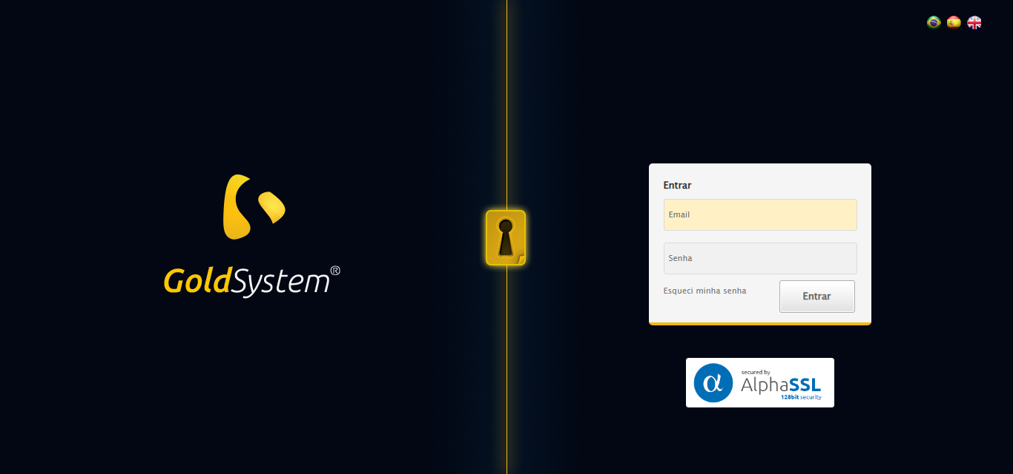

[17:45:18] 🔄 Realizando login...

[17:45:23] ✅ Realizando login realizada com sucesso.

[17:45:25] 📸 Screenshot capturada: realizando_login

Screenshot: realizando_login

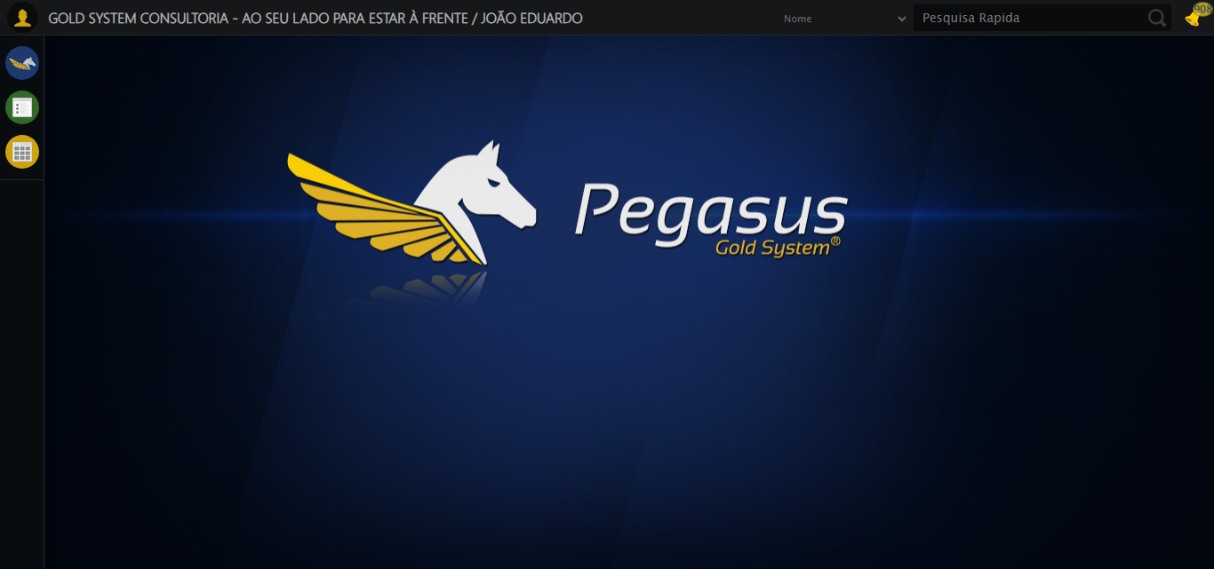

[17:45:25] 🔄 Configurando ambiente...

[17:45:25] 🔍 Zoom ajustado para 90%.

[17:45:27] ✅ Configurando ambiente realizada com sucesso.

[17:45:28] 📸 Screenshot capturada: configurando_ambiente

Screenshot: configurando_ambiente

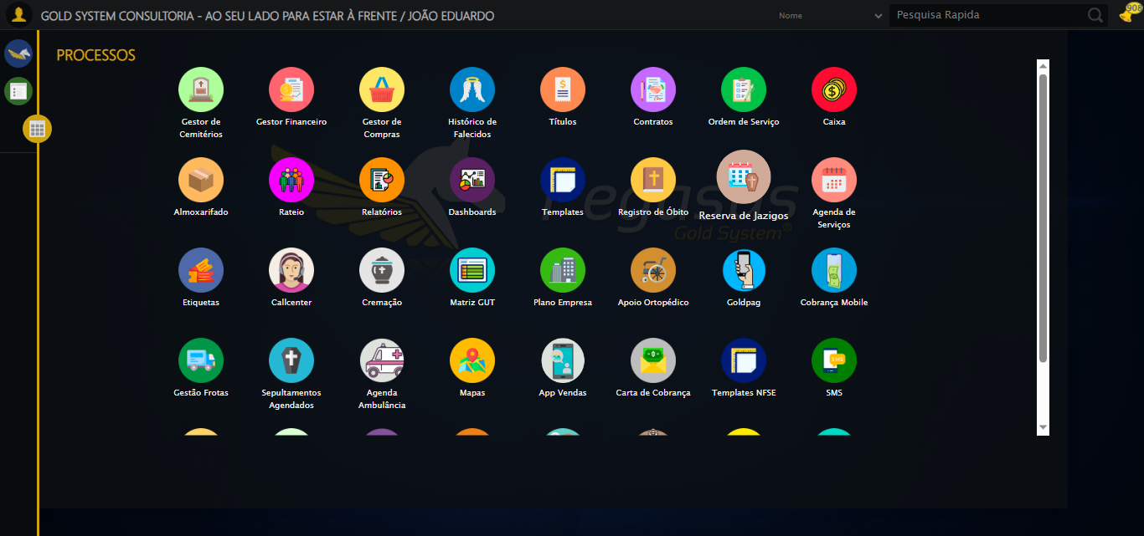

[17:45:28] 🔄 Acessando módulo PET...

[17:45:29] 📸 Screenshot capturada: erro_acessando_módulo_pet

Screenshot: erro_acessando_módulo_pet



[17:45:30] ❌ Acessando módulo PET falhou: ElementClickInterceptedException: Message: element click intercepted: Element <img src="images/icons/newIcons/Pet.png" style="width: 60px;"> is not clickable at point (888, 538). Other element would receive the click: <div class="menuLayer animate process overflow overflowY boxsize active" style="z-index: 195; width: 1367px; left: 50px; height: 635px;">...</div>  
 (Session info: chrome=138.0.7204.185); For documentation on this error, please visit: https://www.selenium.dev/documentation/webdriver/troubleshooting/errors#elementclickinterceptedexception  
Stacktrace:  
 GetHandleVerifier [0x0xc6ba83+63395]  
 GetHandleVerifier [0x0xc6bac4+63460]  
 (No symbol) [0x0xab2113]  
 (No symbol) [0x0xb00ba0]  
 (No symbol) [0x0xafef5a]  
 (No symbol) [0x0xafcab7]  
 (No symbol) [0x0xafbd6d]  
 (No symbol) [0x0xaf0515]  
 (No symbol) [0x0xb1f3ac]  
 (No symbol) [0x0xaeffa4]  
 (No symbol) [0x0xb1f624]  
 (No symbol) [0x0xb407ba]  
 (No symbol) [0x0xb1f1a6]  
 (No symbol) [0x0xaee7b2]  
 (No symbol) [0x0xaef654]  
 GetHandleVerifier [0x0xee8883+2672035]  
 GetHandleVerifier [0x0xee3cba+2652634]  
 GetHandleVerifier [0x0xc92bca+223466]  
 GetHandleVerifier [0x0xc82cb8+158168]  
 GetHandleVerifier [0x0xc8978d+185517]  
 GetHandleVerifier [0x0xc73b78+96408]  
 GetHandleVerifier [0x0xc73d02+96802]  
 GetHandleVerifier [0x0xc5e90a+9770]  
 BaseThreadInitThunk [0x0x7709fcc9+25]  
 RtlGetAppContainerNamedObjectPath [0x0x778882ae+286]  
 RtlGetAppContainerNamedObjectPath [0x0x7788827e+238]

[17:45:30] — stacktrace —

[17:45:30] Traceback (most recent call last):  
 File "C:\RPASelenium\RPAsPegasusSelenium\cenariostestespegasus\Processos\CadastrosCenáriosPet\ConsultaCenáriosContrato\consultadecontratopet1ºcenario.py", line 157, in safe_action  
 resultado = func()  
 File "C:\RPASelenium\RPAsPegasusSelenium\cenariostestespegasus\Processos\CadastrosCenáriosPet\ConsultaCenáriosContrato\consultadecontratopet1ºcenario.py", line 1136, in <lambda>  
 aguardar_elemento("//li[39]/img", timeout=TIMEOUT_DEFAULT, by_type=By.XPATH).click(),  
 ~~~~~~~~~~~~~~~~~~~~~~~~~~~~~~~~~~~~~~~~~~~~~~~~~~~~~~~~~~~~~~~~~~~~~~~~~~~~~~~~~~^^  
 File "C:\RPASelenium\RPAsPegasusSelenium\venv\Lib\site-packages\selenium\webdriver\remote\webelement.py", line 120, in click  
 self._execute(Command.CLICK_ELEMENT)  
 ~~~~~~~~~~~~~^^^^^^^^^^^^^^^^^^^^^^^  
 File "C:\RPASelenium\RPAsPegasusSelenium\venv\Lib\site-packages\selenium\webdriver\remote\webelement.py", line 573, in _execute  
 return self._parent.execute(command, params)  
 ~~~~~~~~~~~~~~~~~~~~^^^^^^^^^^^^^^^^^  
 File "C:\RPASelenium\RPAsPegasusSelenium\venv\Lib\site-packages\selenium\webdriver\remote\webdriver.py", line 458, in execute  
 self.error_handler.check_response(response)  
 ~~~~~~~~~~~~~~~~~~~~~~~~~~~~~~~~~^^^^^^^^^^  
 File "C:\RPASelenium\RPAsPegasusSelenium\venv\Lib\site-packages\selenium\webdriver\remote\errorhandler.py", line 232, in check_response  
 raise exception_class(message, screen, stacktrace)  
selenium.common.exceptions.ElementClickInterceptedException: Message: element click intercepted: Element <img src="images/icons/newIcons/Pet.png" style="width: 60px;"> is not clickable at point (888, 538). Other element would receive the click: <div class="menuLayer animate process overflow overflowY boxsize active" style="z-index: 195; width: 1367px; left: 50px; height: 635px;">...</div>  
 (Session info: chrome=138.0.7204.185); For documentation on this error, please visit: https://www.selenium.dev/documentation/webdriver/troubleshooting/errors#elementclickinterceptedexception  
Stacktrace:  
 GetHandleVerifier [0x0xc6ba83+63395]  
 GetHandleVerifier [0x0xc6bac4+63460]  
 (No symbol) [0x0xab2113]  
 (No symbol) [0x0xb00ba0]  
 (No symbol) [0x0xafef5a]  
 (No symbol) [0x0xafcab7]  
 (No symbol) [0x0xafbd6d]  
 (No symbol) [0x0xaf0515]  
 (No symbol) [0x0xb1f3ac]  
 (No symbol) [0x0xaeffa4]  
 (No symbol) [0x0xb1f624]  
 (No symbol) [0x0xb407ba]  
 (No symbol) [0x0xb1f1a6]  
 (No symbol) [0x0xaee7b2]  
 (No symbol) [0x0xaef654]  
 GetHandleVerifier [0x0xee8883+2672035]  
 GetHandleVerifier [0x0xee3cba+2652634]  
 GetHandleVerifier [0x0xc92bca+223466]  
 GetHandleVerifier [0x0xc82cb8+158168]  
 GetHandleVerifier [0x0xc8978d+185517]  
 GetHandleVerifier [0x0xc73b78+96408]  
 GetHandleVerifier [0x0xc73d02+96802]  
 GetHandleVerifier [0x0xc5e90a+9770]  
 BaseThreadInitThunk [0x0x7709fcc9+25]  
 RtlGetAppContainerNamedObjectPath [0x0x778882ae+286]  
 RtlGetAppContainerNamedObjectPath [0x0x7788827e+238]

[17:45:30] ❌ ERRO CRÍTICO NO TESTE: Message: element click intercepted: Element <img src="images/icons/newIcons/Pet.png" style="width: 60px;"> is not clickable at point (888, 538). Other element would receive the click: <div class="menuLayer animate process overflow overflowY boxsize active" style="z-index: 195; width: 1367px; left: 50px; height: 635px;">...</div>  
 (Session info: chrome=138.0.7204.185); For documentation on this error, please visit: https://www.selenium.dev/documentation/webdriver/troubleshooting/errors#elementclickinterceptedexception  
Stacktrace:  
 GetHandleVerifier [0x0xc6ba83+63395]  
 GetHandleVerifier [0x0xc6bac4+63460]  
 (No symbol) [0x0xab2113]  
 (No symbol) [0x0xb00ba0]  
 (No symbol) [0x0xafef5a]  
 (No symbol) [0x0xafcab7]  
 (No symbol) [0x0xafbd6d]  
 (No symbol) [0x0xaf0515]  
 (No symbol) [0x0xb1f3ac]  
 (No symbol) [0x0xaeffa4]  
 (No symbol) [0x0xb1f624]  
 (No symbol) [0x0xb407ba]  
 (No symbol) [0x0xb1f1a6]  
 (No symbol) [0x0xaee7b2]  
 (No symbol) [0x0xaef654]  
 GetHandleVerifier [0x0xee8883+2672035]  
 GetHandleVerifier [0x0xee3cba+2652634]  
 GetHandleVerifier [0x0xc92bca+223466]  
 GetHandleVerifier [0x0xc82cb8+158168]  
 GetHandleVerifier [0x0xc8978d+185517]  
 GetHandleVerifier [0x0xc73b78+96408]  
 GetHandleVerifier [0x0xc73d02+96802]  
 GetHandleVerifier [0x0xc5e90a+9770]  
 BaseThreadInitThunk [0x0x7709fcc9+25]  
 RtlGetAppContainerNamedObjectPath [0x0x778882ae+286]  
 RtlGetAppContainerNamedObjectPath [0x0x7788827e+238]

[17:45:30] — stacktrace —

[17:45:30] Traceback (most recent call last):  
 File "C:\RPASelenium\RPAsPegasusSelenium\cenariostestespegasus\Processos\CadastrosCenáriosPet\ConsultaCenáriosContrato\consultadecontratopet1ºcenario.py", line 1135, in executar_teste  
 safe_action(doc, "Acessando módulo PET", lambda: (  
 ~~~~~~~~~~~^^^^^^^^^^^^^^^^^^^^^^^^^^^^^^^^^^^^^^^  
 aguardar_elemento("//li[39]/img", timeout=TIMEOUT_DEFAULT, by_type=By.XPATH).click(),  
 ^^^^^^^^^^^^^^^^^^^^^^^^^^^^^^^^^^^^^^^^^^^^^^^^^^^^^^^^^^^^^^^^^^^^^^^^^^^^^^^^^^^^^  
 time.sleep(3)  
 ^^^^^^^^^^^^^  
 ), critico=True)  
 ^^^^^^^^^^^^^^^^  
 File "C:\RPASelenium\RPAsPegasusSelenium\cenariostestespegasus\Processos\CadastrosCenáriosPet\ConsultaCenáriosContrato\consultadecontratopet1ºcenario.py", line 157, in safe_action  
 resultado = func()  
 File "C:\RPASelenium\RPAsPegasusSelenium\cenariostestespegasus\Processos\CadastrosCenáriosPet\ConsultaCenáriosContrato\consultadecontratopet1ºcenario.py", line 1136, in <lambda>  
 aguardar_elemento("//li[39]/img", timeout=TIMEOUT_DEFAULT, by_type=By.XPATH).click(),  
 ~~~~~~~~~~~~~~~~~~~~~~~~~~~~~~~~~~~~~~~~~~~~~~~~~~~~~~~~~~~~~~~~~~~~~~~~~~~~~~~~~~^^  
 File "C:\RPASelenium\RPAsPegasusSelenium\venv\Lib\site-packages\selenium\webdriver\remote\webelement.py", line 120, in click  
 self._execute(Command.CLICK_ELEMENT)  
 ~~~~~~~~~~~~~^^^^^^^^^^^^^^^^^^^^^^^  
 File "C:\RPASelenium\RPAsPegasusSelenium\venv\Lib\site-packages\selenium\webdriver\remote\webelement.py", line 573, in _execute  
 return self._parent.execute(command, params)  
 ~~~~~~~~~~~~~~~~~~~~^^^^^^^^^^^^^^^^^  
 File "C:\RPASelenium\RPAsPegasusSelenium\venv\Lib\site-packages\selenium\webdriver\remote\webdriver.py", line 458, in execute  
 self.error_handler.check_response(response)  
 ~~~~~~~~~~~~~~~~~~~~~~~~~~~~~~~~~^^^^^^^^^^  
 File "C:\RPASelenium\RPAsPegasusSelenium\venv\Lib\site-packages\selenium\webdriver\remote\errorhandler.py", line 232, in check_response  
 raise exception_class(message, screen, stacktrace)  
selenium.common.exceptions.ElementClickInterceptedException: Message: element click intercepted: Element <img src="images/icons/newIcons/Pet.png" style="width: 60px;"> is not clickable at point (888, 538). Other element would receive the click: <div class="menuLayer animate process overflow overflowY boxsize active" style="z-index: 195; width: 1367px; left: 50px; height: 635px;">...</div>  
 (Session info: chrome=138.0.7204.185); For documentation on this error, please visit: https://www.selenium.dev/documentation/webdriver/troubleshooting/errors#elementclickinterceptedexception  
Stacktrace:  
 GetHandleVerifier [0x0xc6ba83+63395]  
 GetHandleVerifier [0x0xc6bac4+63460]  
 (No symbol) [0x0xab2113]  
 (No symbol) [0x0xb00ba0]  
 (No symbol) [0x0xafef5a]  
 (No symbol) [0x0xafcab7]  
 (No symbol) [0x0xafbd6d]  
 (No symbol) [0x0xaf0515]  
 (No symbol) [0x0xb1f3ac]  
 (No symbol) [0x0xaeffa4]  
 (No symbol) [0x0xb1f624]  
 (No symbol) [0x0xb407ba]  
 (No symbol) [0x0xb1f1a6]  
 (No symbol) [0x0xaee7b2]  
 (No symbol) [0x0xaef654]  
 GetHandleVerifier [0x0xee8883+2672035]  
 GetHandleVerifier [0x0xee3cba+2652634]  
 GetHandleVerifier [0x0xc92bca+223466]  
 GetHandleVerifier [0x0xc82cb8+158168]  
 GetHandleVerifier [0x0xc8978d+185517]  
 GetHandleVerifier [0x0xc73b78+96408]  
 GetHandleVerifier [0x0xc73d02+96802]  
 GetHandleVerifier [0x0xc5e90a+9770]  
 BaseThreadInitThunk [0x0x7709fcc9+25]  
 RtlGetAppContainerNamedObjectPath [0x0x778882ae+286]  
 RtlGetAppContainerNamedObjectPath [0x0x7788827e+238]

[17:45:30] 📸 Screenshot capturada: erro_critico_final

Screenshot: erro_critico_final



[17:45:30] 🏁 Finalizando teste...

[17:45:30] ❌ TESTE FINALIZADO COM ERROS.

[17:45:30] ============================================================

==================================================

RESUMO FINAL DO TESTE

==================================================

Teste finalizado em: 14/08/2025 17:45:30

Total de screenshots capturadas: 5