RELATÓRIO DO TESTE

Consulta de Contrato Pet – Cenário 1: Realização da consulta de contrato Pet

Data do teste: 14/08/2025 17:48:17

[17:48:17] 🚀 INICIANDO TESTE DE CONSULTA DE CONTRATO PET

[17:48:17] ============================================================

[17:48:17] 🚀 Inicializando driver do Chrome...

[17:48:26] ✅ Driver inicializado com sucesso

[17:48:26] 🎯 Iniciando execução do teste de consulta de contrato Pet

[17:48:26] 🔄 Acessando sistema...

[17:48:31] ✅ Acessando sistema realizada com sucesso.

[17:48:32] 📸 Screenshot capturada: acessando_sistema

Screenshot: acessando_sistema

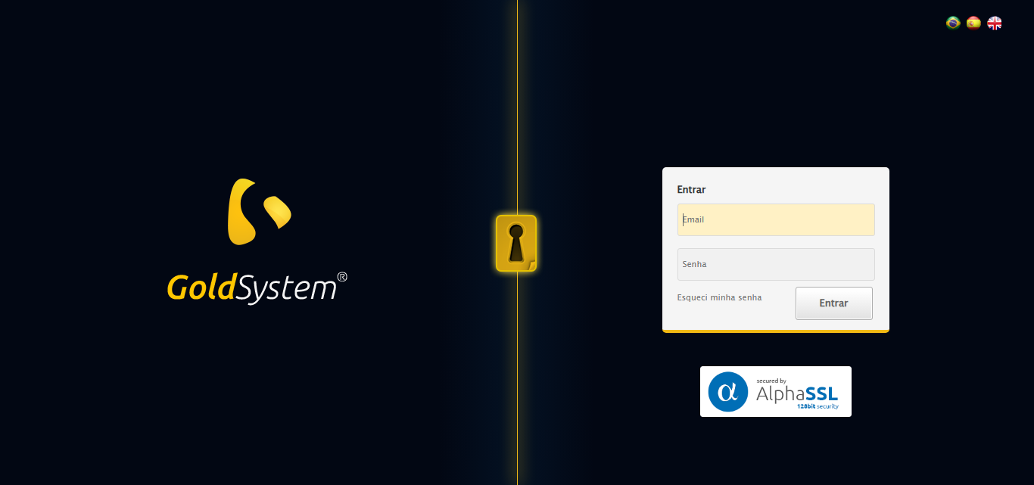

[17:48:32] 🔄 Realizando login...

[17:48:37] ✅ Realizando login realizada com sucesso.

[17:48:39] 📸 Screenshot capturada: realizando_login

Screenshot: realizando_login

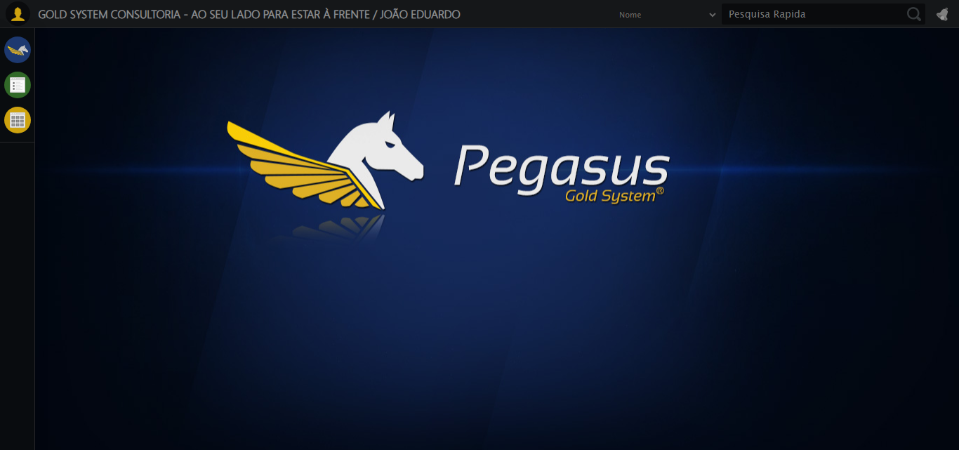

[17:48:39] 🔄 Configurando ambiente...

[17:48:39] 🔍 Zoom ajustado para 90%.

[17:48:41] ✅ Configurando ambiente realizada com sucesso.

[17:48:42] 📸 Screenshot capturada: configurando_ambiente

Screenshot: configurando_ambiente

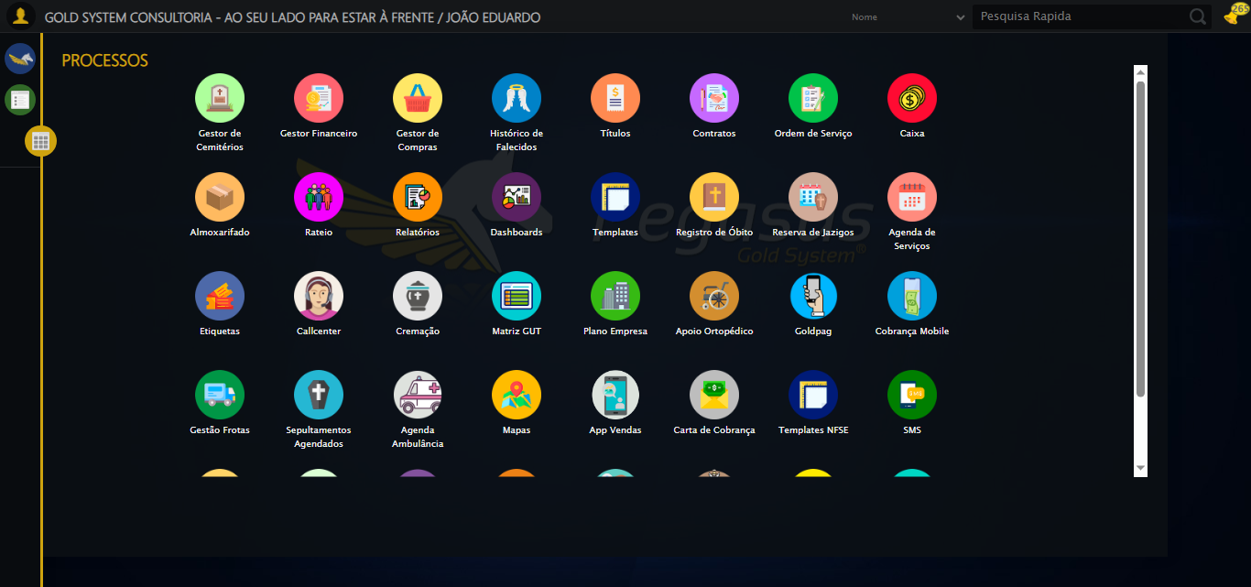

[17:48:42] 🔄 Acessando módulo PET...

[17:48:43] 📸 Screenshot capturada: erro_acessando_módulo_pet

Screenshot: erro_acessando_módulo_pet



[17:48:43] ❌ Acessando módulo PET falhou: JavascriptException: Message: javascript error: Cannot read properties of undefined (reading 'scrollIntoView')  
 (Session info: chrome=138.0.7204.185)  
Stacktrace:  
 GetHandleVerifier [0x0xfcba83+63395]  
 GetHandleVerifier [0x0xfcbac4+63460]  
 (No symbol) [0x0xe12113]  
 (No symbol) [0x0xe188e9]  
 (No symbol) [0x0xe1aec3]  
 (No symbol) [0x0xea17b4]  
 (No symbol) [0x0xe7f3ac]  
 (No symbol) [0x0xea07ba]  
 (No symbol) [0x0xe7f1a6]  
 (No symbol) [0x0xe4e7b2]  
 (No symbol) [0x0xe4f654]  
 GetHandleVerifier [0x0x1248883+2672035]  
 GetHandleVerifier [0x0x1243cba+2652634]  
 GetHandleVerifier [0x0xff2bca+223466]  
 GetHandleVerifier [0x0xfe2cb8+158168]  
 GetHandleVerifier [0x0xfe978d+185517]  
 GetHandleVerifier [0x0xfd3b78+96408]  
 GetHandleVerifier [0x0xfd3d02+96802]  
 GetHandleVerifier [0x0xfbe90a+9770]  
 BaseThreadInitThunk [0x0x7709fcc9+25]  
 RtlGetAppContainerNamedObjectPath [0x0x778882ae+286]  
 RtlGetAppContainerNamedObjectPath [0x0x7788827e+238]

[17:48:43] — stacktrace —

[17:48:43] Traceback (most recent call last):  
 File "C:\RPASelenium\RPAsPegasusSelenium\cenariostestespegasus\Processos\CadastrosCenáriosPet\ConsultaCenáriosContrato\consultadecontratopet1ºcenario.py", line 157, in safe_action  
 resultado = func()  
 File "C:\RPASelenium\RPAsPegasusSelenium\cenariostestespegasus\Processos\CadastrosCenáriosPet\ConsultaCenáriosContrato\consultadecontratopet1ºcenario.py", line 1136, in <lambda>  
 driver.execute_script("arguments[0].scrollIntoView({block: 'center'});"),  
 ~~~~~~~~~~~~~~~~~~~~~^^^^^^^^^^^^^^^^^^^^^^^^^^^^^^^^^^^^^^^^^^^^^^^^^^^  
 File "C:\RPASelenium\RPAsPegasusSelenium\venv\Lib\site-packages\selenium\webdriver\remote\webdriver.py", line 555, in execute_script  
 return self.execute(command, {"script": script, "args": converted_args})["value"]  
 ~~~~~~~~~~~~^^^^^^^^^^^^^^^^^^^^^^^^^^^^^^^^^^^^^^^^^^^^^^^^^^^^^  
 File "C:\RPASelenium\RPAsPegasusSelenium\venv\Lib\site-packages\selenium\webdriver\remote\webdriver.py", line 458, in execute  
 self.error_handler.check_response(response)  
 ~~~~~~~~~~~~~~~~~~~~~~~~~~~~~~~~~^^^^^^^^^^  
 File "C:\RPASelenium\RPAsPegasusSelenium\venv\Lib\site-packages\selenium\webdriver\remote\errorhandler.py", line 232, in check_response  
 raise exception_class(message, screen, stacktrace)  
selenium.common.exceptions.JavascriptException: Message: javascript error: Cannot read properties of undefined (reading 'scrollIntoView')  
 (Session info: chrome=138.0.7204.185)  
Stacktrace:  
 GetHandleVerifier [0x0xfcba83+63395]  
 GetHandleVerifier [0x0xfcbac4+63460]  
 (No symbol) [0x0xe12113]  
 (No symbol) [0x0xe188e9]  
 (No symbol) [0x0xe1aec3]  
 (No symbol) [0x0xea17b4]  
 (No symbol) [0x0xe7f3ac]  
 (No symbol) [0x0xea07ba]  
 (No symbol) [0x0xe7f1a6]  
 (No symbol) [0x0xe4e7b2]  
 (No symbol) [0x0xe4f654]  
 GetHandleVerifier [0x0x1248883+2672035]  
 GetHandleVerifier [0x0x1243cba+2652634]  
 GetHandleVerifier [0x0xff2bca+223466]  
 GetHandleVerifier [0x0xfe2cb8+158168]  
 GetHandleVerifier [0x0xfe978d+185517]  
 GetHandleVerifier [0x0xfd3b78+96408]  
 GetHandleVerifier [0x0xfd3d02+96802]  
 GetHandleVerifier [0x0xfbe90a+9770]  
 BaseThreadInitThunk [0x0x7709fcc9+25]  
 RtlGetAppContainerNamedObjectPath [0x0x778882ae+286]  
 RtlGetAppContainerNamedObjectPath [0x0x7788827e+238]

[17:48:43] ❌ ERRO CRÍTICO NO TESTE: Message: javascript error: Cannot read properties of undefined (reading 'scrollIntoView')  
 (Session info: chrome=138.0.7204.185)  
Stacktrace:  
 GetHandleVerifier [0x0xfcba83+63395]  
 GetHandleVerifier [0x0xfcbac4+63460]  
 (No symbol) [0x0xe12113]  
 (No symbol) [0x0xe188e9]  
 (No symbol) [0x0xe1aec3]  
 (No symbol) [0x0xea17b4]  
 (No symbol) [0x0xe7f3ac]  
 (No symbol) [0x0xea07ba]  
 (No symbol) [0x0xe7f1a6]  
 (No symbol) [0x0xe4e7b2]  
 (No symbol) [0x0xe4f654]  
 GetHandleVerifier [0x0x1248883+2672035]  
 GetHandleVerifier [0x0x1243cba+2652634]  
 GetHandleVerifier [0x0xff2bca+223466]  
 GetHandleVerifier [0x0xfe2cb8+158168]  
 GetHandleVerifier [0x0xfe978d+185517]  
 GetHandleVerifier [0x0xfd3b78+96408]  
 GetHandleVerifier [0x0xfd3d02+96802]  
 GetHandleVerifier [0x0xfbe90a+9770]  
 BaseThreadInitThunk [0x0x7709fcc9+25]  
 RtlGetAppContainerNamedObjectPath [0x0x778882ae+286]  
 RtlGetAppContainerNamedObjectPath [0x0x7788827e+238]

[17:48:43] — stacktrace —

[17:48:43] Traceback (most recent call last):  
 File "C:\RPASelenium\RPAsPegasusSelenium\cenariostestespegasus\Processos\CadastrosCenáriosPet\ConsultaCenáriosContrato\consultadecontratopet1ºcenario.py", line 1135, in executar_teste  
 safe_action(doc, "Acessando módulo PET", lambda: (  
 ~~~~~~~~~~~^^^^^^^^^^^^^^^^^^^^^^^^^^^^^^^^^^^^^^^  
 driver.execute_script("arguments[0].scrollIntoView({block: 'center'});"),  
 ^^^^^^^^^^^^^^^^^^^^^^^^^^^^^^^^^^^^^^^^^^^^^^^^^^^^^^^^^^^^^^^^^^^^^^^^^  
 aguardar_elemento("//li[39]/img", timeout=TIMEOUT_DEFAULT, by_type=By.XPATH).click(),  
 ^^^^^^^^^^^^^^^^^^^^^^^^^^^^^^^^^^^^^^^^^^^^^^^^^^^^^^^^^^^^^^^^^^^^^^^^^^^^^^^^^^^^^  
 time.sleep(3)  
 ^^^^^^^^^^^^^  
 ), critico=True)  
 ^^^^^^^^^^^^^^^^  
 File "C:\RPASelenium\RPAsPegasusSelenium\cenariostestespegasus\Processos\CadastrosCenáriosPet\ConsultaCenáriosContrato\consultadecontratopet1ºcenario.py", line 157, in safe_action  
 resultado = func()  
 File "C:\RPASelenium\RPAsPegasusSelenium\cenariostestespegasus\Processos\CadastrosCenáriosPet\ConsultaCenáriosContrato\consultadecontratopet1ºcenario.py", line 1136, in <lambda>  
 driver.execute_script("arguments[0].scrollIntoView({block: 'center'});"),  
 ~~~~~~~~~~~~~~~~~~~~~^^^^^^^^^^^^^^^^^^^^^^^^^^^^^^^^^^^^^^^^^^^^^^^^^^^  
 File "C:\RPASelenium\RPAsPegasusSelenium\venv\Lib\site-packages\selenium\webdriver\remote\webdriver.py", line 555, in execute_script  
 return self.execute(command, {"script": script, "args": converted_args})["value"]  
 ~~~~~~~~~~~~^^^^^^^^^^^^^^^^^^^^^^^^^^^^^^^^^^^^^^^^^^^^^^^^^^^^^  
 File "C:\RPASelenium\RPAsPegasusSelenium\venv\Lib\site-packages\selenium\webdriver\remote\webdriver.py", line 458, in execute  
 self.error_handler.check_response(response)  
 ~~~~~~~~~~~~~~~~~~~~~~~~~~~~~~~~~^^^^^^^^^^  
 File "C:\RPASelenium\RPAsPegasusSelenium\venv\Lib\site-packages\selenium\webdriver\remote\errorhandler.py", line 232, in check_response  
 raise exception_class(message, screen, stacktrace)  
selenium.common.exceptions.JavascriptException: Message: javascript error: Cannot read properties of undefined (reading 'scrollIntoView')  
 (Session info: chrome=138.0.7204.185)  
Stacktrace:  
 GetHandleVerifier [0x0xfcba83+63395]  
 GetHandleVerifier [0x0xfcbac4+63460]  
 (No symbol) [0x0xe12113]  
 (No symbol) [0x0xe188e9]  
 (No symbol) [0x0xe1aec3]  
 (No symbol) [0x0xea17b4]  
 (No symbol) [0x0xe7f3ac]  
 (No symbol) [0x0xea07ba]  
 (No symbol) [0x0xe7f1a6]  
 (No symbol) [0x0xe4e7b2]  
 (No symbol) [0x0xe4f654]  
 GetHandleVerifier [0x0x1248883+2672035]  
 GetHandleVerifier [0x0x1243cba+2652634]  
 GetHandleVerifier [0x0xff2bca+223466]  
 GetHandleVerifier [0x0xfe2cb8+158168]  
 GetHandleVerifier [0x0xfe978d+185517]  
 GetHandleVerifier [0x0xfd3b78+96408]  
 GetHandleVerifier [0x0xfd3d02+96802]  
 GetHandleVerifier [0x0xfbe90a+9770]  
 BaseThreadInitThunk [0x0x7709fcc9+25]  
 RtlGetAppContainerNamedObjectPath [0x0x778882ae+286]  
 RtlGetAppContainerNamedObjectPath [0x0x7788827e+238]

[17:48:43] 📸 Screenshot capturada: erro_critico_final

Screenshot: erro_critico_final



[17:48:43] 🏁 Finalizando teste...

[17:48:43] ❌ TESTE FINALIZADO COM ERROS.

[17:48:43] ============================================================

==================================================

RESUMO FINAL DO TESTE

==================================================

Teste finalizado em: 14/08/2025 17:48:43

Total de screenshots capturadas: 5