RELATÓRIO DO TESTE

Consulta de Contrato Pet – Cenário 1: Realização da consulta de contrato Pet

Data do teste: 15/08/2025 15:18:27

[15:18:27] 🚀 INICIANDO TESTE DE CONSULTA DE CONTRATO PET

[15:18:27] ============================================================

[15:18:27] 🚀 Inicializando driver do Chrome...

[15:18:35] ✅ Driver inicializado com sucesso

[15:18:35] 🎯 Iniciando execução do teste de consulta de contrato Pet

[15:18:35] 🔄 Acessando sistema...

[15:18:38] ✅ Acessando sistema realizada com sucesso.

[15:18:39] 📸 Screenshot capturada: acessando_sistema

Screenshot: acessando_sistema

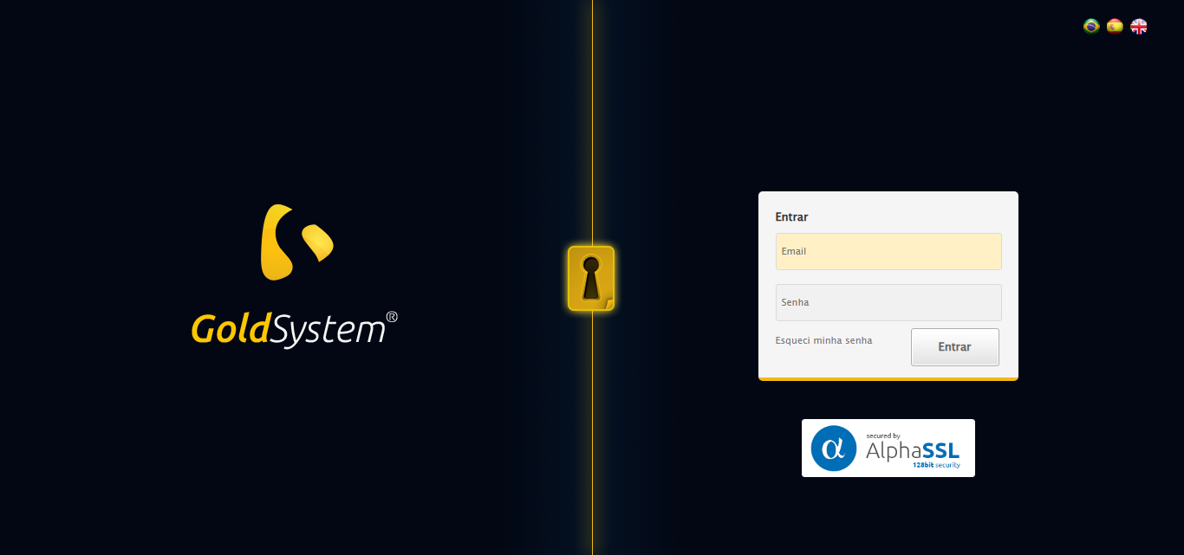

[15:18:39] 🔄 Realizando login...

[15:18:45] ✅ Realizando login realizada com sucesso.

[15:18:47] 📸 Screenshot capturada: realizando_login

Screenshot: realizando_login

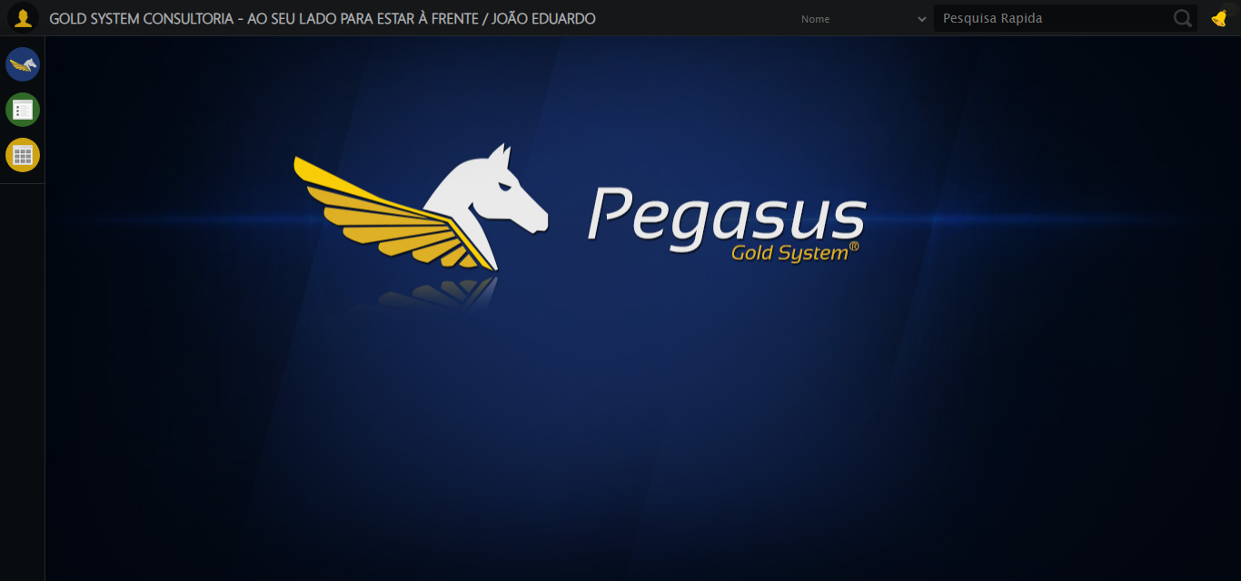

[15:18:47] 🔄 Configurando ambiente...

[15:18:47] 🔍 Zoom ajustado para 90%.

[15:18:49] ✅ Configurando ambiente realizada com sucesso.

[15:18:50] 📸 Screenshot capturada: configurando_ambiente

Screenshot: configurando_ambiente

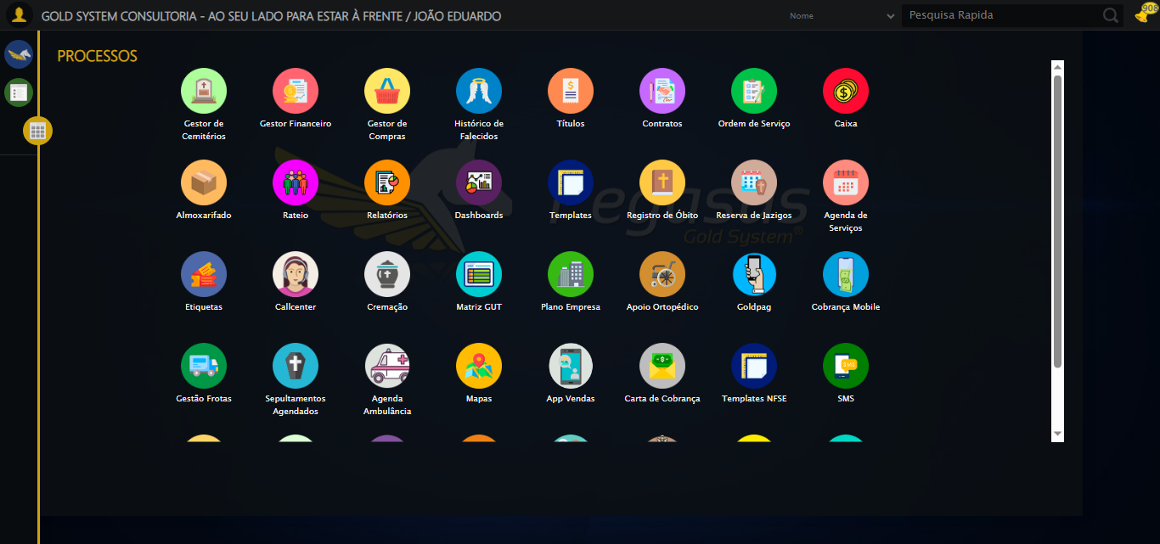

[15:18:50] 🔄 Acessando módulo PET...

[15:18:50] Tentando estratégia de scroll 1...

[15:18:51] ✅ Scroll realizado com estratégia 1

[15:18:52] Tentando estratégia de clique 1 para módulo PET...

[15:18:54] ✅ Clique no módulo PET realizado com estratégia 1

[15:18:54] ✅ Acessando módulo PET realizada com sucesso.

[15:18:55] 📸 Screenshot capturada: acessando_módulo_pet

Screenshot: acessando_módulo_pet

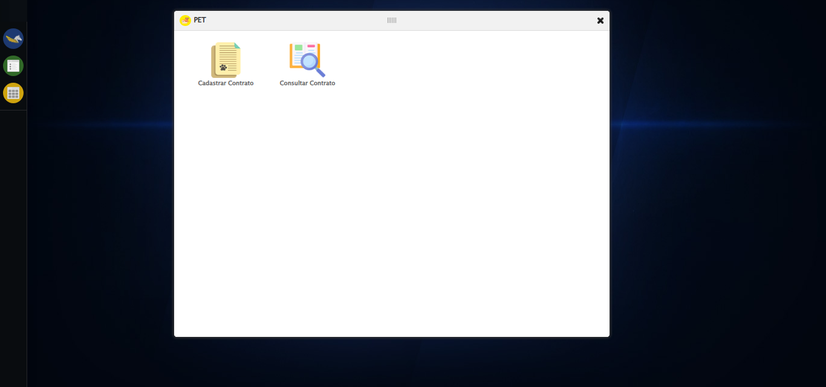

[15:18:55] 🔄 Abrindo consulta de contrato...

[15:18:59] ✅ Abrindo consulta de contrato realizada com sucesso.

[15:19:00] 📸 Screenshot capturada: abrindo_consulta_de_contrato

Screenshot: abrindo_consulta_de_contrato

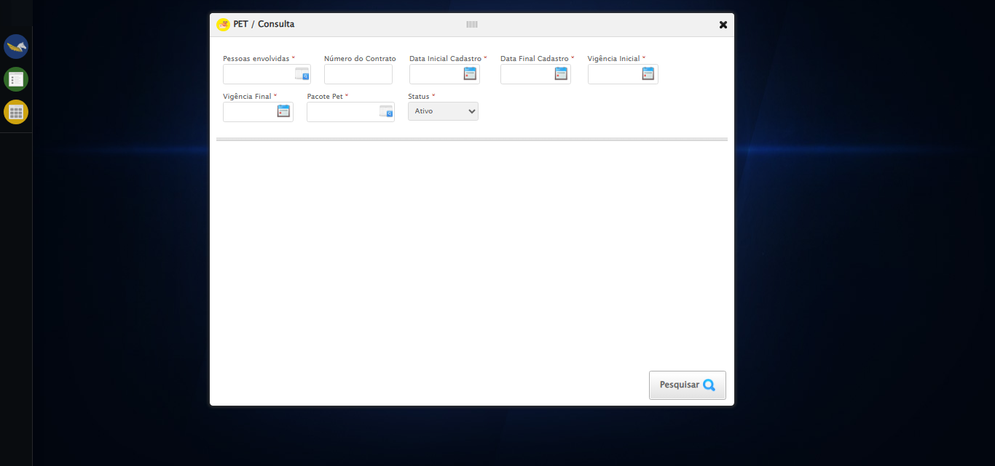

[15:19:00] 🔄 Selecionando Pessoas Envolvidas...

[15:19:00] 🔘 Abrindo modal com botão: #gsPet > div.wdTelas > div.telaConsulta.telaConsultaContratoPet > div > div.formRow.filtrosConsulta > div:nth-child(1) > div > a

[15:19:00] Tentando estratégia de scroll 1...

[15:19:01] ✅ Scroll realizado com estratégia 1

[15:19:03] 🔍 Preenchendo pesquisa com: TESTE TUTOR SELENIUM AUTOMATIZADO

[15:19:04] 🔍 Executando pesquisa...

[15:19:07] 🎯 Selecionando resultado: //td[contains(text(), 'TESTE TUTOR SELENIUM AUTOMATIZADO')]

[15:19:07] Tentando estratégia de scroll 1...

[15:19:08] ✅ Scroll realizado com estratégia 1

[15:19:09] ✅ Seleção no modal concluída

[15:19:09] ✅ Selecionando Pessoas Envolvidas realizada com sucesso.

[15:19:10] 📸 Screenshot capturada: selecionando_pessoas_envolvidas

Screenshot: selecionando_pessoas_envolvidas

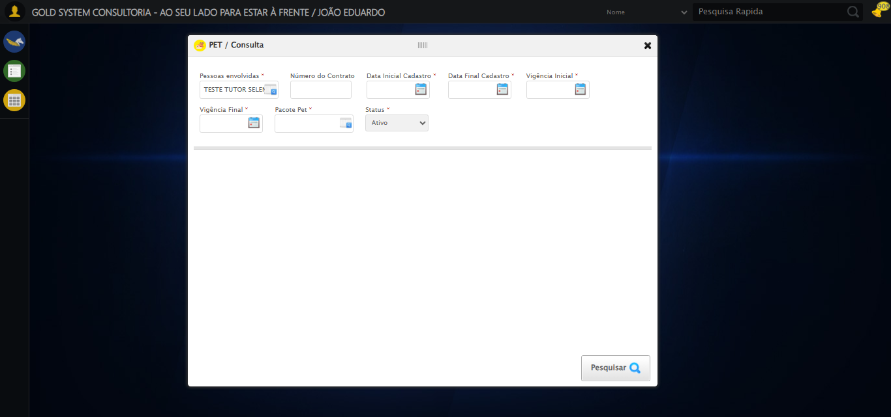

[15:19:10] 🔄 Preenchendo Número do Contrato...

[15:19:10] Tentando estratégia de scroll 1...

[15:19:11] ✅ Scroll realizado com estratégia 1

[15:19:12] ✅ Campo preenchido com estratégia 1: '113079'

[15:19:12] ✅ Preenchendo Número do Contrato realizada com sucesso.

[15:19:14] 📸 Screenshot capturada: preenchendo_número_do_contrato

Screenshot: preenchendo_número_do_contrato

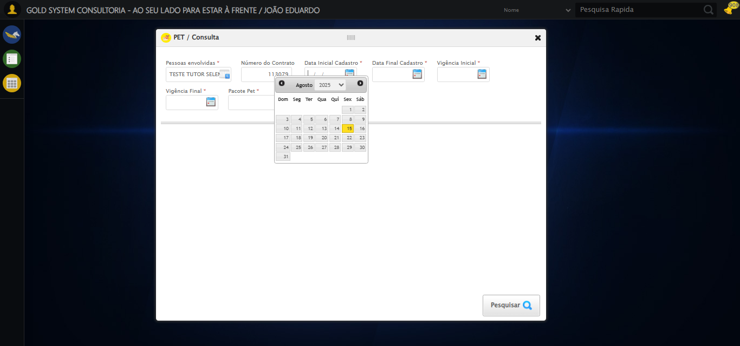

[15:19:14] 🔄 Preenchendo Data Inicial Cadastro...

[15:19:15] 📊 Encontrados 5 campos datepicker

[15:19:15] 🎯 Tentativa 1: Preenchendo datepicker 0 (ID: dp1755281923065) com '13/08/2025'

[15:19:15] Aplicando estratégia 1 para datepicker...

[15:19:16] ✅ Datepicker preenchido com estratégia 1: '13/08/2025'

[15:19:16] ✅ Preenchendo Data Inicial Cadastro realizada com sucesso.

[15:19:17] 📸 Screenshot capturada: preenchendo_data_inicial_cadastro

Screenshot: preenchendo_data_inicial_cadastro

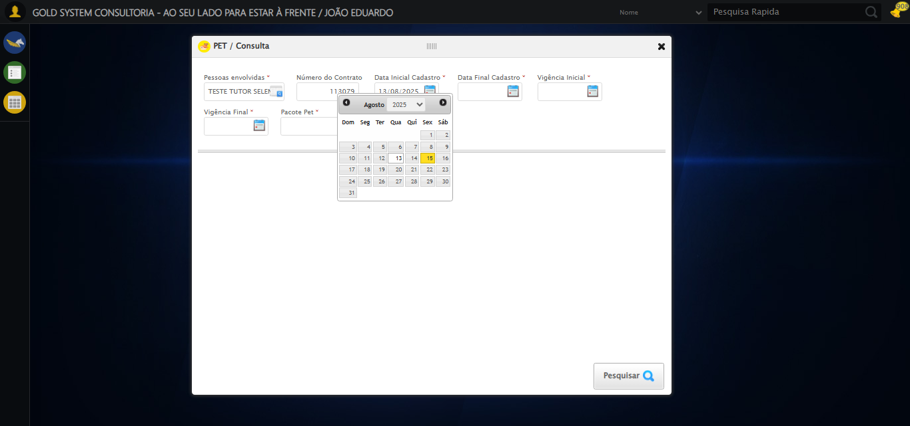

[15:19:17] 🔄 Preenchendo Data Final Cadastro...

[15:19:18] 📊 Encontrados 5 campos datepicker

[15:19:18] 🎯 Tentativa 1: Preenchendo datepicker 1 (ID: dp1755281923066) com '13/08/2025'

[15:19:18] Aplicando estratégia 1 para datepicker...

[15:19:19] ✅ Datepicker preenchido com estratégia 1: '13/08/2025'

[15:19:19] ✅ Preenchendo Data Final Cadastro realizada com sucesso.

[15:19:20] 📸 Screenshot capturada: preenchendo_data_final_cadastro

Screenshot: preenchendo_data_final_cadastro

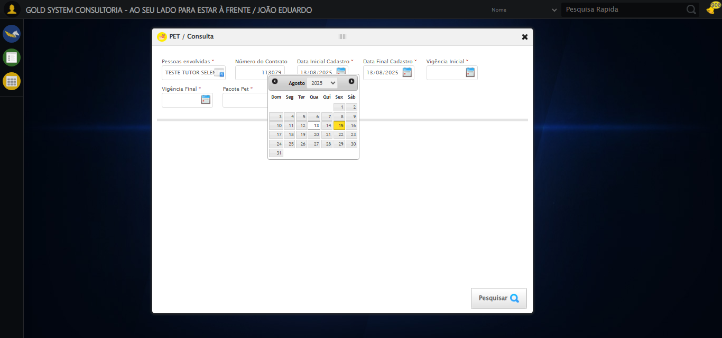

[15:19:20] 🔄 Preenchendo Vigência Inicial...

[15:19:21] 📊 Encontrados 5 campos datepicker

[15:19:21] 🎯 Tentativa 1: Preenchendo datepicker 2 (ID: dp1755281923063) com '13/08/2025'

[15:19:21] Aplicando estratégia 1 para datepicker...

[15:19:22] ✅ Datepicker preenchido com estratégia 1: '13/08/2025'

[15:19:22] ✅ Preenchendo Vigência Inicial realizada com sucesso.

[15:19:23] 📸 Screenshot capturada: preenchendo_vigência_inicial

Screenshot: preenchendo_vigência_inicial

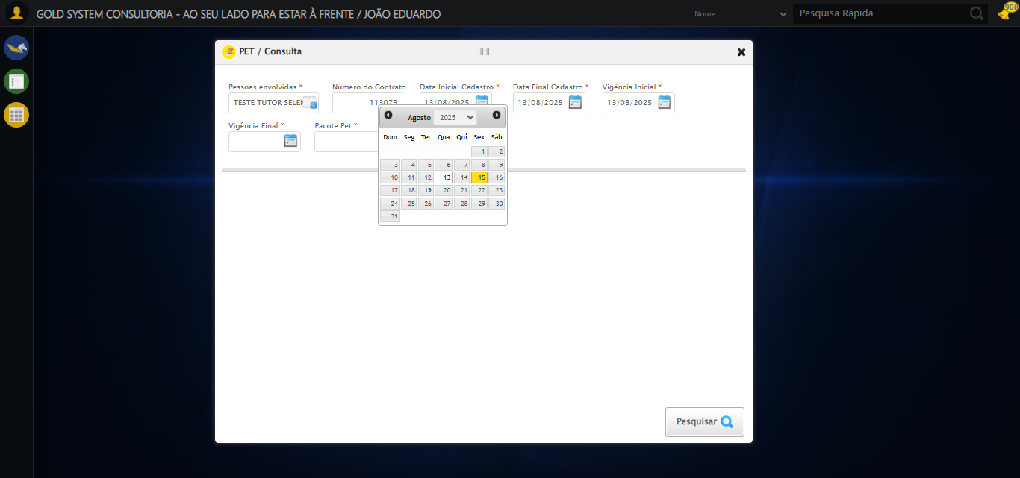

[15:19:23] 🔄 Preenchendo Vigência Final...

[15:19:24] 📊 Encontrados 5 campos datepicker

[15:19:24] 🎯 Tentativa 1: Preenchendo datepicker 3 (ID: dp1755281923064) com '13/11/2025'

[15:19:24] Aplicando estratégia 1 para datepicker...

[15:19:25] ✅ Datepicker preenchido com estratégia 1: '13/11/2025'

[15:19:25] ✅ Preenchendo Vigência Final realizada com sucesso.

[15:19:26] 📸 Screenshot capturada: preenchendo_vigência_final

Screenshot: preenchendo_vigência_final

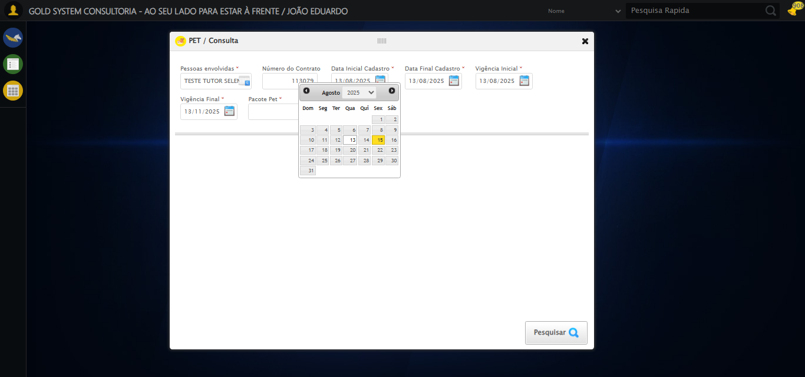

[15:19:26] 🔄 Selecionando Pacote Pet...

[15:19:26] 🔘 Abrindo modal com botão: #gsPet > div.wdTelas > div.telaConsulta.telaConsultaContratoPet > div > div.formRow.filtrosConsulta > div:nth-child(7) > div > a

[15:19:26] Tentando estratégia de scroll 1...

[15:19:27] ✅ Scroll realizado com estratégia 1

[15:19:30] 🔍 Preenchendo pesquisa com: PACOTE PET TESTE SELENIUM AUTOMATIZADO

[15:19:31] 🔍 Executando pesquisa...

[15:19:34] 🎯 Selecionando resultado: //td[contains(text(), 'PACOTE PET TESTE SELENIUM AUTOMATIZADO')]

[15:19:34] Tentando estratégia de scroll 1...

[15:19:35] ✅ Scroll realizado com estratégia 1

[15:19:37] ✅ Seleção no modal concluída

[15:19:37] ✅ Selecionando Pacote Pet realizada com sucesso.

[15:19:38] 📸 Screenshot capturada: selecionando_pacote_pet

Screenshot: selecionando_pacote_pet

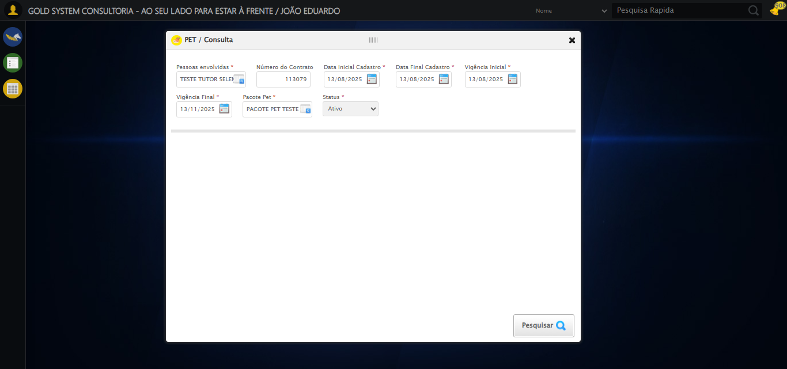

[15:19:38] 🔄 Realizando consulta...

[15:19:38] Tentando estratégia de scroll 1...

[15:19:39] ✅ Scroll realizado com estratégia 1

[15:19:41] ✅ Consulta executada

[15:19:41] ✅ Realizando consulta realizada com sucesso.

[15:19:42] 📸 Screenshot capturada: realizando_consulta

Screenshot: realizando_consulta

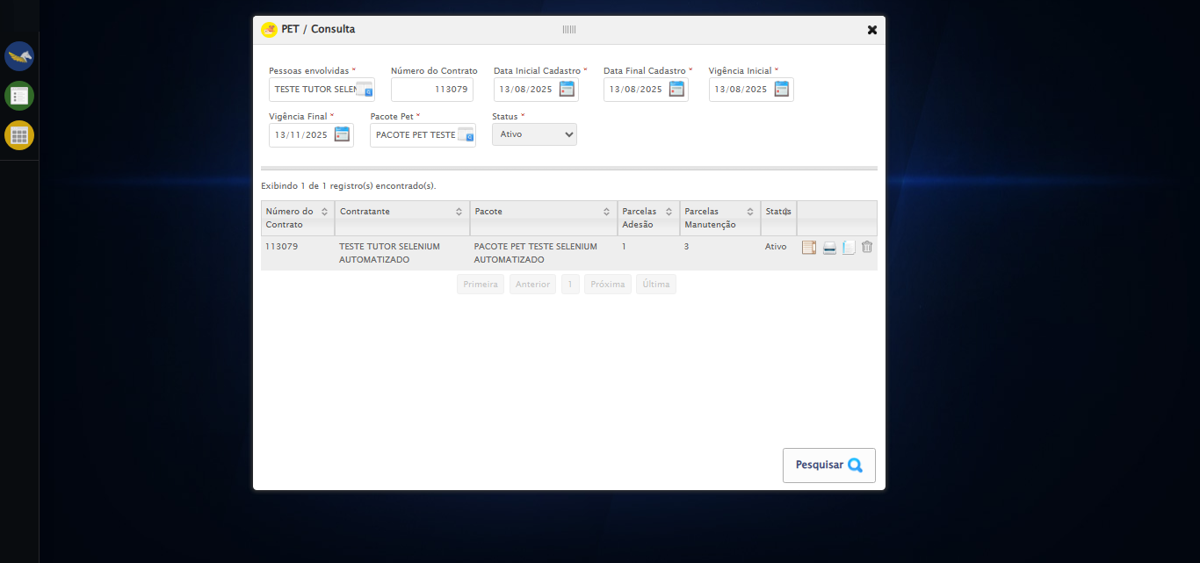

[15:19:42] 🔄 Validando resultados da consulta...

[15:19:42] 🔍 Iniciando validação de registros...

[15:19:47] ✅ Tabela encontrada: #DataTables_Table_2

[15:19:47] ✅ Encontradas 1 linhas válidas com tbody tr:not(.dataTables_empty):not([class*="no-data"])

[15:19:47] ✅ 1 registro(s) encontrado(s)

[15:19:47] Registro 1: 113079 teste tutor selenium automatizado pacote pet teste selenium automatizado 1 3 ativo

[15:19:47] ✅ Validando resultados da consulta realizada com sucesso.

[15:19:48] 📸 Screenshot capturada: validando_resultados_da_consulta

Screenshot: validando_resultados_da_consulta



[15:19:48] ✅ Processando 1 registro(s) encontrado(s)

[15:19:48] 🔄 Visualizando detalhes do Contrato Pet...

[15:19:48] Tentando estratégia de scroll 1...

[15:19:49] ✅ Scroll realizado com estratégia 1

[15:19:50] ✅ Clique realizado com estratégia 1

[15:19:50] ✅ Visualizando detalhes do Contrato Pet realizada com sucesso.

[15:19:51] 📸 Screenshot capturada: visualizando_detalhes_do_contrato_pet

Screenshot: visualizando_detalhes_do_contrato_pet

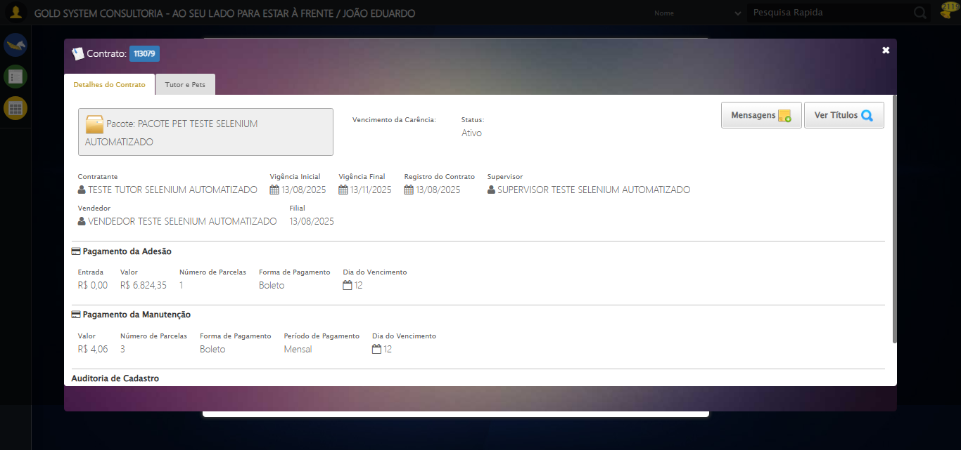

[15:19:51] 🔄 Capturando tela de detalhes...

[15:19:54] 📸 Screenshot capturada: detalhes_contrato_pet

Screenshot: detalhes_contrato_pet



[15:19:54] ✅ Capturando tela de detalhes realizada com sucesso.

[15:19:55] 📸 Screenshot capturada: capturando_tela_de_detalhes

Screenshot: capturando_tela_de_detalhes



[15:19:55] 🔄 Abrindo mensagens do Contrato Pet...

[15:19:55] Tentando estratégia de scroll 1...

[15:19:56] ✅ Scroll realizado com estratégia 1

[15:19:56] ✅ Clique realizado com estratégia 1

[15:19:56] ✅ Abrindo mensagens do Contrato Pet realizada com sucesso.

[15:19:58] 📸 Screenshot capturada: abrindo_mensagens_do_contrato_pet

Screenshot: abrindo_mensagens_do_contrato_pet

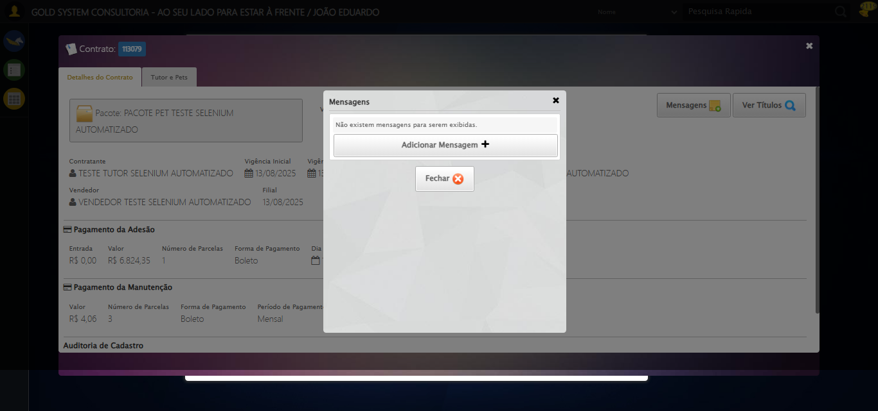

[15:19:58] 🔄 Capturando mensagens...

[15:20:00] 📸 Screenshot capturada: mensagens_contrato_pet

Screenshot: mensagens_contrato_pet



[15:20:00] ✅ Capturando mensagens realizada com sucesso.

[15:20:01] 📸 Screenshot capturada: capturando_mensagens

Screenshot: capturando_mensagens



[15:20:01] 🔄 Adicionando nova mensagem...

[15:20:01] Tentando estratégia de scroll 1...

[15:20:02] ✅ Scroll realizado com estratégia 1

[15:20:02] ✅ Clique realizado com estratégia 1

[15:20:02] ✅ Adicionando nova mensagem realizada com sucesso.

[15:20:04] 📸 Screenshot capturada: adicionando_nova_mensagem

Screenshot: adicionando_nova_mensagem

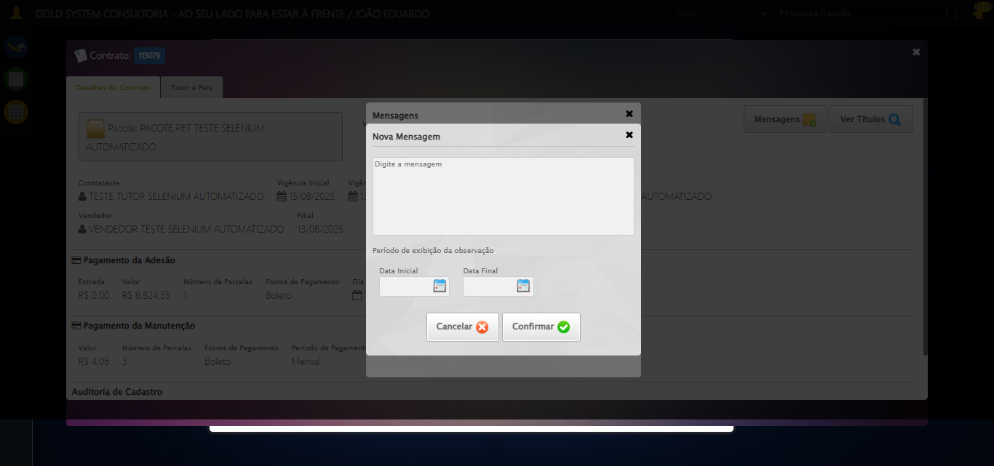

[15:20:04] 🔄 Preenchendo descrição da mensagem...

[15:20:04] ⚠️ Erro na tentativa 1: Índice 1 inválido. Encontradas 1 textareas.. Retentando…

[15:20:05] ⚠️ Erro na tentativa 2: Índice 1 inválido. Encontradas 1 textareas.. Retentando…

[15:20:07] ⚠️ Erro na tentativa 3: Índice 1 inválido. Encontradas 1 textareas.. Retentando…

[15:20:08] ⚠️ Erro na tentativa 4: Índice 1 inválido. Encontradas 1 textareas.. Retentando…

[15:20:11] 📸 Screenshot capturada: erro_preenchendo_descrição_da_mensagem

Screenshot: erro_preenchendo_descrição_da_mensagem

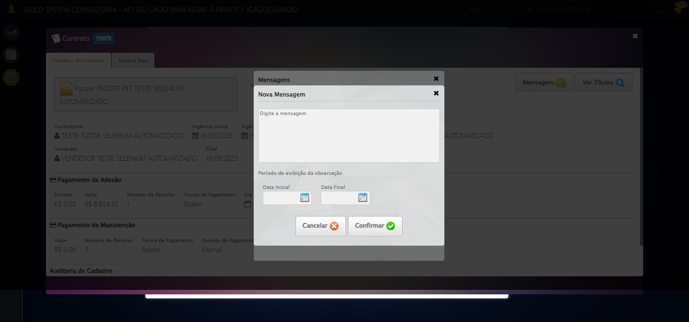

[15:20:11] ❌ Preenchendo descrição da mensagem falhou: Exception: Índice 1 inválido. Encontradas 1 textareas.

[15:20:11] ⚠️ Continuando execução apesar do erro em: Preenchendo descrição da mensagem

[15:20:11] 🔄 Definindo período de exibição - Data Inicial...

[15:20:13] 📊 Encontrados 7 campos datepicker

[15:20:13] 🎯 Tentativa 1: Preenchendo datepicker 4 (ID: dp1755281923067) com '14/08/2025'

[15:20:13] Aplicando estratégia 1 para datepicker...

[15:20:14] ✅ Datepicker preenchido com estratégia 1: '14/08/2025'

[15:20:14] ✅ Definindo período de exibição - Data Inicial realizada com sucesso.

[15:20:15] 📸 Screenshot capturada: definindo_período_de_exibição_-_data_inicial

Screenshot: definindo_período_de_exibição_-_data_inicial

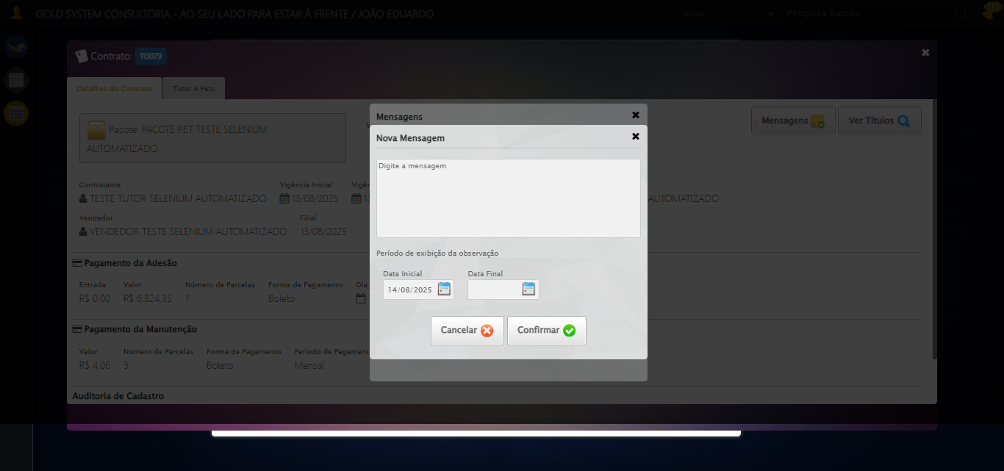

[15:20:15] 🔄 Definindo período de exibição - Data Final...

[15:20:17] 📊 Encontrados 7 campos datepicker

[15:20:17] 🎯 Tentativa 1: Preenchendo datepicker 5 (ID: dp1755281923068) com '24/11/2025'

[15:20:17] Aplicando estratégia 1 para datepicker...

[15:20:18] ✅ Datepicker preenchido com estratégia 1: '24/11/2025'

[15:20:18] ✅ Definindo período de exibição - Data Final realizada com sucesso.

[15:20:19] 📸 Screenshot capturada: definindo_período_de_exibição_-_data_final

Screenshot: definindo_período_de_exibição_-_data_final

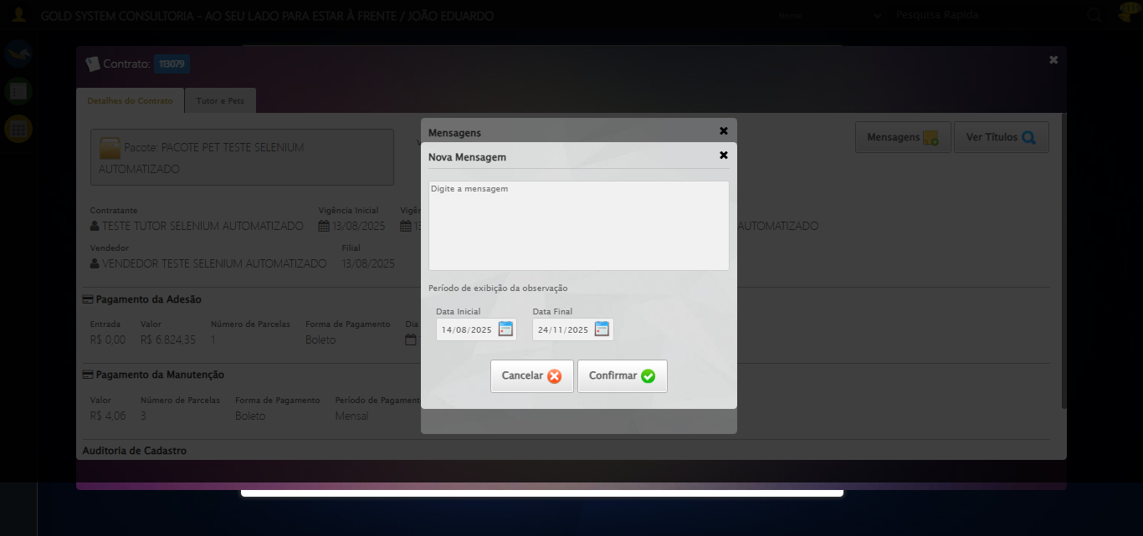

[15:20:19] 🔄 Confirmando mensagem...

[15:20:19] Tentando estratégia de scroll 1...

[15:20:20] ✅ Scroll realizado com estratégia 1

[15:20:21] ⚠️ Estratégia 1 de clique falhou: Message: element click intercepted: Element <a class="btModel btGray hAlign">...</a> is not clickable at point (744, 450). Other element would receive the click: <div class="filterHolder overflow">...</div>  
 (Session info: chrome=138.0.7204.185)  
Stacktrace:  
 GetHandleVerifier [0x0x126ba83+63395]  
 GetHandleVerifier [0x0x126bac4+63460]  
 (No symbol) [0x0x10b2113]  
 (No symbol) [0x0x1100ba0]  
 (No symbol) [0x0x10fef5a]  
 (No symbol) [0x0x10fcab7]  
 (No symbol) [0x0x10fbd6d]  
 (No symbol) [0x0x10f0515]  
 (No symbol) [0x0x111f3ac]  
 (No symbol) [0x0x10effa4]  
 (No symbol) [0x0x111f624]  
 (No symbol) [0x0x11407ba]  
 (No symbol) [0x0x111f1a6]  
 (No symbol) [0x0x10ee7b2]  
 (No symbol) [0x0x10ef654]  
 GetHandleVerifier [0x0x14e8883+2672035]  
 GetHandleVerifier [0x0x14e3cba+2652634]  
 GetHandleVerifier [0x0x1292bca+223466]  
 GetHandleVerifier [0x0x1282cb8+158168]  
 GetHandleVerifier [0x0x128978d+185517]  
 GetHandleVerifier [0x0x1273b78+96408]  
 GetHandleVerifier [0x0x1273d02+96802]  
 GetHandleVerifier [0x0x125e90a+9770]  
 BaseThreadInitThunk [0x0x7709fcc9+25]  
 RtlGetAppContainerNamedObjectPath [0x0x778882ae+286]  
 RtlGetAppContainerNamedObjectPath [0x0x7788827e+238]

[15:20:22] ✅ Clique realizado com estratégia 2

[15:20:22] ✅ Confirmando mensagem realizada com sucesso.

[15:20:23] 📸 Screenshot capturada: confirmando_mensagem

Screenshot: confirmando_mensagem

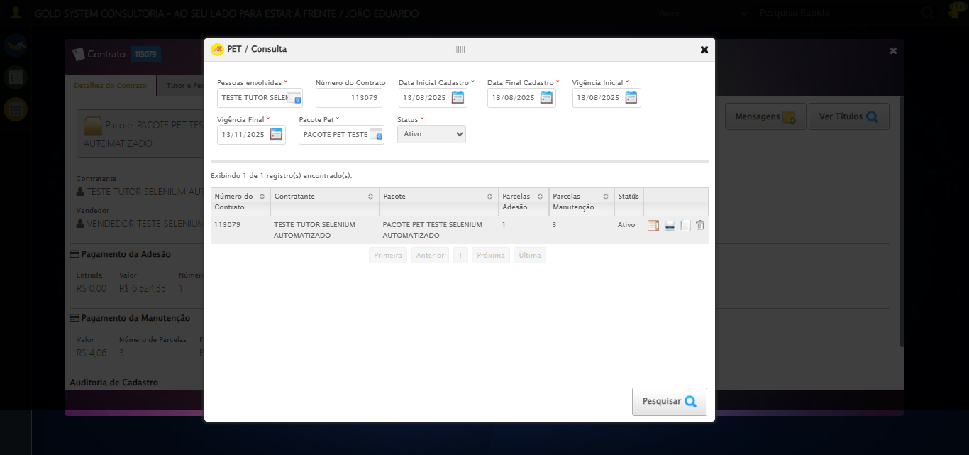

[15:20:23] 🔄 Fechando aba de mensagens...

[15:20:23] Tentando estratégia de scroll 1...

[15:20:24] ✅ Scroll realizado com estratégia 1

[15:20:25] ⚠️ Estratégia 1 de clique falhou: Message: element click intercepted: Element <a class="btModel btGray">...</a> is not clickable at point (692, 279). Other element would receive the click: <textarea placeholder="Digite a mensagem"></textarea>  
 (Session info: chrome=138.0.7204.185)  
Stacktrace:  
 GetHandleVerifier [0x0x126ba83+63395]  
 GetHandleVerifier [0x0x126bac4+63460]  
 (No symbol) [0x0x10b2113]  
 (No symbol) [0x0x1100ba0]  
 (No symbol) [0x0x10fef5a]  
 (No symbol) [0x0x10fcab7]  
 (No symbol) [0x0x10fbd6d]  
 (No symbol) [0x0x10f0515]  
 (No symbol) [0x0x111f3ac]  
 (No symbol) [0x0x10effa4]  
 (No symbol) [0x0x111f624]  
 (No symbol) [0x0x11407ba]  
 (No symbol) [0x0x111f1a6]  
 (No symbol) [0x0x10ee7b2]  
 (No symbol) [0x0x10ef654]  
 GetHandleVerifier [0x0x14e8883+2672035]  
 GetHandleVerifier [0x0x14e3cba+2652634]  
 GetHandleVerifier [0x0x1292bca+223466]  
 GetHandleVerifier [0x0x1282cb8+158168]  
 GetHandleVerifier [0x0x128978d+185517]  
 GetHandleVerifier [0x0x1273b78+96408]  
 GetHandleVerifier [0x0x1273d02+96802]  
 GetHandleVerifier [0x0x125e90a+9770]  
 BaseThreadInitThunk [0x0x7709fcc9+25]  
 RtlGetAppContainerNamedObjectPath [0x0x778882ae+286]  
 RtlGetAppContainerNamedObjectPath [0x0x7788827e+238]

[15:20:26] ✅ Clique realizado com estratégia 2

[15:20:26] ✅ Fechando aba de mensagens realizada com sucesso.

[15:20:27] 📸 Screenshot capturada: fechando_aba_de_mensagens

Screenshot: fechando_aba_de_mensagens

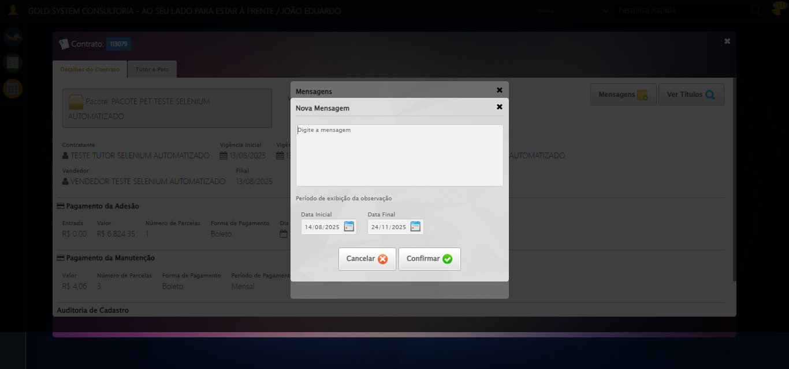

[15:20:27] 🔄 Visualizando títulos do Contrato Pet...

[15:20:58] ❌ Timeout aguardando elemento: /html/body/div[20]/div[2]/div[1]/div/div/div[1]/div[1]/div[3]/button[2] (condição: present, timeout: 30s)

[15:20:58] ❌ Falha ao clicar em /html/body/div[20]/div[2]/div[1]/div/div/div[1]/div[1]/div[3]/button[2]: Message: Elemento não encontrado: /html/body/div[20]/div[2]/div[1]/div/div/div[1]/div[1]/div[3]/button[2] (condição: present)

[15:20:58] 📸 Screenshot capturada: erro_visualizando_títulos_do_contrato_pet

Screenshot: erro_visualizando_títulos_do_contrato_pet

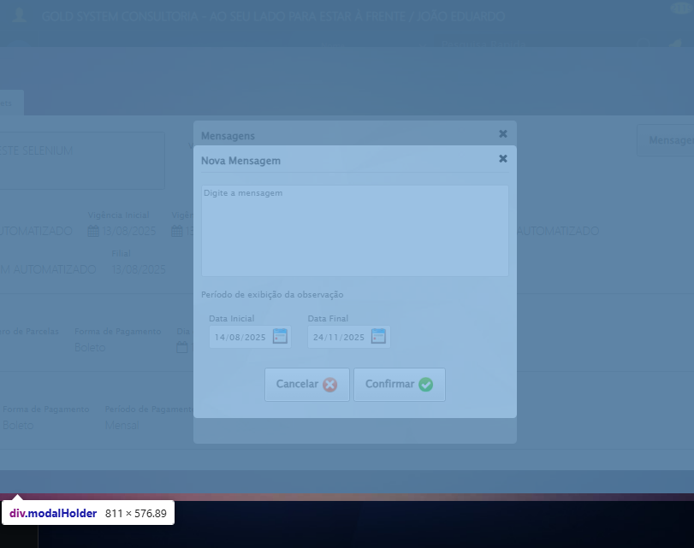

[15:20:58] ❌ Visualizando títulos do Contrato Pet falhou: TimeoutException: Message: Elemento não encontrado: /html/body/div[20]/div[2]/div[1]/div/div/div[1]/div[1]/div[3]/button[2] (condição: present)

[15:20:58] ⚠️ Continuando execução apesar do erro em: Visualizando títulos do Contrato Pet

[15:20:58] 🔄 Aguardando carregamento de títulos...

[15:21:08] 📸 Screenshot capturada: titulos_contrato_pet

Screenshot: titulos_contrato_pet

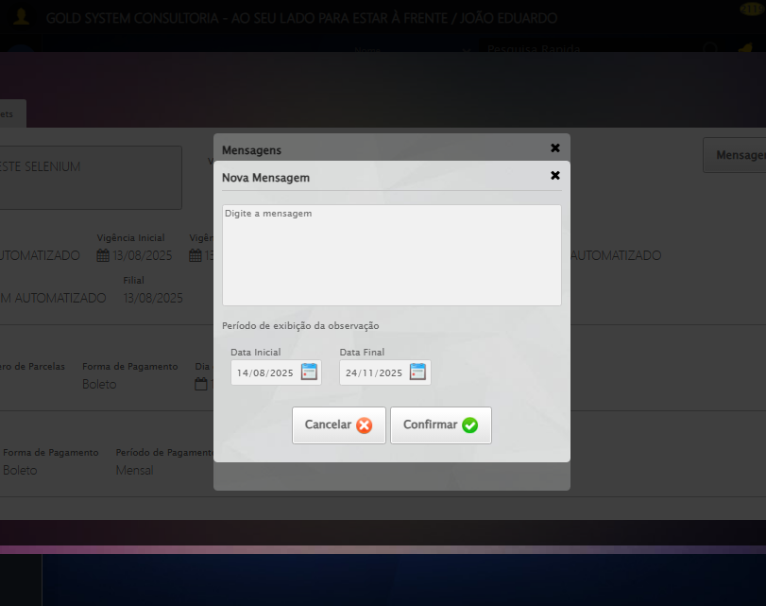

[15:21:08] ✅ Aguardando carregamento de títulos realizada com sucesso.

[15:21:09] 📸 Screenshot capturada: aguardando_carregamento_de_títulos

Screenshot: aguardando_carregamento_de_títulos



[15:21:09] 🔄 Fechando aba de títulos...

[15:21:40] ❌ Timeout aguardando elemento: /html/body/div[20]/div[1]/h2/a (condição: present, timeout: 30s)

[15:21:40] ❌ Falha ao clicar em /html/body/div[20]/div[1]/h2/a: Message: Elemento não encontrado: /html/body/div[20]/div[1]/h2/a (condição: present)

[15:21:40] 📸 Screenshot capturada: erro_fechando_aba_de_títulos

Screenshot: erro_fechando_aba_de_títulos



[15:21:40] ❌ Fechando aba de títulos falhou: TimeoutException: Message: Elemento não encontrado: /html/body/div[20]/div[1]/h2/a (condição: present)

[15:21:40] ⚠️ Continuando execução apesar do erro em: Fechando aba de títulos

[15:21:40] 🔄 Abrindo digitalização de documentos...

[15:22:10] ❌ Timeout aguardando elemento: //*[@id='DataTables_Table_0']/tbody/tr[1]/td[7]/span[2] (condição: present, timeout: 30s)

[15:22:10] ❌ Falha ao clicar em //*[@id='DataTables_Table_0']/tbody/tr[1]/td[7]/span[2]: Message: Elemento não encontrado: //*[@id='DataTables_Table_0']/tbody/tr[1]/td[7]/span[2] (condição: present)

[15:22:10] 📸 Screenshot capturada: erro_abrindo_digitalização_de_documentos

Screenshot: erro_abrindo_digitalização_de_documentos



[15:22:10] ❌ Abrindo digitalização de documentos falhou: TimeoutException: Message: Elemento não encontrado: //*[@id='DataTables_Table_0']/tbody/tr[1]/td[7]/span[2] (condição: present)

[15:22:10] ⚠️ Continuando execução apesar do erro em: Abrindo digitalização de documentos

[15:22:10] 🔄 Adicionando novo documento...

[15:22:18] ❌ Erro aguardando elemento /html/body/div[20]/div[2]/div[1]/div[2]/span: Message: no such window: target window already closed  
from unknown error: web view not found  
 (Session info: chrome=138.0.7204.185)  
Stacktrace:  
 GetHandleVerifier [0x0x126ba83+63395]  
 GetHandleVerifier [0x0x126bac4+63460]  
 (No symbol) [0x0x10b2113]  
 (No symbol) [0x0x1090fb9]  
 (No symbol) [0x0x1125ace]  
 (No symbol) [0x0x1140099]  
 (No symbol) [0x0x111f1a6]  
 (No symbol) [0x0x10ee7b2]  
 (No symbol) [0x0x10ef654]  
 GetHandleVerifier [0x0x14e8883+2672035]  
 GetHandleVerifier [0x0x14e3cba+2652634]  
 GetHandleVerifier [0x0x1292bca+223466]  
 GetHandleVerifier [0x0x1282cb8+158168]  
 GetHandleVerifier [0x0x128978d+185517]  
 GetHandleVerifier [0x0x1273b78+96408]  
 GetHandleVerifier [0x0x1273d02+96802]  
 GetHandleVerifier [0x0x125e90a+9770]  
 BaseThreadInitThunk [0x0x7709fcc9+25]  
 RtlGetAppContainerNamedObjectPath [0x0x778882ae+286]  
 RtlGetAppContainerNamedObjectPath [0x0x7788827e+238]

[15:22:18] ❌ Falha ao clicar em /html/body/div[20]/div[2]/div[1]/div[2]/span: Message: no such window: target window already closed  
from unknown error: web view not found  
 (Session info: chrome=138.0.7204.185)  
Stacktrace:  
 GetHandleVerifier [0x0x126ba83+63395]  
 GetHandleVerifier [0x0x126bac4+63460]  
 (No symbol) [0x0x10b2113]  
 (No symbol) [0x0x1090fb9]  
 (No symbol) [0x0x1125ace]  
 (No symbol) [0x0x1140099]  
 (No symbol) [0x0x111f1a6]  
 (No symbol) [0x0x10ee7b2]  
 (No symbol) [0x0x10ef654]  
 GetHandleVerifier [0x0x14e8883+2672035]  
 GetHandleVerifier [0x0x14e3cba+2652634]  
 GetHandleVerifier [0x0x1292bca+223466]  
 GetHandleVerifier [0x0x1282cb8+158168]  
 GetHandleVerifier [0x0x128978d+185517]  
 GetHandleVerifier [0x0x1273b78+96408]  
 GetHandleVerifier [0x0x1273d02+96802]  
 GetHandleVerifier [0x0x125e90a+9770]  
 BaseThreadInitThunk [0x0x7709fcc9+25]  
 RtlGetAppContainerNamedObjectPath [0x0x778882ae+286]  
 RtlGetAppContainerNamedObjectPath [0x0x7788827e+238]

[15:22:18] ⚠️ Erro ao tirar screenshot erro_adicionando_novo_documento: Message: no such window: target window already closed  
from unknown error: web view not found  
 (Session info: chrome=138.0.7204.185)  
Stacktrace:  
 GetHandleVerifier [0x0x126ba83+63395]  
 GetHandleVerifier [0x0x126bac4+63460]  
 (No symbol) [0x0x10b2113]  
 (No symbol) [0x0x1090fb9]  
 (No symbol) [0x0x1125ace]  
 (No symbol) [0x0x1140099]  
 (No symbol) [0x0x111f1a6]  
 (No symbol) [0x0x10ee7b2]  
 (No symbol) [0x0x10ef654]  
 GetHandleVerifier [0x0x14e8883+2672035]  
 GetHandleVerifier [0x0x14e3cba+2652634]  
 GetHandleVerifier [0x0x1292bca+223466]  
 GetHandleVerifier [0x0x1282cb8+158168]  
 GetHandleVerifier [0x0x128978d+185517]  
 GetHandleVerifier [0x0x1273b78+96408]  
 GetHandleVerifier [0x0x1273d02+96802]  
 GetHandleVerifier [0x0x125e90a+9770]  
 BaseThreadInitThunk [0x0x7709fcc9+25]  
 RtlGetAppContainerNamedObjectPath [0x0x778882ae+286]  
 RtlGetAppContainerNamedObjectPath [0x0x7788827e+238]

[15:22:18] ❌ Adicionando novo documento falhou: NoSuchWindowException: Message: no such window: target window already closed  
from unknown error: web view not found  
 (Session info: chrome=138.0.7204.185)  
Stacktrace:  
 GetHandleVerifier [0x0x126ba83+63395]  
 GetHandleVerifier [0x0x126bac4+63460]  
 (No symbol) [0x0x10b2113]  
 (No symbol) [0x0x1090fb9]  
 (No symbol) [0x0x1125ace]  
 (No symbol) [0x0x1140099]  
 (No symbol) [0x0x111f1a6]  
 (No symbol) [0x0x10ee7b2]  
 (No symbol) [0x0x10ef654]  
 GetHandleVerifier [0x0x14e8883+2672035]  
 GetHandleVerifier [0x0x14e3cba+2652634]  
 GetHandleVerifier [0x0x1292bca+223466]  
 GetHandleVerifier [0x0x1282cb8+158168]  
 GetHandleVerifier [0x0x128978d+185517]  
 GetHandleVerifier [0x0x1273b78+96408]  
 GetHandleVerifier [0x0x1273d02+96802]  
 GetHandleVerifier [0x0x125e90a+9770]  
 BaseThreadInitThunk [0x0x7709fcc9+25]  
 RtlGetAppContainerNamedObjectPath [0x0x778882ae+286]  
 RtlGetAppContainerNamedObjectPath [0x0x7788827e+238]

[15:22:18] ⚠️ Continuando execução apesar do erro em: Adicionando novo documento

[15:22:18] 🔄 Preenchendo descrição do arquivo digitalizado...

[15:22:18] ⚠️ Nenhuma <textarea> encontrada (tentativa 1/5)

[15:22:20] ⚠️ Nenhuma <textarea> encontrada (tentativa 2/5)

[15:22:21] ⚠️ Nenhuma <textarea> encontrada (tentativa 3/5)

[15:22:23] ⚠️ Nenhuma <textarea> encontrada (tentativa 4/5)

[15:22:24] ⚠️ Erro ao tirar screenshot erro_preenchendo_descrição_do_arquivo_digitalizado: Message: no such window: target window already closed  
from unknown error: web view not found  
 (Session info: chrome=138.0.7204.185)  
Stacktrace:  
 GetHandleVerifier [0x0x126ba83+63395]  
 GetHandleVerifier [0x0x126bac4+63460]  
 (No symbol) [0x0x10b2113]  
 (No symbol) [0x0x1090fb9]  
 (No symbol) [0x0x1125ace]  
 (No symbol) [0x0x1140099]  
 (No symbol) [0x0x111f1a6]  
 (No symbol) [0x0x10ee7b2]  
 (No symbol) [0x0x10ef654]  
 GetHandleVerifier [0x0x14e8883+2672035]  
 GetHandleVerifier [0x0x14e3cba+2652634]  
 GetHandleVerifier [0x0x1292bca+223466]  
 GetHandleVerifier [0x0x1282cb8+158168]  
 GetHandleVerifier [0x0x128978d+185517]  
 GetHandleVerifier [0x0x1273b78+96408]  
 GetHandleVerifier [0x0x1273d02+96802]  
 GetHandleVerifier [0x0x125e90a+9770]  
 BaseThreadInitThunk [0x0x7709fcc9+25]  
 RtlGetAppContainerNamedObjectPath [0x0x778882ae+286]  
 RtlGetAppContainerNamedObjectPath [0x0x7788827e+238]

[15:22:24] ❌ Preenchendo descrição do arquivo digitalizado falhou: Exception: Nenhuma <textarea> foi encontrada na página.

[15:22:24] ⚠️ Continuando execução apesar do erro em: Preenchendo descrição do arquivo digitalizado

[15:22:24] 🔄 Fazendo upload do arquivo...

[15:22:24] 📁 Fazendo upload do arquivo: TESTEPNGPET.png

[15:22:24] ❌ Erro aguardando elemento /html/body/div[21]/div[2]/div[1]/div[2]/div/div/div/div/div/div: Message: no such window: target window already closed  
from unknown error: web view not found  
 (Session info: chrome=138.0.7204.185)  
Stacktrace:  
 GetHandleVerifier [0x0x126ba83+63395]  
 GetHandleVerifier [0x0x126bac4+63460]  
 (No symbol) [0x0x10b2113]  
 (No symbol) [0x0x1090fb9]  
 (No symbol) [0x0x1125ace]  
 (No symbol) [0x0x1140099]  
 (No symbol) [0x0x111f1a6]  
 (No symbol) [0x0x10ee7b2]  
 (No symbol) [0x0x10ef654]  
 GetHandleVerifier [0x0x14e8883+2672035]  
 GetHandleVerifier [0x0x14e3cba+2652634]  
 GetHandleVerifier [0x0x1292bca+223466]  
 GetHandleVerifier [0x0x1282cb8+158168]  
 GetHandleVerifier [0x0x128978d+185517]  
 GetHandleVerifier [0x0x1273b78+96408]  
 GetHandleVerifier [0x0x1273d02+96802]  
 GetHandleVerifier [0x0x125e90a+9770]  
 BaseThreadInitThunk [0x0x7709fcc9+25]  
 RtlGetAppContainerNamedObjectPath [0x0x778882ae+286]  
 RtlGetAppContainerNamedObjectPath [0x0x7788827e+238]

[15:22:24] ⚠️ Erro ao tirar screenshot erro_fazendo_upload_do_arquivo: Message: no such window: target window already closed  
from unknown error: web view not found  
 (Session info: chrome=138.0.7204.185)  
Stacktrace:  
 GetHandleVerifier [0x0x126ba83+63395]  
 GetHandleVerifier [0x0x126bac4+63460]  
 (No symbol) [0x0x10b2113]  
 (No symbol) [0x0x1090fb9]  
 (No symbol) [0x0x1125ace]  
 (No symbol) [0x0x1140099]  
 (No symbol) [0x0x111f1a6]  
 (No symbol) [0x0x10ee7b2]  
 (No symbol) [0x0x10ef654]  
 GetHandleVerifier [0x0x14e8883+2672035]  
 GetHandleVerifier [0x0x14e3cba+2652634]  
 GetHandleVerifier [0x0x1292bca+223466]  
 GetHandleVerifier [0x0x1282cb8+158168]  
 GetHandleVerifier [0x0x128978d+185517]  
 GetHandleVerifier [0x0x1273b78+96408]  
 GetHandleVerifier [0x0x1273d02+96802]  
 GetHandleVerifier [0x0x125e90a+9770]  
 BaseThreadInitThunk [0x0x7709fcc9+25]  
 RtlGetAppContainerNamedObjectPath [0x0x778882ae+286]  
 RtlGetAppContainerNamedObjectPath [0x0x7788827e+238]

[15:22:24] ❌ Fazendo upload do arquivo falhou: NoSuchWindowException: Message: no such window: target window already closed  
from unknown error: web view not found  
 (Session info: chrome=138.0.7204.185)  
Stacktrace:  
 GetHandleVerifier [0x0x126ba83+63395]  
 GetHandleVerifier [0x0x126bac4+63460]  
 (No symbol) [0x0x10b2113]  
 (No symbol) [0x0x1090fb9]  
 (No symbol) [0x0x1125ace]  
 (No symbol) [0x0x1140099]  
 (No symbol) [0x0x111f1a6]  
 (No symbol) [0x0x10ee7b2]  
 (No symbol) [0x0x10ef654]  
 GetHandleVerifier [0x0x14e8883+2672035]  
 GetHandleVerifier [0x0x14e3cba+2652634]  
 GetHandleVerifier [0x0x1292bca+223466]  
 GetHandleVerifier [0x0x1282cb8+158168]  
 GetHandleVerifier [0x0x128978d+185517]  
 GetHandleVerifier [0x0x1273b78+96408]  
 GetHandleVerifier [0x0x1273d02+96802]  
 GetHandleVerifier [0x0x125e90a+9770]  
 BaseThreadInitThunk [0x0x7709fcc9+25]  
 RtlGetAppContainerNamedObjectPath [0x0x778882ae+286]  
 RtlGetAppContainerNamedObjectPath [0x0x7788827e+238]

[15:22:24] ⚠️ Continuando execução apesar do erro em: Fazendo upload do arquivo

[15:22:24] 🔄 Salvando arquivo digitalizado...

[15:22:24] ❌ Erro aguardando elemento /html/body/div[21]/div[2]/div[1]/div[3]/a[2]: Message: no such window: target window already closed  
from unknown error: web view not found  
 (Session info: chrome=138.0.7204.185)  
Stacktrace:  
 GetHandleVerifier [0x0x126ba83+63395]  
 GetHandleVerifier [0x0x126bac4+63460]  
 (No symbol) [0x0x10b2113]  
 (No symbol) [0x0x1090fb9]  
 (No symbol) [0x0x1125ace]  
 (No symbol) [0x0x1140099]  
 (No symbol) [0x0x111f1a6]  
 (No symbol) [0x0x10ee7b2]  
 (No symbol) [0x0x10ef654]  
 GetHandleVerifier [0x0x14e8883+2672035]  
 GetHandleVerifier [0x0x14e3cba+2652634]  
 GetHandleVerifier [0x0x1292bca+223466]  
 GetHandleVerifier [0x0x1282cb8+158168]  
 GetHandleVerifier [0x0x128978d+185517]  
 GetHandleVerifier [0x0x1273b78+96408]  
 GetHandleVerifier [0x0x1273d02+96802]  
 GetHandleVerifier [0x0x125e90a+9770]  
 BaseThreadInitThunk [0x0x7709fcc9+25]  
 RtlGetAppContainerNamedObjectPath [0x0x778882ae+286]  
 RtlGetAppContainerNamedObjectPath [0x0x7788827e+238]

[15:22:24] ❌ Falha ao clicar em /html/body/div[21]/div[2]/div[1]/div[3]/a[2]: Message: no such window: target window already closed  
from unknown error: web view not found  
 (Session info: chrome=138.0.7204.185)  
Stacktrace:  
 GetHandleVerifier [0x0x126ba83+63395]  
 GetHandleVerifier [0x0x126bac4+63460]  
 (No symbol) [0x0x10b2113]  
 (No symbol) [0x0x1090fb9]  
 (No symbol) [0x0x1125ace]  
 (No symbol) [0x0x1140099]  
 (No symbol) [0x0x111f1a6]  
 (No symbol) [0x0x10ee7b2]  
 (No symbol) [0x0x10ef654]  
 GetHandleVerifier [0x0x14e8883+2672035]  
 GetHandleVerifier [0x0x14e3cba+2652634]  
 GetHandleVerifier [0x0x1292bca+223466]  
 GetHandleVerifier [0x0x1282cb8+158168]  
 GetHandleVerifier [0x0x128978d+185517]  
 GetHandleVerifier [0x0x1273b78+96408]  
 GetHandleVerifier [0x0x1273d02+96802]  
 GetHandleVerifier [0x0x125e90a+9770]  
 BaseThreadInitThunk [0x0x7709fcc9+25]  
 RtlGetAppContainerNamedObjectPath [0x0x778882ae+286]  
 RtlGetAppContainerNamedObjectPath [0x0x7788827e+238]

[15:22:24] ⚠️ Erro ao tirar screenshot erro_salvando_arquivo_digitalizado: Message: no such window: target window already closed  
from unknown error: web view not found  
 (Session info: chrome=138.0.7204.185)  
Stacktrace:  
 GetHandleVerifier [0x0x126ba83+63395]  
 GetHandleVerifier [0x0x126bac4+63460]  
 (No symbol) [0x0x10b2113]  
 (No symbol) [0x0x1090fb9]  
 (No symbol) [0x0x1125ace]  
 (No symbol) [0x0x1140099]  
 (No symbol) [0x0x111f1a6]  
 (No symbol) [0x0x10ee7b2]  
 (No symbol) [0x0x10ef654]  
 GetHandleVerifier [0x0x14e8883+2672035]  
 GetHandleVerifier [0x0x14e3cba+2652634]  
 GetHandleVerifier [0x0x1292bca+223466]  
 GetHandleVerifier [0x0x1282cb8+158168]  
 GetHandleVerifier [0x0x128978d+185517]  
 GetHandleVerifier [0x0x1273b78+96408]  
 GetHandleVerifier [0x0x1273d02+96802]  
 GetHandleVerifier [0x0x125e90a+9770]  
 BaseThreadInitThunk [0x0x7709fcc9+25]  
 RtlGetAppContainerNamedObjectPath [0x0x778882ae+286]  
 RtlGetAppContainerNamedObjectPath [0x0x7788827e+238]

[15:22:24] ❌ Salvando arquivo digitalizado falhou: NoSuchWindowException: Message: no such window: target window already closed  
from unknown error: web view not found  
 (Session info: chrome=138.0.7204.185)  
Stacktrace:  
 GetHandleVerifier [0x0x126ba83+63395]  
 GetHandleVerifier [0x0x126bac4+63460]  
 (No symbol) [0x0x10b2113]  
 (No symbol) [0x0x1090fb9]  
 (No symbol) [0x0x1125ace]  
 (No symbol) [0x0x1140099]  
 (No symbol) [0x0x111f1a6]  
 (No symbol) [0x0x10ee7b2]  
 (No symbol) [0x0x10ef654]  
 GetHandleVerifier [0x0x14e8883+2672035]  
 GetHandleVerifier [0x0x14e3cba+2652634]  
 GetHandleVerifier [0x0x1292bca+223466]  
 GetHandleVerifier [0x0x1282cb8+158168]  
 GetHandleVerifier [0x0x128978d+185517]  
 GetHandleVerifier [0x0x1273b78+96408]  
 GetHandleVerifier [0x0x1273d02+96802]  
 GetHandleVerifier [0x0x125e90a+9770]  
 BaseThreadInitThunk [0x0x7709fcc9+25]  
 RtlGetAppContainerNamedObjectPath [0x0x778882ae+286]  
 RtlGetAppContainerNamedObjectPath [0x0x7788827e+238]

[15:22:24] ⚠️ Continuando execução apesar do erro em: Salvando arquivo digitalizado

[15:22:24] 🔄 Fechando modal de digitalização...

[15:22:24] ❌ Erro aguardando elemento /html/body/div[20]/div[2]/a: Message: no such window: target window already closed  
from unknown error: web view not found  
 (Session info: chrome=138.0.7204.185)  
Stacktrace:  
 GetHandleVerifier [0x0x126ba83+63395]  
 GetHandleVerifier [0x0x126bac4+63460]  
 (No symbol) [0x0x10b2113]  
 (No symbol) [0x0x1090fb9]  
 (No symbol) [0x0x1125ace]  
 (No symbol) [0x0x1140099]  
 (No symbol) [0x0x111f1a6]  
 (No symbol) [0x0x10ee7b2]  
 (No symbol) [0x0x10ef654]  
 GetHandleVerifier [0x0x14e8883+2672035]  
 GetHandleVerifier [0x0x14e3cba+2652634]  
 GetHandleVerifier [0x0x1292bca+223466]  
 GetHandleVerifier [0x0x1282cb8+158168]  
 GetHandleVerifier [0x0x128978d+185517]  
 GetHandleVerifier [0x0x1273b78+96408]  
 GetHandleVerifier [0x0x1273d02+96802]  
 GetHandleVerifier [0x0x125e90a+9770]  
 BaseThreadInitThunk [0x0x7709fcc9+25]  
 RtlGetAppContainerNamedObjectPath [0x0x778882ae+286]  
 RtlGetAppContainerNamedObjectPath [0x0x7788827e+238]

[15:22:24] ❌ Falha ao clicar em /html/body/div[20]/div[2]/a: Message: no such window: target window already closed  
from unknown error: web view not found  
 (Session info: chrome=138.0.7204.185)  
Stacktrace:  
 GetHandleVerifier [0x0x126ba83+63395]  
 GetHandleVerifier [0x0x126bac4+63460]  
 (No symbol) [0x0x10b2113]  
 (No symbol) [0x0x1090fb9]  
 (No symbol) [0x0x1125ace]  
 (No symbol) [0x0x1140099]  
 (No symbol) [0x0x111f1a6]  
 (No symbol) [0x0x10ee7b2]  
 (No symbol) [0x0x10ef654]  
 GetHandleVerifier [0x0x14e8883+2672035]  
 GetHandleVerifier [0x0x14e3cba+2652634]  
 GetHandleVerifier [0x0x1292bca+223466]  
 GetHandleVerifier [0x0x1282cb8+158168]  
 GetHandleVerifier [0x0x128978d+185517]  
 GetHandleVerifier [0x0x1273b78+96408]  
 GetHandleVerifier [0x0x1273d02+96802]  
 GetHandleVerifier [0x0x125e90a+9770]  
 BaseThreadInitThunk [0x0x7709fcc9+25]  
 RtlGetAppContainerNamedObjectPath [0x0x778882ae+286]  
 RtlGetAppContainerNamedObjectPath [0x0x7788827e+238]

[15:22:24] ⚠️ Erro ao tirar screenshot erro_fechando_modal_de_digitalização: Message: no such window: target window already closed  
from unknown error: web view not found  
 (Session info: chrome=138.0.7204.185)  
Stacktrace:  
 GetHandleVerifier [0x0x126ba83+63395]  
 GetHandleVerifier [0x0x126bac4+63460]  
 (No symbol) [0x0x10b2113]  
 (No symbol) [0x0x1090fb9]  
 (No symbol) [0x0x1125ace]  
 (No symbol) [0x0x1140099]  
 (No symbol) [0x0x111f1a6]  
 (No symbol) [0x0x10ee7b2]  
 (No symbol) [0x0x10ef654]  
 GetHandleVerifier [0x0x14e8883+2672035]  
 GetHandleVerifier [0x0x14e3cba+2652634]  
 GetHandleVerifier [0x0x1292bca+223466]  
 GetHandleVerifier [0x0x1282cb8+158168]  
 GetHandleVerifier [0x0x128978d+185517]  
 GetHandleVerifier [0x0x1273b78+96408]  
 GetHandleVerifier [0x0x1273d02+96802]  
 GetHandleVerifier [0x0x125e90a+9770]  
 BaseThreadInitThunk [0x0x7709fcc9+25]  
 RtlGetAppContainerNamedObjectPath [0x0x778882ae+286]  
 RtlGetAppContainerNamedObjectPath [0x0x7788827e+238]

[15:22:24] ❌ Fechando modal de digitalização falhou: NoSuchWindowException: Message: no such window: target window already closed  
from unknown error: web view not found  
 (Session info: chrome=138.0.7204.185)  
Stacktrace:  
 GetHandleVerifier [0x0x126ba83+63395]  
 GetHandleVerifier [0x0x126bac4+63460]  
 (No symbol) [0x0x10b2113]  
 (No symbol) [0x0x1090fb9]  
 (No symbol) [0x0x1125ace]  
 (No symbol) [0x0x1140099]  
 (No symbol) [0x0x111f1a6]  
 (No symbol) [0x0x10ee7b2]  
 (No symbol) [0x0x10ef654]  
 GetHandleVerifier [0x0x14e8883+2672035]  
 GetHandleVerifier [0x0x14e3cba+2652634]  
 GetHandleVerifier [0x0x1292bca+223466]  
 GetHandleVerifier [0x0x1282cb8+158168]  
 GetHandleVerifier [0x0x128978d+185517]  
 GetHandleVerifier [0x0x1273b78+96408]  
 GetHandleVerifier [0x0x1273d02+96802]  
 GetHandleVerifier [0x0x125e90a+9770]  
 BaseThreadInitThunk [0x0x7709fcc9+25]  
 RtlGetAppContainerNamedObjectPath [0x0x778882ae+286]  
 RtlGetAppContainerNamedObjectPath [0x0x7788827e+238]

[15:22:24] ⚠️ Continuando execução apesar do erro em: Fechando modal de digitalização

[15:22:24] 🔄 Fechando tela de consulta...

[15:22:24] ❌ Erro aguardando elemento #gsPet > div.wdTop.ui-draggable-handle > div > a: Message: no such window: target window already closed  
from unknown error: web view not found  
 (Session info: chrome=138.0.7204.185)  
Stacktrace:  
 GetHandleVerifier [0x0x126ba83+63395]  
 GetHandleVerifier [0x0x126bac4+63460]  
 (No symbol) [0x0x10b2113]  
 (No symbol) [0x0x1090fb9]  
 (No symbol) [0x0x1125ace]  
 (No symbol) [0x0x1140099]  
 (No symbol) [0x0x111f1a6]  
 (No symbol) [0x0x10ee7b2]  
 (No symbol) [0x0x10ef654]  
 GetHandleVerifier [0x0x14e8883+2672035]  
 GetHandleVerifier [0x0x14e3cba+2652634]  
 GetHandleVerifier [0x0x1292bca+223466]  
 GetHandleVerifier [0x0x1282cb8+158168]  
 GetHandleVerifier [0x0x128978d+185517]  
 GetHandleVerifier [0x0x1273b78+96408]  
 GetHandleVerifier [0x0x1273d02+96802]  
 GetHandleVerifier [0x0x125e90a+9770]  
 BaseThreadInitThunk [0x0x7709fcc9+25]  
 RtlGetAppContainerNamedObjectPath [0x0x778882ae+286]  
 RtlGetAppContainerNamedObjectPath [0x0x7788827e+238]

[15:22:24] ❌ Falha ao clicar em #gsPet > div.wdTop.ui-draggable-handle > div > a: Message: no such window: target window already closed  
from unknown error: web view not found  
 (Session info: chrome=138.0.7204.185)  
Stacktrace:  
 GetHandleVerifier [0x0x126ba83+63395]  
 GetHandleVerifier [0x0x126bac4+63460]  
 (No symbol) [0x0x10b2113]  
 (No symbol) [0x0x1090fb9]  
 (No symbol) [0x0x1125ace]  
 (No symbol) [0x0x1140099]  
 (No symbol) [0x0x111f1a6]  
 (No symbol) [0x0x10ee7b2]  
 (No symbol) [0x0x10ef654]  
 GetHandleVerifier [0x0x14e8883+2672035]  
 GetHandleVerifier [0x0x14e3cba+2652634]  
 GetHandleVerifier [0x0x1292bca+223466]  
 GetHandleVerifier [0x0x1282cb8+158168]  
 GetHandleVerifier [0x0x128978d+185517]  
 GetHandleVerifier [0x0x1273b78+96408]  
 GetHandleVerifier [0x0x1273d02+96802]  
 GetHandleVerifier [0x0x125e90a+9770]  
 BaseThreadInitThunk [0x0x7709fcc9+25]  
 RtlGetAppContainerNamedObjectPath [0x0x778882ae+286]  
 RtlGetAppContainerNamedObjectPath [0x0x7788827e+238]

[15:22:24] ⚠️ Erro ao tirar screenshot erro_fechando_tela_de_consulta: Message: no such window: target window already closed  
from unknown error: web view not found  
 (Session info: chrome=138.0.7204.185)  
Stacktrace:  
 GetHandleVerifier [0x0x126ba83+63395]  
 GetHandleVerifier [0x0x126bac4+63460]  
 (No symbol) [0x0x10b2113]  
 (No symbol) [0x0x1090fb9]  
 (No symbol) [0x0x1125ace]  
 (No symbol) [0x0x1140099]  
 (No symbol) [0x0x111f1a6]  
 (No symbol) [0x0x10ee7b2]  
 (No symbol) [0x0x10ef654]  
 GetHandleVerifier [0x0x14e8883+2672035]  
 GetHandleVerifier [0x0x14e3cba+2652634]  
 GetHandleVerifier [0x0x1292bca+223466]  
 GetHandleVerifier [0x0x1282cb8+158168]  
 GetHandleVerifier [0x0x128978d+185517]  
 GetHandleVerifier [0x0x1273b78+96408]  
 GetHandleVerifier [0x0x1273d02+96802]  
 GetHandleVerifier [0x0x125e90a+9770]  
 BaseThreadInitThunk [0x0x7709fcc9+25]  
 RtlGetAppContainerNamedObjectPath [0x0x778882ae+286]  
 RtlGetAppContainerNamedObjectPath [0x0x7788827e+238]

[15:22:24] ❌ Fechando tela de consulta falhou: NoSuchWindowException: Message: no such window: target window already closed  
from unknown error: web view not found  
 (Session info: chrome=138.0.7204.185)  
Stacktrace:  
 GetHandleVerifier [0x0x126ba83+63395]  
 GetHandleVerifier [0x0x126bac4+63460]  
 (No symbol) [0x0x10b2113]  
 (No symbol) [0x0x1090fb9]  
 (No symbol) [0x0x1125ace]  
 (No symbol) [0x0x1140099]  
 (No symbol) [0x0x111f1a6]  
 (No symbol) [0x0x10ee7b2]  
 (No symbol) [0x0x10ef654]  
 GetHandleVerifier [0x0x14e8883+2672035]  
 GetHandleVerifier [0x0x14e3cba+2652634]  
 GetHandleVerifier [0x0x1292bca+223466]  
 GetHandleVerifier [0x0x1282cb8+158168]  
 GetHandleVerifier [0x0x128978d+185517]  
 GetHandleVerifier [0x0x1273b78+96408]  
 GetHandleVerifier [0x0x1273d02+96802]  
 GetHandleVerifier [0x0x125e90a+9770]  
 BaseThreadInitThunk [0x0x7709fcc9+25]  
 RtlGetAppContainerNamedObjectPath [0x0x778882ae+286]  
 RtlGetAppContainerNamedObjectPath [0x0x7788827e+238]

[15:22:24] ⚠️ Continuando execução apesar do erro em: Fechando tela de consulta

[15:22:24] ✅ Teste executado com sucesso completo!

[15:22:24] 🏁 Finalizando teste...

[15:22:24] ✅ TESTE CONCLUÍDO COM SUCESSO!

[15:22:24] ============================================================

==================================================

RESUMO FINAL DO TESTE

==================================================

Teste finalizado em: 15/08/2025 15:22:24

Total de screenshots capturadas: 31