RELATÓRIO DO TESTE

Consulta de Contrato Pet – Cenário 2: Realização da consulta de contrato Pet e conferência das mensagens de alerta.

Data do teste: 15/08/2025 16:03:28

[16:03:28] 🚀 INICIANDO TESTE DE CONSULTA DE CONTRATO PET

[16:03:28] ============================================================

[16:03:28] 🚀 Inicializando driver do Chrome...

[16:03:34] ✅ Driver inicializado com sucesso

[16:03:34] 🎯 Iniciando execução do teste de consulta de contrato Pet

[16:03:34] 🔄 Acessando sistema...

[16:03:38] ✅ Acessando sistema realizada com sucesso.

[16:03:39] 📸 Screenshot capturada: acessando_sistema

Screenshot: acessando_sistema

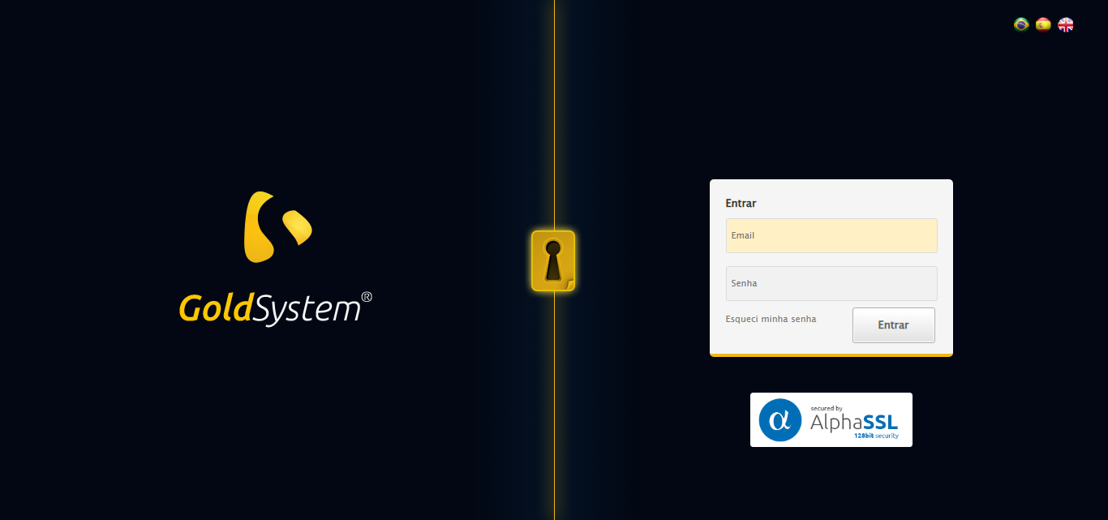

[16:03:39] 🔄 Realizando login...

[16:03:44] ✅ Realizando login realizada com sucesso.

[16:03:46] 📸 Screenshot capturada: realizando_login

Screenshot: realizando_login

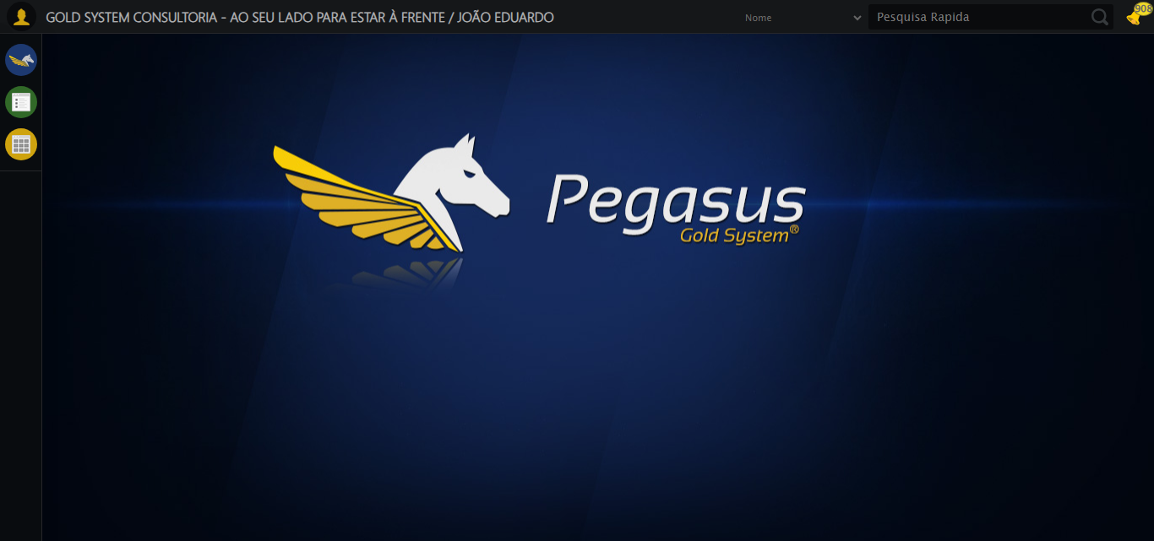

[16:03:46] 🔄 Configurando ambiente...

[16:03:46] 🔍 Zoom ajustado para 90%.

[16:03:48] ✅ Configurando ambiente realizada com sucesso.

[16:03:49] 📸 Screenshot capturada: configurando_ambiente

Screenshot: configurando_ambiente

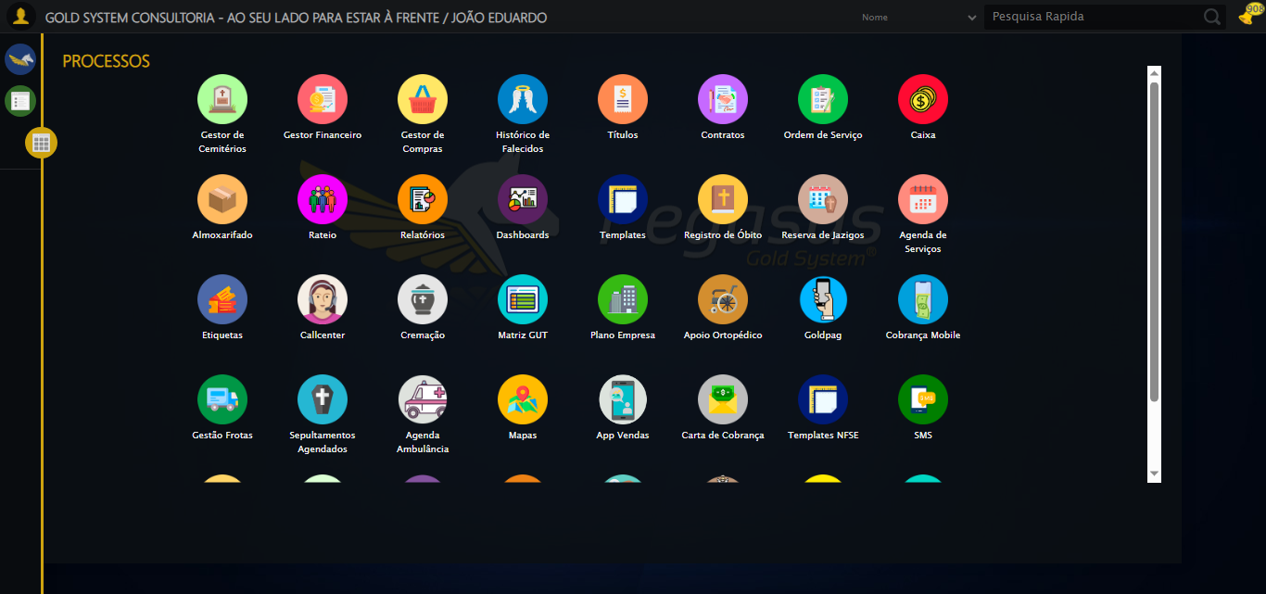

[16:03:49] 🔄 Acessando módulo PET...

[16:03:49] Tentando estratégia de scroll 1...

[16:03:50] ✅ Scroll realizado com estratégia 1

[16:03:51] Tentando estratégia de clique 1 para módulo PET...

[16:03:54] ✅ Clique no módulo PET realizado com estratégia 1

[16:03:54] ✅ Acessando módulo PET realizada com sucesso.

[16:03:55] 📸 Screenshot capturada: acessando_módulo_pet

Screenshot: acessando_módulo_pet

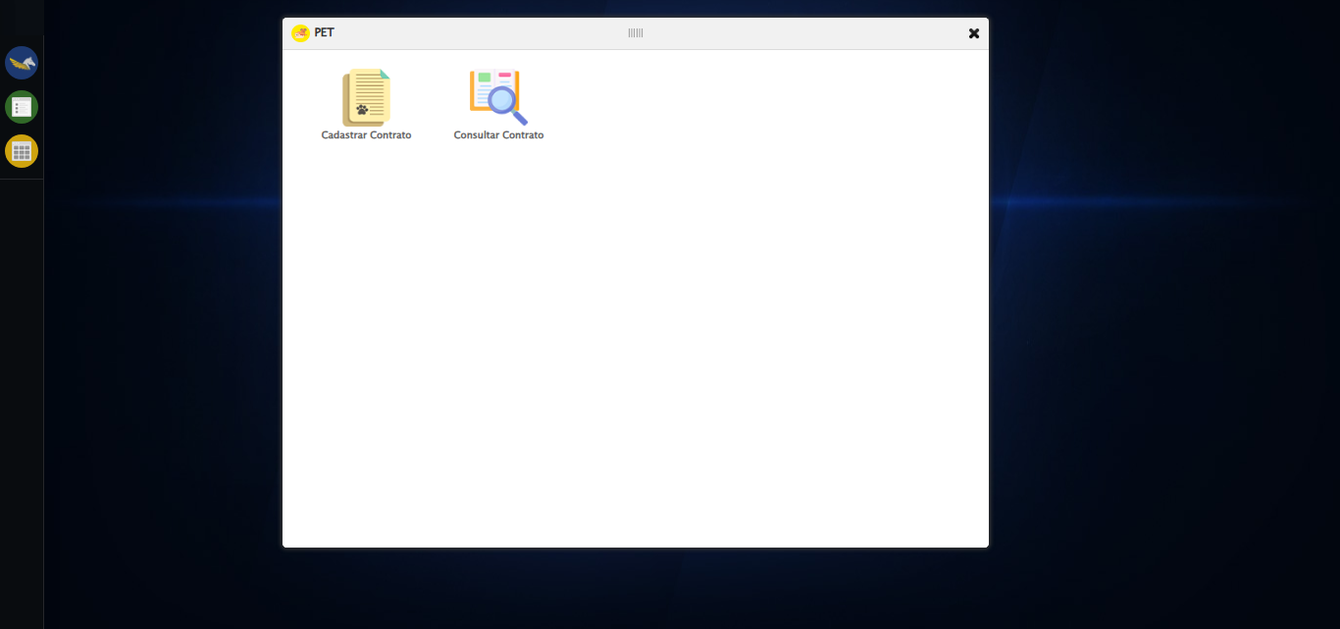

[16:03:55] 🔄 Abrindo consulta de contrato...

[16:03:58] ✅ Abrindo consulta de contrato realizada com sucesso.

[16:03:59] 📸 Screenshot capturada: abrindo_consulta_de_contrato

Screenshot: abrindo_consulta_de_contrato

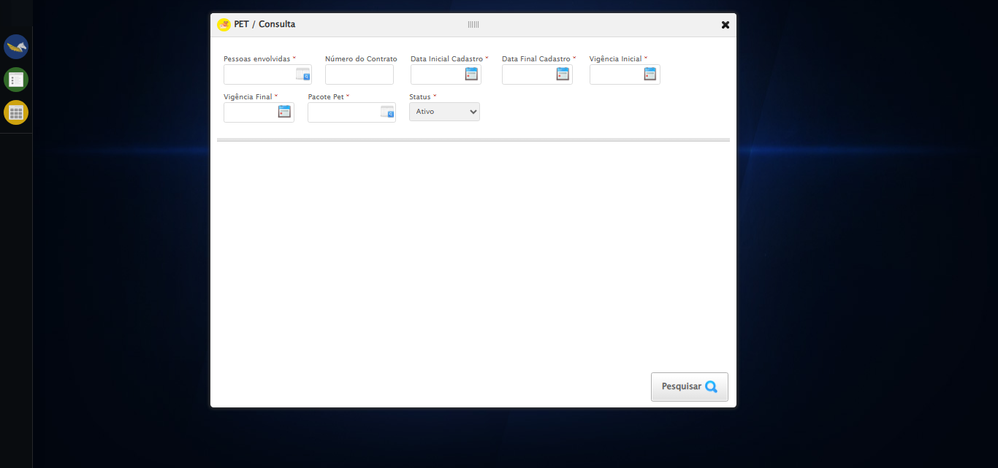

[16:03:59] 🔄 Realizando consulta sem campos preenchidos para verificar mensagem de alerta...

[16:03:59] Tentando estratégia de scroll 1...

[16:04:00] ✅ Scroll realizado com estratégia 1

[16:04:02] ✅ Consulta executada

[16:04:02] ✅ Realizando consulta sem campos preenchidos para verificar mensagem de alerta realizada com sucesso.

[16:04:03] 📸 Screenshot capturada: realizando_consulta_sem_campos_preenchidos_para_verificar_mensagem_de_alerta

Screenshot: realizando_consulta_sem_campos_preenchidos_para_verificar_mensagem_de_alerta

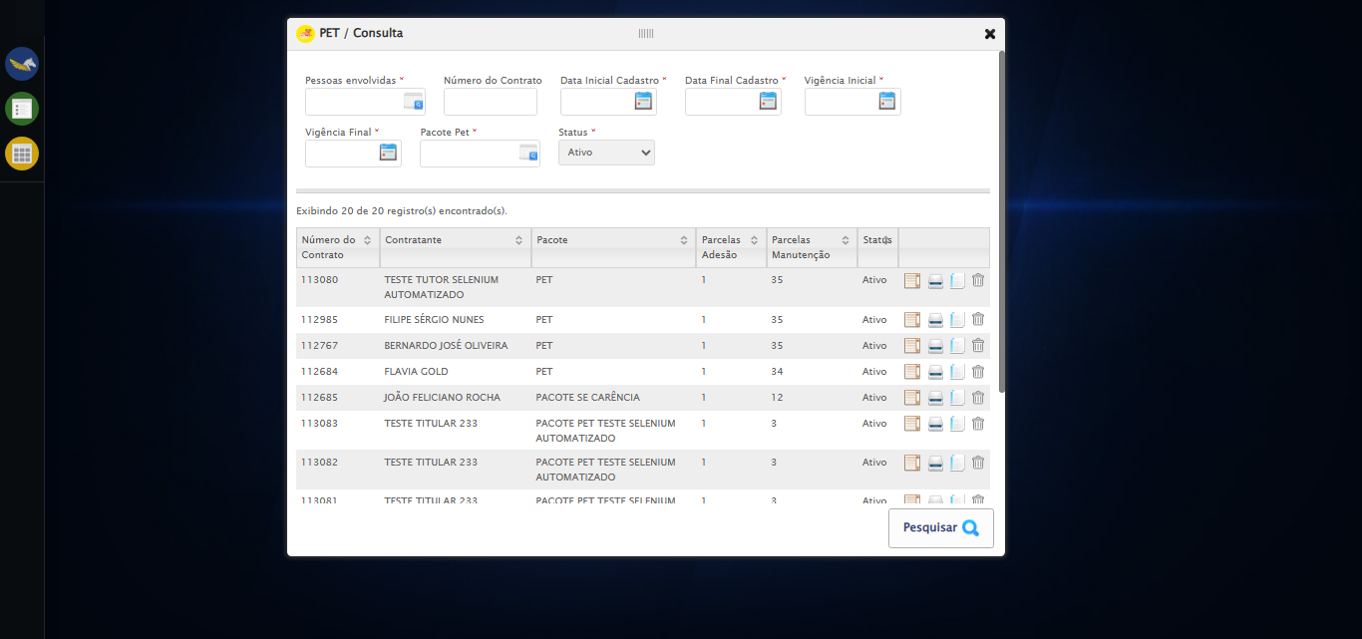

[16:04:03] 🔍 Verificando mensagens de alerta...

[16:04:03] 🔄 Selecionando Pessoas Envolvidas...

[16:04:03] 🔘 Abrindo modal com botão: #gsPet > div.wdTelas > div.telaConsulta.telaConsultaContratoPet > div > div.formRow.filtrosConsulta > div:nth-child(1) > div > a

[16:04:03] Tentando estratégia de scroll 1...

[16:04:04] ✅ Scroll realizado com estratégia 1

[16:04:06] 🔍 Preenchendo pesquisa com: TESTE TUTOR SELENIUM AUTOMATIZADO

[16:04:07] 🔍 Executando pesquisa...

[16:04:10] 🎯 Selecionando resultado: //td[contains(text(), 'TESTE TUTOR SELENIUM AUTOMATIZADO')]

[16:04:10] Tentando estratégia de scroll 1...

[16:04:11] ✅ Scroll realizado com estratégia 1

[16:04:14] ✅ Seleção no modal concluída

[16:04:14] ✅ Selecionando Pessoas Envolvidas realizada com sucesso.

[16:04:15] 📸 Screenshot capturada: selecionando_pessoas_envolvidas

Screenshot: selecionando_pessoas_envolvidas

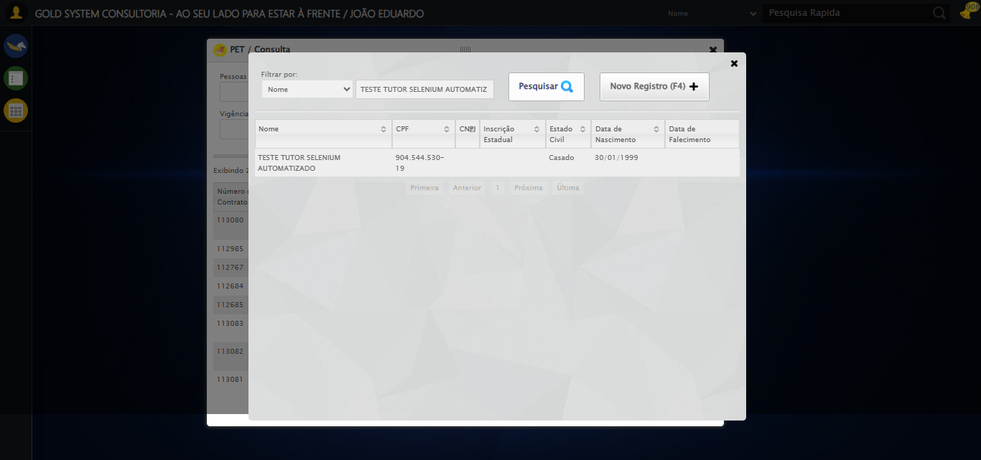

[16:04:15] 🔄 Preenchendo Número do Contrato...

[16:04:15] Tentando estratégia de scroll 1...

[16:04:16] ✅ Scroll realizado com estratégia 1

[16:04:17] ⚠️ Estratégia 1 de preenchimento falhou: Message: element click intercepted: Element <input type="text" class="fc numeroContrato inteiro" name="numeroContrato" maxlength="10" style="width: 90px; text-align: right;"> is not clickable at point (491, 137). Other element would receive the click: <div class="formCol divPesquisa" id="divPesquisa">...</div>  
 (Session info: chrome=138.0.7204.185)  
Stacktrace:  
 GetHandleVerifier [0x0x126ba83+63395]  
 GetHandleVerifier [0x0x126bac4+63460]  
 (No symbol) [0x0x10b2113]  
 (No symbol) [0x0x1100ba0]  
 (No symbol) [0x0x10fef5a]  
 (No symbol) [0x0x10fcab7]  
 (No symbol) [0x0x10fbd6d]  
 (No symbol) [0x0x10f0515]  
 (No symbol) [0x0x111f3ac]  
 (No symbol) [0x0x10effa4]  
 (No symbol) [0x0x111f624]  
 (No symbol) [0x0x11407ba]  
 (No symbol) [0x0x111f1a6]  
 (No symbol) [0x0x10ee7b2]  
 (No symbol) [0x0x10ef654]  
 GetHandleVerifier [0x0x14e8883+2672035]  
 GetHandleVerifier [0x0x14e3cba+2652634]  
 GetHandleVerifier [0x0x1292bca+223466]  
 GetHandleVerifier [0x0x1282cb8+158168]  
 GetHandleVerifier [0x0x128978d+185517]  
 GetHandleVerifier [0x0x1273b78+96408]  
 GetHandleVerifier [0x0x1273d02+96802]  
 GetHandleVerifier [0x0x125e90a+9770]  
 BaseThreadInitThunk [0x0x7709fcc9+25]  
 RtlGetAppContainerNamedObjectPath [0x0x778882ae+286]  
 RtlGetAppContainerNamedObjectPath [0x0x7788827e+238]

[16:04:19] ⚠️ Estratégia 2 não preencheu corretamente. Esperado: '113079', Atual: ''

[16:04:19] ✅ Campo preenchido com estratégia 3: '113079'

[16:04:19] ✅ Preenchendo Número do Contrato realizada com sucesso.

[16:04:20] 📸 Screenshot capturada: preenchendo_número_do_contrato

Screenshot: preenchendo_número_do_contrato

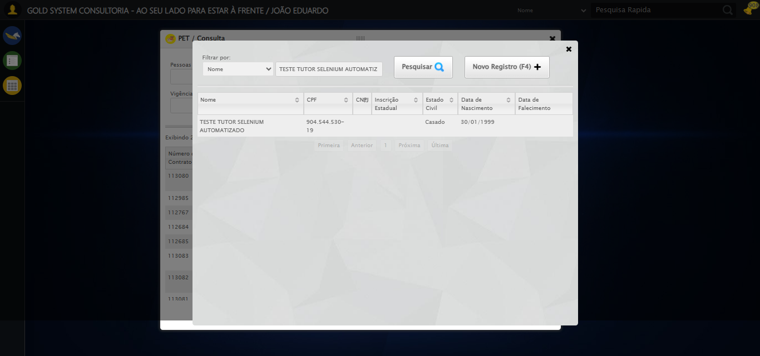

[16:04:20] 🔄 Preenchendo Data Inicial Cadastro...

[16:04:21] 📊 Encontrados 5 campos datepicker

[16:04:21] 🎯 Tentativa 1: Preenchendo datepicker 0 (ID: dp1755284622146) com '13/08/2025'

[16:04:21] Aplicando estratégia 1 para datepicker...

[16:04:22] ✅ Datepicker preenchido com estratégia 1: '13/08/2025'

[16:04:22] ✅ Preenchendo Data Inicial Cadastro realizada com sucesso.

[16:04:23] 📸 Screenshot capturada: preenchendo_data_inicial_cadastro

Screenshot: preenchendo_data_inicial_cadastro



[16:04:24] 🔄 Preenchendo Data Final Cadastro...

[16:04:24] 📊 Encontrados 5 campos datepicker

[16:04:24] 🎯 Tentativa 1: Preenchendo datepicker 1 (ID: dp1755284622147) com '13/08/2025'

[16:04:24] Aplicando estratégia 1 para datepicker...

[16:04:25] ✅ Datepicker preenchido com estratégia 1: '13/08/2025'

[16:04:25] ✅ Preenchendo Data Final Cadastro realizada com sucesso.

[16:04:27] 📸 Screenshot capturada: preenchendo_data_final_cadastro

Screenshot: preenchendo_data_final_cadastro



[16:04:27] 🔄 Preenchendo Vigência Inicial...

[16:04:27] 📊 Encontrados 5 campos datepicker

[16:04:27] 🎯 Tentativa 1: Preenchendo datepicker 2 (ID: dp1755284622144) com '13/08/2025'

[16:04:27] Aplicando estratégia 1 para datepicker...

[16:04:28] ✅ Datepicker preenchido com estratégia 1: '13/08/2025'

[16:04:28] ✅ Preenchendo Vigência Inicial realizada com sucesso.

[16:04:30] 📸 Screenshot capturada: preenchendo_vigência_inicial

Screenshot: preenchendo_vigência_inicial



[16:04:30] 🔄 Preenchendo Vigência Final...

[16:04:30] 📊 Encontrados 5 campos datepicker

[16:04:30] 🎯 Tentativa 1: Preenchendo datepicker 3 (ID: dp1755284622145) com '13/11/2025'

[16:04:30] Aplicando estratégia 1 para datepicker...

[16:04:31] ✅ Datepicker preenchido com estratégia 1: '13/11/2025'

[16:04:31] ✅ Preenchendo Vigência Final realizada com sucesso.

[16:04:33] 📸 Screenshot capturada: preenchendo_vigência_final

Screenshot: preenchendo_vigência_final

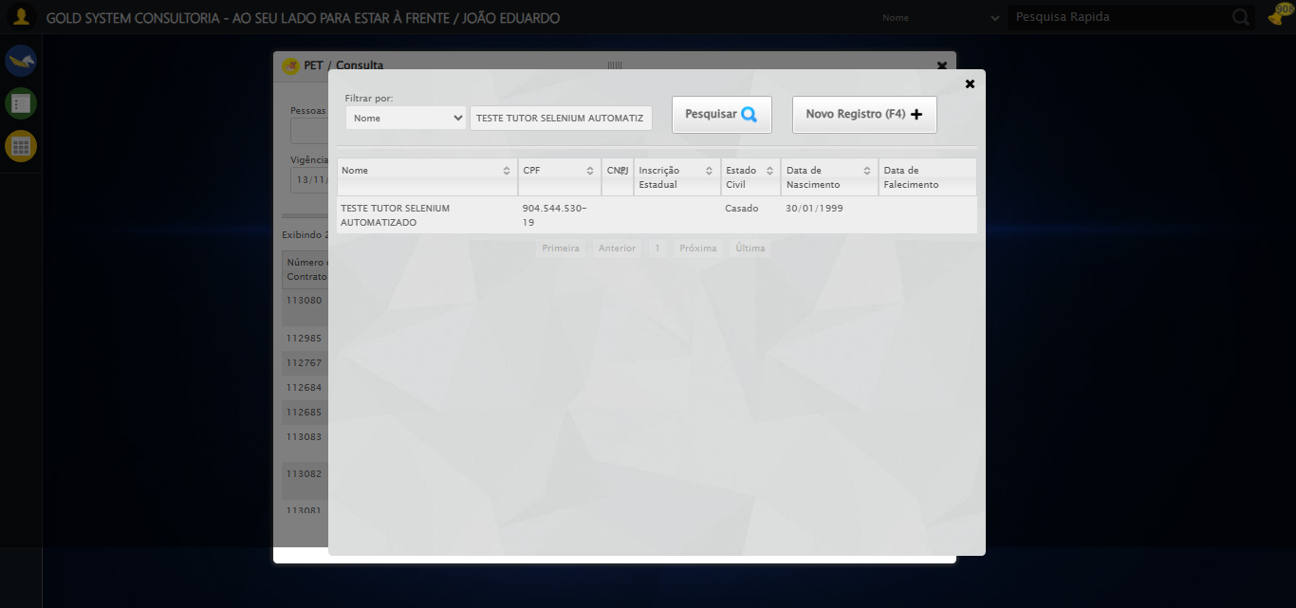

[16:04:33] 🔄 Selecionando Pacote Pet...

[16:04:33] 🔘 Abrindo modal com botão: #gsPet > div.wdTelas > div.telaConsulta.telaConsultaContratoPet > div > div.formRow.filtrosConsulta > div:nth-child(7) > div > a

[16:04:33] Tentando estratégia de scroll 1...

[16:04:33] ✅ Scroll realizado com estratégia 1

[16:04:37] 🔍 Preenchendo pesquisa com: PACOTE PET TESTE SELENIUM AUTOMATIZADO

[16:04:38] 🔍 Executando pesquisa...

[16:04:42] 🎯 Selecionando resultado: //td[contains(text(), 'PACOTE PET TESTE SELENIUM AUTOMATIZADO')]

[16:04:42] Tentando estratégia de scroll 1...

[16:04:43] ✅ Scroll realizado com estratégia 1

[16:04:45] ✅ Seleção no modal concluída

[16:04:45] ✅ Selecionando Pacote Pet realizada com sucesso.

[16:04:46] 📸 Screenshot capturada: selecionando_pacote_pet

Screenshot: selecionando_pacote_pet

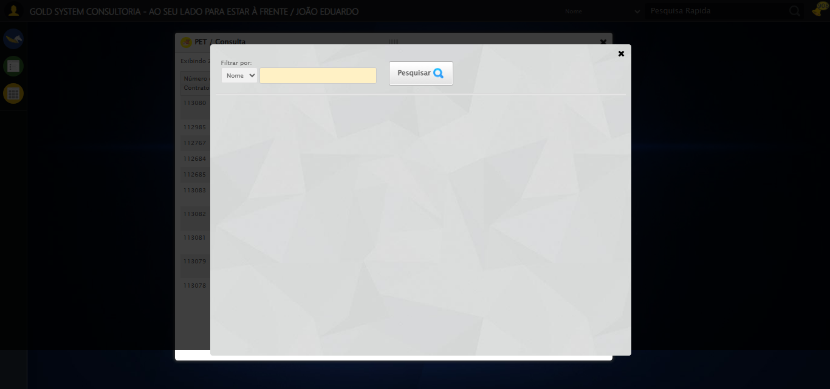

[16:04:46] 🔄 Realizando consulta...

[16:04:46] Tentando estratégia de scroll 1...

[16:04:47] ✅ Scroll realizado com estratégia 1

[16:04:50] ✅ Consulta executada

[16:04:50] ✅ Realizando consulta realizada com sucesso.

[16:04:51] 📸 Screenshot capturada: realizando_consulta

Screenshot: realizando_consulta

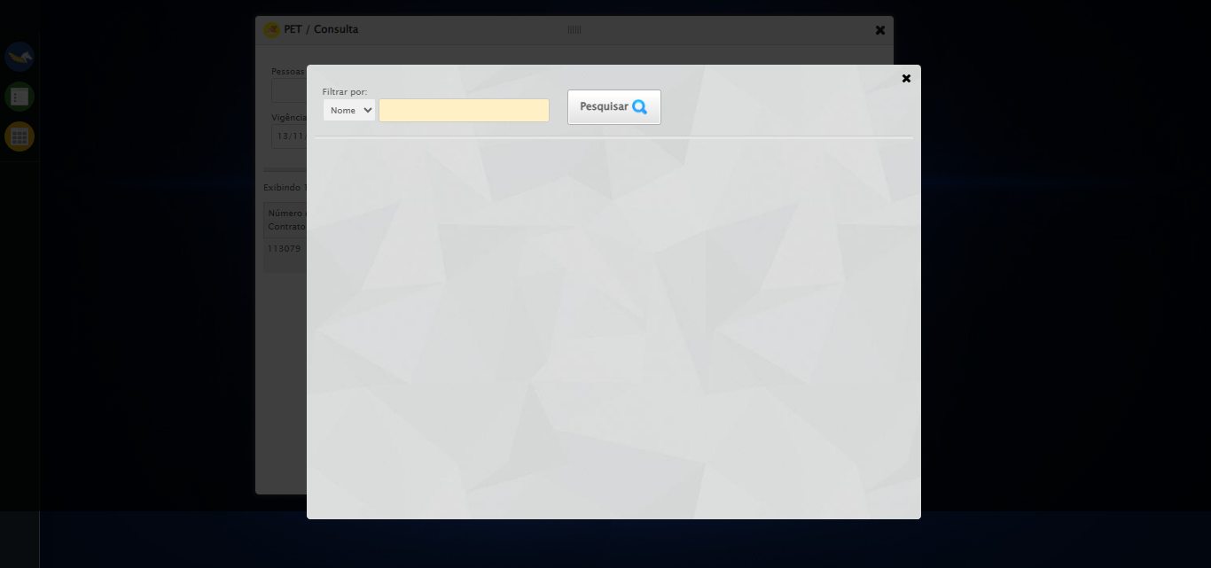

[16:04:51] 🔄 Validando resultados da consulta...

[16:04:51] 🔍 Iniciando validação de registros...

[16:04:57] ✅ Tabela encontrada: #DataTables_Table_2

[16:04:57] ✅ Encontradas 1 linhas válidas com tbody tr:not(.dataTables_empty):not([class*="no-data"])

[16:04:57] ✅ 1 registro(s) encontrado(s)

[16:04:57] Registro 1: 113079 teste tutor selenium automatizado pacote pet teste selenium automatizado 1 3 ativo

[16:04:57] ✅ Validando resultados da consulta realizada com sucesso.

[16:04:58] 📸 Screenshot capturada: validando_resultados_da_consulta

Screenshot: validando_resultados_da_consulta



[16:04:58] ✅ Processando 1 registro(s) encontrado(s)

[16:04:58] 🔄 Visualizando detalhes do Contrato Pet...

[16:04:58] Tentando estratégia de scroll 1...

[16:04:59] ✅ Scroll realizado com estratégia 1

[16:05:00] ⚠️ Estratégia 1 de clique falhou: Message: element click intercepted: Element <span class="sprites sp-dadosDinamicos" title="Detalhes do contrato"></span> is not clickable at point (921, 317). Other element would receive the click: <div class="modal overflow" style="z-index: 10004; left: 50%; top: 50%; width: 750px; height: 550px; margin-left: -375px; margin-top: -275px;">...</div>  
 (Session info: chrome=138.0.7204.185)  
Stacktrace:  
 GetHandleVerifier [0x0x126ba83+63395]  
 GetHandleVerifier [0x0x126bac4+63460]  
 (No symbol) [0x0x10b2113]  
 (No symbol) [0x0x1100ba0]  
 (No symbol) [0x0x10fef5a]  
 (No symbol) [0x0x10fcab7]  
 (No symbol) [0x0x10fbd6d]  
 (No symbol) [0x0x10f0515]  
 (No symbol) [0x0x111f3ac]  
 (No symbol) [0x0x10effa4]  
 (No symbol) [0x0x111f624]  
 (No symbol) [0x0x11407ba]  
 (No symbol) [0x0x111f1a6]  
 (No symbol) [0x0x10ee7b2]  
 (No symbol) [0x0x10ef654]  
 GetHandleVerifier [0x0x14e8883+2672035]  
 GetHandleVerifier [0x0x14e3cba+2652634]  
 GetHandleVerifier [0x0x1292bca+223466]  
 GetHandleVerifier [0x0x1282cb8+158168]  
 GetHandleVerifier [0x0x128978d+185517]  
 GetHandleVerifier [0x0x1273b78+96408]  
 GetHandleVerifier [0x0x1273d02+96802]  
 GetHandleVerifier [0x0x125e90a+9770]  
 BaseThreadInitThunk [0x0x7709fcc9+25]  
 RtlGetAppContainerNamedObjectPath [0x0x778882ae+286]  
 RtlGetAppContainerNamedObjectPath [0x0x7788827e+238]

[16:05:01] ✅ Clique realizado com estratégia 2

[16:05:01] ✅ Visualizando detalhes do Contrato Pet realizada com sucesso.

[16:05:02] 📸 Screenshot capturada: visualizando_detalhes_do_contrato_pet

Screenshot: visualizando_detalhes_do_contrato_pet

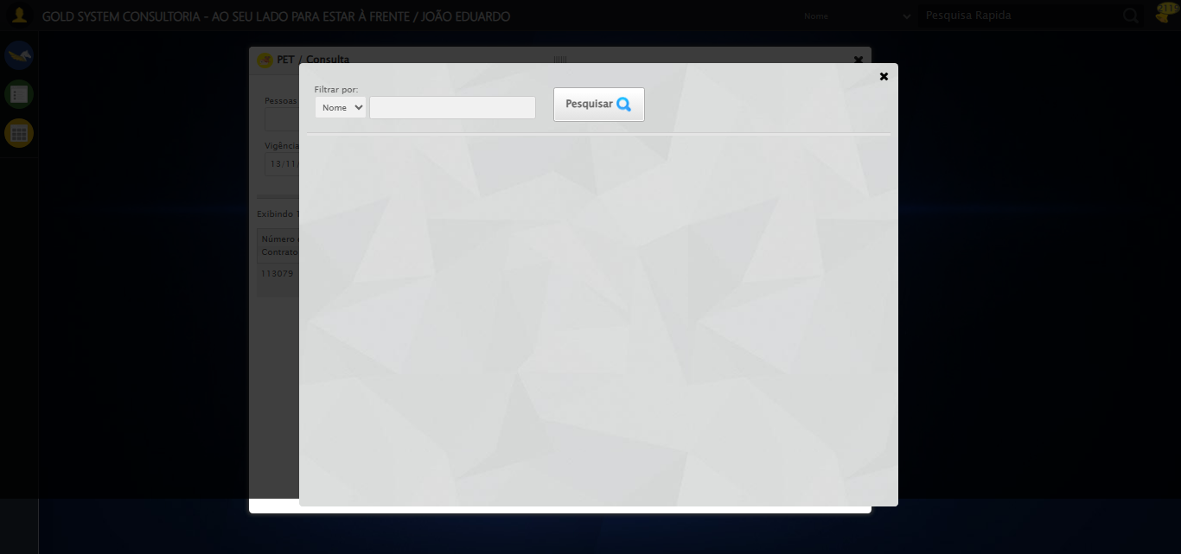

[16:05:02] 🔄 Capturando tela de detalhes...

[16:05:05] 📸 Screenshot capturada: detalhes_contrato_pet

Screenshot: detalhes_contrato_pet



[16:05:05] ✅ Capturando tela de detalhes realizada com sucesso.

[16:05:06] 📸 Screenshot capturada: capturando_tela_de_detalhes

Screenshot: capturando_tela_de_detalhes



[16:05:06] 🔄 Abrindo mensagens do Contrato Pet...

[16:05:23] ❌ Erro aguardando elemento body > div.modalHolder > div.modal.overflow.fullscreen.bgBlur > div.detalhesContratoPet > div > div > div.aba.detalhes > div.row > div.col-sm-4.rAlign > button:nth-child(1): Message: invalid session id: session deleted as the browser has closed the connection  
from disconnected: not connected to DevTools  
 (Session info: chrome=138.0.7204.185)  
Stacktrace:  
 GetHandleVerifier [0x0x126ba83+63395]  
 GetHandleVerifier [0x0x126bac4+63460]  
 (No symbol) [0x0x10b2113]  
 (No symbol) [0x0x10a1b20]  
 (No symbol) [0x0x10bf922]  
 (No symbol) [0x0x1125c9c]  
 (No symbol) [0x0x1140099]  
 (No symbol) [0x0x111f1a6]  
 (No symbol) [0x0x10ee7b2]  
 (No symbol) [0x0x10ef654]  
 GetHandleVerifier [0x0x14e8883+2672035]  
 GetHandleVerifier [0x0x14e3cba+2652634]  
 GetHandleVerifier [0x0x1292bca+223466]  
 GetHandleVerifier [0x0x1282cb8+158168]  
 GetHandleVerifier [0x0x128978d+185517]  
 GetHandleVerifier [0x0x1273b78+96408]  
 GetHandleVerifier [0x0x1273d02+96802]  
 GetHandleVerifier [0x0x125e90a+9770]  
 BaseThreadInitThunk [0x0x7709fcc9+25]  
 RtlGetAppContainerNamedObjectPath [0x0x778882ae+286]  
 RtlGetAppContainerNamedObjectPath [0x0x7788827e+238]

[16:05:23] ❌ Falha ao clicar em body > div.modalHolder > div.modal.overflow.fullscreen.bgBlur > div.detalhesContratoPet > div > div > div.aba.detalhes > div.row > div.col-sm-4.rAlign > button:nth-child(1): Message: invalid session id: session deleted as the browser has closed the connection  
from disconnected: not connected to DevTools  
 (Session info: chrome=138.0.7204.185)  
Stacktrace:  
 GetHandleVerifier [0x0x126ba83+63395]  
 GetHandleVerifier [0x0x126bac4+63460]  
 (No symbol) [0x0x10b2113]  
 (No symbol) [0x0x10a1b20]  
 (No symbol) [0x0x10bf922]  
 (No symbol) [0x0x1125c9c]  
 (No symbol) [0x0x1140099]  
 (No symbol) [0x0x111f1a6]  
 (No symbol) [0x0x10ee7b2]  
 (No symbol) [0x0x10ef654]  
 GetHandleVerifier [0x0x14e8883+2672035]  
 GetHandleVerifier [0x0x14e3cba+2652634]  
 GetHandleVerifier [0x0x1292bca+223466]  
 GetHandleVerifier [0x0x1282cb8+158168]  
 GetHandleVerifier [0x0x128978d+185517]  
 GetHandleVerifier [0x0x1273b78+96408]  
 GetHandleVerifier [0x0x1273d02+96802]  
 GetHandleVerifier [0x0x125e90a+9770]  
 BaseThreadInitThunk [0x0x7709fcc9+25]  
 RtlGetAppContainerNamedObjectPath [0x0x778882ae+286]  
 RtlGetAppContainerNamedObjectPath [0x0x7788827e+238]

[16:05:23] ⚠️ Erro ao tirar screenshot erro_abrindo_mensagens_do_contrato_pet: Message: invalid session id  
Stacktrace:  
 GetHandleVerifier [0x0x126ba83+63395]  
 GetHandleVerifier [0x0x126bac4+63460]  
 (No symbol) [0x0x10b1f70]  
 (No symbol) [0x0x10edaa8]  
 (No symbol) [0x0x111f266]  
 (No symbol) [0x0x111ae65]  
 (No symbol) [0x0x111a3e6]  
 (No symbol) [0x0x1083a45]  
 (No symbol) [0x0x1083f9e]  
 (No symbol) [0x0x108442d]  
 GetHandleVerifier [0x0x14e8883+2672035]  
 GetHandleVerifier [0x0x14e3cba+2652634]  
 GetHandleVerifier [0x0x1292bca+223466]  
 GetHandleVerifier [0x0x1282cb8+158168]  
 GetHandleVerifier [0x0x128978d+185517]  
 (No symbol) [0x0x1083710]  
 (No symbol) [0x0x1082f1d]  
 GetHandleVerifier [0x0x161db9c+3938492]  
 BaseThreadInitThunk [0x0x7709fcc9+25]  
 RtlGetAppContainerNamedObjectPath [0x0x778882ae+286]  
 RtlGetAppContainerNamedObjectPath [0x0x7788827e+238]

[16:05:23] ❌ Abrindo mensagens do Contrato Pet falhou: InvalidSessionIdException: Message: invalid session id: session deleted as the browser has closed the connection  
from disconnected: not connected to DevTools  
 (Session info: chrome=138.0.7204.185)  
Stacktrace:  
 GetHandleVerifier [0x0x126ba83+63395]  
 GetHandleVerifier [0x0x126bac4+63460]  
 (No symbol) [0x0x10b2113]  
 (No symbol) [0x0x10a1b20]  
 (No symbol) [0x0x10bf922]  
 (No symbol) [0x0x1125c9c]  
 (No symbol) [0x0x1140099]  
 (No symbol) [0x0x111f1a6]  
 (No symbol) [0x0x10ee7b2]  
 (No symbol) [0x0x10ef654]  
 GetHandleVerifier [0x0x14e8883+2672035]  
 GetHandleVerifier [0x0x14e3cba+2652634]  
 GetHandleVerifier [0x0x1292bca+223466]  
 GetHandleVerifier [0x0x1282cb8+158168]  
 GetHandleVerifier [0x0x128978d+185517]  
 GetHandleVerifier [0x0x1273b78+96408]  
 GetHandleVerifier [0x0x1273d02+96802]  
 GetHandleVerifier [0x0x125e90a+9770]  
 BaseThreadInitThunk [0x0x7709fcc9+25]  
 RtlGetAppContainerNamedObjectPath [0x0x778882ae+286]  
 RtlGetAppContainerNamedObjectPath [0x0x7788827e+238]

[16:05:23] ⚠️ Continuando execução apesar do erro em: Abrindo mensagens do Contrato Pet

[16:05:23] 🔄 Capturando mensagens...

[16:05:25] ⚠️ Erro ao tirar screenshot mensagens_contrato_pet: Message: invalid session id  
Stacktrace:  
 GetHandleVerifier [0x0x126ba83+63395]  
 GetHandleVerifier [0x0x126bac4+63460]  
 (No symbol) [0x0x10b1f70]  
 (No symbol) [0x0x10edaa8]  
 (No symbol) [0x0x111f266]  
 (No symbol) [0x0x111ae65]  
 (No symbol) [0x0x111a3e6]  
 (No symbol) [0x0x1083a45]  
 (No symbol) [0x0x1083f9e]  
 (No symbol) [0x0x108442d]  
 GetHandleVerifier [0x0x14e8883+2672035]  
 GetHandleVerifier [0x0x14e3cba+2652634]  
 GetHandleVerifier [0x0x1292bca+223466]  
 GetHandleVerifier [0x0x1282cb8+158168]  
 GetHandleVerifier [0x0x128978d+185517]  
 (No symbol) [0x0x1083710]  
 (No symbol) [0x0x1082f1d]  
 GetHandleVerifier [0x0x161db9c+3938492]  
 BaseThreadInitThunk [0x0x7709fcc9+25]  
 RtlGetAppContainerNamedObjectPath [0x0x778882ae+286]  
 RtlGetAppContainerNamedObjectPath [0x0x7788827e+238]

[16:05:25] ✅ Capturando mensagens realizada com sucesso.

[16:05:26] ⚠️ Erro ao tirar screenshot capturando_mensagens: Message: invalid session id  
Stacktrace:  
 GetHandleVerifier [0x0x126ba83+63395]  
 GetHandleVerifier [0x0x126bac4+63460]  
 (No symbol) [0x0x10b1f70]  
 (No symbol) [0x0x10edaa8]  
 (No symbol) [0x0x111f266]  
 (No symbol) [0x0x111ae65]  
 (No symbol) [0x0x111a3e6]  
 (No symbol) [0x0x1083a45]  
 (No symbol) [0x0x1083f9e]  
 (No symbol) [0x0x108442d]  
 GetHandleVerifier [0x0x14e8883+2672035]  
 GetHandleVerifier [0x0x14e3cba+2652634]  
 GetHandleVerifier [0x0x1292bca+223466]  
 GetHandleVerifier [0x0x1282cb8+158168]  
 GetHandleVerifier [0x0x128978d+185517]  
 (No symbol) [0x0x1083710]  
 (No symbol) [0x0x1082f1d]  
 GetHandleVerifier [0x0x161db9c+3938492]  
 BaseThreadInitThunk [0x0x7709fcc9+25]  
 RtlGetAppContainerNamedObjectPath [0x0x778882ae+286]  
 RtlGetAppContainerNamedObjectPath [0x0x7788827e+238]

[16:05:26] 🔄 Adicionando nova mensagem...

[16:05:26] ❌ Erro aguardando elemento /html/body/div[20]/div[2]/div[1]/div[1]/div/a: Message: invalid session id  
Stacktrace:  
 GetHandleVerifier [0x0x126ba83+63395]  
 GetHandleVerifier [0x0x126bac4+63460]  
 (No symbol) [0x0x10b1f70]  
 (No symbol) [0x0x10edaa8]  
 (No symbol) [0x0x111f266]  
 (No symbol) [0x0x111ae65]  
 (No symbol) [0x0x111a3e6]  
 (No symbol) [0x0x1083a45]  
 (No symbol) [0x0x1083f9e]  
 (No symbol) [0x0x108442d]  
 GetHandleVerifier [0x0x14e8883+2672035]  
 GetHandleVerifier [0x0x14e3cba+2652634]  
 GetHandleVerifier [0x0x1292bca+223466]  
 GetHandleVerifier [0x0x1282cb8+158168]  
 GetHandleVerifier [0x0x128978d+185517]  
 (No symbol) [0x0x1083710]  
 (No symbol) [0x0x1082f1d]  
 GetHandleVerifier [0x0x161db9c+3938492]  
 BaseThreadInitThunk [0x0x7709fcc9+25]  
 RtlGetAppContainerNamedObjectPath [0x0x778882ae+286]  
 RtlGetAppContainerNamedObjectPath [0x0x7788827e+238]

[16:05:26] ❌ Falha ao clicar em /html/body/div[20]/div[2]/div[1]/div[1]/div/a: Message: invalid session id  
Stacktrace:  
 GetHandleVerifier [0x0x126ba83+63395]  
 GetHandleVerifier [0x0x126bac4+63460]  
 (No symbol) [0x0x10b1f70]  
 (No symbol) [0x0x10edaa8]  
 (No symbol) [0x0x111f266]  
 (No symbol) [0x0x111ae65]  
 (No symbol) [0x0x111a3e6]  
 (No symbol) [0x0x1083a45]  
 (No symbol) [0x0x1083f9e]  
 (No symbol) [0x0x108442d]  
 GetHandleVerifier [0x0x14e8883+2672035]  
 GetHandleVerifier [0x0x14e3cba+2652634]  
 GetHandleVerifier [0x0x1292bca+223466]  
 GetHandleVerifier [0x0x1282cb8+158168]  
 GetHandleVerifier [0x0x128978d+185517]  
 (No symbol) [0x0x1083710]  
 (No symbol) [0x0x1082f1d]  
 GetHandleVerifier [0x0x161db9c+3938492]  
 BaseThreadInitThunk [0x0x7709fcc9+25]  
 RtlGetAppContainerNamedObjectPath [0x0x778882ae+286]  
 RtlGetAppContainerNamedObjectPath [0x0x7788827e+238]

[16:05:26] ⚠️ Erro ao tirar screenshot erro_adicionando_nova_mensagem: Message: invalid session id  
Stacktrace:  
 GetHandleVerifier [0x0x126ba83+63395]  
 GetHandleVerifier [0x0x126bac4+63460]  
 (No symbol) [0x0x10b1f70]  
 (No symbol) [0x0x10edaa8]  
 (No symbol) [0x0x111f266]  
 (No symbol) [0x0x111ae65]  
 (No symbol) [0x0x111a3e6]  
 (No symbol) [0x0x1083a45]  
 (No symbol) [0x0x1083f9e]  
 (No symbol) [0x0x108442d]  
 GetHandleVerifier [0x0x14e8883+2672035]  
 GetHandleVerifier [0x0x14e3cba+2652634]  
 GetHandleVerifier [0x0x1292bca+223466]  
 GetHandleVerifier [0x0x1282cb8+158168]  
 GetHandleVerifier [0x0x128978d+185517]  
 (No symbol) [0x0x1083710]  
 (No symbol) [0x0x1082f1d]  
 GetHandleVerifier [0x0x161db9c+3938492]  
 BaseThreadInitThunk [0x0x7709fcc9+25]  
 RtlGetAppContainerNamedObjectPath [0x0x778882ae+286]  
 RtlGetAppContainerNamedObjectPath [0x0x7788827e+238]

[16:05:26] ❌ Adicionando nova mensagem falhou: InvalidSessionIdException: Message: invalid session id  
Stacktrace:  
 GetHandleVerifier [0x0x126ba83+63395]  
 GetHandleVerifier [0x0x126bac4+63460]  
 (No symbol) [0x0x10b1f70]  
 (No symbol) [0x0x10edaa8]  
 (No symbol) [0x0x111f266]  
 (No symbol) [0x0x111ae65]  
 (No symbol) [0x0x111a3e6]  
 (No symbol) [0x0x1083a45]  
 (No symbol) [0x0x1083f9e]  
 (No symbol) [0x0x108442d]  
 GetHandleVerifier [0x0x14e8883+2672035]  
 GetHandleVerifier [0x0x14e3cba+2652634]  
 GetHandleVerifier [0x0x1292bca+223466]  
 GetHandleVerifier [0x0x1282cb8+158168]  
 GetHandleVerifier [0x0x128978d+185517]  
 (No symbol) [0x0x1083710]  
 (No symbol) [0x0x1082f1d]  
 GetHandleVerifier [0x0x161db9c+3938492]  
 BaseThreadInitThunk [0x0x7709fcc9+25]  
 RtlGetAppContainerNamedObjectPath [0x0x778882ae+286]  
 RtlGetAppContainerNamedObjectPath [0x0x7788827e+238]

[16:05:26] ⚠️ Continuando execução apesar do erro em: Adicionando nova mensagem

[16:05:26] 🔄 Confirmando mensagem sem registros para verificar mensagem de alerta...

[16:05:26] ❌ Erro aguardando elemento /html/body/div[21]/div[2]/div[1]/div[3]/a[2]: Message: invalid session id  
Stacktrace:  
 GetHandleVerifier [0x0x126ba83+63395]  
 GetHandleVerifier [0x0x126bac4+63460]  
 (No symbol) [0x0x10b1f70]  
 (No symbol) [0x0x10edaa8]  
 (No symbol) [0x0x111f266]  
 (No symbol) [0x0x111ae65]  
 (No symbol) [0x0x111a3e6]  
 (No symbol) [0x0x1083a45]  
 (No symbol) [0x0x1083f9e]  
 (No symbol) [0x0x108442d]  
 GetHandleVerifier [0x0x14e8883+2672035]  
 GetHandleVerifier [0x0x14e3cba+2652634]  
 GetHandleVerifier [0x0x1292bca+223466]  
 GetHandleVerifier [0x0x1282cb8+158168]  
 GetHandleVerifier [0x0x128978d+185517]  
 (No symbol) [0x0x1083710]  
 (No symbol) [0x0x1082f1d]  
 GetHandleVerifier [0x0x161db9c+3938492]  
 BaseThreadInitThunk [0x0x7709fcc9+25]  
 RtlGetAppContainerNamedObjectPath [0x0x778882ae+286]  
 RtlGetAppContainerNamedObjectPath [0x0x7788827e+238]

[16:05:27] ❌ Falha ao clicar em /html/body/div[21]/div[2]/div[1]/div[3]/a[2]: Message: invalid session id  
Stacktrace:  
 GetHandleVerifier [0x0x126ba83+63395]  
 GetHandleVerifier [0x0x126bac4+63460]  
 (No symbol) [0x0x10b1f70]  
 (No symbol) [0x0x10edaa8]  
 (No symbol) [0x0x111f266]  
 (No symbol) [0x0x111ae65]  
 (No symbol) [0x0x111a3e6]  
 (No symbol) [0x0x1083a45]  
 (No symbol) [0x0x1083f9e]  
 (No symbol) [0x0x108442d]  
 GetHandleVerifier [0x0x14e8883+2672035]  
 GetHandleVerifier [0x0x14e3cba+2652634]  
 GetHandleVerifier [0x0x1292bca+223466]  
 GetHandleVerifier [0x0x1282cb8+158168]  
 GetHandleVerifier [0x0x128978d+185517]  
 (No symbol) [0x0x1083710]  
 (No symbol) [0x0x1082f1d]  
 GetHandleVerifier [0x0x161db9c+3938492]  
 BaseThreadInitThunk [0x0x7709fcc9+25]  
 RtlGetAppContainerNamedObjectPath [0x0x778882ae+286]  
 RtlGetAppContainerNamedObjectPath [0x0x7788827e+238]

[16:05:27] ⚠️ Erro ao tirar screenshot erro_confirmando_mensagem_sem_registros_para_verificar_mensagem_de_alerta: Message: invalid session id  
Stacktrace:  
 GetHandleVerifier [0x0x126ba83+63395]  
 GetHandleVerifier [0x0x126bac4+63460]  
 (No symbol) [0x0x10b1f70]  
 (No symbol) [0x0x10edaa8]  
 (No symbol) [0x0x111f266]  
 (No symbol) [0x0x111ae65]  
 (No symbol) [0x0x111a3e6]  
 (No symbol) [0x0x1083a45]  
 (No symbol) [0x0x1083f9e]  
 (No symbol) [0x0x108442d]  
 GetHandleVerifier [0x0x14e8883+2672035]  
 GetHandleVerifier [0x0x14e3cba+2652634]  
 GetHandleVerifier [0x0x1292bca+223466]  
 GetHandleVerifier [0x0x1282cb8+158168]  
 GetHandleVerifier [0x0x128978d+185517]  
 (No symbol) [0x0x1083710]  
 (No symbol) [0x0x1082f1d]  
 GetHandleVerifier [0x0x161db9c+3938492]  
 BaseThreadInitThunk [0x0x7709fcc9+25]  
 RtlGetAppContainerNamedObjectPath [0x0x778882ae+286]  
 RtlGetAppContainerNamedObjectPath [0x0x7788827e+238]

[16:05:27] ❌ Confirmando mensagem sem registros para verificar mensagem de alerta falhou: InvalidSessionIdException: Message: invalid session id  
Stacktrace:  
 GetHandleVerifier [0x0x126ba83+63395]  
 GetHandleVerifier [0x0x126bac4+63460]  
 (No symbol) [0x0x10b1f70]  
 (No symbol) [0x0x10edaa8]  
 (No symbol) [0x0x111f266]  
 (No symbol) [0x0x111ae65]  
 (No symbol) [0x0x111a3e6]  
 (No symbol) [0x0x1083a45]  
 (No symbol) [0x0x1083f9e]  
 (No symbol) [0x0x108442d]  
 GetHandleVerifier [0x0x14e8883+2672035]  
 GetHandleVerifier [0x0x14e3cba+2652634]  
 GetHandleVerifier [0x0x1292bca+223466]  
 GetHandleVerifier [0x0x1282cb8+158168]  
 GetHandleVerifier [0x0x128978d+185517]  
 (No symbol) [0x0x1083710]  
 (No symbol) [0x0x1082f1d]  
 GetHandleVerifier [0x0x161db9c+3938492]  
 BaseThreadInitThunk [0x0x7709fcc9+25]  
 RtlGetAppContainerNamedObjectPath [0x0x778882ae+286]  
 RtlGetAppContainerNamedObjectPath [0x0x7788827e+238]

[16:05:27] ⚠️ Continuando execução apesar do erro em: Confirmando mensagem sem registros para verificar mensagem de alerta

[16:05:27] 🔍 Verificando mensagens de alerta...

[16:05:27] ⚠️ Erro ao buscar alerta .alerts.salvo: Message: invalid session id  
Stacktrace:  
 GetHandleVerifier [0x0x126ba83+63395]  
 GetHandleVerifier [0x0x126bac4+63460]  
 (No symbol) [0x0x10b1f70]  
 (No symbol) [0x0x10edaa8]  
 (No symbol) [0x0x111f266]  
 (No symbol) [0x0x111ae65]  
 (No symbol) [0x0x111a3e6]  
 (No symbol) [0x0x1083a45]  
 (No symbol) [0x0x1083f9e]  
 (No symbol) [0x0x108442d]  
 GetHandleVerifier [0x0x14e8883+2672035]  
 GetHandleVerifier [0x0x14e3cba+2652634]  
 GetHandleVerifier [0x0x1292bca+223466]  
 GetHandleVerifier [0x0x1282cb8+158168]  
 GetHandleVerifier [0x0x128978d+185517]  
 (No symbol) [0x0x1083710]  
 (No symbol) [0x0x1082f1d]  
 GetHandleVerifier [0x0x161db9c+3938492]  
 BaseThreadInitThunk [0x0x7709fcc9+25]  
 RtlGetAppContainerNamedObjectPath [0x0x778882ae+286]  
 RtlGetAppContainerNamedObjectPath [0x0x7788827e+238]

[16:05:27] ⚠️ Erro ao buscar alerta .alerts.alerta: Message: invalid session id  
Stacktrace:  
 GetHandleVerifier [0x0x126ba83+63395]  
 GetHandleVerifier [0x0x126bac4+63460]  
 (No symbol) [0x0x10b1f70]  
 (No symbol) [0x0x10edaa8]  
 (No symbol) [0x0x111f266]  
 (No symbol) [0x0x111ae65]  
 (No symbol) [0x0x111a3e6]  
 (No symbol) [0x0x1083a45]  
 (No symbol) [0x0x1083f9e]  
 (No symbol) [0x0x108442d]  
 GetHandleVerifier [0x0x14e8883+2672035]  
 GetHandleVerifier [0x0x14e3cba+2652634]  
 GetHandleVerifier [0x0x1292bca+223466]  
 GetHandleVerifier [0x0x1282cb8+158168]  
 GetHandleVerifier [0x0x128978d+185517]  
 (No symbol) [0x0x1083710]  
 (No symbol) [0x0x1082f1d]  
 GetHandleVerifier [0x0x161db9c+3938492]  
 BaseThreadInitThunk [0x0x7709fcc9+25]  
 RtlGetAppContainerNamedObjectPath [0x0x778882ae+286]  
 RtlGetAppContainerNamedObjectPath [0x0x7788827e+238]

[16:05:27] ⚠️ Erro ao buscar alerta .alerts.erro: Message: invalid session id  
Stacktrace:  
 GetHandleVerifier [0x0x126ba83+63395]  
 GetHandleVerifier [0x0x126bac4+63460]  
 (No symbol) [0x0x10b1f70]  
 (No symbol) [0x0x10edaa8]  
 (No symbol) [0x0x111f266]  
 (No symbol) [0x0x111ae65]  
 (No symbol) [0x0x111a3e6]  
 (No symbol) [0x0x1083a45]  
 (No symbol) [0x0x1083f9e]  
 (No symbol) [0x0x108442d]  
 GetHandleVerifier [0x0x14e8883+2672035]  
 GetHandleVerifier [0x0x14e3cba+2652634]  
 GetHandleVerifier [0x0x1292bca+223466]  
 GetHandleVerifier [0x0x1282cb8+158168]  
 GetHandleVerifier [0x0x128978d+185517]  
 (No symbol) [0x0x1083710]  
 (No symbol) [0x0x1082f1d]  
 GetHandleVerifier [0x0x161db9c+3938492]  
 BaseThreadInitThunk [0x0x7709fcc9+25]  
 RtlGetAppContainerNamedObjectPath [0x0x778882ae+286]  
 RtlGetAppContainerNamedObjectPath [0x0x7788827e+238]

[16:05:27] ⚠️ Erro ao buscar alerta .alert-success: Message: invalid session id  
Stacktrace:  
 GetHandleVerifier [0x0x126ba83+63395]  
 GetHandleVerifier [0x0x126bac4+63460]  
 (No symbol) [0x0x10b1f70]  
 (No symbol) [0x0x10edaa8]  
 (No symbol) [0x0x111f266]  
 (No symbol) [0x0x111ae65]  
 (No symbol) [0x0x111a3e6]  
 (No symbol) [0x0x1083a45]  
 (No symbol) [0x0x1083f9e]  
 (No symbol) [0x0x108442d]  
 GetHandleVerifier [0x0x14e8883+2672035]  
 GetHandleVerifier [0x0x14e3cba+2652634]  
 GetHandleVerifier [0x0x1292bca+223466]  
 GetHandleVerifier [0x0x1282cb8+158168]  
 GetHandleVerifier [0x0x128978d+185517]  
 (No symbol) [0x0x1083710]  
 (No symbol) [0x0x1082f1d]  
 GetHandleVerifier [0x0x161db9c+3938492]  
 BaseThreadInitThunk [0x0x7709fcc9+25]  
 RtlGetAppContainerNamedObjectPath [0x0x778882ae+286]  
 RtlGetAppContainerNamedObjectPath [0x0x7788827e+238]

[16:05:27] ⚠️ Erro ao buscar alerta .alert-warning: Message: invalid session id  
Stacktrace:  
 GetHandleVerifier [0x0x126ba83+63395]  
 GetHandleVerifier [0x0x126bac4+63460]  
 (No symbol) [0x0x10b1f70]  
 (No symbol) [0x0x10edaa8]  
 (No symbol) [0x0x111f266]  
 (No symbol) [0x0x111ae65]  
 (No symbol) [0x0x111a3e6]  
 (No symbol) [0x0x1083a45]  
 (No symbol) [0x0x1083f9e]  
 (No symbol) [0x0x108442d]  
 GetHandleVerifier [0x0x14e8883+2672035]  
 GetHandleVerifier [0x0x14e3cba+2652634]  
 GetHandleVerifier [0x0x1292bca+223466]  
 GetHandleVerifier [0x0x1282cb8+158168]  
 GetHandleVerifier [0x0x128978d+185517]  
 (No symbol) [0x0x1083710]  
 (No symbol) [0x0x1082f1d]  
 GetHandleVerifier [0x0x161db9c+3938492]  
 BaseThreadInitThunk [0x0x7709fcc9+25]  
 RtlGetAppContainerNamedObjectPath [0x0x778882ae+286]  
 RtlGetAppContainerNamedObjectPath [0x0x7788827e+238]

[16:05:27] ⚠️ Erro ao buscar alerta .alert-danger: Message: invalid session id  
Stacktrace:  
 GetHandleVerifier [0x0x126ba83+63395]  
 GetHandleVerifier [0x0x126bac4+63460]  
 (No symbol) [0x0x10b1f70]  
 (No symbol) [0x0x10edaa8]  
 (No symbol) [0x0x111f266]  
 (No symbol) [0x0x111ae65]  
 (No symbol) [0x0x111a3e6]  
 (No symbol) [0x0x1083a45]  
 (No symbol) [0x0x1083f9e]  
 (No symbol) [0x0x108442d]  
 GetHandleVerifier [0x0x14e8883+2672035]  
 GetHandleVerifier [0x0x14e3cba+2652634]  
 GetHandleVerifier [0x0x1292bca+223466]  
 GetHandleVerifier [0x0x1282cb8+158168]  
 GetHandleVerifier [0x0x128978d+185517]  
 (No symbol) [0x0x1083710]  
 (No symbol) [0x0x1082f1d]  
 GetHandleVerifier [0x0x161db9c+3938492]  
 BaseThreadInitThunk [0x0x7709fcc9+25]  
 RtlGetAppContainerNamedObjectPath [0x0x778882ae+286]  
 RtlGetAppContainerNamedObjectPath [0x0x7788827e+238]

[16:05:27] ⚠️ Erro ao buscar alerta [class*='toast']: Message: invalid session id  
Stacktrace:  
 GetHandleVerifier [0x0x126ba83+63395]  
 GetHandleVerifier [0x0x126bac4+63460]  
 (No symbol) [0x0x10b1f70]  
 (No symbol) [0x0x10edaa8]  
 (No symbol) [0x0x111f266]  
 (No symbol) [0x0x111ae65]  
 (No symbol) [0x0x111a3e6]  
 (No symbol) [0x0x1083a45]  
 (No symbol) [0x0x1083f9e]  
 (No symbol) [0x0x108442d]  
 GetHandleVerifier [0x0x14e8883+2672035]  
 GetHandleVerifier [0x0x14e3cba+2652634]  
 GetHandleVerifier [0x0x1292bca+223466]  
 GetHandleVerifier [0x0x1282cb8+158168]  
 GetHandleVerifier [0x0x128978d+185517]  
 (No symbol) [0x0x1083710]  
 (No symbol) [0x0x1082f1d]  
 GetHandleVerifier [0x0x161db9c+3938492]  
 BaseThreadInitThunk [0x0x7709fcc9+25]  
 RtlGetAppContainerNamedObjectPath [0x0x778882ae+286]  
 RtlGetAppContainerNamedObjectPath [0x0x7788827e+238]

[16:05:27] 🔄 Fechando aba de mensagens...

[16:05:27] ❌ Erro aguardando elemento /html/body/div[20]/div[2]/div[1]/div[2]/a: Message: invalid session id  
Stacktrace:  
 GetHandleVerifier [0x0x126ba83+63395]  
 GetHandleVerifier [0x0x126bac4+63460]  
 (No symbol) [0x0x10b1f70]  
 (No symbol) [0x0x10edaa8]  
 (No symbol) [0x0x111f266]  
 (No symbol) [0x0x111ae65]  
 (No symbol) [0x0x111a3e6]  
 (No symbol) [0x0x1083a45]  
 (No symbol) [0x0x1083f9e]  
 (No symbol) [0x0x108442d]  
 GetHandleVerifier [0x0x14e8883+2672035]  
 GetHandleVerifier [0x0x14e3cba+2652634]  
 GetHandleVerifier [0x0x1292bca+223466]  
 GetHandleVerifier [0x0x1282cb8+158168]  
 GetHandleVerifier [0x0x128978d+185517]  
 (No symbol) [0x0x1083710]  
 (No symbol) [0x0x1082f1d]  
 GetHandleVerifier [0x0x161db9c+3938492]  
 BaseThreadInitThunk [0x0x7709fcc9+25]  
 RtlGetAppContainerNamedObjectPath [0x0x778882ae+286]  
 RtlGetAppContainerNamedObjectPath [0x0x7788827e+238]

[16:05:27] ❌ Falha ao clicar em /html/body/div[20]/div[2]/div[1]/div[2]/a: Message: invalid session id  
Stacktrace:  
 GetHandleVerifier [0x0x126ba83+63395]  
 GetHandleVerifier [0x0x126bac4+63460]  
 (No symbol) [0x0x10b1f70]  
 (No symbol) [0x0x10edaa8]  
 (No symbol) [0x0x111f266]  
 (No symbol) [0x0x111ae65]  
 (No symbol) [0x0x111a3e6]  
 (No symbol) [0x0x1083a45]  
 (No symbol) [0x0x1083f9e]  
 (No symbol) [0x0x108442d]  
 GetHandleVerifier [0x0x14e8883+2672035]  
 GetHandleVerifier [0x0x14e3cba+2652634]  
 GetHandleVerifier [0x0x1292bca+223466]  
 GetHandleVerifier [0x0x1282cb8+158168]  
 GetHandleVerifier [0x0x128978d+185517]  
 (No symbol) [0x0x1083710]  
 (No symbol) [0x0x1082f1d]  
 GetHandleVerifier [0x0x161db9c+3938492]  
 BaseThreadInitThunk [0x0x7709fcc9+25]  
 RtlGetAppContainerNamedObjectPath [0x0x778882ae+286]  
 RtlGetAppContainerNamedObjectPath [0x0x7788827e+238]

[16:05:27] ⚠️ Erro ao tirar screenshot erro_fechando_aba_de_mensagens: Message: invalid session id  
Stacktrace:  
 GetHandleVerifier [0x0x126ba83+63395]  
 GetHandleVerifier [0x0x126bac4+63460]  
 (No symbol) [0x0x10b1f70]  
 (No symbol) [0x0x10edaa8]  
 (No symbol) [0x0x111f266]  
 (No symbol) [0x0x111ae65]  
 (No symbol) [0x0x111a3e6]  
 (No symbol) [0x0x1083a45]  
 (No symbol) [0x0x1083f9e]  
 (No symbol) [0x0x108442d]  
 GetHandleVerifier [0x0x14e8883+2672035]  
 GetHandleVerifier [0x0x14e3cba+2652634]  
 GetHandleVerifier [0x0x1292bca+223466]  
 GetHandleVerifier [0x0x1282cb8+158168]  
 GetHandleVerifier [0x0x128978d+185517]  
 (No symbol) [0x0x1083710]  
 (No symbol) [0x0x1082f1d]  
 GetHandleVerifier [0x0x161db9c+3938492]  
 BaseThreadInitThunk [0x0x7709fcc9+25]  
 RtlGetAppContainerNamedObjectPath [0x0x778882ae+286]  
 RtlGetAppContainerNamedObjectPath [0x0x7788827e+238]

[16:05:27] ❌ Fechando aba de mensagens falhou: InvalidSessionIdException: Message: invalid session id  
Stacktrace:  
 GetHandleVerifier [0x0x126ba83+63395]  
 GetHandleVerifier [0x0x126bac4+63460]  
 (No symbol) [0x0x10b1f70]  
 (No symbol) [0x0x10edaa8]  
 (No symbol) [0x0x111f266]  
 (No symbol) [0x0x111ae65]  
 (No symbol) [0x0x111a3e6]  
 (No symbol) [0x0x1083a45]  
 (No symbol) [0x0x1083f9e]  
 (No symbol) [0x0x108442d]  
 GetHandleVerifier [0x0x14e8883+2672035]  
 GetHandleVerifier [0x0x14e3cba+2652634]  
 GetHandleVerifier [0x0x1292bca+223466]  
 GetHandleVerifier [0x0x1282cb8+158168]  
 GetHandleVerifier [0x0x128978d+185517]  
 (No symbol) [0x0x1083710]  
 (No symbol) [0x0x1082f1d]  
 GetHandleVerifier [0x0x161db9c+3938492]  
 BaseThreadInitThunk [0x0x7709fcc9+25]  
 RtlGetAppContainerNamedObjectPath [0x0x778882ae+286]  
 RtlGetAppContainerNamedObjectPath [0x0x7788827e+238]

[16:05:27] ⚠️ Continuando execução apesar do erro em: Fechando aba de mensagens

[16:05:27] 🔄 Visualizando títulos do Contrato Pet...

[16:05:27] ❌ Erro aguardando elemento //button[@class='btModel btGray' and .//i[contains(@class, 'sp-pesquisar')] and normalize-space(text())='Ver Títulos']: Message: invalid session id  
Stacktrace:  
 GetHandleVerifier [0x0x126ba83+63395]  
 GetHandleVerifier [0x0x126bac4+63460]  
 (No symbol) [0x0x10b1f70]  
 (No symbol) [0x0x10edaa8]  
 (No symbol) [0x0x111f266]  
 (No symbol) [0x0x111ae65]  
 (No symbol) [0x0x111a3e6]  
 (No symbol) [0x0x1083a45]  
 (No symbol) [0x0x1083f9e]  
 (No symbol) [0x0x108442d]  
 GetHandleVerifier [0x0x14e8883+2672035]  
 GetHandleVerifier [0x0x14e3cba+2652634]  
 GetHandleVerifier [0x0x1292bca+223466]  
 GetHandleVerifier [0x0x1282cb8+158168]  
 GetHandleVerifier [0x0x128978d+185517]  
 (No symbol) [0x0x1083710]  
 (No symbol) [0x0x1082f1d]  
 GetHandleVerifier [0x0x161db9c+3938492]  
 BaseThreadInitThunk [0x0x7709fcc9+25]  
 RtlGetAppContainerNamedObjectPath [0x0x778882ae+286]  
 RtlGetAppContainerNamedObjectPath [0x0x7788827e+238]

[16:05:27] ❌ Falha ao clicar em //button[@class='btModel btGray' and .//i[contains(@class, 'sp-pesquisar')] and normalize-space(text())='Ver Títulos']: Message: invalid session id  
Stacktrace:  
 GetHandleVerifier [0x0x126ba83+63395]  
 GetHandleVerifier [0x0x126bac4+63460]  
 (No symbol) [0x0x10b1f70]  
 (No symbol) [0x0x10edaa8]  
 (No symbol) [0x0x111f266]  
 (No symbol) [0x0x111ae65]  
 (No symbol) [0x0x111a3e6]  
 (No symbol) [0x0x1083a45]  
 (No symbol) [0x0x1083f9e]  
 (No symbol) [0x0x108442d]  
 GetHandleVerifier [0x0x14e8883+2672035]  
 GetHandleVerifier [0x0x14e3cba+2652634]  
 GetHandleVerifier [0x0x1292bca+223466]  
 GetHandleVerifier [0x0x1282cb8+158168]  
 GetHandleVerifier [0x0x128978d+185517]  
 (No symbol) [0x0x1083710]  
 (No symbol) [0x0x1082f1d]  
 GetHandleVerifier [0x0x161db9c+3938492]  
 BaseThreadInitThunk [0x0x7709fcc9+25]  
 RtlGetAppContainerNamedObjectPath [0x0x778882ae+286]  
 RtlGetAppContainerNamedObjectPath [0x0x7788827e+238]

[16:05:27] ⚠️ Erro ao tirar screenshot erro_visualizando_títulos_do_contrato_pet: Message: invalid session id  
Stacktrace:  
 GetHandleVerifier [0x0x126ba83+63395]  
 GetHandleVerifier [0x0x126bac4+63460]  
 (No symbol) [0x0x10b1f70]  
 (No symbol) [0x0x10edaa8]  
 (No symbol) [0x0x111f266]  
 (No symbol) [0x0x111ae65]  
 (No symbol) [0x0x111a3e6]  
 (No symbol) [0x0x1083a45]  
 (No symbol) [0x0x1083f9e]  
 (No symbol) [0x0x108442d]  
 GetHandleVerifier [0x0x14e8883+2672035]  
 GetHandleVerifier [0x0x14e3cba+2652634]  
 GetHandleVerifier [0x0x1292bca+223466]  
 GetHandleVerifier [0x0x1282cb8+158168]  
 GetHandleVerifier [0x0x128978d+185517]  
 (No symbol) [0x0x1083710]  
 (No symbol) [0x0x1082f1d]  
 GetHandleVerifier [0x0x161db9c+3938492]  
 BaseThreadInitThunk [0x0x7709fcc9+25]  
 RtlGetAppContainerNamedObjectPath [0x0x778882ae+286]  
 RtlGetAppContainerNamedObjectPath [0x0x7788827e+238]

[16:05:27] ❌ Visualizando títulos do Contrato Pet falhou: InvalidSessionIdException: Message: invalid session id  
Stacktrace:  
 GetHandleVerifier [0x0x126ba83+63395]  
 GetHandleVerifier [0x0x126bac4+63460]  
 (No symbol) [0x0x10b1f70]  
 (No symbol) [0x0x10edaa8]  
 (No symbol) [0x0x111f266]  
 (No symbol) [0x0x111ae65]  
 (No symbol) [0x0x111a3e6]  
 (No symbol) [0x0x1083a45]  
 (No symbol) [0x0x1083f9e]  
 (No symbol) [0x0x108442d]  
 GetHandleVerifier [0x0x14e8883+2672035]  
 GetHandleVerifier [0x0x14e3cba+2652634]  
 GetHandleVerifier [0x0x1292bca+223466]  
 GetHandleVerifier [0x0x1282cb8+158168]  
 GetHandleVerifier [0x0x128978d+185517]  
 (No symbol) [0x0x1083710]  
 (No symbol) [0x0x1082f1d]  
 GetHandleVerifier [0x0x161db9c+3938492]  
 BaseThreadInitThunk [0x0x7709fcc9+25]  
 RtlGetAppContainerNamedObjectPath [0x0x778882ae+286]  
 RtlGetAppContainerNamedObjectPath [0x0x7788827e+238]

[16:05:27] ⚠️ Continuando execução apesar do erro em: Visualizando títulos do Contrato Pet

[16:05:27] 🔄 Aguardando carregamento de títulos...

[16:05:57] ⚠️ Erro ao tirar screenshot titulos_contrato_pet: Message: invalid session id  
Stacktrace:  
 GetHandleVerifier [0x0x126ba83+63395]  
 GetHandleVerifier [0x0x126bac4+63460]  
 (No symbol) [0x0x10b1f70]  
 (No symbol) [0x0x10edaa8]  
 (No symbol) [0x0x111f266]  
 (No symbol) [0x0x111ae65]  
 (No symbol) [0x0x111a3e6]  
 (No symbol) [0x0x1083a45]  
 (No symbol) [0x0x1083f9e]  
 (No symbol) [0x0x108442d]  
 GetHandleVerifier [0x0x14e8883+2672035]  
 GetHandleVerifier [0x0x14e3cba+2652634]  
 GetHandleVerifier [0x0x1292bca+223466]  
 GetHandleVerifier [0x0x1282cb8+158168]  
 GetHandleVerifier [0x0x128978d+185517]  
 (No symbol) [0x0x1083710]  
 (No symbol) [0x0x1082f1d]  
 GetHandleVerifier [0x0x161db9c+3938492]  
 BaseThreadInitThunk [0x0x7709fcc9+25]  
 RtlGetAppContainerNamedObjectPath [0x0x778882ae+286]  
 RtlGetAppContainerNamedObjectPath [0x0x7788827e+238]

[16:05:57] ✅ Aguardando carregamento de títulos realizada com sucesso.

[16:05:58] ⚠️ Erro ao tirar screenshot aguardando_carregamento_de_títulos: Message: invalid session id  
Stacktrace:  
 GetHandleVerifier [0x0x126ba83+63395]  
 GetHandleVerifier [0x0x126bac4+63460]  
 (No symbol) [0x0x10b1f70]  
 (No symbol) [0x0x10edaa8]  
 (No symbol) [0x0x111f266]  
 (No symbol) [0x0x111ae65]  
 (No symbol) [0x0x111a3e6]  
 (No symbol) [0x0x1083a45]  
 (No symbol) [0x0x1083f9e]  
 (No symbol) [0x0x108442d]  
 GetHandleVerifier [0x0x14e8883+2672035]  
 GetHandleVerifier [0x0x14e3cba+2652634]  
 GetHandleVerifier [0x0x1292bca+223466]  
 GetHandleVerifier [0x0x1282cb8+158168]  
 GetHandleVerifier [0x0x128978d+185517]  
 (No symbol) [0x0x1083710]  
 (No symbol) [0x0x1082f1d]  
 GetHandleVerifier [0x0x161db9c+3938492]  
 BaseThreadInitThunk [0x0x7709fcc9+25]  
 RtlGetAppContainerNamedObjectPath [0x0x778882ae+286]  
 RtlGetAppContainerNamedObjectPath [0x0x7788827e+238]

[16:05:58] 🔄 Fechando aba de títulos...

[16:05:58] ❌ Erro aguardando elemento //a[@title='Sair' and contains(@class, 'sp-fecharGrande')]: Message: invalid session id  
Stacktrace:  
 GetHandleVerifier [0x0x126ba83+63395]  
 GetHandleVerifier [0x0x126bac4+63460]  
 (No symbol) [0x0x10b1f70]  
 (No symbol) [0x0x10edaa8]  
 (No symbol) [0x0x111f266]  
 (No symbol) [0x0x111ae65]  
 (No symbol) [0x0x111a3e6]  
 (No symbol) [0x0x1083a45]  
 (No symbol) [0x0x1083f9e]  
 (No symbol) [0x0x108442d]  
 GetHandleVerifier [0x0x14e8883+2672035]  
 GetHandleVerifier [0x0x14e3cba+2652634]  
 GetHandleVerifier [0x0x1292bca+223466]  
 GetHandleVerifier [0x0x1282cb8+158168]  
 GetHandleVerifier [0x0x128978d+185517]  
 (No symbol) [0x0x1083710]  
 (No symbol) [0x0x1082f1d]  
 GetHandleVerifier [0x0x161db9c+3938492]  
 BaseThreadInitThunk [0x0x7709fcc9+25]  
 RtlGetAppContainerNamedObjectPath [0x0x778882ae+286]  
 RtlGetAppContainerNamedObjectPath [0x0x7788827e+238]

[16:05:58] ❌ Falha ao clicar em //a[@title='Sair' and contains(@class, 'sp-fecharGrande')]: Message: invalid session id  
Stacktrace:  
 GetHandleVerifier [0x0x126ba83+63395]  
 GetHandleVerifier [0x0x126bac4+63460]  
 (No symbol) [0x0x10b1f70]  
 (No symbol) [0x0x10edaa8]  
 (No symbol) [0x0x111f266]  
 (No symbol) [0x0x111ae65]  
 (No symbol) [0x0x111a3e6]  
 (No symbol) [0x0x1083a45]  
 (No symbol) [0x0x1083f9e]  
 (No symbol) [0x0x108442d]  
 GetHandleVerifier [0x0x14e8883+2672035]  
 GetHandleVerifier [0x0x14e3cba+2652634]  
 GetHandleVerifier [0x0x1292bca+223466]  
 GetHandleVerifier [0x0x1282cb8+158168]  
 GetHandleVerifier [0x0x128978d+185517]  
 (No symbol) [0x0x1083710]  
 (No symbol) [0x0x1082f1d]  
 GetHandleVerifier [0x0x161db9c+3938492]  
 BaseThreadInitThunk [0x0x7709fcc9+25]  
 RtlGetAppContainerNamedObjectPath [0x0x778882ae+286]  
 RtlGetAppContainerNamedObjectPath [0x0x7788827e+238]

[16:05:58] ⚠️ Erro ao tirar screenshot erro_fechando_aba_de_títulos: Message: invalid session id  
Stacktrace:  
 GetHandleVerifier [0x0x126ba83+63395]  
 GetHandleVerifier [0x0x126bac4+63460]  
 (No symbol) [0x0x10b1f70]  
 (No symbol) [0x0x10edaa8]  
 (No symbol) [0x0x111f266]  
 (No symbol) [0x0x111ae65]  
 (No symbol) [0x0x111a3e6]  
 (No symbol) [0x0x1083a45]  
 (No symbol) [0x0x1083f9e]  
 (No symbol) [0x0x108442d]  
 GetHandleVerifier [0x0x14e8883+2672035]  
 GetHandleVerifier [0x0x14e3cba+2652634]  
 GetHandleVerifier [0x0x1292bca+223466]  
 GetHandleVerifier [0x0x1282cb8+158168]  
 GetHandleVerifier [0x0x128978d+185517]  
 (No symbol) [0x0x1083710]  
 (No symbol) [0x0x1082f1d]  
 GetHandleVerifier [0x0x161db9c+3938492]  
 BaseThreadInitThunk [0x0x7709fcc9+25]  
 RtlGetAppContainerNamedObjectPath [0x0x778882ae+286]  
 RtlGetAppContainerNamedObjectPath [0x0x7788827e+238]

[16:05:58] ❌ Fechando aba de títulos falhou: InvalidSessionIdException: Message: invalid session id  
Stacktrace:  
 GetHandleVerifier [0x0x126ba83+63395]  
 GetHandleVerifier [0x0x126bac4+63460]  
 (No symbol) [0x0x10b1f70]  
 (No symbol) [0x0x10edaa8]  
 (No symbol) [0x0x111f266]  
 (No symbol) [0x0x111ae65]  
 (No symbol) [0x0x111a3e6]  
 (No symbol) [0x0x1083a45]  
 (No symbol) [0x0x1083f9e]  
 (No symbol) [0x0x108442d]  
 GetHandleVerifier [0x0x14e8883+2672035]  
 GetHandleVerifier [0x0x14e3cba+2652634]  
 GetHandleVerifier [0x0x1292bca+223466]  
 GetHandleVerifier [0x0x1282cb8+158168]  
 GetHandleVerifier [0x0x128978d+185517]  
 (No symbol) [0x0x1083710]  
 (No symbol) [0x0x1082f1d]  
 GetHandleVerifier [0x0x161db9c+3938492]  
 BaseThreadInitThunk [0x0x7709fcc9+25]  
 RtlGetAppContainerNamedObjectPath [0x0x778882ae+286]  
 RtlGetAppContainerNamedObjectPath [0x0x7788827e+238]

[16:05:58] ⚠️ Continuando execução apesar do erro em: Fechando aba de títulos

[16:05:58] 🔄 Abrindo digitalização de documentos...

[16:05:58] ❌ Erro aguardando elemento //span[@title='Digitalizar documentos' and contains(@class, 'sp-scanner')]: Message: invalid session id  
Stacktrace:  
 GetHandleVerifier [0x0x126ba83+63395]  
 GetHandleVerifier [0x0x126bac4+63460]  
 (No symbol) [0x0x10b1f70]  
 (No symbol) [0x0x10edaa8]  
 (No symbol) [0x0x111f266]  
 (No symbol) [0x0x111ae65]  
 (No symbol) [0x0x111a3e6]  
 (No symbol) [0x0x1083a45]  
 (No symbol) [0x0x1083f9e]  
 (No symbol) [0x0x108442d]  
 GetHandleVerifier [0x0x14e8883+2672035]  
 GetHandleVerifier [0x0x14e3cba+2652634]  
 GetHandleVerifier [0x0x1292bca+223466]  
 GetHandleVerifier [0x0x1282cb8+158168]  
 GetHandleVerifier [0x0x128978d+185517]  
 (No symbol) [0x0x1083710]  
 (No symbol) [0x0x1082f1d]  
 GetHandleVerifier [0x0x161db9c+3938492]  
 BaseThreadInitThunk [0x0x7709fcc9+25]  
 RtlGetAppContainerNamedObjectPath [0x0x778882ae+286]  
 RtlGetAppContainerNamedObjectPath [0x0x7788827e+238]

[16:05:58] ❌ Falha ao clicar em //span[@title='Digitalizar documentos' and contains(@class, 'sp-scanner')]: Message: invalid session id  
Stacktrace:  
 GetHandleVerifier [0x0x126ba83+63395]  
 GetHandleVerifier [0x0x126bac4+63460]  
 (No symbol) [0x0x10b1f70]  
 (No symbol) [0x0x10edaa8]  
 (No symbol) [0x0x111f266]  
 (No symbol) [0x0x111ae65]  
 (No symbol) [0x0x111a3e6]  
 (No symbol) [0x0x1083a45]  
 (No symbol) [0x0x1083f9e]  
 (No symbol) [0x0x108442d]  
 GetHandleVerifier [0x0x14e8883+2672035]  
 GetHandleVerifier [0x0x14e3cba+2652634]  
 GetHandleVerifier [0x0x1292bca+223466]  
 GetHandleVerifier [0x0x1282cb8+158168]  
 GetHandleVerifier [0x0x128978d+185517]  
 (No symbol) [0x0x1083710]  
 (No symbol) [0x0x1082f1d]  
 GetHandleVerifier [0x0x161db9c+3938492]  
 BaseThreadInitThunk [0x0x7709fcc9+25]  
 RtlGetAppContainerNamedObjectPath [0x0x778882ae+286]  
 RtlGetAppContainerNamedObjectPath [0x0x7788827e+238]

[16:05:58] ⚠️ Erro ao tirar screenshot erro_abrindo_digitalização_de_documentos: Message: invalid session id  
Stacktrace:  
 GetHandleVerifier [0x0x126ba83+63395]  
 GetHandleVerifier [0x0x126bac4+63460]  
 (No symbol) [0x0x10b1f70]  
 (No symbol) [0x0x10edaa8]  
 (No symbol) [0x0x111f266]  
 (No symbol) [0x0x111ae65]  
 (No symbol) [0x0x111a3e6]  
 (No symbol) [0x0x1083a45]  
 (No symbol) [0x0x1083f9e]  
 (No symbol) [0x0x108442d]  
 GetHandleVerifier [0x0x14e8883+2672035]  
 GetHandleVerifier [0x0x14e3cba+2652634]  
 GetHandleVerifier [0x0x1292bca+223466]  
 GetHandleVerifier [0x0x1282cb8+158168]  
 GetHandleVerifier [0x0x128978d+185517]  
 (No symbol) [0x0x1083710]  
 (No symbol) [0x0x1082f1d]  
 GetHandleVerifier [0x0x161db9c+3938492]  
 BaseThreadInitThunk [0x0x7709fcc9+25]  
 RtlGetAppContainerNamedObjectPath [0x0x778882ae+286]  
 RtlGetAppContainerNamedObjectPath [0x0x7788827e+238]

[16:05:58] ❌ Abrindo digitalização de documentos falhou: InvalidSessionIdException: Message: invalid session id  
Stacktrace:  
 GetHandleVerifier [0x0x126ba83+63395]  
 GetHandleVerifier [0x0x126bac4+63460]  
 (No symbol) [0x0x10b1f70]  
 (No symbol) [0x0x10edaa8]  
 (No symbol) [0x0x111f266]  
 (No symbol) [0x0x111ae65]  
 (No symbol) [0x0x111a3e6]  
 (No symbol) [0x0x1083a45]  
 (No symbol) [0x0x1083f9e]  
 (No symbol) [0x0x108442d]  
 GetHandleVerifier [0x0x14e8883+2672035]  
 GetHandleVerifier [0x0x14e3cba+2652634]  
 GetHandleVerifier [0x0x1292bca+223466]  
 GetHandleVerifier [0x0x1282cb8+158168]  
 GetHandleVerifier [0x0x128978d+185517]  
 (No symbol) [0x0x1083710]  
 (No symbol) [0x0x1082f1d]  
 GetHandleVerifier [0x0x161db9c+3938492]  
 BaseThreadInitThunk [0x0x7709fcc9+25]  
 RtlGetAppContainerNamedObjectPath [0x0x778882ae+286]  
 RtlGetAppContainerNamedObjectPath [0x0x7788827e+238]

[16:05:58] ⚠️ Continuando execução apesar do erro em: Abrindo digitalização de documentos

[16:05:58] 🔄 Adicionando novo documento...

[16:05:58] ❌ Erro aguardando elemento //span[contains(@class, 'sp-addFile')]: Message: invalid session id  
Stacktrace:  
 GetHandleVerifier [0x0x126ba83+63395]  
 GetHandleVerifier [0x0x126bac4+63460]  
 (No symbol) [0x0x10b1f70]  
 (No symbol) [0x0x10edaa8]  
 (No symbol) [0x0x111f266]  
 (No symbol) [0x0x111ae65]  
 (No symbol) [0x0x111a3e6]  
 (No symbol) [0x0x1083a45]  
 (No symbol) [0x0x1083f9e]  
 (No symbol) [0x0x108442d]  
 GetHandleVerifier [0x0x14e8883+2672035]  
 GetHandleVerifier [0x0x14e3cba+2652634]  
 GetHandleVerifier [0x0x1292bca+223466]  
 GetHandleVerifier [0x0x1282cb8+158168]  
 GetHandleVerifier [0x0x128978d+185517]  
 (No symbol) [0x0x1083710]  
 (No symbol) [0x0x1082f1d]  
 GetHandleVerifier [0x0x161db9c+3938492]  
 BaseThreadInitThunk [0x0x7709fcc9+25]  
 RtlGetAppContainerNamedObjectPath [0x0x778882ae+286]  
 RtlGetAppContainerNamedObjectPath [0x0x7788827e+238]

[16:05:58] ❌ Falha ao clicar em //span[contains(@class, 'sp-addFile')]: Message: invalid session id  
Stacktrace:  
 GetHandleVerifier [0x0x126ba83+63395]  
 GetHandleVerifier [0x0x126bac4+63460]  
 (No symbol) [0x0x10b1f70]  
 (No symbol) [0x0x10edaa8]  
 (No symbol) [0x0x111f266]  
 (No symbol) [0x0x111ae65]  
 (No symbol) [0x0x111a3e6]  
 (No symbol) [0x0x1083a45]  
 (No symbol) [0x0x1083f9e]  
 (No symbol) [0x0x108442d]  
 GetHandleVerifier [0x0x14e8883+2672035]  
 GetHandleVerifier [0x0x14e3cba+2652634]  
 GetHandleVerifier [0x0x1292bca+223466]  
 GetHandleVerifier [0x0x1282cb8+158168]  
 GetHandleVerifier [0x0x128978d+185517]  
 (No symbol) [0x0x1083710]  
 (No symbol) [0x0x1082f1d]  
 GetHandleVerifier [0x0x161db9c+3938492]  
 BaseThreadInitThunk [0x0x7709fcc9+25]  
 RtlGetAppContainerNamedObjectPath [0x0x778882ae+286]  
 RtlGetAppContainerNamedObjectPath [0x0x7788827e+238]

[16:05:58] ⚠️ Erro ao tirar screenshot erro_adicionando_novo_documento: Message: invalid session id  
Stacktrace:  
 GetHandleVerifier [0x0x126ba83+63395]  
 GetHandleVerifier [0x0x126bac4+63460]  
 (No symbol) [0x0x10b1f70]  
 (No symbol) [0x0x10edaa8]  
 (No symbol) [0x0x111f266]  
 (No symbol) [0x0x111ae65]  
 (No symbol) [0x0x111a3e6]  
 (No symbol) [0x0x1083a45]  
 (No symbol) [0x0x1083f9e]  
 (No symbol) [0x0x108442d]  
 GetHandleVerifier [0x0x14e8883+2672035]  
 GetHandleVerifier [0x0x14e3cba+2652634]  
 GetHandleVerifier [0x0x1292bca+223466]  
 GetHandleVerifier [0x0x1282cb8+158168]  
 GetHandleVerifier [0x0x128978d+185517]  
 (No symbol) [0x0x1083710]  
 (No symbol) [0x0x1082f1d]  
 GetHandleVerifier [0x0x161db9c+3938492]  
 BaseThreadInitThunk [0x0x7709fcc9+25]  
 RtlGetAppContainerNamedObjectPath [0x0x778882ae+286]  
 RtlGetAppContainerNamedObjectPath [0x0x7788827e+238]

[16:05:58] ❌ Adicionando novo documento falhou: InvalidSessionIdException: Message: invalid session id  
Stacktrace:  
 GetHandleVerifier [0x0x126ba83+63395]  
 GetHandleVerifier [0x0x126bac4+63460]  
 (No symbol) [0x0x10b1f70]  
 (No symbol) [0x0x10edaa8]  
 (No symbol) [0x0x111f266]  
 (No symbol) [0x0x111ae65]  
 (No symbol) [0x0x111a3e6]  
 (No symbol) [0x0x1083a45]  
 (No symbol) [0x0x1083f9e]  
 (No symbol) [0x0x108442d]  
 GetHandleVerifier [0x0x14e8883+2672035]  
 GetHandleVerifier [0x0x14e3cba+2652634]  
 GetHandleVerifier [0x0x1292bca+223466]  
 GetHandleVerifier [0x0x1282cb8+158168]  
 GetHandleVerifier [0x0x128978d+185517]  
 (No symbol) [0x0x1083710]  
 (No symbol) [0x0x1082f1d]  
 GetHandleVerifier [0x0x161db9c+3938492]  
 BaseThreadInitThunk [0x0x7709fcc9+25]  
 RtlGetAppContainerNamedObjectPath [0x0x778882ae+286]  
 RtlGetAppContainerNamedObjectPath [0x0x7788827e+238]

[16:05:58] ⚠️ Continuando execução apesar do erro em: Adicionando novo documento

[16:05:58] 🔄 Salvando arquivo digitalizado sem registros para verificar mensagem de alerta...

[16:05:58] ❌ Erro aguardando elemento //a[contains(@class,'btModel') and contains(@class,'btGreen') and normalize-space(.)='Salvar']: Message: invalid session id  
Stacktrace:  
 GetHandleVerifier [0x0x126ba83+63395]  
 GetHandleVerifier [0x0x126bac4+63460]  
 (No symbol) [0x0x10b1f70]  
 (No symbol) [0x0x10edaa8]  
 (No symbol) [0x0x111f266]  
 (No symbol) [0x0x111ae65]  
 (No symbol) [0x0x111a3e6]  
 (No symbol) [0x0x1083a45]  
 (No symbol) [0x0x1083f9e]  
 (No symbol) [0x0x108442d]  
 GetHandleVerifier [0x0x14e8883+2672035]  
 GetHandleVerifier [0x0x14e3cba+2652634]  
 GetHandleVerifier [0x0x1292bca+223466]  
 GetHandleVerifier [0x0x1282cb8+158168]  
 GetHandleVerifier [0x0x128978d+185517]  
 (No symbol) [0x0x1083710]  
 (No symbol) [0x0x1082f1d]  
 GetHandleVerifier [0x0x161db9c+3938492]  
 BaseThreadInitThunk [0x0x7709fcc9+25]  
 RtlGetAppContainerNamedObjectPath [0x0x778882ae+286]  
 RtlGetAppContainerNamedObjectPath [0x0x7788827e+238]

[16:05:58] ❌ Falha ao clicar em //a[contains(@class,'btModel') and contains(@class,'btGreen') and normalize-space(.)='Salvar']: Message: invalid session id  
Stacktrace:  
 GetHandleVerifier [0x0x126ba83+63395]  
 GetHandleVerifier [0x0x126bac4+63460]  
 (No symbol) [0x0x10b1f70]  
 (No symbol) [0x0x10edaa8]  
 (No symbol) [0x0x111f266]  
 (No symbol) [0x0x111ae65]  
 (No symbol) [0x0x111a3e6]  
 (No symbol) [0x0x1083a45]  
 (No symbol) [0x0x1083f9e]  
 (No symbol) [0x0x108442d]  
 GetHandleVerifier [0x0x14e8883+2672035]  
 GetHandleVerifier [0x0x14e3cba+2652634]  
 GetHandleVerifier [0x0x1292bca+223466]  
 GetHandleVerifier [0x0x1282cb8+158168]  
 GetHandleVerifier [0x0x128978d+185517]  
 (No symbol) [0x0x1083710]  
 (No symbol) [0x0x1082f1d]  
 GetHandleVerifier [0x0x161db9c+3938492]  
 BaseThreadInitThunk [0x0x7709fcc9+25]  
 RtlGetAppContainerNamedObjectPath [0x0x778882ae+286]  
 RtlGetAppContainerNamedObjectPath [0x0x7788827e+238]

[16:05:58] ⚠️ Erro ao tirar screenshot erro_salvando_arquivo_digitalizado_sem_registros_para_verificar_mensagem_de_alerta: Message: invalid session id  
Stacktrace:  
 GetHandleVerifier [0x0x126ba83+63395]  
 GetHandleVerifier [0x0x126bac4+63460]  
 (No symbol) [0x0x10b1f70]  
 (No symbol) [0x0x10edaa8]  
 (No symbol) [0x0x111f266]  
 (No symbol) [0x0x111ae65]  
 (No symbol) [0x0x111a3e6]  
 (No symbol) [0x0x1083a45]  
 (No symbol) [0x0x1083f9e]  
 (No symbol) [0x0x108442d]  
 GetHandleVerifier [0x0x14e8883+2672035]  
 GetHandleVerifier [0x0x14e3cba+2652634]  
 GetHandleVerifier [0x0x1292bca+223466]  
 GetHandleVerifier [0x0x1282cb8+158168]  
 GetHandleVerifier [0x0x128978d+185517]  
 (No symbol) [0x0x1083710]  
 (No symbol) [0x0x1082f1d]  
 GetHandleVerifier [0x0x161db9c+3938492]  
 BaseThreadInitThunk [0x0x7709fcc9+25]  
 RtlGetAppContainerNamedObjectPath [0x0x778882ae+286]  
 RtlGetAppContainerNamedObjectPath [0x0x7788827e+238]

[16:05:58] ❌ Salvando arquivo digitalizado sem registros para verificar mensagem de alerta falhou: InvalidSessionIdException: Message: invalid session id  
Stacktrace:  
 GetHandleVerifier [0x0x126ba83+63395]  
 GetHandleVerifier [0x0x126bac4+63460]  
 (No symbol) [0x0x10b1f70]  
 (No symbol) [0x0x10edaa8]  
 (No symbol) [0x0x111f266]  
 (No symbol) [0x0x111ae65]  
 (No symbol) [0x0x111a3e6]  
 (No symbol) [0x0x1083a45]  
 (No symbol) [0x0x1083f9e]  
 (No symbol) [0x0x108442d]  
 GetHandleVerifier [0x0x14e8883+2672035]  
 GetHandleVerifier [0x0x14e3cba+2652634]  
 GetHandleVerifier [0x0x1292bca+223466]  
 GetHandleVerifier [0x0x1282cb8+158168]  
 GetHandleVerifier [0x0x128978d+185517]  
 (No symbol) [0x0x1083710]  
 (No symbol) [0x0x1082f1d]  
 GetHandleVerifier [0x0x161db9c+3938492]  
 BaseThreadInitThunk [0x0x7709fcc9+25]  
 RtlGetAppContainerNamedObjectPath [0x0x778882ae+286]  
 RtlGetAppContainerNamedObjectPath [0x0x7788827e+238]

[16:05:58] ⚠️ Continuando execução apesar do erro em: Salvando arquivo digitalizado sem registros para verificar mensagem de alerta

[16:05:58] 🔍 Verificando mensagens de alerta após digitalização...

[16:05:58] ⚠️ Erro ao buscar alerta .alerts.salvo: Message: invalid session id  
Stacktrace:  
 GetHandleVerifier [0x0x126ba83+63395]  
 GetHandleVerifier [0x0x126bac4+63460]  
 (No symbol) [0x0x10b1f70]  
 (No symbol) [0x0x10edaa8]  
 (No symbol) [0x0x111f266]  
 (No symbol) [0x0x111ae65]  
 (No symbol) [0x0x111a3e6]  
 (No symbol) [0x0x1083a45]  
 (No symbol) [0x0x1083f9e]  
 (No symbol) [0x0x108442d]  
 GetHandleVerifier [0x0x14e8883+2672035]  
 GetHandleVerifier [0x0x14e3cba+2652634]  
 GetHandleVerifier [0x0x1292bca+223466]  
 GetHandleVerifier [0x0x1282cb8+158168]  
 GetHandleVerifier [0x0x128978d+185517]  
 (No symbol) [0x0x1083710]  
 (No symbol) [0x0x1082f1d]  
 GetHandleVerifier [0x0x161db9c+3938492]  
 BaseThreadInitThunk [0x0x7709fcc9+25]  
 RtlGetAppContainerNamedObjectPath [0x0x778882ae+286]  
 RtlGetAppContainerNamedObjectPath [0x0x7788827e+238]

[16:05:58] ⚠️ Erro ao buscar alerta .alerts.alerta: Message: invalid session id  
Stacktrace:  
 GetHandleVerifier [0x0x126ba83+63395]  
 GetHandleVerifier [0x0x126bac4+63460]  
 (No symbol) [0x0x10b1f70]  
 (No symbol) [0x0x10edaa8]  
 (No symbol) [0x0x111f266]  
 (No symbol) [0x0x111ae65]  
 (No symbol) [0x0x111a3e6]  
 (No symbol) [0x0x1083a45]  
 (No symbol) [0x0x1083f9e]  
 (No symbol) [0x0x108442d]  
 GetHandleVerifier [0x0x14e8883+2672035]  
 GetHandleVerifier [0x0x14e3cba+2652634]  
 GetHandleVerifier [0x0x1292bca+223466]  
 GetHandleVerifier [0x0x1282cb8+158168]  
 GetHandleVerifier [0x0x128978d+185517]  
 (No symbol) [0x0x1083710]  
 (No symbol) [0x0x1082f1d]  
 GetHandleVerifier [0x0x161db9c+3938492]  
 BaseThreadInitThunk [0x0x7709fcc9+25]  
 RtlGetAppContainerNamedObjectPath [0x0x778882ae+286]  
 RtlGetAppContainerNamedObjectPath [0x0x7788827e+238]

[16:05:58] ⚠️ Erro ao buscar alerta .alerts.erro: Message: invalid session id  
Stacktrace:  
 GetHandleVerifier [0x0x126ba83+63395]  
 GetHandleVerifier [0x0x126bac4+63460]  
 (No symbol) [0x0x10b1f70]  
 (No symbol) [0x0x10edaa8]  
 (No symbol) [0x0x111f266]  
 (No symbol) [0x0x111ae65]  
 (No symbol) [0x0x111a3e6]  
 (No symbol) [0x0x1083a45]  
 (No symbol) [0x0x1083f9e]  
 (No symbol) [0x0x108442d]  
 GetHandleVerifier [0x0x14e8883+2672035]  
 GetHandleVerifier [0x0x14e3cba+2652634]  
 GetHandleVerifier [0x0x1292bca+223466]  
 GetHandleVerifier [0x0x1282cb8+158168]  
 GetHandleVerifier [0x0x128978d+185517]  
 (No symbol) [0x0x1083710]  
 (No symbol) [0x0x1082f1d]  
 GetHandleVerifier [0x0x161db9c+3938492]  
 BaseThreadInitThunk [0x0x7709fcc9+25]  
 RtlGetAppContainerNamedObjectPath [0x0x778882ae+286]  
 RtlGetAppContainerNamedObjectPath [0x0x7788827e+238]

[16:05:58] ⚠️ Erro ao buscar alerta .alert-success: Message: invalid session id  
Stacktrace:  
 GetHandleVerifier [0x0x126ba83+63395]  
 GetHandleVerifier [0x0x126bac4+63460]  
 (No symbol) [0x0x10b1f70]  
 (No symbol) [0x0x10edaa8]  
 (No symbol) [0x0x111f266]  
 (No symbol) [0x0x111ae65]  
 (No symbol) [0x0x111a3e6]  
 (No symbol) [0x0x1083a45]  
 (No symbol) [0x0x1083f9e]  
 (No symbol) [0x0x108442d]  
 GetHandleVerifier [0x0x14e8883+2672035]  
 GetHandleVerifier [0x0x14e3cba+2652634]  
 GetHandleVerifier [0x0x1292bca+223466]  
 GetHandleVerifier [0x0x1282cb8+158168]  
 GetHandleVerifier [0x0x128978d+185517]  
 (No symbol) [0x0x1083710]  
 (No symbol) [0x0x1082f1d]  
 GetHandleVerifier [0x0x161db9c+3938492]  
 BaseThreadInitThunk [0x0x7709fcc9+25]  
 RtlGetAppContainerNamedObjectPath [0x0x778882ae+286]  
 RtlGetAppContainerNamedObjectPath [0x0x7788827e+238]

[16:05:58] ⚠️ Erro ao buscar alerta .alert-warning: Message: invalid session id  
Stacktrace:  
 GetHandleVerifier [0x0x126ba83+63395]  
 GetHandleVerifier [0x0x126bac4+63460]  
 (No symbol) [0x0x10b1f70]  
 (No symbol) [0x0x10edaa8]  
 (No symbol) [0x0x111f266]  
 (No symbol) [0x0x111ae65]  
 (No symbol) [0x0x111a3e6]  
 (No symbol) [0x0x1083a45]  
 (No symbol) [0x0x1083f9e]  
 (No symbol) [0x0x108442d]  
 GetHandleVerifier [0x0x14e8883+2672035]  
 GetHandleVerifier [0x0x14e3cba+2652634]  
 GetHandleVerifier [0x0x1292bca+223466]  
 GetHandleVerifier [0x0x1282cb8+158168]  
 GetHandleVerifier [0x0x128978d+185517]  
 (No symbol) [0x0x1083710]  
 (No symbol) [0x0x1082f1d]  
 GetHandleVerifier [0x0x161db9c+3938492]  
 BaseThreadInitThunk [0x0x7709fcc9+25]  
 RtlGetAppContainerNamedObjectPath [0x0x778882ae+286]  
 RtlGetAppContainerNamedObjectPath [0x0x7788827e+238]

[16:05:58] ⚠️ Erro ao buscar alerta .alert-danger: Message: invalid session id  
Stacktrace:  
 GetHandleVerifier [0x0x126ba83+63395]  
 GetHandleVerifier [0x0x126bac4+63460]  
 (No symbol) [0x0x10b1f70]  
 (No symbol) [0x0x10edaa8]  
 (No symbol) [0x0x111f266]  
 (No symbol) [0x0x111ae65]  
 (No symbol) [0x0x111a3e6]  
 (No symbol) [0x0x1083a45]  
 (No symbol) [0x0x1083f9e]  
 (No symbol) [0x0x108442d]  
 GetHandleVerifier [0x0x14e8883+2672035]  
 GetHandleVerifier [0x0x14e3cba+2652634]  
 GetHandleVerifier [0x0x1292bca+223466]  
 GetHandleVerifier [0x0x1282cb8+158168]  
 GetHandleVerifier [0x0x128978d+185517]  
 (No symbol) [0x0x1083710]  
 (No symbol) [0x0x1082f1d]  
 GetHandleVerifier [0x0x161db9c+3938492]  
 BaseThreadInitThunk [0x0x7709fcc9+25]  
 RtlGetAppContainerNamedObjectPath [0x0x778882ae+286]  
 RtlGetAppContainerNamedObjectPath [0x0x7788827e+238]

[16:05:58] ⚠️ Erro ao buscar alerta [class*='toast']: Message: invalid session id  
Stacktrace:  
 GetHandleVerifier [0x0x126ba83+63395]  
 GetHandleVerifier [0x0x126bac4+63460]  
 (No symbol) [0x0x10b1f70]  
 (No symbol) [0x0x10edaa8]  
 (No symbol) [0x0x111f266]  
 (No symbol) [0x0x111ae65]  
 (No symbol) [0x0x111a3e6]  
 (No symbol) [0x0x1083a45]  
 (No symbol) [0x0x1083f9e]  
 (No symbol) [0x0x108442d]  
 GetHandleVerifier [0x0x14e8883+2672035]  
 GetHandleVerifier [0x0x14e3cba+2652634]  
 GetHandleVerifier [0x0x1292bca+223466]  
 GetHandleVerifier [0x0x1282cb8+158168]  
 GetHandleVerifier [0x0x128978d+185517]  
 (No symbol) [0x0x1083710]  
 (No symbol) [0x0x1082f1d]  
 GetHandleVerifier [0x0x161db9c+3938492]  
 BaseThreadInitThunk [0x0x7709fcc9+25]  
 RtlGetAppContainerNamedObjectPath [0x0x778882ae+286]  
 RtlGetAppContainerNamedObjectPath [0x0x7788827e+238]

[16:05:58] 🔄 Fechando modal de digitalização...

[16:05:58] ❌ Erro aguardando elemento //a[contains(@class,'fa') and contains(@class,'fa-close')]: Message: invalid session id  
Stacktrace:  
 GetHandleVerifier [0x0x126ba83+63395]  
 GetHandleVerifier [0x0x126bac4+63460]  
 (No symbol) [0x0x10b1f70]  
 (No symbol) [0x0x10edaa8]  
 (No symbol) [0x0x111f266]  
 (No symbol) [0x0x111ae65]  
 (No symbol) [0x0x111a3e6]  
 (No symbol) [0x0x1083a45]  
 (No symbol) [0x0x1083f9e]  
 (No symbol) [0x0x108442d]  
 GetHandleVerifier [0x0x14e8883+2672035]  
 GetHandleVerifier [0x0x14e3cba+2652634]  
 GetHandleVerifier [0x0x1292bca+223466]  
 GetHandleVerifier [0x0x1282cb8+158168]  
 GetHandleVerifier [0x0x128978d+185517]  
 (No symbol) [0x0x1083710]  
 (No symbol) [0x0x1082f1d]  
 GetHandleVerifier [0x0x161db9c+3938492]  
 BaseThreadInitThunk [0x0x7709fcc9+25]  
 RtlGetAppContainerNamedObjectPath [0x0x778882ae+286]  
 RtlGetAppContainerNamedObjectPath [0x0x7788827e+238]

[16:05:58] ❌ Falha ao clicar em //a[contains(@class,'fa') and contains(@class,'fa-close')]: Message: invalid session id  
Stacktrace:  
 GetHandleVerifier [0x0x126ba83+63395]  
 GetHandleVerifier [0x0x126bac4+63460]  
 (No symbol) [0x0x10b1f70]  
 (No symbol) [0x0x10edaa8]  
 (No symbol) [0x0x111f266]  
 (No symbol) [0x0x111ae65]  
 (No symbol) [0x0x111a3e6]  
 (No symbol) [0x0x1083a45]  
 (No symbol) [0x0x1083f9e]  
 (No symbol) [0x0x108442d]  
 GetHandleVerifier [0x0x14e8883+2672035]  
 GetHandleVerifier [0x0x14e3cba+2652634]  
 GetHandleVerifier [0x0x1292bca+223466]  
 GetHandleVerifier [0x0x1282cb8+158168]  
 GetHandleVerifier [0x0x128978d+185517]  
 (No symbol) [0x0x1083710]  
 (No symbol) [0x0x1082f1d]  
 GetHandleVerifier [0x0x161db9c+3938492]  
 BaseThreadInitThunk [0x0x7709fcc9+25]  
 RtlGetAppContainerNamedObjectPath [0x0x778882ae+286]  
 RtlGetAppContainerNamedObjectPath [0x0x7788827e+238]

[16:05:58] ⚠️ Erro ao tirar screenshot erro_fechando_modal_de_digitalização: Message: invalid session id  
Stacktrace:  
 GetHandleVerifier [0x0x126ba83+63395]  
 GetHandleVerifier [0x0x126bac4+63460]  
 (No symbol) [0x0x10b1f70]  
 (No symbol) [0x0x10edaa8]  
 (No symbol) [0x0x111f266]  
 (No symbol) [0x0x111ae65]  
 (No symbol) [0x0x111a3e6]  
 (No symbol) [0x0x1083a45]  
 (No symbol) [0x0x1083f9e]  
 (No symbol) [0x0x108442d]  
 GetHandleVerifier [0x0x14e8883+2672035]  
 GetHandleVerifier [0x0x14e3cba+2652634]  
 GetHandleVerifier [0x0x1292bca+223466]  
 GetHandleVerifier [0x0x1282cb8+158168]  
 GetHandleVerifier [0x0x128978d+185517]  
 (No symbol) [0x0x1083710]  
 (No symbol) [0x0x1082f1d]  
 GetHandleVerifier [0x0x161db9c+3938492]  
 BaseThreadInitThunk [0x0x7709fcc9+25]  
 RtlGetAppContainerNamedObjectPath [0x0x778882ae+286]  
 RtlGetAppContainerNamedObjectPath [0x0x7788827e+238]

[16:05:58] ❌ Fechando modal de digitalização falhou: InvalidSessionIdException: Message: invalid session id  
Stacktrace:  
 GetHandleVerifier [0x0x126ba83+63395]  
 GetHandleVerifier [0x0x126bac4+63460]  
 (No symbol) [0x0x10b1f70]  
 (No symbol) [0x0x10edaa8]  
 (No symbol) [0x0x111f266]  
 (No symbol) [0x0x111ae65]  
 (No symbol) [0x0x111a3e6]  
 (No symbol) [0x0x1083a45]  
 (No symbol) [0x0x1083f9e]  
 (No symbol) [0x0x108442d]  
 GetHandleVerifier [0x0x14e8883+2672035]  
 GetHandleVerifier [0x0x14e3cba+2652634]  
 GetHandleVerifier [0x0x1292bca+223466]  
 GetHandleVerifier [0x0x1282cb8+158168]  
 GetHandleVerifier [0x0x128978d+185517]  
 (No symbol) [0x0x1083710]  
 (No symbol) [0x0x1082f1d]  
 GetHandleVerifier [0x0x161db9c+3938492]  
 BaseThreadInitThunk [0x0x7709fcc9+25]  
 RtlGetAppContainerNamedObjectPath [0x0x778882ae+286]  
 RtlGetAppContainerNamedObjectPath [0x0x7788827e+238]

[16:05:58] ⚠️ Continuando execução apesar do erro em: Fechando modal de digitalização

[16:05:58] 🔄 Fechando tela de consulta...

[16:05:58] ❌ Erro aguardando elemento #gsPet > div.wdTop.ui-draggable-handle > div > a: Message: invalid session id  
Stacktrace:  
 GetHandleVerifier [0x0x126ba83+63395]  
 GetHandleVerifier [0x0x126bac4+63460]  
 (No symbol) [0x0x10b1f70]  
 (No symbol) [0x0x10edaa8]  
 (No symbol) [0x0x111f266]  
 (No symbol) [0x0x111ae65]  
 (No symbol) [0x0x111a3e6]  
 (No symbol) [0x0x1083a45]  
 (No symbol) [0x0x1083f9e]  
 (No symbol) [0x0x108442d]  
 GetHandleVerifier [0x0x14e8883+2672035]  
 GetHandleVerifier [0x0x14e3cba+2652634]  
 GetHandleVerifier [0x0x1292bca+223466]  
 GetHandleVerifier [0x0x1282cb8+158168]  
 GetHandleVerifier [0x0x128978d+185517]  
 (No symbol) [0x0x1083710]  
 (No symbol) [0x0x1082f1d]  
 GetHandleVerifier [0x0x161db9c+3938492]  
 BaseThreadInitThunk [0x0x7709fcc9+25]  
 RtlGetAppContainerNamedObjectPath [0x0x778882ae+286]  
 RtlGetAppContainerNamedObjectPath [0x0x7788827e+238]

[16:05:58] ❌ Falha ao clicar em #gsPet > div.wdTop.ui-draggable-handle > div > a: Message: invalid session id  
Stacktrace:  
 GetHandleVerifier [0x0x126ba83+63395]  
 GetHandleVerifier [0x0x126bac4+63460]  
 (No symbol) [0x0x10b1f70]  
 (No symbol) [0x0x10edaa8]  
 (No symbol) [0x0x111f266]  
 (No symbol) [0x0x111ae65]  
 (No symbol) [0x0x111a3e6]  
 (No symbol) [0x0x1083a45]  
 (No symbol) [0x0x1083f9e]  
 (No symbol) [0x0x108442d]  
 GetHandleVerifier [0x0x14e8883+2672035]  
 GetHandleVerifier [0x0x14e3cba+2652634]  
 GetHandleVerifier [0x0x1292bca+223466]  
 GetHandleVerifier [0x0x1282cb8+158168]  
 GetHandleVerifier [0x0x128978d+185517]  
 (No symbol) [0x0x1083710]  
 (No symbol) [0x0x1082f1d]  
 GetHandleVerifier [0x0x161db9c+3938492]  
 BaseThreadInitThunk [0x0x7709fcc9+25]  
 RtlGetAppContainerNamedObjectPath [0x0x778882ae+286]  
 RtlGetAppContainerNamedObjectPath [0x0x7788827e+238]

[16:05:58] ⚠️ Erro ao tirar screenshot erro_fechando_tela_de_consulta: Message: invalid session id  
Stacktrace:  
 GetHandleVerifier [0x0x126ba83+63395]  
 GetHandleVerifier [0x0x126bac4+63460]  
 (No symbol) [0x0x10b1f70]  
 (No symbol) [0x0x10edaa8]  
 (No symbol) [0x0x111f266]  
 (No symbol) [0x0x111ae65]  
 (No symbol) [0x0x111a3e6]  
 (No symbol) [0x0x1083a45]  
 (No symbol) [0x0x1083f9e]  
 (No symbol) [0x0x108442d]  
 GetHandleVerifier [0x0x14e8883+2672035]  
 GetHandleVerifier [0x0x14e3cba+2652634]  
 GetHandleVerifier [0x0x1292bca+223466]  
 GetHandleVerifier [0x0x1282cb8+158168]  
 GetHandleVerifier [0x0x128978d+185517]  
 (No symbol) [0x0x1083710]  
 (No symbol) [0x0x1082f1d]  
 GetHandleVerifier [0x0x161db9c+3938492]  
 BaseThreadInitThunk [0x0x7709fcc9+25]  
 RtlGetAppContainerNamedObjectPath [0x0x778882ae+286]  
 RtlGetAppContainerNamedObjectPath [0x0x7788827e+238]

[16:05:58] ❌ Fechando tela de consulta falhou: InvalidSessionIdException: Message: invalid session id  
Stacktrace:  
 GetHandleVerifier [0x0x126ba83+63395]  
 GetHandleVerifier [0x0x126bac4+63460]  
 (No symbol) [0x0x10b1f70]  
 (No symbol) [0x0x10edaa8]  
 (No symbol) [0x0x111f266]  
 (No symbol) [0x0x111ae65]  
 (No symbol) [0x0x111a3e6]  
 (No symbol) [0x0x1083a45]  
 (No symbol) [0x0x1083f9e]  
 (No symbol) [0x0x108442d]  
 GetHandleVerifier [0x0x14e8883+2672035]  
 GetHandleVerifier [0x0x14e3cba+2652634]  
 GetHandleVerifier [0x0x1292bca+223466]  
 GetHandleVerifier [0x0x1282cb8+158168]  
 GetHandleVerifier [0x0x128978d+185517]  
 (No symbol) [0x0x1083710]  
 (No symbol) [0x0x1082f1d]  
 GetHandleVerifier [0x0x161db9c+3938492]  
 BaseThreadInitThunk [0x0x7709fcc9+25]  
 RtlGetAppContainerNamedObjectPath [0x0x778882ae+286]  
 RtlGetAppContainerNamedObjectPath [0x0x7788827e+238]

[16:05:58] ⚠️ Continuando execução apesar do erro em: Fechando tela de consulta

[16:05:58] ✅ Teste executado com sucesso completo!

[16:05:58] 🏁 Finalizando teste...

[16:05:58] ✅ TESTE CONCLUÍDO COM SUCESSO!

[16:05:58] ============================================================

==================================================

RESUMO FINAL DO TESTE

==================================================

Teste finalizado em: 15/08/2025 16:05:58

Total de screenshots capturadas: 18