RELATÓRIO DO TESTE

Consulta de Contrato Pet – Cenário 2: Realização da consulta de contrato Pet e conferência das mensagens de alerta.

Data do teste: 15/08/2025 16:21:12

[16:21:12] 🚀 INICIANDO TESTE DE CONSULTA DE CONTRATO PET

[16:21:12] ============================================================

[16:21:12] 🚀 Inicializando driver do Chrome...

[16:21:20] ✅ Driver inicializado com sucesso

[16:21:20] 🎯 Iniciando execução do teste de consulta de contrato Pet

[16:21:20] 🔄 Acessando sistema...

[16:21:24] ✅ Acessando sistema realizada com sucesso.

[16:21:25] 📸 Screenshot capturada: acessando_sistema

Screenshot: acessando_sistema

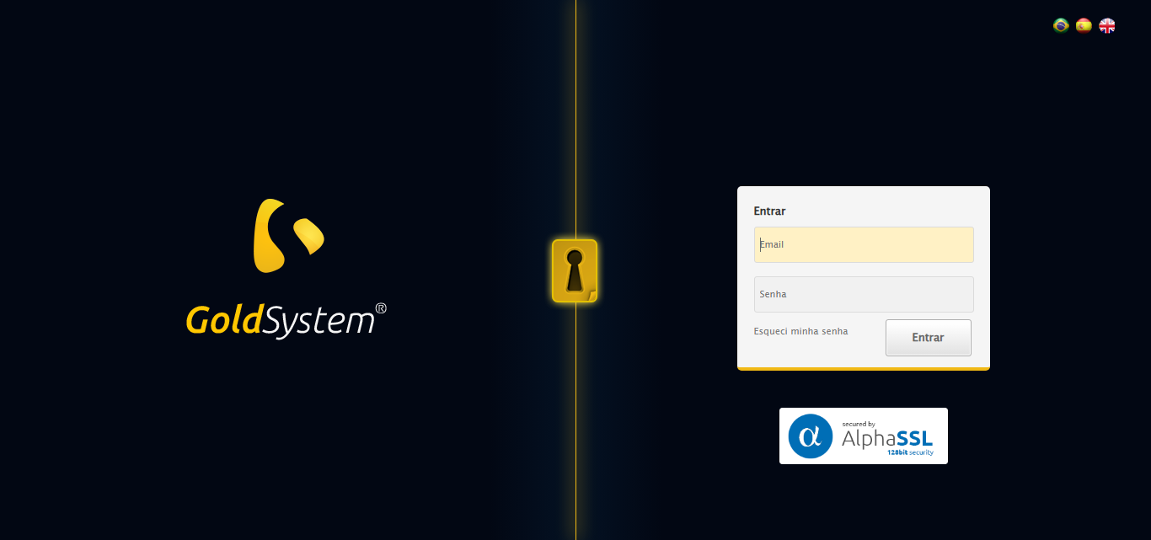

[16:21:25] 🔄 Realizando login...

[16:21:30] ✅ Realizando login realizada com sucesso.

[16:21:34] 📸 Screenshot capturada: realizando_login

Screenshot: realizando_login

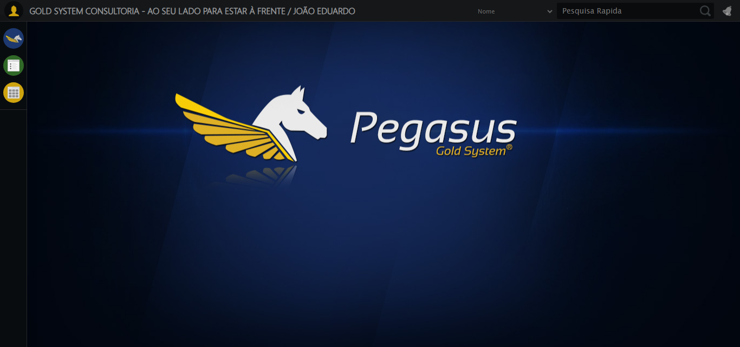

[16:21:34] 🔄 Configurando ambiente...

[16:21:34] 🔍 Zoom ajustado para 90%.

[16:21:36] ✅ Configurando ambiente realizada com sucesso.

[16:21:37] 📸 Screenshot capturada: configurando_ambiente

Screenshot: configurando_ambiente

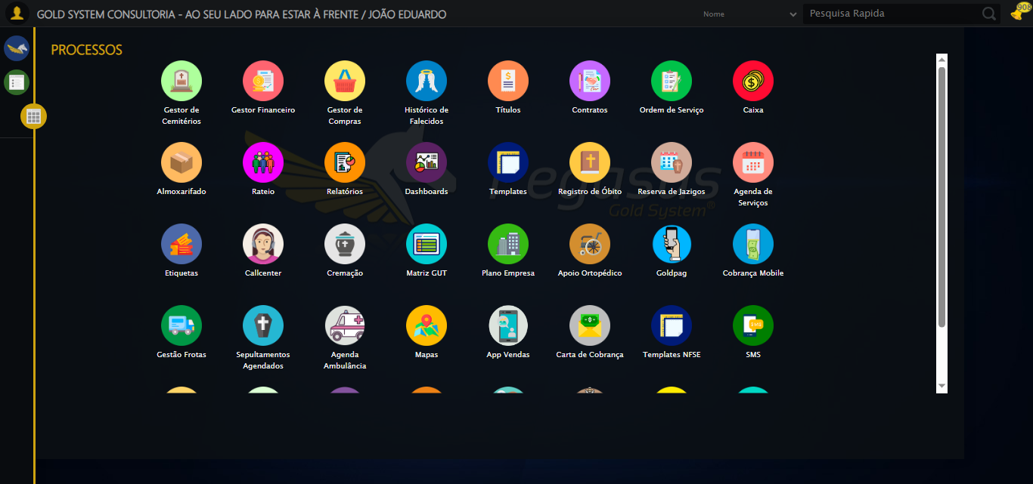

[16:21:37] 🔄 Acessando módulo PET...

[16:21:37] Tentando estratégia de scroll 1...

[16:21:38] ✅ Scroll realizado com estratégia 1

[16:21:39] Tentando estratégia de clique 1 para módulo PET...

[16:21:41] ✅ Clique no módulo PET realizado com estratégia 1

[16:21:41] ✅ Acessando módulo PET realizada com sucesso.

[16:21:43] 📸 Screenshot capturada: acessando_módulo_pet

Screenshot: acessando_módulo_pet

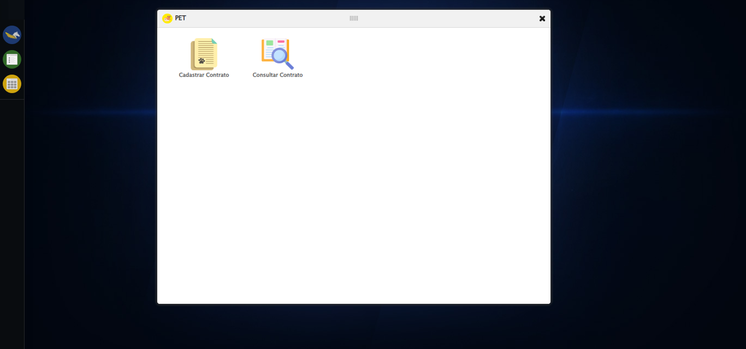

[16:21:43] 🔄 Abrindo consulta de contrato...

[16:21:49] ✅ Abrindo consulta de contrato realizada com sucesso.

[16:21:50] 📸 Screenshot capturada: abrindo_consulta_de_contrato

Screenshot: abrindo_consulta_de_contrato

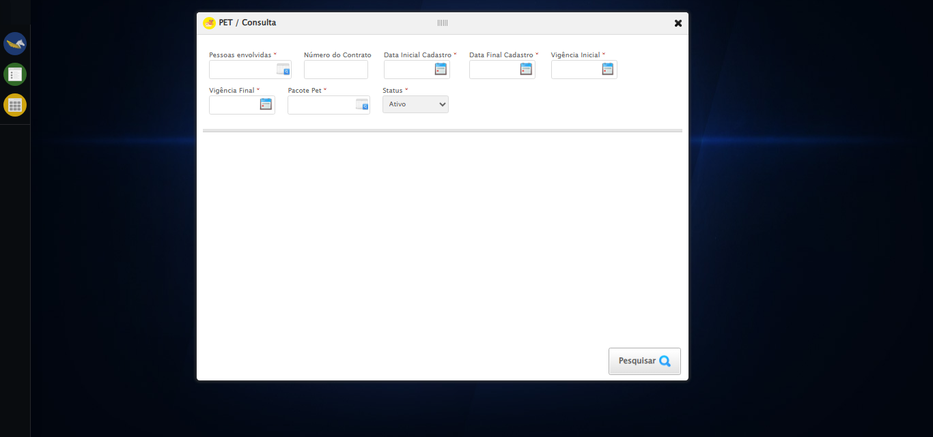

[16:21:50] 🔄 Selecionando Pessoas Envolvidas...

[16:21:50] 🔘 Abrindo modal com botão: #gsPet > div.wdTelas > div.telaConsulta.telaConsultaContratoPet > div > div.formRow.filtrosConsulta > div:nth-child(1) > div > a

[16:21:50] Tentando estratégia de scroll 1...

[16:21:51] ✅ Scroll realizado com estratégia 1

[16:21:53] 🔍 Preenchendo pesquisa com: TESTE TUTOR SELENIUM AUTOMATIZADO

[16:21:55] 🔍 Executando pesquisa...

[16:21:58] 🎯 Selecionando resultado: //td[contains(text(), 'TESTE TUTOR SELENIUM AUTOMATIZADO')]

[16:21:58] Tentando estratégia de scroll 1...

[16:21:59] ✅ Scroll realizado com estratégia 1

[16:22:00] ✅ Seleção no modal concluída

[16:22:00] ✅ Selecionando Pessoas Envolvidas realizada com sucesso.

[16:22:01] 📸 Screenshot capturada: selecionando_pessoas_envolvidas

Screenshot: selecionando_pessoas_envolvidas

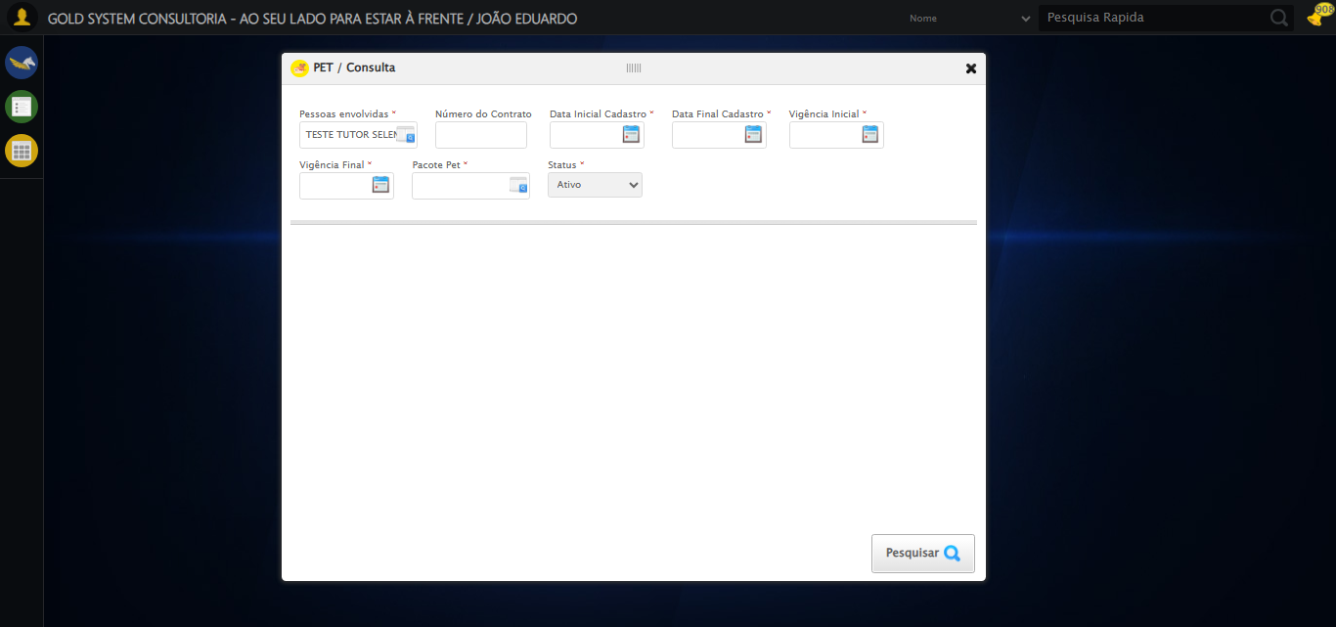

[16:22:01] 🔄 Preenchendo Número do Contrato...

[16:22:01] Tentando estratégia de scroll 1...

[16:22:02] ✅ Scroll realizado com estratégia 1

[16:22:04] ✅ Campo preenchido com estratégia 1: '113079'

[16:22:04] ✅ Preenchendo Número do Contrato realizada com sucesso.

[16:22:05] 📸 Screenshot capturada: preenchendo_número_do_contrato

Screenshot: preenchendo_número_do_contrato

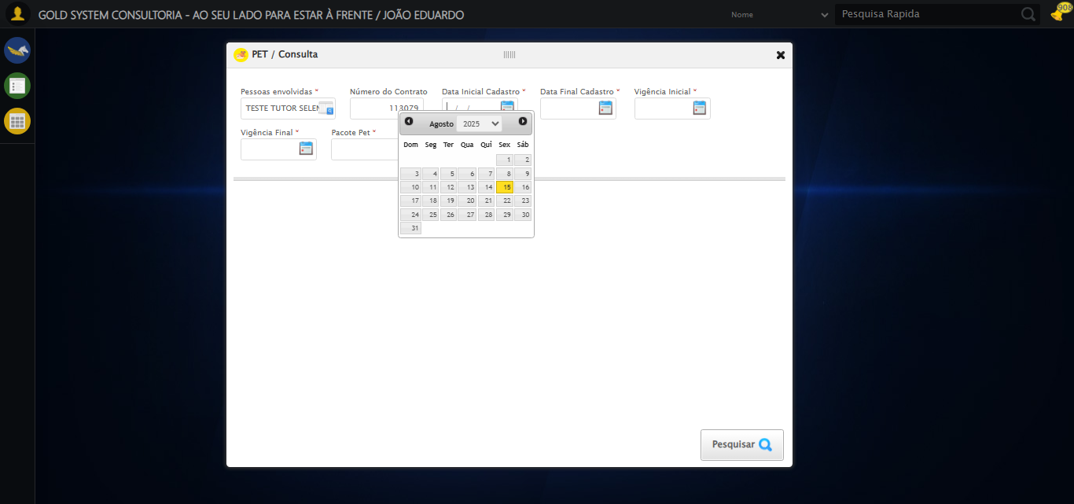

[16:22:05] 🔄 Preenchendo Data Inicial Cadastro...

[16:22:06] 📊 Encontrados 5 campos datepicker

[16:22:06] 🎯 Tentativa 1: Preenchendo datepicker 0 (ID: dp1755285688431) com '13/08/2025'

[16:22:06] Aplicando estratégia 1 para datepicker...

[16:22:07] ✅ Datepicker preenchido com estratégia 1: '13/08/2025'

[16:22:07] ✅ Preenchendo Data Inicial Cadastro realizada com sucesso.

[16:22:08] 📸 Screenshot capturada: preenchendo_data_inicial_cadastro

Screenshot: preenchendo_data_inicial_cadastro

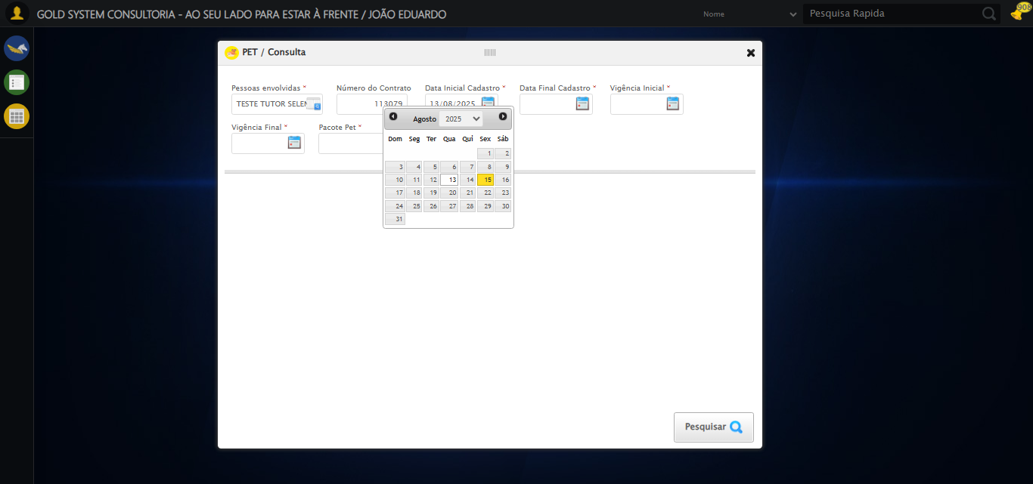

[16:22:08] 🔄 Preenchendo Data Final Cadastro...

[16:22:10] 📊 Encontrados 5 campos datepicker

[16:22:10] 🎯 Tentativa 1: Preenchendo datepicker 1 (ID: dp1755285688432) com '13/08/2025'

[16:22:10] Aplicando estratégia 1 para datepicker...

[16:22:11] ✅ Datepicker preenchido com estratégia 1: '13/08/2025'

[16:22:11] ✅ Preenchendo Data Final Cadastro realizada com sucesso.

[16:22:12] 📸 Screenshot capturada: preenchendo_data_final_cadastro

Screenshot: preenchendo_data_final_cadastro

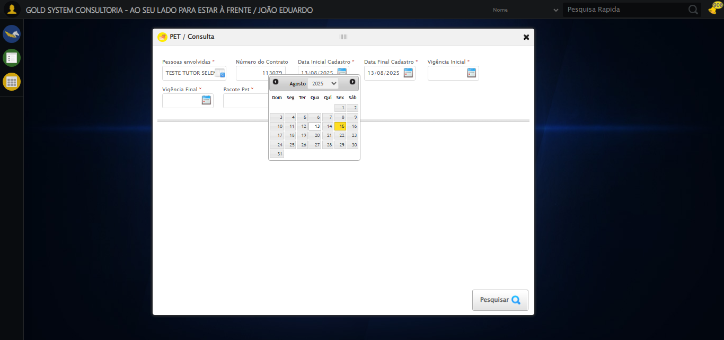

[16:22:12] 🔄 Preenchendo Vigência Inicial...

[16:22:14] 📊 Encontrados 5 campos datepicker

[16:22:14] 🎯 Tentativa 1: Preenchendo datepicker 2 (ID: dp1755285688429) com '13/08/2025'

[16:22:14] Aplicando estratégia 1 para datepicker...

[16:22:15] ✅ Datepicker preenchido com estratégia 1: '13/08/2025'

[16:22:15] ✅ Preenchendo Vigência Inicial realizada com sucesso.

[16:22:16] 📸 Screenshot capturada: preenchendo_vigência_inicial

Screenshot: preenchendo_vigência_inicial

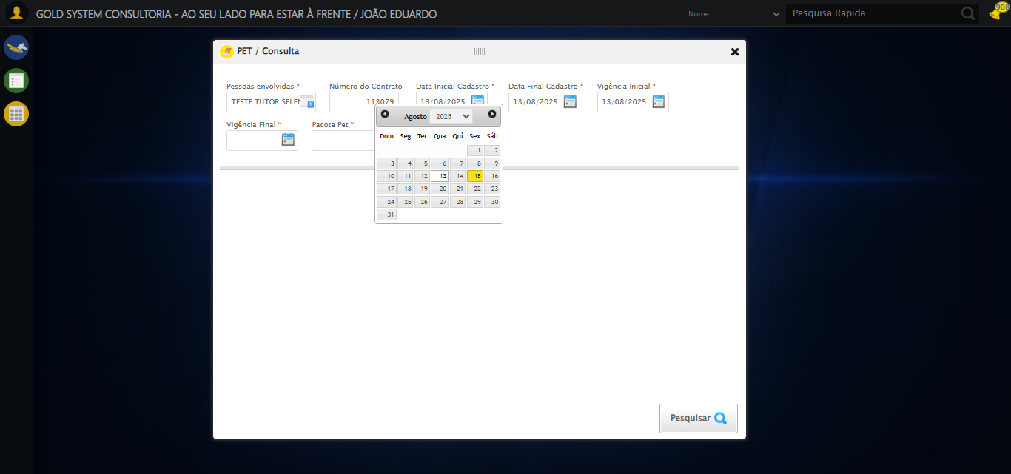

[16:22:16] 🔄 Preenchendo Vigência Final...

[16:22:18] 📊 Encontrados 5 campos datepicker

[16:22:18] 🎯 Tentativa 1: Preenchendo datepicker 3 (ID: dp1755285688430) com '13/11/2025'

[16:22:18] Aplicando estratégia 1 para datepicker...

[16:22:19] ✅ Datepicker preenchido com estratégia 1: '13/11/2025'

[16:22:19] ✅ Preenchendo Vigência Final realizada com sucesso.

[16:22:20] 📸 Screenshot capturada: preenchendo_vigência_final

Screenshot: preenchendo_vigência_final

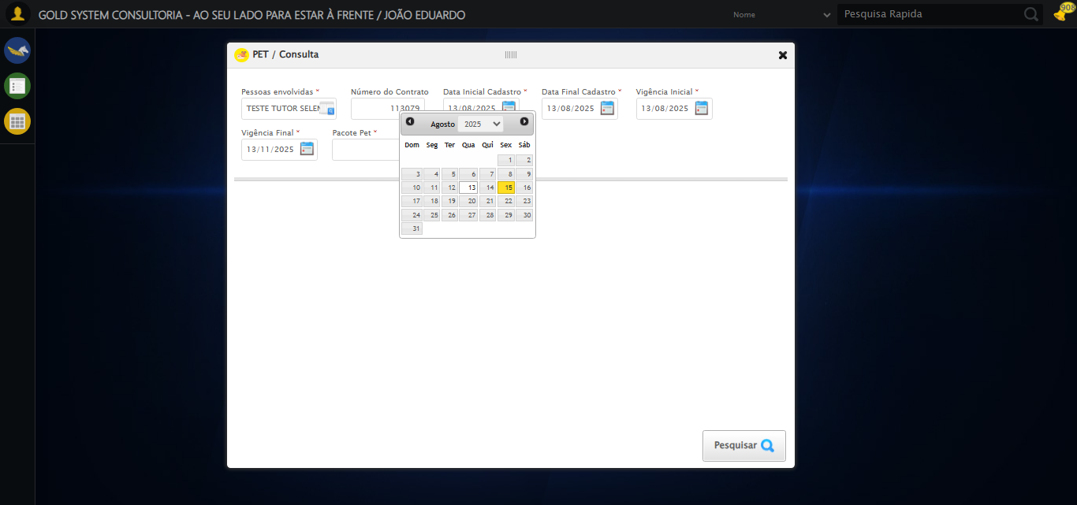

[16:22:20] 🔄 Selecionando Pacote Pet...

[16:22:20] 🔘 Abrindo modal com botão: #gsPet > div.wdTelas > div.telaConsulta.telaConsultaContratoPet > div > div.formRow.filtrosConsulta > div:nth-child(7) > div > a

[16:22:20] Tentando estratégia de scroll 1...

[16:22:21] ✅ Scroll realizado com estratégia 1

[16:22:25] 🔍 Preenchendo pesquisa com: PACOTE PET TESTE SELENIUM AUTOMATIZADO

[16:22:27] 🔍 Executando pesquisa...

[16:22:30] 🎯 Selecionando resultado: //td[contains(text(), 'PACOTE PET TESTE SELENIUM AUTOMATIZADO')]

[16:22:30] Tentando estratégia de scroll 1...

[16:22:31] ✅ Scroll realizado com estratégia 1

[16:22:33] ✅ Seleção no modal concluída

[16:22:33] ✅ Selecionando Pacote Pet realizada com sucesso.

[16:22:34] 📸 Screenshot capturada: selecionando_pacote_pet

Screenshot: selecionando_pacote_pet

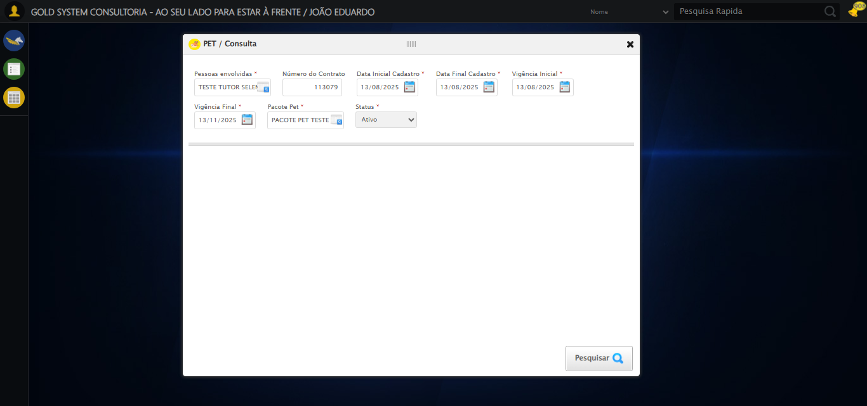

[16:22:34] 🔄 Realizando consulta...

[16:22:34] Tentando estratégia de scroll 1...

[16:22:35] ✅ Scroll realizado com estratégia 1

[16:22:37] ✅ Consulta executada

[16:22:37] ✅ Realizando consulta realizada com sucesso.

[16:22:38] 📸 Screenshot capturada: realizando_consulta

Screenshot: realizando_consulta

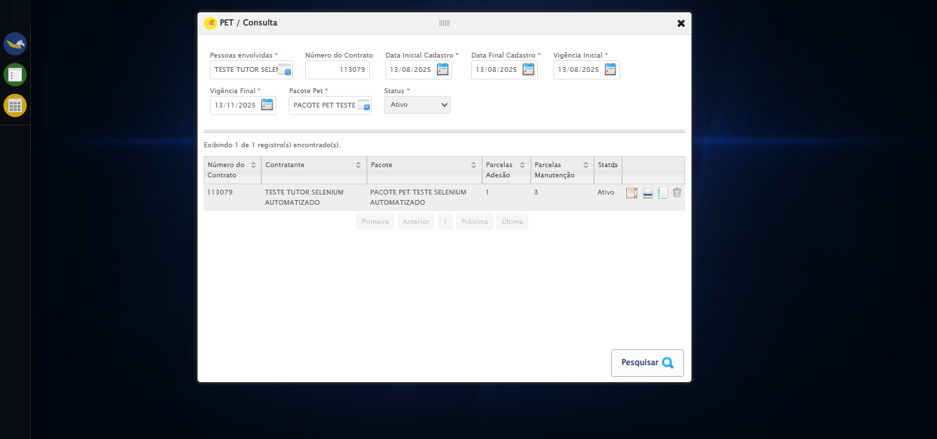

[16:22:38] 🔄 Validando resultados da consulta...

[16:22:38] 🔍 Iniciando validação de registros...

[16:22:43] ✅ Tabela encontrada: #DataTables_Table_2

[16:22:43] ✅ Encontradas 1 linhas válidas com tbody tr:not(.dataTables_empty):not([class*="no-data"])

[16:22:43] ✅ 1 registro(s) encontrado(s)

[16:22:43] Registro 1: 113079 teste tutor selenium automatizado pacote pet teste selenium automatizado 1 3 ativo

[16:22:44] ✅ Validando resultados da consulta realizada com sucesso.

[16:22:45] 📸 Screenshot capturada: validando_resultados_da_consulta

Screenshot: validando_resultados_da_consulta

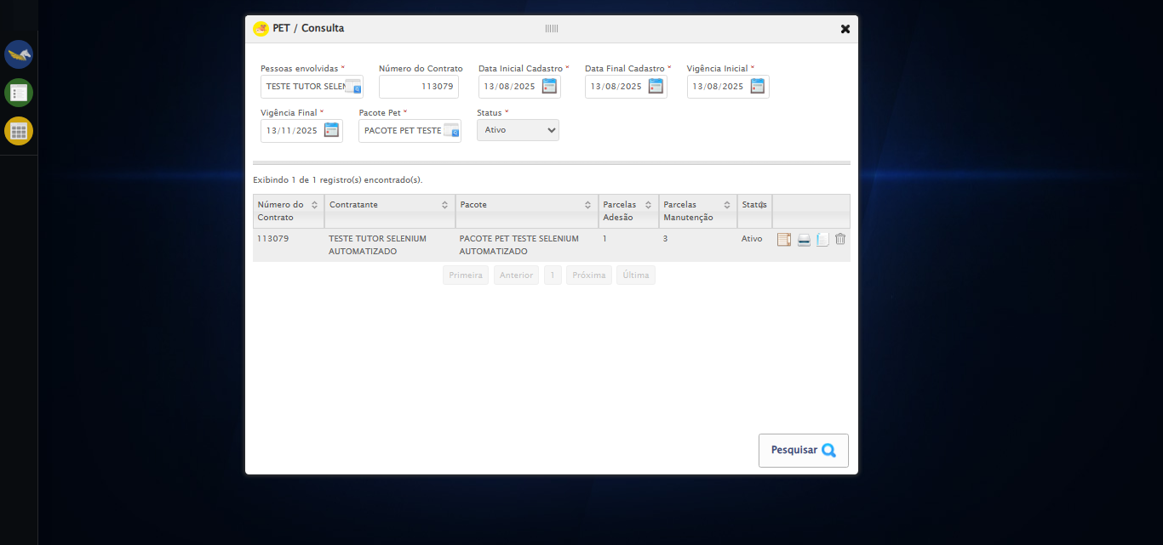

[16:22:45] ✅ Processando 1 registro(s) encontrado(s)

[16:22:45] 🔄 Visualizando detalhes do Contrato Pet...

[16:22:45] Tentando estratégia de scroll 1...

[16:22:46] ✅ Scroll realizado com estratégia 1

[16:22:46] ✅ Clique realizado com estratégia 1

[16:22:46] ✅ Visualizando detalhes do Contrato Pet realizada com sucesso.

[16:22:49] 📸 Screenshot capturada: visualizando_detalhes_do_contrato_pet

Screenshot: visualizando_detalhes_do_contrato_pet

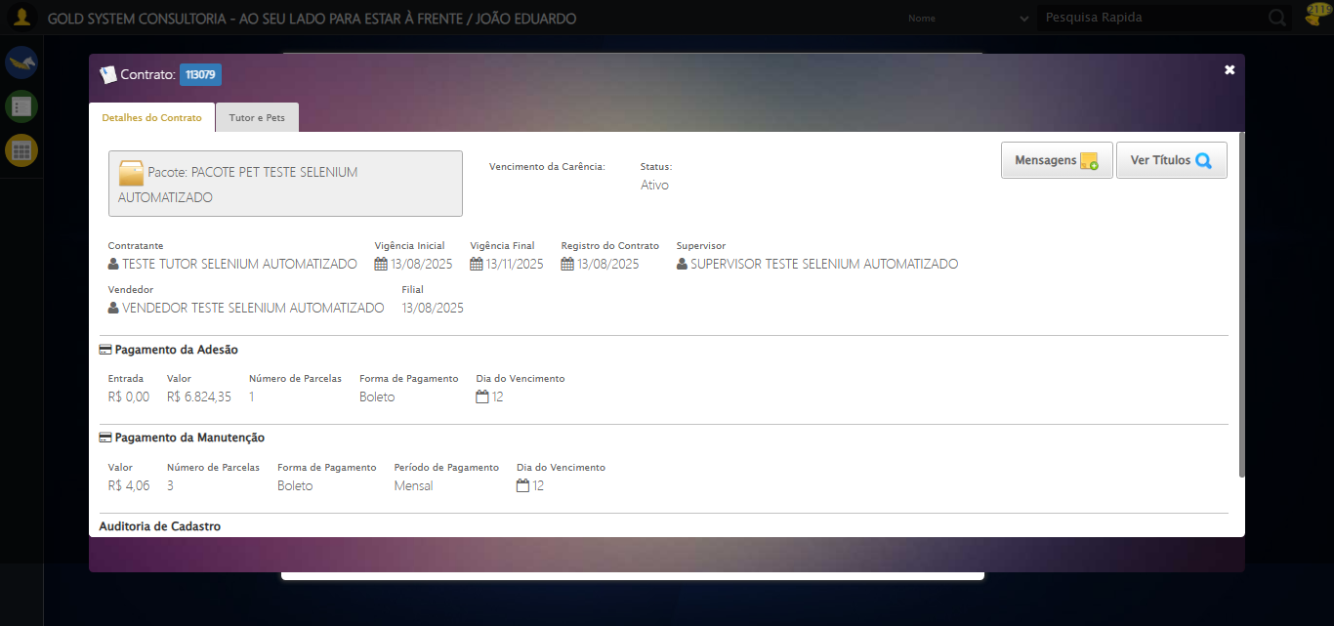

[16:22:49] 🔄 Capturando tela de detalhes...

[16:22:52] 📸 Screenshot capturada: detalhes_contrato_pet

Screenshot: detalhes_contrato_pet



[16:22:52] ✅ Capturando tela de detalhes realizada com sucesso.

[16:22:53] 📸 Screenshot capturada: capturando_tela_de_detalhes

Screenshot: capturando_tela_de_detalhes



[16:22:53] 🔄 Abrindo mensagens do Contrato Pet...

[16:22:53] Tentando estratégia de scroll 1...

[16:22:54] ✅ Scroll realizado com estratégia 1

[16:22:55] ✅ Clique realizado com estratégia 1

[16:22:55] ✅ Abrindo mensagens do Contrato Pet realizada com sucesso.

[16:22:56] 📸 Screenshot capturada: abrindo_mensagens_do_contrato_pet

Screenshot: abrindo_mensagens_do_contrato_pet

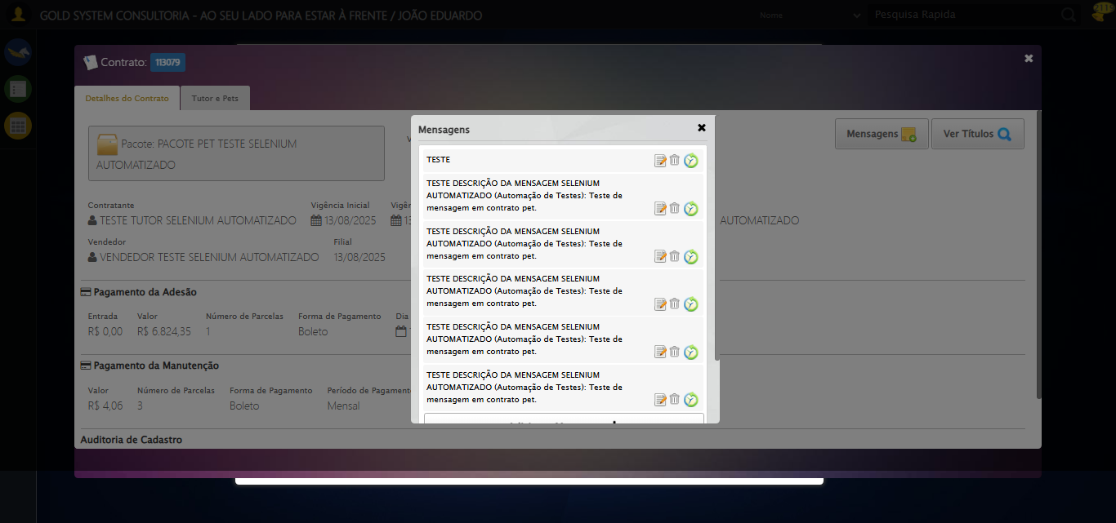

[16:22:56] 🔄 Capturando mensagens...

[16:22:58] 📸 Screenshot capturada: mensagens_contrato_pet

Screenshot: mensagens_contrato_pet



[16:22:58] ✅ Capturando mensagens realizada com sucesso.

[16:23:00] 📸 Screenshot capturada: capturando_mensagens

Screenshot: capturando_mensagens



[16:23:00] 🔄 Adicionando nova mensagem...

[16:23:00] Tentando estratégia de scroll 1...

[16:23:01] ✅ Scroll realizado com estratégia 1

[16:23:02] ✅ Clique realizado com estratégia 1

[16:23:02] ✅ Adicionando nova mensagem realizada com sucesso.

[16:23:03] 📸 Screenshot capturada: adicionando_nova_mensagem

Screenshot: adicionando_nova_mensagem

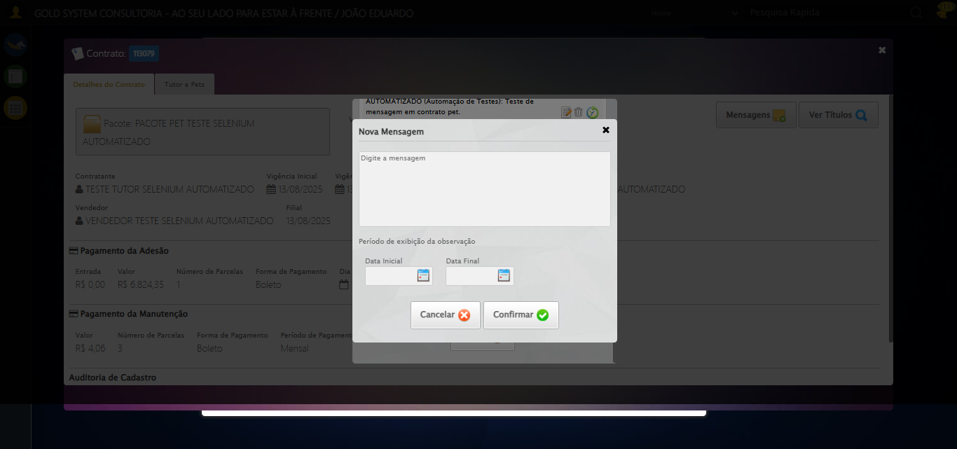

[16:23:03] 🔄 Confirmando mensagem sem registros para verificar mensagem de alerta...

[16:23:04] Tentando estratégia de scroll 1...

[16:23:04] ✅ Scroll realizado com estratégia 1

[16:23:05] ✅ Clique realizado com estratégia 1

[16:23:05] ✅ Confirmando mensagem sem registros para verificar mensagem de alerta realizada com sucesso.

[16:23:06] 📸 Screenshot capturada: confirmando_mensagem_sem_registros_para_verificar_mensagem_de_alerta

Screenshot: confirmando_mensagem_sem_registros_para_verificar_mensagem_de_alerta

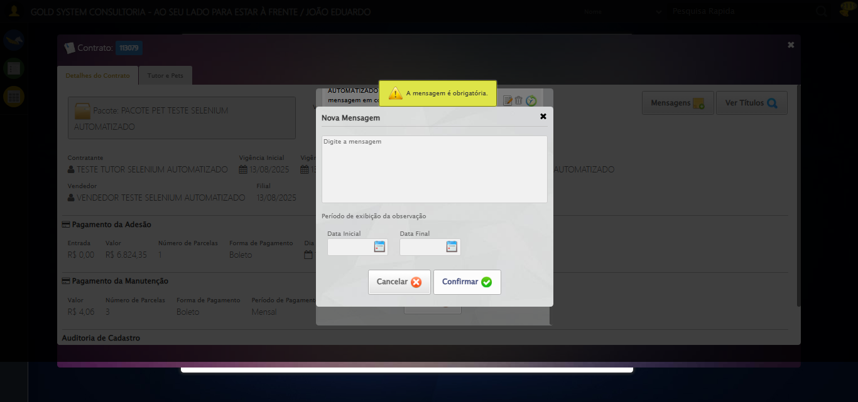

[16:23:06] 🔍 Verificando mensagens de alerta...

[16:23:06] 📢 ⚠️ Alerta: A mensagem é obrigatória.

[16:23:06] 🔄 Fechando aba de mensagens...

[16:23:06] Tentando estratégia de scroll 1...

[16:23:07] ✅ Scroll realizado com estratégia 1

[16:23:08] ⚠️ Estratégia 1 de clique falhou: Message: element click intercepted: Element <a class="btModel btGray">...</a> is not clickable at point (689, 481). Other element would receive the click: <div class="modal overflow" style="z-index: 10006; left: 50%; top: 50%; width: 400px; height: 335px; margin-left: -200px; margin-top: -167.5px;">...</div>  
 (Session info: chrome=138.0.7204.185)  
Stacktrace:  
 GetHandleVerifier [0x0x126ba83+63395]  
 GetHandleVerifier [0x0x126bac4+63460]  
 (No symbol) [0x0x10b2113]  
 (No symbol) [0x0x1100ba0]  
 (No symbol) [0x0x10fef5a]  
 (No symbol) [0x0x10fcab7]  
 (No symbol) [0x0x10fbd6d]  
 (No symbol) [0x0x10f0515]  
 (No symbol) [0x0x111f3ac]  
 (No symbol) [0x0x10effa4]  
 (No symbol) [0x0x111f624]  
 (No symbol) [0x0x11407ba]  
 (No symbol) [0x0x111f1a6]  
 (No symbol) [0x0x10ee7b2]  
 (No symbol) [0x0x10ef654]  
 GetHandleVerifier [0x0x14e8883+2672035]  
 GetHandleVerifier [0x0x14e3cba+2652634]  
 GetHandleVerifier [0x0x1292bca+223466]  
 GetHandleVerifier [0x0x1282cb8+158168]  
 GetHandleVerifier [0x0x128978d+185517]  
 GetHandleVerifier [0x0x1273b78+96408]  
 GetHandleVerifier [0x0x1273d02+96802]  
 GetHandleVerifier [0x0x125e90a+9770]  
 BaseThreadInitThunk [0x0x7709fcc9+25]  
 RtlGetAppContainerNamedObjectPath [0x0x778882ae+286]  
 RtlGetAppContainerNamedObjectPath [0x0x7788827e+238]

[16:23:09] ✅ Clique realizado com estratégia 2

[16:23:09] ✅ Fechando aba de mensagens realizada com sucesso.

[16:23:10] 📸 Screenshot capturada: fechando_aba_de_mensagens

Screenshot: fechando_aba_de_mensagens

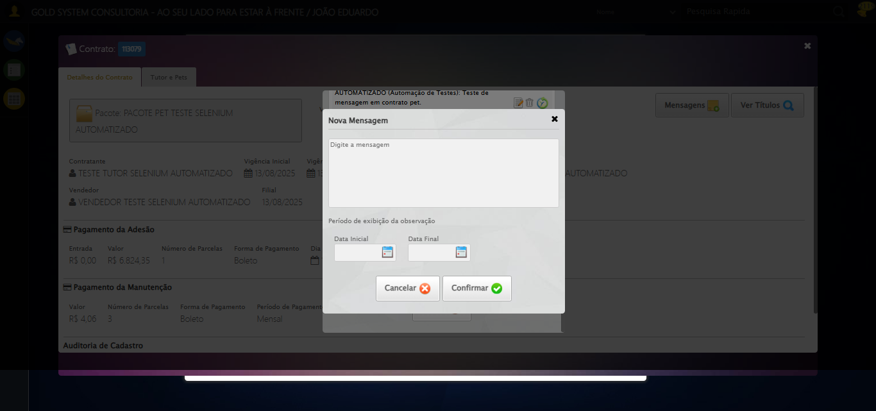

[16:23:10] 🔄 Visualizando títulos do Contrato Pet...

[16:23:11] Tentando estratégia de scroll 1...

[16:23:11] ✅ Scroll realizado com estratégia 1

[16:23:13] ⚠️ Estratégia 1 de clique falhou: Message: element click intercepted: Element <button class="btModel btGray" style="position: relative; float: right;">...</button> is not clickable at point (1196, 164). Other element would receive the click: <div class="blockScreen" style="height: 641px; z-index: 10005; opacity: 0.5;"></div>  
 (Session info: chrome=138.0.7204.185)  
Stacktrace:  
 GetHandleVerifier [0x0x126ba83+63395]  
 GetHandleVerifier [0x0x126bac4+63460]  
 (No symbol) [0x0x10b2113]  
 (No symbol) [0x0x1100ba0]  
 (No symbol) [0x0x10fef5a]  
 (No symbol) [0x0x10fcab7]  
 (No symbol) [0x0x10fbd6d]  
 (No symbol) [0x0x10f0515]  
 (No symbol) [0x0x111f3ac]  
 (No symbol) [0x0x10effa4]  
 (No symbol) [0x0x111f624]  
 (No symbol) [0x0x11407ba]  
 (No symbol) [0x0x111f1a6]  
 (No symbol) [0x0x10ee7b2]  
 (No symbol) [0x0x10ef654]  
 GetHandleVerifier [0x0x14e8883+2672035]  
 GetHandleVerifier [0x0x14e3cba+2652634]  
 GetHandleVerifier [0x0x1292bca+223466]  
 GetHandleVerifier [0x0x1282cb8+158168]  
 GetHandleVerifier [0x0x128978d+185517]  
 GetHandleVerifier [0x0x1273b78+96408]  
 GetHandleVerifier [0x0x1273d02+96802]  
 GetHandleVerifier [0x0x125e90a+9770]  
 BaseThreadInitThunk [0x0x7709fcc9+25]  
 RtlGetAppContainerNamedObjectPath [0x0x778882ae+286]  
 RtlGetAppContainerNamedObjectPath [0x0x7788827e+238]

[16:23:13] ✅ Clique realizado com estratégia 2

[16:23:13] ✅ Visualizando títulos do Contrato Pet realizada com sucesso.

[16:23:14] 📸 Screenshot capturada: visualizando_títulos_do_contrato_pet

Screenshot: visualizando_títulos_do_contrato_pet



[16:23:15] 🔄 Aguardando carregamento de títulos...

[16:23:45] 📸 Screenshot capturada: titulos_contrato_pet

Screenshot: titulos_contrato_pet

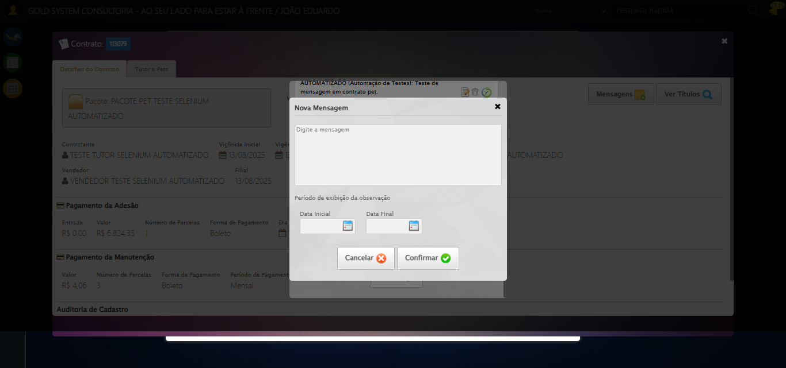

[16:23:45] ✅ Aguardando carregamento de títulos realizada com sucesso.

[16:23:46] 📸 Screenshot capturada: aguardando_carregamento_de_títulos

Screenshot: aguardando_carregamento_de_títulos



[16:23:46] 🔄 Fechando aba de títulos...

[16:23:48] ❌ Erro aguardando elemento //a[@title='Sair' and contains(@class, 'sp-fecharGrande')]: Message: invalid session id: session deleted as the browser has closed the connection  
from disconnected: not connected to DevTools  
 (Session info: chrome=138.0.7204.185)  
Stacktrace:  
 GetHandleVerifier [0x0x126ba83+63395]  
 GetHandleVerifier [0x0x126bac4+63460]  
 (No symbol) [0x0x10b2113]  
 (No symbol) [0x0x10a1b20]  
 (No symbol) [0x0x10bf922]  
 (No symbol) [0x0x1125c9c]  
 (No symbol) [0x0x1140099]  
 (No symbol) [0x0x111f1a6]  
 (No symbol) [0x0x10ee7b2]  
 (No symbol) [0x0x10ef654]  
 GetHandleVerifier [0x0x14e8883+2672035]  
 GetHandleVerifier [0x0x14e3cba+2652634]  
 GetHandleVerifier [0x0x1292bca+223466]  
 GetHandleVerifier [0x0x1282cb8+158168]  
 GetHandleVerifier [0x0x128978d+185517]  
 GetHandleVerifier [0x0x1273b78+96408]  
 GetHandleVerifier [0x0x1273d02+96802]  
 GetHandleVerifier [0x0x125e90a+9770]  
 BaseThreadInitThunk [0x0x7709fcc9+25]  
 RtlGetAppContainerNamedObjectPath [0x0x778882ae+286]  
 RtlGetAppContainerNamedObjectPath [0x0x7788827e+238]

[16:23:48] ❌ Falha ao clicar em //a[@title='Sair' and contains(@class, 'sp-fecharGrande')]: Message: invalid session id: session deleted as the browser has closed the connection  
from disconnected: not connected to DevTools  
 (Session info: chrome=138.0.7204.185)  
Stacktrace:  
 GetHandleVerifier [0x0x126ba83+63395]  
 GetHandleVerifier [0x0x126bac4+63460]  
 (No symbol) [0x0x10b2113]  
 (No symbol) [0x0x10a1b20]  
 (No symbol) [0x0x10bf922]  
 (No symbol) [0x0x1125c9c]  
 (No symbol) [0x0x1140099]  
 (No symbol) [0x0x111f1a6]  
 (No symbol) [0x0x10ee7b2]  
 (No symbol) [0x0x10ef654]  
 GetHandleVerifier [0x0x14e8883+2672035]  
 GetHandleVerifier [0x0x14e3cba+2652634]  
 GetHandleVerifier [0x0x1292bca+223466]  
 GetHandleVerifier [0x0x1282cb8+158168]  
 GetHandleVerifier [0x0x128978d+185517]  
 GetHandleVerifier [0x0x1273b78+96408]  
 GetHandleVerifier [0x0x1273d02+96802]  
 GetHandleVerifier [0x0x125e90a+9770]  
 BaseThreadInitThunk [0x0x7709fcc9+25]  
 RtlGetAppContainerNamedObjectPath [0x0x778882ae+286]  
 RtlGetAppContainerNamedObjectPath [0x0x7788827e+238]

[16:23:48] ⚠️ Erro ao tirar screenshot erro_fechando_aba_de_títulos: Message: invalid session id  
Stacktrace:  
 GetHandleVerifier [0x0x126ba83+63395]  
 GetHandleVerifier [0x0x126bac4+63460]  
 (No symbol) [0x0x10b1f70]  
 (No symbol) [0x0x10edaa8]  
 (No symbol) [0x0x111f266]  
 (No symbol) [0x0x111ae65]  
 (No symbol) [0x0x111a3e6]  
 (No symbol) [0x0x1083a45]  
 (No symbol) [0x0x1083f9e]  
 (No symbol) [0x0x108442d]  
 GetHandleVerifier [0x0x14e8883+2672035]  
 GetHandleVerifier [0x0x14e3cba+2652634]  
 GetHandleVerifier [0x0x1292bca+223466]  
 GetHandleVerifier [0x0x1282cb8+158168]  
 GetHandleVerifier [0x0x128978d+185517]  
 (No symbol) [0x0x1083710]  
 (No symbol) [0x0x1082f1d]  
 GetHandleVerifier [0x0x161db9c+3938492]  
 BaseThreadInitThunk [0x0x7709fcc9+25]  
 RtlGetAppContainerNamedObjectPath [0x0x778882ae+286]  
 RtlGetAppContainerNamedObjectPath [0x0x7788827e+238]

[16:23:48] ❌ Fechando aba de títulos falhou: InvalidSessionIdException: Message: invalid session id: session deleted as the browser has closed the connection  
from disconnected: not connected to DevTools  
 (Session info: chrome=138.0.7204.185)  
Stacktrace:  
 GetHandleVerifier [0x0x126ba83+63395]  
 GetHandleVerifier [0x0x126bac4+63460]  
 (No symbol) [0x0x10b2113]  
 (No symbol) [0x0x10a1b20]  
 (No symbol) [0x0x10bf922]  
 (No symbol) [0x0x1125c9c]  
 (No symbol) [0x0x1140099]  
 (No symbol) [0x0x111f1a6]  
 (No symbol) [0x0x10ee7b2]  
 (No symbol) [0x0x10ef654]  
 GetHandleVerifier [0x0x14e8883+2672035]  
 GetHandleVerifier [0x0x14e3cba+2652634]  
 GetHandleVerifier [0x0x1292bca+223466]  
 GetHandleVerifier [0x0x1282cb8+158168]  
 GetHandleVerifier [0x0x128978d+185517]  
 GetHandleVerifier [0x0x1273b78+96408]  
 GetHandleVerifier [0x0x1273d02+96802]  
 GetHandleVerifier [0x0x125e90a+9770]  
 BaseThreadInitThunk [0x0x7709fcc9+25]  
 RtlGetAppContainerNamedObjectPath [0x0x778882ae+286]  
 RtlGetAppContainerNamedObjectPath [0x0x7788827e+238]

[16:23:48] ⚠️ Continuando execução apesar do erro em: Fechando aba de títulos

[16:23:48] 🔄 Abrindo digitalização de documentos...

[16:23:48] ❌ Erro aguardando elemento //span[@title='Digitalizar documentos' and contains(@class, 'sp-scanner')]: Message: invalid session id  
Stacktrace:  
 GetHandleVerifier [0x0x126ba83+63395]  
 GetHandleVerifier [0x0x126bac4+63460]  
 (No symbol) [0x0x10b1f70]  
 (No symbol) [0x0x10edaa8]  
 (No symbol) [0x0x111f266]  
 (No symbol) [0x0x111ae65]  
 (No symbol) [0x0x111a3e6]  
 (No symbol) [0x0x1083a45]  
 (No symbol) [0x0x1083f9e]  
 (No symbol) [0x0x108442d]  
 GetHandleVerifier [0x0x14e8883+2672035]  
 GetHandleVerifier [0x0x14e3cba+2652634]  
 GetHandleVerifier [0x0x1292bca+223466]  
 GetHandleVerifier [0x0x1282cb8+158168]  
 GetHandleVerifier [0x0x128978d+185517]  
 (No symbol) [0x0x1083710]  
 (No symbol) [0x0x1082f1d]  
 GetHandleVerifier [0x0x161db9c+3938492]  
 BaseThreadInitThunk [0x0x7709fcc9+25]  
 RtlGetAppContainerNamedObjectPath [0x0x778882ae+286]  
 RtlGetAppContainerNamedObjectPath [0x0x7788827e+238]

[16:23:48] ❌ Falha ao clicar em //span[@title='Digitalizar documentos' and contains(@class, 'sp-scanner')]: Message: invalid session id  
Stacktrace:  
 GetHandleVerifier [0x0x126ba83+63395]  
 GetHandleVerifier [0x0x126bac4+63460]  
 (No symbol) [0x0x10b1f70]  
 (No symbol) [0x0x10edaa8]  
 (No symbol) [0x0x111f266]  
 (No symbol) [0x0x111ae65]  
 (No symbol) [0x0x111a3e6]  
 (No symbol) [0x0x1083a45]  
 (No symbol) [0x0x1083f9e]  
 (No symbol) [0x0x108442d]  
 GetHandleVerifier [0x0x14e8883+2672035]  
 GetHandleVerifier [0x0x14e3cba+2652634]  
 GetHandleVerifier [0x0x1292bca+223466]  
 GetHandleVerifier [0x0x1282cb8+158168]  
 GetHandleVerifier [0x0x128978d+185517]  
 (No symbol) [0x0x1083710]  
 (No symbol) [0x0x1082f1d]  
 GetHandleVerifier [0x0x161db9c+3938492]  
 BaseThreadInitThunk [0x0x7709fcc9+25]  
 RtlGetAppContainerNamedObjectPath [0x0x778882ae+286]  
 RtlGetAppContainerNamedObjectPath [0x0x7788827e+238]

[16:23:48] ⚠️ Erro ao tirar screenshot erro_abrindo_digitalização_de_documentos: Message: invalid session id  
Stacktrace:  
 GetHandleVerifier [0x0x126ba83+63395]  
 GetHandleVerifier [0x0x126bac4+63460]  
 (No symbol) [0x0x10b1f70]  
 (No symbol) [0x0x10edaa8]  
 (No symbol) [0x0x111f266]  
 (No symbol) [0x0x111ae65]  
 (No symbol) [0x0x111a3e6]  
 (No symbol) [0x0x1083a45]  
 (No symbol) [0x0x1083f9e]  
 (No symbol) [0x0x108442d]  
 GetHandleVerifier [0x0x14e8883+2672035]  
 GetHandleVerifier [0x0x14e3cba+2652634]  
 GetHandleVerifier [0x0x1292bca+223466]  
 GetHandleVerifier [0x0x1282cb8+158168]  
 GetHandleVerifier [0x0x128978d+185517]  
 (No symbol) [0x0x1083710]  
 (No symbol) [0x0x1082f1d]  
 GetHandleVerifier [0x0x161db9c+3938492]  
 BaseThreadInitThunk [0x0x7709fcc9+25]  
 RtlGetAppContainerNamedObjectPath [0x0x778882ae+286]  
 RtlGetAppContainerNamedObjectPath [0x0x7788827e+238]

[16:23:49] ❌ Abrindo digitalização de documentos falhou: InvalidSessionIdException: Message: invalid session id  
Stacktrace:  
 GetHandleVerifier [0x0x126ba83+63395]  
 GetHandleVerifier [0x0x126bac4+63460]  
 (No symbol) [0x0x10b1f70]  
 (No symbol) [0x0x10edaa8]  
 (No symbol) [0x0x111f266]  
 (No symbol) [0x0x111ae65]  
 (No symbol) [0x0x111a3e6]  
 (No symbol) [0x0x1083a45]  
 (No symbol) [0x0x1083f9e]  
 (No symbol) [0x0x108442d]  
 GetHandleVerifier [0x0x14e8883+2672035]  
 GetHandleVerifier [0x0x14e3cba+2652634]  
 GetHandleVerifier [0x0x1292bca+223466]  
 GetHandleVerifier [0x0x1282cb8+158168]  
 GetHandleVerifier [0x0x128978d+185517]  
 (No symbol) [0x0x1083710]  
 (No symbol) [0x0x1082f1d]  
 GetHandleVerifier [0x0x161db9c+3938492]  
 BaseThreadInitThunk [0x0x7709fcc9+25]  
 RtlGetAppContainerNamedObjectPath [0x0x778882ae+286]  
 RtlGetAppContainerNamedObjectPath [0x0x7788827e+238]

[16:23:49] ⚠️ Continuando execução apesar do erro em: Abrindo digitalização de documentos

[16:23:49] 🔄 Adicionando novo documento...

[16:23:49] ❌ Erro aguardando elemento //span[contains(@class, 'sp-addFile')]: Message: invalid session id  
Stacktrace:  
 GetHandleVerifier [0x0x126ba83+63395]  
 GetHandleVerifier [0x0x126bac4+63460]  
 (No symbol) [0x0x10b1f70]  
 (No symbol) [0x0x10edaa8]  
 (No symbol) [0x0x111f266]  
 (No symbol) [0x0x111ae65]  
 (No symbol) [0x0x111a3e6]  
 (No symbol) [0x0x1083a45]  
 (No symbol) [0x0x1083f9e]  
 (No symbol) [0x0x108442d]  
 GetHandleVerifier [0x0x14e8883+2672035]  
 GetHandleVerifier [0x0x14e3cba+2652634]  
 GetHandleVerifier [0x0x1292bca+223466]  
 GetHandleVerifier [0x0x1282cb8+158168]  
 GetHandleVerifier [0x0x128978d+185517]  
 (No symbol) [0x0x1083710]  
 (No symbol) [0x0x1082f1d]  
 GetHandleVerifier [0x0x161db9c+3938492]  
 BaseThreadInitThunk [0x0x7709fcc9+25]  
 RtlGetAppContainerNamedObjectPath [0x0x778882ae+286]  
 RtlGetAppContainerNamedObjectPath [0x0x7788827e+238]

[16:23:49] ❌ Falha ao clicar em //span[contains(@class, 'sp-addFile')]: Message: invalid session id  
Stacktrace:  
 GetHandleVerifier [0x0x126ba83+63395]  
 GetHandleVerifier [0x0x126bac4+63460]  
 (No symbol) [0x0x10b1f70]  
 (No symbol) [0x0x10edaa8]  
 (No symbol) [0x0x111f266]  
 (No symbol) [0x0x111ae65]  
 (No symbol) [0x0x111a3e6]  
 (No symbol) [0x0x1083a45]  
 (No symbol) [0x0x1083f9e]  
 (No symbol) [0x0x108442d]  
 GetHandleVerifier [0x0x14e8883+2672035]  
 GetHandleVerifier [0x0x14e3cba+2652634]  
 GetHandleVerifier [0x0x1292bca+223466]  
 GetHandleVerifier [0x0x1282cb8+158168]  
 GetHandleVerifier [0x0x128978d+185517]  
 (No symbol) [0x0x1083710]  
 (No symbol) [0x0x1082f1d]  
 GetHandleVerifier [0x0x161db9c+3938492]  
 BaseThreadInitThunk [0x0x7709fcc9+25]  
 RtlGetAppContainerNamedObjectPath [0x0x778882ae+286]  
 RtlGetAppContainerNamedObjectPath [0x0x7788827e+238]

[16:23:49] ⚠️ Erro ao tirar screenshot erro_adicionando_novo_documento: Message: invalid session id  
Stacktrace:  
 GetHandleVerifier [0x0x126ba83+63395]  
 GetHandleVerifier [0x0x126bac4+63460]  
 (No symbol) [0x0x10b1f70]  
 (No symbol) [0x0x10edaa8]  
 (No symbol) [0x0x111f266]  
 (No symbol) [0x0x111ae65]  
 (No symbol) [0x0x111a3e6]  
 (No symbol) [0x0x1083a45]  
 (No symbol) [0x0x1083f9e]  
 (No symbol) [0x0x108442d]  
 GetHandleVerifier [0x0x14e8883+2672035]  
 GetHandleVerifier [0x0x14e3cba+2652634]  
 GetHandleVerifier [0x0x1292bca+223466]  
 GetHandleVerifier [0x0x1282cb8+158168]  
 GetHandleVerifier [0x0x128978d+185517]  
 (No symbol) [0x0x1083710]  
 (No symbol) [0x0x1082f1d]  
 GetHandleVerifier [0x0x161db9c+3938492]  
 BaseThreadInitThunk [0x0x7709fcc9+25]  
 RtlGetAppContainerNamedObjectPath [0x0x778882ae+286]  
 RtlGetAppContainerNamedObjectPath [0x0x7788827e+238]

[16:23:49] ❌ Adicionando novo documento falhou: InvalidSessionIdException: Message: invalid session id  
Stacktrace:  
 GetHandleVerifier [0x0x126ba83+63395]  
 GetHandleVerifier [0x0x126bac4+63460]  
 (No symbol) [0x0x10b1f70]  
 (No symbol) [0x0x10edaa8]  
 (No symbol) [0x0x111f266]  
 (No symbol) [0x0x111ae65]  
 (No symbol) [0x0x111a3e6]  
 (No symbol) [0x0x1083a45]  
 (No symbol) [0x0x1083f9e]  
 (No symbol) [0x0x108442d]  
 GetHandleVerifier [0x0x14e8883+2672035]  
 GetHandleVerifier [0x0x14e3cba+2652634]  
 GetHandleVerifier [0x0x1292bca+223466]  
 GetHandleVerifier [0x0x1282cb8+158168]  
 GetHandleVerifier [0x0x128978d+185517]  
 (No symbol) [0x0x1083710]  
 (No symbol) [0x0x1082f1d]  
 GetHandleVerifier [0x0x161db9c+3938492]  
 BaseThreadInitThunk [0x0x7709fcc9+25]  
 RtlGetAppContainerNamedObjectPath [0x0x778882ae+286]  
 RtlGetAppContainerNamedObjectPath [0x0x7788827e+238]

[16:23:49] ⚠️ Continuando execução apesar do erro em: Adicionando novo documento

[16:23:49] 🔄 Salvando arquivo digitalizado sem registros para verificar mensagem de alerta...

[16:23:49] ❌ Erro aguardando elemento //a[contains(@class,'btModel') and contains(@class,'btGreen') and normalize-space(.)='Salvar']: Message: invalid session id  
Stacktrace:  
 GetHandleVerifier [0x0x126ba83+63395]  
 GetHandleVerifier [0x0x126bac4+63460]  
 (No symbol) [0x0x10b1f70]  
 (No symbol) [0x0x10edaa8]  
 (No symbol) [0x0x111f266]  
 (No symbol) [0x0x111ae65]  
 (No symbol) [0x0x111a3e6]  
 (No symbol) [0x0x1083a45]  
 (No symbol) [0x0x1083f9e]  
 (No symbol) [0x0x108442d]  
 GetHandleVerifier [0x0x14e8883+2672035]  
 GetHandleVerifier [0x0x14e3cba+2652634]  
 GetHandleVerifier [0x0x1292bca+223466]  
 GetHandleVerifier [0x0x1282cb8+158168]  
 GetHandleVerifier [0x0x128978d+185517]  
 (No symbol) [0x0x1083710]  
 (No symbol) [0x0x1082f1d]  
 GetHandleVerifier [0x0x161db9c+3938492]  
 BaseThreadInitThunk [0x0x7709fcc9+25]  
 RtlGetAppContainerNamedObjectPath [0x0x778882ae+286]  
 RtlGetAppContainerNamedObjectPath [0x0x7788827e+238]

[16:23:49] ❌ Falha ao clicar em //a[contains(@class,'btModel') and contains(@class,'btGreen') and normalize-space(.)='Salvar']: Message: invalid session id  
Stacktrace:  
 GetHandleVerifier [0x0x126ba83+63395]  
 GetHandleVerifier [0x0x126bac4+63460]  
 (No symbol) [0x0x10b1f70]  
 (No symbol) [0x0x10edaa8]  
 (No symbol) [0x0x111f266]  
 (No symbol) [0x0x111ae65]  
 (No symbol) [0x0x111a3e6]  
 (No symbol) [0x0x1083a45]  
 (No symbol) [0x0x1083f9e]  
 (No symbol) [0x0x108442d]  
 GetHandleVerifier [0x0x14e8883+2672035]  
 GetHandleVerifier [0x0x14e3cba+2652634]  
 GetHandleVerifier [0x0x1292bca+223466]  
 GetHandleVerifier [0x0x1282cb8+158168]  
 GetHandleVerifier [0x0x128978d+185517]  
 (No symbol) [0x0x1083710]  
 (No symbol) [0x0x1082f1d]  
 GetHandleVerifier [0x0x161db9c+3938492]  
 BaseThreadInitThunk [0x0x7709fcc9+25]  
 RtlGetAppContainerNamedObjectPath [0x0x778882ae+286]  
 RtlGetAppContainerNamedObjectPath [0x0x7788827e+238]

[16:23:49] ⚠️ Erro ao tirar screenshot erro_salvando_arquivo_digitalizado_sem_registros_para_verificar_mensagem_de_alerta: Message: invalid session id  
Stacktrace:  
 GetHandleVerifier [0x0x126ba83+63395]  
 GetHandleVerifier [0x0x126bac4+63460]  
 (No symbol) [0x0x10b1f70]  
 (No symbol) [0x0x10edaa8]  
 (No symbol) [0x0x111f266]  
 (No symbol) [0x0x111ae65]  
 (No symbol) [0x0x111a3e6]  
 (No symbol) [0x0x1083a45]  
 (No symbol) [0x0x1083f9e]  
 (No symbol) [0x0x108442d]  
 GetHandleVerifier [0x0x14e8883+2672035]  
 GetHandleVerifier [0x0x14e3cba+2652634]  
 GetHandleVerifier [0x0x1292bca+223466]  
 GetHandleVerifier [0x0x1282cb8+158168]  
 GetHandleVerifier [0x0x128978d+185517]  
 (No symbol) [0x0x1083710]  
 (No symbol) [0x0x1082f1d]  
 GetHandleVerifier [0x0x161db9c+3938492]  
 BaseThreadInitThunk [0x0x7709fcc9+25]  
 RtlGetAppContainerNamedObjectPath [0x0x778882ae+286]  
 RtlGetAppContainerNamedObjectPath [0x0x7788827e+238]

[16:23:49] ❌ Salvando arquivo digitalizado sem registros para verificar mensagem de alerta falhou: InvalidSessionIdException: Message: invalid session id  
Stacktrace:  
 GetHandleVerifier [0x0x126ba83+63395]  
 GetHandleVerifier [0x0x126bac4+63460]  
 (No symbol) [0x0x10b1f70]  
 (No symbol) [0x0x10edaa8]  
 (No symbol) [0x0x111f266]  
 (No symbol) [0x0x111ae65]  
 (No symbol) [0x0x111a3e6]  
 (No symbol) [0x0x1083a45]  
 (No symbol) [0x0x1083f9e]  
 (No symbol) [0x0x108442d]  
 GetHandleVerifier [0x0x14e8883+2672035]  
 GetHandleVerifier [0x0x14e3cba+2652634]  
 GetHandleVerifier [0x0x1292bca+223466]  
 GetHandleVerifier [0x0x1282cb8+158168]  
 GetHandleVerifier [0x0x128978d+185517]  
 (No symbol) [0x0x1083710]  
 (No symbol) [0x0x1082f1d]  
 GetHandleVerifier [0x0x161db9c+3938492]  
 BaseThreadInitThunk [0x0x7709fcc9+25]  
 RtlGetAppContainerNamedObjectPath [0x0x778882ae+286]  
 RtlGetAppContainerNamedObjectPath [0x0x7788827e+238]

[16:23:49] ⚠️ Continuando execução apesar do erro em: Salvando arquivo digitalizado sem registros para verificar mensagem de alerta

[16:23:49] 🔍 Verificando mensagens de alerta após digitalização...

[16:23:49] ⚠️ Erro ao buscar alerta .alerts.salvo: Message: invalid session id  
Stacktrace:  
 GetHandleVerifier [0x0x126ba83+63395]  
 GetHandleVerifier [0x0x126bac4+63460]  
 (No symbol) [0x0x10b1f70]  
 (No symbol) [0x0x10edaa8]  
 (No symbol) [0x0x111f266]  
 (No symbol) [0x0x111ae65]  
 (No symbol) [0x0x111a3e6]  
 (No symbol) [0x0x1083a45]  
 (No symbol) [0x0x1083f9e]  
 (No symbol) [0x0x108442d]  
 GetHandleVerifier [0x0x14e8883+2672035]  
 GetHandleVerifier [0x0x14e3cba+2652634]  
 GetHandleVerifier [0x0x1292bca+223466]  
 GetHandleVerifier [0x0x1282cb8+158168]  
 GetHandleVerifier [0x0x128978d+185517]  
 (No symbol) [0x0x1083710]  
 (No symbol) [0x0x1082f1d]  
 GetHandleVerifier [0x0x161db9c+3938492]  
 BaseThreadInitThunk [0x0x7709fcc9+25]  
 RtlGetAppContainerNamedObjectPath [0x0x778882ae+286]  
 RtlGetAppContainerNamedObjectPath [0x0x7788827e+238]

[16:23:49] ⚠️ Erro ao buscar alerta .alerts.alerta: Message: invalid session id  
Stacktrace:  
 GetHandleVerifier [0x0x126ba83+63395]  
 GetHandleVerifier [0x0x126bac4+63460]  
 (No symbol) [0x0x10b1f70]  
 (No symbol) [0x0x10edaa8]  
 (No symbol) [0x0x111f266]  
 (No symbol) [0x0x111ae65]  
 (No symbol) [0x0x111a3e6]  
 (No symbol) [0x0x1083a45]  
 (No symbol) [0x0x1083f9e]  
 (No symbol) [0x0x108442d]  
 GetHandleVerifier [0x0x14e8883+2672035]  
 GetHandleVerifier [0x0x14e3cba+2652634]  
 GetHandleVerifier [0x0x1292bca+223466]  
 GetHandleVerifier [0x0x1282cb8+158168]  
 GetHandleVerifier [0x0x128978d+185517]  
 (No symbol) [0x0x1083710]  
 (No symbol) [0x0x1082f1d]  
 GetHandleVerifier [0x0x161db9c+3938492]  
 BaseThreadInitThunk [0x0x7709fcc9+25]  
 RtlGetAppContainerNamedObjectPath [0x0x778882ae+286]  
 RtlGetAppContainerNamedObjectPath [0x0x7788827e+238]

[16:23:49] ⚠️ Erro ao buscar alerta .alerts.erro: Message: invalid session id  
Stacktrace:  
 GetHandleVerifier [0x0x126ba83+63395]  
 GetHandleVerifier [0x0x126bac4+63460]  
 (No symbol) [0x0x10b1f70]  
 (No symbol) [0x0x10edaa8]  
 (No symbol) [0x0x111f266]  
 (No symbol) [0x0x111ae65]  
 (No symbol) [0x0x111a3e6]  
 (No symbol) [0x0x1083a45]  
 (No symbol) [0x0x1083f9e]  
 (No symbol) [0x0x108442d]  
 GetHandleVerifier [0x0x14e8883+2672035]  
 GetHandleVerifier [0x0x14e3cba+2652634]  
 GetHandleVerifier [0x0x1292bca+223466]  
 GetHandleVerifier [0x0x1282cb8+158168]  
 GetHandleVerifier [0x0x128978d+185517]  
 (No symbol) [0x0x1083710]  
 (No symbol) [0x0x1082f1d]  
 GetHandleVerifier [0x0x161db9c+3938492]  
 BaseThreadInitThunk [0x0x7709fcc9+25]  
 RtlGetAppContainerNamedObjectPath [0x0x778882ae+286]  
 RtlGetAppContainerNamedObjectPath [0x0x7788827e+238]

[16:23:49] ⚠️ Erro ao buscar alerta .alert-success: Message: invalid session id  
Stacktrace:  
 GetHandleVerifier [0x0x126ba83+63395]  
 GetHandleVerifier [0x0x126bac4+63460]  
 (No symbol) [0x0x10b1f70]  
 (No symbol) [0x0x10edaa8]  
 (No symbol) [0x0x111f266]  
 (No symbol) [0x0x111ae65]  
 (No symbol) [0x0x111a3e6]  
 (No symbol) [0x0x1083a45]  
 (No symbol) [0x0x1083f9e]  
 (No symbol) [0x0x108442d]  
 GetHandleVerifier [0x0x14e8883+2672035]  
 GetHandleVerifier [0x0x14e3cba+2652634]  
 GetHandleVerifier [0x0x1292bca+223466]  
 GetHandleVerifier [0x0x1282cb8+158168]  
 GetHandleVerifier [0x0x128978d+185517]  
 (No symbol) [0x0x1083710]  
 (No symbol) [0x0x1082f1d]  
 GetHandleVerifier [0x0x161db9c+3938492]  
 BaseThreadInitThunk [0x0x7709fcc9+25]  
 RtlGetAppContainerNamedObjectPath [0x0x778882ae+286]  
 RtlGetAppContainerNamedObjectPath [0x0x7788827e+238]

[16:23:49] ⚠️ Erro ao buscar alerta .alert-warning: Message: invalid session id  
Stacktrace:  
 GetHandleVerifier [0x0x126ba83+63395]  
 GetHandleVerifier [0x0x126bac4+63460]  
 (No symbol) [0x0x10b1f70]  
 (No symbol) [0x0x10edaa8]  
 (No symbol) [0x0x111f266]  
 (No symbol) [0x0x111ae65]  
 (No symbol) [0x0x111a3e6]  
 (No symbol) [0x0x1083a45]  
 (No symbol) [0x0x1083f9e]  
 (No symbol) [0x0x108442d]  
 GetHandleVerifier [0x0x14e8883+2672035]  
 GetHandleVerifier [0x0x14e3cba+2652634]  
 GetHandleVerifier [0x0x1292bca+223466]  
 GetHandleVerifier [0x0x1282cb8+158168]  
 GetHandleVerifier [0x0x128978d+185517]  
 (No symbol) [0x0x1083710]  
 (No symbol) [0x0x1082f1d]  
 GetHandleVerifier [0x0x161db9c+3938492]  
 BaseThreadInitThunk [0x0x7709fcc9+25]  
 RtlGetAppContainerNamedObjectPath [0x0x778882ae+286]  
 RtlGetAppContainerNamedObjectPath [0x0x7788827e+238]

[16:23:49] ⚠️ Erro ao buscar alerta .alert-danger: Message: invalid session id  
Stacktrace:  
 GetHandleVerifier [0x0x126ba83+63395]  
 GetHandleVerifier [0x0x126bac4+63460]  
 (No symbol) [0x0x10b1f70]  
 (No symbol) [0x0x10edaa8]  
 (No symbol) [0x0x111f266]  
 (No symbol) [0x0x111ae65]  
 (No symbol) [0x0x111a3e6]  
 (No symbol) [0x0x1083a45]  
 (No symbol) [0x0x1083f9e]  
 (No symbol) [0x0x108442d]  
 GetHandleVerifier [0x0x14e8883+2672035]  
 GetHandleVerifier [0x0x14e3cba+2652634]  
 GetHandleVerifier [0x0x1292bca+223466]  
 GetHandleVerifier [0x0x1282cb8+158168]  
 GetHandleVerifier [0x0x128978d+185517]  
 (No symbol) [0x0x1083710]  
 (No symbol) [0x0x1082f1d]  
 GetHandleVerifier [0x0x161db9c+3938492]  
 BaseThreadInitThunk [0x0x7709fcc9+25]  
 RtlGetAppContainerNamedObjectPath [0x0x778882ae+286]  
 RtlGetAppContainerNamedObjectPath [0x0x7788827e+238]

[16:23:49] ⚠️ Erro ao buscar alerta [class*='toast']: Message: invalid session id  
Stacktrace:  
 GetHandleVerifier [0x0x126ba83+63395]  
 GetHandleVerifier [0x0x126bac4+63460]  
 (No symbol) [0x0x10b1f70]  
 (No symbol) [0x0x10edaa8]  
 (No symbol) [0x0x111f266]  
 (No symbol) [0x0x111ae65]  
 (No symbol) [0x0x111a3e6]  
 (No symbol) [0x0x1083a45]  
 (No symbol) [0x0x1083f9e]  
 (No symbol) [0x0x108442d]  
 GetHandleVerifier [0x0x14e8883+2672035]  
 GetHandleVerifier [0x0x14e3cba+2652634]  
 GetHandleVerifier [0x0x1292bca+223466]  
 GetHandleVerifier [0x0x1282cb8+158168]  
 GetHandleVerifier [0x0x128978d+185517]  
 (No symbol) [0x0x1083710]  
 (No symbol) [0x0x1082f1d]  
 GetHandleVerifier [0x0x161db9c+3938492]  
 BaseThreadInitThunk [0x0x7709fcc9+25]  
 RtlGetAppContainerNamedObjectPath [0x0x778882ae+286]  
 RtlGetAppContainerNamedObjectPath [0x0x7788827e+238]

[16:23:49] 🔄 Fechando modal de digitalização...

[16:23:49] ❌ Erro aguardando elemento //a[contains(@class,'fa') and contains(@class,'fa-close')]: Message: invalid session id  
Stacktrace:  
 GetHandleVerifier [0x0x126ba83+63395]  
 GetHandleVerifier [0x0x126bac4+63460]  
 (No symbol) [0x0x10b1f70]  
 (No symbol) [0x0x10edaa8]  
 (No symbol) [0x0x111f266]  
 (No symbol) [0x0x111ae65]  
 (No symbol) [0x0x111a3e6]  
 (No symbol) [0x0x1083a45]  
 (No symbol) [0x0x1083f9e]  
 (No symbol) [0x0x108442d]  
 GetHandleVerifier [0x0x14e8883+2672035]  
 GetHandleVerifier [0x0x14e3cba+2652634]  
 GetHandleVerifier [0x0x1292bca+223466]  
 GetHandleVerifier [0x0x1282cb8+158168]  
 GetHandleVerifier [0x0x128978d+185517]  
 (No symbol) [0x0x1083710]  
 (No symbol) [0x0x1082f1d]  
 GetHandleVerifier [0x0x161db9c+3938492]  
 BaseThreadInitThunk [0x0x7709fcc9+25]  
 RtlGetAppContainerNamedObjectPath [0x0x778882ae+286]  
 RtlGetAppContainerNamedObjectPath [0x0x7788827e+238]

[16:23:49] ❌ Falha ao clicar em //a[contains(@class,'fa') and contains(@class,'fa-close')]: Message: invalid session id  
Stacktrace:  
 GetHandleVerifier [0x0x126ba83+63395]  
 GetHandleVerifier [0x0x126bac4+63460]  
 (No symbol) [0x0x10b1f70]  
 (No symbol) [0x0x10edaa8]  
 (No symbol) [0x0x111f266]  
 (No symbol) [0x0x111ae65]  
 (No symbol) [0x0x111a3e6]  
 (No symbol) [0x0x1083a45]  
 (No symbol) [0x0x1083f9e]  
 (No symbol) [0x0x108442d]  
 GetHandleVerifier [0x0x14e8883+2672035]  
 GetHandleVerifier [0x0x14e3cba+2652634]  
 GetHandleVerifier [0x0x1292bca+223466]  
 GetHandleVerifier [0x0x1282cb8+158168]  
 GetHandleVerifier [0x0x128978d+185517]  
 (No symbol) [0x0x1083710]  
 (No symbol) [0x0x1082f1d]  
 GetHandleVerifier [0x0x161db9c+3938492]  
 BaseThreadInitThunk [0x0x7709fcc9+25]  
 RtlGetAppContainerNamedObjectPath [0x0x778882ae+286]  
 RtlGetAppContainerNamedObjectPath [0x0x7788827e+238]

[16:23:49] ⚠️ Erro ao tirar screenshot erro_fechando_modal_de_digitalização: Message: invalid session id  
Stacktrace:  
 GetHandleVerifier [0x0x126ba83+63395]  
 GetHandleVerifier [0x0x126bac4+63460]  
 (No symbol) [0x0x10b1f70]  
 (No symbol) [0x0x10edaa8]  
 (No symbol) [0x0x111f266]  
 (No symbol) [0x0x111ae65]  
 (No symbol) [0x0x111a3e6]  
 (No symbol) [0x0x1083a45]  
 (No symbol) [0x0x1083f9e]  
 (No symbol) [0x0x108442d]  
 GetHandleVerifier [0x0x14e8883+2672035]  
 GetHandleVerifier [0x0x14e3cba+2652634]  
 GetHandleVerifier [0x0x1292bca+223466]  
 GetHandleVerifier [0x0x1282cb8+158168]  
 GetHandleVerifier [0x0x128978d+185517]  
 (No symbol) [0x0x1083710]  
 (No symbol) [0x0x1082f1d]  
 GetHandleVerifier [0x0x161db9c+3938492]  
 BaseThreadInitThunk [0x0x7709fcc9+25]  
 RtlGetAppContainerNamedObjectPath [0x0x778882ae+286]  
 RtlGetAppContainerNamedObjectPath [0x0x7788827e+238]

[16:23:49] ❌ Fechando modal de digitalização falhou: InvalidSessionIdException: Message: invalid session id  
Stacktrace:  
 GetHandleVerifier [0x0x126ba83+63395]  
 GetHandleVerifier [0x0x126bac4+63460]  
 (No symbol) [0x0x10b1f70]  
 (No symbol) [0x0x10edaa8]  
 (No symbol) [0x0x111f266]  
 (No symbol) [0x0x111ae65]  
 (No symbol) [0x0x111a3e6]  
 (No symbol) [0x0x1083a45]  
 (No symbol) [0x0x1083f9e]  
 (No symbol) [0x0x108442d]  
 GetHandleVerifier [0x0x14e8883+2672035]  
 GetHandleVerifier [0x0x14e3cba+2652634]  
 GetHandleVerifier [0x0x1292bca+223466]  
 GetHandleVerifier [0x0x1282cb8+158168]  
 GetHandleVerifier [0x0x128978d+185517]  
 (No symbol) [0x0x1083710]  
 (No symbol) [0x0x1082f1d]  
 GetHandleVerifier [0x0x161db9c+3938492]  
 BaseThreadInitThunk [0x0x7709fcc9+25]  
 RtlGetAppContainerNamedObjectPath [0x0x778882ae+286]  
 RtlGetAppContainerNamedObjectPath [0x0x7788827e+238]

[16:23:49] ⚠️ Continuando execução apesar do erro em: Fechando modal de digitalização

[16:23:49] 🔄 Fechando tela de consulta...

[16:23:49] ❌ Erro aguardando elemento #gsPet > div.wdTop.ui-draggable-handle > div > a: Message: invalid session id  
Stacktrace:  
 GetHandleVerifier [0x0x126ba83+63395]  
 GetHandleVerifier [0x0x126bac4+63460]  
 (No symbol) [0x0x10b1f70]  
 (No symbol) [0x0x10edaa8]  
 (No symbol) [0x0x111f266]  
 (No symbol) [0x0x111ae65]  
 (No symbol) [0x0x111a3e6]  
 (No symbol) [0x0x1083a45]  
 (No symbol) [0x0x1083f9e]  
 (No symbol) [0x0x108442d]  
 GetHandleVerifier [0x0x14e8883+2672035]  
 GetHandleVerifier [0x0x14e3cba+2652634]  
 GetHandleVerifier [0x0x1292bca+223466]  
 GetHandleVerifier [0x0x1282cb8+158168]  
 GetHandleVerifier [0x0x128978d+185517]  
 (No symbol) [0x0x1083710]  
 (No symbol) [0x0x1082f1d]  
 GetHandleVerifier [0x0x161db9c+3938492]  
 BaseThreadInitThunk [0x0x7709fcc9+25]  
 RtlGetAppContainerNamedObjectPath [0x0x778882ae+286]  
 RtlGetAppContainerNamedObjectPath [0x0x7788827e+238]

[16:23:49] ❌ Falha ao clicar em #gsPet > div.wdTop.ui-draggable-handle > div > a: Message: invalid session id  
Stacktrace:  
 GetHandleVerifier [0x0x126ba83+63395]  
 GetHandleVerifier [0x0x126bac4+63460]  
 (No symbol) [0x0x10b1f70]  
 (No symbol) [0x0x10edaa8]  
 (No symbol) [0x0x111f266]  
 (No symbol) [0x0x111ae65]  
 (No symbol) [0x0x111a3e6]  
 (No symbol) [0x0x1083a45]  
 (No symbol) [0x0x1083f9e]  
 (No symbol) [0x0x108442d]  
 GetHandleVerifier [0x0x14e8883+2672035]  
 GetHandleVerifier [0x0x14e3cba+2652634]  
 GetHandleVerifier [0x0x1292bca+223466]  
 GetHandleVerifier [0x0x1282cb8+158168]  
 GetHandleVerifier [0x0x128978d+185517]  
 (No symbol) [0x0x1083710]  
 (No symbol) [0x0x1082f1d]  
 GetHandleVerifier [0x0x161db9c+3938492]  
 BaseThreadInitThunk [0x0x7709fcc9+25]  
 RtlGetAppContainerNamedObjectPath [0x0x778882ae+286]  
 RtlGetAppContainerNamedObjectPath [0x0x7788827e+238]

[16:23:49] ⚠️ Erro ao tirar screenshot erro_fechando_tela_de_consulta: Message: invalid session id  
Stacktrace:  
 GetHandleVerifier [0x0x126ba83+63395]  
 GetHandleVerifier [0x0x126bac4+63460]  
 (No symbol) [0x0x10b1f70]  
 (No symbol) [0x0x10edaa8]  
 (No symbol) [0x0x111f266]  
 (No symbol) [0x0x111ae65]  
 (No symbol) [0x0x111a3e6]  
 (No symbol) [0x0x1083a45]  
 (No symbol) [0x0x1083f9e]  
 (No symbol) [0x0x108442d]  
 GetHandleVerifier [0x0x14e8883+2672035]  
 GetHandleVerifier [0x0x14e3cba+2652634]  
 GetHandleVerifier [0x0x1292bca+223466]  
 GetHandleVerifier [0x0x1282cb8+158168]  
 GetHandleVerifier [0x0x128978d+185517]  
 (No symbol) [0x0x1083710]  
 (No symbol) [0x0x1082f1d]  
 GetHandleVerifier [0x0x161db9c+3938492]  
 BaseThreadInitThunk [0x0x7709fcc9+25]  
 RtlGetAppContainerNamedObjectPath [0x0x778882ae+286]  
 RtlGetAppContainerNamedObjectPath [0x0x7788827e+238]

[16:23:49] ❌ Fechando tela de consulta falhou: InvalidSessionIdException: Message: invalid session id  
Stacktrace:  
 GetHandleVerifier [0x0x126ba83+63395]  
 GetHandleVerifier [0x0x126bac4+63460]  
 (No symbol) [0x0x10b1f70]  
 (No symbol) [0x0x10edaa8]  
 (No symbol) [0x0x111f266]  
 (No symbol) [0x0x111ae65]  
 (No symbol) [0x0x111a3e6]  
 (No symbol) [0x0x1083a45]  
 (No symbol) [0x0x1083f9e]  
 (No symbol) [0x0x108442d]  
 GetHandleVerifier [0x0x14e8883+2672035]  
 GetHandleVerifier [0x0x14e3cba+2652634]  
 GetHandleVerifier [0x0x1292bca+223466]  
 GetHandleVerifier [0x0x1282cb8+158168]  
 GetHandleVerifier [0x0x128978d+185517]  
 (No symbol) [0x0x1083710]  
 (No symbol) [0x0x1082f1d]  
 GetHandleVerifier [0x0x161db9c+3938492]  
 BaseThreadInitThunk [0x0x7709fcc9+25]  
 RtlGetAppContainerNamedObjectPath [0x0x778882ae+286]  
 RtlGetAppContainerNamedObjectPath [0x0x7788827e+238]

[16:23:49] ⚠️ Continuando execução apesar do erro em: Fechando tela de consulta

[16:23:49] ✅ Teste executado com sucesso completo!

[16:23:49] 🏁 Finalizando teste...

[16:23:49] ✅ TESTE CONCLUÍDO COM SUCESSO!

[16:23:49] ============================================================

==================================================

RESUMO FINAL DO TESTE

==================================================

Teste finalizado em: 15/08/2025 16:23:49

Total de screenshots capturadas: 26