RELATÓRIO DO TESTE

Consulta de Contrato Pet – Cenário 2: Realização da consulta de contrato Pet e conferência das mensagens de alerta.

Data do teste: 15/08/2025 16:35:02

[16:35:02] 🚀 INICIANDO TESTE DE CONSULTA DE CONTRATO PET

[16:35:02] ============================================================

[16:35:02] 🚀 Inicializando driver do Chrome...

[16:35:09] ✅ Driver inicializado com sucesso

[16:35:09] 🎯 Iniciando execução do teste de consulta de contrato Pet

[16:35:09] 🔄 Acessando sistema...

[16:35:13] ✅ Acessando sistema realizada com sucesso.

[16:35:14] 📸 Screenshot capturada: acessando_sistema

Screenshot: acessando_sistema

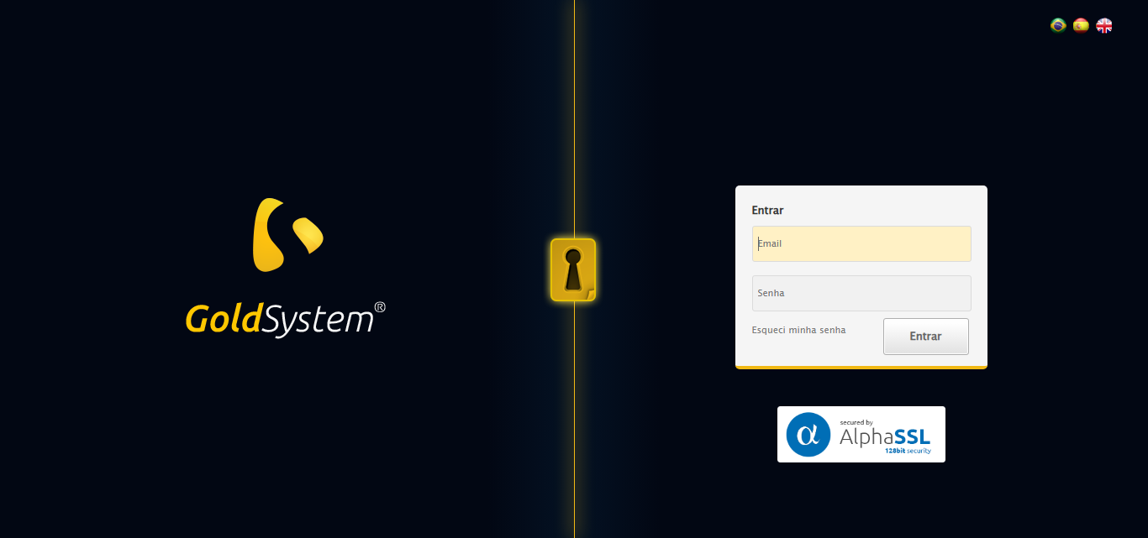

[16:35:14] 🔄 Realizando login...

[16:35:20] ✅ Realizando login realizada com sucesso.

[16:35:26] 📸 Screenshot capturada: realizando_login

Screenshot: realizando_login

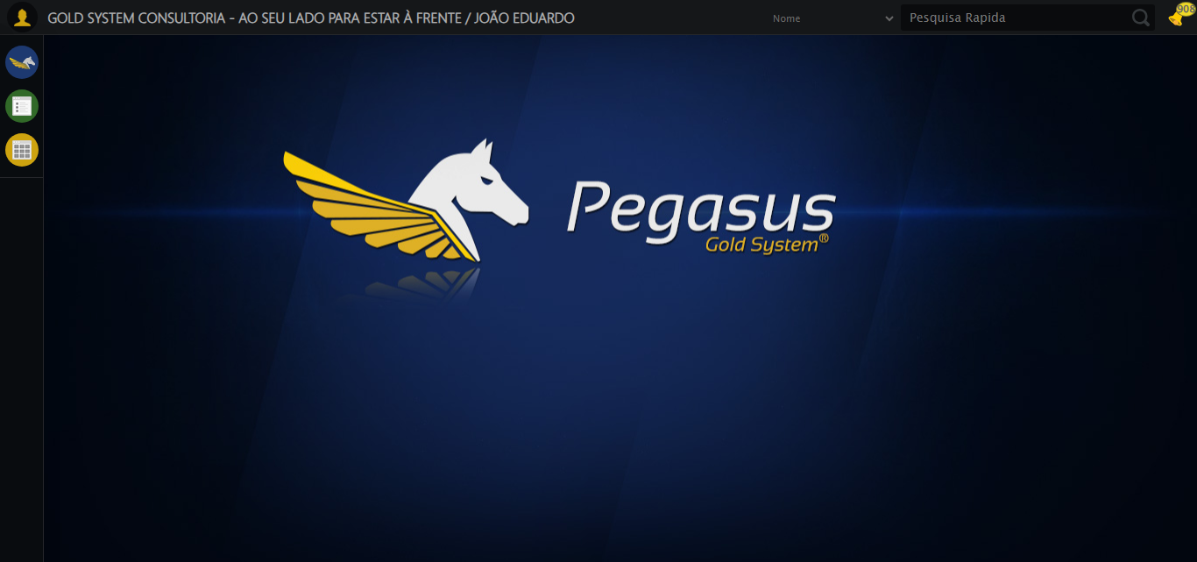

[16:35:26] 🔄 Configurando ambiente...

[16:35:26] 🔍 Zoom ajustado para 90%.

[16:35:29] ✅ Configurando ambiente realizada com sucesso.

[16:35:30] 📸 Screenshot capturada: configurando_ambiente

Screenshot: configurando_ambiente

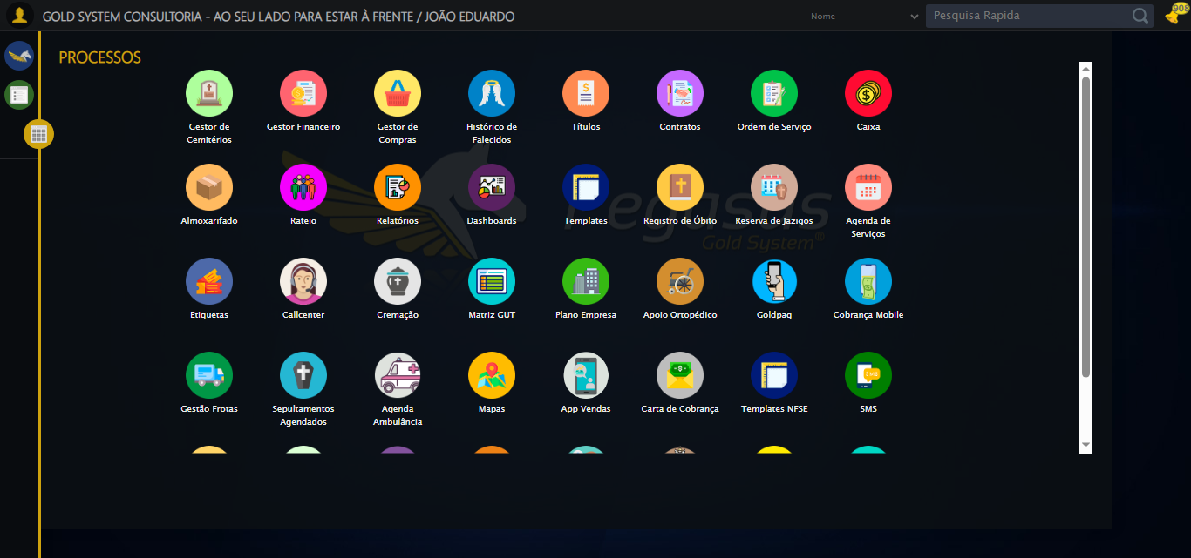

[16:35:30] 🔄 Acessando módulo PET...

[16:35:30] Tentando estratégia de scroll 1...

[16:35:31] ✅ Scroll realizado com estratégia 1

[16:35:32] Tentando estratégia de clique 1 para módulo PET...

[16:35:34] ✅ Clique no módulo PET realizado com estratégia 1

[16:35:34] ✅ Acessando módulo PET realizada com sucesso.

[16:35:35] 📸 Screenshot capturada: acessando_módulo_pet

Screenshot: acessando_módulo_pet

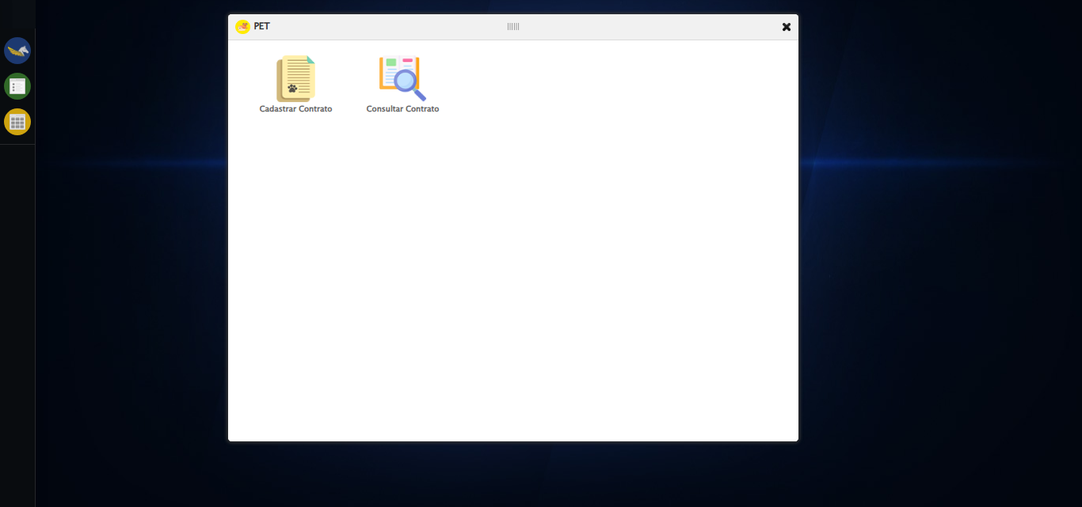

[16:35:35] 🔄 Abrindo consulta de contrato...

[16:35:38] ✅ Abrindo consulta de contrato realizada com sucesso.

[16:35:39] 📸 Screenshot capturada: abrindo_consulta_de_contrato

Screenshot: abrindo_consulta_de_contrato

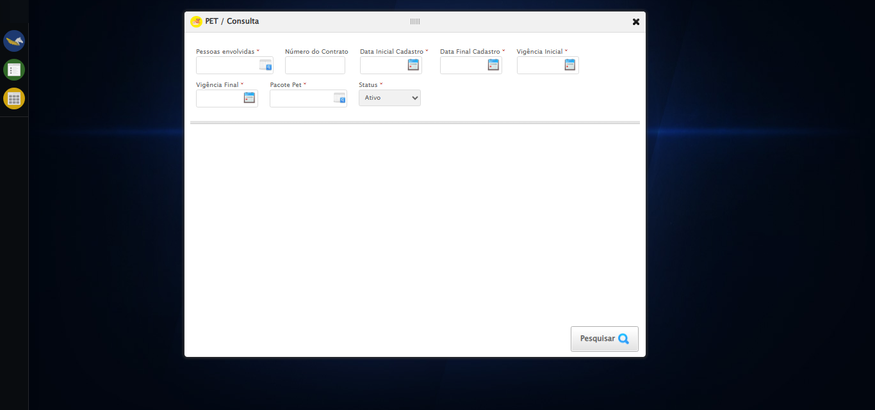

[16:35:39] 🔄 Selecionando Pessoas Envolvidas...

[16:35:39] 🔘 Abrindo modal com botão: #gsPet > div.wdTelas > div.telaConsulta.telaConsultaContratoPet > div > div.formRow.filtrosConsulta > div:nth-child(1) > div > a

[16:35:39] Tentando estratégia de scroll 1...

[16:35:40] ✅ Scroll realizado com estratégia 1

[16:35:42] 🔍 Preenchendo pesquisa com: TESTE TUTOR SELENIUM AUTOMATIZADO

[16:35:43] 🔍 Executando pesquisa...

[16:35:47] 🎯 Selecionando resultado: //td[contains(text(), 'TESTE TUTOR SELENIUM AUTOMATIZADO')]

[16:35:47] Tentando estratégia de scroll 1...

[16:35:47] ✅ Scroll realizado com estratégia 1

[16:35:49] ✅ Seleção no modal concluída

[16:35:49] ✅ Selecionando Pessoas Envolvidas realizada com sucesso.

[16:35:50] 📸 Screenshot capturada: selecionando_pessoas_envolvidas

Screenshot: selecionando_pessoas_envolvidas

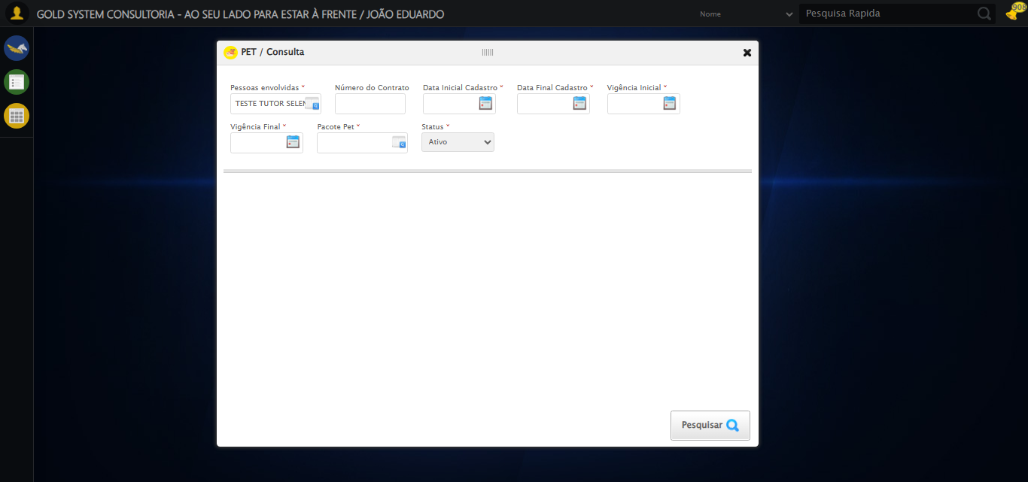

[16:35:50] 🔄 Preenchendo Número do Contrato...

[16:35:50] Tentando estratégia de scroll 1...

[16:35:51] ✅ Scroll realizado com estratégia 1

[16:35:52] ✅ Campo preenchido com estratégia 1: '113079'

[16:35:52] ✅ Preenchendo Número do Contrato realizada com sucesso.

[16:35:53] 📸 Screenshot capturada: preenchendo_número_do_contrato

Screenshot: preenchendo_número_do_contrato

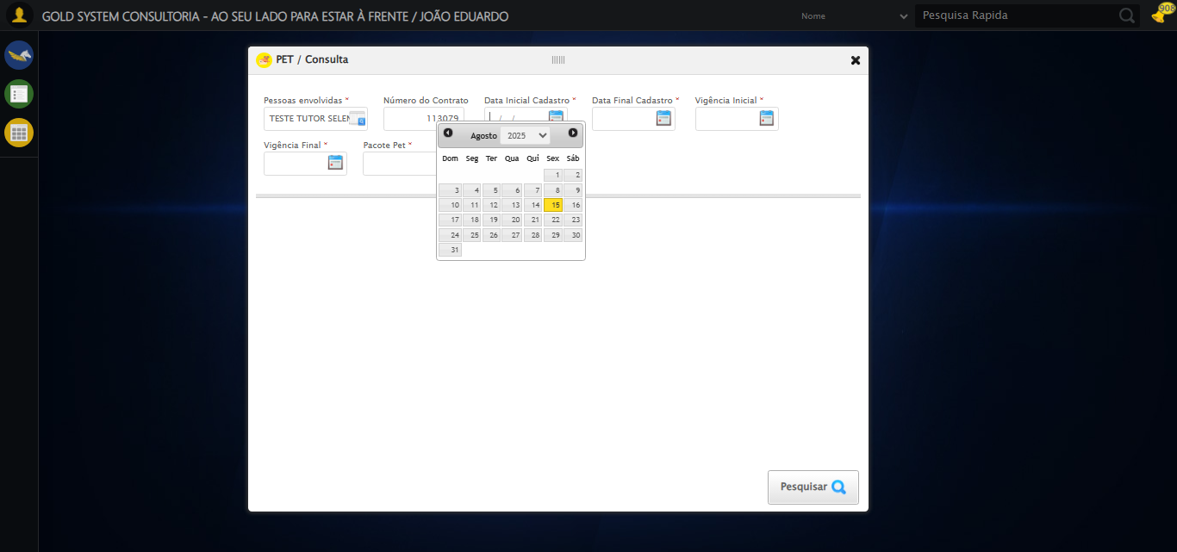

[16:35:53] 🔄 Preenchendo Data Inicial Cadastro...

[16:35:54] 📊 Encontrados 5 campos datepicker

[16:35:54] 🎯 Tentativa 1: Preenchendo datepicker 0 (ID: dp1755286518446) com '13/08/2025'

[16:35:54] Aplicando estratégia 1 para datepicker...

[16:35:55] ✅ Datepicker preenchido com estratégia 1: '13/08/2025'

[16:35:55] ✅ Preenchendo Data Inicial Cadastro realizada com sucesso.

[16:35:56] 📸 Screenshot capturada: preenchendo_data_inicial_cadastro

Screenshot: preenchendo_data_inicial_cadastro

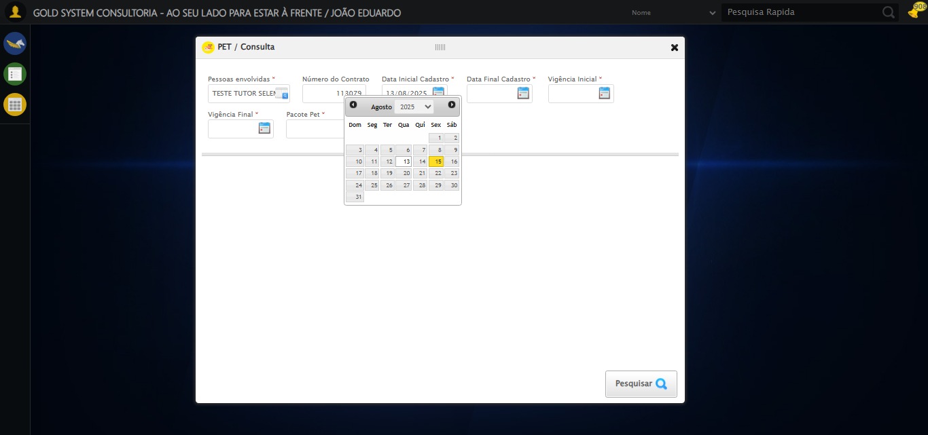

[16:35:56] 🔄 Preenchendo Data Final Cadastro...

[16:35:57] 📊 Encontrados 5 campos datepicker

[16:35:57] 🎯 Tentativa 1: Preenchendo datepicker 1 (ID: dp1755286518447) com '13/08/2025'

[16:35:57] Aplicando estratégia 1 para datepicker...

[16:35:58] ✅ Datepicker preenchido com estratégia 1: '13/08/2025'

[16:35:58] ✅ Preenchendo Data Final Cadastro realizada com sucesso.

[16:35:59] 📸 Screenshot capturada: preenchendo_data_final_cadastro

Screenshot: preenchendo_data_final_cadastro

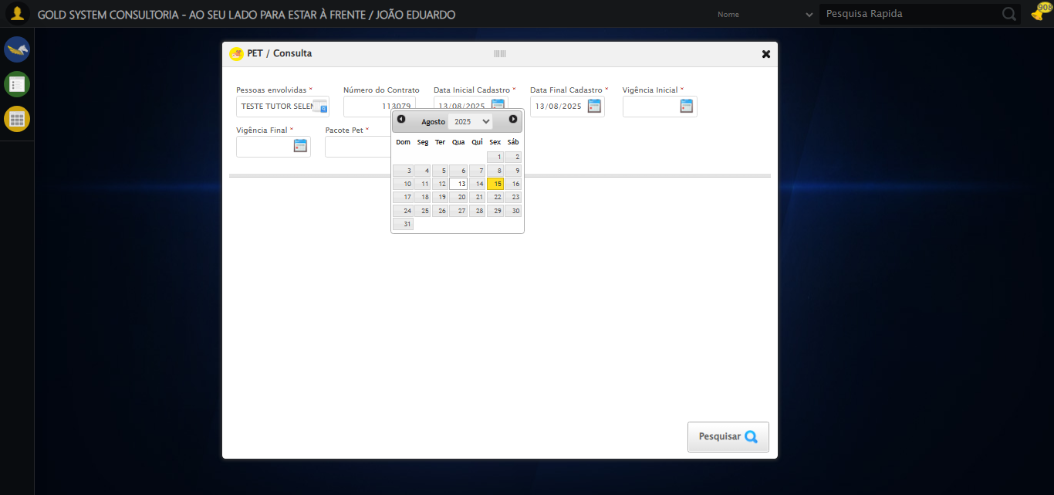

[16:35:59] 🔄 Preenchendo Vigência Inicial...

[16:36:00] 📊 Encontrados 5 campos datepicker

[16:36:00] 🎯 Tentativa 1: Preenchendo datepicker 2 (ID: dp1755286518444) com '13/08/2025'

[16:36:00] Aplicando estratégia 1 para datepicker...

[16:36:01] ✅ Datepicker preenchido com estratégia 1: '13/08/2025'

[16:36:01] ✅ Preenchendo Vigência Inicial realizada com sucesso.

[16:36:02] 📸 Screenshot capturada: preenchendo_vigência_inicial

Screenshot: preenchendo_vigência_inicial

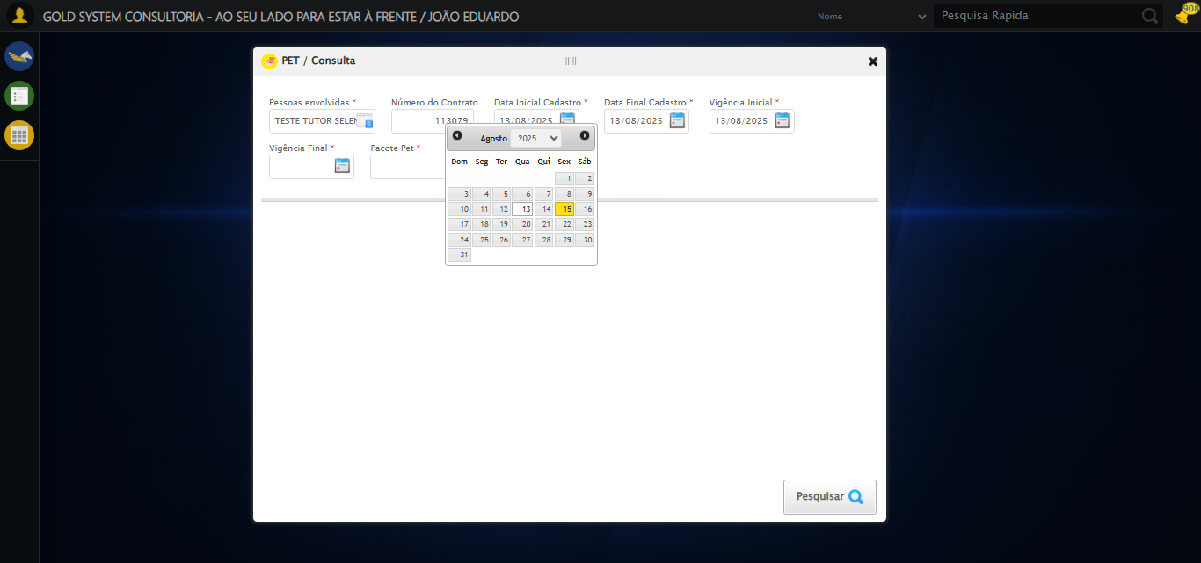

[16:36:03] 🔄 Preenchendo Vigência Final...

[16:36:03] 📊 Encontrados 5 campos datepicker

[16:36:03] 🎯 Tentativa 1: Preenchendo datepicker 3 (ID: dp1755286518445) com '13/11/2025'

[16:36:03] Aplicando estratégia 1 para datepicker...

[16:36:04] ✅ Datepicker preenchido com estratégia 1: '13/11/2025'

[16:36:04] ✅ Preenchendo Vigência Final realizada com sucesso.

[16:36:06] 📸 Screenshot capturada: preenchendo_vigência_final

Screenshot: preenchendo_vigência_final

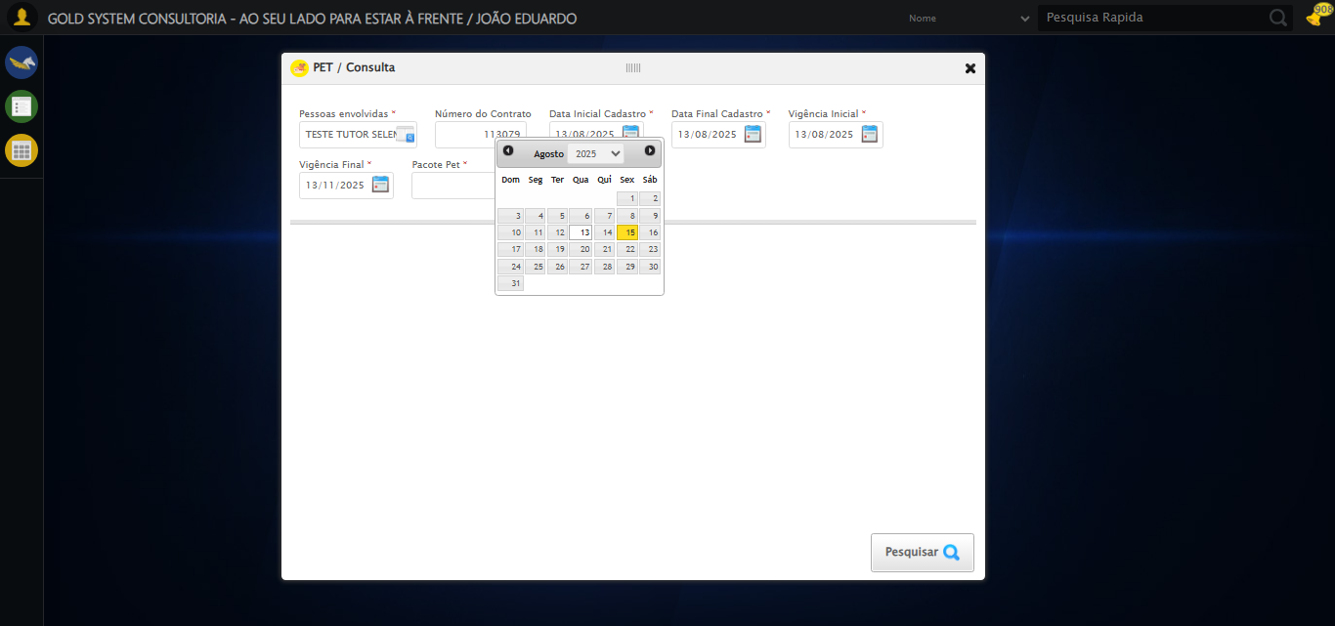

[16:36:06] 🔄 Selecionando Pacote Pet...

[16:36:06] 🔘 Abrindo modal com botão: #gsPet > div.wdTelas > div.telaConsulta.telaConsultaContratoPet > div > div.formRow.filtrosConsulta > div:nth-child(7) > div > a

[16:36:06] Tentando estratégia de scroll 1...

[16:36:06] ✅ Scroll realizado com estratégia 1

[16:36:10] 🔍 Preenchendo pesquisa com: PACOTE PET TESTE SELENIUM AUTOMATIZADO

[16:36:11] 🔍 Executando pesquisa...

[16:36:14] 🎯 Selecionando resultado: //td[contains(text(), 'PACOTE PET TESTE SELENIUM AUTOMATIZADO')]

[16:36:14] Tentando estratégia de scroll 1...

[16:36:15] ✅ Scroll realizado com estratégia 1

[16:36:16] ✅ Seleção no modal concluída

[16:36:16] ✅ Selecionando Pacote Pet realizada com sucesso.

[16:36:17] 📸 Screenshot capturada: selecionando_pacote_pet

Screenshot: selecionando_pacote_pet

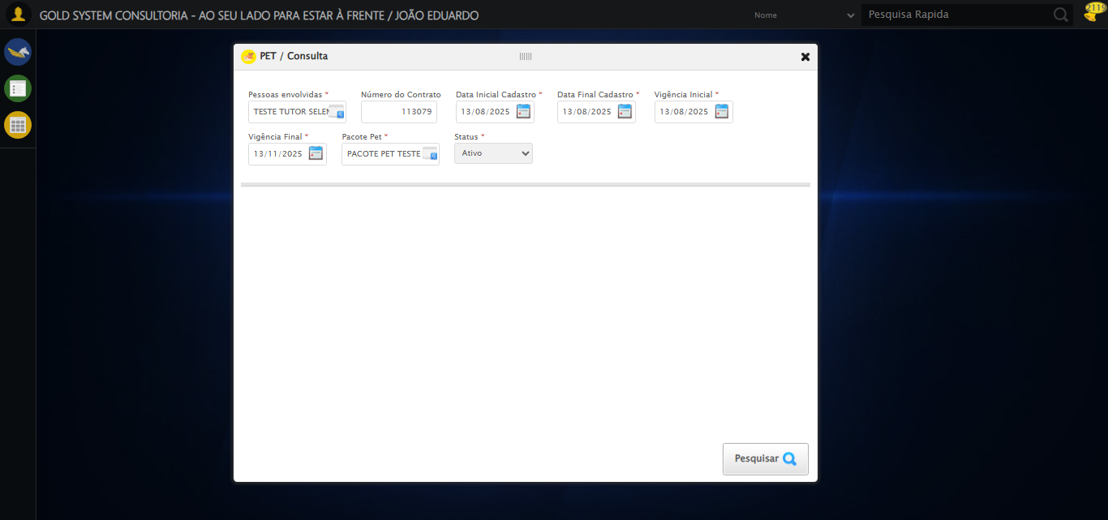

[16:36:17] 🔄 Realizando consulta...

[16:36:17] Tentando estratégia de scroll 1...

[16:36:18] ✅ Scroll realizado com estratégia 1

[16:36:20] ✅ Consulta executada

[16:36:20] ✅ Realizando consulta realizada com sucesso.

[16:36:21] 📸 Screenshot capturada: realizando_consulta

Screenshot: realizando_consulta

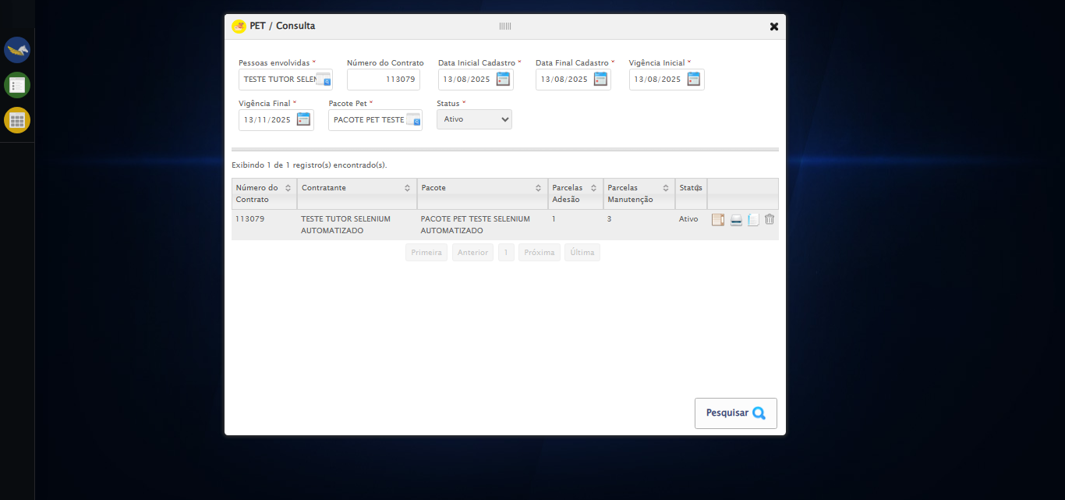

[16:36:21] 🔄 Validando resultados da consulta...

[16:36:21] 🔍 Iniciando validação de registros...

[16:36:26] ✅ Tabela encontrada: #DataTables_Table_2

[16:36:26] ✅ Encontradas 1 linhas válidas com tbody tr:not(.dataTables_empty):not([class*="no-data"])

[16:36:26] ✅ 1 registro(s) encontrado(s)

[16:36:26] Registro 1: 113079 teste tutor selenium automatizado pacote pet teste selenium automatizado 1 3 ativo

[16:36:27] ✅ Validando resultados da consulta realizada com sucesso.

[16:36:28] 📸 Screenshot capturada: validando_resultados_da_consulta

Screenshot: validando_resultados_da_consulta

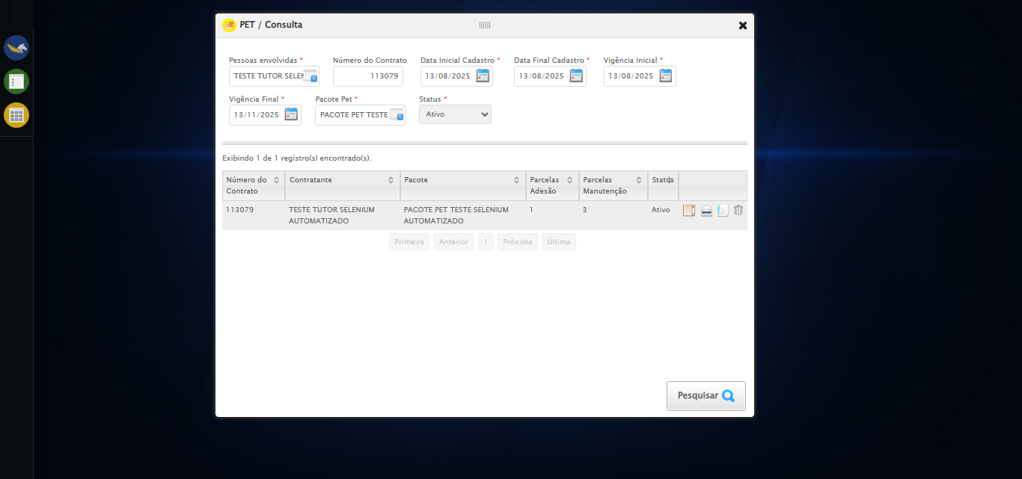

[16:36:28] ✅ Processando 1 registro(s) encontrado(s)

[16:36:28] 🔄 Visualizando detalhes do Contrato Pet...

[16:36:28] Tentando estratégia de scroll 1...

[16:36:29] ✅ Scroll realizado com estratégia 1

[16:36:29] ✅ Clique realizado com estratégia 1

[16:36:29] ✅ Visualizando detalhes do Contrato Pet realizada com sucesso.

[16:36:30] 📸 Screenshot capturada: visualizando_detalhes_do_contrato_pet

Screenshot: visualizando_detalhes_do_contrato_pet

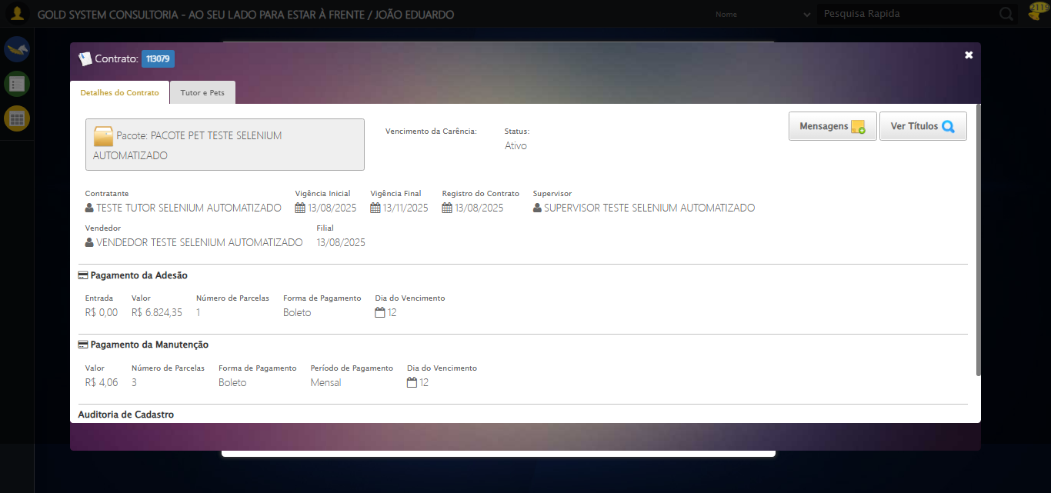

[16:36:30] 🔄 Capturando tela de detalhes...

[16:36:34] 📸 Screenshot capturada: detalhes_contrato_pet

Screenshot: detalhes_contrato_pet



[16:36:34] ✅ Capturando tela de detalhes realizada com sucesso.

[16:36:35] 📸 Screenshot capturada: capturando_tela_de_detalhes

Screenshot: capturando_tela_de_detalhes



[16:36:35] 🔄 Abrindo mensagens do Contrato Pet...

[16:36:35] Tentando estratégia de scroll 1...

[16:36:36] ✅ Scroll realizado com estratégia 1

[16:36:36] ✅ Clique realizado com estratégia 1

[16:36:36] ✅ Abrindo mensagens do Contrato Pet realizada com sucesso.

[16:36:37] 📸 Screenshot capturada: abrindo_mensagens_do_contrato_pet

Screenshot: abrindo_mensagens_do_contrato_pet

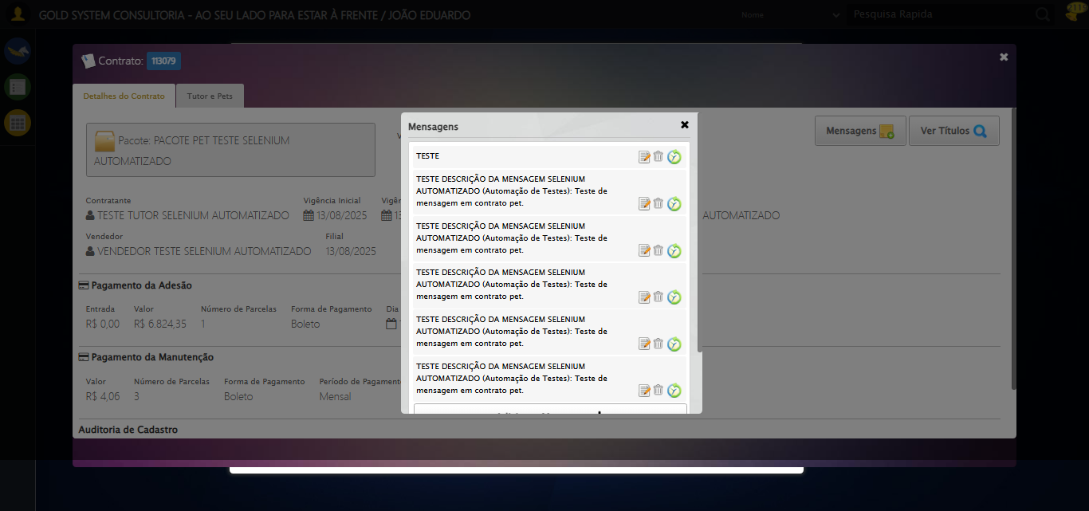

[16:36:37] 🔄 Capturando mensagens...

[16:36:40] 📸 Screenshot capturada: mensagens_contrato_pet

Screenshot: mensagens_contrato_pet



[16:36:40] ✅ Capturando mensagens realizada com sucesso.

[16:36:41] 📸 Screenshot capturada: capturando_mensagens

Screenshot: capturando_mensagens



[16:36:41] 🔄 Adicionando nova mensagem...

[16:36:41] Tentando estratégia de scroll 1...

[16:36:42] ✅ Scroll realizado com estratégia 1

[16:36:43] ✅ Clique realizado com estratégia 1

[16:36:43] ✅ Adicionando nova mensagem realizada com sucesso.

[16:36:44] 📸 Screenshot capturada: adicionando_nova_mensagem

Screenshot: adicionando_nova_mensagem

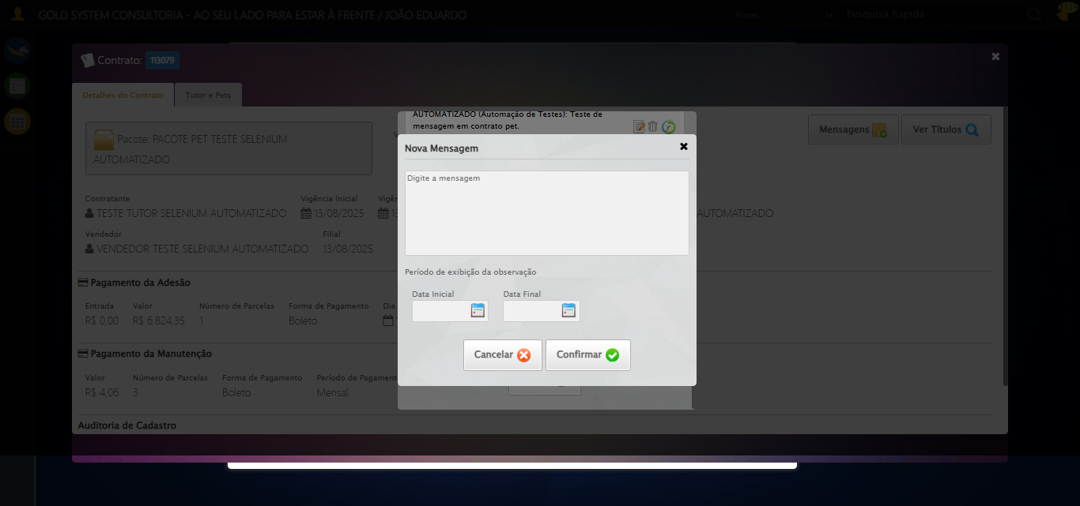

[16:36:44] 🔄 Confirmando mensagem sem registros para verificar mensagem de alerta...

[16:36:44] Tentando estratégia de scroll 1...

[16:36:45] ✅ Scroll realizado com estratégia 1

[16:36:46] ✅ Clique realizado com estratégia 1

[16:36:46] ✅ Confirmando mensagem sem registros para verificar mensagem de alerta realizada com sucesso.

[16:36:47] 📸 Screenshot capturada: confirmando_mensagem_sem_registros_para_verificar_mensagem_de_alerta

Screenshot: confirmando_mensagem_sem_registros_para_verificar_mensagem_de_alerta

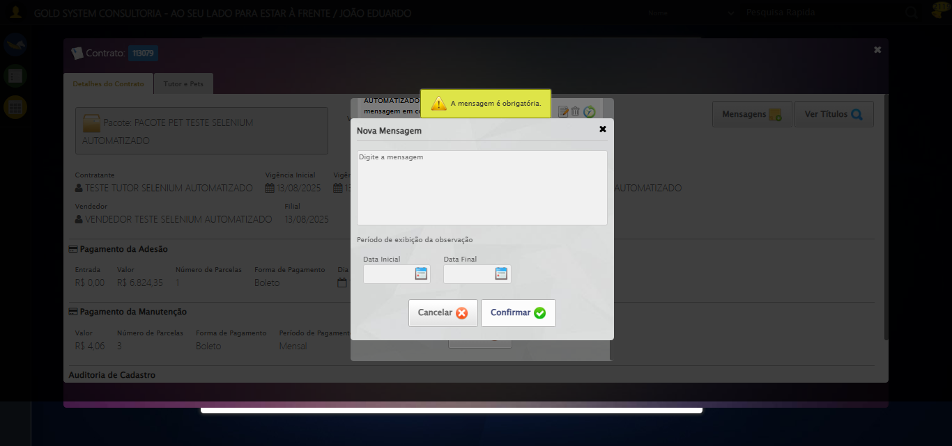

[16:36:47] 🔍 Verificando mensagens de alerta...

[16:36:47] 📢 ⚠️ Alerta: A mensagem é obrigatória.

[16:36:47] 🔄 Fechando a aba do cadastro de Mensagens...

[16:36:47] ⚠️ Elemento não está visível para scroll

[16:36:47] ⚠️ Problemas com scroll, continuando mesmo assim: //a[contains(@class,'btModel') and contains(@class,'btGray') and contains(normalize-space(.), 'Cancelar')]

[16:36:52] ❌ Timeout aguardando elemento: //a[contains(@class,'btModel') and contains(@class,'btGray') and contains(normalize-space(.), 'Cancelar')] (condição: clickable, timeout: 5s)

[16:36:52] ⚠️ Elemento não ficou clicável, tentando mesmo assim: //a[contains(@class,'btModel') and contains(@class,'btGray') and contains(normalize-space(.), 'Cancelar')]

[16:36:52] ⚠️ Estratégia 1 de clique falhou: Message: element not interactable  
 (Session info: chrome=138.0.7204.185)  
Stacktrace:  
 GetHandleVerifier [0x0x126ba83+63395]  
 GetHandleVerifier [0x0x126bac4+63460]  
 (No symbol) [0x0x10b1f70]  
 (No symbol) [0x0x10fb9f4]  
 (No symbol) [0x0x10f0515]  
 (No symbol) [0x0x111f3ac]  
 (No symbol) [0x0x10effa4]  
 (No symbol) [0x0x111f624]  
 (No symbol) [0x0x11407ba]  
 (No symbol) [0x0x111f1a6]  
 (No symbol) [0x0x10ee7b2]  
 (No symbol) [0x0x10ef654]  
 GetHandleVerifier [0x0x14e8883+2672035]  
 GetHandleVerifier [0x0x14e3cba+2652634]  
 GetHandleVerifier [0x0x1292bca+223466]  
 GetHandleVerifier [0x0x1282cb8+158168]  
 GetHandleVerifier [0x0x128978d+185517]  
 GetHandleVerifier [0x0x1273b78+96408]  
 GetHandleVerifier [0x0x1273d02+96802]  
 GetHandleVerifier [0x0x125e90a+9770]  
 BaseThreadInitThunk [0x0x7709fcc9+25]  
 RtlGetAppContainerNamedObjectPath [0x0x778882ae+286]  
 RtlGetAppContainerNamedObjectPath [0x0x7788827e+238]

[16:36:52] ⚠️ Estratégia 2 de clique falhou: Message: element not interactable: has no size and location  
 (Session info: chrome=138.0.7204.185)  
Stacktrace:  
 GetHandleVerifier [0x0x126ba83+63395]  
 GetHandleVerifier [0x0x126bac4+63460]  
 (No symbol) [0x0x10b2113]  
 (No symbol) [0x0x10b88e9]  
 (No symbol) [0x0x10bac7a]  
 (No symbol) [0x0x10bacf7]  
 (No symbol) [0x0x11002b4]  
 (No symbol) [0x0x10ff827]  
 (No symbol) [0x0x114917f]  
 (No symbol) [0x0x111f3ac]  
 (No symbol) [0x0x11407ba]  
 (No symbol) [0x0x111f1a6]  
 (No symbol) [0x0x10ee7b2]  
 (No symbol) [0x0x10ef654]  
 GetHandleVerifier [0x0x14e8883+2672035]  
 GetHandleVerifier [0x0x14e3cba+2652634]  
 GetHandleVerifier [0x0x1292bca+223466]  
 GetHandleVerifier [0x0x1282cb8+158168]  
 GetHandleVerifier [0x0x128978d+185517]  
 GetHandleVerifier [0x0x1273b78+96408]  
 GetHandleVerifier [0x0x1273d02+96802]  
 GetHandleVerifier [0x0x125e90a+9770]  
 BaseThreadInitThunk [0x0x7709fcc9+25]  
 RtlGetAppContainerNamedObjectPath [0x0x778882ae+286]  
 RtlGetAppContainerNamedObjectPath [0x0x7788827e+238]

[16:36:53] ✅ Clique realizado com estratégia 3

[16:36:53] ✅ Fechando a aba do cadastro de Mensagens realizada com sucesso.

[16:36:54] 📸 Screenshot capturada: fechando_a_aba_do_cadastro_de_mensagens

Screenshot: fechando_a_aba_do_cadastro_de_mensagens

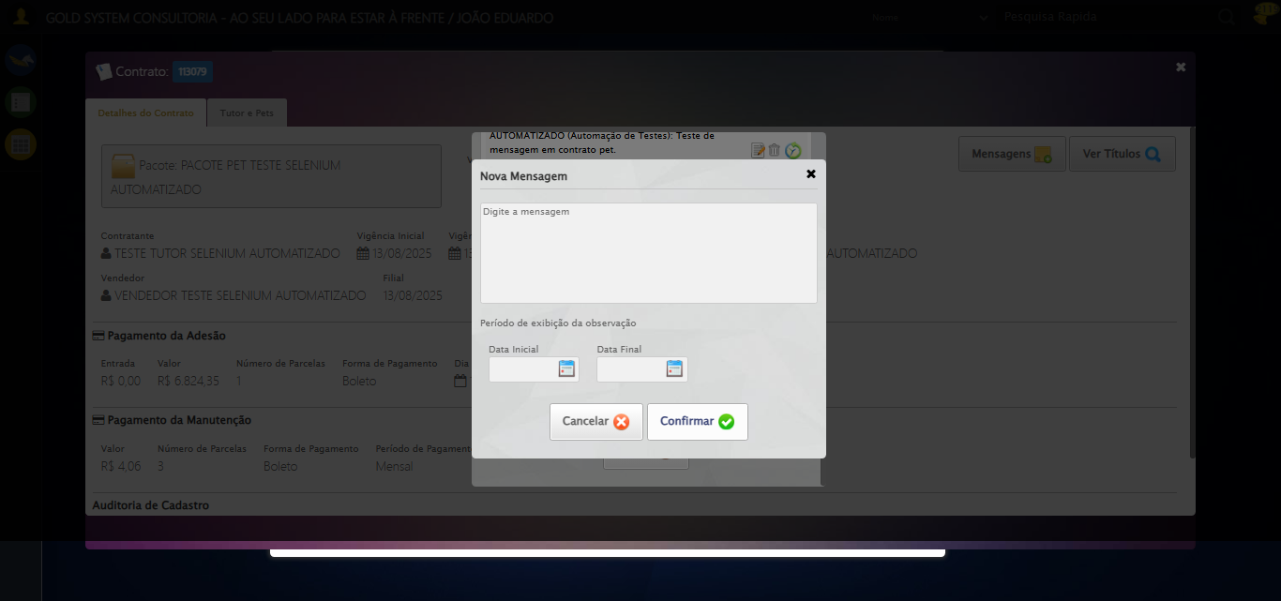

[16:36:54] 🔄 Fechando aba de mensagens...

[16:36:54] Tentando estratégia de scroll 1...

[16:36:55] ✅ Scroll realizado com estratégia 1

[16:36:56] ⚠️ Estratégia 1 de clique falhou: Message: element click intercepted: Element <a class="btModel btGray">...</a> is not clickable at point (689, 481). Other element would receive the click: <div class="modal overflow" style="z-index: 10006; left: 50%; top: 50%; width: 400px; height: 335px; margin-left: -200px; margin-top: -167.5px;">...</div>  
 (Session info: chrome=138.0.7204.185)  
Stacktrace:  
 GetHandleVerifier [0x0x126ba83+63395]  
 GetHandleVerifier [0x0x126bac4+63460]  
 (No symbol) [0x0x10b2113]  
 (No symbol) [0x0x1100ba0]  
 (No symbol) [0x0x10fef5a]  
 (No symbol) [0x0x10fcab7]  
 (No symbol) [0x0x10fbd6d]  
 (No symbol) [0x0x10f0515]  
 (No symbol) [0x0x111f3ac]  
 (No symbol) [0x0x10effa4]  
 (No symbol) [0x0x111f624]  
 (No symbol) [0x0x11407ba]  
 (No symbol) [0x0x111f1a6]  
 (No symbol) [0x0x10ee7b2]  
 (No symbol) [0x0x10ef654]  
 GetHandleVerifier [0x0x14e8883+2672035]  
 GetHandleVerifier [0x0x14e3cba+2652634]  
 GetHandleVerifier [0x0x1292bca+223466]  
 GetHandleVerifier [0x0x1282cb8+158168]  
 GetHandleVerifier [0x0x128978d+185517]  
 GetHandleVerifier [0x0x1273b78+96408]  
 GetHandleVerifier [0x0x1273d02+96802]  
 GetHandleVerifier [0x0x125e90a+9770]  
 BaseThreadInitThunk [0x0x7709fcc9+25]  
 RtlGetAppContainerNamedObjectPath [0x0x778882ae+286]  
 RtlGetAppContainerNamedObjectPath [0x0x7788827e+238]

[16:36:57] ✅ Clique realizado com estratégia 2

[16:36:57] ✅ Fechando aba de mensagens realizada com sucesso.

[16:36:58] 📸 Screenshot capturada: fechando_aba_de_mensagens

Screenshot: fechando_aba_de_mensagens



[16:36:58] 🔄 Visualizando títulos do Contrato Pet...

[16:36:58] Tentando estratégia de scroll 1...

[16:36:59] ✅ Scroll realizado com estratégia 1

[16:37:00] ⚠️ Estratégia 1 de clique falhou: Message: element click intercepted: Element <button class="btModel btGray" style="position: relative; float: right;">...</button> is not clickable at point (1196, 164). Other element would receive the click: <div class="blockScreen" style="height: 641px; z-index: 10005; opacity: 0.5;"></div>  
 (Session info: chrome=138.0.7204.185)  
Stacktrace:  
 GetHandleVerifier [0x0x126ba83+63395]  
 GetHandleVerifier [0x0x126bac4+63460]  
 (No symbol) [0x0x10b2113]  
 (No symbol) [0x0x1100ba0]  
 (No symbol) [0x0x10fef5a]  
 (No symbol) [0x0x10fcab7]  
 (No symbol) [0x0x10fbd6d]  
 (No symbol) [0x0x10f0515]  
 (No symbol) [0x0x111f3ac]  
 (No symbol) [0x0x10effa4]  
 (No symbol) [0x0x111f624]  
 (No symbol) [0x0x11407ba]  
 (No symbol) [0x0x111f1a6]  
 (No symbol) [0x0x10ee7b2]  
 (No symbol) [0x0x10ef654]  
 GetHandleVerifier [0x0x14e8883+2672035]  
 GetHandleVerifier [0x0x14e3cba+2652634]  
 GetHandleVerifier [0x0x1292bca+223466]  
 GetHandleVerifier [0x0x1282cb8+158168]  
 GetHandleVerifier [0x0x128978d+185517]  
 GetHandleVerifier [0x0x1273b78+96408]  
 GetHandleVerifier [0x0x1273d02+96802]  
 GetHandleVerifier [0x0x125e90a+9770]  
 BaseThreadInitThunk [0x0x7709fcc9+25]  
 RtlGetAppContainerNamedObjectPath [0x0x778882ae+286]  
 RtlGetAppContainerNamedObjectPath [0x0x7788827e+238]

[16:37:01] ✅ Clique realizado com estratégia 2

[16:37:01] ✅ Visualizando títulos do Contrato Pet realizada com sucesso.

[16:37:02] 📸 Screenshot capturada: visualizando_títulos_do_contrato_pet

Screenshot: visualizando_títulos_do_contrato_pet



[16:37:02] 🔄 Aguardando carregamento de títulos...

[16:37:32] 📸 Screenshot capturada: titulos_contrato_pet

Screenshot: titulos_contrato_pet

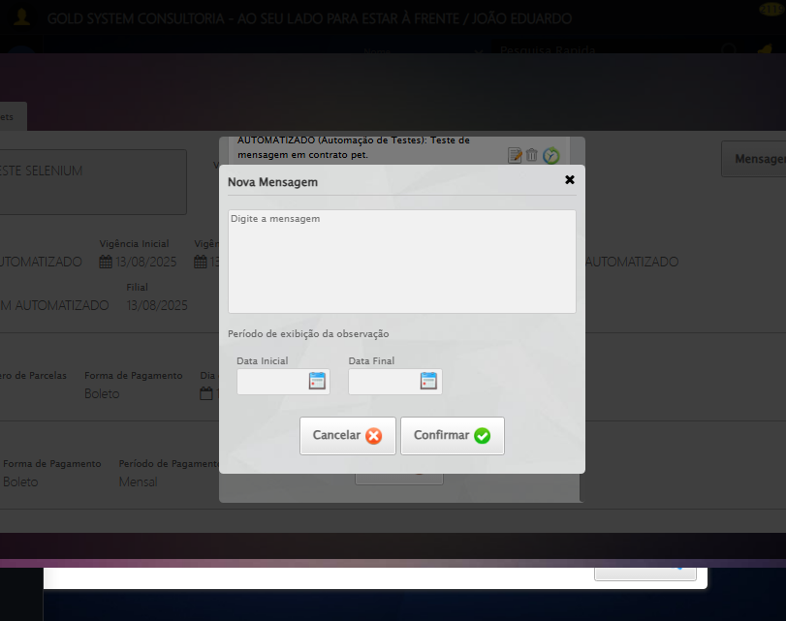

[16:37:32] ✅ Aguardando carregamento de títulos realizada com sucesso.

[16:37:33] 📸 Screenshot capturada: aguardando_carregamento_de_títulos

Screenshot: aguardando_carregamento_de_títulos



[16:37:33] 🔄 Fechando aba de títulos...

[16:38:03] ❌ Timeout aguardando elemento: //a[@title='Sair' and contains(@class, 'sp-fecharGrande')] (condição: present, timeout: 30s)

[16:38:03] ❌ Falha ao clicar em //a[@title='Sair' and contains(@class, 'sp-fecharGrande')]: Message: Elemento não encontrado: //a[@title='Sair' and contains(@class, 'sp-fecharGrande')] (condição: present)

[16:38:04] 📸 Screenshot capturada: erro_fechando_aba_de_títulos

Screenshot: erro_fechando_aba_de_títulos



[16:38:04] ❌ Fechando aba de títulos falhou: TimeoutException: Message: Elemento não encontrado: //a[@title='Sair' and contains(@class, 'sp-fecharGrande')] (condição: present)

[16:38:04] ⚠️ Continuando execução apesar do erro em: Fechando aba de títulos

[16:38:04] 🔄 Abrindo digitalização de documentos...

[16:38:04] Tentando estratégia de scroll 1...

[16:38:05] ✅ Scroll realizado com estratégia 1

[16:38:06] ⚠️ Estratégia 1 de clique falhou: Message: element click intercepted: Element <span class="sprites sp-scanner" title="Digitalizar documentos"></span> is not clickable at point (665, 320). Other element would receive the click: <div class="blockScreen" style="height: 641px; z-index: 10005; opacity: 0.5;"></div>  
 (Session info: chrome=138.0.7204.185)  
Stacktrace:  
 GetHandleVerifier [0x0x126ba83+63395]  
 GetHandleVerifier [0x0x126bac4+63460]  
 (No symbol) [0x0x10b2113]  
 (No symbol) [0x0x1100ba0]  
 (No symbol) [0x0x10fef5a]  
 (No symbol) [0x0x10fcab7]  
 (No symbol) [0x0x10fbd6d]  
 (No symbol) [0x0x10f0515]  
 (No symbol) [0x0x111f3ac]  
 (No symbol) [0x0x10effa4]  
 (No symbol) [0x0x111f624]  
 (No symbol) [0x0x11407ba]  
 (No symbol) [0x0x111f1a6]  
 (No symbol) [0x0x10ee7b2]  
 (No symbol) [0x0x10ef654]  
 GetHandleVerifier [0x0x14e8883+2672035]  
 GetHandleVerifier [0x0x14e3cba+2652634]  
 GetHandleVerifier [0x0x1292bca+223466]  
 GetHandleVerifier [0x0x1282cb8+158168]  
 GetHandleVerifier [0x0x128978d+185517]  
 GetHandleVerifier [0x0x1273b78+96408]  
 GetHandleVerifier [0x0x1273d02+96802]  
 GetHandleVerifier [0x0x125e90a+9770]  
 BaseThreadInitThunk [0x0x7709fcc9+25]  
 RtlGetAppContainerNamedObjectPath [0x0x778882ae+286]  
 RtlGetAppContainerNamedObjectPath [0x0x7788827e+238]

[16:38:07] ✅ Clique realizado com estratégia 2

[16:38:07] ✅ Abrindo digitalização de documentos realizada com sucesso.

[16:38:08] 📸 Screenshot capturada: abrindo_digitalização_de_documentos

Screenshot: abrindo_digitalização_de_documentos

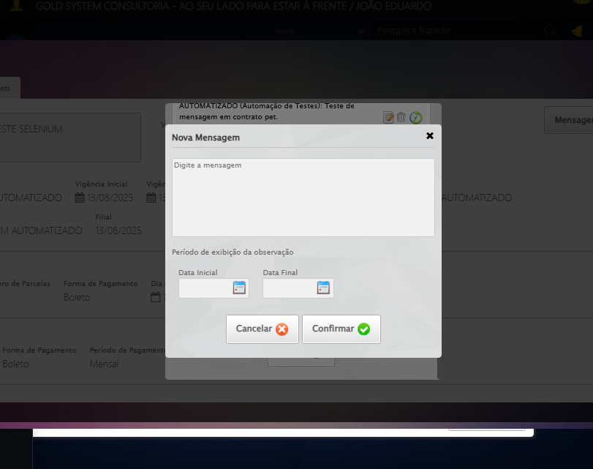

[16:38:08] 🔄 Adicionando novo documento...

[16:38:09] ❌ Erro aguardando elemento //span[contains(@class, 'sp-addFile')]: Message: invalid session id: session deleted as the browser has closed the connection  
from disconnected: not connected to DevTools  
 (Session info: chrome=138.0.7204.185)  
Stacktrace:  
 GetHandleVerifier [0x0x126ba83+63395]  
 GetHandleVerifier [0x0x126bac4+63460]  
 (No symbol) [0x0x10b2113]  
 (No symbol) [0x0x10a1b20]  
 (No symbol) [0x0x10bf922]  
 (No symbol) [0x0x1125c9c]  
 (No symbol) [0x0x1140099]  
 (No symbol) [0x0x111f1a6]  
 (No symbol) [0x0x10ee7b2]  
 (No symbol) [0x0x10ef654]  
 GetHandleVerifier [0x0x14e8883+2672035]  
 GetHandleVerifier [0x0x14e3cba+2652634]  
 GetHandleVerifier [0x0x1292bca+223466]  
 GetHandleVerifier [0x0x1282cb8+158168]  
 GetHandleVerifier [0x0x128978d+185517]  
 GetHandleVerifier [0x0x1273b78+96408]  
 GetHandleVerifier [0x0x1273d02+96802]  
 GetHandleVerifier [0x0x125e90a+9770]  
 BaseThreadInitThunk [0x0x7709fcc9+25]  
 RtlGetAppContainerNamedObjectPath [0x0x778882ae+286]  
 RtlGetAppContainerNamedObjectPath [0x0x7788827e+238]

[16:38:09] ❌ Falha ao clicar em //span[contains(@class, 'sp-addFile')]: Message: invalid session id: session deleted as the browser has closed the connection  
from disconnected: not connected to DevTools  
 (Session info: chrome=138.0.7204.185)  
Stacktrace:  
 GetHandleVerifier [0x0x126ba83+63395]  
 GetHandleVerifier [0x0x126bac4+63460]  
 (No symbol) [0x0x10b2113]  
 (No symbol) [0x0x10a1b20]  
 (No symbol) [0x0x10bf922]  
 (No symbol) [0x0x1125c9c]  
 (No symbol) [0x0x1140099]  
 (No symbol) [0x0x111f1a6]  
 (No symbol) [0x0x10ee7b2]  
 (No symbol) [0x0x10ef654]  
 GetHandleVerifier [0x0x14e8883+2672035]  
 GetHandleVerifier [0x0x14e3cba+2652634]  
 GetHandleVerifier [0x0x1292bca+223466]  
 GetHandleVerifier [0x0x1282cb8+158168]  
 GetHandleVerifier [0x0x128978d+185517]  
 GetHandleVerifier [0x0x1273b78+96408]  
 GetHandleVerifier [0x0x1273d02+96802]  
 GetHandleVerifier [0x0x125e90a+9770]  
 BaseThreadInitThunk [0x0x7709fcc9+25]  
 RtlGetAppContainerNamedObjectPath [0x0x778882ae+286]  
 RtlGetAppContainerNamedObjectPath [0x0x7788827e+238]

[16:38:11] ⚠️ Erro ao tirar screenshot erro_adicionando_novo_documento: Message: invalid session id  
Stacktrace:  
 GetHandleVerifier [0x0x126ba83+63395]  
 GetHandleVerifier [0x0x126bac4+63460]  
 (No symbol) [0x0x10b1f70]  
 (No symbol) [0x0x10edaa8]  
 (No symbol) [0x0x111f266]  
 (No symbol) [0x0x111ae65]  
 (No symbol) [0x0x111a3e6]  
 (No symbol) [0x0x1083a45]  
 (No symbol) [0x0x1083f9e]  
 (No symbol) [0x0x108442d]  
 GetHandleVerifier [0x0x14e8883+2672035]  
 GetHandleVerifier [0x0x14e3cba+2652634]  
 GetHandleVerifier [0x0x1292bca+223466]  
 GetHandleVerifier [0x0x1282cb8+158168]  
 GetHandleVerifier [0x0x128978d+185517]  
 (No symbol) [0x0x1083710]  
 (No symbol) [0x0x1082f1d]  
 GetHandleVerifier [0x0x161db9c+3938492]  
 BaseThreadInitThunk [0x0x7709fcc9+25]  
 RtlGetAppContainerNamedObjectPath [0x0x778882ae+286]  
 RtlGetAppContainerNamedObjectPath [0x0x7788827e+238]

[16:38:11] ❌ Adicionando novo documento falhou: InvalidSessionIdException: Message: invalid session id: session deleted as the browser has closed the connection  
from disconnected: not connected to DevTools  
 (Session info: chrome=138.0.7204.185)  
Stacktrace:  
 GetHandleVerifier [0x0x126ba83+63395]  
 GetHandleVerifier [0x0x126bac4+63460]  
 (No symbol) [0x0x10b2113]  
 (No symbol) [0x0x10a1b20]  
 (No symbol) [0x0x10bf922]  
 (No symbol) [0x0x1125c9c]  
 (No symbol) [0x0x1140099]  
 (No symbol) [0x0x111f1a6]  
 (No symbol) [0x0x10ee7b2]  
 (No symbol) [0x0x10ef654]  
 GetHandleVerifier [0x0x14e8883+2672035]  
 GetHandleVerifier [0x0x14e3cba+2652634]  
 GetHandleVerifier [0x0x1292bca+223466]  
 GetHandleVerifier [0x0x1282cb8+158168]  
 GetHandleVerifier [0x0x128978d+185517]  
 GetHandleVerifier [0x0x1273b78+96408]  
 GetHandleVerifier [0x0x1273d02+96802]  
 GetHandleVerifier [0x0x125e90a+9770]  
 BaseThreadInitThunk [0x0x7709fcc9+25]  
 RtlGetAppContainerNamedObjectPath [0x0x778882ae+286]  
 RtlGetAppContainerNamedObjectPath [0x0x7788827e+238]

[16:38:11] ⚠️ Continuando execução apesar do erro em: Adicionando novo documento

[16:38:11] 🔄 Salvando arquivo digitalizado sem registros para verificar mensagem de alerta...

[16:38:11] ❌ Erro aguardando elemento //a[contains(@class,'btModel') and contains(@class,'btGreen') and normalize-space(.)='Salvar']: Message: invalid session id  
Stacktrace:  
 GetHandleVerifier [0x0x126ba83+63395]  
 GetHandleVerifier [0x0x126bac4+63460]  
 (No symbol) [0x0x10b1f70]  
 (No symbol) [0x0x10edaa8]  
 (No symbol) [0x0x111f266]  
 (No symbol) [0x0x111ae65]  
 (No symbol) [0x0x111a3e6]  
 (No symbol) [0x0x1083a45]  
 (No symbol) [0x0x1083f9e]  
 (No symbol) [0x0x108442d]  
 GetHandleVerifier [0x0x14e8883+2672035]  
 GetHandleVerifier [0x0x14e3cba+2652634]  
 GetHandleVerifier [0x0x1292bca+223466]  
 GetHandleVerifier [0x0x1282cb8+158168]  
 GetHandleVerifier [0x0x128978d+185517]  
 (No symbol) [0x0x1083710]  
 (No symbol) [0x0x1082f1d]  
 GetHandleVerifier [0x0x161db9c+3938492]  
 BaseThreadInitThunk [0x0x7709fcc9+25]  
 RtlGetAppContainerNamedObjectPath [0x0x778882ae+286]  
 RtlGetAppContainerNamedObjectPath [0x0x7788827e+238]

[16:38:11] ❌ Falha ao clicar em //a[contains(@class,'btModel') and contains(@class,'btGreen') and normalize-space(.)='Salvar']: Message: invalid session id  
Stacktrace:  
 GetHandleVerifier [0x0x126ba83+63395]  
 GetHandleVerifier [0x0x126bac4+63460]  
 (No symbol) [0x0x10b1f70]  
 (No symbol) [0x0x10edaa8]  
 (No symbol) [0x0x111f266]  
 (No symbol) [0x0x111ae65]  
 (No symbol) [0x0x111a3e6]  
 (No symbol) [0x0x1083a45]  
 (No symbol) [0x0x1083f9e]  
 (No symbol) [0x0x108442d]  
 GetHandleVerifier [0x0x14e8883+2672035]  
 GetHandleVerifier [0x0x14e3cba+2652634]  
 GetHandleVerifier [0x0x1292bca+223466]  
 GetHandleVerifier [0x0x1282cb8+158168]  
 GetHandleVerifier [0x0x128978d+185517]  
 (No symbol) [0x0x1083710]  
 (No symbol) [0x0x1082f1d]  
 GetHandleVerifier [0x0x161db9c+3938492]  
 BaseThreadInitThunk [0x0x7709fcc9+25]  
 RtlGetAppContainerNamedObjectPath [0x0x778882ae+286]  
 RtlGetAppContainerNamedObjectPath [0x0x7788827e+238]

[16:38:11] ⚠️ Erro ao tirar screenshot erro_salvando_arquivo_digitalizado_sem_registros_para_verificar_mensagem_de_alerta: Message: invalid session id  
Stacktrace:  
 GetHandleVerifier [0x0x126ba83+63395]  
 GetHandleVerifier [0x0x126bac4+63460]  
 (No symbol) [0x0x10b1f70]  
 (No symbol) [0x0x10edaa8]  
 (No symbol) [0x0x111f266]  
 (No symbol) [0x0x111ae65]  
 (No symbol) [0x0x111a3e6]  
 (No symbol) [0x0x1083a45]  
 (No symbol) [0x0x1083f9e]  
 (No symbol) [0x0x108442d]  
 GetHandleVerifier [0x0x14e8883+2672035]  
 GetHandleVerifier [0x0x14e3cba+2652634]  
 GetHandleVerifier [0x0x1292bca+223466]  
 GetHandleVerifier [0x0x1282cb8+158168]  
 GetHandleVerifier [0x0x128978d+185517]  
 (No symbol) [0x0x1083710]  
 (No symbol) [0x0x1082f1d]  
 GetHandleVerifier [0x0x161db9c+3938492]  
 BaseThreadInitThunk [0x0x7709fcc9+25]  
 RtlGetAppContainerNamedObjectPath [0x0x778882ae+286]  
 RtlGetAppContainerNamedObjectPath [0x0x7788827e+238]

[16:38:11] ❌ Salvando arquivo digitalizado sem registros para verificar mensagem de alerta falhou: InvalidSessionIdException: Message: invalid session id  
Stacktrace:  
 GetHandleVerifier [0x0x126ba83+63395]  
 GetHandleVerifier [0x0x126bac4+63460]  
 (No symbol) [0x0x10b1f70]  
 (No symbol) [0x0x10edaa8]  
 (No symbol) [0x0x111f266]  
 (No symbol) [0x0x111ae65]  
 (No symbol) [0x0x111a3e6]  
 (No symbol) [0x0x1083a45]  
 (No symbol) [0x0x1083f9e]  
 (No symbol) [0x0x108442d]  
 GetHandleVerifier [0x0x14e8883+2672035]  
 GetHandleVerifier [0x0x14e3cba+2652634]  
 GetHandleVerifier [0x0x1292bca+223466]  
 GetHandleVerifier [0x0x1282cb8+158168]  
 GetHandleVerifier [0x0x128978d+185517]  
 (No symbol) [0x0x1083710]  
 (No symbol) [0x0x1082f1d]  
 GetHandleVerifier [0x0x161db9c+3938492]  
 BaseThreadInitThunk [0x0x7709fcc9+25]  
 RtlGetAppContainerNamedObjectPath [0x0x778882ae+286]  
 RtlGetAppContainerNamedObjectPath [0x0x7788827e+238]

[16:38:11] ⚠️ Continuando execução apesar do erro em: Salvando arquivo digitalizado sem registros para verificar mensagem de alerta

[16:38:11] 🔍 Verificando mensagens de alerta após digitalização...

[16:38:11] ⚠️ Erro ao buscar alerta .alerts.salvo: Message: invalid session id  
Stacktrace:  
 GetHandleVerifier [0x0x126ba83+63395]  
 GetHandleVerifier [0x0x126bac4+63460]  
 (No symbol) [0x0x10b1f70]  
 (No symbol) [0x0x10edaa8]  
 (No symbol) [0x0x111f266]  
 (No symbol) [0x0x111ae65]  
 (No symbol) [0x0x111a3e6]  
 (No symbol) [0x0x1083a45]  
 (No symbol) [0x0x1083f9e]  
 (No symbol) [0x0x108442d]  
 GetHandleVerifier [0x0x14e8883+2672035]  
 GetHandleVerifier [0x0x14e3cba+2652634]  
 GetHandleVerifier [0x0x1292bca+223466]  
 GetHandleVerifier [0x0x1282cb8+158168]  
 GetHandleVerifier [0x0x128978d+185517]  
 (No symbol) [0x0x1083710]  
 (No symbol) [0x0x1082f1d]  
 GetHandleVerifier [0x0x161db9c+3938492]  
 BaseThreadInitThunk [0x0x7709fcc9+25]  
 RtlGetAppContainerNamedObjectPath [0x0x778882ae+286]  
 RtlGetAppContainerNamedObjectPath [0x0x7788827e+238]

[16:38:11] ⚠️ Erro ao buscar alerta .alerts.alerta: Message: invalid session id  
Stacktrace:  
 GetHandleVerifier [0x0x126ba83+63395]  
 GetHandleVerifier [0x0x126bac4+63460]  
 (No symbol) [0x0x10b1f70]  
 (No symbol) [0x0x10edaa8]  
 (No symbol) [0x0x111f266]  
 (No symbol) [0x0x111ae65]  
 (No symbol) [0x0x111a3e6]  
 (No symbol) [0x0x1083a45]  
 (No symbol) [0x0x1083f9e]  
 (No symbol) [0x0x108442d]  
 GetHandleVerifier [0x0x14e8883+2672035]  
 GetHandleVerifier [0x0x14e3cba+2652634]  
 GetHandleVerifier [0x0x1292bca+223466]  
 GetHandleVerifier [0x0x1282cb8+158168]  
 GetHandleVerifier [0x0x128978d+185517]  
 (No symbol) [0x0x1083710]  
 (No symbol) [0x0x1082f1d]  
 GetHandleVerifier [0x0x161db9c+3938492]  
 BaseThreadInitThunk [0x0x7709fcc9+25]  
 RtlGetAppContainerNamedObjectPath [0x0x778882ae+286]  
 RtlGetAppContainerNamedObjectPath [0x0x7788827e+238]

[16:38:11] ⚠️ Erro ao buscar alerta .alerts.erro: Message: invalid session id  
Stacktrace:  
 GetHandleVerifier [0x0x126ba83+63395]  
 GetHandleVerifier [0x0x126bac4+63460]  
 (No symbol) [0x0x10b1f70]  
 (No symbol) [0x0x10edaa8]  
 (No symbol) [0x0x111f266]  
 (No symbol) [0x0x111ae65]  
 (No symbol) [0x0x111a3e6]  
 (No symbol) [0x0x1083a45]  
 (No symbol) [0x0x1083f9e]  
 (No symbol) [0x0x108442d]  
 GetHandleVerifier [0x0x14e8883+2672035]  
 GetHandleVerifier [0x0x14e3cba+2652634]  
 GetHandleVerifier [0x0x1292bca+223466]  
 GetHandleVerifier [0x0x1282cb8+158168]  
 GetHandleVerifier [0x0x128978d+185517]  
 (No symbol) [0x0x1083710]  
 (No symbol) [0x0x1082f1d]  
 GetHandleVerifier [0x0x161db9c+3938492]  
 BaseThreadInitThunk [0x0x7709fcc9+25]  
 RtlGetAppContainerNamedObjectPath [0x0x778882ae+286]  
 RtlGetAppContainerNamedObjectPath [0x0x7788827e+238]

[16:38:11] ⚠️ Erro ao buscar alerta .alert-success: Message: invalid session id  
Stacktrace:  
 GetHandleVerifier [0x0x126ba83+63395]  
 GetHandleVerifier [0x0x126bac4+63460]  
 (No symbol) [0x0x10b1f70]  
 (No symbol) [0x0x10edaa8]  
 (No symbol) [0x0x111f266]  
 (No symbol) [0x0x111ae65]  
 (No symbol) [0x0x111a3e6]  
 (No symbol) [0x0x1083a45]  
 (No symbol) [0x0x1083f9e]  
 (No symbol) [0x0x108442d]  
 GetHandleVerifier [0x0x14e8883+2672035]  
 GetHandleVerifier [0x0x14e3cba+2652634]  
 GetHandleVerifier [0x0x1292bca+223466]  
 GetHandleVerifier [0x0x1282cb8+158168]  
 GetHandleVerifier [0x0x128978d+185517]  
 (No symbol) [0x0x1083710]  
 (No symbol) [0x0x1082f1d]  
 GetHandleVerifier [0x0x161db9c+3938492]  
 BaseThreadInitThunk [0x0x7709fcc9+25]  
 RtlGetAppContainerNamedObjectPath [0x0x778882ae+286]  
 RtlGetAppContainerNamedObjectPath [0x0x7788827e+238]

[16:38:11] ⚠️ Erro ao buscar alerta .alert-warning: Message: invalid session id  
Stacktrace:  
 GetHandleVerifier [0x0x126ba83+63395]  
 GetHandleVerifier [0x0x126bac4+63460]  
 (No symbol) [0x0x10b1f70]  
 (No symbol) [0x0x10edaa8]  
 (No symbol) [0x0x111f266]  
 (No symbol) [0x0x111ae65]  
 (No symbol) [0x0x111a3e6]  
 (No symbol) [0x0x1083a45]  
 (No symbol) [0x0x1083f9e]  
 (No symbol) [0x0x108442d]  
 GetHandleVerifier [0x0x14e8883+2672035]  
 GetHandleVerifier [0x0x14e3cba+2652634]  
 GetHandleVerifier [0x0x1292bca+223466]  
 GetHandleVerifier [0x0x1282cb8+158168]  
 GetHandleVerifier [0x0x128978d+185517]  
 (No symbol) [0x0x1083710]  
 (No symbol) [0x0x1082f1d]  
 GetHandleVerifier [0x0x161db9c+3938492]  
 BaseThreadInitThunk [0x0x7709fcc9+25]  
 RtlGetAppContainerNamedObjectPath [0x0x778882ae+286]  
 RtlGetAppContainerNamedObjectPath [0x0x7788827e+238]

[16:38:11] ⚠️ Erro ao buscar alerta .alert-danger: Message: invalid session id  
Stacktrace:  
 GetHandleVerifier [0x0x126ba83+63395]  
 GetHandleVerifier [0x0x126bac4+63460]  
 (No symbol) [0x0x10b1f70]  
 (No symbol) [0x0x10edaa8]  
 (No symbol) [0x0x111f266]  
 (No symbol) [0x0x111ae65]  
 (No symbol) [0x0x111a3e6]  
 (No symbol) [0x0x1083a45]  
 (No symbol) [0x0x1083f9e]  
 (No symbol) [0x0x108442d]  
 GetHandleVerifier [0x0x14e8883+2672035]  
 GetHandleVerifier [0x0x14e3cba+2652634]  
 GetHandleVerifier [0x0x1292bca+223466]  
 GetHandleVerifier [0x0x1282cb8+158168]  
 GetHandleVerifier [0x0x128978d+185517]  
 (No symbol) [0x0x1083710]  
 (No symbol) [0x0x1082f1d]  
 GetHandleVerifier [0x0x161db9c+3938492]  
 BaseThreadInitThunk [0x0x7709fcc9+25]  
 RtlGetAppContainerNamedObjectPath [0x0x778882ae+286]  
 RtlGetAppContainerNamedObjectPath [0x0x7788827e+238]

[16:38:11] ⚠️ Erro ao buscar alerta [class*='toast']: Message: invalid session id  
Stacktrace:  
 GetHandleVerifier [0x0x126ba83+63395]  
 GetHandleVerifier [0x0x126bac4+63460]  
 (No symbol) [0x0x10b1f70]  
 (No symbol) [0x0x10edaa8]  
 (No symbol) [0x0x111f266]  
 (No symbol) [0x0x111ae65]  
 (No symbol) [0x0x111a3e6]  
 (No symbol) [0x0x1083a45]  
 (No symbol) [0x0x1083f9e]  
 (No symbol) [0x0x108442d]  
 GetHandleVerifier [0x0x14e8883+2672035]  
 GetHandleVerifier [0x0x14e3cba+2652634]  
 GetHandleVerifier [0x0x1292bca+223466]  
 GetHandleVerifier [0x0x1282cb8+158168]  
 GetHandleVerifier [0x0x128978d+185517]  
 (No symbol) [0x0x1083710]  
 (No symbol) [0x0x1082f1d]  
 GetHandleVerifier [0x0x161db9c+3938492]  
 BaseThreadInitThunk [0x0x7709fcc9+25]  
 RtlGetAppContainerNamedObjectPath [0x0x778882ae+286]  
 RtlGetAppContainerNamedObjectPath [0x0x7788827e+238]

[16:38:11] 🔄 Fechando modal de digitalização...

[16:38:11] ❌ Erro aguardando elemento //a[contains(@class,'fa') and contains(@class,'fa-close')]: Message: invalid session id  
Stacktrace:  
 GetHandleVerifier [0x0x126ba83+63395]  
 GetHandleVerifier [0x0x126bac4+63460]  
 (No symbol) [0x0x10b1f70]  
 (No symbol) [0x0x10edaa8]  
 (No symbol) [0x0x111f266]  
 (No symbol) [0x0x111ae65]  
 (No symbol) [0x0x111a3e6]  
 (No symbol) [0x0x1083a45]  
 (No symbol) [0x0x1083f9e]  
 (No symbol) [0x0x108442d]  
 GetHandleVerifier [0x0x14e8883+2672035]  
 GetHandleVerifier [0x0x14e3cba+2652634]  
 GetHandleVerifier [0x0x1292bca+223466]  
 GetHandleVerifier [0x0x1282cb8+158168]  
 GetHandleVerifier [0x0x128978d+185517]  
 (No symbol) [0x0x1083710]  
 (No symbol) [0x0x1082f1d]  
 GetHandleVerifier [0x0x161db9c+3938492]  
 BaseThreadInitThunk [0x0x7709fcc9+25]  
 RtlGetAppContainerNamedObjectPath [0x0x778882ae+286]  
 RtlGetAppContainerNamedObjectPath [0x0x7788827e+238]

[16:38:11] ❌ Falha ao clicar em //a[contains(@class,'fa') and contains(@class,'fa-close')]: Message: invalid session id  
Stacktrace:  
 GetHandleVerifier [0x0x126ba83+63395]  
 GetHandleVerifier [0x0x126bac4+63460]  
 (No symbol) [0x0x10b1f70]  
 (No symbol) [0x0x10edaa8]  
 (No symbol) [0x0x111f266]  
 (No symbol) [0x0x111ae65]  
 (No symbol) [0x0x111a3e6]  
 (No symbol) [0x0x1083a45]  
 (No symbol) [0x0x1083f9e]  
 (No symbol) [0x0x108442d]  
 GetHandleVerifier [0x0x14e8883+2672035]  
 GetHandleVerifier [0x0x14e3cba+2652634]  
 GetHandleVerifier [0x0x1292bca+223466]  
 GetHandleVerifier [0x0x1282cb8+158168]  
 GetHandleVerifier [0x0x128978d+185517]  
 (No symbol) [0x0x1083710]  
 (No symbol) [0x0x1082f1d]  
 GetHandleVerifier [0x0x161db9c+3938492]  
 BaseThreadInitThunk [0x0x7709fcc9+25]  
 RtlGetAppContainerNamedObjectPath [0x0x778882ae+286]  
 RtlGetAppContainerNamedObjectPath [0x0x7788827e+238]

[16:38:11] ⚠️ Erro ao tirar screenshot erro_fechando_modal_de_digitalização: Message: invalid session id  
Stacktrace:  
 GetHandleVerifier [0x0x126ba83+63395]  
 GetHandleVerifier [0x0x126bac4+63460]  
 (No symbol) [0x0x10b1f70]  
 (No symbol) [0x0x10edaa8]  
 (No symbol) [0x0x111f266]  
 (No symbol) [0x0x111ae65]  
 (No symbol) [0x0x111a3e6]  
 (No symbol) [0x0x1083a45]  
 (No symbol) [0x0x1083f9e]  
 (No symbol) [0x0x108442d]  
 GetHandleVerifier [0x0x14e8883+2672035]  
 GetHandleVerifier [0x0x14e3cba+2652634]  
 GetHandleVerifier [0x0x1292bca+223466]  
 GetHandleVerifier [0x0x1282cb8+158168]  
 GetHandleVerifier [0x0x128978d+185517]  
 (No symbol) [0x0x1083710]  
 (No symbol) [0x0x1082f1d]  
 GetHandleVerifier [0x0x161db9c+3938492]  
 BaseThreadInitThunk [0x0x7709fcc9+25]  
 RtlGetAppContainerNamedObjectPath [0x0x778882ae+286]  
 RtlGetAppContainerNamedObjectPath [0x0x7788827e+238]

[16:38:11] ❌ Fechando modal de digitalização falhou: InvalidSessionIdException: Message: invalid session id  
Stacktrace:  
 GetHandleVerifier [0x0x126ba83+63395]  
 GetHandleVerifier [0x0x126bac4+63460]  
 (No symbol) [0x0x10b1f70]  
 (No symbol) [0x0x10edaa8]  
 (No symbol) [0x0x111f266]  
 (No symbol) [0x0x111ae65]  
 (No symbol) [0x0x111a3e6]  
 (No symbol) [0x0x1083a45]  
 (No symbol) [0x0x1083f9e]  
 (No symbol) [0x0x108442d]  
 GetHandleVerifier [0x0x14e8883+2672035]  
 GetHandleVerifier [0x0x14e3cba+2652634]  
 GetHandleVerifier [0x0x1292bca+223466]  
 GetHandleVerifier [0x0x1282cb8+158168]  
 GetHandleVerifier [0x0x128978d+185517]  
 (No symbol) [0x0x1083710]  
 (No symbol) [0x0x1082f1d]  
 GetHandleVerifier [0x0x161db9c+3938492]  
 BaseThreadInitThunk [0x0x7709fcc9+25]  
 RtlGetAppContainerNamedObjectPath [0x0x778882ae+286]  
 RtlGetAppContainerNamedObjectPath [0x0x7788827e+238]

[16:38:11] ⚠️ Continuando execução apesar do erro em: Fechando modal de digitalização

[16:38:11] 🔄 Fechando tela de consulta...

[16:38:11] ❌ Erro aguardando elemento #gsPet > div.wdTop.ui-draggable-handle > div > a: Message: invalid session id  
Stacktrace:  
 GetHandleVerifier [0x0x126ba83+63395]  
 GetHandleVerifier [0x0x126bac4+63460]  
 (No symbol) [0x0x10b1f70]  
 (No symbol) [0x0x10edaa8]  
 (No symbol) [0x0x111f266]  
 (No symbol) [0x0x111ae65]  
 (No symbol) [0x0x111a3e6]  
 (No symbol) [0x0x1083a45]  
 (No symbol) [0x0x1083f9e]  
 (No symbol) [0x0x108442d]  
 GetHandleVerifier [0x0x14e8883+2672035]  
 GetHandleVerifier [0x0x14e3cba+2652634]  
 GetHandleVerifier [0x0x1292bca+223466]  
 GetHandleVerifier [0x0x1282cb8+158168]  
 GetHandleVerifier [0x0x128978d+185517]  
 (No symbol) [0x0x1083710]  
 (No symbol) [0x0x1082f1d]  
 GetHandleVerifier [0x0x161db9c+3938492]  
 BaseThreadInitThunk [0x0x7709fcc9+25]  
 RtlGetAppContainerNamedObjectPath [0x0x778882ae+286]  
 RtlGetAppContainerNamedObjectPath [0x0x7788827e+238]

[16:38:11] ❌ Falha ao clicar em #gsPet > div.wdTop.ui-draggable-handle > div > a: Message: invalid session id  
Stacktrace:  
 GetHandleVerifier [0x0x126ba83+63395]  
 GetHandleVerifier [0x0x126bac4+63460]  
 (No symbol) [0x0x10b1f70]  
 (No symbol) [0x0x10edaa8]  
 (No symbol) [0x0x111f266]  
 (No symbol) [0x0x111ae65]  
 (No symbol) [0x0x111a3e6]  
 (No symbol) [0x0x1083a45]  
 (No symbol) [0x0x1083f9e]  
 (No symbol) [0x0x108442d]  
 GetHandleVerifier [0x0x14e8883+2672035]  
 GetHandleVerifier [0x0x14e3cba+2652634]  
 GetHandleVerifier [0x0x1292bca+223466]  
 GetHandleVerifier [0x0x1282cb8+158168]  
 GetHandleVerifier [0x0x128978d+185517]  
 (No symbol) [0x0x1083710]  
 (No symbol) [0x0x1082f1d]  
 GetHandleVerifier [0x0x161db9c+3938492]  
 BaseThreadInitThunk [0x0x7709fcc9+25]  
 RtlGetAppContainerNamedObjectPath [0x0x778882ae+286]  
 RtlGetAppContainerNamedObjectPath [0x0x7788827e+238]

[16:38:11] ⚠️ Erro ao tirar screenshot erro_fechando_tela_de_consulta: Message: invalid session id  
Stacktrace:  
 GetHandleVerifier [0x0x126ba83+63395]  
 GetHandleVerifier [0x0x126bac4+63460]  
 (No symbol) [0x0x10b1f70]  
 (No symbol) [0x0x10edaa8]  
 (No symbol) [0x0x111f266]  
 (No symbol) [0x0x111ae65]  
 (No symbol) [0x0x111a3e6]  
 (No symbol) [0x0x1083a45]  
 (No symbol) [0x0x1083f9e]  
 (No symbol) [0x0x108442d]  
 GetHandleVerifier [0x0x14e8883+2672035]  
 GetHandleVerifier [0x0x14e3cba+2652634]  
 GetHandleVerifier [0x0x1292bca+223466]  
 GetHandleVerifier [0x0x1282cb8+158168]  
 GetHandleVerifier [0x0x128978d+185517]  
 (No symbol) [0x0x1083710]  
 (No symbol) [0x0x1082f1d]  
 GetHandleVerifier [0x0x161db9c+3938492]  
 BaseThreadInitThunk [0x0x7709fcc9+25]  
 RtlGetAppContainerNamedObjectPath [0x0x778882ae+286]  
 RtlGetAppContainerNamedObjectPath [0x0x7788827e+238]

[16:38:11] ❌ Fechando tela de consulta falhou: InvalidSessionIdException: Message: invalid session id  
Stacktrace:  
 GetHandleVerifier [0x0x126ba83+63395]  
 GetHandleVerifier [0x0x126bac4+63460]  
 (No symbol) [0x0x10b1f70]  
 (No symbol) [0x0x10edaa8]  
 (No symbol) [0x0x111f266]  
 (No symbol) [0x0x111ae65]  
 (No symbol) [0x0x111a3e6]  
 (No symbol) [0x0x1083a45]  
 (No symbol) [0x0x1083f9e]  
 (No symbol) [0x0x108442d]  
 GetHandleVerifier [0x0x14e8883+2672035]  
 GetHandleVerifier [0x0x14e3cba+2652634]  
 GetHandleVerifier [0x0x1292bca+223466]  
 GetHandleVerifier [0x0x1282cb8+158168]  
 GetHandleVerifier [0x0x128978d+185517]  
 (No symbol) [0x0x1083710]  
 (No symbol) [0x0x1082f1d]  
 GetHandleVerifier [0x0x161db9c+3938492]  
 BaseThreadInitThunk [0x0x7709fcc9+25]  
 RtlGetAppContainerNamedObjectPath [0x0x778882ae+286]  
 RtlGetAppContainerNamedObjectPath [0x0x7788827e+238]

[16:38:11] ⚠️ Continuando execução apesar do erro em: Fechando tela de consulta

[16:38:11] ✅ Teste executado com sucesso completo!

[16:38:11] 🏁 Finalizando teste...

[16:38:11] ✅ TESTE CONCLUÍDO COM SUCESSO!

[16:38:11] ============================================================

==================================================

RESUMO FINAL DO TESTE

==================================================

Teste finalizado em: 15/08/2025 16:38:11

Total de screenshots capturadas: 29