RELATÓRIO DO TESTE

Consulta de Contrato Pet – Cenário 2: Realização da consulta de contrato Pet e conferência das mensagens de alerta.

Data do teste: 15/08/2025 16:43:21

[16:43:21] 🚀 INICIANDO TESTE DE CONSULTA DE CONTRATO PET

[16:43:21] ============================================================

[16:43:21] 🚀 Inicializando driver do Chrome...

[16:43:29] ✅ Driver inicializado com sucesso

[16:43:29] 🎯 Iniciando execução do teste de consulta de contrato Pet

[16:43:29] 🔄 Acessando sistema...

[16:43:32] ✅ Acessando sistema realizada com sucesso.

[16:43:33] 📸 Screenshot capturada: acessando_sistema

Screenshot: acessando_sistema

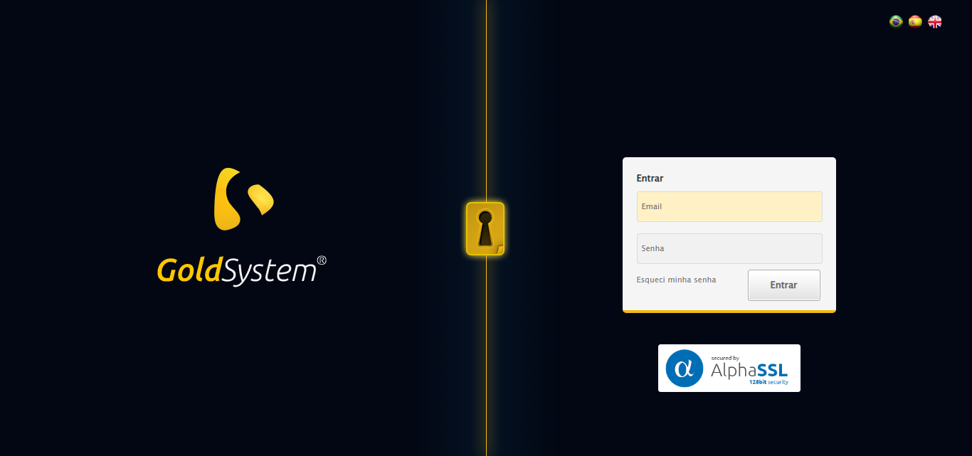

[16:43:33] 🔄 Realizando login...

[16:43:38] ✅ Realizando login realizada com sucesso.

[16:43:41] 📸 Screenshot capturada: realizando_login

Screenshot: realizando_login

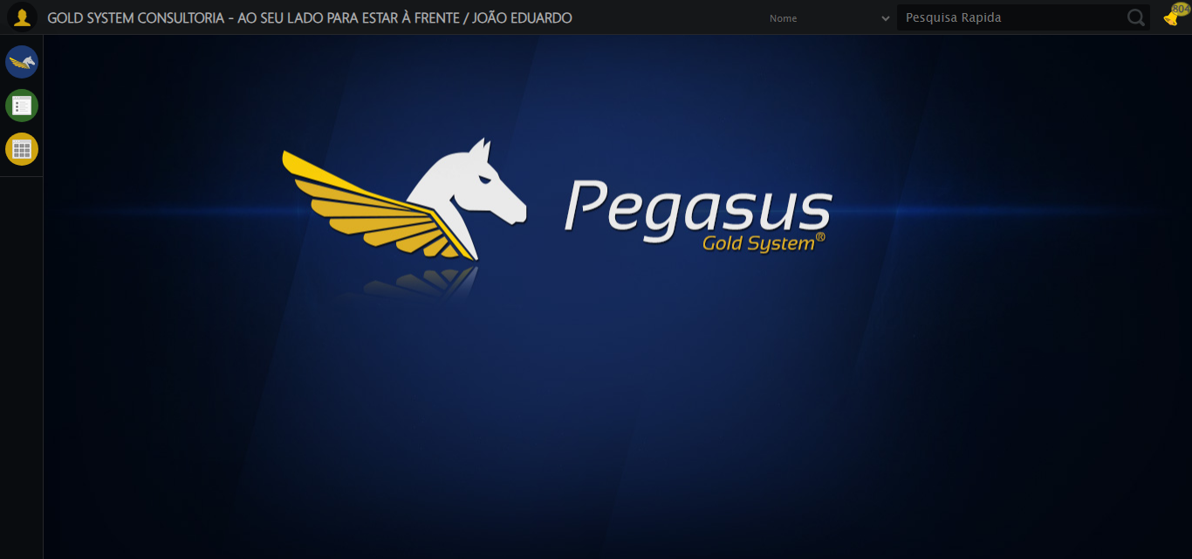

[16:43:41] 🔄 Configurando ambiente...

[16:43:41] 🔍 Zoom ajustado para 90%.

[16:43:43] ✅ Configurando ambiente realizada com sucesso.

[16:43:44] 📸 Screenshot capturada: configurando_ambiente

Screenshot: configurando_ambiente

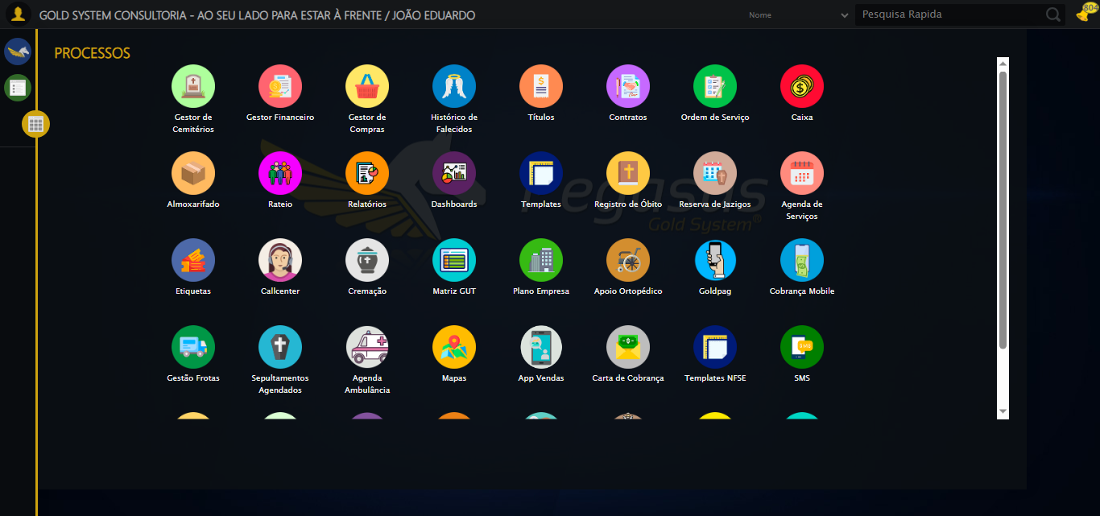

[16:43:44] 🔄 Acessando módulo PET...

[16:43:44] Tentando estratégia de scroll 1...

[16:43:45] ✅ Scroll realizado com estratégia 1

[16:43:46] Tentando estratégia de clique 1 para módulo PET...

[16:43:48] ✅ Clique no módulo PET realizado com estratégia 1

[16:43:48] ✅ Acessando módulo PET realizada com sucesso.

[16:43:49] 📸 Screenshot capturada: acessando_módulo_pet

Screenshot: acessando_módulo_pet

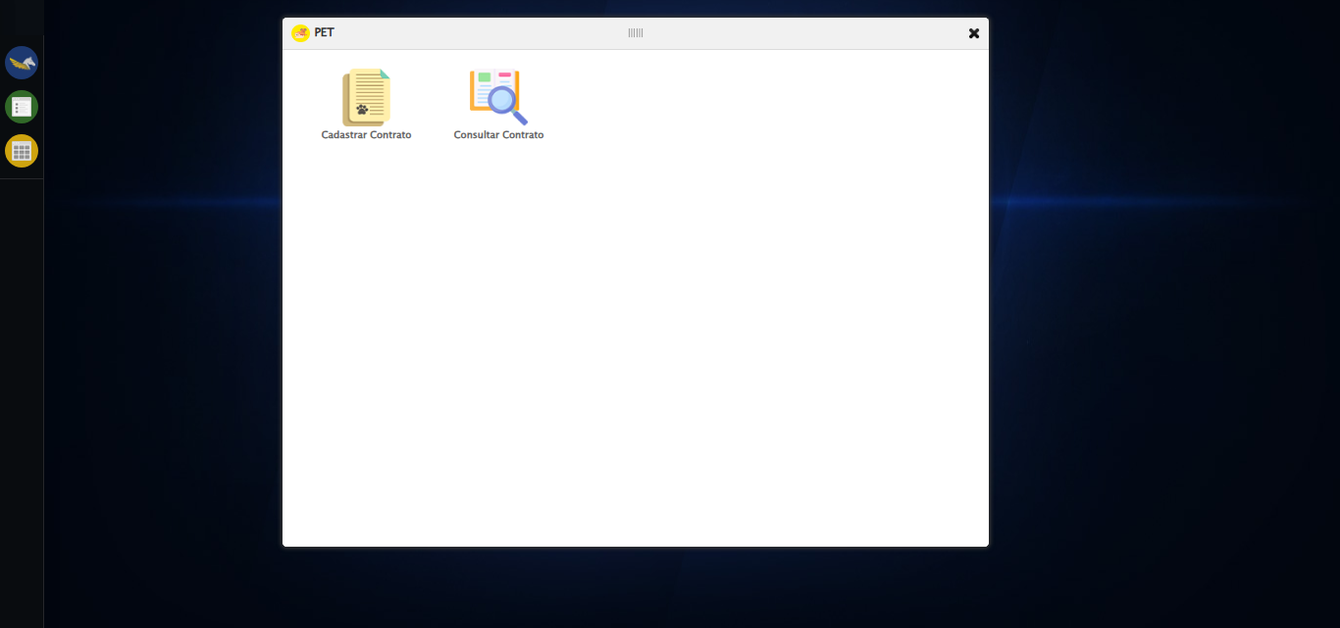

[16:43:49] 🔄 Abrindo consulta de contrato...

[16:43:52] ✅ Abrindo consulta de contrato realizada com sucesso.

[16:43:54] 📸 Screenshot capturada: abrindo_consulta_de_contrato

Screenshot: abrindo_consulta_de_contrato

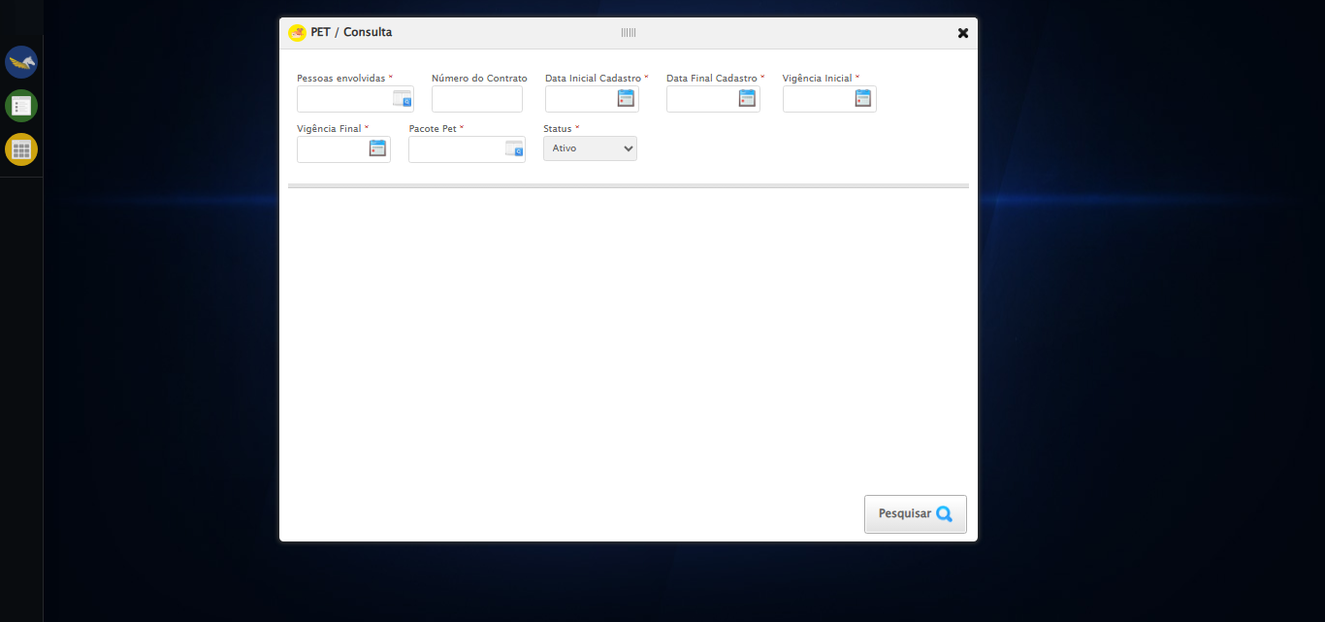

[16:43:54] 🔄 Selecionando Pessoas Envolvidas...

[16:43:54] 🔘 Abrindo modal com botão: #gsPet > div.wdTelas > div.telaConsulta.telaConsultaContratoPet > div > div.formRow.filtrosConsulta > div:nth-child(1) > div > a

[16:43:54] Tentando estratégia de scroll 1...

[16:43:54] ✅ Scroll realizado com estratégia 1

[16:43:57] 🔍 Preenchendo pesquisa com: TESTE TUTOR SELENIUM AUTOMATIZADO

[16:43:58] 🔍 Executando pesquisa...

[16:44:01] 🎯 Selecionando resultado: //td[contains(text(), 'TESTE TUTOR SELENIUM AUTOMATIZADO')]

[16:44:01] Tentando estratégia de scroll 1...

[16:44:02] ✅ Scroll realizado com estratégia 1

[16:44:03] ✅ Seleção no modal concluída

[16:44:03] ✅ Selecionando Pessoas Envolvidas realizada com sucesso.

[16:44:04] 📸 Screenshot capturada: selecionando_pessoas_envolvidas

Screenshot: selecionando_pessoas_envolvidas

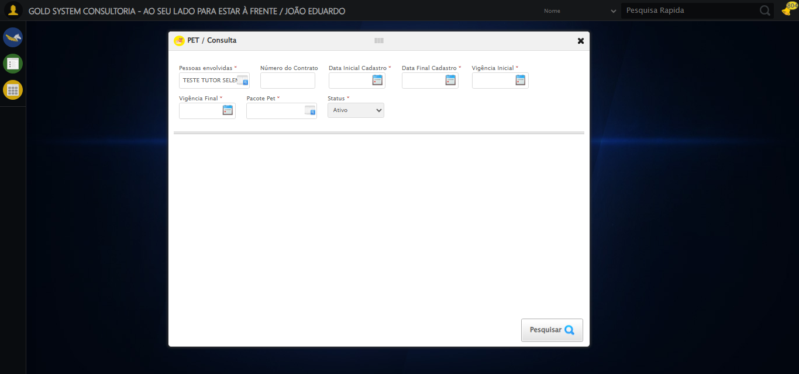

[16:44:04] 🔄 Preenchendo Número do Contrato...

[16:44:04] Tentando estratégia de scroll 1...

[16:44:05] ✅ Scroll realizado com estratégia 1

[16:44:06] ✅ Campo preenchido com estratégia 1: '113079'

[16:44:06] ✅ Preenchendo Número do Contrato realizada com sucesso.

[16:44:07] 📸 Screenshot capturada: preenchendo_número_do_contrato

Screenshot: preenchendo_número_do_contrato

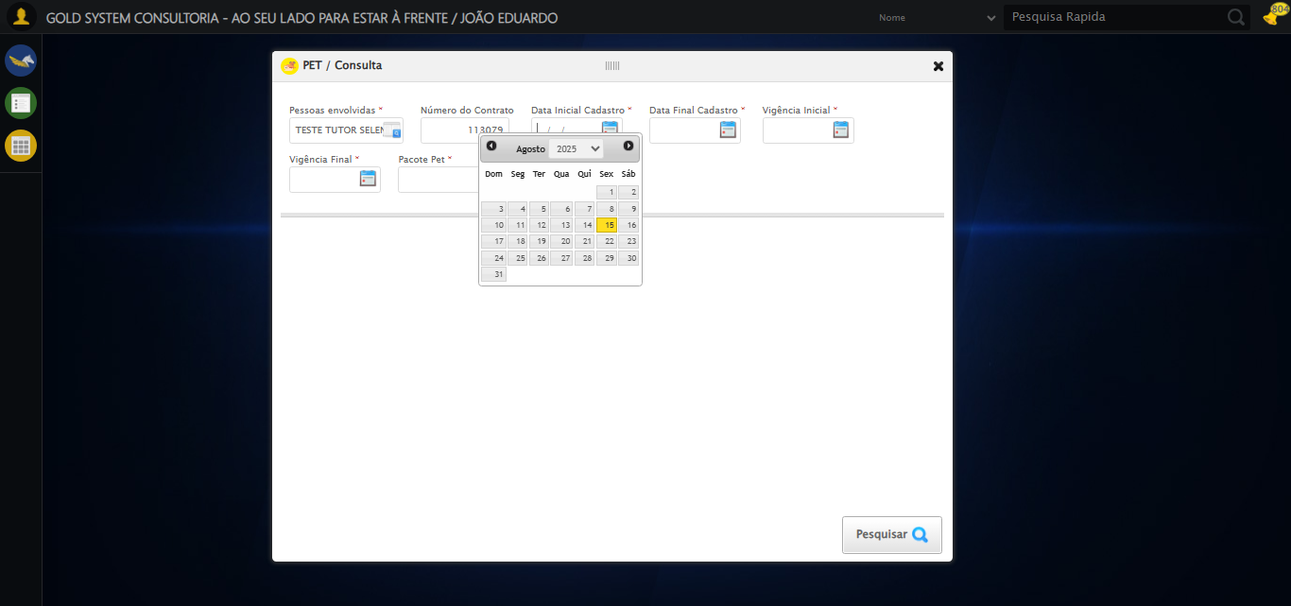

[16:44:07] 🔄 Preenchendo Data Inicial Cadastro...

[16:44:08] 📊 Encontrados 5 campos datepicker

[16:44:08] 🎯 Tentativa 1: Preenchendo datepicker 0 (ID: dp1755287016584) com '13/08/2025'

[16:44:08] Aplicando estratégia 1 para datepicker...

[16:44:09] ✅ Datepicker preenchido com estratégia 1: '13/08/2025'

[16:44:09] ✅ Preenchendo Data Inicial Cadastro realizada com sucesso.

[16:44:10] 📸 Screenshot capturada: preenchendo_data_inicial_cadastro

Screenshot: preenchendo_data_inicial_cadastro

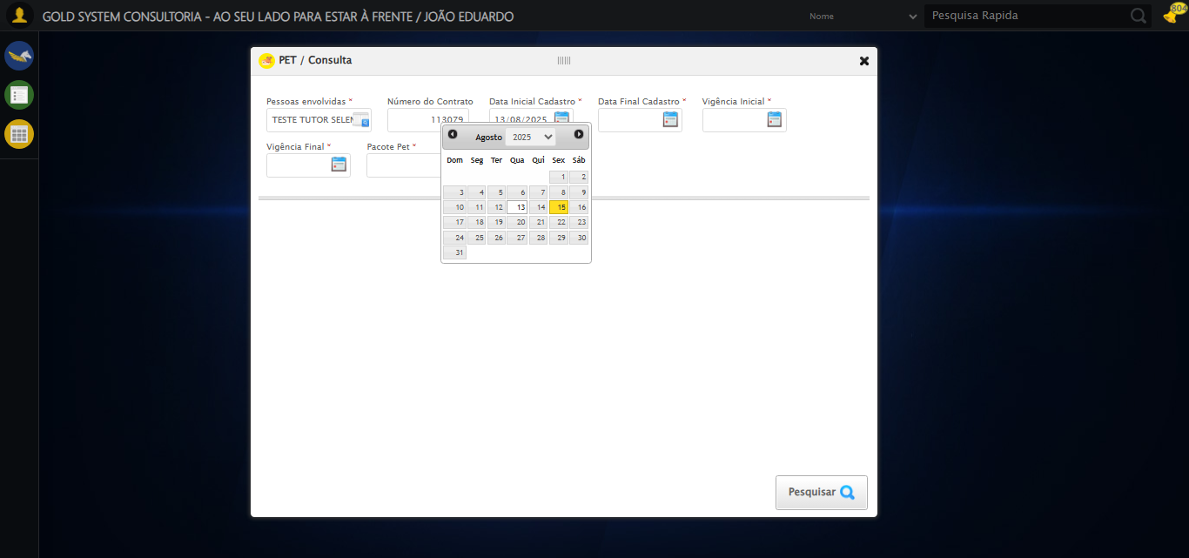

[16:44:11] 🔄 Preenchendo Data Final Cadastro...

[16:44:11] 📊 Encontrados 5 campos datepicker

[16:44:11] 🎯 Tentativa 1: Preenchendo datepicker 1 (ID: dp1755287016585) com '13/08/2025'

[16:44:11] Aplicando estratégia 1 para datepicker...

[16:44:12] ✅ Datepicker preenchido com estratégia 1: '13/08/2025'

[16:44:12] ✅ Preenchendo Data Final Cadastro realizada com sucesso.

[16:44:14] 📸 Screenshot capturada: preenchendo_data_final_cadastro

Screenshot: preenchendo_data_final_cadastro

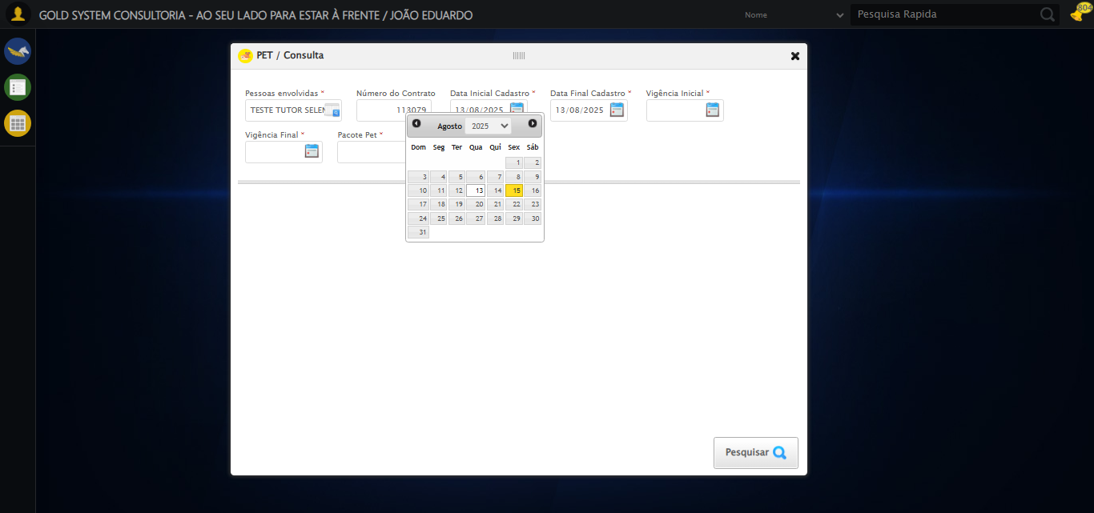

[16:44:14] 🔄 Preenchendo Vigência Inicial...

[16:44:14] 📊 Encontrados 5 campos datepicker

[16:44:14] 🎯 Tentativa 1: Preenchendo datepicker 2 (ID: dp1755287016582) com '13/08/2025'

[16:44:14] Aplicando estratégia 1 para datepicker...

[16:44:16] ✅ Datepicker preenchido com estratégia 1: '13/08/2025'

[16:44:16] ✅ Preenchendo Vigência Inicial realizada com sucesso.

[16:44:17] 📸 Screenshot capturada: preenchendo_vigência_inicial

Screenshot: preenchendo_vigência_inicial

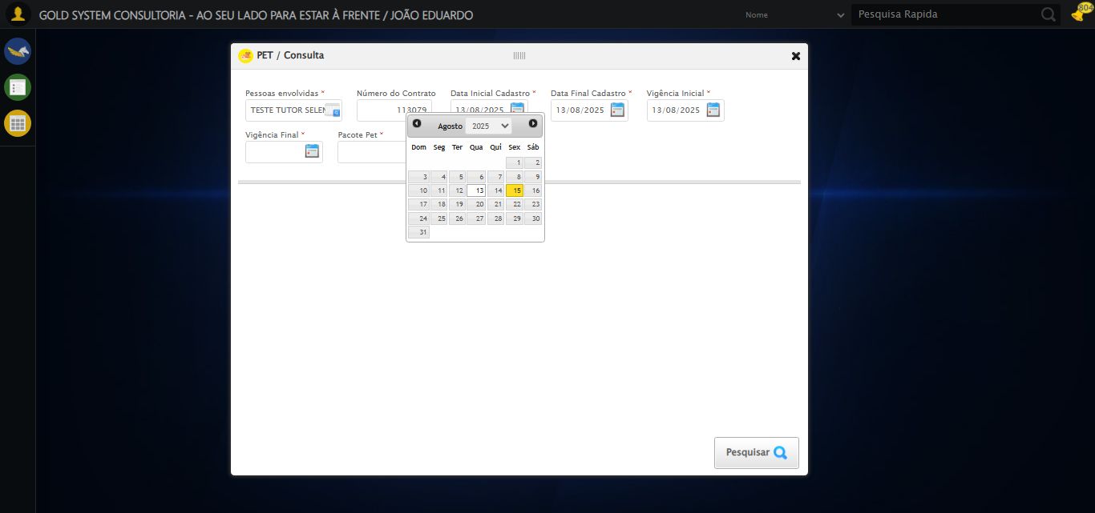

[16:44:17] 🔄 Preenchendo Vigência Final...

[16:44:18] 📊 Encontrados 5 campos datepicker

[16:44:18] 🎯 Tentativa 1: Preenchendo datepicker 3 (ID: dp1755287016583) com '13/11/2025'

[16:44:18] Aplicando estratégia 1 para datepicker...

[16:44:19] ✅ Datepicker preenchido com estratégia 1: '13/11/2025'

[16:44:19] ✅ Preenchendo Vigência Final realizada com sucesso.

[16:44:20] 📸 Screenshot capturada: preenchendo_vigência_final

Screenshot: preenchendo_vigência_final

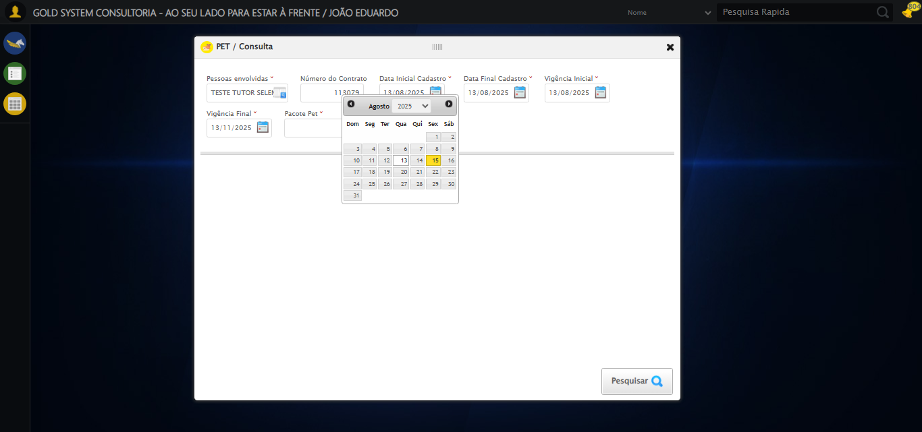

[16:44:20] 🔄 Selecionando Pacote Pet...

[16:44:20] 🔘 Abrindo modal com botão: #gsPet > div.wdTelas > div.telaConsulta.telaConsultaContratoPet > div > div.formRow.filtrosConsulta > div:nth-child(7) > div > a

[16:44:20] Tentando estratégia de scroll 1...

[16:44:21] ✅ Scroll realizado com estratégia 1

[16:44:24] 🔍 Preenchendo pesquisa com: PACOTE PET TESTE SELENIUM AUTOMATIZADO

[16:44:25] 🔍 Executando pesquisa...

[16:44:28] 🎯 Selecionando resultado: //td[contains(text(), 'PACOTE PET TESTE SELENIUM AUTOMATIZADO')]

[16:44:28] Tentando estratégia de scroll 1...

[16:44:29] ✅ Scroll realizado com estratégia 1

[16:44:30] ✅ Seleção no modal concluída

[16:44:30] ✅ Selecionando Pacote Pet realizada com sucesso.

[16:44:31] 📸 Screenshot capturada: selecionando_pacote_pet

Screenshot: selecionando_pacote_pet

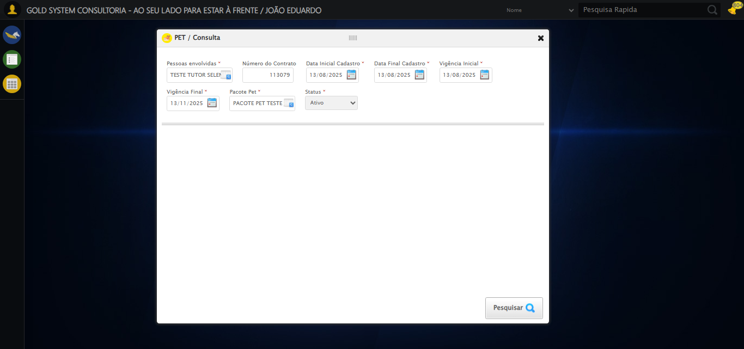

[16:44:31] 🔄 Realizando consulta...

[16:44:31] Tentando estratégia de scroll 1...

[16:44:32] ✅ Scroll realizado com estratégia 1

[16:44:34] ✅ Consulta executada

[16:44:34] ✅ Realizando consulta realizada com sucesso.

[16:44:35] 📸 Screenshot capturada: realizando_consulta

Screenshot: realizando_consulta

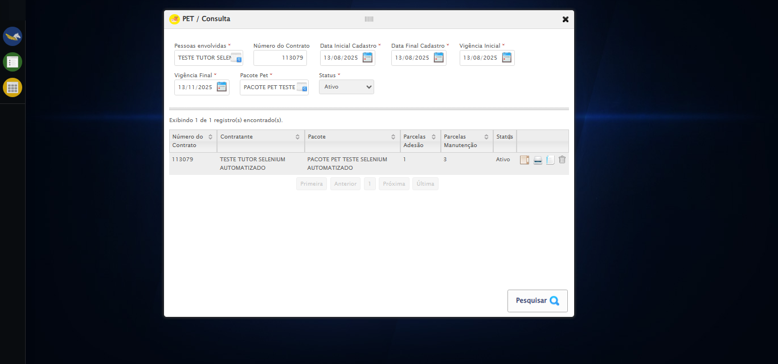

[16:44:35] 🔄 Validando resultados da consulta...

[16:44:35] 🔍 Iniciando validação de registros...

[16:44:41] ✅ Tabela encontrada: #DataTables_Table_2

[16:44:41] ✅ Encontradas 1 linhas válidas com tbody tr:not(.dataTables_empty):not([class*="no-data"])

[16:44:41] ✅ 1 registro(s) encontrado(s)

[16:44:41] Registro 1: 113079 teste tutor selenium automatizado pacote pet teste selenium automatizado 1 3 ativo

[16:44:41] ✅ Validando resultados da consulta realizada com sucesso.

[16:44:42] 📸 Screenshot capturada: validando_resultados_da_consulta

Screenshot: validando_resultados_da_consulta



[16:44:42] ✅ Processando 1 registro(s) encontrado(s)

[16:44:42] 🔄 Visualizando detalhes do Contrato Pet...

[16:44:42] Tentando estratégia de scroll 1...

[16:44:43] ✅ Scroll realizado com estratégia 1

[16:44:43] ✅ Clique realizado com estratégia 1

[16:44:43] ✅ Visualizando detalhes do Contrato Pet realizada com sucesso.

[16:44:45] 📸 Screenshot capturada: visualizando_detalhes_do_contrato_pet

Screenshot: visualizando_detalhes_do_contrato_pet

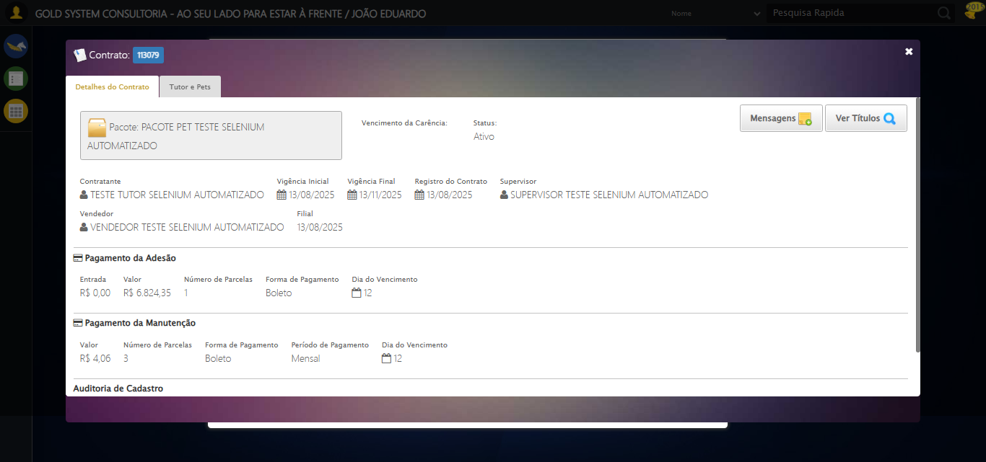

[16:44:45] 🔄 Capturando tela de detalhes...

[16:44:48] 📸 Screenshot capturada: detalhes_contrato_pet

Screenshot: detalhes_contrato_pet



[16:44:48] ✅ Capturando tela de detalhes realizada com sucesso.

[16:44:49] 📸 Screenshot capturada: capturando_tela_de_detalhes

Screenshot: capturando_tela_de_detalhes



[16:44:49] 🔄 Abrindo mensagens do Contrato Pet...

[16:44:49] Tentando estratégia de scroll 1...

[16:44:50] ✅ Scroll realizado com estratégia 1

[16:44:50] ✅ Clique realizado com estratégia 1

[16:44:50] ✅ Abrindo mensagens do Contrato Pet realizada com sucesso.

[16:44:51] 📸 Screenshot capturada: abrindo_mensagens_do_contrato_pet

Screenshot: abrindo_mensagens_do_contrato_pet

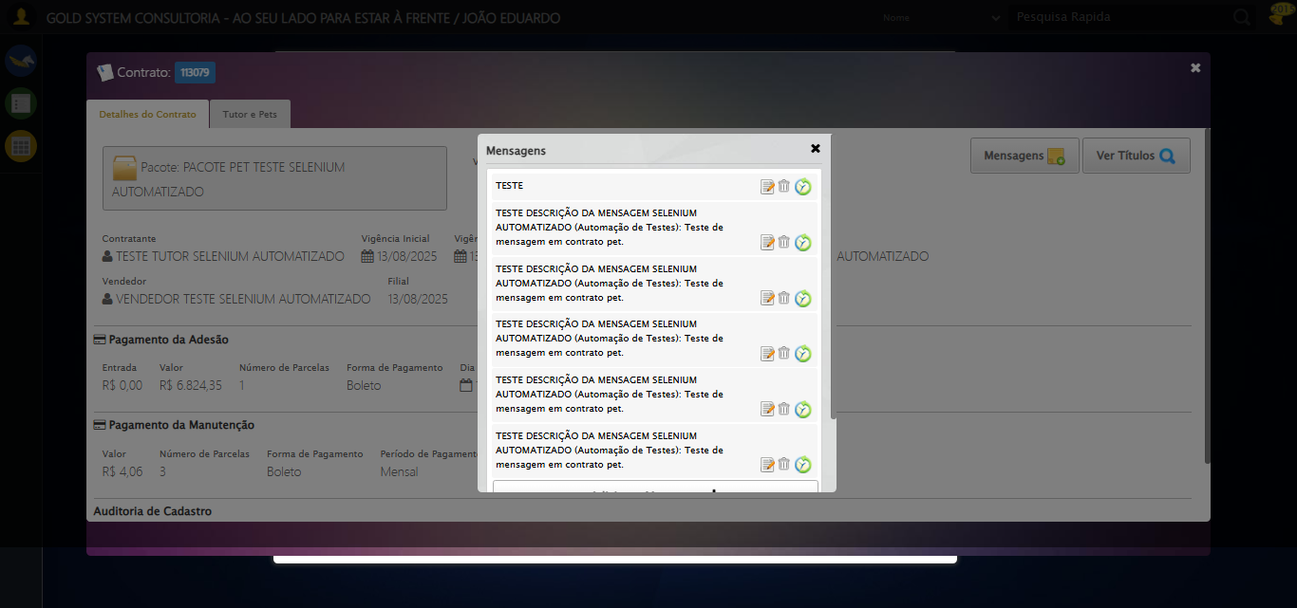

[16:44:51] 🔄 Capturando mensagens...

[16:44:54] 📸 Screenshot capturada: mensagens_contrato_pet

Screenshot: mensagens_contrato_pet



[16:44:54] ✅ Capturando mensagens realizada com sucesso.

[16:44:55] 📸 Screenshot capturada: capturando_mensagens

Screenshot: capturando_mensagens



[16:44:55] 🔄 Adicionando nova mensagem...

[16:44:55] Tentando estratégia de scroll 1...

[16:44:56] ✅ Scroll realizado com estratégia 1

[16:44:56] ✅ Clique realizado com estratégia 1

[16:44:56] ✅ Adicionando nova mensagem realizada com sucesso.

[16:44:57] 📸 Screenshot capturada: adicionando_nova_mensagem

Screenshot: adicionando_nova_mensagem

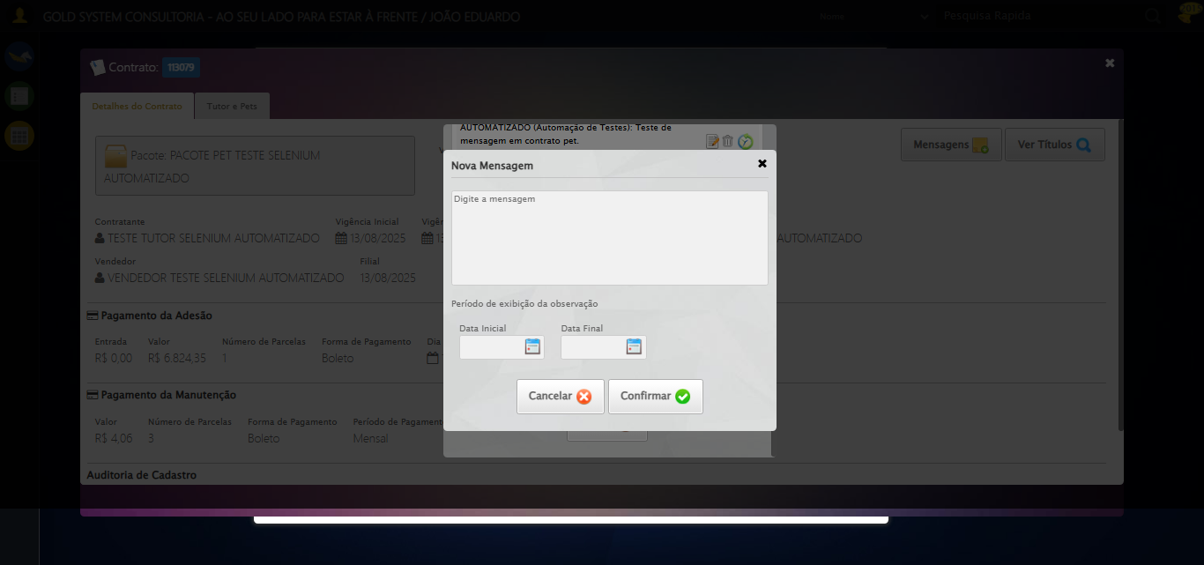

[16:44:57] 🔄 Confirmando mensagem sem registros para verificar mensagem de alerta...

[16:44:57] Tentando estratégia de scroll 1...

[16:44:58] ✅ Scroll realizado com estratégia 1

[16:44:59] ✅ Clique realizado com estratégia 1

[16:44:59] ✅ Confirmando mensagem sem registros para verificar mensagem de alerta realizada com sucesso.

[16:45:00] 📸 Screenshot capturada: confirmando_mensagem_sem_registros_para_verificar_mensagem_de_alerta

Screenshot: confirmando_mensagem_sem_registros_para_verificar_mensagem_de_alerta

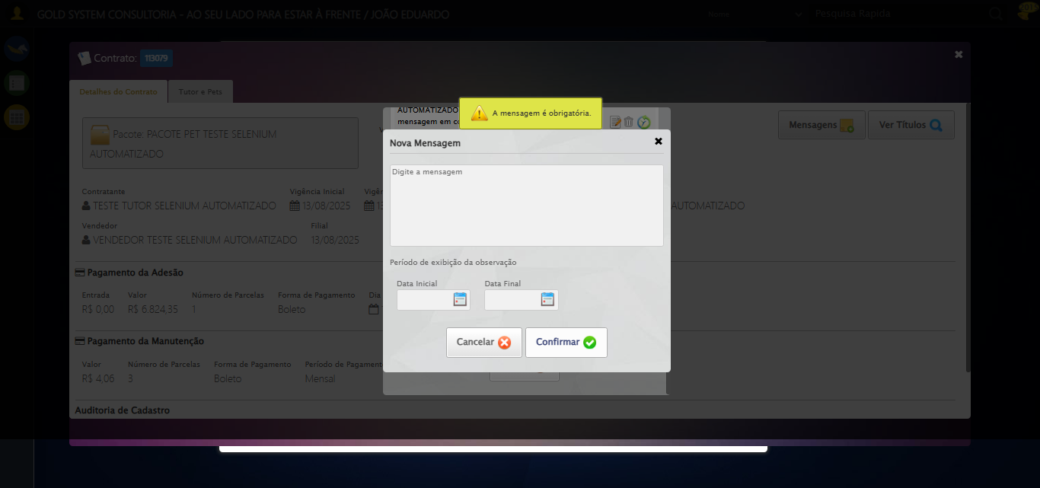

[16:45:00] 🔍 Verificando mensagens de alerta...

[16:45:00] 📢 ⚠️ Alerta: A mensagem é obrigatória.

[16:45:00] 🔄 Fechando a aba do cadastro de Mensagens...

[16:45:00] Tentando estratégia de scroll 1...

[16:45:01] ✅ Scroll realizado com estratégia 1

[16:45:02] ⚠️ Estratégia 1 de clique falhou: Message: element click intercepted: Element <a class="fa fa-close"></a> is not clickable at point (1259, 72). Other element would receive the click: <div class="blockScreen" style="height: 641px; z-index: 10005; opacity: 0.5;"></div>  
 (Session info: chrome=138.0.7204.185)  
Stacktrace:  
 GetHandleVerifier [0x0x126ba83+63395]  
 GetHandleVerifier [0x0x126bac4+63460]  
 (No symbol) [0x0x10b2113]  
 (No symbol) [0x0x1100ba0]  
 (No symbol) [0x0x10fef5a]  
 (No symbol) [0x0x10fcab7]  
 (No symbol) [0x0x10fbd6d]  
 (No symbol) [0x0x10f0515]  
 (No symbol) [0x0x111f3ac]  
 (No symbol) [0x0x10effa4]  
 (No symbol) [0x0x111f624]  
 (No symbol) [0x0x11407ba]  
 (No symbol) [0x0x111f1a6]  
 (No symbol) [0x0x10ee7b2]  
 (No symbol) [0x0x10ef654]  
 GetHandleVerifier [0x0x14e8883+2672035]  
 GetHandleVerifier [0x0x14e3cba+2652634]  
 GetHandleVerifier [0x0x1292bca+223466]  
 GetHandleVerifier [0x0x1282cb8+158168]  
 GetHandleVerifier [0x0x128978d+185517]  
 GetHandleVerifier [0x0x1273b78+96408]  
 GetHandleVerifier [0x0x1273d02+96802]  
 GetHandleVerifier [0x0x125e90a+9770]  
 BaseThreadInitThunk [0x0x7709fcc9+25]  
 RtlGetAppContainerNamedObjectPath [0x0x778882ae+286]  
 RtlGetAppContainerNamedObjectPath [0x0x7788827e+238]

[16:45:03] ✅ Clique realizado com estratégia 2

[16:45:03] ✅ Fechando a aba do cadastro de Mensagens realizada com sucesso.

[16:45:04] 📸 Screenshot capturada: fechando_a_aba_do_cadastro_de_mensagens

Screenshot: fechando_a_aba_do_cadastro_de_mensagens

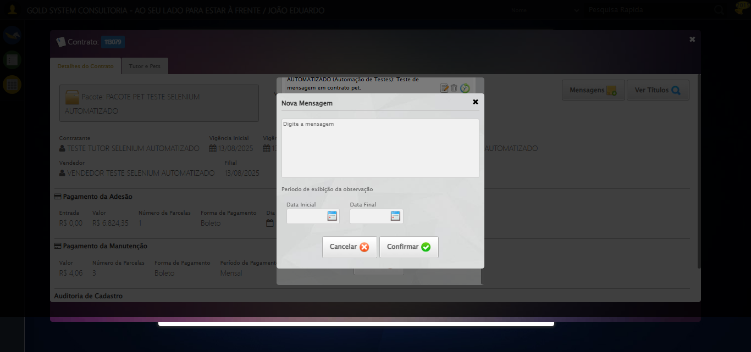

[16:45:04] 🔄 Fechando aba de mensagens...

[16:45:04] Tentando estratégia de scroll 1...

[16:45:05] ✅ Scroll realizado com estratégia 1

[16:45:06] ⚠️ Estratégia 1 de clique falhou: Message: element click intercepted: Element <a class="btModel btGray">...</a> is not clickable at point (689, 481). Other element would receive the click: <div class="modal overflow" style="z-index: 10006; left: 50%; top: 50%; width: 400px; height: 335px; margin-left: -200px; margin-top: -167.5px;">...</div>  
 (Session info: chrome=138.0.7204.185)  
Stacktrace:  
 GetHandleVerifier [0x0x126ba83+63395]  
 GetHandleVerifier [0x0x126bac4+63460]  
 (No symbol) [0x0x10b2113]  
 (No symbol) [0x0x1100ba0]  
 (No symbol) [0x0x10fef5a]  
 (No symbol) [0x0x10fcab7]  
 (No symbol) [0x0x10fbd6d]  
 (No symbol) [0x0x10f0515]  
 (No symbol) [0x0x111f3ac]  
 (No symbol) [0x0x10effa4]  
 (No symbol) [0x0x111f624]  
 (No symbol) [0x0x11407ba]  
 (No symbol) [0x0x111f1a6]  
 (No symbol) [0x0x10ee7b2]  
 (No symbol) [0x0x10ef654]  
 GetHandleVerifier [0x0x14e8883+2672035]  
 GetHandleVerifier [0x0x14e3cba+2652634]  
 GetHandleVerifier [0x0x1292bca+223466]  
 GetHandleVerifier [0x0x1282cb8+158168]  
 GetHandleVerifier [0x0x128978d+185517]  
 GetHandleVerifier [0x0x1273b78+96408]  
 GetHandleVerifier [0x0x1273d02+96802]  
 GetHandleVerifier [0x0x125e90a+9770]  
 BaseThreadInitThunk [0x0x7709fcc9+25]  
 RtlGetAppContainerNamedObjectPath [0x0x778882ae+286]  
 RtlGetAppContainerNamedObjectPath [0x0x7788827e+238]

[16:45:07] ✅ Clique realizado com estratégia 2

[16:45:07] ✅ Fechando aba de mensagens realizada com sucesso.

[16:45:08] 📸 Screenshot capturada: fechando_aba_de_mensagens

Screenshot: fechando_aba_de_mensagens



[16:45:08] 🔄 Visualizando títulos do Contrato Pet...

[16:45:08] Tentando estratégia de scroll 1...

[16:45:09] ✅ Scroll realizado com estratégia 1

[16:45:10] ⚠️ Estratégia 1 de clique falhou: Message: element click intercepted: Element <button class="btModel btGray" style="position: relative; float: right;">...</button> is not clickable at point (1196, 164). Other element would receive the click: <div class="blockScreen" style="height: 641px; z-index: 10005; opacity: 0.5;"></div>  
 (Session info: chrome=138.0.7204.185)  
Stacktrace:  
 GetHandleVerifier [0x0x126ba83+63395]  
 GetHandleVerifier [0x0x126bac4+63460]  
 (No symbol) [0x0x10b2113]  
 (No symbol) [0x0x1100ba0]  
 (No symbol) [0x0x10fef5a]  
 (No symbol) [0x0x10fcab7]  
 (No symbol) [0x0x10fbd6d]  
 (No symbol) [0x0x10f0515]  
 (No symbol) [0x0x111f3ac]  
 (No symbol) [0x0x10effa4]  
 (No symbol) [0x0x111f624]  
 (No symbol) [0x0x11407ba]  
 (No symbol) [0x0x111f1a6]  
 (No symbol) [0x0x10ee7b2]  
 (No symbol) [0x0x10ef654]  
 GetHandleVerifier [0x0x14e8883+2672035]  
 GetHandleVerifier [0x0x14e3cba+2652634]  
 GetHandleVerifier [0x0x1292bca+223466]  
 GetHandleVerifier [0x0x1282cb8+158168]  
 GetHandleVerifier [0x0x128978d+185517]  
 GetHandleVerifier [0x0x1273b78+96408]  
 GetHandleVerifier [0x0x1273d02+96802]  
 GetHandleVerifier [0x0x125e90a+9770]  
 BaseThreadInitThunk [0x0x7709fcc9+25]  
 RtlGetAppContainerNamedObjectPath [0x0x778882ae+286]  
 RtlGetAppContainerNamedObjectPath [0x0x7788827e+238]

[16:45:11] ✅ Clique realizado com estratégia 2

[16:45:11] ✅ Visualizando títulos do Contrato Pet realizada com sucesso.

[16:45:12] 📸 Screenshot capturada: visualizando_títulos_do_contrato_pet

Screenshot: visualizando_títulos_do_contrato_pet



[16:45:12] 🔄 Aguardando carregamento de títulos...

[16:45:42] 📸 Screenshot capturada: titulos_contrato_pet

Screenshot: titulos_contrato_pet

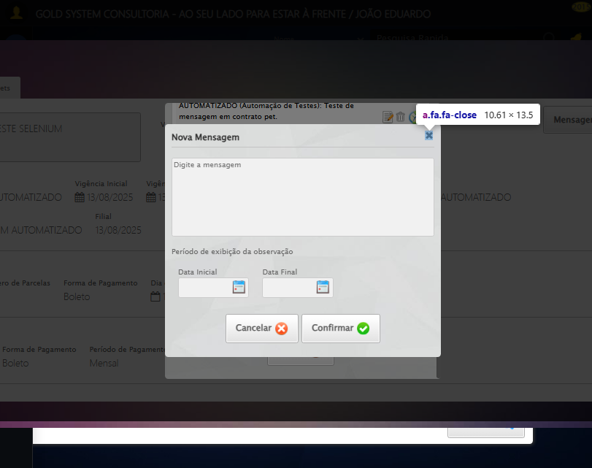

[16:45:42] ✅ Aguardando carregamento de títulos realizada com sucesso.

[16:45:43] 📸 Screenshot capturada: aguardando_carregamento_de_títulos

Screenshot: aguardando_carregamento_de_títulos



[16:45:43] 🔄 Fechando aba de títulos...

[16:46:13] ❌ Timeout aguardando elemento: //a[@title='Sair' and contains(@class, 'sp-fecharGrande')] (condição: present, timeout: 30s)

[16:46:13] ❌ Falha ao clicar em //a[@title='Sair' and contains(@class, 'sp-fecharGrande')]: Message: Elemento não encontrado: //a[@title='Sair' and contains(@class, 'sp-fecharGrande')] (condição: present)

[16:46:14] 📸 Screenshot capturada: erro_fechando_aba_de_títulos

Screenshot: erro_fechando_aba_de_títulos

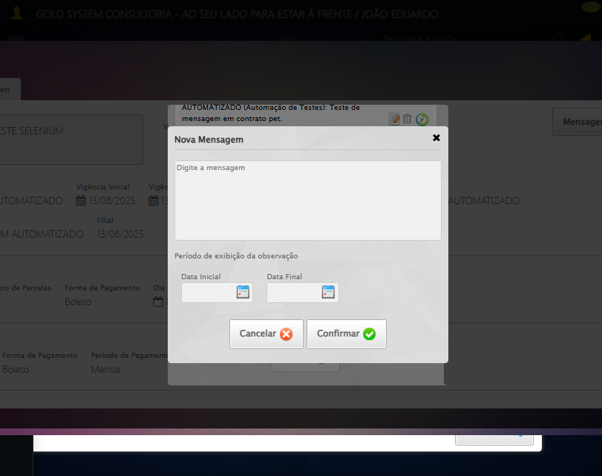

[16:46:14] ❌ Fechando aba de títulos falhou: TimeoutException: Message: Elemento não encontrado: //a[@title='Sair' and contains(@class, 'sp-fecharGrande')] (condição: present)

[16:46:14] ⚠️ Continuando execução apesar do erro em: Fechando aba de títulos

[16:46:14] 🔄 Abrindo digitalização de documentos...

[16:46:14] Tentando estratégia de scroll 1...

[16:46:15] ✅ Scroll realizado com estratégia 1

[16:46:16] ⚠️ Estratégia 1 de clique falhou: Message: element click intercepted: Element <span class="sprites sp-scanner" title="Digitalizar documentos"></span> is not clickable at point (665, 320). Other element would receive the click: <div class="blockScreen" style="height: 641px; z-index: 10005; opacity: 0.5;"></div>  
 (Session info: chrome=138.0.7204.185)  
Stacktrace:  
 GetHandleVerifier [0x0x126ba83+63395]  
 GetHandleVerifier [0x0x126bac4+63460]  
 (No symbol) [0x0x10b2113]  
 (No symbol) [0x0x1100ba0]  
 (No symbol) [0x0x10fef5a]  
 (No symbol) [0x0x10fcab7]  
 (No symbol) [0x0x10fbd6d]  
 (No symbol) [0x0x10f0515]  
 (No symbol) [0x0x111f3ac]  
 (No symbol) [0x0x10effa4]  
 (No symbol) [0x0x111f624]  
 (No symbol) [0x0x11407ba]  
 (No symbol) [0x0x111f1a6]  
 (No symbol) [0x0x10ee7b2]  
 (No symbol) [0x0x10ef654]  
 GetHandleVerifier [0x0x14e8883+2672035]  
 GetHandleVerifier [0x0x14e3cba+2652634]  
 GetHandleVerifier [0x0x1292bca+223466]  
 GetHandleVerifier [0x0x1282cb8+158168]  
 GetHandleVerifier [0x0x128978d+185517]  
 GetHandleVerifier [0x0x1273b78+96408]  
 GetHandleVerifier [0x0x1273d02+96802]  
 GetHandleVerifier [0x0x125e90a+9770]  
 BaseThreadInitThunk [0x0x7709fcc9+25]  
 RtlGetAppContainerNamedObjectPath [0x0x778882ae+286]  
 RtlGetAppContainerNamedObjectPath [0x0x7788827e+238]

[16:46:17] ✅ Clique realizado com estratégia 2

[16:46:17] ✅ Abrindo digitalização de documentos realizada com sucesso.

[16:46:18] 📸 Screenshot capturada: abrindo_digitalização_de_documentos

Screenshot: abrindo_digitalização_de_documentos

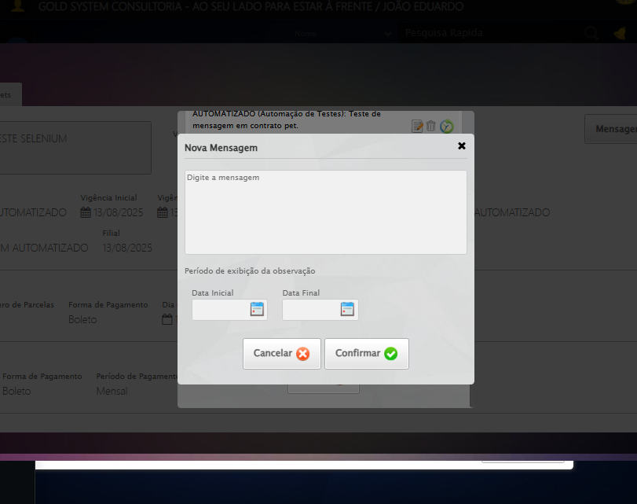

[16:46:18] 🔄 Adicionando novo documento...

[16:46:20] ❌ Erro aguardando elemento //span[contains(@class, 'sp-addFile')]: Message: no such window: target window already closed  
from unknown error: web view not found  
 (Session info: chrome=138.0.7204.185)  
Stacktrace:  
 GetHandleVerifier [0x0x126ba83+63395]  
 GetHandleVerifier [0x0x126bac4+63460]  
 (No symbol) [0x0x10b2113]  
 (No symbol) [0x0x1090fb9]  
 (No symbol) [0x0x1125ace]  
 (No symbol) [0x0x1140099]  
 (No symbol) [0x0x111f1a6]  
 (No symbol) [0x0x10ee7b2]  
 (No symbol) [0x0x10ef654]  
 GetHandleVerifier [0x0x14e8883+2672035]  
 GetHandleVerifier [0x0x14e3cba+2652634]  
 GetHandleVerifier [0x0x1292bca+223466]  
 GetHandleVerifier [0x0x1282cb8+158168]  
 GetHandleVerifier [0x0x128978d+185517]  
 GetHandleVerifier [0x0x1273b78+96408]  
 GetHandleVerifier [0x0x1273d02+96802]  
 GetHandleVerifier [0x0x125e90a+9770]  
 BaseThreadInitThunk [0x0x7709fcc9+25]  
 RtlGetAppContainerNamedObjectPath [0x0x778882ae+286]  
 RtlGetAppContainerNamedObjectPath [0x0x7788827e+238]

[16:46:20] ❌ Falha ao clicar em //span[contains(@class, 'sp-addFile')]: Message: no such window: target window already closed  
from unknown error: web view not found  
 (Session info: chrome=138.0.7204.185)  
Stacktrace:  
 GetHandleVerifier [0x0x126ba83+63395]  
 GetHandleVerifier [0x0x126bac4+63460]  
 (No symbol) [0x0x10b2113]  
 (No symbol) [0x0x1090fb9]  
 (No symbol) [0x0x1125ace]  
 (No symbol) [0x0x1140099]  
 (No symbol) [0x0x111f1a6]  
 (No symbol) [0x0x10ee7b2]  
 (No symbol) [0x0x10ef654]  
 GetHandleVerifier [0x0x14e8883+2672035]  
 GetHandleVerifier [0x0x14e3cba+2652634]  
 GetHandleVerifier [0x0x1292bca+223466]  
 GetHandleVerifier [0x0x1282cb8+158168]  
 GetHandleVerifier [0x0x128978d+185517]  
 GetHandleVerifier [0x0x1273b78+96408]  
 GetHandleVerifier [0x0x1273d02+96802]  
 GetHandleVerifier [0x0x125e90a+9770]  
 BaseThreadInitThunk [0x0x7709fcc9+25]  
 RtlGetAppContainerNamedObjectPath [0x0x778882ae+286]  
 RtlGetAppContainerNamedObjectPath [0x0x7788827e+238]

[16:46:20] ⚠️ Erro ao tirar screenshot erro_adicionando_novo_documento: Message: no such window: target window already closed  
from unknown error: web view not found  
 (Session info: chrome=138.0.7204.185)  
Stacktrace:  
 GetHandleVerifier [0x0x126ba83+63395]  
 GetHandleVerifier [0x0x126bac4+63460]  
 (No symbol) [0x0x10b2113]  
 (No symbol) [0x0x1090fb9]  
 (No symbol) [0x0x1125ace]  
 (No symbol) [0x0x1140099]  
 (No symbol) [0x0x111f1a6]  
 (No symbol) [0x0x10ee7b2]  
 (No symbol) [0x0x10ef654]  
 GetHandleVerifier [0x0x14e8883+2672035]  
 GetHandleVerifier [0x0x14e3cba+2652634]  
 GetHandleVerifier [0x0x1292bca+223466]  
 GetHandleVerifier [0x0x1282cb8+158168]  
 GetHandleVerifier [0x0x128978d+185517]  
 GetHandleVerifier [0x0x1273b78+96408]  
 GetHandleVerifier [0x0x1273d02+96802]  
 GetHandleVerifier [0x0x125e90a+9770]  
 BaseThreadInitThunk [0x0x7709fcc9+25]  
 RtlGetAppContainerNamedObjectPath [0x0x778882ae+286]  
 RtlGetAppContainerNamedObjectPath [0x0x7788827e+238]

[16:46:20] ❌ Adicionando novo documento falhou: NoSuchWindowException: Message: no such window: target window already closed  
from unknown error: web view not found  
 (Session info: chrome=138.0.7204.185)  
Stacktrace:  
 GetHandleVerifier [0x0x126ba83+63395]  
 GetHandleVerifier [0x0x126bac4+63460]  
 (No symbol) [0x0x10b2113]  
 (No symbol) [0x0x1090fb9]  
 (No symbol) [0x0x1125ace]  
 (No symbol) [0x0x1140099]  
 (No symbol) [0x0x111f1a6]  
 (No symbol) [0x0x10ee7b2]  
 (No symbol) [0x0x10ef654]  
 GetHandleVerifier [0x0x14e8883+2672035]  
 GetHandleVerifier [0x0x14e3cba+2652634]  
 GetHandleVerifier [0x0x1292bca+223466]  
 GetHandleVerifier [0x0x1282cb8+158168]  
 GetHandleVerifier [0x0x128978d+185517]  
 GetHandleVerifier [0x0x1273b78+96408]  
 GetHandleVerifier [0x0x1273d02+96802]  
 GetHandleVerifier [0x0x125e90a+9770]  
 BaseThreadInitThunk [0x0x7709fcc9+25]  
 RtlGetAppContainerNamedObjectPath [0x0x778882ae+286]  
 RtlGetAppContainerNamedObjectPath [0x0x7788827e+238]

[16:46:20] ⚠️ Continuando execução apesar do erro em: Adicionando novo documento

[16:46:21] 🔄 Salvando arquivo digitalizado sem registros para verificar mensagem de alerta...

[16:46:21] ❌ Erro aguardando elemento //a[contains(@class,'btModel') and contains(@class,'btGreen') and normalize-space(.)='Salvar']: Message: no such window: target window already closed  
from unknown error: web view not found  
 (Session info: chrome=138.0.7204.185)  
Stacktrace:  
 GetHandleVerifier [0x0x126ba83+63395]  
 GetHandleVerifier [0x0x126bac4+63460]  
 (No symbol) [0x0x10b2113]  
 (No symbol) [0x0x1090fb9]  
 (No symbol) [0x0x1125ace]  
 (No symbol) [0x0x1140099]  
 (No symbol) [0x0x111f1a6]  
 (No symbol) [0x0x10ee7b2]  
 (No symbol) [0x0x10ef654]  
 GetHandleVerifier [0x0x14e8883+2672035]  
 GetHandleVerifier [0x0x14e3cba+2652634]  
 GetHandleVerifier [0x0x1292bca+223466]  
 GetHandleVerifier [0x0x1282cb8+158168]  
 GetHandleVerifier [0x0x128978d+185517]  
 GetHandleVerifier [0x0x1273b78+96408]  
 GetHandleVerifier [0x0x1273d02+96802]  
 GetHandleVerifier [0x0x125e90a+9770]  
 BaseThreadInitThunk [0x0x7709fcc9+25]  
 RtlGetAppContainerNamedObjectPath [0x0x778882ae+286]  
 RtlGetAppContainerNamedObjectPath [0x0x7788827e+238]

[16:46:21] ❌ Falha ao clicar em //a[contains(@class,'btModel') and contains(@class,'btGreen') and normalize-space(.)='Salvar']: Message: no such window: target window already closed  
from unknown error: web view not found  
 (Session info: chrome=138.0.7204.185)  
Stacktrace:  
 GetHandleVerifier [0x0x126ba83+63395]  
 GetHandleVerifier [0x0x126bac4+63460]  
 (No symbol) [0x0x10b2113]  
 (No symbol) [0x0x1090fb9]  
 (No symbol) [0x0x1125ace]  
 (No symbol) [0x0x1140099]  
 (No symbol) [0x0x111f1a6]  
 (No symbol) [0x0x10ee7b2]  
 (No symbol) [0x0x10ef654]  
 GetHandleVerifier [0x0x14e8883+2672035]  
 GetHandleVerifier [0x0x14e3cba+2652634]  
 GetHandleVerifier [0x0x1292bca+223466]  
 GetHandleVerifier [0x0x1282cb8+158168]  
 GetHandleVerifier [0x0x128978d+185517]  
 GetHandleVerifier [0x0x1273b78+96408]  
 GetHandleVerifier [0x0x1273d02+96802]  
 GetHandleVerifier [0x0x125e90a+9770]  
 BaseThreadInitThunk [0x0x7709fcc9+25]  
 RtlGetAppContainerNamedObjectPath [0x0x778882ae+286]  
 RtlGetAppContainerNamedObjectPath [0x0x7788827e+238]

[16:46:21] ⚠️ Erro ao tirar screenshot erro_salvando_arquivo_digitalizado_sem_registros_para_verificar_mensagem_de_alerta: Message: no such window: target window already closed  
from unknown error: web view not found  
 (Session info: chrome=138.0.7204.185)  
Stacktrace:  
 GetHandleVerifier [0x0x126ba83+63395]  
 GetHandleVerifier [0x0x126bac4+63460]  
 (No symbol) [0x0x10b2113]  
 (No symbol) [0x0x1090fb9]  
 (No symbol) [0x0x1125ace]  
 (No symbol) [0x0x1140099]  
 (No symbol) [0x0x111f1a6]  
 (No symbol) [0x0x10ee7b2]  
 (No symbol) [0x0x10ef654]  
 GetHandleVerifier [0x0x14e8883+2672035]  
 GetHandleVerifier [0x0x14e3cba+2652634]  
 GetHandleVerifier [0x0x1292bca+223466]  
 GetHandleVerifier [0x0x1282cb8+158168]  
 GetHandleVerifier [0x0x128978d+185517]  
 GetHandleVerifier [0x0x1273b78+96408]  
 GetHandleVerifier [0x0x1273d02+96802]  
 GetHandleVerifier [0x0x125e90a+9770]  
 BaseThreadInitThunk [0x0x7709fcc9+25]  
 RtlGetAppContainerNamedObjectPath [0x0x778882ae+286]  
 RtlGetAppContainerNamedObjectPath [0x0x7788827e+238]

[16:46:21] ❌ Salvando arquivo digitalizado sem registros para verificar mensagem de alerta falhou: NoSuchWindowException: Message: no such window: target window already closed  
from unknown error: web view not found  
 (Session info: chrome=138.0.7204.185)  
Stacktrace:  
 GetHandleVerifier [0x0x126ba83+63395]  
 GetHandleVerifier [0x0x126bac4+63460]  
 (No symbol) [0x0x10b2113]  
 (No symbol) [0x0x1090fb9]  
 (No symbol) [0x0x1125ace]  
 (No symbol) [0x0x1140099]  
 (No symbol) [0x0x111f1a6]  
 (No symbol) [0x0x10ee7b2]  
 (No symbol) [0x0x10ef654]  
 GetHandleVerifier [0x0x14e8883+2672035]  
 GetHandleVerifier [0x0x14e3cba+2652634]  
 GetHandleVerifier [0x0x1292bca+223466]  
 GetHandleVerifier [0x0x1282cb8+158168]  
 GetHandleVerifier [0x0x128978d+185517]  
 GetHandleVerifier [0x0x1273b78+96408]  
 GetHandleVerifier [0x0x1273d02+96802]  
 GetHandleVerifier [0x0x125e90a+9770]  
 BaseThreadInitThunk [0x0x7709fcc9+25]  
 RtlGetAppContainerNamedObjectPath [0x0x778882ae+286]  
 RtlGetAppContainerNamedObjectPath [0x0x7788827e+238]

[16:46:21] ⚠️ Continuando execução apesar do erro em: Salvando arquivo digitalizado sem registros para verificar mensagem de alerta

[16:46:21] 🔍 Verificando mensagens de alerta após digitalização...

[16:46:21] ⚠️ Erro ao buscar alerta .alerts.salvo: Message: no such window: target window already closed  
from unknown error: web view not found  
 (Session info: chrome=138.0.7204.185)  
Stacktrace:  
 GetHandleVerifier [0x0x126ba83+63395]  
 GetHandleVerifier [0x0x126bac4+63460]  
 (No symbol) [0x0x10b2113]  
 (No symbol) [0x0x1090fb9]  
 (No symbol) [0x0x1125ace]  
 (No symbol) [0x0x1140099]  
 (No symbol) [0x0x111f1a6]  
 (No symbol) [0x0x10ee7b2]  
 (No symbol) [0x0x10ef654]  
 GetHandleVerifier [0x0x14e8883+2672035]  
 GetHandleVerifier [0x0x14e3cba+2652634]  
 GetHandleVerifier [0x0x1292bca+223466]  
 GetHandleVerifier [0x0x1282cb8+158168]  
 GetHandleVerifier [0x0x128978d+185517]  
 GetHandleVerifier [0x0x1273b78+96408]  
 GetHandleVerifier [0x0x1273d02+96802]  
 GetHandleVerifier [0x0x125e90a+9770]  
 BaseThreadInitThunk [0x0x7709fcc9+25]  
 RtlGetAppContainerNamedObjectPath [0x0x778882ae+286]  
 RtlGetAppContainerNamedObjectPath [0x0x7788827e+238]

[16:46:21] ⚠️ Erro ao buscar alerta .alerts.alerta: Message: no such window: target window already closed  
from unknown error: web view not found  
 (Session info: chrome=138.0.7204.185)  
Stacktrace:  
 GetHandleVerifier [0x0x126ba83+63395]  
 GetHandleVerifier [0x0x126bac4+63460]  
 (No symbol) [0x0x10b2113]  
 (No symbol) [0x0x1090fb9]  
 (No symbol) [0x0x1125ace]  
 (No symbol) [0x0x1140099]  
 (No symbol) [0x0x111f1a6]  
 (No symbol) [0x0x10ee7b2]  
 (No symbol) [0x0x10ef654]  
 GetHandleVerifier [0x0x14e8883+2672035]  
 GetHandleVerifier [0x0x14e3cba+2652634]  
 GetHandleVerifier [0x0x1292bca+223466]  
 GetHandleVerifier [0x0x1282cb8+158168]  
 GetHandleVerifier [0x0x128978d+185517]  
 GetHandleVerifier [0x0x1273b78+96408]  
 GetHandleVerifier [0x0x1273d02+96802]  
 GetHandleVerifier [0x0x125e90a+9770]  
 BaseThreadInitThunk [0x0x7709fcc9+25]  
 RtlGetAppContainerNamedObjectPath [0x0x778882ae+286]  
 RtlGetAppContainerNamedObjectPath [0x0x7788827e+238]

[16:46:21] ⚠️ Erro ao buscar alerta .alerts.erro: Message: no such window: target window already closed  
from unknown error: web view not found  
 (Session info: chrome=138.0.7204.185)  
Stacktrace:  
 GetHandleVerifier [0x0x126ba83+63395]  
 GetHandleVerifier [0x0x126bac4+63460]  
 (No symbol) [0x0x10b2113]  
 (No symbol) [0x0x1090fb9]  
 (No symbol) [0x0x1125ace]  
 (No symbol) [0x0x1140099]  
 (No symbol) [0x0x111f1a6]  
 (No symbol) [0x0x10ee7b2]  
 (No symbol) [0x0x10ef654]  
 GetHandleVerifier [0x0x14e8883+2672035]  
 GetHandleVerifier [0x0x14e3cba+2652634]  
 GetHandleVerifier [0x0x1292bca+223466]  
 GetHandleVerifier [0x0x1282cb8+158168]  
 GetHandleVerifier [0x0x128978d+185517]  
 GetHandleVerifier [0x0x1273b78+96408]  
 GetHandleVerifier [0x0x1273d02+96802]  
 GetHandleVerifier [0x0x125e90a+9770]  
 BaseThreadInitThunk [0x0x7709fcc9+25]  
 RtlGetAppContainerNamedObjectPath [0x0x778882ae+286]  
 RtlGetAppContainerNamedObjectPath [0x0x7788827e+238]

[16:46:21] ⚠️ Erro ao buscar alerta .alert-success: Message: no such window: target window already closed  
from unknown error: web view not found  
 (Session info: chrome=138.0.7204.185)  
Stacktrace:  
 GetHandleVerifier [0x0x126ba83+63395]  
 GetHandleVerifier [0x0x126bac4+63460]  
 (No symbol) [0x0x10b2113]  
 (No symbol) [0x0x1090fb9]  
 (No symbol) [0x0x1125ace]  
 (No symbol) [0x0x1140099]  
 (No symbol) [0x0x111f1a6]  
 (No symbol) [0x0x10ee7b2]  
 (No symbol) [0x0x10ef654]  
 GetHandleVerifier [0x0x14e8883+2672035]  
 GetHandleVerifier [0x0x14e3cba+2652634]  
 GetHandleVerifier [0x0x1292bca+223466]  
 GetHandleVerifier [0x0x1282cb8+158168]  
 GetHandleVerifier [0x0x128978d+185517]  
 GetHandleVerifier [0x0x1273b78+96408]  
 GetHandleVerifier [0x0x1273d02+96802]  
 GetHandleVerifier [0x0x125e90a+9770]  
 BaseThreadInitThunk [0x0x7709fcc9+25]  
 RtlGetAppContainerNamedObjectPath [0x0x778882ae+286]  
 RtlGetAppContainerNamedObjectPath [0x0x7788827e+238]

[16:46:21] ⚠️ Erro ao buscar alerta .alert-warning: Message: no such window: target window already closed  
from unknown error: web view not found  
 (Session info: chrome=138.0.7204.185)  
Stacktrace:  
 GetHandleVerifier [0x0x126ba83+63395]  
 GetHandleVerifier [0x0x126bac4+63460]  
 (No symbol) [0x0x10b2113]  
 (No symbol) [0x0x1090fb9]  
 (No symbol) [0x0x1125ace]  
 (No symbol) [0x0x1140099]  
 (No symbol) [0x0x111f1a6]  
 (No symbol) [0x0x10ee7b2]  
 (No symbol) [0x0x10ef654]  
 GetHandleVerifier [0x0x14e8883+2672035]  
 GetHandleVerifier [0x0x14e3cba+2652634]  
 GetHandleVerifier [0x0x1292bca+223466]  
 GetHandleVerifier [0x0x1282cb8+158168]  
 GetHandleVerifier [0x0x128978d+185517]  
 GetHandleVerifier [0x0x1273b78+96408]  
 GetHandleVerifier [0x0x1273d02+96802]  
 GetHandleVerifier [0x0x125e90a+9770]  
 BaseThreadInitThunk [0x0x7709fcc9+25]  
 RtlGetAppContainerNamedObjectPath [0x0x778882ae+286]  
 RtlGetAppContainerNamedObjectPath [0x0x7788827e+238]

[16:46:21] ⚠️ Erro ao buscar alerta .alert-danger: Message: no such window: target window already closed  
from unknown error: web view not found  
 (Session info: chrome=138.0.7204.185)  
Stacktrace:  
 GetHandleVerifier [0x0x126ba83+63395]  
 GetHandleVerifier [0x0x126bac4+63460]  
 (No symbol) [0x0x10b2113]  
 (No symbol) [0x0x1090fb9]  
 (No symbol) [0x0x1125ace]  
 (No symbol) [0x0x1140099]  
 (No symbol) [0x0x111f1a6]  
 (No symbol) [0x0x10ee7b2]  
 (No symbol) [0x0x10ef654]  
 GetHandleVerifier [0x0x14e8883+2672035]  
 GetHandleVerifier [0x0x14e3cba+2652634]  
 GetHandleVerifier [0x0x1292bca+223466]  
 GetHandleVerifier [0x0x1282cb8+158168]  
 GetHandleVerifier [0x0x128978d+185517]  
 GetHandleVerifier [0x0x1273b78+96408]  
 GetHandleVerifier [0x0x1273d02+96802]  
 GetHandleVerifier [0x0x125e90a+9770]  
 BaseThreadInitThunk [0x0x7709fcc9+25]  
 RtlGetAppContainerNamedObjectPath [0x0x778882ae+286]  
 RtlGetAppContainerNamedObjectPath [0x0x7788827e+238]

[16:46:21] ⚠️ Erro ao buscar alerta [class*='toast']: Message: no such window: target window already closed  
from unknown error: web view not found  
 (Session info: chrome=138.0.7204.185)  
Stacktrace:  
 GetHandleVerifier [0x0x126ba83+63395]  
 GetHandleVerifier [0x0x126bac4+63460]  
 (No symbol) [0x0x10b2113]  
 (No symbol) [0x0x1090fb9]  
 (No symbol) [0x0x1125ace]  
 (No symbol) [0x0x1140099]  
 (No symbol) [0x0x111f1a6]  
 (No symbol) [0x0x10ee7b2]  
 (No symbol) [0x0x10ef654]  
 GetHandleVerifier [0x0x14e8883+2672035]  
 GetHandleVerifier [0x0x14e3cba+2652634]  
 GetHandleVerifier [0x0x1292bca+223466]  
 GetHandleVerifier [0x0x1282cb8+158168]  
 GetHandleVerifier [0x0x128978d+185517]  
 GetHandleVerifier [0x0x1273b78+96408]  
 GetHandleVerifier [0x0x1273d02+96802]  
 GetHandleVerifier [0x0x125e90a+9770]  
 BaseThreadInitThunk [0x0x7709fcc9+25]  
 RtlGetAppContainerNamedObjectPath [0x0x778882ae+286]  
 RtlGetAppContainerNamedObjectPath [0x0x7788827e+238]

[16:46:21] 🔄 Fechando modal de digitalização...

[16:46:21] ❌ Erro aguardando elemento //a[contains(@class,'fa') and contains(@class,'fa-close')]: Message: no such window: target window already closed  
from unknown error: web view not found  
 (Session info: chrome=138.0.7204.185)  
Stacktrace:  
 GetHandleVerifier [0x0x126ba83+63395]  
 GetHandleVerifier [0x0x126bac4+63460]  
 (No symbol) [0x0x10b2113]  
 (No symbol) [0x0x1090fb9]  
 (No symbol) [0x0x1125ace]  
 (No symbol) [0x0x1140099]  
 (No symbol) [0x0x111f1a6]  
 (No symbol) [0x0x10ee7b2]  
 (No symbol) [0x0x10ef654]  
 GetHandleVerifier [0x0x14e8883+2672035]  
 GetHandleVerifier [0x0x14e3cba+2652634]  
 GetHandleVerifier [0x0x1292bca+223466]  
 GetHandleVerifier [0x0x1282cb8+158168]  
 GetHandleVerifier [0x0x128978d+185517]  
 GetHandleVerifier [0x0x1273b78+96408]  
 GetHandleVerifier [0x0x1273d02+96802]  
 GetHandleVerifier [0x0x125e90a+9770]  
 BaseThreadInitThunk [0x0x7709fcc9+25]  
 RtlGetAppContainerNamedObjectPath [0x0x778882ae+286]  
 RtlGetAppContainerNamedObjectPath [0x0x7788827e+238]

[16:46:21] ❌ Falha ao clicar em //a[contains(@class,'fa') and contains(@class,'fa-close')]: Message: no such window: target window already closed  
from unknown error: web view not found  
 (Session info: chrome=138.0.7204.185)  
Stacktrace:  
 GetHandleVerifier [0x0x126ba83+63395]  
 GetHandleVerifier [0x0x126bac4+63460]  
 (No symbol) [0x0x10b2113]  
 (No symbol) [0x0x1090fb9]  
 (No symbol) [0x0x1125ace]  
 (No symbol) [0x0x1140099]  
 (No symbol) [0x0x111f1a6]  
 (No symbol) [0x0x10ee7b2]  
 (No symbol) [0x0x10ef654]  
 GetHandleVerifier [0x0x14e8883+2672035]  
 GetHandleVerifier [0x0x14e3cba+2652634]  
 GetHandleVerifier [0x0x1292bca+223466]  
 GetHandleVerifier [0x0x1282cb8+158168]  
 GetHandleVerifier [0x0x128978d+185517]  
 GetHandleVerifier [0x0x1273b78+96408]  
 GetHandleVerifier [0x0x1273d02+96802]  
 GetHandleVerifier [0x0x125e90a+9770]  
 BaseThreadInitThunk [0x0x7709fcc9+25]  
 RtlGetAppContainerNamedObjectPath [0x0x778882ae+286]  
 RtlGetAppContainerNamedObjectPath [0x0x7788827e+238]

[16:46:21] ⚠️ Erro ao tirar screenshot erro_fechando_modal_de_digitalização: Message: no such window: target window already closed  
from unknown error: web view not found  
 (Session info: chrome=138.0.7204.185)  
Stacktrace:  
 GetHandleVerifier [0x0x126ba83+63395]  
 GetHandleVerifier [0x0x126bac4+63460]  
 (No symbol) [0x0x10b2113]  
 (No symbol) [0x0x1090fb9]  
 (No symbol) [0x0x1125ace]  
 (No symbol) [0x0x1140099]  
 (No symbol) [0x0x111f1a6]  
 (No symbol) [0x0x10ee7b2]  
 (No symbol) [0x0x10ef654]  
 GetHandleVerifier [0x0x14e8883+2672035]  
 GetHandleVerifier [0x0x14e3cba+2652634]  
 GetHandleVerifier [0x0x1292bca+223466]  
 GetHandleVerifier [0x0x1282cb8+158168]  
 GetHandleVerifier [0x0x128978d+185517]  
 GetHandleVerifier [0x0x1273b78+96408]  
 GetHandleVerifier [0x0x1273d02+96802]  
 GetHandleVerifier [0x0x125e90a+9770]  
 BaseThreadInitThunk [0x0x7709fcc9+25]  
 RtlGetAppContainerNamedObjectPath [0x0x778882ae+286]  
 RtlGetAppContainerNamedObjectPath [0x0x7788827e+238]

[16:46:21] ❌ Fechando modal de digitalização falhou: NoSuchWindowException: Message: no such window: target window already closed  
from unknown error: web view not found  
 (Session info: chrome=138.0.7204.185)  
Stacktrace:  
 GetHandleVerifier [0x0x126ba83+63395]  
 GetHandleVerifier [0x0x126bac4+63460]  
 (No symbol) [0x0x10b2113]  
 (No symbol) [0x0x1090fb9]  
 (No symbol) [0x0x1125ace]  
 (No symbol) [0x0x1140099]  
 (No symbol) [0x0x111f1a6]  
 (No symbol) [0x0x10ee7b2]  
 (No symbol) [0x0x10ef654]  
 GetHandleVerifier [0x0x14e8883+2672035]  
 GetHandleVerifier [0x0x14e3cba+2652634]  
 GetHandleVerifier [0x0x1292bca+223466]  
 GetHandleVerifier [0x0x1282cb8+158168]  
 GetHandleVerifier [0x0x128978d+185517]  
 GetHandleVerifier [0x0x1273b78+96408]  
 GetHandleVerifier [0x0x1273d02+96802]  
 GetHandleVerifier [0x0x125e90a+9770]  
 BaseThreadInitThunk [0x0x7709fcc9+25]  
 RtlGetAppContainerNamedObjectPath [0x0x778882ae+286]  
 RtlGetAppContainerNamedObjectPath [0x0x7788827e+238]

[16:46:21] ⚠️ Continuando execução apesar do erro em: Fechando modal de digitalização

[16:46:21] 🔄 Fechando tela de consulta...

[16:46:21] ❌ Erro aguardando elemento #gsPet > div.wdTop.ui-draggable-handle > div > a: Message: no such window: target window already closed  
from unknown error: web view not found  
 (Session info: chrome=138.0.7204.185)  
Stacktrace:  
 GetHandleVerifier [0x0x126ba83+63395]  
 GetHandleVerifier [0x0x126bac4+63460]  
 (No symbol) [0x0x10b2113]  
 (No symbol) [0x0x1090fb9]  
 (No symbol) [0x0x1125ace]  
 (No symbol) [0x0x1140099]  
 (No symbol) [0x0x111f1a6]  
 (No symbol) [0x0x10ee7b2]  
 (No symbol) [0x0x10ef654]  
 GetHandleVerifier [0x0x14e8883+2672035]  
 GetHandleVerifier [0x0x14e3cba+2652634]  
 GetHandleVerifier [0x0x1292bca+223466]  
 GetHandleVerifier [0x0x1282cb8+158168]  
 GetHandleVerifier [0x0x128978d+185517]  
 GetHandleVerifier [0x0x1273b78+96408]  
 GetHandleVerifier [0x0x1273d02+96802]  
 GetHandleVerifier [0x0x125e90a+9770]  
 BaseThreadInitThunk [0x0x7709fcc9+25]  
 RtlGetAppContainerNamedObjectPath [0x0x778882ae+286]  
 RtlGetAppContainerNamedObjectPath [0x0x7788827e+238]

[16:46:21] ❌ Falha ao clicar em #gsPet > div.wdTop.ui-draggable-handle > div > a: Message: no such window: target window already closed  
from unknown error: web view not found  
 (Session info: chrome=138.0.7204.185)  
Stacktrace:  
 GetHandleVerifier [0x0x126ba83+63395]  
 GetHandleVerifier [0x0x126bac4+63460]  
 (No symbol) [0x0x10b2113]  
 (No symbol) [0x0x1090fb9]  
 (No symbol) [0x0x1125ace]  
 (No symbol) [0x0x1140099]  
 (No symbol) [0x0x111f1a6]  
 (No symbol) [0x0x10ee7b2]  
 (No symbol) [0x0x10ef654]  
 GetHandleVerifier [0x0x14e8883+2672035]  
 GetHandleVerifier [0x0x14e3cba+2652634]  
 GetHandleVerifier [0x0x1292bca+223466]  
 GetHandleVerifier [0x0x1282cb8+158168]  
 GetHandleVerifier [0x0x128978d+185517]  
 GetHandleVerifier [0x0x1273b78+96408]  
 GetHandleVerifier [0x0x1273d02+96802]  
 GetHandleVerifier [0x0x125e90a+9770]  
 BaseThreadInitThunk [0x0x7709fcc9+25]  
 RtlGetAppContainerNamedObjectPath [0x0x778882ae+286]  
 RtlGetAppContainerNamedObjectPath [0x0x7788827e+238]

[16:46:21] ⚠️ Erro ao tirar screenshot erro_fechando_tela_de_consulta: Message: no such window: target window already closed  
from unknown error: web view not found  
 (Session info: chrome=138.0.7204.185)  
Stacktrace:  
 GetHandleVerifier [0x0x126ba83+63395]  
 GetHandleVerifier [0x0x126bac4+63460]  
 (No symbol) [0x0x10b2113]  
 (No symbol) [0x0x1090fb9]  
 (No symbol) [0x0x1125ace]  
 (No symbol) [0x0x1140099]  
 (No symbol) [0x0x111f1a6]  
 (No symbol) [0x0x10ee7b2]  
 (No symbol) [0x0x10ef654]  
 GetHandleVerifier [0x0x14e8883+2672035]  
 GetHandleVerifier [0x0x14e3cba+2652634]  
 GetHandleVerifier [0x0x1292bca+223466]  
 GetHandleVerifier [0x0x1282cb8+158168]  
 GetHandleVerifier [0x0x128978d+185517]  
 GetHandleVerifier [0x0x1273b78+96408]  
 GetHandleVerifier [0x0x1273d02+96802]  
 GetHandleVerifier [0x0x125e90a+9770]  
 BaseThreadInitThunk [0x0x7709fcc9+25]  
 RtlGetAppContainerNamedObjectPath [0x0x778882ae+286]  
 RtlGetAppContainerNamedObjectPath [0x0x7788827e+238]

[16:46:21] ❌ Fechando tela de consulta falhou: NoSuchWindowException: Message: no such window: target window already closed  
from unknown error: web view not found  
 (Session info: chrome=138.0.7204.185)  
Stacktrace:  
 GetHandleVerifier [0x0x126ba83+63395]  
 GetHandleVerifier [0x0x126bac4+63460]  
 (No symbol) [0x0x10b2113]  
 (No symbol) [0x0x1090fb9]  
 (No symbol) [0x0x1125ace]  
 (No symbol) [0x0x1140099]  
 (No symbol) [0x0x111f1a6]  
 (No symbol) [0x0x10ee7b2]  
 (No symbol) [0x0x10ef654]  
 GetHandleVerifier [0x0x14e8883+2672035]  
 GetHandleVerifier [0x0x14e3cba+2652634]  
 GetHandleVerifier [0x0x1292bca+223466]  
 GetHandleVerifier [0x0x1282cb8+158168]  
 GetHandleVerifier [0x0x128978d+185517]  
 GetHandleVerifier [0x0x1273b78+96408]  
 GetHandleVerifier [0x0x1273d02+96802]  
 GetHandleVerifier [0x0x125e90a+9770]  
 BaseThreadInitThunk [0x0x7709fcc9+25]  
 RtlGetAppContainerNamedObjectPath [0x0x778882ae+286]  
 RtlGetAppContainerNamedObjectPath [0x0x7788827e+238]

[16:46:21] ⚠️ Continuando execução apesar do erro em: Fechando tela de consulta

[16:46:21] ✅ Teste executado com sucesso completo!

[16:46:21] 🏁 Finalizando teste...

[16:46:21] ✅ TESTE CONCLUÍDO COM SUCESSO!

[16:46:21] ============================================================

==================================================

RESUMO FINAL DO TESTE

==================================================

Teste finalizado em: 15/08/2025 16:46:21

Total de screenshots capturadas: 29