RELATÓRIO DO TESTE

Consulta de Contrato Pet – Cenário 1: Realização da consulta de contrato Pet

Data do teste: 14/08/2025 16:45:12

🚀 Iniciando teste de consulta de Contrato Pet

🔄 Acessando sistema...

✅ Acessando sistema realizada com sucesso.

Screenshot: acessando_sistema

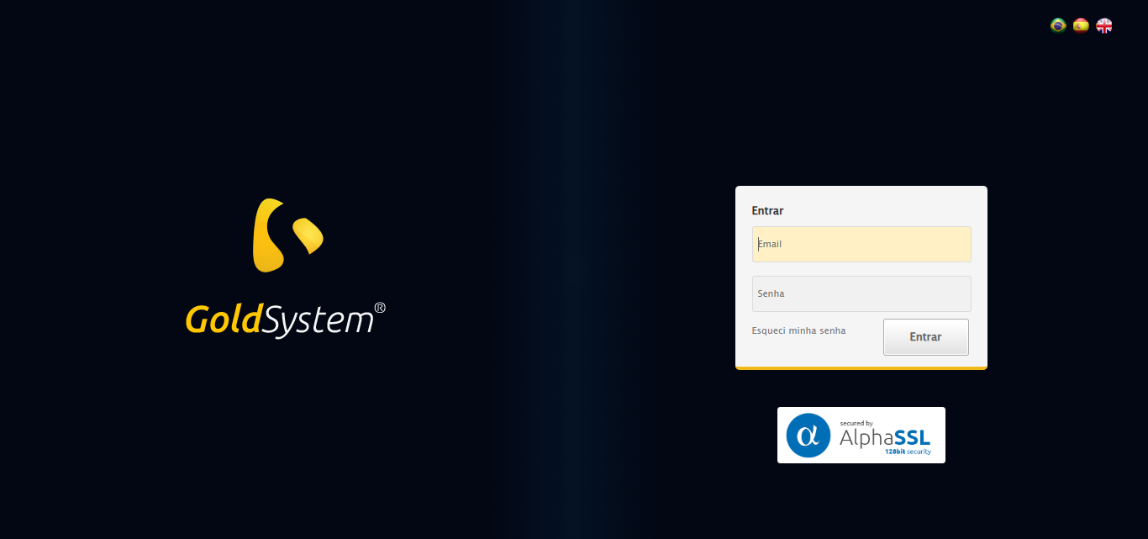

🔄 Realizando login...

✅ Realizando login realizada com sucesso.

Screenshot: realizando_login

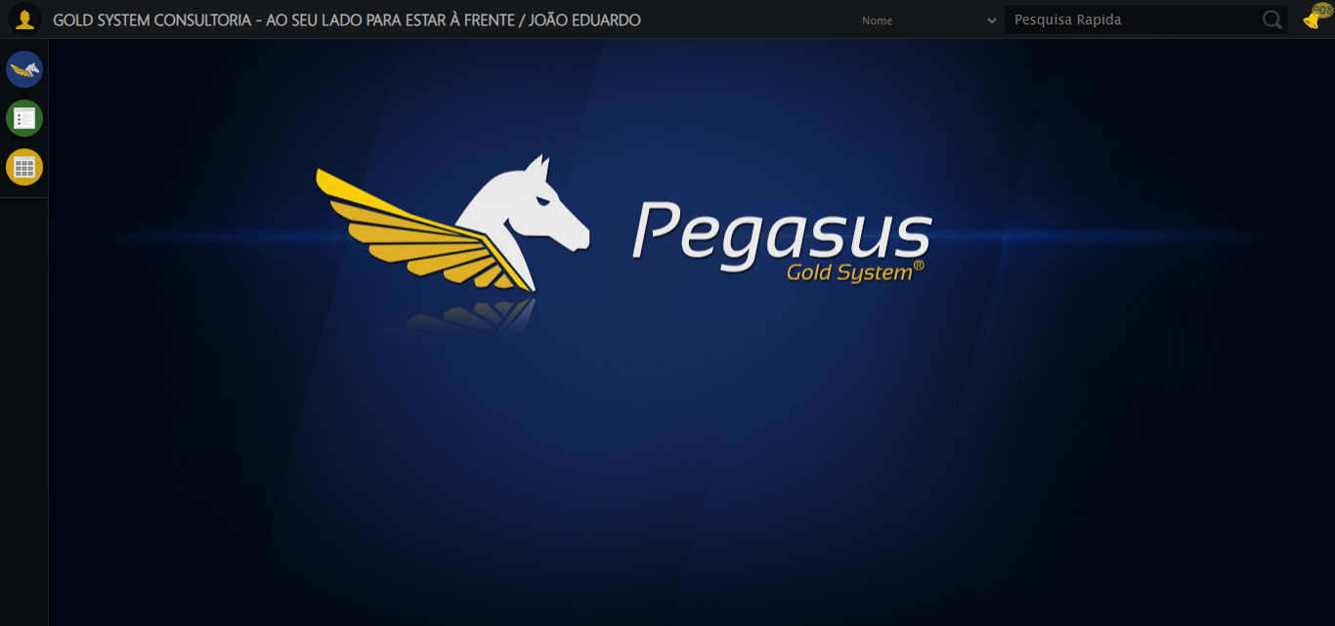

🔄 Ajustando zoom e abrindo menu...

🔍 Zoom ajustado para 90%.

✅ Ajustando zoom e abrindo menu realizada com sucesso.

Screenshot: ajustando_zoom_e_abrindo_menu

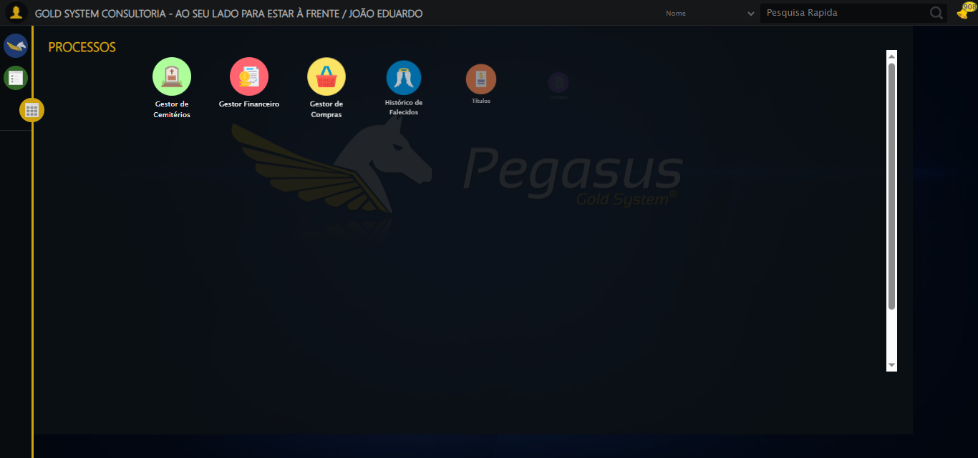

🔄 Acessando PET...

✅ Acessando PET realizada com sucesso.

Screenshot: acessando_pet

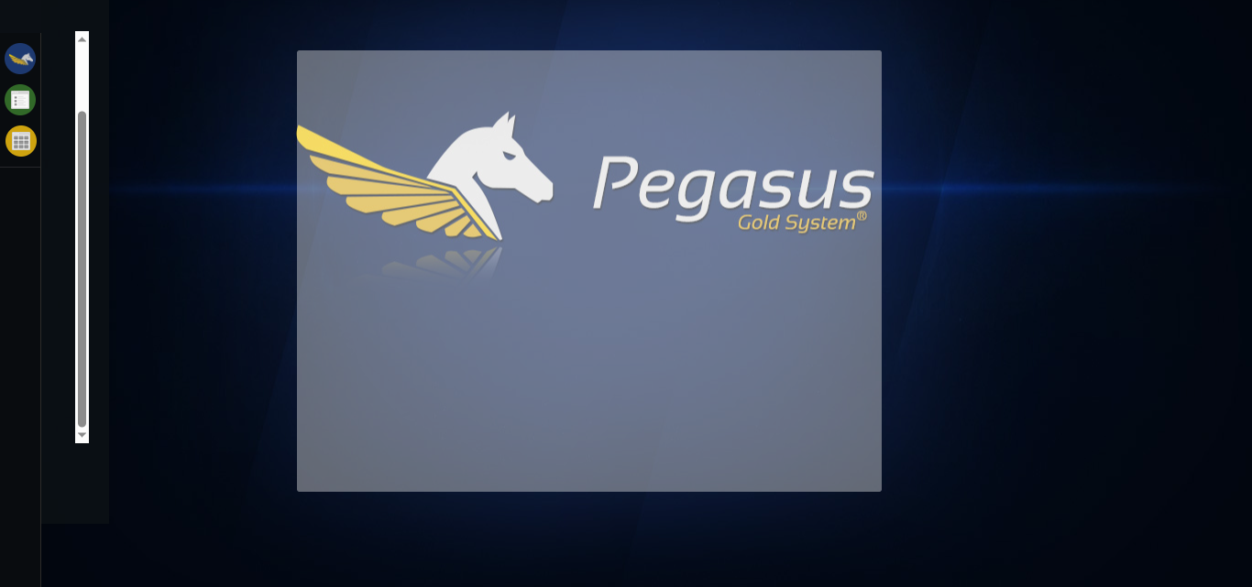

🔄 Clicando em Consultar Contrato...

✅ Clicando em Consultar Contrato realizada com sucesso.

Screenshot: clicando_em_consultar_contrato

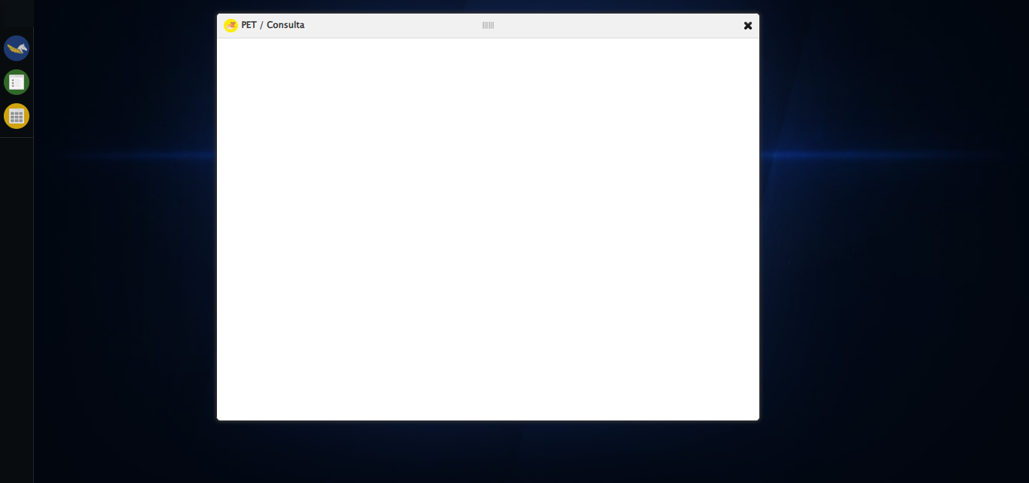

🔄 Selecionando Pessoas Envolvidas...

✅ Selecionando Pessoas Envolvidas realizada com sucesso.

Screenshot: selecionando_pessoas_envolvidas

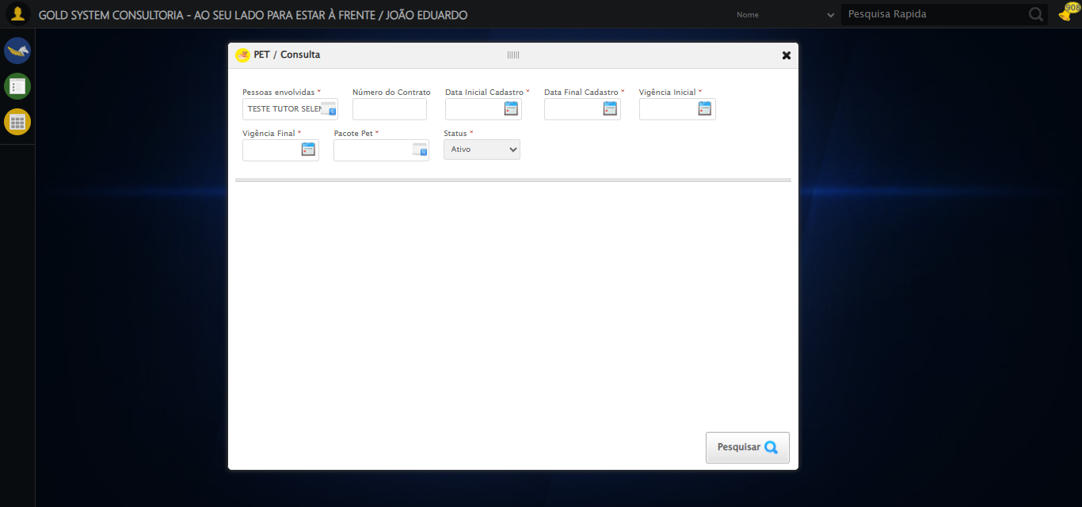

🔄 Preenchendo Número do Contrato...

✅ Campo preenchido com estratégia 1

✅ Preenchendo Número do Contrato realizada com sucesso.

Screenshot: preenchendo_número_do_contrato

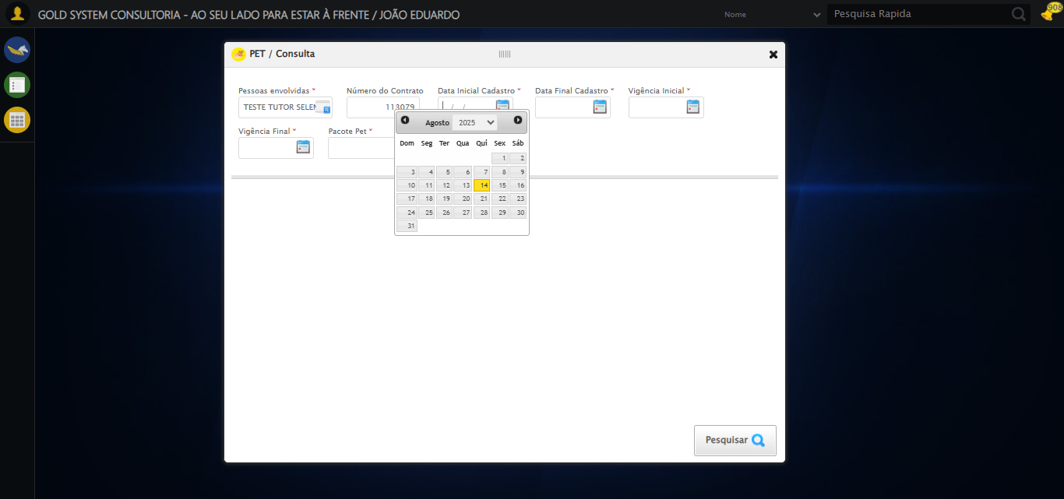

🔄 Preenchendo Data Inicial Cadastro...

📊 Encontrados 5 campos datepicker

🎯 Preenchendo datepicker 0 (ID: dp1755200726846) com '13/08/2025'

Tentando estratégia 1 para datepicker...

✅ Datepicker preenchido com estratégia 1: '13/08/2025'

✅ Preenchendo Data Inicial Cadastro realizada com sucesso.

Screenshot: preenchendo_data_inicial_cadastro

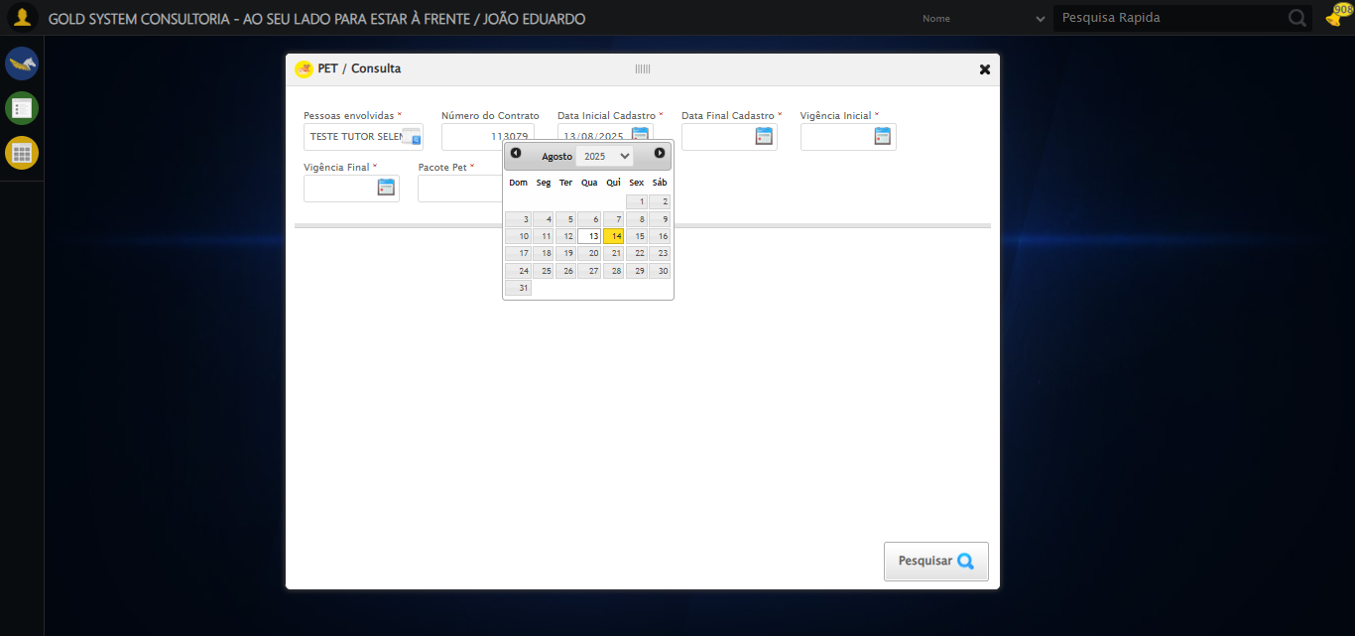

🔄 Preenchendo Data Final Cadastro...

📊 Encontrados 5 campos datepicker

🎯 Preenchendo datepicker 1 (ID: dp1755200726847) com '13/08/2025'

Tentando estratégia 1 para datepicker...

✅ Datepicker preenchido com estratégia 1: '13/08/2025'

✅ Preenchendo Data Final Cadastro realizada com sucesso.

Screenshot: preenchendo_data_final_cadastro

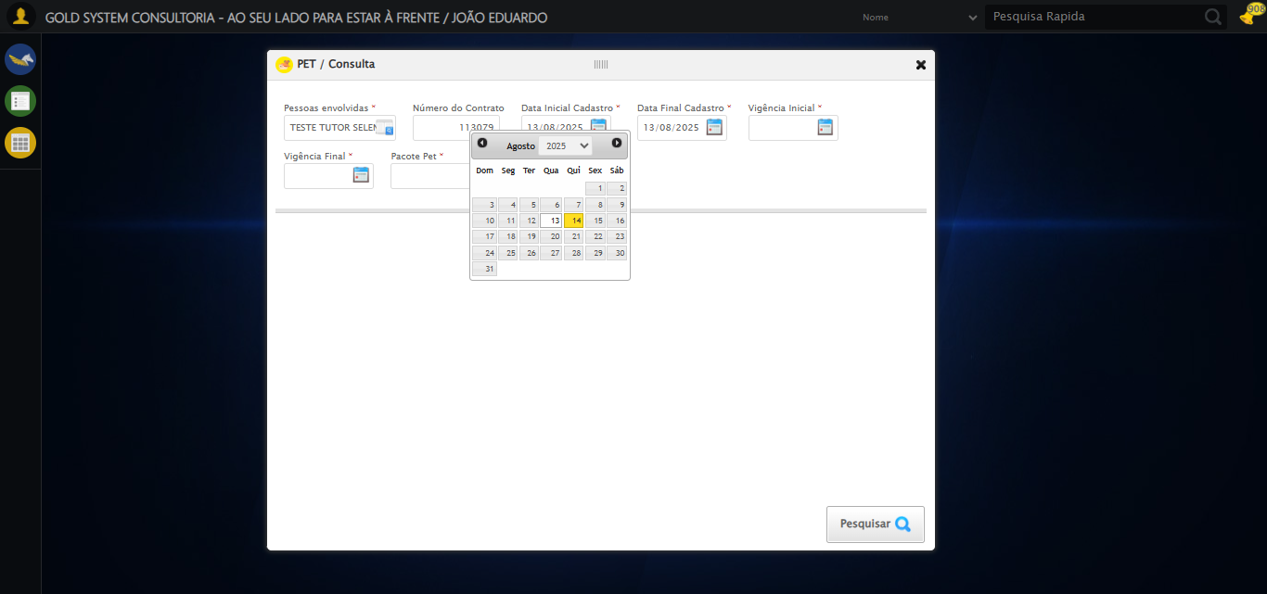

🔄 Preenchendo Vigência Inicial...

📊 Encontrados 5 campos datepicker

🎯 Preenchendo datepicker 2 (ID: dp1755200726844) com '13/08/2025'

Tentando estratégia 1 para datepicker...

✅ Datepicker preenchido com estratégia 1: '13/08/2025'

✅ Preenchendo Vigência Inicial realizada com sucesso.

Screenshot: preenchendo_vigência_inicial

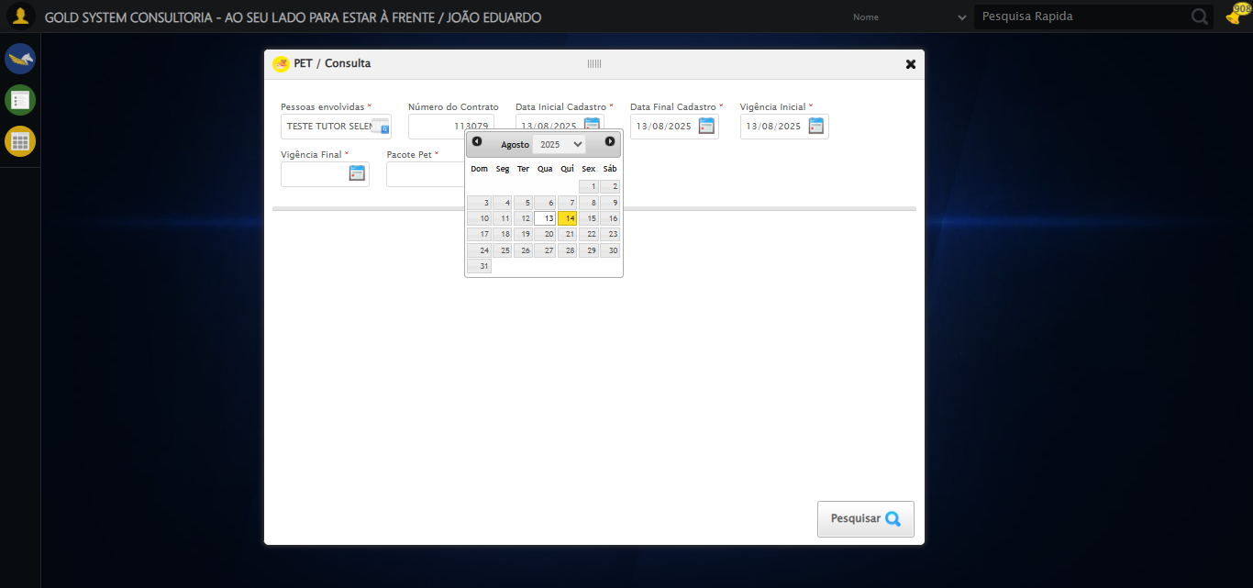

🔄 Preenchendo Vigência Final...

📊 Encontrados 5 campos datepicker

🎯 Preenchendo datepicker 3 (ID: dp1755200726845) com '13/11/2025'

Tentando estratégia 1 para datepicker...

✅ Datepicker preenchido com estratégia 1: '13/11/2025'

✅ Preenchendo Vigência Final realizada com sucesso.

Screenshot: preenchendo_vigência_final

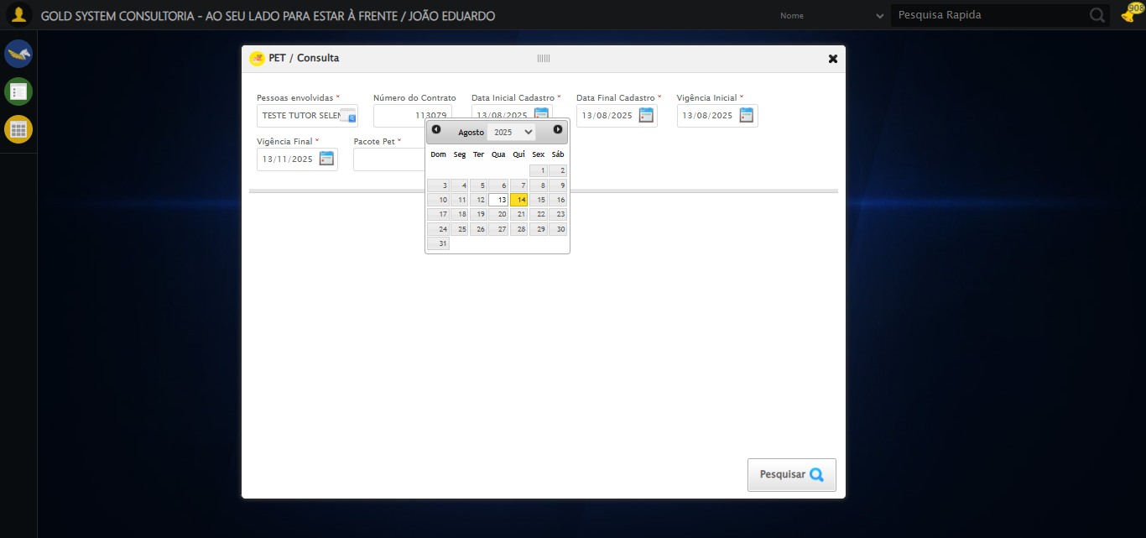

🔄 Selecionando Pacote Pet...

✅ Selecionando Pacote Pet realizada com sucesso.

Screenshot: selecionando_pacote_pet

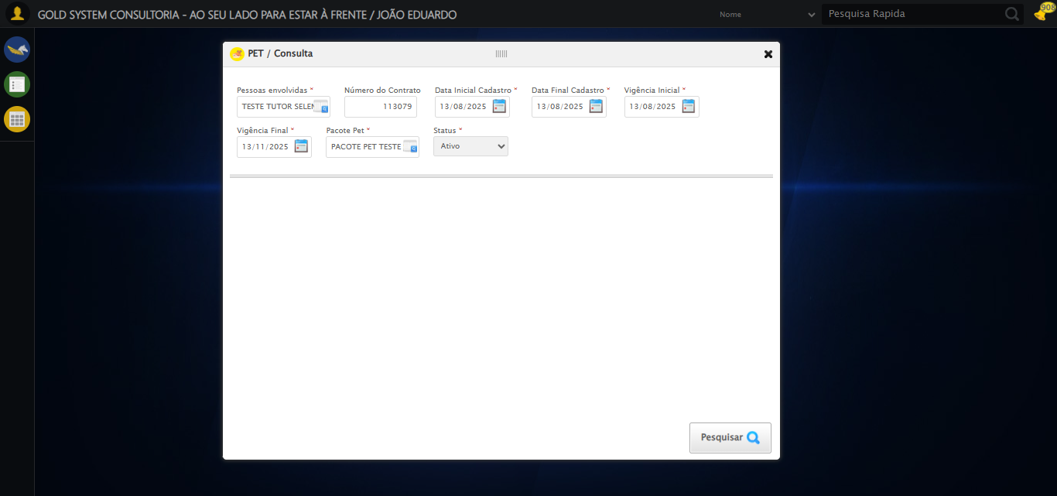

🔄 Realizando consulta...

✅ Realizando consulta realizada com sucesso.

Screenshot: realizando_consulta

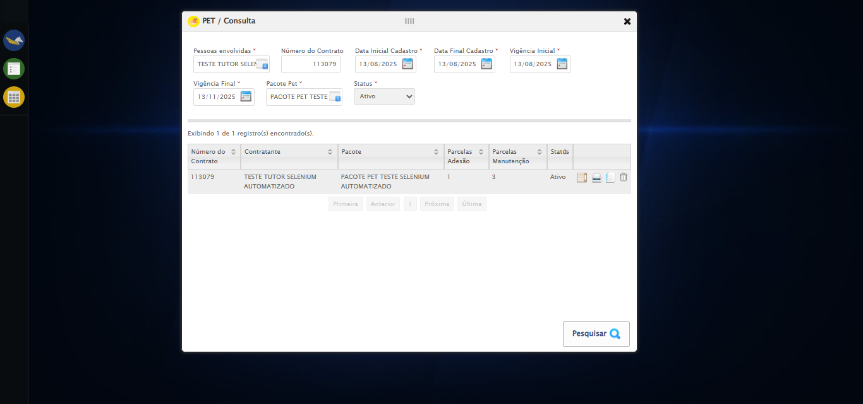

🔄 Validando resultados da consulta...

🔍 Iniciando validação de registros...

✅ Tabela encontrada: table[id*="DataTables"]

✅ Encontradas 1 linhas válidas

✅ 1 registro(s) encontrado(s)

Registro 1: 113079 teste tutor selenium automatizado pacote pet teste selenium automatizado 1 3 ativo

ℹ️ Nenhuma mensagem de alerta encontrada.

✅ Validando resultados da consulta realizada com sucesso.

Screenshot: validando_resultados_da_consulta



✅ Continuando com processamento de 1 registro(s)

🔄 Visualizando detalhes do Contrato Pet...

✅ Visualizando detalhes do Contrato Pet realizada com sucesso.

Screenshot: visualizando_detalhes_do_contrato_pet

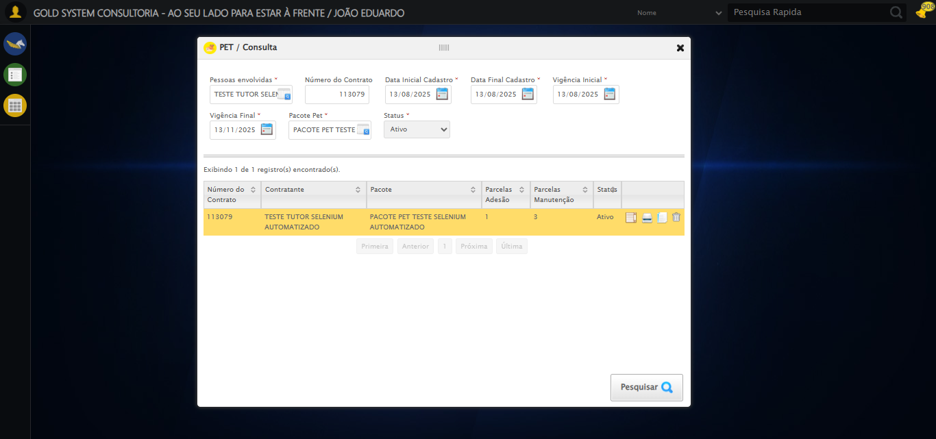

🔄 Capturando detalhes...

Screenshot: detalhes_contrato_pet

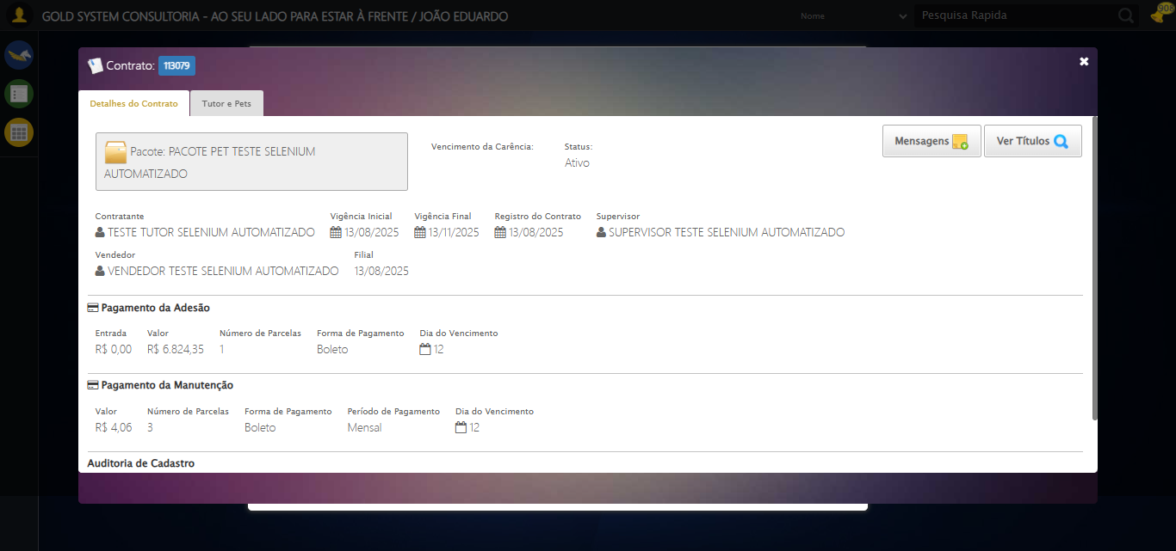

✅ Capturando detalhes realizada com sucesso.

Screenshot: capturando_detalhes



🔄 Conferindo Mensagens do Contrato Pet...

✅ Conferindo Mensagens do Contrato Pet realizada com sucesso.

Screenshot: conferindo_mensagens_do_contrato_pet

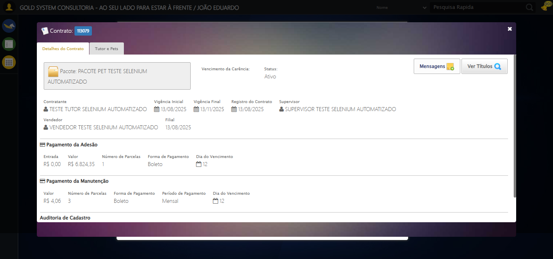

🔄 Capturando Mensagens do Contrato Pet...

Screenshot: mensagens_contrato_pet

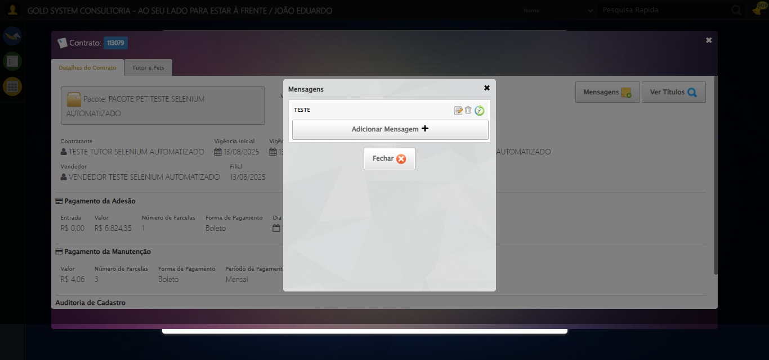

✅ Capturando Mensagens do Contrato Pet realizada com sucesso.

Screenshot: capturando_mensagens_do_contrato_pet



🔄 Clicando em Adicionar Mensagem...

Screenshot: erro_clicando_em_adicionar_mensagem

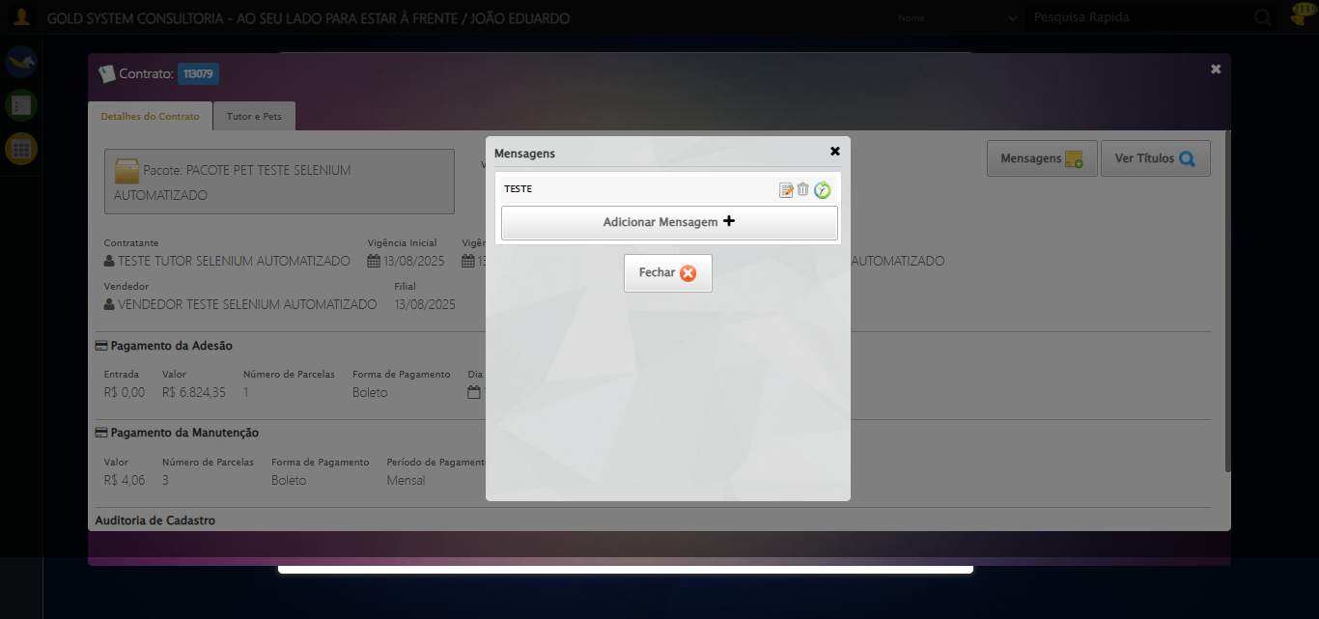

❌ Clicando em Adicionar Mensagem falhou: TimeoutException: Message: Elemento não encontrado: body > div:nth-child(306) > div.modal.overflow > div.mensagemContratos > div.content > div > a (condição: clickable)

— stacktrace —

Traceback (most recent call last):  
 File "C:\RPASelenium\RPAsPegasusSelenium\cenariostestespegasus\Processos\CadastrosCenáriosPet\ConsultaCenáriosContrato\consultadecontratopet1ºcenario.py", line 797, in aguardar_elemento  
 elemento = WebDriverWait(driver, timeout).until(  
 condicoes[condicao]((by_type, seletor))  
 )  
 File "C:\RPASelenium\RPAsPegasusSelenium\venv\Lib\site-packages\selenium\webdriver\support\wait.py", line 138, in until  
 raise TimeoutException(message, screen, stacktrace)  
selenium.common.exceptions.TimeoutException: Message:   
Stacktrace:  
 GetHandleVerifier [0x0xc6ba83+63395]  
 GetHandleVerifier [0x0xc6bac4+63460]  
 (No symbol) [0x0xab2113]  
 (No symbol) [0x0xafa85e]  
 (No symbol) [0x0xafabfb]  
 (No symbol) [0x0xb42f92]  
 (No symbol) [0x0xb1f3f4]  
 (No symbol) [0x0xb407ba]  
 (No symbol) [0x0xb1f1a6]  
 (No symbol) [0x0xaee7b2]  
 (No symbol) [0x0xaef654]  
 GetHandleVerifier [0x0xee8883+2672035]  
 GetHandleVerifier [0x0xee3cba+2652634]  
 GetHandleVerifier [0x0xc92bca+223466]  
 GetHandleVerifier [0x0xc82cb8+158168]  
 GetHandleVerifier [0x0xc8978d+185517]  
 GetHandleVerifier [0x0xc73b78+96408]  
 GetHandleVerifier [0x0xc73d02+96802]  
 GetHandleVerifier [0x0xc5e90a+9770]  
 BaseThreadInitThunk [0x0x7709fcc9+25]  
 RtlGetAppContainerNamedObjectPath [0x0x778882ae+286]  
 RtlGetAppContainerNamedObjectPath [0x0x7788827e+238]  
  
  
During handling of the above exception, another exception occurred:  
  
Traceback (most recent call last):  
 File "C:\RPASelenium\RPAsPegasusSelenium\cenariostestespegasus\Processos\CadastrosCenáriosPet\ConsultaCenáriosContrato\consultadecontratopet1ºcenario.py", line 173, in safe_action  
 func()  
 ~~~~^^  
 File "C:\RPASelenium\RPAsPegasusSelenium\cenariostestespegasus\Processos\CadastrosCenáriosPet\ConsultaCenáriosContrato\consultadecontratopet1ºcenario.py", line 920, in acao  
 elemento = aguardar_elemento(seletor)  
 File "C:\RPASelenium\RPAsPegasusSelenium\cenariostestespegasus\Processos\CadastrosCenáriosPet\ConsultaCenáriosContrato\consultadecontratopet1ºcenario.py", line 802, in aguardar_elemento  
 raise TimeoutException(f"Elemento não encontrado: {seletor} (condição: {condicao})")  
selenium.common.exceptions.TimeoutException: Message: Elemento não encontrado: body > div:nth-child(306) > div.modal.overflow > div.mensagemContratos > div.content > div > a (condição: clickable)

🔄 Preenchendo descrição da mensagem...

Screenshot: erro_preenchendo_descrição_da_mensagem



❌ Preenchendo descrição da mensagem falhou: TimeoutException: Message: Elemento não encontrado: body > div:nth-child(307) > div.modal.overflow > div.cadastroMensagem > div:nth-child(3) > textarea (condição: clickable)

— stacktrace —

Traceback (most recent call last):  
 File "C:\RPASelenium\RPAsPegasusSelenium\cenariostestespegasus\Processos\CadastrosCenáriosPet\ConsultaCenáriosContrato\consultadecontratopet1ºcenario.py", line 797, in aguardar_elemento  
 elemento = WebDriverWait(driver, timeout).until(  
 condicoes[condicao]((by_type, seletor))  
 )  
 File "C:\RPASelenium\RPAsPegasusSelenium\venv\Lib\site-packages\selenium\webdriver\support\wait.py", line 138, in until  
 raise TimeoutException(message, screen, stacktrace)  
selenium.common.exceptions.TimeoutException: Message:   
Stacktrace:  
 GetHandleVerifier [0x0xc6ba83+63395]  
 GetHandleVerifier [0x0xc6bac4+63460]  
 (No symbol) [0x0xab2113]  
 (No symbol) [0x0xafa85e]  
 (No symbol) [0x0xafabfb]  
 (No symbol) [0x0xb42f92]  
 (No symbol) [0x0xb1f3f4]  
 (No symbol) [0x0xb407ba]  
 (No symbol) [0x0xb1f1a6]  
 (No symbol) [0x0xaee7b2]  
 (No symbol) [0x0xaef654]  
 GetHandleVerifier [0x0xee8883+2672035]  
 GetHandleVerifier [0x0xee3cba+2652634]  
 GetHandleVerifier [0x0xc92bca+223466]  
 GetHandleVerifier [0x0xc82cb8+158168]  
 GetHandleVerifier [0x0xc8978d+185517]  
 GetHandleVerifier [0x0xc73b78+96408]  
 GetHandleVerifier [0x0xc73d02+96802]  
 GetHandleVerifier [0x0xc5e90a+9770]  
 BaseThreadInitThunk [0x0x7709fcc9+25]  
 RtlGetAppContainerNamedObjectPath [0x0x778882ae+286]  
 RtlGetAppContainerNamedObjectPath [0x0x7788827e+238]  
  
  
During handling of the above exception, another exception occurred:  
  
Traceback (most recent call last):  
 File "C:\RPASelenium\RPAsPegasusSelenium\cenariostestespegasus\Processos\CadastrosCenáriosPet\ConsultaCenáriosContrato\consultadecontratopet1ºcenario.py", line 173, in safe_action  
 func()  
 ~~~~^^  
 File "C:\RPASelenium\RPAsPegasusSelenium\cenariostestespegasus\Processos\CadastrosCenáriosPet\ConsultaCenáriosContrato\consultadecontratopet1ºcenario.py", line 829, in acao  
 elemento = aguardar_elemento(seletor, condicao='clickable')  
 File "C:\RPASelenium\RPAsPegasusSelenium\cenariostestespegasus\Processos\CadastrosCenáriosPet\ConsultaCenáriosContrato\consultadecontratopet1ºcenario.py", line 802, in aguardar_elemento  
 raise TimeoutException(f"Elemento não encontrado: {seletor} (condição: {condicao})")  
selenium.common.exceptions.TimeoutException: Message: Elemento não encontrado: body > div:nth-child(307) > div.modal.overflow > div.cadastroMensagem > div:nth-child(3) > textarea (condição: clickable)

🔄 Preenchendo Data Inicial do Período de exibição da observação...

📊 Encontrados 5 campos datepicker

🎯 Preenchendo datepicker 0 (ID: dp1755200726846) com '14/08/2025'

Tentando estratégia 1 para datepicker...

✅ Datepicker preenchido com estratégia 1: '14/08/2025'

✅ Preenchendo Data Inicial do Período de exibição da observação realizada com sucesso.

Screenshot: preenchendo_data_inicial_do_período_de_exibição_da_observação



🔄 Preenchendo Data Final do Período de exibição da observação...

📊 Encontrados 5 campos datepicker

🎯 Preenchendo datepicker 1 (ID: dp1755200726847) com '24/11/2025'

Tentando estratégia 1 para datepicker...

✅ Datepicker preenchido com estratégia 1: '24/11/2025'

✅ Preenchendo Data Final do Período de exibição da observação realizada com sucesso.

Screenshot: preenchendo_data_final_do_período_de_exibição_da_observação



🔄 Confirmando mensagem...

Screenshot: erro_confirmando_mensagem



❌ Confirmando mensagem falhou: TimeoutException: Message: Elemento não encontrado: body > div:nth-child(307) > div.modal.overflow > div.cadastroMensagem > div.formRow.hAlign > a.btModel.btGray.hAlign (condição: clickable)

— stacktrace —

Traceback (most recent call last):  
 File "C:\RPASelenium\RPAsPegasusSelenium\cenariostestespegasus\Processos\CadastrosCenáriosPet\ConsultaCenáriosContrato\consultadecontratopet1ºcenario.py", line 797, in aguardar_elemento  
 elemento = WebDriverWait(driver, timeout).until(  
 condicoes[condicao]((by_type, seletor))  
 )  
 File "C:\RPASelenium\RPAsPegasusSelenium\venv\Lib\site-packages\selenium\webdriver\support\wait.py", line 138, in until  
 raise TimeoutException(message, screen, stacktrace)  
selenium.common.exceptions.TimeoutException: Message:   
Stacktrace:  
 GetHandleVerifier [0x0xc6ba83+63395]  
 GetHandleVerifier [0x0xc6bac4+63460]  
 (No symbol) [0x0xab2113]  
 (No symbol) [0x0xafa85e]  
 (No symbol) [0x0xafabfb]  
 (No symbol) [0x0xb42f92]  
 (No symbol) [0x0xb1f3f4]  
 (No symbol) [0x0xb407ba]  
 (No symbol) [0x0xb1f1a6]  
 (No symbol) [0x0xaee7b2]  
 (No symbol) [0x0xaef654]  
 GetHandleVerifier [0x0xee8883+2672035]  
 GetHandleVerifier [0x0xee3cba+2652634]  
 GetHandleVerifier [0x0xc92bca+223466]  
 GetHandleVerifier [0x0xc82cb8+158168]  
 GetHandleVerifier [0x0xc8978d+185517]  
 GetHandleVerifier [0x0xc73b78+96408]  
 GetHandleVerifier [0x0xc73d02+96802]  
 GetHandleVerifier [0x0xc5e90a+9770]  
 BaseThreadInitThunk [0x0x7709fcc9+25]  
 RtlGetAppContainerNamedObjectPath [0x0x778882ae+286]  
 RtlGetAppContainerNamedObjectPath [0x0x7788827e+238]  
  
  
During handling of the above exception, another exception occurred:  
  
Traceback (most recent call last):  
 File "C:\RPASelenium\RPAsPegasusSelenium\cenariostestespegasus\Processos\CadastrosCenáriosPet\ConsultaCenáriosContrato\consultadecontratopet1ºcenario.py", line 173, in safe_action  
 func()  
 ~~~~^^  
 File "C:\RPASelenium\RPAsPegasusSelenium\cenariostestespegasus\Processos\CadastrosCenáriosPet\ConsultaCenáriosContrato\consultadecontratopet1ºcenario.py", line 920, in acao  
 elemento = aguardar_elemento(seletor)  
 File "C:\RPASelenium\RPAsPegasusSelenium\cenariostestespegasus\Processos\CadastrosCenáriosPet\ConsultaCenáriosContrato\consultadecontratopet1ºcenario.py", line 802, in aguardar_elemento  
 raise TimeoutException(f"Elemento não encontrado: {seletor} (condição: {condicao})")  
selenium.common.exceptions.TimeoutException: Message: Elemento não encontrado: body > div:nth-child(307) > div.modal.overflow > div.cadastroMensagem > div.formRow.hAlign > a.btModel.btGray.hAlign (condição: clickable)

🔄 Fechando aba de Mensagens...

⚠️ Erro ao tirar screenshot erro_fechando_aba_de_mensagens: Message: invalid session id; For documentation on this error, please visit: https://www.selenium.dev/documentation/webdriver/troubleshooting/errors#invalidsessionidexception  
Stacktrace:  
 GetHandleVerifier [0x0xc6ba83+63395]  
 GetHandleVerifier [0x0xc6bac4+63460]  
 (No symbol) [0x0xab1f70]  
 (No symbol) [0x0xaedaa8]  
 (No symbol) [0x0xb1f266]  
 (No symbol) [0x0xb1ae65]  
 (No symbol) [0x0xb1a3e6]  
 (No symbol) [0x0xa83a45]  
 (No symbol) [0x0xa83f9e]  
 (No symbol) [0x0xa8442d]  
 GetHandleVerifier [0x0xee8883+2672035]  
 GetHandleVerifier [0x0xee3cba+2652634]  
 GetHandleVerifier [0x0xc92bca+223466]  
 GetHandleVerifier [0x0xc82cb8+158168]  
 GetHandleVerifier [0x0xc8978d+185517]  
 (No symbol) [0x0xa83710]  
 (No symbol) [0x0xa82f1d]  
 GetHandleVerifier [0x0x101db9c+3938492]  
 BaseThreadInitThunk [0x0x7709fcc9+25]  
 RtlGetAppContainerNamedObjectPath [0x0x778882ae+286]  
 RtlGetAppContainerNamedObjectPath [0x0x7788827e+238]

❌ Fechando aba de Mensagens falhou: InvalidSessionIdException: Message: invalid session id: session deleted as the browser has closed the connection  
from disconnected: not connected to DevTools  
 (Session info: chrome=138.0.7204.185); For documentation on this error, please visit: https://www.selenium.dev/documentation/webdriver/troubleshooting/errors#invalidsessionidexception  
Stacktrace:  
 GetHandleVerifier [0x0xc6ba83+63395]  
 GetHandleVerifier [0x0xc6bac4+63460]  
 (No symbol) [0x0xab2113]  
 (No symbol) [0x0xaa1b20]  
 (No symbol) [0x0xabf922]  
 (No symbol) [0x0xb25c9c]  
 (No symbol) [0x0xb40099]  
 (No symbol) [0x0xb1f1a6]  
 (No symbol) [0x0xaee7b2]  
 (No symbol) [0x0xaef654]  
 GetHandleVerifier [0x0xee8883+2672035]  
 GetHandleVerifier [0x0xee3cba+2652634]  
 GetHandleVerifier [0x0xc92bca+223466]  
 GetHandleVerifier [0x0xc82cb8+158168]  
 GetHandleVerifier [0x0xc8978d+185517]  
 GetHandleVerifier [0x0xc73b78+96408]  
 GetHandleVerifier [0x0xc73d02+96802]  
 GetHandleVerifier [0x0xc5e90a+9770]  
 BaseThreadInitThunk [0x0x7709fcc9+25]  
 RtlGetAppContainerNamedObjectPath [0x0x778882ae+286]  
 RtlGetAppContainerNamedObjectPath [0x0x7788827e+238]

— stacktrace —

Traceback (most recent call last):  
 File "C:\RPASelenium\RPAsPegasusSelenium\cenariostestespegasus\Processos\CadastrosCenáriosPet\ConsultaCenáriosContrato\consultadecontratopet1ºcenario.py", line 173, in safe_action  
 func()  
 ~~~~^^  
 File "C:\RPASelenium\RPAsPegasusSelenium\cenariostestespegasus\Processos\CadastrosCenáriosPet\ConsultaCenáriosContrato\consultadecontratopet1ºcenario.py", line 920, in acao  
 elemento = aguardar_elemento(seletor)  
 File "C:\RPASelenium\RPAsPegasusSelenium\cenariostestespegasus\Processos\CadastrosCenáriosPet\ConsultaCenáriosContrato\consultadecontratopet1ºcenario.py", line 797, in aguardar_elemento  
 elemento = WebDriverWait(driver, timeout).until(  
 condicoes[condicao]((by_type, seletor))  
 )  
 File "C:\RPASelenium\RPAsPegasusSelenium\venv\Lib\site-packages\selenium\webdriver\support\wait.py", line 129, in until  
 value = method(self._driver)  
 File "C:\RPASelenium\RPAsPegasusSelenium\venv\Lib\site-packages\selenium\webdriver\support\expected_conditions.py", line 624, in _predicate  
 target = driver.find_element(*target) # grab element at locator  
 File "C:\RPASelenium\RPAsPegasusSelenium\venv\Lib\site-packages\selenium\webdriver\remote\webdriver.py", line 926, in find_element  
 return self.execute(Command.FIND_ELEMENT, {"using": by, "value": value})["value"]  
 ~~~~~~~~~~~~^^^^^^^^^^^^^^^^^^^^^^^^^^^^^^^^^^^^^^^^^^^^^^^^^^^^^  
 File "C:\RPASelenium\RPAsPegasusSelenium\venv\Lib\site-packages\selenium\webdriver\remote\webdriver.py", line 458, in execute  
 self.error_handler.check_response(response)  
 ~~~~~~~~~~~~~~~~~~~~~~~~~~~~~~~~~^^^^^^^^^^  
 File "C:\RPASelenium\RPAsPegasusSelenium\venv\Lib\site-packages\selenium\webdriver\remote\errorhandler.py", line 232, in check_response  
 raise exception_class(message, screen, stacktrace)  
selenium.common.exceptions.InvalidSessionIdException: Message: invalid session id: session deleted as the browser has closed the connection  
from disconnected: not connected to DevTools  
 (Session info: chrome=138.0.7204.185); For documentation on this error, please visit: https://www.selenium.dev/documentation/webdriver/troubleshooting/errors#invalidsessionidexception  
Stacktrace:  
 GetHandleVerifier [0x0xc6ba83+63395]  
 GetHandleVerifier [0x0xc6bac4+63460]  
 (No symbol) [0x0xab2113]  
 (No symbol) [0x0xaa1b20]  
 (No symbol) [0x0xabf922]  
 (No symbol) [0x0xb25c9c]  
 (No symbol) [0x0xb40099]  
 (No symbol) [0x0xb1f1a6]  
 (No symbol) [0x0xaee7b2]  
 (No symbol) [0x0xaef654]  
 GetHandleVerifier [0x0xee8883+2672035]  
 GetHandleVerifier [0x0xee3cba+2652634]  
 GetHandleVerifier [0x0xc92bca+223466]  
 GetHandleVerifier [0x0xc82cb8+158168]  
 GetHandleVerifier [0x0xc8978d+185517]  
 GetHandleVerifier [0x0xc73b78+96408]  
 GetHandleVerifier [0x0xc73d02+96802]  
 GetHandleVerifier [0x0xc5e90a+9770]  
 BaseThreadInitThunk [0x0x7709fcc9+25]  
 RtlGetAppContainerNamedObjectPath [0x0x778882ae+286]  
 RtlGetAppContainerNamedObjectPath [0x0x7788827e+238]

🔄 Conferindo Títulos do Contrato Pet...

⚠️ Erro ao tirar screenshot erro_conferindo_títulos_do_contrato_pet: Message: invalid session id; For documentation on this error, please visit: https://www.selenium.dev/documentation/webdriver/troubleshooting/errors#invalidsessionidexception  
Stacktrace:  
 GetHandleVerifier [0x0xc6ba83+63395]  
 GetHandleVerifier [0x0xc6bac4+63460]  
 (No symbol) [0x0xab1f70]  
 (No symbol) [0x0xaedaa8]  
 (No symbol) [0x0xb1f266]  
 (No symbol) [0x0xb1ae65]  
 (No symbol) [0x0xb1a3e6]  
 (No symbol) [0x0xa83a45]  
 (No symbol) [0x0xa83f9e]  
 (No symbol) [0x0xa8442d]  
 GetHandleVerifier [0x0xee8883+2672035]  
 GetHandleVerifier [0x0xee3cba+2652634]  
 GetHandleVerifier [0x0xc92bca+223466]  
 GetHandleVerifier [0x0xc82cb8+158168]  
 GetHandleVerifier [0x0xc8978d+185517]  
 (No symbol) [0x0xa83710]  
 (No symbol) [0x0xa82f1d]  
 GetHandleVerifier [0x0x101db9c+3938492]  
 BaseThreadInitThunk [0x0x7709fcc9+25]  
 RtlGetAppContainerNamedObjectPath [0x0x778882ae+286]  
 RtlGetAppContainerNamedObjectPath [0x0x7788827e+238]

❌ Conferindo Títulos do Contrato Pet falhou: InvalidSessionIdException: Message: invalid session id; For documentation on this error, please visit: https://www.selenium.dev/documentation/webdriver/troubleshooting/errors#invalidsessionidexception  
Stacktrace:  
 GetHandleVerifier [0x0xc6ba83+63395]  
 GetHandleVerifier [0x0xc6bac4+63460]  
 (No symbol) [0x0xab1f70]  
 (No symbol) [0x0xaedaa8]  
 (No symbol) [0x0xb1f266]  
 (No symbol) [0x0xb1ae65]  
 (No symbol) [0x0xb1a3e6]  
 (No symbol) [0x0xa83a45]  
 (No symbol) [0x0xa83f9e]  
 (No symbol) [0x0xa8442d]  
 GetHandleVerifier [0x0xee8883+2672035]  
 GetHandleVerifier [0x0xee3cba+2652634]  
 GetHandleVerifier [0x0xc92bca+223466]  
 GetHandleVerifier [0x0xc82cb8+158168]  
 GetHandleVerifier [0x0xc8978d+185517]  
 (No symbol) [0x0xa83710]  
 (No symbol) [0x0xa82f1d]  
 GetHandleVerifier [0x0x101db9c+3938492]  
 BaseThreadInitThunk [0x0x7709fcc9+25]  
 RtlGetAppContainerNamedObjectPath [0x0x778882ae+286]  
 RtlGetAppContainerNamedObjectPath [0x0x7788827e+238]

— stacktrace —

Traceback (most recent call last):  
 File "C:\RPASelenium\RPAsPegasusSelenium\cenariostestespegasus\Processos\CadastrosCenáriosPet\ConsultaCenáriosContrato\consultadecontratopet1ºcenario.py", line 173, in safe_action  
 func()  
 ~~~~^^  
 File "C:\RPASelenium\RPAsPegasusSelenium\cenariostestespegasus\Processos\CadastrosCenáriosPet\ConsultaCenáriosContrato\consultadecontratopet1ºcenario.py", line 920, in acao  
 elemento = aguardar_elemento(seletor)  
 File "C:\RPASelenium\RPAsPegasusSelenium\cenariostestespegasus\Processos\CadastrosCenáriosPet\ConsultaCenáriosContrato\consultadecontratopet1ºcenario.py", line 797, in aguardar_elemento  
 elemento = WebDriverWait(driver, timeout).until(  
 condicoes[condicao]((by_type, seletor))  
 )  
 File "C:\RPASelenium\RPAsPegasusSelenium\venv\Lib\site-packages\selenium\webdriver\support\wait.py", line 129, in until  
 value = method(self._driver)  
 File "C:\RPASelenium\RPAsPegasusSelenium\venv\Lib\site-packages\selenium\webdriver\support\expected_conditions.py", line 624, in _predicate  
 target = driver.find_element(*target) # grab element at locator  
 File "C:\RPASelenium\RPAsPegasusSelenium\venv\Lib\site-packages\selenium\webdriver\remote\webdriver.py", line 926, in find_element  
 return self.execute(Command.FIND_ELEMENT, {"using": by, "value": value})["value"]  
 ~~~~~~~~~~~~^^^^^^^^^^^^^^^^^^^^^^^^^^^^^^^^^^^^^^^^^^^^^^^^^^^^^  
 File "C:\RPASelenium\RPAsPegasusSelenium\venv\Lib\site-packages\selenium\webdriver\remote\webdriver.py", line 458, in execute  
 self.error_handler.check_response(response)  
 ~~~~~~~~~~~~~~~~~~~~~~~~~~~~~~~~~^^^^^^^^^^  
 File "C:\RPASelenium\RPAsPegasusSelenium\venv\Lib\site-packages\selenium\webdriver\remote\errorhandler.py", line 232, in check_response  
 raise exception_class(message, screen, stacktrace)  
selenium.common.exceptions.InvalidSessionIdException: Message: invalid session id; For documentation on this error, please visit: https://www.selenium.dev/documentation/webdriver/troubleshooting/errors#invalidsessionidexception  
Stacktrace:  
 GetHandleVerifier [0x0xc6ba83+63395]  
 GetHandleVerifier [0x0xc6bac4+63460]  
 (No symbol) [0x0xab1f70]  
 (No symbol) [0x0xaedaa8]  
 (No symbol) [0x0xb1f266]  
 (No symbol) [0x0xb1ae65]  
 (No symbol) [0x0xb1a3e6]  
 (No symbol) [0x0xa83a45]  
 (No symbol) [0x0xa83f9e]  
 (No symbol) [0x0xa8442d]  
 GetHandleVerifier [0x0xee8883+2672035]  
 GetHandleVerifier [0x0xee3cba+2652634]  
 GetHandleVerifier [0x0xc92bca+223466]  
 GetHandleVerifier [0x0xc82cb8+158168]  
 GetHandleVerifier [0x0xc8978d+185517]  
 (No symbol) [0x0xa83710]  
 (No symbol) [0x0xa82f1d]  
 GetHandleVerifier [0x0x101db9c+3938492]  
 BaseThreadInitThunk [0x0x7709fcc9+25]  
 RtlGetAppContainerNamedObjectPath [0x0x778882ae+286]  
 RtlGetAppContainerNamedObjectPath [0x0x7788827e+238]

🔄 Capturando Títulos do Contrato Pet...

⚠️ Erro ao tirar screenshot titulos_contrato_pet: Message: invalid session id; For documentation on this error, please visit: https://www.selenium.dev/documentation/webdriver/troubleshooting/errors#invalidsessionidexception  
Stacktrace:  
 GetHandleVerifier [0x0xc6ba83+63395]  
 GetHandleVerifier [0x0xc6bac4+63460]  
 (No symbol) [0x0xab1f70]  
 (No symbol) [0x0xaedaa8]  
 (No symbol) [0x0xb1f266]  
 (No symbol) [0x0xb1ae65]  
 (No symbol) [0x0xb1a3e6]  
 (No symbol) [0x0xa83a45]  
 (No symbol) [0x0xa83f9e]  
 (No symbol) [0x0xa8442d]  
 GetHandleVerifier [0x0xee8883+2672035]  
 GetHandleVerifier [0x0xee3cba+2652634]  
 GetHandleVerifier [0x0xc92bca+223466]  
 GetHandleVerifier [0x0xc82cb8+158168]  
 GetHandleVerifier [0x0xc8978d+185517]  
 (No symbol) [0x0xa83710]  
 (No symbol) [0x0xa82f1d]  
 GetHandleVerifier [0x0x101db9c+3938492]  
 BaseThreadInitThunk [0x0x7709fcc9+25]  
 RtlGetAppContainerNamedObjectPath [0x0x778882ae+286]  
 RtlGetAppContainerNamedObjectPath [0x0x7788827e+238]

✅ Capturando Títulos do Contrato Pet realizada com sucesso.

⚠️ Erro ao tirar screenshot capturando_títulos_do_contrato_pet: Message: invalid session id; For documentation on this error, please visit: https://www.selenium.dev/documentation/webdriver/troubleshooting/errors#invalidsessionidexception  
Stacktrace:  
 GetHandleVerifier [0x0xc6ba83+63395]  
 GetHandleVerifier [0x0xc6bac4+63460]  
 (No symbol) [0x0xab1f70]  
 (No symbol) [0x0xaedaa8]  
 (No symbol) [0x0xb1f266]  
 (No symbol) [0x0xb1ae65]  
 (No symbol) [0x0xb1a3e6]  
 (No symbol) [0x0xa83a45]  
 (No symbol) [0x0xa83f9e]  
 (No symbol) [0x0xa8442d]  
 GetHandleVerifier [0x0xee8883+2672035]  
 GetHandleVerifier [0x0xee3cba+2652634]  
 GetHandleVerifier [0x0xc92bca+223466]  
 GetHandleVerifier [0x0xc82cb8+158168]  
 GetHandleVerifier [0x0xc8978d+185517]  
 (No symbol) [0x0xa83710]  
 (No symbol) [0x0xa82f1d]  
 GetHandleVerifier [0x0x101db9c+3938492]  
 BaseThreadInitThunk [0x0x7709fcc9+25]  
 RtlGetAppContainerNamedObjectPath [0x0x778882ae+286]  
 RtlGetAppContainerNamedObjectPath [0x0x7788827e+238]

🔄 Fechando aba de Geração de Títulos...

⚠️ Erro ao tirar screenshot erro_fechando_aba_de_geração_de_títulos: Message: invalid session id; For documentation on this error, please visit: https://www.selenium.dev/documentation/webdriver/troubleshooting/errors#invalidsessionidexception  
Stacktrace:  
 GetHandleVerifier [0x0xc6ba83+63395]  
 GetHandleVerifier [0x0xc6bac4+63460]  
 (No symbol) [0x0xab1f70]  
 (No symbol) [0x0xaedaa8]  
 (No symbol) [0x0xb1f266]  
 (No symbol) [0x0xb1ae65]  
 (No symbol) [0x0xb1a3e6]  
 (No symbol) [0x0xa83a45]  
 (No symbol) [0x0xa83f9e]  
 (No symbol) [0x0xa8442d]  
 GetHandleVerifier [0x0xee8883+2672035]  
 GetHandleVerifier [0x0xee3cba+2652634]  
 GetHandleVerifier [0x0xc92bca+223466]  
 GetHandleVerifier [0x0xc82cb8+158168]  
 GetHandleVerifier [0x0xc8978d+185517]  
 (No symbol) [0x0xa83710]  
 (No symbol) [0x0xa82f1d]  
 GetHandleVerifier [0x0x101db9c+3938492]  
 BaseThreadInitThunk [0x0x7709fcc9+25]  
 RtlGetAppContainerNamedObjectPath [0x0x778882ae+286]  
 RtlGetAppContainerNamedObjectPath [0x0x7788827e+238]

❌ Fechando aba de Geração de Títulos falhou: InvalidSessionIdException: Message: invalid session id; For documentation on this error, please visit: https://www.selenium.dev/documentation/webdriver/troubleshooting/errors#invalidsessionidexception  
Stacktrace:  
 GetHandleVerifier [0x0xc6ba83+63395]  
 GetHandleVerifier [0x0xc6bac4+63460]  
 (No symbol) [0x0xab1f70]  
 (No symbol) [0x0xaedaa8]  
 (No symbol) [0x0xb1f266]  
 (No symbol) [0x0xb1ae65]  
 (No symbol) [0x0xb1a3e6]  
 (No symbol) [0x0xa83a45]  
 (No symbol) [0x0xa83f9e]  
 (No symbol) [0x0xa8442d]  
 GetHandleVerifier [0x0xee8883+2672035]  
 GetHandleVerifier [0x0xee3cba+2652634]  
 GetHandleVerifier [0x0xc92bca+223466]  
 GetHandleVerifier [0x0xc82cb8+158168]  
 GetHandleVerifier [0x0xc8978d+185517]  
 (No symbol) [0x0xa83710]  
 (No symbol) [0x0xa82f1d]  
 GetHandleVerifier [0x0x101db9c+3938492]  
 BaseThreadInitThunk [0x0x7709fcc9+25]  
 RtlGetAppContainerNamedObjectPath [0x0x778882ae+286]  
 RtlGetAppContainerNamedObjectPath [0x0x7788827e+238]

— stacktrace —

Traceback (most recent call last):  
 File "C:\RPASelenium\RPAsPegasusSelenium\cenariostestespegasus\Processos\CadastrosCenáriosPet\ConsultaCenáriosContrato\consultadecontratopet1ºcenario.py", line 173, in safe_action  
 func()  
 ~~~~^^  
 File "C:\RPASelenium\RPAsPegasusSelenium\cenariostestespegasus\Processos\CadastrosCenáriosPet\ConsultaCenáriosContrato\consultadecontratopet1ºcenario.py", line 920, in acao  
 elemento = aguardar_elemento(seletor)  
 File "C:\RPASelenium\RPAsPegasusSelenium\cenariostestespegasus\Processos\CadastrosCenáriosPet\ConsultaCenáriosContrato\consultadecontratopet1ºcenario.py", line 797, in aguardar_elemento  
 elemento = WebDriverWait(driver, timeout).until(  
 condicoes[condicao]((by_type, seletor))  
 )  
 File "C:\RPASelenium\RPAsPegasusSelenium\venv\Lib\site-packages\selenium\webdriver\support\wait.py", line 129, in until  
 value = method(self._driver)  
 File "C:\RPASelenium\RPAsPegasusSelenium\venv\Lib\site-packages\selenium\webdriver\support\expected_conditions.py", line 624, in _predicate  
 target = driver.find_element(*target) # grab element at locator  
 File "C:\RPASelenium\RPAsPegasusSelenium\venv\Lib\site-packages\selenium\webdriver\remote\webdriver.py", line 926, in find_element  
 return self.execute(Command.FIND_ELEMENT, {"using": by, "value": value})["value"]  
 ~~~~~~~~~~~~^^^^^^^^^^^^^^^^^^^^^^^^^^^^^^^^^^^^^^^^^^^^^^^^^^^^^  
 File "C:\RPASelenium\RPAsPegasusSelenium\venv\Lib\site-packages\selenium\webdriver\remote\webdriver.py", line 458, in execute  
 self.error_handler.check_response(response)  
 ~~~~~~~~~~~~~~~~~~~~~~~~~~~~~~~~~^^^^^^^^^^  
 File "C:\RPASelenium\RPAsPegasusSelenium\venv\Lib\site-packages\selenium\webdriver\remote\errorhandler.py", line 232, in check_response  
 raise exception_class(message, screen, stacktrace)  
selenium.common.exceptions.InvalidSessionIdException: Message: invalid session id; For documentation on this error, please visit: https://www.selenium.dev/documentation/webdriver/troubleshooting/errors#invalidsessionidexception  
Stacktrace:  
 GetHandleVerifier [0x0xc6ba83+63395]  
 GetHandleVerifier [0x0xc6bac4+63460]  
 (No symbol) [0x0xab1f70]  
 (No symbol) [0x0xaedaa8]  
 (No symbol) [0x0xb1f266]  
 (No symbol) [0x0xb1ae65]  
 (No symbol) [0x0xb1a3e6]  
 (No symbol) [0x0xa83a45]  
 (No symbol) [0x0xa83f9e]  
 (No symbol) [0x0xa8442d]  
 GetHandleVerifier [0x0xee8883+2672035]  
 GetHandleVerifier [0x0xee3cba+2652634]  
 GetHandleVerifier [0x0xc92bca+223466]  
 GetHandleVerifier [0x0xc82cb8+158168]  
 GetHandleVerifier [0x0xc8978d+185517]  
 (No symbol) [0x0xa83710]  
 (No symbol) [0x0xa82f1d]  
 GetHandleVerifier [0x0x101db9c+3938492]  
 BaseThreadInitThunk [0x0x7709fcc9+25]  
 RtlGetAppContainerNamedObjectPath [0x0x778882ae+286]  
 RtlGetAppContainerNamedObjectPath [0x0x7788827e+238]

🔄 Abrindo digitalização de documentos...

⚠️ Erro ao tirar screenshot erro_abrindo_digitalização_de_documentos: Message: invalid session id; For documentation on this error, please visit: https://www.selenium.dev/documentation/webdriver/troubleshooting/errors#invalidsessionidexception  
Stacktrace:  
 GetHandleVerifier [0x0xc6ba83+63395]  
 GetHandleVerifier [0x0xc6bac4+63460]  
 (No symbol) [0x0xab1f70]  
 (No symbol) [0x0xaedaa8]  
 (No symbol) [0x0xb1f266]  
 (No symbol) [0x0xb1ae65]  
 (No symbol) [0x0xb1a3e6]  
 (No symbol) [0x0xa83a45]  
 (No symbol) [0x0xa83f9e]  
 (No symbol) [0x0xa8442d]  
 GetHandleVerifier [0x0xee8883+2672035]  
 GetHandleVerifier [0x0xee3cba+2652634]  
 GetHandleVerifier [0x0xc92bca+223466]  
 GetHandleVerifier [0x0xc82cb8+158168]  
 GetHandleVerifier [0x0xc8978d+185517]  
 (No symbol) [0x0xa83710]  
 (No symbol) [0x0xa82f1d]  
 GetHandleVerifier [0x0x101db9c+3938492]  
 BaseThreadInitThunk [0x0x7709fcc9+25]  
 RtlGetAppContainerNamedObjectPath [0x0x778882ae+286]  
 RtlGetAppContainerNamedObjectPath [0x0x7788827e+238]

❌ Abrindo digitalização de documentos falhou: InvalidSessionIdException: Message: invalid session id; For documentation on this error, please visit: https://www.selenium.dev/documentation/webdriver/troubleshooting/errors#invalidsessionidexception  
Stacktrace:  
 GetHandleVerifier [0x0xc6ba83+63395]  
 GetHandleVerifier [0x0xc6bac4+63460]  
 (No symbol) [0x0xab1f70]  
 (No symbol) [0x0xaedaa8]  
 (No symbol) [0x0xb1f266]  
 (No symbol) [0x0xb1ae65]  
 (No symbol) [0x0xb1a3e6]  
 (No symbol) [0x0xa83a45]  
 (No symbol) [0x0xa83f9e]  
 (No symbol) [0x0xa8442d]  
 GetHandleVerifier [0x0xee8883+2672035]  
 GetHandleVerifier [0x0xee3cba+2652634]  
 GetHandleVerifier [0x0xc92bca+223466]  
 GetHandleVerifier [0x0xc82cb8+158168]  
 GetHandleVerifier [0x0xc8978d+185517]  
 (No symbol) [0x0xa83710]  
 (No symbol) [0x0xa82f1d]  
 GetHandleVerifier [0x0x101db9c+3938492]  
 BaseThreadInitThunk [0x0x7709fcc9+25]  
 RtlGetAppContainerNamedObjectPath [0x0x778882ae+286]  
 RtlGetAppContainerNamedObjectPath [0x0x7788827e+238]

— stacktrace —

Traceback (most recent call last):  
 File "C:\RPASelenium\RPAsPegasusSelenium\cenariostestespegasus\Processos\CadastrosCenáriosPet\ConsultaCenáriosContrato\consultadecontratopet1ºcenario.py", line 173, in safe_action  
 func()  
 ~~~~^^  
 File "C:\RPASelenium\RPAsPegasusSelenium\cenariostestespegasus\Processos\CadastrosCenáriosPet\ConsultaCenáriosContrato\consultadecontratopet1ºcenario.py", line 920, in acao  
 elemento = aguardar_elemento(seletor)  
 File "C:\RPASelenium\RPAsPegasusSelenium\cenariostestespegasus\Processos\CadastrosCenáriosPet\ConsultaCenáriosContrato\consultadecontratopet1ºcenario.py", line 797, in aguardar_elemento  
 elemento = WebDriverWait(driver, timeout).until(  
 condicoes[condicao]((by_type, seletor))  
 )  
 File "C:\RPASelenium\RPAsPegasusSelenium\venv\Lib\site-packages\selenium\webdriver\support\wait.py", line 129, in until  
 value = method(self._driver)  
 File "C:\RPASelenium\RPAsPegasusSelenium\venv\Lib\site-packages\selenium\webdriver\support\expected_conditions.py", line 624, in _predicate  
 target = driver.find_element(*target) # grab element at locator  
 File "C:\RPASelenium\RPAsPegasusSelenium\venv\Lib\site-packages\selenium\webdriver\remote\webdriver.py", line 926, in find_element  
 return self.execute(Command.FIND_ELEMENT, {"using": by, "value": value})["value"]  
 ~~~~~~~~~~~~^^^^^^^^^^^^^^^^^^^^^^^^^^^^^^^^^^^^^^^^^^^^^^^^^^^^^  
 File "C:\RPASelenium\RPAsPegasusSelenium\venv\Lib\site-packages\selenium\webdriver\remote\webdriver.py", line 458, in execute  
 self.error_handler.check_response(response)  
 ~~~~~~~~~~~~~~~~~~~~~~~~~~~~~~~~~^^^^^^^^^^  
 File "C:\RPASelenium\RPAsPegasusSelenium\venv\Lib\site-packages\selenium\webdriver\remote\errorhandler.py", line 232, in check_response  
 raise exception_class(message, screen, stacktrace)  
selenium.common.exceptions.InvalidSessionIdException: Message: invalid session id; For documentation on this error, please visit: https://www.selenium.dev/documentation/webdriver/troubleshooting/errors#invalidsessionidexception  
Stacktrace:  
 GetHandleVerifier [0x0xc6ba83+63395]  
 GetHandleVerifier [0x0xc6bac4+63460]  
 (No symbol) [0x0xab1f70]  
 (No symbol) [0x0xaedaa8]  
 (No symbol) [0x0xb1f266]  
 (No symbol) [0x0xb1ae65]  
 (No symbol) [0x0xb1a3e6]  
 (No symbol) [0x0xa83a45]  
 (No symbol) [0x0xa83f9e]  
 (No symbol) [0x0xa8442d]  
 GetHandleVerifier [0x0xee8883+2672035]  
 GetHandleVerifier [0x0xee3cba+2652634]  
 GetHandleVerifier [0x0xc92bca+223466]  
 GetHandleVerifier [0x0xc82cb8+158168]  
 GetHandleVerifier [0x0xc8978d+185517]  
 (No symbol) [0x0xa83710]  
 (No symbol) [0x0xa82f1d]  
 GetHandleVerifier [0x0x101db9c+3938492]  
 BaseThreadInitThunk [0x0x7709fcc9+25]  
 RtlGetAppContainerNamedObjectPath [0x0x778882ae+286]  
 RtlGetAppContainerNamedObjectPath [0x0x7788827e+238]

🔄 Adicionando novo documento...

⚠️ Erro ao tirar screenshot erro_adicionando_novo_documento: Message: invalid session id; For documentation on this error, please visit: https://www.selenium.dev/documentation/webdriver/troubleshooting/errors#invalidsessionidexception  
Stacktrace:  
 GetHandleVerifier [0x0xc6ba83+63395]  
 GetHandleVerifier [0x0xc6bac4+63460]  
 (No symbol) [0x0xab1f70]  
 (No symbol) [0x0xaedaa8]  
 (No symbol) [0x0xb1f266]  
 (No symbol) [0x0xb1ae65]  
 (No symbol) [0x0xb1a3e6]  
 (No symbol) [0x0xa83a45]  
 (No symbol) [0x0xa83f9e]  
 (No symbol) [0x0xa8442d]  
 GetHandleVerifier [0x0xee8883+2672035]  
 GetHandleVerifier [0x0xee3cba+2652634]  
 GetHandleVerifier [0x0xc92bca+223466]  
 GetHandleVerifier [0x0xc82cb8+158168]  
 GetHandleVerifier [0x0xc8978d+185517]  
 (No symbol) [0x0xa83710]  
 (No symbol) [0x0xa82f1d]  
 GetHandleVerifier [0x0x101db9c+3938492]  
 BaseThreadInitThunk [0x0x7709fcc9+25]  
 RtlGetAppContainerNamedObjectPath [0x0x778882ae+286]  
 RtlGetAppContainerNamedObjectPath [0x0x7788827e+238]

❌ Adicionando novo documento falhou: InvalidSessionIdException: Message: invalid session id; For documentation on this error, please visit: https://www.selenium.dev/documentation/webdriver/troubleshooting/errors#invalidsessionidexception  
Stacktrace:  
 GetHandleVerifier [0x0xc6ba83+63395]  
 GetHandleVerifier [0x0xc6bac4+63460]  
 (No symbol) [0x0xab1f70]  
 (No symbol) [0x0xaedaa8]  
 (No symbol) [0x0xb1f266]  
 (No symbol) [0x0xb1ae65]  
 (No symbol) [0x0xb1a3e6]  
 (No symbol) [0x0xa83a45]  
 (No symbol) [0x0xa83f9e]  
 (No symbol) [0x0xa8442d]  
 GetHandleVerifier [0x0xee8883+2672035]  
 GetHandleVerifier [0x0xee3cba+2652634]  
 GetHandleVerifier [0x0xc92bca+223466]  
 GetHandleVerifier [0x0xc82cb8+158168]  
 GetHandleVerifier [0x0xc8978d+185517]  
 (No symbol) [0x0xa83710]  
 (No symbol) [0x0xa82f1d]  
 GetHandleVerifier [0x0x101db9c+3938492]  
 BaseThreadInitThunk [0x0x7709fcc9+25]  
 RtlGetAppContainerNamedObjectPath [0x0x778882ae+286]  
 RtlGetAppContainerNamedObjectPath [0x0x7788827e+238]

— stacktrace —

Traceback (most recent call last):  
 File "C:\RPASelenium\RPAsPegasusSelenium\cenariostestespegasus\Processos\CadastrosCenáriosPet\ConsultaCenáriosContrato\consultadecontratopet1ºcenario.py", line 173, in safe_action  
 func()  
 ~~~~^^  
 File "C:\RPASelenium\RPAsPegasusSelenium\cenariostestespegasus\Processos\CadastrosCenáriosPet\ConsultaCenáriosContrato\consultadecontratopet1ºcenario.py", line 920, in acao  
 elemento = aguardar_elemento(seletor)  
 File "C:\RPASelenium\RPAsPegasusSelenium\cenariostestespegasus\Processos\CadastrosCenáriosPet\ConsultaCenáriosContrato\consultadecontratopet1ºcenario.py", line 797, in aguardar_elemento  
 elemento = WebDriverWait(driver, timeout).until(  
 condicoes[condicao]((by_type, seletor))  
 )  
 File "C:\RPASelenium\RPAsPegasusSelenium\venv\Lib\site-packages\selenium\webdriver\support\wait.py", line 129, in until  
 value = method(self._driver)  
 File "C:\RPASelenium\RPAsPegasusSelenium\venv\Lib\site-packages\selenium\webdriver\support\expected_conditions.py", line 624, in _predicate  
 target = driver.find_element(*target) # grab element at locator  
 File "C:\RPASelenium\RPAsPegasusSelenium\venv\Lib\site-packages\selenium\webdriver\remote\webdriver.py", line 926, in find_element  
 return self.execute(Command.FIND_ELEMENT, {"using": by, "value": value})["value"]  
 ~~~~~~~~~~~~^^^^^^^^^^^^^^^^^^^^^^^^^^^^^^^^^^^^^^^^^^^^^^^^^^^^^  
 File "C:\RPASelenium\RPAsPegasusSelenium\venv\Lib\site-packages\selenium\webdriver\remote\webdriver.py", line 458, in execute  
 self.error_handler.check_response(response)  
 ~~~~~~~~~~~~~~~~~~~~~~~~~~~~~~~~~^^^^^^^^^^  
 File "C:\RPASelenium\RPAsPegasusSelenium\venv\Lib\site-packages\selenium\webdriver\remote\errorhandler.py", line 232, in check_response  
 raise exception_class(message, screen, stacktrace)  
selenium.common.exceptions.InvalidSessionIdException: Message: invalid session id; For documentation on this error, please visit: https://www.selenium.dev/documentation/webdriver/troubleshooting/errors#invalidsessionidexception  
Stacktrace:  
 GetHandleVerifier [0x0xc6ba83+63395]  
 GetHandleVerifier [0x0xc6bac4+63460]  
 (No symbol) [0x0xab1f70]  
 (No symbol) [0x0xaedaa8]  
 (No symbol) [0x0xb1f266]  
 (No symbol) [0x0xb1ae65]  
 (No symbol) [0x0xb1a3e6]  
 (No symbol) [0x0xa83a45]  
 (No symbol) [0x0xa83f9e]  
 (No symbol) [0x0xa8442d]  
 GetHandleVerifier [0x0xee8883+2672035]  
 GetHandleVerifier [0x0xee3cba+2652634]  
 GetHandleVerifier [0x0xc92bca+223466]  
 GetHandleVerifier [0x0xc82cb8+158168]  
 GetHandleVerifier [0x0xc8978d+185517]  
 (No symbol) [0x0xa83710]  
 (No symbol) [0x0xa82f1d]  
 GetHandleVerifier [0x0x101db9c+3938492]  
 BaseThreadInitThunk [0x0x7709fcc9+25]  
 RtlGetAppContainerNamedObjectPath [0x0x778882ae+286]  
 RtlGetAppContainerNamedObjectPath [0x0x7788827e+238]

🔄 Preenchendo descrição do arquivo...

⚠️ Erro ao tirar screenshot erro_preenchendo_descrição_do_arquivo: Message: invalid session id; For documentation on this error, please visit: https://www.selenium.dev/documentation/webdriver/troubleshooting/errors#invalidsessionidexception  
Stacktrace:  
 GetHandleVerifier [0x0xc6ba83+63395]  
 GetHandleVerifier [0x0xc6bac4+63460]  
 (No symbol) [0x0xab1f70]  
 (No symbol) [0x0xaedaa8]  
 (No symbol) [0x0xb1f266]  
 (No symbol) [0x0xb1ae65]  
 (No symbol) [0x0xb1a3e6]  
 (No symbol) [0x0xa83a45]  
 (No symbol) [0x0xa83f9e]  
 (No symbol) [0x0xa8442d]  
 GetHandleVerifier [0x0xee8883+2672035]  
 GetHandleVerifier [0x0xee3cba+2652634]  
 GetHandleVerifier [0x0xc92bca+223466]  
 GetHandleVerifier [0x0xc82cb8+158168]  
 GetHandleVerifier [0x0xc8978d+185517]  
 (No symbol) [0x0xa83710]  
 (No symbol) [0x0xa82f1d]  
 GetHandleVerifier [0x0x101db9c+3938492]  
 BaseThreadInitThunk [0x0x7709fcc9+25]  
 RtlGetAppContainerNamedObjectPath [0x0x778882ae+286]  
 RtlGetAppContainerNamedObjectPath [0x0x7788827e+238]

❌ Preenchendo descrição do arquivo falhou: InvalidSessionIdException: Message: invalid session id; For documentation on this error, please visit: https://www.selenium.dev/documentation/webdriver/troubleshooting/errors#invalidsessionidexception  
Stacktrace:  
 GetHandleVerifier [0x0xc6ba83+63395]  
 GetHandleVerifier [0x0xc6bac4+63460]  
 (No symbol) [0x0xab1f70]  
 (No symbol) [0x0xaedaa8]  
 (No symbol) [0x0xb1f266]  
 (No symbol) [0x0xb1ae65]  
 (No symbol) [0x0xb1a3e6]  
 (No symbol) [0x0xa83a45]  
 (No symbol) [0x0xa83f9e]  
 (No symbol) [0x0xa8442d]  
 GetHandleVerifier [0x0xee8883+2672035]  
 GetHandleVerifier [0x0xee3cba+2652634]  
 GetHandleVerifier [0x0xc92bca+223466]  
 GetHandleVerifier [0x0xc82cb8+158168]  
 GetHandleVerifier [0x0xc8978d+185517]  
 (No symbol) [0x0xa83710]  
 (No symbol) [0x0xa82f1d]  
 GetHandleVerifier [0x0x101db9c+3938492]  
 BaseThreadInitThunk [0x0x7709fcc9+25]  
 RtlGetAppContainerNamedObjectPath [0x0x778882ae+286]  
 RtlGetAppContainerNamedObjectPath [0x0x7788827e+238]

— stacktrace —

Traceback (most recent call last):  
 File "C:\RPASelenium\RPAsPegasusSelenium\cenariostestespegasus\Processos\CadastrosCenáriosPet\ConsultaCenáriosContrato\consultadecontratopet1ºcenario.py", line 173, in safe_action  
 func()  
 ~~~~^^  
 File "C:\RPASelenium\RPAsPegasusSelenium\cenariostestespegasus\Processos\CadastrosCenáriosPet\ConsultaCenáriosContrato\consultadecontratopet1ºcenario.py", line 829, in acao  
 elemento = aguardar_elemento(seletor, condicao='clickable')  
 File "C:\RPASelenium\RPAsPegasusSelenium\cenariostestespegasus\Processos\CadastrosCenáriosPet\ConsultaCenáriosContrato\consultadecontratopet1ºcenario.py", line 797, in aguardar_elemento  
 elemento = WebDriverWait(driver, timeout).until(  
 condicoes[condicao]((by_type, seletor))  
 )  
 File "C:\RPASelenium\RPAsPegasusSelenium\venv\Lib\site-packages\selenium\webdriver\support\wait.py", line 129, in until  
 value = method(self._driver)  
 File "C:\RPASelenium\RPAsPegasusSelenium\venv\Lib\site-packages\selenium\webdriver\support\expected_conditions.py", line 624, in _predicate  
 target = driver.find_element(*target) # grab element at locator  
 File "C:\RPASelenium\RPAsPegasusSelenium\venv\Lib\site-packages\selenium\webdriver\remote\webdriver.py", line 926, in find_element  
 return self.execute(Command.FIND_ELEMENT, {"using": by, "value": value})["value"]  
 ~~~~~~~~~~~~^^^^^^^^^^^^^^^^^^^^^^^^^^^^^^^^^^^^^^^^^^^^^^^^^^^^^  
 File "C:\RPASelenium\RPAsPegasusSelenium\venv\Lib\site-packages\selenium\webdriver\remote\webdriver.py", line 458, in execute  
 self.error_handler.check_response(response)  
 ~~~~~~~~~~~~~~~~~~~~~~~~~~~~~~~~~^^^^^^^^^^  
 File "C:\RPASelenium\RPAsPegasusSelenium\venv\Lib\site-packages\selenium\webdriver\remote\errorhandler.py", line 232, in check_response  
 raise exception_class(message, screen, stacktrace)  
selenium.common.exceptions.InvalidSessionIdException: Message: invalid session id; For documentation on this error, please visit: https://www.selenium.dev/documentation/webdriver/troubleshooting/errors#invalidsessionidexception  
Stacktrace:  
 GetHandleVerifier [0x0xc6ba83+63395]  
 GetHandleVerifier [0x0xc6bac4+63460]  
 (No symbol) [0x0xab1f70]  
 (No symbol) [0x0xaedaa8]  
 (No symbol) [0x0xb1f266]  
 (No symbol) [0x0xb1ae65]  
 (No symbol) [0x0xb1a3e6]  
 (No symbol) [0x0xa83a45]  
 (No symbol) [0x0xa83f9e]  
 (No symbol) [0x0xa8442d]  
 GetHandleVerifier [0x0xee8883+2672035]  
 GetHandleVerifier [0x0xee3cba+2652634]  
 GetHandleVerifier [0x0xc92bca+223466]  
 GetHandleVerifier [0x0xc82cb8+158168]  
 GetHandleVerifier [0x0xc8978d+185517]  
 (No symbol) [0x0xa83710]  
 (No symbol) [0x0xa82f1d]  
 GetHandleVerifier [0x0x101db9c+3938492]  
 BaseThreadInitThunk [0x0x7709fcc9+25]  
 RtlGetAppContainerNamedObjectPath [0x0x778882ae+286]  
 RtlGetAppContainerNamedObjectPath [0x0x7788827e+238]

🔄 Fazendo upload do arquivo...

⚠️ Erro ao tirar screenshot erro_fazendo_upload_do_arquivo: Message: invalid session id; For documentation on this error, please visit: https://www.selenium.dev/documentation/webdriver/troubleshooting/errors#invalidsessionidexception  
Stacktrace:  
 GetHandleVerifier [0x0xc6ba83+63395]  
 GetHandleVerifier [0x0xc6bac4+63460]  
 (No symbol) [0x0xab1f70]  
 (No symbol) [0x0xaedaa8]  
 (No symbol) [0x0xb1f266]  
 (No symbol) [0x0xb1ae65]  
 (No symbol) [0x0xb1a3e6]  
 (No symbol) [0x0xa83a45]  
 (No symbol) [0x0xa83f9e]  
 (No symbol) [0x0xa8442d]  
 GetHandleVerifier [0x0xee8883+2672035]  
 GetHandleVerifier [0x0xee3cba+2652634]  
 GetHandleVerifier [0x0xc92bca+223466]  
 GetHandleVerifier [0x0xc82cb8+158168]  
 GetHandleVerifier [0x0xc8978d+185517]  
 (No symbol) [0x0xa83710]  
 (No symbol) [0x0xa82f1d]  
 GetHandleVerifier [0x0x101db9c+3938492]  
 BaseThreadInitThunk [0x0x7709fcc9+25]  
 RtlGetAppContainerNamedObjectPath [0x0x778882ae+286]  
 RtlGetAppContainerNamedObjectPath [0x0x7788827e+238]

❌ Fazendo upload do arquivo falhou: InvalidSessionIdException: Message: invalid session id; For documentation on this error, please visit: https://www.selenium.dev/documentation/webdriver/troubleshooting/errors#invalidsessionidexception  
Stacktrace:  
 GetHandleVerifier [0x0xc6ba83+63395]  
 GetHandleVerifier [0x0xc6bac4+63460]  
 (No symbol) [0x0xab1f70]  
 (No symbol) [0x0xaedaa8]  
 (No symbol) [0x0xb1f266]  
 (No symbol) [0x0xb1ae65]  
 (No symbol) [0x0xb1a3e6]  
 (No symbol) [0x0xa83a45]  
 (No symbol) [0x0xa83f9e]  
 (No symbol) [0x0xa8442d]  
 GetHandleVerifier [0x0xee8883+2672035]  
 GetHandleVerifier [0x0xee3cba+2652634]  
 GetHandleVerifier [0x0xc92bca+223466]  
 GetHandleVerifier [0x0xc82cb8+158168]  
 GetHandleVerifier [0x0xc8978d+185517]  
 (No symbol) [0x0xa83710]  
 (No symbol) [0x0xa82f1d]  
 GetHandleVerifier [0x0x101db9c+3938492]  
 BaseThreadInitThunk [0x0x7709fcc9+25]  
 RtlGetAppContainerNamedObjectPath [0x0x778882ae+286]  
 RtlGetAppContainerNamedObjectPath [0x0x7788827e+238]

— stacktrace —

Traceback (most recent call last):  
 File "C:\RPASelenium\RPAsPegasusSelenium\cenariostestespegasus\Processos\CadastrosCenáriosPet\ConsultaCenáriosContrato\consultadecontratopet1ºcenario.py", line 173, in safe_action  
 func()  
 ~~~~^^  
 File "C:\RPASelenium\RPAsPegasusSelenium\cenariostestespegasus\Processos\CadastrosCenáriosPet\ConsultaCenáriosContrato\consultadecontratopet1ºcenario.py", line 350, in acao  
 input_file = aguardar_elemento(seletor_input, timeout=timeout)  
 File "C:\RPASelenium\RPAsPegasusSelenium\cenariostestespegasus\Processos\CadastrosCenáriosPet\ConsultaCenáriosContrato\consultadecontratopet1ºcenario.py", line 797, in aguardar_elemento  
 elemento = WebDriverWait(driver, timeout).until(  
 condicoes[condicao]((by_type, seletor))  
 )  
 File "C:\RPASelenium\RPAsPegasusSelenium\venv\Lib\site-packages\selenium\webdriver\support\wait.py", line 129, in until  
 value = method(self._driver)  
 File "C:\RPASelenium\RPAsPegasusSelenium\venv\Lib\site-packages\selenium\webdriver\support\expected_conditions.py", line 624, in _predicate  
 target = driver.find_element(*target) # grab element at locator  
 File "C:\RPASelenium\RPAsPegasusSelenium\venv\Lib\site-packages\selenium\webdriver\remote\webdriver.py", line 926, in find_element  
 return self.execute(Command.FIND_ELEMENT, {"using": by, "value": value})["value"]  
 ~~~~~~~~~~~~^^^^^^^^^^^^^^^^^^^^^^^^^^^^^^^^^^^^^^^^^^^^^^^^^^^^^  
 File "C:\RPASelenium\RPAsPegasusSelenium\venv\Lib\site-packages\selenium\webdriver\remote\webdriver.py", line 458, in execute  
 self.error_handler.check_response(response)  
 ~~~~~~~~~~~~~~~~~~~~~~~~~~~~~~~~~^^^^^^^^^^  
 File "C:\RPASelenium\RPAsPegasusSelenium\venv\Lib\site-packages\selenium\webdriver\remote\errorhandler.py", line 232, in check_response  
 raise exception_class(message, screen, stacktrace)  
selenium.common.exceptions.InvalidSessionIdException: Message: invalid session id; For documentation on this error, please visit: https://www.selenium.dev/documentation/webdriver/troubleshooting/errors#invalidsessionidexception  
Stacktrace:  
 GetHandleVerifier [0x0xc6ba83+63395]  
 GetHandleVerifier [0x0xc6bac4+63460]  
 (No symbol) [0x0xab1f70]  
 (No symbol) [0x0xaedaa8]  
 (No symbol) [0x0xb1f266]  
 (No symbol) [0x0xb1ae65]  
 (No symbol) [0x0xb1a3e6]  
 (No symbol) [0x0xa83a45]  
 (No symbol) [0x0xa83f9e]  
 (No symbol) [0x0xa8442d]  
 GetHandleVerifier [0x0xee8883+2672035]  
 GetHandleVerifier [0x0xee3cba+2652634]  
 GetHandleVerifier [0x0xc92bca+223466]  
 GetHandleVerifier [0x0xc82cb8+158168]  
 GetHandleVerifier [0x0xc8978d+185517]  
 (No symbol) [0x0xa83710]  
 (No symbol) [0x0xa82f1d]  
 GetHandleVerifier [0x0x101db9c+3938492]  
 BaseThreadInitThunk [0x0x7709fcc9+25]  
 RtlGetAppContainerNamedObjectPath [0x0x778882ae+286]  
 RtlGetAppContainerNamedObjectPath [0x0x7788827e+238]

🔄 Salvando arquivo digitalizado...

⚠️ Erro ao tirar screenshot erro_salvando_arquivo_digitalizado: Message: invalid session id; For documentation on this error, please visit: https://www.selenium.dev/documentation/webdriver/troubleshooting/errors#invalidsessionidexception  
Stacktrace:  
 GetHandleVerifier [0x0xc6ba83+63395]  
 GetHandleVerifier [0x0xc6bac4+63460]  
 (No symbol) [0x0xab1f70]  
 (No symbol) [0x0xaedaa8]  
 (No symbol) [0x0xb1f266]  
 (No symbol) [0x0xb1ae65]  
 (No symbol) [0x0xb1a3e6]  
 (No symbol) [0x0xa83a45]  
 (No symbol) [0x0xa83f9e]  
 (No symbol) [0x0xa8442d]  
 GetHandleVerifier [0x0xee8883+2672035]  
 GetHandleVerifier [0x0xee3cba+2652634]  
 GetHandleVerifier [0x0xc92bca+223466]  
 GetHandleVerifier [0x0xc82cb8+158168]  
 GetHandleVerifier [0x0xc8978d+185517]  
 (No symbol) [0x0xa83710]  
 (No symbol) [0x0xa82f1d]  
 GetHandleVerifier [0x0x101db9c+3938492]  
 BaseThreadInitThunk [0x0x7709fcc9+25]  
 RtlGetAppContainerNamedObjectPath [0x0x778882ae+286]  
 RtlGetAppContainerNamedObjectPath [0x0x7788827e+238]

❌ Salvando arquivo digitalizado falhou: InvalidSessionIdException: Message: invalid session id; For documentation on this error, please visit: https://www.selenium.dev/documentation/webdriver/troubleshooting/errors#invalidsessionidexception  
Stacktrace:  
 GetHandleVerifier [0x0xc6ba83+63395]  
 GetHandleVerifier [0x0xc6bac4+63460]  
 (No symbol) [0x0xab1f70]  
 (No symbol) [0x0xaedaa8]  
 (No symbol) [0x0xb1f266]  
 (No symbol) [0x0xb1ae65]  
 (No symbol) [0x0xb1a3e6]  
 (No symbol) [0x0xa83a45]  
 (No symbol) [0x0xa83f9e]  
 (No symbol) [0x0xa8442d]  
 GetHandleVerifier [0x0xee8883+2672035]  
 GetHandleVerifier [0x0xee3cba+2652634]  
 GetHandleVerifier [0x0xc92bca+223466]  
 GetHandleVerifier [0x0xc82cb8+158168]  
 GetHandleVerifier [0x0xc8978d+185517]  
 (No symbol) [0x0xa83710]  
 (No symbol) [0x0xa82f1d]  
 GetHandleVerifier [0x0x101db9c+3938492]  
 BaseThreadInitThunk [0x0x7709fcc9+25]  
 RtlGetAppContainerNamedObjectPath [0x0x778882ae+286]  
 RtlGetAppContainerNamedObjectPath [0x0x7788827e+238]

— stacktrace —

Traceback (most recent call last):  
 File "C:\RPASelenium\RPAsPegasusSelenium\cenariostestespegasus\Processos\CadastrosCenáriosPet\ConsultaCenáriosContrato\consultadecontratopet1ºcenario.py", line 173, in safe_action  
 func()  
 ~~~~^^  
 File "C:\RPASelenium\RPAsPegasusSelenium\cenariostestespegasus\Processos\CadastrosCenáriosPet\ConsultaCenáriosContrato\consultadecontratopet1ºcenario.py", line 920, in acao  
 elemento = aguardar_elemento(seletor)  
 File "C:\RPASelenium\RPAsPegasusSelenium\cenariostestespegasus\Processos\CadastrosCenáriosPet\ConsultaCenáriosContrato\consultadecontratopet1ºcenario.py", line 797, in aguardar_elemento  
 elemento = WebDriverWait(driver, timeout).until(  
 condicoes[condicao]((by_type, seletor))  
 )  
 File "C:\RPASelenium\RPAsPegasusSelenium\venv\Lib\site-packages\selenium\webdriver\support\wait.py", line 129, in until  
 value = method(self._driver)  
 File "C:\RPASelenium\RPAsPegasusSelenium\venv\Lib\site-packages\selenium\webdriver\support\expected_conditions.py", line 624, in _predicate  
 target = driver.find_element(*target) # grab element at locator  
 File "C:\RPASelenium\RPAsPegasusSelenium\venv\Lib\site-packages\selenium\webdriver\remote\webdriver.py", line 926, in find_element  
 return self.execute(Command.FIND_ELEMENT, {"using": by, "value": value})["value"]  
 ~~~~~~~~~~~~^^^^^^^^^^^^^^^^^^^^^^^^^^^^^^^^^^^^^^^^^^^^^^^^^^^^^  
 File "C:\RPASelenium\RPAsPegasusSelenium\venv\Lib\site-packages\selenium\webdriver\remote\webdriver.py", line 458, in execute  
 self.error_handler.check_response(response)  
 ~~~~~~~~~~~~~~~~~~~~~~~~~~~~~~~~~^^^^^^^^^^  
 File "C:\RPASelenium\RPAsPegasusSelenium\venv\Lib\site-packages\selenium\webdriver\remote\errorhandler.py", line 232, in check_response  
 raise exception_class(message, screen, stacktrace)  
selenium.common.exceptions.InvalidSessionIdException: Message: invalid session id; For documentation on this error, please visit: https://www.selenium.dev/documentation/webdriver/troubleshooting/errors#invalidsessionidexception  
Stacktrace:  
 GetHandleVerifier [0x0xc6ba83+63395]  
 GetHandleVerifier [0x0xc6bac4+63460]  
 (No symbol) [0x0xab1f70]  
 (No symbol) [0x0xaedaa8]  
 (No symbol) [0x0xb1f266]  
 (No symbol) [0x0xb1ae65]  
 (No symbol) [0x0xb1a3e6]  
 (No symbol) [0x0xa83a45]  
 (No symbol) [0x0xa83f9e]  
 (No symbol) [0x0xa8442d]  
 GetHandleVerifier [0x0xee8883+2672035]  
 GetHandleVerifier [0x0xee3cba+2652634]  
 GetHandleVerifier [0x0xc92bca+223466]  
 GetHandleVerifier [0x0xc82cb8+158168]  
 GetHandleVerifier [0x0xc8978d+185517]  
 (No symbol) [0x0xa83710]  
 (No symbol) [0x0xa82f1d]  
 GetHandleVerifier [0x0x101db9c+3938492]  
 BaseThreadInitThunk [0x0x7709fcc9+25]  
 RtlGetAppContainerNamedObjectPath [0x0x778882ae+286]  
 RtlGetAppContainerNamedObjectPath [0x0x7788827e+238]

🔄 Fechando modal de digitalização...

⚠️ Erro ao tirar screenshot erro_fechando_modal_de_digitalização: Message: invalid session id; For documentation on this error, please visit: https://www.selenium.dev/documentation/webdriver/troubleshooting/errors#invalidsessionidexception  
Stacktrace:  
 GetHandleVerifier [0x0xc6ba83+63395]  
 GetHandleVerifier [0x0xc6bac4+63460]  
 (No symbol) [0x0xab1f70]  
 (No symbol) [0x0xaedaa8]  
 (No symbol) [0x0xb1f266]  
 (No symbol) [0x0xb1ae65]  
 (No symbol) [0x0xb1a3e6]  
 (No symbol) [0x0xa83a45]  
 (No symbol) [0x0xa83f9e]  
 (No symbol) [0x0xa8442d]  
 GetHandleVerifier [0x0xee8883+2672035]  
 GetHandleVerifier [0x0xee3cba+2652634]  
 GetHandleVerifier [0x0xc92bca+223466]  
 GetHandleVerifier [0x0xc82cb8+158168]  
 GetHandleVerifier [0x0xc8978d+185517]  
 (No symbol) [0x0xa83710]  
 (No symbol) [0x0xa82f1d]  
 GetHandleVerifier [0x0x101db9c+3938492]  
 BaseThreadInitThunk [0x0x7709fcc9+25]  
 RtlGetAppContainerNamedObjectPath [0x0x778882ae+286]  
 RtlGetAppContainerNamedObjectPath [0x0x7788827e+238]

❌ Fechando modal de digitalização falhou: InvalidSessionIdException: Message: invalid session id; For documentation on this error, please visit: https://www.selenium.dev/documentation/webdriver/troubleshooting/errors#invalidsessionidexception  
Stacktrace:  
 GetHandleVerifier [0x0xc6ba83+63395]  
 GetHandleVerifier [0x0xc6bac4+63460]  
 (No symbol) [0x0xab1f70]  
 (No symbol) [0x0xaedaa8]  
 (No symbol) [0x0xb1f266]  
 (No symbol) [0x0xb1ae65]  
 (No symbol) [0x0xb1a3e6]  
 (No symbol) [0x0xa83a45]  
 (No symbol) [0x0xa83f9e]  
 (No symbol) [0x0xa8442d]  
 GetHandleVerifier [0x0xee8883+2672035]  
 GetHandleVerifier [0x0xee3cba+2652634]  
 GetHandleVerifier [0x0xc92bca+223466]  
 GetHandleVerifier [0x0xc82cb8+158168]  
 GetHandleVerifier [0x0xc8978d+185517]  
 (No symbol) [0x0xa83710]  
 (No symbol) [0x0xa82f1d]  
 GetHandleVerifier [0x0x101db9c+3938492]  
 BaseThreadInitThunk [0x0x7709fcc9+25]  
 RtlGetAppContainerNamedObjectPath [0x0x778882ae+286]  
 RtlGetAppContainerNamedObjectPath [0x0x7788827e+238]

— stacktrace —

Traceback (most recent call last):  
 File "C:\RPASelenium\RPAsPegasusSelenium\cenariostestespegasus\Processos\CadastrosCenáriosPet\ConsultaCenáriosContrato\consultadecontratopet1ºcenario.py", line 173, in safe_action  
 func()  
 ~~~~^^  
 File "C:\RPASelenium\RPAsPegasusSelenium\cenariostestespegasus\Processos\CadastrosCenáriosPet\ConsultaCenáriosContrato\consultadecontratopet1ºcenario.py", line 920, in acao  
 elemento = aguardar_elemento(seletor)  
 File "C:\RPASelenium\RPAsPegasusSelenium\cenariostestespegasus\Processos\CadastrosCenáriosPet\ConsultaCenáriosContrato\consultadecontratopet1ºcenario.py", line 797, in aguardar_elemento  
 elemento = WebDriverWait(driver, timeout).until(  
 condicoes[condicao]((by_type, seletor))  
 )  
 File "C:\RPASelenium\RPAsPegasusSelenium\venv\Lib\site-packages\selenium\webdriver\support\wait.py", line 129, in until  
 value = method(self._driver)  
 File "C:\RPASelenium\RPAsPegasusSelenium\venv\Lib\site-packages\selenium\webdriver\support\expected_conditions.py", line 624, in _predicate  
 target = driver.find_element(*target) # grab element at locator  
 File "C:\RPASelenium\RPAsPegasusSelenium\venv\Lib\site-packages\selenium\webdriver\remote\webdriver.py", line 926, in find_element  
 return self.execute(Command.FIND_ELEMENT, {"using": by, "value": value})["value"]  
 ~~~~~~~~~~~~^^^^^^^^^^^^^^^^^^^^^^^^^^^^^^^^^^^^^^^^^^^^^^^^^^^^^  
 File "C:\RPASelenium\RPAsPegasusSelenium\venv\Lib\site-packages\selenium\webdriver\remote\webdriver.py", line 458, in execute  
 self.error_handler.check_response(response)  
 ~~~~~~~~~~~~~~~~~~~~~~~~~~~~~~~~~^^^^^^^^^^  
 File "C:\RPASelenium\RPAsPegasusSelenium\venv\Lib\site-packages\selenium\webdriver\remote\errorhandler.py", line 232, in check_response  
 raise exception_class(message, screen, stacktrace)  
selenium.common.exceptions.InvalidSessionIdException: Message: invalid session id; For documentation on this error, please visit: https://www.selenium.dev/documentation/webdriver/troubleshooting/errors#invalidsessionidexception  
Stacktrace:  
 GetHandleVerifier [0x0xc6ba83+63395]  
 GetHandleVerifier [0x0xc6bac4+63460]  
 (No symbol) [0x0xab1f70]  
 (No symbol) [0x0xaedaa8]  
 (No symbol) [0x0xb1f266]  
 (No symbol) [0x0xb1ae65]  
 (No symbol) [0x0xb1a3e6]  
 (No symbol) [0x0xa83a45]  
 (No symbol) [0x0xa83f9e]  
 (No symbol) [0x0xa8442d]  
 GetHandleVerifier [0x0xee8883+2672035]  
 GetHandleVerifier [0x0xee3cba+2652634]  
 GetHandleVerifier [0x0xc92bca+223466]  
 GetHandleVerifier [0x0xc82cb8+158168]  
 GetHandleVerifier [0x0xc8978d+185517]  
 (No symbol) [0x0xa83710]  
 (No symbol) [0x0xa82f1d]  
 GetHandleVerifier [0x0x101db9c+3938492]  
 BaseThreadInitThunk [0x0x7709fcc9+25]  
 RtlGetAppContainerNamedObjectPath [0x0x778882ae+286]  
 RtlGetAppContainerNamedObjectPath [0x0x7788827e+238]

🔄 Fechando tela...

⚠️ Erro ao tirar screenshot erro_fechando_tela: Message: invalid session id; For documentation on this error, please visit: https://www.selenium.dev/documentation/webdriver/troubleshooting/errors#invalidsessionidexception  
Stacktrace:  
 GetHandleVerifier [0x0xc6ba83+63395]  
 GetHandleVerifier [0x0xc6bac4+63460]  
 (No symbol) [0x0xab1f70]  
 (No symbol) [0x0xaedaa8]  
 (No symbol) [0x0xb1f266]  
 (No symbol) [0x0xb1ae65]  
 (No symbol) [0x0xb1a3e6]  
 (No symbol) [0x0xa83a45]  
 (No symbol) [0x0xa83f9e]  
 (No symbol) [0x0xa8442d]  
 GetHandleVerifier [0x0xee8883+2672035]  
 GetHandleVerifier [0x0xee3cba+2652634]  
 GetHandleVerifier [0x0xc92bca+223466]  
 GetHandleVerifier [0x0xc82cb8+158168]  
 GetHandleVerifier [0x0xc8978d+185517]  
 (No symbol) [0x0xa83710]  
 (No symbol) [0x0xa82f1d]  
 GetHandleVerifier [0x0x101db9c+3938492]  
 BaseThreadInitThunk [0x0x7709fcc9+25]  
 RtlGetAppContainerNamedObjectPath [0x0x778882ae+286]  
 RtlGetAppContainerNamedObjectPath [0x0x7788827e+238]

❌ Fechando tela falhou: InvalidSessionIdException: Message: invalid session id; For documentation on this error, please visit: https://www.selenium.dev/documentation/webdriver/troubleshooting/errors#invalidsessionidexception  
Stacktrace:  
 GetHandleVerifier [0x0xc6ba83+63395]  
 GetHandleVerifier [0x0xc6bac4+63460]  
 (No symbol) [0x0xab1f70]  
 (No symbol) [0x0xaedaa8]  
 (No symbol) [0x0xb1f266]  
 (No symbol) [0x0xb1ae65]  
 (No symbol) [0x0xb1a3e6]  
 (No symbol) [0x0xa83a45]  
 (No symbol) [0x0xa83f9e]  
 (No symbol) [0x0xa8442d]  
 GetHandleVerifier [0x0xee8883+2672035]  
 GetHandleVerifier [0x0xee3cba+2652634]  
 GetHandleVerifier [0x0xc92bca+223466]  
 GetHandleVerifier [0x0xc82cb8+158168]  
 GetHandleVerifier [0x0xc8978d+185517]  
 (No symbol) [0x0xa83710]  
 (No symbol) [0x0xa82f1d]  
 GetHandleVerifier [0x0x101db9c+3938492]  
 BaseThreadInitThunk [0x0x7709fcc9+25]  
 RtlGetAppContainerNamedObjectPath [0x0x778882ae+286]  
 RtlGetAppContainerNamedObjectPath [0x0x7788827e+238]

— stacktrace —

Traceback (most recent call last):  
 File "C:\RPASelenium\RPAsPegasusSelenium\cenariostestespegasus\Processos\CadastrosCenáriosPet\ConsultaCenáriosContrato\consultadecontratopet1ºcenario.py", line 173, in safe_action  
 func()  
 ~~~~^^  
 File "C:\RPASelenium\RPAsPegasusSelenium\cenariostestespegasus\Processos\CadastrosCenáriosPet\ConsultaCenáriosContrato\consultadecontratopet1ºcenario.py", line 920, in acao  
 elemento = aguardar_elemento(seletor)  
 File "C:\RPASelenium\RPAsPegasusSelenium\cenariostestespegasus\Processos\CadastrosCenáriosPet\ConsultaCenáriosContrato\consultadecontratopet1ºcenario.py", line 797, in aguardar_elemento  
 elemento = WebDriverWait(driver, timeout).until(  
 condicoes[condicao]((by_type, seletor))  
 )  
 File "C:\RPASelenium\RPAsPegasusSelenium\venv\Lib\site-packages\selenium\webdriver\support\wait.py", line 129, in until  
 value = method(self._driver)  
 File "C:\RPASelenium\RPAsPegasusSelenium\venv\Lib\site-packages\selenium\webdriver\support\expected_conditions.py", line 624, in _predicate  
 target = driver.find_element(*target) # grab element at locator  
 File "C:\RPASelenium\RPAsPegasusSelenium\venv\Lib\site-packages\selenium\webdriver\remote\webdriver.py", line 926, in find_element  
 return self.execute(Command.FIND_ELEMENT, {"using": by, "value": value})["value"]  
 ~~~~~~~~~~~~^^^^^^^^^^^^^^^^^^^^^^^^^^^^^^^^^^^^^^^^^^^^^^^^^^^^^  
 File "C:\RPASelenium\RPAsPegasusSelenium\venv\Lib\site-packages\selenium\webdriver\remote\webdriver.py", line 458, in execute  
 self.error_handler.check_response(response)  
 ~~~~~~~~~~~~~~~~~~~~~~~~~~~~~~~~~^^^^^^^^^^  
 File "C:\RPASelenium\RPAsPegasusSelenium\venv\Lib\site-packages\selenium\webdriver\remote\errorhandler.py", line 232, in check_response  
 raise exception_class(message, screen, stacktrace)  
selenium.common.exceptions.InvalidSessionIdException: Message: invalid session id; For documentation on this error, please visit: https://www.selenium.dev/documentation/webdriver/troubleshooting/errors#invalidsessionidexception  
Stacktrace:  
 GetHandleVerifier [0x0xc6ba83+63395]  
 GetHandleVerifier [0x0xc6bac4+63460]  
 (No symbol) [0x0xab1f70]  
 (No symbol) [0x0xaedaa8]  
 (No symbol) [0x0xb1f266]  
 (No symbol) [0x0xb1ae65]  
 (No symbol) [0x0xb1a3e6]  
 (No symbol) [0x0xa83a45]  
 (No symbol) [0x0xa83f9e]  
 (No symbol) [0x0xa8442d]  
 GetHandleVerifier [0x0xee8883+2672035]  
 GetHandleVerifier [0x0xee3cba+2652634]  
 GetHandleVerifier [0x0xc92bca+223466]  
 GetHandleVerifier [0x0xc82cb8+158168]  
 GetHandleVerifier [0x0xc8978d+185517]  
 (No symbol) [0x0xa83710]  
 (No symbol) [0x0xa82f1d]  
 GetHandleVerifier [0x0x101db9c+3938492]  
 BaseThreadInitThunk [0x0x7709fcc9+25]  
 RtlGetAppContainerNamedObjectPath [0x0x778882ae+286]  
 RtlGetAppContainerNamedObjectPath [0x0x7788827e+238]

✅ Teste executado com sucesso!

✅ Teste concluído.

✅ Teste executado com sucesso!