RELATÓRIO DO TESTE

Consulta de PIMS - Gestor de Compras – Cenário 1: Preenchimento completo e salvamento

Data do teste: 07/10/2025 14:12:55

🚀 Iniciando teste de Consulta de PIMS

🔄 Acessando sistema...

✅ Acessando sistema realizada com sucesso.

Screenshot: acessando sistema

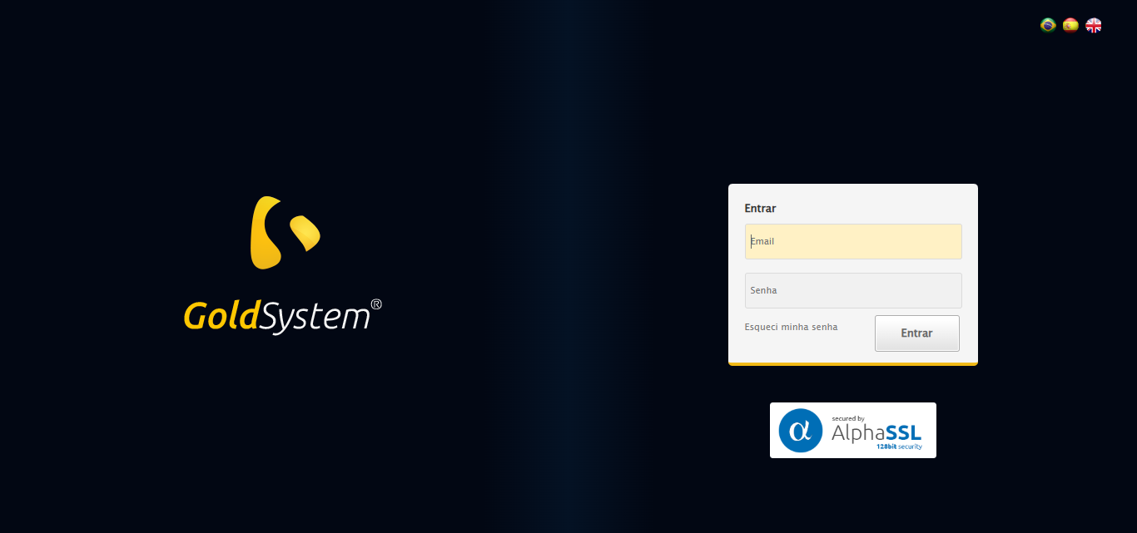

🔄 Realizando login...

✅ Realizando login realizada com sucesso.

Screenshot: realizando login

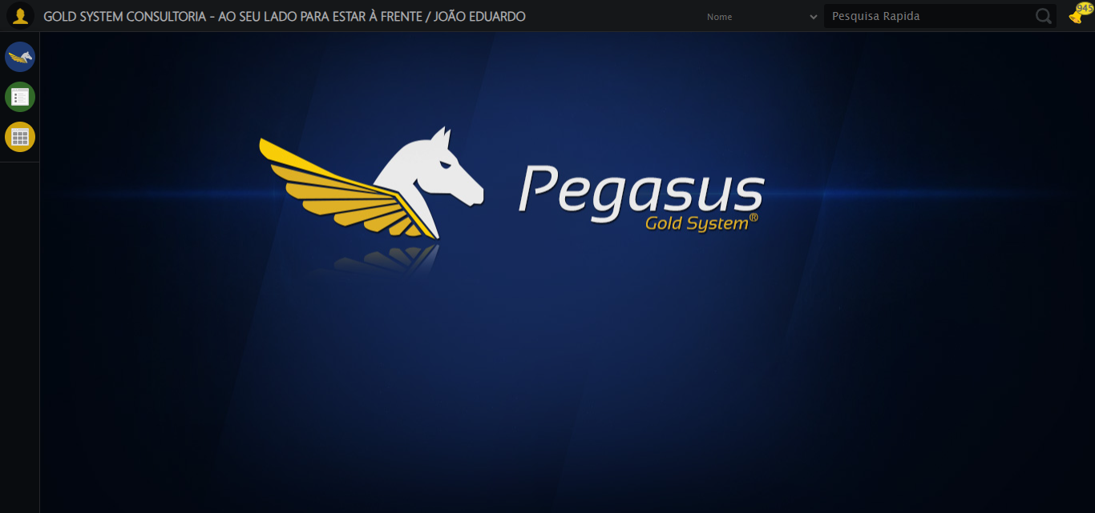

🔄 Ajustando zoom e abrindo menu...

🔍 Zoom ajustado para 90%.

✅ Ajustando zoom e abrindo menu realizada com sucesso.

Screenshot: ajustando zoom e abrindo menu

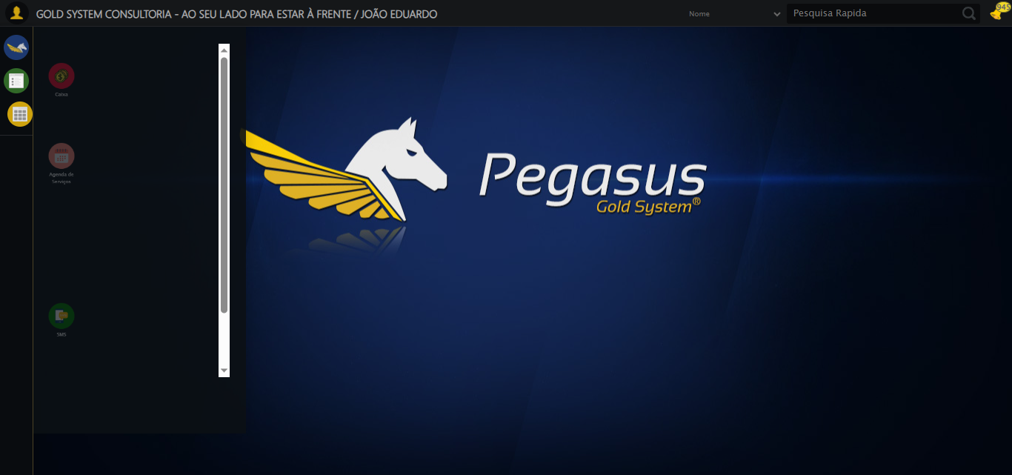

🔄 Acessando Gestor de Compras...

✅ Acessando Gestor de Compras realizada com sucesso.

Screenshot: acessando gestor de compras

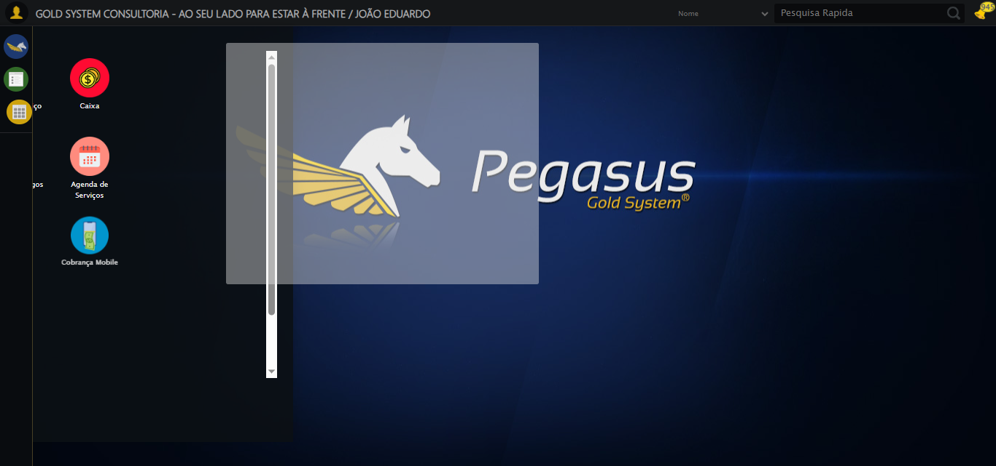

🔄 Clicando em Consulta de PIMS...

✅ Clicando em Consulta de PIMS realizada com sucesso.

Screenshot: clicando em consulta de pims

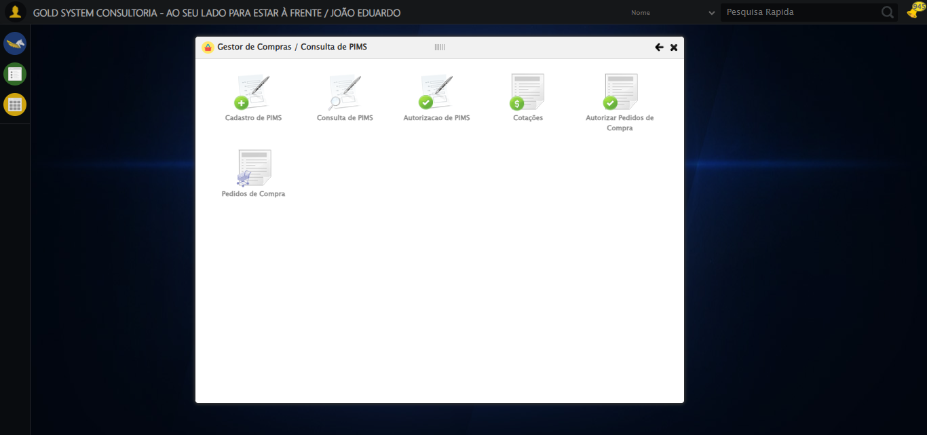

🔄 Preenchendo Número do PIMS...

✅ Preenchendo Número do PIMS realizada com sucesso.

Screenshot: preenchendo número do pims

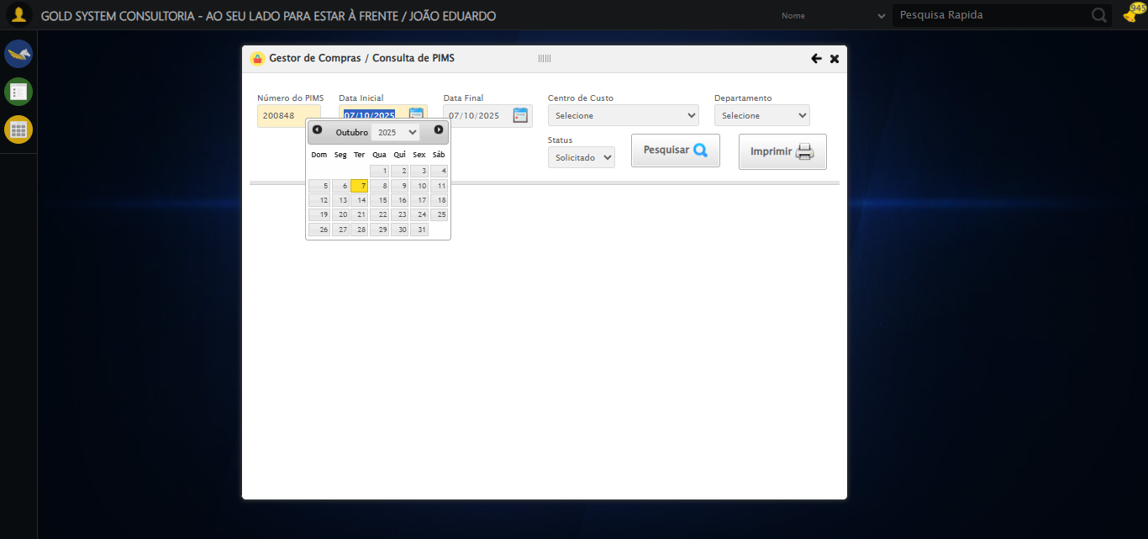

🔄 Selecionando Centro de Custo...

✅ Selecionando Centro de Custo realizada com sucesso.

Screenshot: selecionando centro de custo

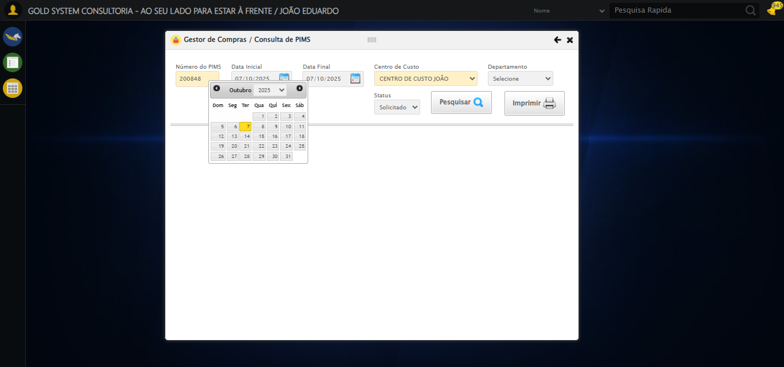

🔄 Selecionando Departamento...

✅ Selecionando Departamento realizada com sucesso.

Screenshot: selecionando departamento

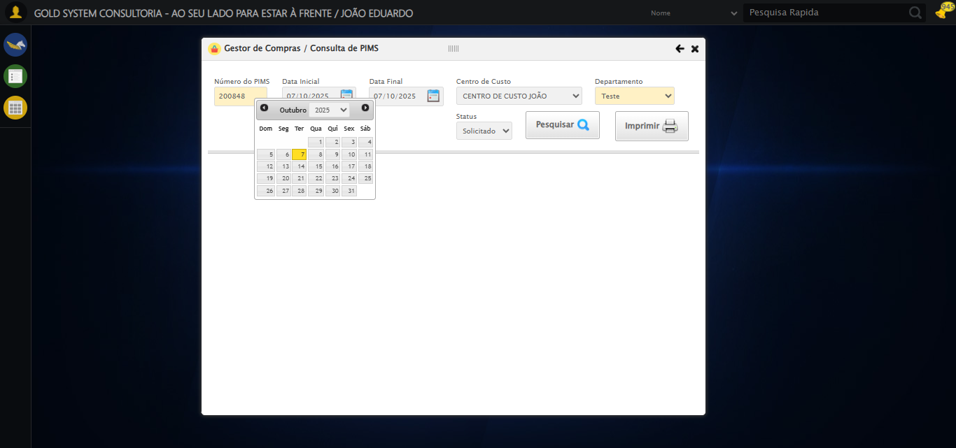

🔄 Selecionando Status...

✅ Selecionando Status realizada com sucesso.

Screenshot: selecionando status



🔄 Realizando consulta...

✅ Realizando consulta realizada com sucesso.

Screenshot: realizando consulta

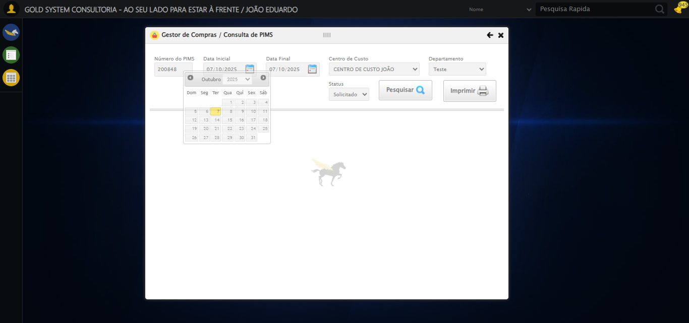

🔄 Alterando Quantidade do Serviço...

⚠️ Tentativa 1 falhou: Message:   
Stacktrace:  
 GetHandleVerifier [0x0x10dc333+65459]  
 GetHandleVerifier [0x0x10dc374+65524]  
 (No symbol) [0x0xefd973]  
 (No symbol) [0x0xf476e7]  
 (No symbol) [0x0xf47a8b]  
 (No symbol) [0x0xf8dea2]  
 (No symbol) [0x0xf69e44]  
 (No symbol) [0x0xf8b606]  
 (No symbol) [0x0xf69bf6]  
 (No symbol) [0x0xf3b38e]  
 (No symbol) [0x0xf3c274]  
 GetHandleVerifier [0x0x135eda3+2697763]  
 GetHandleVerifier [0x0x1359ec7+2677575]  
 GetHandleVerifier [0x0x1104194+228884]  
 GetHandleVerifier [0x0x10f49f8+165496]  
 GetHandleVerifier [0x0x10fb18d+192013]  
 GetHandleVerifier [0x0x10e47d8+99416]  
 GetHandleVerifier [0x0x10e4972+99826]  
 GetHandleVerifier [0x0x10cebea+10346]  
 BaseThreadInitThunk [0x0x755bfcc9+25]  
 RtlGetAppContainerNamedObjectPath [0x0x773a82ae+286]  
 RtlGetAppContainerNamedObjectPath [0x0x773a827e+238]

⚠️ Tentativa 2 falhou: Message: invalid session id: session deleted as the browser has closed the connection  
from disconnected: not connected to DevTools  
 (Session info: chrome=140.0.7339.208); For documentation on this error, please visit: https://www.selenium.dev/documentation/webdriver/troubleshooting/errors#invalidsessionidexception  
Stacktrace:  
 GetHandleVerifier [0x0x10dc333+65459]  
 GetHandleVerifier [0x0x10dc374+65524]  
 (No symbol) [0x0xefd973]  
 (No symbol) [0x0xeecdf0]  
 (No symbol) [0x0xf0b4af]  
 (No symbol) [0x0xf70775]  
 (No symbol) [0x0xf8aef9]  
 (No symbol) [0x0xf69bf6]  
 (No symbol) [0x0xf3b38e]  
 (No symbol) [0x0xf3c274]  
 GetHandleVerifier [0x0x135eda3+2697763]  
 GetHandleVerifier [0x0x1359ec7+2677575]  
 GetHandleVerifier [0x0x1104194+228884]  
 GetHandleVerifier [0x0x10f49f8+165496]  
 GetHandleVerifier [0x0x10fb18d+192013]  
 GetHandleVerifier [0x0x10e47d8+99416]  
 GetHandleVerifier [0x0x10e4972+99826]  
 GetHandleVerifier [0x0x10cebea+10346]  
 BaseThreadInitThunk [0x0x755bfcc9+25]  
 RtlGetAppContainerNamedObjectPath [0x0x773a82ae+286]  
 RtlGetAppContainerNamedObjectPath [0x0x773a827e+238]

⚠️ Tentativa 3 falhou: Message: invalid session id; For documentation on this error, please visit: https://www.selenium.dev/documentation/webdriver/troubleshooting/errors#invalidsessionidexception  
Stacktrace:  
 GetHandleVerifier [0x0x10dc333+65459]  
 GetHandleVerifier [0x0x10dc374+65524]  
 (No symbol) [0x0xefd7c0]  
 (No symbol) [0x0xf3a663]  
 (No symbol) [0x0xf69cb6]  
 (No symbol) [0x0xf6555e]  
 (No symbol) [0x0xf64ad3]  
 (No symbol) [0x0xece73d]  
 (No symbol) [0x0xececbe]  
 (No symbol) [0x0xecf15d]  
 GetHandleVerifier [0x0x135eda3+2697763]  
 GetHandleVerifier [0x0x1359ec7+2677575]  
 GetHandleVerifier [0x0x1104194+228884]  
 GetHandleVerifier [0x0x10f49f8+165496]  
 GetHandleVerifier [0x0x10fb18d+192013]  
 (No symbol) [0x0xece3f2]  
 (No symbol) [0x0xecdb72]  
 GetHandleVerifier [0x0x14b340c+4092044]  
 BaseThreadInitThunk [0x0x755bfcc9+25]  
 RtlGetAppContainerNamedObjectPath [0x0x773a82ae+286]  
 RtlGetAppContainerNamedObjectPath [0x0x773a827e+238]

✅ Alterando Quantidade do Serviço realizada com sucesso.

⚠️ Erro ao tirar screenshot alterando quantidade do serviço: Message: invalid session id; For documentation on this error, please visit: https://www.selenium.dev/documentation/webdriver/troubleshooting/errors#invalidsessionidexception  
Stacktrace:  
 GetHandleVerifier [0x0x10dc333+65459]  
 GetHandleVerifier [0x0x10dc374+65524]  
 (No symbol) [0x0xefd7c0]  
 (No symbol) [0x0xf3a663]  
 (No symbol) [0x0xf69cb6]  
 (No symbol) [0x0xf6555e]  
 (No symbol) [0x0xf64ad3]  
 (No symbol) [0x0xece73d]  
 (No symbol) [0x0xececbe]  
 (No symbol) [0x0xecf15d]  
 GetHandleVerifier [0x0x135eda3+2697763]  
 GetHandleVerifier [0x0x1359ec7+2677575]  
 GetHandleVerifier [0x0x1104194+228884]  
 GetHandleVerifier [0x0x10f49f8+165496]  
 GetHandleVerifier [0x0x10fb18d+192013]  
 (No symbol) [0x0xece3f2]  
 (No symbol) [0x0xecdb72]  
 GetHandleVerifier [0x0x14b340c+4092044]  
 BaseThreadInitThunk [0x0x755bfcc9+25]  
 RtlGetAppContainerNamedObjectPath [0x0x773a82ae+286]  
 RtlGetAppContainerNamedObjectPath [0x0x773a827e+238]

🔄 Alterando Quantidade do Produto...

❌ Erro inesperado ao alterando quantidade do produto: Message: invalid session id; For documentation on this error, please visit: https://www.selenium.dev/documentation/webdriver/troubleshooting/errors#invalidsessionidexception  
Stacktrace:  
 GetHandleVerifier [0x0x10dc333+65459]  
 GetHandleVerifier [0x0x10dc374+65524]  
 (No symbol) [0x0xefd7c0]  
 (No symbol) [0x0xf3a663]  
 (No symbol) [0x0xf69cb6]  
 (No symbol) [0x0xf6555e]  
 (No symbol) [0x0xf64ad3]  
 (No symbol) [0x0xece73d]  
 (No symbol) [0x0xececbe]  
 (No symbol) [0x0xecf15d]  
 GetHandleVerifier [0x0x135eda3+2697763]  
 GetHandleVerifier [0x0x1359ec7+2677575]  
 GetHandleVerifier [0x0x1104194+228884]  
 GetHandleVerifier [0x0x10f49f8+165496]  
 GetHandleVerifier [0x0x10fb18d+192013]  
 (No symbol) [0x0xece3f2]  
 (No symbol) [0x0xecdb72]  
 GetHandleVerifier [0x0x14b340c+4092044]  
 BaseThreadInitThunk [0x0x755bfcc9+25]  
 RtlGetAppContainerNamedObjectPath [0x0x773a82ae+286]  
 RtlGetAppContainerNamedObjectPath [0x0x773a827e+238]

⚠️ Erro ao tirar screenshot erro_alterando quantidade do produto: Message: invalid session id; For documentation on this error, please visit: https://www.selenium.dev/documentation/webdriver/troubleshooting/errors#invalidsessionidexception  
Stacktrace:  
 GetHandleVerifier [0x0x10dc333+65459]  
 GetHandleVerifier [0x0x10dc374+65524]  
 (No symbol) [0x0xefd7c0]  
 (No symbol) [0x0xf3a663]  
 (No symbol) [0x0xf69cb6]  
 (No symbol) [0x0xf6555e]  
 (No symbol) [0x0xf64ad3]  
 (No symbol) [0x0xece73d]  
 (No symbol) [0x0xececbe]  
 (No symbol) [0x0xecf15d]  
 GetHandleVerifier [0x0x135eda3+2697763]  
 GetHandleVerifier [0x0x1359ec7+2677575]  
 GetHandleVerifier [0x0x1104194+228884]  
 GetHandleVerifier [0x0x10f49f8+165496]  
 GetHandleVerifier [0x0x10fb18d+192013]  
 (No symbol) [0x0xece3f2]  
 (No symbol) [0x0xecdb72]  
 GetHandleVerifier [0x0x14b340c+4092044]  
 BaseThreadInitThunk [0x0x755bfcc9+25]  
 RtlGetAppContainerNamedObjectPath [0x0x773a82ae+286]  
 RtlGetAppContainerNamedObjectPath [0x0x773a827e+238]

🔄 Adicionando mensagem no Serviço...

❌ Erro ao clicar robusto: Message: invalid session id; For documentation on this error, please visit: https://www.selenium.dev/documentation/webdriver/troubleshooting/errors#invalidsessionidexception  
Stacktrace:  
 GetHandleVerifier [0x0x10dc333+65459]  
 GetHandleVerifier [0x0x10dc374+65524]  
 (No symbol) [0x0xefd7c0]  
 (No symbol) [0x0xf3a663]  
 (No symbol) [0x0xf69cb6]  
 (No symbol) [0x0xf6555e]  
 (No symbol) [0x0xf64ad3]  
 (No symbol) [0x0xece73d]  
 (No symbol) [0x0xececbe]  
 (No symbol) [0x0xecf15d]  
 GetHandleVerifier [0x0x135eda3+2697763]  
 GetHandleVerifier [0x0x1359ec7+2677575]  
 GetHandleVerifier [0x0x1104194+228884]  
 GetHandleVerifier [0x0x10f49f8+165496]  
 GetHandleVerifier [0x0x10fb18d+192013]  
 (No symbol) [0x0xece3f2]  
 (No symbol) [0x0xecdb72]  
 GetHandleVerifier [0x0x14b340c+4092044]  
 BaseThreadInitThunk [0x0x755bfcc9+25]  
 RtlGetAppContainerNamedObjectPath [0x0x773a82ae+286]  
 RtlGetAppContainerNamedObjectPath [0x0x773a827e+238]

✅ Adicionando mensagem no Serviço realizada com sucesso.

⚠️ Erro ao tirar screenshot adicionando mensagem no serviço: Message: invalid session id; For documentation on this error, please visit: https://www.selenium.dev/documentation/webdriver/troubleshooting/errors#invalidsessionidexception  
Stacktrace:  
 GetHandleVerifier [0x0x10dc333+65459]  
 GetHandleVerifier [0x0x10dc374+65524]  
 (No symbol) [0x0xefd7c0]  
 (No symbol) [0x0xf3a663]  
 (No symbol) [0x0xf69cb6]  
 (No symbol) [0x0xf6555e]  
 (No symbol) [0x0xf64ad3]  
 (No symbol) [0x0xece73d]  
 (No symbol) [0x0xececbe]  
 (No symbol) [0x0xecf15d]  
 GetHandleVerifier [0x0x135eda3+2697763]  
 GetHandleVerifier [0x0x1359ec7+2677575]  
 GetHandleVerifier [0x0x1104194+228884]  
 GetHandleVerifier [0x0x10f49f8+165496]  
 GetHandleVerifier [0x0x10fb18d+192013]  
 (No symbol) [0x0xece3f2]  
 (No symbol) [0x0xecdb72]  
 GetHandleVerifier [0x0x14b340c+4092044]  
 BaseThreadInitThunk [0x0x755bfcc9+25]  
 RtlGetAppContainerNamedObjectPath [0x0x773a82ae+286]  
 RtlGetAppContainerNamedObjectPath [0x0x773a827e+238]

⚠️ Nenhuma textarea encontrada (tentativa 1/5)

⚠️ Nenhuma textarea encontrada (tentativa 2/5)

⚠️ Nenhuma textarea encontrada (tentativa 3/5)

⚠️ Nenhuma textarea encontrada (tentativa 4/5)

❌ ERRO FATAL: Nenhuma textarea foi encontrada na página.

⚠️ Erro ao tirar screenshot erro_fatal: Message: invalid session id; For documentation on this error, please visit: https://www.selenium.dev/documentation/webdriver/troubleshooting/errors#invalidsessionidexception  
Stacktrace:  
 GetHandleVerifier [0x0x10dc333+65459]  
 GetHandleVerifier [0x0x10dc374+65524]  
 (No symbol) [0x0xefd7c0]  
 (No symbol) [0x0xf3a663]  
 (No symbol) [0x0xf69cb6]  
 (No symbol) [0x0xf6555e]  
 (No symbol) [0x0xf64ad3]  
 (No symbol) [0x0xece73d]  
 (No symbol) [0x0xececbe]  
 (No symbol) [0x0xecf15d]  
 GetHandleVerifier [0x0x135eda3+2697763]  
 GetHandleVerifier [0x0x1359ec7+2677575]  
 GetHandleVerifier [0x0x1104194+228884]  
 GetHandleVerifier [0x0x10f49f8+165496]  
 GetHandleVerifier [0x0x10fb18d+192013]  
 (No symbol) [0x0xece3f2]  
 (No symbol) [0x0xecdb72]  
 GetHandleVerifier [0x0x14b340c+4092044]  
 BaseThreadInitThunk [0x0x755bfcc9+25]  
 RtlGetAppContainerNamedObjectPath [0x0x773a82ae+286]  
 RtlGetAppContainerNamedObjectPath [0x0x773a827e+238]

✅ Teste concluído.

❌ Teste finalizado com erros.