RELATÓRIO DO TESTE

Cadastro de Locação de Equipamentos - Apoio Ortopédico – Cenário 1: Preenchimento completo e salvamento

Data do teste: 22/08/2025 17:50:48

🚀 Iniciando teste de Consulta de Devolução de Equipamentos

🔄 Acessando sistema...

✅ Acessando sistema realizada com sucesso.

Screenshot: acessando sistema

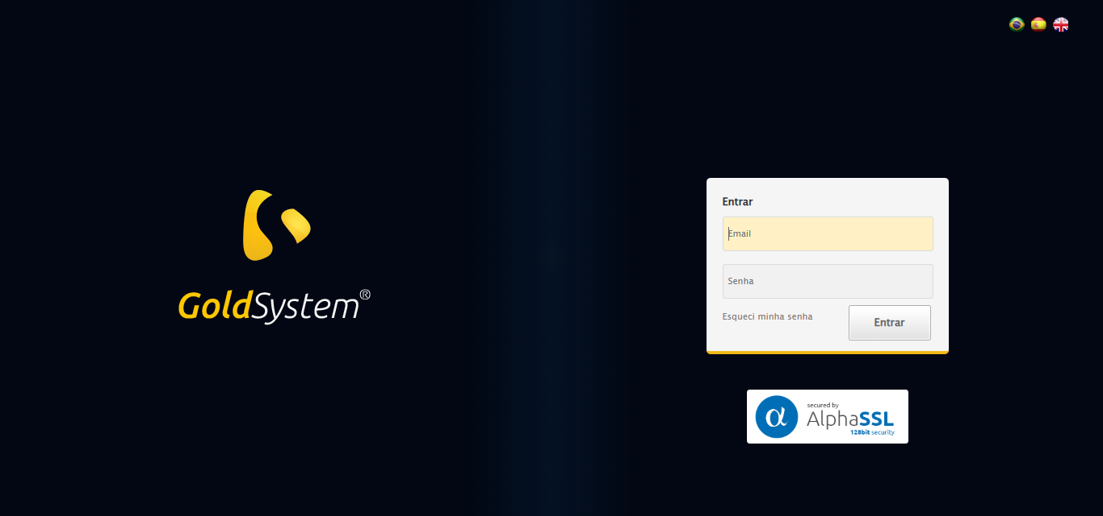

🔄 Realizando login...

✅ Realizando login realizada com sucesso.

Screenshot: realizando login

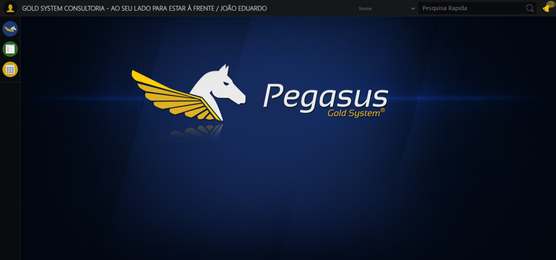

🔄 Ajustando zoom e abrindo menu...

🔍 Zoom ajustado para 90%.

✅ Ajustando zoom e abrindo menu realizada com sucesso.

Screenshot: ajustando zoom e abrindo menu

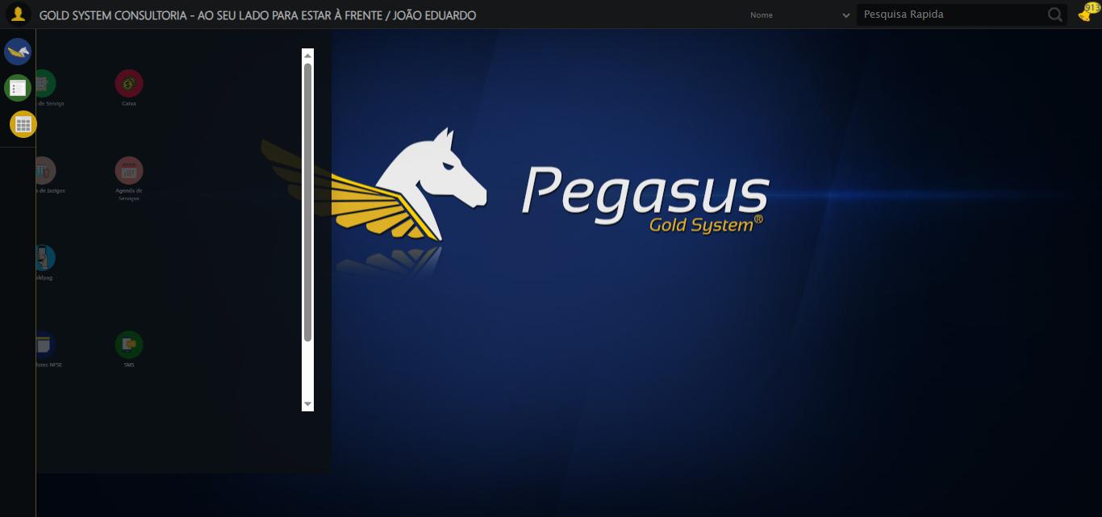

🔄 Acessando Apoio Ortopédico...

✅ Acessando Apoio Ortopédico realizada com sucesso.

Screenshot: acessando apoio ortopédico

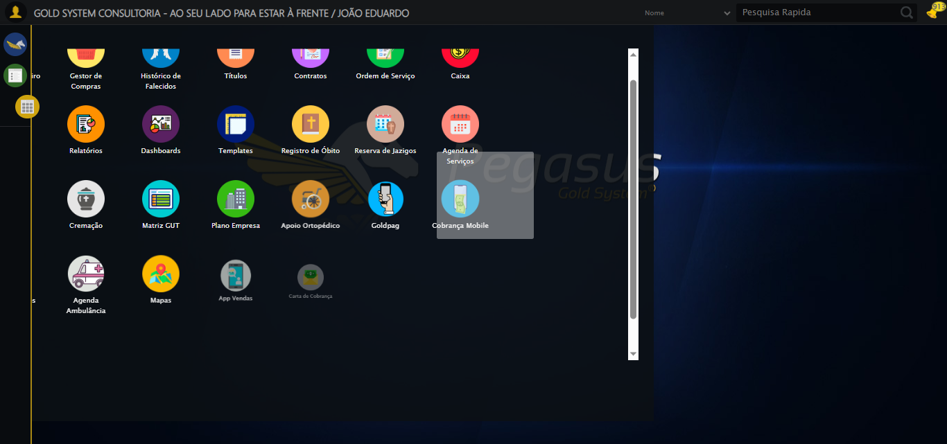

🔄 Clicando em Devolução de Equipamentos...

✅ Clicando em Devolução de Equipamentos realizada com sucesso.

Screenshot: clicando em devolução de equipamentos

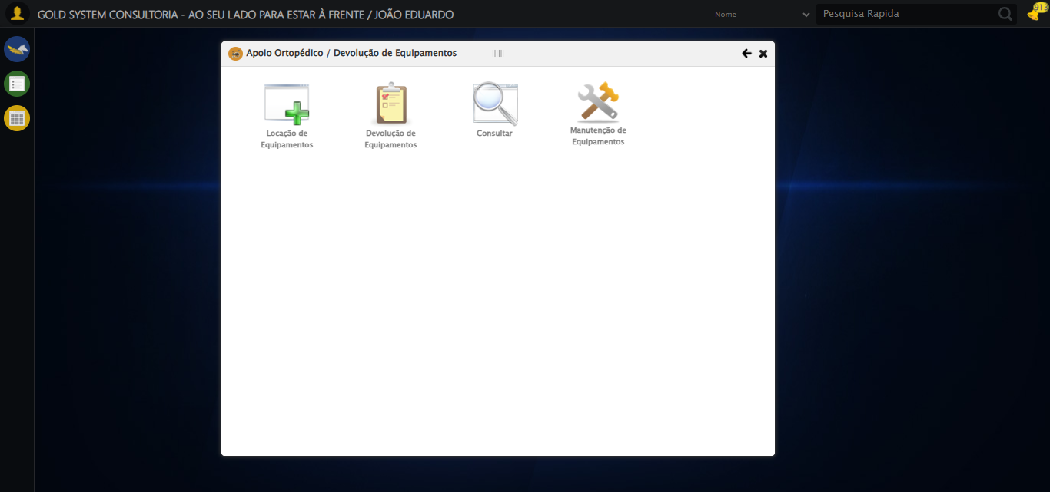

🔄 Preenchendo o Número da Locação...

✅ Preenchendo o Número da Locação realizada com sucesso.

Screenshot: preenchendo o número da locação

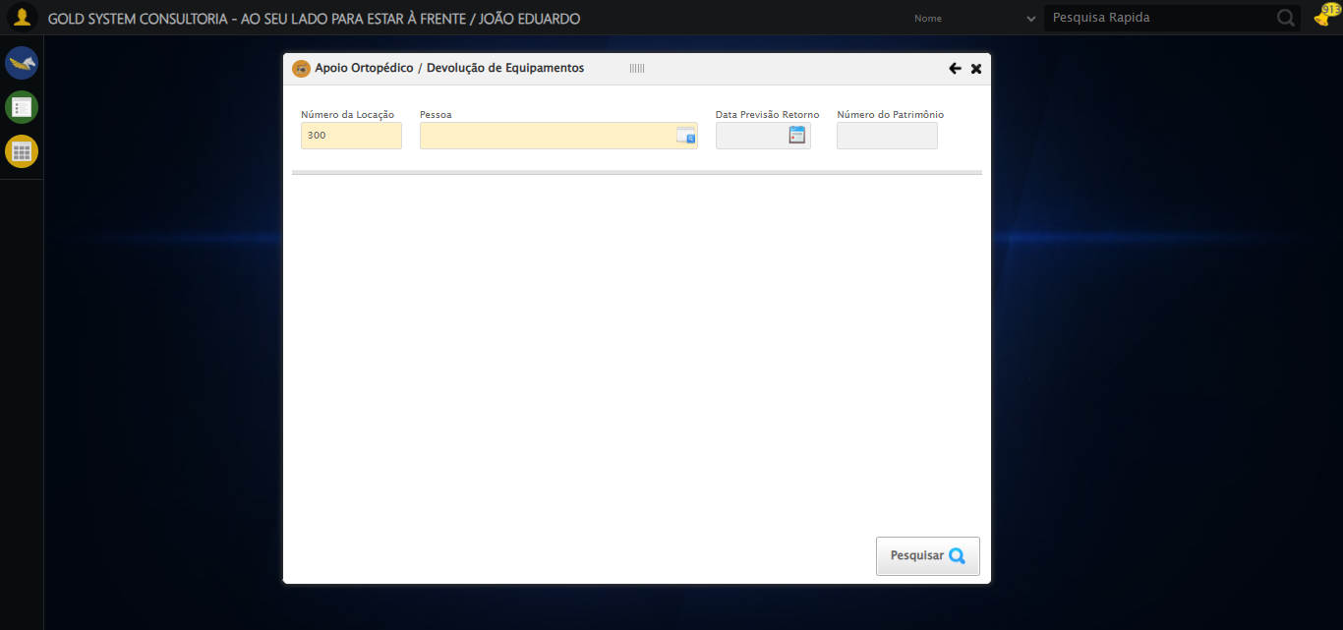

🔄 Selecionando Pessoa...

✅ Selecionando Pessoa realizada com sucesso.

Screenshot: selecionando pessoa



🔄 Abrindo Lov de Pessoas...

❌ Erro inesperado ao abrindo lov de pessoas: clicar_elemento_xpath_robusto() missing 1 required positional argument: 'xpath'

Screenshot: erro_abrindo lov de pessoas



🔄 Preenchendo o Nome do Titular...

⚠️ Tentativa 1 falhou: Message:   
Stacktrace:  
 GetHandleVerifier [0x0xf6ffc3+65331]  
 GetHandleVerifier [0x0xf70004+65396]  
 (No symbol) [0x0xd63f63]  
 (No symbol) [0x0xdac99e]  
 (No symbol) [0x0xdacd3b]  
 (No symbol) [0x0xdf53d2]  
 (No symbol) [0x0xdd1524]  
 (No symbol) [0x0xdf2bcb]  
 (No symbol) [0x0xdd12d6]  
 (No symbol) [0x0xda0910]  
 (No symbol) [0x0xda1784]  
 GetHandleVerifier [0x0x11b38b3+2439203]  
 GetHandleVerifier [0x0x11aeae2+2419282]  
 GetHandleVerifier [0x0xf9712a+225434]  
 GetHandleVerifier [0x0xf86e08+159096]  
 GetHandleVerifier [0x0xf8dd5d+187597]  
 GetHandleVerifier [0x0xf77ad8+96840]  
 GetHandleVerifier [0x0xf77c62+97234]  
 GetHandleVerifier [0x0xf6277a+9962]  
 BaseThreadInitThunk [0x0x76b1fcc9+25]  
 RtlGetAppContainerNamedObjectPath [0x0x776a82ae+286]  
 RtlGetAppContainerNamedObjectPath [0x0x776a827e+238]

⚠️ Tentativa 2 falhou: Message:   
Stacktrace:  
 GetHandleVerifier [0x0xf6ffc3+65331]  
 GetHandleVerifier [0x0xf70004+65396]  
 (No symbol) [0x0xd63f63]  
 (No symbol) [0x0xdac99e]  
 (No symbol) [0x0xdacd3b]  
 (No symbol) [0x0xdf53d2]  
 (No symbol) [0x0xdd1524]  
 (No symbol) [0x0xdf2bcb]  
 (No symbol) [0x0xdd12d6]  
 (No symbol) [0x0xda0910]  
 (No symbol) [0x0xda1784]  
 GetHandleVerifier [0x0x11b38b3+2439203]  
 GetHandleVerifier [0x0x11aeae2+2419282]  
 GetHandleVerifier [0x0xf9712a+225434]  
 GetHandleVerifier [0x0xf86e08+159096]  
 GetHandleVerifier [0x0xf8dd5d+187597]  
 GetHandleVerifier [0x0xf77ad8+96840]  
 GetHandleVerifier [0x0xf77c62+97234]  
 GetHandleVerifier [0x0xf6277a+9962]  
 BaseThreadInitThunk [0x0x76b1fcc9+25]  
 RtlGetAppContainerNamedObjectPath [0x0x776a82ae+286]  
 RtlGetAppContainerNamedObjectPath [0x0x776a827e+238]

⚠️ Tentativa 3 falhou: Message: invalid session id: session deleted as the browser has closed the connection  
from disconnected: not connected to DevTools  
 (Session info: chrome=139.0.7258.128)  
Stacktrace:  
 GetHandleVerifier [0x0xf6ffc3+65331]  
 GetHandleVerifier [0x0xf70004+65396]  
 (No symbol) [0x0xd63f63]  
 (No symbol) [0x0xd538e0]  
 (No symbol) [0x0xd71709]  
 (No symbol) [0x0xdd7e4c]  
 (No symbol) [0x0xdf24d9]  
 (No symbol) [0x0xdd12d6]  
 (No symbol) [0x0xda0910]  
 (No symbol) [0x0xda1784]  
 GetHandleVerifier [0x0x11b38b3+2439203]  
 GetHandleVerifier [0x0x11aeae2+2419282]  
 GetHandleVerifier [0x0xf9712a+225434]  
 GetHandleVerifier [0x0xf86e08+159096]  
 GetHandleVerifier [0x0xf8dd5d+187597]  
 GetHandleVerifier [0x0xf77ad8+96840]  
 GetHandleVerifier [0x0xf77c62+97234]  
 GetHandleVerifier [0x0xf6277a+9962]  
 BaseThreadInitThunk [0x0x76b1fcc9+25]  
 RtlGetAppContainerNamedObjectPath [0x0x776a82ae+286]  
 RtlGetAppContainerNamedObjectPath [0x0x776a827e+238]

✅ Preenchendo o Nome do Titular realizada com sucesso.

⚠️ Erro ao tirar screenshot preenchendo o nome do titular: Message: invalid session id  
Stacktrace:  
 GetHandleVerifier [0x0xf6ffc3+65331]  
 GetHandleVerifier [0x0xf70004+65396]  
 (No symbol) [0x0xd63dc0]  
 (No symbol) [0x0xd9fbd8]  
 (No symbol) [0x0xdd1396]  
 (No symbol) [0x0xdccf70]  
 (No symbol) [0x0xdcc4f6]  
 (No symbol) [0x0xd359b5]  
 (No symbol) [0x0xd35f0e]  
 (No symbol) [0x0xd3639d]  
 GetHandleVerifier [0x0x11b38b3+2439203]  
 GetHandleVerifier [0x0x11aeae2+2419282]  
 GetHandleVerifier [0x0xf9712a+225434]  
 GetHandleVerifier [0x0xf86e08+159096]  
 GetHandleVerifier [0x0xf8dd5d+187597]  
 (No symbol) [0x0xd35680]  
 (No symbol) [0x0xd34e8e]  
 GetHandleVerifier [0x0x12ca2ec+3580508]  
 BaseThreadInitThunk [0x0x76b1fcc9+25]  
 RtlGetAppContainerNamedObjectPath [0x0x776a82ae+286]  
 RtlGetAppContainerNamedObjectPath [0x0x776a827e+238]

🔄 Pesquisando Titular...

❌ Erro inesperado ao pesquisando titular: clicar_elemento_xpath_robusto() missing 1 required positional argument: 'xpath'

⚠️ Erro ao tirar screenshot erro_pesquisando titular: Message: invalid session id  
Stacktrace:  
 GetHandleVerifier [0x0xf6ffc3+65331]  
 GetHandleVerifier [0x0xf70004+65396]  
 (No symbol) [0x0xd63dc0]  
 (No symbol) [0x0xd9fbd8]  
 (No symbol) [0x0xdd1396]  
 (No symbol) [0x0xdccf70]  
 (No symbol) [0x0xdcc4f6]  
 (No symbol) [0x0xd359b5]  
 (No symbol) [0x0xd35f0e]  
 (No symbol) [0x0xd3639d]  
 GetHandleVerifier [0x0x11b38b3+2439203]  
 GetHandleVerifier [0x0x11aeae2+2419282]  
 GetHandleVerifier [0x0xf9712a+225434]  
 GetHandleVerifier [0x0xf86e08+159096]  
 GetHandleVerifier [0x0xf8dd5d+187597]  
 (No symbol) [0x0xd35680]  
 (No symbol) [0x0xd34e8e]  
 GetHandleVerifier [0x0x12ca2ec+3580508]  
 BaseThreadInitThunk [0x0x76b1fcc9+25]  
 RtlGetAppContainerNamedObjectPath [0x0x776a82ae+286]  
 RtlGetAppContainerNamedObjectPath [0x0x776a827e+238]

🔄 Selecionando Titular...

❌ Erro inesperado ao selecionando titular: clicar_elemento_xpath_robusto() missing 1 required positional argument: 'xpath'

⚠️ Erro ao tirar screenshot erro_selecionando titular: Message: invalid session id  
Stacktrace:  
 GetHandleVerifier [0x0xf6ffc3+65331]  
 GetHandleVerifier [0x0xf70004+65396]  
 (No symbol) [0x0xd63dc0]  
 (No symbol) [0x0xd9fbd8]  
 (No symbol) [0x0xdd1396]  
 (No symbol) [0x0xdccf70]  
 (No symbol) [0x0xdcc4f6]  
 (No symbol) [0x0xd359b5]  
 (No symbol) [0x0xd35f0e]  
 (No symbol) [0x0xd3639d]  
 GetHandleVerifier [0x0x11b38b3+2439203]  
 GetHandleVerifier [0x0x11aeae2+2419282]  
 GetHandleVerifier [0x0xf9712a+225434]  
 GetHandleVerifier [0x0xf86e08+159096]  
 GetHandleVerifier [0x0xf8dd5d+187597]  
 (No symbol) [0x0xd35680]  
 (No symbol) [0x0xd34e8e]  
 GetHandleVerifier [0x0x12ca2ec+3580508]  
 BaseThreadInitThunk [0x0x76b1fcc9+25]  
 RtlGetAppContainerNamedObjectPath [0x0x776a82ae+286]  
 RtlGetAppContainerNamedObjectPath [0x0x776a827e+238]

🔄 Preenchendo Número do Patrimônio...

⚠️ Tentativa 1 falhou: Message: invalid session id  
Stacktrace:  
 GetHandleVerifier [0x0xf6ffc3+65331]  
 GetHandleVerifier [0x0xf70004+65396]  
 (No symbol) [0x0xd63dc0]  
 (No symbol) [0x0xd9fbd8]  
 (No symbol) [0x0xdd1396]  
 (No symbol) [0x0xdccf70]  
 (No symbol) [0x0xdcc4f6]  
 (No symbol) [0x0xd359b5]  
 (No symbol) [0x0xd35f0e]  
 (No symbol) [0x0xd3639d]  
 GetHandleVerifier [0x0x11b38b3+2439203]  
 GetHandleVerifier [0x0x11aeae2+2419282]  
 GetHandleVerifier [0x0xf9712a+225434]  
 GetHandleVerifier [0x0xf86e08+159096]  
 GetHandleVerifier [0x0xf8dd5d+187597]  
 (No symbol) [0x0xd35680]  
 (No symbol) [0x0xd34e8e]  
 GetHandleVerifier [0x0x12ca2ec+3580508]  
 BaseThreadInitThunk [0x0x76b1fcc9+25]  
 RtlGetAppContainerNamedObjectPath [0x0x776a82ae+286]  
 RtlGetAppContainerNamedObjectPath [0x0x776a827e+238]

⚠️ Tentativa 2 falhou: Message: invalid session id  
Stacktrace:  
 GetHandleVerifier [0x0xf6ffc3+65331]  
 GetHandleVerifier [0x0xf70004+65396]  
 (No symbol) [0x0xd63dc0]  
 (No symbol) [0x0xd9fbd8]  
 (No symbol) [0x0xdd1396]  
 (No symbol) [0x0xdccf70]  
 (No symbol) [0x0xdcc4f6]  
 (No symbol) [0x0xd359b5]  
 (No symbol) [0x0xd35f0e]  
 (No symbol) [0x0xd3639d]  
 GetHandleVerifier [0x0x11b38b3+2439203]  
 GetHandleVerifier [0x0x11aeae2+2419282]  
 GetHandleVerifier [0x0xf9712a+225434]  
 GetHandleVerifier [0x0xf86e08+159096]  
 GetHandleVerifier [0x0xf8dd5d+187597]  
 (No symbol) [0x0xd35680]  
 (No symbol) [0x0xd34e8e]  
 GetHandleVerifier [0x0x12ca2ec+3580508]  
 BaseThreadInitThunk [0x0x76b1fcc9+25]  
 RtlGetAppContainerNamedObjectPath [0x0x776a82ae+286]  
 RtlGetAppContainerNamedObjectPath [0x0x776a827e+238]

⚠️ Tentativa 3 falhou: Message: invalid session id  
Stacktrace:  
 GetHandleVerifier [0x0xf6ffc3+65331]  
 GetHandleVerifier [0x0xf70004+65396]  
 (No symbol) [0x0xd63dc0]  
 (No symbol) [0x0xd9fbd8]  
 (No symbol) [0x0xdd1396]  
 (No symbol) [0x0xdccf70]  
 (No symbol) [0x0xdcc4f6]  
 (No symbol) [0x0xd359b5]  
 (No symbol) [0x0xd35f0e]  
 (No symbol) [0x0xd3639d]  
 GetHandleVerifier [0x0x11b38b3+2439203]  
 GetHandleVerifier [0x0x11aeae2+2419282]  
 GetHandleVerifier [0x0xf9712a+225434]  
 GetHandleVerifier [0x0xf86e08+159096]  
 GetHandleVerifier [0x0xf8dd5d+187597]  
 (No symbol) [0x0xd35680]  
 (No symbol) [0x0xd34e8e]  
 GetHandleVerifier [0x0x12ca2ec+3580508]  
 BaseThreadInitThunk [0x0x76b1fcc9+25]  
 RtlGetAppContainerNamedObjectPath [0x0x776a82ae+286]  
 RtlGetAppContainerNamedObjectPath [0x0x776a827e+238]

✅ Preenchendo Número do Patrimônio realizada com sucesso.

⚠️ Erro ao tirar screenshot preenchendo número do patrimônio: Message: invalid session id  
Stacktrace:  
 GetHandleVerifier [0x0xf6ffc3+65331]  
 GetHandleVerifier [0x0xf70004+65396]  
 (No symbol) [0x0xd63dc0]  
 (No symbol) [0x0xd9fbd8]  
 (No symbol) [0x0xdd1396]  
 (No symbol) [0x0xdccf70]  
 (No symbol) [0x0xdcc4f6]  
 (No symbol) [0x0xd359b5]  
 (No symbol) [0x0xd35f0e]  
 (No symbol) [0x0xd3639d]  
 GetHandleVerifier [0x0x11b38b3+2439203]  
 GetHandleVerifier [0x0x11aeae2+2419282]  
 GetHandleVerifier [0x0xf9712a+225434]  
 GetHandleVerifier [0x0xf86e08+159096]  
 GetHandleVerifier [0x0xf8dd5d+187597]  
 (No symbol) [0x0xd35680]  
 (No symbol) [0x0xd34e8e]  
 GetHandleVerifier [0x0x12ca2ec+3580508]  
 BaseThreadInitThunk [0x0x76b1fcc9+25]  
 RtlGetAppContainerNamedObjectPath [0x0x776a82ae+286]  
 RtlGetAppContainerNamedObjectPath [0x0x776a827e+238]

🔄 Realizando consulta...

❌ Erro inesperado ao realizando consulta: Message: invalid session id  
Stacktrace:  
 GetHandleVerifier [0x0xf6ffc3+65331]  
 GetHandleVerifier [0x0xf70004+65396]  
 (No symbol) [0x0xd63dc0]  
 (No symbol) [0x0xd9fbd8]  
 (No symbol) [0x0xdd1396]  
 (No symbol) [0x0xdccf70]  
 (No symbol) [0x0xdcc4f6]  
 (No symbol) [0x0xd359b5]  
 (No symbol) [0x0xd35f0e]  
 (No symbol) [0x0xd3639d]  
 GetHandleVerifier [0x0x11b38b3+2439203]  
 GetHandleVerifier [0x0x11aeae2+2419282]  
 GetHandleVerifier [0x0xf9712a+225434]  
 GetHandleVerifier [0x0xf86e08+159096]  
 GetHandleVerifier [0x0xf8dd5d+187597]  
 (No symbol) [0x0xd35680]  
 (No symbol) [0x0xd34e8e]  
 GetHandleVerifier [0x0x12ca2ec+3580508]  
 BaseThreadInitThunk [0x0x76b1fcc9+25]  
 RtlGetAppContainerNamedObjectPath [0x0x776a82ae+286]  
 RtlGetAppContainerNamedObjectPath [0x0x776a827e+238]

⚠️ Erro ao tirar screenshot erro_realizando consulta: Message: invalid session id  
Stacktrace:  
 GetHandleVerifier [0x0xf6ffc3+65331]  
 GetHandleVerifier [0x0xf70004+65396]  
 (No symbol) [0x0xd63dc0]  
 (No symbol) [0x0xd9fbd8]  
 (No symbol) [0x0xdd1396]  
 (No symbol) [0x0xdccf70]  
 (No symbol) [0x0xdcc4f6]  
 (No symbol) [0x0xd359b5]  
 (No symbol) [0x0xd35f0e]  
 (No symbol) [0x0xd3639d]  
 GetHandleVerifier [0x0x11b38b3+2439203]  
 GetHandleVerifier [0x0x11aeae2+2419282]  
 GetHandleVerifier [0x0xf9712a+225434]  
 GetHandleVerifier [0x0xf86e08+159096]  
 GetHandleVerifier [0x0xf8dd5d+187597]  
 (No symbol) [0x0xd35680]  
 (No symbol) [0x0xd34e8e]  
 GetHandleVerifier [0x0x12ca2ec+3580508]  
 BaseThreadInitThunk [0x0x76b1fcc9+25]  
 RtlGetAppContainerNamedObjectPath [0x0x776a82ae+286]  
 RtlGetAppContainerNamedObjectPath [0x0x776a827e+238]

❌ ERRO FATAL: safe_action() got an unexpected keyword argument 'critico'

⚠️ Erro ao tirar screenshot erro_fatal: Message: invalid session id  
Stacktrace:  
 GetHandleVerifier [0x0xf6ffc3+65331]  
 GetHandleVerifier [0x0xf70004+65396]  
 (No symbol) [0x0xd63dc0]  
 (No symbol) [0x0xd9fbd8]  
 (No symbol) [0x0xdd1396]  
 (No symbol) [0x0xdccf70]  
 (No symbol) [0x0xdcc4f6]  
 (No symbol) [0x0xd359b5]  
 (No symbol) [0x0xd35f0e]  
 (No symbol) [0x0xd3639d]  
 GetHandleVerifier [0x0x11b38b3+2439203]  
 GetHandleVerifier [0x0x11aeae2+2419282]  
 GetHandleVerifier [0x0xf9712a+225434]  
 GetHandleVerifier [0x0xf86e08+159096]  
 GetHandleVerifier [0x0xf8dd5d+187597]  
 (No symbol) [0x0xd35680]  
 (No symbol) [0x0xd34e8e]  
 GetHandleVerifier [0x0x12ca2ec+3580508]  
 BaseThreadInitThunk [0x0x76b1fcc9+25]  
 RtlGetAppContainerNamedObjectPath [0x0x776a82ae+286]  
 RtlGetAppContainerNamedObjectPath [0x0x776a827e+238]

✅ Teste concluído.

❌ Teste finalizado com erros.