RELATÓRIO DO TESTE

Consulta de Devolução de Equipamentos - Apoio Ortopédico – Cenário 1: Teste de disparo das mensagnes de alerta e erro.

Data do teste: 25/08/2025 14:36:02

🚀 Iniciando teste de Consulta de Devolução de Equipamentos

🔄 Acessando sistema...

✅ Acessando sistema realizada com sucesso.

Screenshot: acessando_sistema

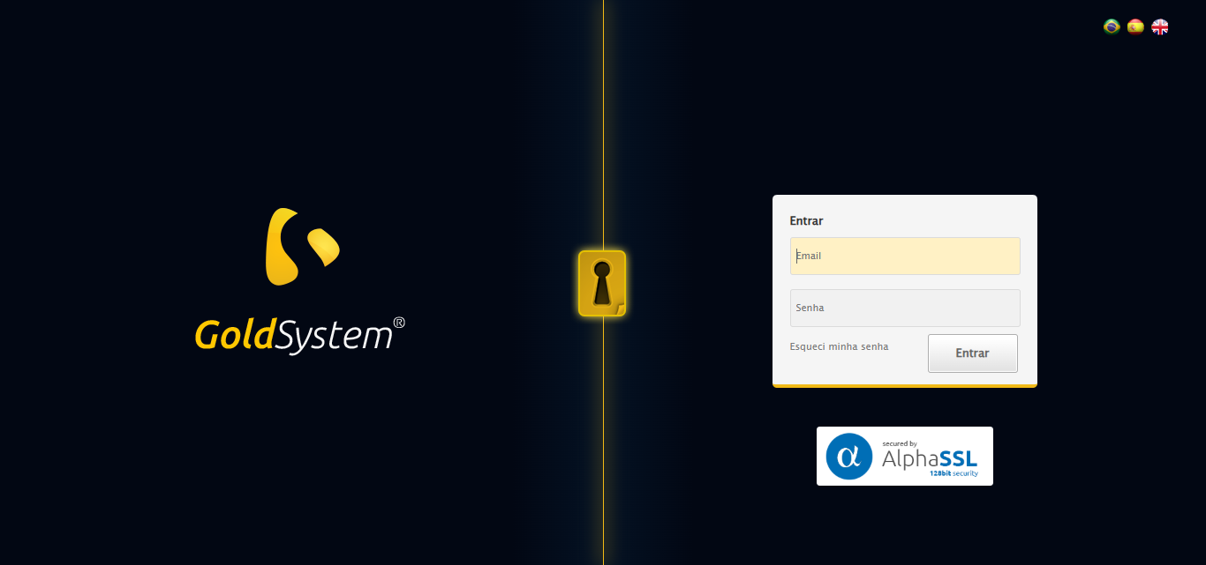

🔄 Realizando login...

✅ Realizando login realizada com sucesso.

⚠️ Erro ao tirar screenshot realizando_login: Message: invalid session id: session deleted as the browser has closed the connection  
from disconnected: not connected to DevTools  
 (Session info: chrome=139.0.7258.128)  
Stacktrace:  
 GetHandleVerifier [0x0xd2ffc3+65331]  
 GetHandleVerifier [0x0xd30004+65396]  
 (No symbol) [0x0xb23f63]  
 (No symbol) [0x0xb138e0]  
 (No symbol) [0x0xb31709]  
 (No symbol) [0x0xb97e4c]  
 (No symbol) [0x0xbb24d9]  
 (No symbol) [0x0xb912d6]  
 (No symbol) [0x0xb60910]  
 (No symbol) [0x0xb61784]  
 GetHandleVerifier [0x0xf738b3+2439203]  
 GetHandleVerifier [0x0xf6eae2+2419282]  
 GetHandleVerifier [0x0xd5712a+225434]  
 GetHandleVerifier [0x0xd46e08+159096]  
 GetHandleVerifier [0x0xd4dd5d+187597]  
 GetHandleVerifier [0x0xd37ad8+96840]  
 GetHandleVerifier [0x0xd37c62+97234]  
 GetHandleVerifier [0x0xd2277a+9962]  
 BaseThreadInitThunk [0x0x76b1fcc9+25]  
 RtlGetAppContainerNamedObjectPath [0x0x776a82ae+286]  
 RtlGetAppContainerNamedObjectPath [0x0x776a827e+238]

🔄 Ajustando zoom e abrindo menu...

⚠️ Erro ao ajustar zoom: Message: invalid session id  
Stacktrace:  
 GetHandleVerifier [0x0xd2ffc3+65331]  
 GetHandleVerifier [0x0xd30004+65396]  
 (No symbol) [0x0xb23dc0]  
 (No symbol) [0x0xb5fbd8]  
 (No symbol) [0x0xb91396]  
 (No symbol) [0x0xb8cf70]  
 (No symbol) [0x0xb8c4f6]  
 (No symbol) [0x0xaf59b5]  
 (No symbol) [0x0xaf5f0e]  
 (No symbol) [0x0xaf639d]  
 GetHandleVerifier [0x0xf738b3+2439203]  
 GetHandleVerifier [0x0xf6eae2+2419282]  
 GetHandleVerifier [0x0xd5712a+225434]  
 GetHandleVerifier [0x0xd46e08+159096]  
 GetHandleVerifier [0x0xd4dd5d+187597]  
 (No symbol) [0x0xaf5680]  
 (No symbol) [0x0xaf4e8e]  
 GetHandleVerifier [0x0x108a2ec+3580508]  
 BaseThreadInitThunk [0x0x76b1fcc9+25]  
 RtlGetAppContainerNamedObjectPath [0x0x776a82ae+286]  
 RtlGetAppContainerNamedObjectPath [0x0x776a827e+238]

⚠️ Erro ao tirar screenshot erro_ajustando_zoom_e_abrindo_menu: Message: invalid session id  
Stacktrace:  
 GetHandleVerifier [0x0xd2ffc3+65331]  
 GetHandleVerifier [0x0xd30004+65396]  
 (No symbol) [0x0xb23dc0]  
 (No symbol) [0x0xb5fbd8]  
 (No symbol) [0x0xb91396]  
 (No symbol) [0x0xb8cf70]  
 (No symbol) [0x0xb8c4f6]  
 (No symbol) [0x0xaf59b5]  
 (No symbol) [0x0xaf5f0e]  
 (No symbol) [0x0xaf639d]  
 GetHandleVerifier [0x0xf738b3+2439203]  
 GetHandleVerifier [0x0xf6eae2+2419282]  
 GetHandleVerifier [0x0xd5712a+225434]  
 GetHandleVerifier [0x0xd46e08+159096]  
 GetHandleVerifier [0x0xd4dd5d+187597]  
 (No symbol) [0x0xaf5680]  
 (No symbol) [0x0xaf4e8e]  
 GetHandleVerifier [0x0x108a2ec+3580508]  
 BaseThreadInitThunk [0x0x76b1fcc9+25]  
 RtlGetAppContainerNamedObjectPath [0x0x776a82ae+286]  
 RtlGetAppContainerNamedObjectPath [0x0x776a827e+238]

❌ ERRO FATAL: log() takes 2 positional arguments but 3 were given

⚠️ Erro ao tirar screenshot erro_fatal: Message: invalid session id  
Stacktrace:  
 GetHandleVerifier [0x0xd2ffc3+65331]  
 GetHandleVerifier [0x0xd30004+65396]  
 (No symbol) [0x0xb23dc0]  
 (No symbol) [0x0xb5fbd8]  
 (No symbol) [0x0xb91396]  
 (No symbol) [0x0xb8cf70]  
 (No symbol) [0x0xb8c4f6]  
 (No symbol) [0x0xaf59b5]  
 (No symbol) [0x0xaf5f0e]  
 (No symbol) [0x0xaf639d]  
 GetHandleVerifier [0x0xf738b3+2439203]  
 GetHandleVerifier [0x0xf6eae2+2419282]  
 GetHandleVerifier [0x0xd5712a+225434]  
 GetHandleVerifier [0x0xd46e08+159096]  
 GetHandleVerifier [0x0xd4dd5d+187597]  
 (No symbol) [0x0xaf5680]  
 (No symbol) [0x0xaf4e8e]  
 GetHandleVerifier [0x0x108a2ec+3580508]  
 BaseThreadInitThunk [0x0x76b1fcc9+25]  
 RtlGetAppContainerNamedObjectPath [0x0x776a82ae+286]  
 RtlGetAppContainerNamedObjectPath [0x0x776a827e+238]

✅ Teste concluído.

❌ Teste finalizado com erros.