RELATÓRIO DO TESTE

Cadastro de Equipamentos – Cenário 1: Preenchimento completo e salvamento.

Data do teste: 13/08/2025 15:57:00

🔄 Acessando sistema...

✅ Acessando sistema realizada com sucesso.

Screenshot: acessando_sistema

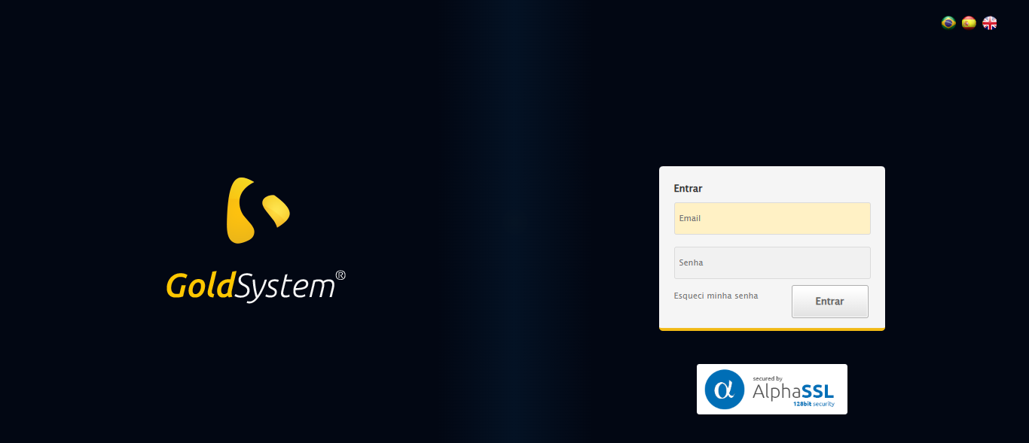

🔄 Realizando login...

✅ Realizando login realizada com sucesso.

Screenshot: realizando_login

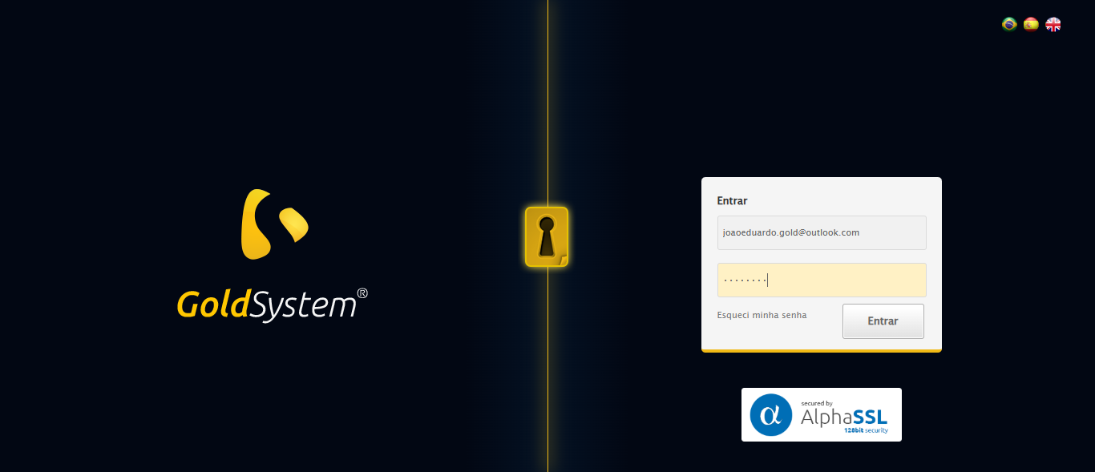

🔄 Ajustando zoom...

🔍 Zoom ajustado para 90%.

✅ Ajustando zoom realizada com sucesso.

Screenshot: ajustando_zoom

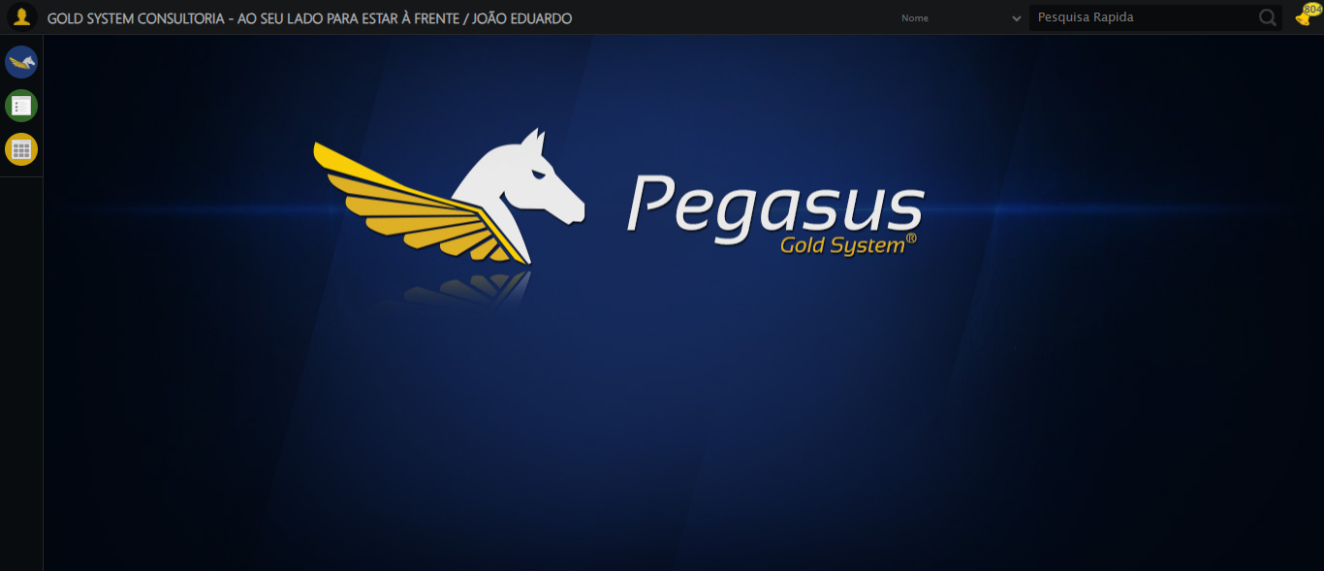

🔄 Abrindo menu Equipamento...

✅ Abrindo menu Equipamento realizada com sucesso.

Screenshot: abrindo_menu_equipamento

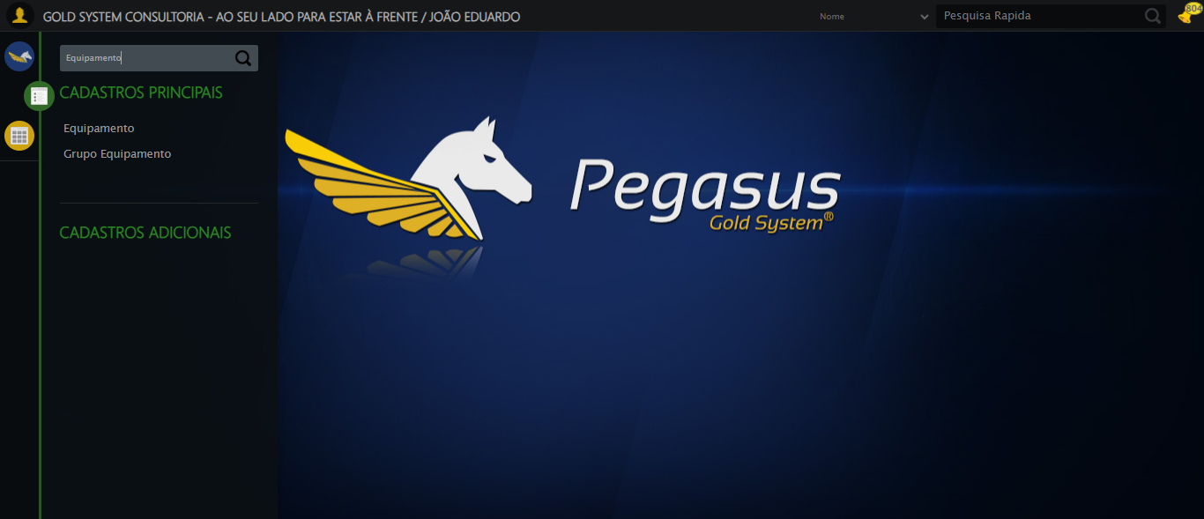

🔄 Selecionando opção de Equipamento...

✅ Selecionando opção de Equipamento realizada com sucesso.

Screenshot: selecionando_opção_de_equipamento

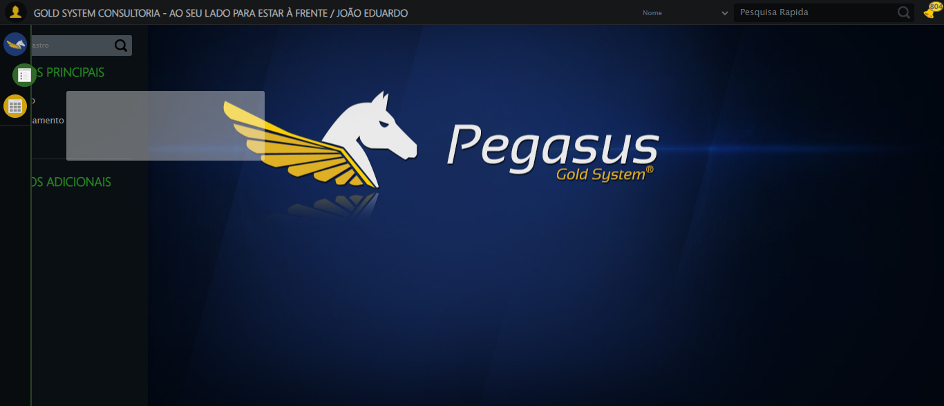

🔄 Clicando em Cadastrar...

❌ Erro ao clicando em cadastrar: Message:   
Stacktrace:  
 GetHandleVerifier [0x0x3aba83+63395]  
 GetHandleVerifier [0x0x3abac4+63460]  
 (No symbol) [0x0x1f2113]  
 (No symbol) [0x0x23a85e]  
 (No symbol) [0x0x23abfb]  
 (No symbol) [0x0x282f92]  
 (No symbol) [0x0x25f3f4]  
 (No symbol) [0x0x2807ba]  
 (No symbol) [0x0x25f1a6]  
 (No symbol) [0x0x22e7b2]  
 (No symbol) [0x0x22f654]  
 GetHandleVerifier [0x0x628883+2672035]  
 GetHandleVerifier [0x0x623cba+2652634]  
 GetHandleVerifier [0x0x3d2bca+223466]  
 GetHandleVerifier [0x0x3c2cb8+158168]  
 GetHandleVerifier [0x0x3c978d+185517]  
 GetHandleVerifier [0x0x3b3b78+96408]  
 GetHandleVerifier [0x0x3b3d02+96802]  
 GetHandleVerifier [0x0x39e90a+9770]  
 BaseThreadInitThunk [0x0x7633fcc9+25]  
 RtlGetAppContainerNamedObjectPath [0x0x76f182ae+286]  
 RtlGetAppContainerNamedObjectPath [0x0x76f1827e+238]

Screenshot: erro_clicando_em_cadastrar

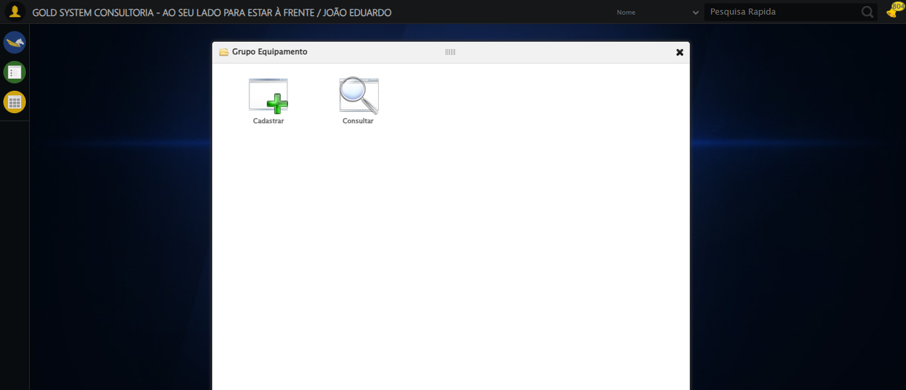

🔄 Abrindo LOV Grupo...

❌ Erro ao abrindo lov grupo: Message:   
Stacktrace:  
 GetHandleVerifier [0x0x3aba83+63395]  
 GetHandleVerifier [0x0x3abac4+63460]  
 (No symbol) [0x0x1f2113]  
 (No symbol) [0x0x23a85e]  
 (No symbol) [0x0x23abfb]  
 (No symbol) [0x0x282f92]  
 (No symbol) [0x0x25f3f4]  
 (No symbol) [0x0x2807ba]  
 (No symbol) [0x0x25f1a6]  
 (No symbol) [0x0x22e7b2]  
 (No symbol) [0x0x22f654]  
 GetHandleVerifier [0x0x628883+2672035]  
 GetHandleVerifier [0x0x623cba+2652634]  
 GetHandleVerifier [0x0x3d2bca+223466]  
 GetHandleVerifier [0x0x3c2cb8+158168]  
 GetHandleVerifier [0x0x3c978d+185517]  
 GetHandleVerifier [0x0x3b3b78+96408]  
 GetHandleVerifier [0x0x3b3d02+96802]  
 GetHandleVerifier [0x0x39e90a+9770]  
 BaseThreadInitThunk [0x0x7633fcc9+25]  
 RtlGetAppContainerNamedObjectPath [0x0x76f182ae+286]  
 RtlGetAppContainerNamedObjectPath [0x0x76f1827e+238]

Screenshot: erro_abrindo_lov_grupo

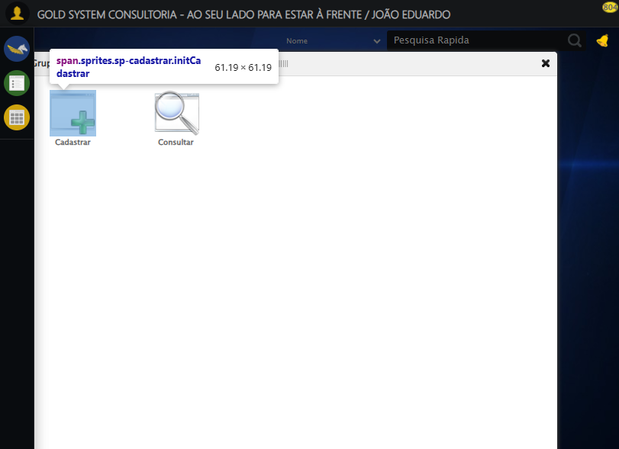

🔄 Selecionando Grupo...

❌ Erro ao interagir com elemento #fmod_10057 > div.wdTelas > div.telaCadastro.clearfix > div.catWrapper > div > div.cat_dadosEquipamento.categoriaHolder > div > div > div > div:nth-child(2) > div > a: Message:   
Stacktrace:  
 GetHandleVerifier [0x0x3aba83+63395]  
 GetHandleVerifier [0x0x3abac4+63460]  
 (No symbol) [0x0x1f2113]  
 (No symbol) [0x0x23a85e]  
 (No symbol) [0x0x23abfb]  
 (No symbol) [0x0x282f92]  
 (No symbol) [0x0x25f3f4]  
 (No symbol) [0x0x2807ba]  
 (No symbol) [0x0x25f1a6]  
 (No symbol) [0x0x22e7b2]  
 (No symbol) [0x0x22f654]  
 GetHandleVerifier [0x0x628883+2672035]  
 GetHandleVerifier [0x0x623cba+2652634]  
 GetHandleVerifier [0x0x3d2bca+223466]  
 GetHandleVerifier [0x0x3c2cb8+158168]  
 GetHandleVerifier [0x0x3c978d+185517]  
 GetHandleVerifier [0x0x3b3b78+96408]  
 GetHandleVerifier [0x0x3b3d02+96802]  
 GetHandleVerifier [0x0x39e90a+9770]  
 BaseThreadInitThunk [0x0x7633fcc9+25]  
 RtlGetAppContainerNamedObjectPath [0x0x76f182ae+286]  
 RtlGetAppContainerNamedObjectPath [0x0x76f1827e+238]

❌ Erro ao selecionando grupo: Message:   
Stacktrace:  
 GetHandleVerifier [0x0x3aba83+63395]  
 GetHandleVerifier [0x0x3abac4+63460]  
 (No symbol) [0x0x1f2113]  
 (No symbol) [0x0x23a85e]  
 (No symbol) [0x0x23abfb]  
 (No symbol) [0x0x282f92]  
 (No symbol) [0x0x25f3f4]  
 (No symbol) [0x0x2807ba]  
 (No symbol) [0x0x25f1a6]  
 (No symbol) [0x0x22e7b2]  
 (No symbol) [0x0x22f654]  
 GetHandleVerifier [0x0x628883+2672035]  
 GetHandleVerifier [0x0x623cba+2652634]  
 GetHandleVerifier [0x0x3d2bca+223466]  
 GetHandleVerifier [0x0x3c2cb8+158168]  
 GetHandleVerifier [0x0x3c978d+185517]  
 GetHandleVerifier [0x0x3b3b78+96408]  
 GetHandleVerifier [0x0x3b3d02+96802]  
 GetHandleVerifier [0x0x39e90a+9770]  
 BaseThreadInitThunk [0x0x7633fcc9+25]  
 RtlGetAppContainerNamedObjectPath [0x0x76f182ae+286]  
 RtlGetAppContainerNamedObjectPath [0x0x76f1827e+238]

Screenshot: erro_selecionando_grupo

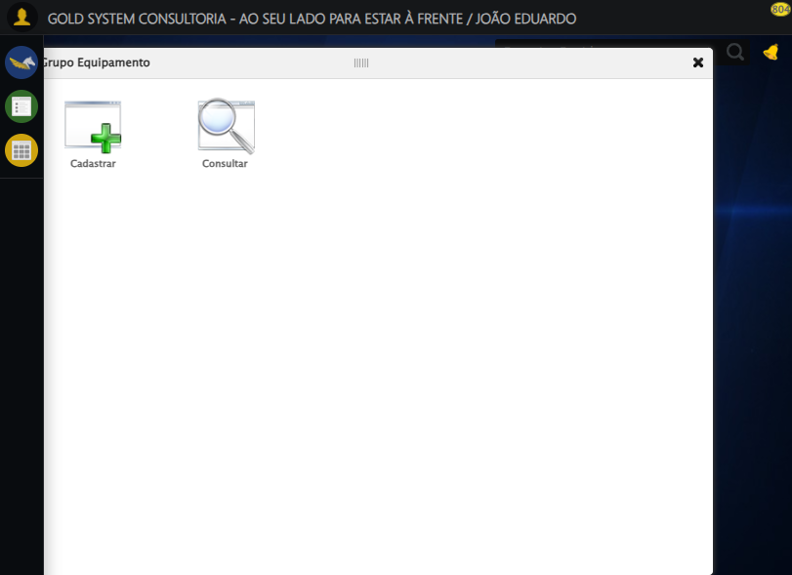

🔄 Preenchendo número de patrimônio...

❌ Erro ao preenchendo número de patrimônio: Message:   
Stacktrace:  
 GetHandleVerifier [0x0x3aba83+63395]  
 GetHandleVerifier [0x0x3abac4+63460]  
 (No symbol) [0x0x1f2113]  
 (No symbol) [0x0x23a85e]  
 (No symbol) [0x0x23abfb]  
 (No symbol) [0x0x282f92]  
 (No symbol) [0x0x25f3f4]  
 (No symbol) [0x0x2807ba]  
 (No symbol) [0x0x25f1a6]  
 (No symbol) [0x0x22e7b2]  
 (No symbol) [0x0x22f654]  
 GetHandleVerifier [0x0x628883+2672035]  
 GetHandleVerifier [0x0x623cba+2652634]  
 GetHandleVerifier [0x0x3d2bca+223466]  
 GetHandleVerifier [0x0x3c2cb8+158168]  
 GetHandleVerifier [0x0x3c978d+185517]  
 GetHandleVerifier [0x0x3b3b78+96408]  
 GetHandleVerifier [0x0x3b3d02+96802]  
 GetHandleVerifier [0x0x39e90a+9770]  
 BaseThreadInitThunk [0x0x7633fcc9+25]  
 RtlGetAppContainerNamedObjectPath [0x0x76f182ae+286]  
 RtlGetAppContainerNamedObjectPath [0x0x76f1827e+238]

Screenshot: erro_preenchendo_número_de_patrimônio



🔄 Preenchendo nome do equipamento...

❌ Erro ao preenchendo nome do equipamento: Message:   
Stacktrace:  
 GetHandleVerifier [0x0x3aba83+63395]  
 GetHandleVerifier [0x0x3abac4+63460]  
 (No symbol) [0x0x1f2113]  
 (No symbol) [0x0x23a85e]  
 (No symbol) [0x0x23abfb]  
 (No symbol) [0x0x282f92]  
 (No symbol) [0x0x25f3f4]  
 (No symbol) [0x0x2807ba]  
 (No symbol) [0x0x25f1a6]  
 (No symbol) [0x0x22e7b2]  
 (No symbol) [0x0x22f654]  
 GetHandleVerifier [0x0x628883+2672035]  
 GetHandleVerifier [0x0x623cba+2652634]  
 GetHandleVerifier [0x0x3d2bca+223466]  
 GetHandleVerifier [0x0x3c2cb8+158168]  
 GetHandleVerifier [0x0x3c978d+185517]  
 GetHandleVerifier [0x0x3b3b78+96408]  
 GetHandleVerifier [0x0x3b3d02+96802]  
 GetHandleVerifier [0x0x39e90a+9770]  
 BaseThreadInitThunk [0x0x7633fcc9+25]  
 RtlGetAppContainerNamedObjectPath [0x0x76f182ae+286]  
 RtlGetAppContainerNamedObjectPath [0x0x76f1827e+238]

Screenshot: erro_preenchendo_nome_do_equipamento

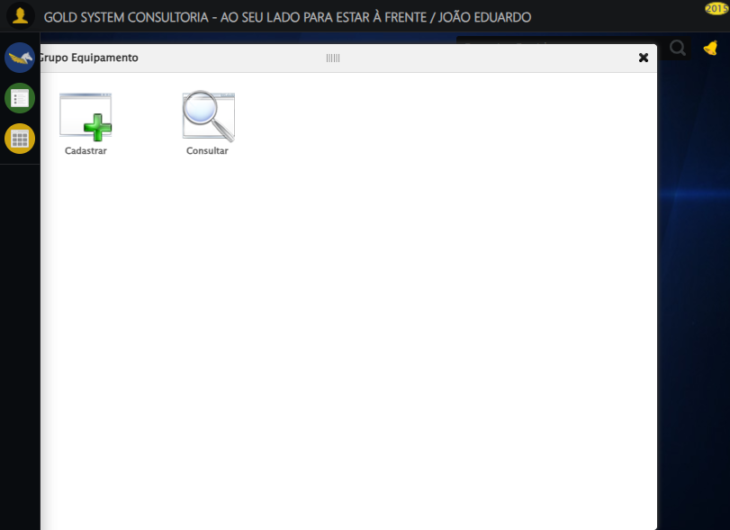

🔄 Preenchendo observação...

❌ Erro ao preenchendo observação: Message:   
Stacktrace:  
 GetHandleVerifier [0x0x3aba83+63395]  
 GetHandleVerifier [0x0x3abac4+63460]  
 (No symbol) [0x0x1f2113]  
 (No symbol) [0x0x23a85e]  
 (No symbol) [0x0x23abfb]  
 (No symbol) [0x0x282f92]  
 (No symbol) [0x0x25f3f4]  
 (No symbol) [0x0x2807ba]  
 (No symbol) [0x0x25f1a6]  
 (No symbol) [0x0x22e7b2]  
 (No symbol) [0x0x22f654]  
 GetHandleVerifier [0x0x628883+2672035]  
 GetHandleVerifier [0x0x623cba+2652634]  
 GetHandleVerifier [0x0x3d2bca+223466]  
 GetHandleVerifier [0x0x3c2cb8+158168]  
 GetHandleVerifier [0x0x3c978d+185517]  
 GetHandleVerifier [0x0x3b3b78+96408]  
 GetHandleVerifier [0x0x3b3d02+96802]  
 GetHandleVerifier [0x0x39e90a+9770]  
 BaseThreadInitThunk [0x0x7633fcc9+25]  
 RtlGetAppContainerNamedObjectPath [0x0x76f182ae+286]  
 RtlGetAppContainerNamedObjectPath [0x0x76f1827e+238]

Screenshot: erro_preenchendo_observação



🔄 Preenchendo valor de venda...

❌ Erro ao preenchendo valor de venda: Message: no such window: target window already closed  
from unknown error: web view not found  
 (Session info: chrome=138.0.7204.185)  
Stacktrace:  
 GetHandleVerifier [0x0x3aba83+63395]  
 GetHandleVerifier [0x0x3abac4+63460]  
 (No symbol) [0x0x1f2113]  
 (No symbol) [0x0x1d0fb9]  
 (No symbol) [0x0x265ace]  
 (No symbol) [0x0x280099]  
 (No symbol) [0x0x25f1a6]  
 (No symbol) [0x0x22e7b2]  
 (No symbol) [0x0x22f654]  
 GetHandleVerifier [0x0x628883+2672035]  
 GetHandleVerifier [0x0x623cba+2652634]  
 GetHandleVerifier [0x0x3d2bca+223466]  
 GetHandleVerifier [0x0x3c2cb8+158168]  
 GetHandleVerifier [0x0x3c978d+185517]  
 GetHandleVerifier [0x0x3b3b78+96408]  
 GetHandleVerifier [0x0x3b3d02+96802]  
 GetHandleVerifier [0x0x39e90a+9770]  
 BaseThreadInitThunk [0x0x7633fcc9+25]  
 RtlGetAppContainerNamedObjectPath [0x0x76f182ae+286]  
 RtlGetAppContainerNamedObjectPath [0x0x76f1827e+238]

❌ ERRO FATAL: Message: no such window: target window already closed  
from unknown error: web view not found  
 (Session info: chrome=138.0.7204.185)  
Stacktrace:  
 GetHandleVerifier [0x0x3aba83+63395]  
 GetHandleVerifier [0x0x3abac4+63460]  
 (No symbol) [0x0x1f2113]  
 (No symbol) [0x0x1d0fb9]  
 (No symbol) [0x0x265ace]  
 (No symbol) [0x0x280099]  
 (No symbol) [0x0x25f1a6]  
 (No symbol) [0x0x22e7b2]  
 (No symbol) [0x0x22f654]  
 GetHandleVerifier [0x0x628883+2672035]  
 GetHandleVerifier [0x0x623cba+2652634]  
 GetHandleVerifier [0x0x3d2bca+223466]  
 GetHandleVerifier [0x0x3c2cb8+158168]  
 GetHandleVerifier [0x0x3c978d+185517]  
 GetHandleVerifier [0x0x3b3b78+96408]  
 GetHandleVerifier [0x0x3b3d02+96802]  
 GetHandleVerifier [0x0x39e90a+9770]  
 BaseThreadInitThunk [0x0x7633fcc9+25]  
 RtlGetAppContainerNamedObjectPath [0x0x76f182ae+286]  
 RtlGetAppContainerNamedObjectPath [0x0x76f1827e+238]

✅ Teste concluído com sucesso.