RELATÓRIO DO TESTE

Cadastro de Equipamentos – Cenário 1: Preenchimento completo e salvamento.

Data do teste: 22/08/2025 16:43:55

🔄 Acessando sistema...

✅ Acessando sistema realizada com sucesso.

Screenshot: acessando_sistema

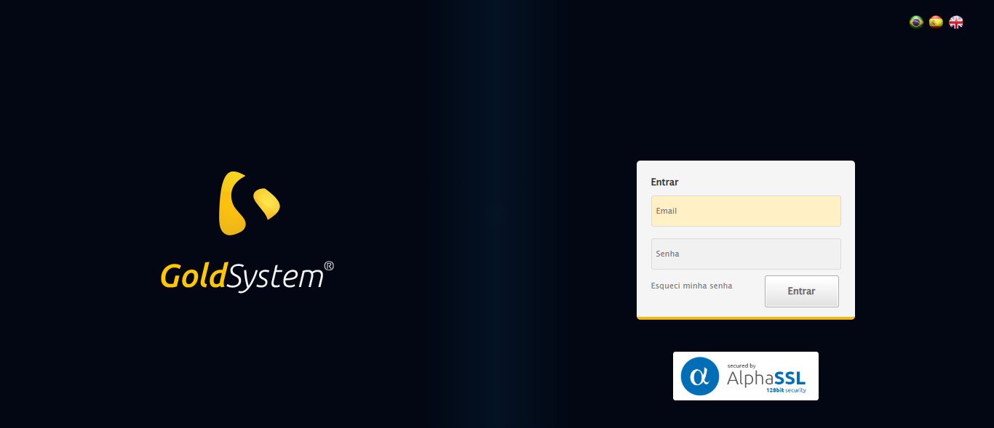

🔄 Realizando login...

❌ Erro ao realizando login: Message: target frame detached: received Inspector.detached event  
 (failed to check if window was closed: disconnected: Unable to receive message from renderer)  
 (Session info: chrome=139.0.7258.128)  
Stacktrace:  
 GetHandleVerifier [0x0xb1ffc3+65331]  
 GetHandleVerifier [0x0xb20004+65396]  
 (No symbol) [0x0x913f63]  
 (No symbol) [0x0x905f08]  
 (No symbol) [0x0x9050d8]  
 (No symbol) [0x0x904c53]  
 (No symbol) [0x0x904961]  
 (No symbol) [0x0x902904]  
 (No symbol) [0x0x9033cd]  
 (No symbol) [0x0x91a2b0]  
 (No symbol) [0x0x91ca7a]  
 (No symbol) [0x0x91caf7]  
 (No symbol) [0x0x95748f]  
 (No symbol) [0x0x955aa2]  
 (No symbol) [0x0x9814dc]  
 (No symbol) [0x0x9520d4]  
 (No symbol) [0x0x981754]  
 (No symbol) [0x0x9a2bcb]  
 (No symbol) [0x0x9812d6]  
 (No symbol) [0x0x950910]  
 (No symbol) [0x0x951784]  
 GetHandleVerifier [0x0xd638b3+2439203]  
 GetHandleVerifier [0x0xd5eae2+2419282]  
 GetHandleVerifier [0x0xb4712a+225434]  
 GetHandleVerifier [0x0xb36e08+159096]  
 GetHandleVerifier [0x0xb3dd5d+187597]  
 GetHandleVerifier [0x0xb27ad8+96840]  
 GetHandleVerifier [0x0xb27c62+97234]  
 GetHandleVerifier [0x0xb1277a+9962]  
 BaseThreadInitThunk [0x0x76b1fcc9+25]  
 RtlGetAppContainerNamedObjectPath [0x0x776a82ae+286]  
 RtlGetAppContainerNamedObjectPath [0x0x776a827e+238]

❌ ERRO FATAL: Message: invalid session id: session deleted as the browser has closed the connection  
from disconnected: not connected to DevTools  
 (Session info: chrome=139.0.7258.128)  
Stacktrace:  
 GetHandleVerifier [0x0xb1ffc3+65331]  
 GetHandleVerifier [0x0xb20004+65396]  
 (No symbol) [0x0x913f63]  
 (No symbol) [0x0x9038e0]  
 (No symbol) [0x0x921709]  
 (No symbol) [0x0x987e4c]  
 (No symbol) [0x0x9a24d9]  
 (No symbol) [0x0x9812d6]  
 (No symbol) [0x0x950910]  
 (No symbol) [0x0x951784]  
 GetHandleVerifier [0x0xd638b3+2439203]  
 GetHandleVerifier [0x0xd5eae2+2419282]  
 GetHandleVerifier [0x0xb4712a+225434]  
 GetHandleVerifier [0x0xb36e08+159096]  
 GetHandleVerifier [0x0xb3dd5d+187597]  
 GetHandleVerifier [0x0xb27ad8+96840]  
 GetHandleVerifier [0x0xb27c62+97234]  
 GetHandleVerifier [0x0xb1277a+9962]  
 BaseThreadInitThunk [0x0x76b1fcc9+25]  
 RtlGetAppContainerNamedObjectPath [0x0x776a82ae+286]  
 RtlGetAppContainerNamedObjectPath [0x0x776a827e+238]

✅ Teste concluído com sucesso.