RELATÓRIO DO TESTE

Processo: Fechamento Plano Empresa – Cenário 1: Nesse teste, o usuário irá realizar o fechamento de um Plano Empresa.

Data do teste: 15/08/2025 17:36:28

🚀 Iniciando teste de cadastro de Contrato Pet

🔄 Acessando sistema...

✅ Acessando sistema realizada com sucesso.

Screenshot: acessando_sistema

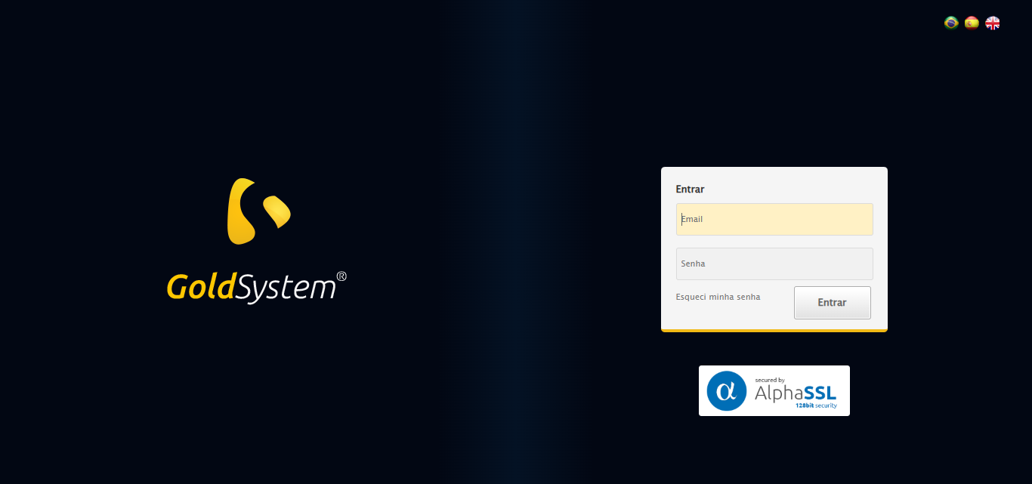

🔄 Realizando login...

✅ Realizando login realizada com sucesso.

Screenshot: realizando_login

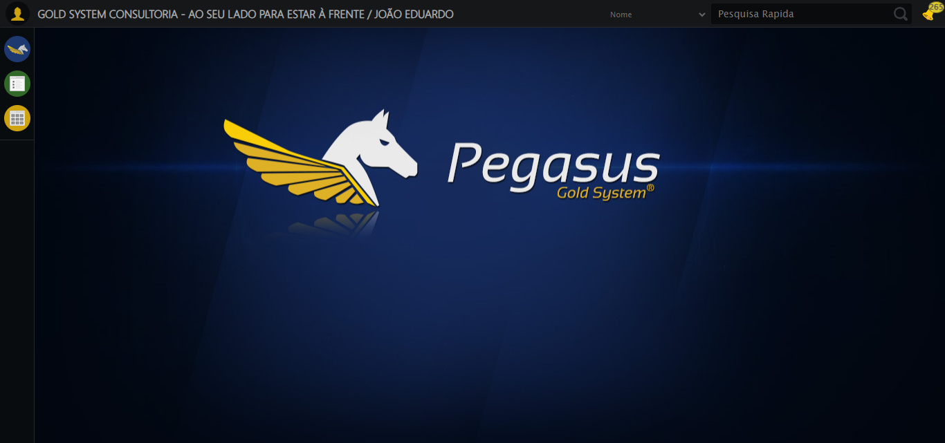

🔄 Ajustando zoom e abrindo menu...

🔍 Zoom ajustado para 90%.

✅ Ajustando zoom e abrindo menu realizada com sucesso.

Screenshot: ajustando_zoom_e_abrindo_menu

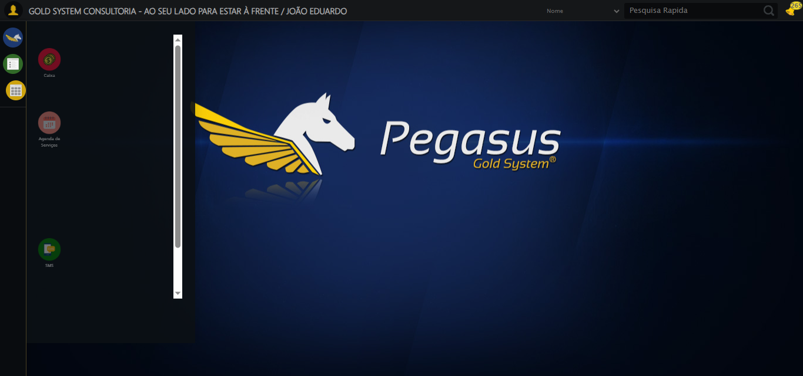

🔄 Acessando Plano Empresa...

✅ Acessando Plano Empresa realizada com sucesso.

Screenshot: acessando_plano_empresa

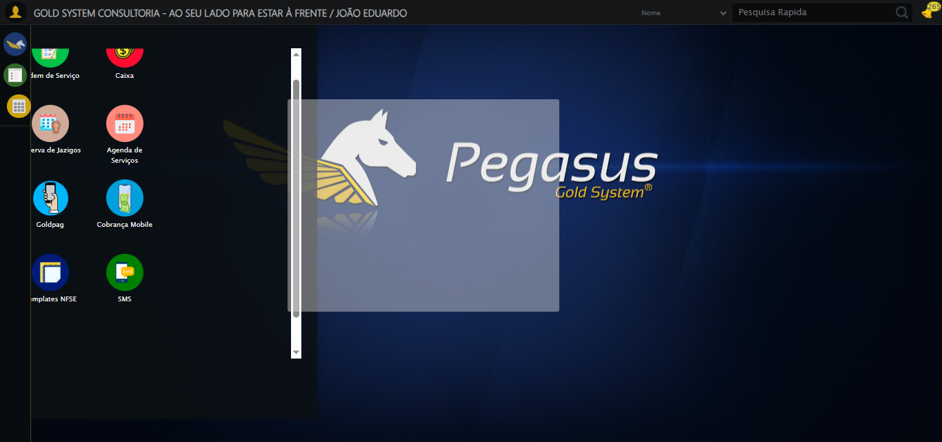

🔄 Clicando em Fechamento...

✅ Clicando em Fechamento realizada com sucesso.

Screenshot: clicando_em_fechamento

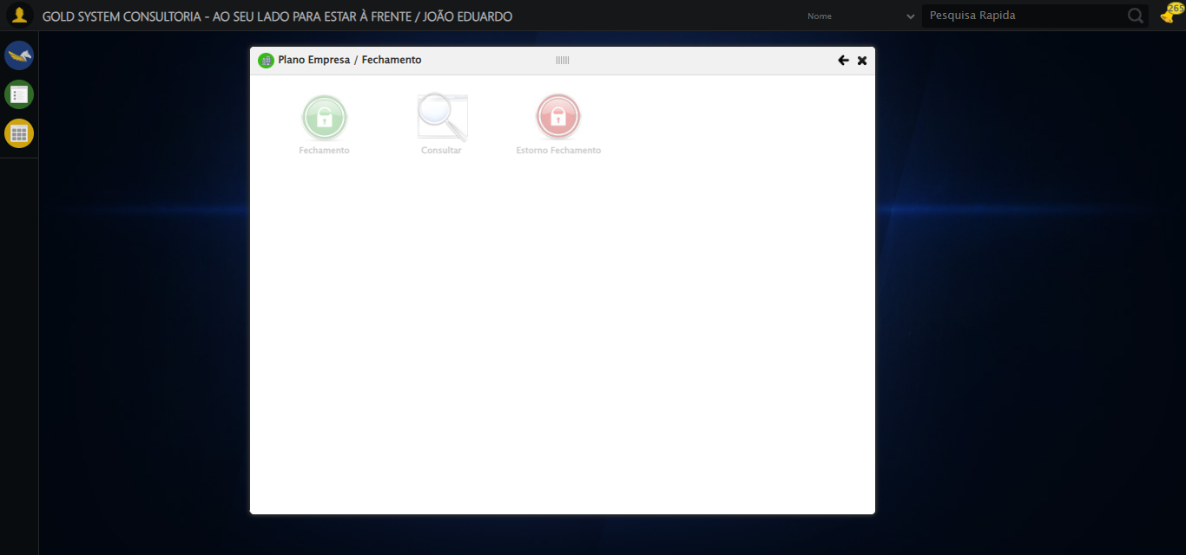

🔄 Abrindo o Lov para selecionar o Plano Empresa...

✅ Abrindo o Lov para selecionar o Plano Empresa realizada com sucesso.

Screenshot: abrindo_o_lov_para_selecionar_o_plano_empresa

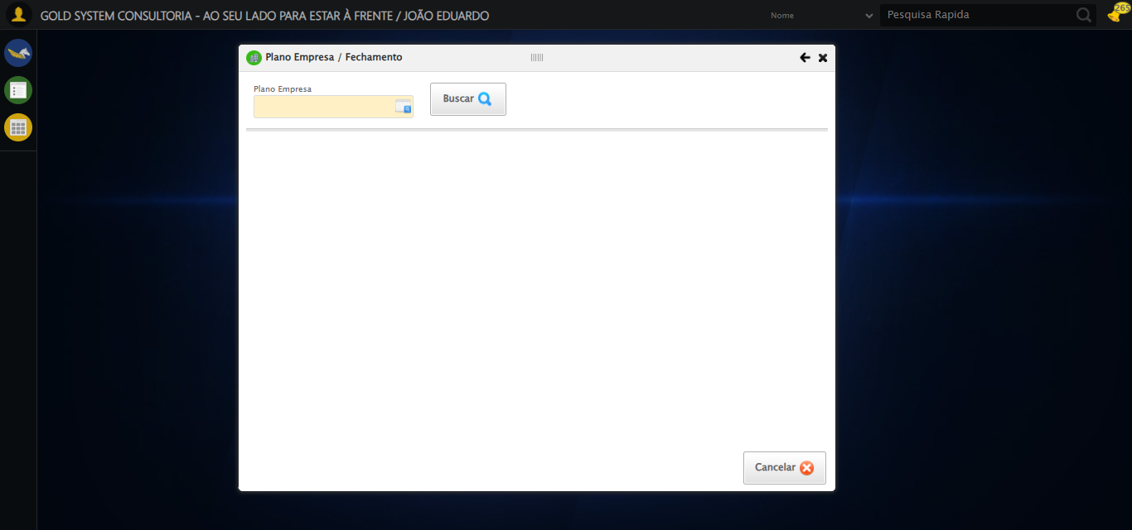

🔄 Selecionando Tipo de Filtro como CNPJ...

Screenshot: erro_selecionando_tipo_de_filtro_como_cnpj

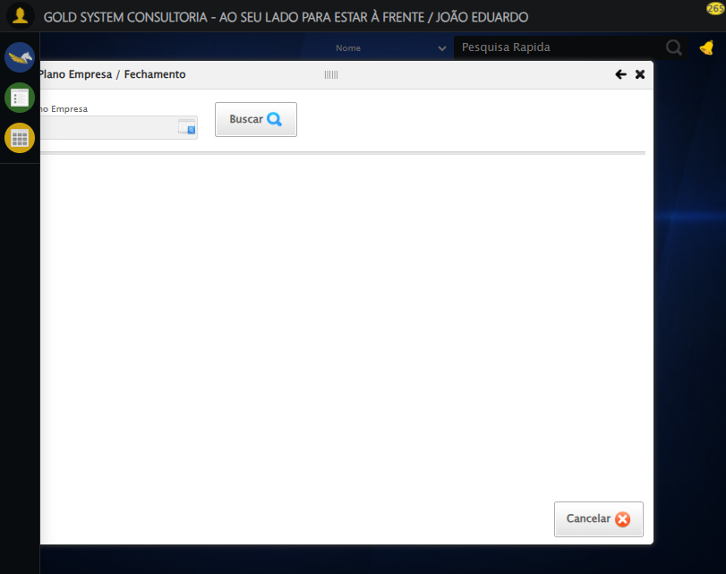

❌ Selecionando Tipo de Filtro como CNPJ falhou: TimeoutException: Message:   
Stacktrace:  
 GetHandleVerifier [0x0x3fba83+63395]  
 GetHandleVerifier [0x0x3fbac4+63460]  
 (No symbol) [0x0x242113]  
 (No symbol) [0x0x28a85e]  
 (No symbol) [0x0x28abfb]  
 (No symbol) [0x0x2d2f92]  
 (No symbol) [0x0x2af3f4]  
 (No symbol) [0x0x2d07ba]  
 (No symbol) [0x0x2af1a6]  
 (No symbol) [0x0x27e7b2]  
 (No symbol) [0x0x27f654]  
 GetHandleVerifier [0x0x678883+2672035]  
 GetHandleVerifier [0x0x673cba+2652634]  
 GetHandleVerifier [0x0x422bca+223466]  
 GetHandleVerifier [0x0x412cb8+158168]  
 GetHandleVerifier [0x0x41978d+185517]  
 GetHandleVerifier [0x0x403b78+96408]  
 GetHandleVerifier [0x0x403d02+96802]  
 GetHandleVerifier [0x0x3ee90a+9770]  
 BaseThreadInitThunk [0x0x7709fcc9+25]  
 RtlGetAppContainerNamedObjectPath [0x0x778882ae+286]  
 RtlGetAppContainerNamedObjectPath [0x0x7788827e+238]

— stacktrace —

Traceback (most recent call last):  
 File "C:\RPASelenium\RPAsPegasusSelenium\cenariostestespegasus\Processos\CenáriosPlanoEmpresa\PlanoEmpresaFechamento\processoplanoempresafechamento1ºcenario.py", line 158, in safe_action  
 func()  
 ~~~~^^  
 File "C:\RPASelenium\RPAsPegasusSelenium\cenariostestespegasus\Processos\CenáriosPlanoEmpresa\PlanoEmpresaFechamento\processoplanoempresafechamento1ºcenario.py", line 1207, in <lambda>  
 Select(wait.until(EC.presence_of_element_located((By.CSS_SELECTOR, "body > div.modalHolder > div.modal.overflow > div:nth-child(1) > div.formRow.formLastLine > div:nth-child(1) > select")))).select_by_visible_text("CNPJ")  
 ~~~~~~~~~~^^^^^^^^^^^^^^^^^^^^^^^^^^^^^^^^^^^^^^^^^^^^^^^^^^^^^^^^^^^^^^^^^^^^^^^^^^^^^^^^^^^^^^^^^^^^^^^^^^^^^^^^^^^^^^^^^^^^^^^^^^^^^^^^^^^^^^^^^^^^^^^^^^^^^^^^^^^^^^^^^^^^^^^^^^^^  
 File "C:\Python313\Lib\site-packages\selenium\webdriver\support\wait.py", line 146, in until  
 raise TimeoutException(message, screen, stacktrace)  
selenium.common.exceptions.TimeoutException: Message:   
Stacktrace:  
 GetHandleVerifier [0x0x3fba83+63395]  
 GetHandleVerifier [0x0x3fbac4+63460]  
 (No symbol) [0x0x242113]  
 (No symbol) [0x0x28a85e]  
 (No symbol) [0x0x28abfb]  
 (No symbol) [0x0x2d2f92]  
 (No symbol) [0x0x2af3f4]  
 (No symbol) [0x0x2d07ba]  
 (No symbol) [0x0x2af1a6]  
 (No symbol) [0x0x27e7b2]  
 (No symbol) [0x0x27f654]  
 GetHandleVerifier [0x0x678883+2672035]  
 GetHandleVerifier [0x0x673cba+2652634]  
 GetHandleVerifier [0x0x422bca+223466]  
 GetHandleVerifier [0x0x412cb8+158168]  
 GetHandleVerifier [0x0x41978d+185517]  
 GetHandleVerifier [0x0x403b78+96408]  
 GetHandleVerifier [0x0x403d02+96802]  
 GetHandleVerifier [0x0x3ee90a+9770]  
 BaseThreadInitThunk [0x0x7709fcc9+25]  
 RtlGetAppContainerNamedObjectPath [0x0x778882ae+286]  
 RtlGetAppContainerNamedObjectPath [0x0x7788827e+238]

🔄 Preenchendo CNPJ...

⚠️ Tentativa 1 falhou: Message: invalid selector: Unable to locate an element with the xpath expression body > div.modalHolder > div.modal.overflow > div:nth-child(1) > div.formRow.formLastLine > div:nth-child(2) > input because of the following error:  
SyntaxError: Failed to execute 'evaluate' on 'Document': The string 'body > div.modalHolder > div.modal.overflow > div:nth-child(1) > div.formRow.formLastLine > div:nth-child(2) > input' is not a valid XPath expression.  
 (Session info: chrome=138.0.7204.185); For documentation on this error, please visit: https://www.selenium.dev/documentation/webdriver/troubleshooting/errors#invalid-selector-exception  
Stacktrace:  
 GetHandleVerifier [0x0x3fba83+63395]  
 GetHandleVerifier [0x0x3fbac4+63460]  
 (No symbol) [0x0x242113]  
 (No symbol) [0x0x2488e9]  
 (No symbol) [0x0x24ac7a]  
 (No symbol) [0x0x24acf7]  
 (No symbol) [0x0x28a0f4]  
 (No symbol) [0x0x28abfb]  
 (No symbol) [0x0x2d2f92]  
 (No symbol) [0x0x2af3f4]  
 (No symbol) [0x0x2d07ba]  
 (No symbol) [0x0x2af1a6]  
 (No symbol) [0x0x27e7b2]  
 (No symbol) [0x0x27f654]  
 GetHandleVerifier [0x0x678883+2672035]  
 GetHandleVerifier [0x0x673cba+2652634]  
 GetHandleVerifier [0x0x422bca+223466]  
 GetHandleVerifier [0x0x412cb8+158168]  
 GetHandleVerifier [0x0x41978d+185517]  
 GetHandleVerifier [0x0x403b78+96408]  
 GetHandleVerifier [0x0x403d02+96802]  
 GetHandleVerifier [0x0x3ee90a+9770]  
 BaseThreadInitThunk [0x0x7709fcc9+25]  
 RtlGetAppContainerNamedObjectPath [0x0x778882ae+286]  
 RtlGetAppContainerNamedObjectPath [0x0x7788827e+238]

⚠️ Tentativa 2 falhou: Message: invalid selector: Unable to locate an element with the xpath expression body > div.modalHolder > div.modal.overflow > div:nth-child(1) > div.formRow.formLastLine > div:nth-child(2) > input because of the following error:  
SyntaxError: Failed to execute 'evaluate' on 'Document': The string 'body > div.modalHolder > div.modal.overflow > div:nth-child(1) > div.formRow.formLastLine > div:nth-child(2) > input' is not a valid XPath expression.  
 (Session info: chrome=138.0.7204.185); For documentation on this error, please visit: https://www.selenium.dev/documentation/webdriver/troubleshooting/errors#invalid-selector-exception  
Stacktrace:  
 GetHandleVerifier [0x0x3fba83+63395]  
 GetHandleVerifier [0x0x3fbac4+63460]  
 (No symbol) [0x0x242113]  
 (No symbol) [0x0x2488e9]  
 (No symbol) [0x0x24ac7a]  
 (No symbol) [0x0x24acf7]  
 (No symbol) [0x0x28a0f4]  
 (No symbol) [0x0x28abfb]  
 (No symbol) [0x0x2d2f92]  
 (No symbol) [0x0x2af3f4]  
 (No symbol) [0x0x2d07ba]  
 (No symbol) [0x0x2af1a6]  
 (No symbol) [0x0x27e7b2]  
 (No symbol) [0x0x27f654]  
 GetHandleVerifier [0x0x678883+2672035]  
 GetHandleVerifier [0x0x673cba+2652634]  
 GetHandleVerifier [0x0x422bca+223466]  
 GetHandleVerifier [0x0x412cb8+158168]  
 GetHandleVerifier [0x0x41978d+185517]  
 GetHandleVerifier [0x0x403b78+96408]  
 GetHandleVerifier [0x0x403d02+96802]  
 GetHandleVerifier [0x0x3ee90a+9770]  
 BaseThreadInitThunk [0x0x7709fcc9+25]  
 RtlGetAppContainerNamedObjectPath [0x0x778882ae+286]  
 RtlGetAppContainerNamedObjectPath [0x0x7788827e+238]

⚠️ Tentativa 3 falhou: Message: invalid selector: Unable to locate an element with the xpath expression body > div.modalHolder > div.modal.overflow > div:nth-child(1) > div.formRow.formLastLine > div:nth-child(2) > input because of the following error:  
SyntaxError: Failed to execute 'evaluate' on 'Document': The string 'body > div.modalHolder > div.modal.overflow > div:nth-child(1) > div.formRow.formLastLine > div:nth-child(2) > input' is not a valid XPath expression.  
 (Session info: chrome=138.0.7204.185); For documentation on this error, please visit: https://www.selenium.dev/documentation/webdriver/troubleshooting/errors#invalid-selector-exception  
Stacktrace:  
 GetHandleVerifier [0x0x3fba83+63395]  
 GetHandleVerifier [0x0x3fbac4+63460]  
 (No symbol) [0x0x242113]  
 (No symbol) [0x0x2488e9]  
 (No symbol) [0x0x24ac7a]  
 (No symbol) [0x0x24acf7]  
 (No symbol) [0x0x28a0f4]  
 (No symbol) [0x0x28abfb]  
 (No symbol) [0x0x2d2f92]  
 (No symbol) [0x0x2af3f4]  
 (No symbol) [0x0x2d07ba]  
 (No symbol) [0x0x2af1a6]  
 (No symbol) [0x0x27e7b2]  
 (No symbol) [0x0x27f654]  
 GetHandleVerifier [0x0x678883+2672035]  
 GetHandleVerifier [0x0x673cba+2652634]  
 GetHandleVerifier [0x0x422bca+223466]  
 GetHandleVerifier [0x0x412cb8+158168]  
 GetHandleVerifier [0x0x41978d+185517]  
 GetHandleVerifier [0x0x403b78+96408]  
 GetHandleVerifier [0x0x403d02+96802]  
 GetHandleVerifier [0x0x3ee90a+9770]  
 BaseThreadInitThunk [0x0x7709fcc9+25]  
 RtlGetAppContainerNamedObjectPath [0x0x778882ae+286]  
 RtlGetAppContainerNamedObjectPath [0x0x7788827e+238]

✅ Preenchendo CNPJ realizada com sucesso.

Screenshot: preenchendo_cnpj



🔄 Pesquisando Plano Empresa...

⚠️ Erro ao tirar screenshot erro_pesquisando_plano_empresa: Message: no such window: target window already closed  
from unknown error: web view not found  
 (Session info: chrome=138.0.7204.185)  
Stacktrace:  
 GetHandleVerifier [0x0x3fba83+63395]  
 GetHandleVerifier [0x0x3fbac4+63460]  
 (No symbol) [0x0x242113]  
 (No symbol) [0x0x220fb9]  
 (No symbol) [0x0x2b5ace]  
 (No symbol) [0x0x2d0099]  
 (No symbol) [0x0x2af1a6]  
 (No symbol) [0x0x27e7b2]  
 (No symbol) [0x0x27f654]  
 GetHandleVerifier [0x0x678883+2672035]  
 GetHandleVerifier [0x0x673cba+2652634]  
 GetHandleVerifier [0x0x422bca+223466]  
 GetHandleVerifier [0x0x412cb8+158168]  
 GetHandleVerifier [0x0x41978d+185517]  
 GetHandleVerifier [0x0x403b78+96408]  
 GetHandleVerifier [0x0x403d02+96802]  
 GetHandleVerifier [0x0x3ee90a+9770]  
 BaseThreadInitThunk [0x0x7709fcc9+25]  
 RtlGetAppContainerNamedObjectPath [0x0x778882ae+286]  
 RtlGetAppContainerNamedObjectPath [0x0x7788827e+238]

❌ Pesquisando Plano Empresa falhou: AttributeError: 'NoneType' object has no attribute 'is_displayed'

— stacktrace —

Traceback (most recent call last):  
 File "C:\RPASelenium\RPAsPegasusSelenium\cenariostestespegasus\Processos\CenáriosPlanoEmpresa\PlanoEmpresaFechamento\processoplanoempresafechamento1ºcenario.py", line 158, in safe_action  
 func()  
 ~~~~^^  
 File "C:\RPASelenium\RPAsPegasusSelenium\cenariostestespegasus\Processos\CenáriosPlanoEmpresa\PlanoEmpresaFechamento\processoplanoempresafechamento1ºcenario.py", line 1217, in <lambda>  
 wait.until(EC.element_to_be_clickable((By.CSS_SELECTOR, 'body > div.modalHolder > div.modal.overflow > div:nth-child(1) > div.formRow.formLastLine > div:nth-child(4) > a'))).click()  
 ~~~~~~~~~~^^^^^^^^^^^^^^^^^^^^^^^^^^^^^^^^^^^^^^^^^^^^^^^^^^^^^^^^^^^^^^^^^^^^^^^^^^^^^^^^^^^^^^^^^^^^^^^^^^^^^^^^^^^^^^^^^^^^^^^^^^^^^^^^^^^^^^^^^^^^^^^^^^^^^^^^^^^^^^^^^^^  
 File "C:\Python313\Lib\site-packages\selenium\webdriver\support\wait.py", line 137, in until  
 value = method(self._driver)  
 File "C:\Python313\Lib\site-packages\selenium\webdriver\support\expected_conditions.py", line 632, in _predicate  
 element = visibility_of(target)(driver)  
 File "C:\Python313\Lib\site-packages\selenium\webdriver\support\expected_conditions.py", line 260, in _predicate  
 return _element_if_visible(element)  
 File "C:\Python313\Lib\site-packages\selenium\webdriver\support\expected_conditions.py", line 280, in _element_if_visible  
 return element if element.is_displayed() == visibility else False  
 ^^^^^^^^^^^^^^^^^^^^  
AttributeError: 'NoneType' object has no attribute 'is_displayed'

🔄 Clicando no resultado da pesquisa...

⚠️ Erro ao tirar screenshot erro_clicando_no_resultado_da_pesquisa: Message: no such window: target window already closed  
from unknown error: web view not found  
 (Session info: chrome=138.0.7204.185)  
Stacktrace:  
 GetHandleVerifier [0x0x3fba83+63395]  
 GetHandleVerifier [0x0x3fbac4+63460]  
 (No symbol) [0x0x242113]  
 (No symbol) [0x0x220fb9]  
 (No symbol) [0x0x2b5ace]  
 (No symbol) [0x0x2d0099]  
 (No symbol) [0x0x2af1a6]  
 (No symbol) [0x0x27e7b2]  
 (No symbol) [0x0x27f654]  
 GetHandleVerifier [0x0x678883+2672035]  
 GetHandleVerifier [0x0x673cba+2652634]  
 GetHandleVerifier [0x0x422bca+223466]  
 GetHandleVerifier [0x0x412cb8+158168]  
 GetHandleVerifier [0x0x41978d+185517]  
 GetHandleVerifier [0x0x403b78+96408]  
 GetHandleVerifier [0x0x403d02+96802]  
 GetHandleVerifier [0x0x3ee90a+9770]  
 BaseThreadInitThunk [0x0x7709fcc9+25]  
 RtlGetAppContainerNamedObjectPath [0x0x778882ae+286]  
 RtlGetAppContainerNamedObjectPath [0x0x7788827e+238]

❌ Clicando no resultado da pesquisa falhou: NoSuchWindowException: Message: no such window: target window already closed  
from unknown error: web view not found  
 (Session info: chrome=138.0.7204.185)  
Stacktrace:  
 GetHandleVerifier [0x0x3fba83+63395]  
 GetHandleVerifier [0x0x3fbac4+63460]  
 (No symbol) [0x0x242113]  
 (No symbol) [0x0x220fb9]  
 (No symbol) [0x0x2b5ace]  
 (No symbol) [0x0x2d0099]  
 (No symbol) [0x0x2af1a6]  
 (No symbol) [0x0x27e7b2]  
 (No symbol) [0x0x27f654]  
 GetHandleVerifier [0x0x678883+2672035]  
 GetHandleVerifier [0x0x673cba+2652634]  
 GetHandleVerifier [0x0x422bca+223466]  
 GetHandleVerifier [0x0x412cb8+158168]  
 GetHandleVerifier [0x0x41978d+185517]  
 GetHandleVerifier [0x0x403b78+96408]  
 GetHandleVerifier [0x0x403d02+96802]  
 GetHandleVerifier [0x0x3ee90a+9770]  
 BaseThreadInitThunk [0x0x7709fcc9+25]  
 RtlGetAppContainerNamedObjectPath [0x0x778882ae+286]  
 RtlGetAppContainerNamedObjectPath [0x0x7788827e+238]

— stacktrace —

Traceback (most recent call last):  
 File "C:\RPASelenium\RPAsPegasusSelenium\cenariostestespegasus\Processos\CenáriosPlanoEmpresa\PlanoEmpresaFechamento\processoplanoempresafechamento1ºcenario.py", line 158, in safe_action  
 func()  
 ~~~~^^  
 File "C:\RPASelenium\RPAsPegasusSelenium\cenariostestespegasus\Processos\CenáriosPlanoEmpresa\PlanoEmpresaFechamento\processoplanoempresafechamento1ºcenario.py", line 1223, in <lambda>  
 wait.until(EC.element_to_be_clickable((By.XPATH, "//td[contains(text(), 'PLANO EMPRESA TESTE SELENIUM AUTOMATIZADO')]"))).click(),  
 ~~~~~~~~~~^^^^^^^^^^^^^^^^^^^^^^^^^^^^^^^^^^^^^^^^^^^^^^^^^^^^^^^^^^^^^^^^^^^^^^^^^^^^^^^^^^^^^^^^^^^^^^^^^^^^^^^^^^^^^^^  
 File "C:\Python313\Lib\site-packages\selenium\webdriver\support\wait.py", line 137, in until  
 value = method(self._driver)  
 File "C:\Python313\Lib\site-packages\selenium\webdriver\support\expected_conditions.py", line 631, in _predicate  
 target = driver.find_element(*target) # grab element at locator  
 File "C:\Python313\Lib\site-packages\selenium\webdriver\remote\webdriver.py", line 898, in find_element  
 return self.execute(Command.FIND_ELEMENT, {"using": by, "value": value})["value"]  
 ~~~~~~~~~~~~^^^^^^^^^^^^^^^^^^^^^^^^^^^^^^^^^^^^^^^^^^^^^^^^^^^^^  
 File "C:\Python313\Lib\site-packages\selenium\webdriver\remote\webdriver.py", line 429, in execute  
 self.error_handler.check_response(response)  
 ~~~~~~~~~~~~~~~~~~~~~~~~~~~~~~~~~^^^^^^^^^^  
 File "C:\Python313\Lib\site-packages\selenium\webdriver\remote\errorhandler.py", line 232, in check_response  
 raise exception_class(message, screen, stacktrace)  
selenium.common.exceptions.NoSuchWindowException: Message: no such window: target window already closed  
from unknown error: web view not found  
 (Session info: chrome=138.0.7204.185)  
Stacktrace:  
 GetHandleVerifier [0x0x3fba83+63395]  
 GetHandleVerifier [0x0x3fbac4+63460]  
 (No symbol) [0x0x242113]  
 (No symbol) [0x0x220fb9]  
 (No symbol) [0x0x2b5ace]  
 (No symbol) [0x0x2d0099]  
 (No symbol) [0x0x2af1a6]  
 (No symbol) [0x0x27e7b2]  
 (No symbol) [0x0x27f654]  
 GetHandleVerifier [0x0x678883+2672035]  
 GetHandleVerifier [0x0x673cba+2652634]  
 GetHandleVerifier [0x0x422bca+223466]  
 GetHandleVerifier [0x0x412cb8+158168]  
 GetHandleVerifier [0x0x41978d+185517]  
 GetHandleVerifier [0x0x403b78+96408]  
 GetHandleVerifier [0x0x403d02+96802]  
 GetHandleVerifier [0x0x3ee90a+9770]  
 BaseThreadInitThunk [0x0x7709fcc9+25]  
 RtlGetAppContainerNamedObjectPath [0x0x778882ae+286]  
 RtlGetAppContainerNamedObjectPath [0x0x7788827e+238]

🔄 Buscando Plano Empresa...

⚠️ Erro ao tirar screenshot erro_buscando_plano_empresa: Message: no such window: target window already closed  
from unknown error: web view not found  
 (Session info: chrome=138.0.7204.185)  
Stacktrace:  
 GetHandleVerifier [0x0x3fba83+63395]  
 GetHandleVerifier [0x0x3fbac4+63460]  
 (No symbol) [0x0x242113]  
 (No symbol) [0x0x220fb9]  
 (No symbol) [0x0x2b5ace]  
 (No symbol) [0x0x2d0099]  
 (No symbol) [0x0x2af1a6]  
 (No symbol) [0x0x27e7b2]  
 (No symbol) [0x0x27f654]  
 GetHandleVerifier [0x0x678883+2672035]  
 GetHandleVerifier [0x0x673cba+2652634]  
 GetHandleVerifier [0x0x422bca+223466]  
 GetHandleVerifier [0x0x412cb8+158168]  
 GetHandleVerifier [0x0x41978d+185517]  
 GetHandleVerifier [0x0x403b78+96408]  
 GetHandleVerifier [0x0x403d02+96802]  
 GetHandleVerifier [0x0x3ee90a+9770]  
 BaseThreadInitThunk [0x0x7709fcc9+25]  
 RtlGetAppContainerNamedObjectPath [0x0x778882ae+286]  
 RtlGetAppContainerNamedObjectPath [0x0x7788827e+238]

❌ Buscando Plano Empresa falhou: NoSuchWindowException: Message: no such window: target window already closed  
from unknown error: web view not found  
 (Session info: chrome=138.0.7204.185)  
Stacktrace:  
 GetHandleVerifier [0x0x3fba83+63395]  
 GetHandleVerifier [0x0x3fbac4+63460]  
 (No symbol) [0x0x242113]  
 (No symbol) [0x0x220fb9]  
 (No symbol) [0x0x2b5ace]  
 (No symbol) [0x0x2d0099]  
 (No symbol) [0x0x2af1a6]  
 (No symbol) [0x0x27e7b2]  
 (No symbol) [0x0x27f654]  
 GetHandleVerifier [0x0x678883+2672035]  
 GetHandleVerifier [0x0x673cba+2652634]  
 GetHandleVerifier [0x0x422bca+223466]  
 GetHandleVerifier [0x0x412cb8+158168]  
 GetHandleVerifier [0x0x41978d+185517]  
 GetHandleVerifier [0x0x403b78+96408]  
 GetHandleVerifier [0x0x403d02+96802]  
 GetHandleVerifier [0x0x3ee90a+9770]  
 BaseThreadInitThunk [0x0x7709fcc9+25]  
 RtlGetAppContainerNamedObjectPath [0x0x778882ae+286]  
 RtlGetAppContainerNamedObjectPath [0x0x7788827e+238]

— stacktrace —

Traceback (most recent call last):  
 File "C:\RPASelenium\RPAsPegasusSelenium\cenariostestespegasus\Processos\CenáriosPlanoEmpresa\PlanoEmpresaFechamento\processoplanoempresafechamento1ºcenario.py", line 158, in safe_action  
 func()  
 ~~~~^^  
 File "C:\RPASelenium\RPAsPegasusSelenium\cenariostestespegasus\Processos\CenáriosPlanoEmpresa\PlanoEmpresaFechamento\processoplanoempresafechamento1ºcenario.py", line 1230, in <lambda>  
 wait.until(EC.element_to_be_clickable((By.CSS_SELECTOR, '#gsPlanoEmpresa > div.wdTelas > div:nth-child(4) > div.formRow.formLastLine > div:nth-child(2) > a'))).click()  
 ~~~~~~~~~~^^^^^^^^^^^^^^^^^^^^^^^^^^^^^^^^^^^^^^^^^^^^^^^^^^^^^^^^^^^^^^^^^^^^^^^^^^^^^^^^^^^^^^^^^^^^^^^^^^^^^^^^^^^^^^^^^^^^^^^^^^^^^^^^^^^^^^^^^^^^^^^^^^^^^  
 File "C:\Python313\Lib\site-packages\selenium\webdriver\support\wait.py", line 137, in until  
 value = method(self._driver)  
 File "C:\Python313\Lib\site-packages\selenium\webdriver\support\expected_conditions.py", line 631, in _predicate  
 target = driver.find_element(*target) # grab element at locator  
 File "C:\Python313\Lib\site-packages\selenium\webdriver\remote\webdriver.py", line 898, in find_element  
 return self.execute(Command.FIND_ELEMENT, {"using": by, "value": value})["value"]  
 ~~~~~~~~~~~~^^^^^^^^^^^^^^^^^^^^^^^^^^^^^^^^^^^^^^^^^^^^^^^^^^^^^  
 File "C:\Python313\Lib\site-packages\selenium\webdriver\remote\webdriver.py", line 429, in execute  
 self.error_handler.check_response(response)  
 ~~~~~~~~~~~~~~~~~~~~~~~~~~~~~~~~~^^^^^^^^^^  
 File "C:\Python313\Lib\site-packages\selenium\webdriver\remote\errorhandler.py", line 232, in check_response  
 raise exception_class(message, screen, stacktrace)  
selenium.common.exceptions.NoSuchWindowException: Message: no such window: target window already closed  
from unknown error: web view not found  
 (Session info: chrome=138.0.7204.185)  
Stacktrace:  
 GetHandleVerifier [0x0x3fba83+63395]  
 GetHandleVerifier [0x0x3fbac4+63460]  
 (No symbol) [0x0x242113]  
 (No symbol) [0x0x220fb9]  
 (No symbol) [0x0x2b5ace]  
 (No symbol) [0x0x2d0099]  
 (No symbol) [0x0x2af1a6]  
 (No symbol) [0x0x27e7b2]  
 (No symbol) [0x0x27f654]  
 GetHandleVerifier [0x0x678883+2672035]  
 GetHandleVerifier [0x0x673cba+2652634]  
 GetHandleVerifier [0x0x422bca+223466]  
 GetHandleVerifier [0x0x412cb8+158168]  
 GetHandleVerifier [0x0x41978d+185517]  
 GetHandleVerifier [0x0x403b78+96408]  
 GetHandleVerifier [0x0x403d02+96802]  
 GetHandleVerifier [0x0x3ee90a+9770]  
 BaseThreadInitThunk [0x0x7709fcc9+25]  
 RtlGetAppContainerNamedObjectPath [0x0x778882ae+286]  
 RtlGetAppContainerNamedObjectPath [0x0x7788827e+238]

🔄 Preenchendo Data de Vencimento...

✅ Preenchendo Data de Vencimento realizada com sucesso.

⚠️ Erro ao tirar screenshot preenchendo_data_de_vencimento: Message: no such window: target window already closed  
from unknown error: web view not found  
 (Session info: chrome=138.0.7204.185)  
Stacktrace:  
 GetHandleVerifier [0x0x3fba83+63395]  
 GetHandleVerifier [0x0x3fbac4+63460]  
 (No symbol) [0x0x242113]  
 (No symbol) [0x0x220fb9]  
 (No symbol) [0x0x2b5ace]  
 (No symbol) [0x0x2d0099]  
 (No symbol) [0x0x2af1a6]  
 (No symbol) [0x0x27e7b2]  
 (No symbol) [0x0x27f654]  
 GetHandleVerifier [0x0x678883+2672035]  
 GetHandleVerifier [0x0x673cba+2652634]  
 GetHandleVerifier [0x0x422bca+223466]  
 GetHandleVerifier [0x0x412cb8+158168]  
 GetHandleVerifier [0x0x41978d+185517]  
 GetHandleVerifier [0x0x403b78+96408]  
 GetHandleVerifier [0x0x403d02+96802]  
 GetHandleVerifier [0x0x3ee90a+9770]  
 BaseThreadInitThunk [0x0x7709fcc9+25]  
 RtlGetAppContainerNamedObjectPath [0x0x778882ae+286]  
 RtlGetAppContainerNamedObjectPath [0x0x7788827e+238]

🔄 Selecionando Tipo Valor Base...

⚠️ Erro ao tirar screenshot erro_selecionando_tipo_valor_base: Message: no such window: target window already closed  
from unknown error: web view not found  
 (Session info: chrome=138.0.7204.185)  
Stacktrace:  
 GetHandleVerifier [0x0x3fba83+63395]  
 GetHandleVerifier [0x0x3fbac4+63460]  
 (No symbol) [0x0x242113]  
 (No symbol) [0x0x220fb9]  
 (No symbol) [0x0x2b5ace]  
 (No symbol) [0x0x2d0099]  
 (No symbol) [0x0x2af1a6]  
 (No symbol) [0x0x27e7b2]  
 (No symbol) [0x0x27f654]  
 GetHandleVerifier [0x0x678883+2672035]  
 GetHandleVerifier [0x0x673cba+2652634]  
 GetHandleVerifier [0x0x422bca+223466]  
 GetHandleVerifier [0x0x412cb8+158168]  
 GetHandleVerifier [0x0x41978d+185517]  
 GetHandleVerifier [0x0x403b78+96408]  
 GetHandleVerifier [0x0x403d02+96802]  
 GetHandleVerifier [0x0x3ee90a+9770]  
 BaseThreadInitThunk [0x0x7709fcc9+25]  
 RtlGetAppContainerNamedObjectPath [0x0x778882ae+286]  
 RtlGetAppContainerNamedObjectPath [0x0x7788827e+238]

❌ Selecionando Tipo Valor Base falhou: NoSuchWindowException: Message: no such window: target window already closed  
from unknown error: web view not found  
 (Session info: chrome=138.0.7204.185)  
Stacktrace:  
 GetHandleVerifier [0x0x3fba83+63395]  
 GetHandleVerifier [0x0x3fbac4+63460]  
 (No symbol) [0x0x242113]  
 (No symbol) [0x0x220fb9]  
 (No symbol) [0x0x2b5ace]  
 (No symbol) [0x0x2d0099]  
 (No symbol) [0x0x2af1a6]  
 (No symbol) [0x0x27e7b2]  
 (No symbol) [0x0x27f654]  
 GetHandleVerifier [0x0x678883+2672035]  
 GetHandleVerifier [0x0x673cba+2652634]  
 GetHandleVerifier [0x0x422bca+223466]  
 GetHandleVerifier [0x0x412cb8+158168]  
 GetHandleVerifier [0x0x41978d+185517]  
 GetHandleVerifier [0x0x403b78+96408]  
 GetHandleVerifier [0x0x403d02+96802]  
 GetHandleVerifier [0x0x3ee90a+9770]  
 BaseThreadInitThunk [0x0x7709fcc9+25]  
 RtlGetAppContainerNamedObjectPath [0x0x778882ae+286]  
 RtlGetAppContainerNamedObjectPath [0x0x7788827e+238]

— stacktrace —

Traceback (most recent call last):  
 File "C:\RPASelenium\RPAsPegasusSelenium\cenariostestespegasus\Processos\CenáriosPlanoEmpresa\PlanoEmpresaFechamento\processoplanoempresafechamento1ºcenario.py", line 158, in safe_action  
 func()  
 ~~~~^^  
 File "C:\RPASelenium\RPAsPegasusSelenium\cenariostestespegasus\Processos\CenáriosPlanoEmpresa\PlanoEmpresaFechamento\processoplanoempresafechamento1ºcenario.py", line 1238, in <lambda>  
 Select(wait.until(EC.presence_of_element_located((By.CSS_SELECTOR, "#gsPlanoEmpresa > div.wdTelas > div:nth-child(4) > div.contentHolder.clearfix.overflow.overflowY > div:nth-child(2) > div:nth-child(2) > select")))).select_by_visible_text("Valor Contrato")  
 ~~~~~~~~~~^^^^^^^^^^^^^^^^^^^^^^^^^^^^^^^^^^^^^^^^^^^^^^^^^^^^^^^^^^^^^^^^^^^^^^^^^^^^^^^^^^^^^^^^^^^^^^^^^^^^^^^^^^^^^^^^^^^^^^^^^^^^^^^^^^^^^^^^^^^^^^^^^^^^^^^^^^^^^^^^^^^^^^^^^^^^^^^^^^^^^^^^^^^^^^^^^^^^^^  
 File "C:\Python313\Lib\site-packages\selenium\webdriver\support\wait.py", line 137, in until  
 value = method(self._driver)  
 File "C:\Python313\Lib\site-packages\selenium\webdriver\support\expected_conditions.py", line 110, in _predicate  
 return driver.find_element(*locator)  
 ~~~~~~~~~~~~~~~~~~~^^^^^^^^^^  
 File "C:\Python313\Lib\site-packages\selenium\webdriver\remote\webdriver.py", line 898, in find_element  
 return self.execute(Command.FIND_ELEMENT, {"using": by, "value": value})["value"]  
 ~~~~~~~~~~~~^^^^^^^^^^^^^^^^^^^^^^^^^^^^^^^^^^^^^^^^^^^^^^^^^^^^^  
 File "C:\Python313\Lib\site-packages\selenium\webdriver\remote\webdriver.py", line 429, in execute  
 self.error_handler.check_response(response)  
 ~~~~~~~~~~~~~~~~~~~~~~~~~~~~~~~~~^^^^^^^^^^  
 File "C:\Python313\Lib\site-packages\selenium\webdriver\remote\errorhandler.py", line 232, in check_response  
 raise exception_class(message, screen, stacktrace)  
selenium.common.exceptions.NoSuchWindowException: Message: no such window: target window already closed  
from unknown error: web view not found  
 (Session info: chrome=138.0.7204.185)  
Stacktrace:  
 GetHandleVerifier [0x0x3fba83+63395]  
 GetHandleVerifier [0x0x3fbac4+63460]  
 (No symbol) [0x0x242113]  
 (No symbol) [0x0x220fb9]  
 (No symbol) [0x0x2b5ace]  
 (No symbol) [0x0x2d0099]  
 (No symbol) [0x0x2af1a6]  
 (No symbol) [0x0x27e7b2]  
 (No symbol) [0x0x27f654]  
 GetHandleVerifier [0x0x678883+2672035]  
 GetHandleVerifier [0x0x673cba+2652634]  
 GetHandleVerifier [0x0x422bca+223466]  
 GetHandleVerifier [0x0x412cb8+158168]  
 GetHandleVerifier [0x0x41978d+185517]  
 GetHandleVerifier [0x0x403b78+96408]  
 GetHandleVerifier [0x0x403d02+96802]  
 GetHandleVerifier [0x0x3ee90a+9770]  
 BaseThreadInitThunk [0x0x7709fcc9+25]  
 RtlGetAppContainerNamedObjectPath [0x0x778882ae+286]  
 RtlGetAppContainerNamedObjectPath [0x0x7788827e+238]

🔄 Selecionando Tipo de reajuste...

⚠️ Erro ao tirar screenshot erro_selecionando_tipo_de_reajuste: Message: no such window: target window already closed  
from unknown error: web view not found  
 (Session info: chrome=138.0.7204.185)  
Stacktrace:  
 GetHandleVerifier [0x0x3fba83+63395]  
 GetHandleVerifier [0x0x3fbac4+63460]  
 (No symbol) [0x0x242113]  
 (No symbol) [0x0x220fb9]  
 (No symbol) [0x0x2b5ace]  
 (No symbol) [0x0x2d0099]  
 (No symbol) [0x0x2af1a6]  
 (No symbol) [0x0x27e7b2]  
 (No symbol) [0x0x27f654]  
 GetHandleVerifier [0x0x678883+2672035]  
 GetHandleVerifier [0x0x673cba+2652634]  
 GetHandleVerifier [0x0x422bca+223466]  
 GetHandleVerifier [0x0x412cb8+158168]  
 GetHandleVerifier [0x0x41978d+185517]  
 GetHandleVerifier [0x0x403b78+96408]  
 GetHandleVerifier [0x0x403d02+96802]  
 GetHandleVerifier [0x0x3ee90a+9770]  
 BaseThreadInitThunk [0x0x7709fcc9+25]  
 RtlGetAppContainerNamedObjectPath [0x0x778882ae+286]  
 RtlGetAppContainerNamedObjectPath [0x0x7788827e+238]

❌ Selecionando Tipo de reajuste falhou: NoSuchWindowException: Message: no such window: target window already closed  
from unknown error: web view not found  
 (Session info: chrome=138.0.7204.185)  
Stacktrace:  
 GetHandleVerifier [0x0x3fba83+63395]  
 GetHandleVerifier [0x0x3fbac4+63460]  
 (No symbol) [0x0x242113]  
 (No symbol) [0x0x220fb9]  
 (No symbol) [0x0x2b5ace]  
 (No symbol) [0x0x2d0099]  
 (No symbol) [0x0x2af1a6]  
 (No symbol) [0x0x27e7b2]  
 (No symbol) [0x0x27f654]  
 GetHandleVerifier [0x0x678883+2672035]  
 GetHandleVerifier [0x0x673cba+2652634]  
 GetHandleVerifier [0x0x422bca+223466]  
 GetHandleVerifier [0x0x412cb8+158168]  
 GetHandleVerifier [0x0x41978d+185517]  
 GetHandleVerifier [0x0x403b78+96408]  
 GetHandleVerifier [0x0x403d02+96802]  
 GetHandleVerifier [0x0x3ee90a+9770]  
 BaseThreadInitThunk [0x0x7709fcc9+25]  
 RtlGetAppContainerNamedObjectPath [0x0x778882ae+286]  
 RtlGetAppContainerNamedObjectPath [0x0x7788827e+238]

— stacktrace —

Traceback (most recent call last):  
 File "C:\RPASelenium\RPAsPegasusSelenium\cenariostestespegasus\Processos\CenáriosPlanoEmpresa\PlanoEmpresaFechamento\processoplanoempresafechamento1ºcenario.py", line 158, in safe_action  
 func()  
 ~~~~^^  
 File "C:\RPASelenium\RPAsPegasusSelenium\cenariostestespegasus\Processos\CenáriosPlanoEmpresa\PlanoEmpresaFechamento\processoplanoempresafechamento1ºcenario.py", line 1243, in <lambda>  
 Select(wait.until(EC.presence_of_element_located((By.CSS_SELECTOR, "#gsPlanoEmpresa > div.wdTelas > div:nth-child(4) > div.contentHolder.clearfix.overflow.overflowY > div:nth-child(2) > div:nth-child(3) > select")))).select_by_visible_text("Desconto")  
 ~~~~~~~~~~^^^^^^^^^^^^^^^^^^^^^^^^^^^^^^^^^^^^^^^^^^^^^^^^^^^^^^^^^^^^^^^^^^^^^^^^^^^^^^^^^^^^^^^^^^^^^^^^^^^^^^^^^^^^^^^^^^^^^^^^^^^^^^^^^^^^^^^^^^^^^^^^^^^^^^^^^^^^^^^^^^^^^^^^^^^^^^^^^^^^^^^^^^^^^^^^^^^^^^  
 File "C:\Python313\Lib\site-packages\selenium\webdriver\support\wait.py", line 137, in until  
 value = method(self._driver)  
 File "C:\Python313\Lib\site-packages\selenium\webdriver\support\expected_conditions.py", line 110, in _predicate  
 return driver.find_element(*locator)  
 ~~~~~~~~~~~~~~~~~~~^^^^^^^^^^  
 File "C:\Python313\Lib\site-packages\selenium\webdriver\remote\webdriver.py", line 898, in find_element  
 return self.execute(Command.FIND_ELEMENT, {"using": by, "value": value})["value"]  
 ~~~~~~~~~~~~^^^^^^^^^^^^^^^^^^^^^^^^^^^^^^^^^^^^^^^^^^^^^^^^^^^^^  
 File "C:\Python313\Lib\site-packages\selenium\webdriver\remote\webdriver.py", line 429, in execute  
 self.error_handler.check_response(response)  
 ~~~~~~~~~~~~~~~~~~~~~~~~~~~~~~~~~^^^^^^^^^^  
 File "C:\Python313\Lib\site-packages\selenium\webdriver\remote\errorhandler.py", line 232, in check_response  
 raise exception_class(message, screen, stacktrace)  
selenium.common.exceptions.NoSuchWindowException: Message: no such window: target window already closed  
from unknown error: web view not found  
 (Session info: chrome=138.0.7204.185)  
Stacktrace:  
 GetHandleVerifier [0x0x3fba83+63395]  
 GetHandleVerifier [0x0x3fbac4+63460]  
 (No symbol) [0x0x242113]  
 (No symbol) [0x0x220fb9]  
 (No symbol) [0x0x2b5ace]  
 (No symbol) [0x0x2d0099]  
 (No symbol) [0x0x2af1a6]  
 (No symbol) [0x0x27e7b2]  
 (No symbol) [0x0x27f654]  
 GetHandleVerifier [0x0x678883+2672035]  
 GetHandleVerifier [0x0x673cba+2652634]  
 GetHandleVerifier [0x0x422bca+223466]  
 GetHandleVerifier [0x0x412cb8+158168]  
 GetHandleVerifier [0x0x41978d+185517]  
 GetHandleVerifier [0x0x403b78+96408]  
 GetHandleVerifier [0x0x403d02+96802]  
 GetHandleVerifier [0x0x3ee90a+9770]  
 BaseThreadInitThunk [0x0x7709fcc9+25]  
 RtlGetAppContainerNamedObjectPath [0x0x778882ae+286]  
 RtlGetAppContainerNamedObjectPath [0x0x7788827e+238]

🔄 Preenchendo Taxa de Reajuste...

⚠️ Tentativa 1 falhou: Message: no such window: target window already closed  
from unknown error: web view not found  
 (Session info: chrome=138.0.7204.185)  
Stacktrace:  
 GetHandleVerifier [0x0x3fba83+63395]  
 GetHandleVerifier [0x0x3fbac4+63460]  
 (No symbol) [0x0x242113]  
 (No symbol) [0x0x220fb9]  
 (No symbol) [0x0x2b5ace]  
 (No symbol) [0x0x2d0099]  
 (No symbol) [0x0x2af1a6]  
 (No symbol) [0x0x27e7b2]  
 (No symbol) [0x0x27f654]  
 GetHandleVerifier [0x0x678883+2672035]  
 GetHandleVerifier [0x0x673cba+2652634]  
 GetHandleVerifier [0x0x422bca+223466]  
 GetHandleVerifier [0x0x412cb8+158168]  
 GetHandleVerifier [0x0x41978d+185517]  
 GetHandleVerifier [0x0x403b78+96408]  
 GetHandleVerifier [0x0x403d02+96802]  
 GetHandleVerifier [0x0x3ee90a+9770]  
 BaseThreadInitThunk [0x0x7709fcc9+25]  
 RtlGetAppContainerNamedObjectPath [0x0x778882ae+286]  
 RtlGetAppContainerNamedObjectPath [0x0x7788827e+238]

⚠️ Tentativa 2 falhou: Message: no such window: target window already closed  
from unknown error: web view not found  
 (Session info: chrome=138.0.7204.185)  
Stacktrace:  
 GetHandleVerifier [0x0x3fba83+63395]  
 GetHandleVerifier [0x0x3fbac4+63460]  
 (No symbol) [0x0x242113]  
 (No symbol) [0x0x220fb9]  
 (No symbol) [0x0x2b5ace]  
 (No symbol) [0x0x2d0099]  
 (No symbol) [0x0x2af1a6]  
 (No symbol) [0x0x27e7b2]  
 (No symbol) [0x0x27f654]  
 GetHandleVerifier [0x0x678883+2672035]  
 GetHandleVerifier [0x0x673cba+2652634]  
 GetHandleVerifier [0x0x422bca+223466]  
 GetHandleVerifier [0x0x412cb8+158168]  
 GetHandleVerifier [0x0x41978d+185517]  
 GetHandleVerifier [0x0x403b78+96408]  
 GetHandleVerifier [0x0x403d02+96802]  
 GetHandleVerifier [0x0x3ee90a+9770]  
 BaseThreadInitThunk [0x0x7709fcc9+25]  
 RtlGetAppContainerNamedObjectPath [0x0x778882ae+286]  
 RtlGetAppContainerNamedObjectPath [0x0x7788827e+238]

⚠️ Tentativa 3 falhou: Message: no such window: target window already closed  
from unknown error: web view not found  
 (Session info: chrome=138.0.7204.185)  
Stacktrace:  
 GetHandleVerifier [0x0x3fba83+63395]  
 GetHandleVerifier [0x0x3fbac4+63460]  
 (No symbol) [0x0x242113]  
 (No symbol) [0x0x220fb9]  
 (No symbol) [0x0x2b5ace]  
 (No symbol) [0x0x2d0099]  
 (No symbol) [0x0x2af1a6]  
 (No symbol) [0x0x27e7b2]  
 (No symbol) [0x0x27f654]  
 GetHandleVerifier [0x0x678883+2672035]  
 GetHandleVerifier [0x0x673cba+2652634]  
 GetHandleVerifier [0x0x422bca+223466]  
 GetHandleVerifier [0x0x412cb8+158168]  
 GetHandleVerifier [0x0x41978d+185517]  
 GetHandleVerifier [0x0x403b78+96408]  
 GetHandleVerifier [0x0x403d02+96802]  
 GetHandleVerifier [0x0x3ee90a+9770]  
 BaseThreadInitThunk [0x0x7709fcc9+25]  
 RtlGetAppContainerNamedObjectPath [0x0x778882ae+286]  
 RtlGetAppContainerNamedObjectPath [0x0x7788827e+238]

✅ Preenchendo Taxa de Reajuste realizada com sucesso.

⚠️ Erro ao tirar screenshot preenchendo_taxa_de_reajuste: Message: no such window: target window already closed  
from unknown error: web view not found  
 (Session info: chrome=138.0.7204.185)  
Stacktrace:  
 GetHandleVerifier [0x0x3fba83+63395]  
 GetHandleVerifier [0x0x3fbac4+63460]  
 (No symbol) [0x0x242113]  
 (No symbol) [0x0x220fb9]  
 (No symbol) [0x0x2b5ace]  
 (No symbol) [0x0x2d0099]  
 (No symbol) [0x0x2af1a6]  
 (No symbol) [0x0x27e7b2]  
 (No symbol) [0x0x27f654]  
 GetHandleVerifier [0x0x678883+2672035]  
 GetHandleVerifier [0x0x673cba+2652634]  
 GetHandleVerifier [0x0x422bca+223466]  
 GetHandleVerifier [0x0x412cb8+158168]  
 GetHandleVerifier [0x0x41978d+185517]  
 GetHandleVerifier [0x0x403b78+96408]  
 GetHandleVerifier [0x0x403d02+96802]  
 GetHandleVerifier [0x0x3ee90a+9770]  
 BaseThreadInitThunk [0x0x7709fcc9+25]  
 RtlGetAppContainerNamedObjectPath [0x0x778882ae+286]  
 RtlGetAppContainerNamedObjectPath [0x0x7788827e+238]

🔄 Selecionando Tipo Mensalidade...

⚠️ Erro ao tirar screenshot erro_selecionando_tipo_mensalidade: Message: no such window: target window already closed  
from unknown error: web view not found  
 (Session info: chrome=138.0.7204.185)  
Stacktrace:  
 GetHandleVerifier [0x0x3fba83+63395]  
 GetHandleVerifier [0x0x3fbac4+63460]  
 (No symbol) [0x0x242113]  
 (No symbol) [0x0x220fb9]  
 (No symbol) [0x0x2b5ace]  
 (No symbol) [0x0x2d0099]  
 (No symbol) [0x0x2af1a6]  
 (No symbol) [0x0x27e7b2]  
 (No symbol) [0x0x27f654]  
 GetHandleVerifier [0x0x678883+2672035]  
 GetHandleVerifier [0x0x673cba+2652634]  
 GetHandleVerifier [0x0x422bca+223466]  
 GetHandleVerifier [0x0x412cb8+158168]  
 GetHandleVerifier [0x0x41978d+185517]  
 GetHandleVerifier [0x0x403b78+96408]  
 GetHandleVerifier [0x0x403d02+96802]  
 GetHandleVerifier [0x0x3ee90a+9770]  
 BaseThreadInitThunk [0x0x7709fcc9+25]  
 RtlGetAppContainerNamedObjectPath [0x0x778882ae+286]  
 RtlGetAppContainerNamedObjectPath [0x0x7788827e+238]

❌ Selecionando Tipo Mensalidade falhou: NoSuchWindowException: Message: no such window: target window already closed  
from unknown error: web view not found  
 (Session info: chrome=138.0.7204.185)  
Stacktrace:  
 GetHandleVerifier [0x0x3fba83+63395]  
 GetHandleVerifier [0x0x3fbac4+63460]  
 (No symbol) [0x0x242113]  
 (No symbol) [0x0x220fb9]  
 (No symbol) [0x0x2b5ace]  
 (No symbol) [0x0x2d0099]  
 (No symbol) [0x0x2af1a6]  
 (No symbol) [0x0x27e7b2]  
 (No symbol) [0x0x27f654]  
 GetHandleVerifier [0x0x678883+2672035]  
 GetHandleVerifier [0x0x673cba+2652634]  
 GetHandleVerifier [0x0x422bca+223466]  
 GetHandleVerifier [0x0x412cb8+158168]  
 GetHandleVerifier [0x0x41978d+185517]  
 GetHandleVerifier [0x0x403b78+96408]  
 GetHandleVerifier [0x0x403d02+96802]  
 GetHandleVerifier [0x0x3ee90a+9770]  
 BaseThreadInitThunk [0x0x7709fcc9+25]  
 RtlGetAppContainerNamedObjectPath [0x0x778882ae+286]  
 RtlGetAppContainerNamedObjectPath [0x0x7788827e+238]

— stacktrace —

Traceback (most recent call last):  
 File "C:\RPASelenium\RPAsPegasusSelenium\cenariostestespegasus\Processos\CenáriosPlanoEmpresa\PlanoEmpresaFechamento\processoplanoempresafechamento1ºcenario.py", line 158, in safe_action  
 func()  
 ~~~~^^  
 File "C:\RPASelenium\RPAsPegasusSelenium\cenariostestespegasus\Processos\CenáriosPlanoEmpresa\PlanoEmpresaFechamento\processoplanoempresafechamento1ºcenario.py", line 182, in acao  
 safe_scroll_and_interact(btn_selector, "click")  
 ~~~~~~~~~~~~~~~~~~~~~~~~^^^^^^^^^^^^^^^^^^^^^^^  
 File "C:\RPASelenium\RPAsPegasusSelenium\cenariostestespegasus\Processos\CenáriosPlanoEmpresa\PlanoEmpresaFechamento\processoplanoempresafechamento1ºcenario.py", line 272, in safe_scroll_and_interact  
 element = WebDriverWait(driver, timeout).until(EC.presence_of_element_located((by_type, selector)))  
 File "C:\Python313\Lib\site-packages\selenium\webdriver\support\wait.py", line 137, in until  
 value = method(self._driver)  
 File "C:\Python313\Lib\site-packages\selenium\webdriver\support\expected_conditions.py", line 110, in _predicate  
 return driver.find_element(*locator)  
 ~~~~~~~~~~~~~~~~~~~^^^^^^^^^^  
 File "C:\Python313\Lib\site-packages\selenium\webdriver\remote\webdriver.py", line 898, in find_element  
 return self.execute(Command.FIND_ELEMENT, {"using": by, "value": value})["value"]  
 ~~~~~~~~~~~~^^^^^^^^^^^^^^^^^^^^^^^^^^^^^^^^^^^^^^^^^^^^^^^^^^^^^  
 File "C:\Python313\Lib\site-packages\selenium\webdriver\remote\webdriver.py", line 429, in execute  
 self.error_handler.check_response(response)  
 ~~~~~~~~~~~~~~~~~~~~~~~~~~~~~~~~~^^^^^^^^^^  
 File "C:\Python313\Lib\site-packages\selenium\webdriver\remote\errorhandler.py", line 232, in check_response  
 raise exception_class(message, screen, stacktrace)  
selenium.common.exceptions.NoSuchWindowException: Message: no such window: target window already closed  
from unknown error: web view not found  
 (Session info: chrome=138.0.7204.185)  
Stacktrace:  
 GetHandleVerifier [0x0x3fba83+63395]  
 GetHandleVerifier [0x0x3fbac4+63460]  
 (No symbol) [0x0x242113]  
 (No symbol) [0x0x220fb9]  
 (No symbol) [0x0x2b5ace]  
 (No symbol) [0x0x2d0099]  
 (No symbol) [0x0x2af1a6]  
 (No symbol) [0x0x27e7b2]  
 (No symbol) [0x0x27f654]  
 GetHandleVerifier [0x0x678883+2672035]  
 GetHandleVerifier [0x0x673cba+2652634]  
 GetHandleVerifier [0x0x422bca+223466]  
 GetHandleVerifier [0x0x412cb8+158168]  
 GetHandleVerifier [0x0x41978d+185517]  
 GetHandleVerifier [0x0x403b78+96408]  
 GetHandleVerifier [0x0x403d02+96802]  
 GetHandleVerifier [0x0x3ee90a+9770]  
 BaseThreadInitThunk [0x0x7709fcc9+25]  
 RtlGetAppContainerNamedObjectPath [0x0x778882ae+286]  
 RtlGetAppContainerNamedObjectPath [0x0x7788827e+238]

🔄 Realizando fechamento de Plano Empresa...

⚠️ Erro ao tirar screenshot erro_realizando_fechamento_de_plano_empresa: Message: no such window: target window already closed  
from unknown error: web view not found  
 (Session info: chrome=138.0.7204.185)  
Stacktrace:  
 GetHandleVerifier [0x0x3fba83+63395]  
 GetHandleVerifier [0x0x3fbac4+63460]  
 (No symbol) [0x0x242113]  
 (No symbol) [0x0x220fb9]  
 (No symbol) [0x0x2b5ace]  
 (No symbol) [0x0x2d0099]  
 (No symbol) [0x0x2af1a6]  
 (No symbol) [0x0x27e7b2]  
 (No symbol) [0x0x27f654]  
 GetHandleVerifier [0x0x678883+2672035]  
 GetHandleVerifier [0x0x673cba+2652634]  
 GetHandleVerifier [0x0x422bca+223466]  
 GetHandleVerifier [0x0x412cb8+158168]  
 GetHandleVerifier [0x0x41978d+185517]  
 GetHandleVerifier [0x0x403b78+96408]  
 GetHandleVerifier [0x0x403d02+96802]  
 GetHandleVerifier [0x0x3ee90a+9770]  
 BaseThreadInitThunk [0x0x7709fcc9+25]  
 RtlGetAppContainerNamedObjectPath [0x0x778882ae+286]  
 RtlGetAppContainerNamedObjectPath [0x0x7788827e+238]

❌ Realizando fechamento de Plano Empresa falhou: NoSuchWindowException: Message: no such window: target window already closed  
from unknown error: web view not found  
 (Session info: chrome=138.0.7204.185)  
Stacktrace:  
 GetHandleVerifier [0x0x3fba83+63395]  
 GetHandleVerifier [0x0x3fbac4+63460]  
 (No symbol) [0x0x242113]  
 (No symbol) [0x0x220fb9]  
 (No symbol) [0x0x2b5ace]  
 (No symbol) [0x0x2d0099]  
 (No symbol) [0x0x2af1a6]  
 (No symbol) [0x0x27e7b2]  
 (No symbol) [0x0x27f654]  
 GetHandleVerifier [0x0x678883+2672035]  
 GetHandleVerifier [0x0x673cba+2652634]  
 GetHandleVerifier [0x0x422bca+223466]  
 GetHandleVerifier [0x0x412cb8+158168]  
 GetHandleVerifier [0x0x41978d+185517]  
 GetHandleVerifier [0x0x403b78+96408]  
 GetHandleVerifier [0x0x403d02+96802]  
 GetHandleVerifier [0x0x3ee90a+9770]  
 BaseThreadInitThunk [0x0x7709fcc9+25]  
 RtlGetAppContainerNamedObjectPath [0x0x778882ae+286]  
 RtlGetAppContainerNamedObjectPath [0x0x7788827e+238]

— stacktrace —

Traceback (most recent call last):  
 File "C:\RPASelenium\RPAsPegasusSelenium\cenariostestespegasus\Processos\CenáriosPlanoEmpresa\PlanoEmpresaFechamento\processoplanoempresafechamento1ºcenario.py", line 158, in safe_action  
 func()  
 ~~~~^^  
 File "C:\RPASelenium\RPAsPegasusSelenium\cenariostestespegasus\Processos\CenáriosPlanoEmpresa\PlanoEmpresaFechamento\processoplanoempresafechamento1ºcenario.py", line 1262, in <lambda>  
 wait.until(EC.element_to_be_clickable((By.CSS_SELECTOR, '#gsPlanoEmpresa > div.wdTelas > div:nth-child(4) > div.btnHolder > a:nth-child(2)'))).click()  
 ~~~~~~~~~~^^^^^^^^^^^^^^^^^^^^^^^^^^^^^^^^^^^^^^^^^^^^^^^^^^^^^^^^^^^^^^^^^^^^^^^^^^^^^^^^^^^^^^^^^^^^^^^^^^^^^^^^^^^^^^^^^^^^^^^^^^^^^^^^^^^^  
 File "C:\Python313\Lib\site-packages\selenium\webdriver\support\wait.py", line 137, in until  
 value = method(self._driver)  
 File "C:\Python313\Lib\site-packages\selenium\webdriver\support\expected_conditions.py", line 631, in _predicate  
 target = driver.find_element(*target) # grab element at locator  
 File "C:\Python313\Lib\site-packages\selenium\webdriver\remote\webdriver.py", line 898, in find_element  
 return self.execute(Command.FIND_ELEMENT, {"using": by, "value": value})["value"]  
 ~~~~~~~~~~~~^^^^^^^^^^^^^^^^^^^^^^^^^^^^^^^^^^^^^^^^^^^^^^^^^^^^^  
 File "C:\Python313\Lib\site-packages\selenium\webdriver\remote\webdriver.py", line 429, in execute  
 self.error_handler.check_response(response)  
 ~~~~~~~~~~~~~~~~~~~~~~~~~~~~~~~~~^^^^^^^^^^  
 File "C:\Python313\Lib\site-packages\selenium\webdriver\remote\errorhandler.py", line 232, in check_response  
 raise exception_class(message, screen, stacktrace)  
selenium.common.exceptions.NoSuchWindowException: Message: no such window: target window already closed  
from unknown error: web view not found  
 (Session info: chrome=138.0.7204.185)  
Stacktrace:  
 GetHandleVerifier [0x0x3fba83+63395]  
 GetHandleVerifier [0x0x3fbac4+63460]  
 (No symbol) [0x0x242113]  
 (No symbol) [0x0x220fb9]  
 (No symbol) [0x0x2b5ace]  
 (No symbol) [0x0x2d0099]  
 (No symbol) [0x0x2af1a6]  
 (No symbol) [0x0x27e7b2]  
 (No symbol) [0x0x27f654]  
 GetHandleVerifier [0x0x678883+2672035]  
 GetHandleVerifier [0x0x673cba+2652634]  
 GetHandleVerifier [0x0x422bca+223466]  
 GetHandleVerifier [0x0x412cb8+158168]  
 GetHandleVerifier [0x0x41978d+185517]  
 GetHandleVerifier [0x0x403b78+96408]  
 GetHandleVerifier [0x0x403d02+96802]  
 GetHandleVerifier [0x0x3ee90a+9770]  
 BaseThreadInitThunk [0x0x7709fcc9+25]  
 RtlGetAppContainerNamedObjectPath [0x0x778882ae+286]  
 RtlGetAppContainerNamedObjectPath [0x0x7788827e+238]

🔄 Fechando modal...

✅ Fechando modal realizada com sucesso.

⚠️ Erro ao tirar screenshot fechando_modal: Message: no such window: target window already closed  
from unknown error: web view not found  
 (Session info: chrome=138.0.7204.185)  
Stacktrace:  
 GetHandleVerifier [0x0x3fba83+63395]  
 GetHandleVerifier [0x0x3fbac4+63460]  
 (No symbol) [0x0x242113]  
 (No symbol) [0x0x220fb9]  
 (No symbol) [0x0x2b5ace]  
 (No symbol) [0x0x2d0099]  
 (No symbol) [0x0x2af1a6]  
 (No symbol) [0x0x27e7b2]  
 (No symbol) [0x0x27f654]  
 GetHandleVerifier [0x0x678883+2672035]  
 GetHandleVerifier [0x0x673cba+2652634]  
 GetHandleVerifier [0x0x422bca+223466]  
 GetHandleVerifier [0x0x412cb8+158168]  
 GetHandleVerifier [0x0x41978d+185517]  
 GetHandleVerifier [0x0x403b78+96408]  
 GetHandleVerifier [0x0x403d02+96802]  
 GetHandleVerifier [0x0x3ee90a+9770]  
 BaseThreadInitThunk [0x0x7709fcc9+25]  
 RtlGetAppContainerNamedObjectPath [0x0x778882ae+286]  
 RtlGetAppContainerNamedObjectPath [0x0x7788827e+238]

🔍 Verificando mensagens de alerta...

ℹ️ Nenhuma mensagem de alerta encontrada.

✅ Teste concluído.

✅ Teste executado com sucesso!