RELATÓRIO DO TESTE

Cadastro de Formas de Pagamento MXM – Cenário 1: Preenchimento completo e salvamento.

Data do teste: 18/09/2025 17:53:55

🔄 Acessando sistema...

✅ Acessando sistema realizada com sucesso.

Screenshot: acessando_sistema

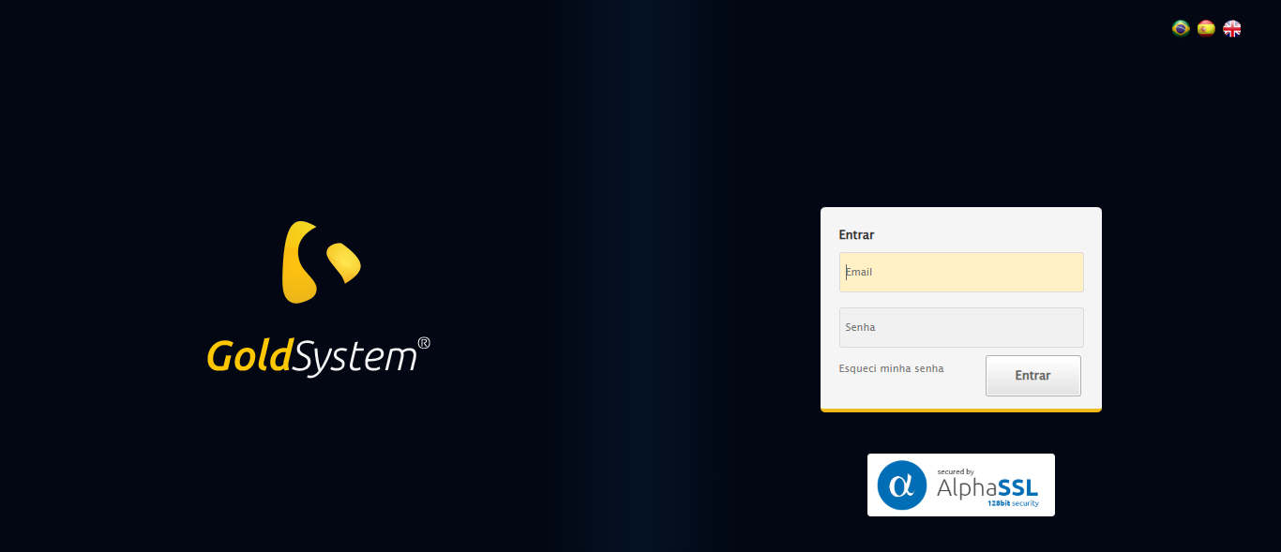

🔄 Realizando login...

✅ Realizando login realizada com sucesso.

Screenshot: realizando_login

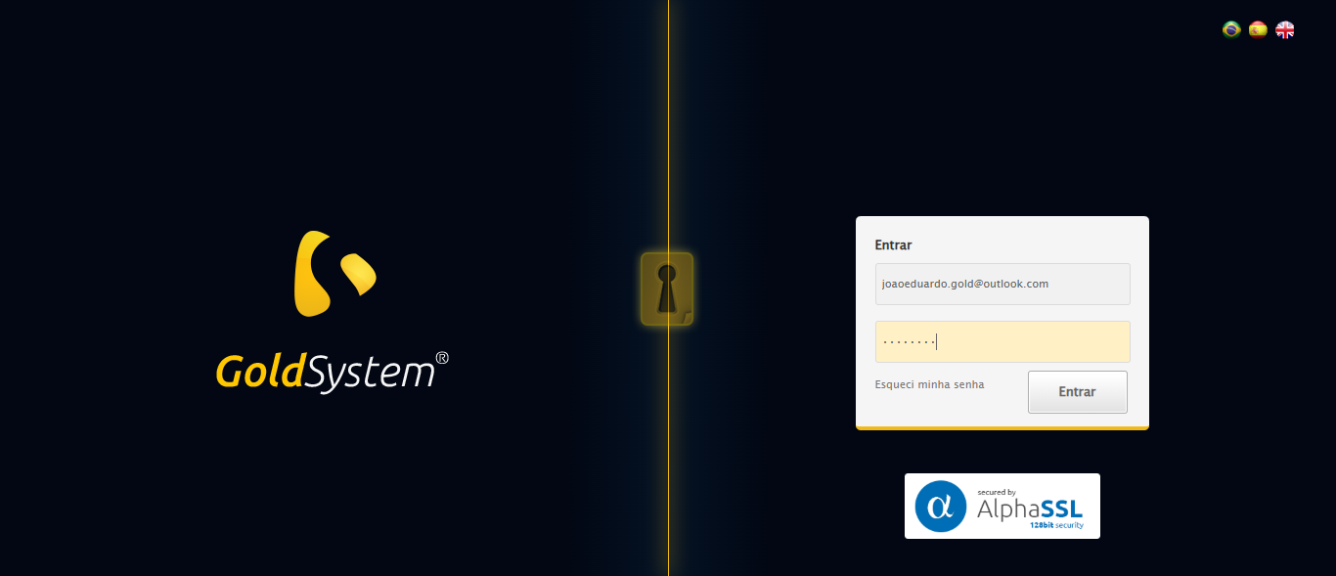

🔄 Esperando sistema carregar e ajustando zoom...

🔍 Zoom ajustado para 90%.

✅ Esperando sistema carregar e ajustando zoom realizada com sucesso.

Screenshot: esperando_sistema_carregar_e_ajustando_zoom

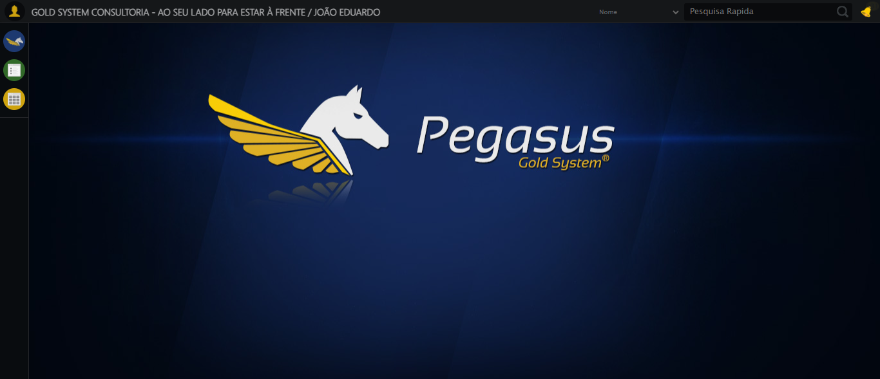

🔄 Abrindo menu Formas de Pagamento MXM...

✅ Abrindo menu Formas de Pagamento MXM realizada com sucesso.

Screenshot: abrindo_menu_formas_de_pagamento_mxm

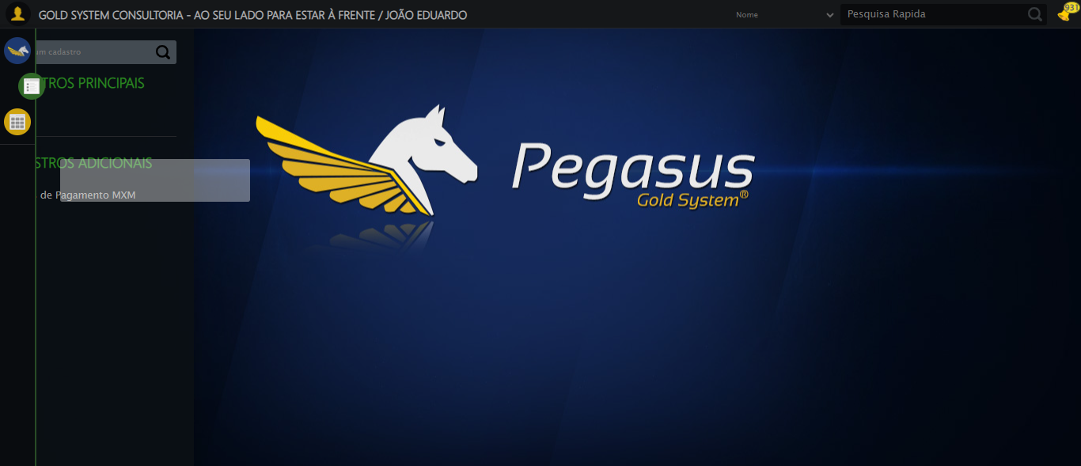

🔄 Clicando em Cadastrar...

✅ Clicando em Cadastrar realizada com sucesso.

Screenshot: clicando_em_cadastrar

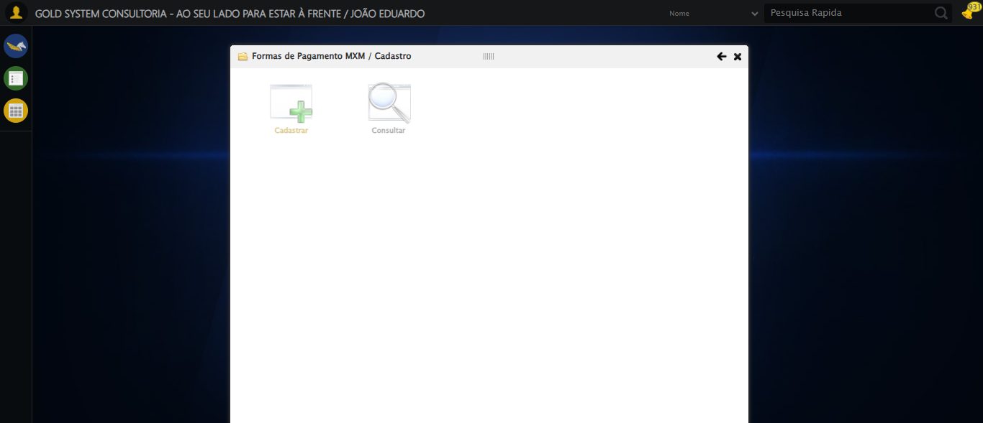

🔄 Selecionando a Filial...

✅ Selecionando a Filial realizada com sucesso.

Screenshot: selecionando_a_filial

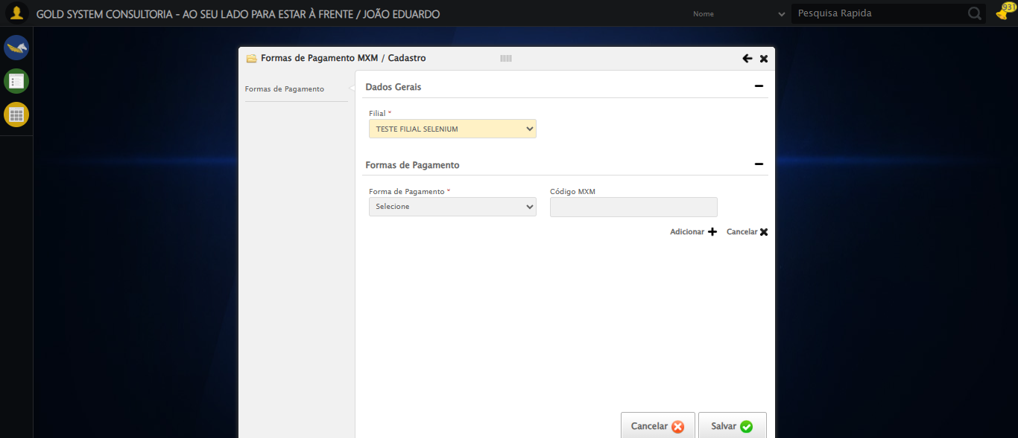

🔄 Selecionando a Forma de Pagamento 'Boleto'...

✅ Selecionando a Forma de Pagamento 'Boleto' realizada com sucesso.

Screenshot: selecionando_a_forma_de_pagamento_'boleto'

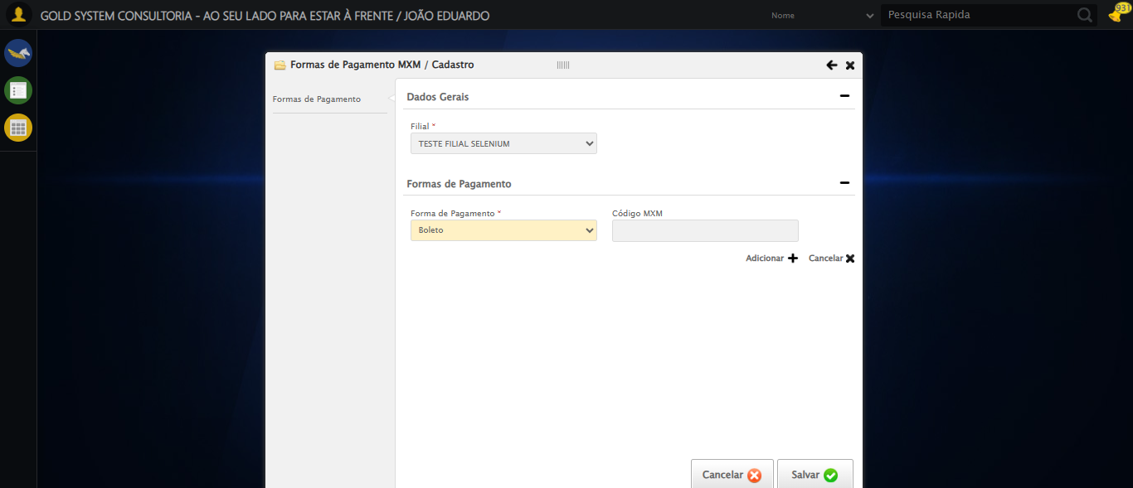

🔄 Preechendo o Código MXM...

✅ Preechendo o Código MXM realizada com sucesso.

Screenshot: preechendo_o_código_mxm

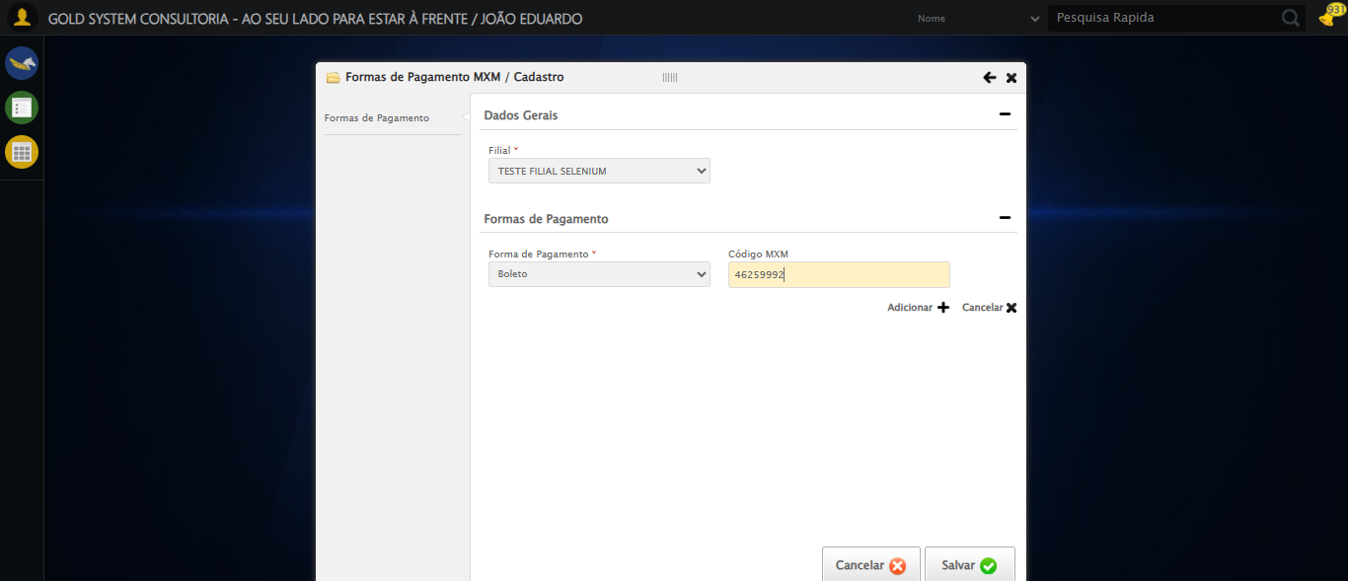

🔄 Adicionando Forma de Pagamento...

✅ Adicionando Forma de Pagamento realizada com sucesso.

Screenshot: adicionando_forma_de_pagamento

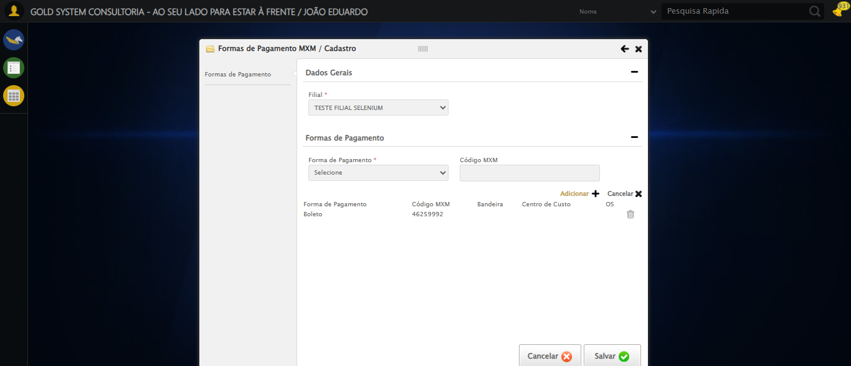

🔄 Selecionando a Forma de Pagamento 'Cartão de Crédito'...

✅ Selecionando a Forma de Pagamento 'Cartão de Crédito' realizada com sucesso.

Screenshot: selecionando_a_forma_de_pagamento_'cartão_de_crédito'

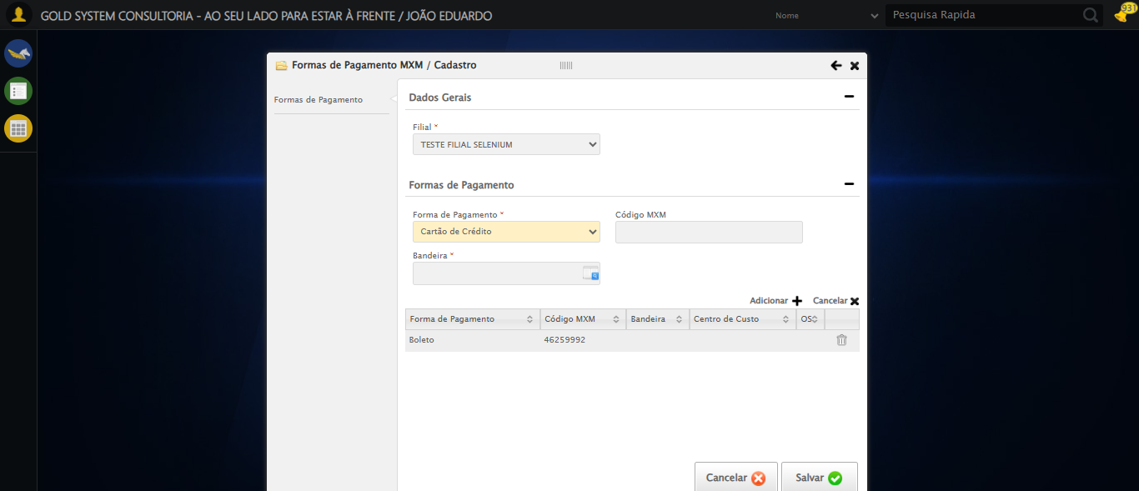

🔄 Preechendo o Código MXM...

✅ Preechendo o Código MXM realizada com sucesso.

🔄 Selecionando a Bandeira do Cartão de Crédito...

❌ Erro ao selecionando a bandeira do cartão de crédito: Message: stale element reference: stale element not found in the current frame  
 (Session info: chrome=140.0.7339.128); For documentation on this error, please visit: https://www.selenium.dev/documentation/webdriver/troubleshooting/errors#staleelementreferenceexception  
Stacktrace:  
 GetHandleVerifier [0x0xfc0c13+66051]  
 GetHandleVerifier [0x0xfc0c54+66116]  
 (No symbol) [0x0xd9db33]  
 (No symbol) [0x0xda44f7]  
 (No symbol) [0x0xda68d4]  
 (No symbol) [0x0xda6968]  
 (No symbol) [0x0xde95fa]  
 (No symbol) [0x0xddd2ba]  
 (No symbol) [0x0xe09f8c]  
 (No symbol) [0x0xddcd94]  
 (No symbol) [0x0xe0a144]  
 (No symbol) [0x0xe2b7f1]  
 (No symbol) [0x0xe09d86]  
 (No symbol) [0x0xddb53e]  
 (No symbol) [0x0xddc414]  
 GetHandleVerifier [0x0x1208a13+2457603]  
 GetHandleVerifier [0x0x12039d2+2437058]  
 GetHandleVerifier [0x0xfe97f2+232930]  
 GetHandleVerifier [0x0xfd9a18+167944]  
 GetHandleVerifier [0x0xfe092d+196381]  
 GetHandleVerifier [0x0xfc8ee8+99544]  
 GetHandleVerifier [0x0xfc9082+99954]  
 GetHandleVerifier [0x0xfb322a+10266]  
 BaseThreadInitThunk [0x0x7726fcc9+25]  
 RtlGetAppContainerNamedObjectPath [0x0x778b82ae+286]  
 RtlGetAppContainerNamedObjectPath [0x0x778b827e+238]

Screenshot: erro_selecionando_a_bandeira_do_cartão_de_crédito

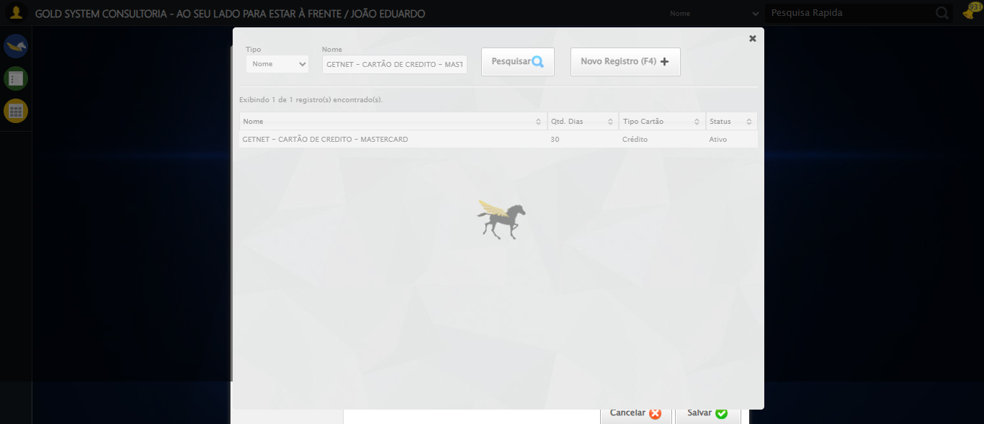

🔄 Adicionando Forma de Pagamento...

❌ Erro ao adicionando forma de pagamento: Message: element click intercepted: Element <a class="btAddGroup">...</a> is not clickable at point (931, 360). Other element would receive the click: <div class="modal overflow" style="z-index: 10002; left: 50%; top: 50%; width: 800px; height: 570px; margin-left: -400px; margin-top: -285px;">...</div>  
 (Session info: chrome=140.0.7339.128); For documentation on this error, please visit: https://www.selenium.dev/documentation/webdriver/troubleshooting/errors#elementclickinterceptedexception  
Stacktrace:  
 GetHandleVerifier [0x0xfc0c13+66051]  
 GetHandleVerifier [0x0xfc0c54+66116]  
 (No symbol) [0x0xd9db33]  
 (No symbol) [0x0xdedd90]  
 (No symbol) [0x0xdec0f3]  
 (No symbol) [0x0xde9ba7]  
 (No symbol) [0x0xde8e2d]  
 (No symbol) [0x0xddd335]  
 (No symbol) [0x0xe09f8c]  
 (No symbol) [0x0xddcd94]  
 (No symbol) [0x0xe0a144]  
 (No symbol) [0x0xe2b7f1]  
 (No symbol) [0x0xe09d86]  
 (No symbol) [0x0xddb53e]  
 (No symbol) [0x0xddc414]  
 GetHandleVerifier [0x0x1208a13+2457603]  
 GetHandleVerifier [0x0x12039d2+2437058]  
 GetHandleVerifier [0x0xfe97f2+232930]  
 GetHandleVerifier [0x0xfd9a18+167944]  
 GetHandleVerifier [0x0xfe092d+196381]  
 GetHandleVerifier [0x0xfc8ee8+99544]  
 GetHandleVerifier [0x0xfc9082+99954]  
 GetHandleVerifier [0x0xfb322a+10266]  
 BaseThreadInitThunk [0x0x7726fcc9+25]  
 RtlGetAppContainerNamedObjectPath [0x0x778b82ae+286]  
 RtlGetAppContainerNamedObjectPath [0x0x778b827e+238]

Screenshot: erro_adicionando_forma_de_pagamento

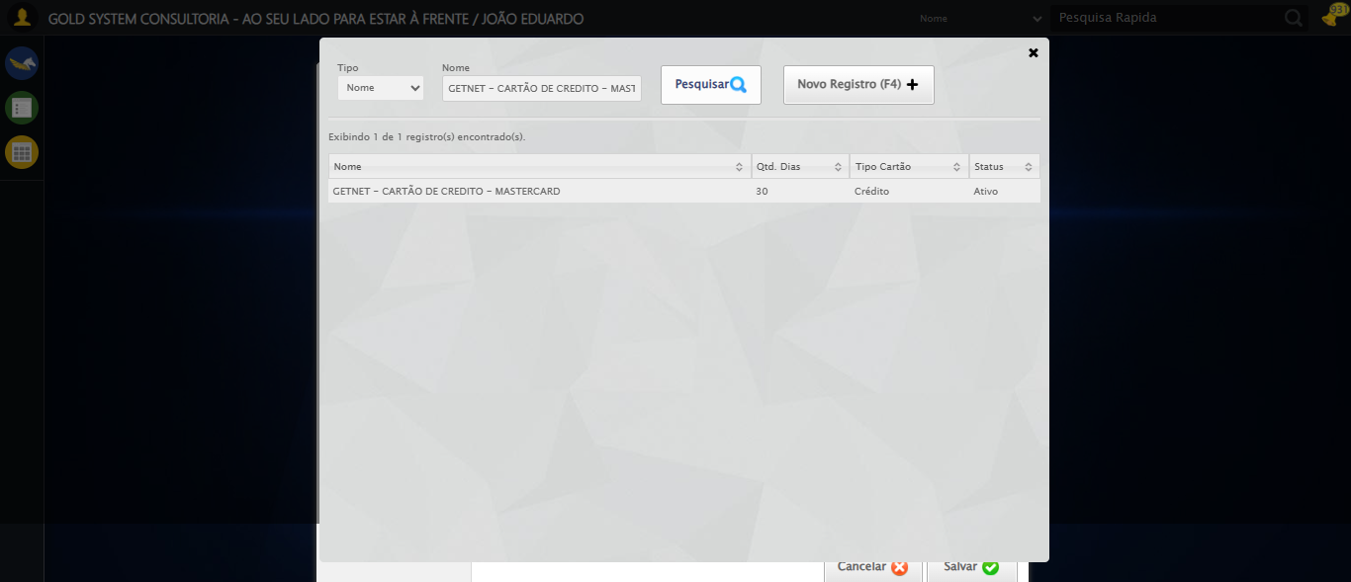

🔄 Selecionando a Forma de Pagamento 'Cartão de Débito'...

✅ Selecionando a Forma de Pagamento 'Cartão de Débito' realizada com sucesso.

Screenshot: selecionando_a_forma_de_pagamento_'cartão_de_débito'



🔄 Preechendo o Código MXM...

✅ Preechendo o Código MXM realizada com sucesso.

🔄 Selecionando a Bandeira do Cartão de Débito...

❌ Erro ao selecionando a bandeira do cartão de débito: Message: element click intercepted: Element <a class="sprites sp-openLov"></a> is not clickable at point (707, 326). Other element would receive the click: <div class="modal overflow" style="z-index: 10002; left: 50%; top: 50%; width: 800px; height: 570px; margin-left: -400px; margin-top: -285px;">...</div>  
 (Session info: chrome=140.0.7339.128); For documentation on this error, please visit: https://www.selenium.dev/documentation/webdriver/troubleshooting/errors#elementclickinterceptedexception  
Stacktrace:  
 GetHandleVerifier [0x0xfc0c13+66051]  
 GetHandleVerifier [0x0xfc0c54+66116]  
 (No symbol) [0x0xd9db33]  
 (No symbol) [0x0xdedd90]  
 (No symbol) [0x0xdec0f3]  
 (No symbol) [0x0xde9ba7]  
 (No symbol) [0x0xde8e2d]  
 (No symbol) [0x0xddd335]  
 (No symbol) [0x0xe09f8c]  
 (No symbol) [0x0xddcd94]  
 (No symbol) [0x0xe0a144]  
 (No symbol) [0x0xe2b7f1]  
 (No symbol) [0x0xe09d86]  
 (No symbol) [0x0xddb53e]  
 (No symbol) [0x0xddc414]  
 GetHandleVerifier [0x0x1208a13+2457603]  
 GetHandleVerifier [0x0x12039d2+2437058]  
 GetHandleVerifier [0x0xfe97f2+232930]  
 GetHandleVerifier [0x0xfd9a18+167944]  
 GetHandleVerifier [0x0xfe092d+196381]  
 GetHandleVerifier [0x0xfc8ee8+99544]  
 GetHandleVerifier [0x0xfc9082+99954]  
 GetHandleVerifier [0x0xfb322a+10266]  
 BaseThreadInitThunk [0x0x7726fcc9+25]  
 RtlGetAppContainerNamedObjectPath [0x0x778b82ae+286]  
 RtlGetAppContainerNamedObjectPath [0x0x778b827e+238]

Screenshot: erro_selecionando_a_bandeira_do_cartão_de_débito



🔄 Adicionando Forma de Pagamento...

❌ Erro ao adicionando forma de pagamento: Message: element click intercepted: Element <a class="btAddGroup">...</a> is not clickable at point (931, 360). Other element would receive the click: <div class="modal overflow" style="z-index: 10002; left: 50%; top: 50%; width: 800px; height: 570px; margin-left: -400px; margin-top: -285px;">...</div>  
 (Session info: chrome=140.0.7339.128); For documentation on this error, please visit: https://www.selenium.dev/documentation/webdriver/troubleshooting/errors#elementclickinterceptedexception  
Stacktrace:  
 GetHandleVerifier [0x0xfc0c13+66051]  
 GetHandleVerifier [0x0xfc0c54+66116]  
 (No symbol) [0x0xd9db33]  
 (No symbol) [0x0xdedd90]  
 (No symbol) [0x0xdec0f3]  
 (No symbol) [0x0xde9ba7]  
 (No symbol) [0x0xde8e2d]  
 (No symbol) [0x0xddd335]  
 (No symbol) [0x0xe09f8c]  
 (No symbol) [0x0xddcd94]  
 (No symbol) [0x0xe0a144]  
 (No symbol) [0x0xe2b7f1]  
 (No symbol) [0x0xe09d86]  
 (No symbol) [0x0xddb53e]  
 (No symbol) [0x0xddc414]  
 GetHandleVerifier [0x0x1208a13+2457603]  
 GetHandleVerifier [0x0x12039d2+2437058]  
 GetHandleVerifier [0x0xfe97f2+232930]  
 GetHandleVerifier [0x0xfd9a18+167944]  
 GetHandleVerifier [0x0xfe092d+196381]  
 GetHandleVerifier [0x0xfc8ee8+99544]  
 GetHandleVerifier [0x0xfc9082+99954]  
 GetHandleVerifier [0x0xfb322a+10266]  
 BaseThreadInitThunk [0x0x7726fcc9+25]  
 RtlGetAppContainerNamedObjectPath [0x0x778b82ae+286]  
 RtlGetAppContainerNamedObjectPath [0x0x778b827e+238]

🔄 Selecionando a Forma de Pagamento 'Cheque a Prazo'...

✅ Selecionando a Forma de Pagamento 'Cheque a Prazo' realizada com sucesso.

Screenshot: selecionando_a_forma_de_pagamento_'cheque_a_prazo'

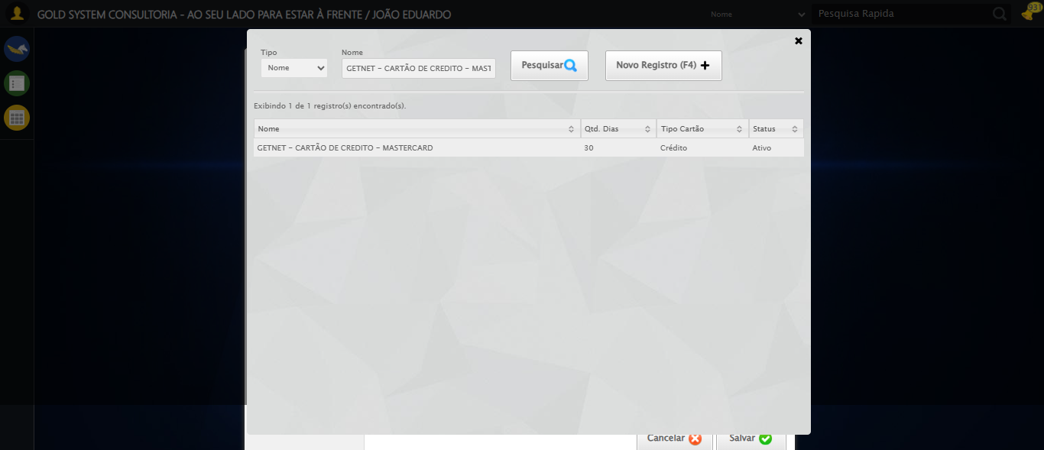

🔄 Preechendo o Código MXM...

✅ Preechendo o Código MXM realizada com sucesso.

🔄 Adicionando Forma de Pagamento...

❌ Erro ao adicionando forma de pagamento: Message: element click intercepted: Element <a class="btAddGroup">...</a> is not clickable at point (931, 311). Other element would receive the click: <div class="modal overflow" style="z-index: 10002; left: 50%; top: 50%; width: 800px; height: 570px; margin-left: -400px; margin-top: -285px;">...</div>  
 (Session info: chrome=140.0.7339.128); For documentation on this error, please visit: https://www.selenium.dev/documentation/webdriver/troubleshooting/errors#elementclickinterceptedexception  
Stacktrace:  
 GetHandleVerifier [0x0xfc0c13+66051]  
 GetHandleVerifier [0x0xfc0c54+66116]  
 (No symbol) [0x0xd9db33]  
 (No symbol) [0x0xdedd90]  
 (No symbol) [0x0xdec0f3]  
 (No symbol) [0x0xde9ba7]  
 (No symbol) [0x0xde8e2d]  
 (No symbol) [0x0xddd335]  
 (No symbol) [0x0xe09f8c]  
 (No symbol) [0x0xddcd94]  
 (No symbol) [0x0xe0a144]  
 (No symbol) [0x0xe2b7f1]  
 (No symbol) [0x0xe09d86]  
 (No symbol) [0x0xddb53e]  
 (No symbol) [0x0xddc414]  
 GetHandleVerifier [0x0x1208a13+2457603]  
 GetHandleVerifier [0x0x12039d2+2437058]  
 GetHandleVerifier [0x0xfe97f2+232930]  
 GetHandleVerifier [0x0xfd9a18+167944]  
 GetHandleVerifier [0x0xfe092d+196381]  
 GetHandleVerifier [0x0xfc8ee8+99544]  
 GetHandleVerifier [0x0xfc9082+99954]  
 GetHandleVerifier [0x0xfb322a+10266]  
 BaseThreadInitThunk [0x0x7726fcc9+25]  
 RtlGetAppContainerNamedObjectPath [0x0x778b82ae+286]  
 RtlGetAppContainerNamedObjectPath [0x0x778b827e+238]

🔄 Selecionando a Forma de Pagamento 'Cheque a Vista'...

✅ Selecionando a Forma de Pagamento 'Cheque a Vista' realizada com sucesso.

Screenshot: selecionando_a_forma_de_pagamento_'cheque_a_vista'



🔄 Preechendo o Código MXM...

✅ Preechendo o Código MXM realizada com sucesso.

🔄 Adicionando Forma de Pagamento...

❌ Erro ao adicionando forma de pagamento: Message: element click intercepted: Element <a class="btAddGroup">...</a> is not clickable at point (931, 311). Other element would receive the click: <div class="modal overflow" style="z-index: 10002; left: 50%; top: 50%; width: 800px; height: 570px; margin-left: -400px; margin-top: -285px;">...</div>  
 (Session info: chrome=140.0.7339.128); For documentation on this error, please visit: https://www.selenium.dev/documentation/webdriver/troubleshooting/errors#elementclickinterceptedexception  
Stacktrace:  
 GetHandleVerifier [0x0xfc0c13+66051]  
 GetHandleVerifier [0x0xfc0c54+66116]  
 (No symbol) [0x0xd9db33]  
 (No symbol) [0x0xdedd90]  
 (No symbol) [0x0xdec0f3]  
 (No symbol) [0x0xde9ba7]  
 (No symbol) [0x0xde8e2d]  
 (No symbol) [0x0xddd335]  
 (No symbol) [0x0xe09f8c]  
 (No symbol) [0x0xddcd94]  
 (No symbol) [0x0xe0a144]  
 (No symbol) [0x0xe2b7f1]  
 (No symbol) [0x0xe09d86]  
 (No symbol) [0x0xddb53e]  
 (No symbol) [0x0xddc414]  
 GetHandleVerifier [0x0x1208a13+2457603]  
 GetHandleVerifier [0x0x12039d2+2437058]  
 GetHandleVerifier [0x0xfe97f2+232930]  
 GetHandleVerifier [0x0xfd9a18+167944]  
 GetHandleVerifier [0x0xfe092d+196381]  
 GetHandleVerifier [0x0xfc8ee8+99544]  
 GetHandleVerifier [0x0xfc9082+99954]  
 GetHandleVerifier [0x0xfb322a+10266]  
 BaseThreadInitThunk [0x0x7726fcc9+25]  
 RtlGetAppContainerNamedObjectPath [0x0x778b82ae+286]  
 RtlGetAppContainerNamedObjectPath [0x0x778b827e+238]

🔄 Selecionando a Forma de Pagamento 'Depósito'...

✅ Selecionando a Forma de Pagamento 'Depósito' realizada com sucesso.

Screenshot: selecionando_a_forma_de_pagamento_'depósito'



🔄 Preechendo o Código MXM...

✅ Preechendo o Código MXM realizada com sucesso.

🔄 Selecionando a opção para não possuir titulo de OS...

❌ Erro ao selecionando a opção para não possuir titulo de os: Message: element click intercepted: Element <input type="radio" class="fc tituloOS" value="NAO" name="tituloOS"> is not clickable at point (544, 324). Other element would receive the click: <div class="modal overflow" style="z-index: 10002; left: 50%; top: 50%; width: 800px; height: 570px; margin-left: -400px; margin-top: -285px;">...</div>  
 (Session info: chrome=140.0.7339.128); For documentation on this error, please visit: https://www.selenium.dev/documentation/webdriver/troubleshooting/errors#elementclickinterceptedexception  
Stacktrace:  
 GetHandleVerifier [0x0xfc0c13+66051]  
 GetHandleVerifier [0x0xfc0c54+66116]  
 (No symbol) [0x0xd9db33]  
 (No symbol) [0x0xdedd90]  
 (No symbol) [0x0xdec0f3]  
 (No symbol) [0x0xde9ba7]  
 (No symbol) [0x0xde8e2d]  
 (No symbol) [0x0xddd335]  
 (No symbol) [0x0xe09f8c]  
 (No symbol) [0x0xddcd94]  
 (No symbol) [0x0xe0a144]  
 (No symbol) [0x0xe2b7f1]  
 (No symbol) [0x0xe09d86]  
 (No symbol) [0x0xddb53e]  
 (No symbol) [0x0xddc414]  
 GetHandleVerifier [0x0x1208a13+2457603]  
 GetHandleVerifier [0x0x12039d2+2437058]  
 GetHandleVerifier [0x0xfe97f2+232930]  
 GetHandleVerifier [0x0xfd9a18+167944]  
 GetHandleVerifier [0x0xfe092d+196381]  
 GetHandleVerifier [0x0xfc8ee8+99544]  
 GetHandleVerifier [0x0xfc9082+99954]  
 GetHandleVerifier [0x0xfb322a+10266]  
 BaseThreadInitThunk [0x0x7726fcc9+25]  
 RtlGetAppContainerNamedObjectPath [0x0x778b82ae+286]  
 RtlGetAppContainerNamedObjectPath [0x0x778b827e+238]

Screenshot: erro_selecionando_a_opção_para_não_possuir_titulo_de_os



🔄 Adicionando Forma de Pagamento...

❌ Erro ao adicionando forma de pagamento: Message: element click intercepted: Element <a class="btAddGroup">...</a> is not clickable at point (931, 360). Other element would receive the click: <div class="modal overflow" style="z-index: 10002; left: 50%; top: 50%; width: 800px; height: 570px; margin-left: -400px; margin-top: -285px;">...</div>  
 (Session info: chrome=140.0.7339.128); For documentation on this error, please visit: https://www.selenium.dev/documentation/webdriver/troubleshooting/errors#elementclickinterceptedexception  
Stacktrace:  
 GetHandleVerifier [0x0xfc0c13+66051]  
 GetHandleVerifier [0x0xfc0c54+66116]  
 (No symbol) [0x0xd9db33]  
 (No symbol) [0x0xdedd90]  
 (No symbol) [0x0xdec0f3]  
 (No symbol) [0x0xde9ba7]  
 (No symbol) [0x0xde8e2d]  
 (No symbol) [0x0xddd335]  
 (No symbol) [0x0xe09f8c]  
 (No symbol) [0x0xddcd94]  
 (No symbol) [0x0xe0a144]  
 (No symbol) [0x0xe2b7f1]  
 (No symbol) [0x0xe09d86]  
 (No symbol) [0x0xddb53e]  
 (No symbol) [0x0xddc414]  
 GetHandleVerifier [0x0x1208a13+2457603]  
 GetHandleVerifier [0x0x12039d2+2437058]  
 GetHandleVerifier [0x0xfe97f2+232930]  
 GetHandleVerifier [0x0xfd9a18+167944]  
 GetHandleVerifier [0x0xfe092d+196381]  
 GetHandleVerifier [0x0xfc8ee8+99544]  
 GetHandleVerifier [0x0xfc9082+99954]  
 GetHandleVerifier [0x0xfb322a+10266]  
 BaseThreadInitThunk [0x0x7726fcc9+25]  
 RtlGetAppContainerNamedObjectPath [0x0x778b82ae+286]  
 RtlGetAppContainerNamedObjectPath [0x0x778b827e+238]

🔄 Selecionando a Forma de Pagamento 'Dinheiro'...

✅ Selecionando a Forma de Pagamento 'Dinheiro' realizada com sucesso.

Screenshot: selecionando_a_forma_de_pagamento_'dinheiro'



🔄 Preechendo o Código MXM...

✅ Preechendo o Código MXM realizada com sucesso.

🔄 Selecionando a opção para não possuir titulo de OS...

❌ Erro ao selecionando a opção para não possuir titulo de os: Message: element click intercepted: Element <input type="radio" class="fc tituloOS" value="NAO" name="tituloOS"> is not clickable at point (544, 324). Other element would receive the click: <div class="modal overflow" style="z-index: 10002; left: 50%; top: 50%; width: 800px; height: 570px; margin-left: -400px; margin-top: -285px;">...</div>  
 (Session info: chrome=140.0.7339.128); For documentation on this error, please visit: https://www.selenium.dev/documentation/webdriver/troubleshooting/errors#elementclickinterceptedexception  
Stacktrace:  
 GetHandleVerifier [0x0xfc0c13+66051]  
 GetHandleVerifier [0x0xfc0c54+66116]  
 (No symbol) [0x0xd9db33]  
 (No symbol) [0x0xdedd90]  
 (No symbol) [0x0xdec0f3]  
 (No symbol) [0x0xde9ba7]  
 (No symbol) [0x0xde8e2d]  
 (No symbol) [0x0xddd335]  
 (No symbol) [0x0xe09f8c]  
 (No symbol) [0x0xddcd94]  
 (No symbol) [0x0xe0a144]  
 (No symbol) [0x0xe2b7f1]  
 (No symbol) [0x0xe09d86]  
 (No symbol) [0x0xddb53e]  
 (No symbol) [0x0xddc414]  
 GetHandleVerifier [0x0x1208a13+2457603]  
 GetHandleVerifier [0x0x12039d2+2437058]  
 GetHandleVerifier [0x0xfe97f2+232930]  
 GetHandleVerifier [0x0xfd9a18+167944]  
 GetHandleVerifier [0x0xfe092d+196381]  
 GetHandleVerifier [0x0xfc8ee8+99544]  
 GetHandleVerifier [0x0xfc9082+99954]  
 GetHandleVerifier [0x0xfb322a+10266]  
 BaseThreadInitThunk [0x0x7726fcc9+25]  
 RtlGetAppContainerNamedObjectPath [0x0x778b82ae+286]  
 RtlGetAppContainerNamedObjectPath [0x0x778b827e+238]

🔄 Adicionando Forma de Pagamento...

❌ Erro ao adicionando forma de pagamento: Message: element click intercepted: Element <a class="btAddGroup">...</a> is not clickable at point (931, 360). Other element would receive the click: <div class="modal overflow" style="z-index: 10002; left: 50%; top: 50%; width: 800px; height: 570px; margin-left: -400px; margin-top: -285px;">...</div>  
 (Session info: chrome=140.0.7339.128); For documentation on this error, please visit: https://www.selenium.dev/documentation/webdriver/troubleshooting/errors#elementclickinterceptedexception  
Stacktrace:  
 GetHandleVerifier [0x0xfc0c13+66051]  
 GetHandleVerifier [0x0xfc0c54+66116]  
 (No symbol) [0x0xd9db33]  
 (No symbol) [0x0xdedd90]  
 (No symbol) [0x0xdec0f3]  
 (No symbol) [0x0xde9ba7]  
 (No symbol) [0x0xde8e2d]  
 (No symbol) [0x0xddd335]  
 (No symbol) [0x0xe09f8c]  
 (No symbol) [0x0xddcd94]  
 (No symbol) [0x0xe0a144]  
 (No symbol) [0x0xe2b7f1]  
 (No symbol) [0x0xe09d86]  
 (No symbol) [0x0xddb53e]  
 (No symbol) [0x0xddc414]  
 GetHandleVerifier [0x0x1208a13+2457603]  
 GetHandleVerifier [0x0x12039d2+2437058]  
 GetHandleVerifier [0x0xfe97f2+232930]  
 GetHandleVerifier [0x0xfd9a18+167944]  
 GetHandleVerifier [0x0xfe092d+196381]  
 GetHandleVerifier [0x0xfc8ee8+99544]  
 GetHandleVerifier [0x0xfc9082+99954]  
 GetHandleVerifier [0x0xfb322a+10266]  
 BaseThreadInitThunk [0x0x7726fcc9+25]  
 RtlGetAppContainerNamedObjectPath [0x0x778b82ae+286]  
 RtlGetAppContainerNamedObjectPath [0x0x778b827e+238]

🔄 Selecionando a Forma de Pagamento 'Retorno Bancário'...

✅ Selecionando a Forma de Pagamento 'Retorno Bancário' realizada com sucesso.

Screenshot: selecionando_a_forma_de_pagamento_'retorno_bancário'



🔄 Preechendo o Código MXM...

✅ Preechendo o Código MXM realizada com sucesso.

🔄 Adicionando Forma de Pagamento...

❌ Erro ao adicionando forma de pagamento: Message: element click intercepted: Element <a class="btAddGroup">...</a> is not clickable at point (931, 311). Other element would receive the click: <div class="modal overflow" style="z-index: 10002; left: 50%; top: 50%; width: 800px; height: 570px; margin-left: -400px; margin-top: -285px;">...</div>  
 (Session info: chrome=140.0.7339.128); For documentation on this error, please visit: https://www.selenium.dev/documentation/webdriver/troubleshooting/errors#elementclickinterceptedexception  
Stacktrace:  
 GetHandleVerifier [0x0xfc0c13+66051]  
 GetHandleVerifier [0x0xfc0c54+66116]  
 (No symbol) [0x0xd9db33]  
 (No symbol) [0x0xdedd90]  
 (No symbol) [0x0xdec0f3]  
 (No symbol) [0x0xde9ba7]  
 (No symbol) [0x0xde8e2d]  
 (No symbol) [0x0xddd335]  
 (No symbol) [0x0xe09f8c]  
 (No symbol) [0x0xddcd94]  
 (No symbol) [0x0xe0a144]  
 (No symbol) [0x0xe2b7f1]  
 (No symbol) [0x0xe09d86]  
 (No symbol) [0x0xddb53e]  
 (No symbol) [0x0xddc414]  
 GetHandleVerifier [0x0x1208a13+2457603]  
 GetHandleVerifier [0x0x12039d2+2437058]  
 GetHandleVerifier [0x0xfe97f2+232930]  
 GetHandleVerifier [0x0xfd9a18+167944]  
 GetHandleVerifier [0x0xfe092d+196381]  
 GetHandleVerifier [0x0xfc8ee8+99544]  
 GetHandleVerifier [0x0xfc9082+99954]  
 GetHandleVerifier [0x0xfb322a+10266]  
 BaseThreadInitThunk [0x0x7726fcc9+25]  
 RtlGetAppContainerNamedObjectPath [0x0x778b82ae+286]  
 RtlGetAppContainerNamedObjectPath [0x0x778b827e+238]

🔄 Selecionando a Forma de Pagamento 'Vindi'...

✅ Selecionando a Forma de Pagamento 'Vindi' realizada com sucesso.

Screenshot: selecionando_a_forma_de_pagamento_'vindi'



🔄 Preechendo o Código MXM...

✅ Preechendo o Código MXM realizada com sucesso.

🔄 Adicionando Forma de Pagamento...

❌ Erro ao adicionando forma de pagamento: Message: element click intercepted: Element <a class="btAddGroup">...</a> is not clickable at point (931, 311). Other element would receive the click: <div class="modal overflow" style="z-index: 10002; left: 50%; top: 50%; width: 800px; height: 570px; margin-left: -400px; margin-top: -285px;">...</div>  
 (Session info: chrome=140.0.7339.128); For documentation on this error, please visit: https://www.selenium.dev/documentation/webdriver/troubleshooting/errors#elementclickinterceptedexception  
Stacktrace:  
 GetHandleVerifier [0x0xfc0c13+66051]  
 GetHandleVerifier [0x0xfc0c54+66116]  
 (No symbol) [0x0xd9db33]  
 (No symbol) [0x0xdedd90]  
 (No symbol) [0x0xdec0f3]  
 (No symbol) [0x0xde9ba7]  
 (No symbol) [0x0xde8e2d]  
 (No symbol) [0x0xddd335]  
 (No symbol) [0x0xe09f8c]  
 (No symbol) [0x0xddcd94]  
 (No symbol) [0x0xe0a144]  
 (No symbol) [0x0xe2b7f1]  
 (No symbol) [0x0xe09d86]  
 (No symbol) [0x0xddb53e]  
 (No symbol) [0x0xddc414]  
 GetHandleVerifier [0x0x1208a13+2457603]  
 GetHandleVerifier [0x0x12039d2+2437058]  
 GetHandleVerifier [0x0xfe97f2+232930]  
 GetHandleVerifier [0x0xfd9a18+167944]  
 GetHandleVerifier [0x0xfe092d+196381]  
 GetHandleVerifier [0x0xfc8ee8+99544]  
 GetHandleVerifier [0x0xfc9082+99954]  
 GetHandleVerifier [0x0xfb322a+10266]  
 BaseThreadInitThunk [0x0x7726fcc9+25]  
 RtlGetAppContainerNamedObjectPath [0x0x778b82ae+286]  
 RtlGetAppContainerNamedObjectPath [0x0x778b827e+238]

🔄 Selecionando a Forma de Pagamento 'Faturado'...

✅ Selecionando a Forma de Pagamento 'Faturado' realizada com sucesso.

Screenshot: selecionando_a_forma_de_pagamento_'faturado'



🔄 Preechendo o Código MXM...

✅ Preechendo o Código MXM realizada com sucesso.

🔄 Adicionando Forma de Pagamento...

❌ Erro ao adicionando forma de pagamento: Message: element click intercepted: Element <a class="btAddGroup">...</a> is not clickable at point (931, 311). Other element would receive the click: <div class="modal overflow" style="z-index: 10002; left: 50%; top: 50%; width: 800px; height: 570px; margin-left: -400px; margin-top: -285px;">...</div>  
 (Session info: chrome=140.0.7339.128); For documentation on this error, please visit: https://www.selenium.dev/documentation/webdriver/troubleshooting/errors#elementclickinterceptedexception  
Stacktrace:  
 GetHandleVerifier [0x0xfc0c13+66051]  
 GetHandleVerifier [0x0xfc0c54+66116]  
 (No symbol) [0x0xd9db33]  
 (No symbol) [0x0xdedd90]  
 (No symbol) [0x0xdec0f3]  
 (No symbol) [0x0xde9ba7]  
 (No symbol) [0x0xde8e2d]  
 (No symbol) [0x0xddd335]  
 (No symbol) [0x0xe09f8c]  
 (No symbol) [0x0xddcd94]  
 (No symbol) [0x0xe0a144]  
 (No symbol) [0x0xe2b7f1]  
 (No symbol) [0x0xe09d86]  
 (No symbol) [0x0xddb53e]  
 (No symbol) [0x0xddc414]  
 GetHandleVerifier [0x0x1208a13+2457603]  
 GetHandleVerifier [0x0x12039d2+2437058]  
 GetHandleVerifier [0x0xfe97f2+232930]  
 GetHandleVerifier [0x0xfd9a18+167944]  
 GetHandleVerifier [0x0xfe092d+196381]  
 GetHandleVerifier [0x0xfc8ee8+99544]  
 GetHandleVerifier [0x0xfc9082+99954]  
 GetHandleVerifier [0x0xfb322a+10266]  
 BaseThreadInitThunk [0x0x7726fcc9+25]  
 RtlGetAppContainerNamedObjectPath [0x0x778b82ae+286]  
 RtlGetAppContainerNamedObjectPath [0x0x778b827e+238]

🔄 Selecionando a Forma de Pagamento 'PIX'...

✅ Selecionando a Forma de Pagamento 'PIX' realizada com sucesso.

Screenshot: selecionando_a_forma_de_pagamento_'pix'



🔄 Preechendo o Código MXM...

✅ Preechendo o Código MXM realizada com sucesso.

🔄 Selecionando a opção para não possuir titulo de OS...

❌ Erro ao selecionando a opção para não possuir titulo de os: Message: element click intercepted: Element <input type="radio" class="fc tituloOS" value="NAO" name="tituloOS"> is not clickable at point (544, 324). Other element would receive the click: <div class="modal overflow" style="z-index: 10002; left: 50%; top: 50%; width: 800px; height: 570px; margin-left: -400px; margin-top: -285px;">...</div>  
 (Session info: chrome=140.0.7339.128); For documentation on this error, please visit: https://www.selenium.dev/documentation/webdriver/troubleshooting/errors#elementclickinterceptedexception  
Stacktrace:  
 GetHandleVerifier [0x0xfc0c13+66051]  
 GetHandleVerifier [0x0xfc0c54+66116]  
 (No symbol) [0x0xd9db33]  
 (No symbol) [0x0xdedd90]  
 (No symbol) [0x0xdec0f3]  
 (No symbol) [0x0xde9ba7]  
 (No symbol) [0x0xde8e2d]  
 (No symbol) [0x0xddd335]  
 (No symbol) [0x0xe09f8c]  
 (No symbol) [0x0xddcd94]  
 (No symbol) [0x0xe0a144]  
 (No symbol) [0x0xe2b7f1]  
 (No symbol) [0x0xe09d86]  
 (No symbol) [0x0xddb53e]  
 (No symbol) [0x0xddc414]  
 GetHandleVerifier [0x0x1208a13+2457603]  
 GetHandleVerifier [0x0x12039d2+2437058]  
 GetHandleVerifier [0x0xfe97f2+232930]  
 GetHandleVerifier [0x0xfd9a18+167944]  
 GetHandleVerifier [0x0xfe092d+196381]  
 GetHandleVerifier [0x0xfc8ee8+99544]  
 GetHandleVerifier [0x0xfc9082+99954]  
 GetHandleVerifier [0x0xfb322a+10266]  
 BaseThreadInitThunk [0x0x7726fcc9+25]  
 RtlGetAppContainerNamedObjectPath [0x0x778b82ae+286]  
 RtlGetAppContainerNamedObjectPath [0x0x778b827e+238]

🔄 Adicionando Forma de Pagamento...

❌ Erro ao adicionando forma de pagamento: Message: element click intercepted: Element <a class="btAddGroup">...</a> is not clickable at point (931, 360). Other element would receive the click: <div class="modal overflow" style="z-index: 10002; left: 50%; top: 50%; width: 800px; height: 570px; margin-left: -400px; margin-top: -285px;">...</div>  
 (Session info: chrome=140.0.7339.128); For documentation on this error, please visit: https://www.selenium.dev/documentation/webdriver/troubleshooting/errors#elementclickinterceptedexception  
Stacktrace:  
 GetHandleVerifier [0x0xfc0c13+66051]  
 GetHandleVerifier [0x0xfc0c54+66116]  
 (No symbol) [0x0xd9db33]  
 (No symbol) [0x0xdedd90]  
 (No symbol) [0x0xdec0f3]  
 (No symbol) [0x0xde9ba7]  
 (No symbol) [0x0xde8e2d]  
 (No symbol) [0x0xddd335]  
 (No symbol) [0x0xe09f8c]  
 (No symbol) [0x0xddcd94]  
 (No symbol) [0x0xe0a144]  
 (No symbol) [0x0xe2b7f1]  
 (No symbol) [0x0xe09d86]  
 (No symbol) [0x0xddb53e]  
 (No symbol) [0x0xddc414]  
 GetHandleVerifier [0x0x1208a13+2457603]  
 GetHandleVerifier [0x0x12039d2+2437058]  
 GetHandleVerifier [0x0xfe97f2+232930]  
 GetHandleVerifier [0x0xfd9a18+167944]  
 GetHandleVerifier [0x0xfe092d+196381]  
 GetHandleVerifier [0x0xfc8ee8+99544]  
 GetHandleVerifier [0x0xfc9082+99954]  
 GetHandleVerifier [0x0xfb322a+10266]  
 BaseThreadInitThunk [0x0x7726fcc9+25]  
 RtlGetAppContainerNamedObjectPath [0x0x778b82ae+286]  
 RtlGetAppContainerNamedObjectPath [0x0x778b827e+238]

🔄 Selecionando a Forma de Pagamento 'Transferência'...

✅ Selecionando a Forma de Pagamento 'Transferência' realizada com sucesso.

Screenshot: selecionando_a_forma_de_pagamento_'transferência'



🔄 Preechendo o Código MXM...

✅ Preechendo o Código MXM realizada com sucesso.

🔄 Selecionando a opção para não possuir titulo de OS...

❌ Erro ao selecionando a opção para não possuir titulo de os: Message: element click intercepted: Element <input type="radio" class="fc tituloOS" value="NAO" name="tituloOS"> is not clickable at point (544, 324). Other element would receive the click: <div class="modal overflow" style="z-index: 10002; left: 50%; top: 50%; width: 800px; height: 570px; margin-left: -400px; margin-top: -285px;">...</div>  
 (Session info: chrome=140.0.7339.128); For documentation on this error, please visit: https://www.selenium.dev/documentation/webdriver/troubleshooting/errors#elementclickinterceptedexception  
Stacktrace:  
 GetHandleVerifier [0x0xfc0c13+66051]  
 GetHandleVerifier [0x0xfc0c54+66116]  
 (No symbol) [0x0xd9db33]  
 (No symbol) [0x0xdedd90]  
 (No symbol) [0x0xdec0f3]  
 (No symbol) [0x0xde9ba7]  
 (No symbol) [0x0xde8e2d]  
 (No symbol) [0x0xddd335]  
 (No symbol) [0x0xe09f8c]  
 (No symbol) [0x0xddcd94]  
 (No symbol) [0x0xe0a144]  
 (No symbol) [0x0xe2b7f1]  
 (No symbol) [0x0xe09d86]  
 (No symbol) [0x0xddb53e]  
 (No symbol) [0x0xddc414]  
 GetHandleVerifier [0x0x1208a13+2457603]  
 GetHandleVerifier [0x0x12039d2+2437058]  
 GetHandleVerifier [0x0xfe97f2+232930]  
 GetHandleVerifier [0x0xfd9a18+167944]  
 GetHandleVerifier [0x0xfe092d+196381]  
 GetHandleVerifier [0x0xfc8ee8+99544]  
 GetHandleVerifier [0x0xfc9082+99954]  
 GetHandleVerifier [0x0xfb322a+10266]  
 BaseThreadInitThunk [0x0x7726fcc9+25]  
 RtlGetAppContainerNamedObjectPath [0x0x778b82ae+286]  
 RtlGetAppContainerNamedObjectPath [0x0x778b827e+238]

🔄 Adicionando Forma de Pagamento...

❌ Erro ao adicionando forma de pagamento: Message: element click intercepted: Element <a class="btAddGroup">...</a> is not clickable at point (931, 360). Other element would receive the click: <div class="modal overflow" style="z-index: 10002; left: 50%; top: 50%; width: 800px; height: 570px; margin-left: -400px; margin-top: -285px;">...</div>  
 (Session info: chrome=140.0.7339.128); For documentation on this error, please visit: https://www.selenium.dev/documentation/webdriver/troubleshooting/errors#elementclickinterceptedexception  
Stacktrace:  
 GetHandleVerifier [0x0xfc0c13+66051]  
 GetHandleVerifier [0x0xfc0c54+66116]  
 (No symbol) [0x0xd9db33]  
 (No symbol) [0x0xdedd90]  
 (No symbol) [0x0xdec0f3]  
 (No symbol) [0x0xde9ba7]  
 (No symbol) [0x0xde8e2d]  
 (No symbol) [0x0xddd335]  
 (No symbol) [0x0xe09f8c]  
 (No symbol) [0x0xddcd94]  
 (No symbol) [0x0xe0a144]  
 (No symbol) [0x0xe2b7f1]  
 (No symbol) [0x0xe09d86]  
 (No symbol) [0x0xddb53e]  
 (No symbol) [0x0xddc414]  
 GetHandleVerifier [0x0x1208a13+2457603]  
 GetHandleVerifier [0x0x12039d2+2437058]  
 GetHandleVerifier [0x0xfe97f2+232930]  
 GetHandleVerifier [0x0xfd9a18+167944]  
 GetHandleVerifier [0x0xfe092d+196381]  
 GetHandleVerifier [0x0xfc8ee8+99544]  
 GetHandleVerifier [0x0xfc9082+99954]  
 GetHandleVerifier [0x0xfb322a+10266]  
 BaseThreadInitThunk [0x0x7726fcc9+25]  
 RtlGetAppContainerNamedObjectPath [0x0x778b82ae+286]  
 RtlGetAppContainerNamedObjectPath [0x0x778b827e+238]

🔄 Salvando cadastro...

✅ Salvando cadastro realizada com sucesso.

Screenshot: salvando_cadastro

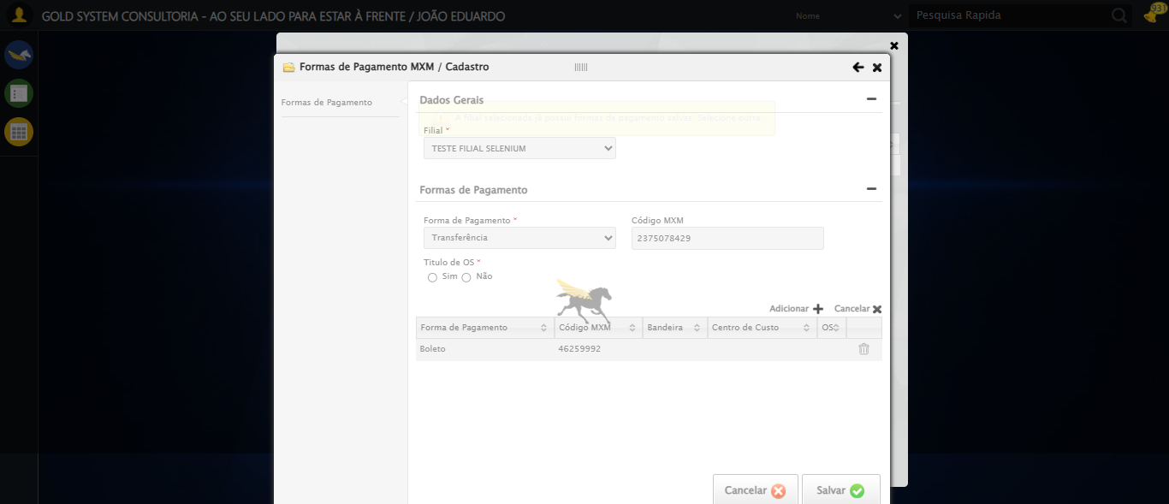

🔄 Fechando modal após salvamento...

✅ Fechando modal após salvamento realizada com sucesso.

Screenshot: fechando_modal_após_salvamento

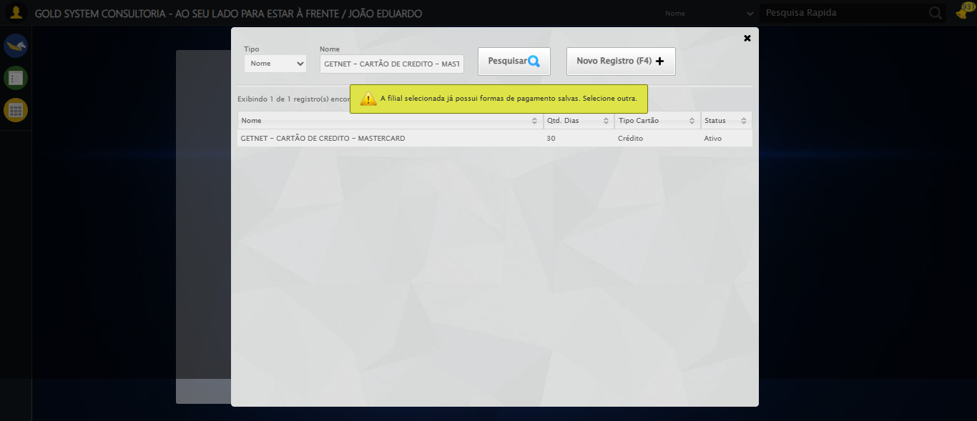

📢 ⚠️ Alerta: A filial selecionada já possui formas de pagamento salvas. Selecione outra.

✅ Teste concluído com sucesso.