RELATÓRIO DO TESTE

Cadastro de Formas de Pagamento MXM – Cenário 1: Preenchimento completo e salvamento.

Data do teste: 22/09/2025 14:18:59

🔄 Acessando sistema...

✅ Acessando sistema realizada com sucesso.

Screenshot: acessando_sistema



🔄 Realizando login...

✅ Realizando login realizada com sucesso.

Screenshot: realizando_login

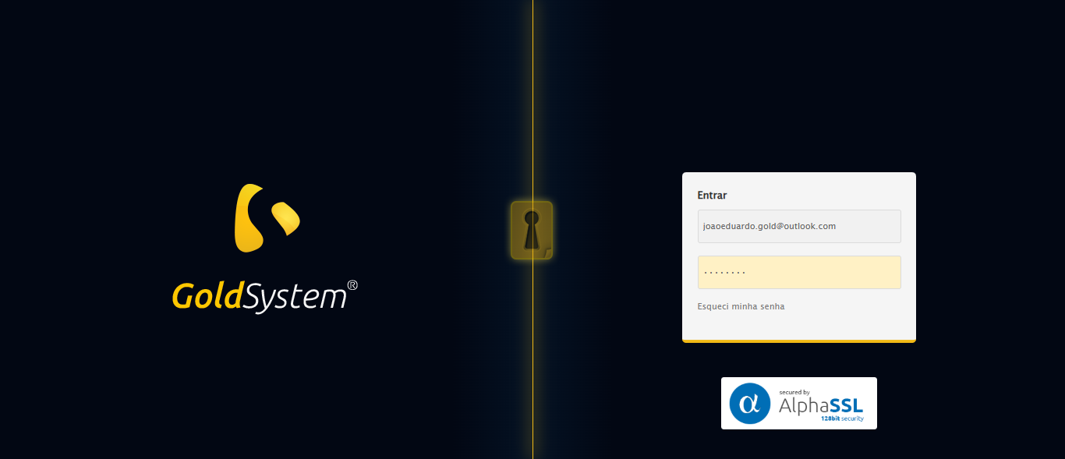

🔄 Esperando sistema carregar e ajustando zoom...

⚠️ Erro ao ajustar zoom: Message: target frame detached  
 (failed to check if window was closed: disconnected: Unable to receive message from renderer)  
 (Session info: chrome=140.0.7339.129)  
Stacktrace:  
 GetHandleVerifier [0x0x6a0c13+66051]  
 GetHandleVerifier [0x0x6a0c54+66116]  
 (No symbol) [0x0x47d980]  
 (No symbol) [0x0x46e059]  
 (No symbol) [0x0x46d18a]  
 (No symbol) [0x0x48b6db]  
 (No symbol) [0x0x48a9ed]  
 (No symbol) [0x0x50b700]  
 (No symbol) [0x0x4e9d86]  
 (No symbol) [0x0x4bb53e]  
 (No symbol) [0x0x4bc414]  
 GetHandleVerifier [0x0x8e8a13+2457603]  
 GetHandleVerifier [0x0x8e39d2+2437058]  
 GetHandleVerifier [0x0x6c97f2+232930]  
 GetHandleVerifier [0x0x6b9a18+167944]  
 GetHandleVerifier [0x0x6c092d+196381]  
 GetHandleVerifier [0x0x6a8ee8+99544]  
 GetHandleVerifier [0x0x6a9082+99954]  
 GetHandleVerifier [0x0x69322a+10266]  
 BaseThreadInitThunk [0x0x7728fcc9+25]  
 RtlGetAppContainerNamedObjectPath [0x0x77e782ae+286]  
 RtlGetAppContainerNamedObjectPath [0x0x77e7827e+238]

✅ Esperando sistema carregar e ajustando zoom realizada com sucesso.

❌ Erro ao esperando sistema carregar e ajustando zoom: Message: invalid session id: session deleted as the browser has closed the connection  
from disconnected: not connected to DevTools  
 (Session info: chrome=140.0.7339.129); For documentation on this error, please visit: https://www.selenium.dev/documentation/webdriver/troubleshooting/errors#invalidsessionidexception  
Stacktrace:  
 GetHandleVerifier [0x0x6a0c13+66051]  
 GetHandleVerifier [0x0x6a0c54+66116]  
 (No symbol) [0x0x47db33]  
 (No symbol) [0x0x46cfd0]  
 (No symbol) [0x0x48b6db]  
 (No symbol) [0x0x4f09b5]  
 (No symbol) [0x0x50b109]  
 (No symbol) [0x0x4e9d86]  
 (No symbol) [0x0x4bb53e]  
 (No symbol) [0x0x4bc414]  
 GetHandleVerifier [0x0x8e8a13+2457603]  
 GetHandleVerifier [0x0x8e39d2+2437058]  
 GetHandleVerifier [0x0x6c97f2+232930]  
 GetHandleVerifier [0x0x6b9a18+167944]  
 GetHandleVerifier [0x0x6c092d+196381]  
 GetHandleVerifier [0x0x6a8ee8+99544]  
 GetHandleVerifier [0x0x6a9082+99954]  
 GetHandleVerifier [0x0x69322a+10266]  
 BaseThreadInitThunk [0x0x7728fcc9+25]  
 RtlGetAppContainerNamedObjectPath [0x0x77e782ae+286]  
 RtlGetAppContainerNamedObjectPath [0x0x77e7827e+238]

❌ ERRO FATAL: Message: invalid session id; For documentation on this error, please visit: https://www.selenium.dev/documentation/webdriver/troubleshooting/errors#invalidsessionidexception  
Stacktrace:  
 GetHandleVerifier [0x0x6a0c13+66051]  
 GetHandleVerifier [0x0x6a0c54+66116]  
 (No symbol) [0x0x47d980]  
 (No symbol) [0x0x4ba813]  
 (No symbol) [0x0x4e9e46]  
 (No symbol) [0x0x4e5709]  
 (No symbol) [0x0x4e4c83]  
 (No symbol) [0x0x44e93d]  
 (No symbol) [0x0x44eebe]  
 (No symbol) [0x0x44f35d]  
 GetHandleVerifier [0x0x8e8a13+2457603]  
 GetHandleVerifier [0x0x8e39d2+2437058]  
 GetHandleVerifier [0x0x6c97f2+232930]  
 GetHandleVerifier [0x0x6b9a18+167944]  
 GetHandleVerifier [0x0x6c092d+196381]  
 (No symbol) [0x0x44e5f2]  
 (No symbol) [0x0x44de09]  
 GetHandleVerifier [0x0xa1450c+3685116]  
 BaseThreadInitThunk [0x0x7728fcc9+25]  
 RtlGetAppContainerNamedObjectPath [0x0x77e782ae+286]  
 RtlGetAppContainerNamedObjectPath [0x0x77e7827e+238]

✅ Teste concluído com sucesso.